# Internet Variable Relation Report: Married Females

Source file: 20251214-ScalesData-Combined_ver0.7-Cleaned-IncomeNormalized.csv

## Emotional Support - Raw Score vs Functional Impairment - Raw Score

Test: spearman; statistic: -0.17245800872346576; p-value: 0.2687827867971684;

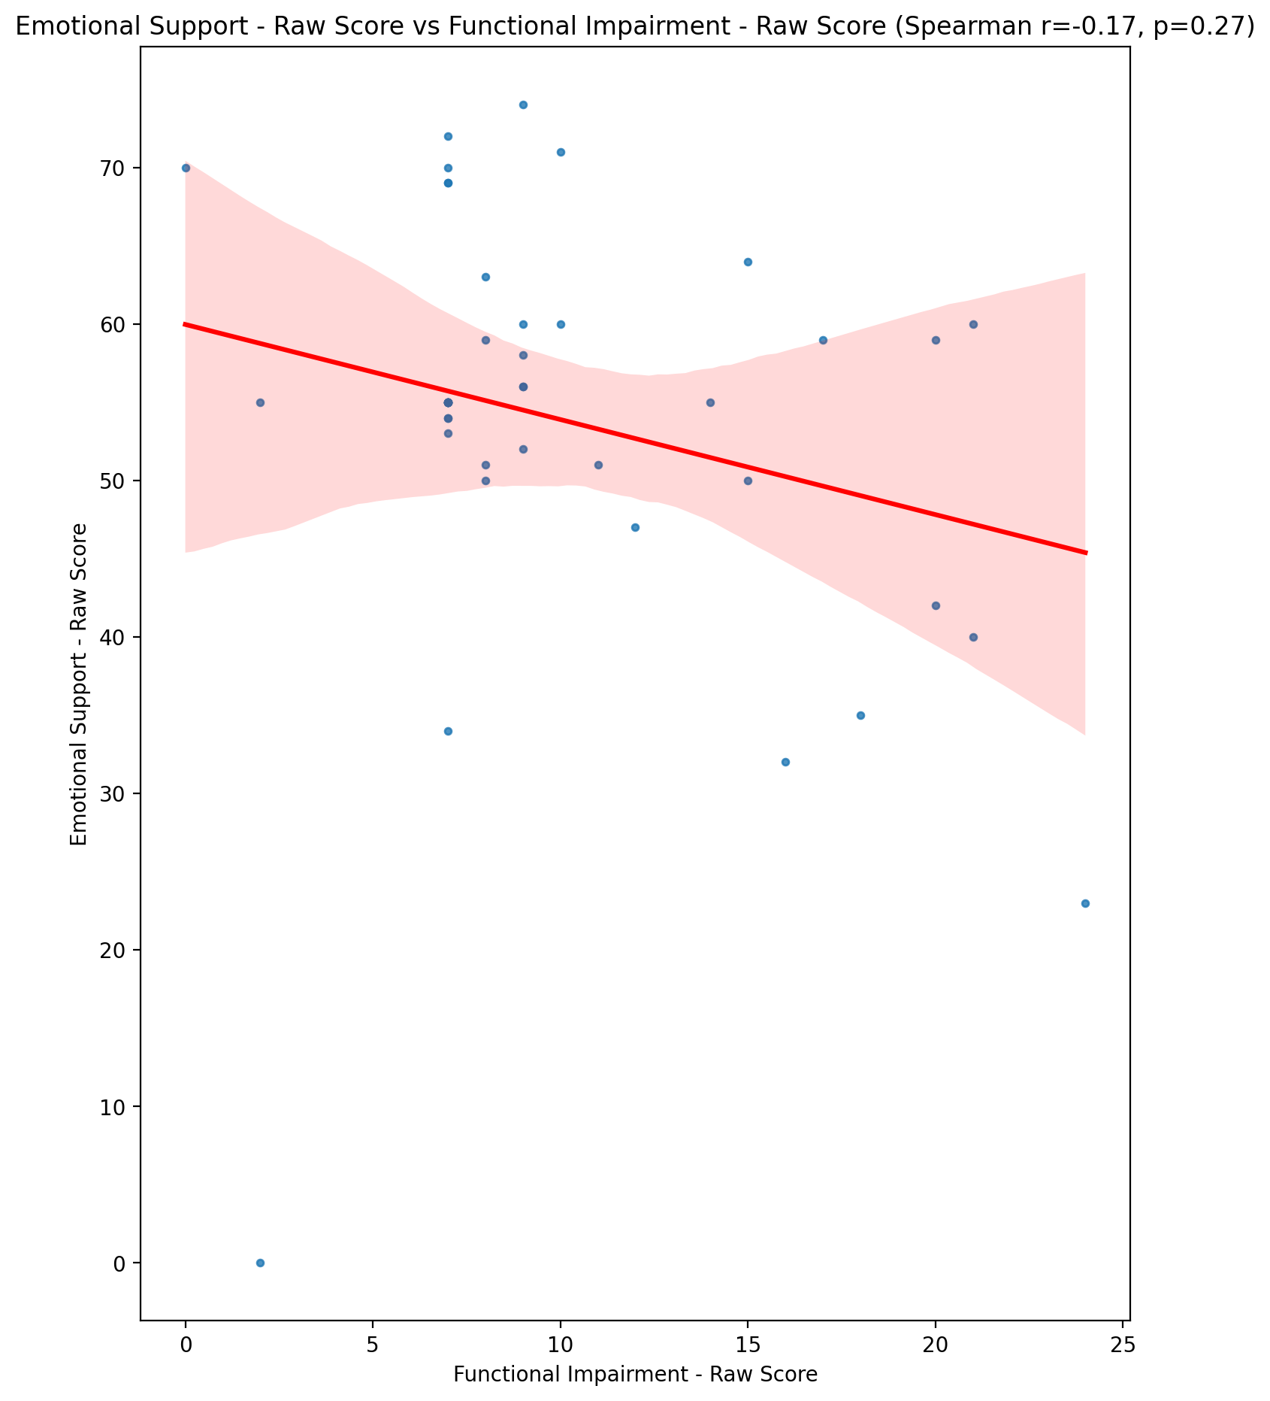

## Informational Support - Raw Score vs Functional Impairment - Raw Score

Test: spearman; statistic: -0.3116314824699502; p-value: 0.041925812303801865;

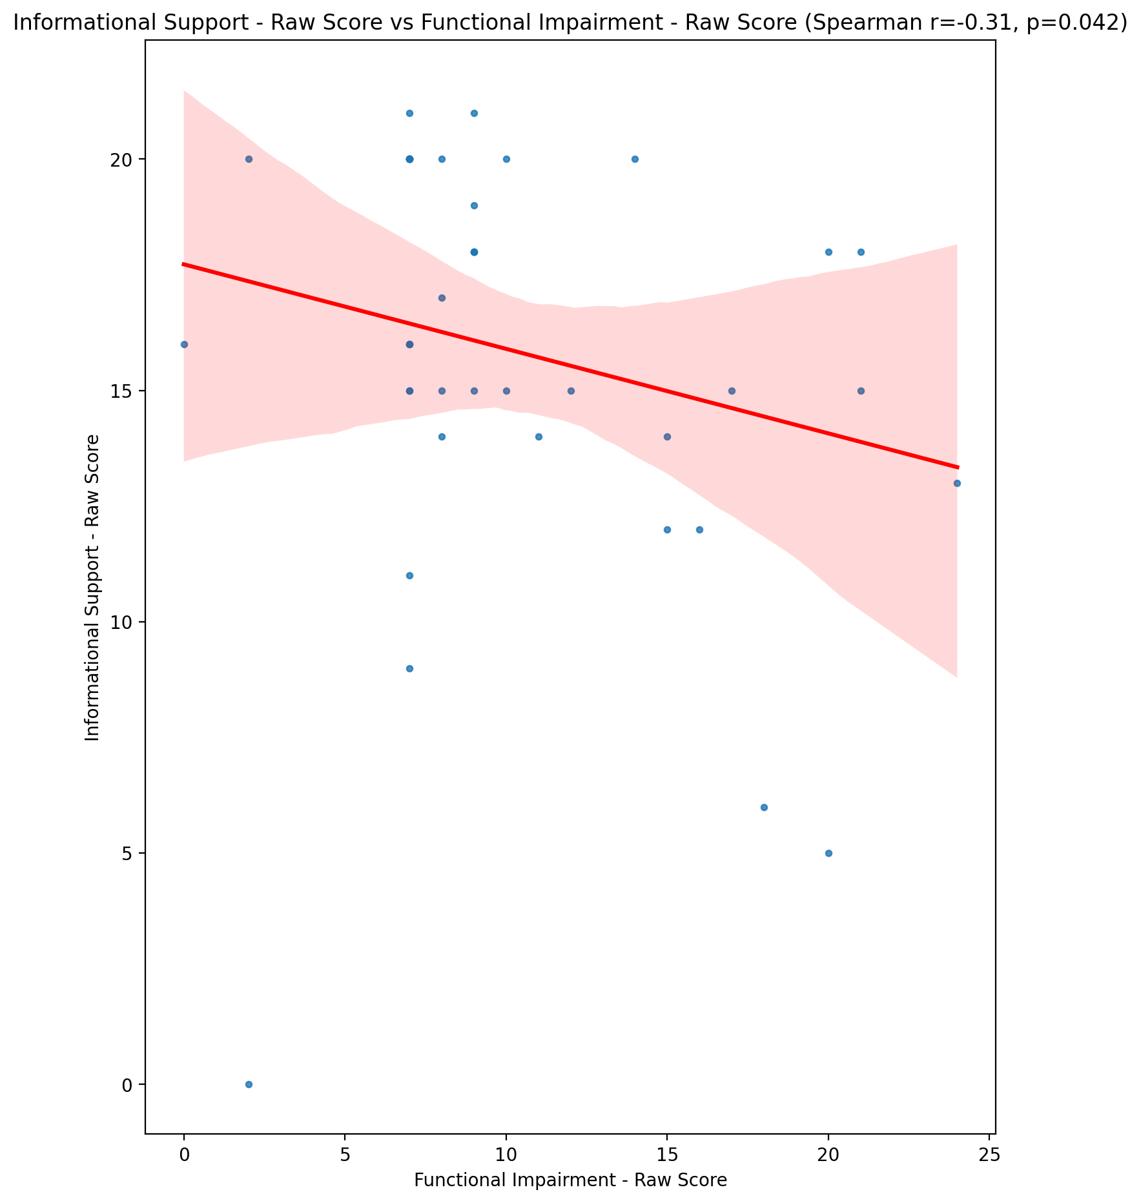

## Instrumental Support - Raw Score vs Functional Impairment - Raw Score

Test: spearman; statistic: -0.20771986577237836; p-value: 0.18135159644023977;

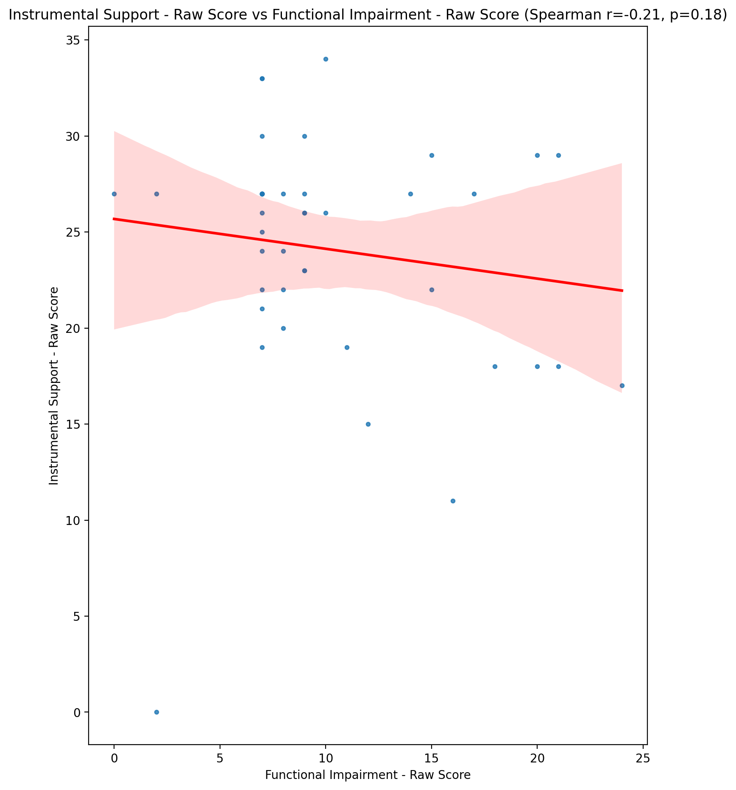

## Emotional Support - T Score vs Functional Impairment - Raw Score

Test: spearman; statistic: -0.19859594066748693; p-value: 0.20171979643099933;

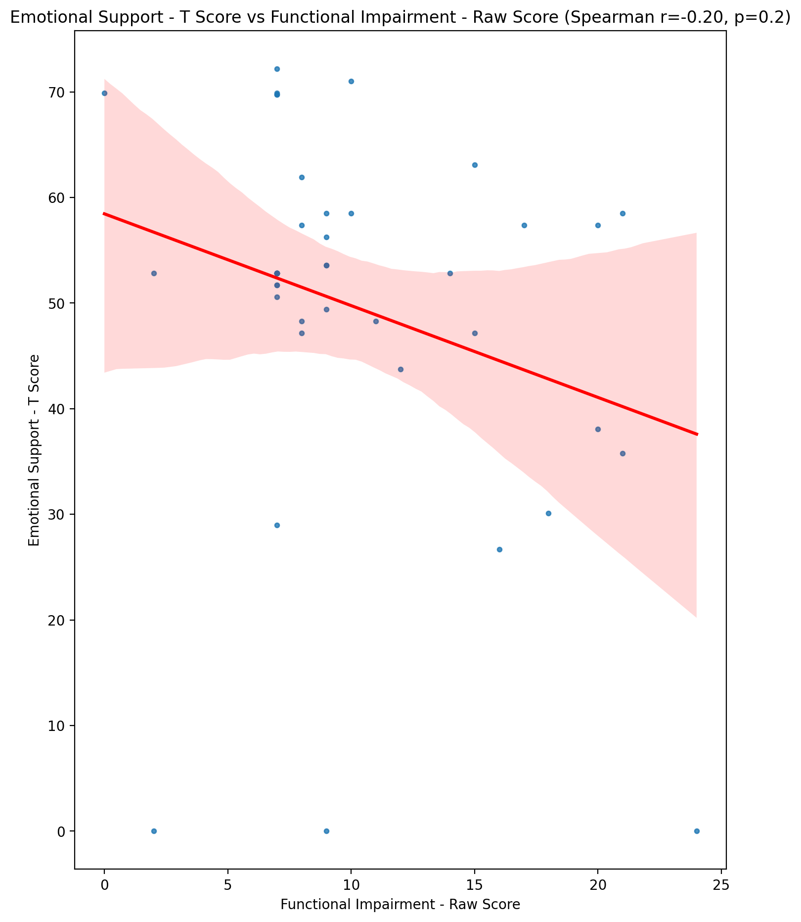

## Informational Support - T Score vs Functional Impairment - Raw Score

Test: spearman; statistic: -0.3172413079716049; p-value: 0.0381841741256046;

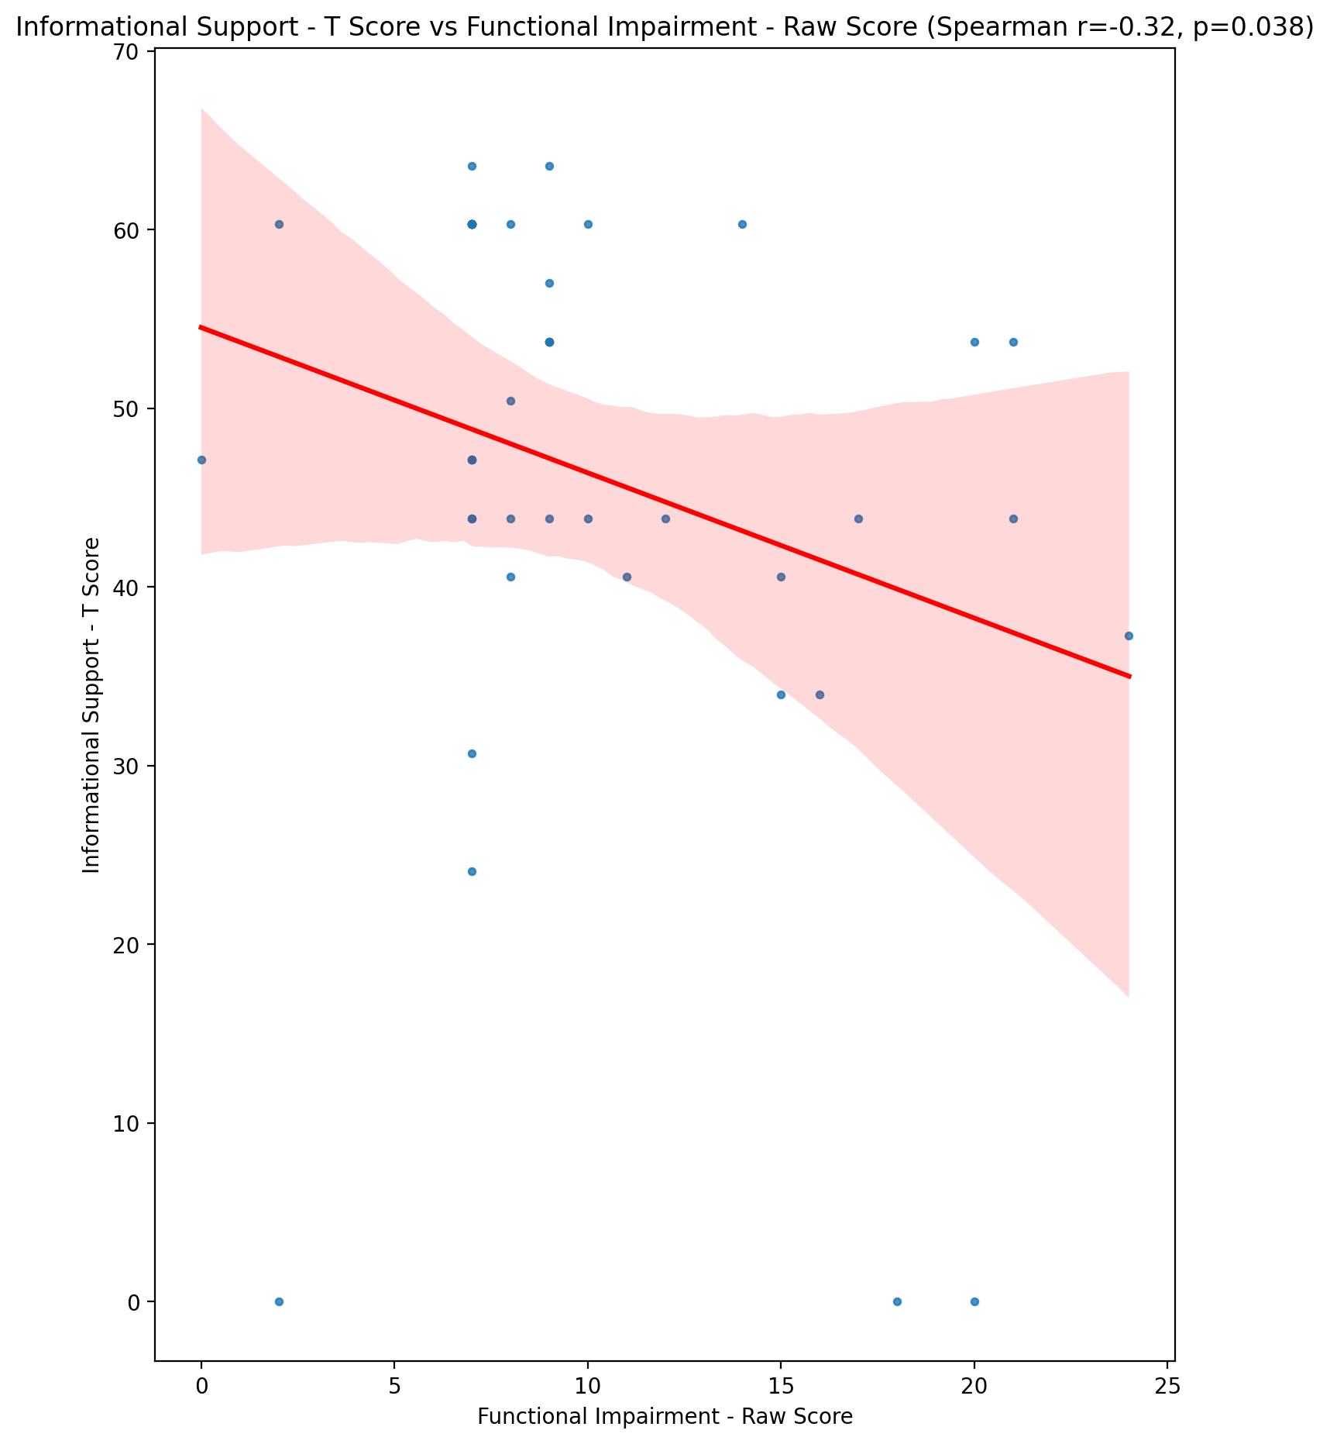

## Instrumental Support - T Score vs Functional Impairment - Raw Score

Test: spearman; statistic: -0.21034894690283396; p-value: 0.17576536981943017;

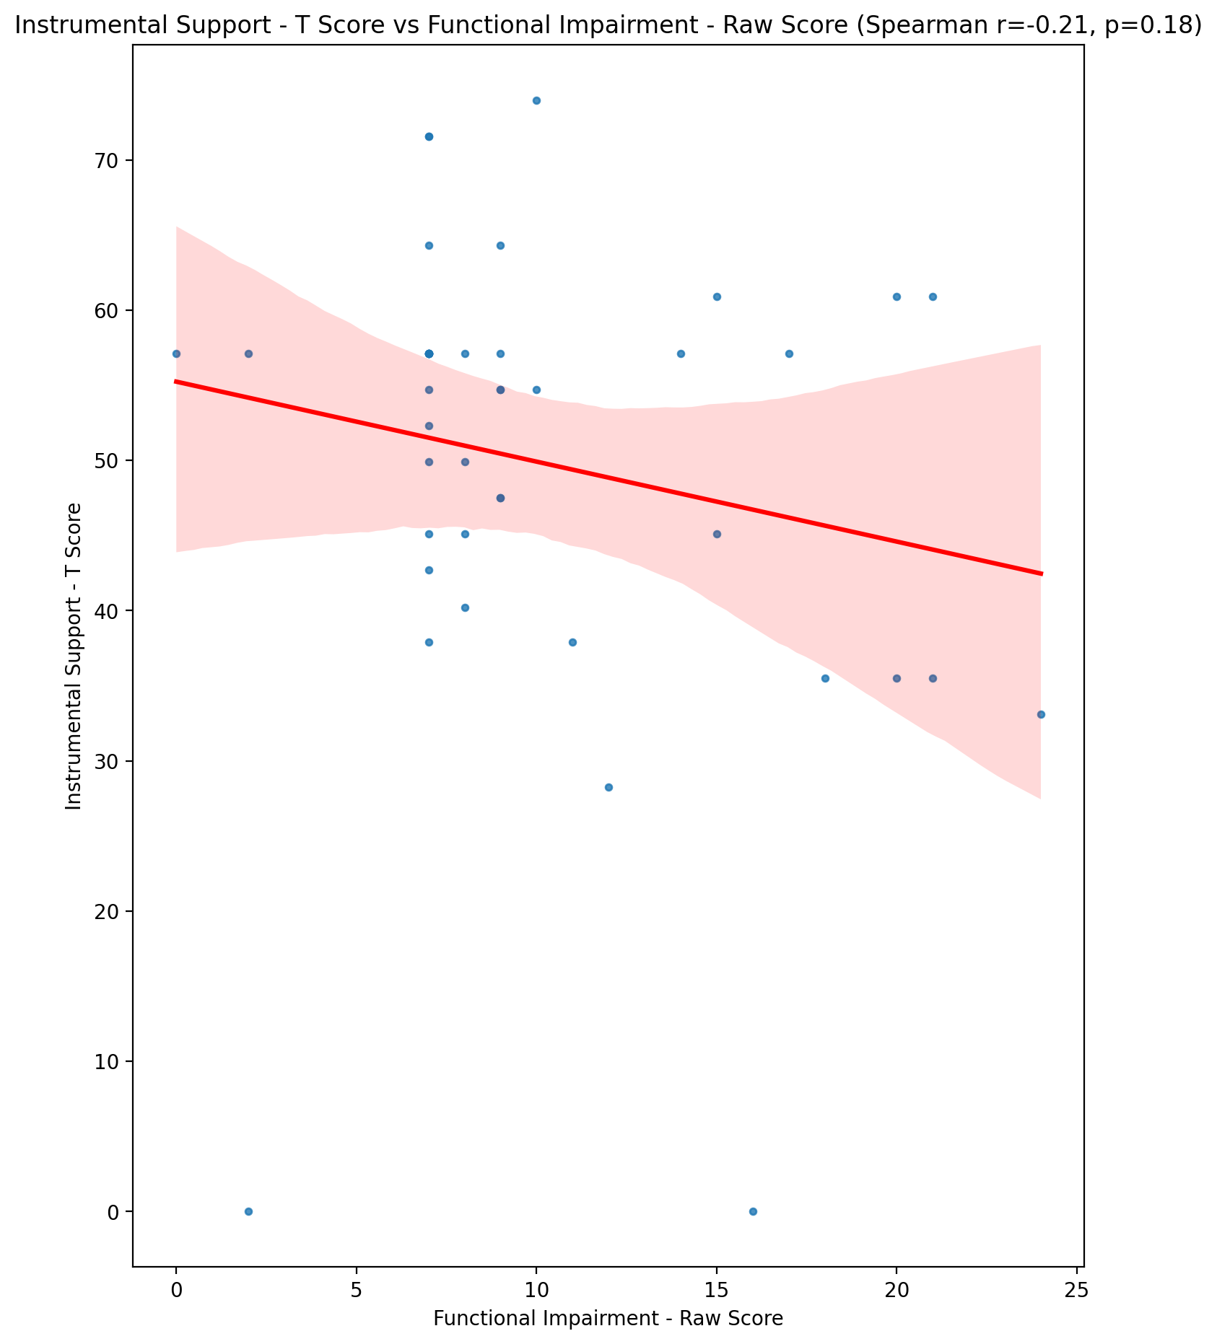

## Perceived Social Support Total T Score vs Functional Impairment - Raw Score

Test: spearman; statistic: -0.2526890052932903; p-value: 0.10208706920347223;

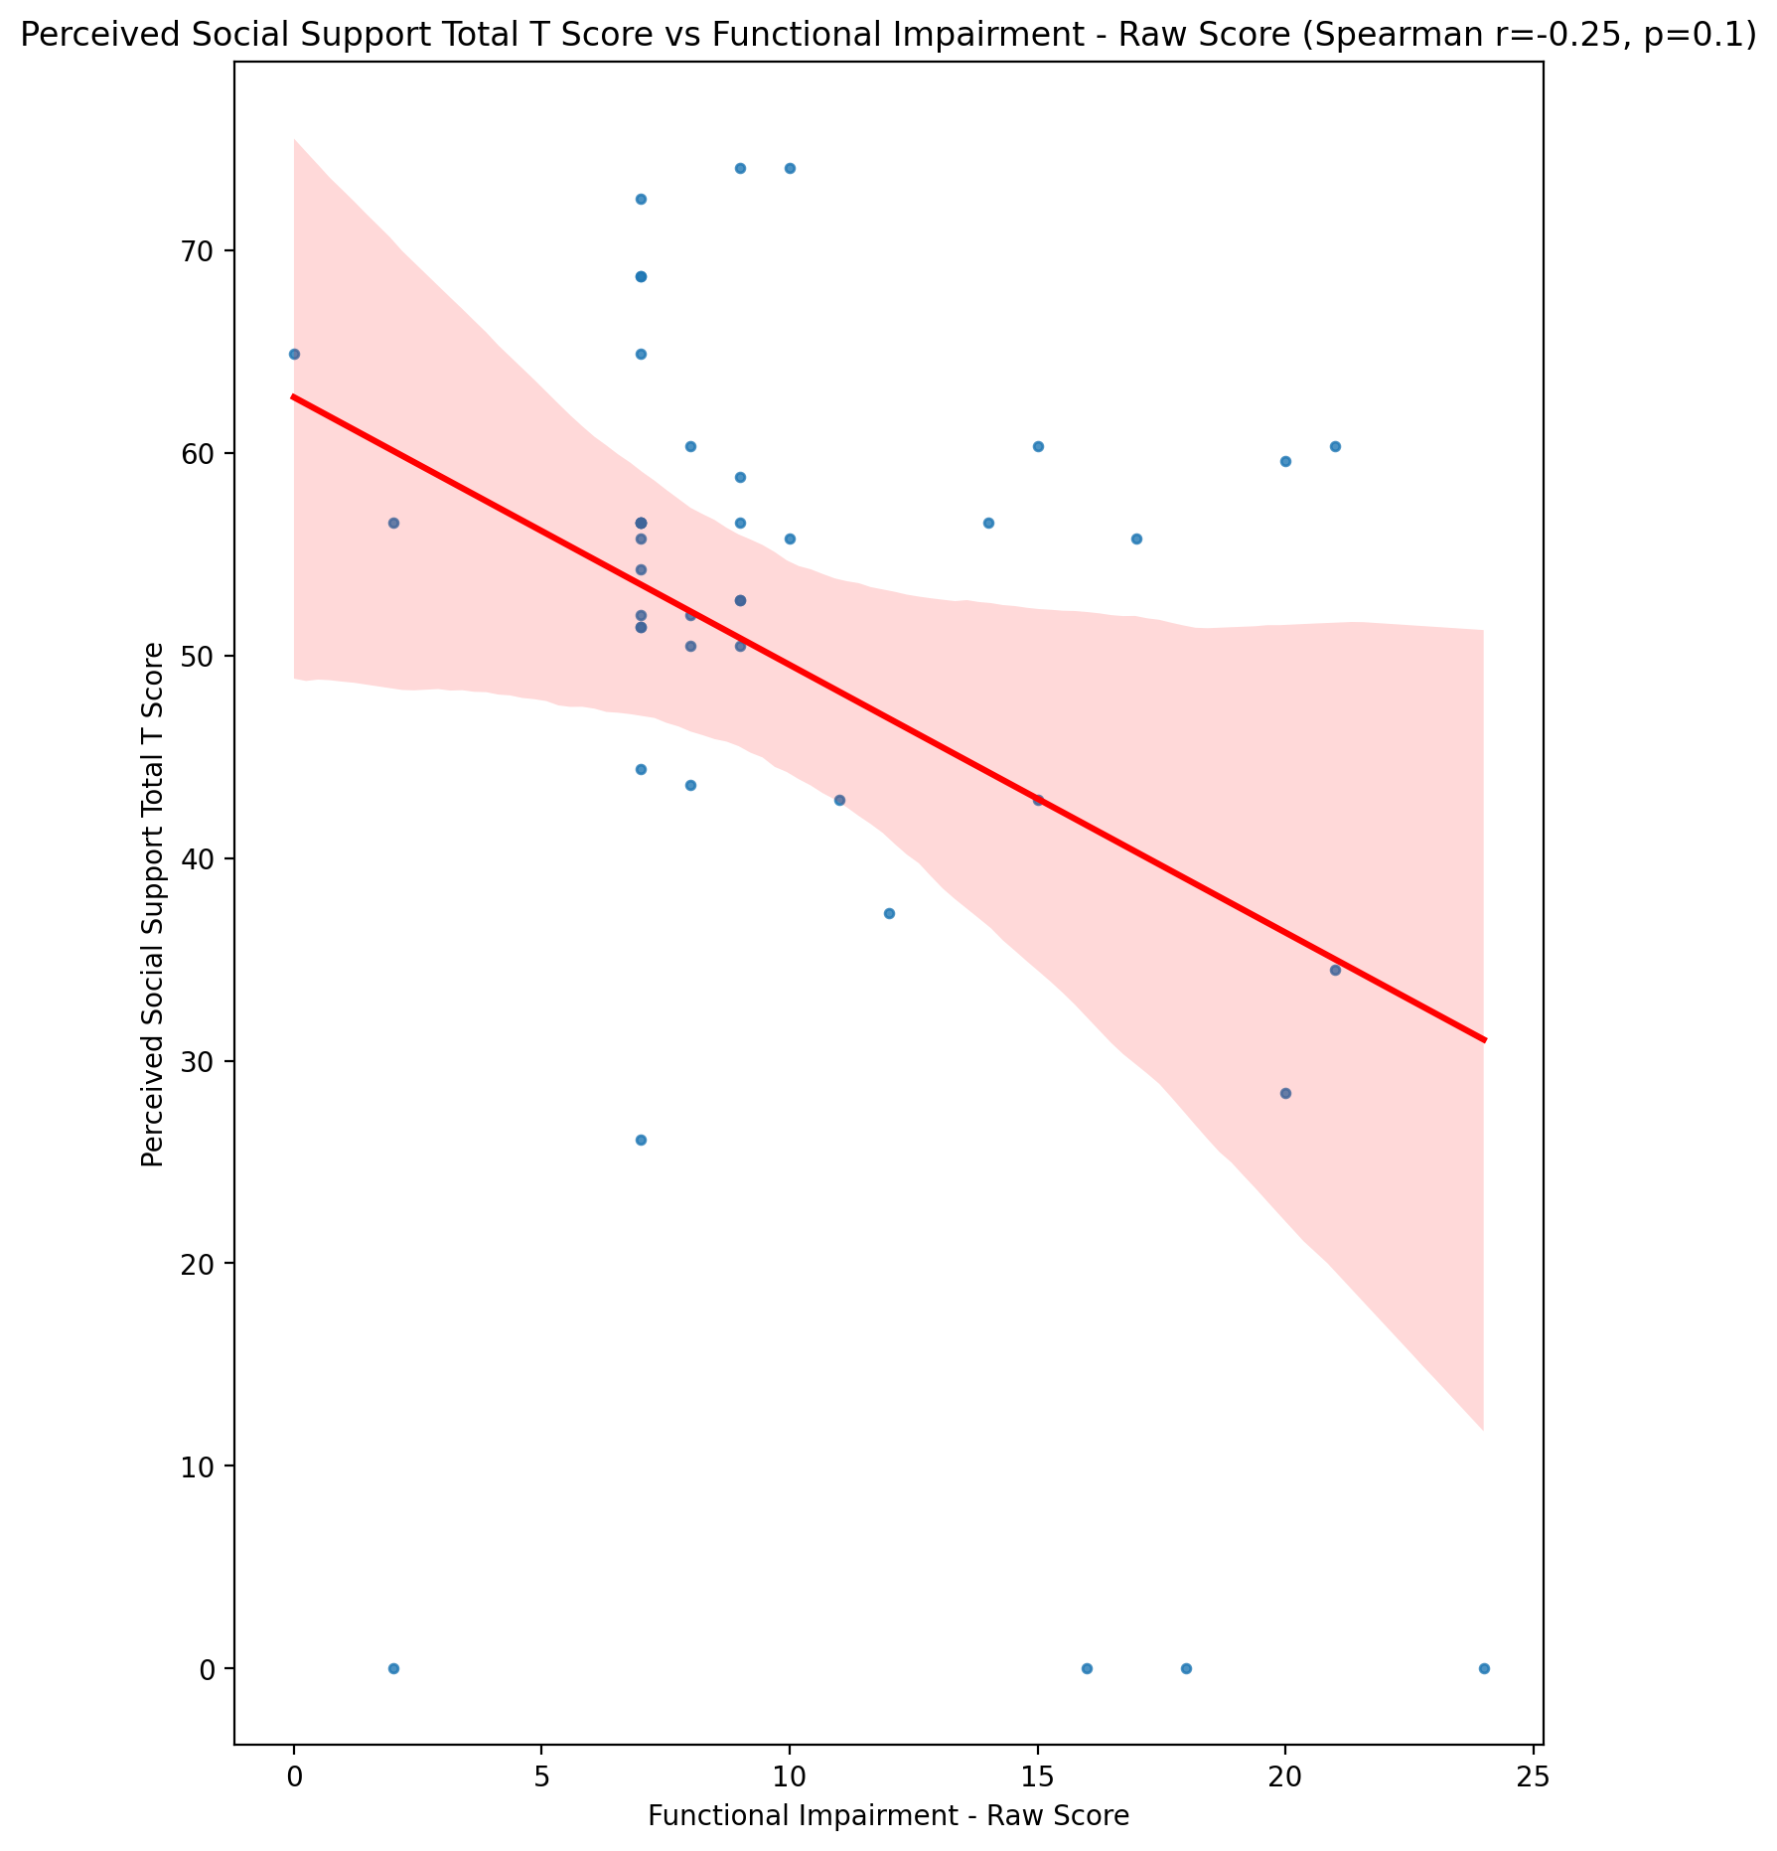

## Emotional Support - Rank vs Functional Impairment - Raw Score

Test: None; statistic: None; p-value: None; Test not run: unsupported type combination.

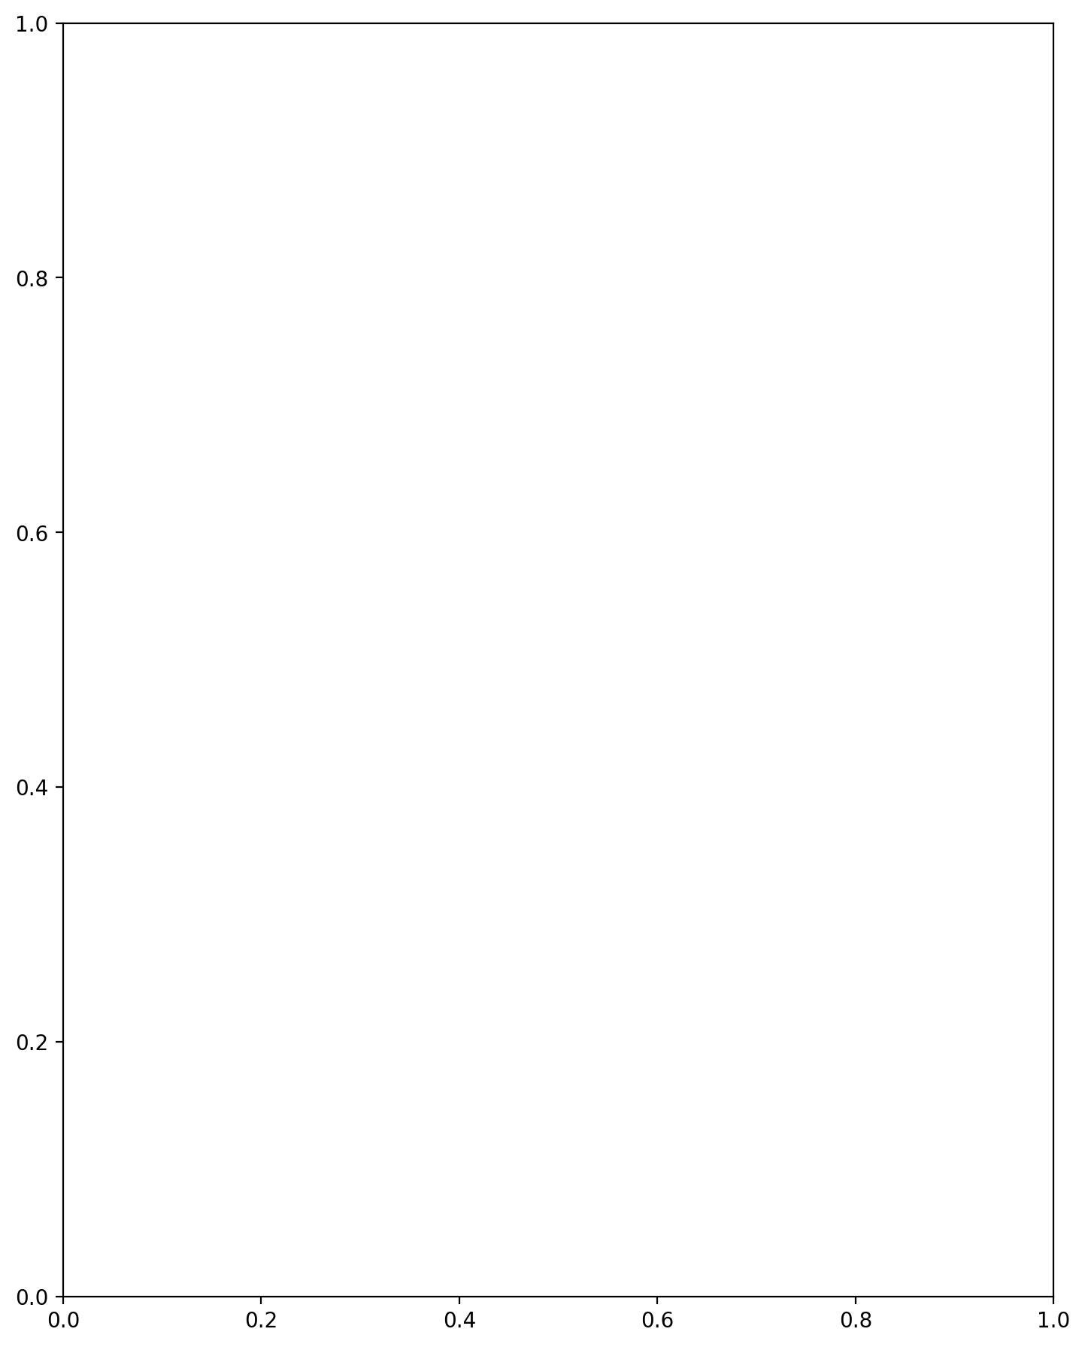

## Informational Support - Rank vs Functional Impairment - Raw Score

Test: None; statistic: None; p-value: None; Test not run: unsupported type combination.



## Instrumental Support - Rank vs Functional Impairment - Raw Score

Test: None; statistic: None; p-value: None; Test not run: unsupported type combination.



## Perceived Social Support TOTAL - Rank vs Functional Impairment - Raw Score

Test: None; statistic: None; p-value: None; Test not run: unsupported type combination.



## Power Self Concept - Real Self Concept Score vs Functional Impairment - Raw Score

Test: spearman; statistic: -0.2314563146683522; p-value: 0.13533259027513964;

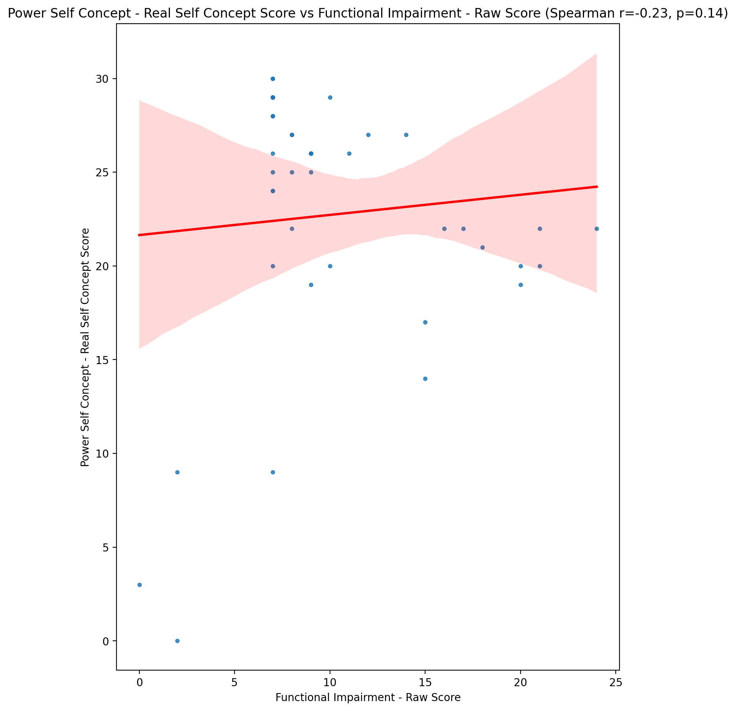

## Power Self Concept - Ideal Self Concept score vs Functional Impairment - Raw Score

Test: spearman; statistic: -0.12830643520535062; p-value: 0.4122353439802954;

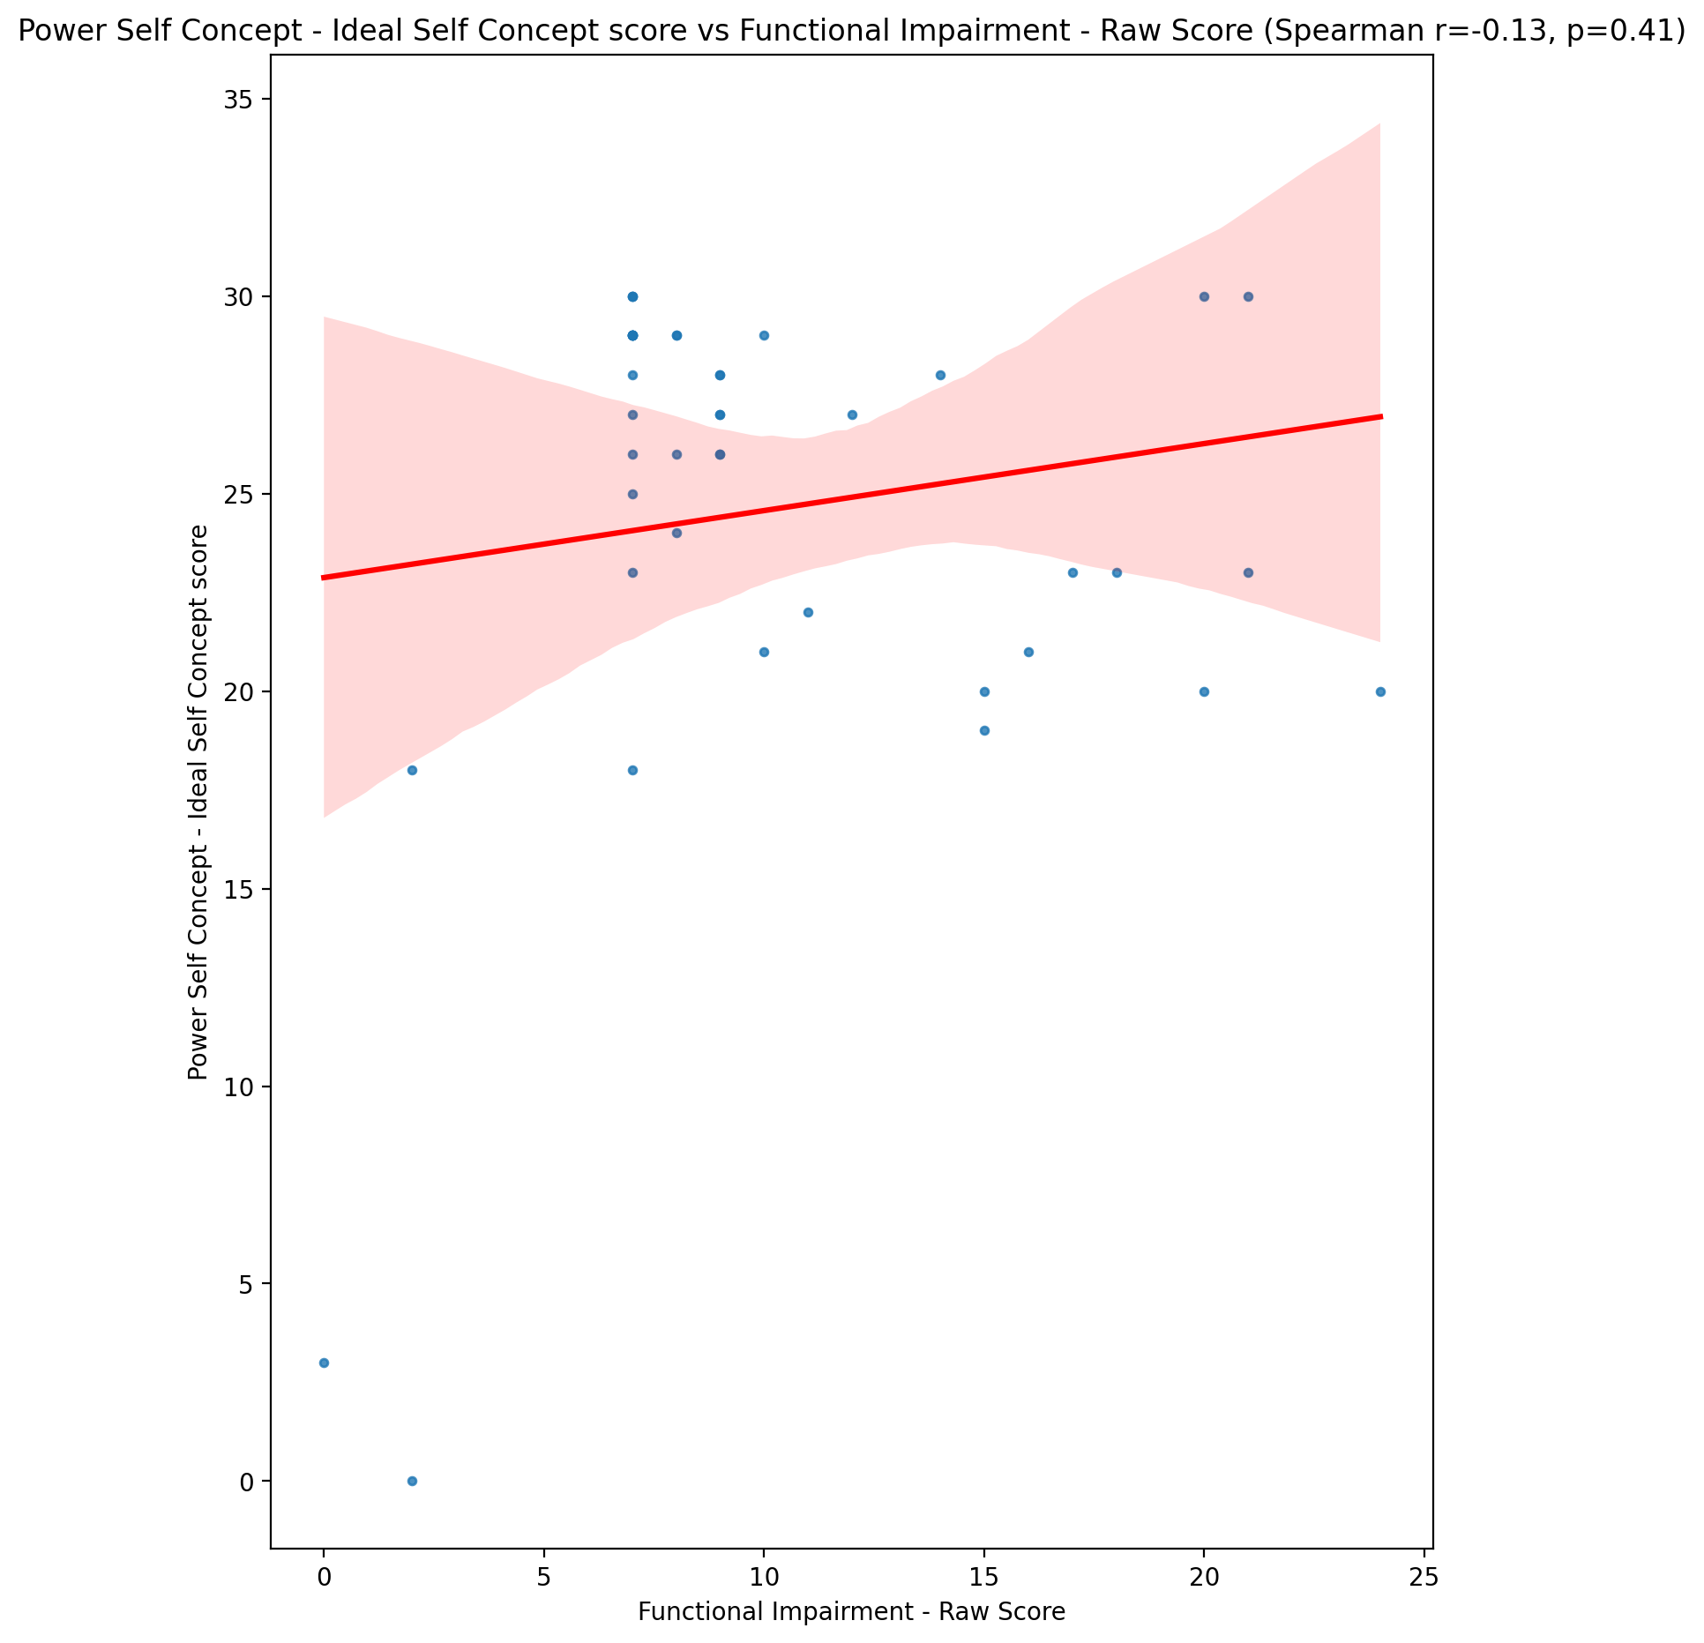

## Power Self Concept – Social Self Concept Score vs Functional Impairment - Raw Score

Test: spearman; statistic: -0.1517597675179289; p-value: 0.33131271433069887;

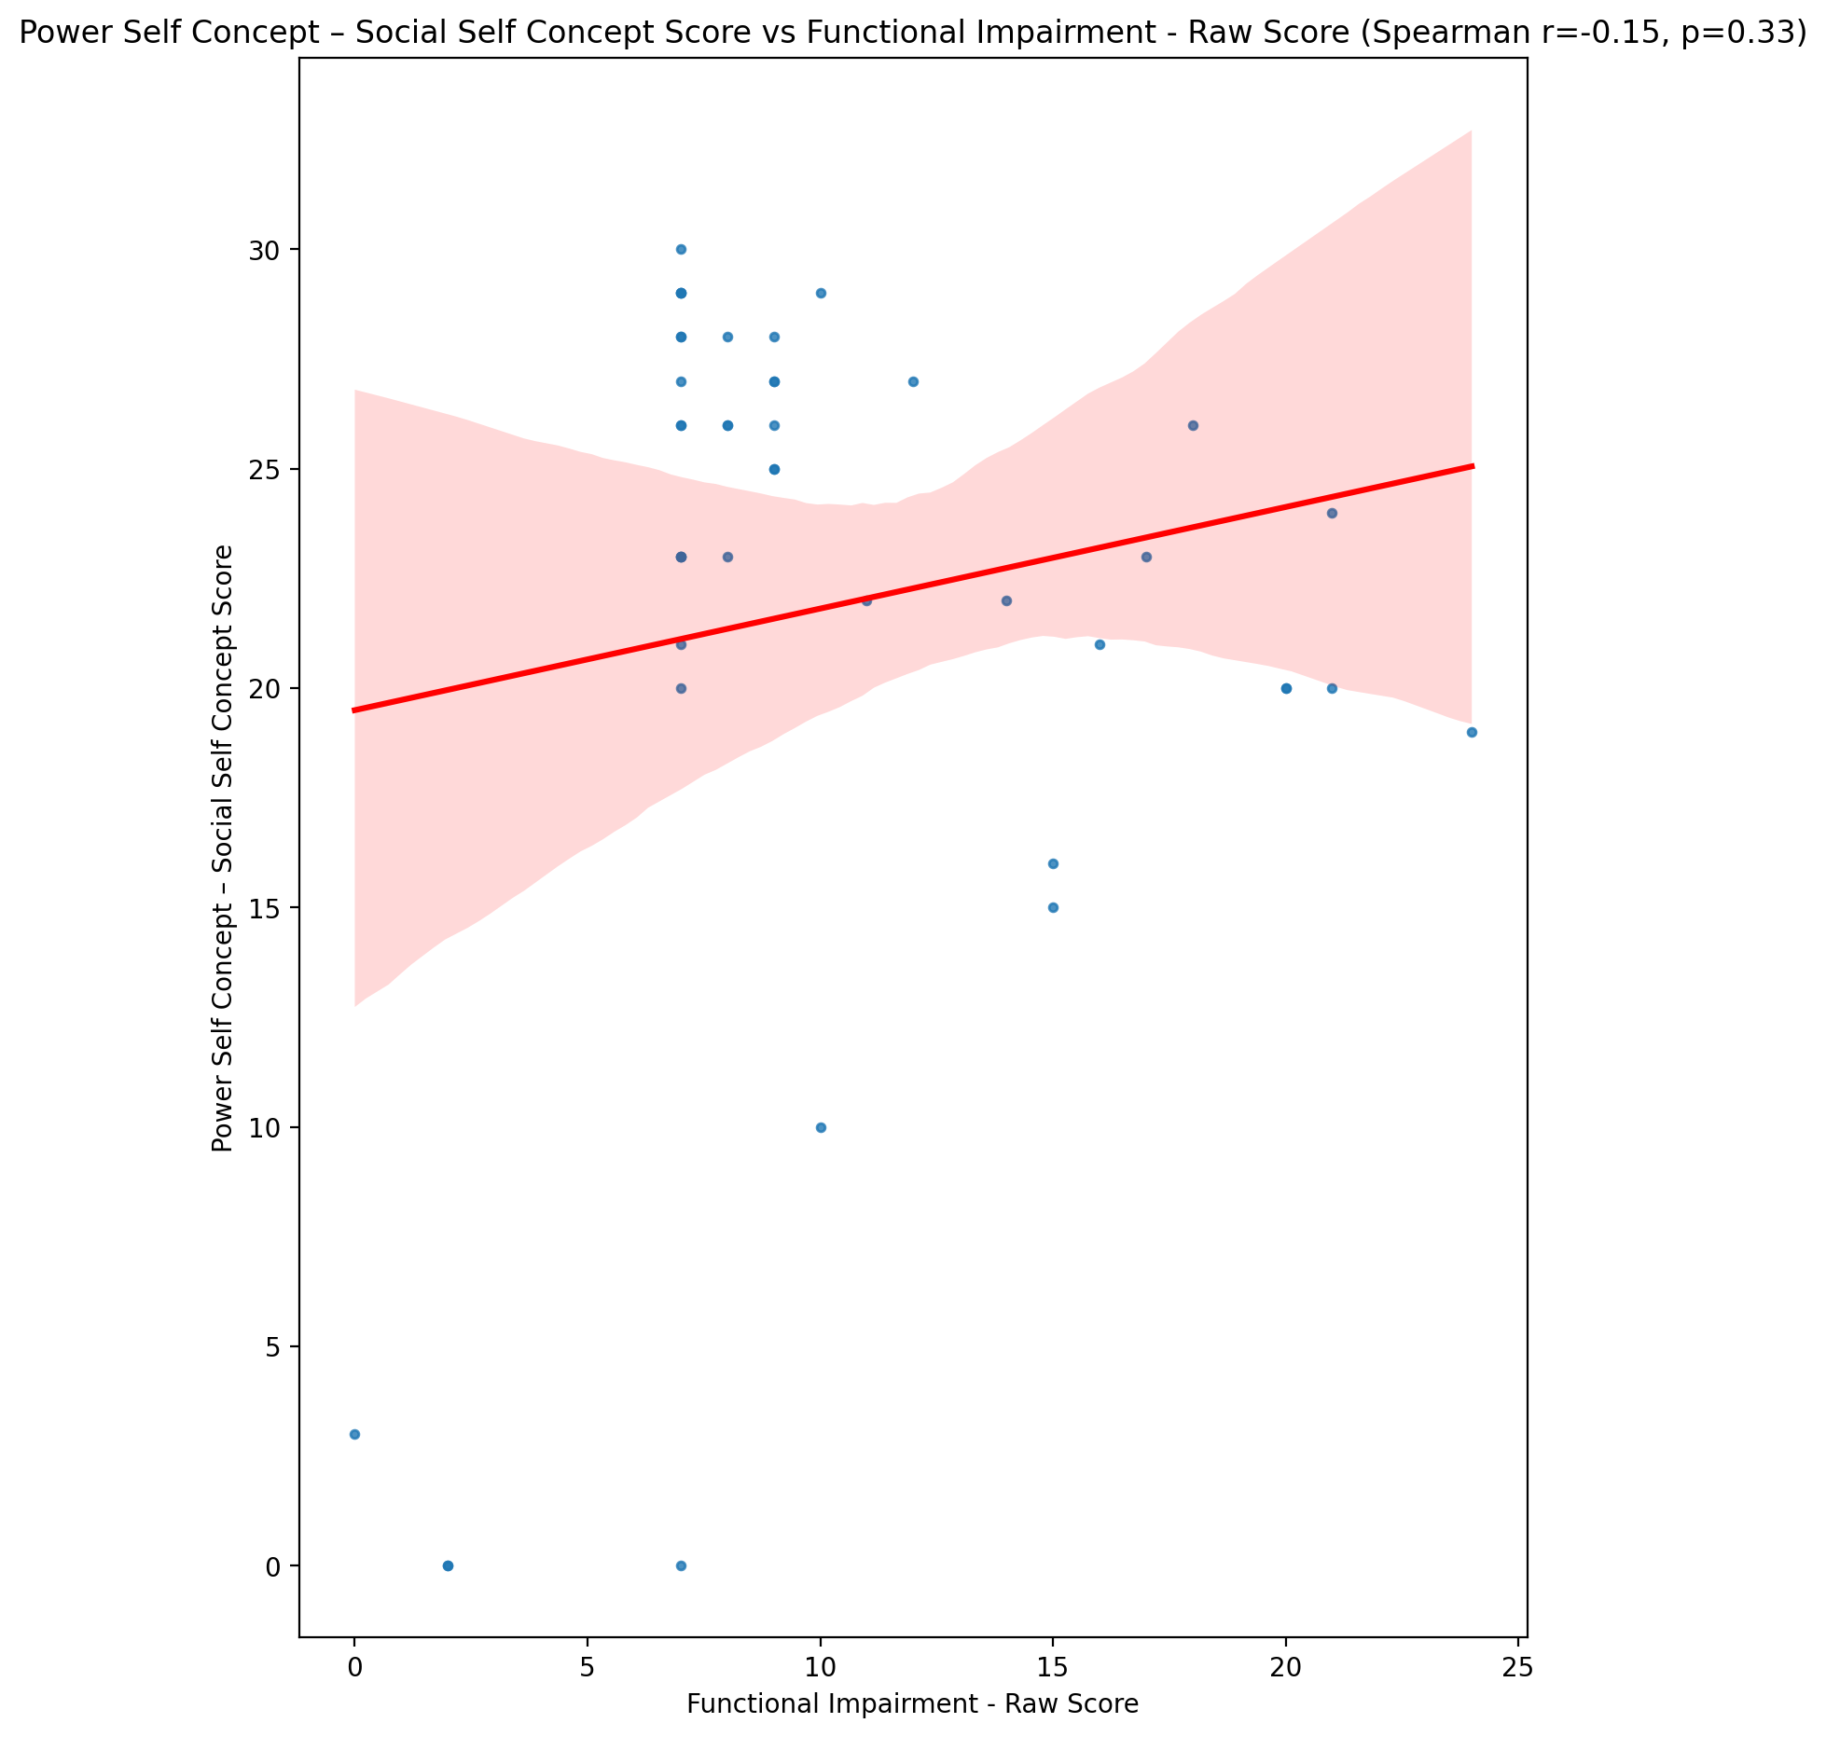

## Social Self Concept - Real Self Concept Score vs Functional Impairment - Raw Score

Test: spearman; statistic: -0.1806940343265327; p-value: 0.24623211250843802;

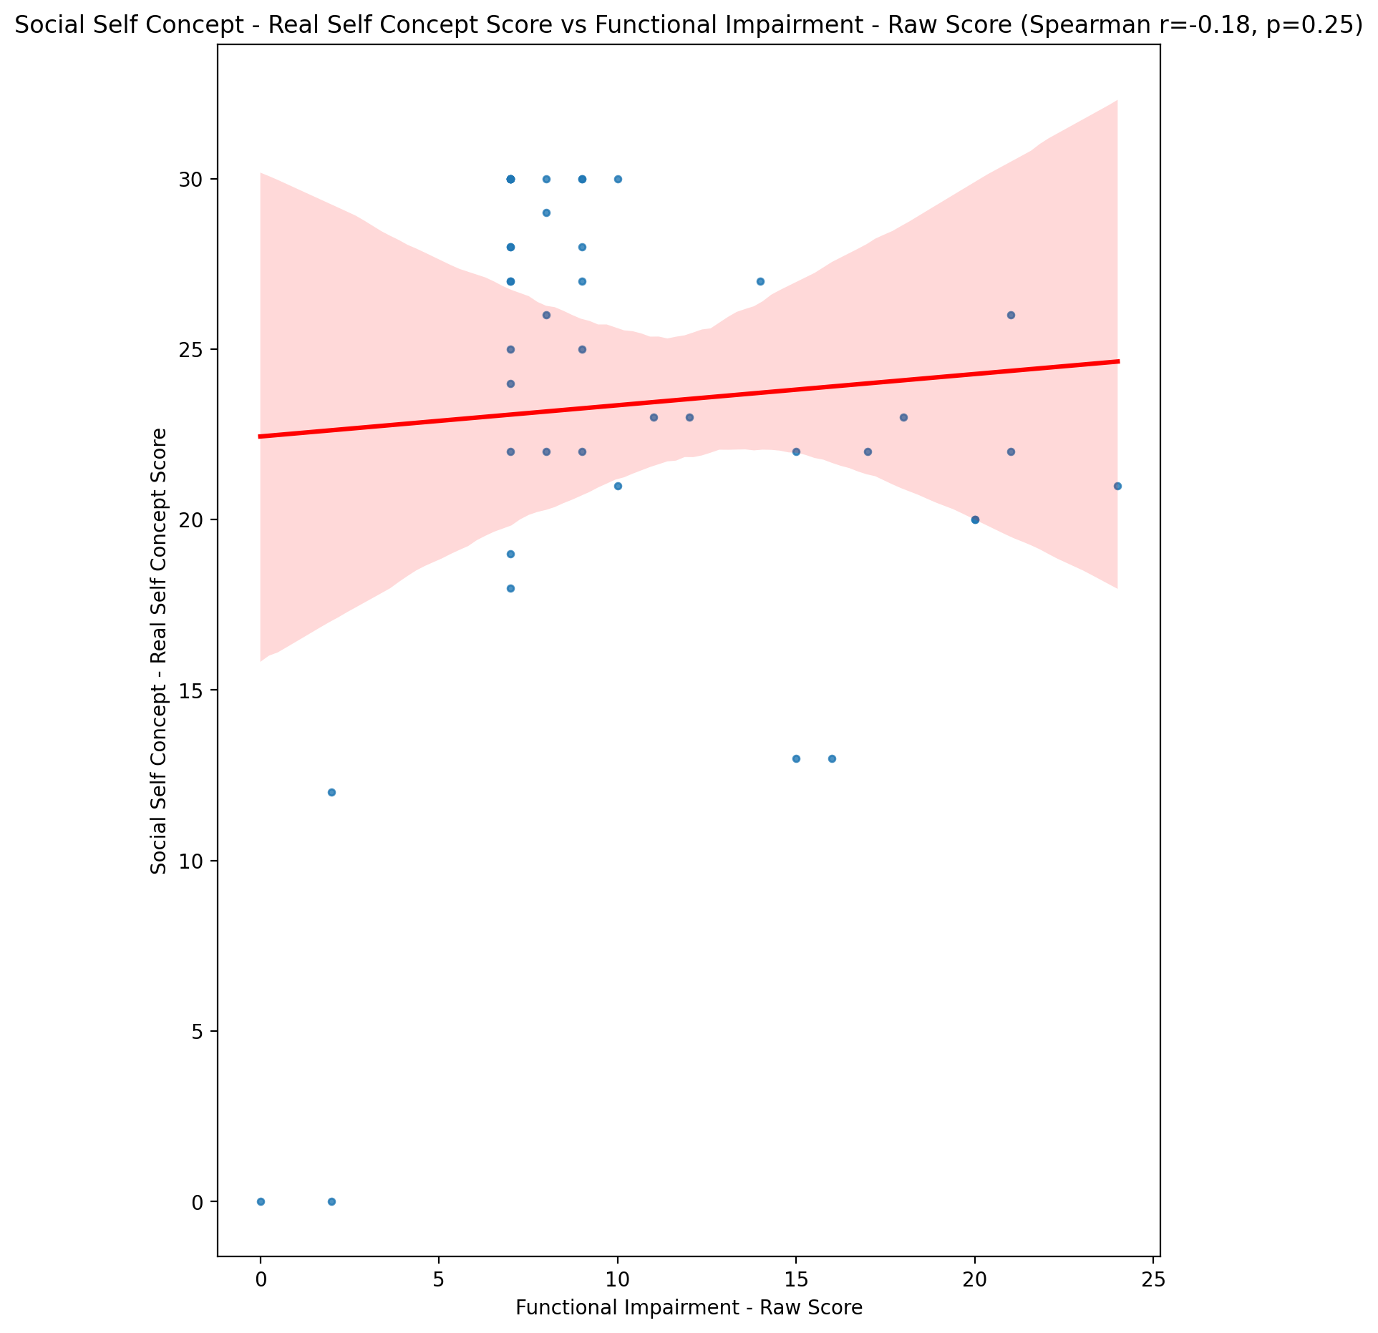

## Social Self Concept – Social Self Concept Score vs Functional Impairment - Raw Score

Test: spearman; statistic: -0.097626881657345; p-value: 0.5334103455854657;

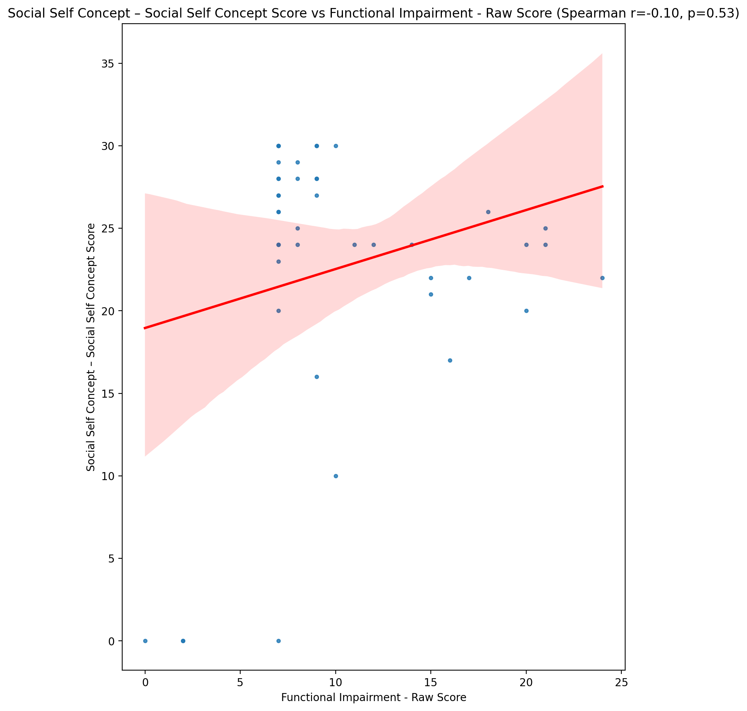

## Ability Self Concept - Real Self Concept Score vs Functional Impairment - Raw Score

Test: spearman; statistic: -0.20481153669651098; p-value: 0.18767768325350956;

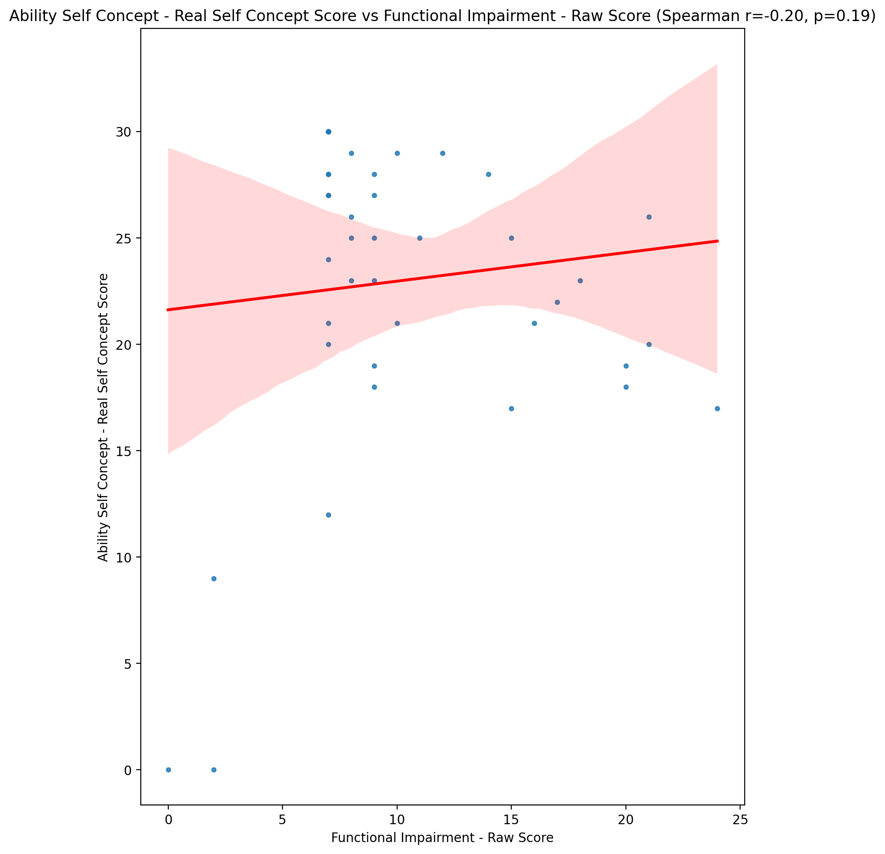

## Ability Self Concept - Ideal Self Concept Score vs Functional Impairment - Raw Score

Test: spearman; statistic: -0.15335148493835193; p-value: 0.32620619198970924;

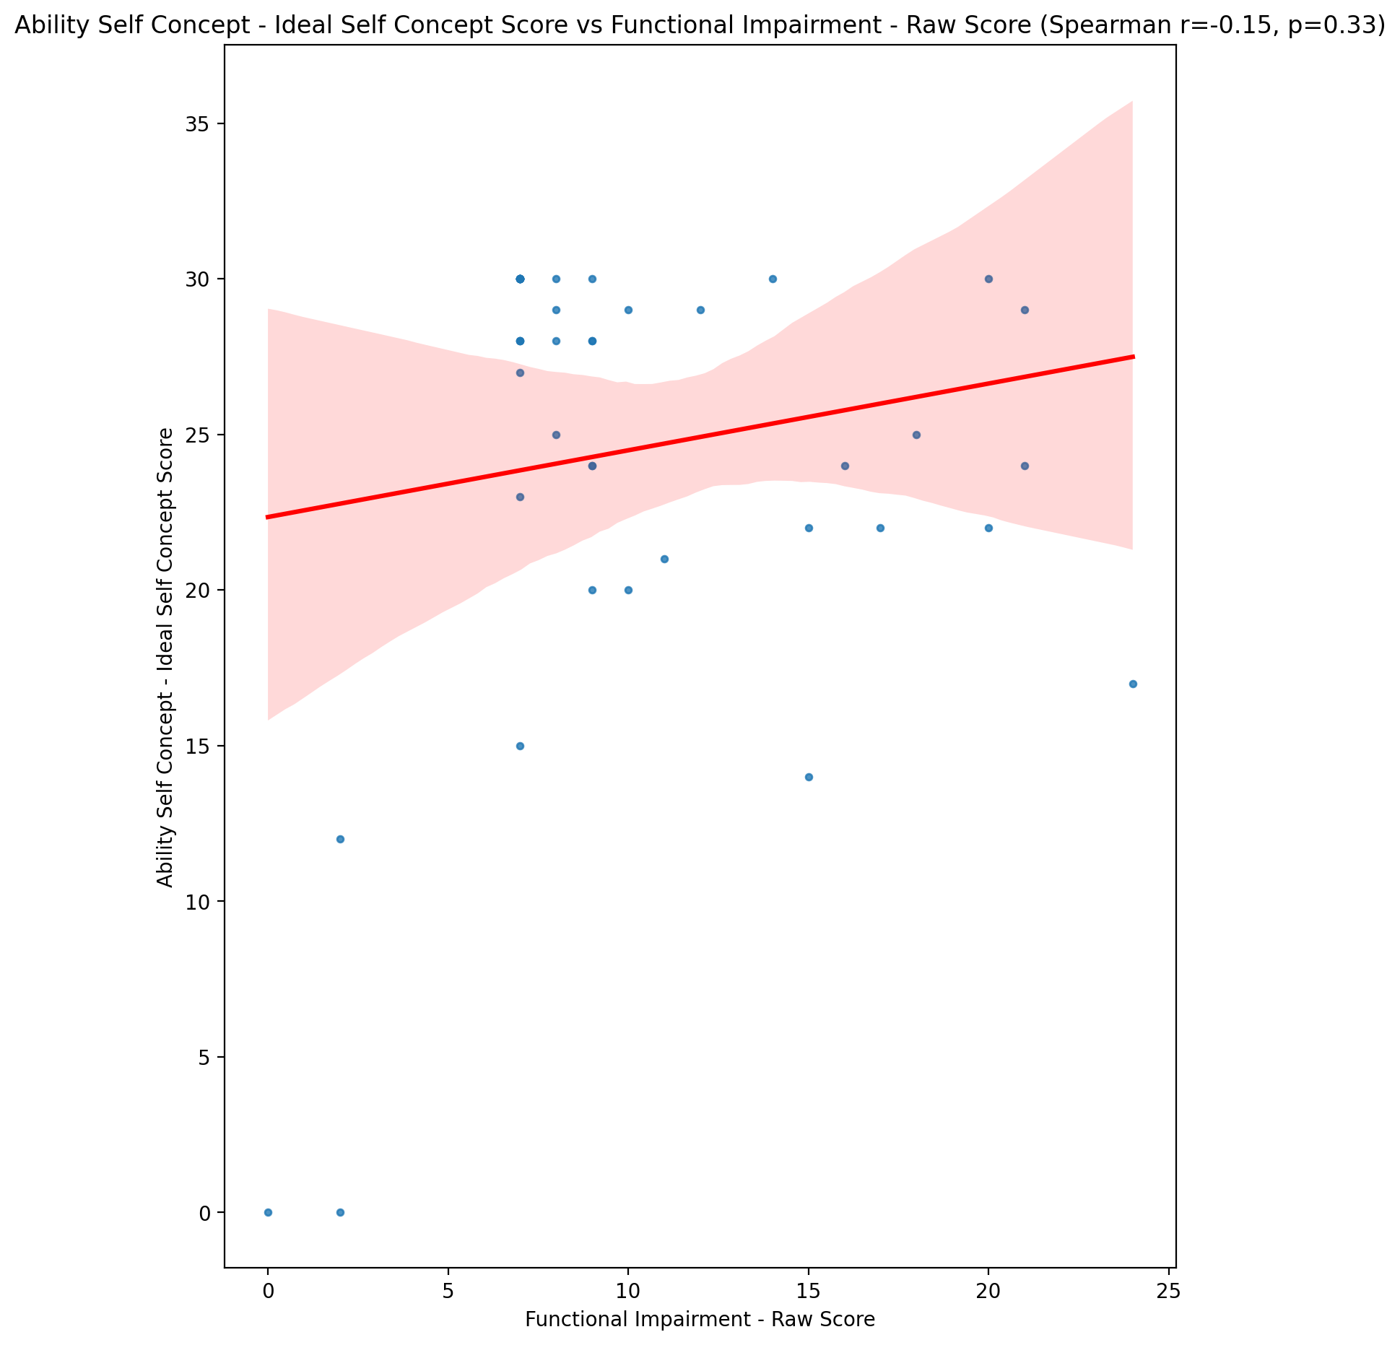

## Ability Self Concept – Social Self Concept Score vs Functional Impairment - Raw Score

Test: spearman; statistic: -0.08136602869460163; p-value: 0.6039756232492337;

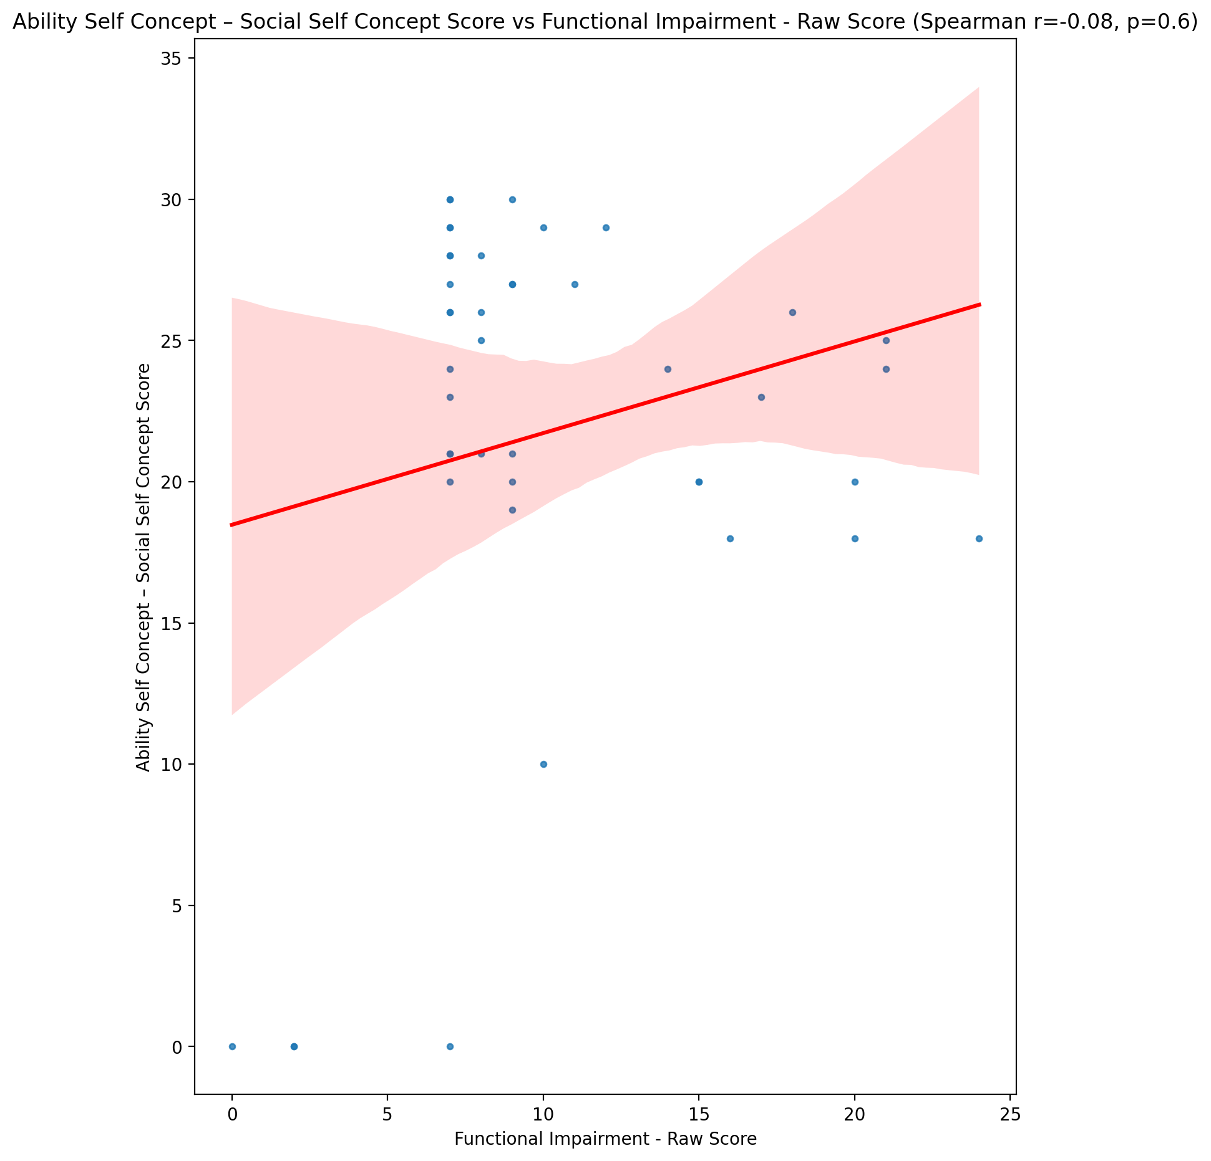

## Physical Self Concept - Real Self Concept Score vs Functional Impairment - Raw Score

Test: spearman; statistic: -0.22177295357725055; p-value: 0.15292437789781033;

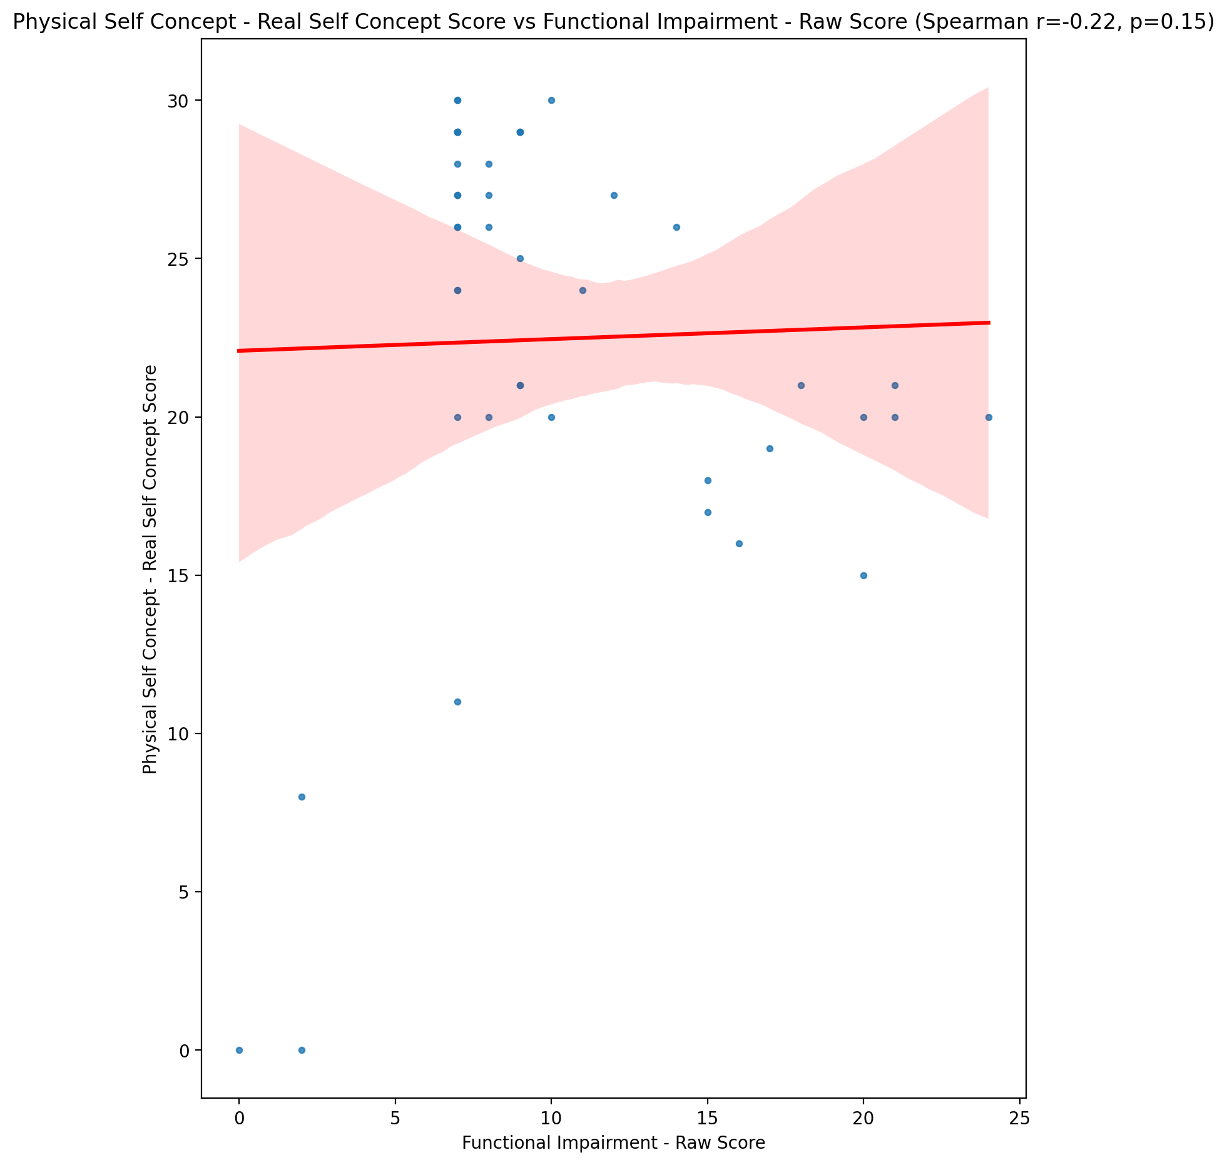

## Physical Self Concept – Ideal Self Concept Score vs Functional Impairment - Raw Score

Test: spearman; statistic: -0.11954373547919851; p-value: 0.44513805290969877;

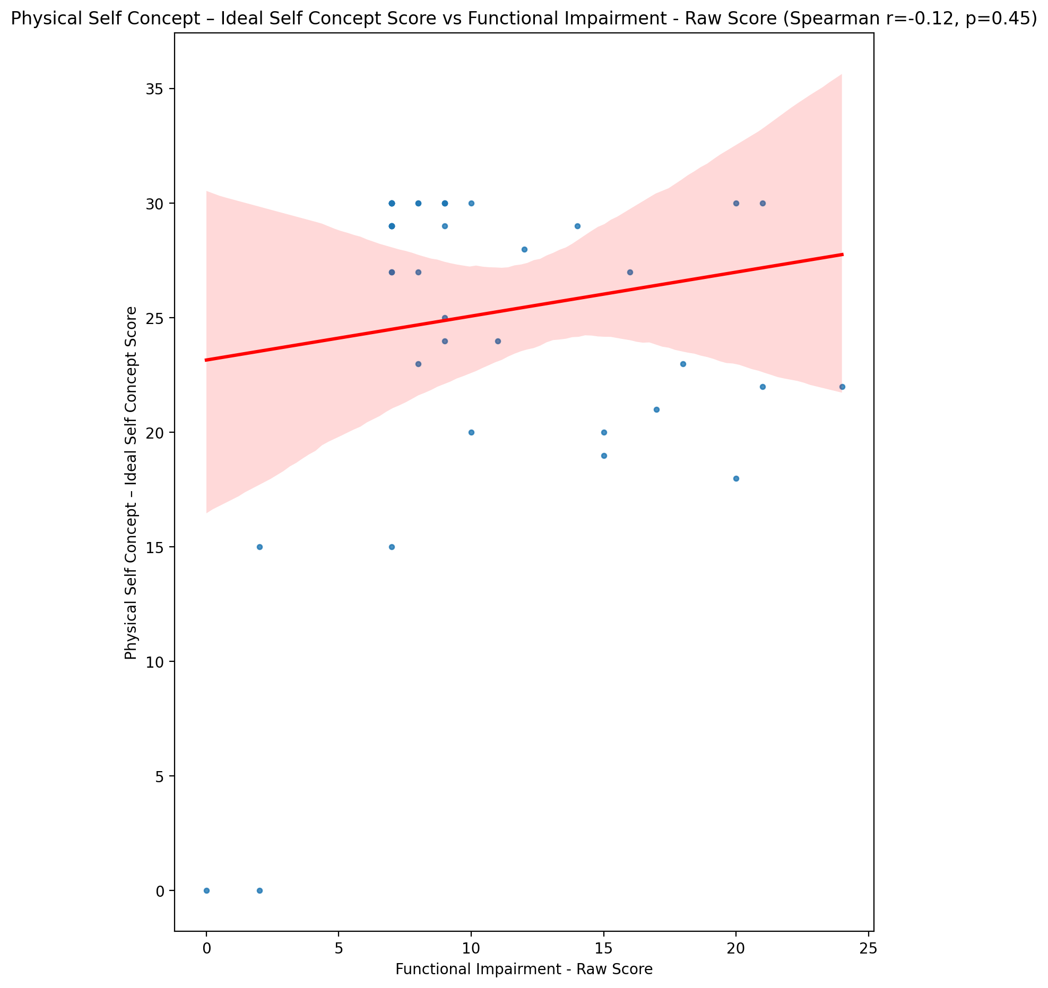

## Physical Self Concept – Social Self Concept Score vs Functional Impairment - Raw Score

Test: spearman; statistic: 0.11047111258527531; p-value: 0.4806705999283336;

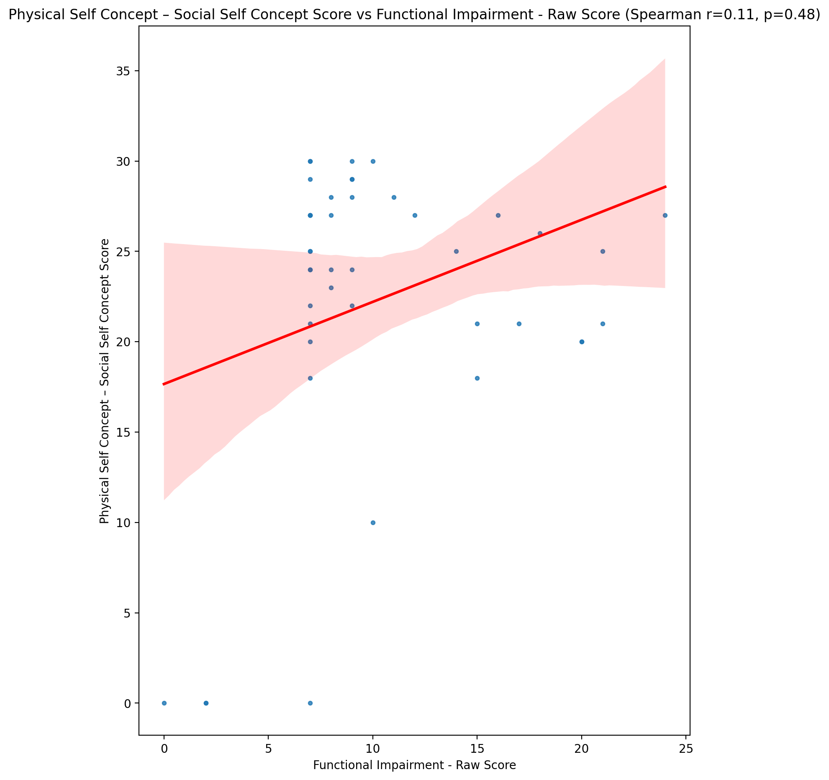

## Psychological Self Concept - Real Self Concept Score vs Functional Impairment - Raw Score

Test: spearman; statistic: -0.21072359634881188; p-value: 0.17497949377036925;

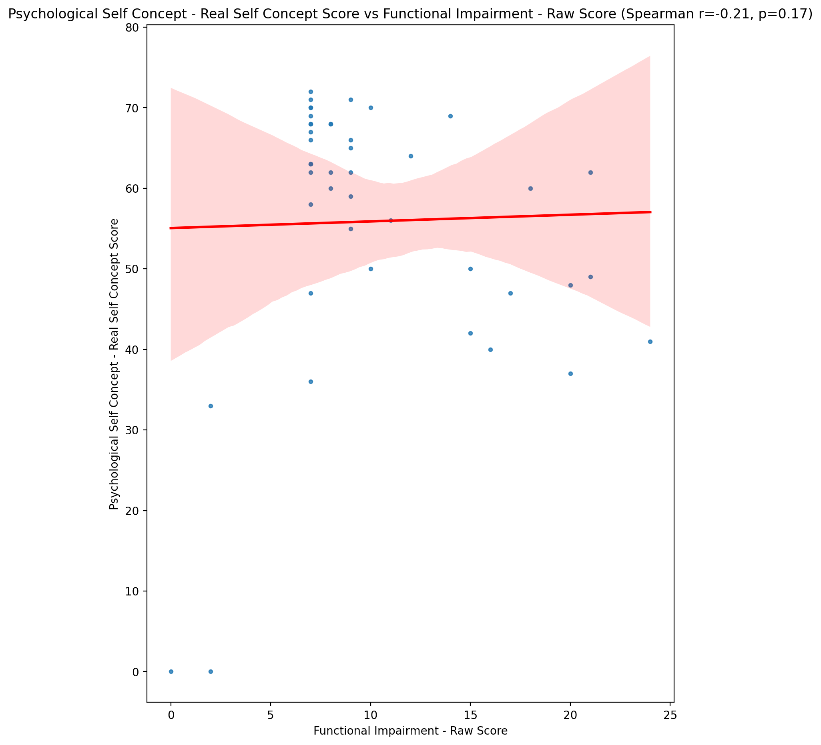

## Psychological Self Concept – Ideal Self Concept Score vs Functional Impairment - Raw Score

Test: spearman; statistic: -0.14770071445535338; p-value: 0.3445587052318506;

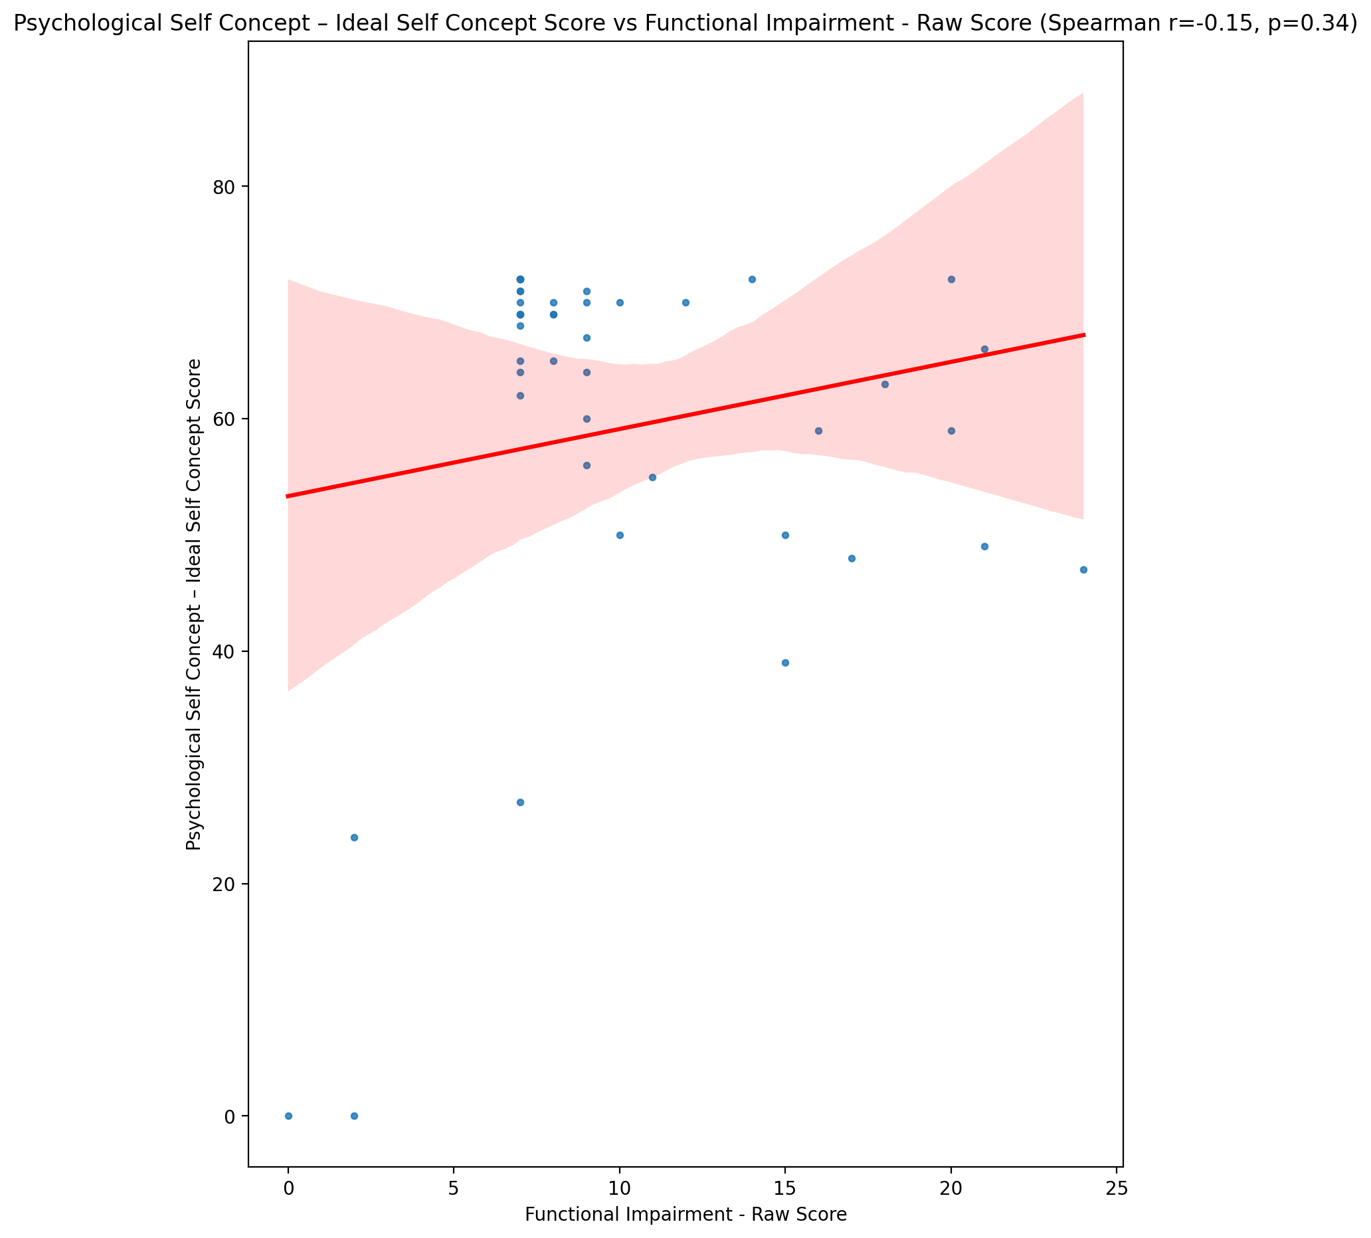

## Psychological Self Concept – Social Self Concept Score vs Functional Impairment - Raw Score

Test: spearman; statistic: -0.15622701739246533; p-value: 0.31710658043125867;

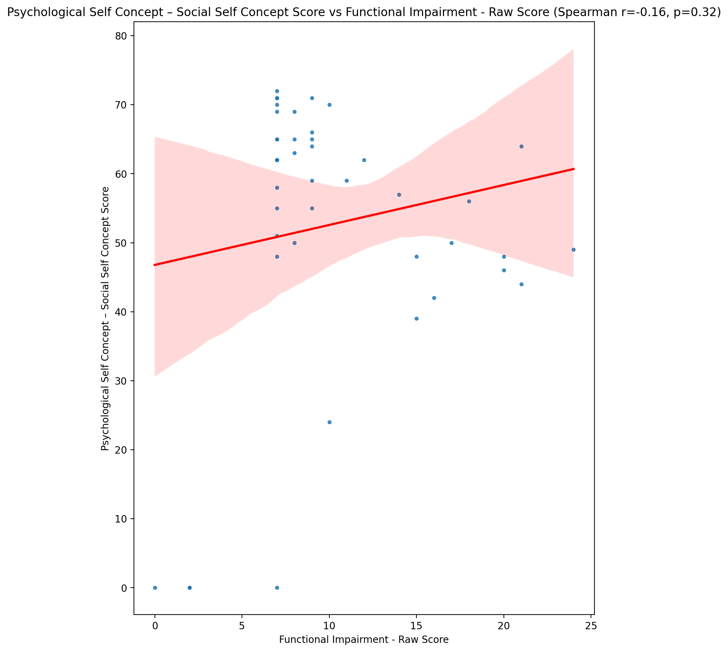

## Real Self Concept Total Score vs Functional Impairment - Raw Score

Test: spearman; statistic: -0.24328005601815872; p-value: 0.11594893159456786;

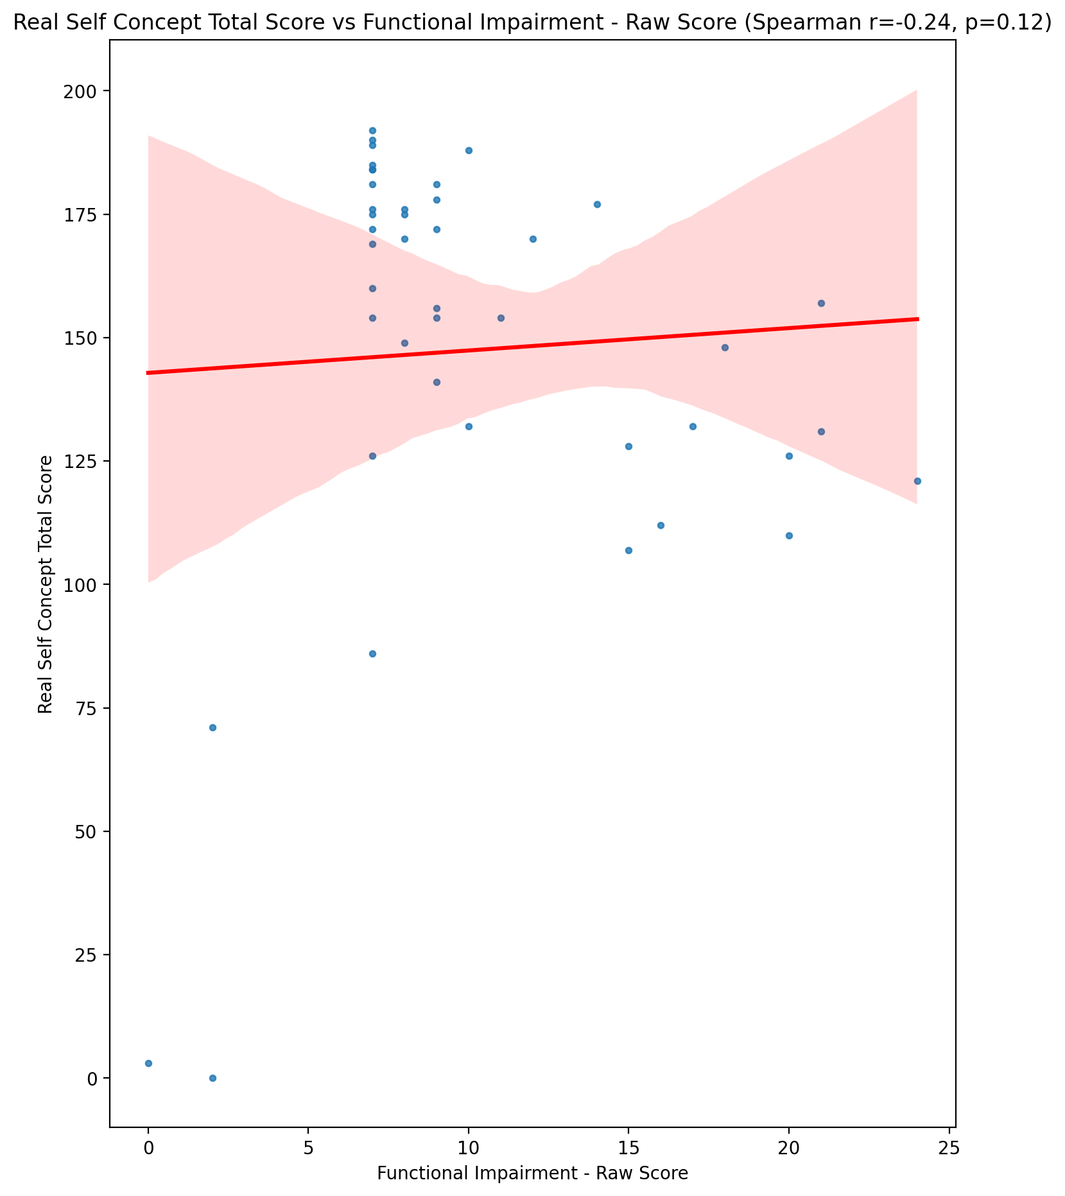

## Ideal Self Concept Total Score vs Functional Impairment - Raw Score

Test: spearman; statistic: -0.18261886056352908; p-value: 0.24115167879772037;

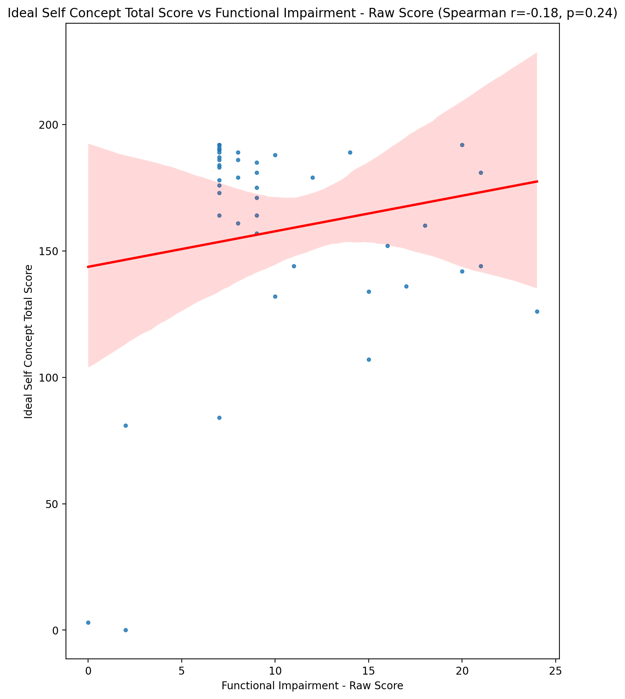

## Social Self Concept Total Score vs Functional Impairment - Raw Score

Test: spearman; statistic: -0.11879321144463471; p-value: 0.44802155808784183;

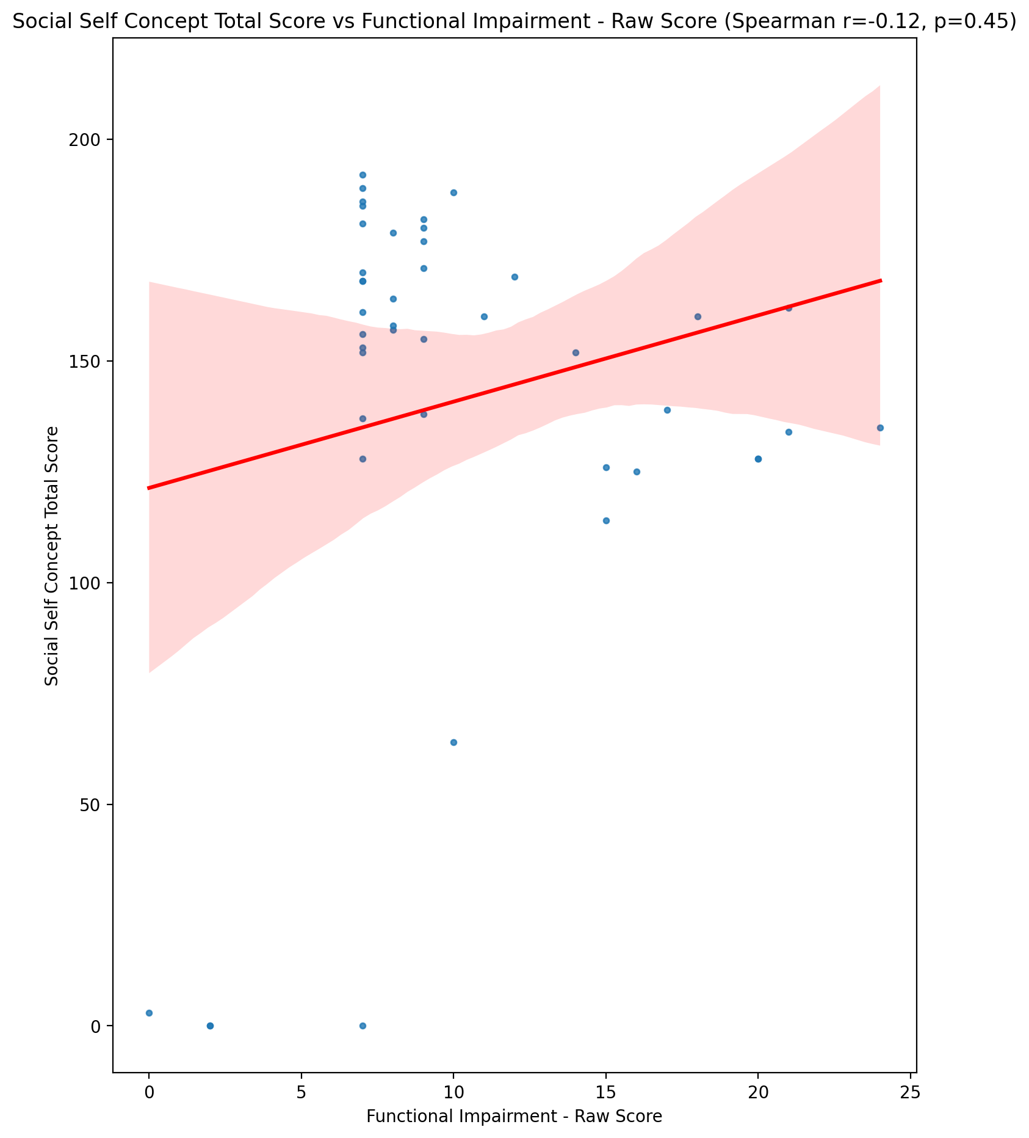

## Ideal Self Concept Total Category vs Functional Impairment - Raw Score

Test: None; statistic: None; p-value: None; Test not run: unsupported type combination.



## Perceived Social Stress Score vs Functional Impairment - Raw Score

Test: spearman; statistic: 0.21552401634450297; p-value: 0.16513255640877514;

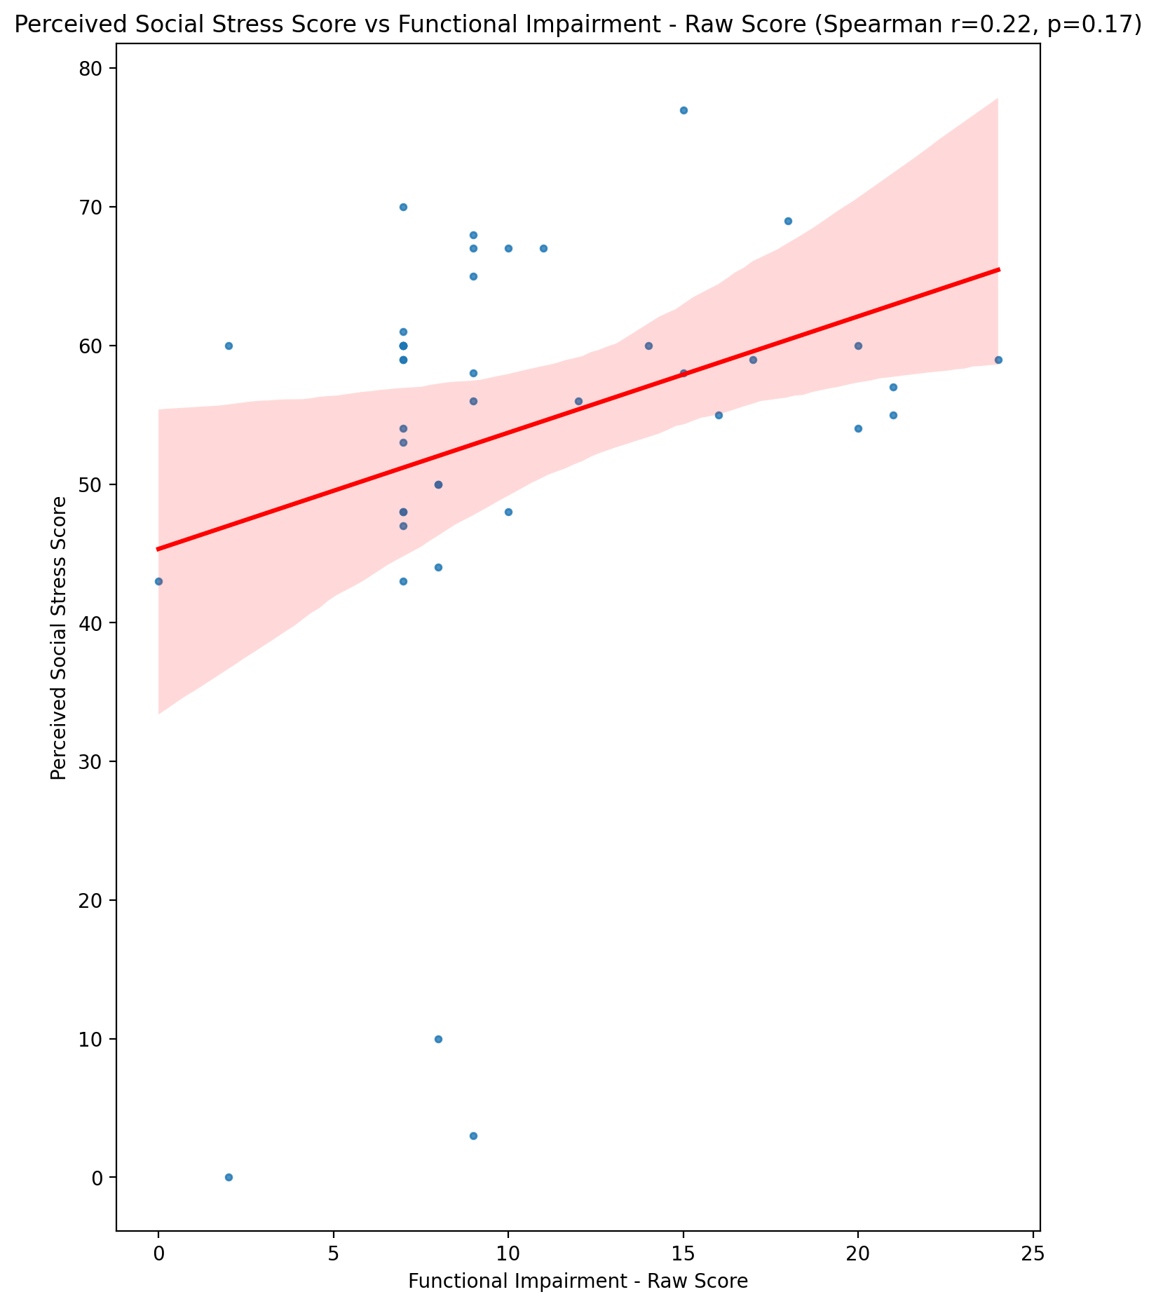

## Perceived Social Stress Category vs Functional Impairment - Raw Score

Test: None; statistic: None; p-value: None; Test not run: unsupported type combination.



## Emotional Support - Raw Score vs Withdrawl - Raw Score

Test: spearman; statistic: -0.47760400271309816; p-value: 0.0012006509334110576;

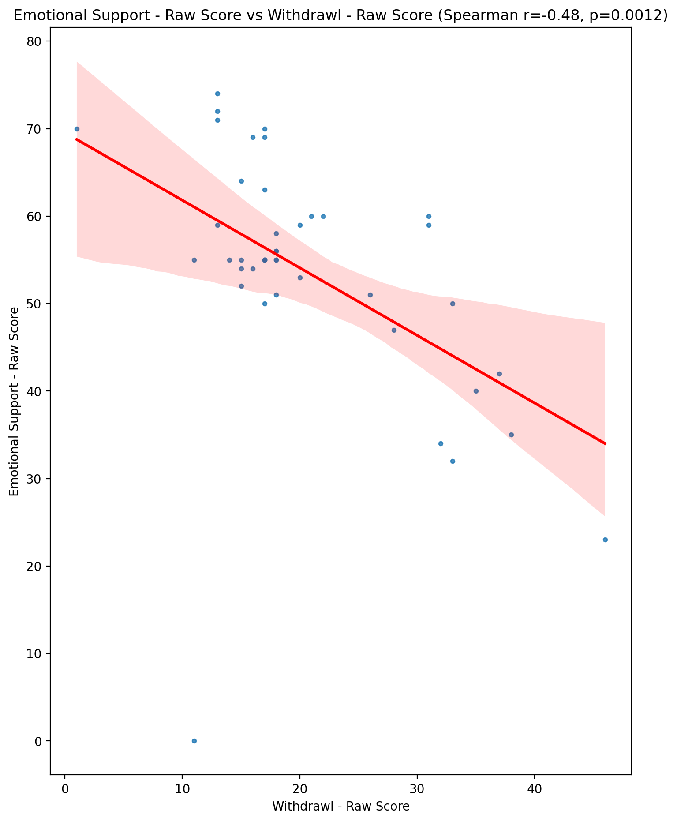

## Informational Support - Raw Score vs Withdrawl - Raw Score

Test: spearman; statistic: -0.44190610756242815; p-value: 0.0030094142949537695;

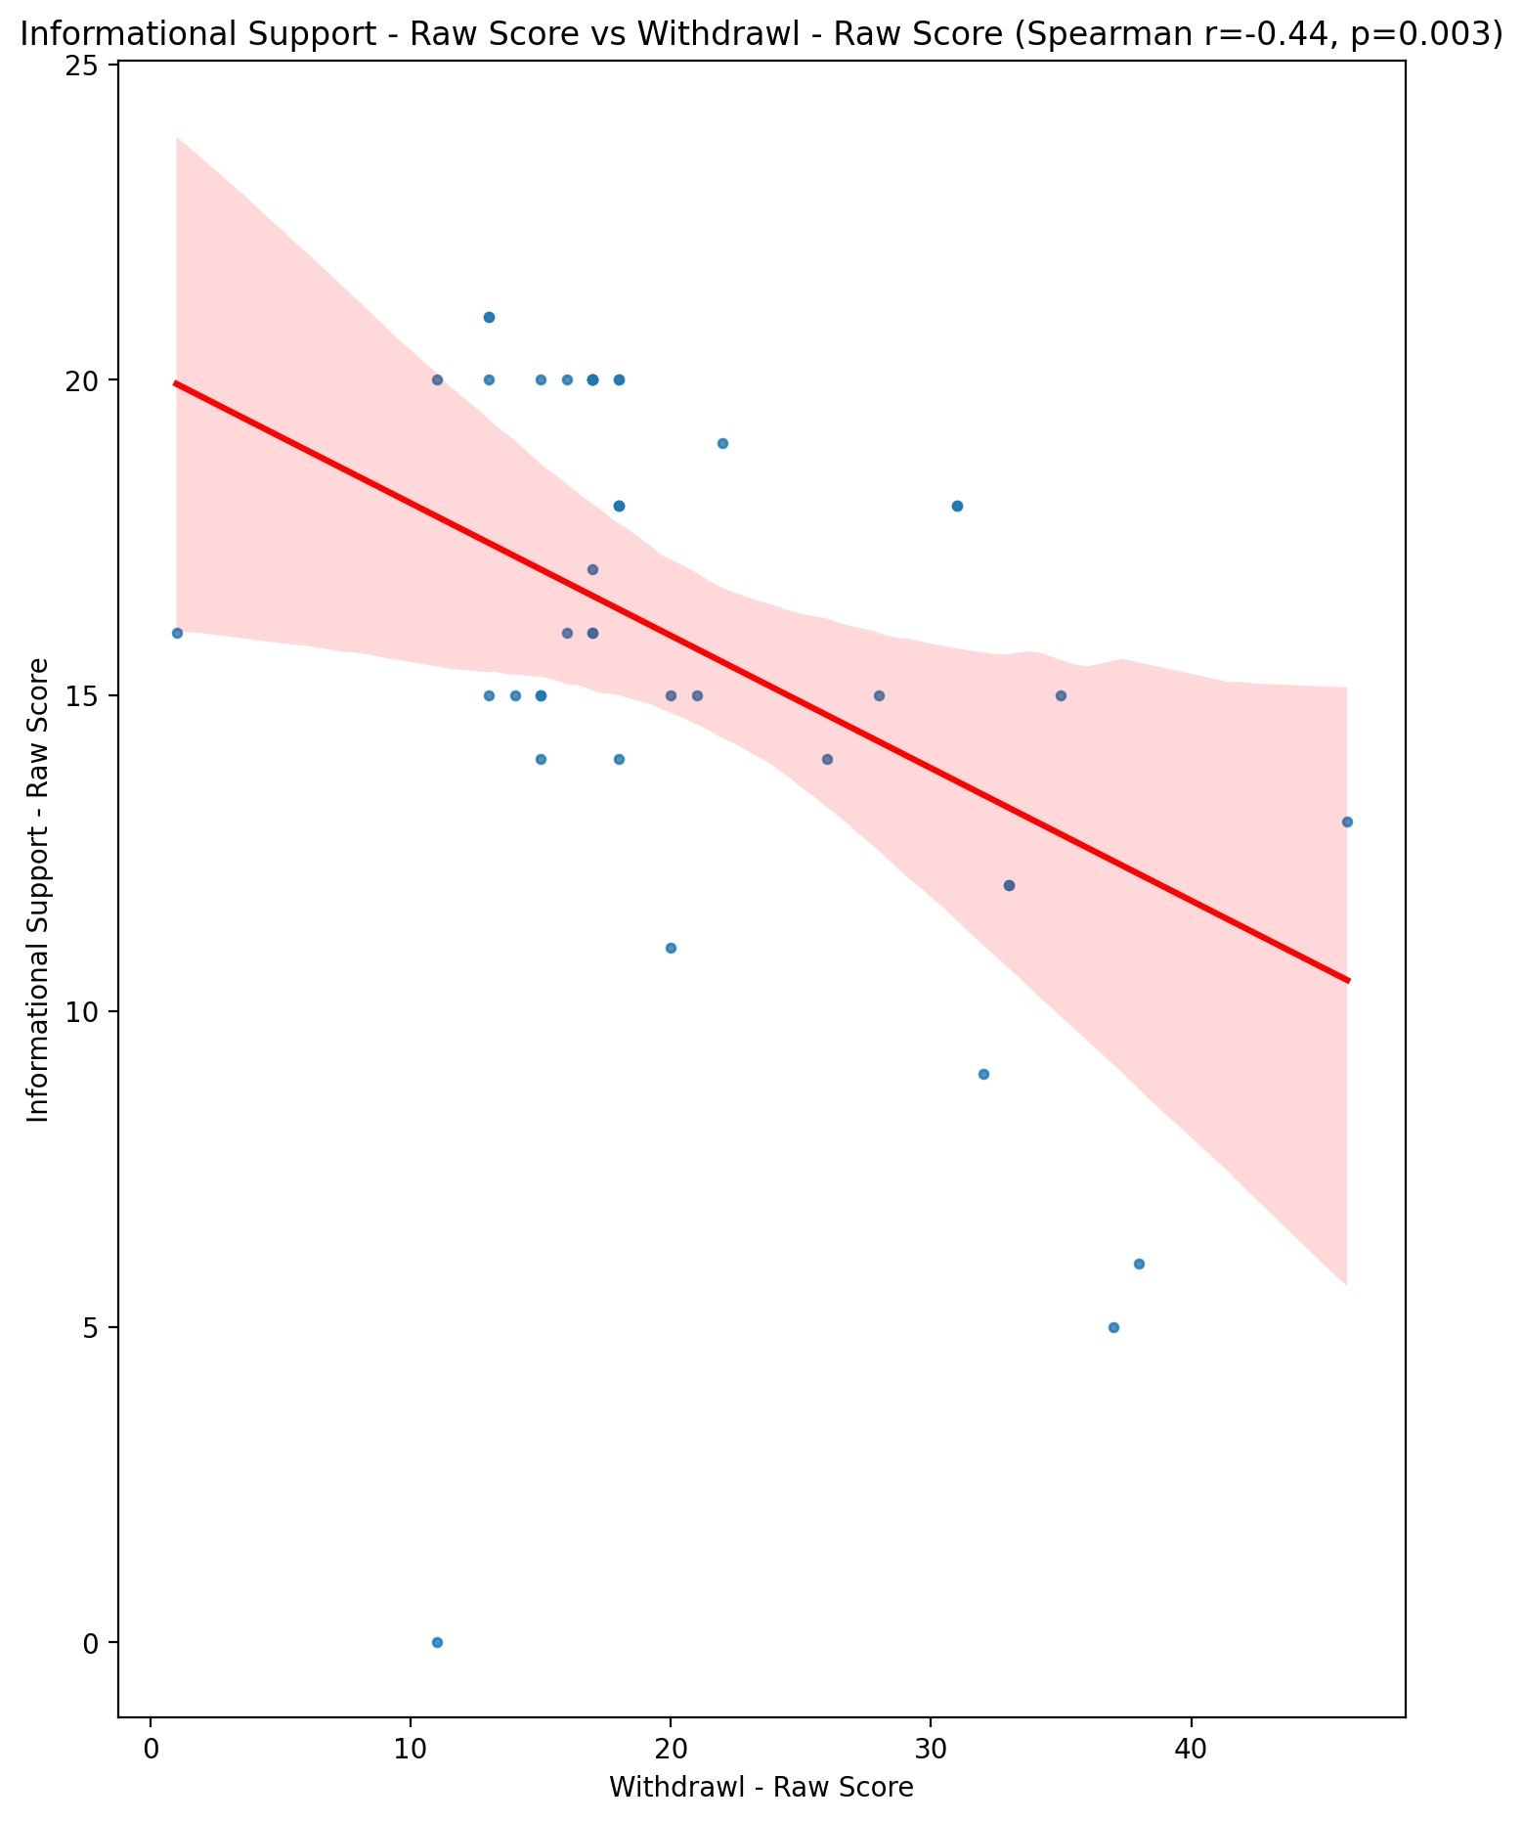

## Instrumental Support - Raw Score vs Withdrawl - Raw Score

Test: spearman; statistic: -0.539867702828622; p-value: 0.00018673550745538443;

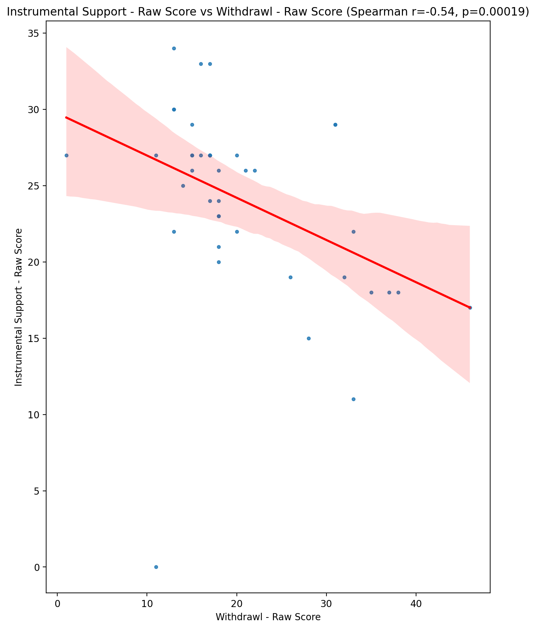

## Emotional Support - T Score vs Withdrawl - Raw Score

Test: spearman; statistic: -0.3751049476320953; p-value: 0.01319402827664035;

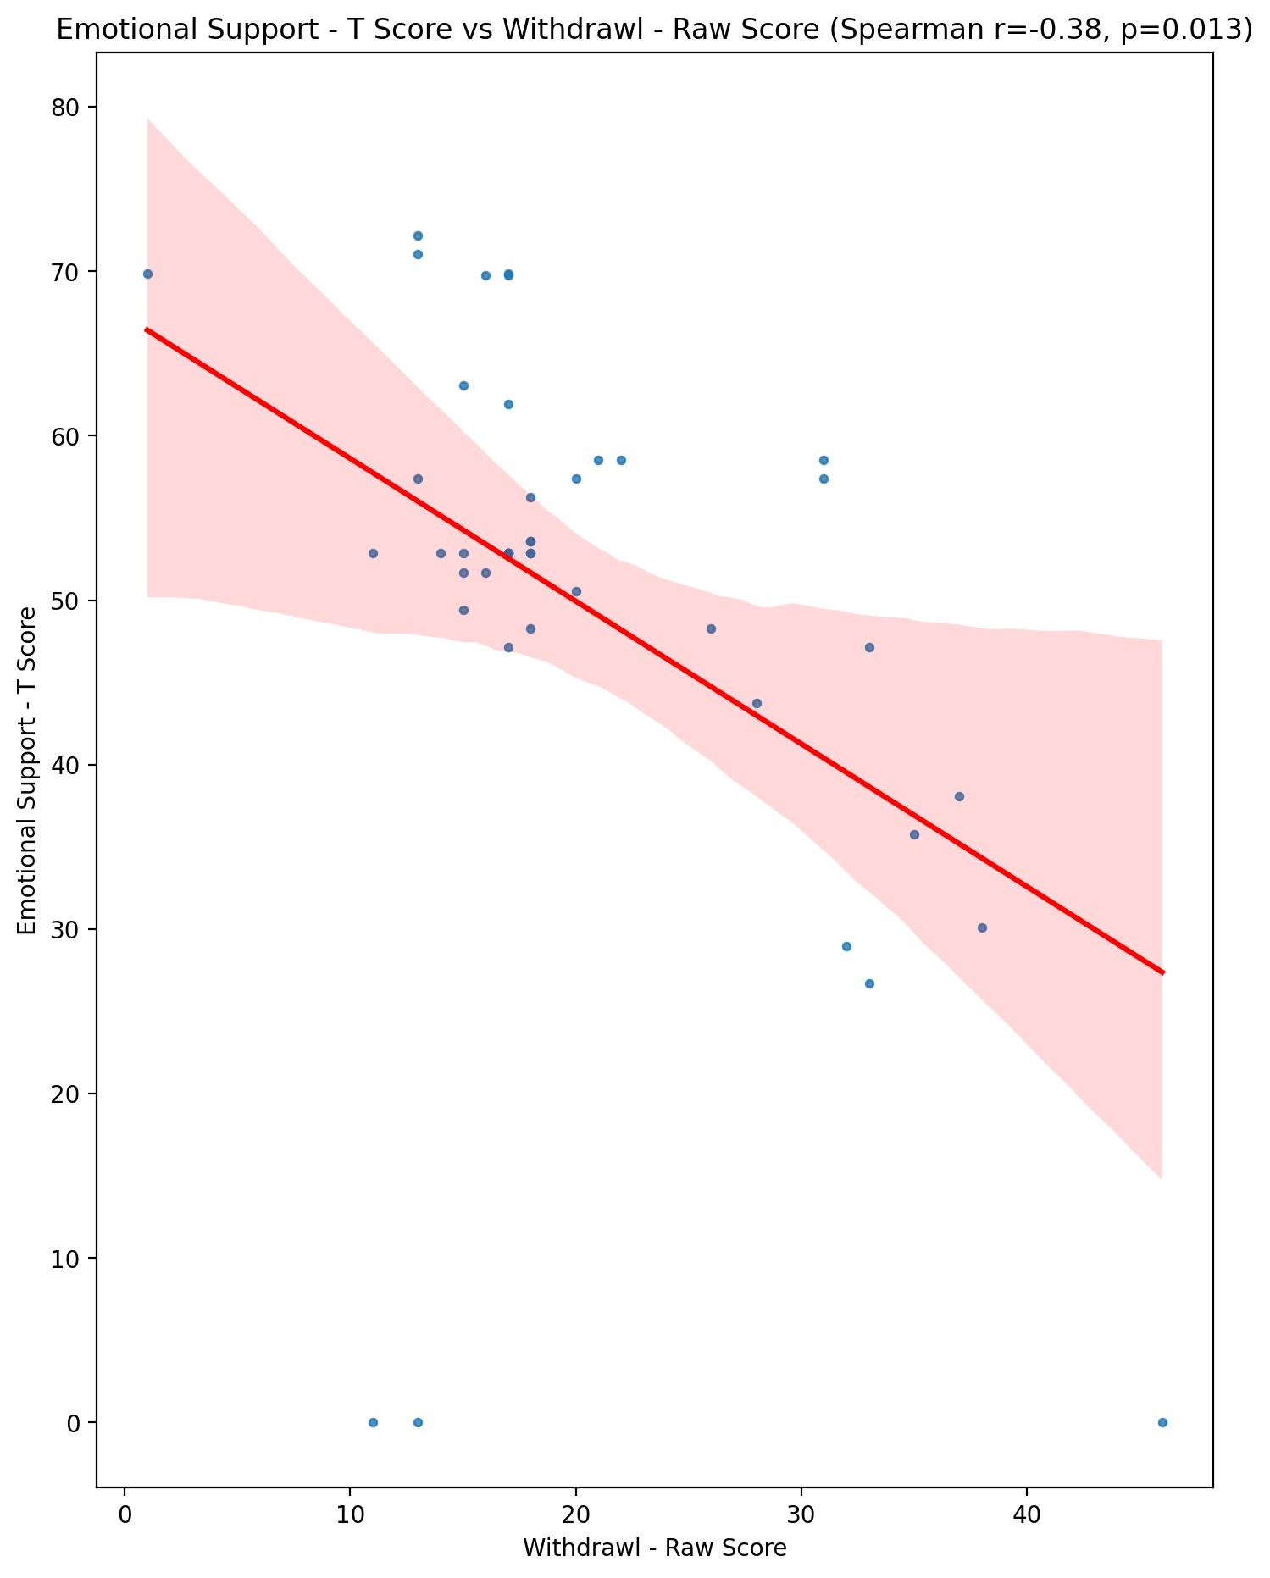

## Informational Support - T Score vs Withdrawl - Raw Score

Test: spearman; statistic: -0.44805171770254093; p-value: 0.002586887954592931;

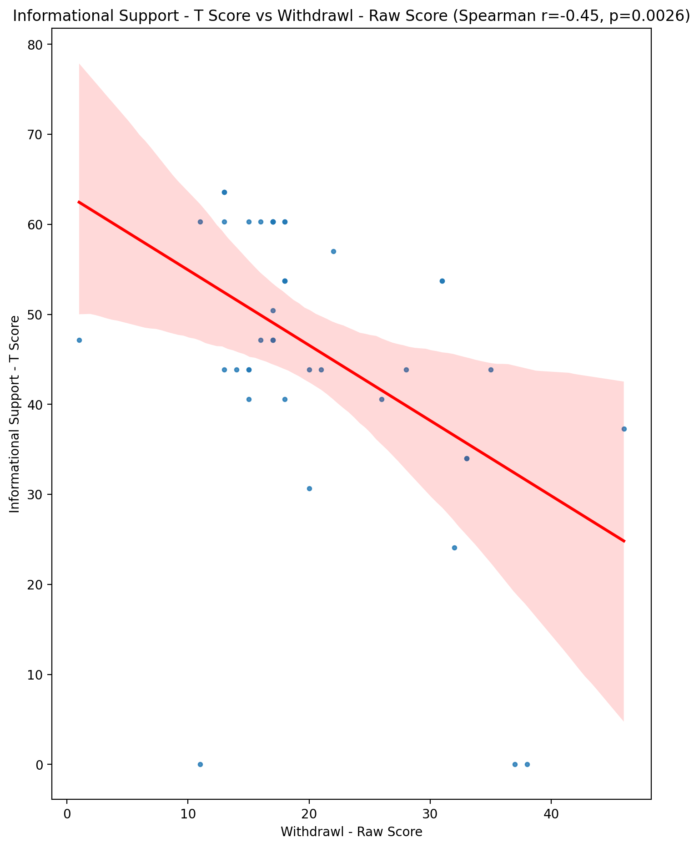

## Instrumental Support - T Score vs Withdrawl - Raw Score

Test: spearman; statistic: -0.5426546771569922; p-value: 0.00017032802889979944;

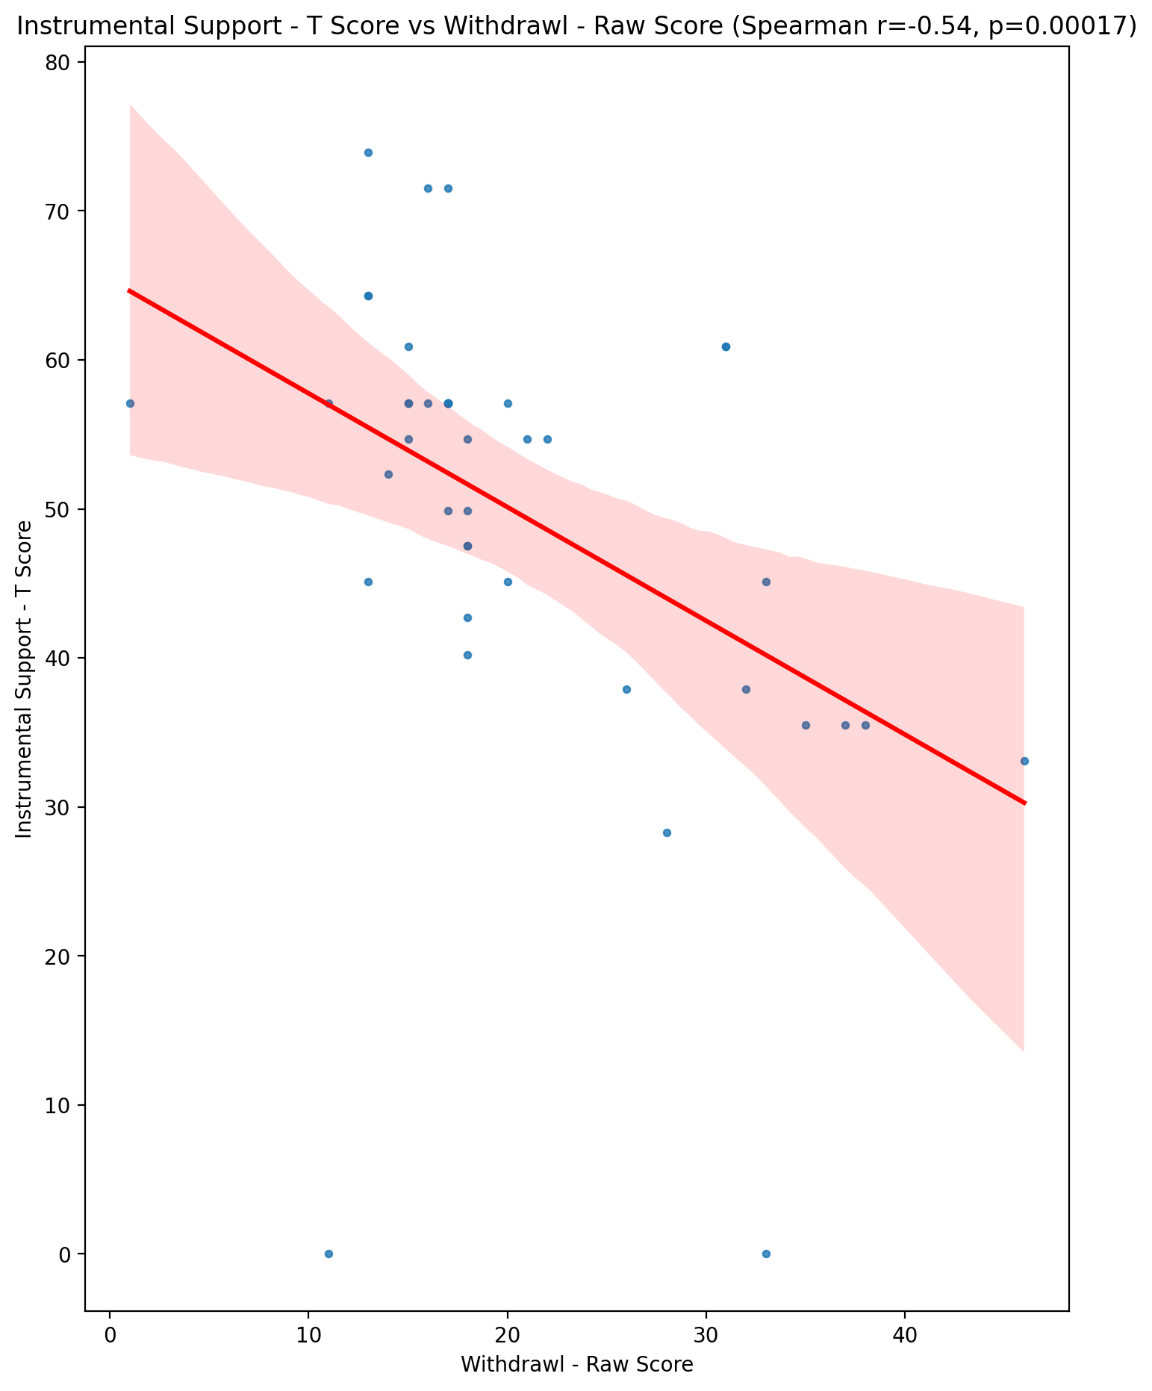

## Perceived Social Support Total T Score vs Withdrawl - Raw Score

Test: spearman; statistic: -0.5264274817972828; p-value: 0.00028775713848645454;

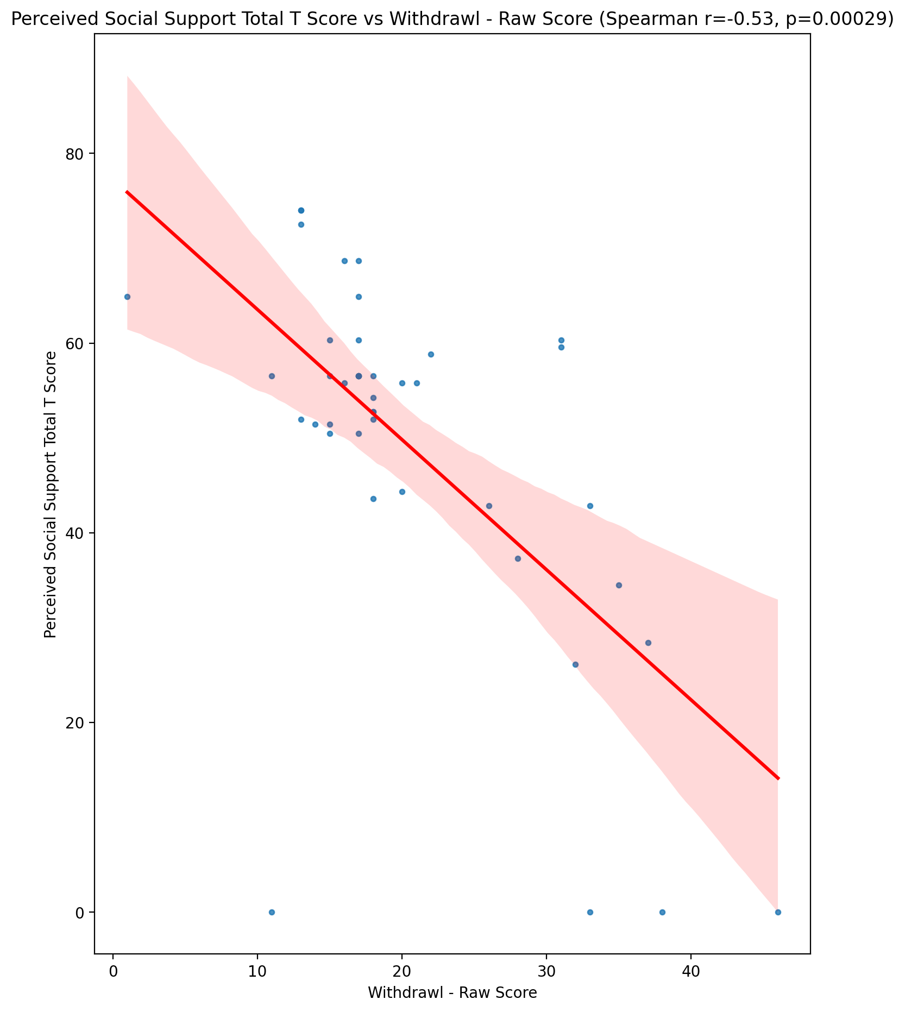

## Emotional Support - Rank vs Withdrawl - Raw Score

Test: None; statistic: None; p-value: None; Test not run: unsupported type combination.



## Informational Support - Rank vs Withdrawl - Raw Score

Test: None; statistic: None; p-value: None; Test not run: unsupported type combination.



## Instrumental Support - Rank vs Withdrawl - Raw Score

Test: None; statistic: None; p-value: None; Test not run: unsupported type combination.



## Perceived Social Support TOTAL - Rank vs Withdrawl - Raw Score

Test: None; statistic: None; p-value: None; Test not run: unsupported type combination.



## Power Self Concept - Real Self Concept Score vs Withdrawl - Raw Score

Test: spearman; statistic: -0.12667307948334663; p-value: 0.4182607367776221;

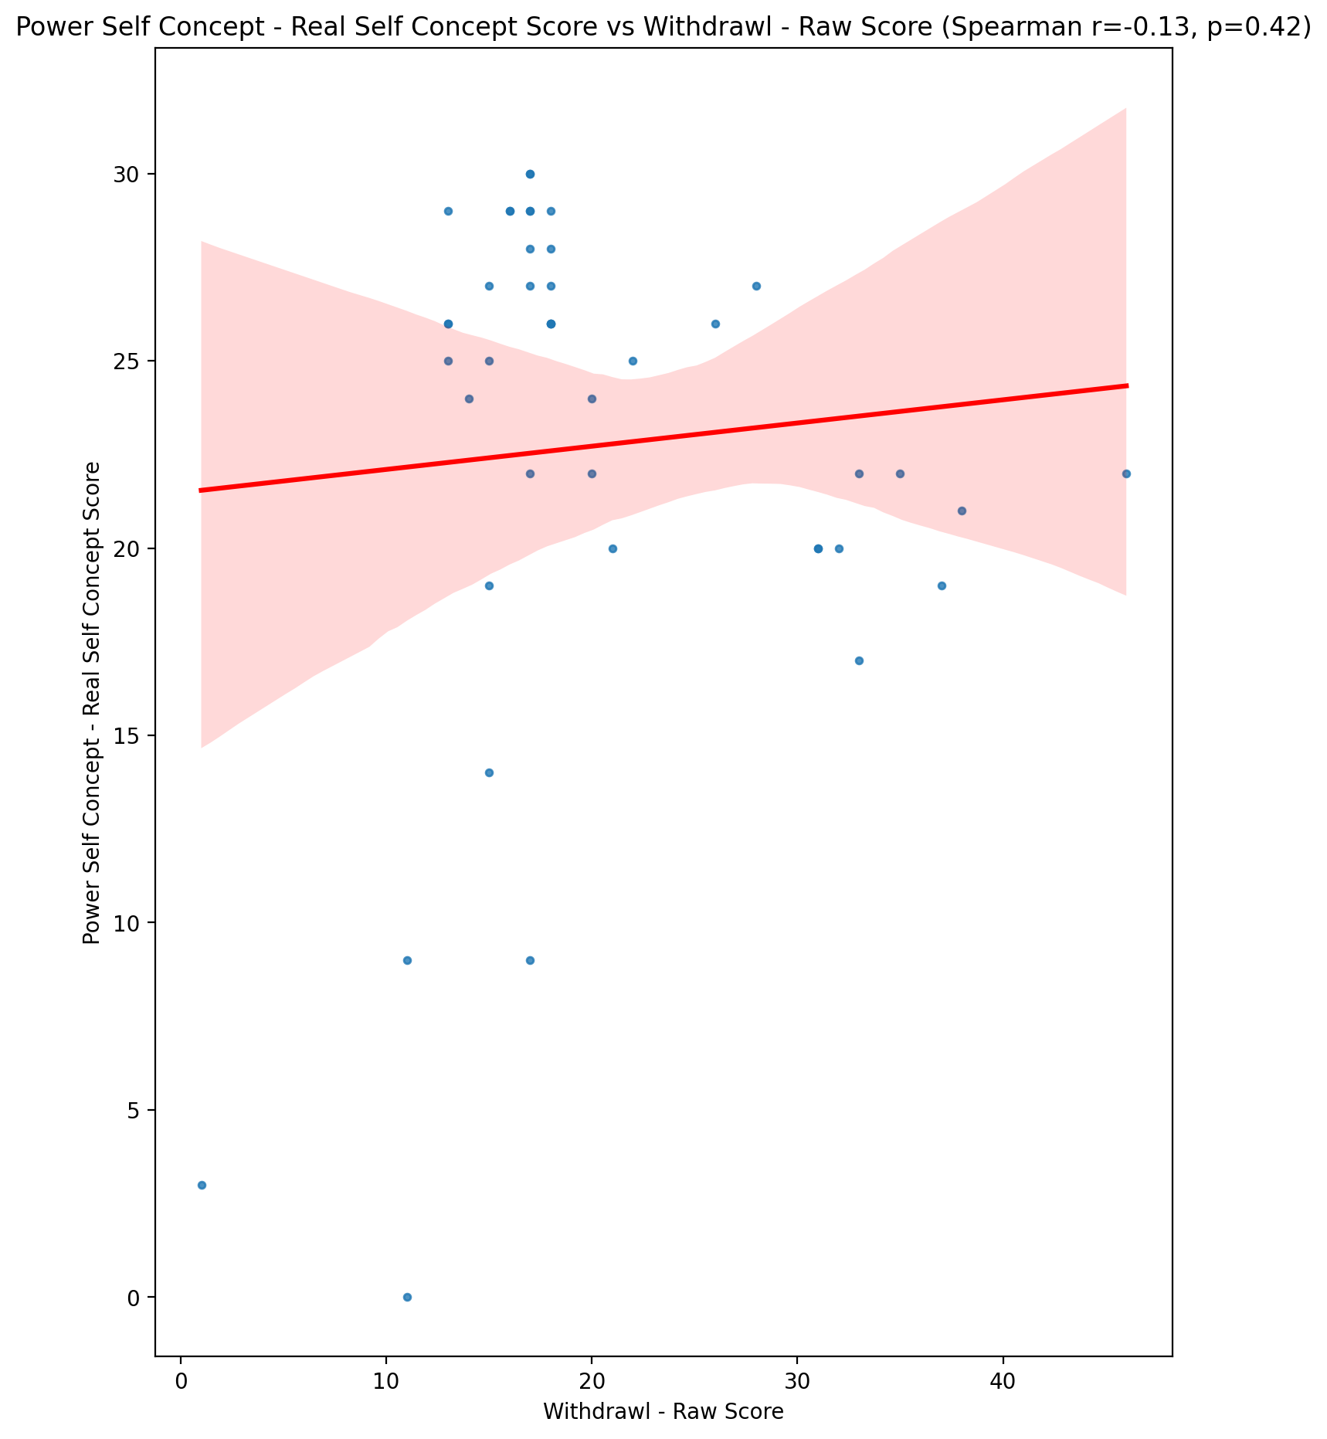

## Power Self Concept - Ideal Self Concept score vs Withdrawl - Raw Score

Test: spearman; statistic: 0.019191094391355624; p-value: 0.9027823624452951;

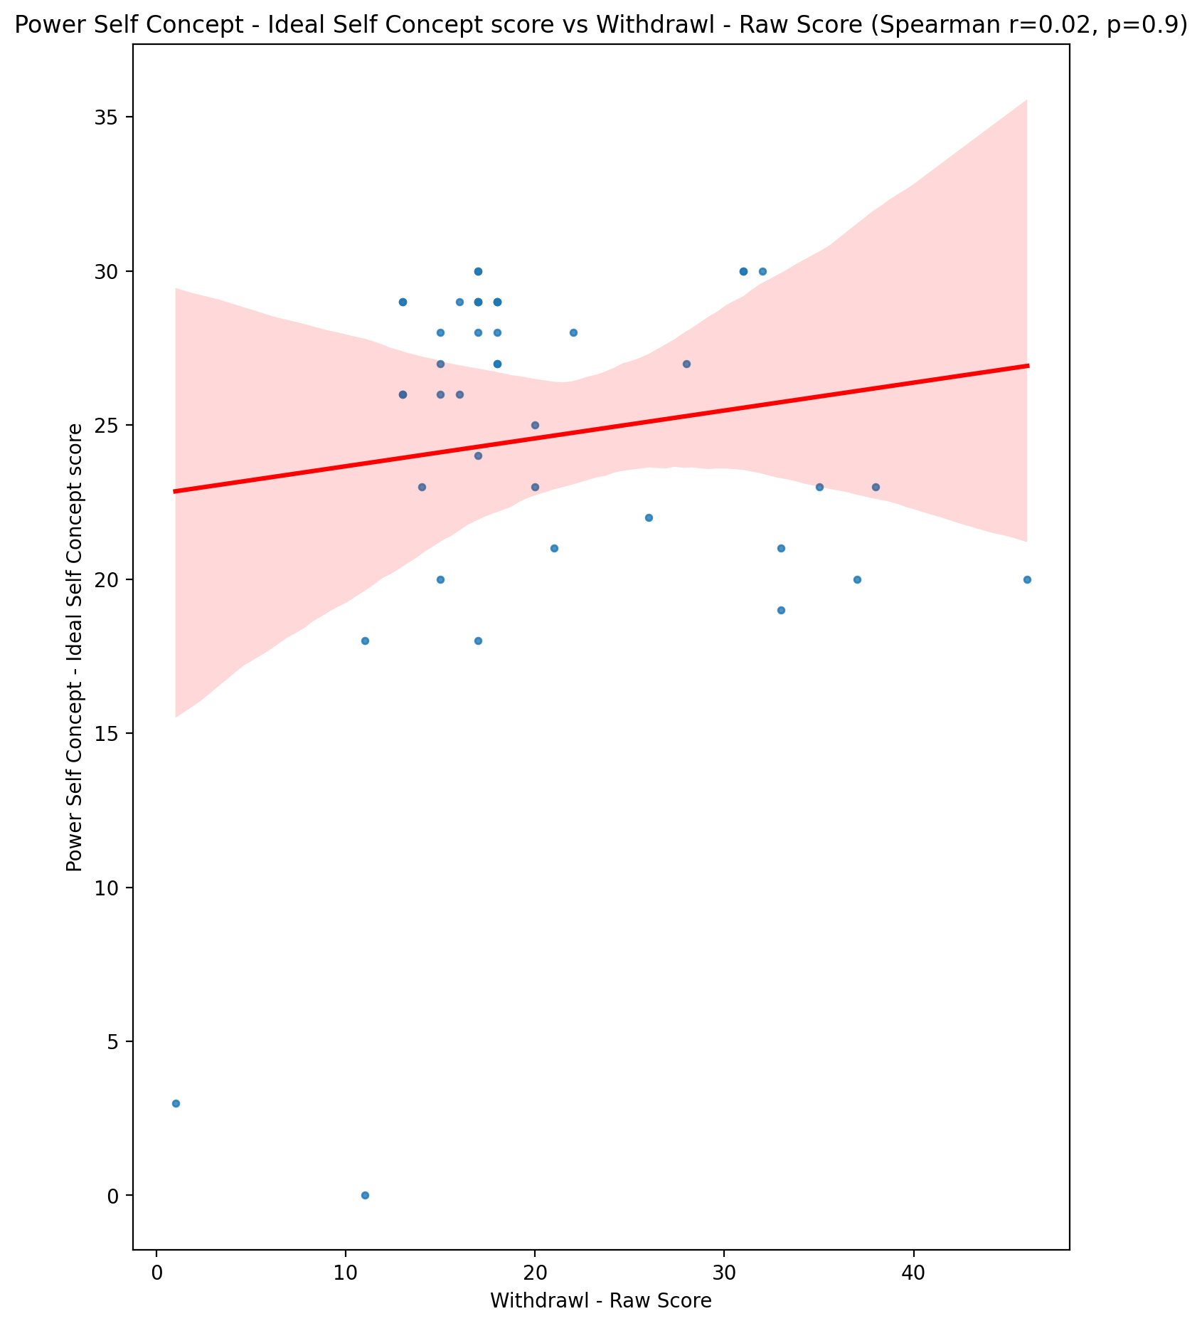

## Power Self Concept – Social Self Concept Score vs Withdrawl - Raw Score

Test: spearman; statistic: -0.1427865558682239; p-value: 0.36102380034346504;

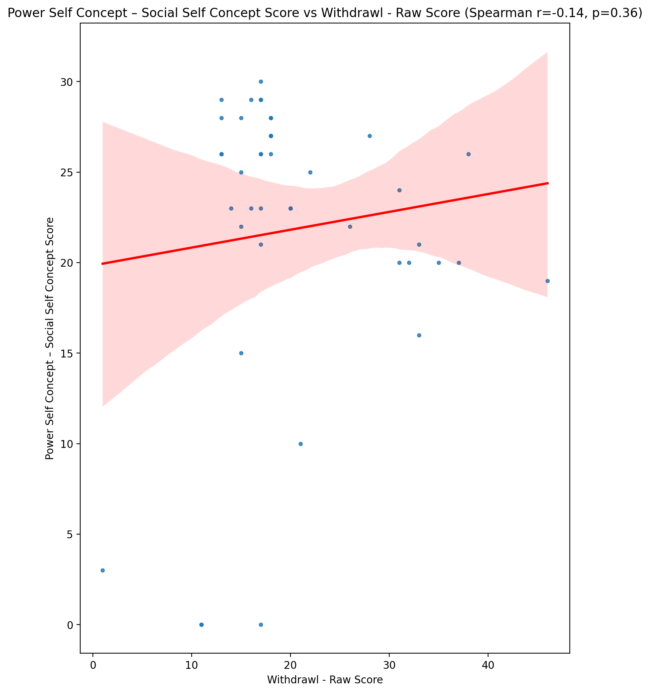

## Social Self Concept - Real Self Concept Score vs Withdrawl - Raw Score

Test: spearman; statistic: -0.309342951690406; p-value: 0.04353559625988234;

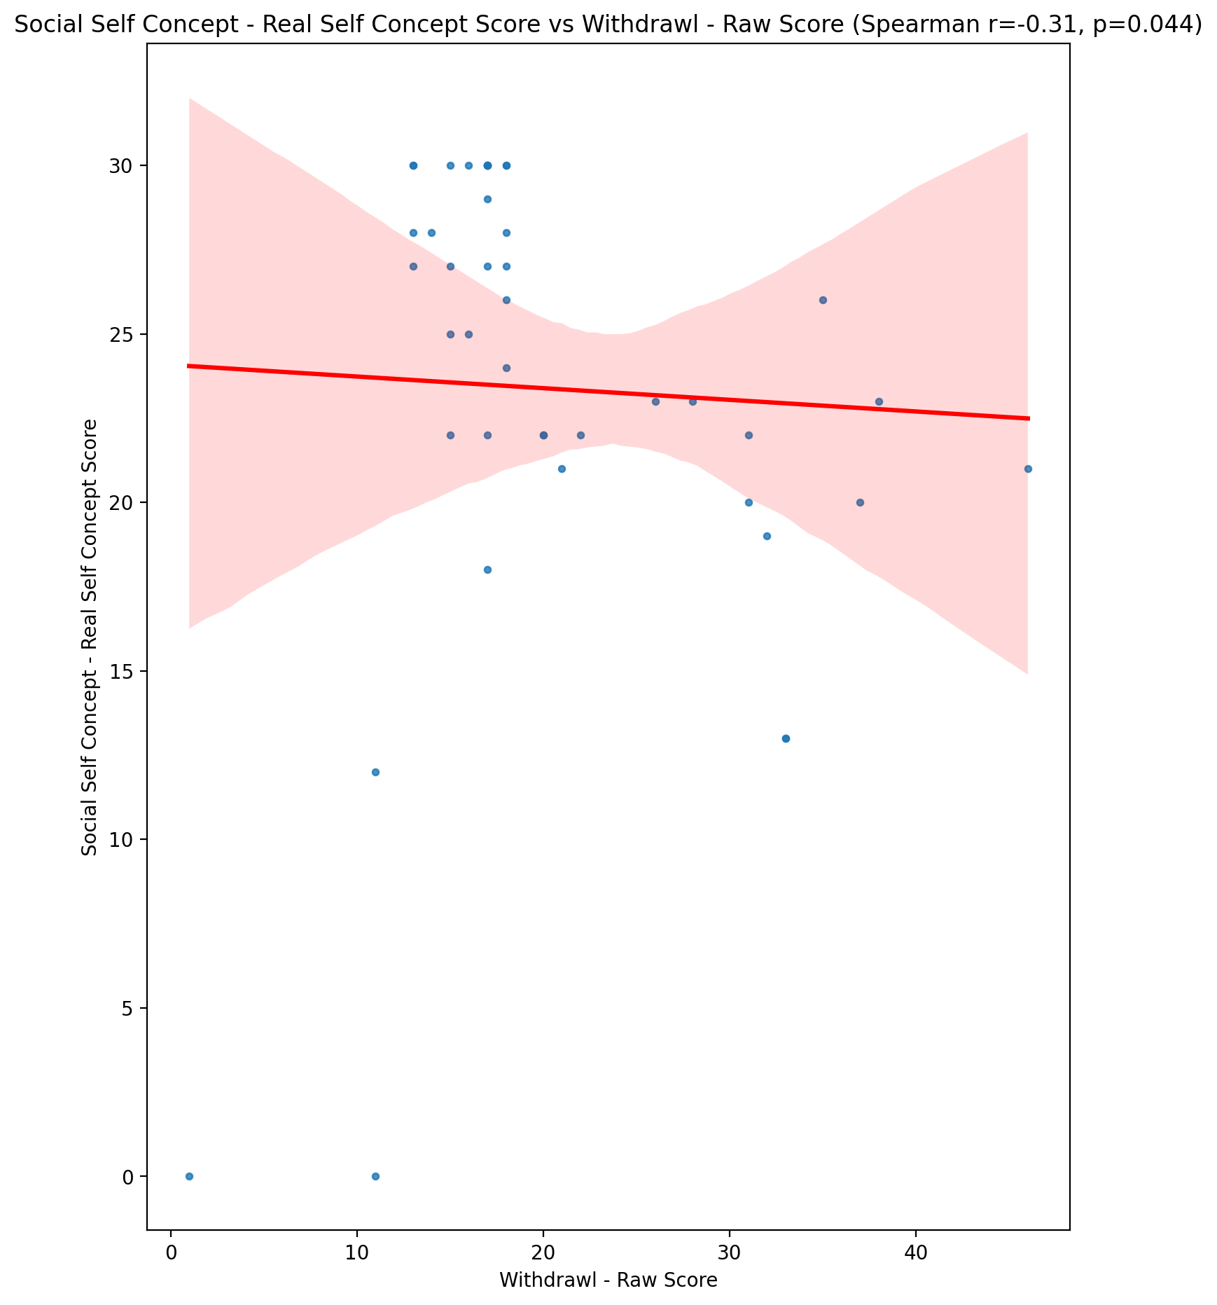

## Social Self Concept – Social Self Concept Score vs Withdrawl - Raw Score

Test: spearman; statistic: -0.2585180280721134; p-value: 0.09415970402266327;

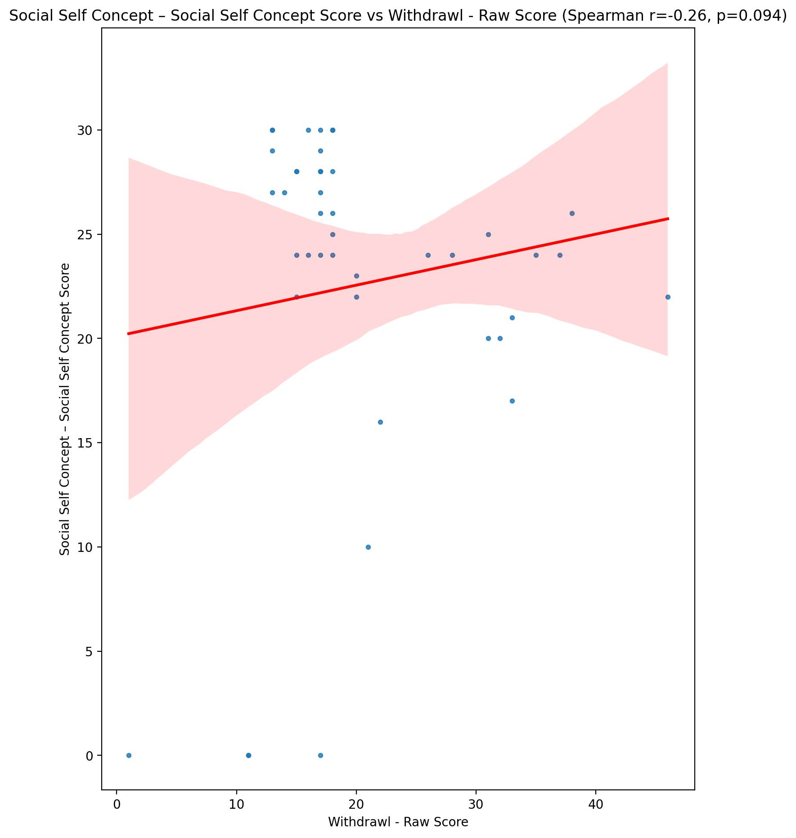

## Ability Self Concept - Real Self Concept Score vs Withdrawl - Raw Score

Test: spearman; statistic: -0.18204706768603213; p-value: 0.24265340421702655;

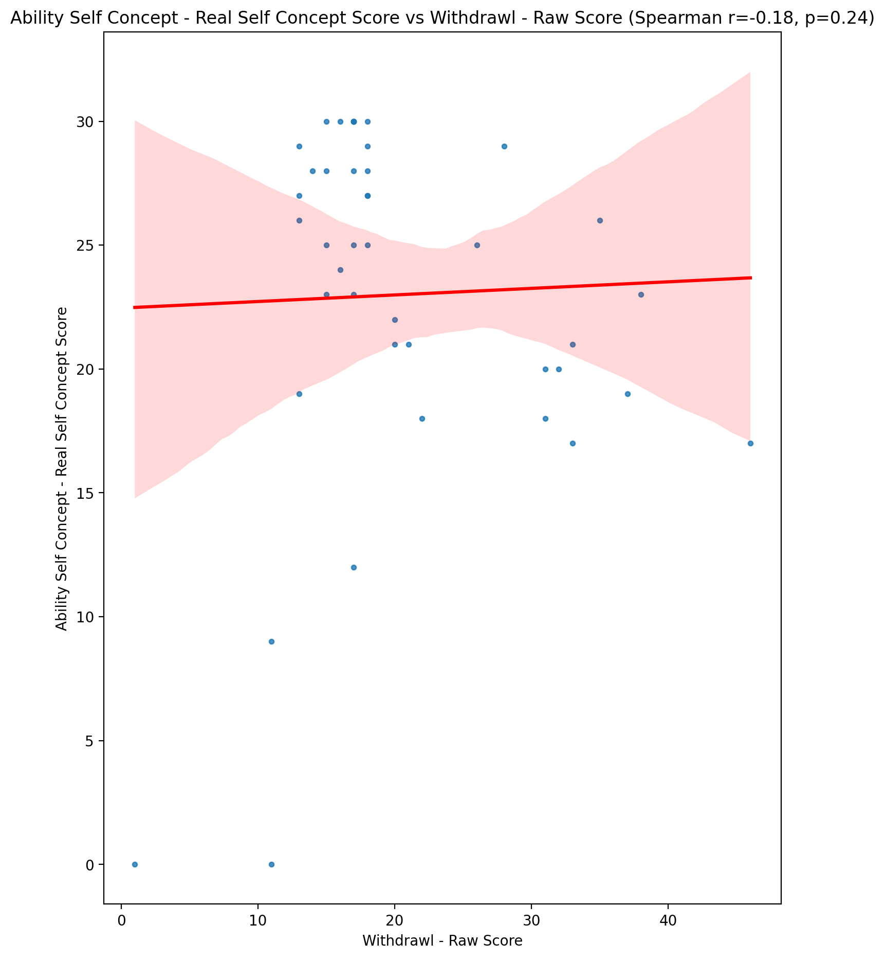

## Ability Self Concept - Ideal Self Concept Score vs Withdrawl - Raw Score

Test: spearman; statistic: -0.04356303858500495; p-value: 0.7814914232725052;

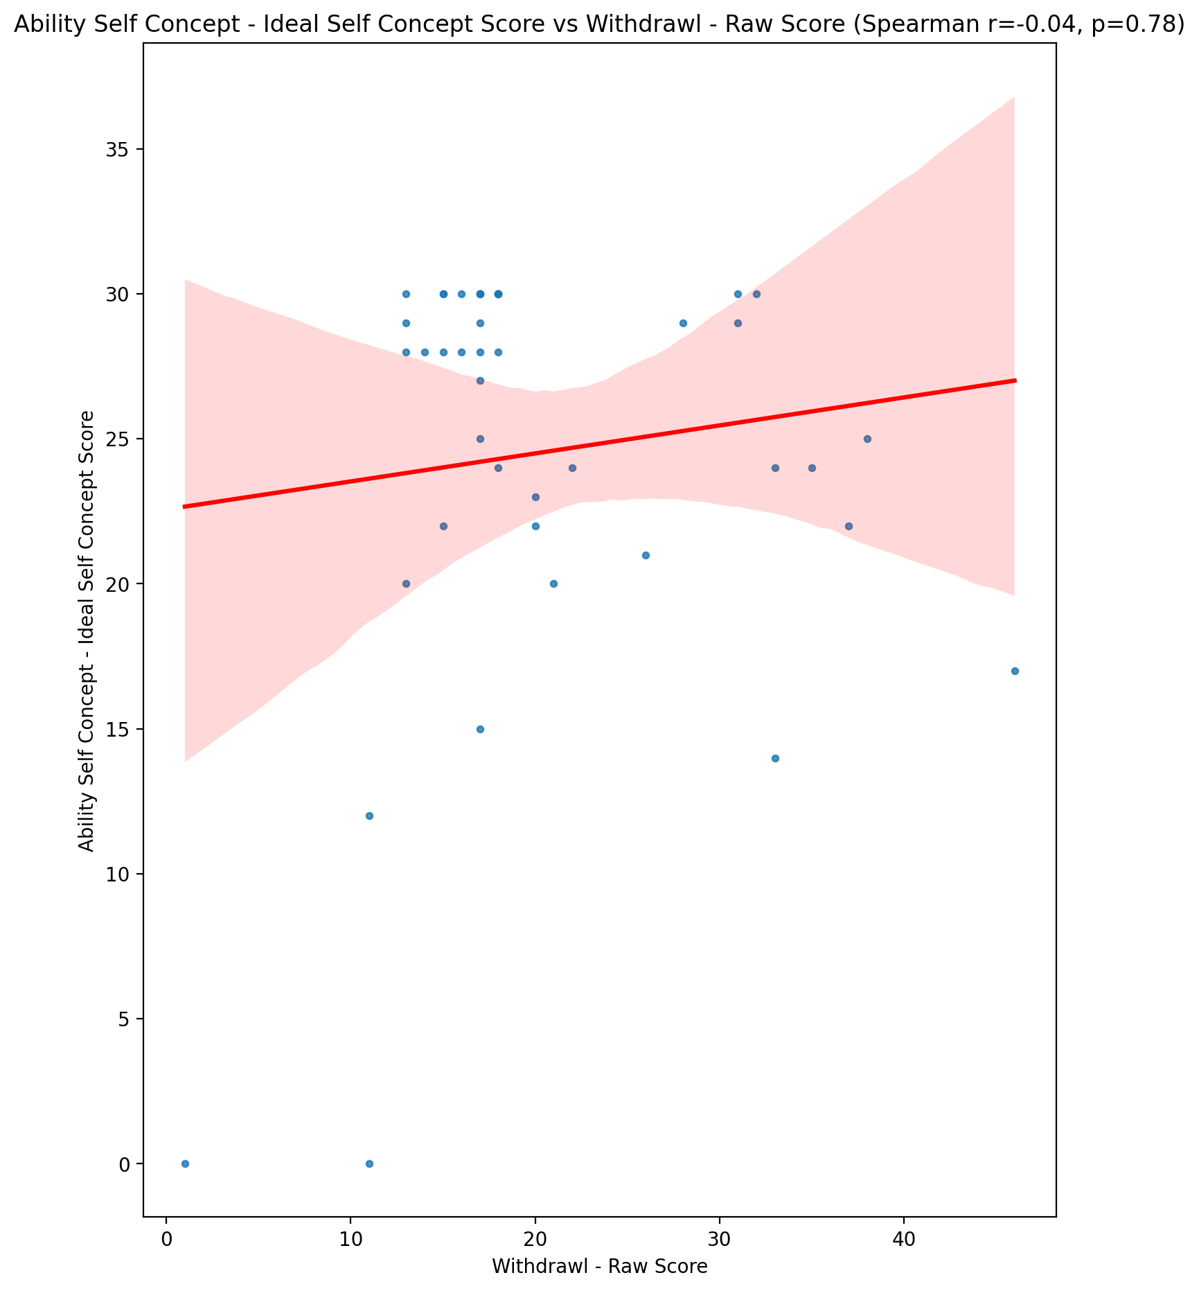

## Ability Self Concept – Social Self Concept Score vs Withdrawl - Raw Score

Test: spearman; statistic: -0.1562313120846687; p-value: 0.317093110960217;

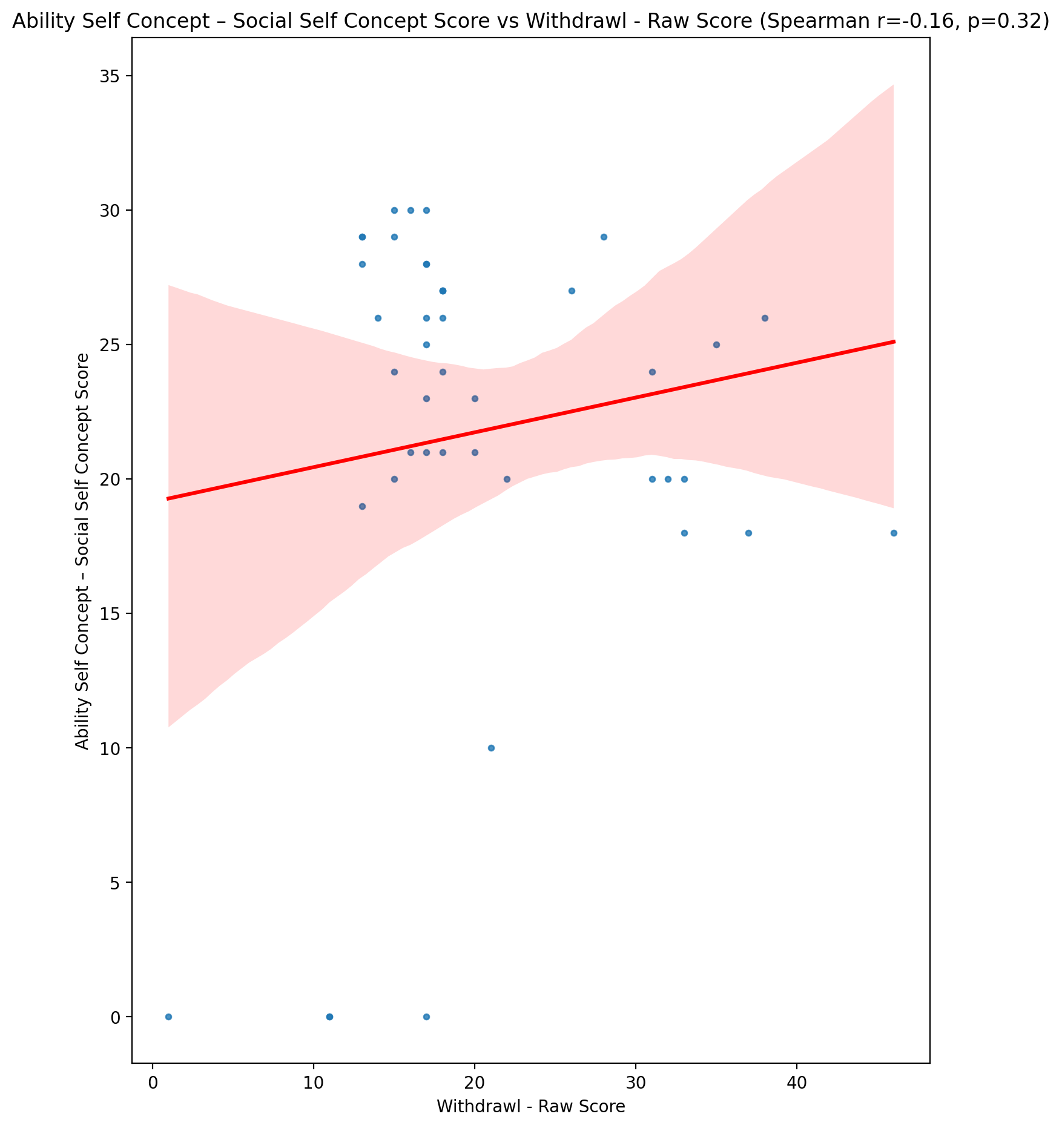

## Physical Self Concept - Real Self Concept Score vs Withdrawl - Raw Score

Test: spearman; statistic: -0.18048298866224532; p-value: 0.24679351234820598;

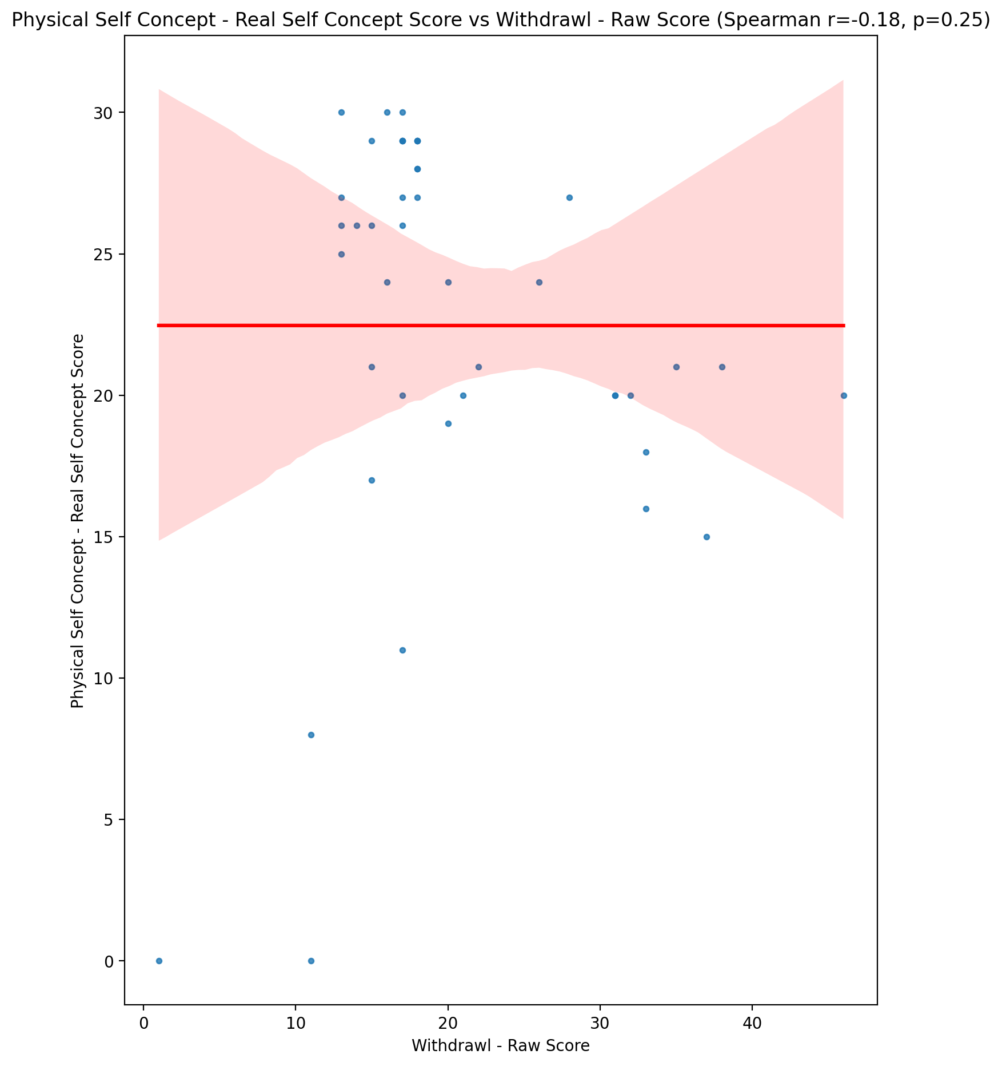

## Physical Self Concept – Ideal Self Concept Score vs Withdrawl - Raw Score

Test: spearman; statistic: -0.03158627445854503; p-value: 0.8406424741059877;

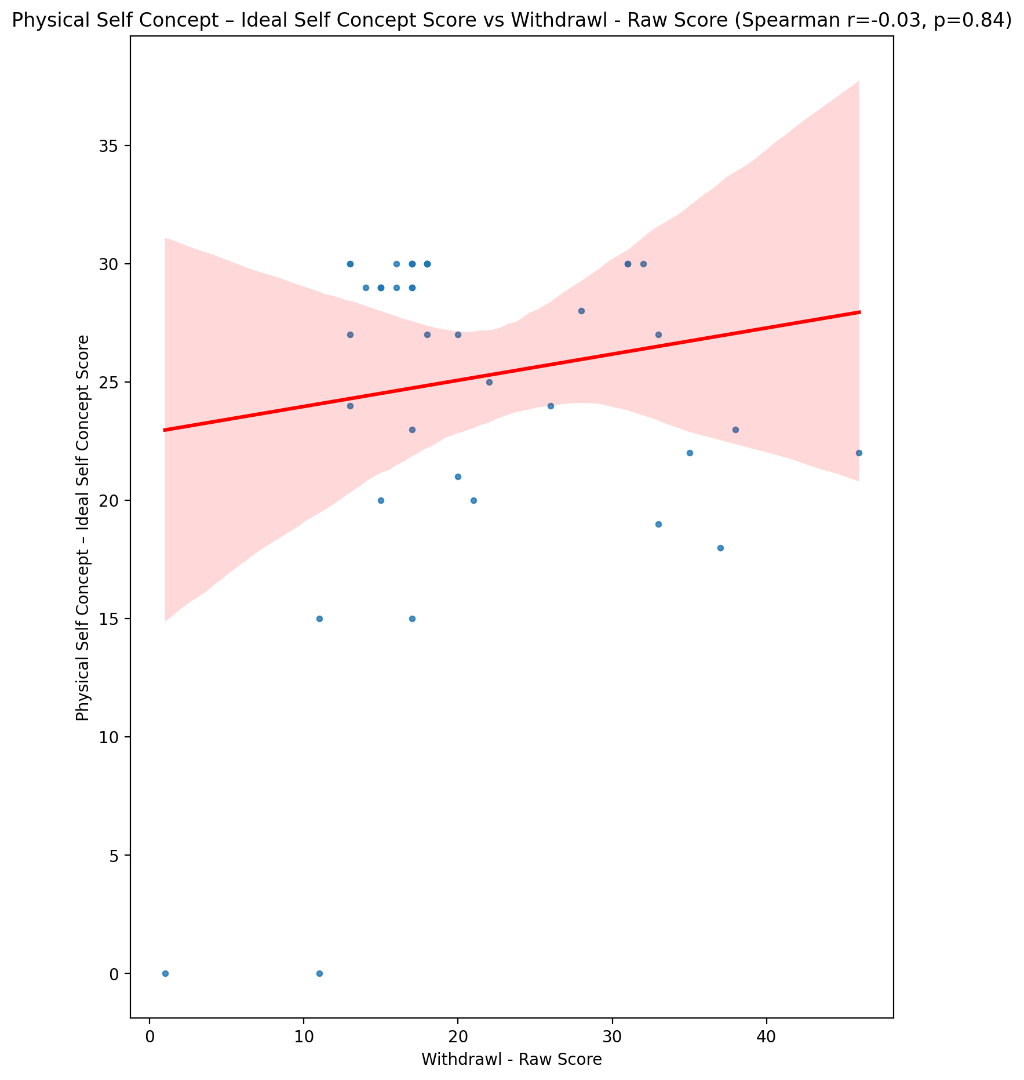

## Physical Self Concept – Social Self Concept Score vs Withdrawl - Raw Score

Test: spearman; statistic: -0.03565437734774918; p-value: 0.8204361653809452;

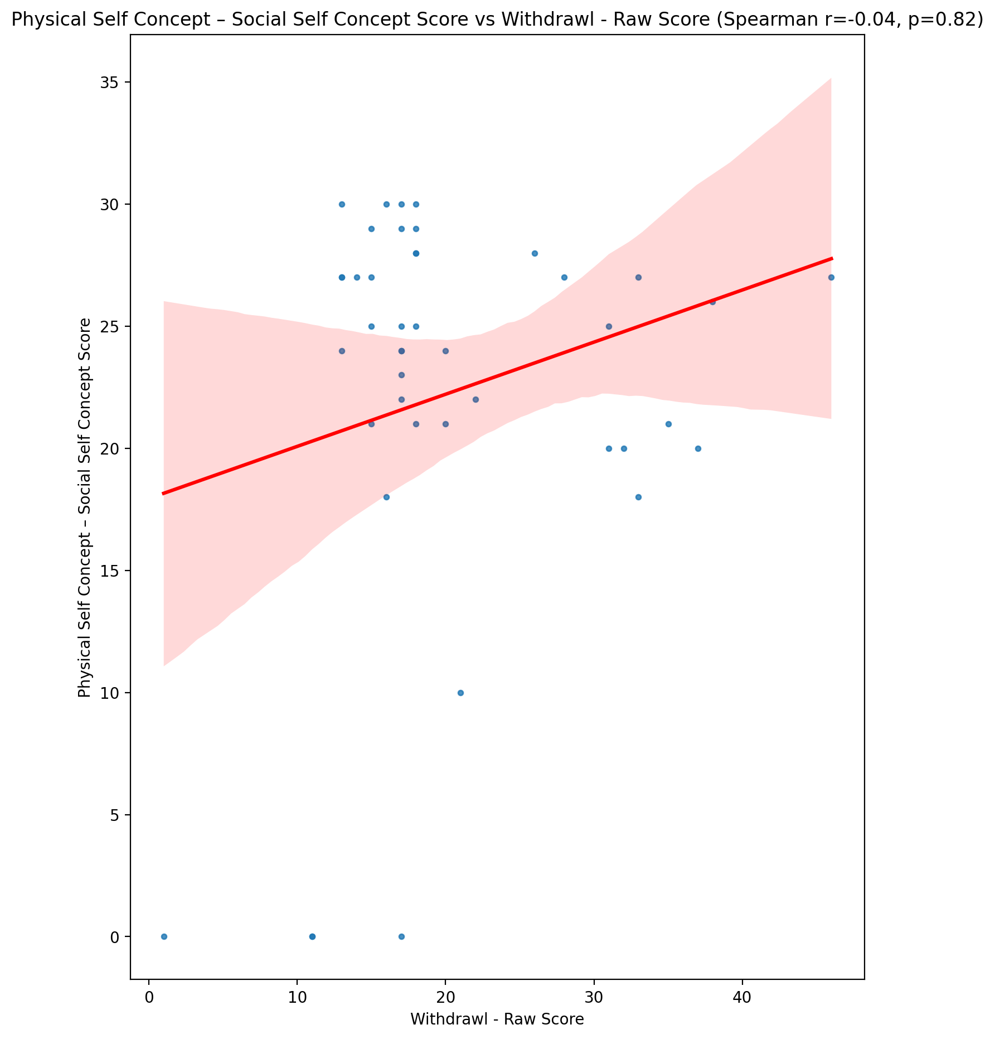

## Psychological Self Concept - Real Self Concept Score vs Withdrawl - Raw Score

Test: spearman; statistic: -0.29842167585870255; p-value: 0.05192390607502403;

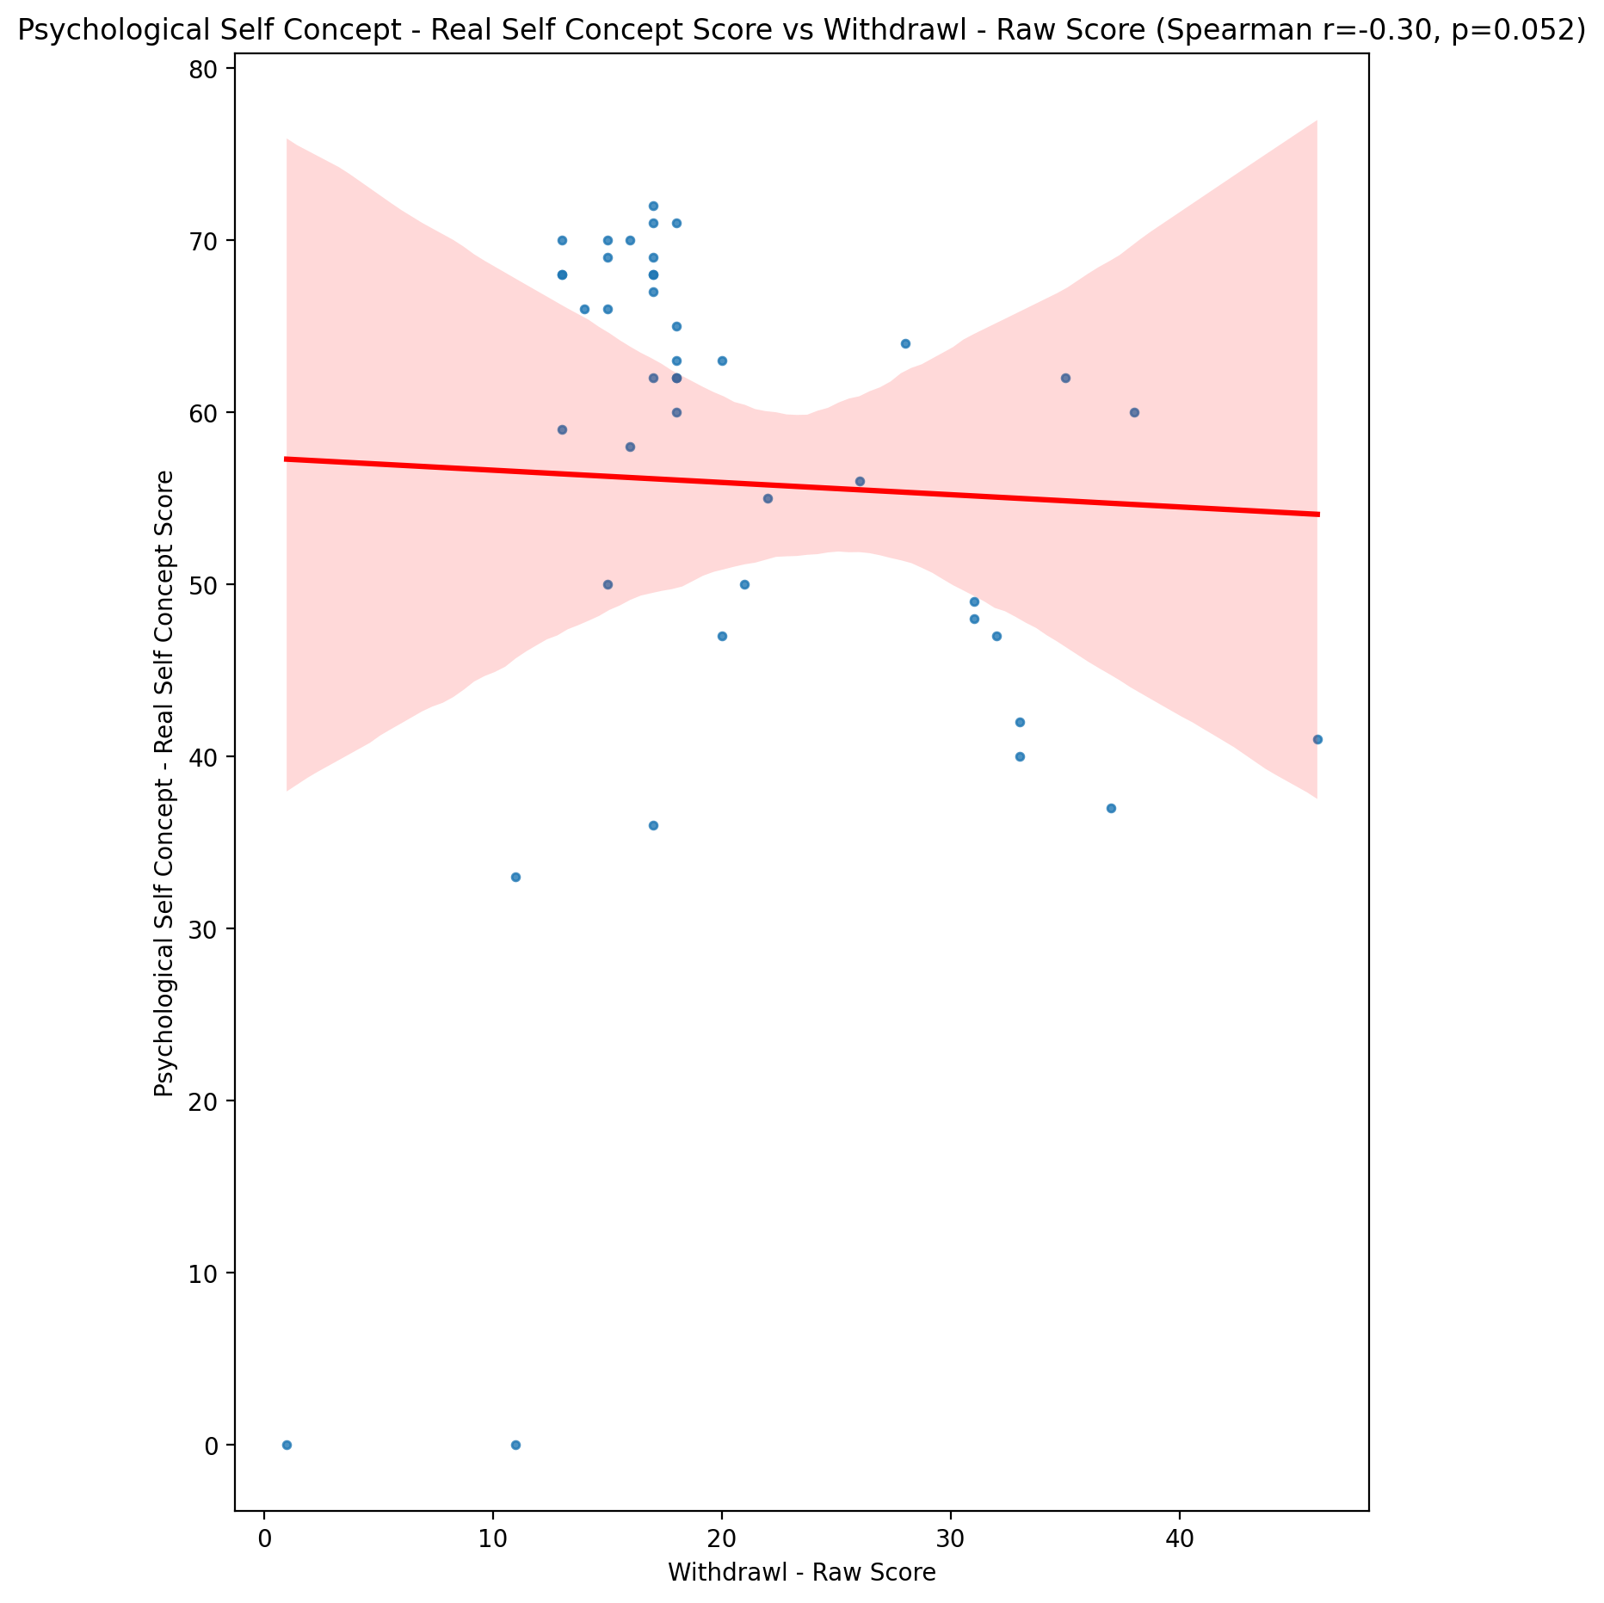

## Psychological Self Concept – Ideal Self Concept Score vs Withdrawl - Raw Score

Test: spearman; statistic: -0.06648913014182746; p-value: 0.671842890433694;

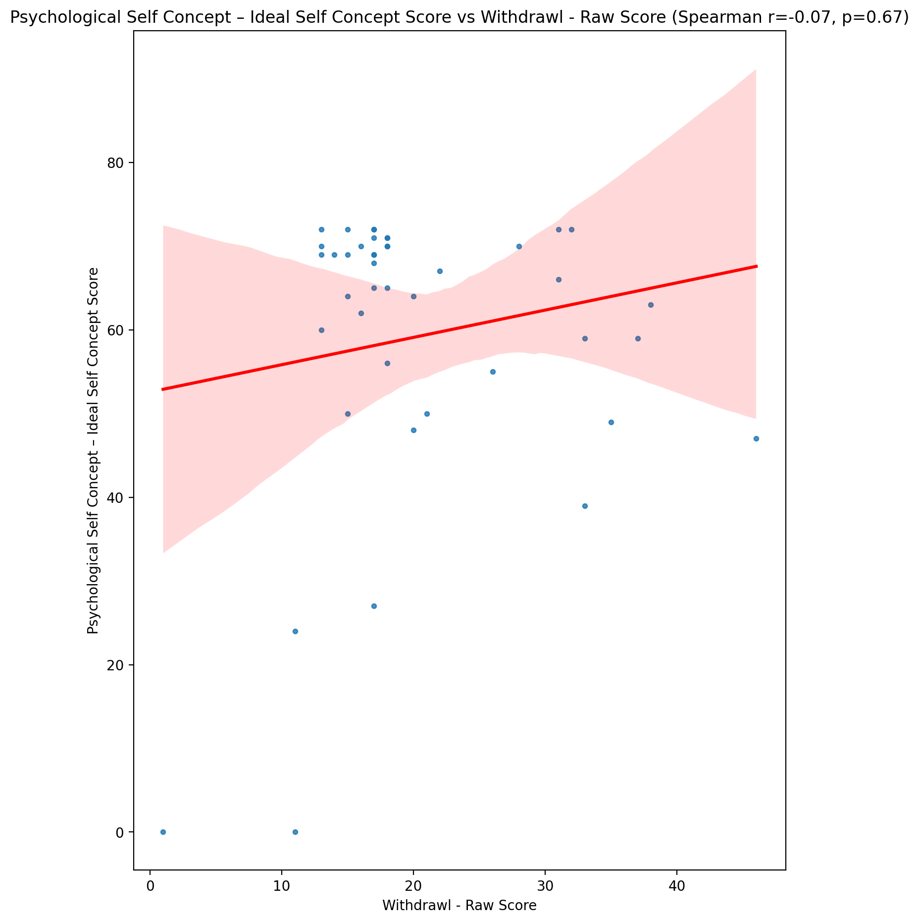

## Psychological Self Concept – Social Self Concept Score vs Withdrawl - Raw Score

Test: spearman; statistic: -0.26711219703308187; p-value: 0.08334906203200844;

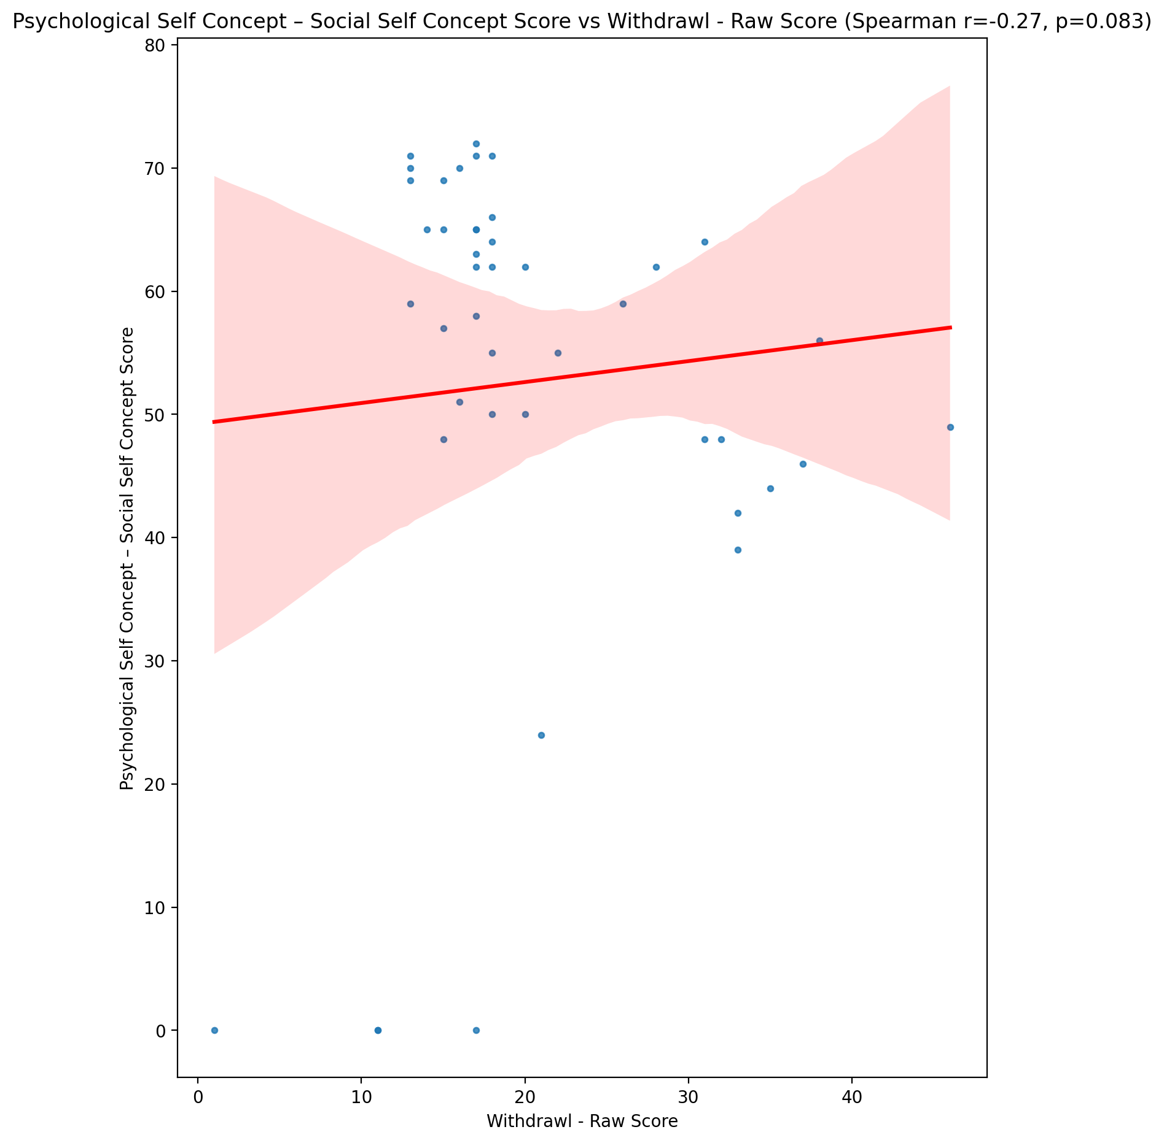

## Real Self Concept Total Score vs Withdrawl - Raw Score

Test: spearman; statistic: -0.2737388184588309; p-value: 0.07569471857054497;

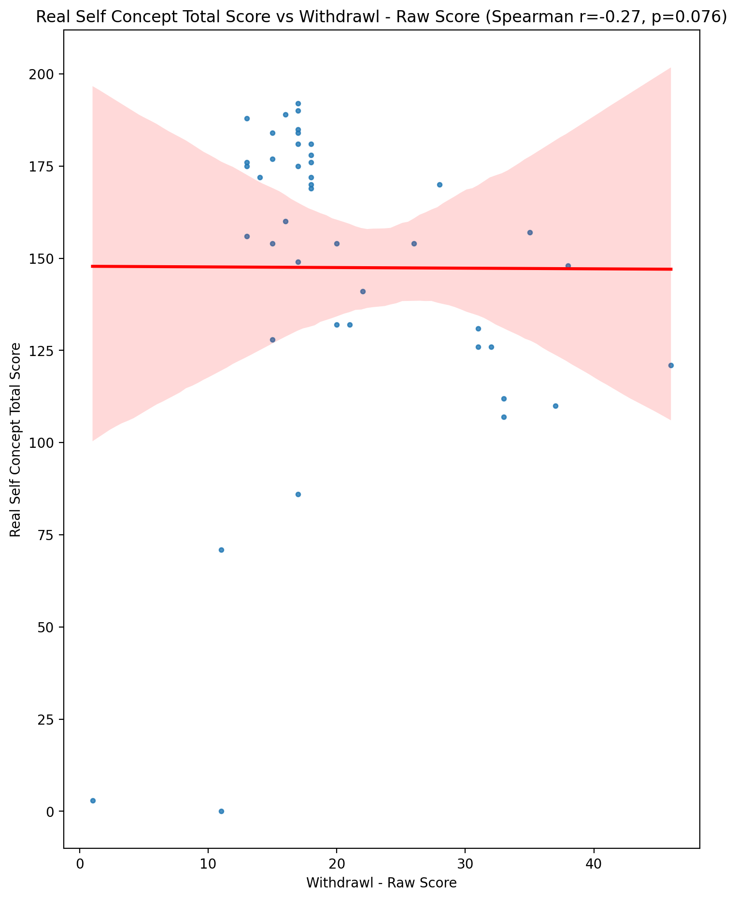

## Ideal Self Concept Total Score vs Withdrawl - Raw Score

Test: spearman; statistic: -0.07166817320054929; p-value: 0.6478871493839404;

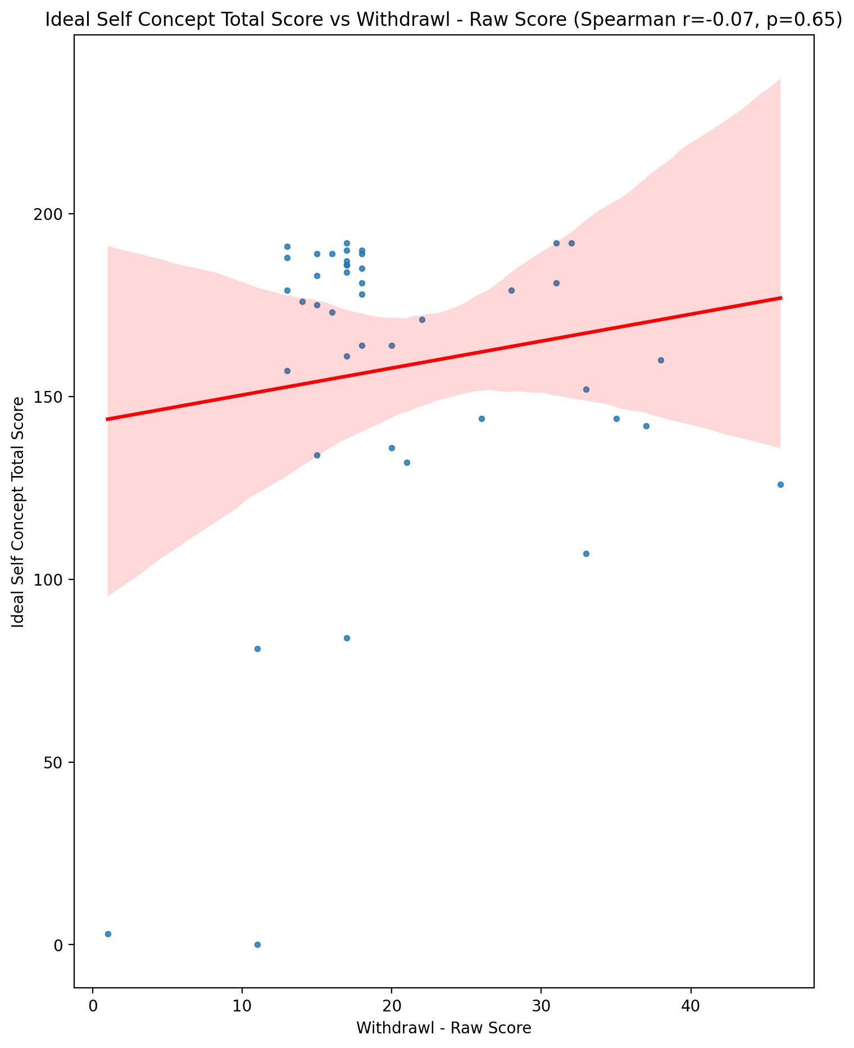

## Social Self Concept Total Score vs Withdrawl - Raw Score

Test: spearman; statistic: -0.21156233844147287; p-value: 0.1732292830418637;

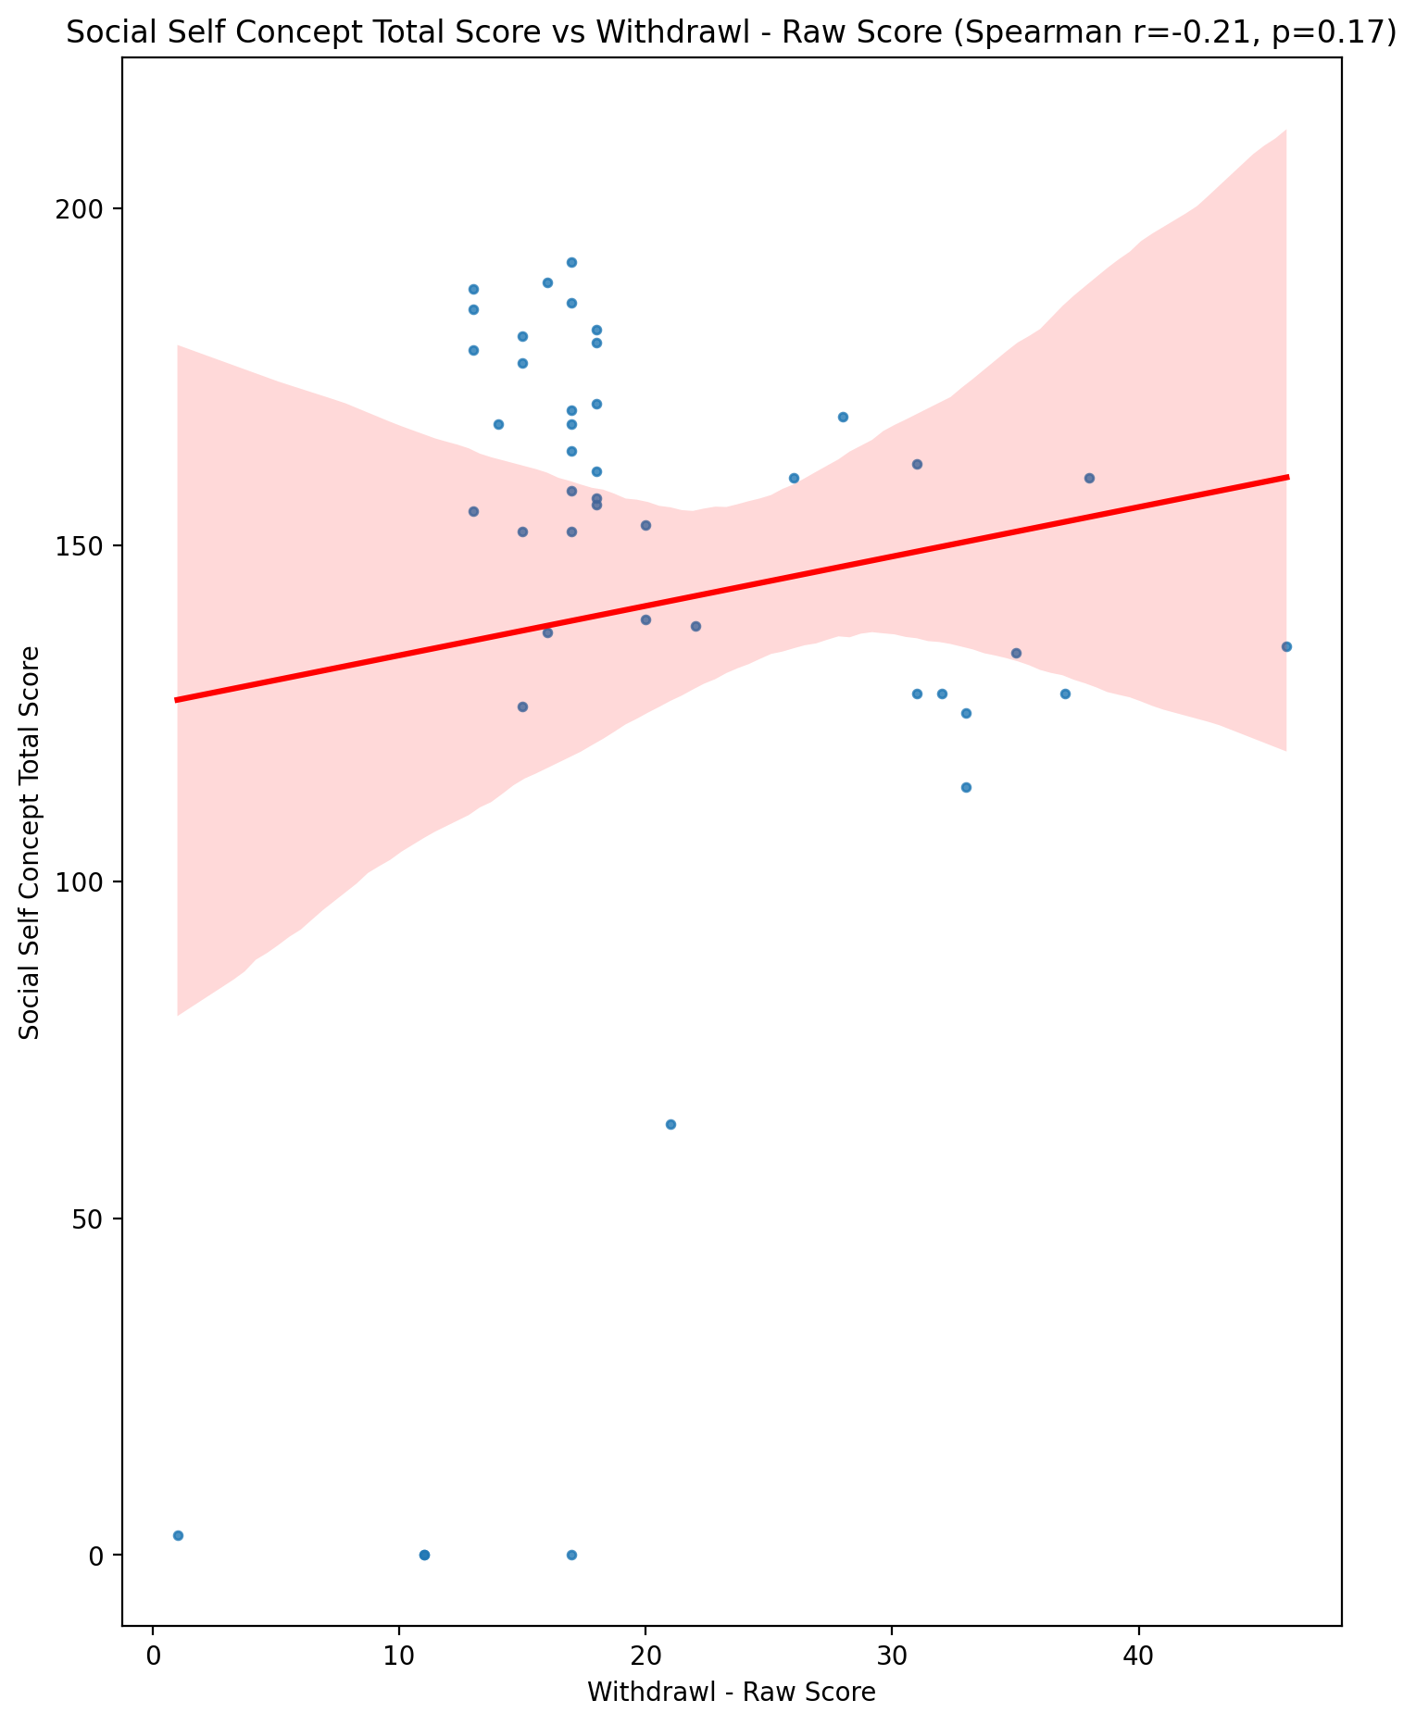

## Ideal Self Concept Total Category vs Withdrawl - Raw Score

Test: None; statistic: None; p-value: None; Test not run: unsupported type combination.



## Perceived Social Stress Score vs Withdrawl - Raw Score

Test: spearman; statistic: 0.35939201389643727; p-value: 0.017936155835435293;

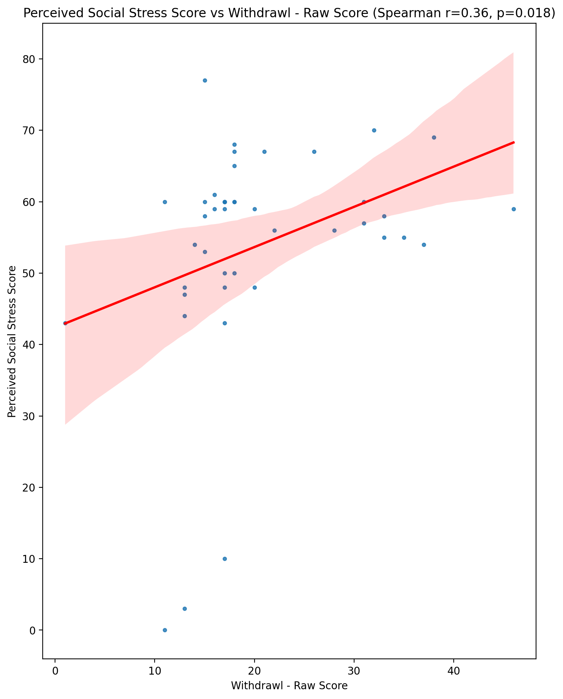

## Perceived Social Stress Category vs Withdrawl - Raw Score

Test: None; statistic: None; p-value: None; Test not run: unsupported type combination.



## Emotional Support - Raw Score vs Occupational & Relationship Consequences - Raw Score

Test: spearman; statistic: -0.41468092186861494; p-value: 0.005695587125398835;

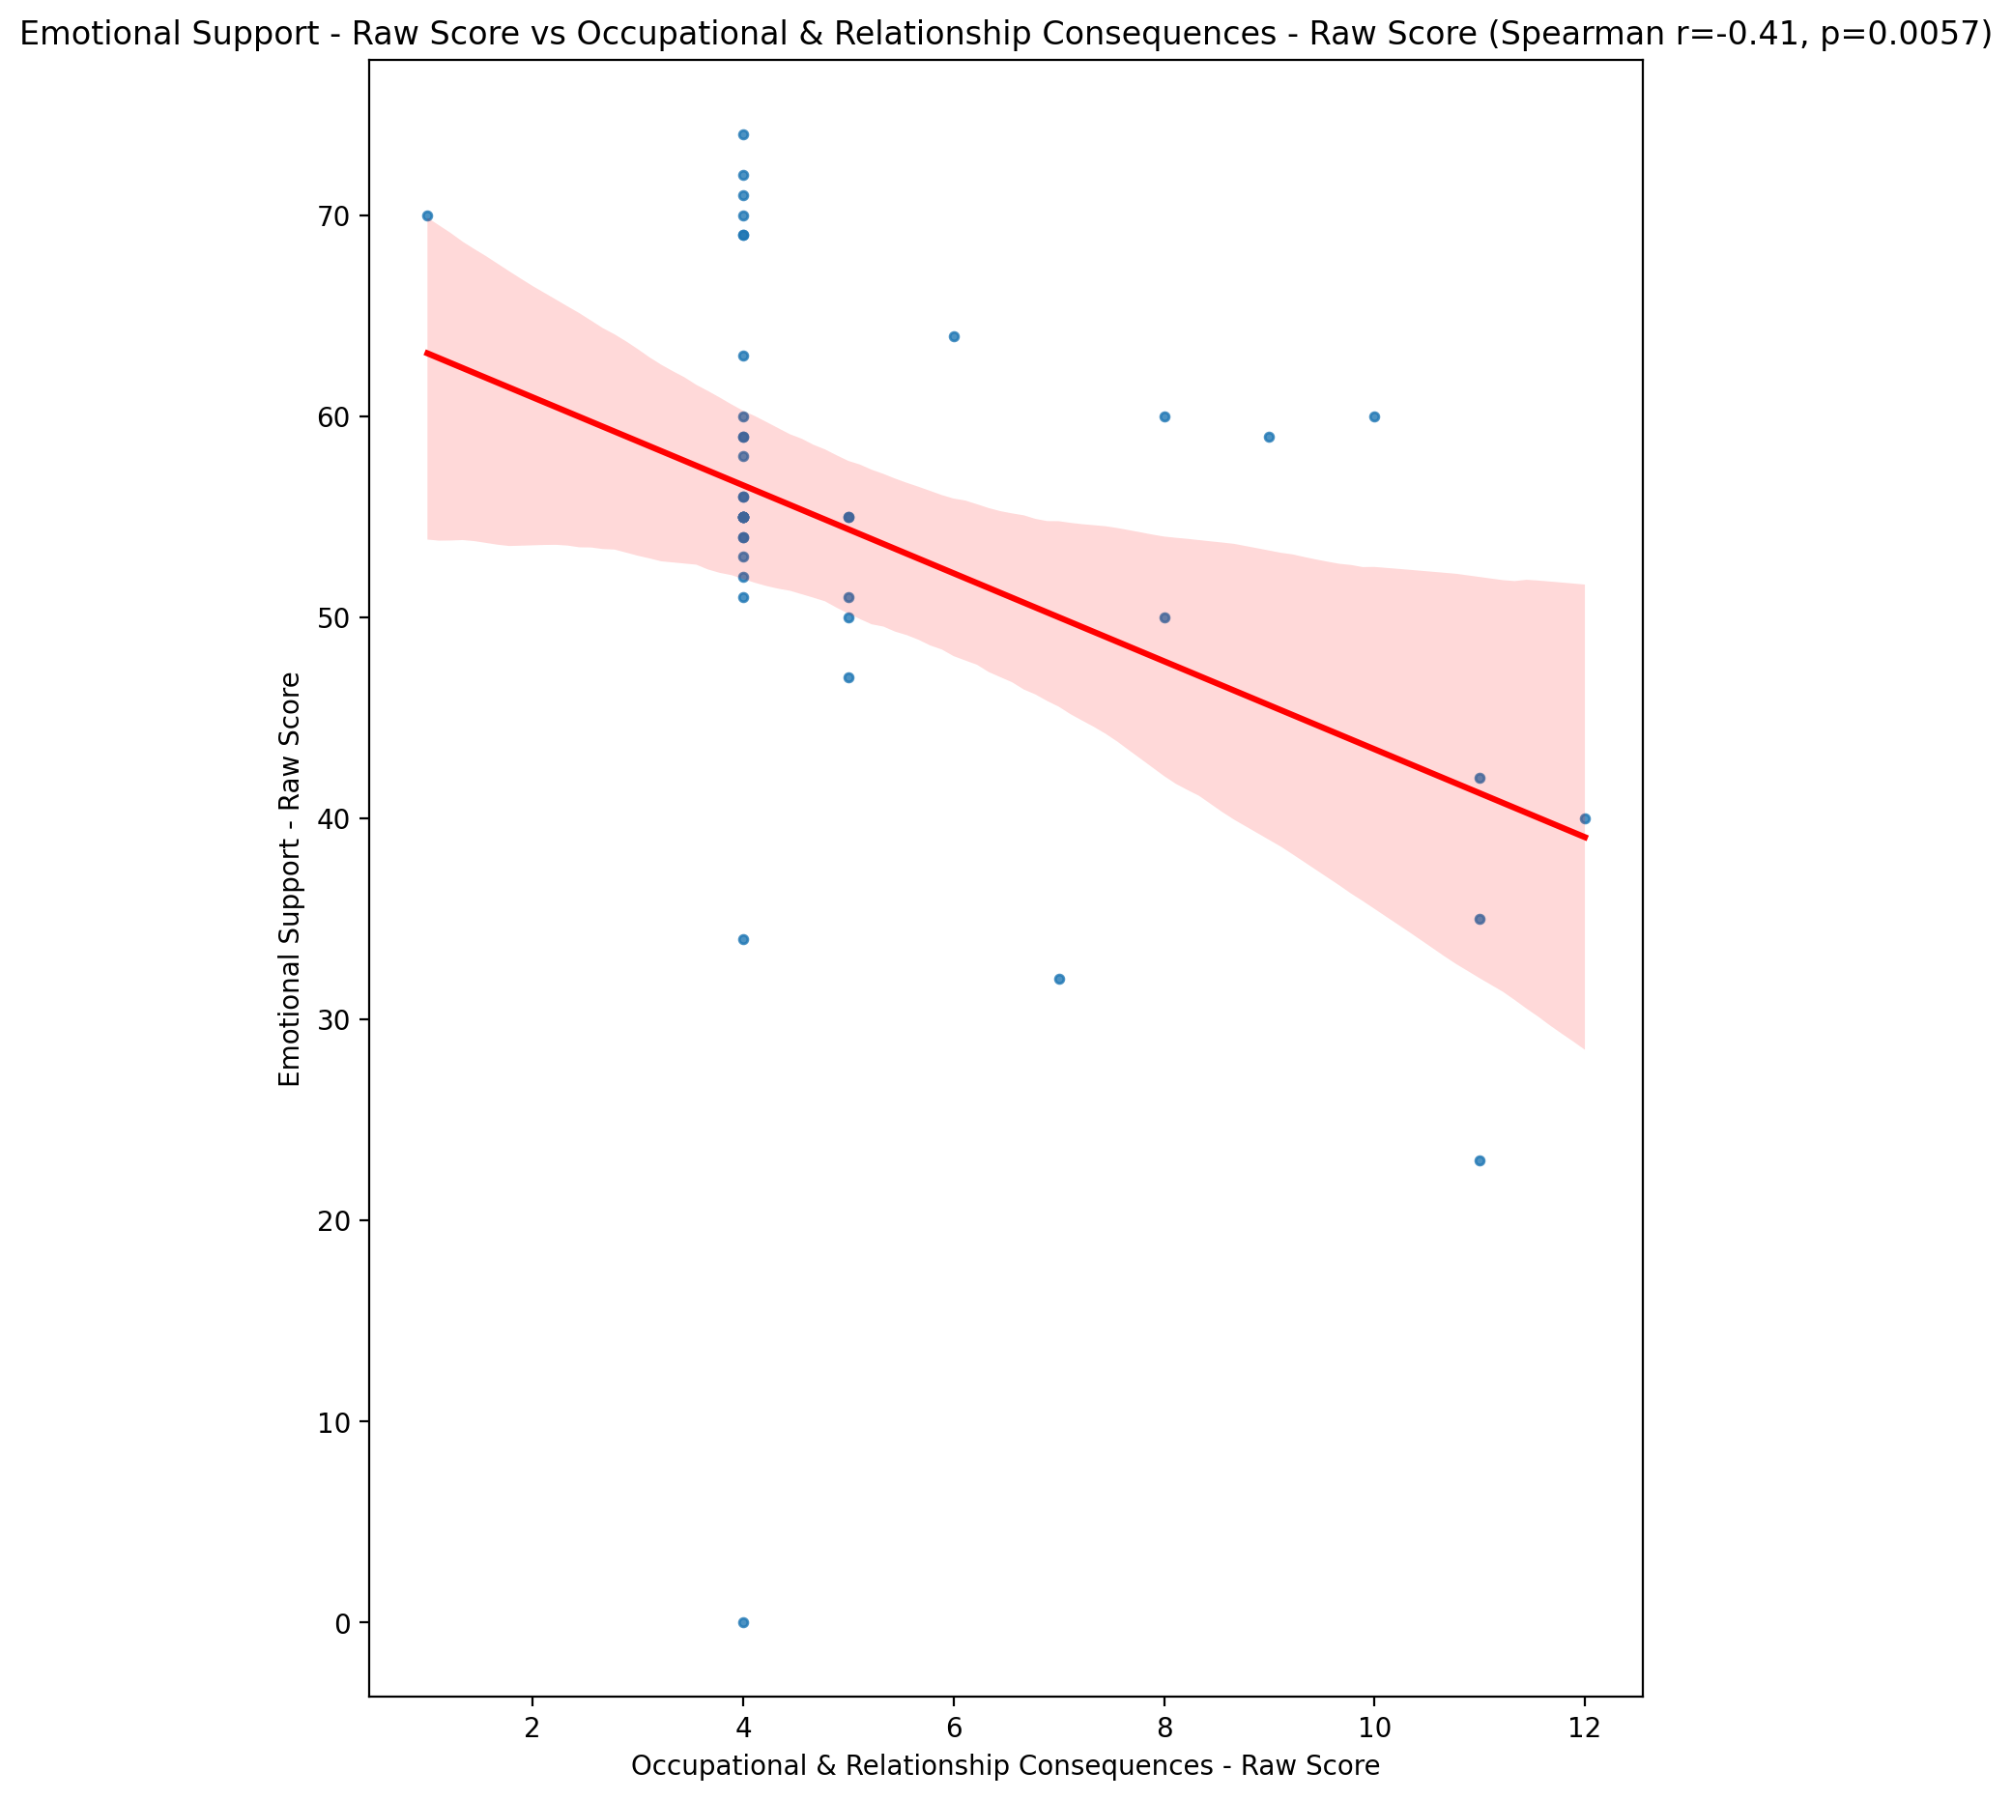

## Informational Support - Raw Score vs Occupational & Relationship Consequences - Raw Score

Test: spearman; statistic: -0.3838121279816235; p-value: 0.011059816868540852;

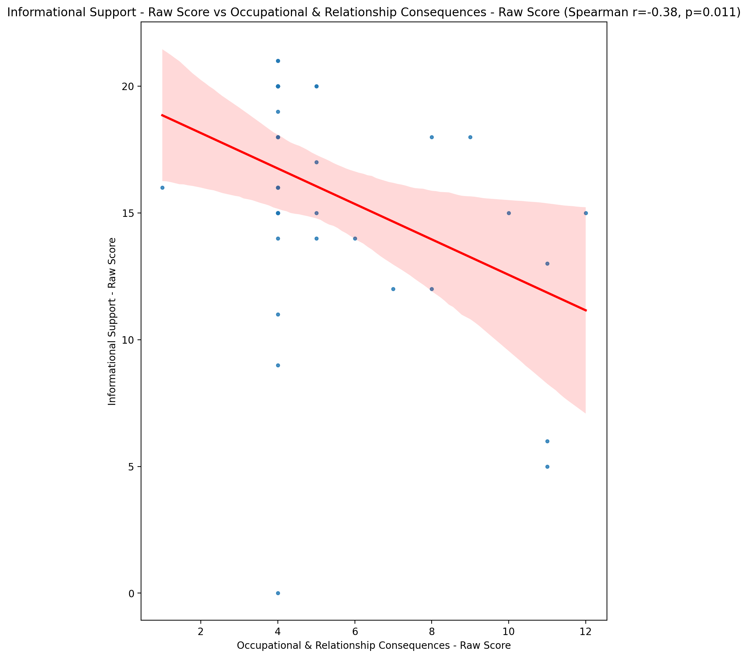

## Instrumental Support - Raw Score vs Occupational & Relationship Consequences - Raw Score

Test: spearman; statistic: -0.2896198824189484; p-value: 0.059592252653171196;

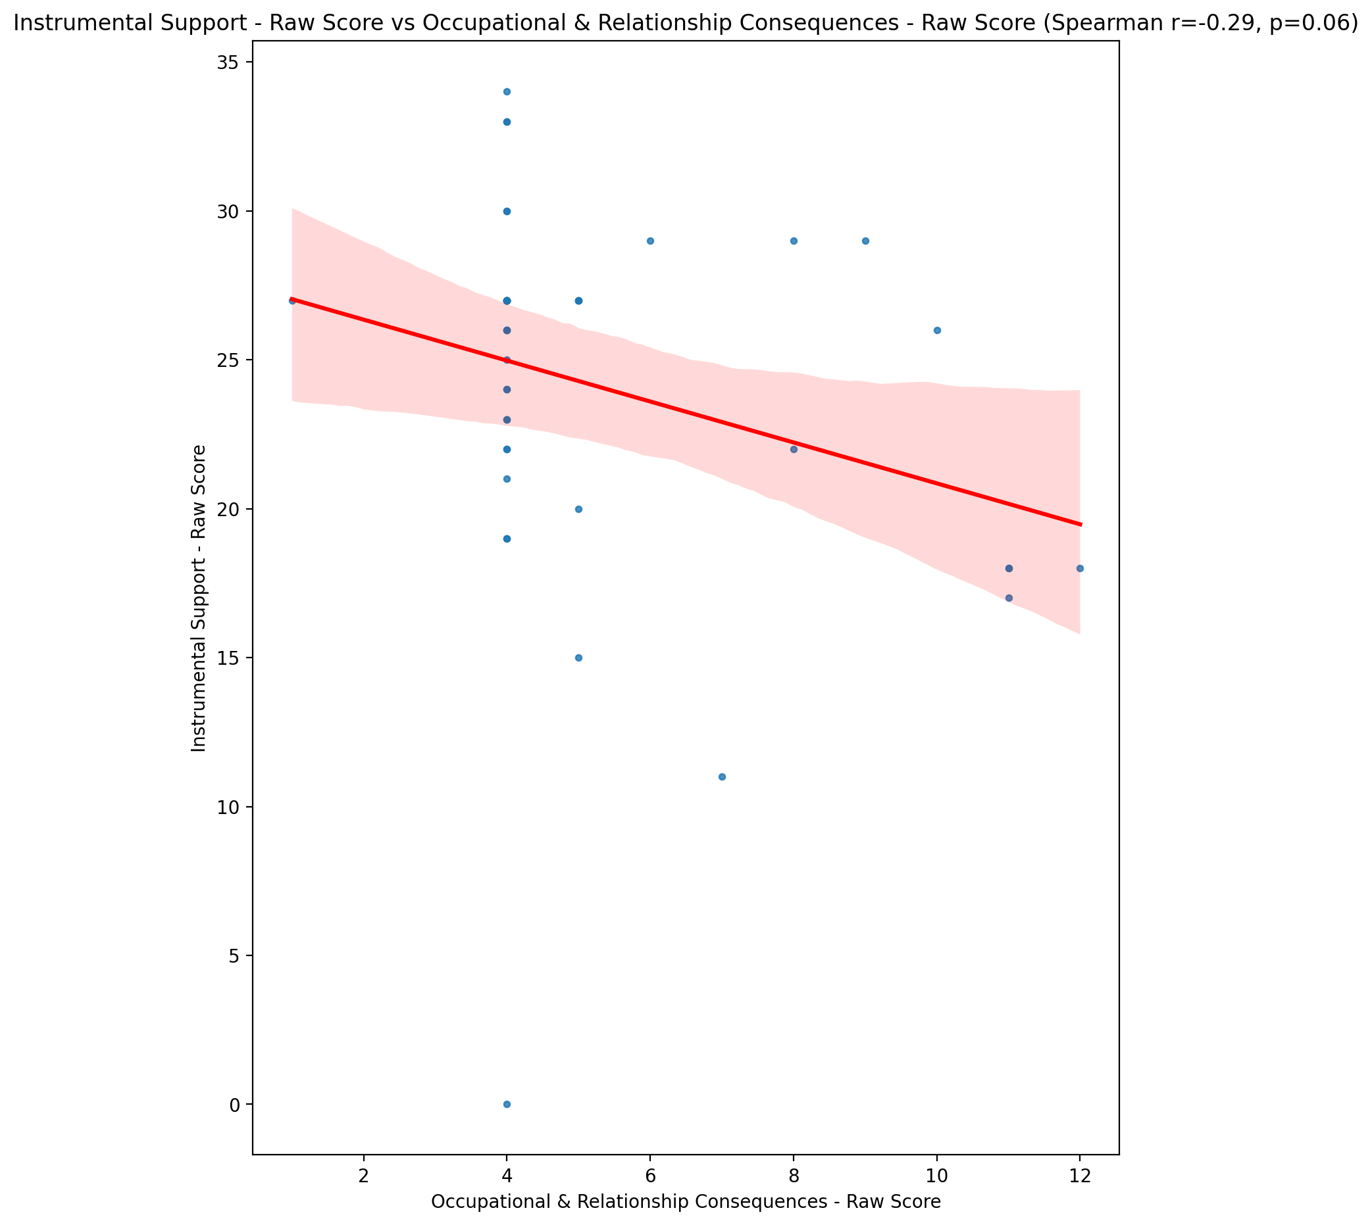

## Emotional Support - T Score vs Occupational & Relationship Consequences - Raw Score

Test: spearman; statistic: -0.3665639660027575; p-value: 0.015618449768578433;

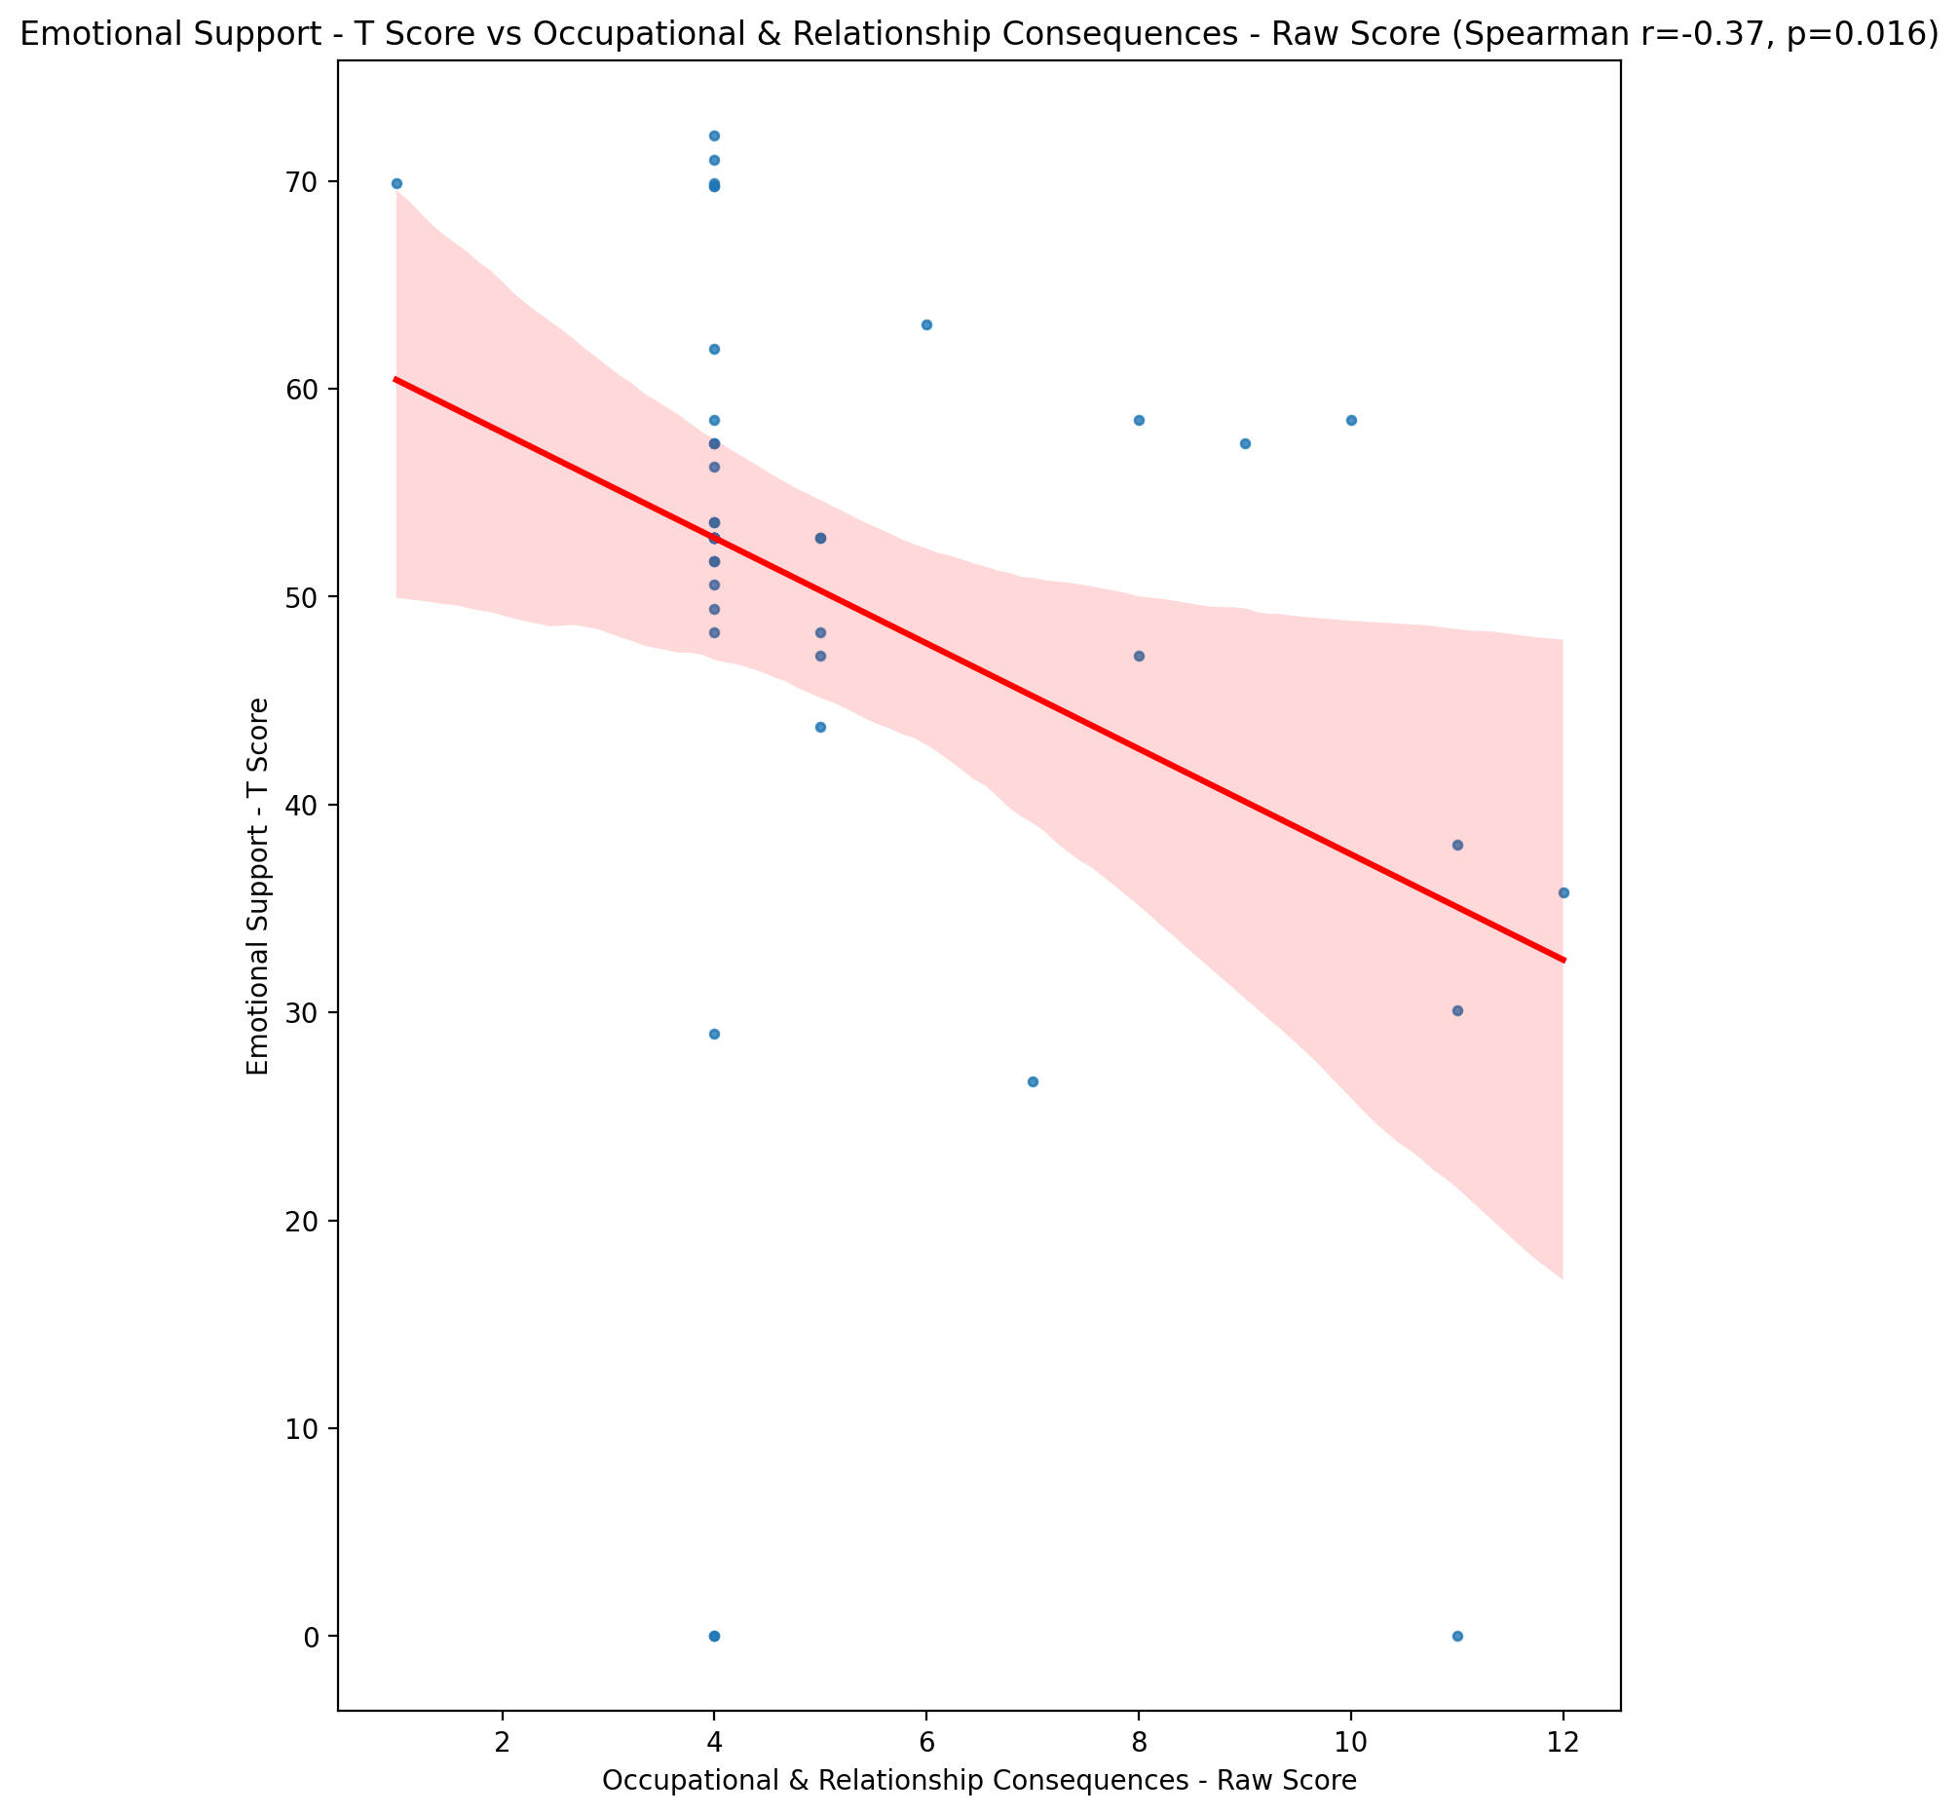

## Informational Support - T Score vs Occupational & Relationship Consequences - Raw Score

Test: spearman; statistic: -0.3884630781687879; p-value: 0.010046061881725271;

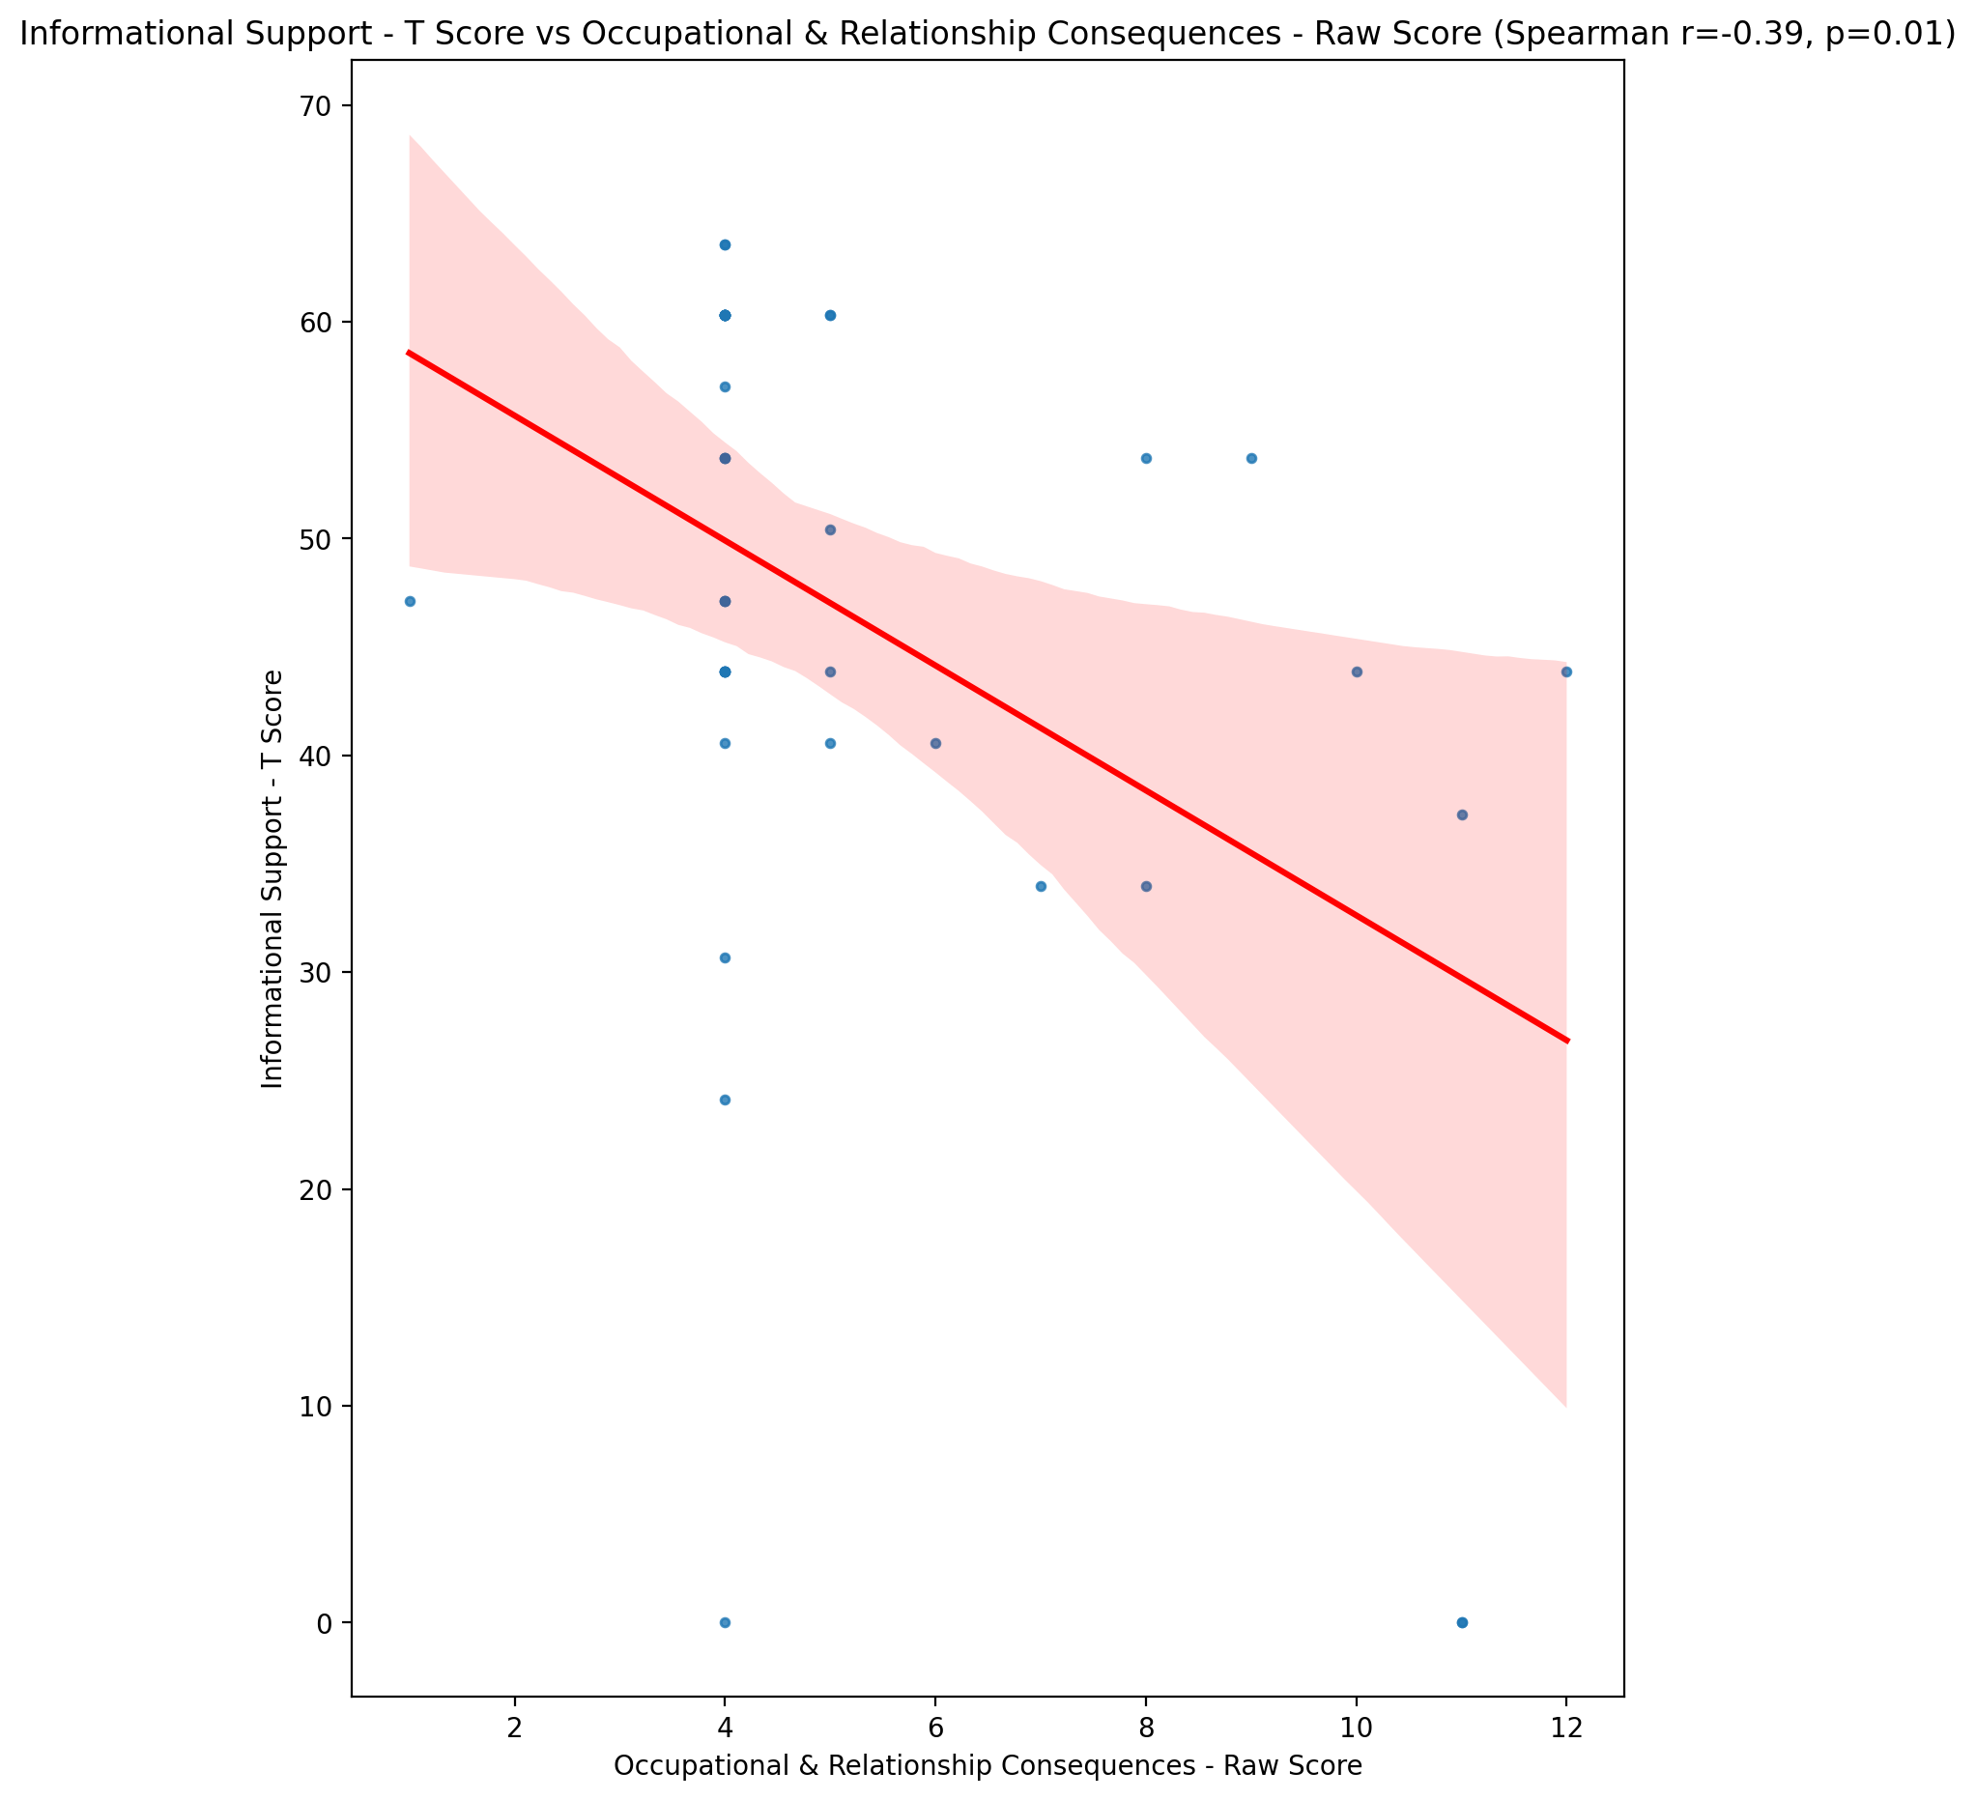

## Instrumental Support - T Score vs Occupational & Relationship Consequences - Raw Score

Test: spearman; statistic: -0.29139497382721635; p-value: 0.05797706218823278;

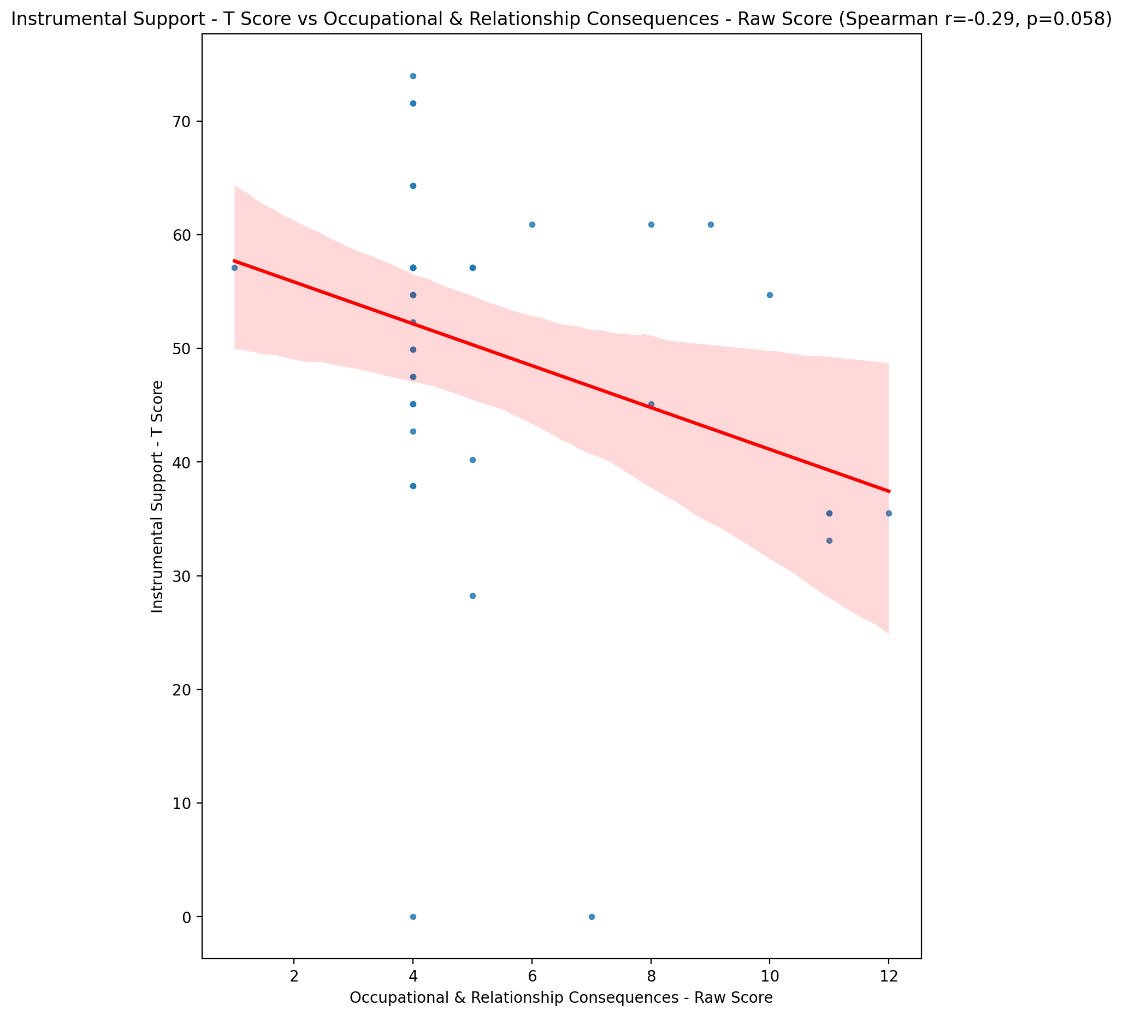

## Perceived Social Support Total T Score vs Occupational & Relationship Consequences - Raw Score

Test: spearman; statistic: -0.3962033559663377; p-value: 0.008535299101304832;

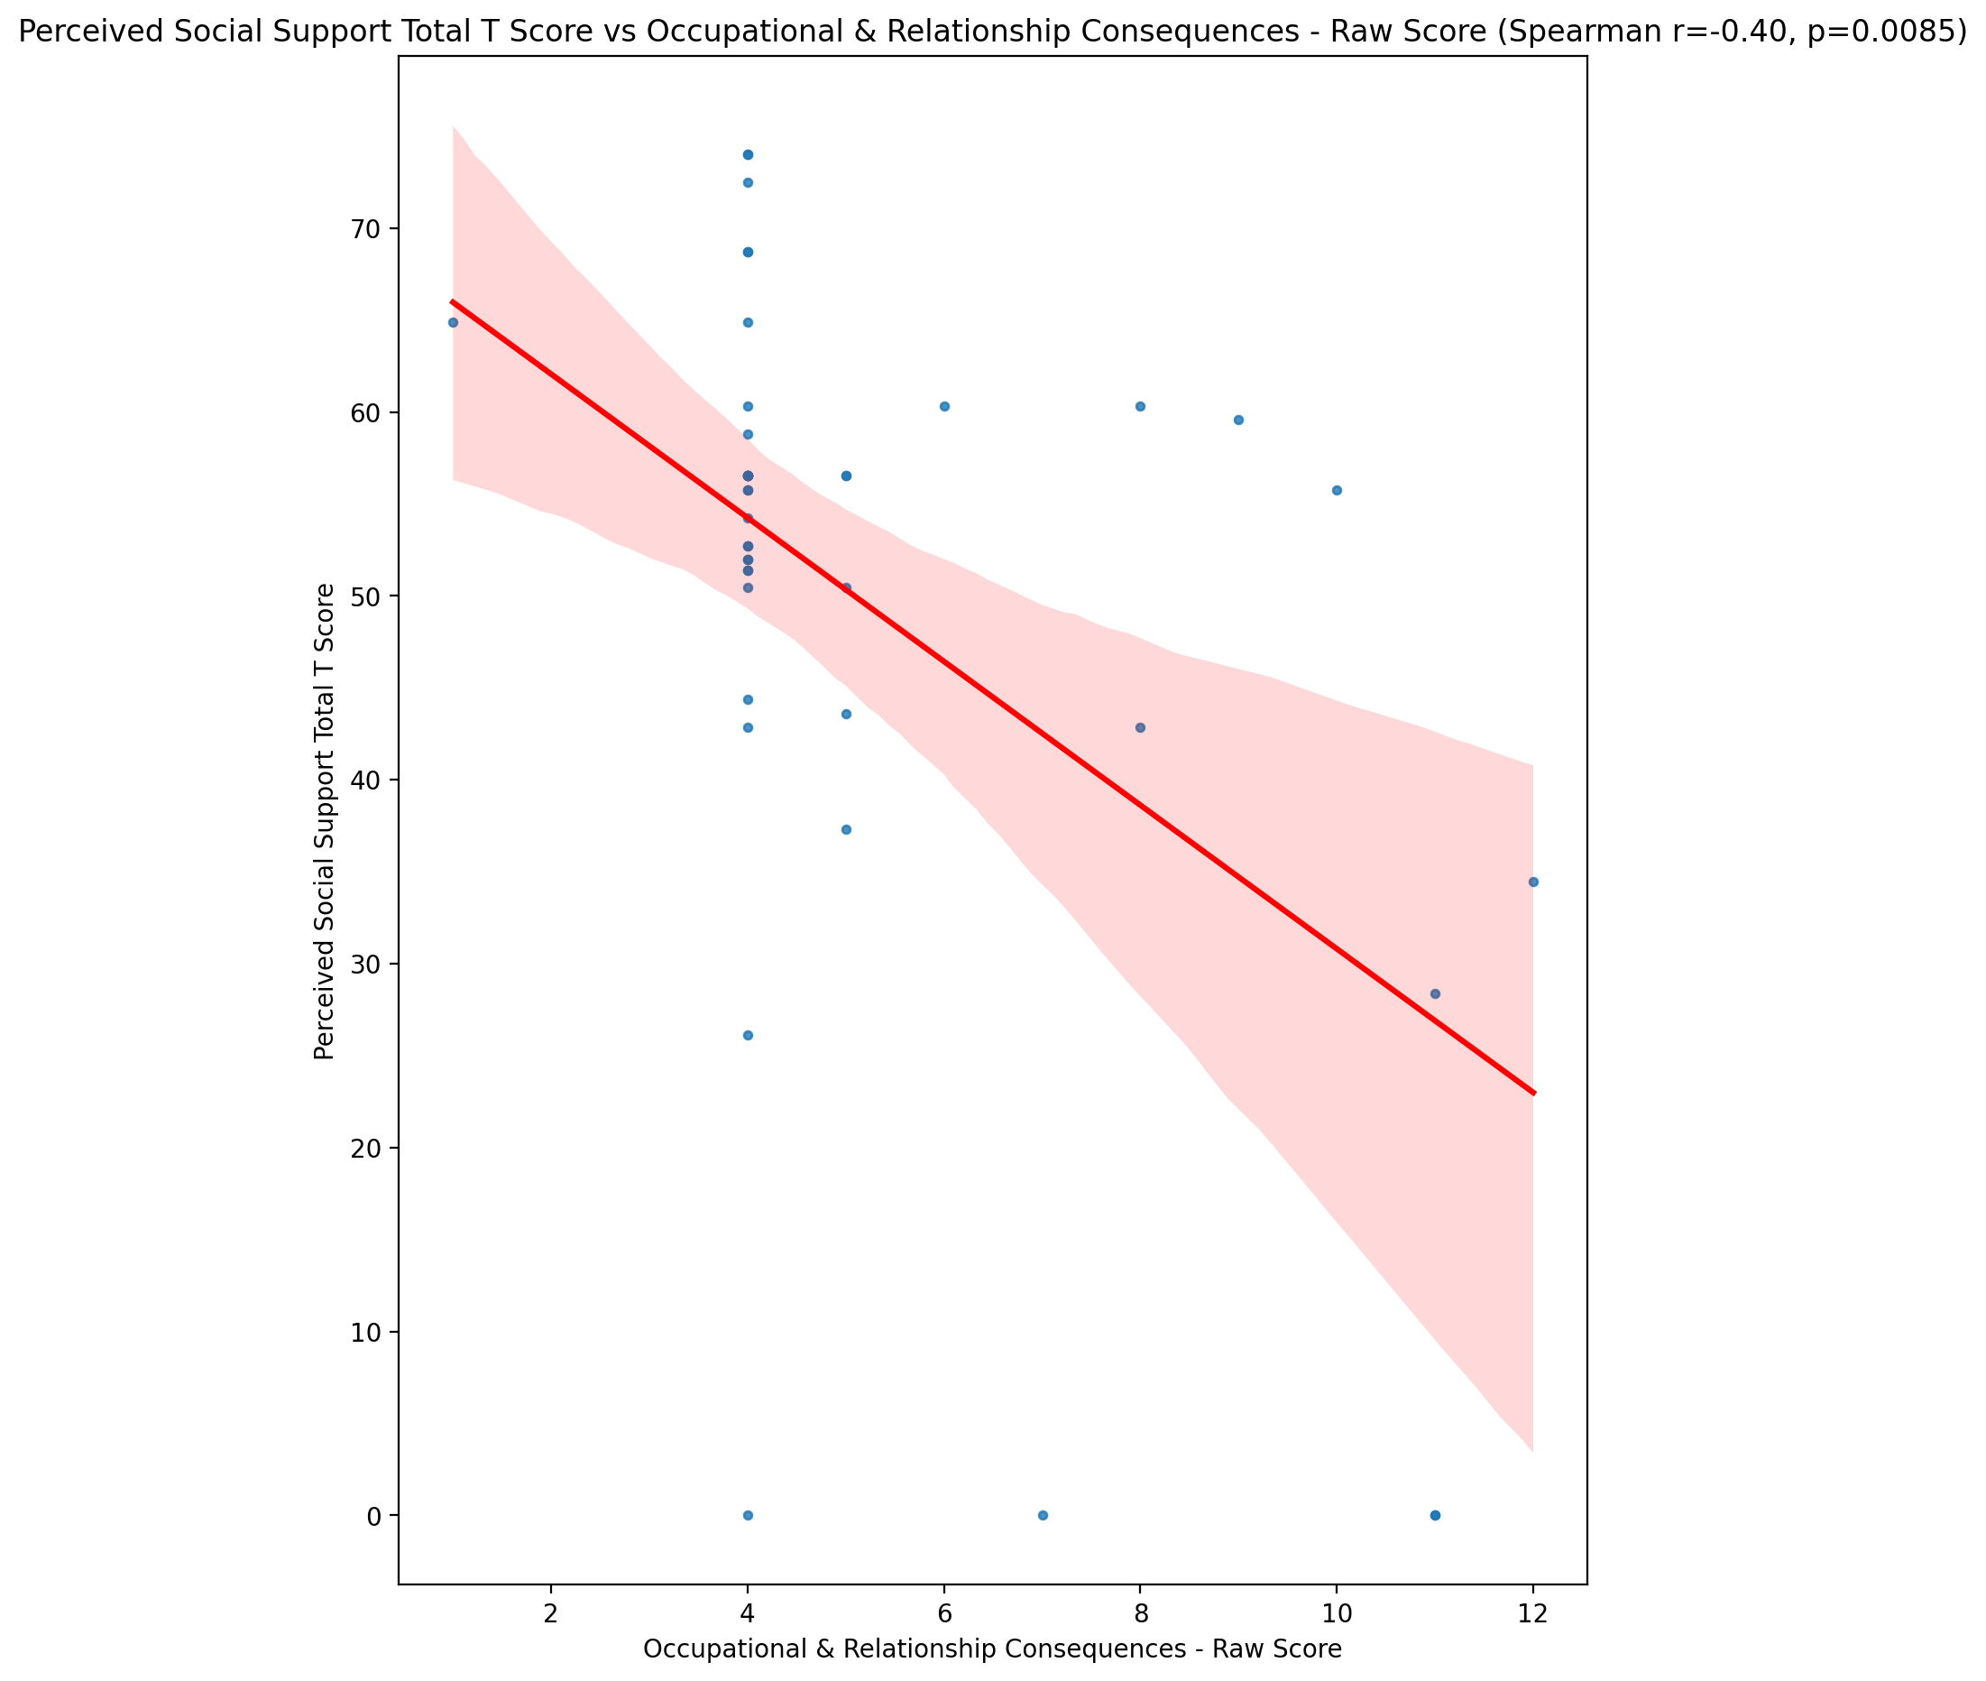

## Emotional Support - Rank vs Occupational & Relationship Consequences - Raw Score

Test: None; statistic: None; p-value: None; Test not run: unsupported type combination.



## Informational Support - Rank vs Occupational & Relationship Consequences - Raw Score

Test: None; statistic: None; p-value: None; Test not run: unsupported type combination.



## Instrumental Support - Rank vs Occupational & Relationship Consequences - Raw Score

Test: None; statistic: None; p-value: None; Test not run: unsupported type combination.



## Perceived Social Support TOTAL - Rank vs Occupational & Relationship Consequences - Raw Score

Test: None; statistic: None; p-value: None; Test not run: unsupported type combination.



## Power Self Concept - Real Self Concept Score vs Occupational & Relationship Consequences - Raw Score

Test: spearman; statistic: -0.33574813684723254; p-value: 0.027728643387694537;

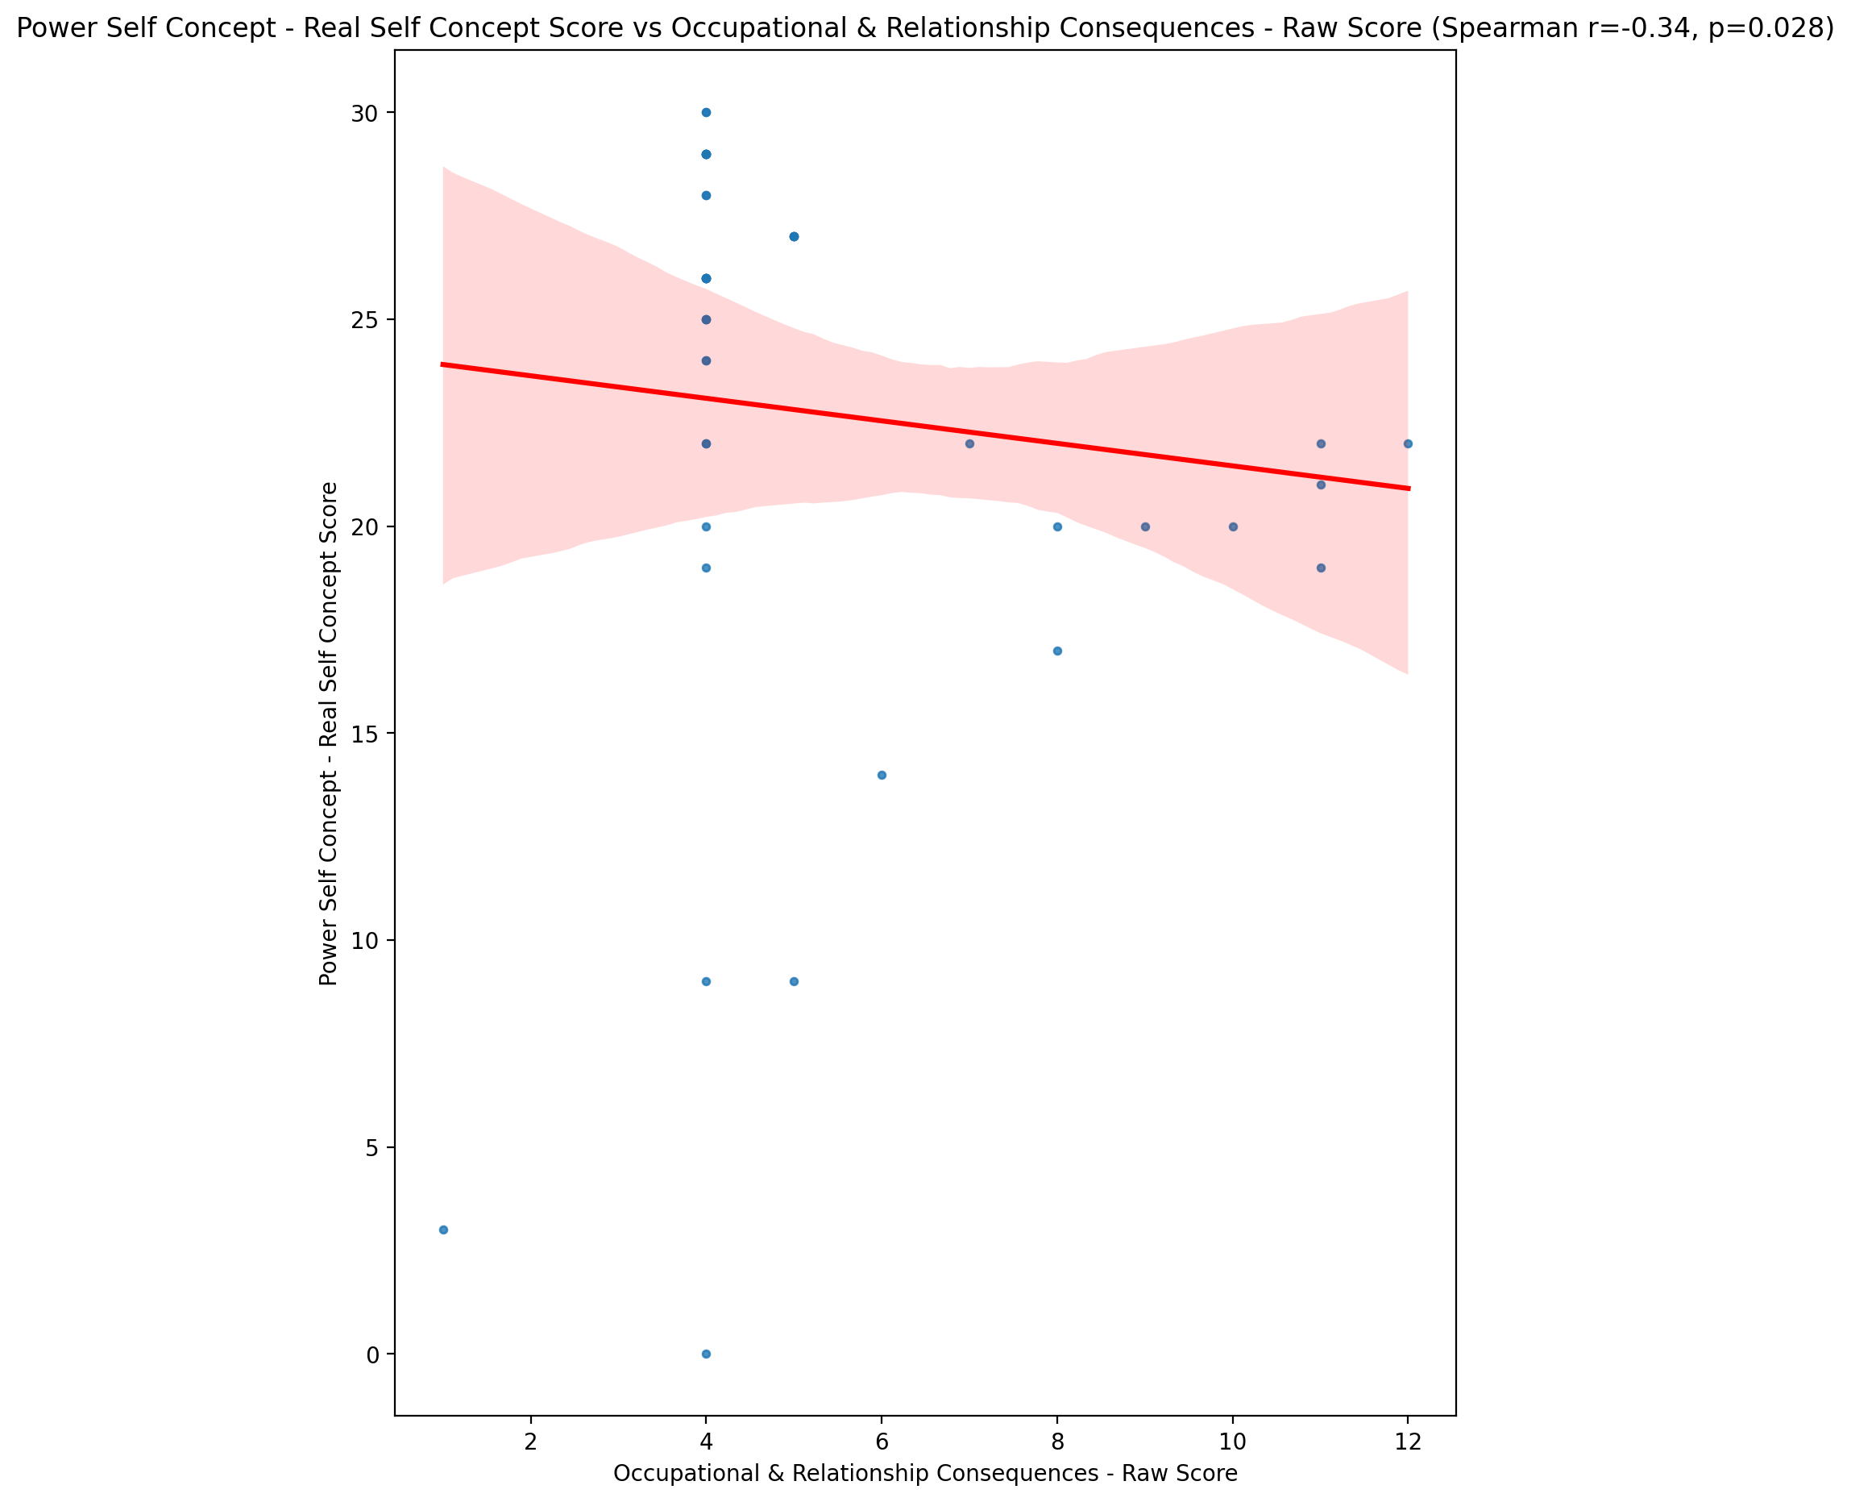

## Power Self Concept - Ideal Self Concept score vs Occupational & Relationship Consequences - Raw Score

Test: spearman; statistic: -0.19553213154824348; p-value: 0.20890627214205487;

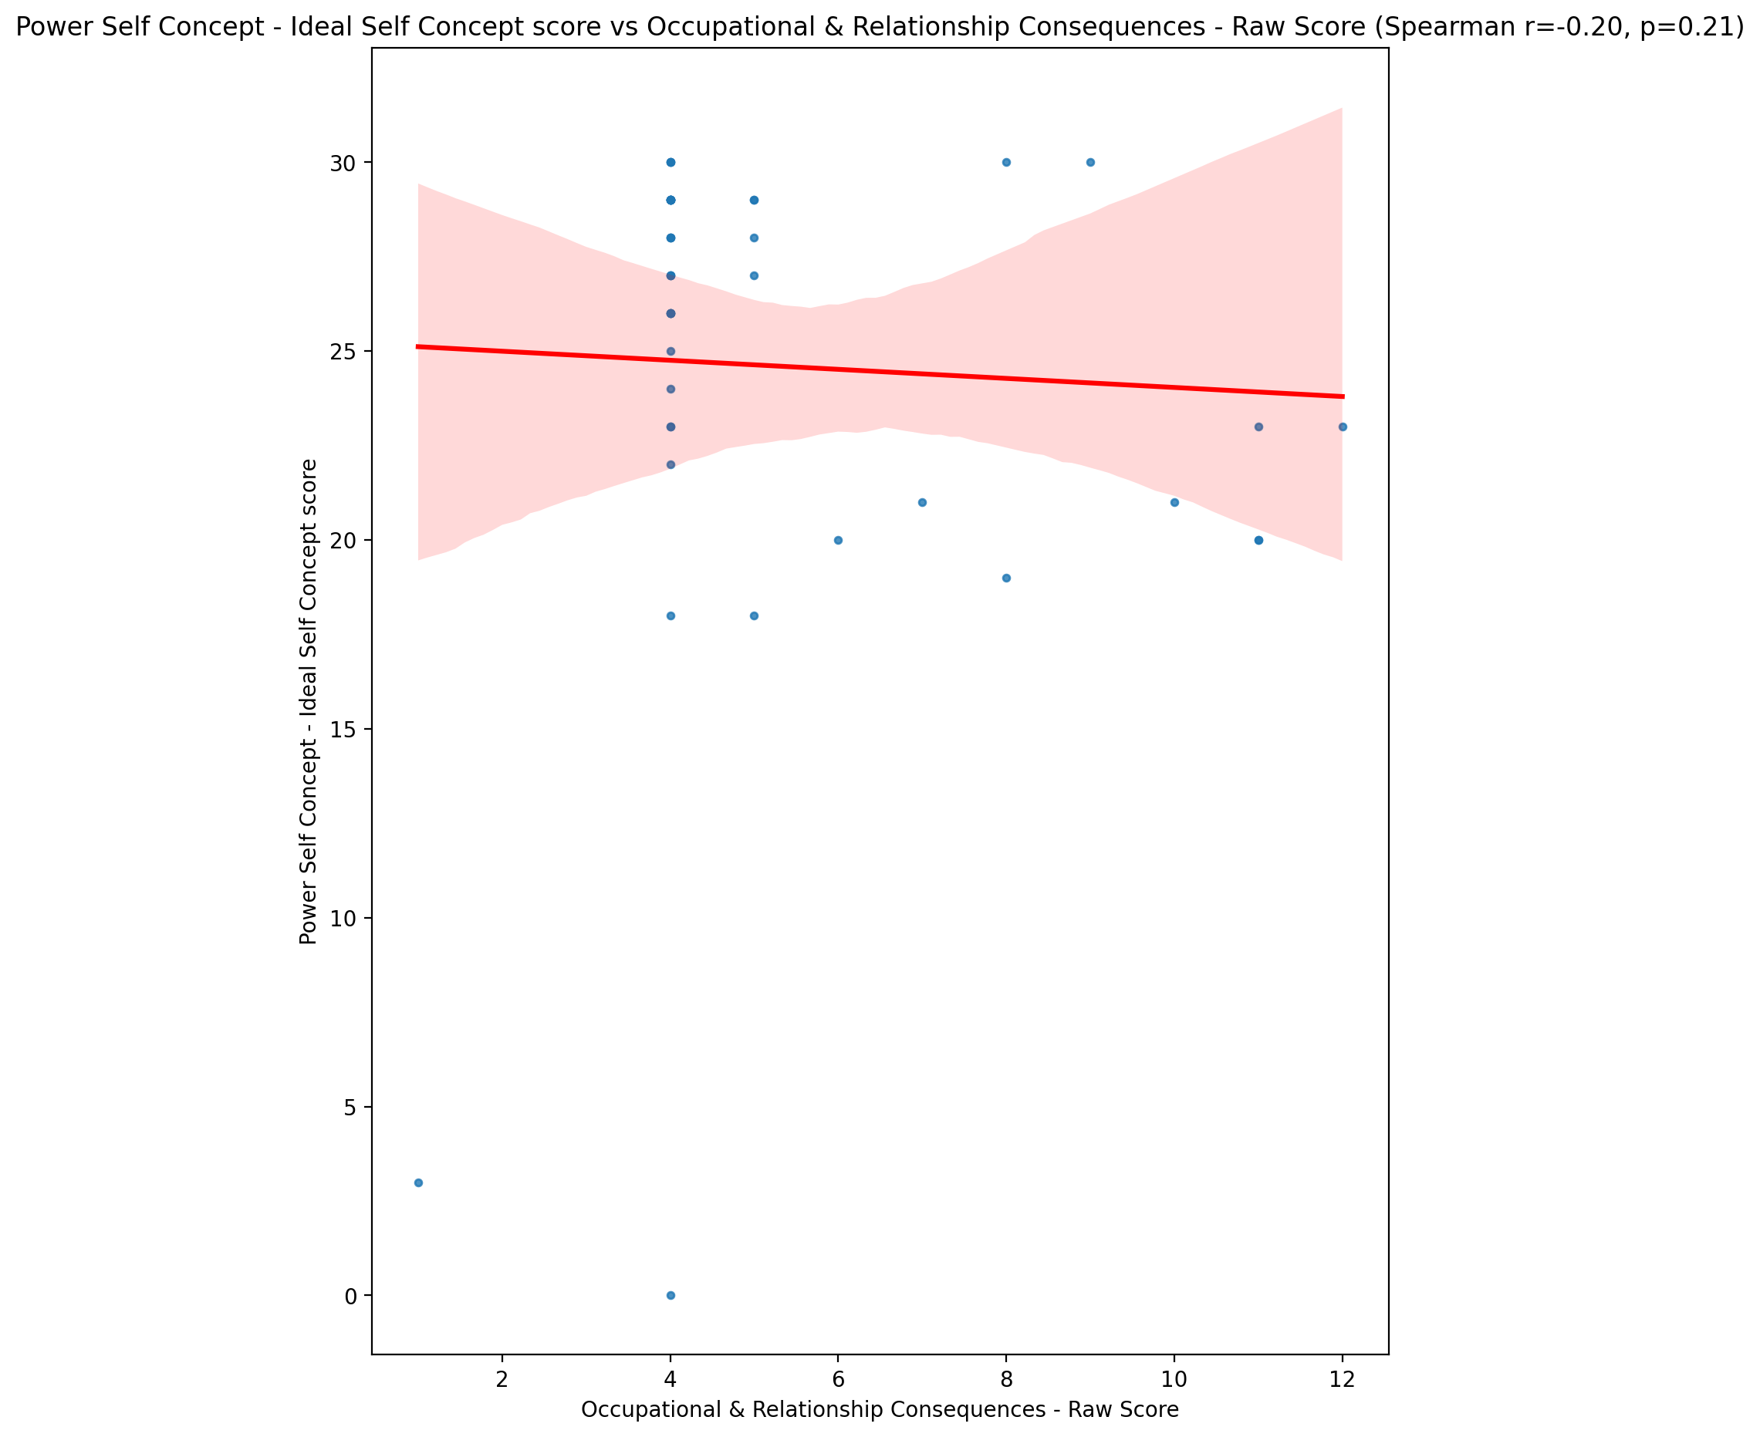

## Power Self Concept – Social Self Concept Score vs Occupational & Relationship Consequences - Raw Score

Test: spearman; statistic: -0.3728412834027946; p-value: 0.013803082537748807;

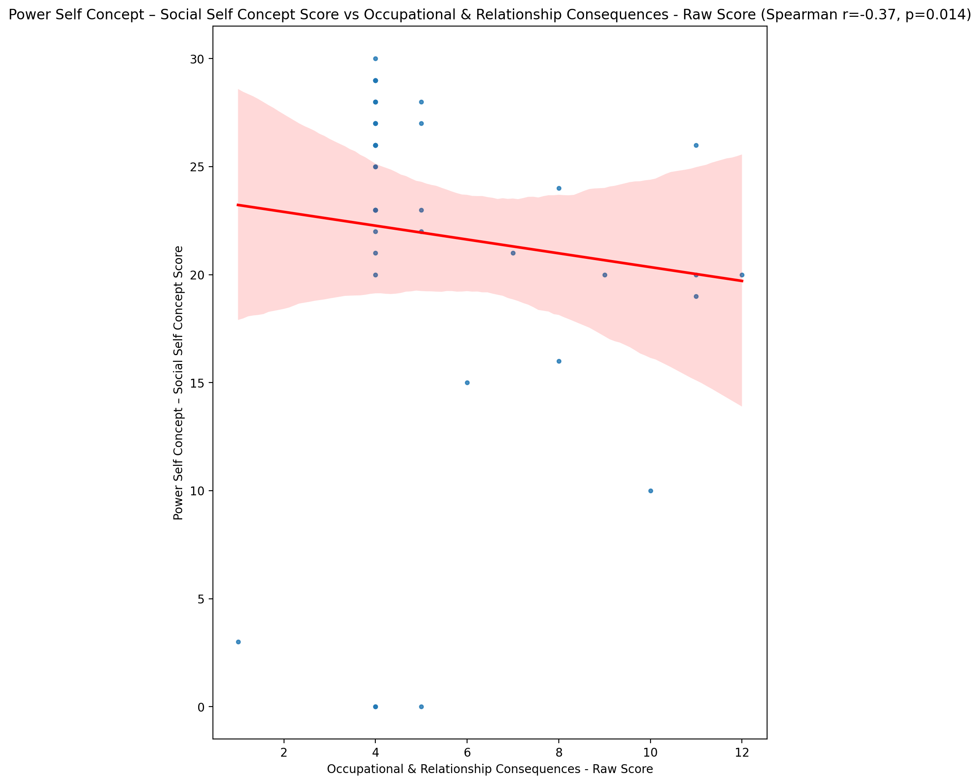

## Social Self Concept - Real Self Concept Score vs Occupational & Relationship Consequences - Raw Score

Test: spearman; statistic: -0.35779716124007993; p-value: 0.018489190847792988;

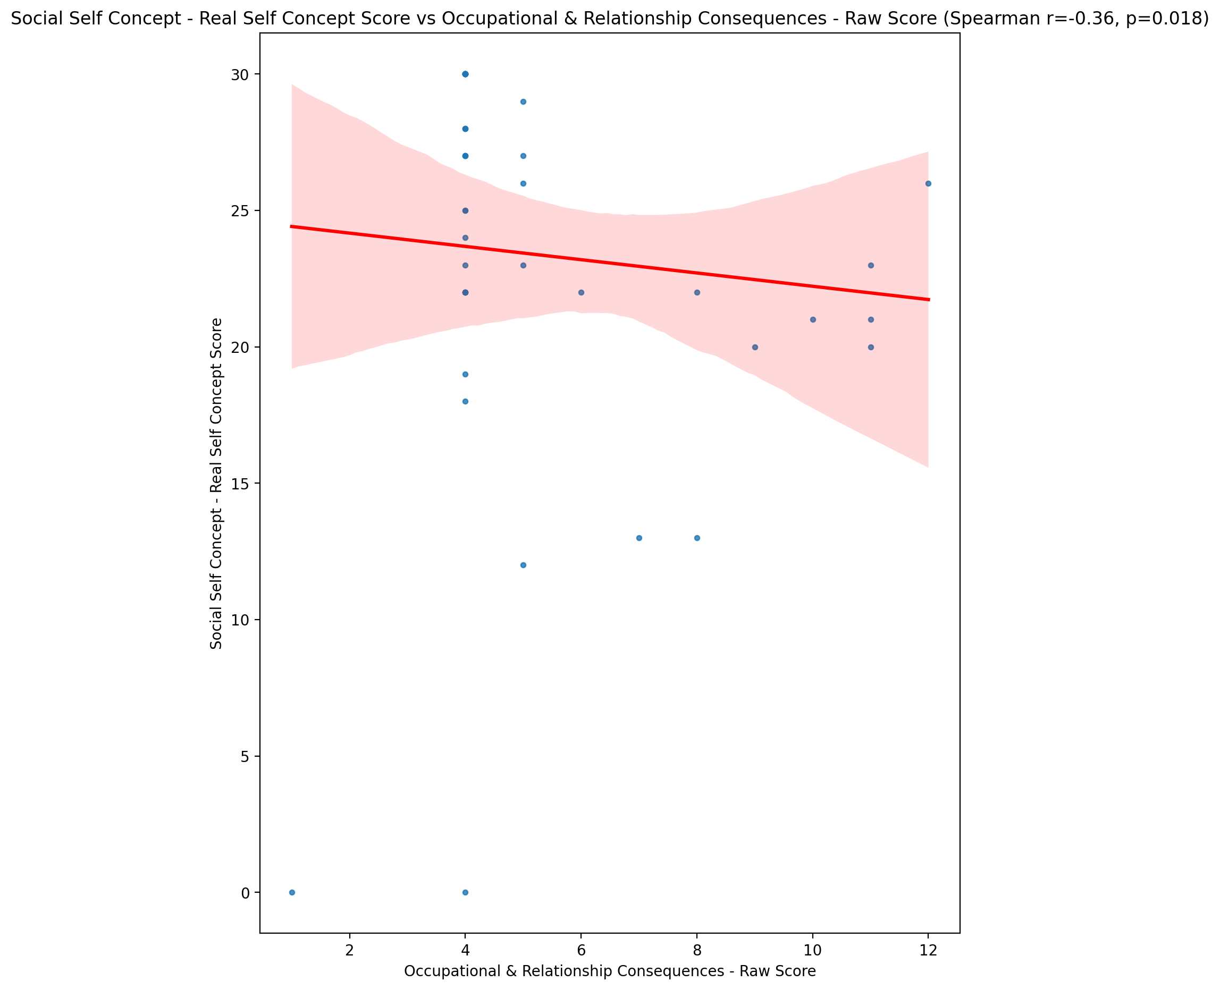

## Social Self Concept – Social Self Concept Score vs Occupational & Relationship Consequences - Raw Score

Test: spearman; statistic: -0.3034423980617438; p-value: 0.047918966401283014;

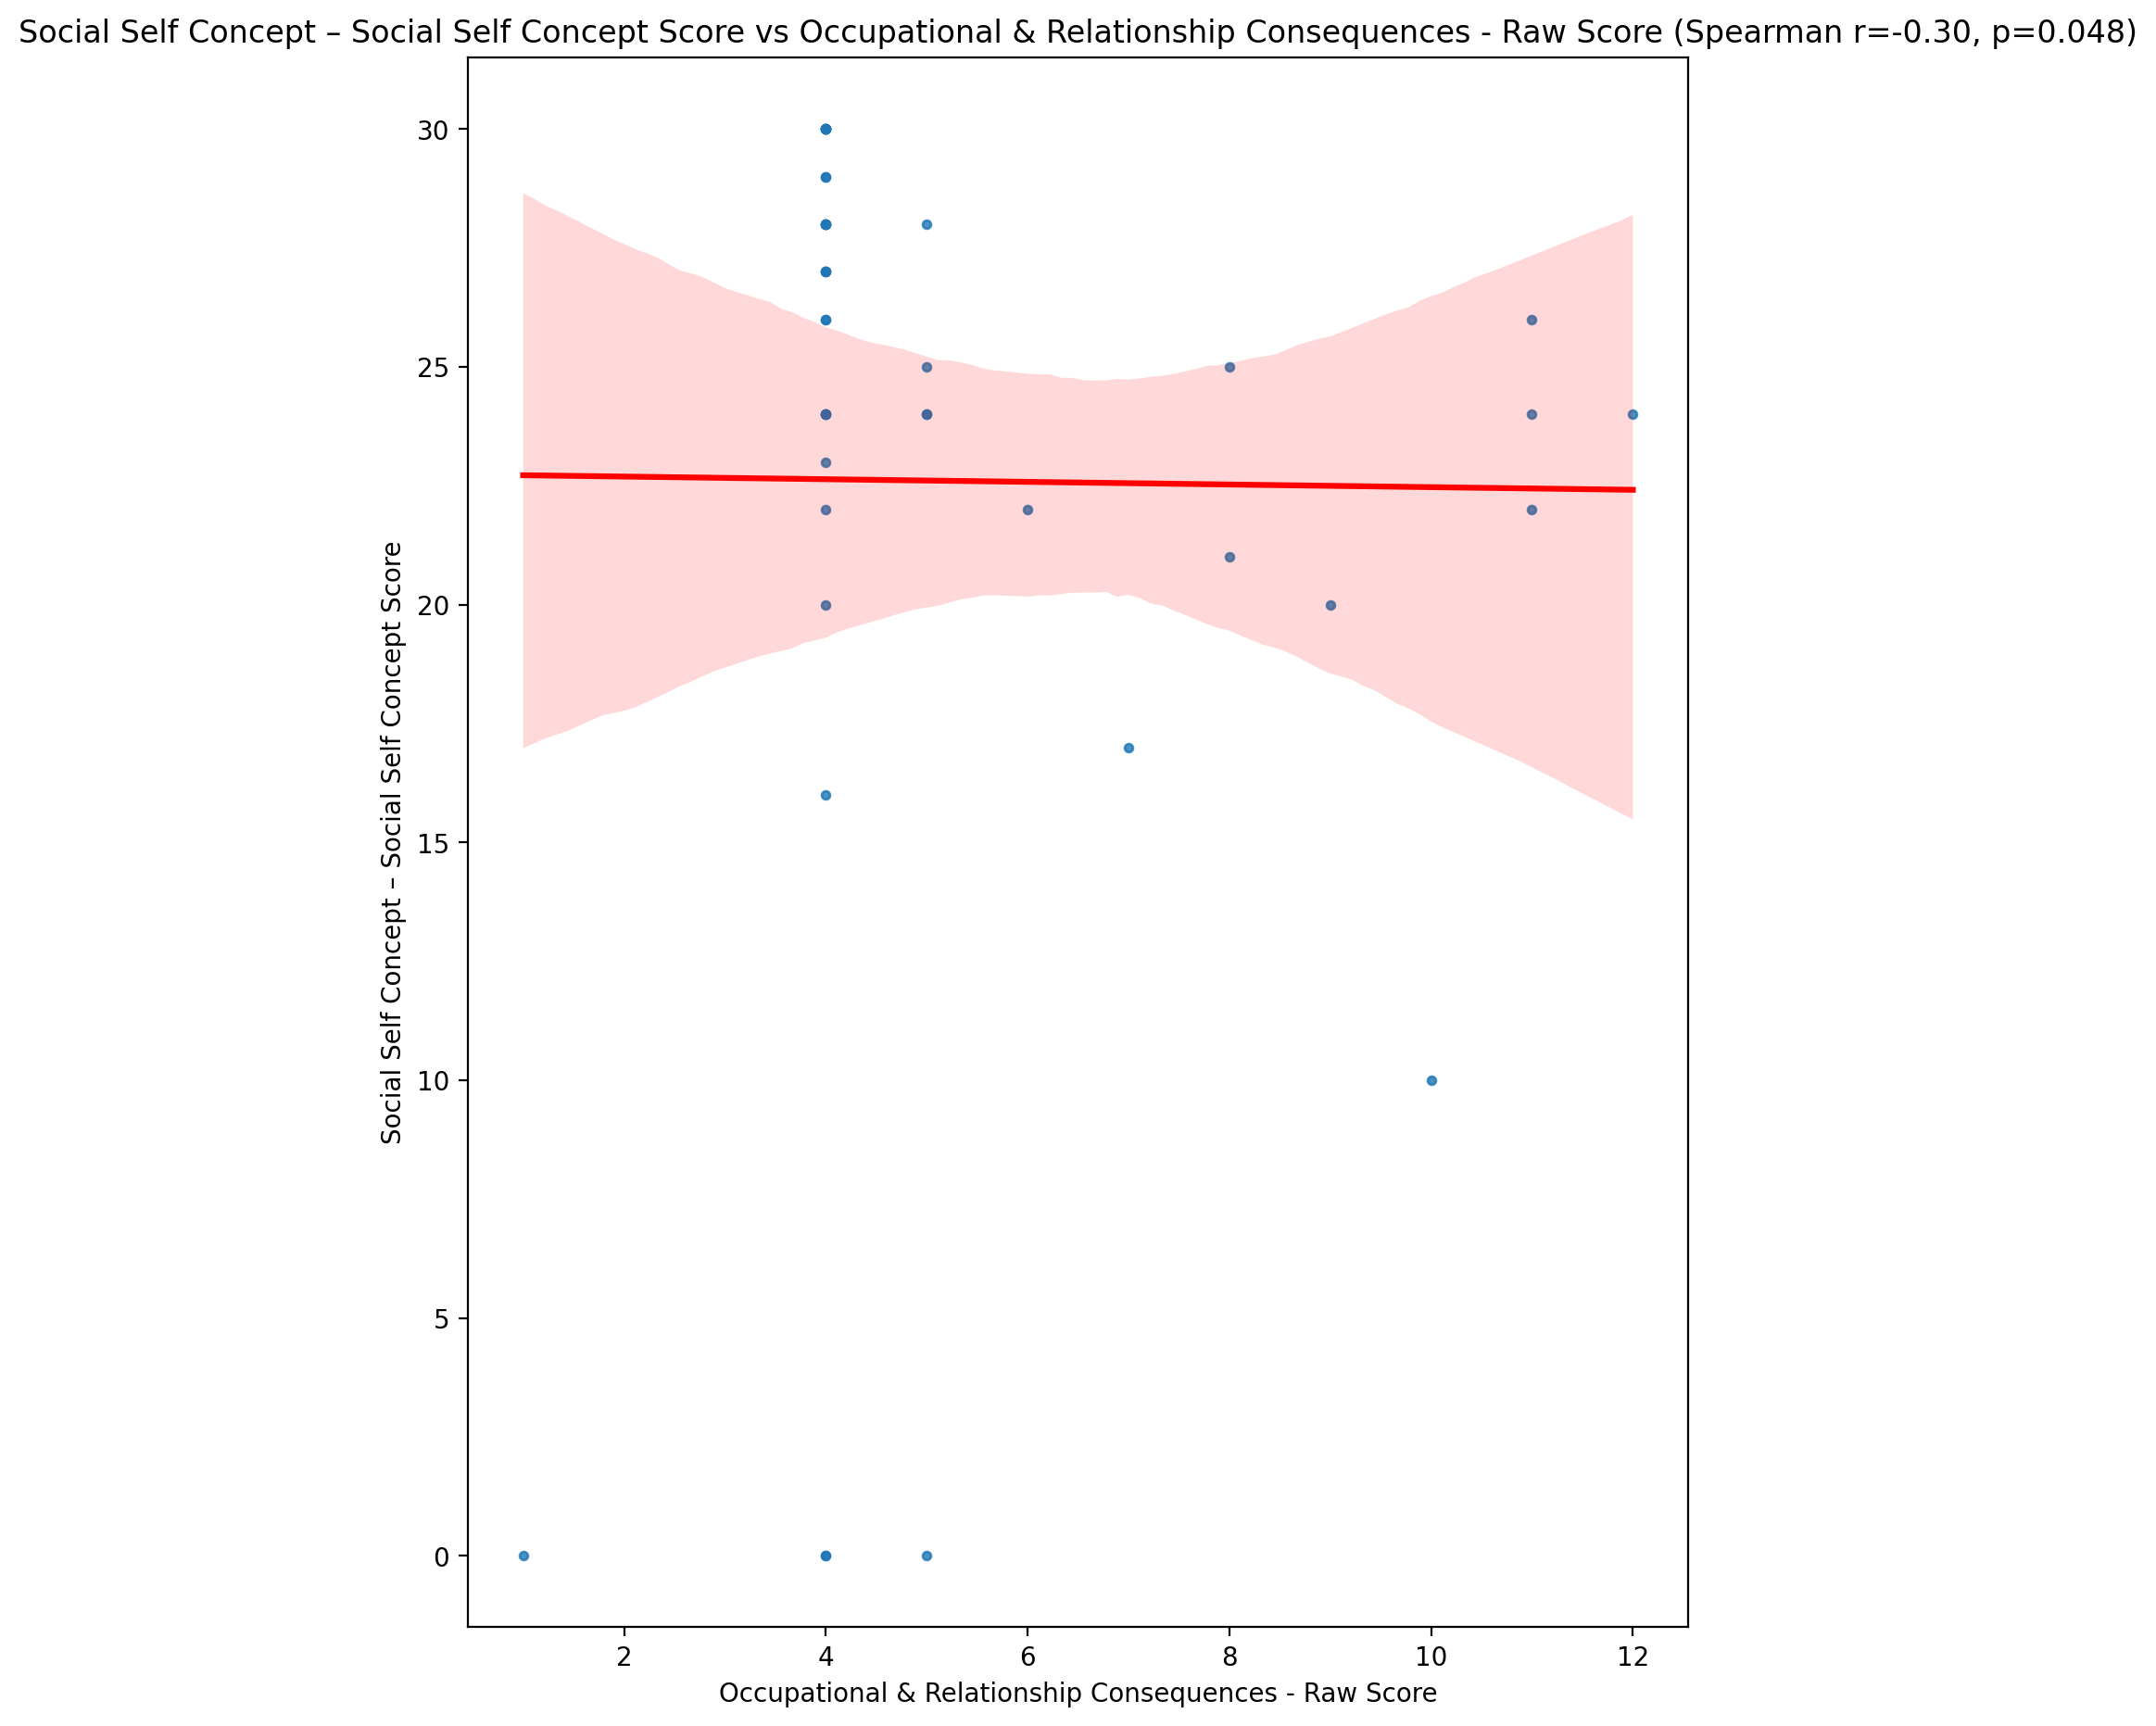

## Ability Self Concept - Real Self Concept Score vs Occupational & Relationship Consequences - Raw Score

Test: spearman; statistic: -0.2549664431133226; p-value: 0.09893106366366773;

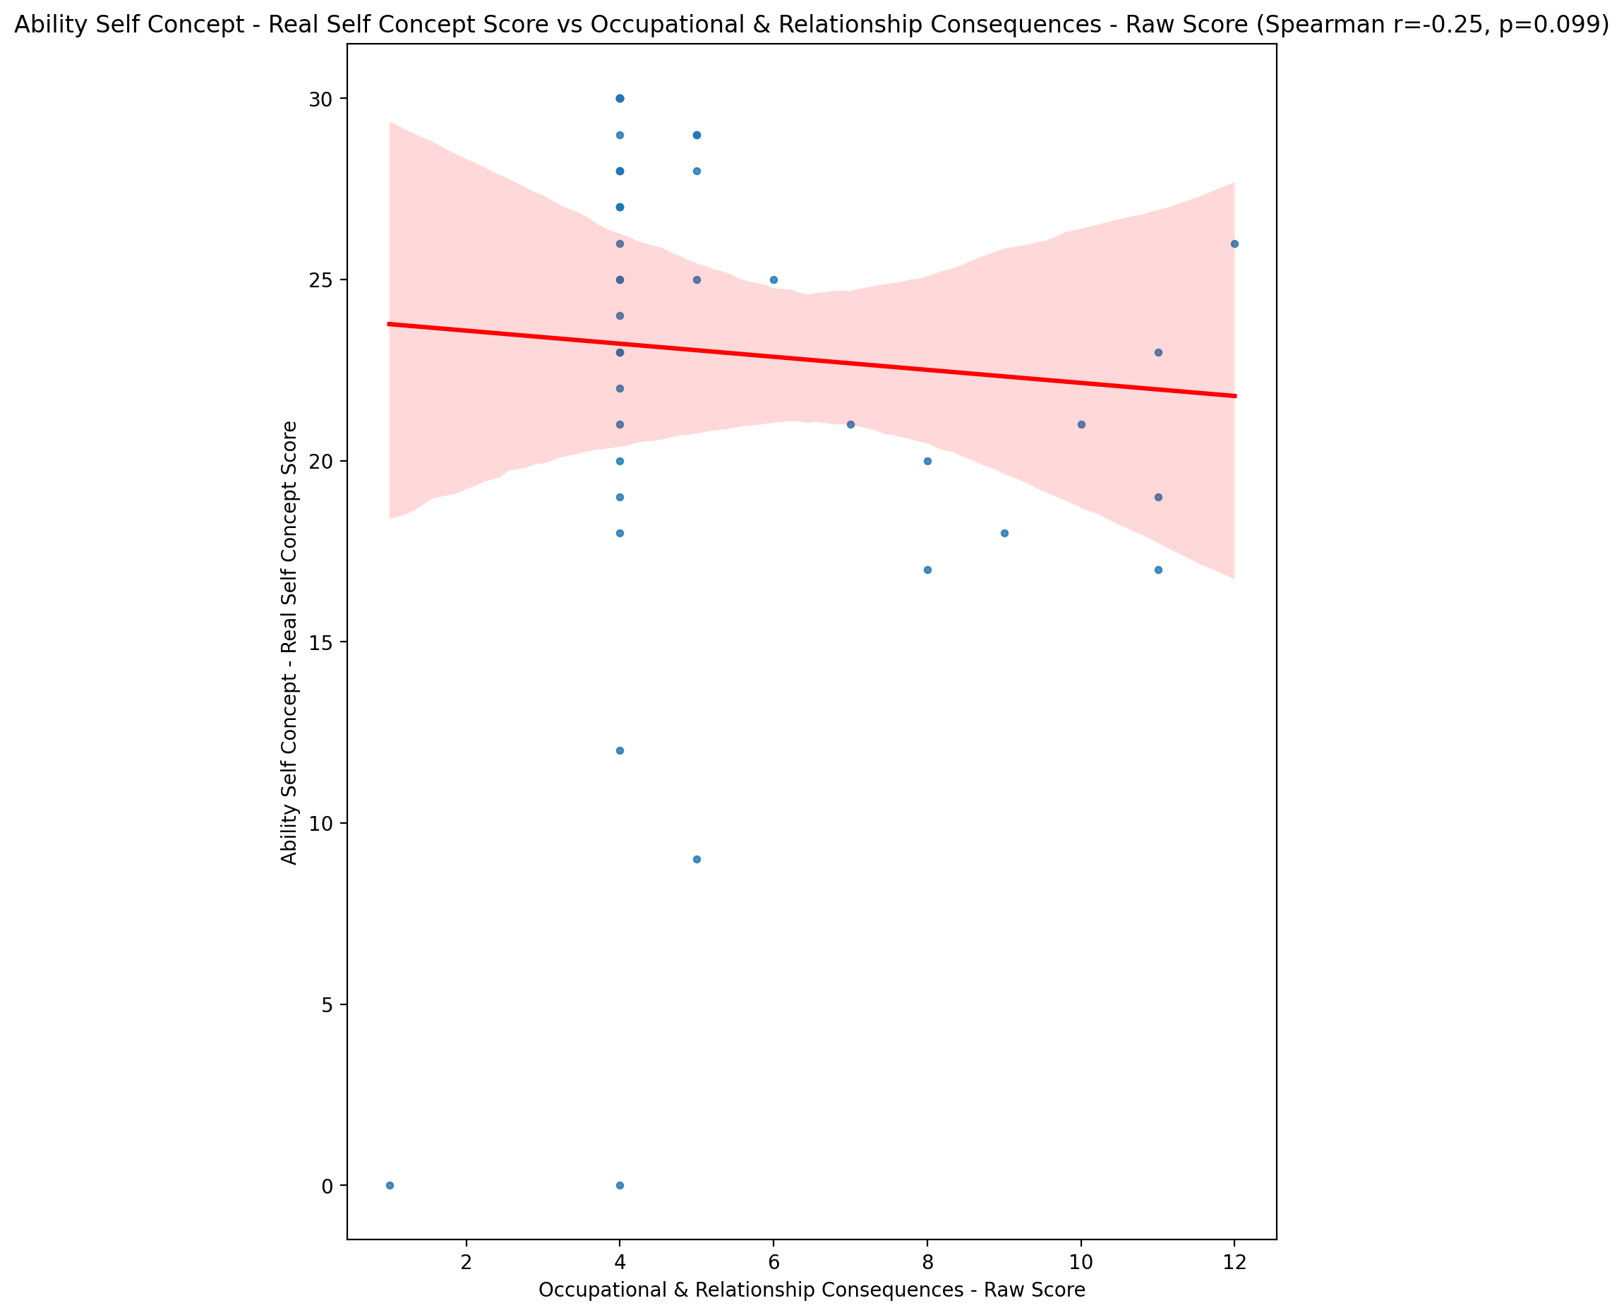

## Ability Self Concept - Ideal Self Concept Score vs Occupational & Relationship Consequences - Raw Score

Test: spearman; statistic: -0.15824651963006953; p-value: 0.3108126716940432;

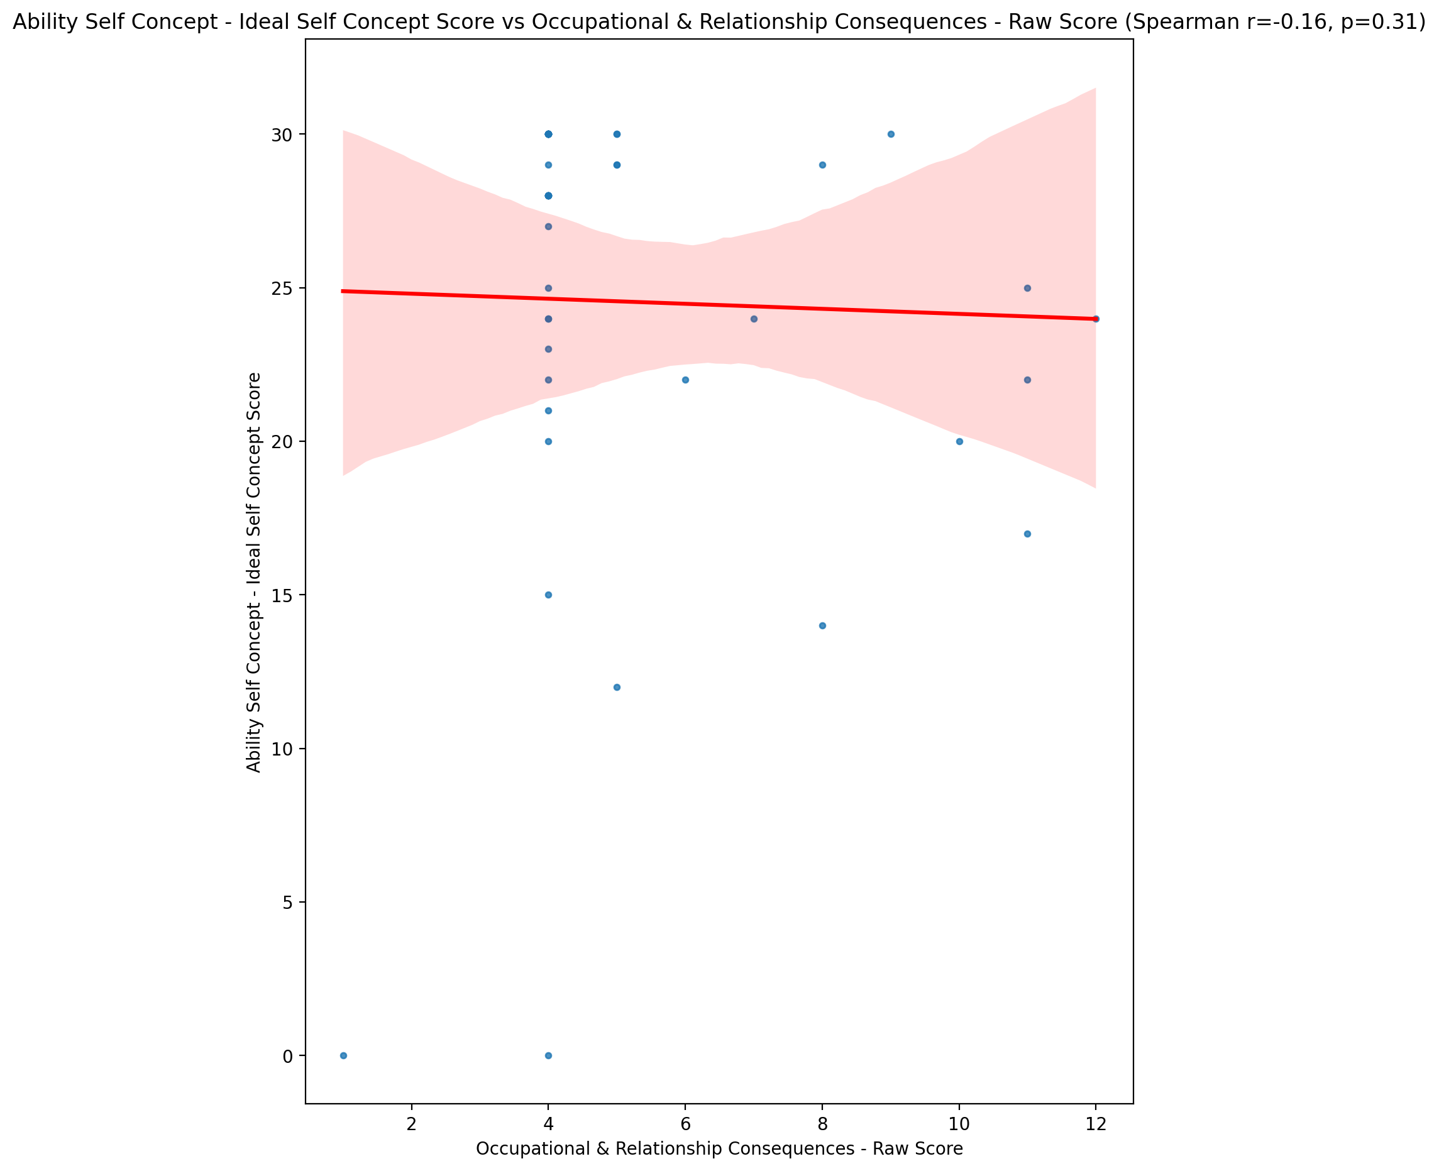

## Ability Self Concept – Social Self Concept Score vs Occupational & Relationship Consequences - Raw Score

Test: spearman; statistic: -0.2946519019424563; p-value: 0.05510472700025707;

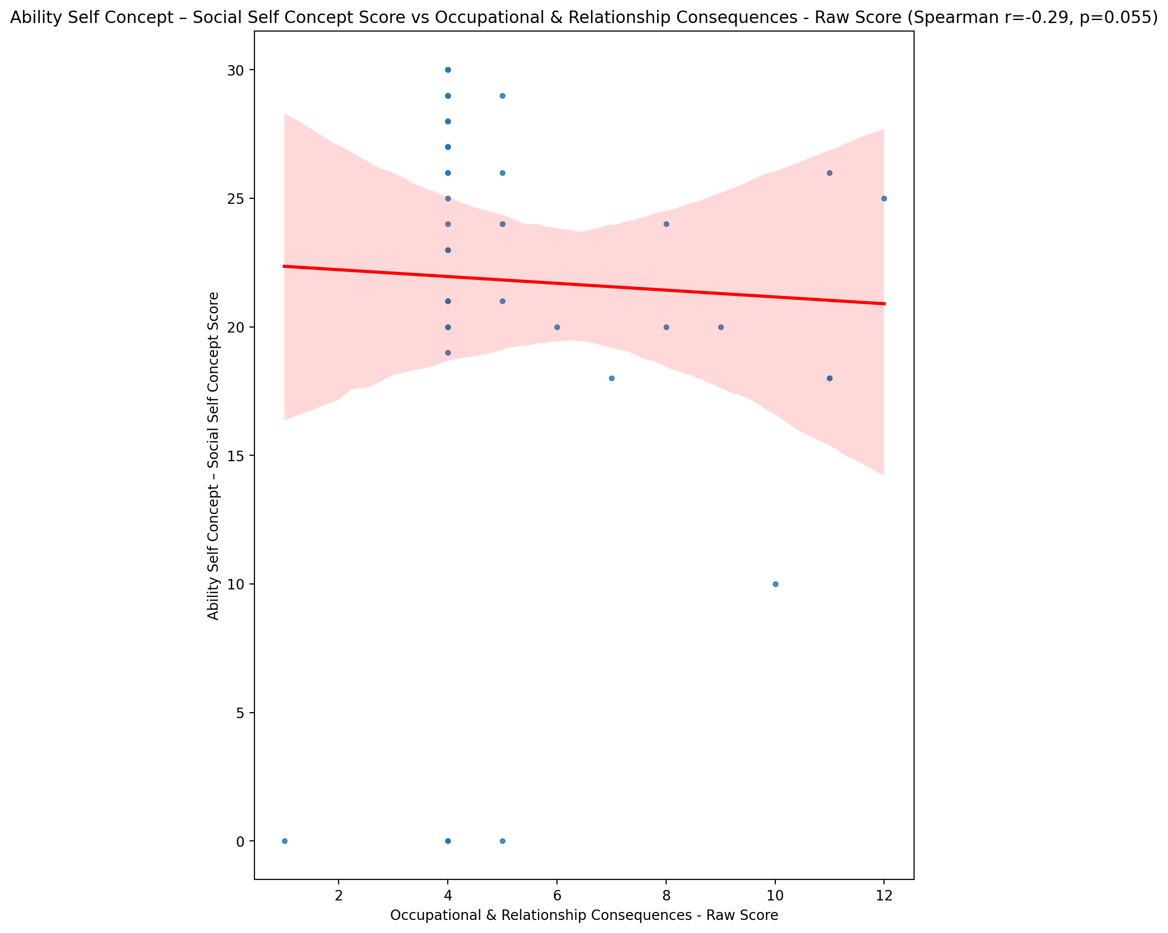

## Physical Self Concept - Real Self Concept Score vs Occupational & Relationship Consequences - Raw Score

Test: spearman; statistic: -0.3688306931079416; p-value: 0.014940892192700114;

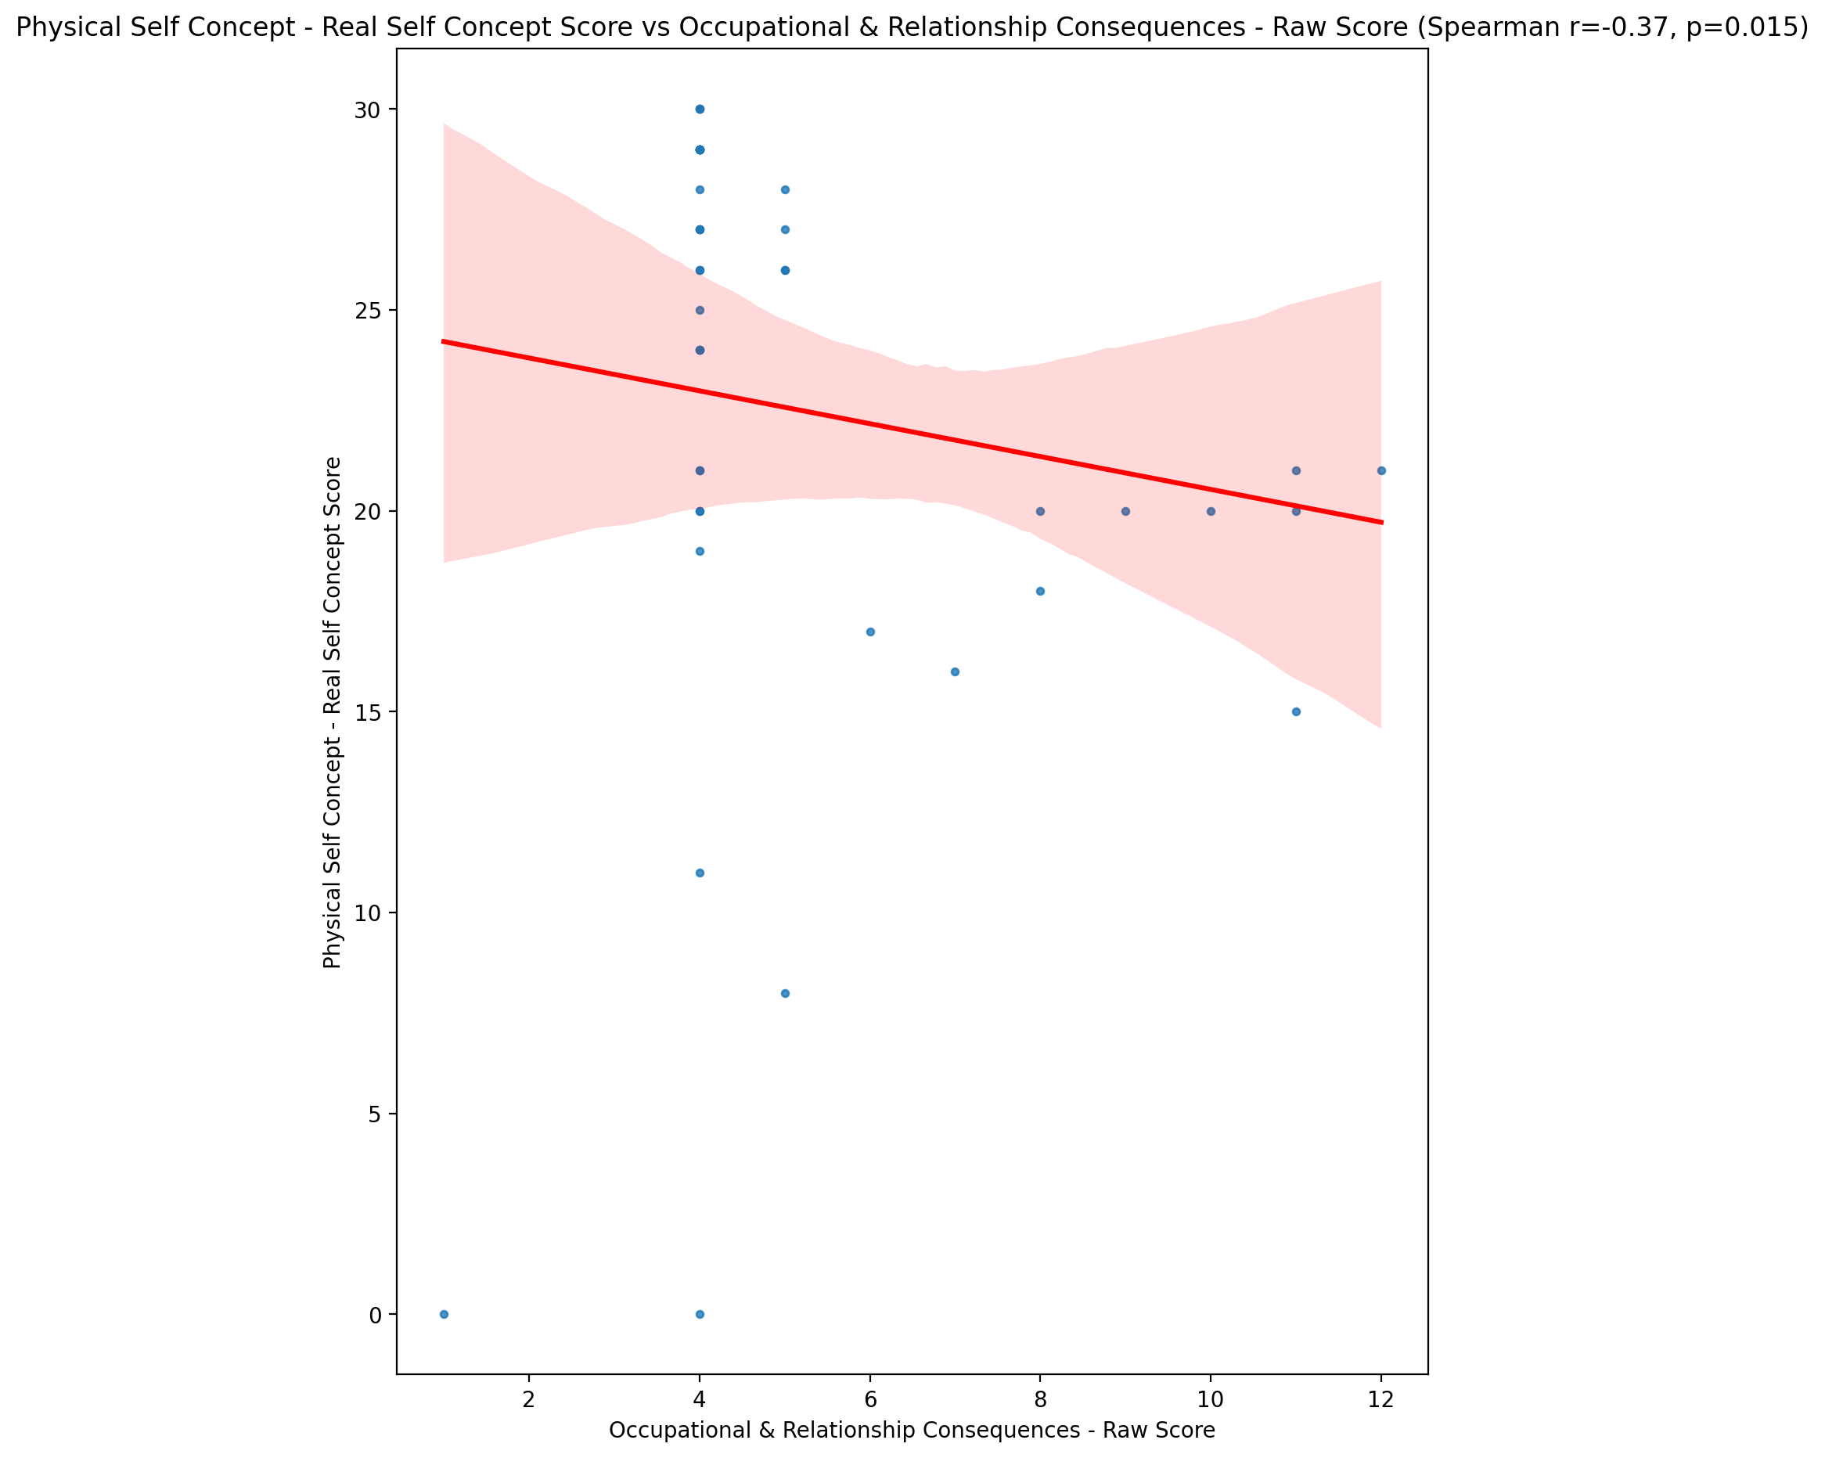

## Physical Self Concept – Ideal Self Concept Score vs Occupational & Relationship Consequences - Raw Score

Test: spearman; statistic: -0.22387398672994838; p-value: 0.14897210242374537;

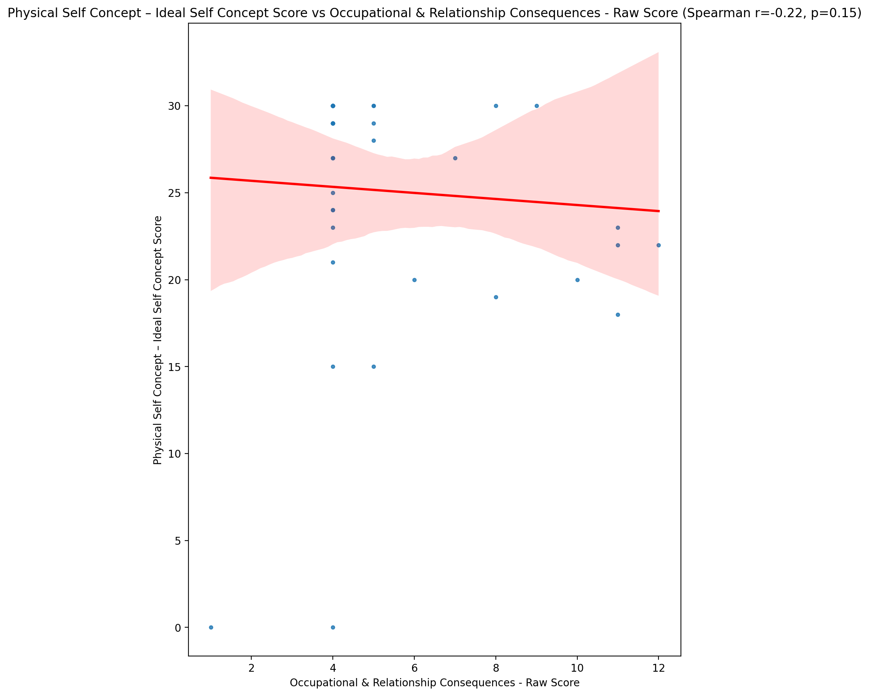

## Physical Self Concept – Social Self Concept Score vs Occupational & Relationship Consequences - Raw Score

Test: spearman; statistic: -0.1889995681178728; p-value: 0.22482070270134685;

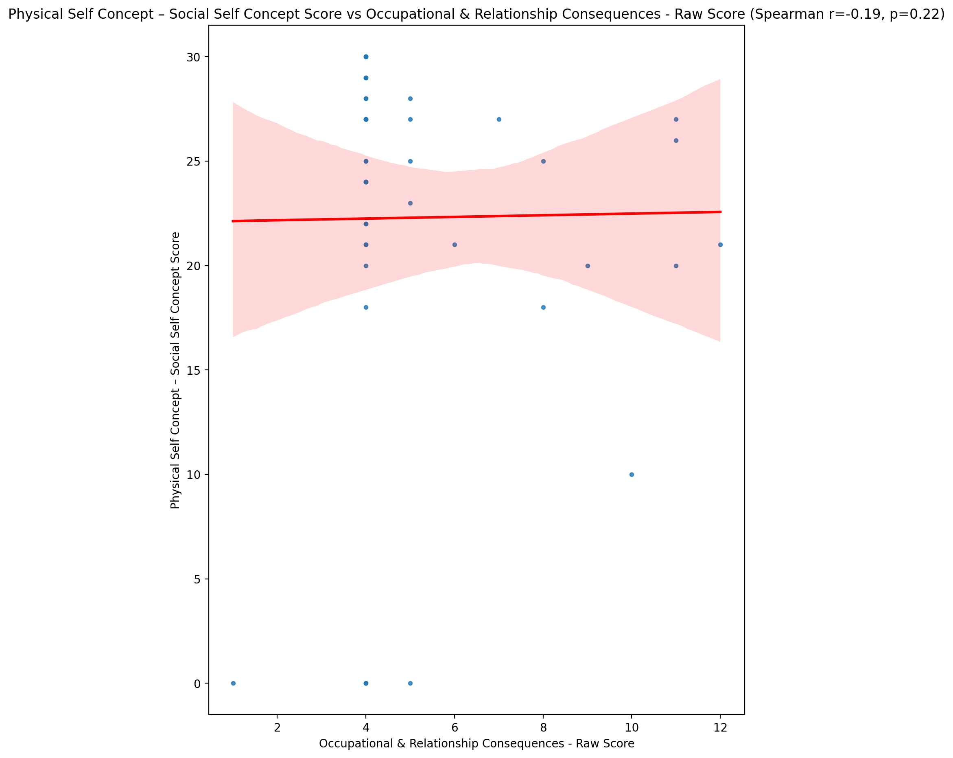

## Psychological Self Concept - Real Self Concept Score vs Occupational & Relationship Consequences - Raw Score

Test: spearman; statistic: -0.3312818135082925; p-value: 0.03000407344696769;

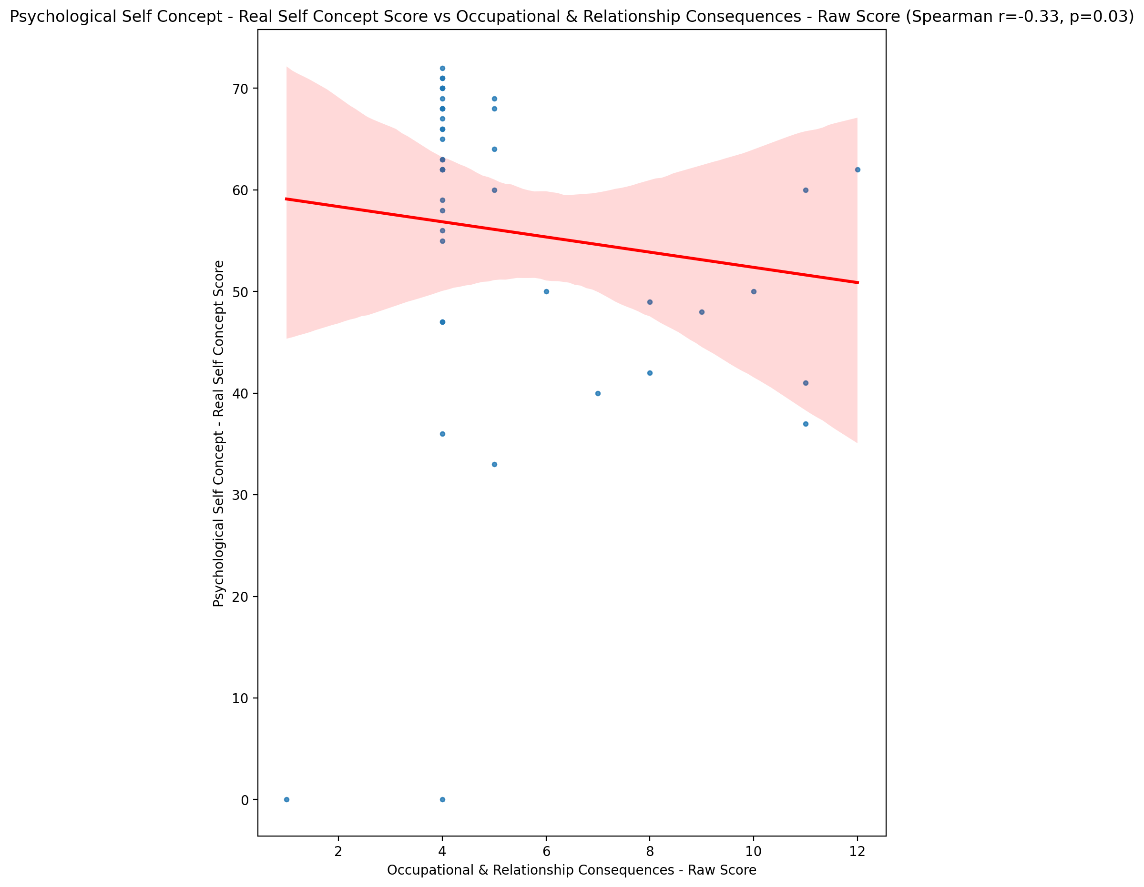

## Psychological Self Concept – Ideal Self Concept Score vs Occupational & Relationship Consequences - Raw Score

Test: spearman; statistic: -0.1971332499930575; p-value: 0.2051287256893956;

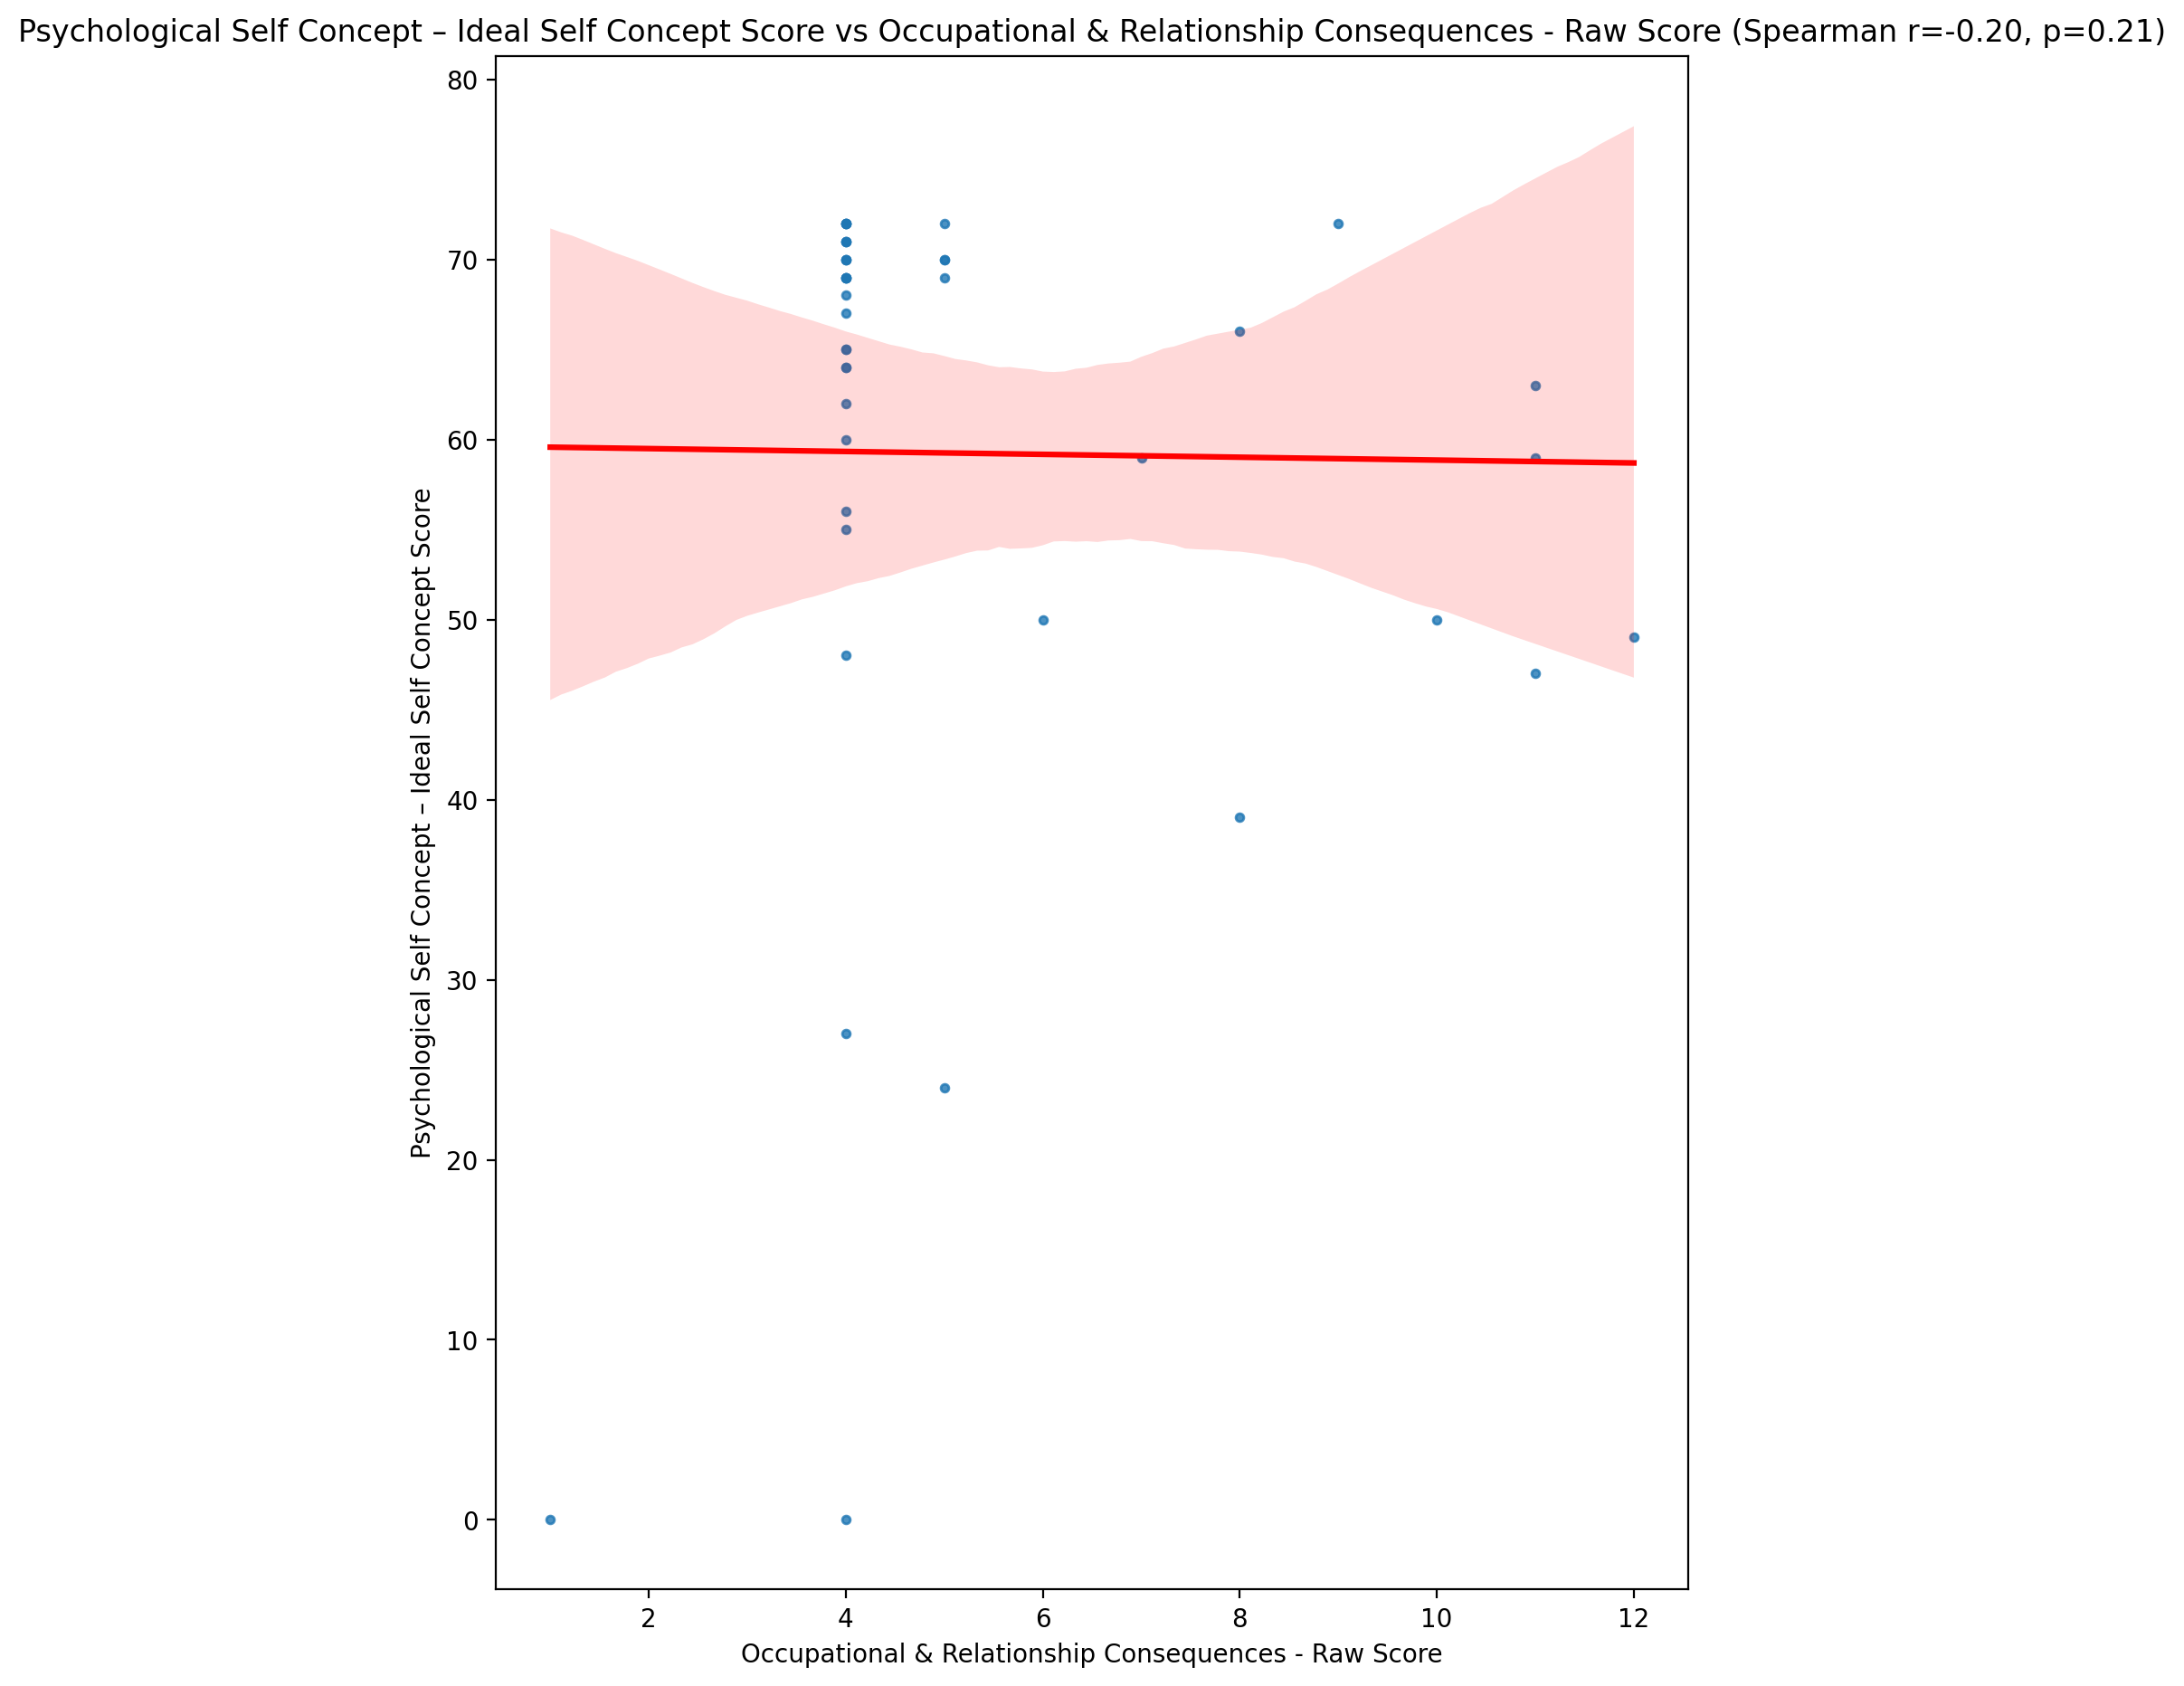

## Psychological Self Concept – Social Self Concept Score vs Occupational & Relationship Consequences - Raw Score

Test: spearman; statistic: -0.42487411687058957; p-value: 0.0045125481575784415;

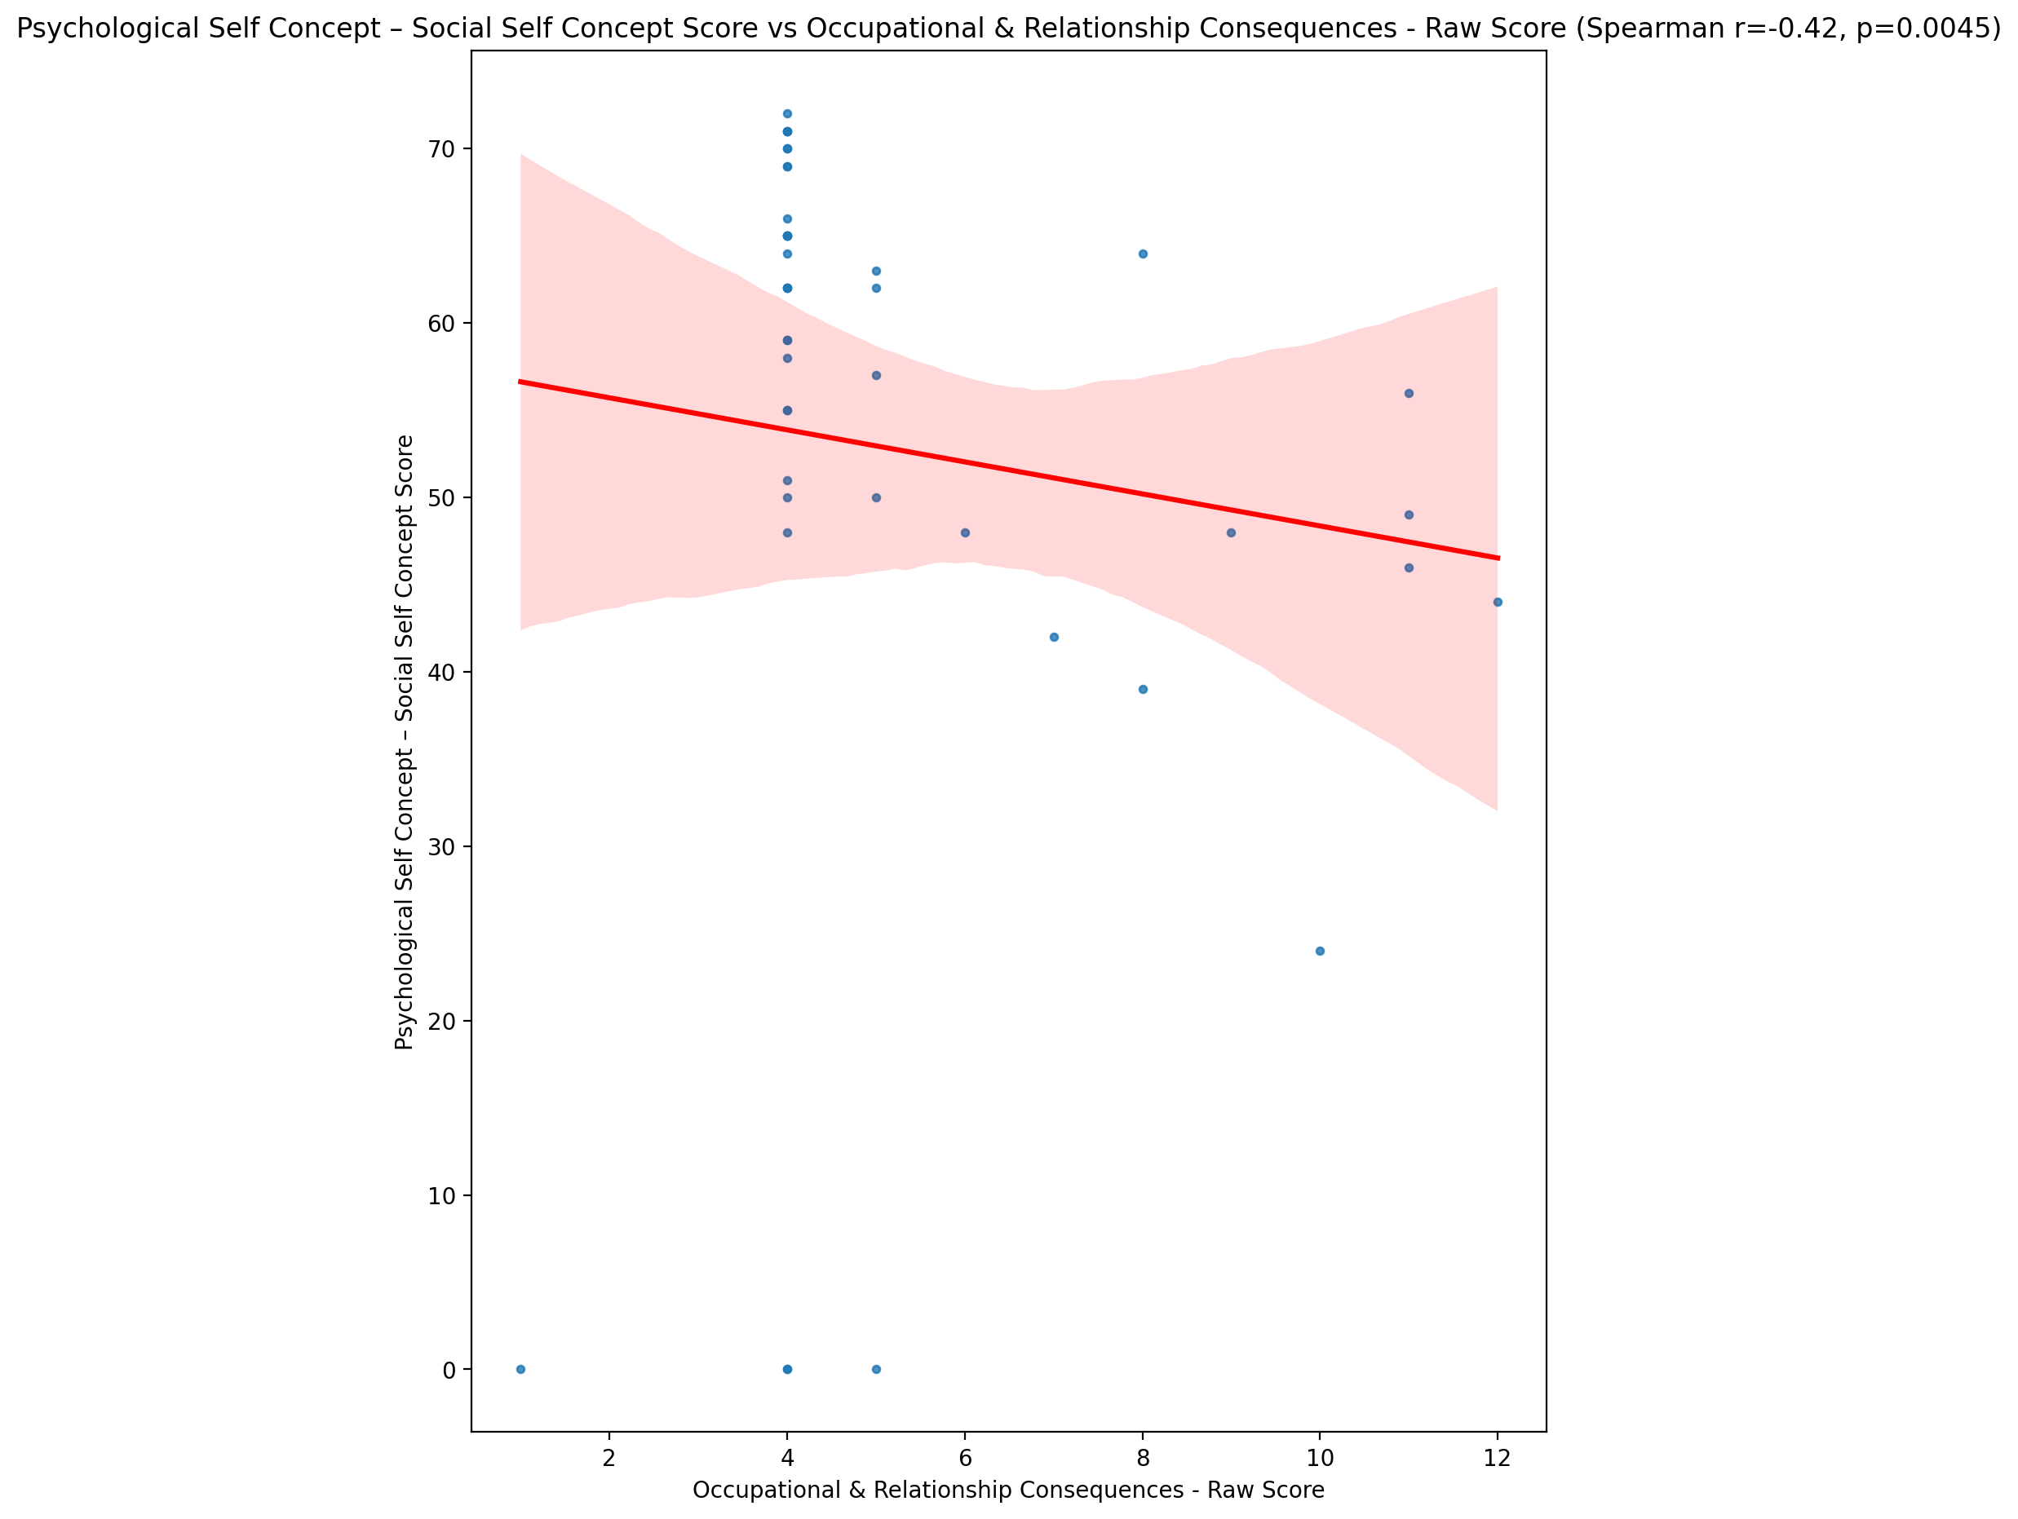

## Real Self Concept Total Score vs Occupational & Relationship Consequences - Raw Score

Test: spearman; statistic: -0.3719198733647318; p-value: 0.014057750191810282;

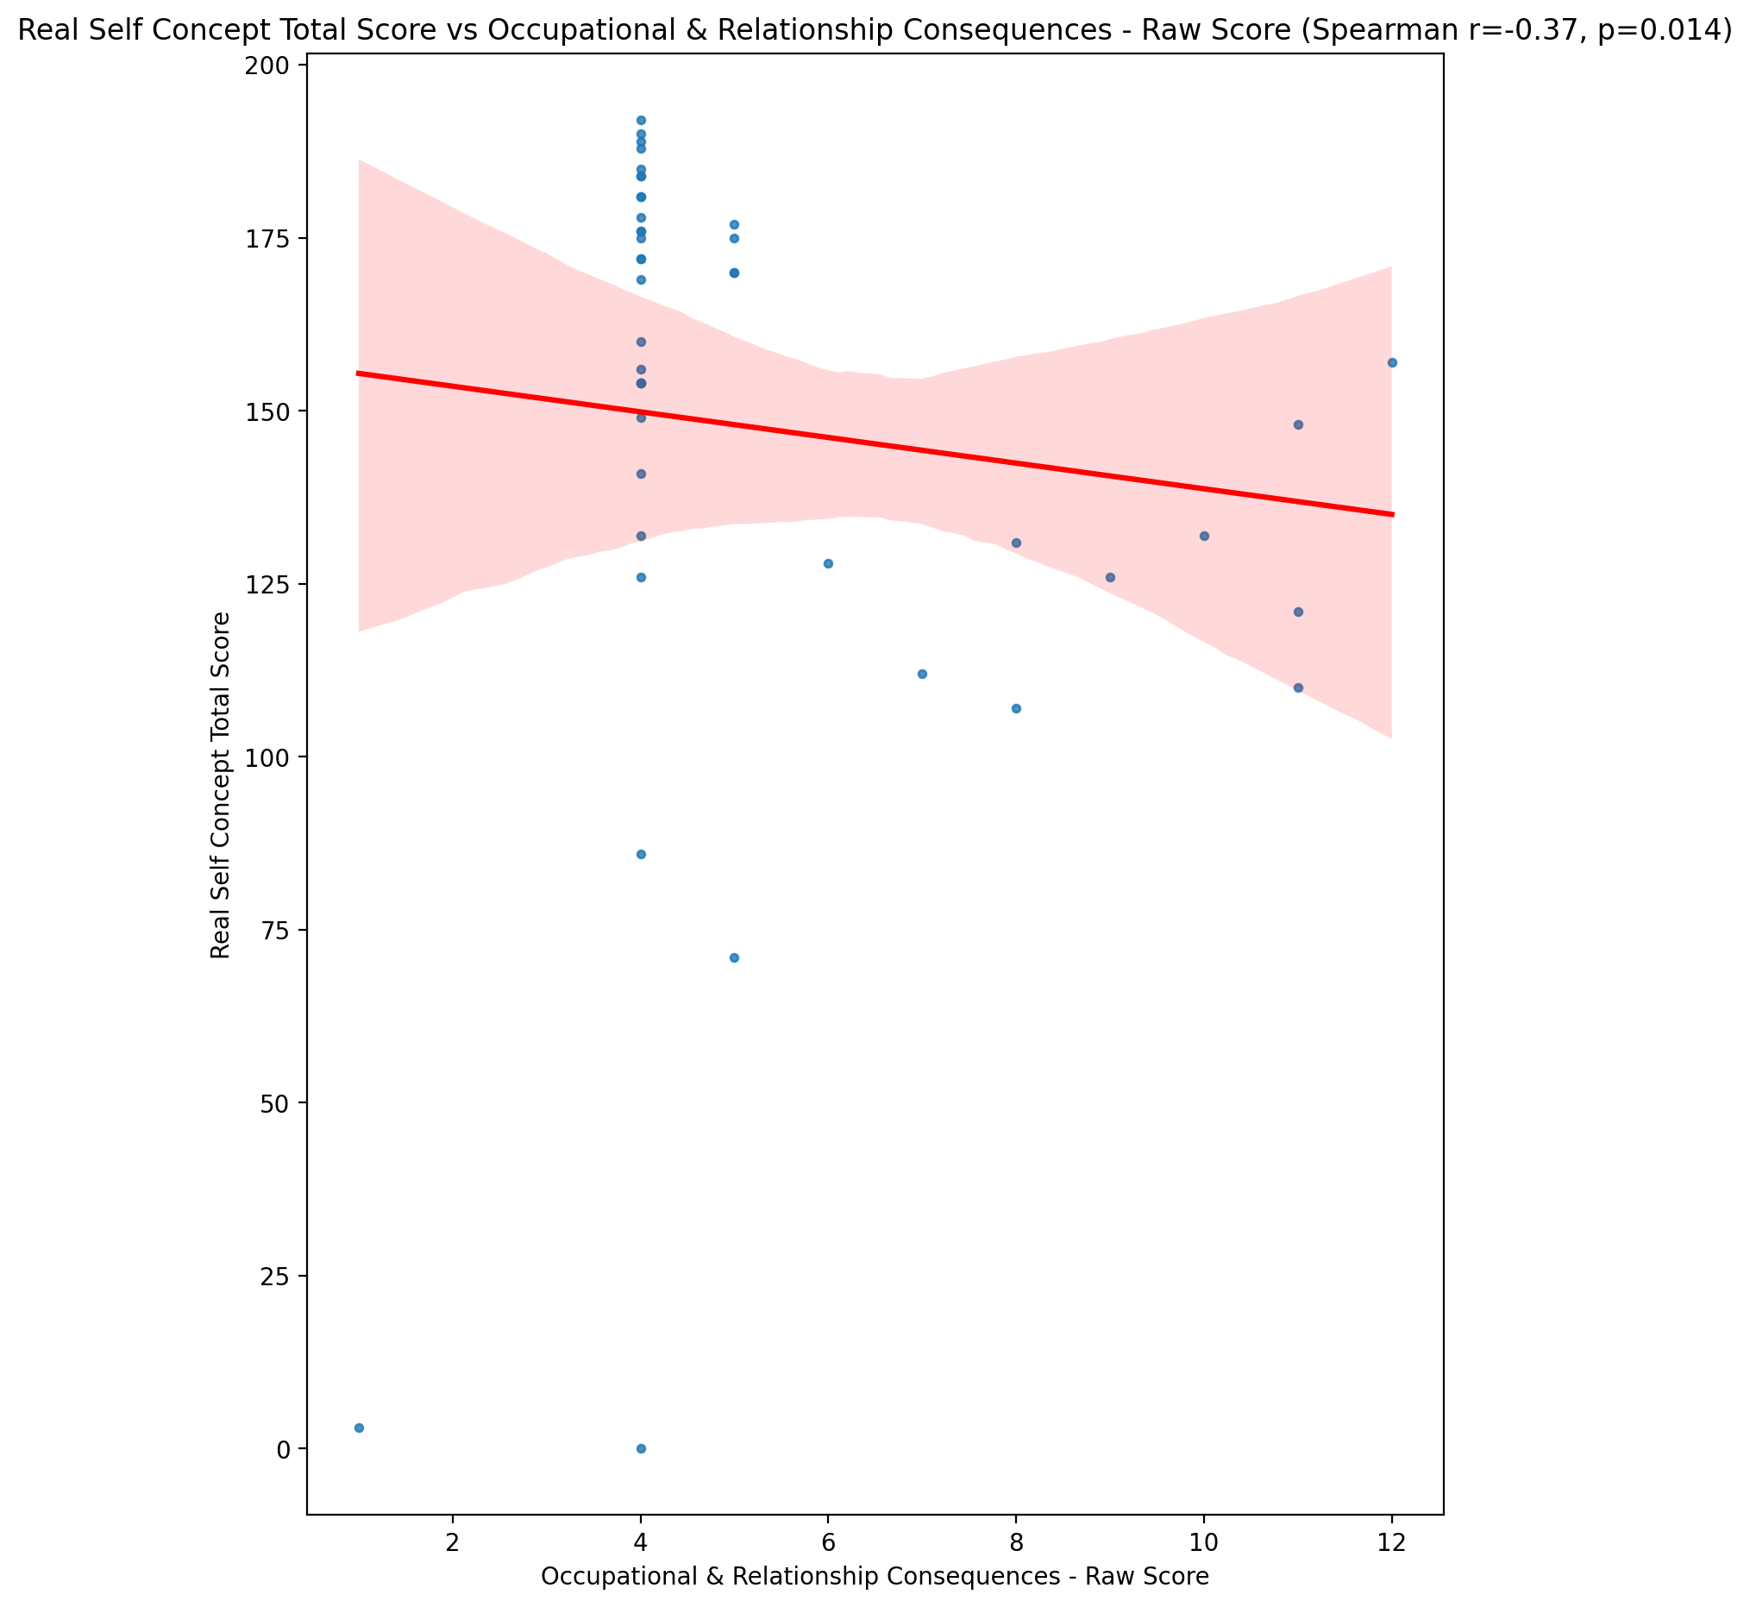

## Ideal Self Concept Total Score vs Occupational & Relationship Consequences - Raw Score

Test: spearman; statistic: -0.20973297606571795; p-value: 0.17706295247949416;

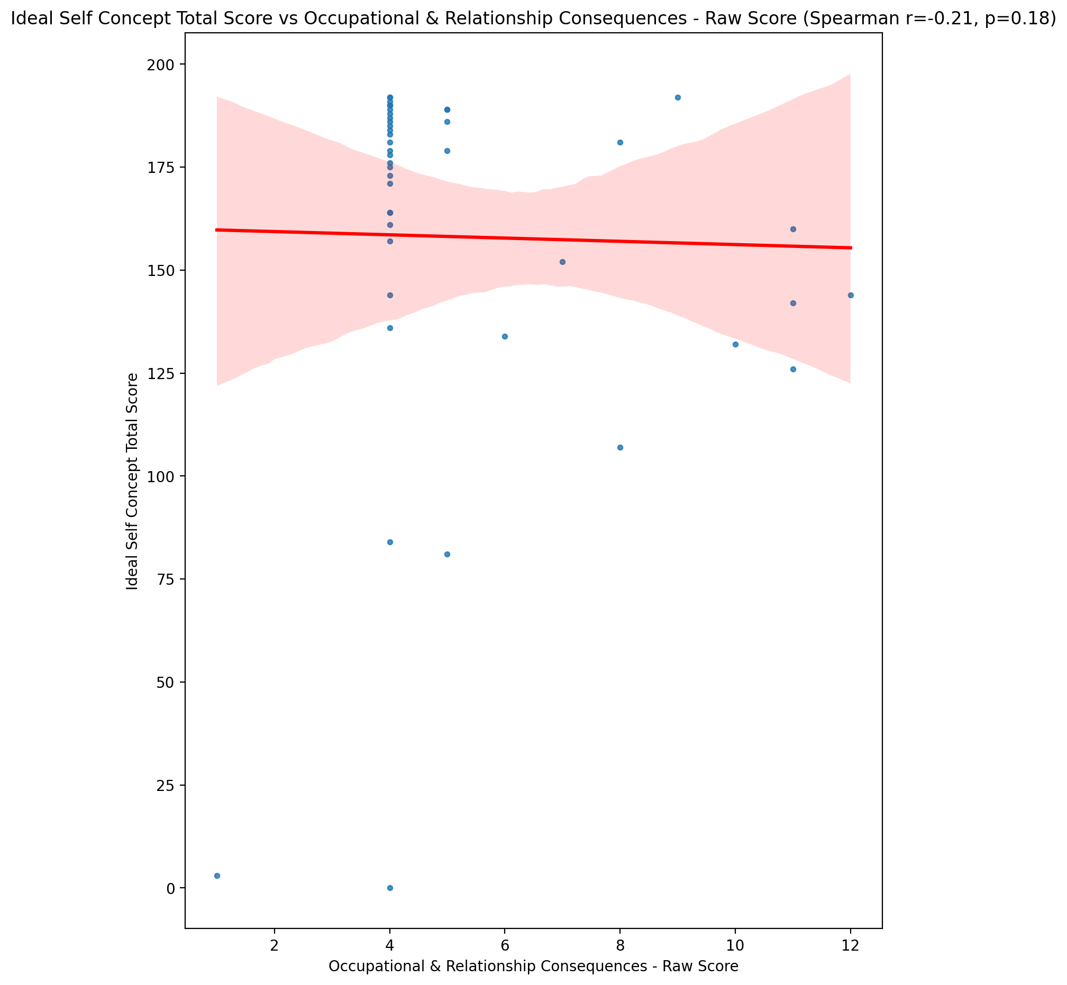

## Social Self Concept Total Score vs Occupational & Relationship Consequences - Raw Score

Test: spearman; statistic: -0.38838266049950243; p-value: 0.010062888972597134;

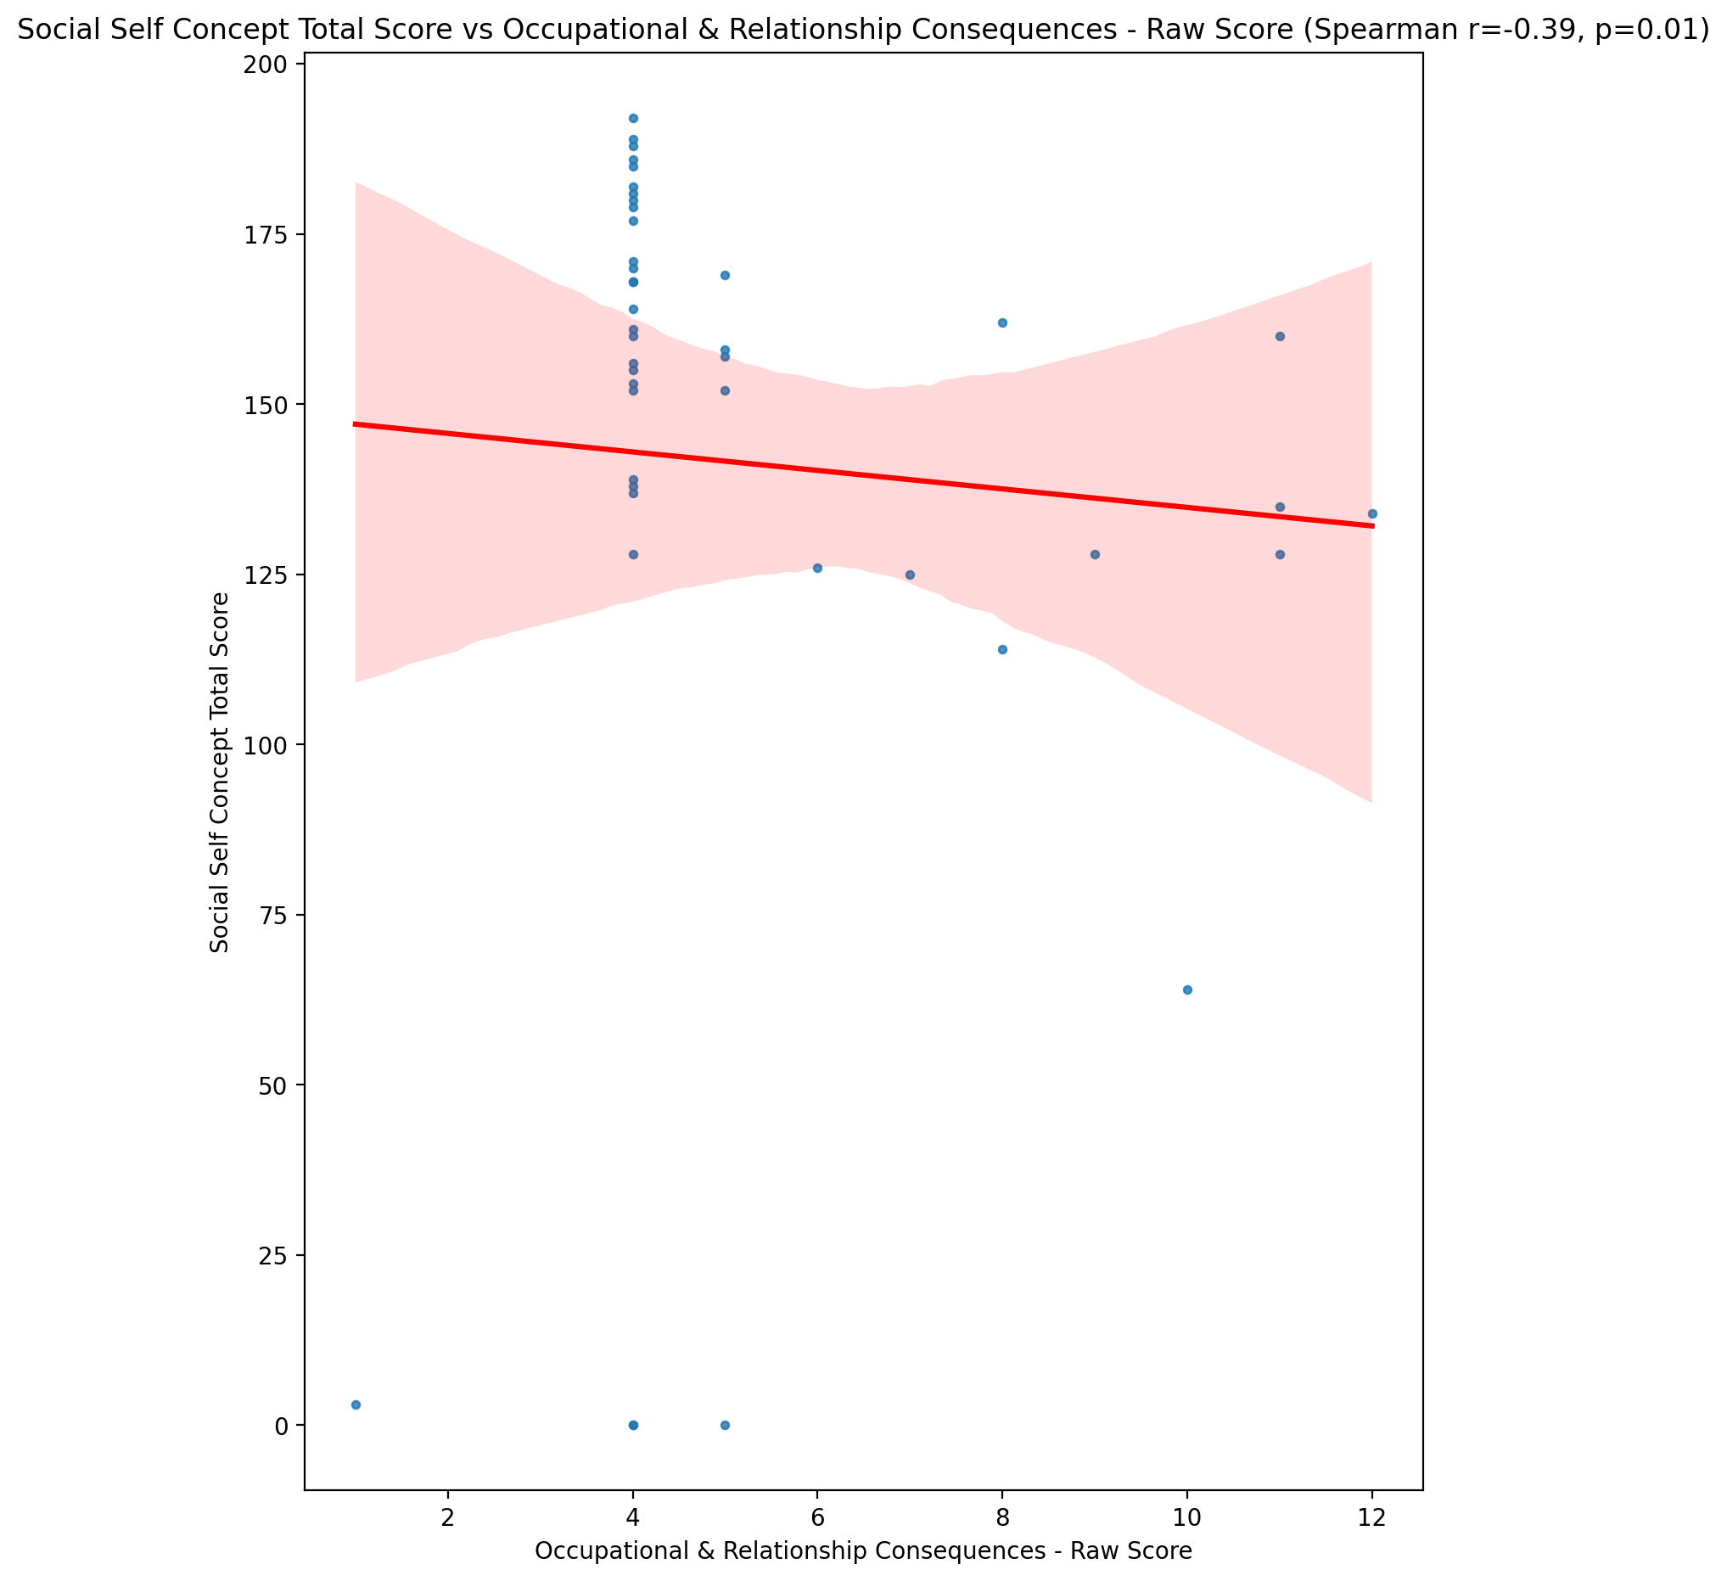

## Ideal Self Concept Total Category vs Occupational & Relationship Consequences - Raw Score

Test: None; statistic: None; p-value: None; Test not run: unsupported type combination.



## Perceived Social Stress Score vs Occupational & Relationship Consequences - Raw Score

Test: spearman; statistic: 0.20120701785774708; p-value: 0.19573370799409667;

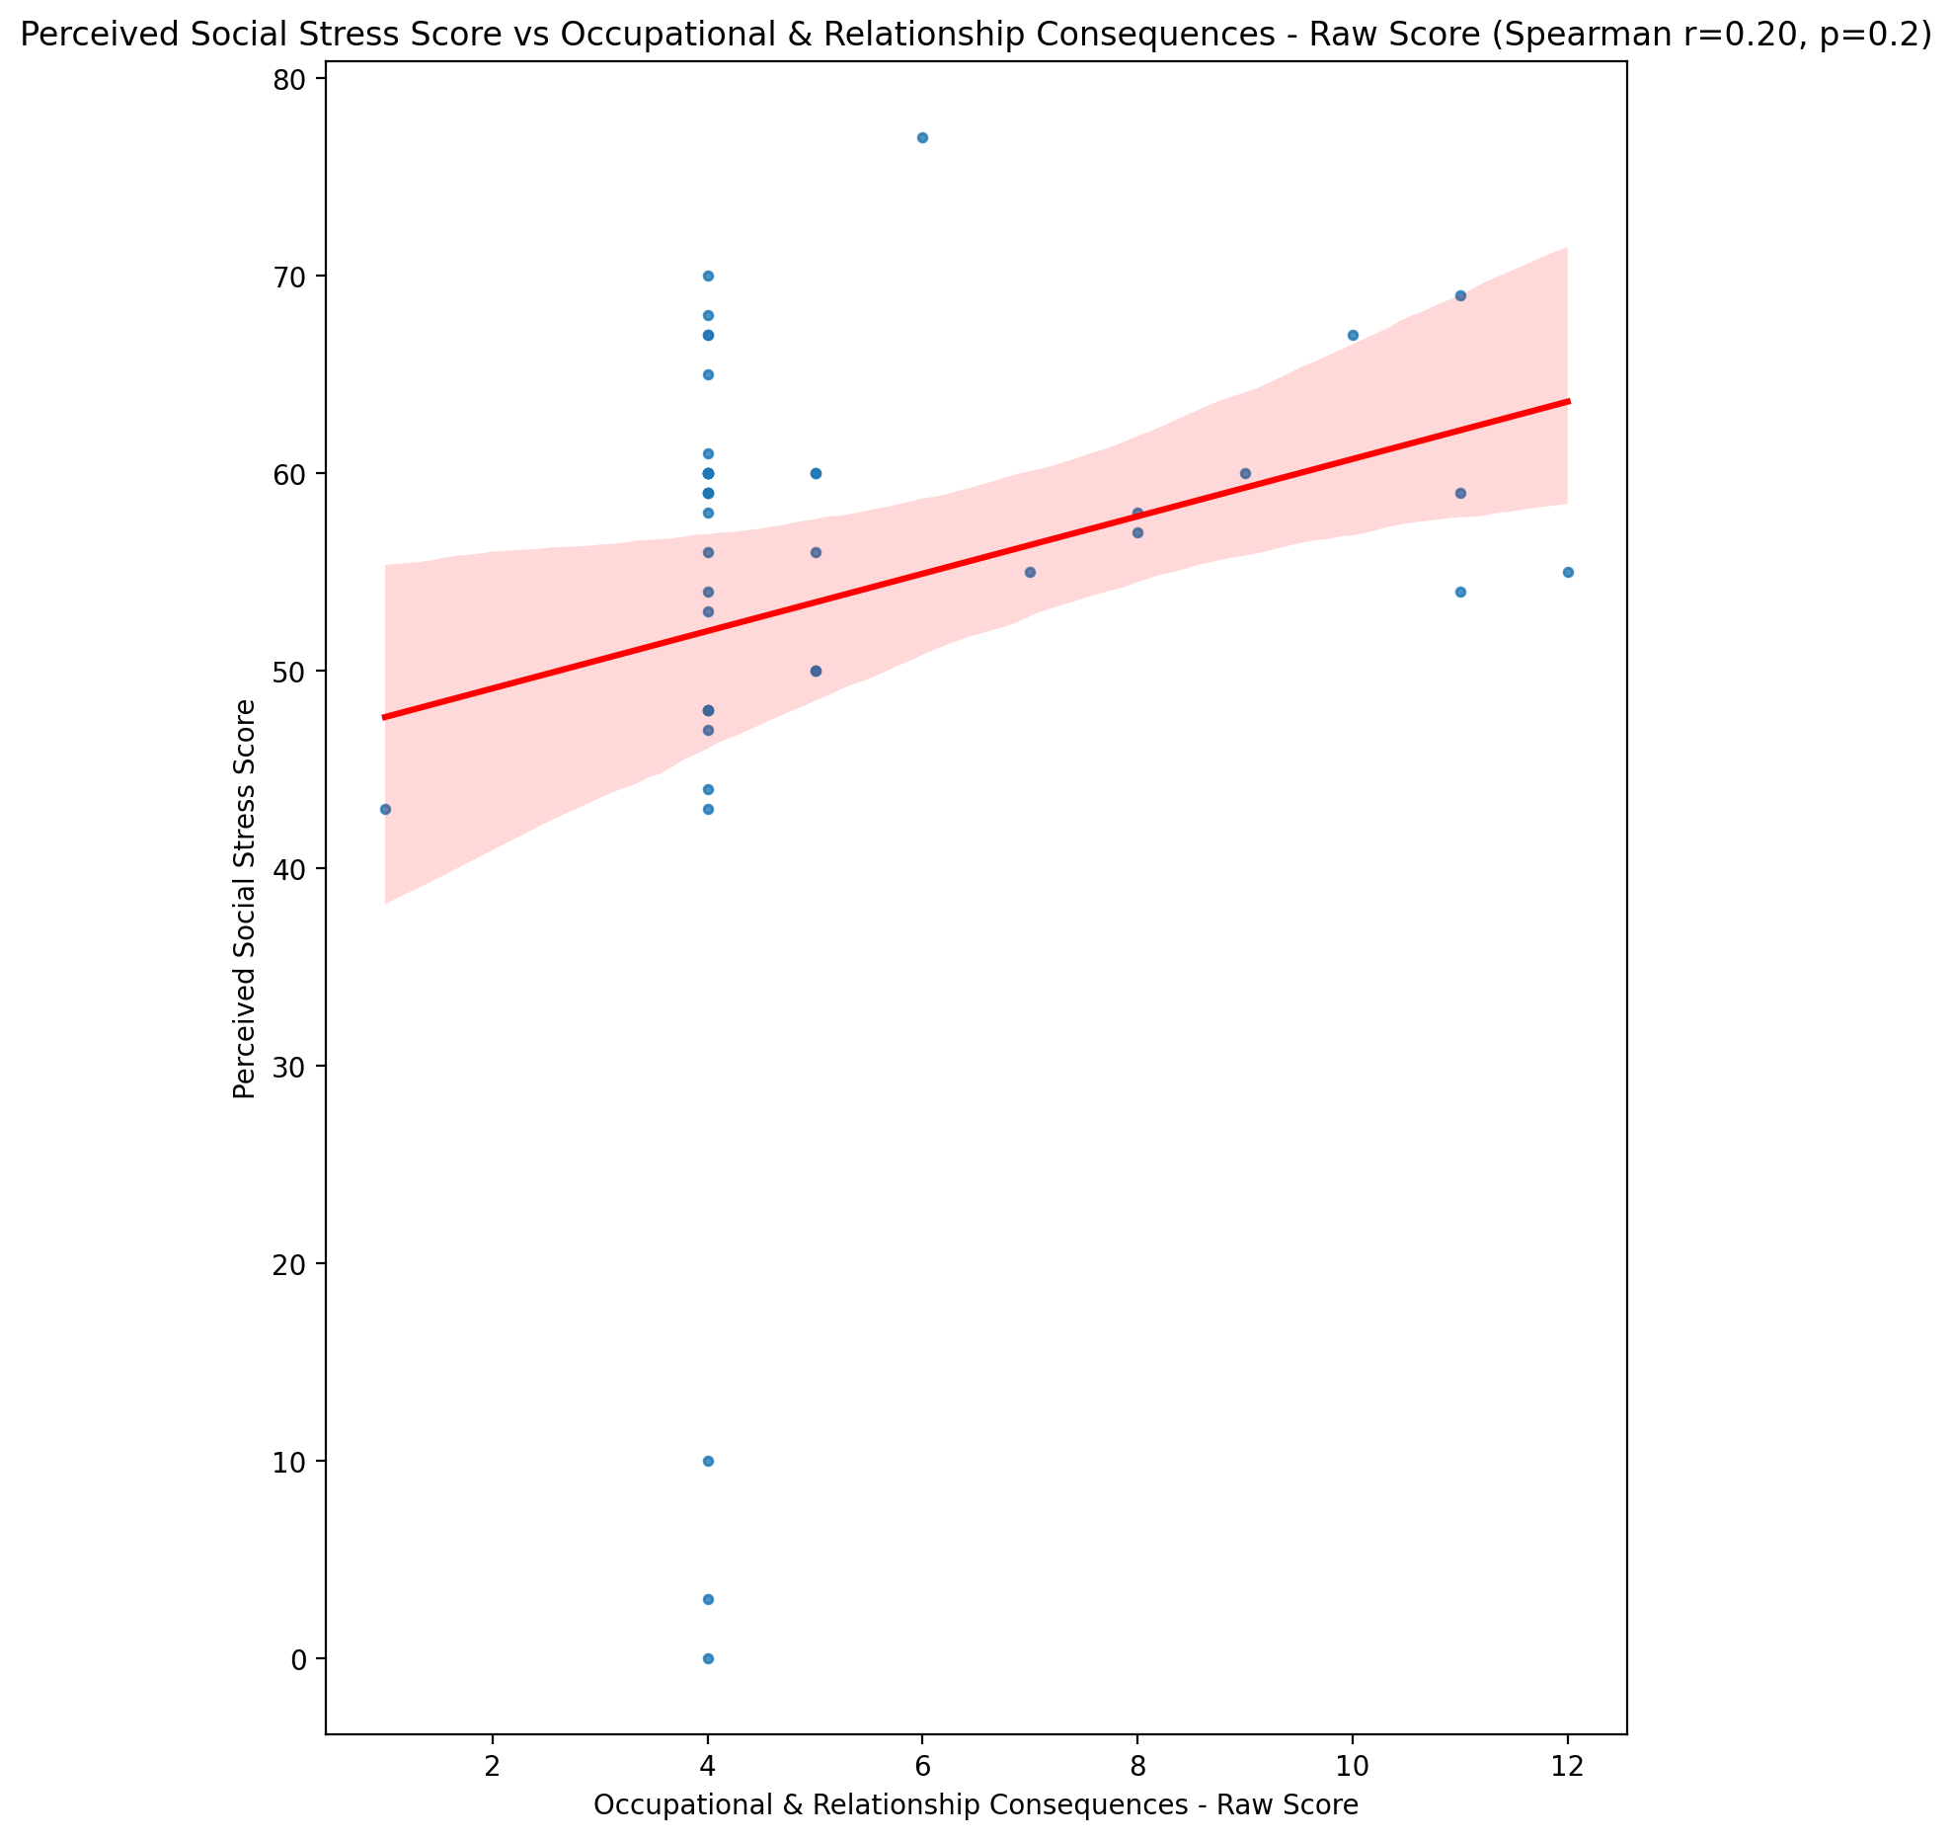

## Perceived Social Stress Category vs Occupational & Relationship Consequences - Raw Score

Test: None; statistic: None; p-value: None; Test not run: unsupported type combination.



## Emotional Support - Raw Score vs Compulsive Behaviour - Raw Score

Test: spearman; statistic: -0.4529405229410867; p-value: 0.002288989637193242;

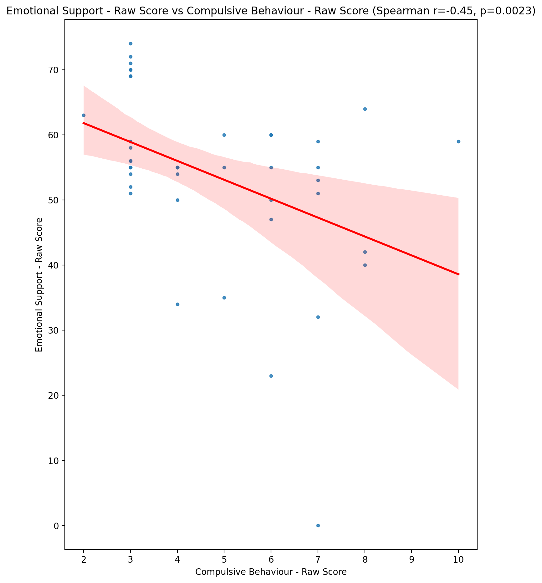

## Informational Support - Raw Score vs Compulsive Behaviour - Raw Score

Test: spearman; statistic: -0.4128771995166683; p-value: 0.005930825523191863;

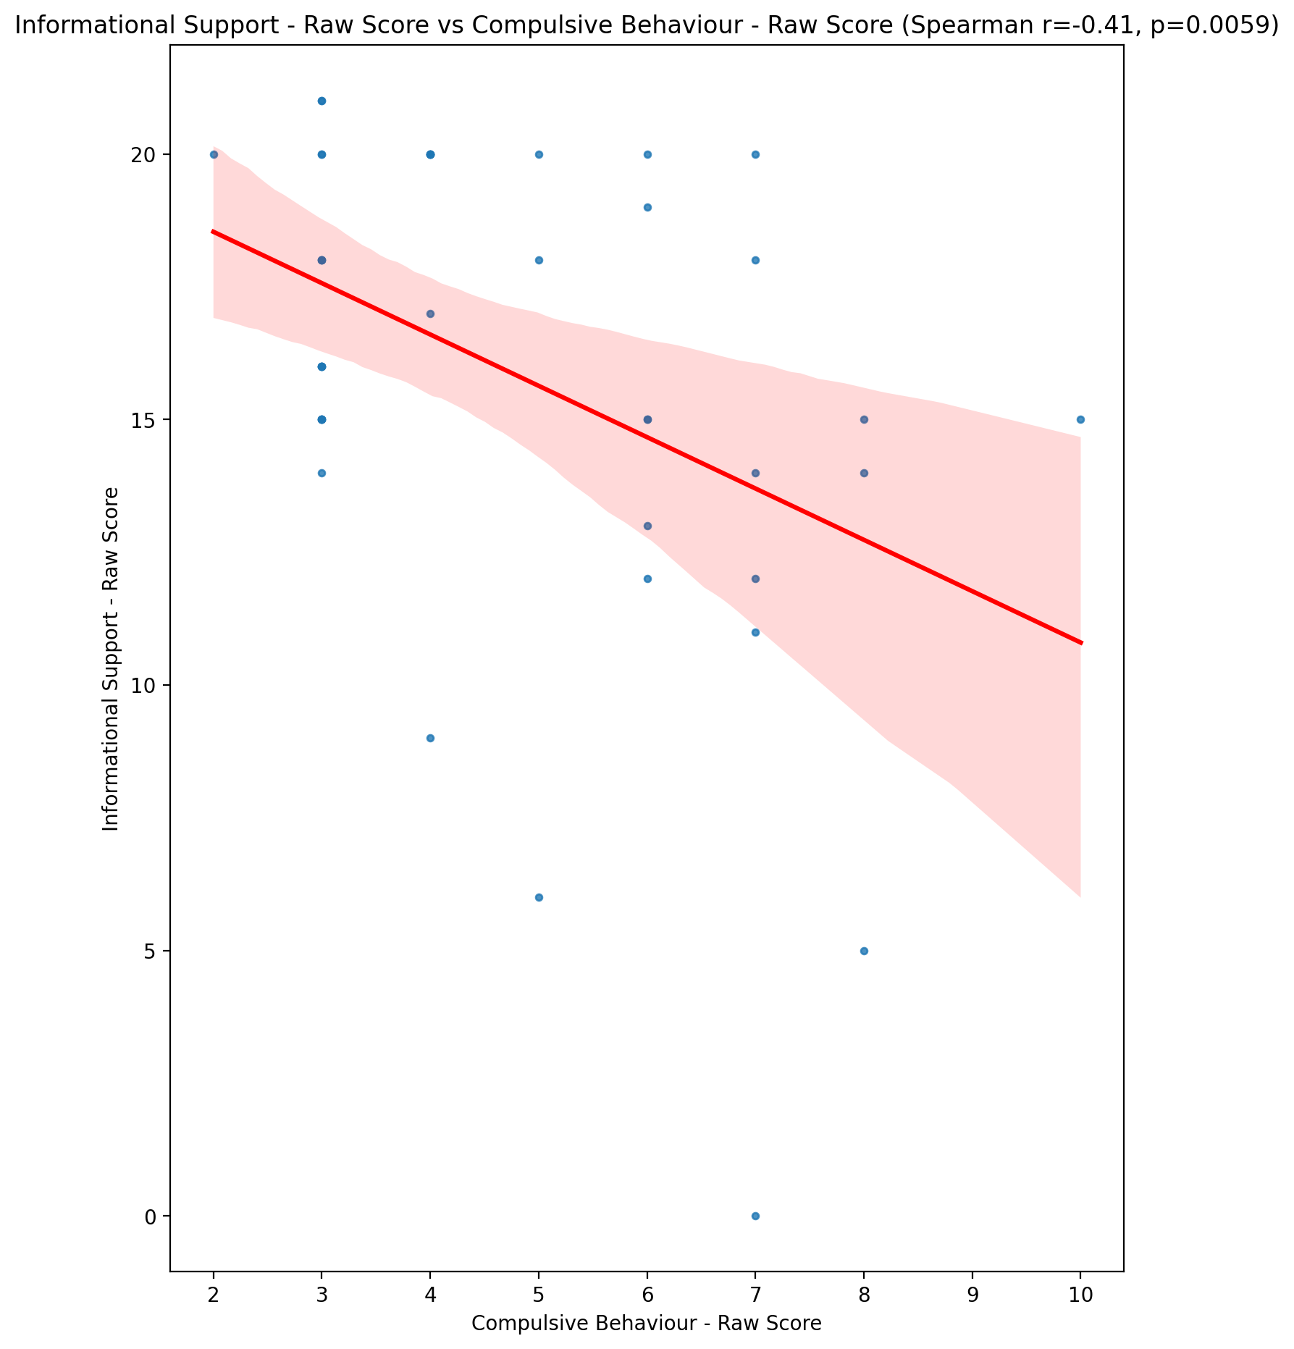

## Instrumental Support - Raw Score vs Compulsive Behaviour - Raw Score

Test: spearman; statistic: -0.30998517924373703; p-value: 0.04307885353652257;

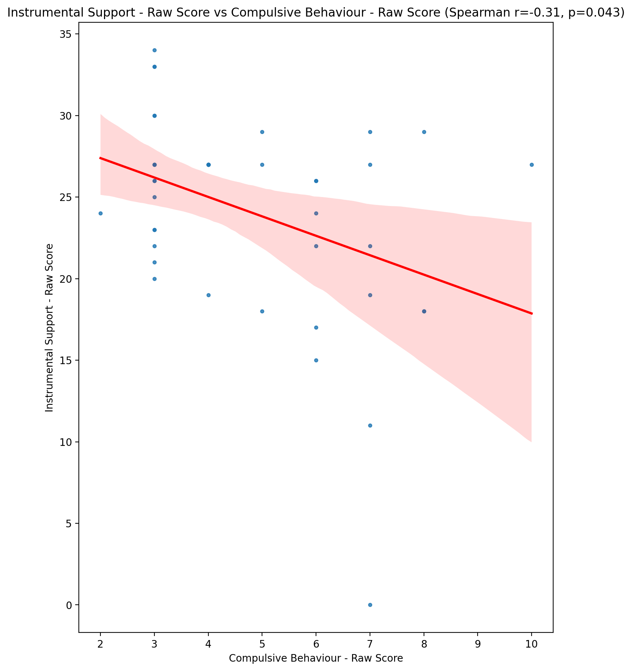

## Emotional Support - T Score vs Compulsive Behaviour - Raw Score

Test: spearman; statistic: -0.3720758850275539; p-value: 0.014014351662463856;

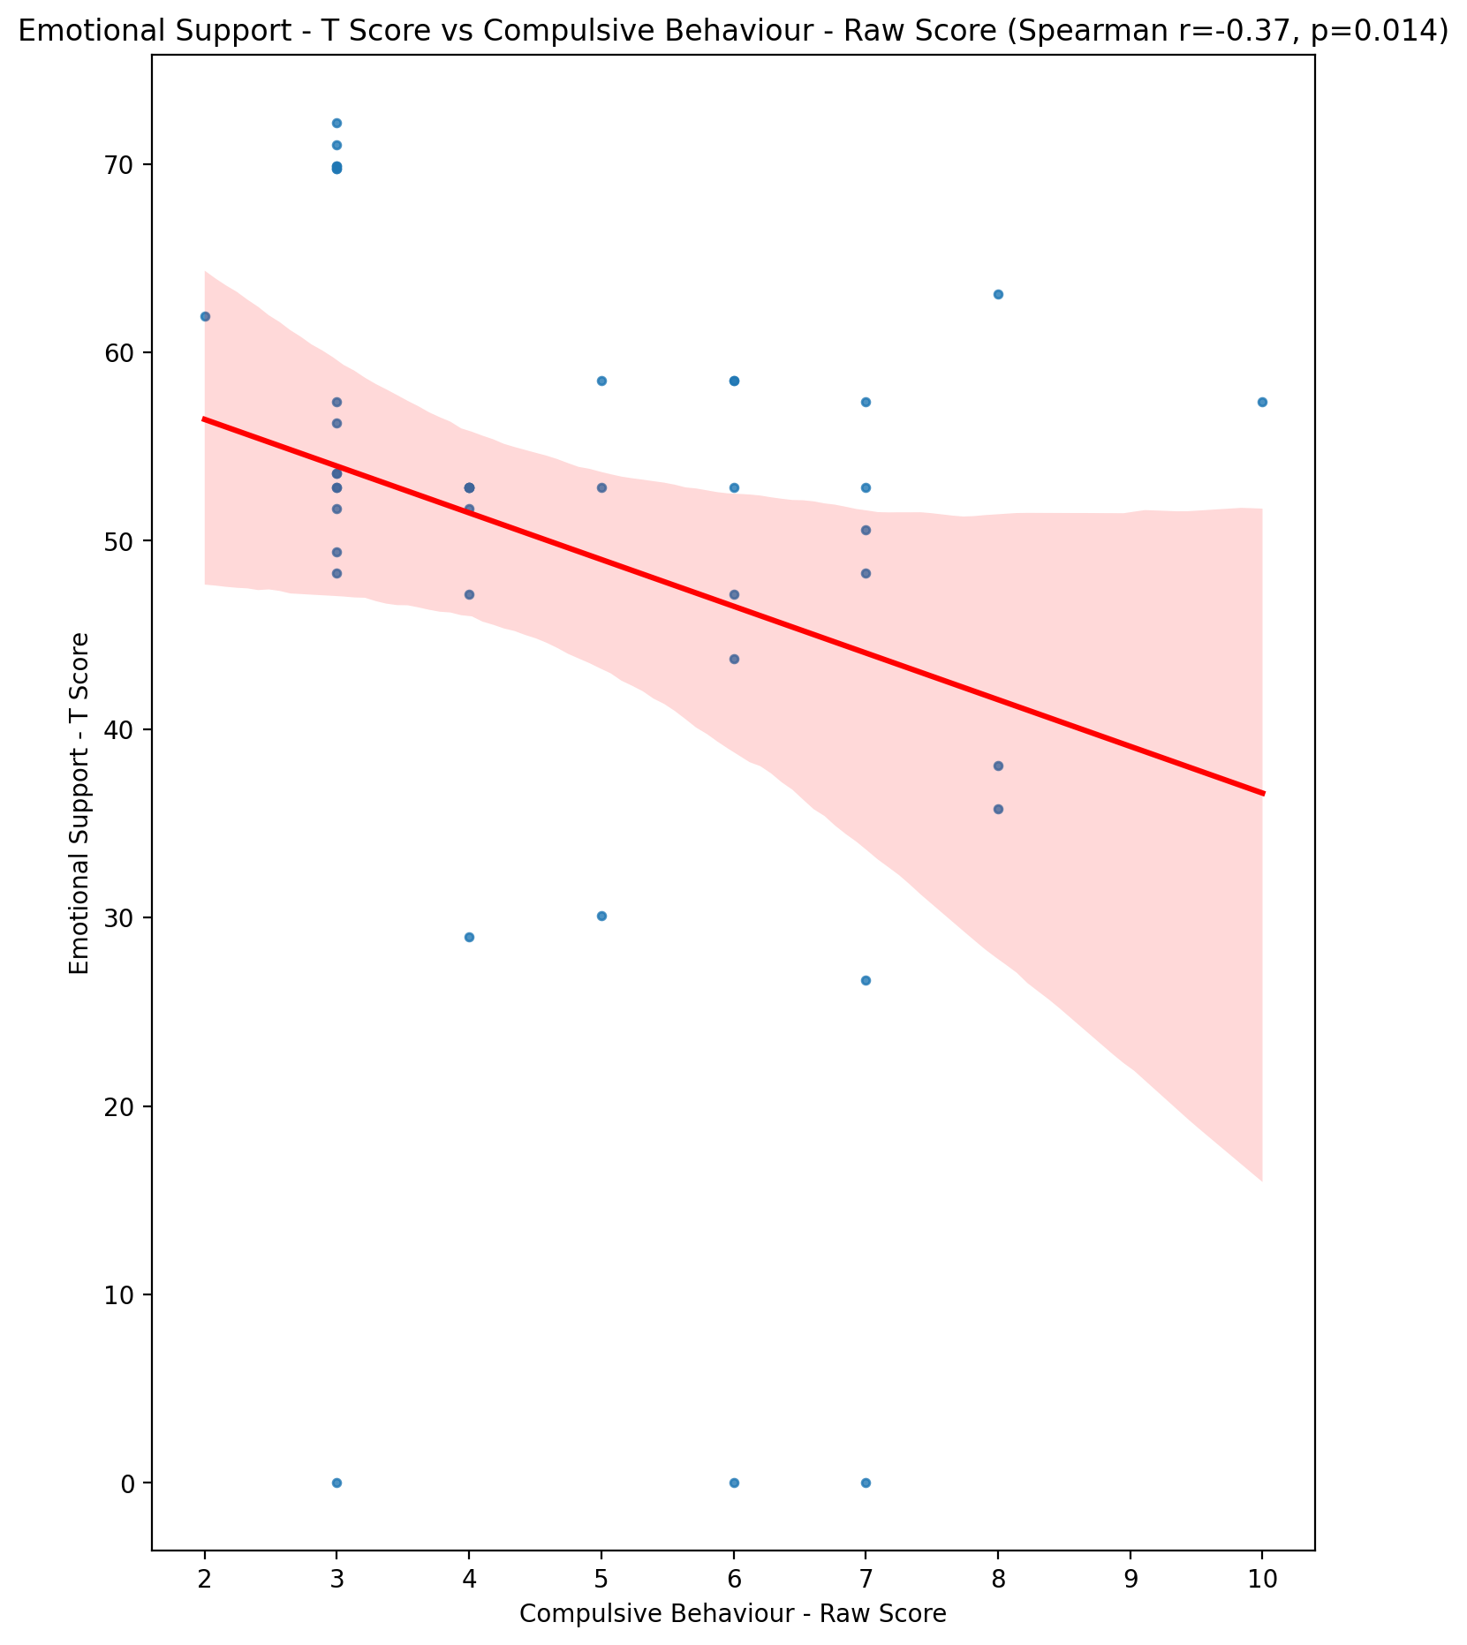

## Informational Support - T Score vs Compulsive Behaviour - Raw Score

Test: spearman; statistic: -0.4112828081044108; p-value: 0.006145734809020281;

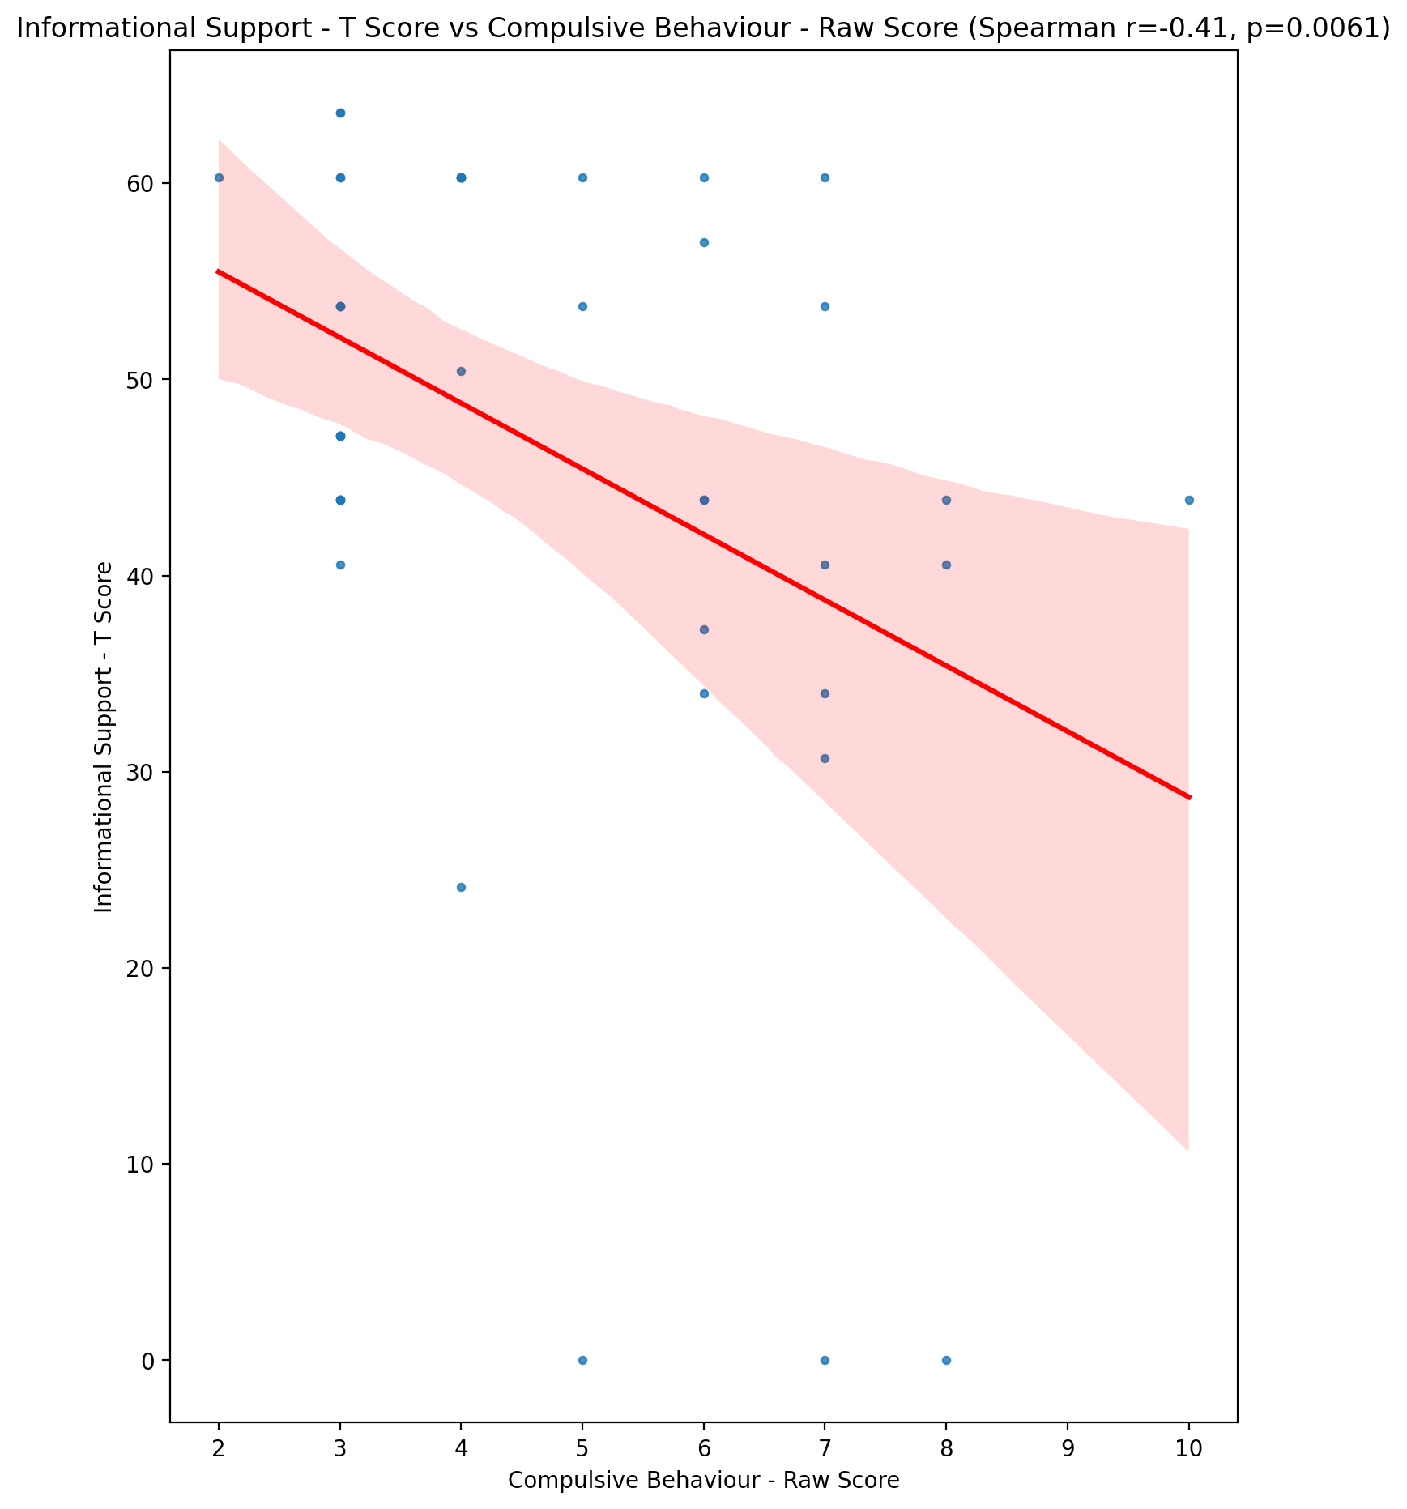

## Instrumental Support - T Score vs Compulsive Behaviour - Raw Score

Test: spearman; statistic: -0.3099971660645394; p-value: 0.043070365896757175;

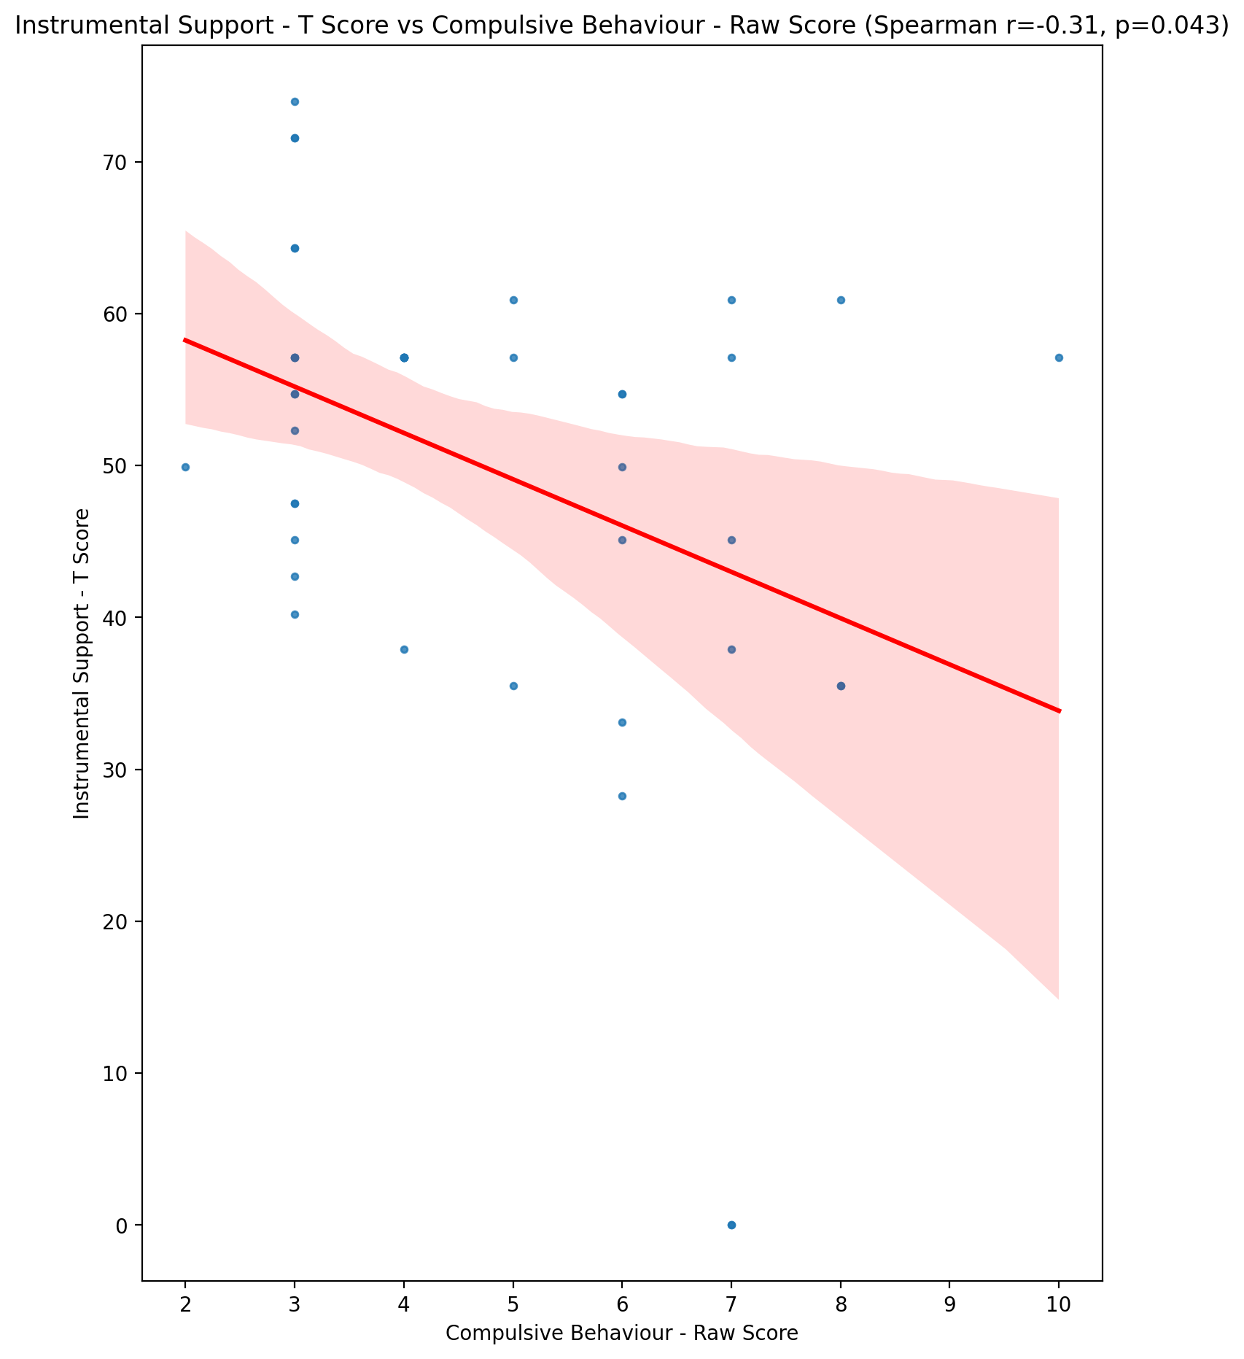

## Perceived Social Support Total T Score vs Compulsive Behaviour - Raw Score

Test: spearman; statistic: -0.4089669498611764; p-value: 0.006469902585841442;

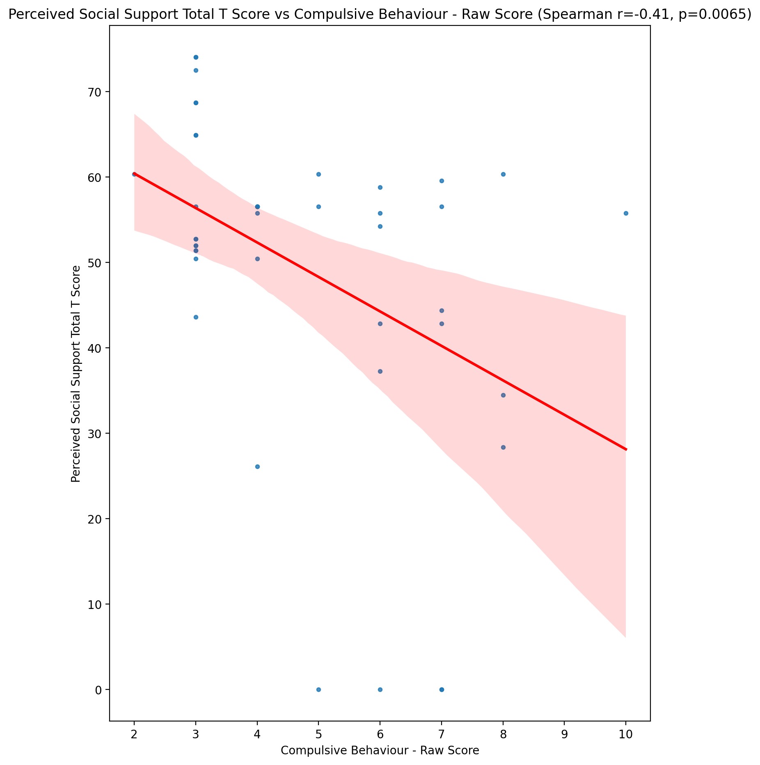

## Emotional Support - Rank vs Compulsive Behaviour - Raw Score

Test: None; statistic: None; p-value: None; Test not run: unsupported type combination.



## Informational Support - Rank vs Compulsive Behaviour - Raw Score

Test: None; statistic: None; p-value: None; Test not run: unsupported type combination.



## Instrumental Support - Rank vs Compulsive Behaviour - Raw Score

Test: None; statistic: None; p-value: None; Test not run: unsupported type combination.



## Perceived Social Support TOTAL - Rank vs Compulsive Behaviour - Raw Score

Test: None; statistic: None; p-value: None; Test not run: unsupported type combination.



## Power Self Concept - Real Self Concept Score vs Compulsive Behaviour - Raw Score

Test: spearman; statistic: -0.3487104741064729; p-value: 0.021921452365185296;

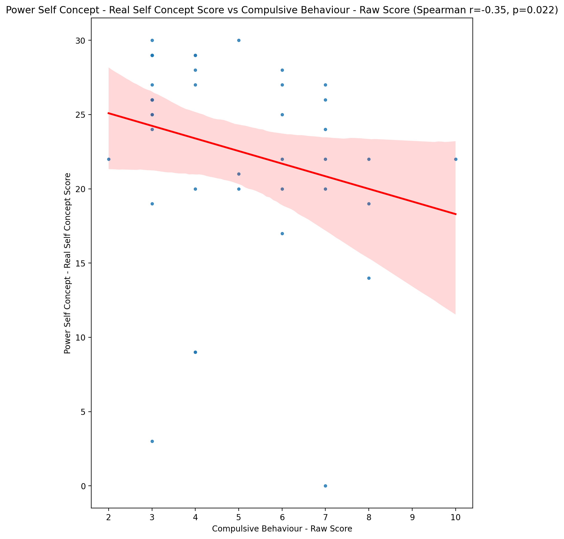

## Power Self Concept - Ideal Self Concept score vs Compulsive Behaviour - Raw Score

Test: spearman; statistic: -0.32444721119617764; p-value: 0.03378354881234858;

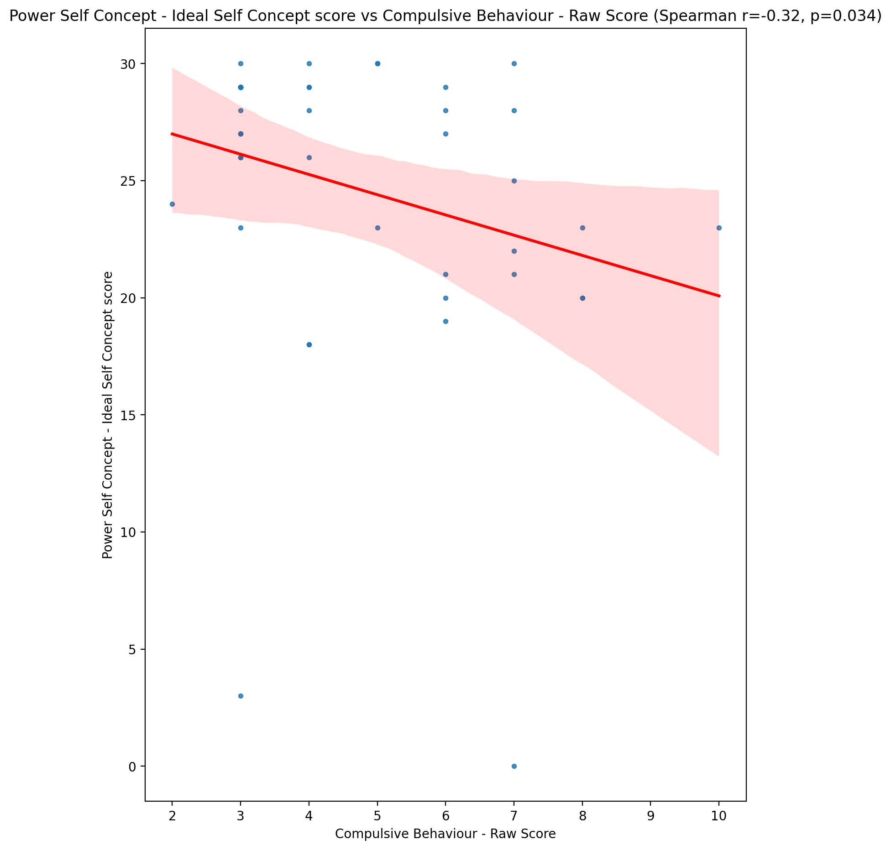

## Power Self Concept – Social Self Concept Score vs Compulsive Behaviour - Raw Score

Test: spearman; statistic: -0.5971343656320519; p-value: 2.3682389705624092e-05;

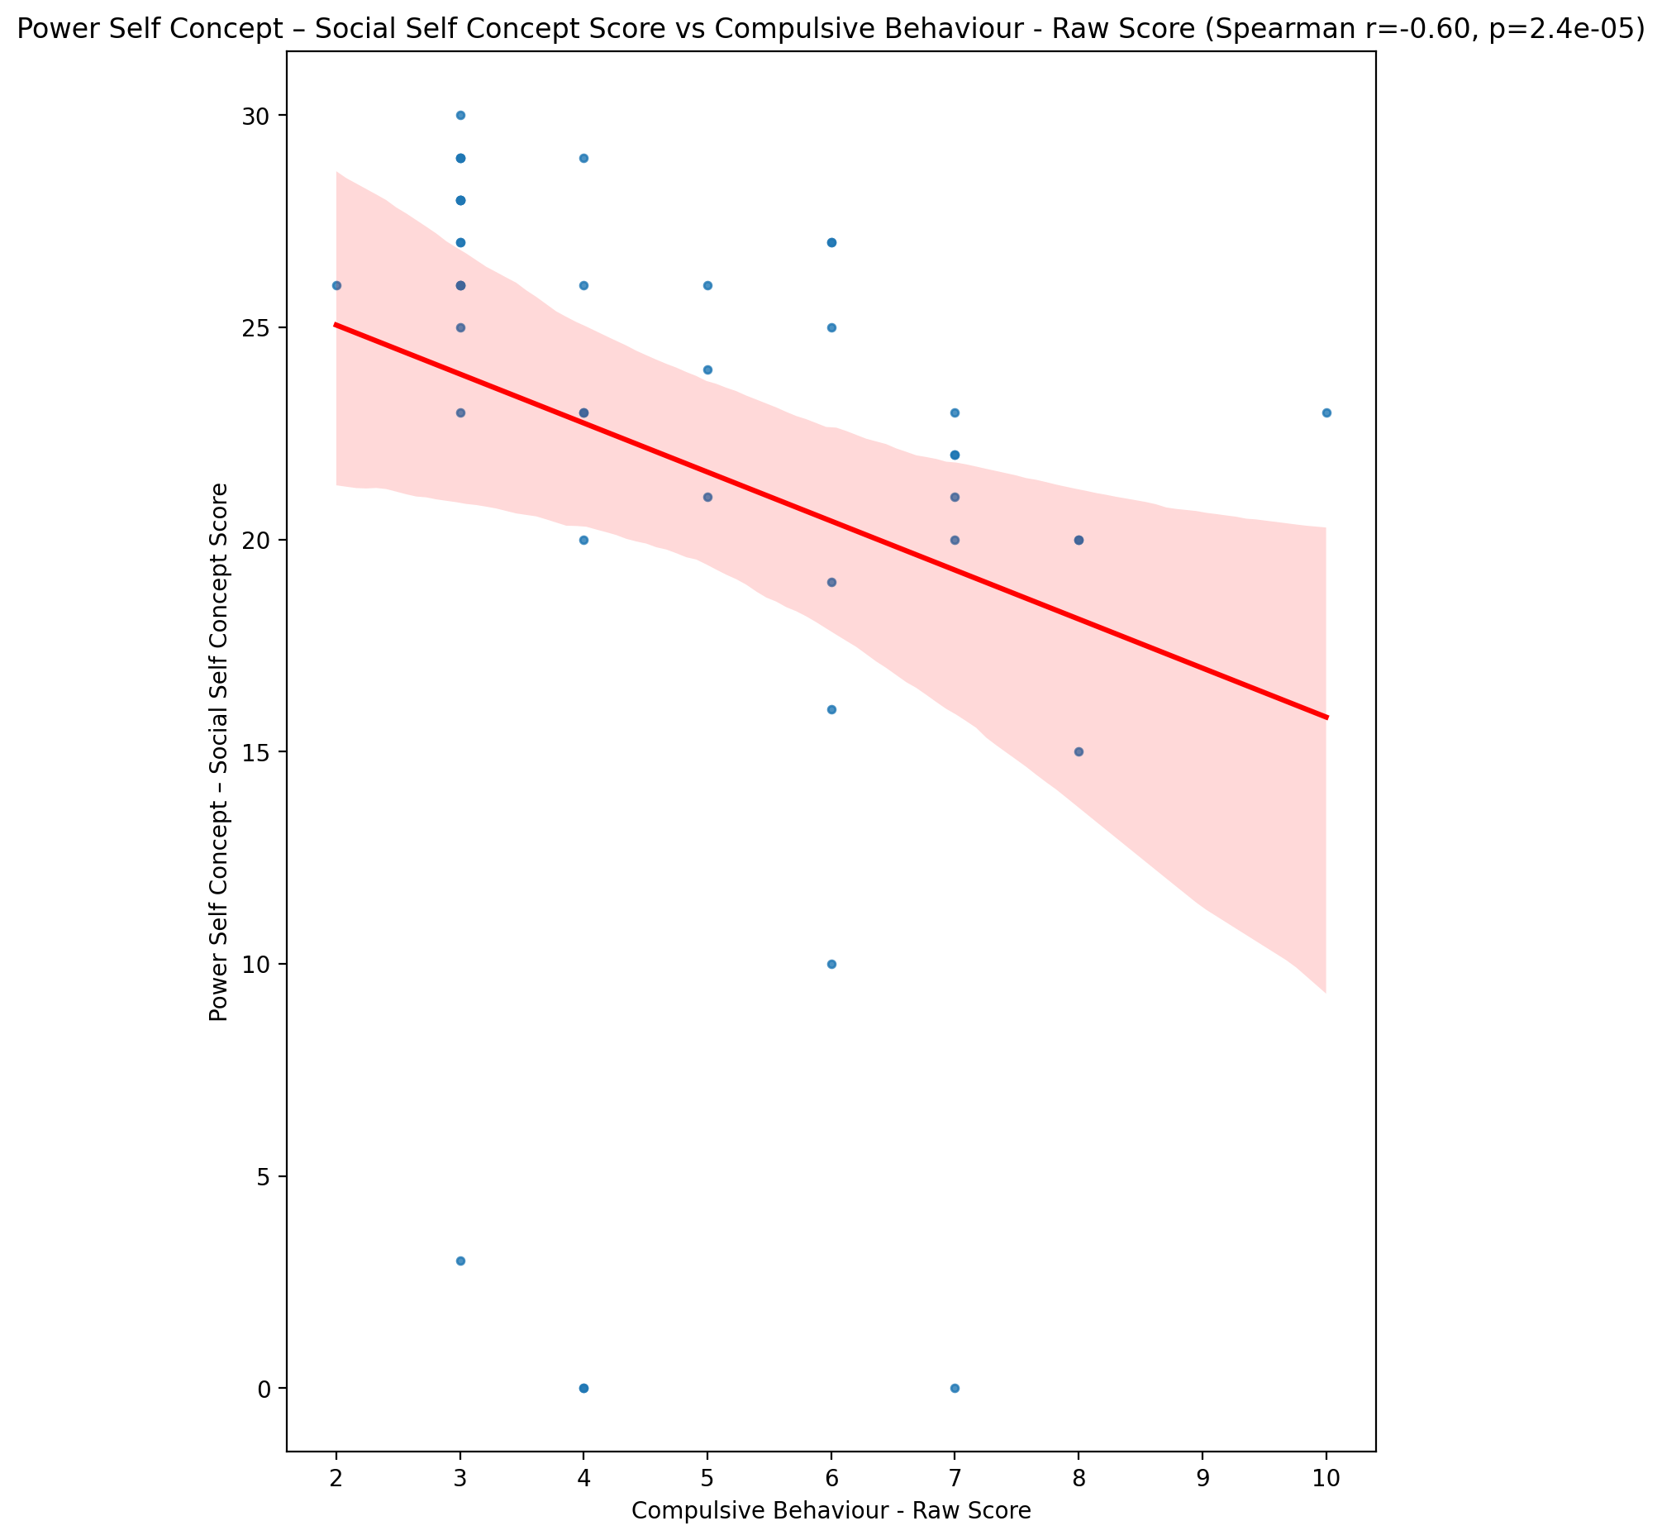

## Social Self Concept - Real Self Concept Score vs Compulsive Behaviour - Raw Score

Test: spearman; statistic: -0.5055189649580306; p-value: 0.0005445879070848674;

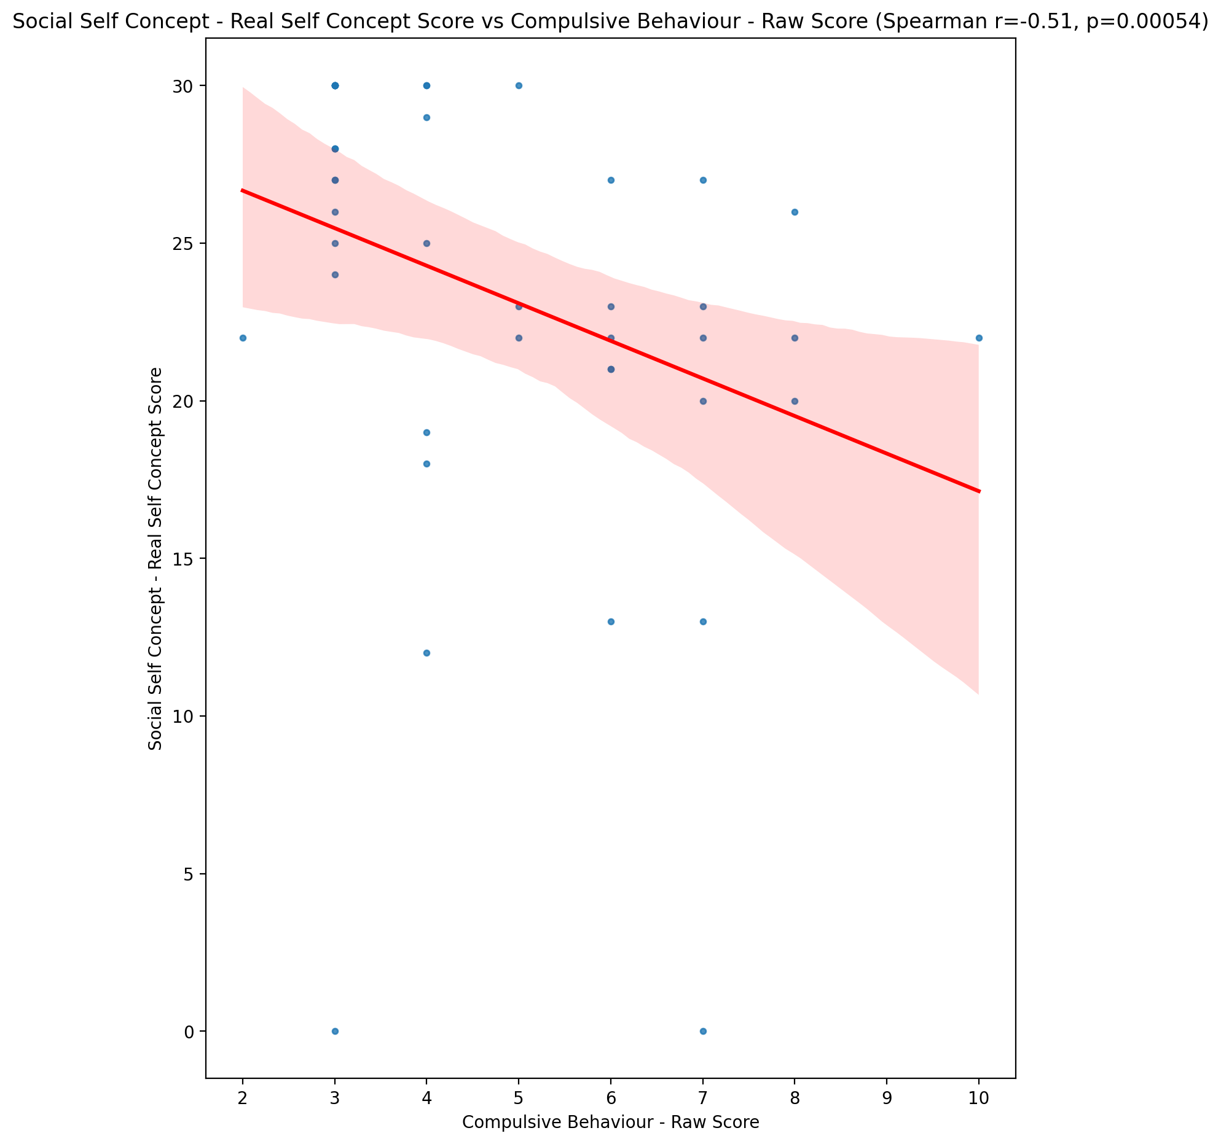

## Social Self Concept – Social Self Concept Score vs Compulsive Behaviour - Raw Score

Test: spearman; statistic: -0.6270165899242539; p-value: 6.828912421620542e-06;

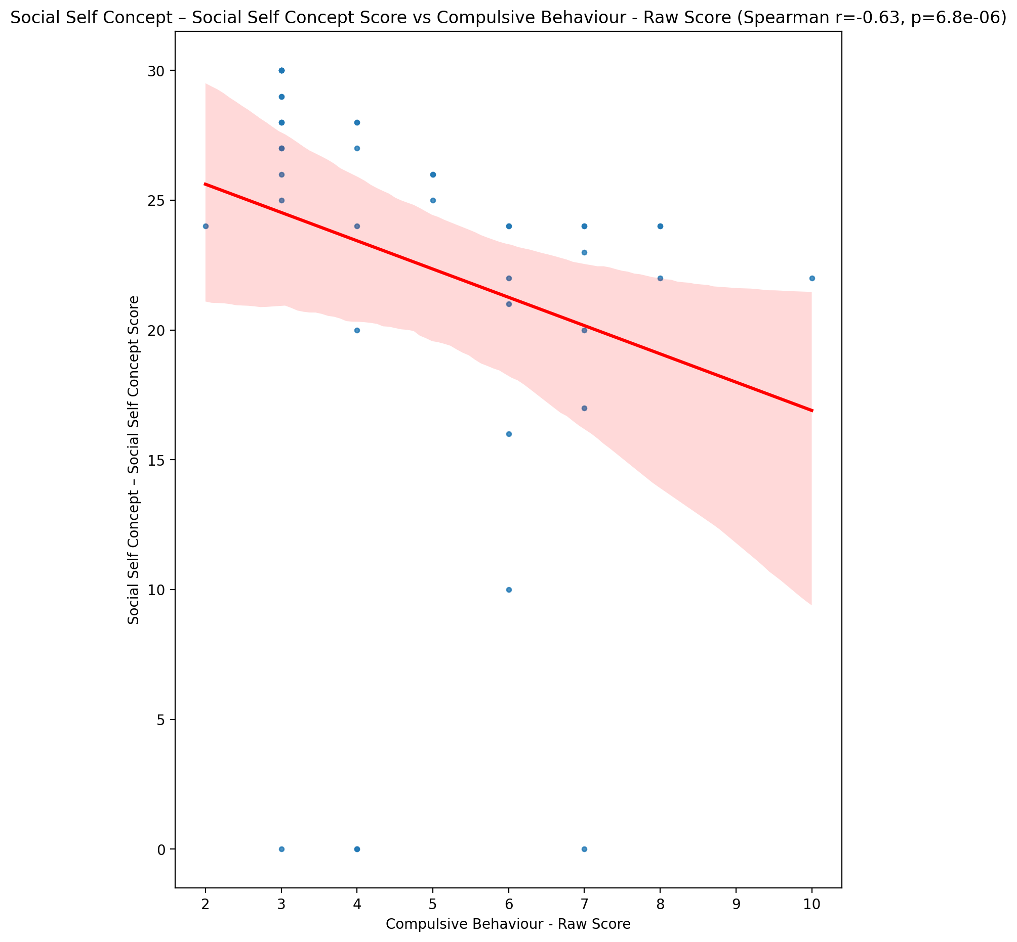

## Ability Self Concept - Real Self Concept Score vs Compulsive Behaviour - Raw Score

Test: spearman; statistic: -0.3360716625116638; p-value: 0.027569541782305203;

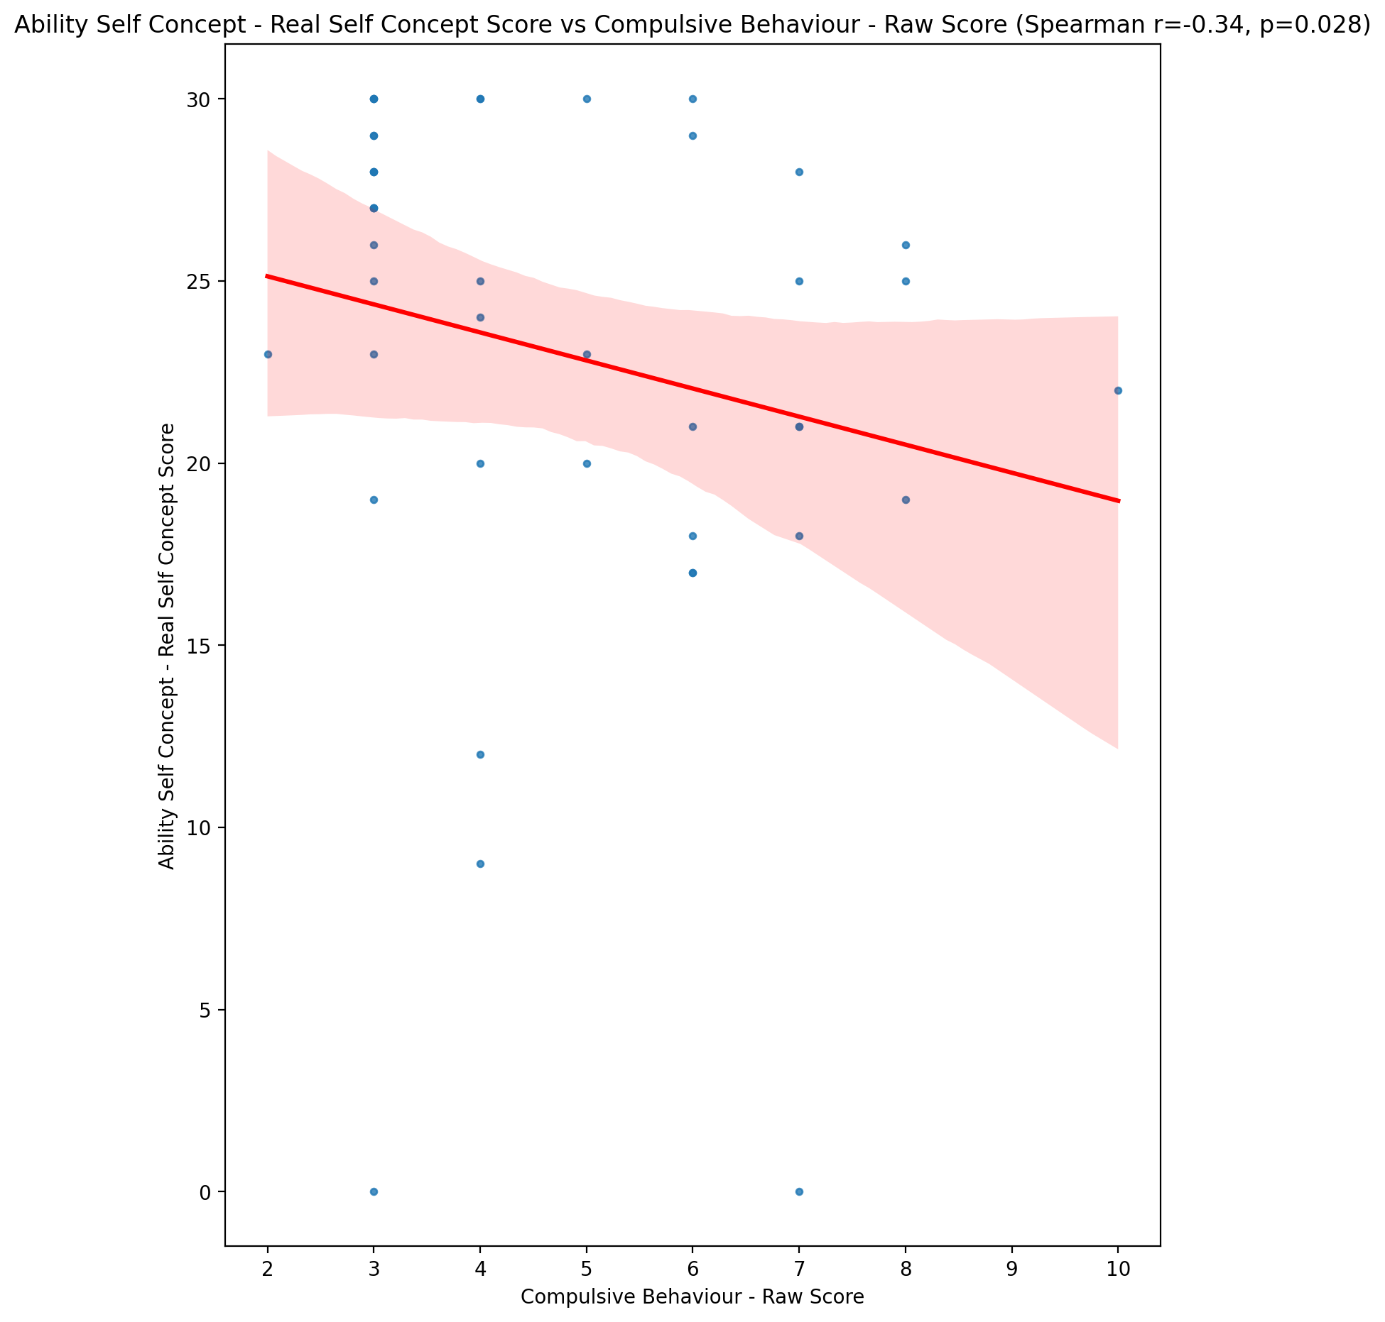

## Ability Self Concept - Ideal Self Concept Score vs Compulsive Behaviour - Raw Score

Test: spearman; statistic: -0.355079953434253; p-value: 0.01946449691650352;

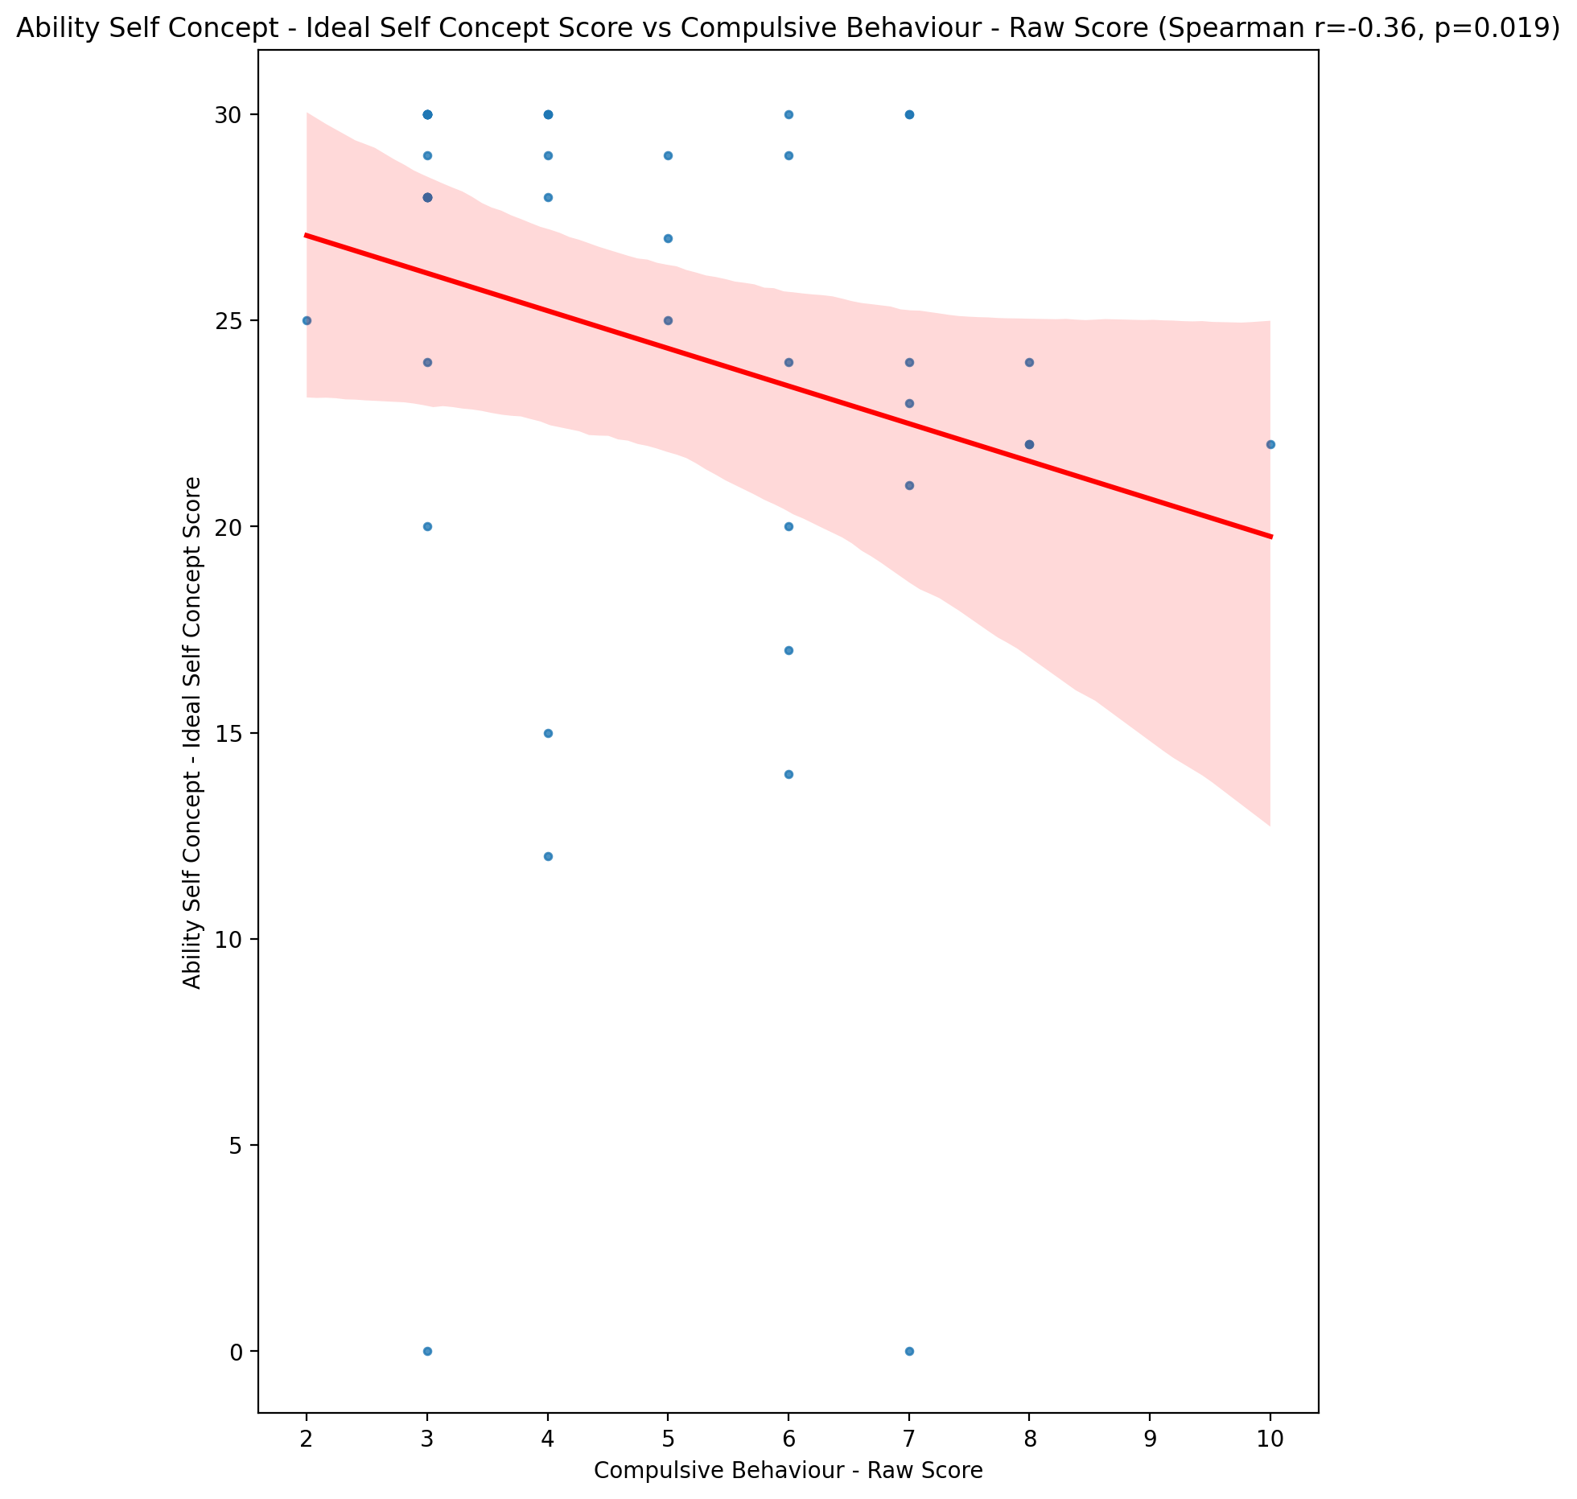

## Ability Self Concept – Social Self Concept Score vs Compulsive Behaviour - Raw Score

Test: spearman; statistic: -0.4505839907915589; p-value: 0.0024285800870769737;

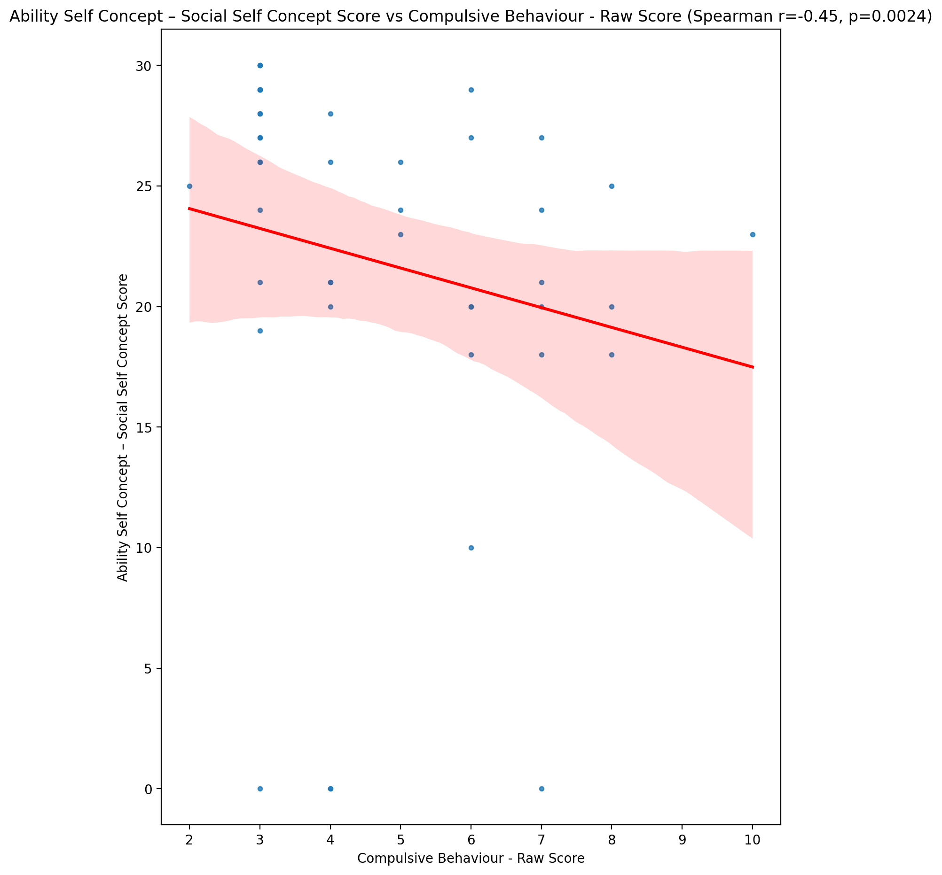

## Physical Self Concept - Real Self Concept Score vs Compulsive Behaviour - Raw Score

Test: spearman; statistic: -0.5242057554693758; p-value: 0.00030854626694123245;

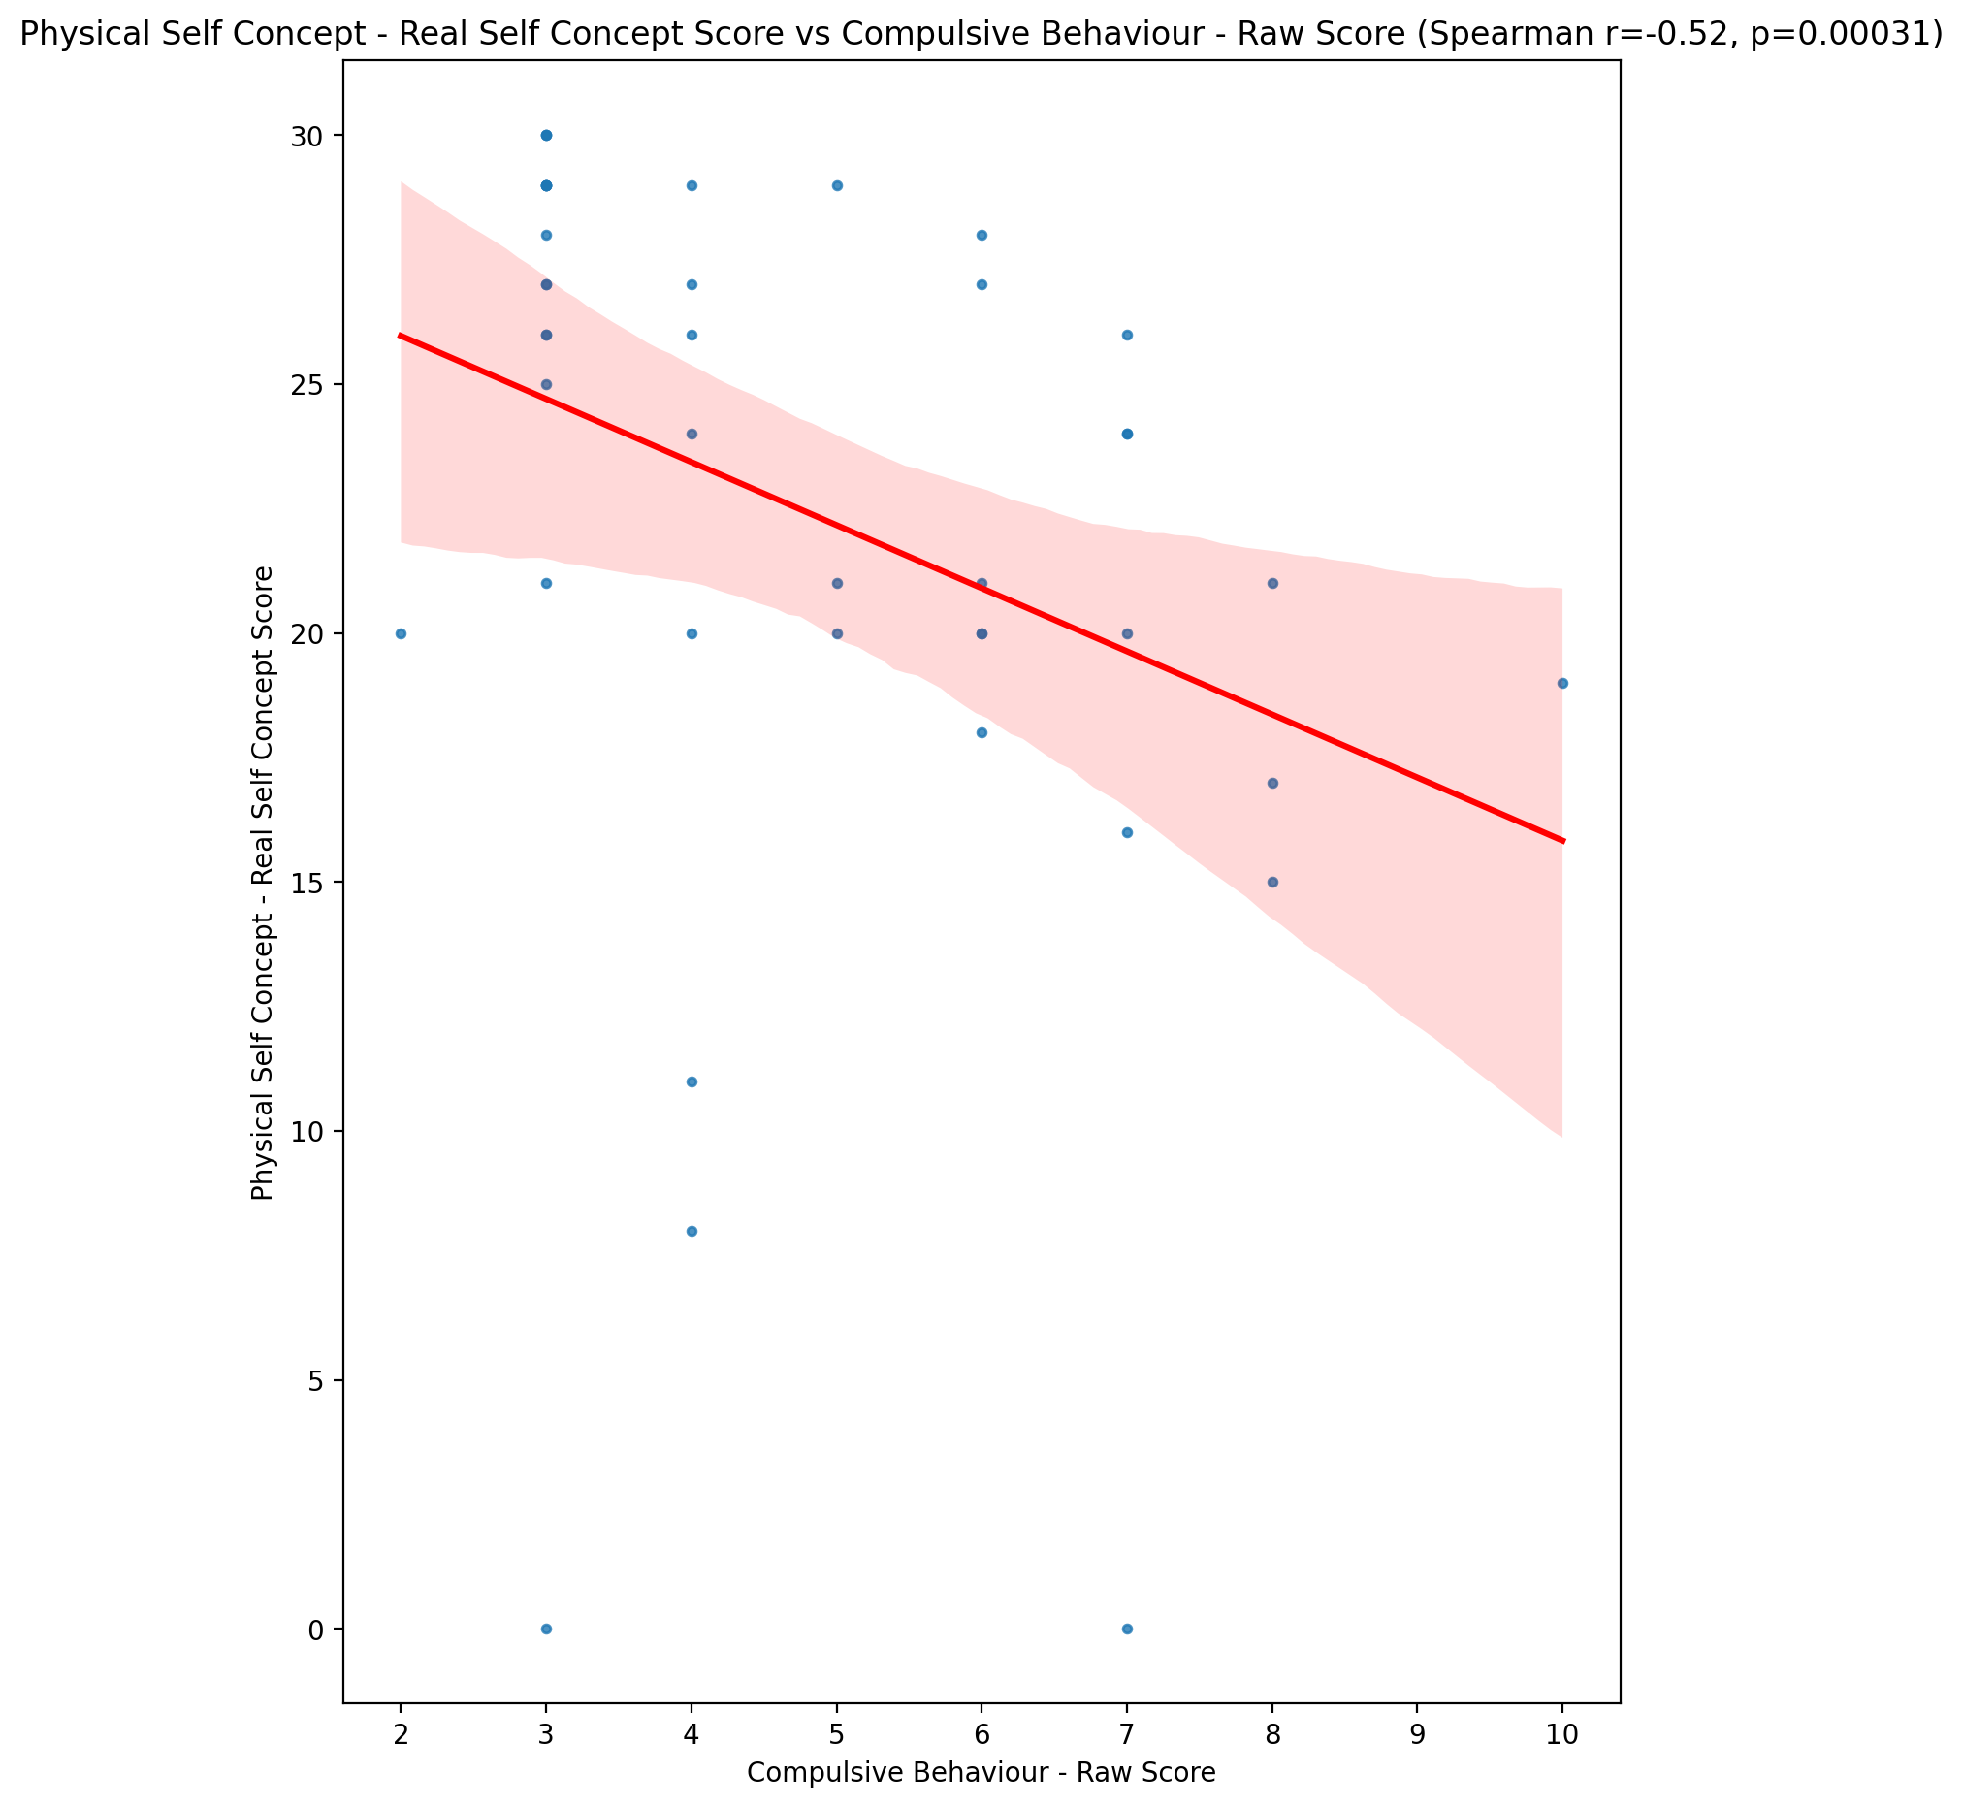

## Physical Self Concept – Ideal Self Concept Score vs Compulsive Behaviour - Raw Score

Test: spearman; statistic: -0.4280921304432696; p-value: 0.004186571191357492;

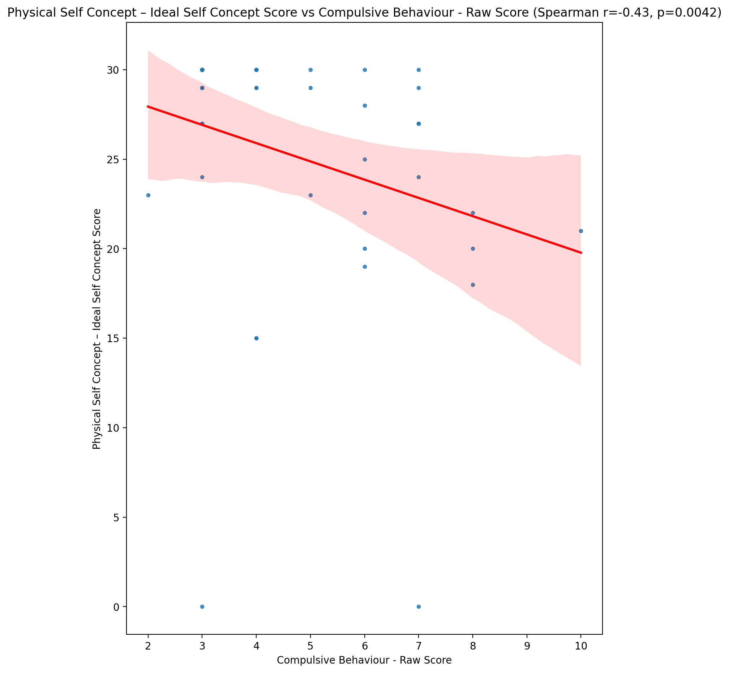

## Physical Self Concept – Social Self Concept Score vs Compulsive Behaviour - Raw Score

Test: spearman; statistic: -0.4958782954863421; p-value: 0.0007210223433888703;

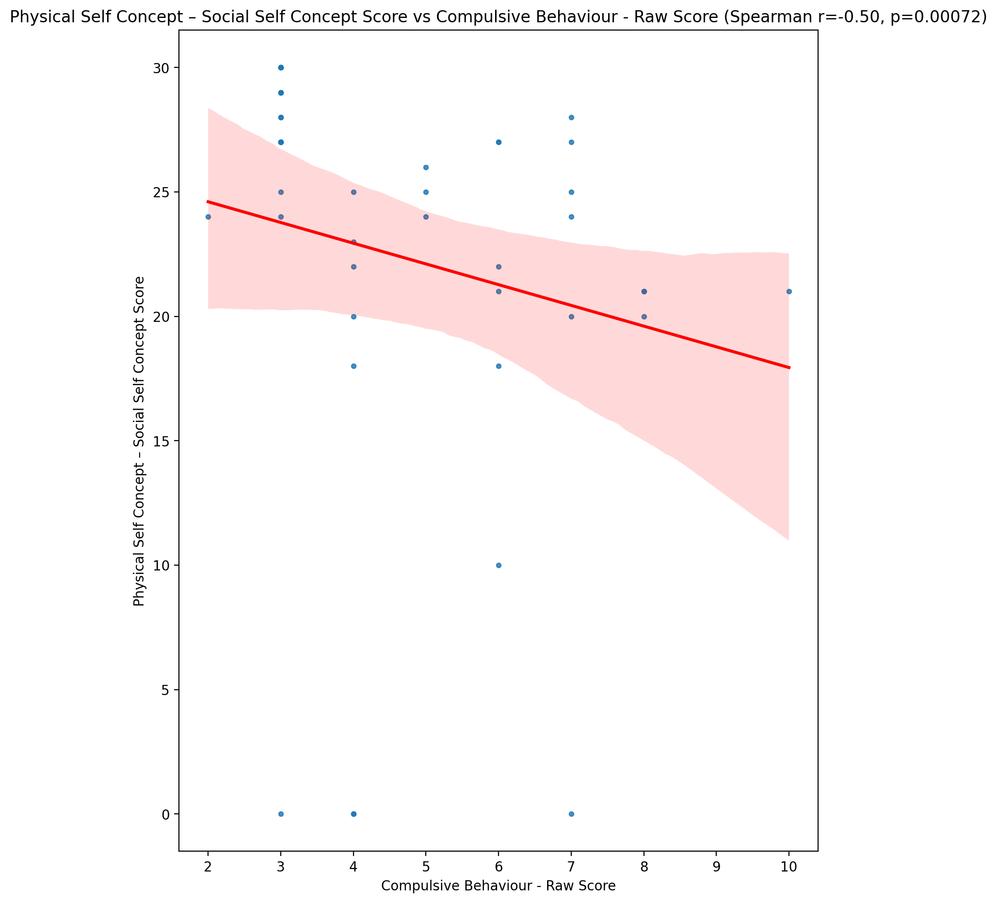

## Psychological Self Concept - Real Self Concept Score vs Compulsive Behaviour - Raw Score

Test: spearman; statistic: -0.4734672436687013; p-value: 0.0013423863796327615;

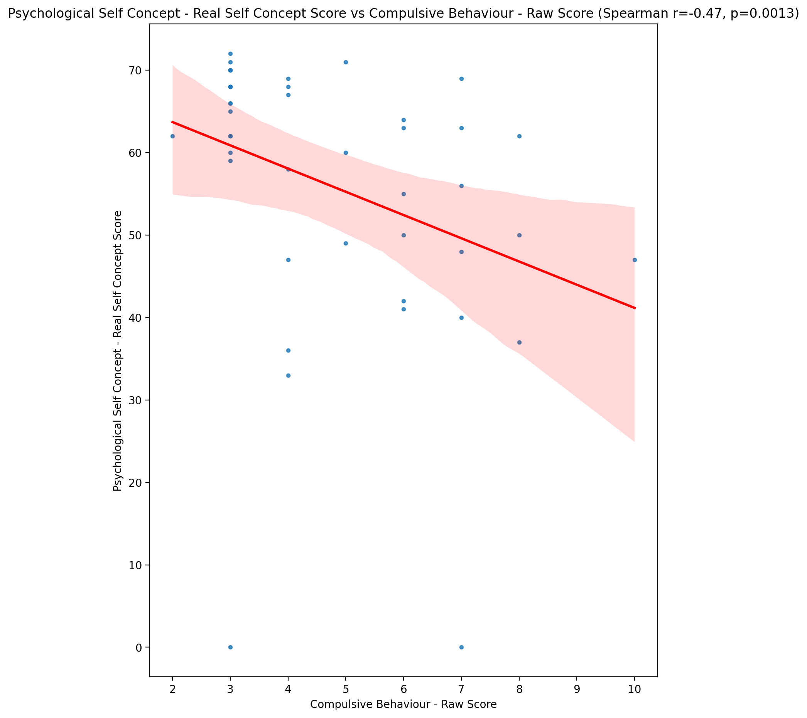

## Psychological Self Concept – Ideal Self Concept Score vs Compulsive Behaviour - Raw Score

Test: spearman; statistic: -0.34195237300647446; p-value: 0.02480711638465881;

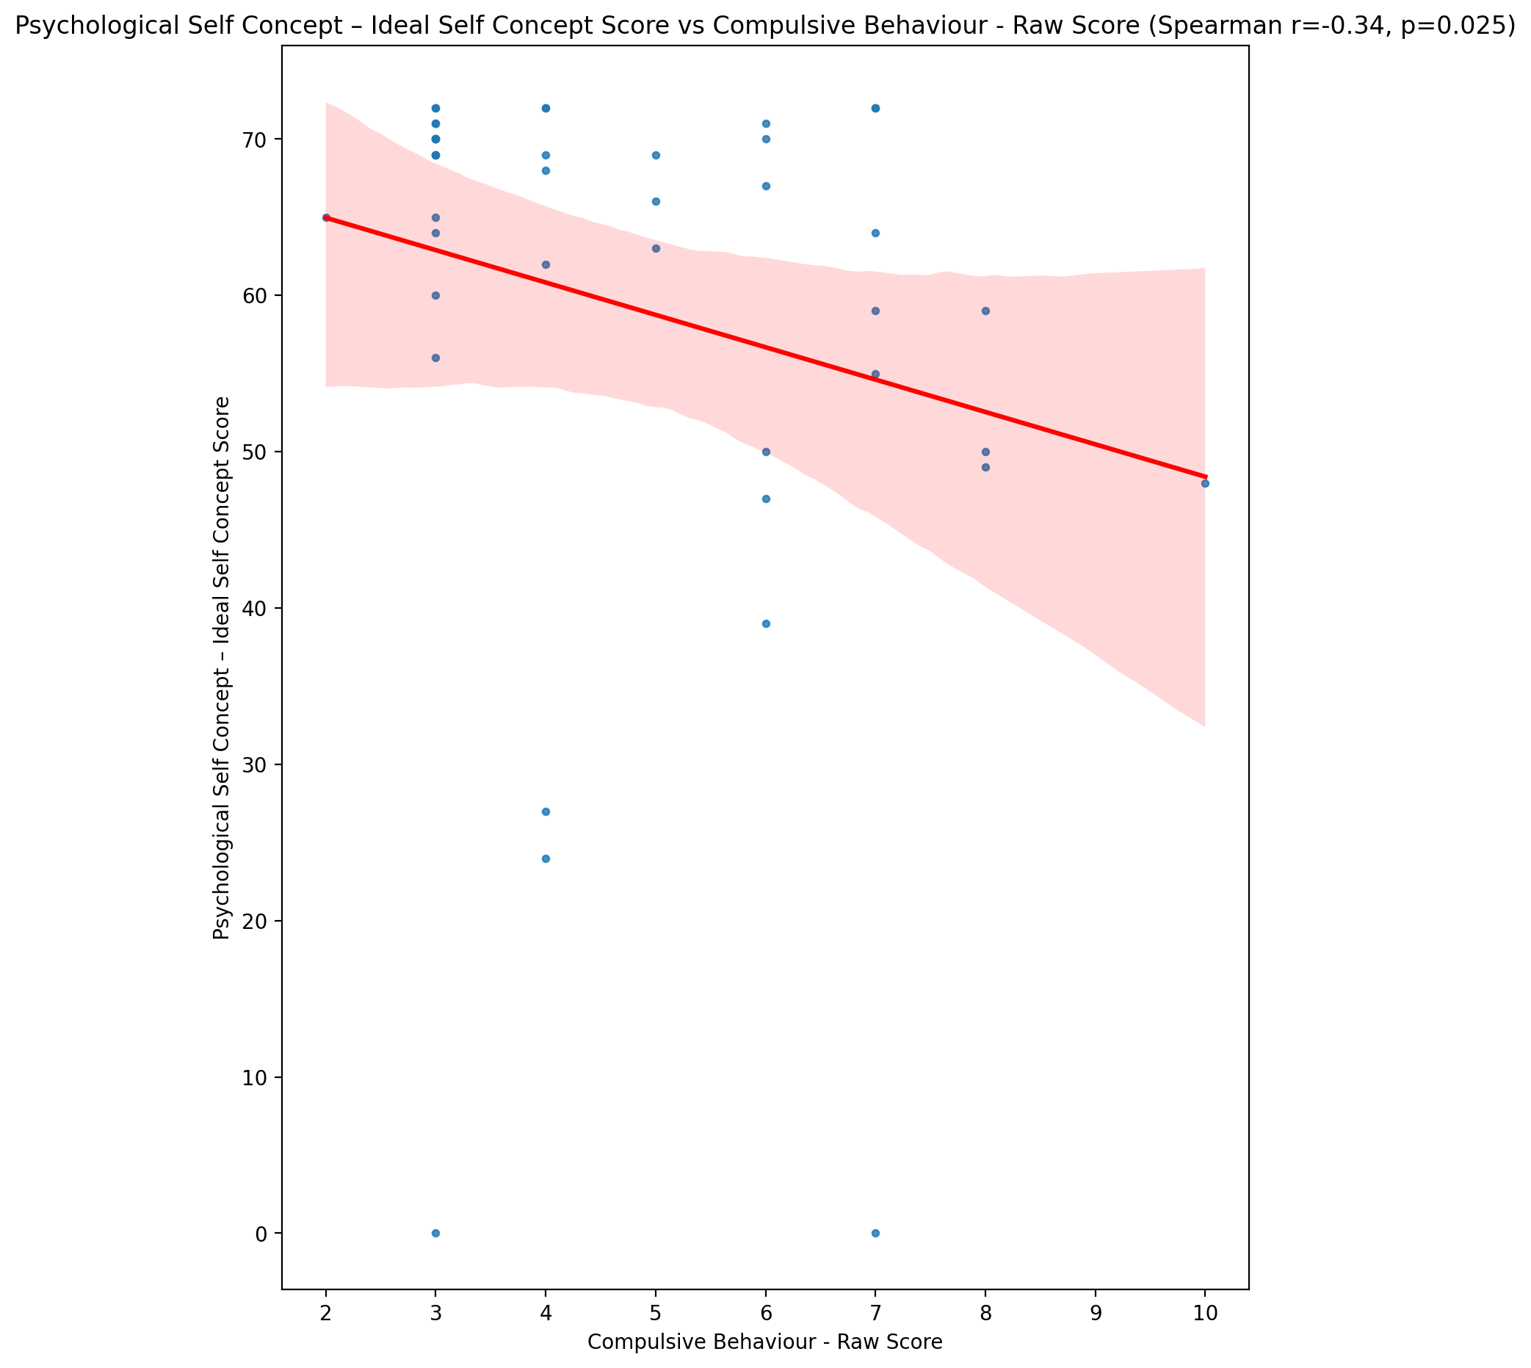

## Psychological Self Concept – Social Self Concept Score vs Compulsive Behaviour - Raw Score

Test: spearman; statistic: -0.608585283071328; p-value: 1.4926275763752764e-05;

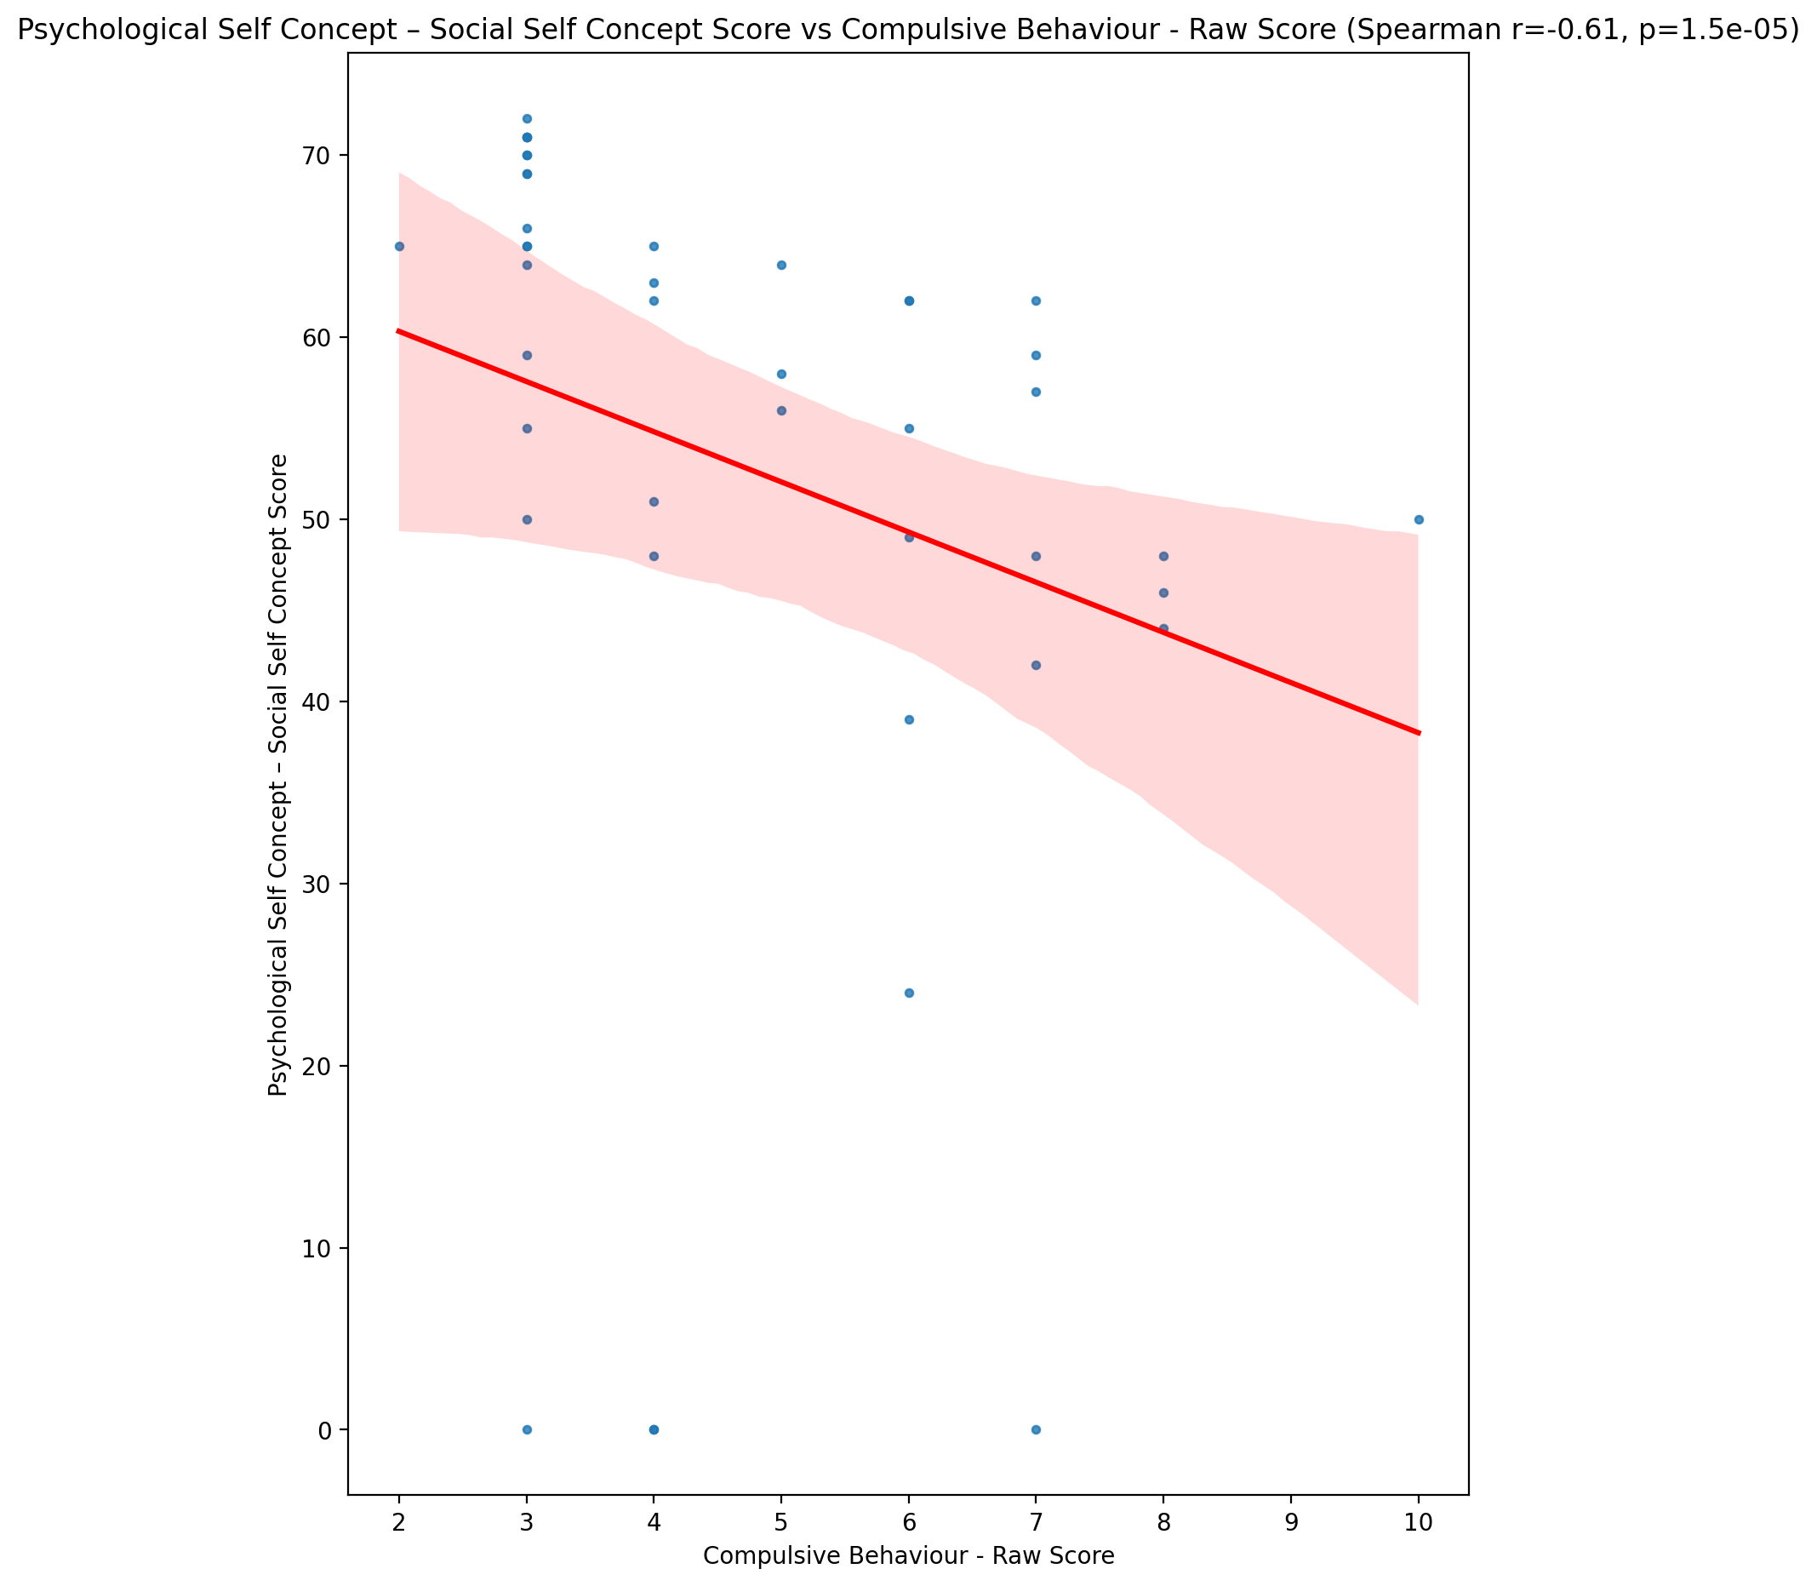

## Real Self Concept Total Score vs Compulsive Behaviour - Raw Score

Test: spearman; statistic: -0.46823589244308544; p-value: 0.001542782226918845;

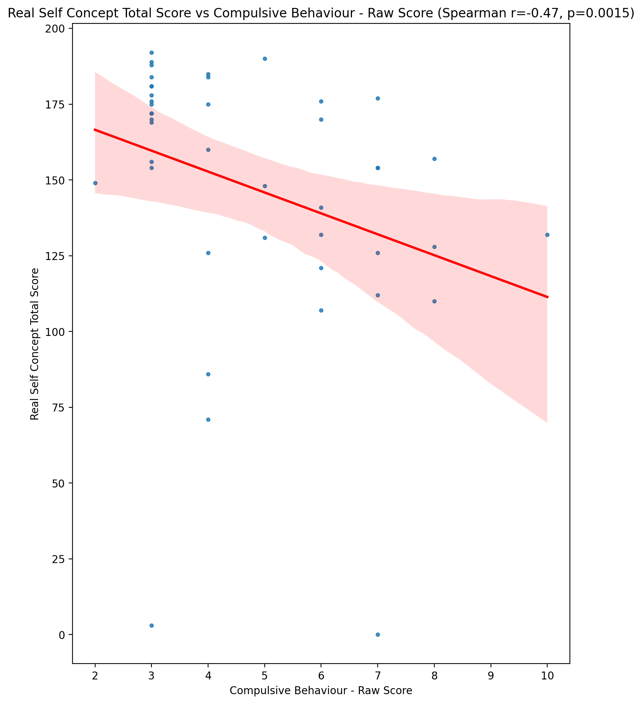

## Ideal Self Concept Total Score vs Compulsive Behaviour - Raw Score

Test: spearman; statistic: -0.3492344614984102; p-value: 0.021709980074278795;

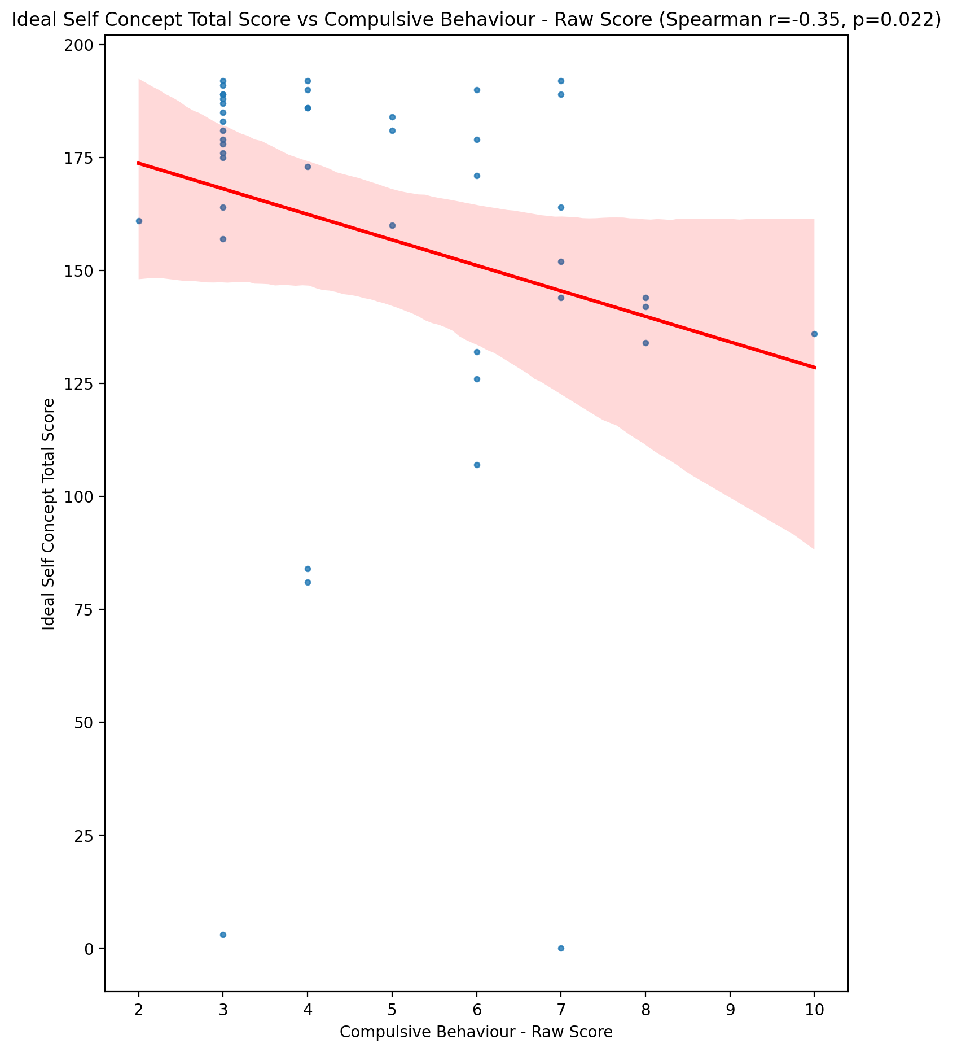

## Social Self Concept Total Score vs Compulsive Behaviour - Raw Score

Test: spearman; statistic: -0.6196776262346355; p-value: 9.379232048271658e-06;

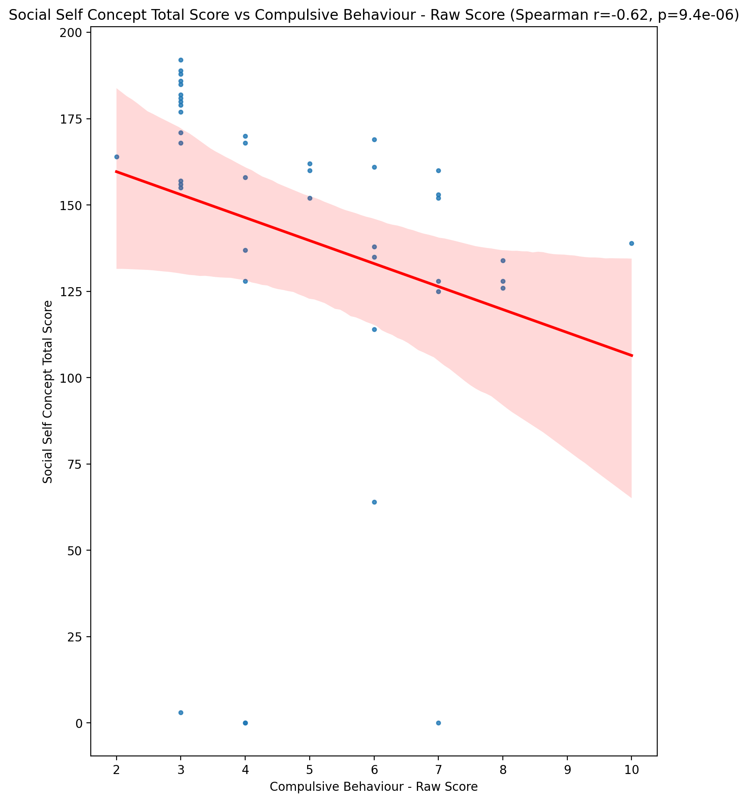

## Ideal Self Concept Total Category vs Compulsive Behaviour - Raw Score

Test: None; statistic: None; p-value: None; Test not run: unsupported type combination.



## Perceived Social Stress Score vs Compulsive Behaviour - Raw Score

Test: spearman; statistic: 0.2523061861850142; p-value: 0.10262505775971162;

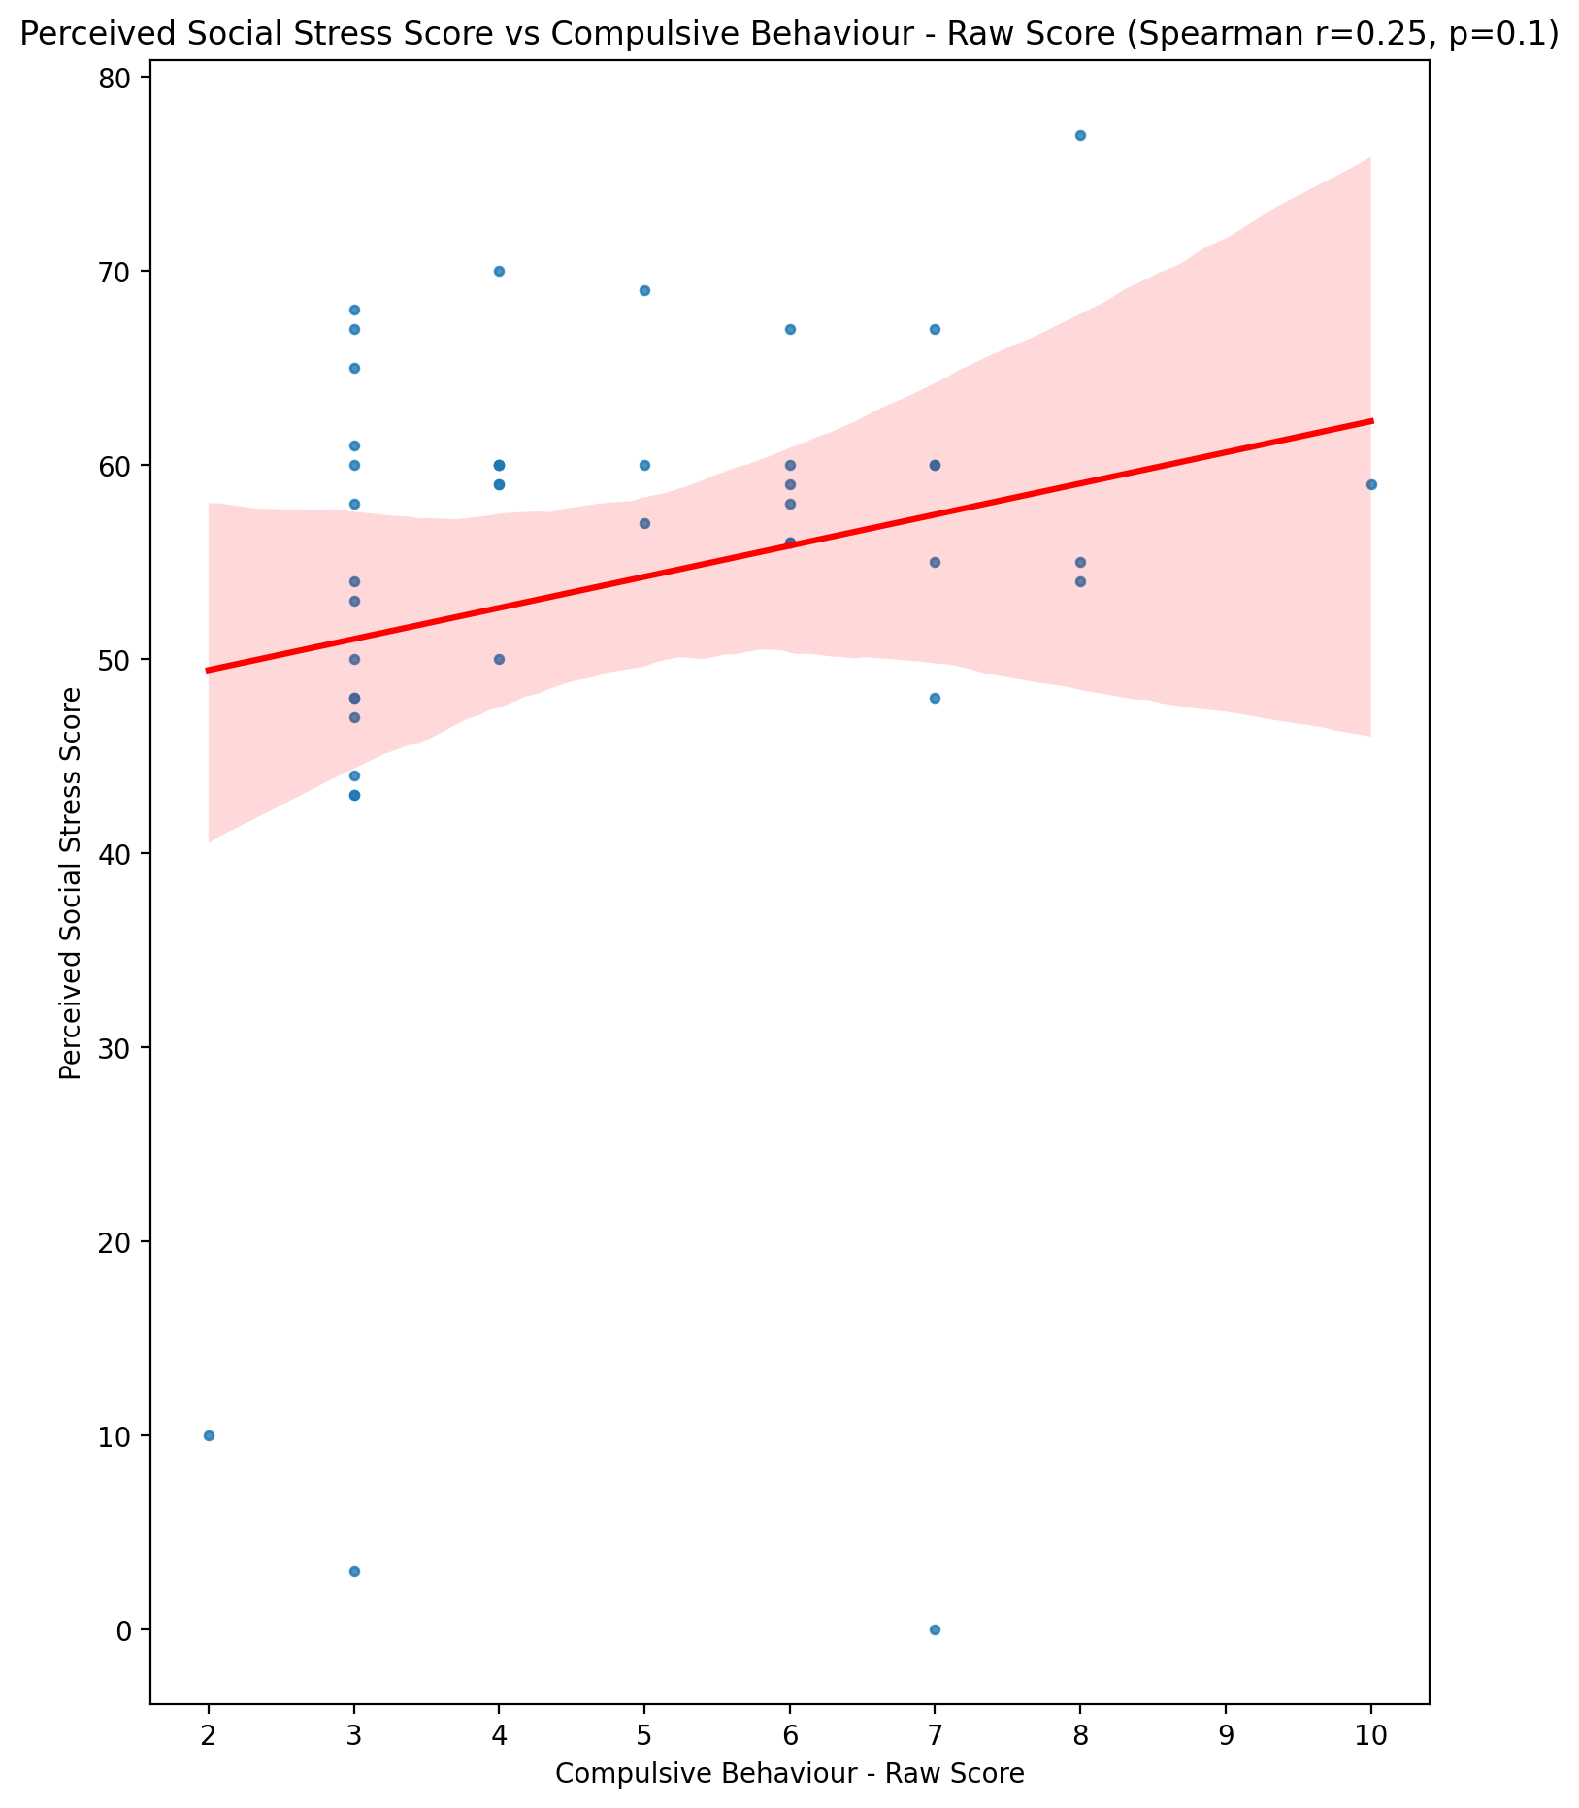

## Perceived Social Stress Category vs Compulsive Behaviour - Raw Score

Test: None; statistic: None; p-value: None; Test not run: unsupported type combination.



## Emotional Support - Raw Score vs Obsession with Internet - Raw Score

Test: spearman; statistic: -0.3511736478542488; p-value: 0.02094216580811693;

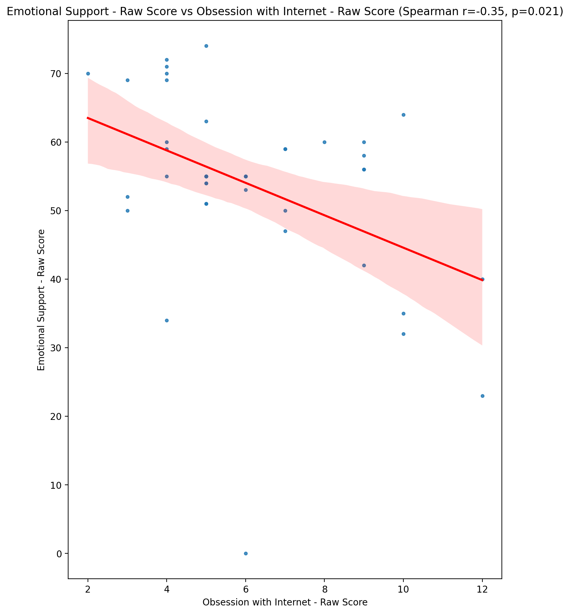

## Informational Support - Raw Score vs Obsession with Internet - Raw Score

Test: spearman; statistic: -0.34446397259950884; p-value: 0.02369975294394006;

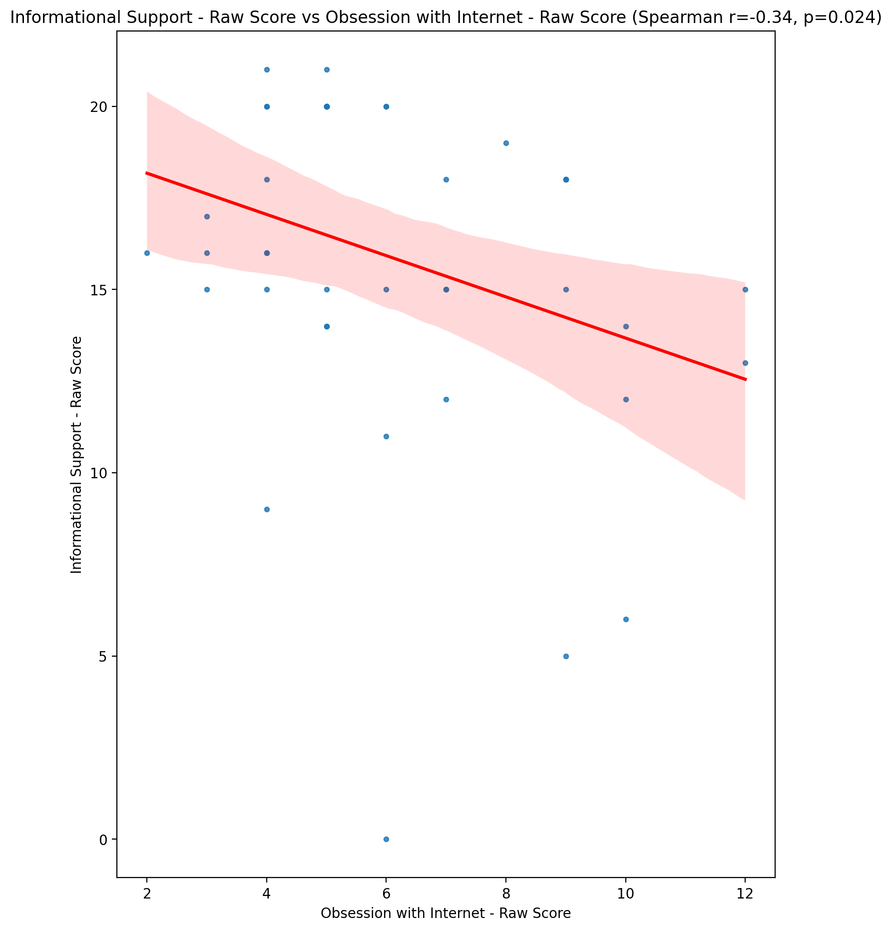

## Instrumental Support - Raw Score vs Obsession with Internet - Raw Score

Test: spearman; statistic: -0.5148777674746023; p-value: 0.000411399798192268;

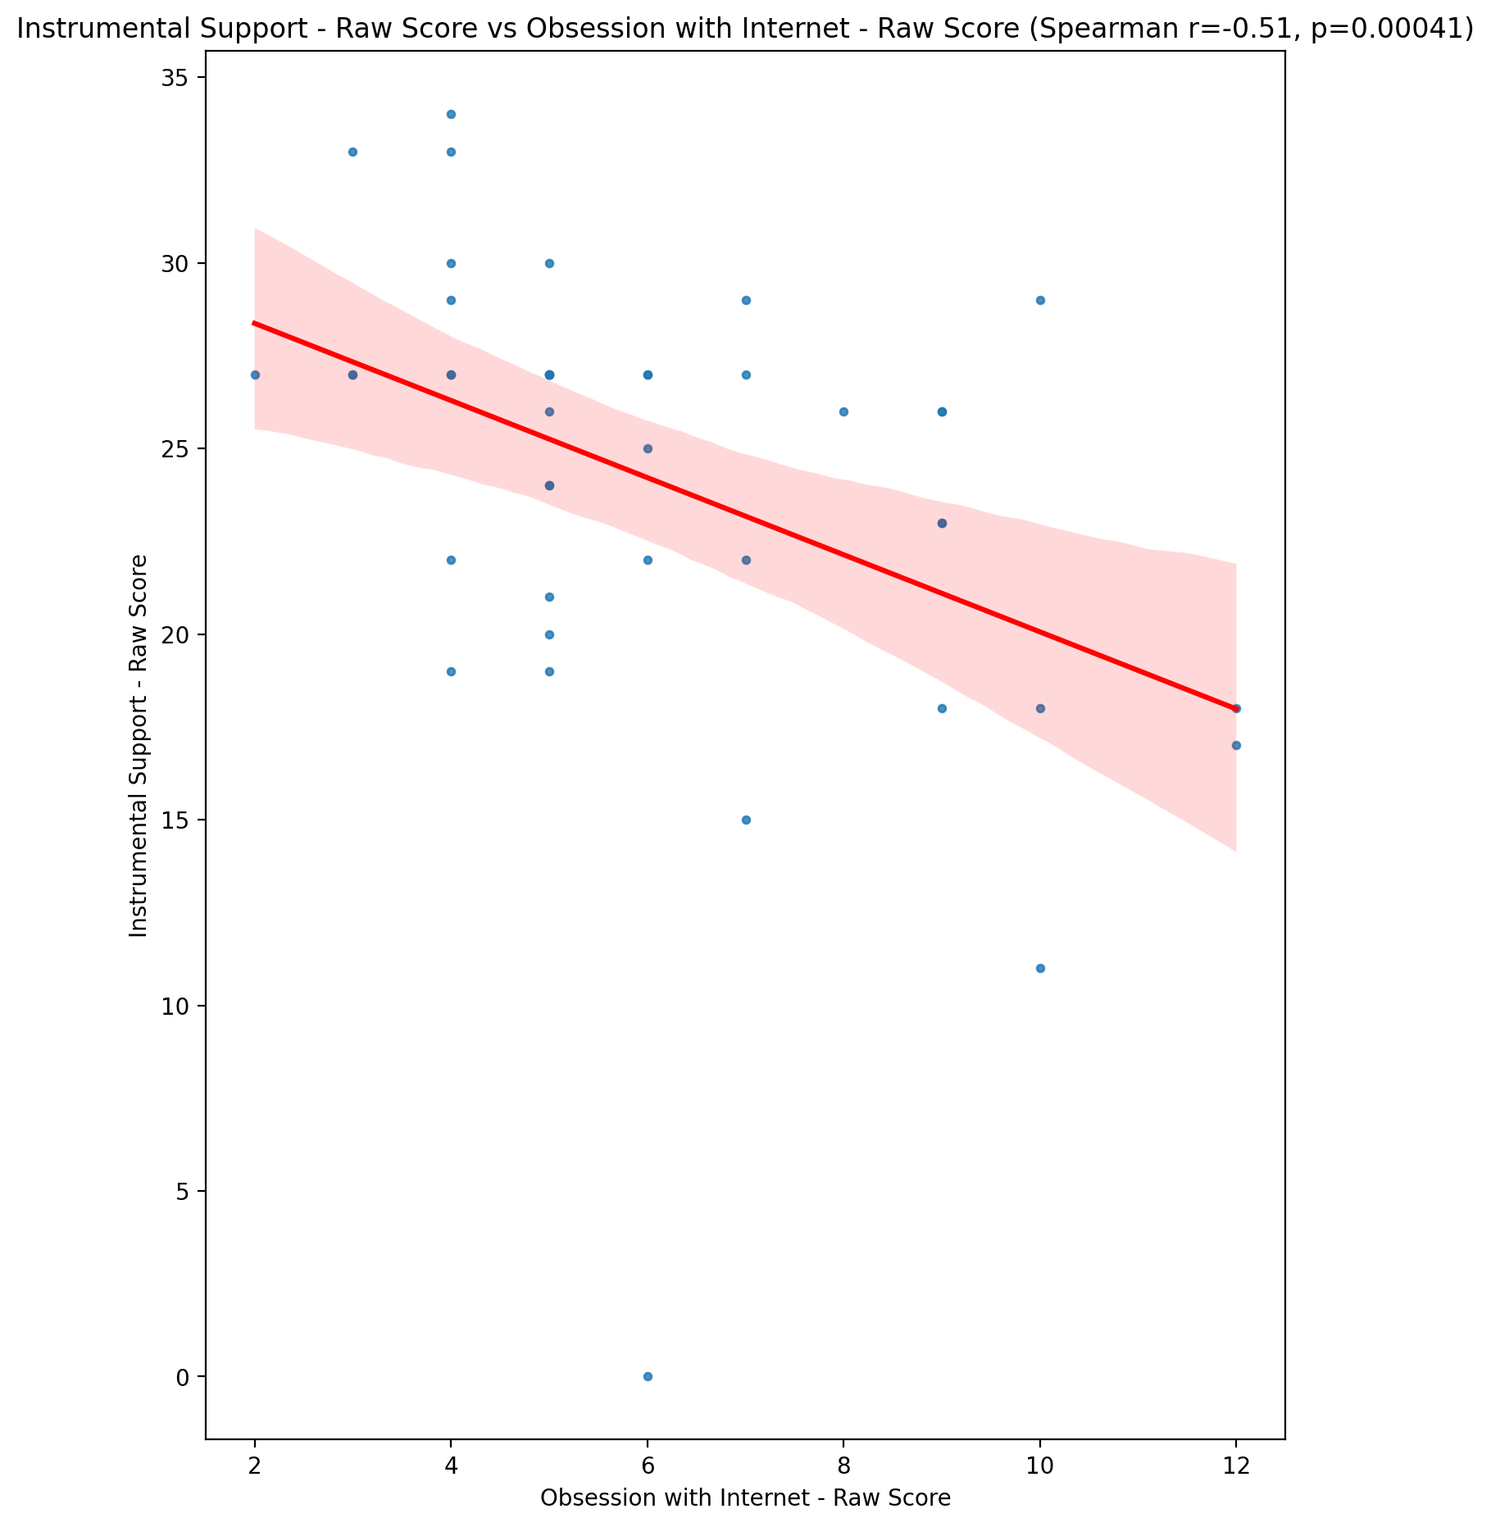

## Emotional Support - T Score vs Obsession with Internet - Raw Score

Test: spearman; statistic: -0.3285227229699166; p-value: 0.031485396679064005;

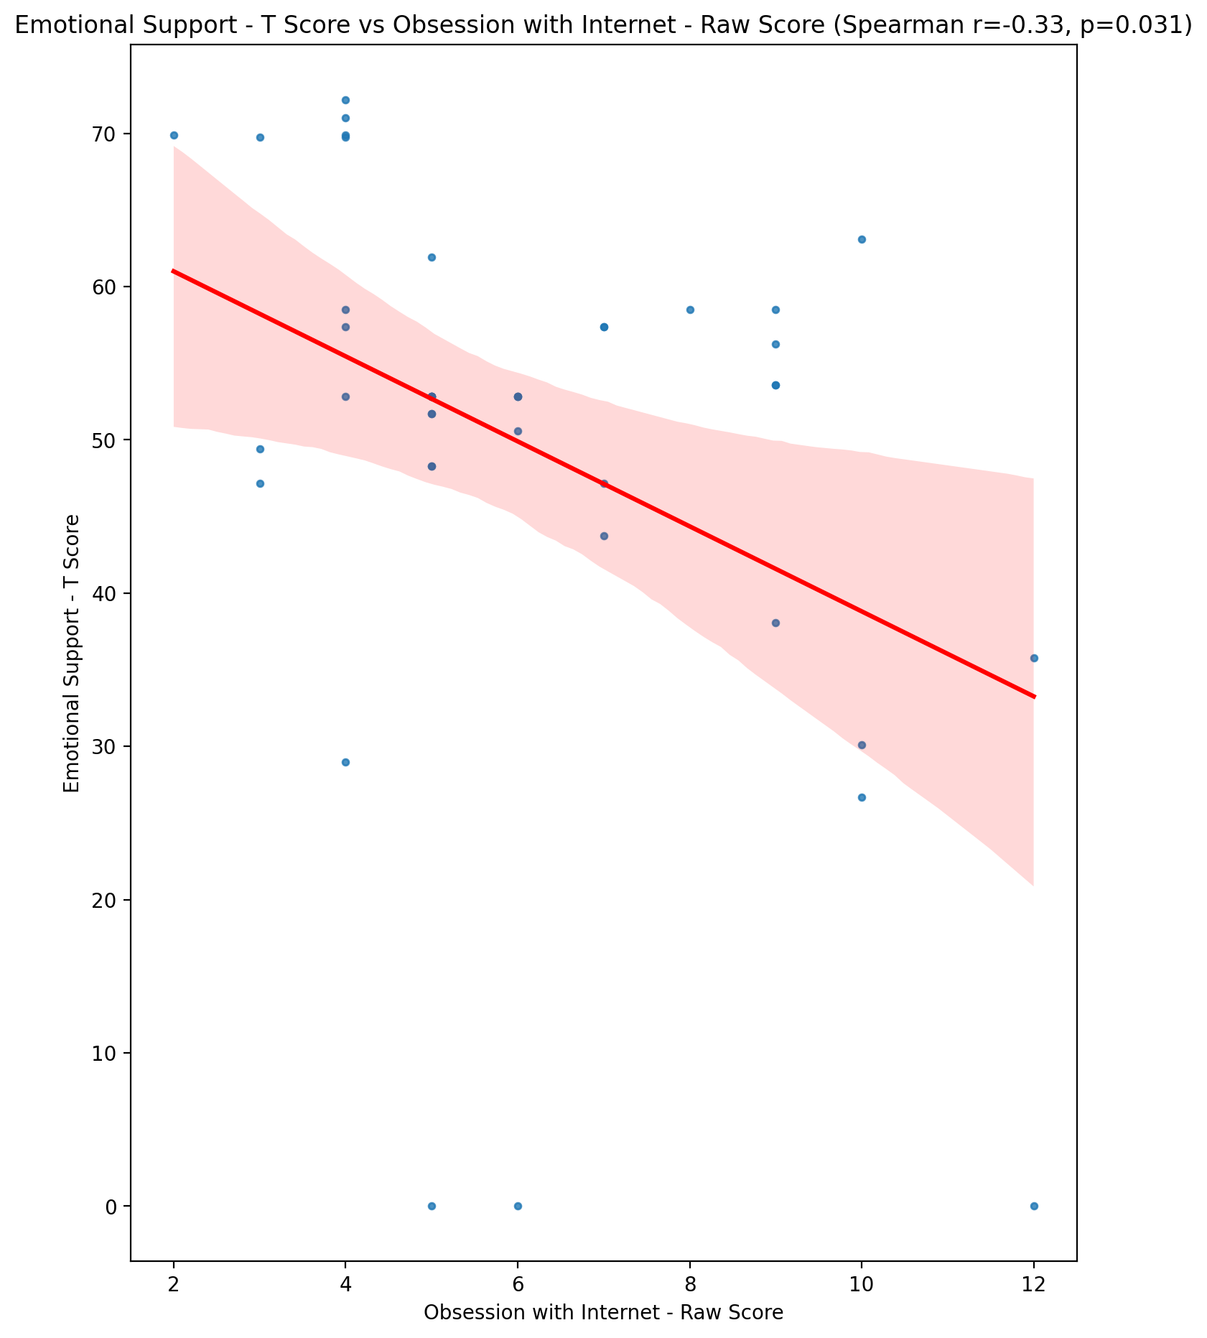

## Informational Support - T Score vs Obsession with Internet - Raw Score

Test: spearman; statistic: -0.3466895165924795; p-value: 0.022753305329379036;

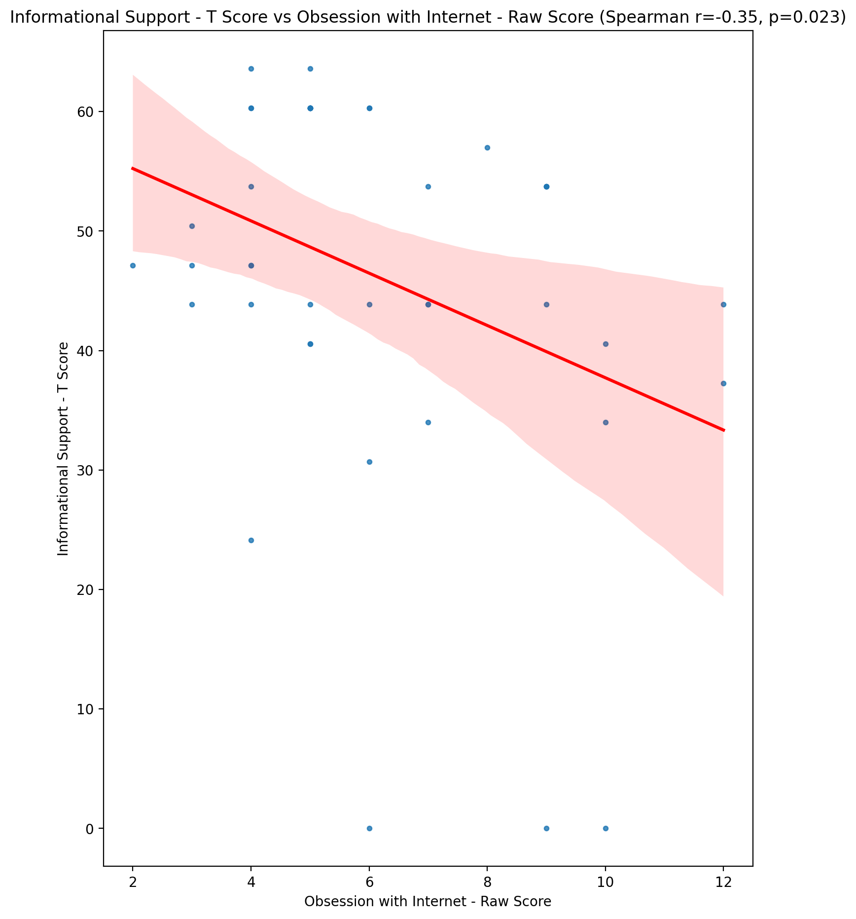

## Instrumental Support - T Score vs Obsession with Internet - Raw Score

Test: spearman; statistic: -0.51598248804675; p-value: 0.0003977900078102026;

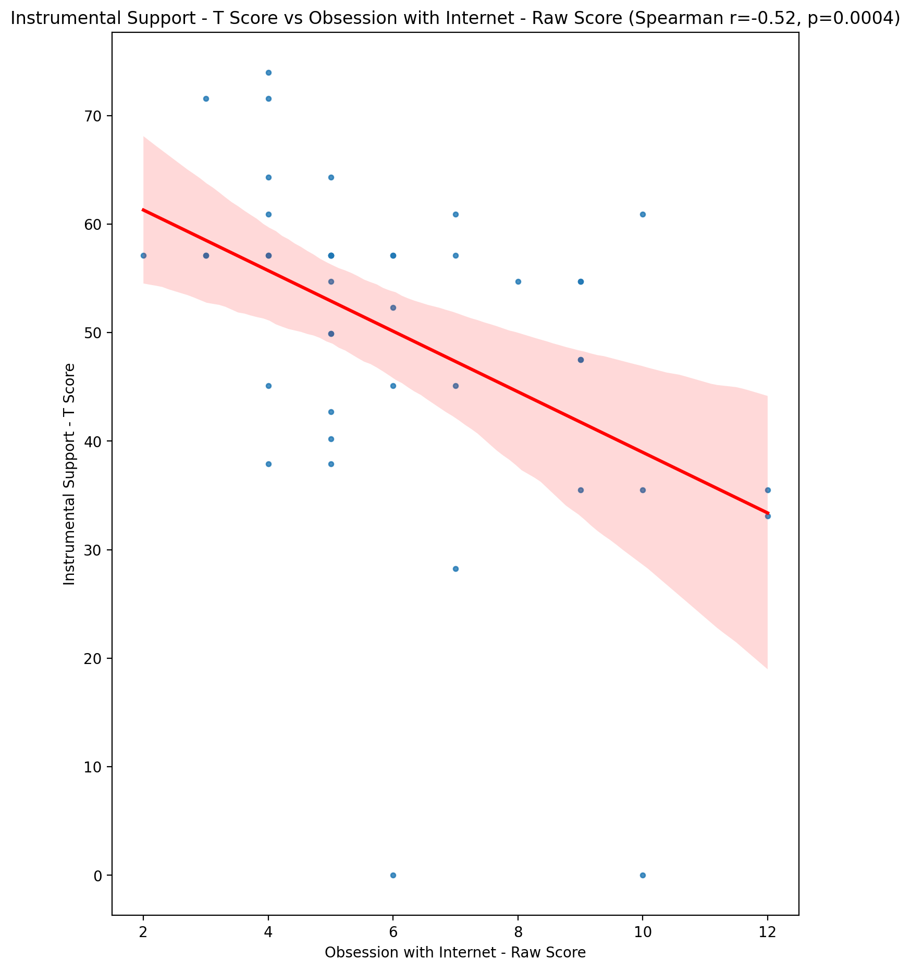

## Perceived Social Support Total T Score vs Obsession with Internet - Raw Score

Test: spearman; statistic: -0.4344606477761861; p-value: 0.0036015556022022327;

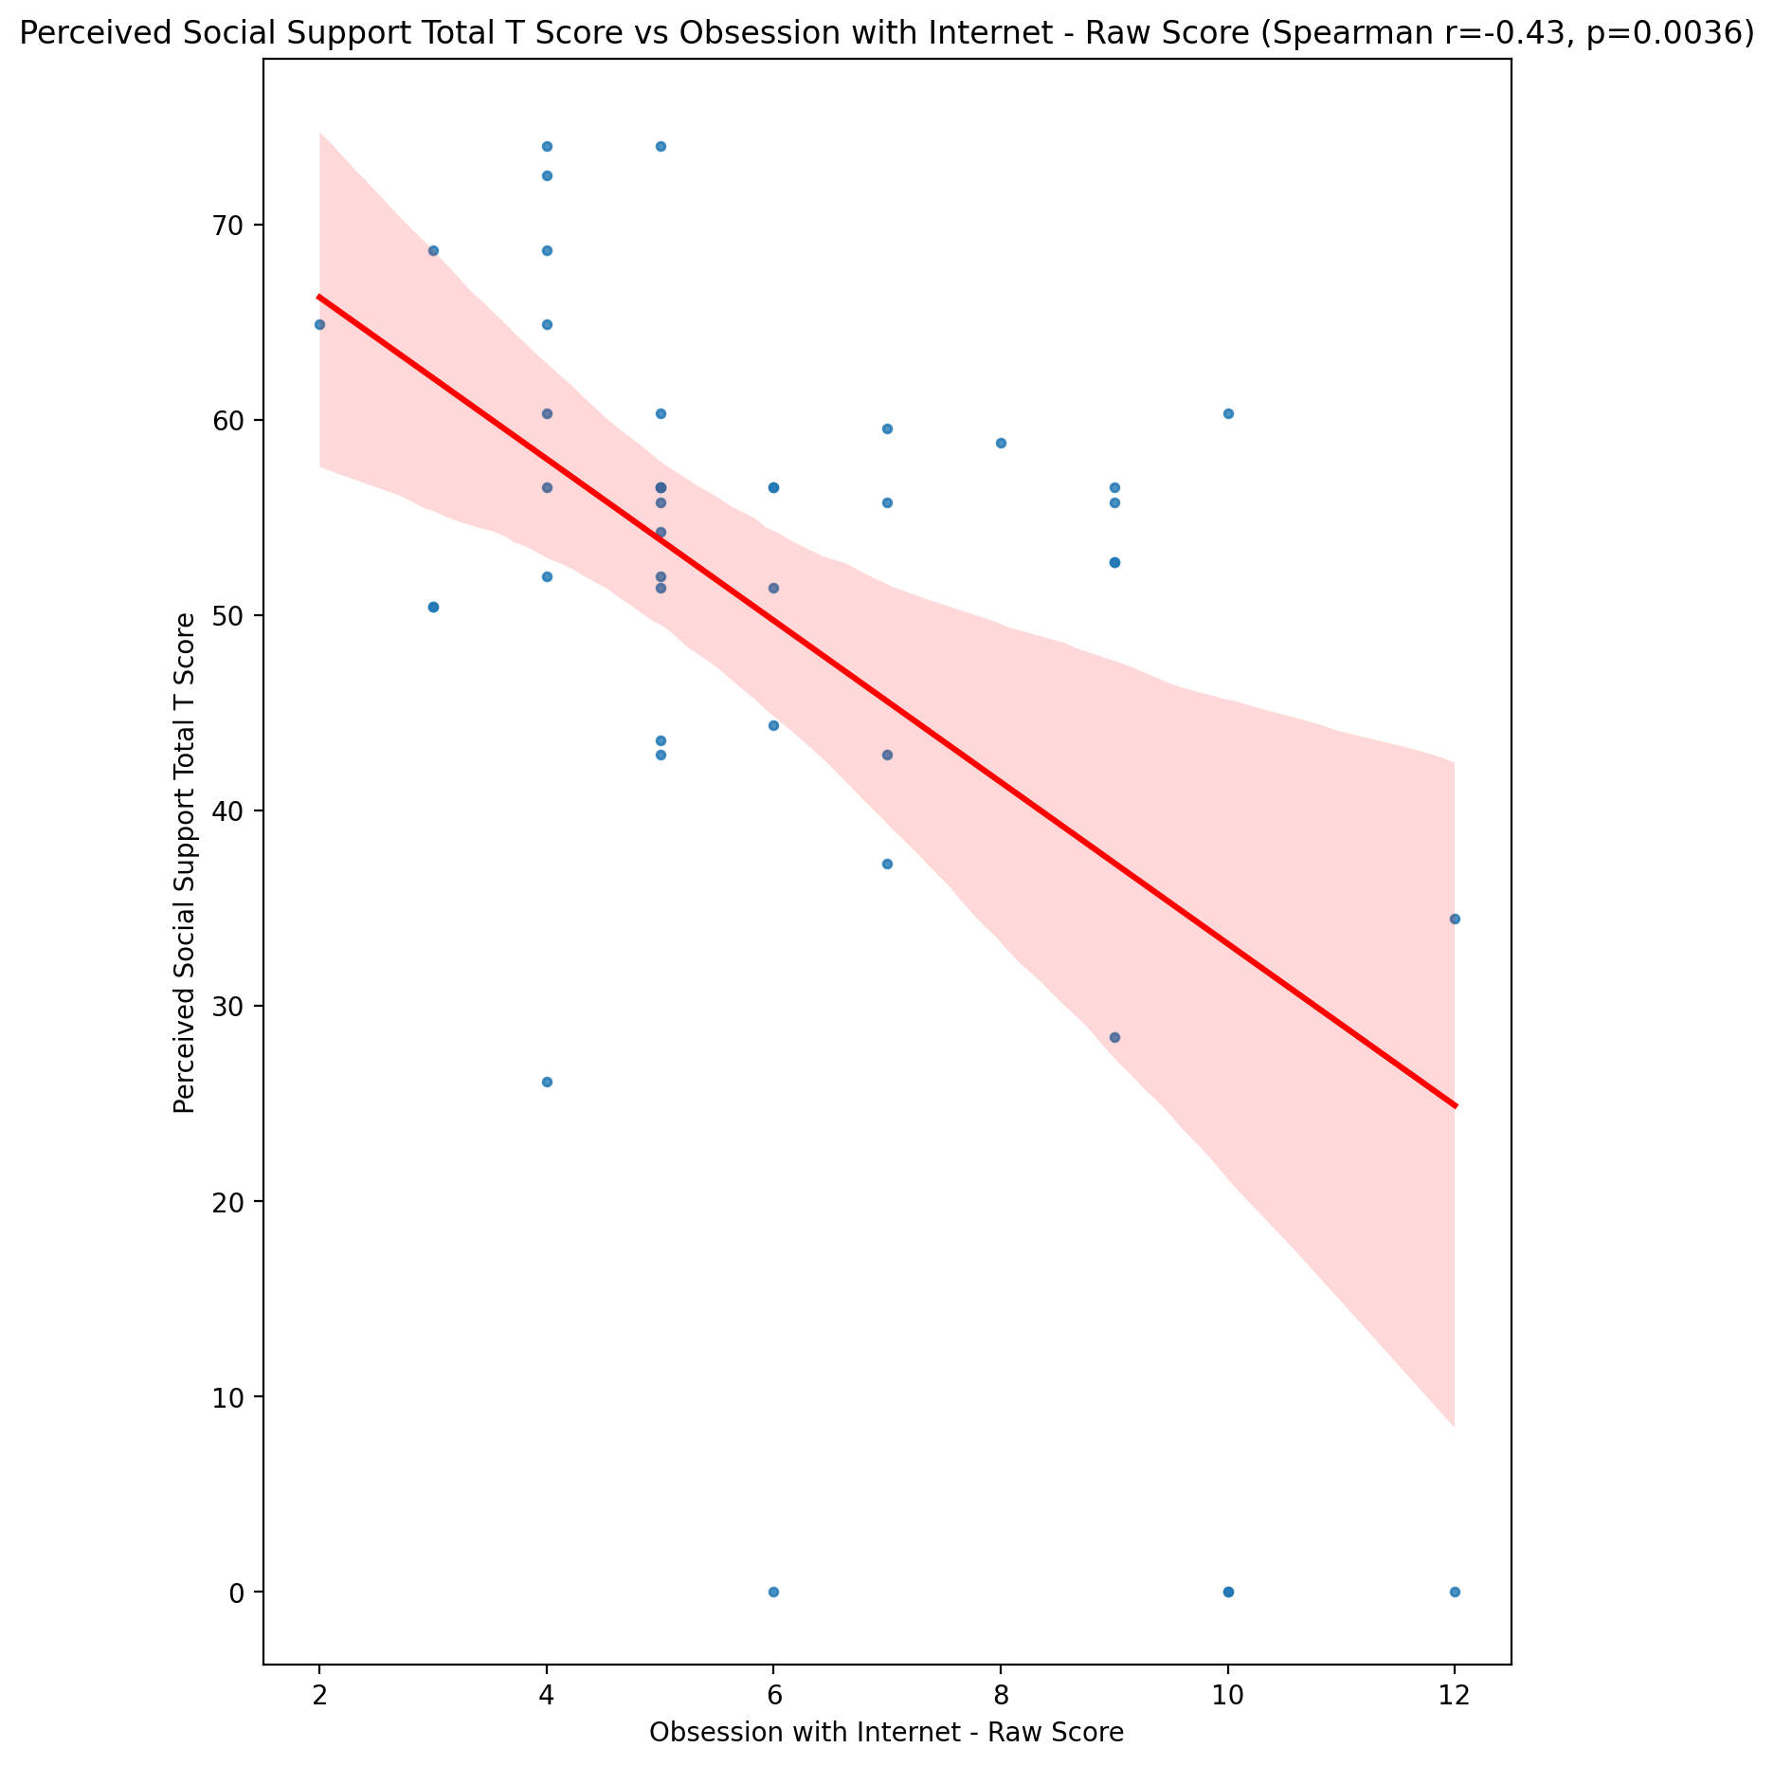

## Emotional Support - Rank vs Obsession with Internet - Raw Score

Test: None; statistic: None; p-value: None; Test not run: unsupported type combination.



## Informational Support - Rank vs Obsession with Internet - Raw Score

Test: None; statistic: None; p-value: None; Test not run: unsupported type combination.



## Instrumental Support - Rank vs Obsession with Internet - Raw Score

Test: None; statistic: None; p-value: None; Test not run: unsupported type combination.



## Perceived Social Support TOTAL - Rank vs Obsession with Internet - Raw Score

Test: None; statistic: None; p-value: None; Test not run: unsupported type combination.



## Power Self Concept - Real Self Concept Score vs Obsession with Internet - Raw Score

Test: spearman; statistic: -0.282216528830968; p-value: 0.06672003918924052;

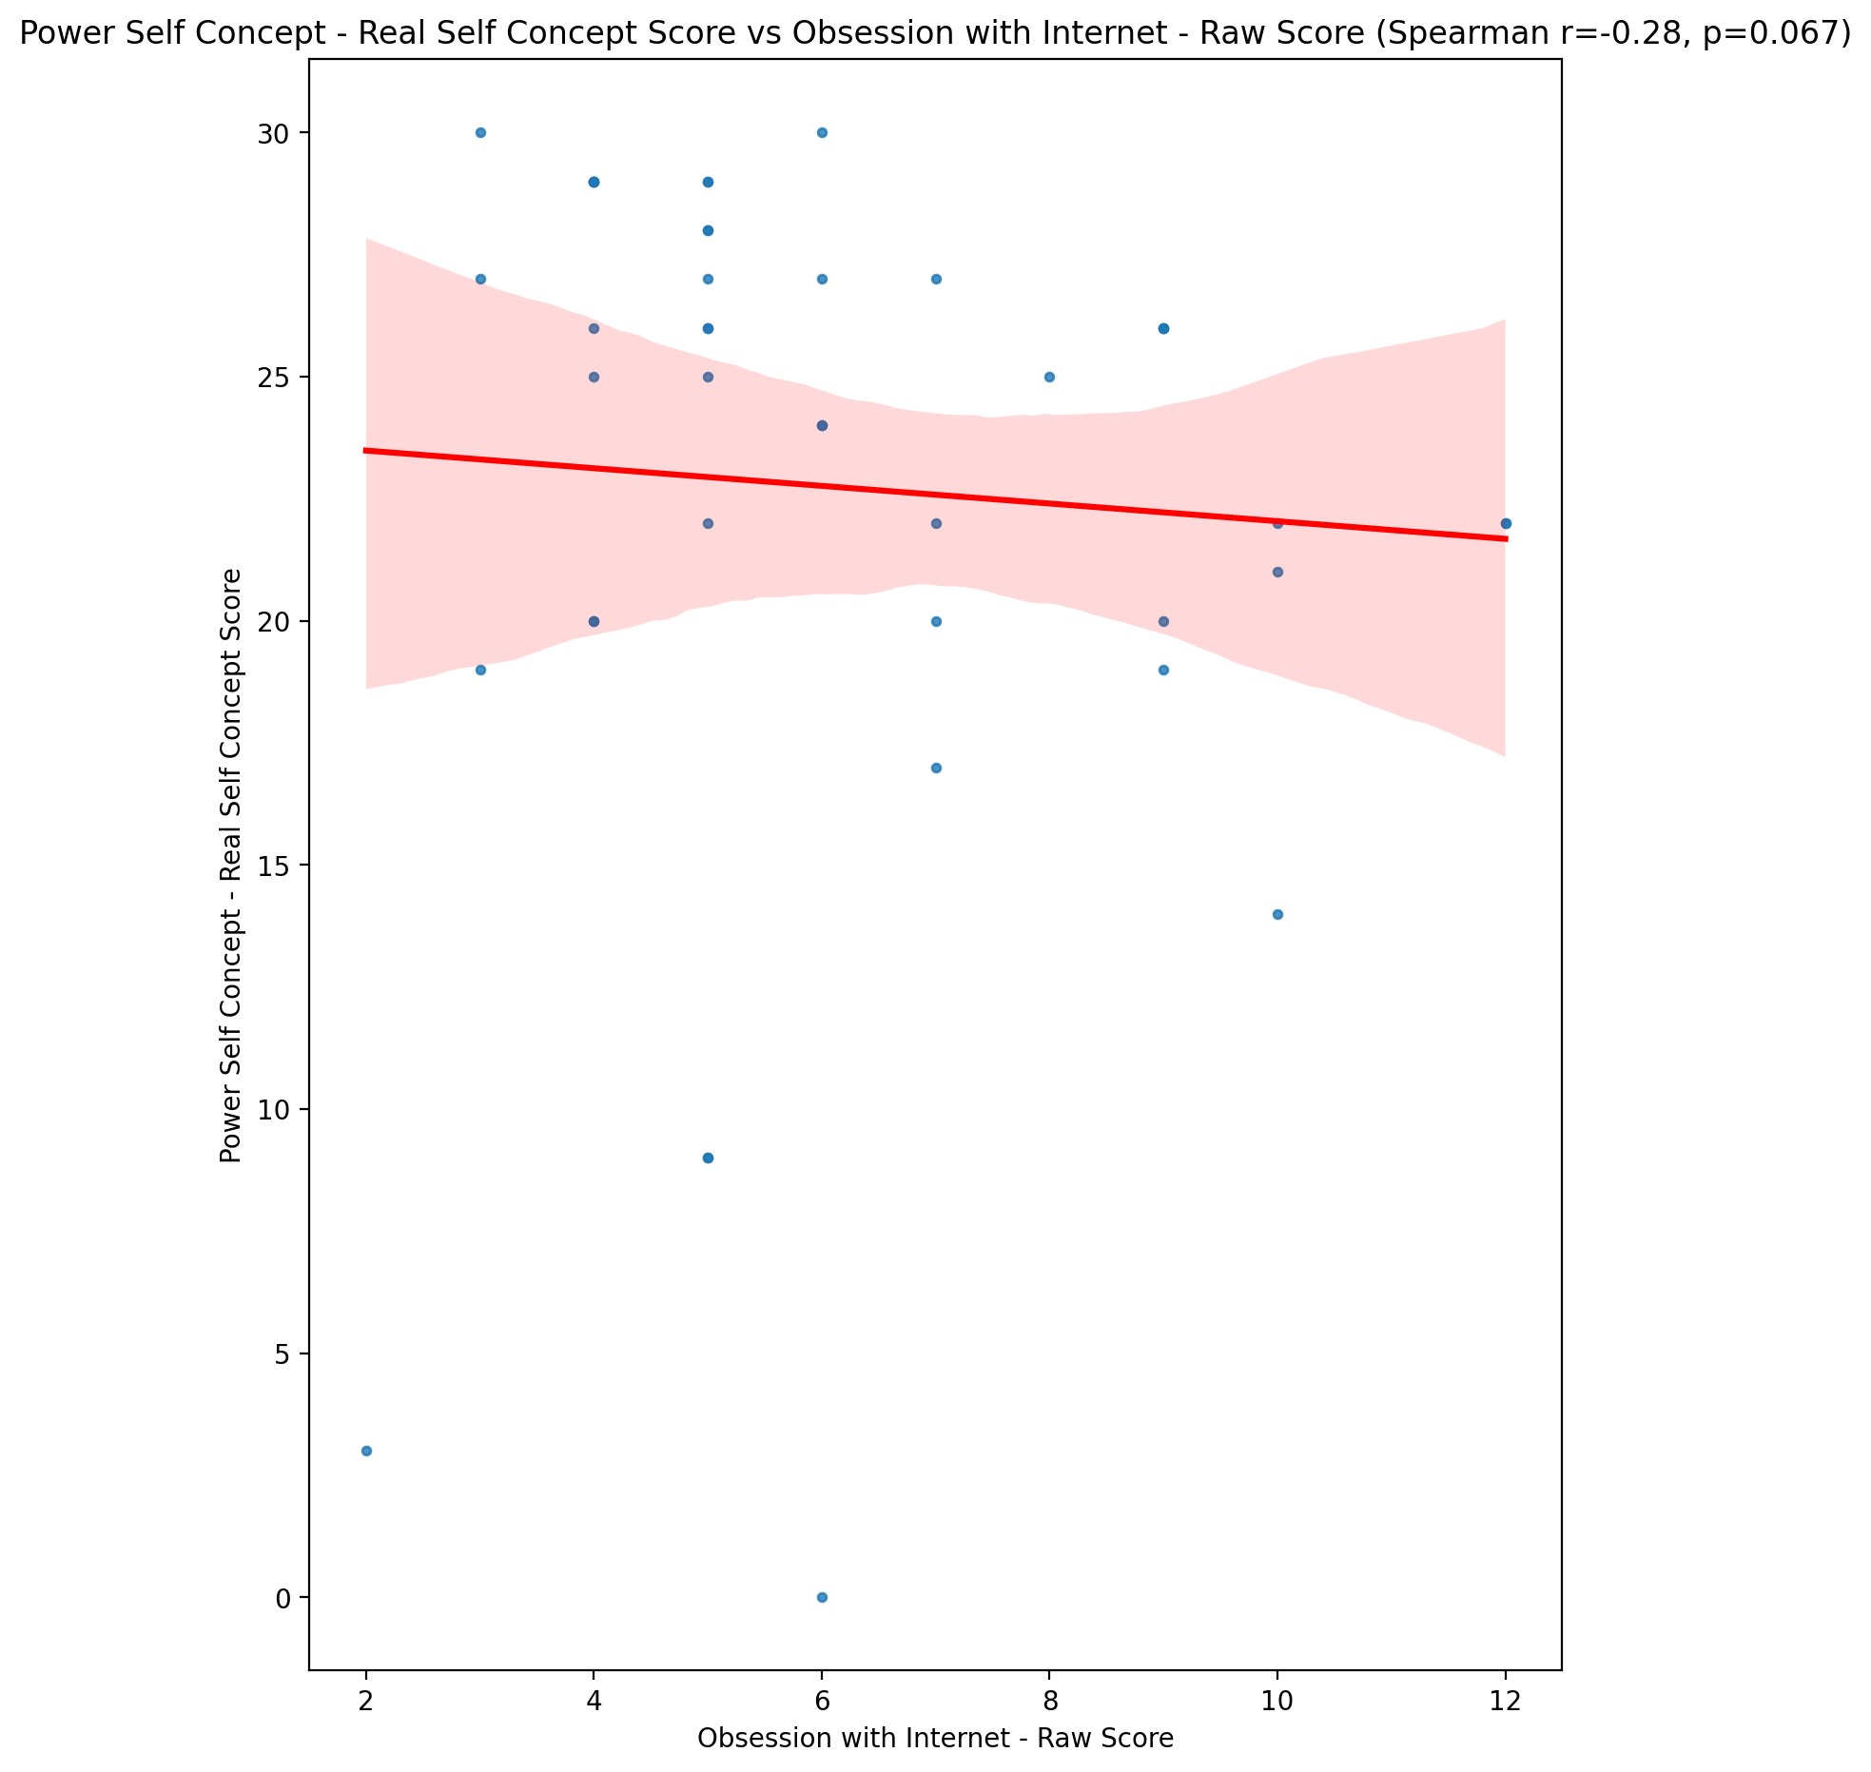

## Power Self Concept - Ideal Self Concept score vs Obsession with Internet - Raw Score

Test: spearman; statistic: -0.4263178015843611; p-value: 0.004363666481693572;

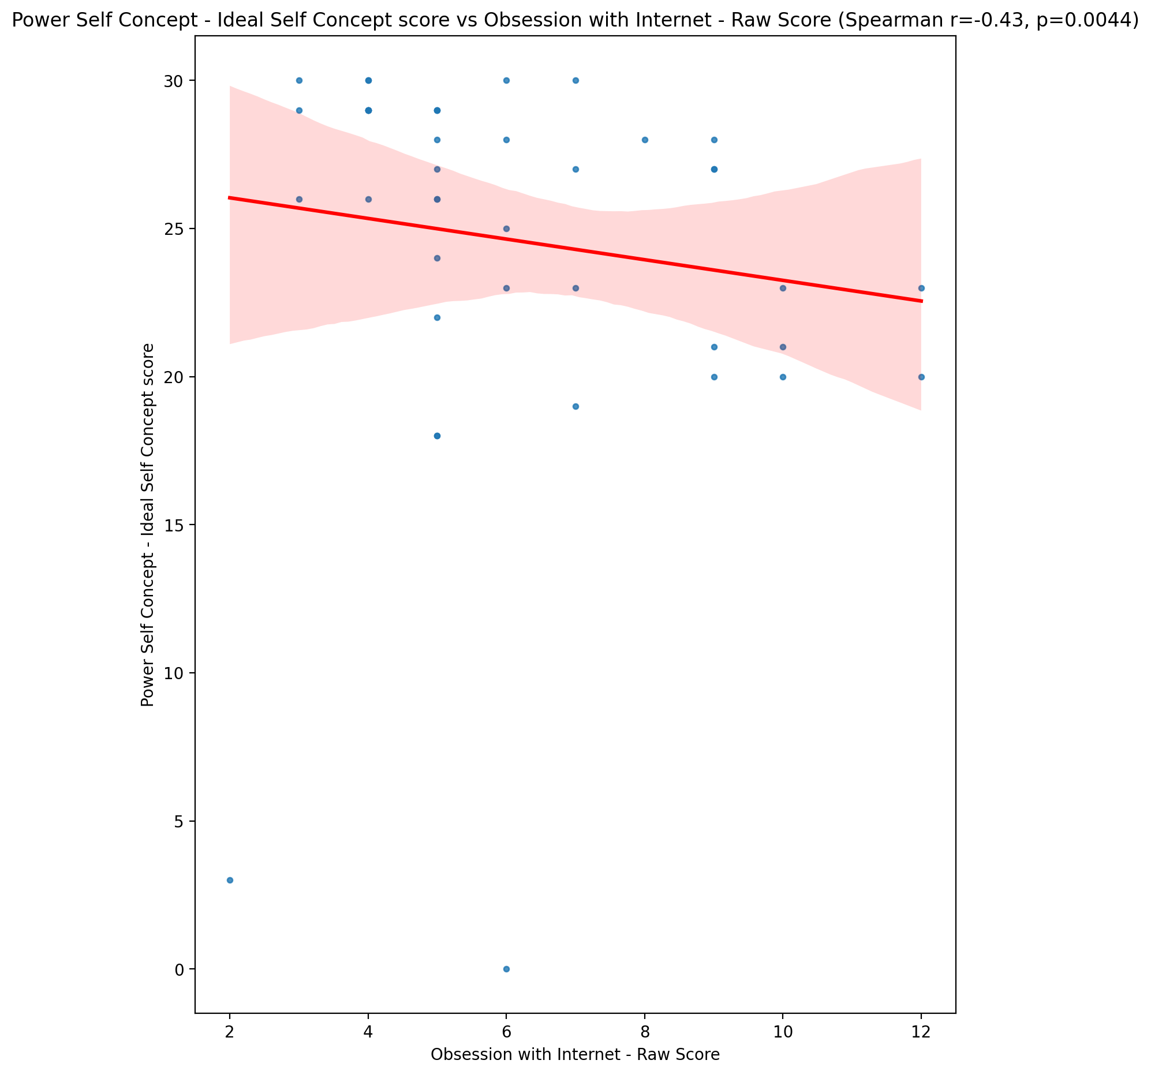

## Power Self Concept – Social Self Concept Score vs Obsession with Internet - Raw Score

Test: spearman; statistic: -0.34279094174817737; p-value: 0.024432691882672494;

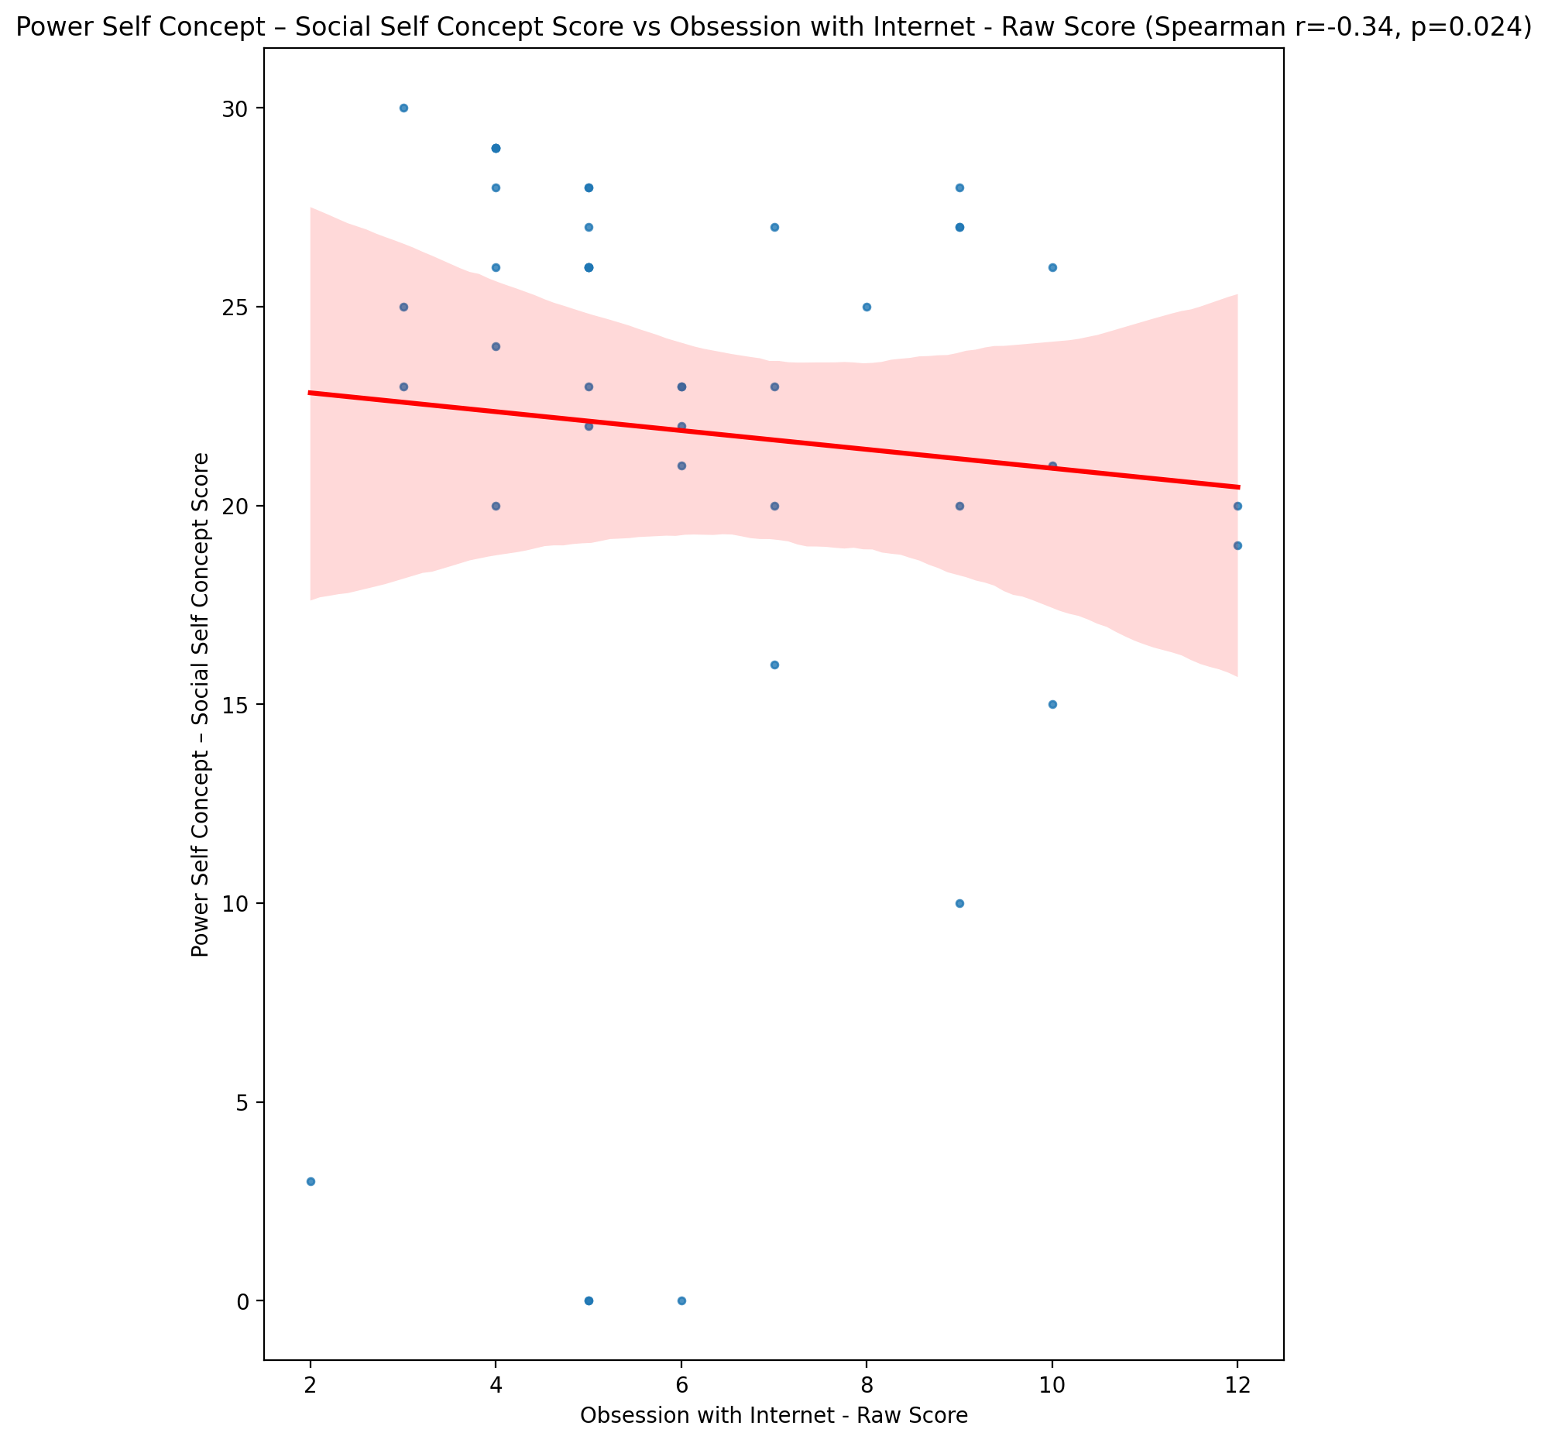

## Social Self Concept - Real Self Concept Score vs Obsession with Internet - Raw Score

Test: spearman; statistic: -0.27184670064999056; p-value: 0.07782162087460472;

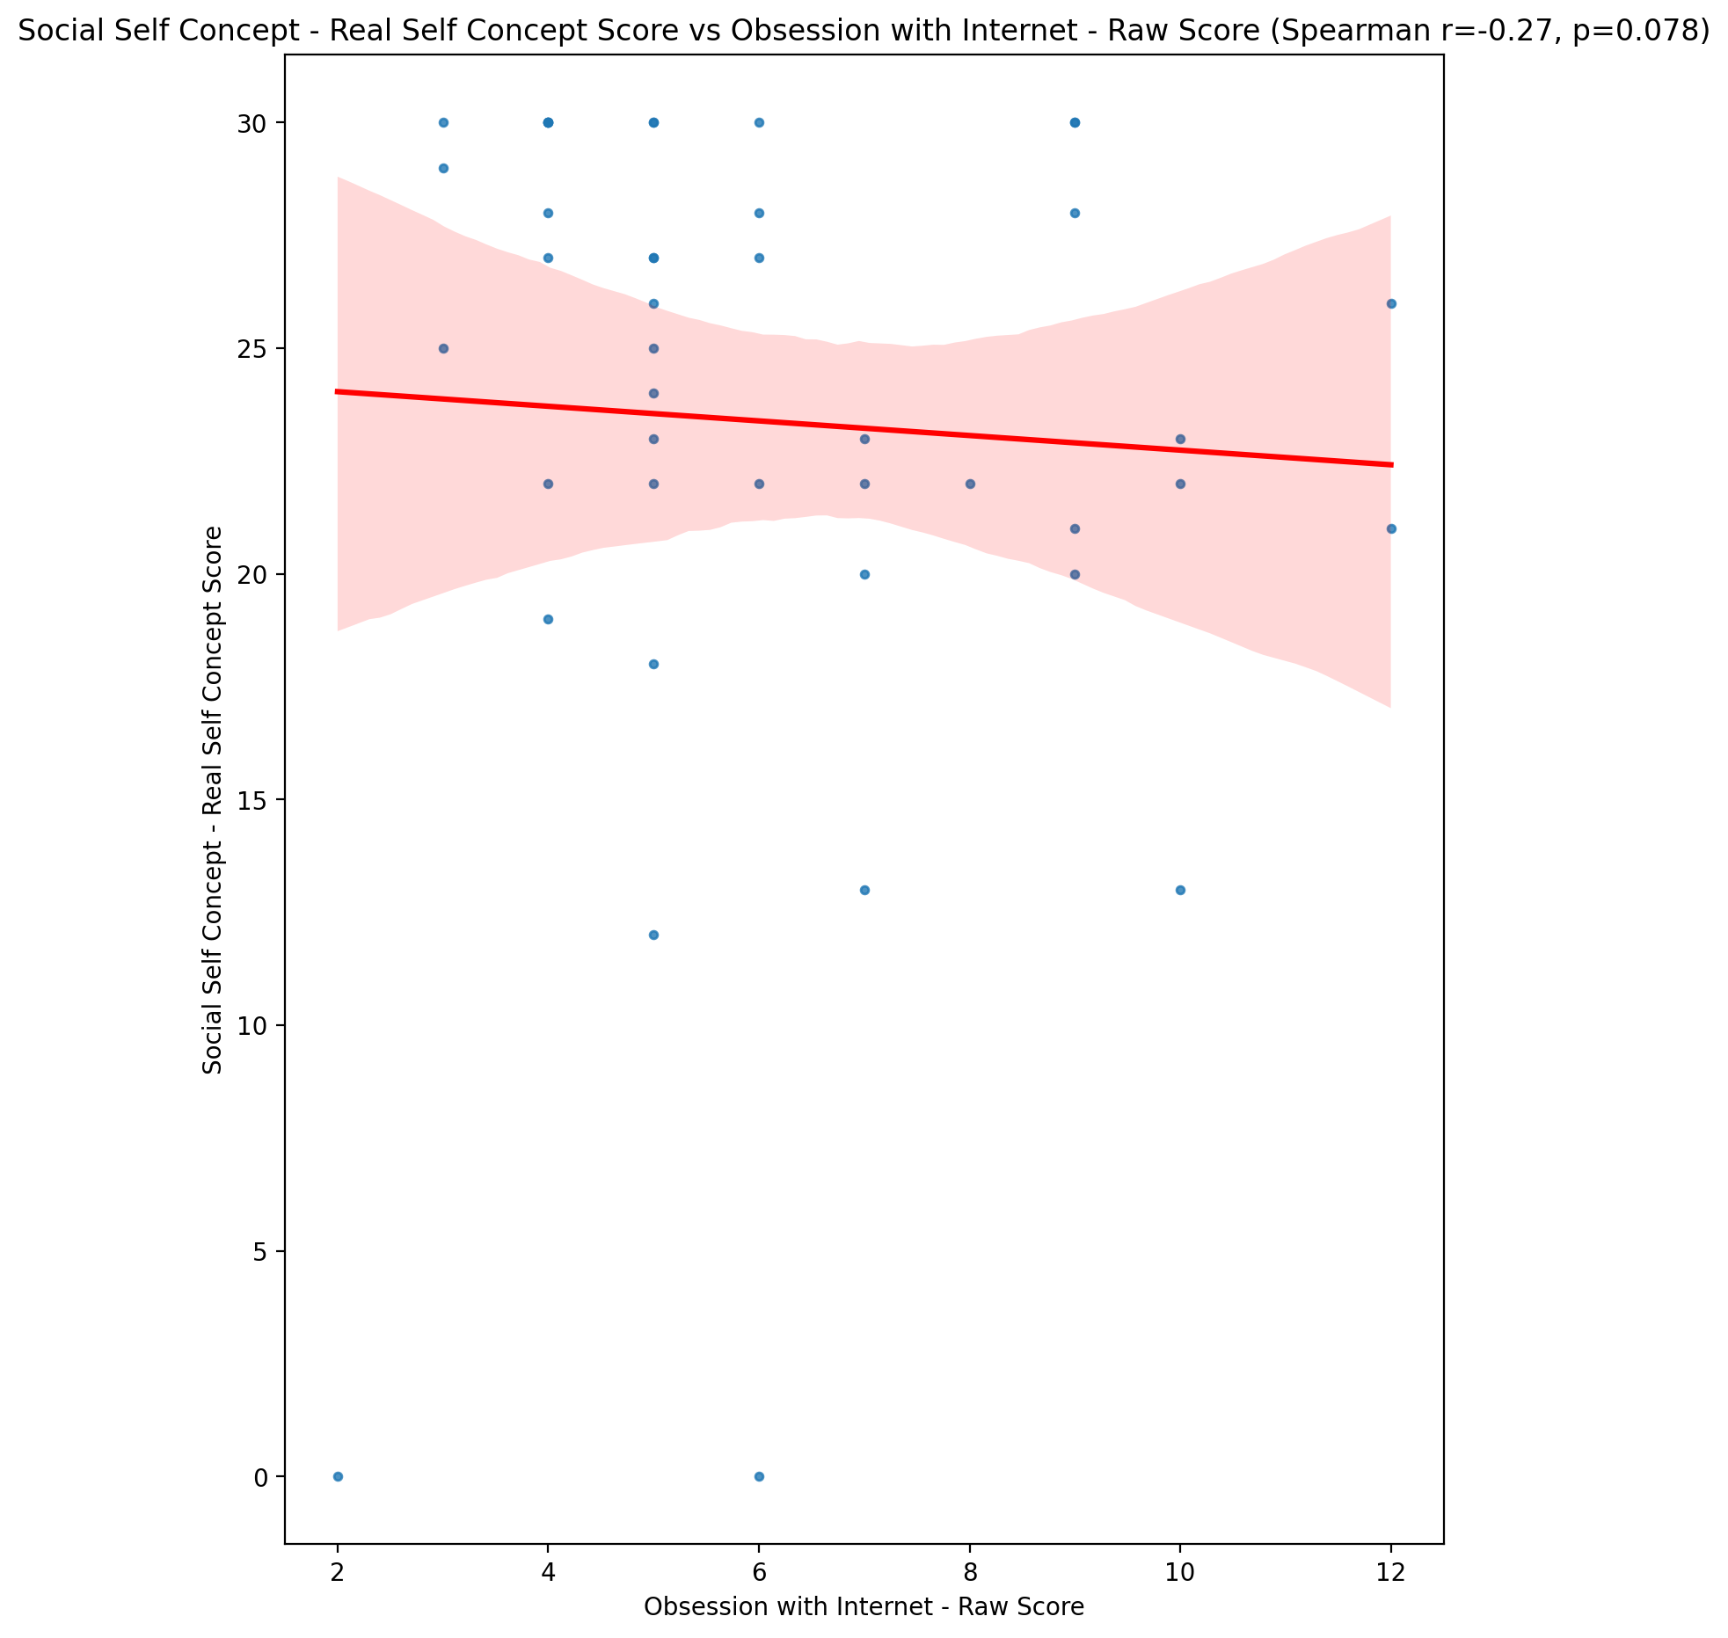

## Social Self Concept – Social Self Concept Score vs Obsession with Internet - Raw Score

Test: spearman; statistic: -0.34737741031736036; p-value: 0.022467244399430313;

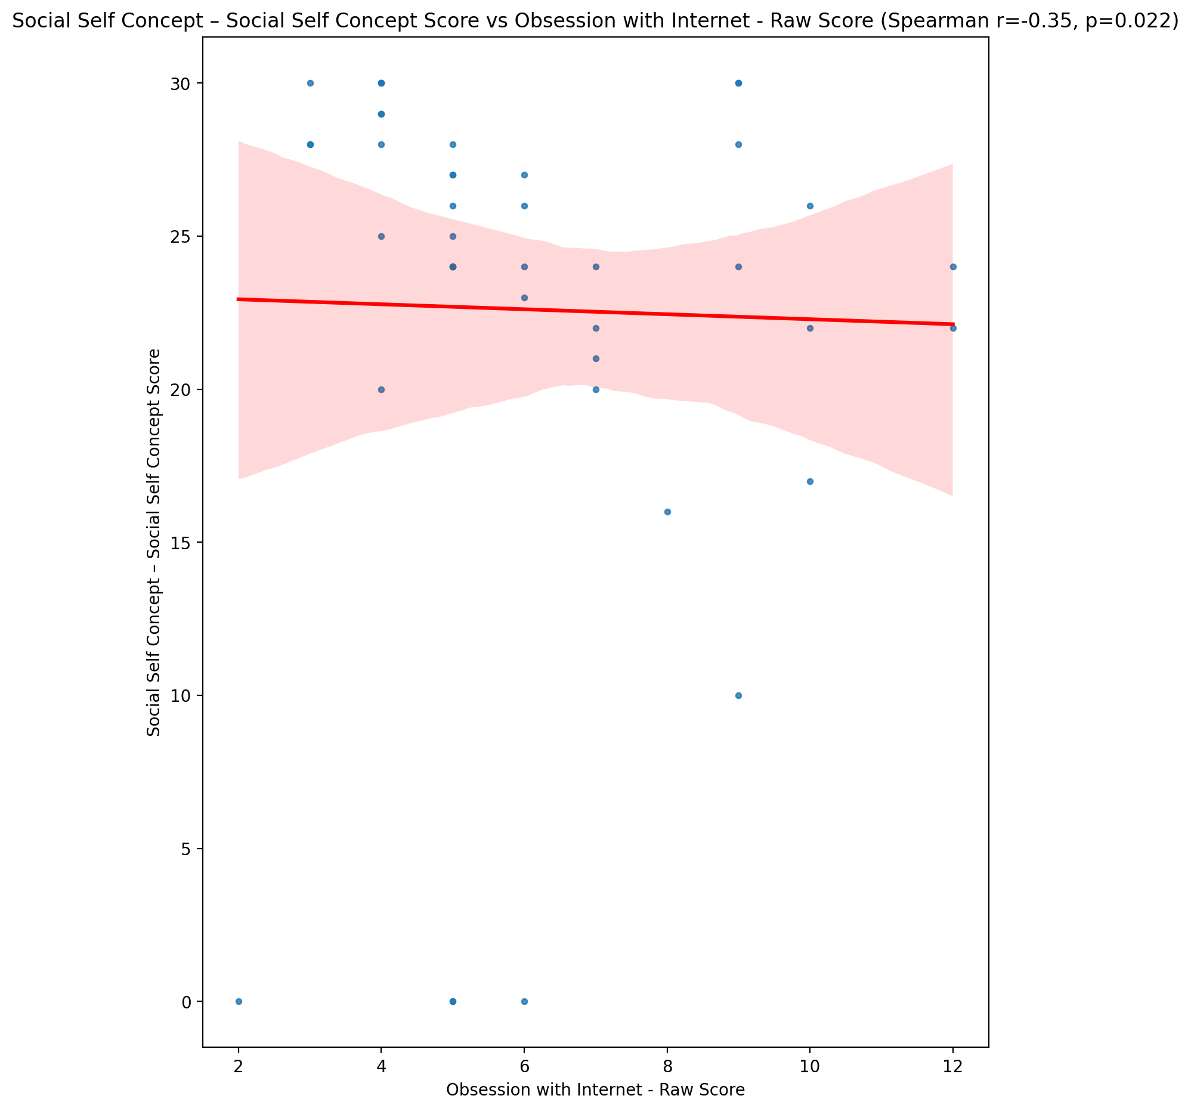

## Ability Self Concept - Real Self Concept Score vs Obsession with Internet - Raw Score

Test: spearman; statistic: -0.21786198643036786; p-value: 0.16048494056622883;

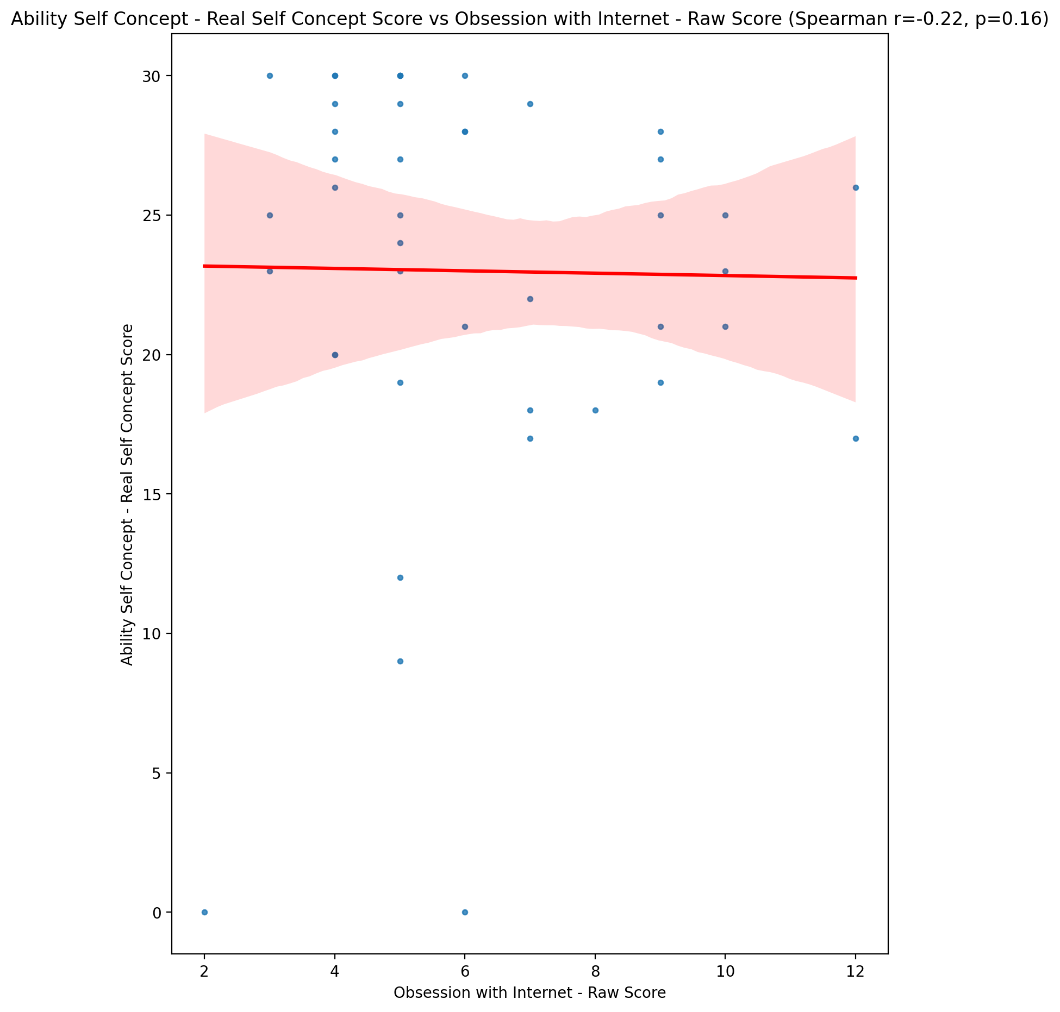

## Ability Self Concept - Ideal Self Concept Score vs Obsession with Internet - Raw Score

Test: spearman; statistic: -0.36141592703631936; p-value: 0.01725448111957257;

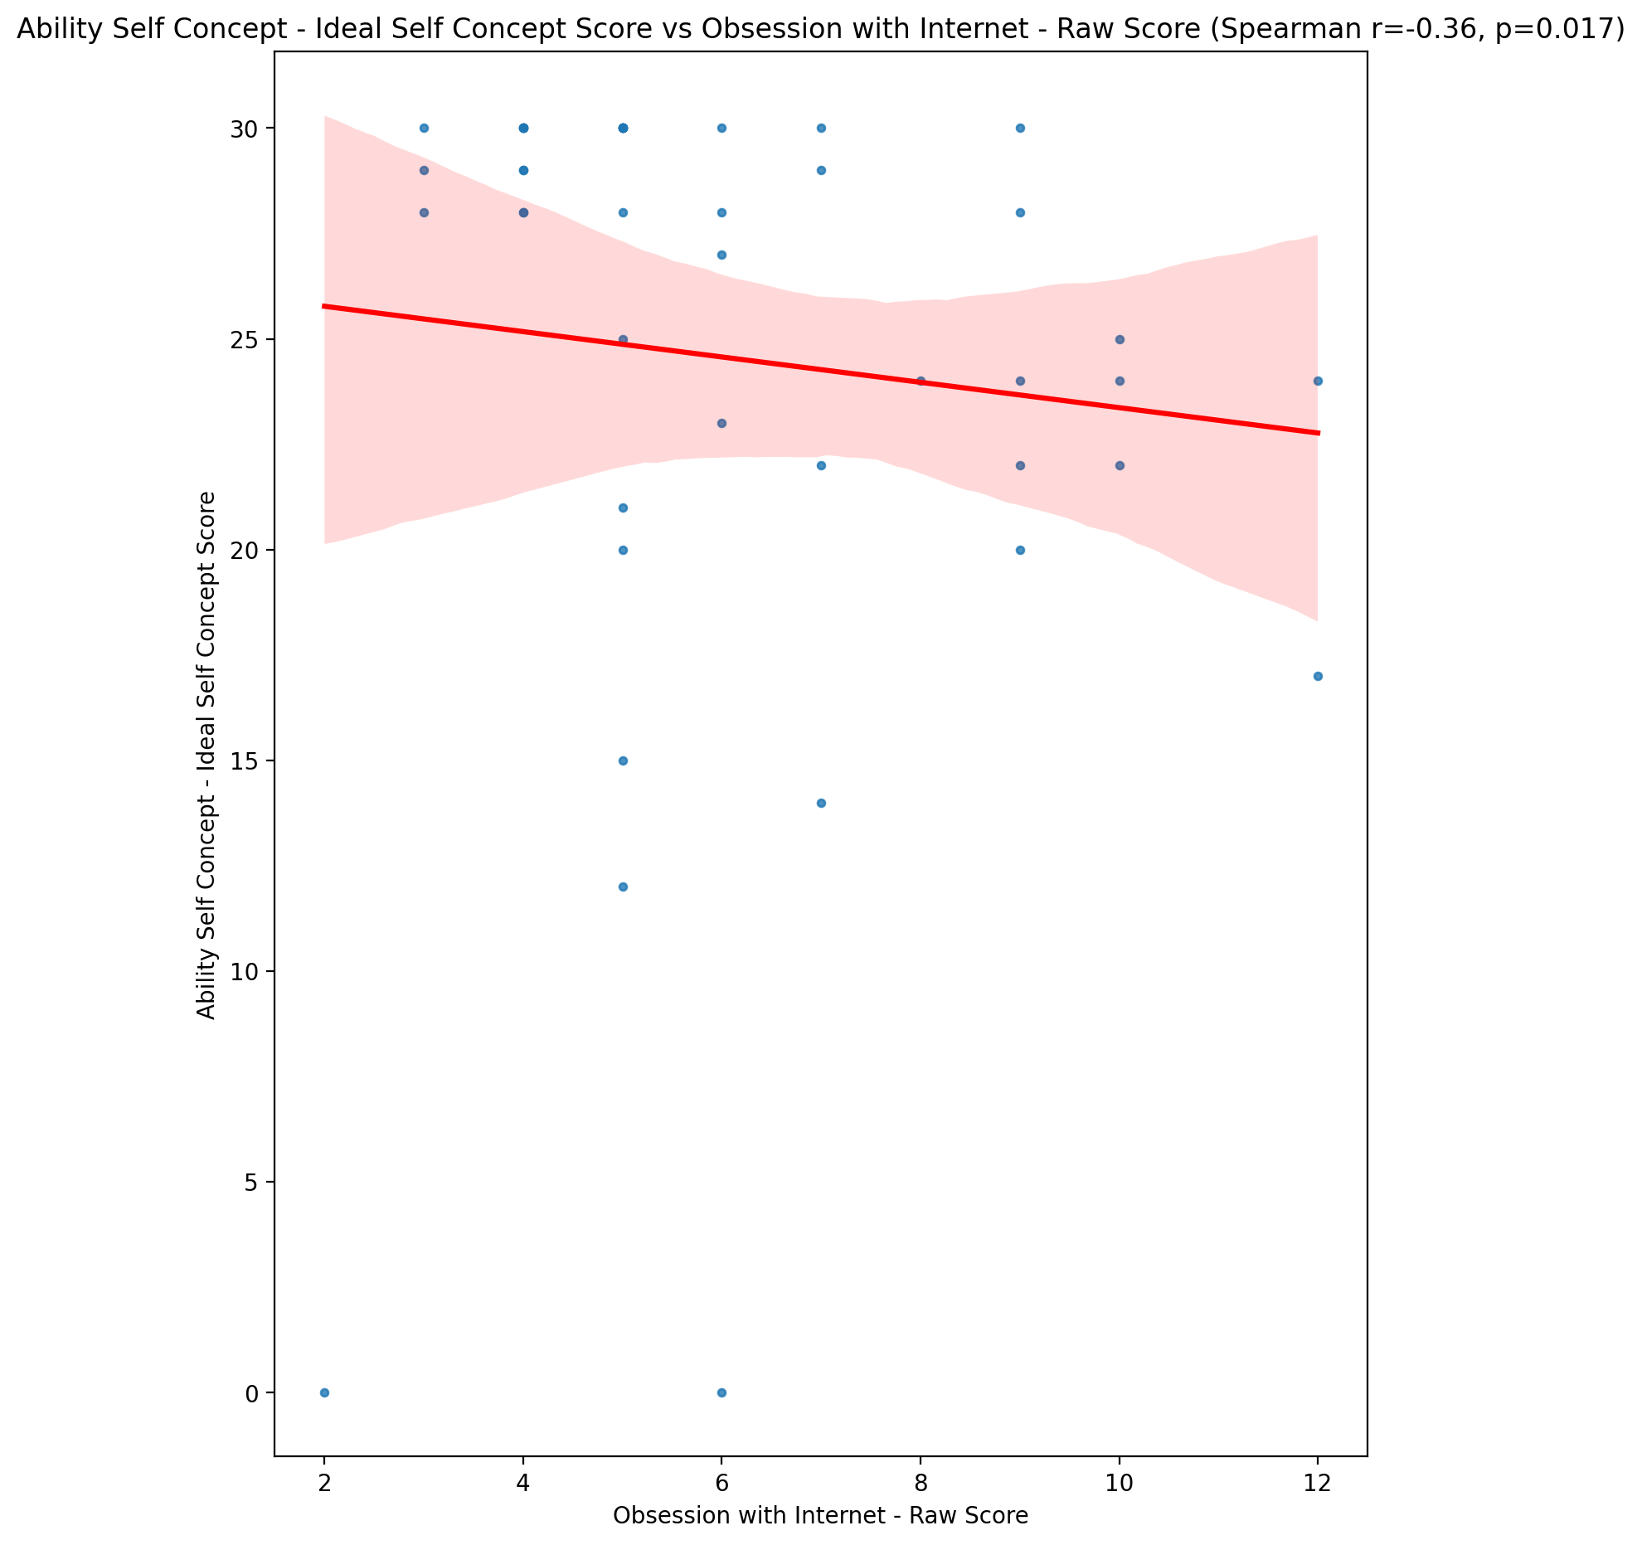

## Ability Self Concept – Social Self Concept Score vs Obsession with Internet - Raw Score

Test: spearman; statistic: -0.36304210340356075; p-value: 0.016722738038630832;

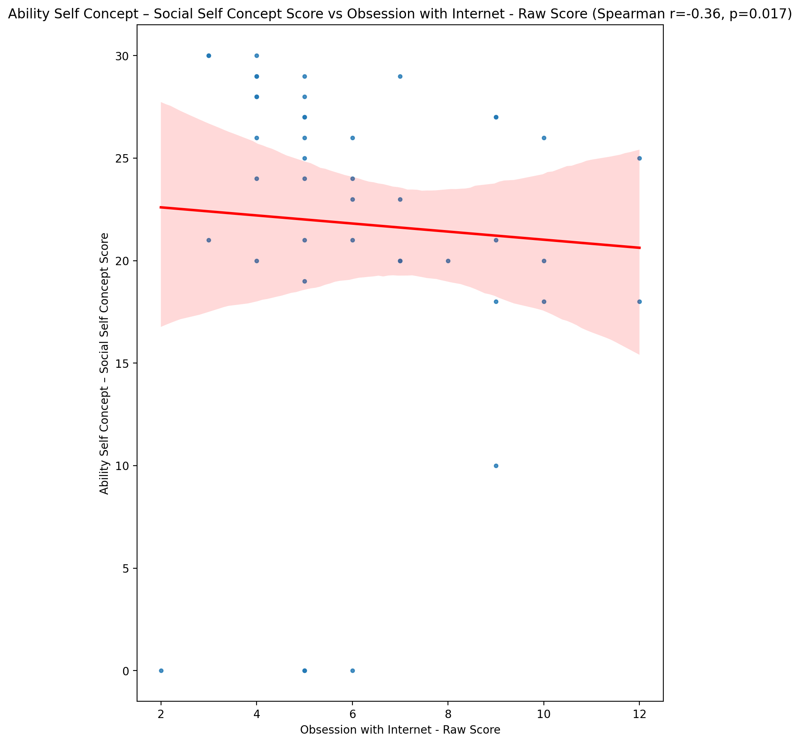

## Physical Self Concept - Real Self Concept Score vs Obsession with Internet - Raw Score

Test: spearman; statistic: -0.2571849762631024; p-value: 0.09592931155248646;

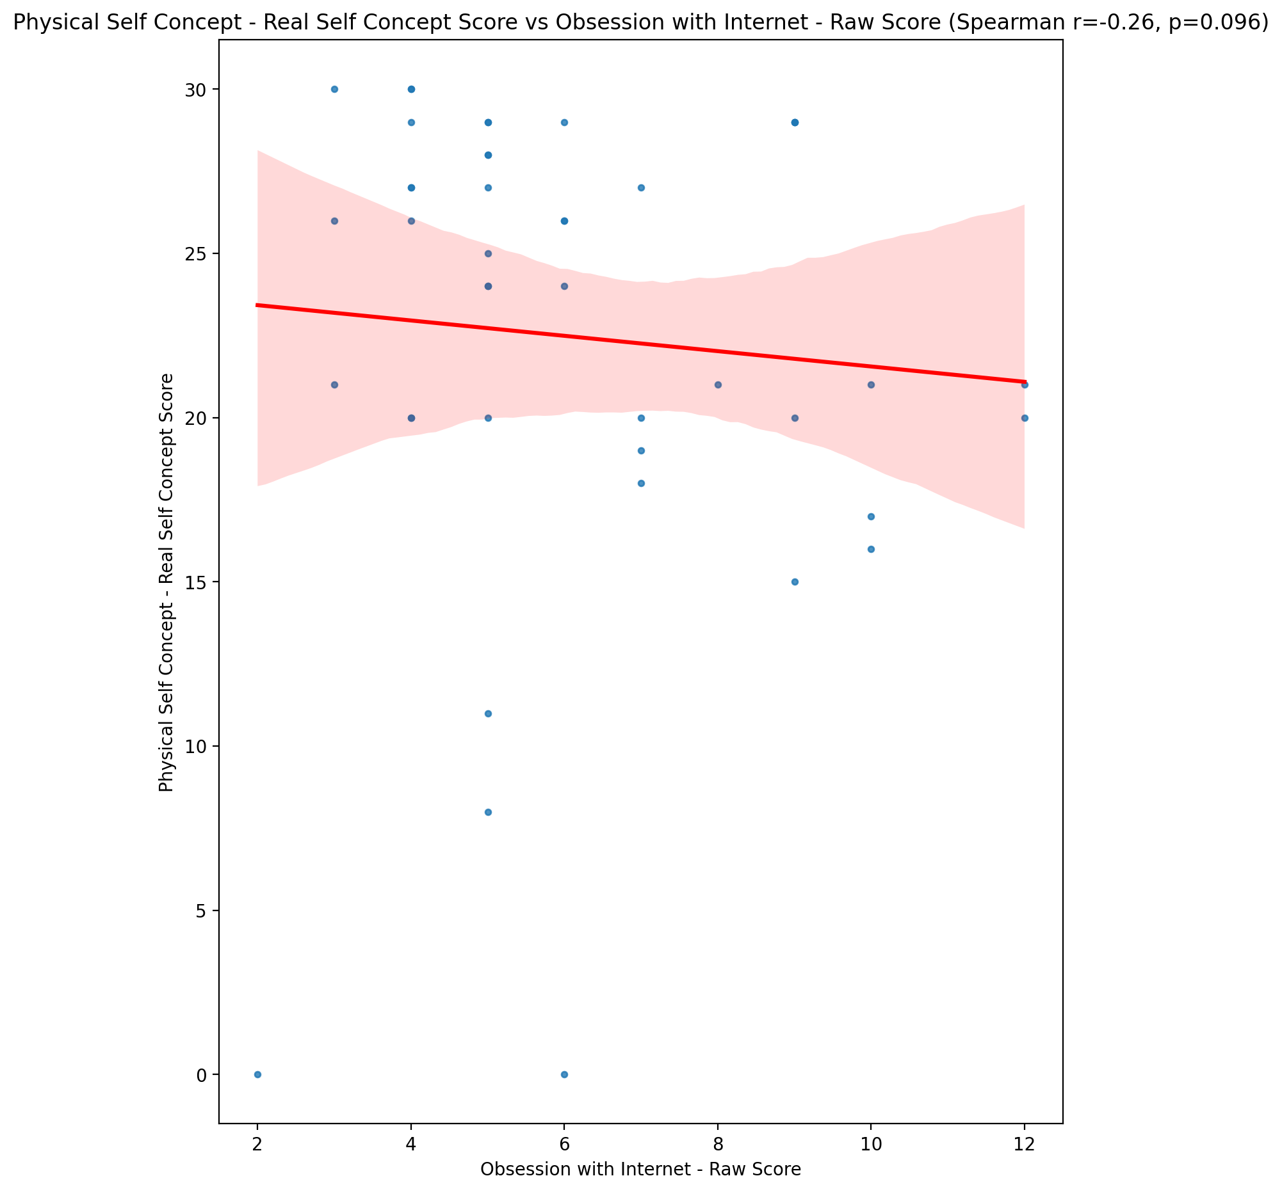

## Physical Self Concept – Ideal Self Concept Score vs Obsession with Internet - Raw Score

Test: spearman; statistic: -0.3607857864217857; p-value: 0.01746433355251005;

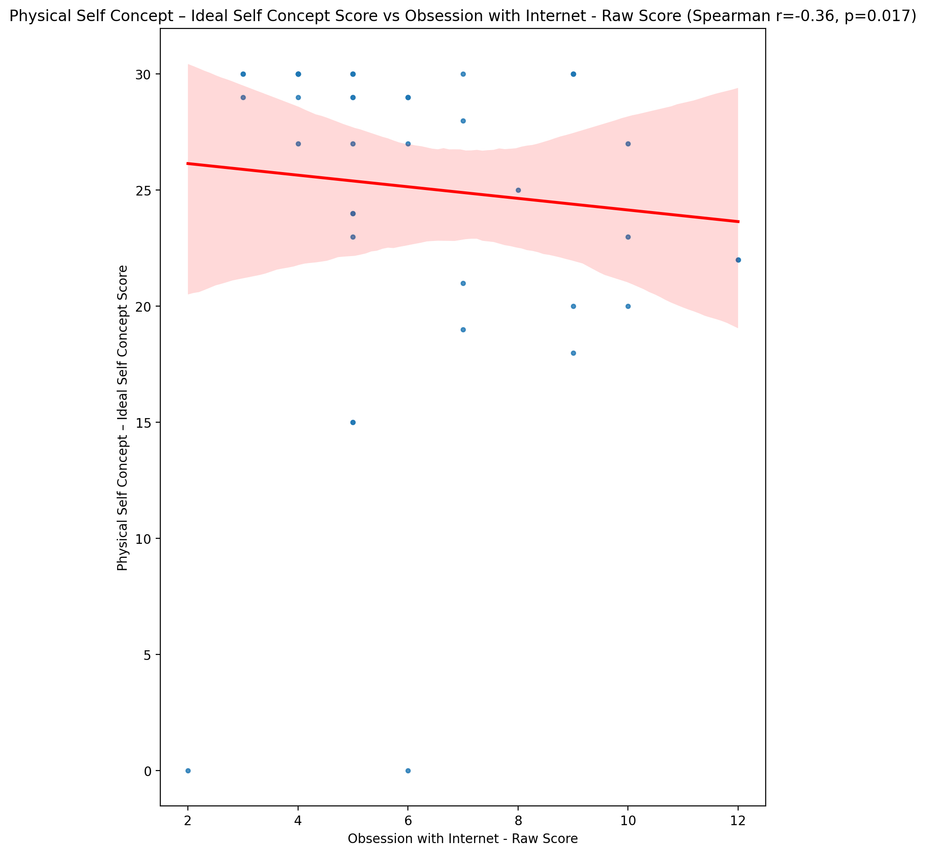

## Physical Self Concept – Social Self Concept Score vs Obsession with Internet - Raw Score

Test: spearman; statistic: -0.13394162939908513; p-value: 0.3918315349939382;

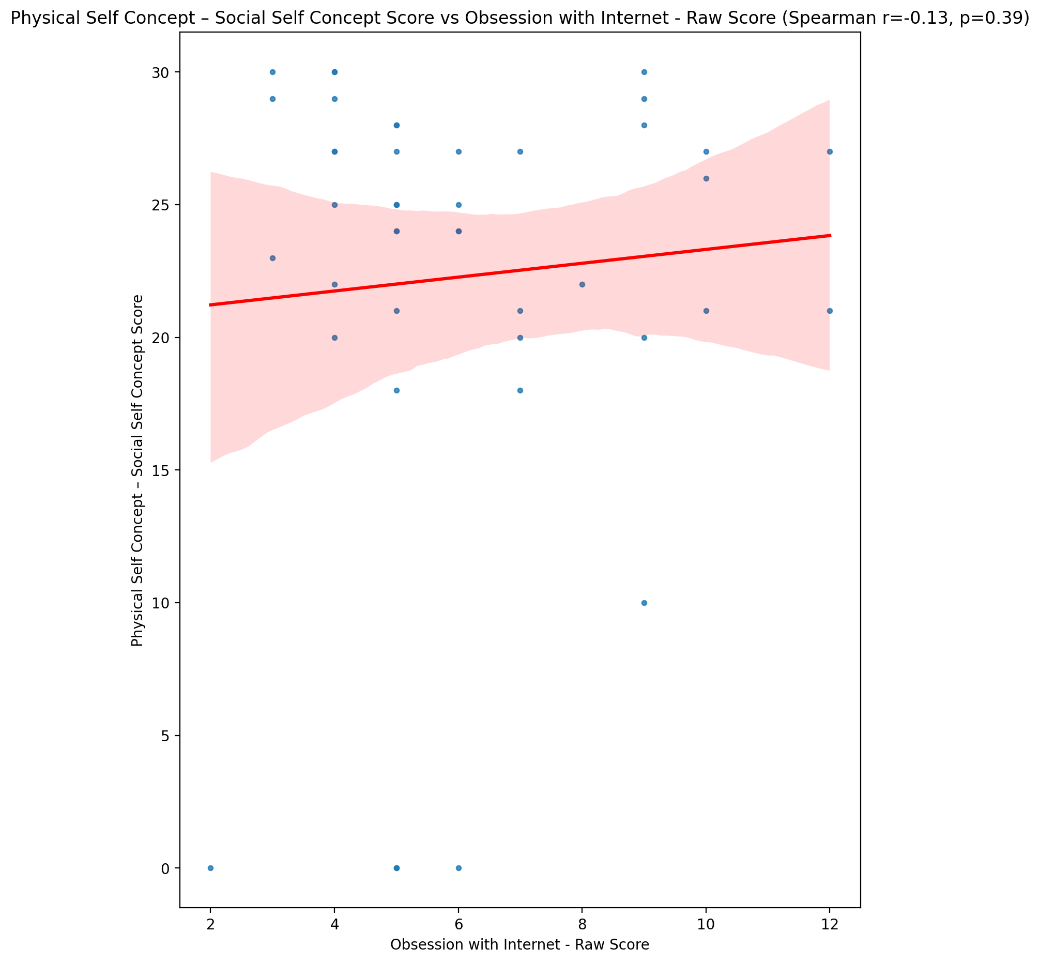

## Psychological Self Concept - Real Self Concept Score vs Obsession with Internet - Raw Score

Test: spearman; statistic: -0.3191534154028172; p-value: 0.03697310689478427;

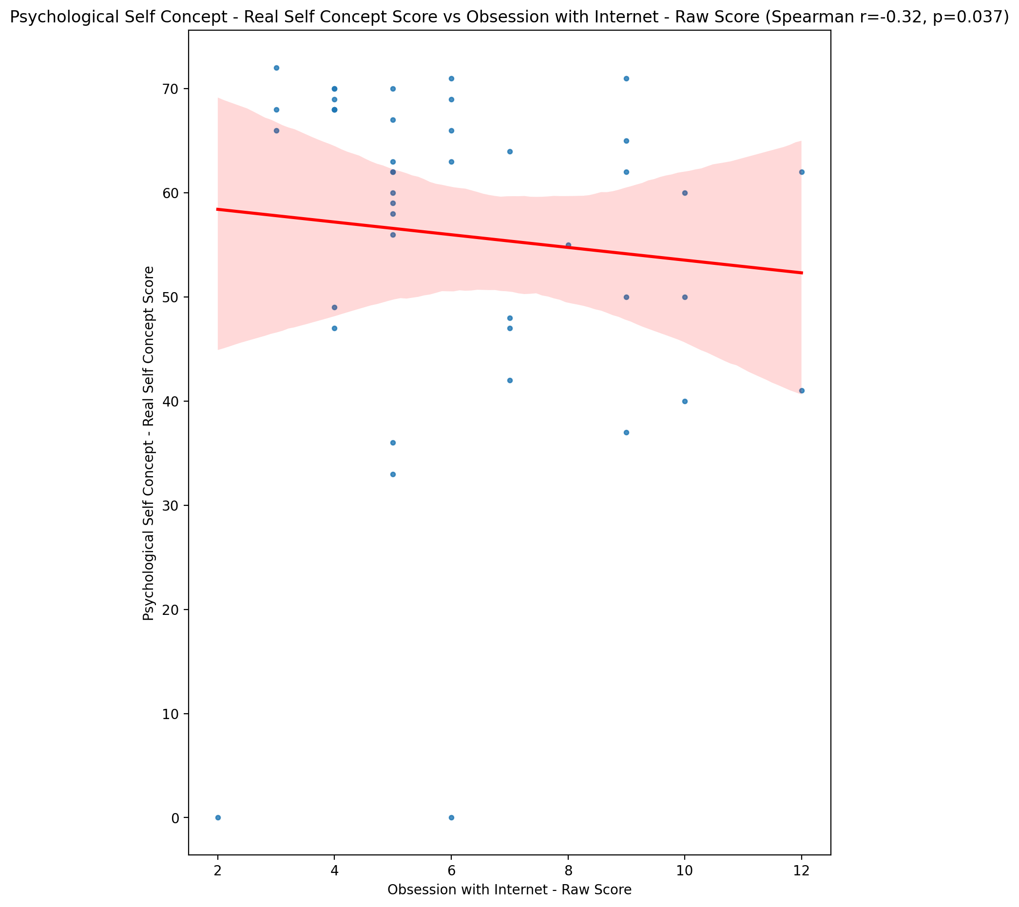

## Psychological Self Concept – Ideal Self Concept Score vs Obsession with Internet - Raw Score

Test: spearman; statistic: -0.34946900373571294; p-value: 0.021615878126869503;

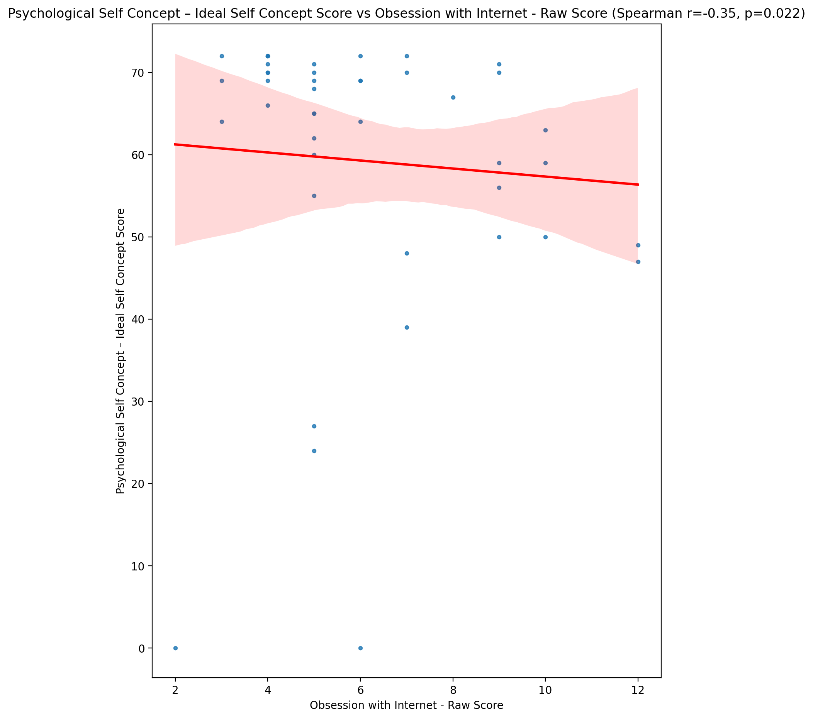

## Psychological Self Concept – Social Self Concept Score vs Obsession with Internet - Raw Score

Test: spearman; statistic: -0.40848882083480065; p-value: 0.006538643197391726;

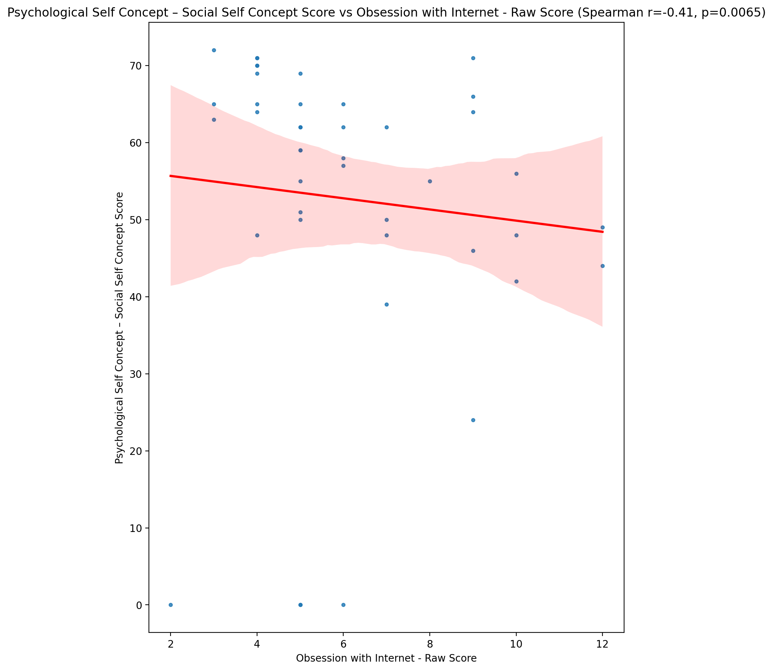

## Real Self Concept Total Score vs Obsession with Internet - Raw Score

Test: spearman; statistic: -0.3060438091821561; p-value: 0.04594436729663131;

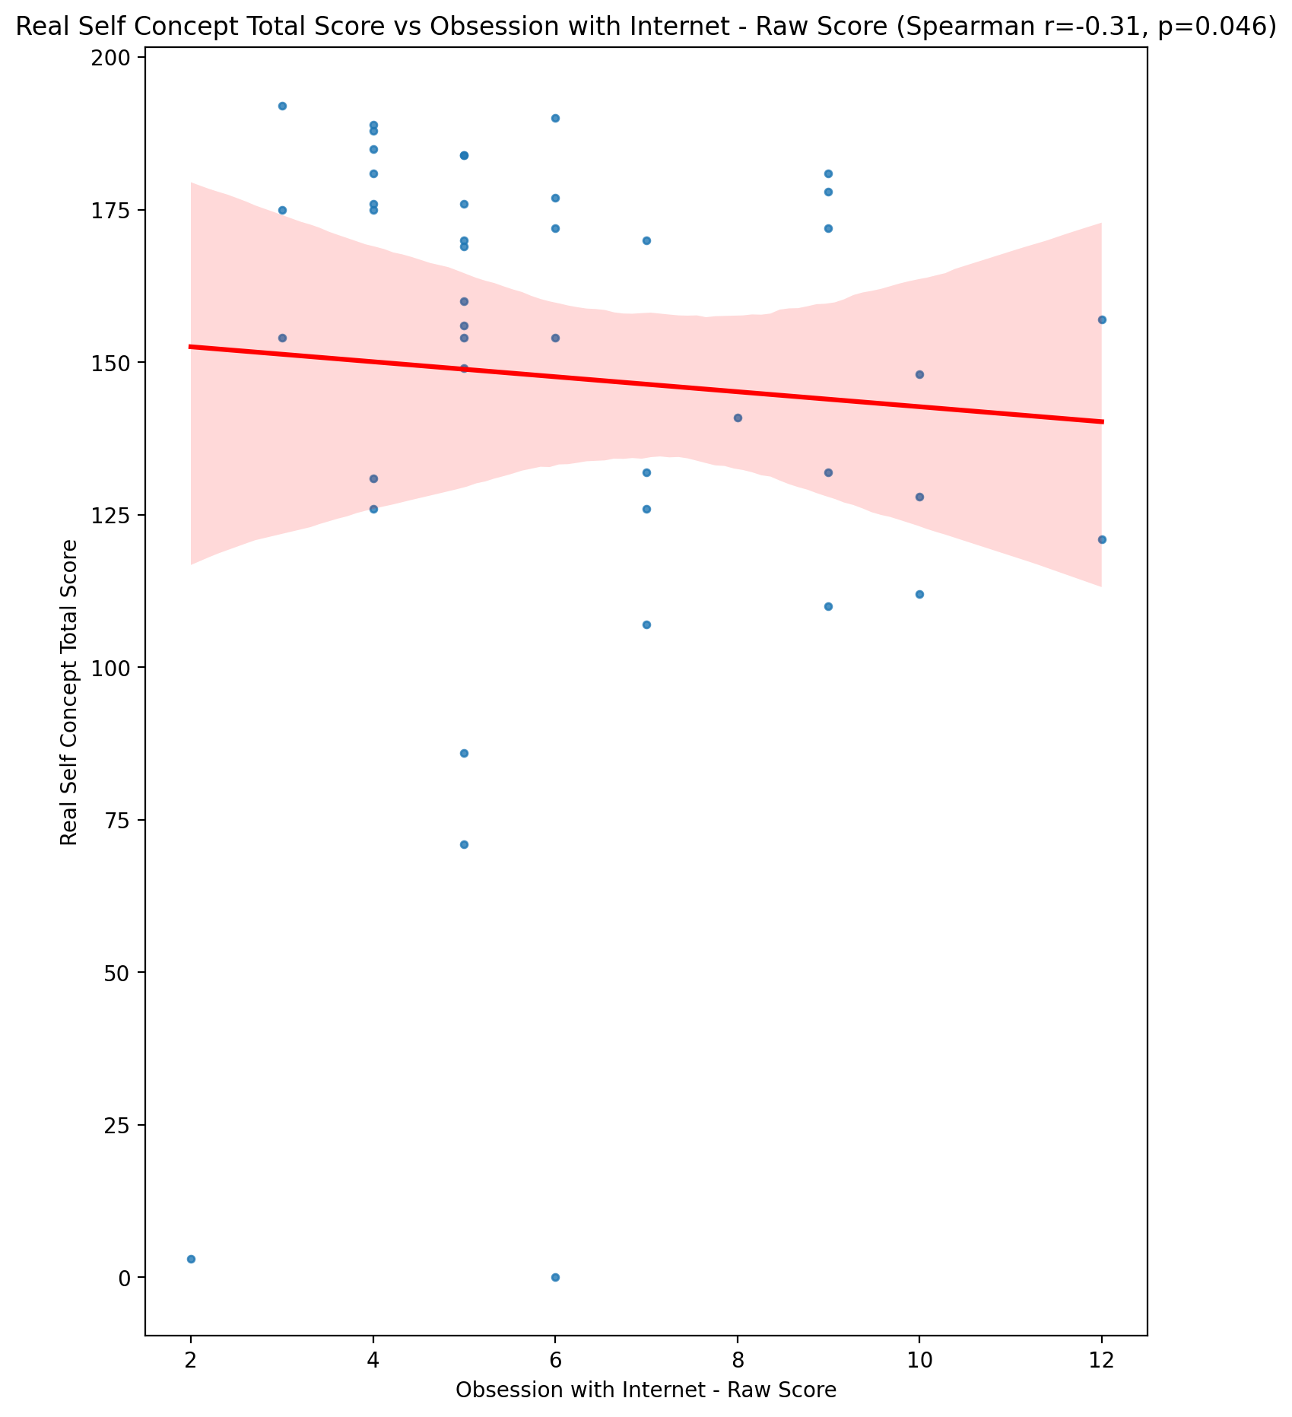

## Ideal Self Concept Total Score vs Obsession with Internet - Raw Score

Test: spearman; statistic: -0.4365217025537612; p-value: 0.003428218471280108;

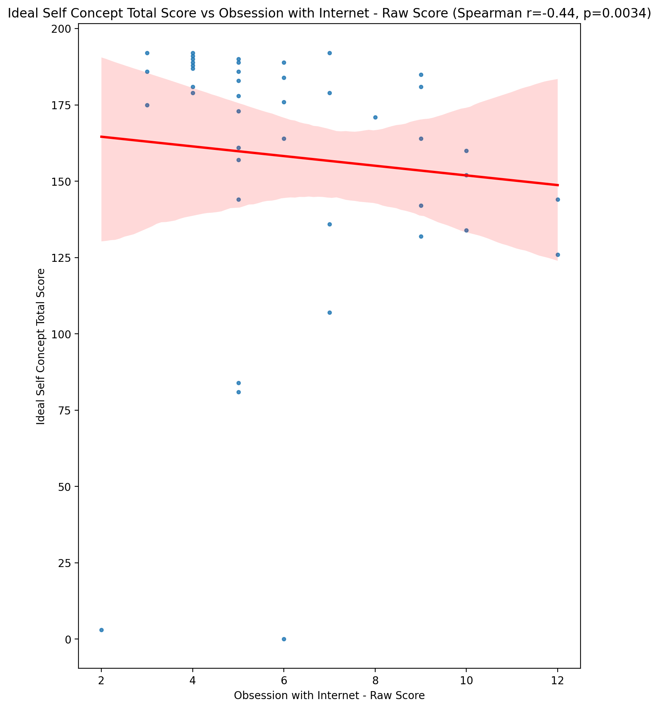

## Social Self Concept Total Score vs Obsession with Internet - Raw Score

Test: spearman; statistic: -0.38373709147154644; p-value: 0.011076864074891264;

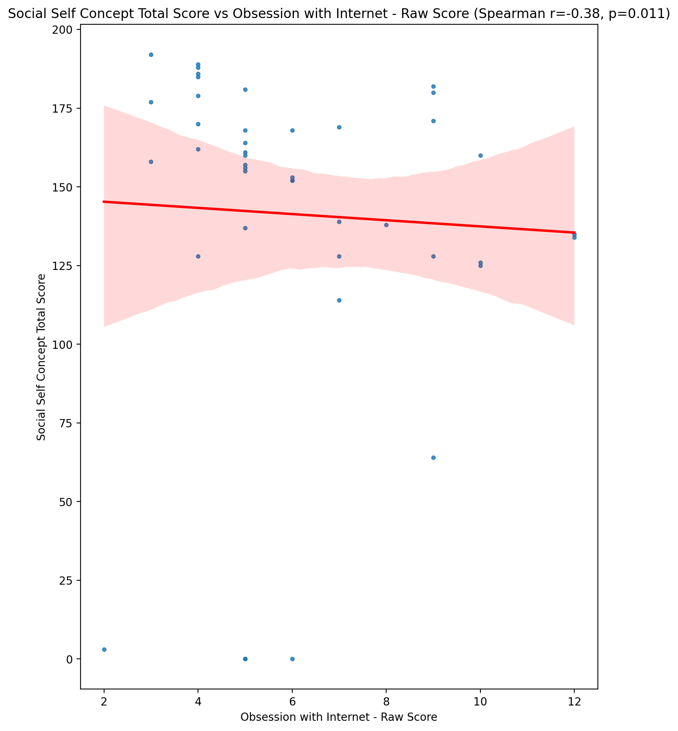

## Ideal Self Concept Total Category vs Obsession with Internet - Raw Score

Test: None; statistic: None; p-value: None; Test not run: unsupported type combination.



## Perceived Social Stress Score vs Obsession with Internet - Raw Score

Test: spearman; statistic: 0.3702372557621648; p-value: 0.014533114214474318;

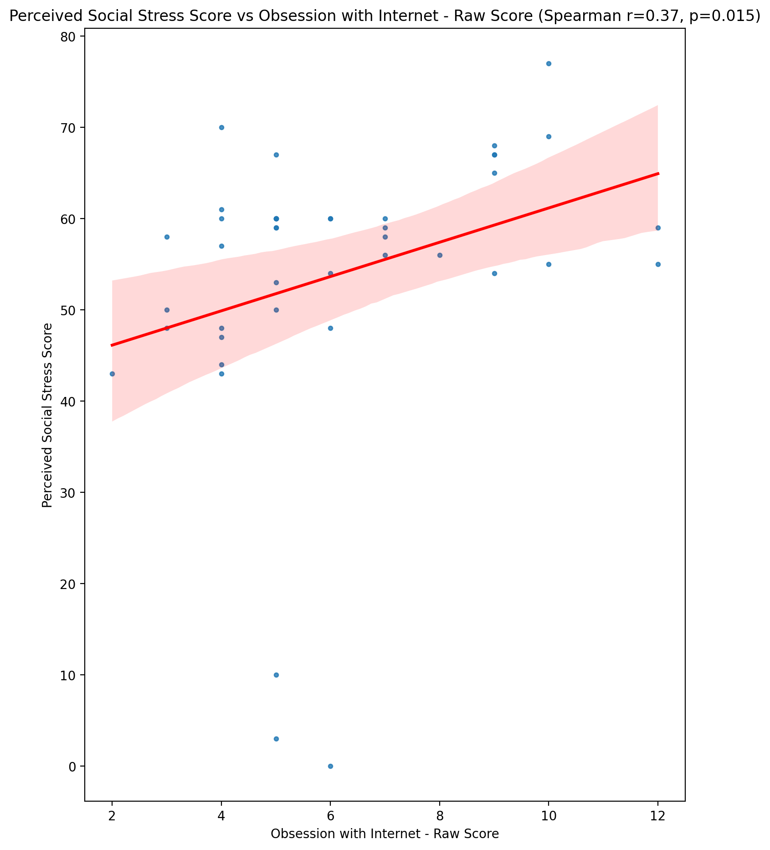

## Perceived Social Stress Category vs Obsession with Internet - Raw Score

Test: None; statistic: None; p-value: None; Test not run: unsupported type combination.



## Emotional Support - Raw Score vs Internet as a Source of Recreation - Raw Score

Test: spearman; statistic: -0.17493638815120915; p-value: 0.261857929909766;

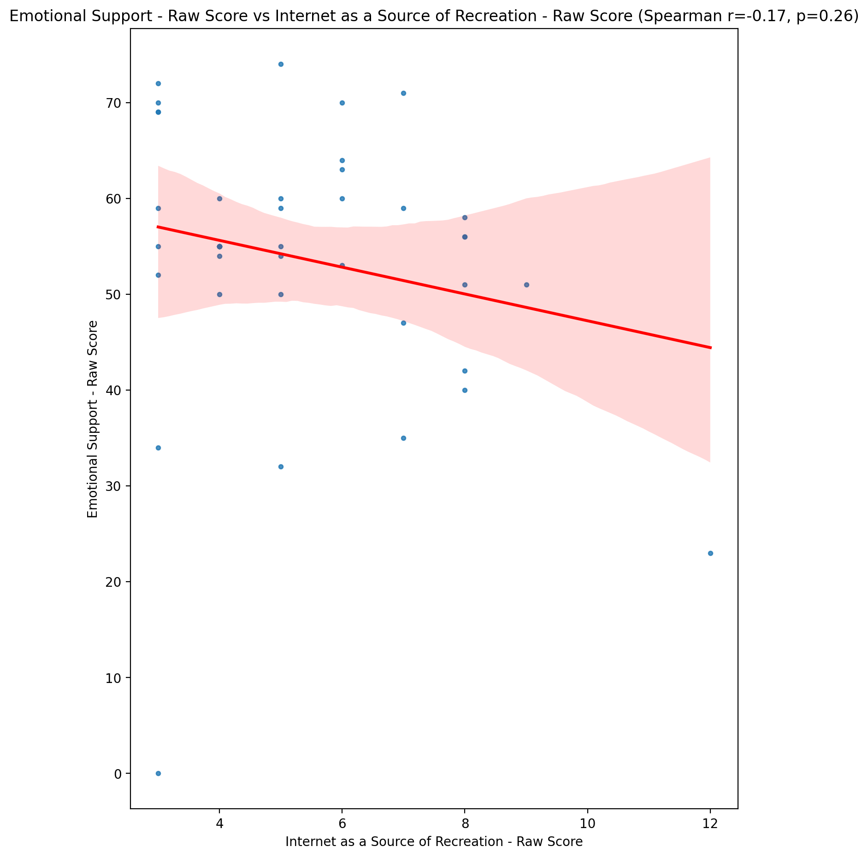

## Informational Support - Raw Score vs Internet as a Source of Recreation - Raw Score

Test: spearman; statistic: -0.1874374896623847; p-value: 0.2287465098906379;

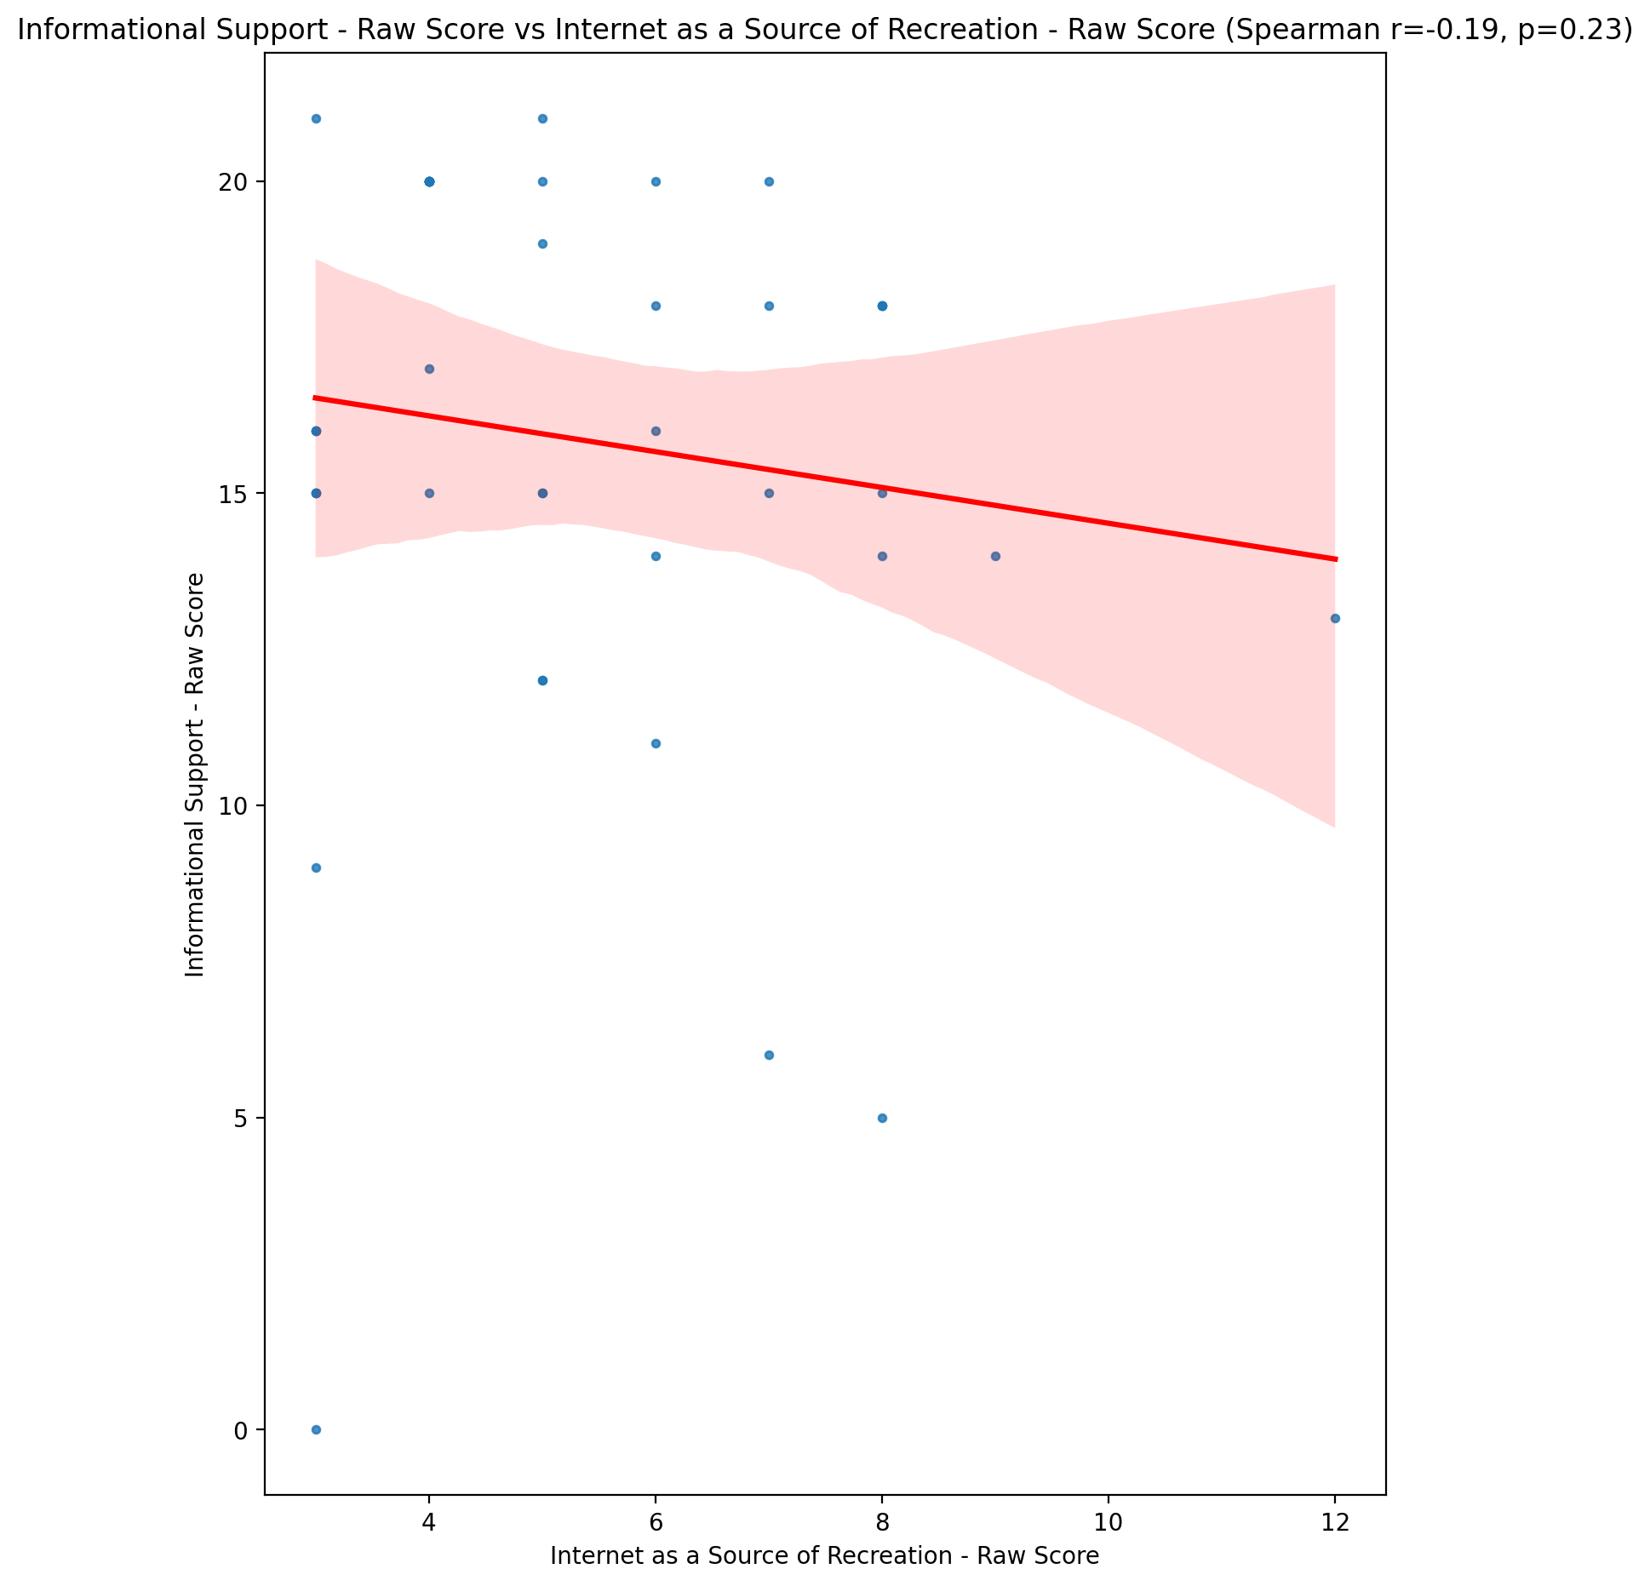

## Instrumental Support - Raw Score vs Internet as a Source of Recreation - Raw Score

Test: spearman; statistic: -0.3733580137517788; p-value: 0.013661987975401297;

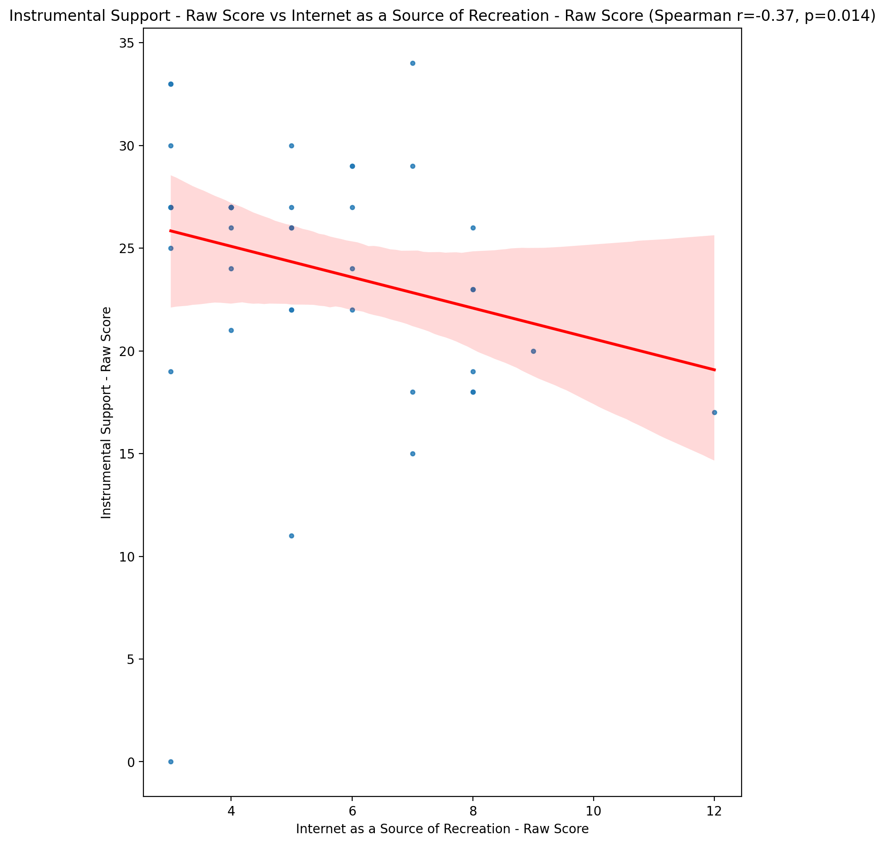

## Emotional Support - T Score vs Internet as a Source of Recreation - Raw Score

Test: spearman; statistic: -0.18467682850483877; p-value: 0.23579895664035888;

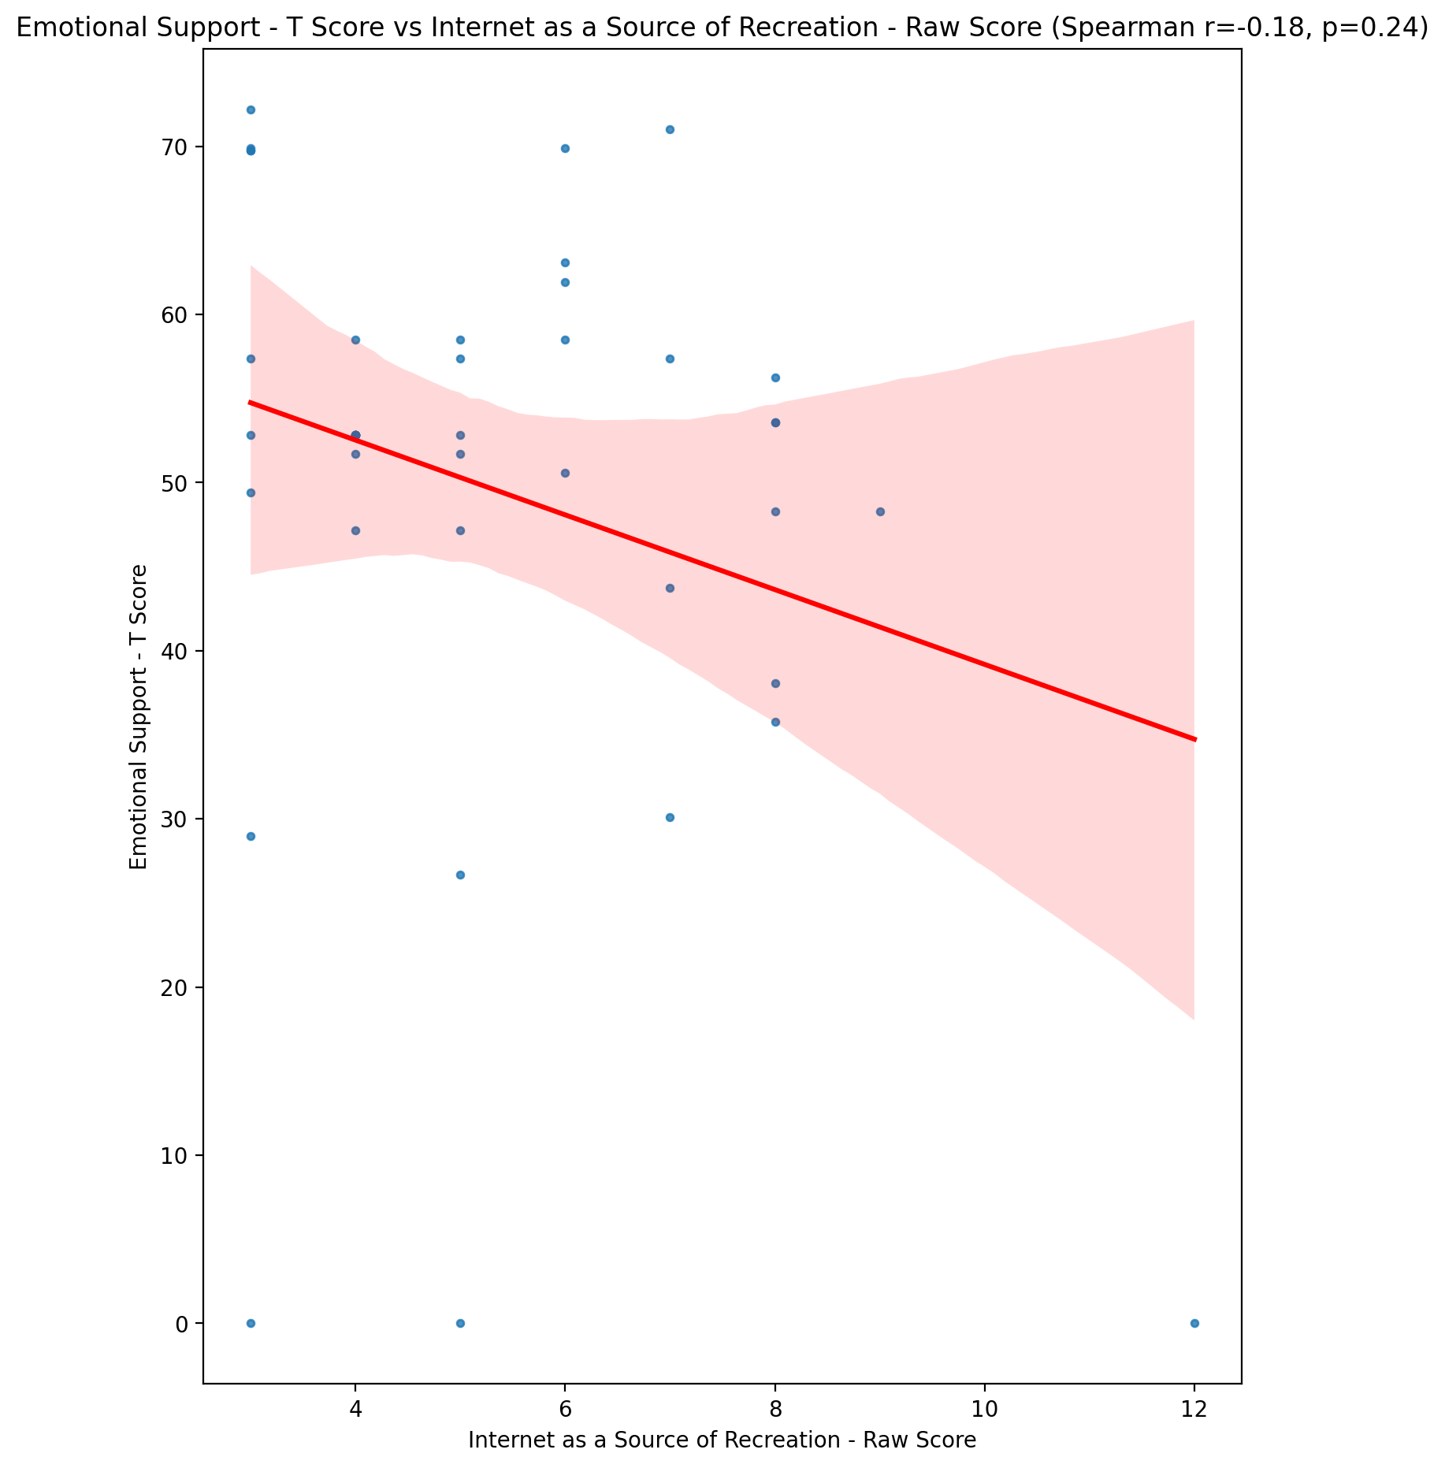

## Informational Support - T Score vs Internet as a Source of Recreation - Raw Score

Test: spearman; statistic: -0.1918958089187597; p-value: 0.21766506668152202;

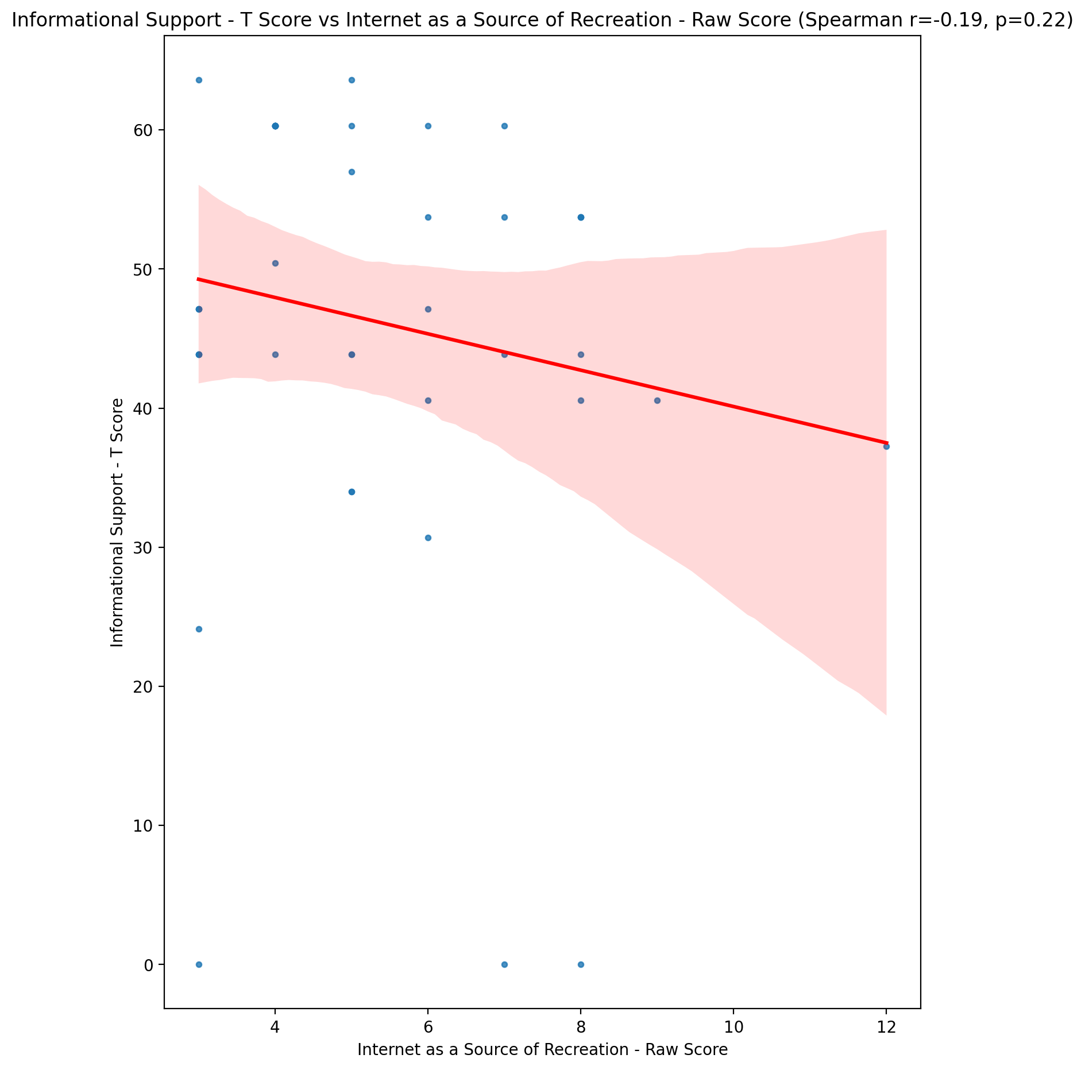

## Instrumental Support - T Score vs Internet as a Source of Recreation - Raw Score

Test: spearman; statistic: -0.3747695416936914; p-value: 0.01328280151216645;

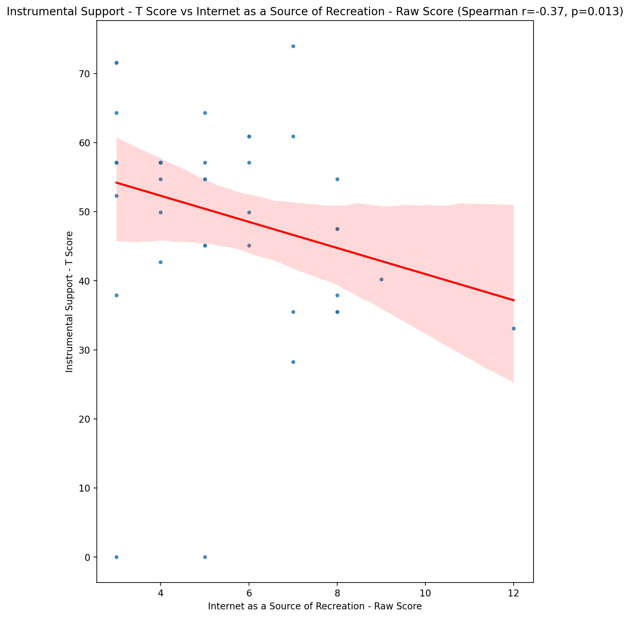

## Perceived Social Support Total T Score vs Internet as a Source of Recreation - Raw Score

Test: spearman; statistic: -0.2318256931056376; p-value: 0.13469271107024694;

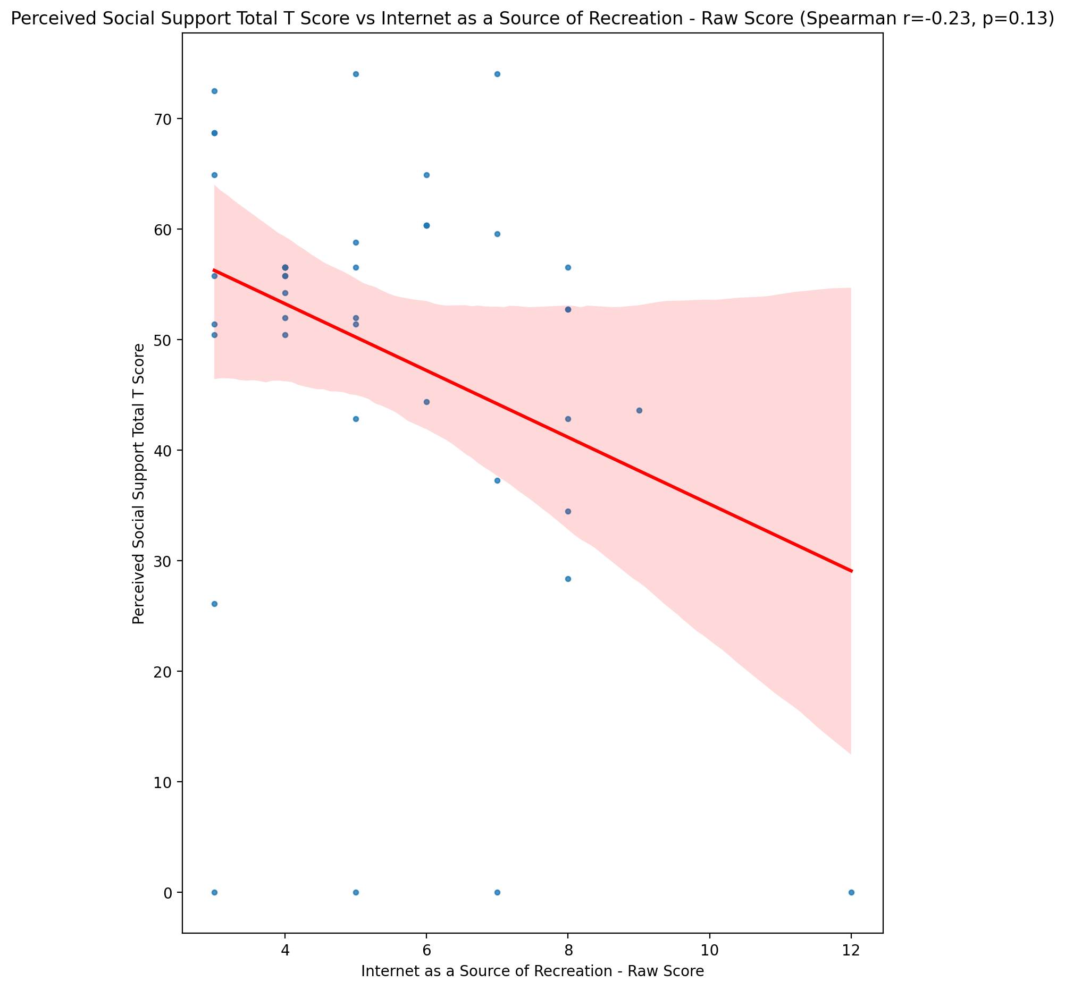

## Emotional Support - Rank vs Internet as a Source of Recreation - Raw Score

Test: None; statistic: None; p-value: None; Test not run: unsupported type combination.



## Informational Support - Rank vs Internet as a Source of Recreation - Raw Score

Test: None; statistic: None; p-value: None; Test not run: unsupported type combination.



## Instrumental Support - Rank vs Internet as a Source of Recreation - Raw Score

Test: None; statistic: None; p-value: None; Test not run: unsupported type combination.



## Perceived Social Support TOTAL - Rank vs Internet as a Source of Recreation - Raw Score

Test: None; statistic: None; p-value: None; Test not run: unsupported type combination.



## Power Self Concept - Real Self Concept Score vs Internet as a Source of Recreation - Raw Score

Test: spearman; statistic: 0.028657915524797437; p-value: 0.8552512910512309;

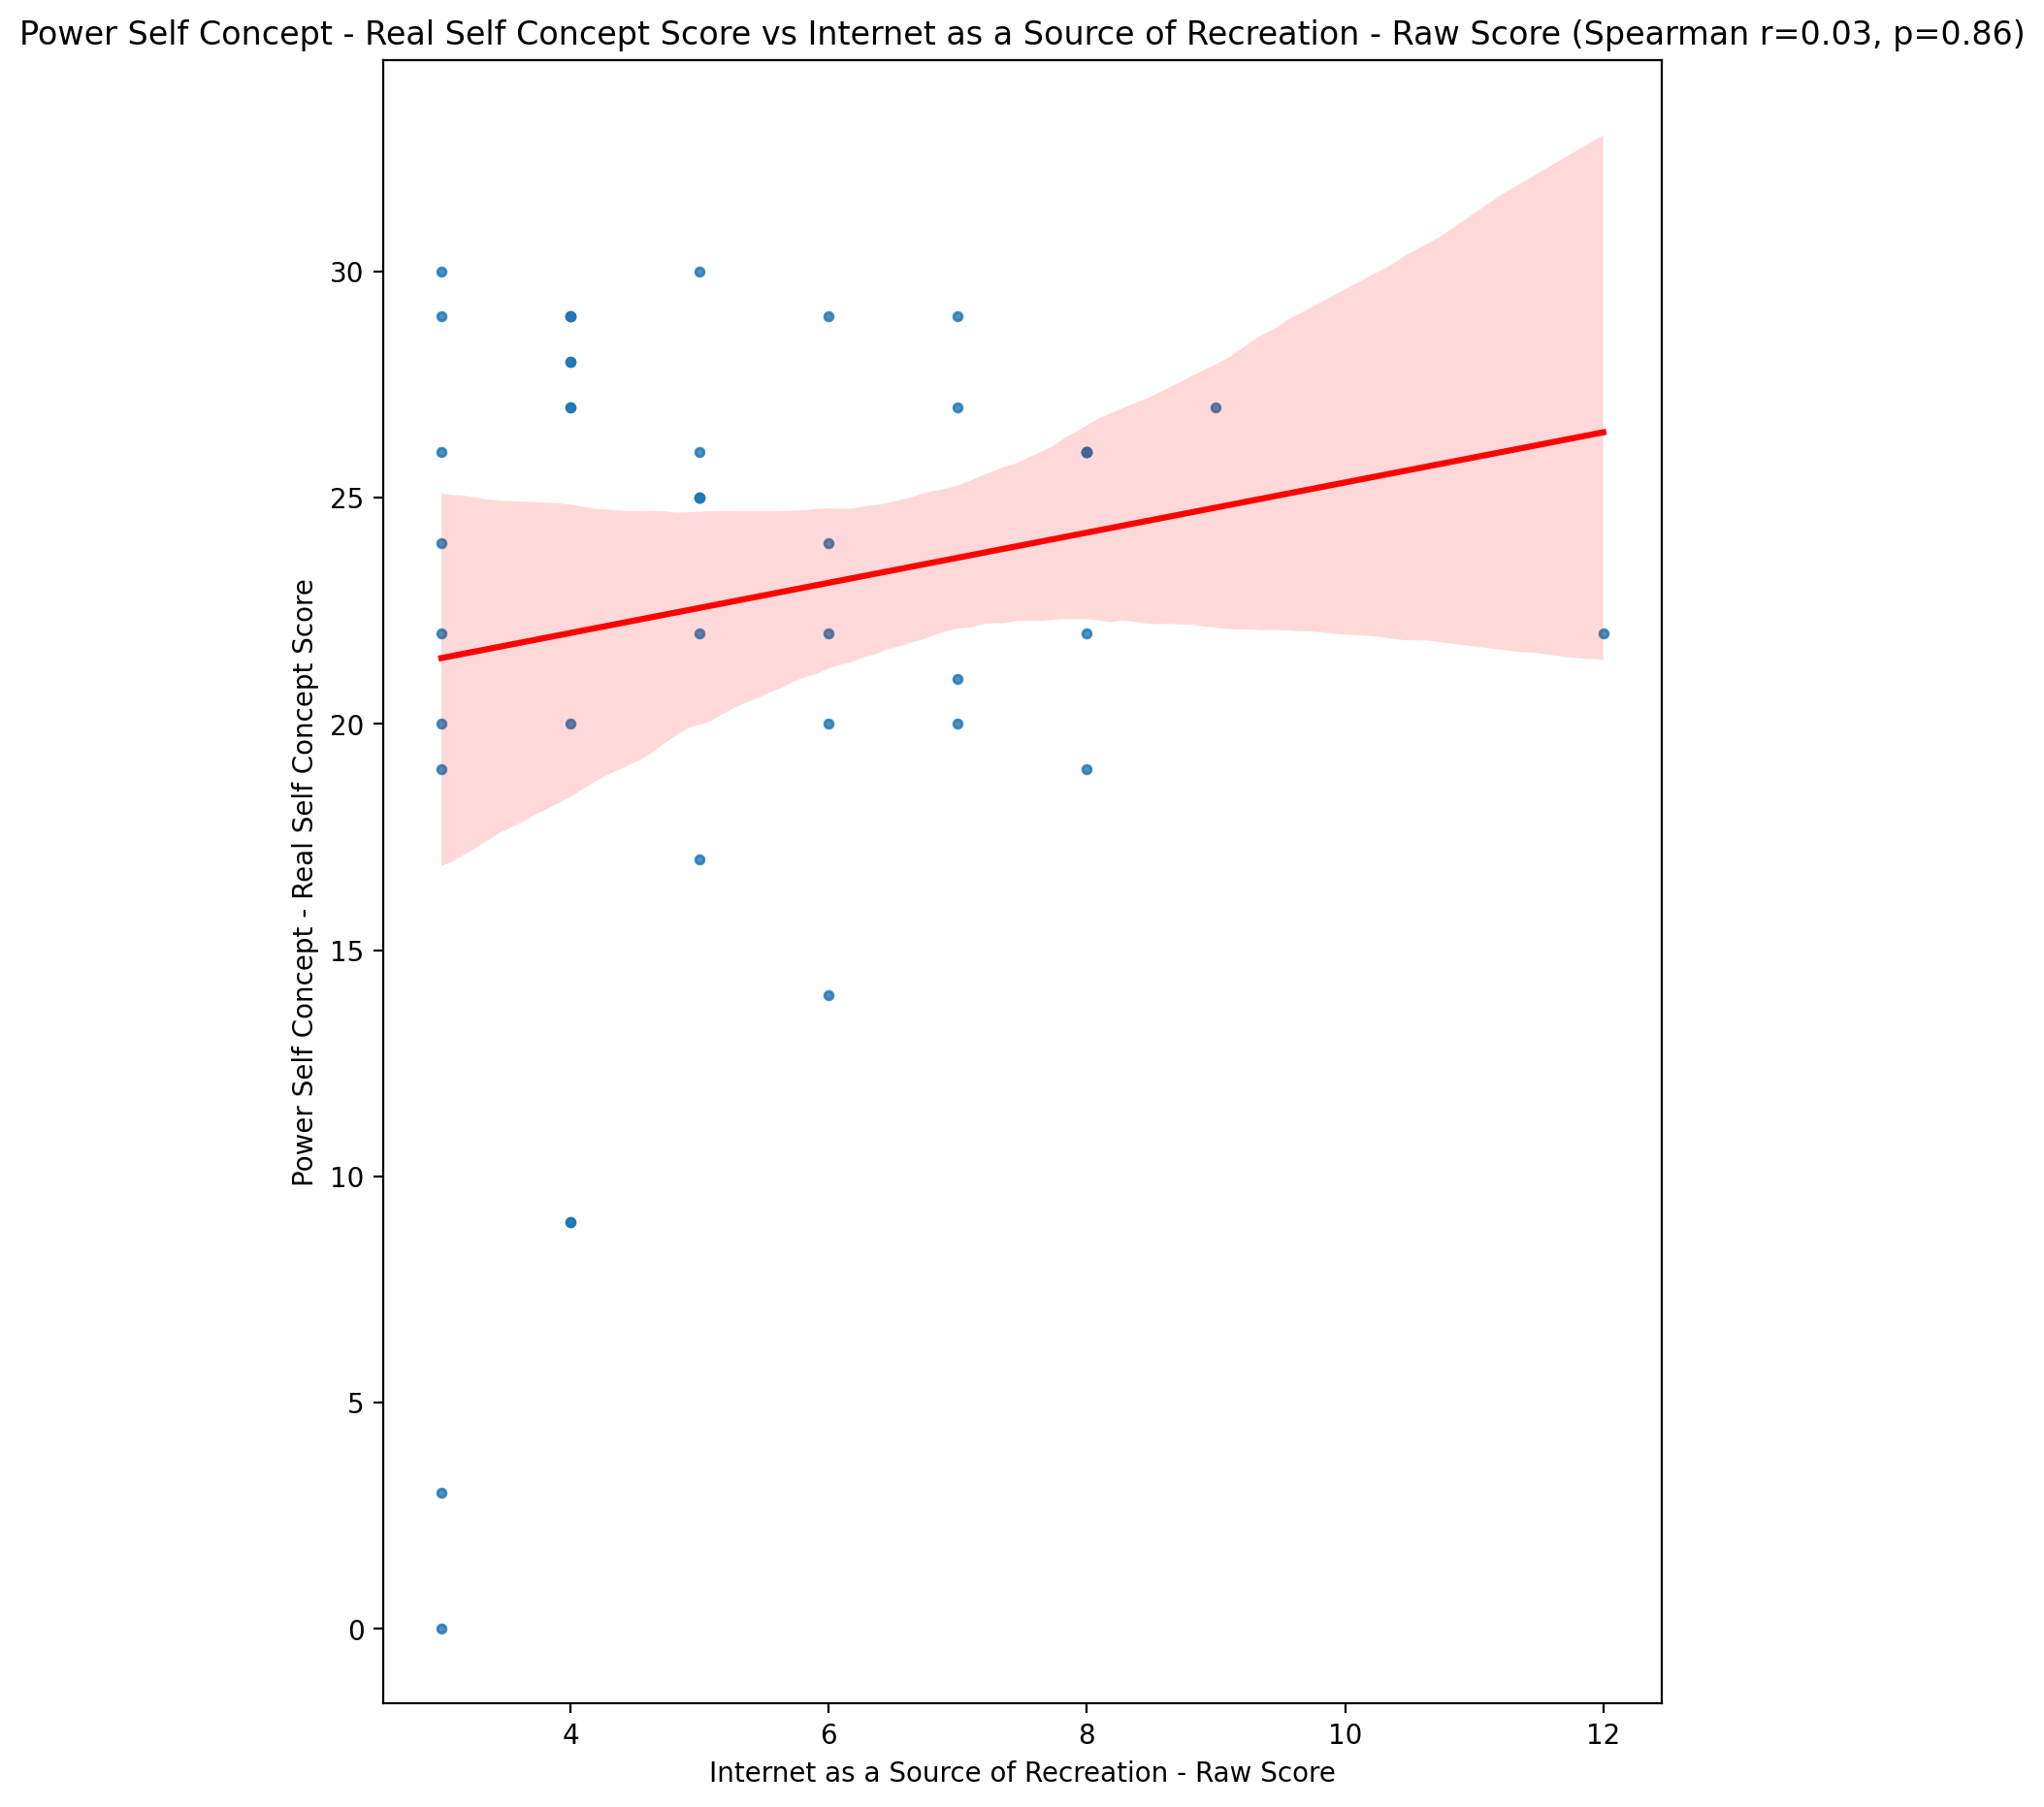

## Power Self Concept - Ideal Self Concept score vs Internet as a Source of Recreation - Raw Score

Test: spearman; statistic: -0.04317424881746125; p-value: 0.7833944965048469;

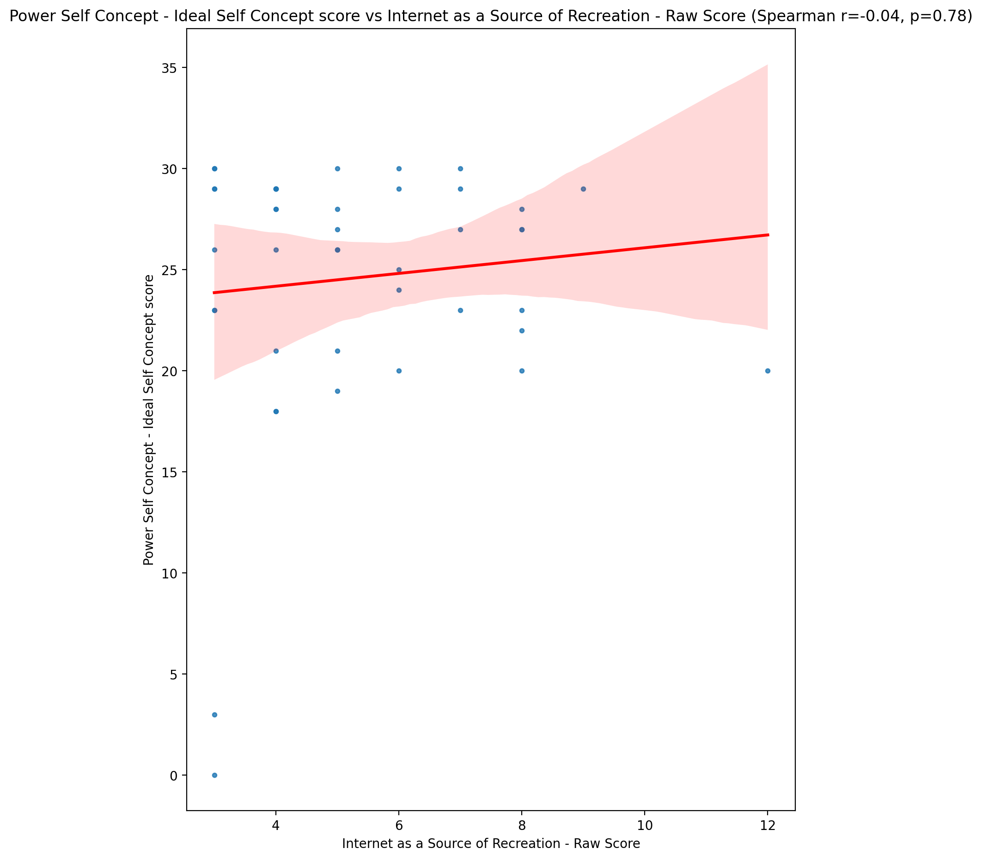

## Power Self Concept – Social Self Concept Score vs Internet as a Source of Recreation - Raw Score

Test: spearman; statistic: 0.09404031045883596; p-value: 0.5486235464780913;

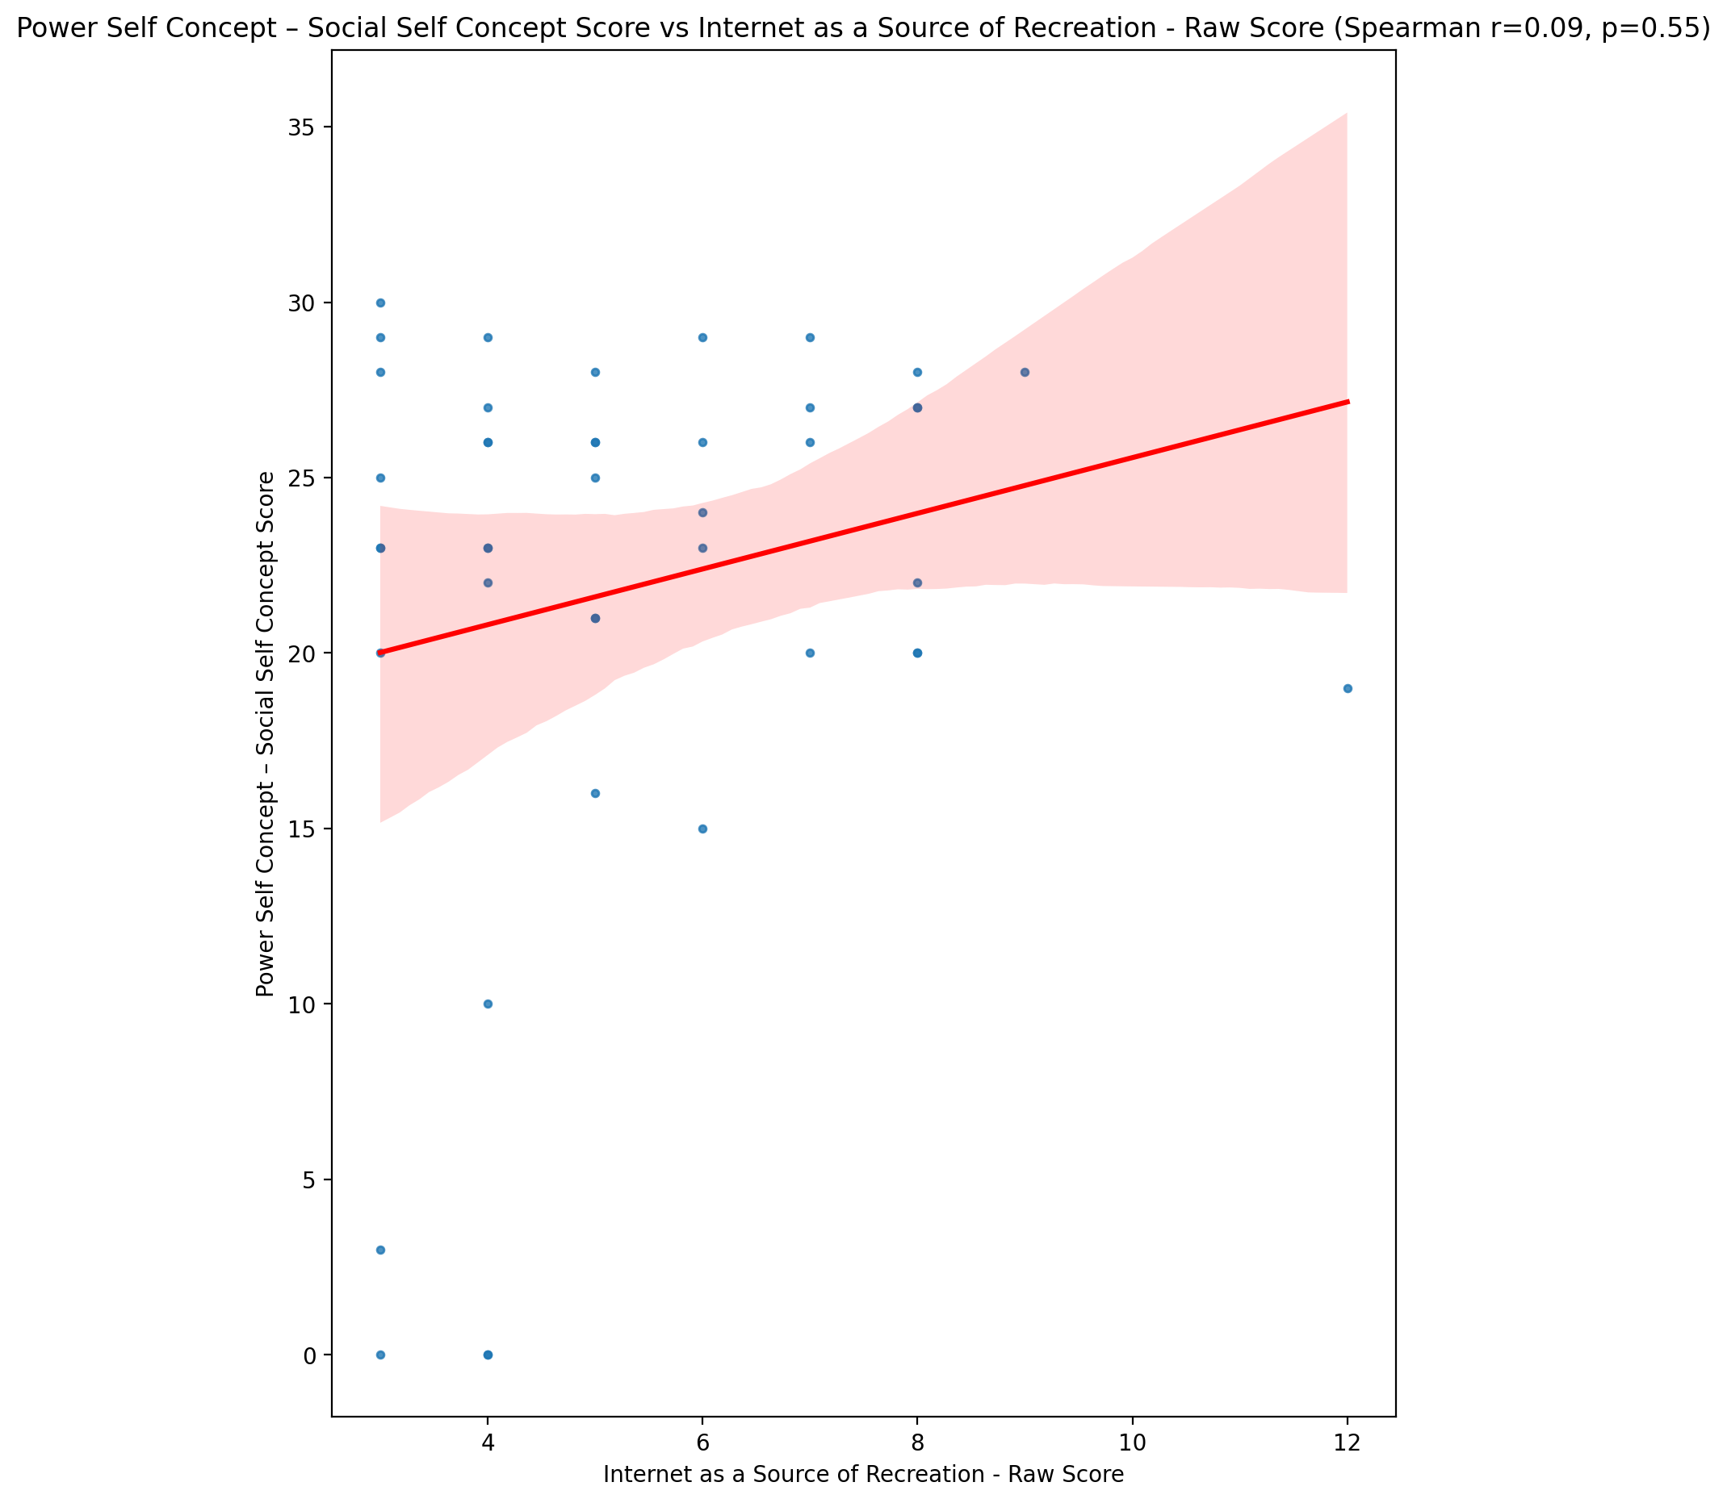

## Social Self Concept - Real Self Concept Score vs Internet as a Source of Recreation - Raw Score

Test: spearman; statistic: 0.03418755887299381; p-value: 0.8277093618872541;

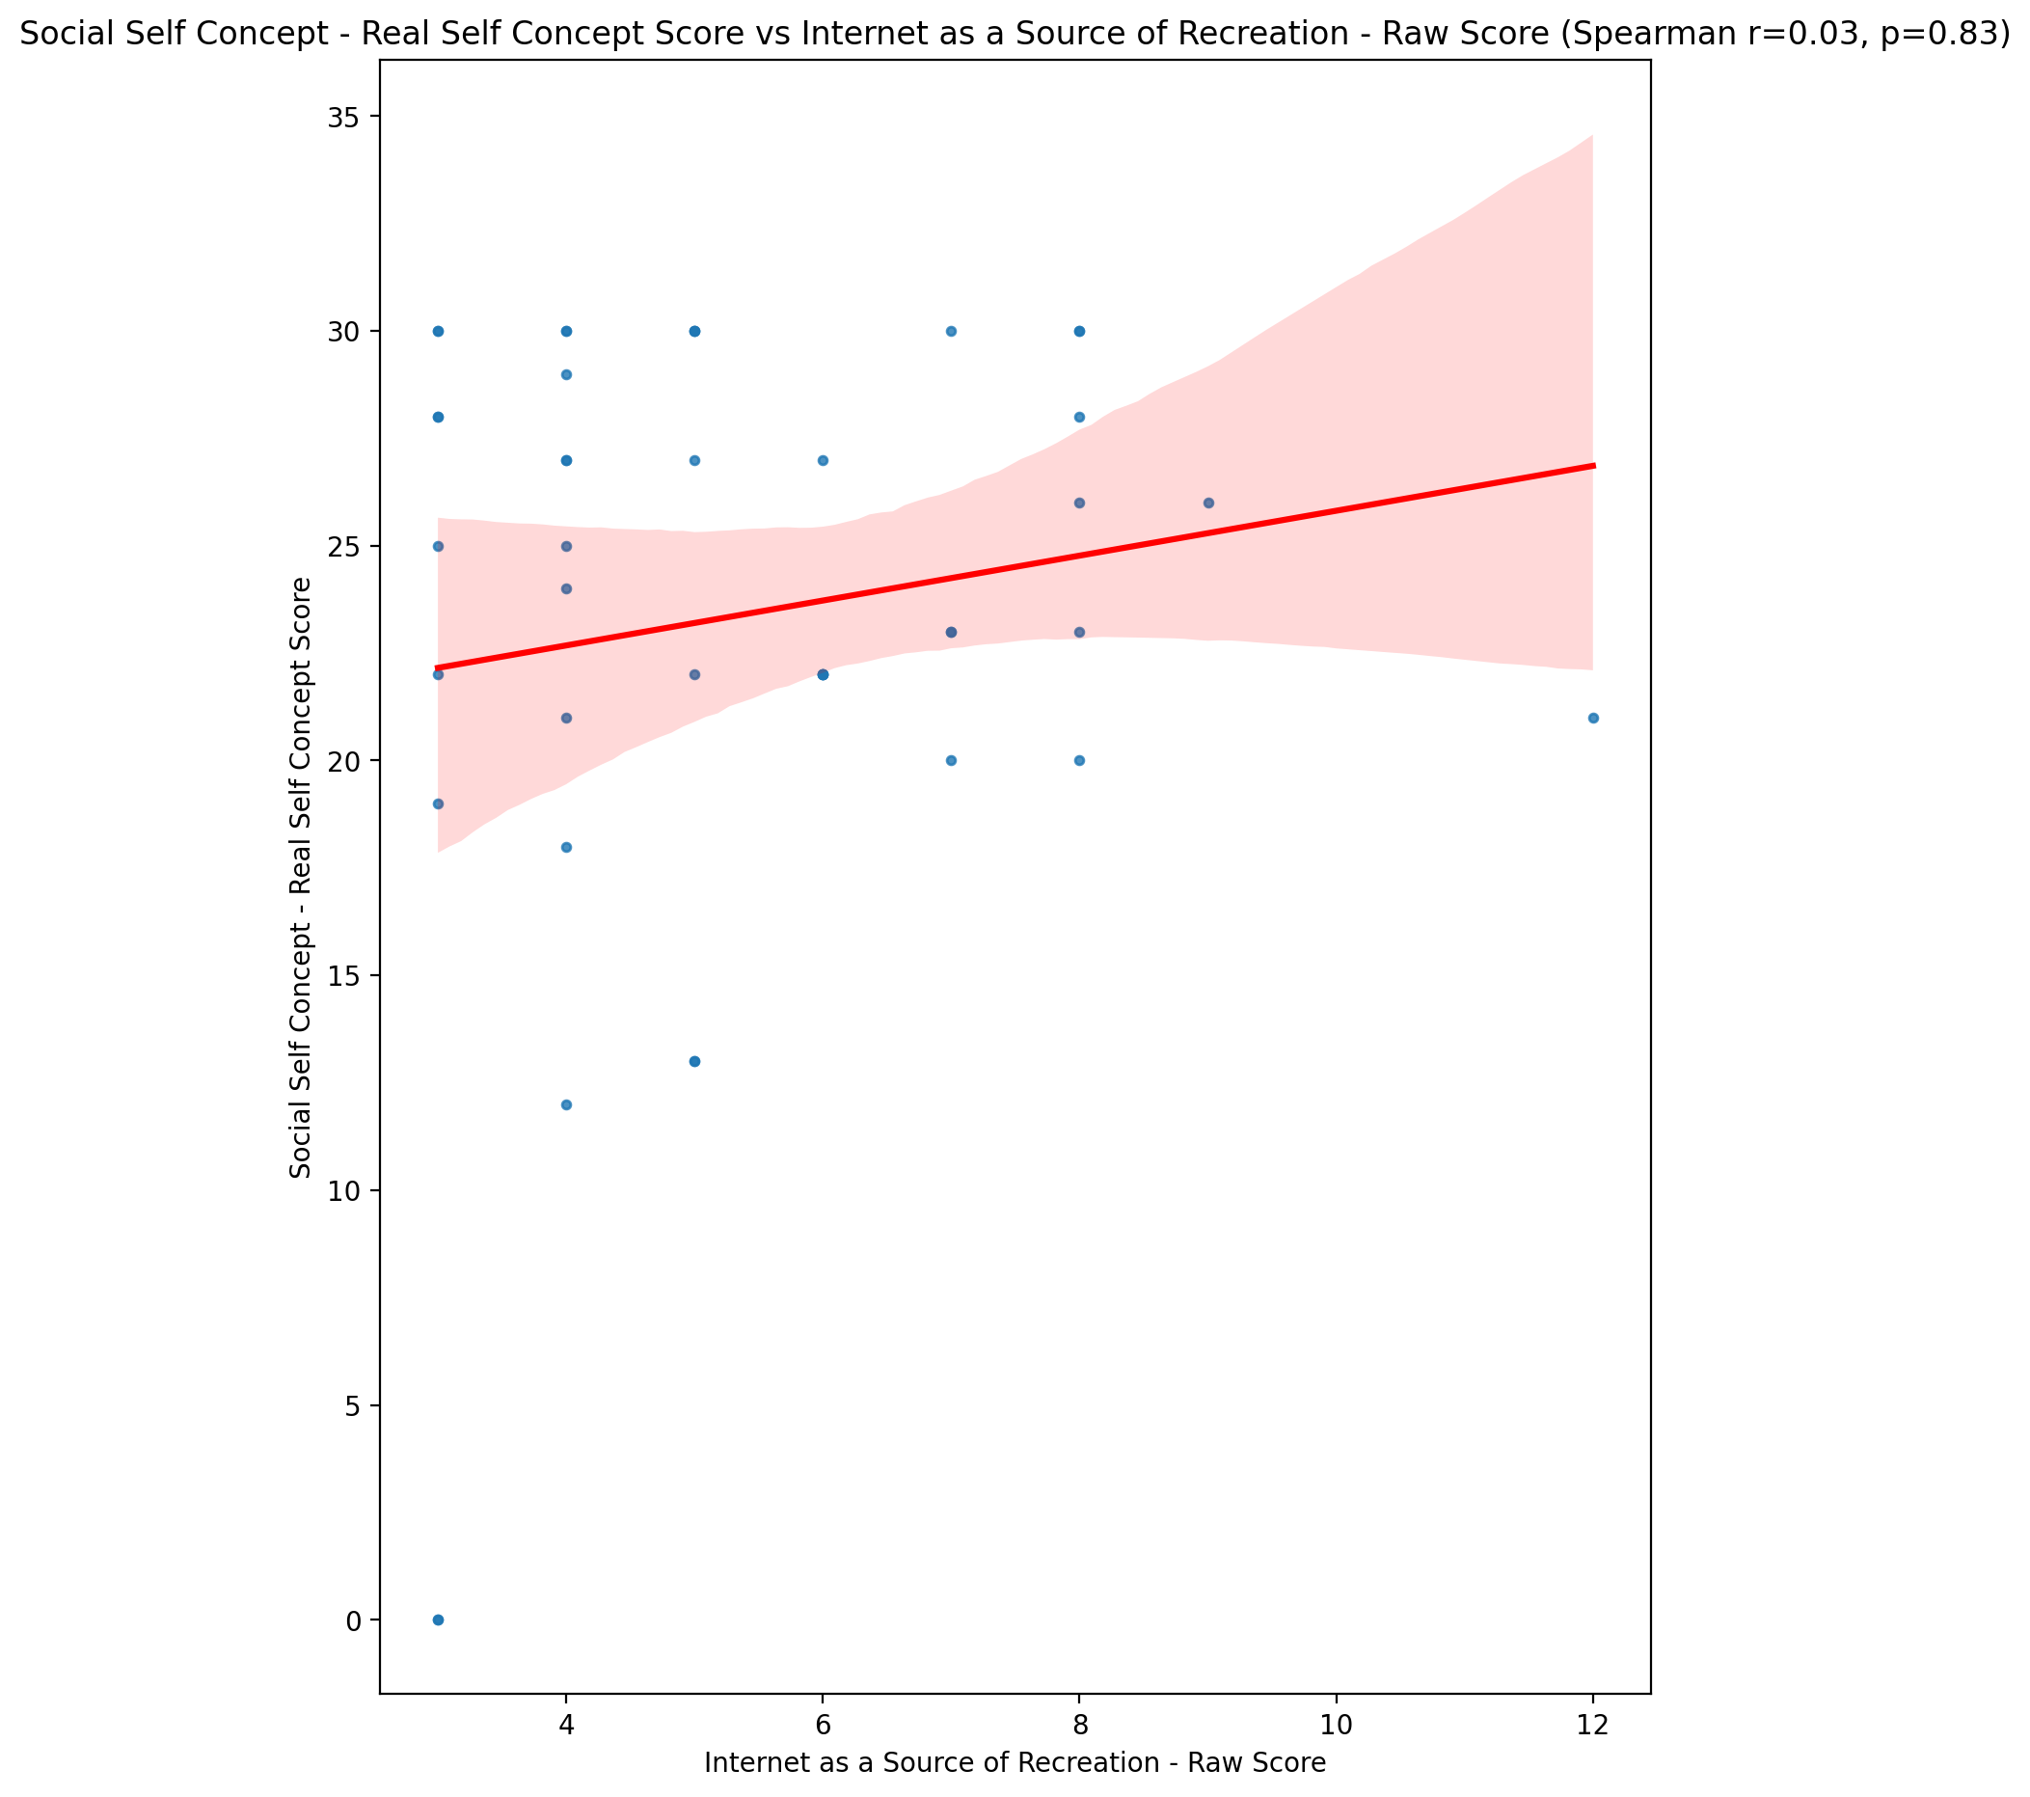

## Social Self Concept – Social Self Concept Score vs Internet as a Source of Recreation - Raw Score

Test: spearman; statistic: 0.08044952902899703; p-value: 0.6080700844730174;

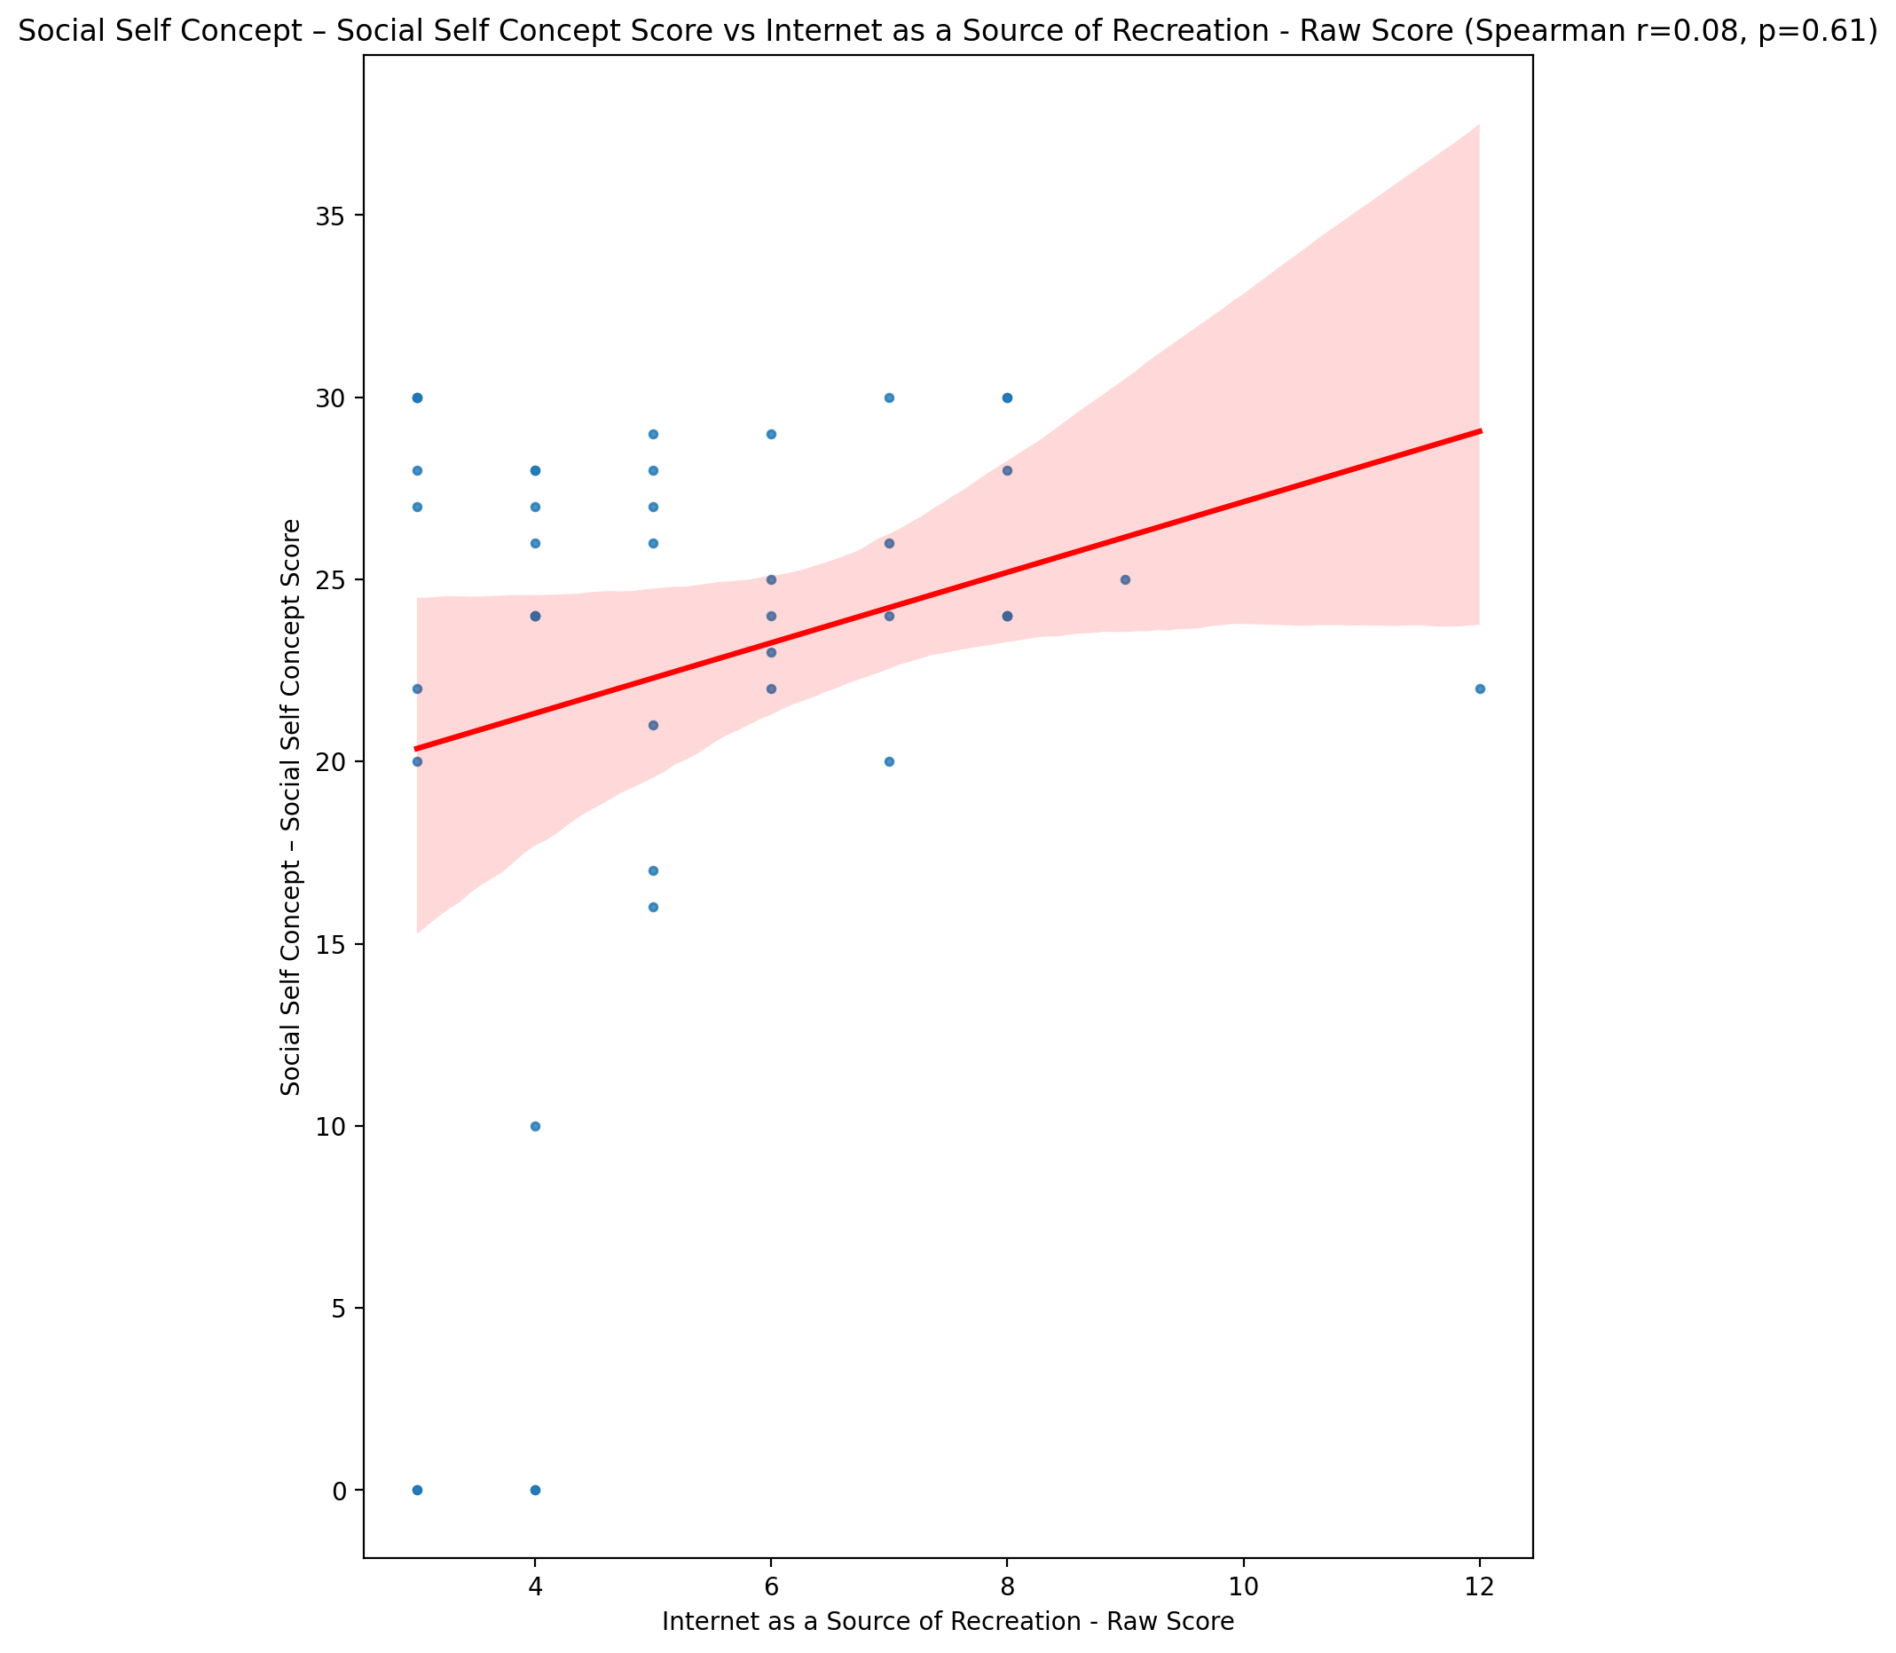

## Ability Self Concept - Real Self Concept Score vs Internet as a Source of Recreation - Raw Score

Test: spearman; statistic: 0.0033099616040211375; p-value: 0.9831935439381864;

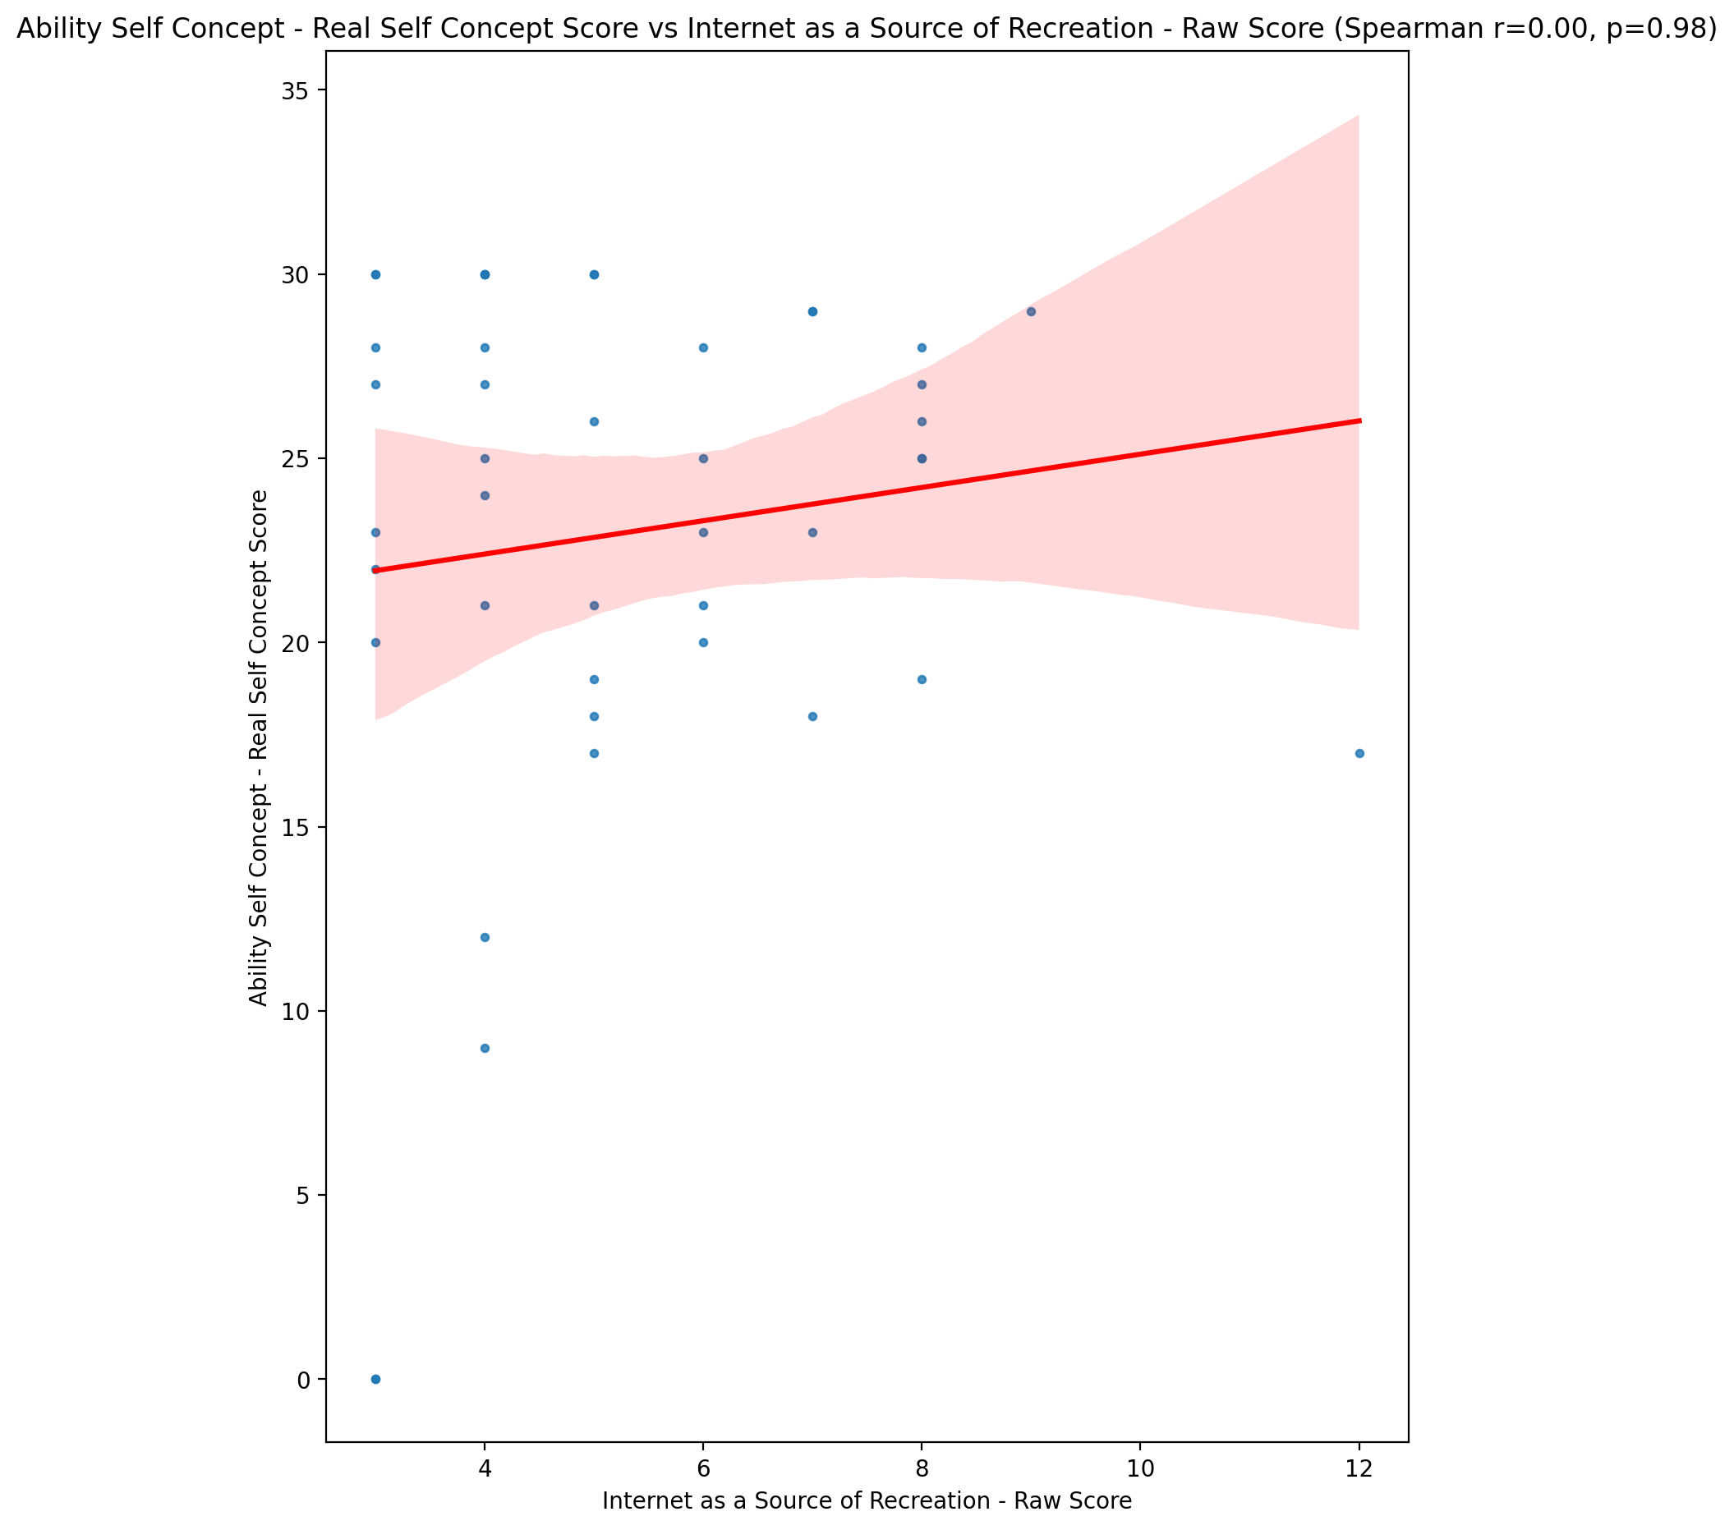

## Ability Self Concept - Ideal Self Concept Score vs Internet as a Source of Recreation - Raw Score

Test: spearman; statistic: -0.1033286874607685; p-value: 0.5096556764037723;

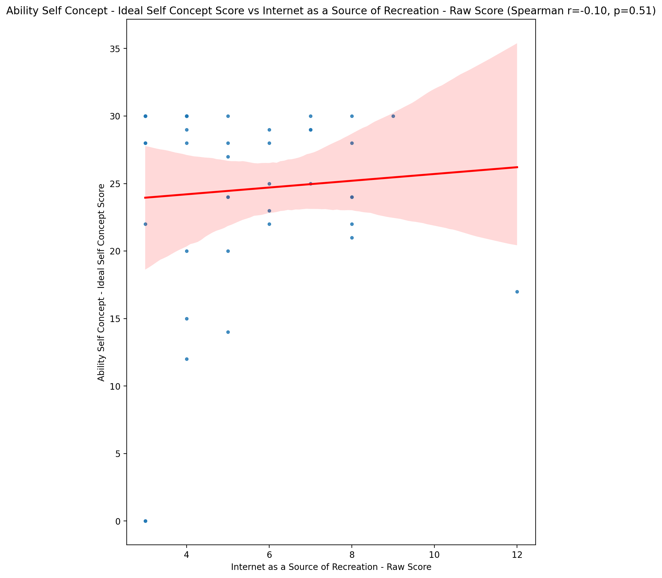

## Ability Self Concept – Social Self Concept Score vs Internet as a Source of Recreation - Raw Score

Test: spearman; statistic: 0.007540765884555703; p-value: 0.9617228958414423;

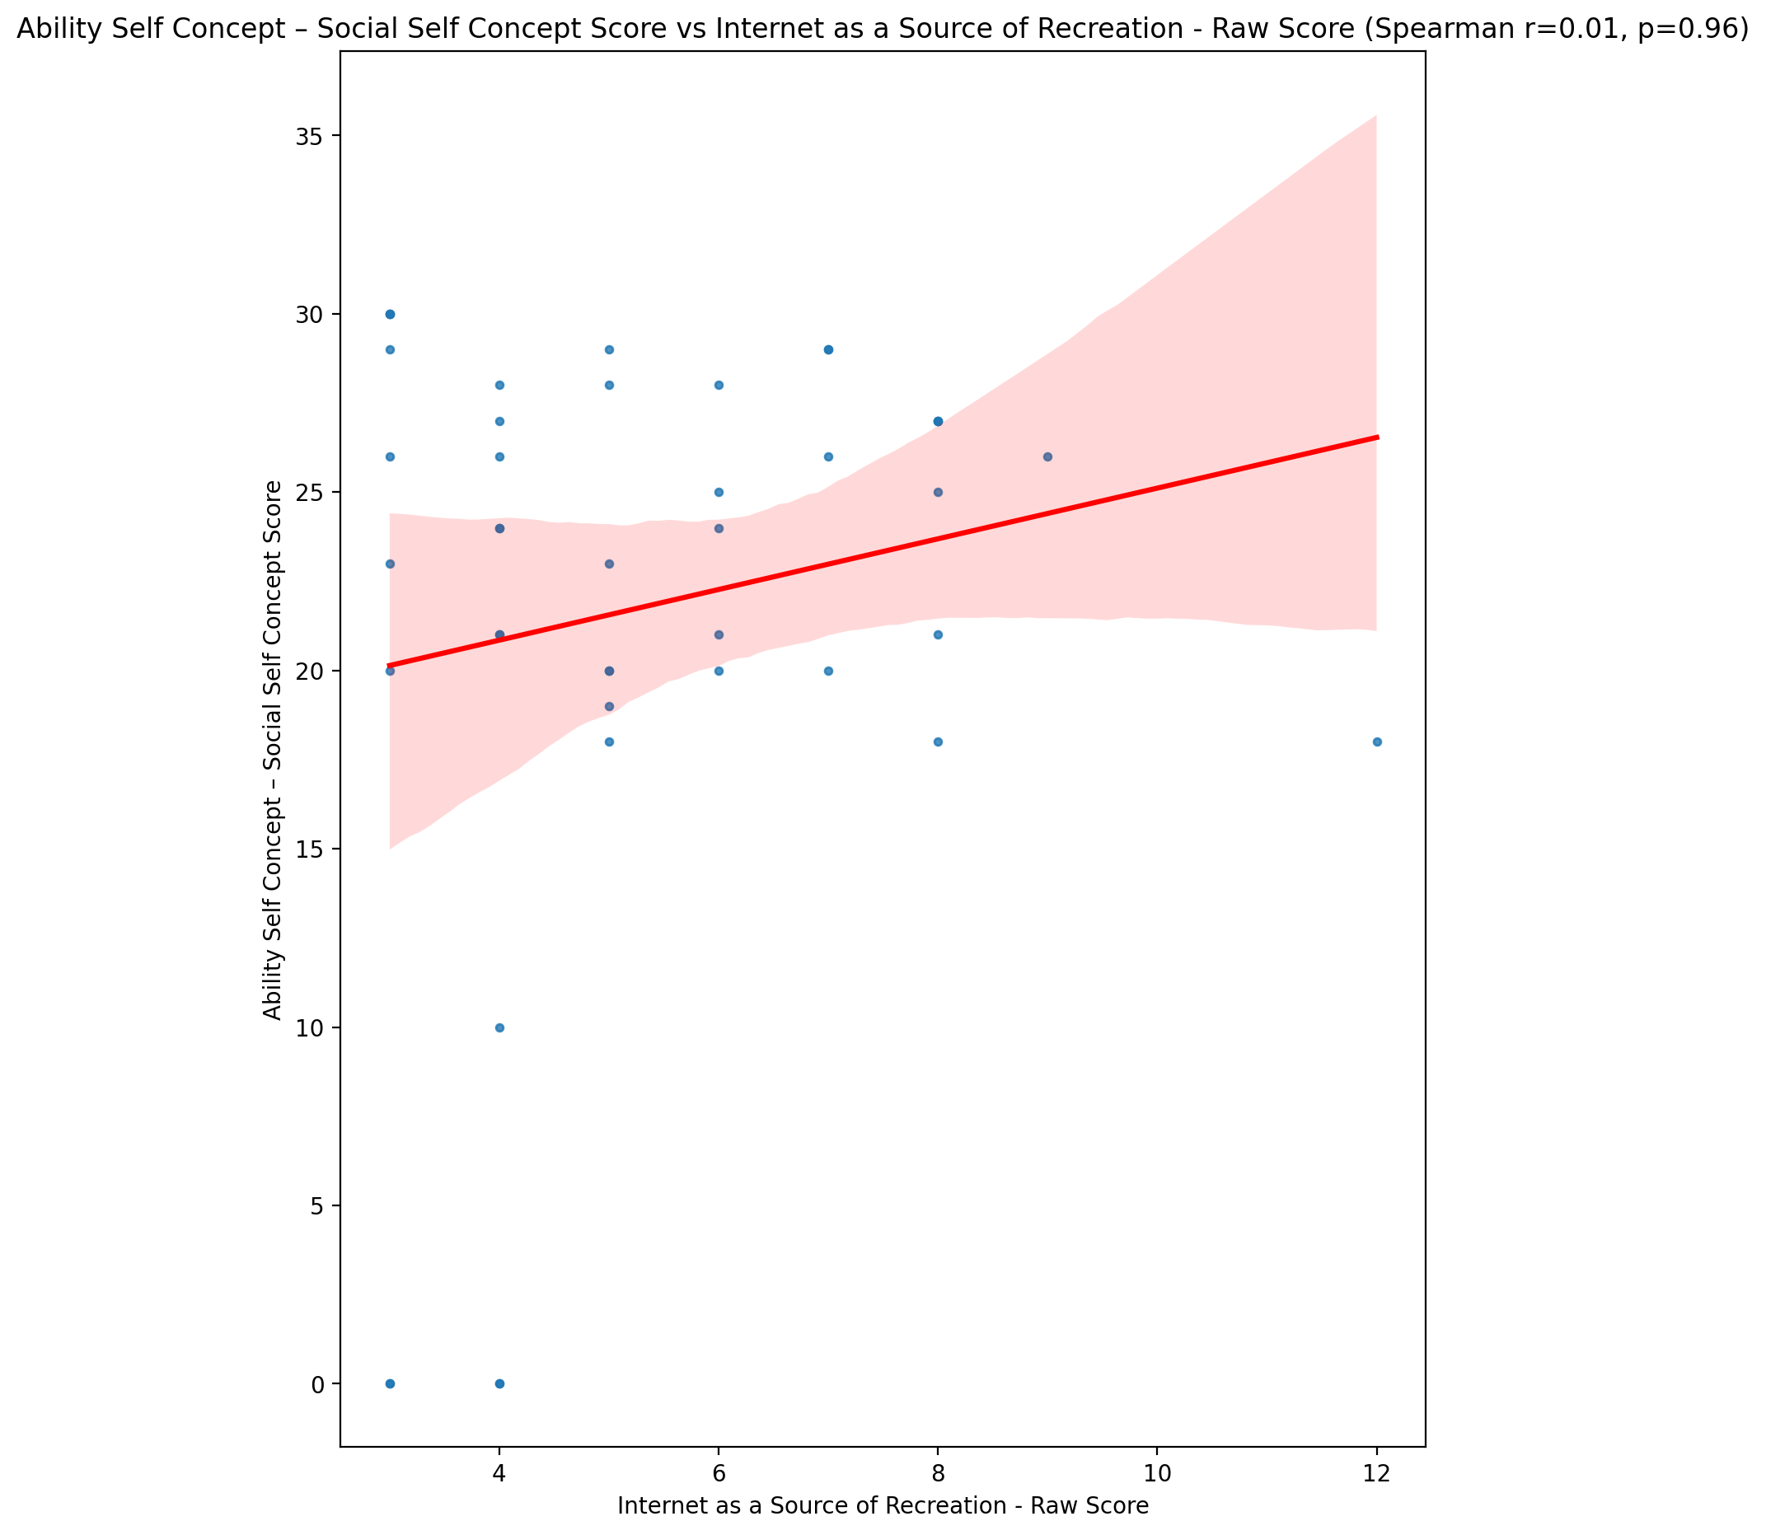

## Physical Self Concept - Real Self Concept Score vs Internet as a Source of Recreation - Raw Score

Test: spearman; statistic: 0.11684213526622754; p-value: 0.4555651618730615;

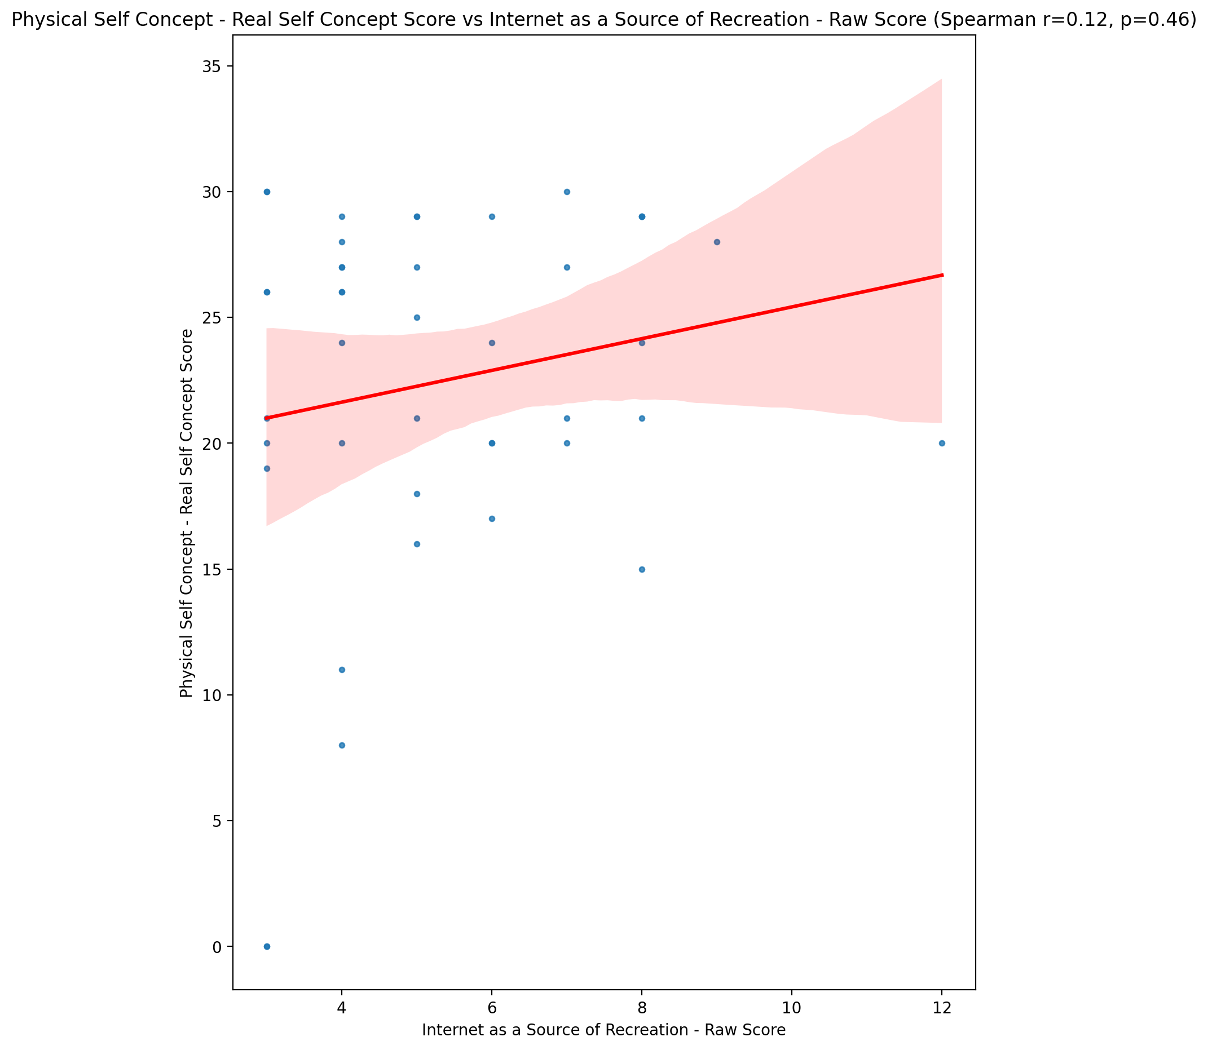

## Physical Self Concept – Ideal Self Concept Score vs Internet as a Source of Recreation - Raw Score

Test: spearman; statistic: 0.032339192599353646; p-value: 0.8368946839773562;

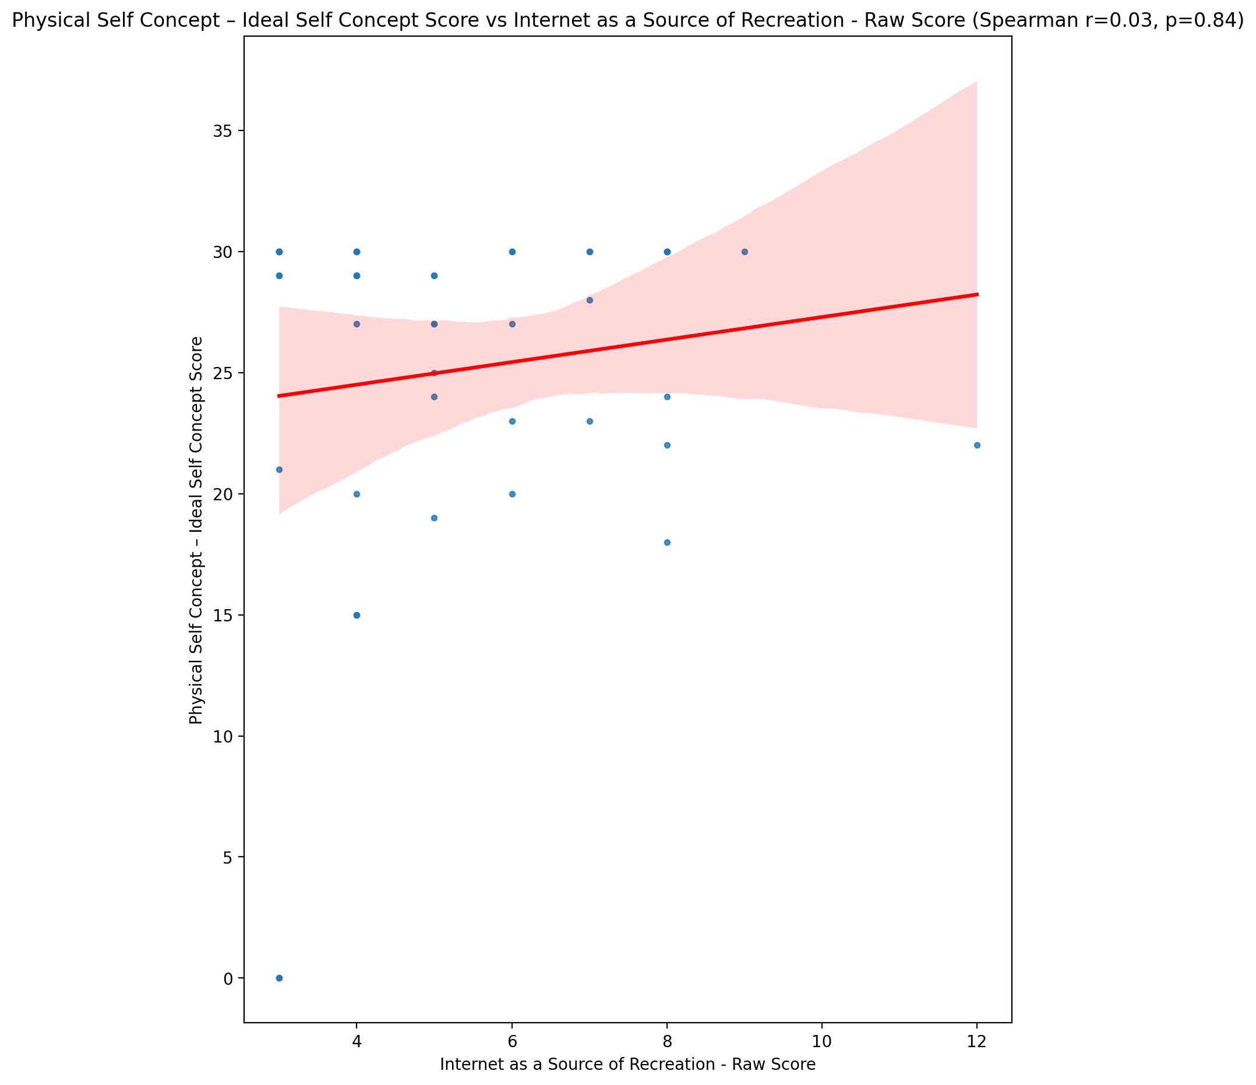

## Physical Self Concept – Social Self Concept Score vs Internet as a Source of Recreation - Raw Score

Test: spearman; statistic: 0.27746079261629114; p-value: 0.07164436798682039;

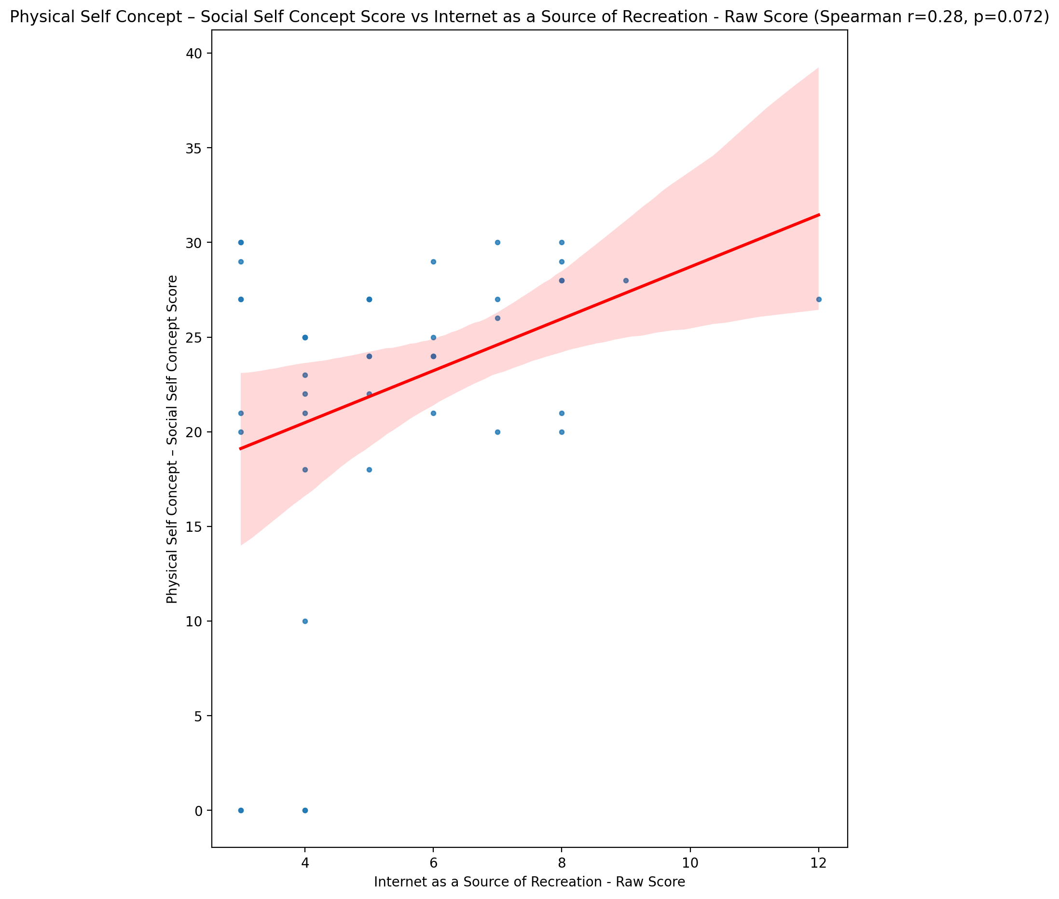

## Psychological Self Concept - Real Self Concept Score vs Internet as a Source of Recreation - Raw Score

Test: spearman; statistic: -0.03386145545370039; p-value: 0.8293282980797692;

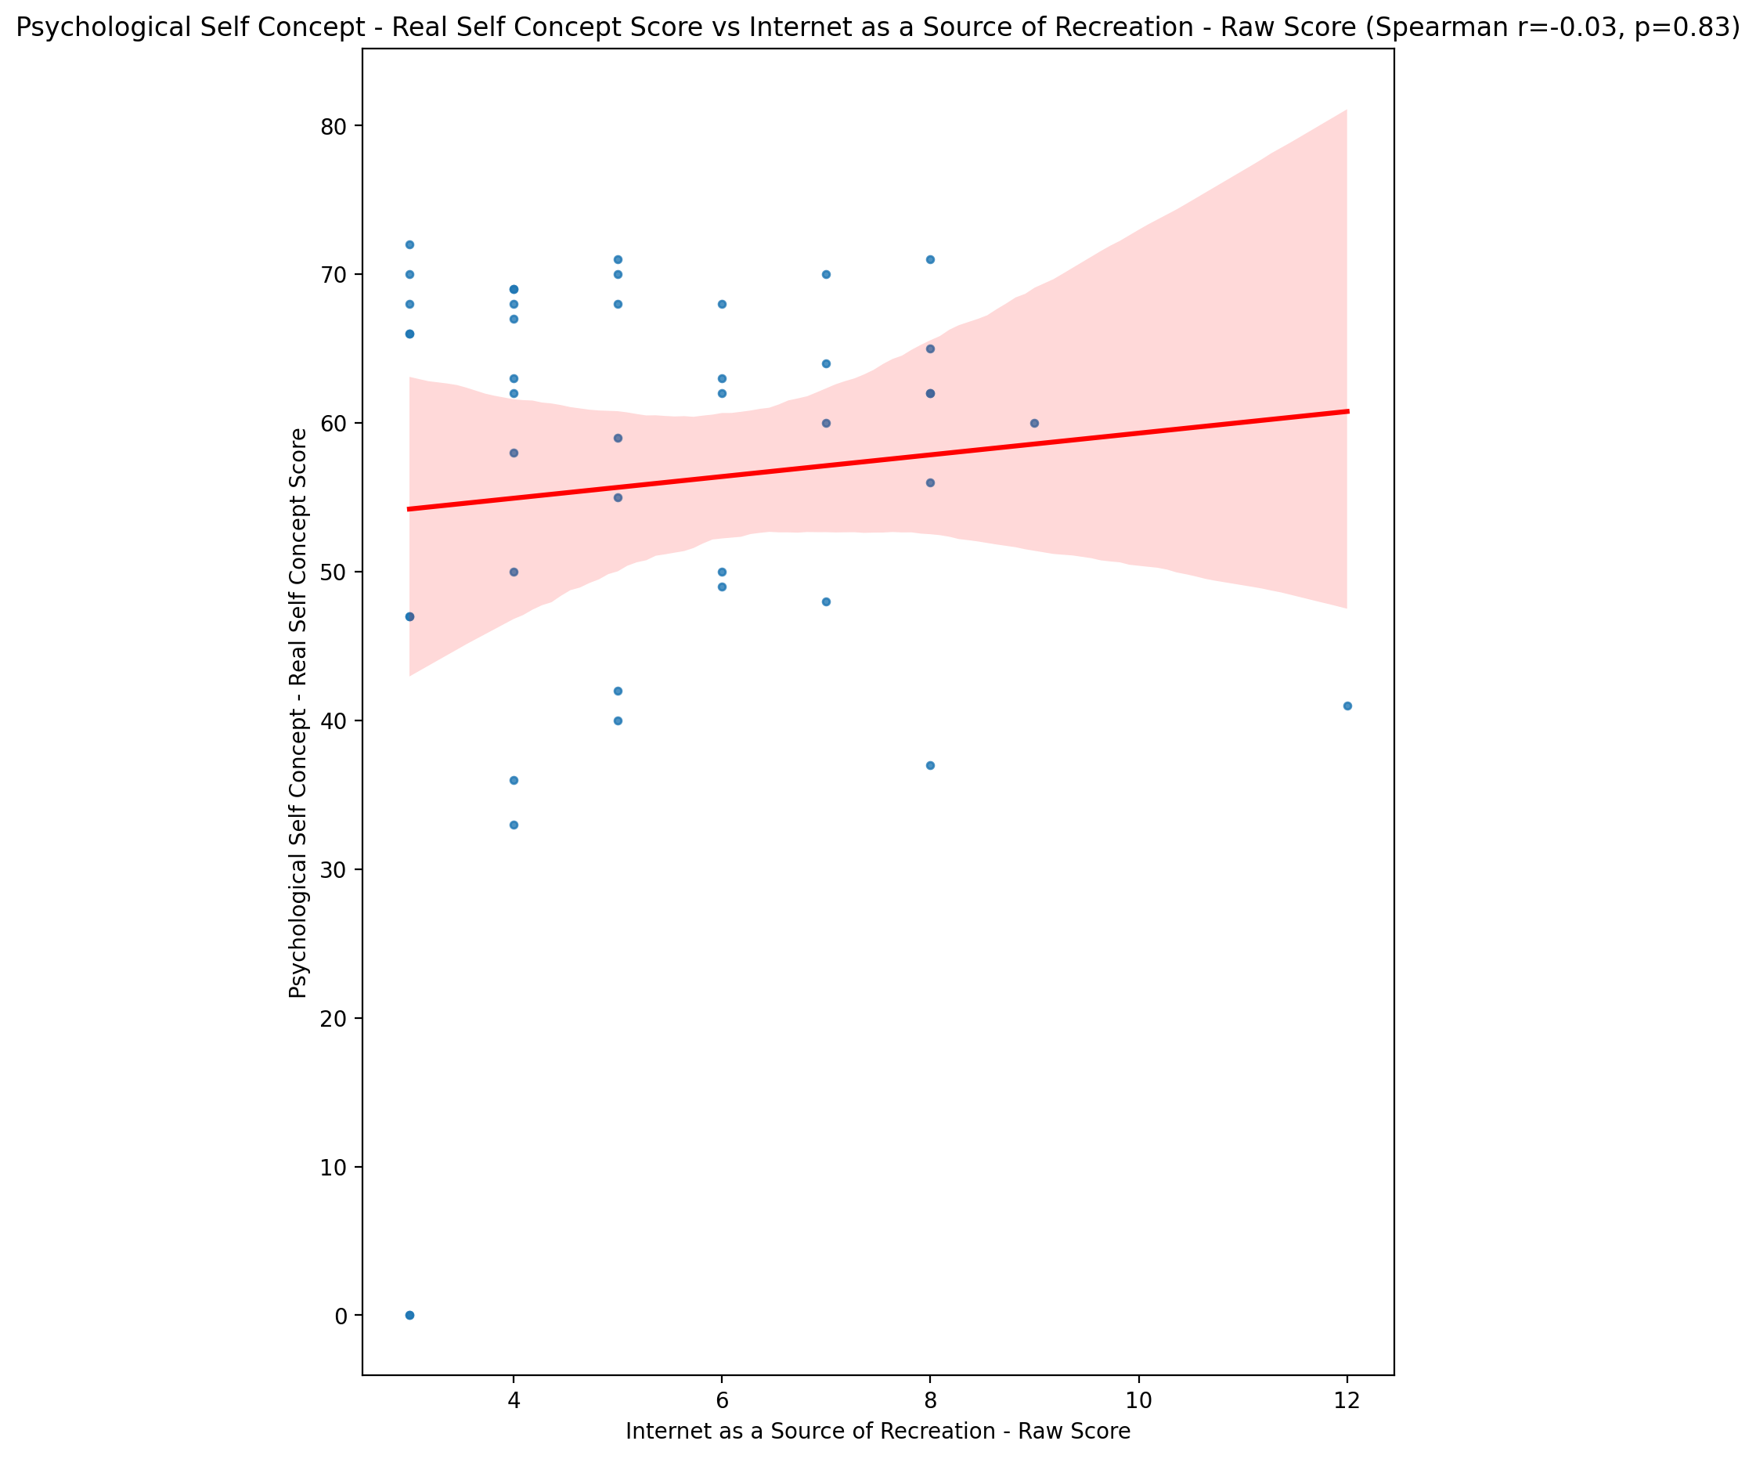

## Psychological Self Concept – Ideal Self Concept Score vs Internet as a Source of Recreation - Raw Score

Test: spearman; statistic: -0.04739189578770143; p-value: 0.7628185770020213;

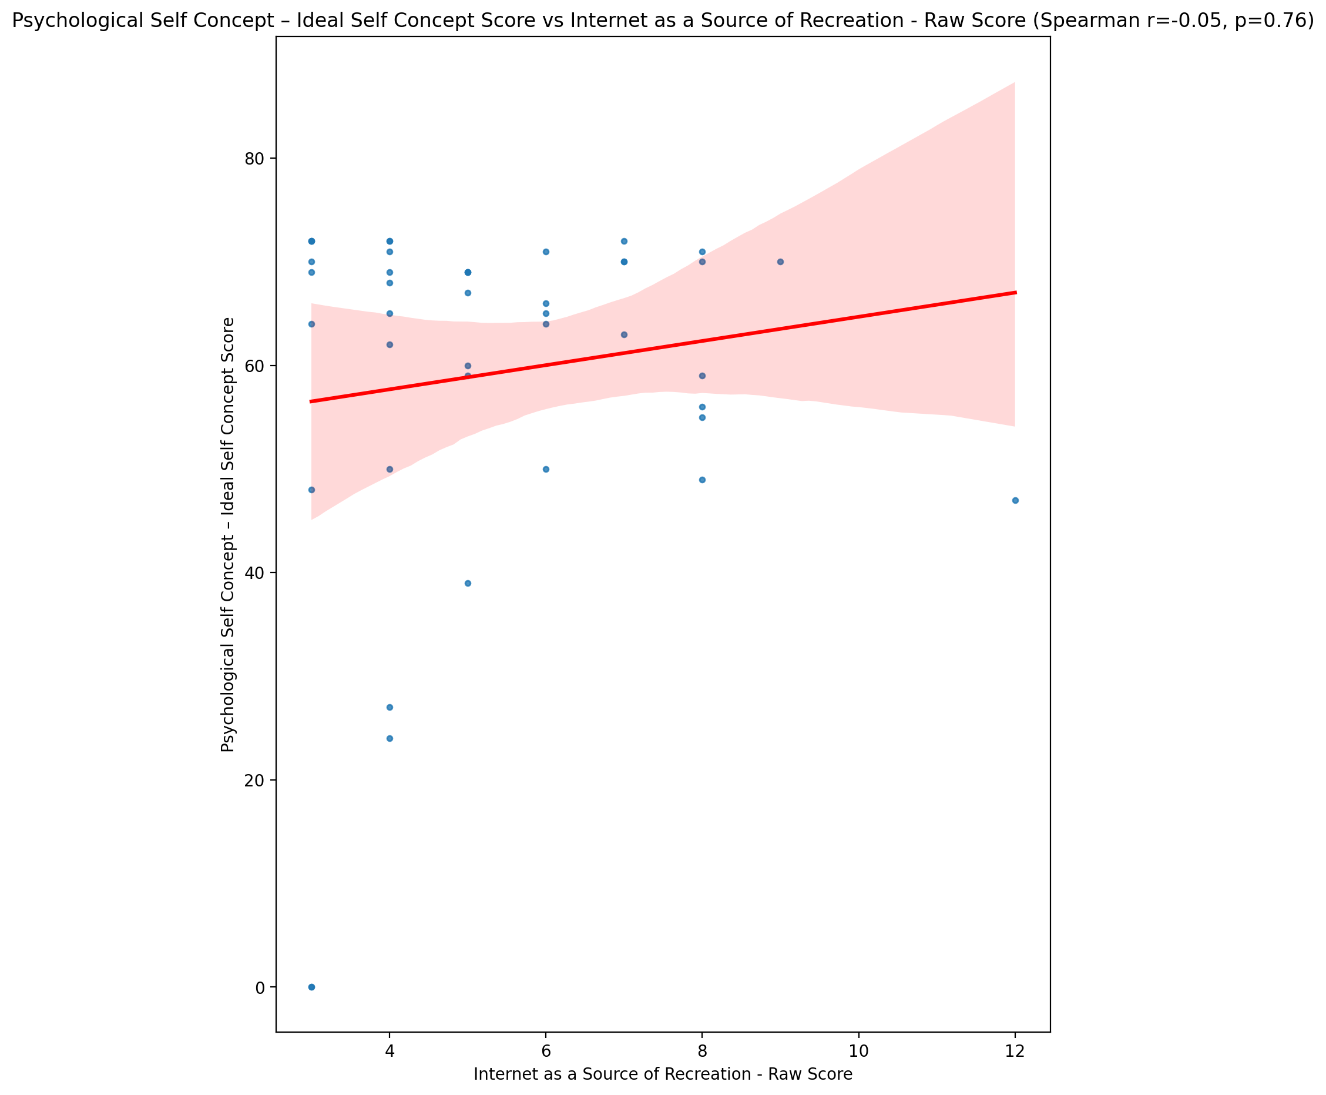

## Psychological Self Concept – Social Self Concept Score vs Internet as a Source of Recreation - Raw Score

Test: spearman; statistic: 0.021739561719696356; p-value: 0.8899469163352334;

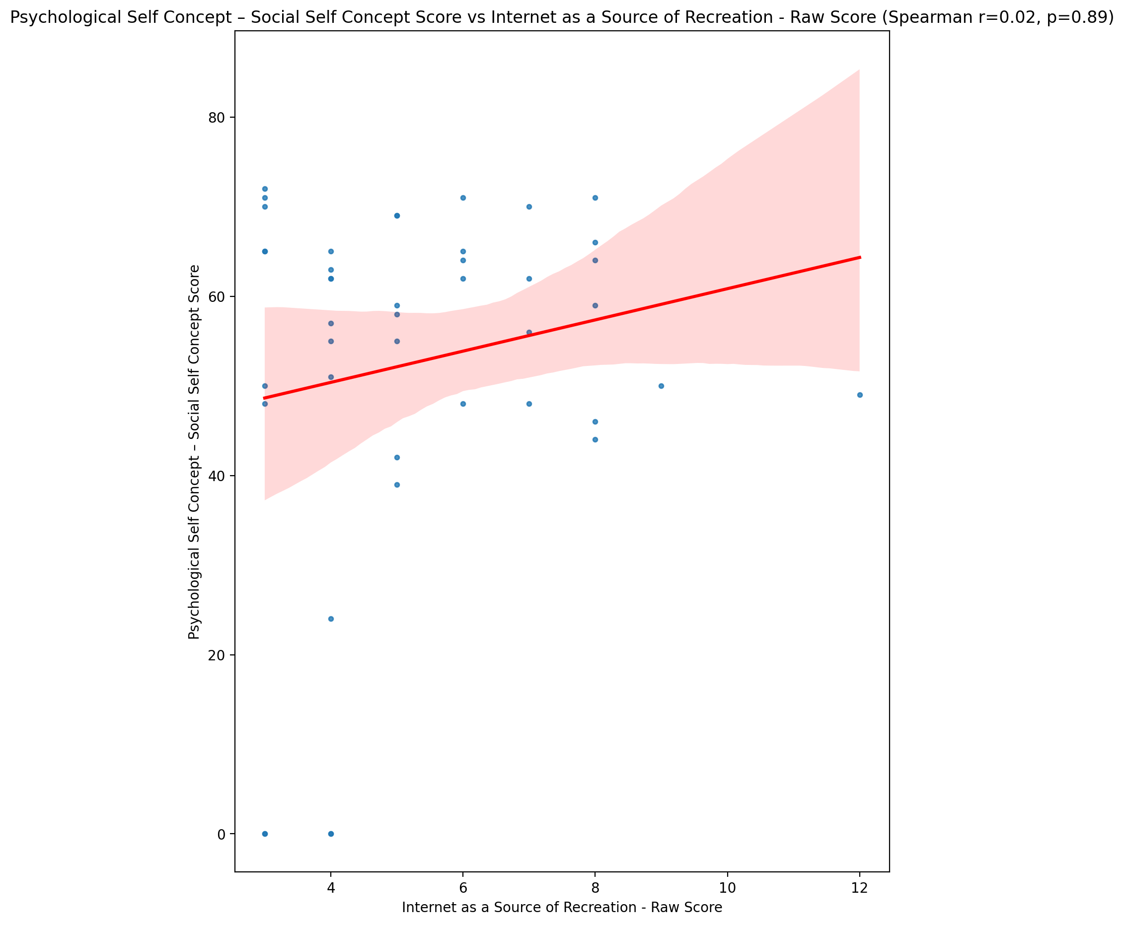

## Real Self Concept Total Score vs Internet as a Source of Recreation - Raw Score

Test: spearman; statistic: -0.003989715351959766; p-value: 0.9797427217292121;

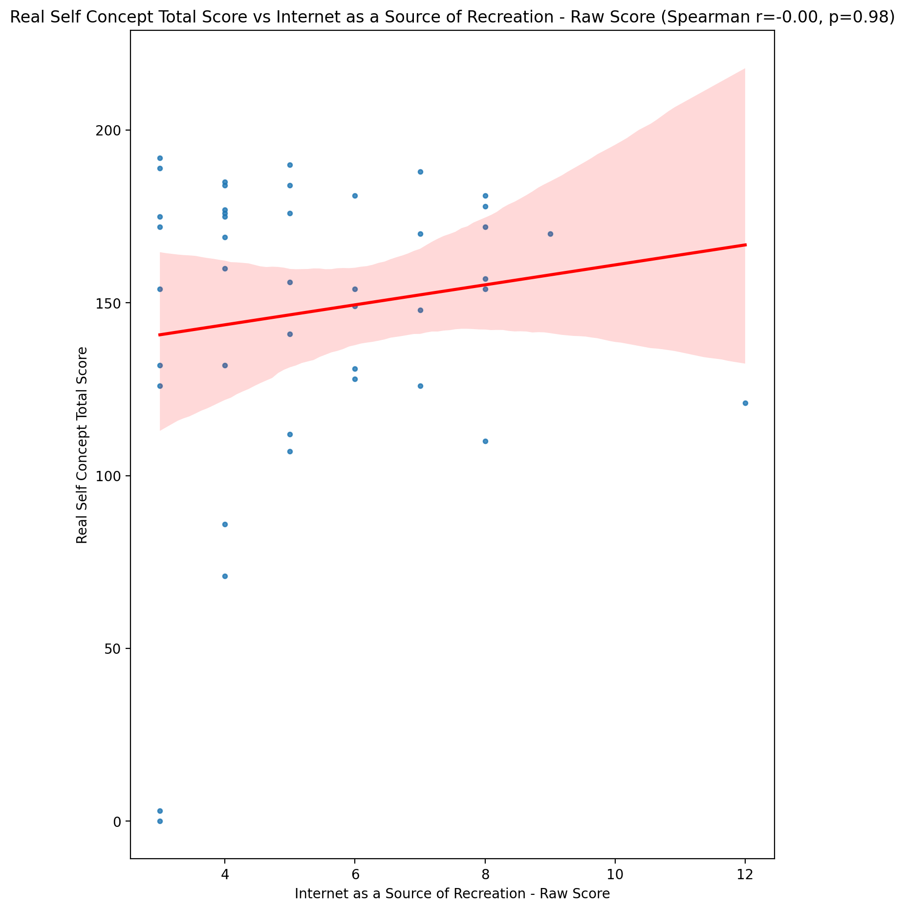

## Ideal Self Concept Total Score vs Internet as a Source of Recreation - Raw Score

Test: spearman; statistic: -0.09564530911086642; p-value: 0.541790172267296;

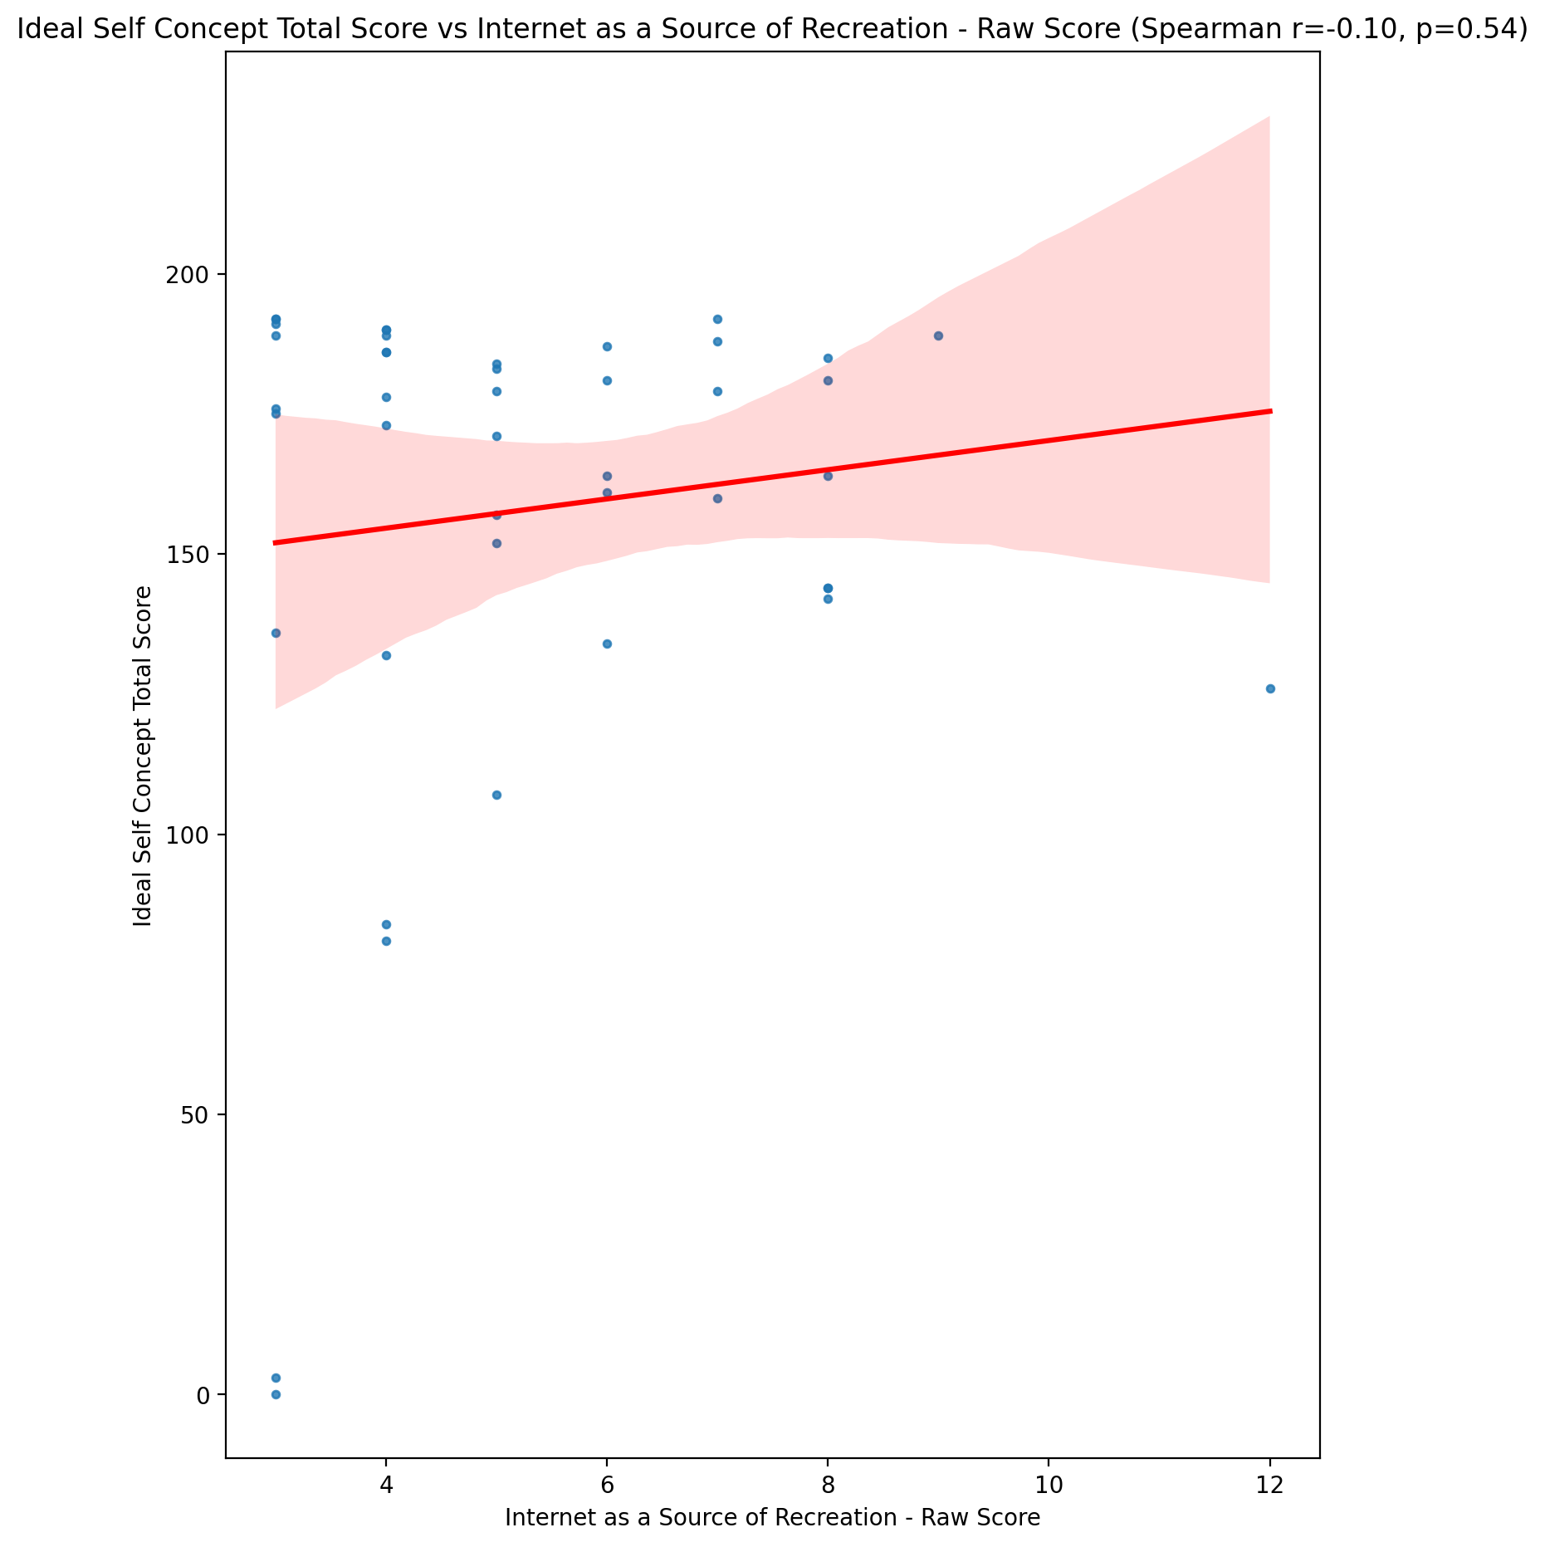

## Social Self Concept Total Score vs Internet as a Source of Recreation - Raw Score

Test: spearman; statistic: 0.0675924310183484; p-value: 0.6667115705385394;

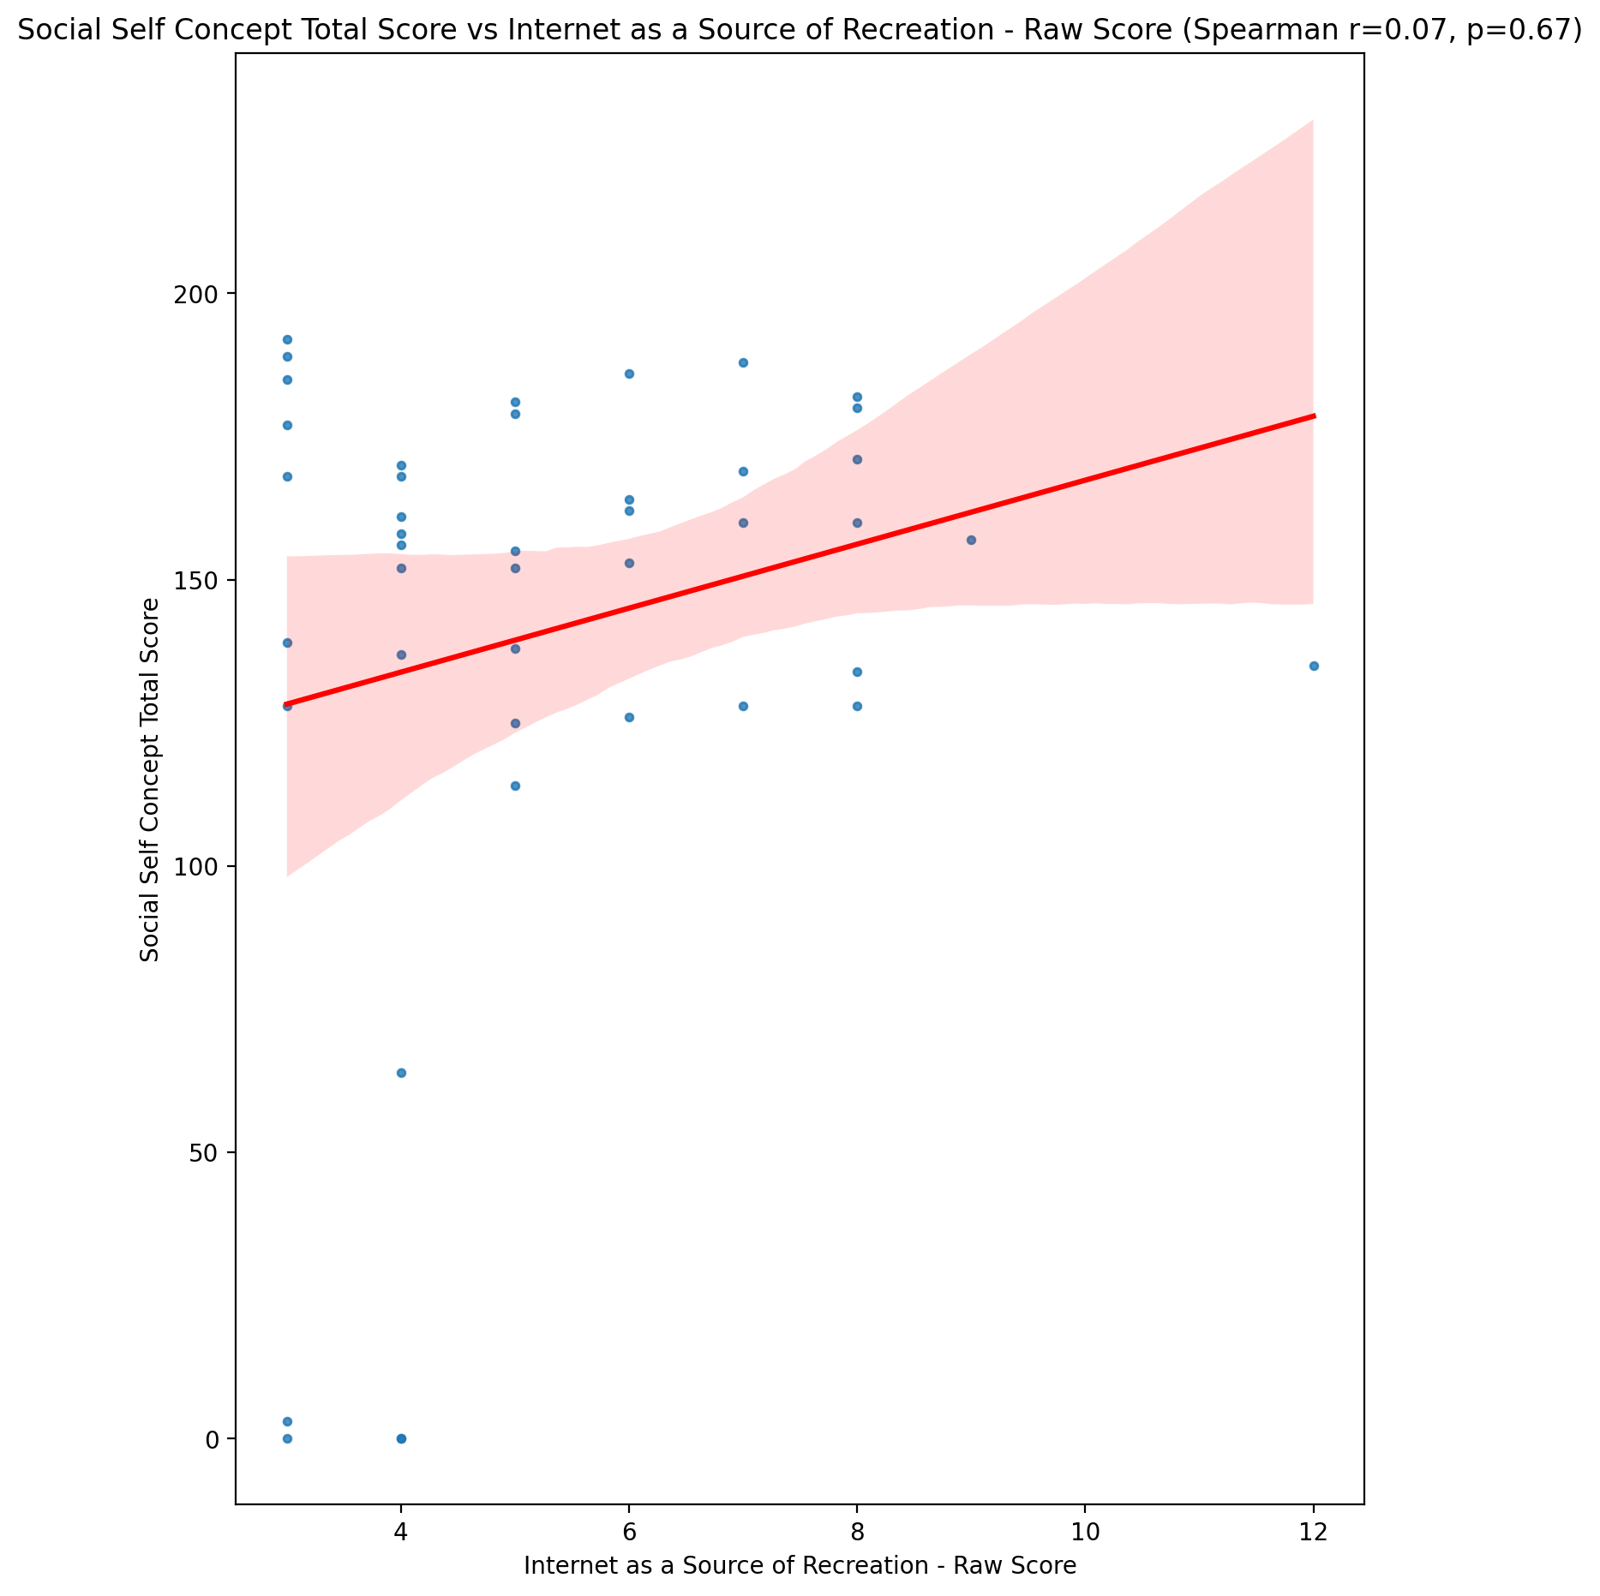

## Ideal Self Concept Total Category vs Internet as a Source of Recreation - Raw Score

Test: None; statistic: None; p-value: None; Test not run: unsupported type combination.



## Perceived Social Stress Score vs Internet as a Source of Recreation - Raw Score

Test: spearman; statistic: 0.11593124618923642; p-value: 0.4591104280595484;

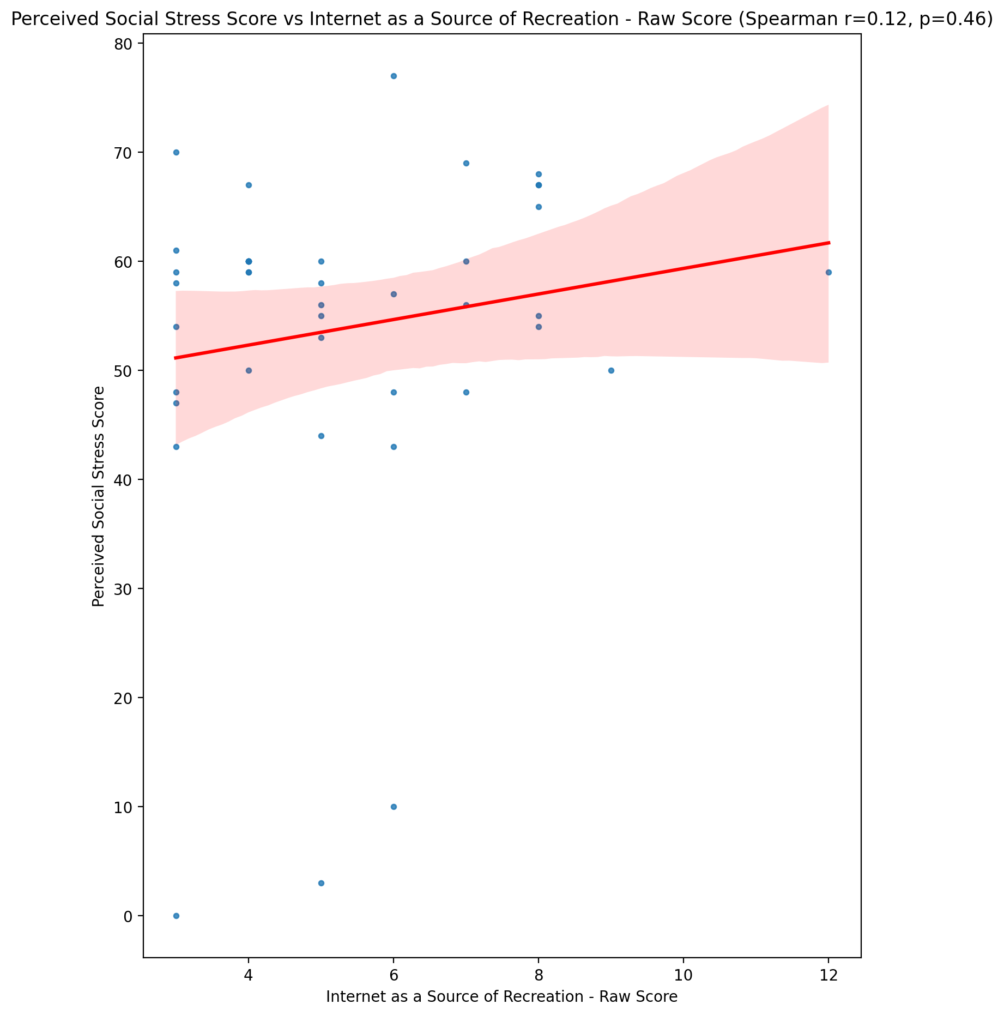

## Perceived Social Stress Category vs Internet as a Source of Recreation - Raw Score

Test: None; statistic: None; p-value: None; Test not run: unsupported type combination.



## Emotional Support - Raw Score vs Enhanced Socialization - Raw Score

Test: spearman; statistic: 0.05349138360126138; p-value: 0.7333486767938792;

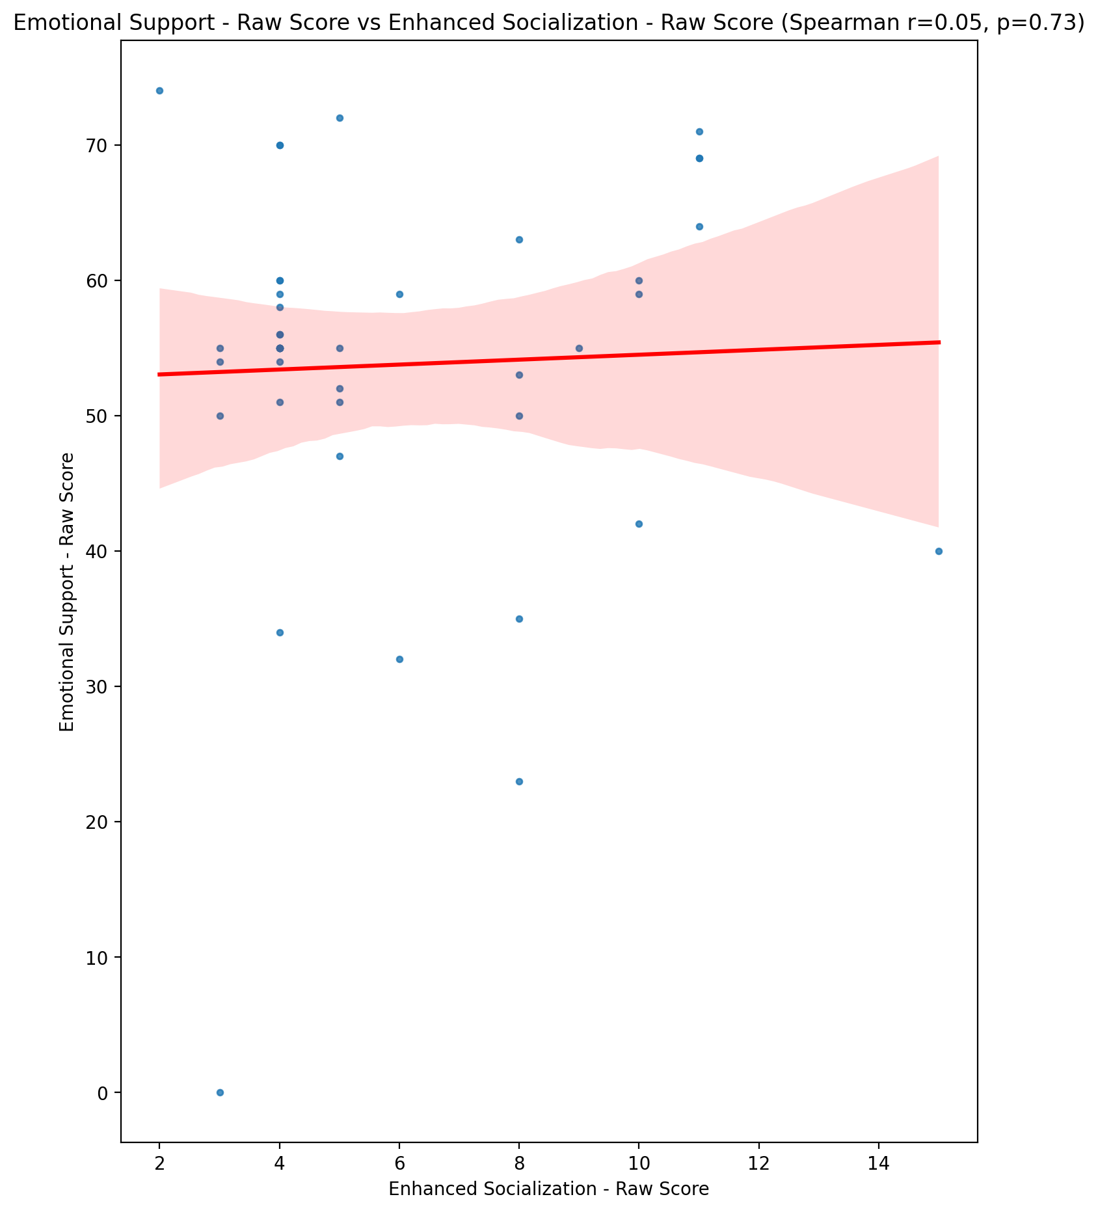

## Informational Support - Raw Score vs Enhanced Socialization - Raw Score

Test: spearman; statistic: -0.1062894555748394; p-value: 0.4975345925450423;

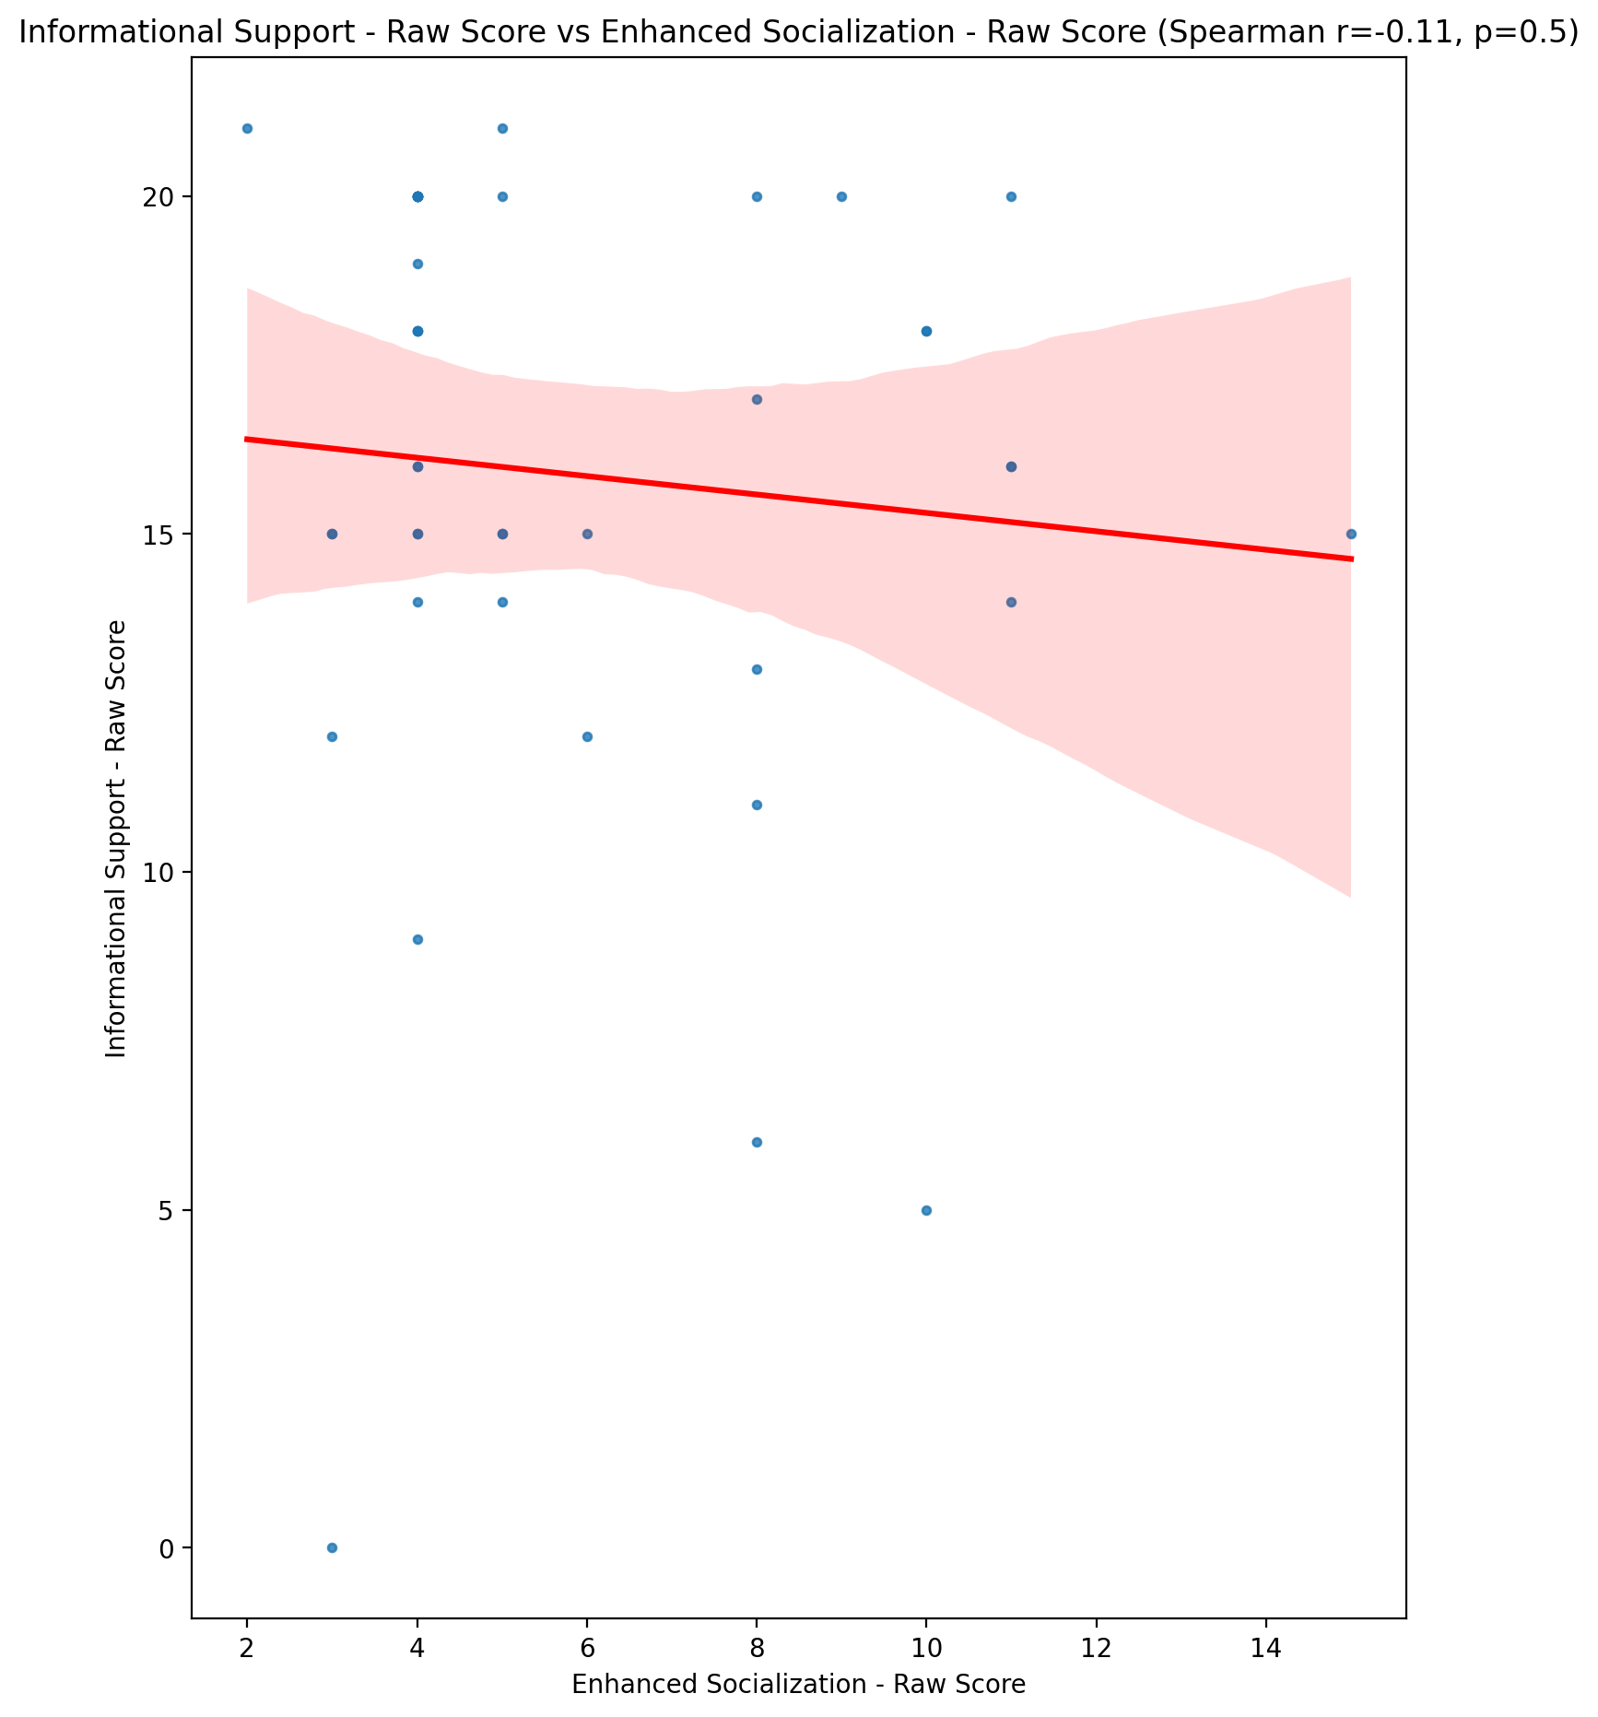

## Instrumental Support - Raw Score vs Enhanced Socialization - Raw Score

Test: spearman; statistic: 0.17565906553277713; p-value: 0.25986125272489935;

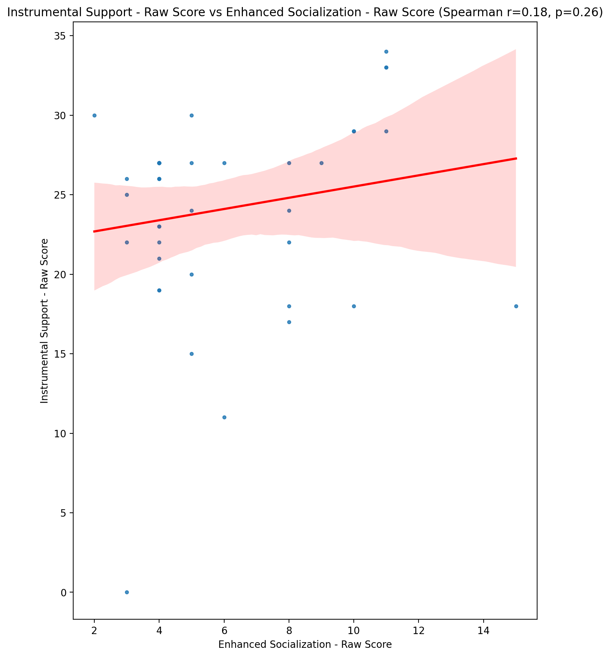

## Emotional Support - T Score vs Enhanced Socialization - Raw Score

Test: spearman; statistic: 0.19050866184782705; p-value: 0.22107231128747729;

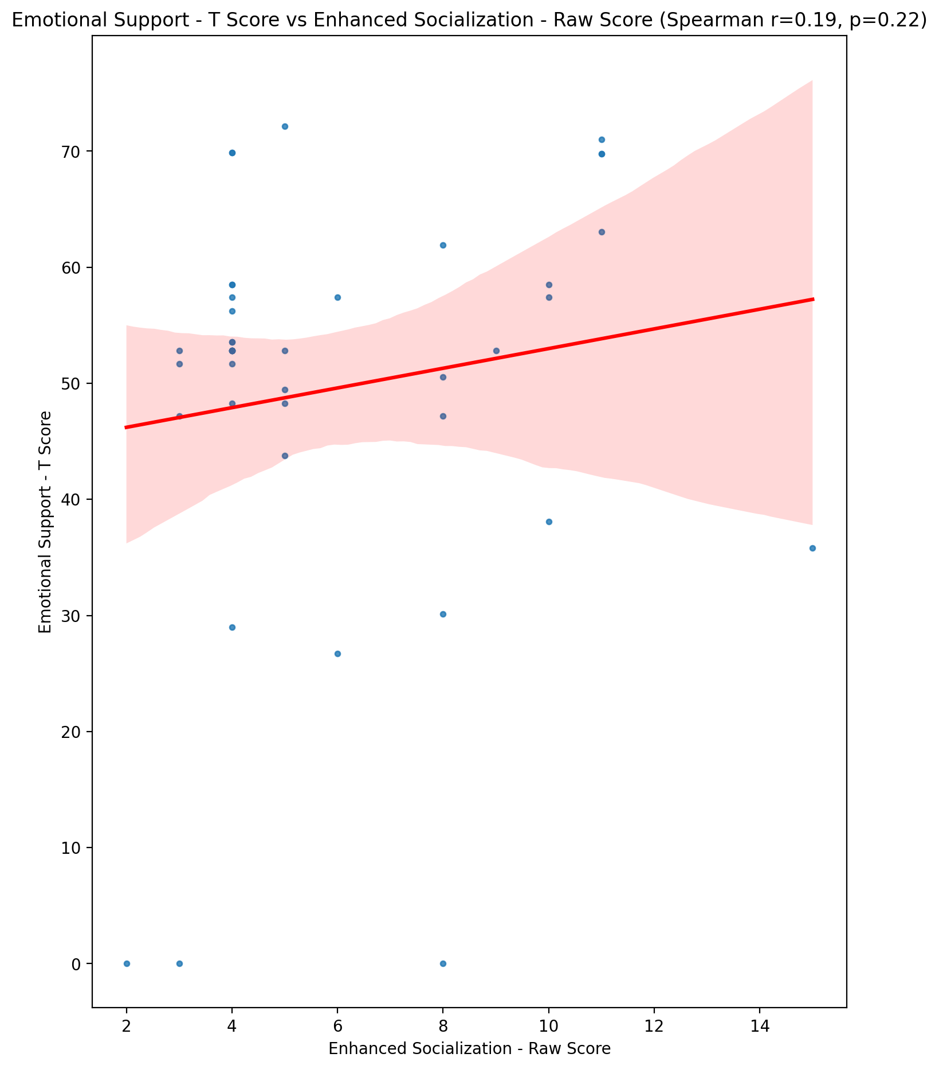

## Informational Support - T Score vs Enhanced Socialization - Raw Score

Test: spearman; statistic: -0.11081948128826706; p-value: 0.47927934804673067;

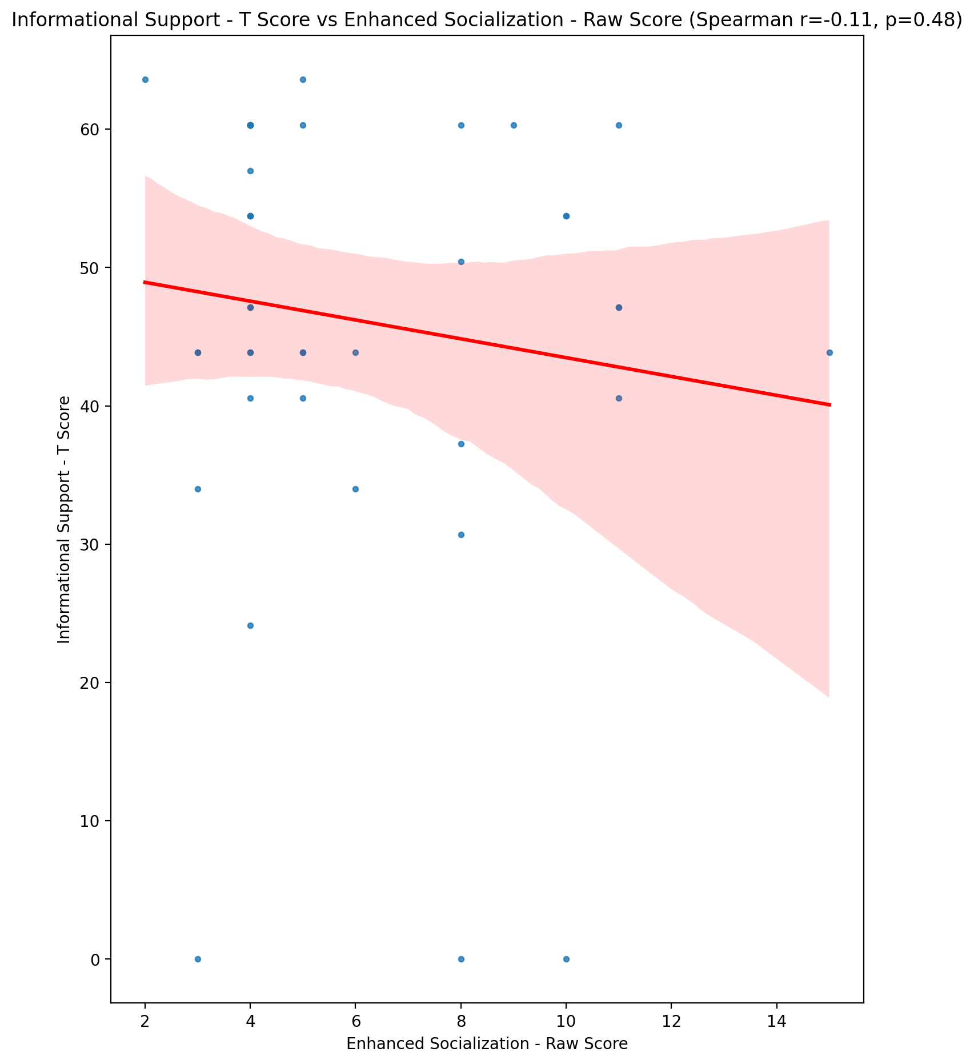

## Instrumental Support - T Score vs Enhanced Socialization - Raw Score

Test: spearman; statistic: 0.17368852966118373; p-value: 0.26532959590622435;

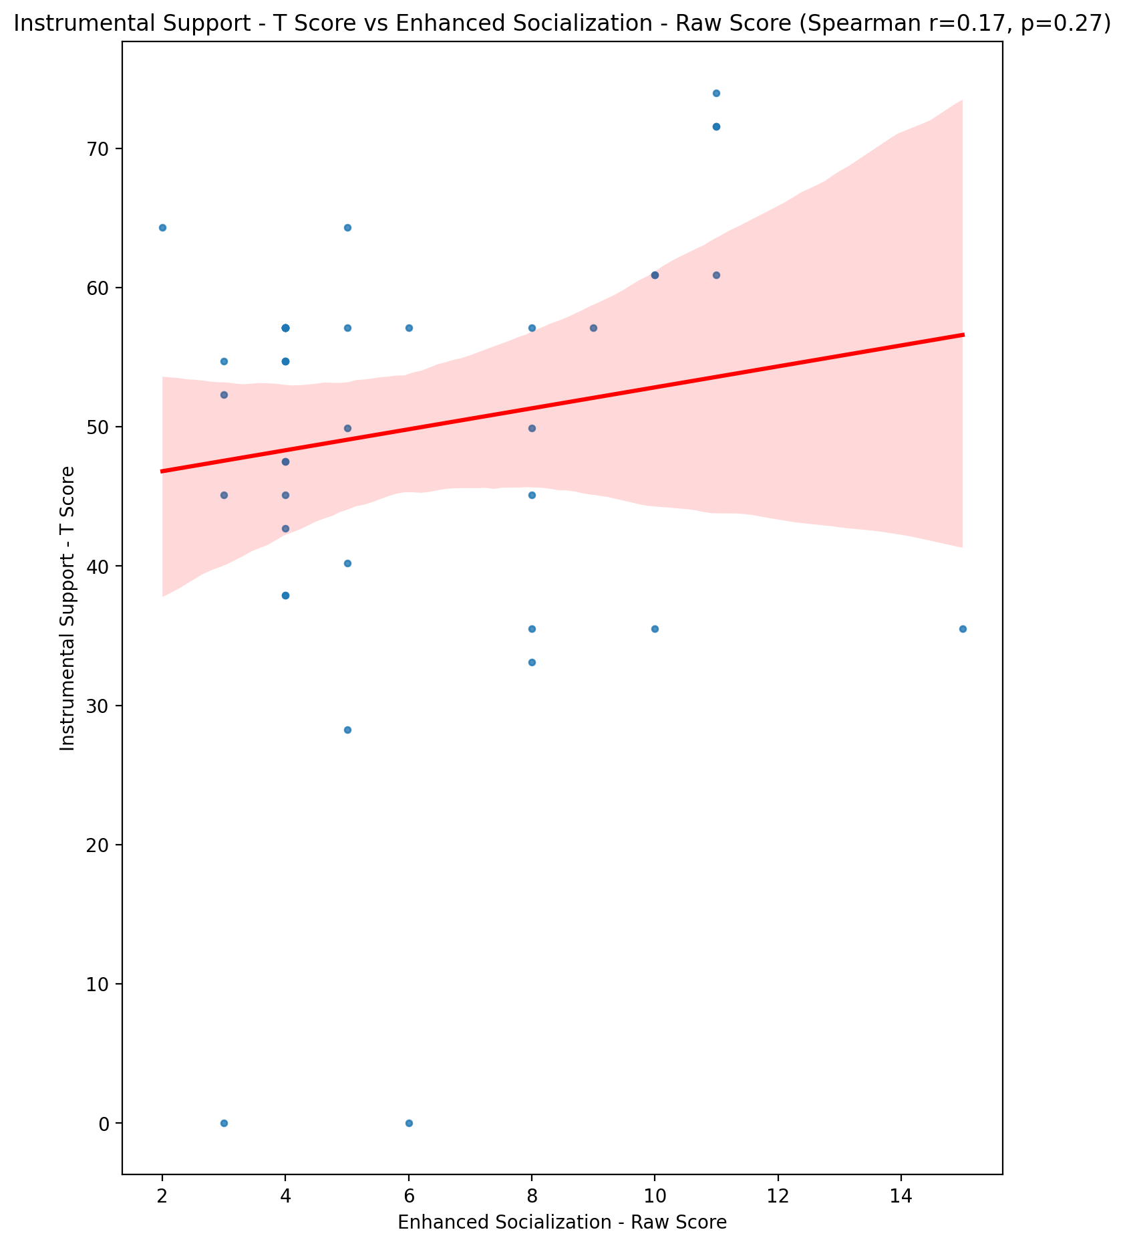

## Perceived Social Support Total T Score vs Enhanced Socialization - Raw Score

Test: spearman; statistic: 0.10292997048327963; p-value: 0.5112992748401081;

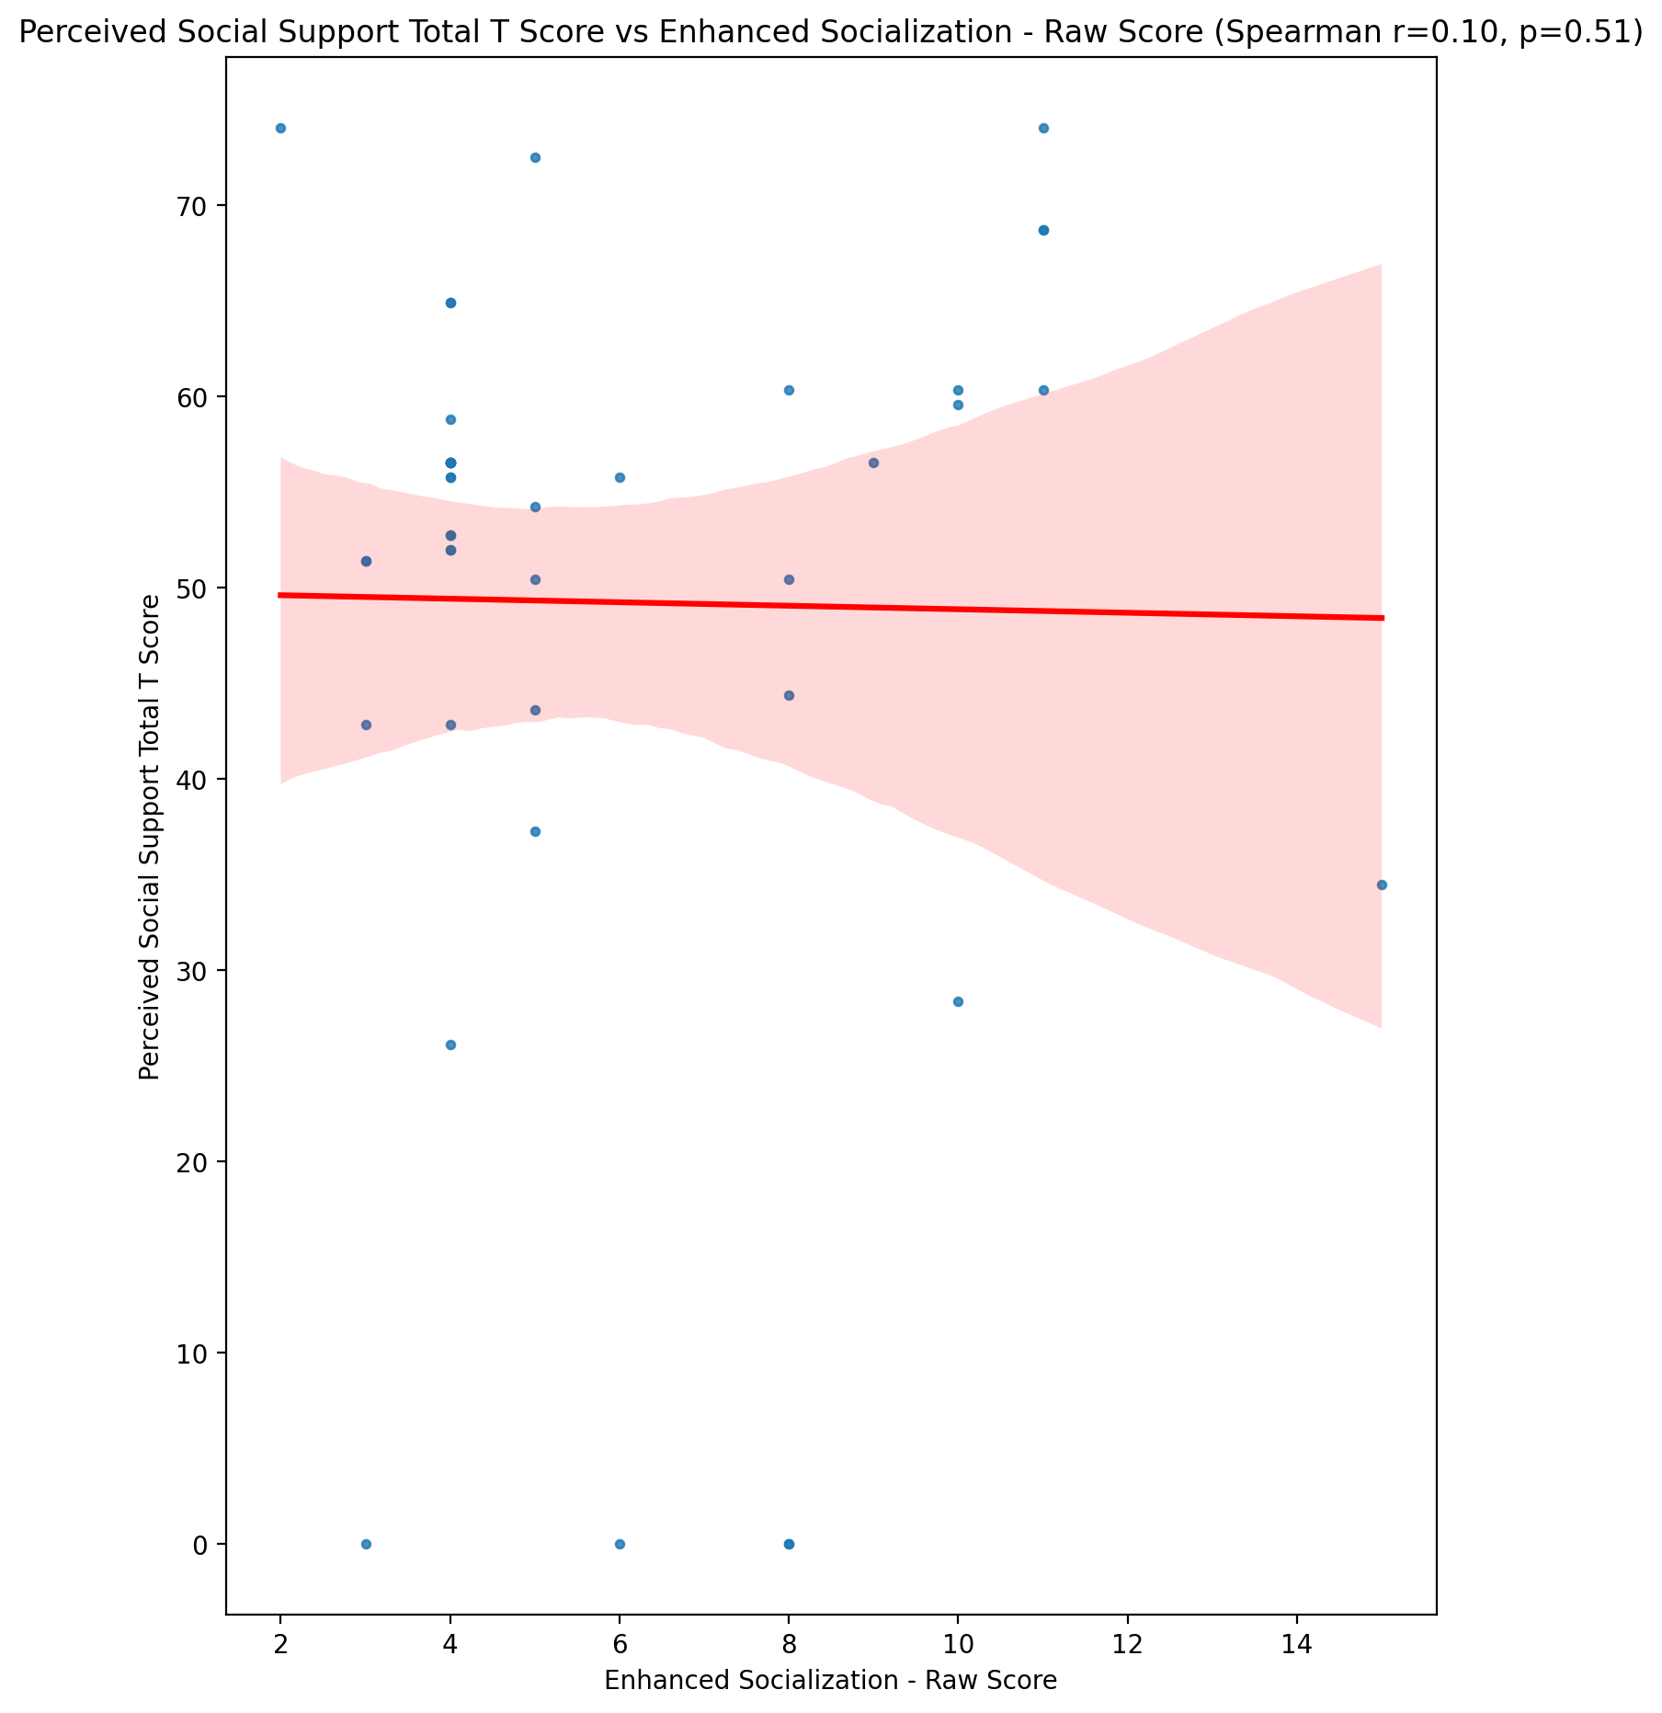

## Emotional Support - Rank vs Enhanced Socialization - Raw Score

Test: None; statistic: None; p-value: None; Test not run: unsupported type combination.



## Informational Support - Rank vs Enhanced Socialization - Raw Score

Test: None; statistic: None; p-value: None; Test not run: unsupported type combination.



## Instrumental Support - Rank vs Enhanced Socialization - Raw Score

Test: None; statistic: None; p-value: None; Test not run: unsupported type combination.



## Perceived Social Support TOTAL - Rank vs Enhanced Socialization - Raw Score

Test: None; statistic: None; p-value: None; Test not run: unsupported type combination.



## Power Self Concept - Real Self Concept Score vs Enhanced Socialization - Raw Score

Test: spearman; statistic: 0.04663101345769567; p-value: 0.7665191072041266;

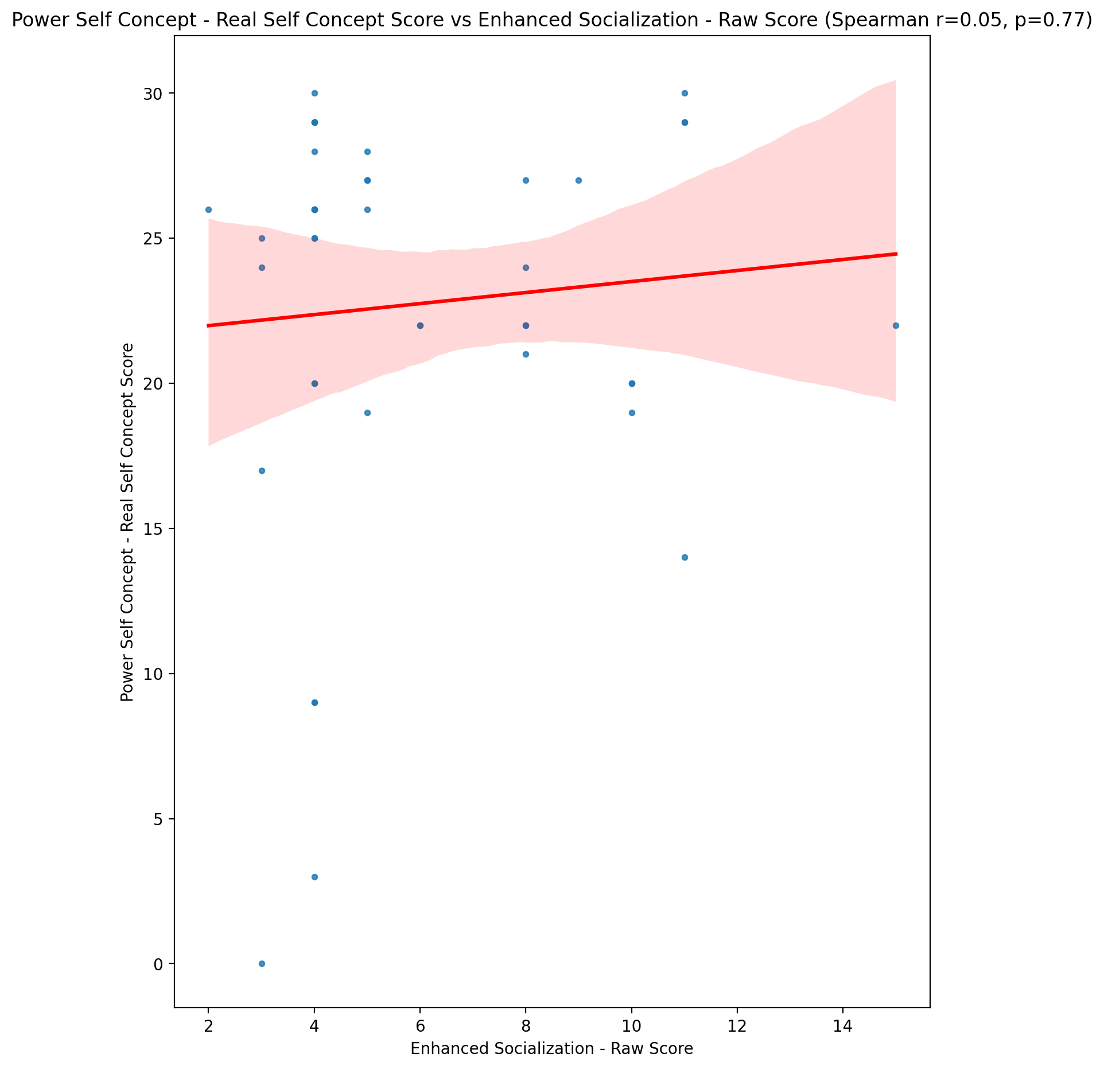

## Power Self Concept - Ideal Self Concept score vs Enhanced Socialization - Raw Score

Test: spearman; statistic: 0.2078586653855768; p-value: 0.18105354295775994;

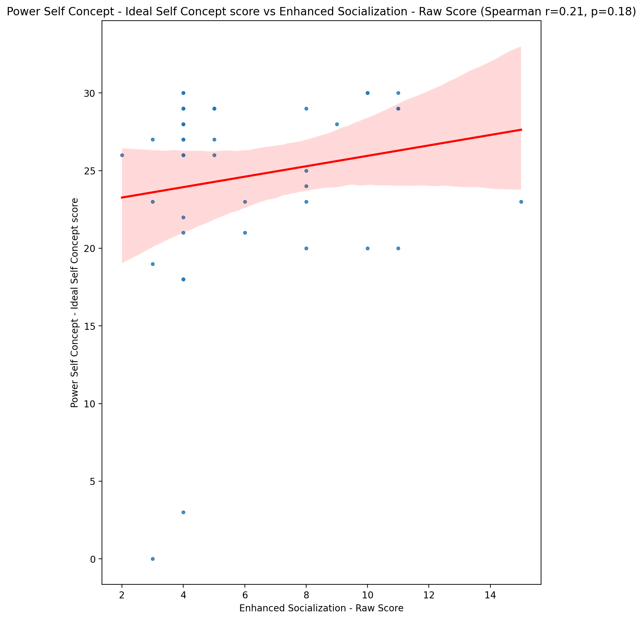

## Power Self Concept – Social Self Concept Score vs Enhanced Socialization - Raw Score

Test: spearman; statistic: 0.08268903903342358; p-value: 0.5980862133335951;

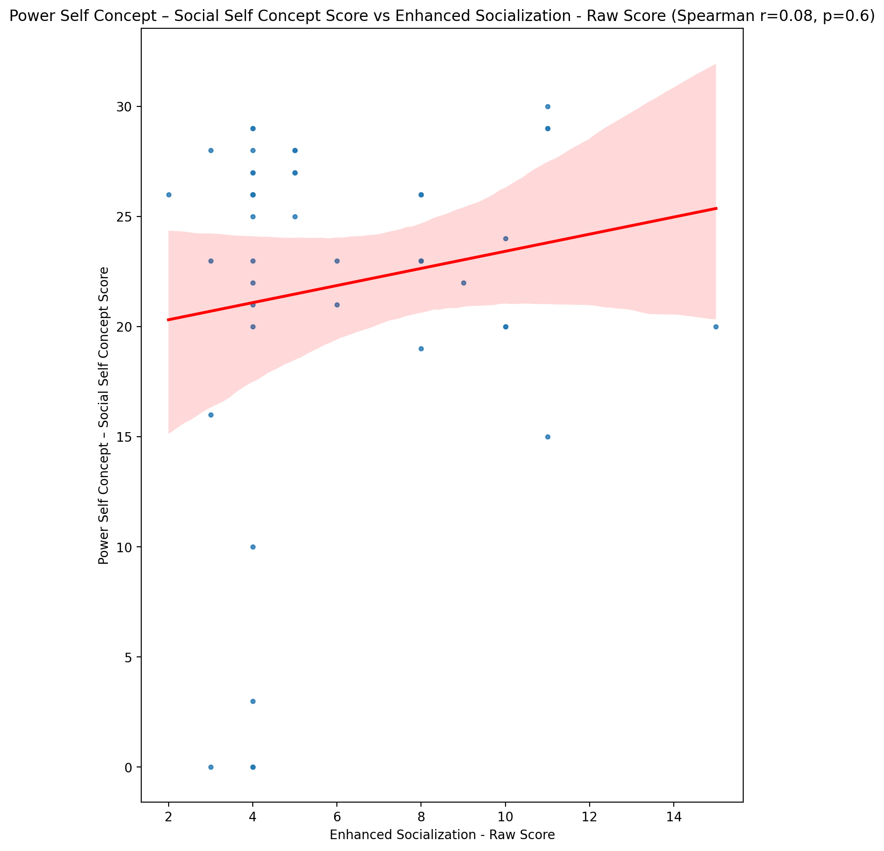

## Social Self Concept - Real Self Concept Score vs Enhanced Socialization - Raw Score

Test: spearman; statistic: 0.004926206246782106; p-value: 0.9749891642316082;

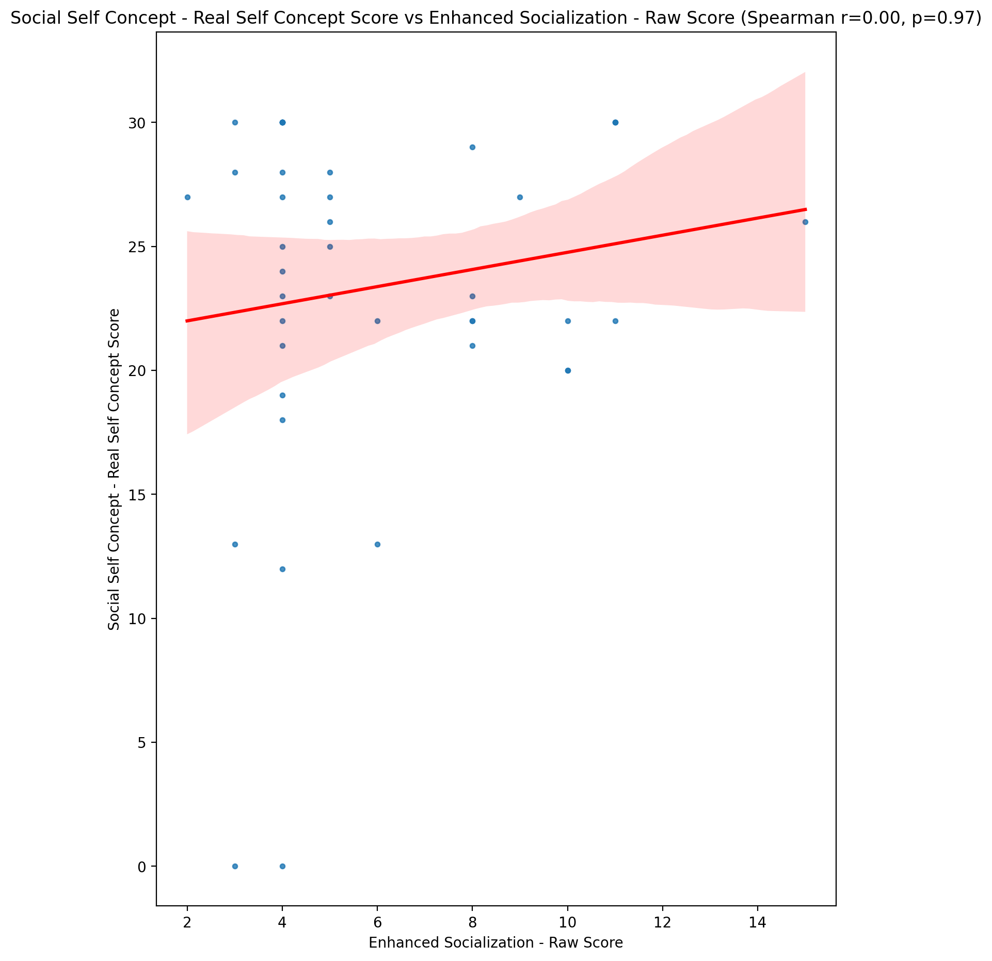

## Social Self Concept – Social Self Concept Score vs Enhanced Socialization - Raw Score

Test: spearman; statistic: 0.0801324419112808; p-value: 0.6094894392663204;

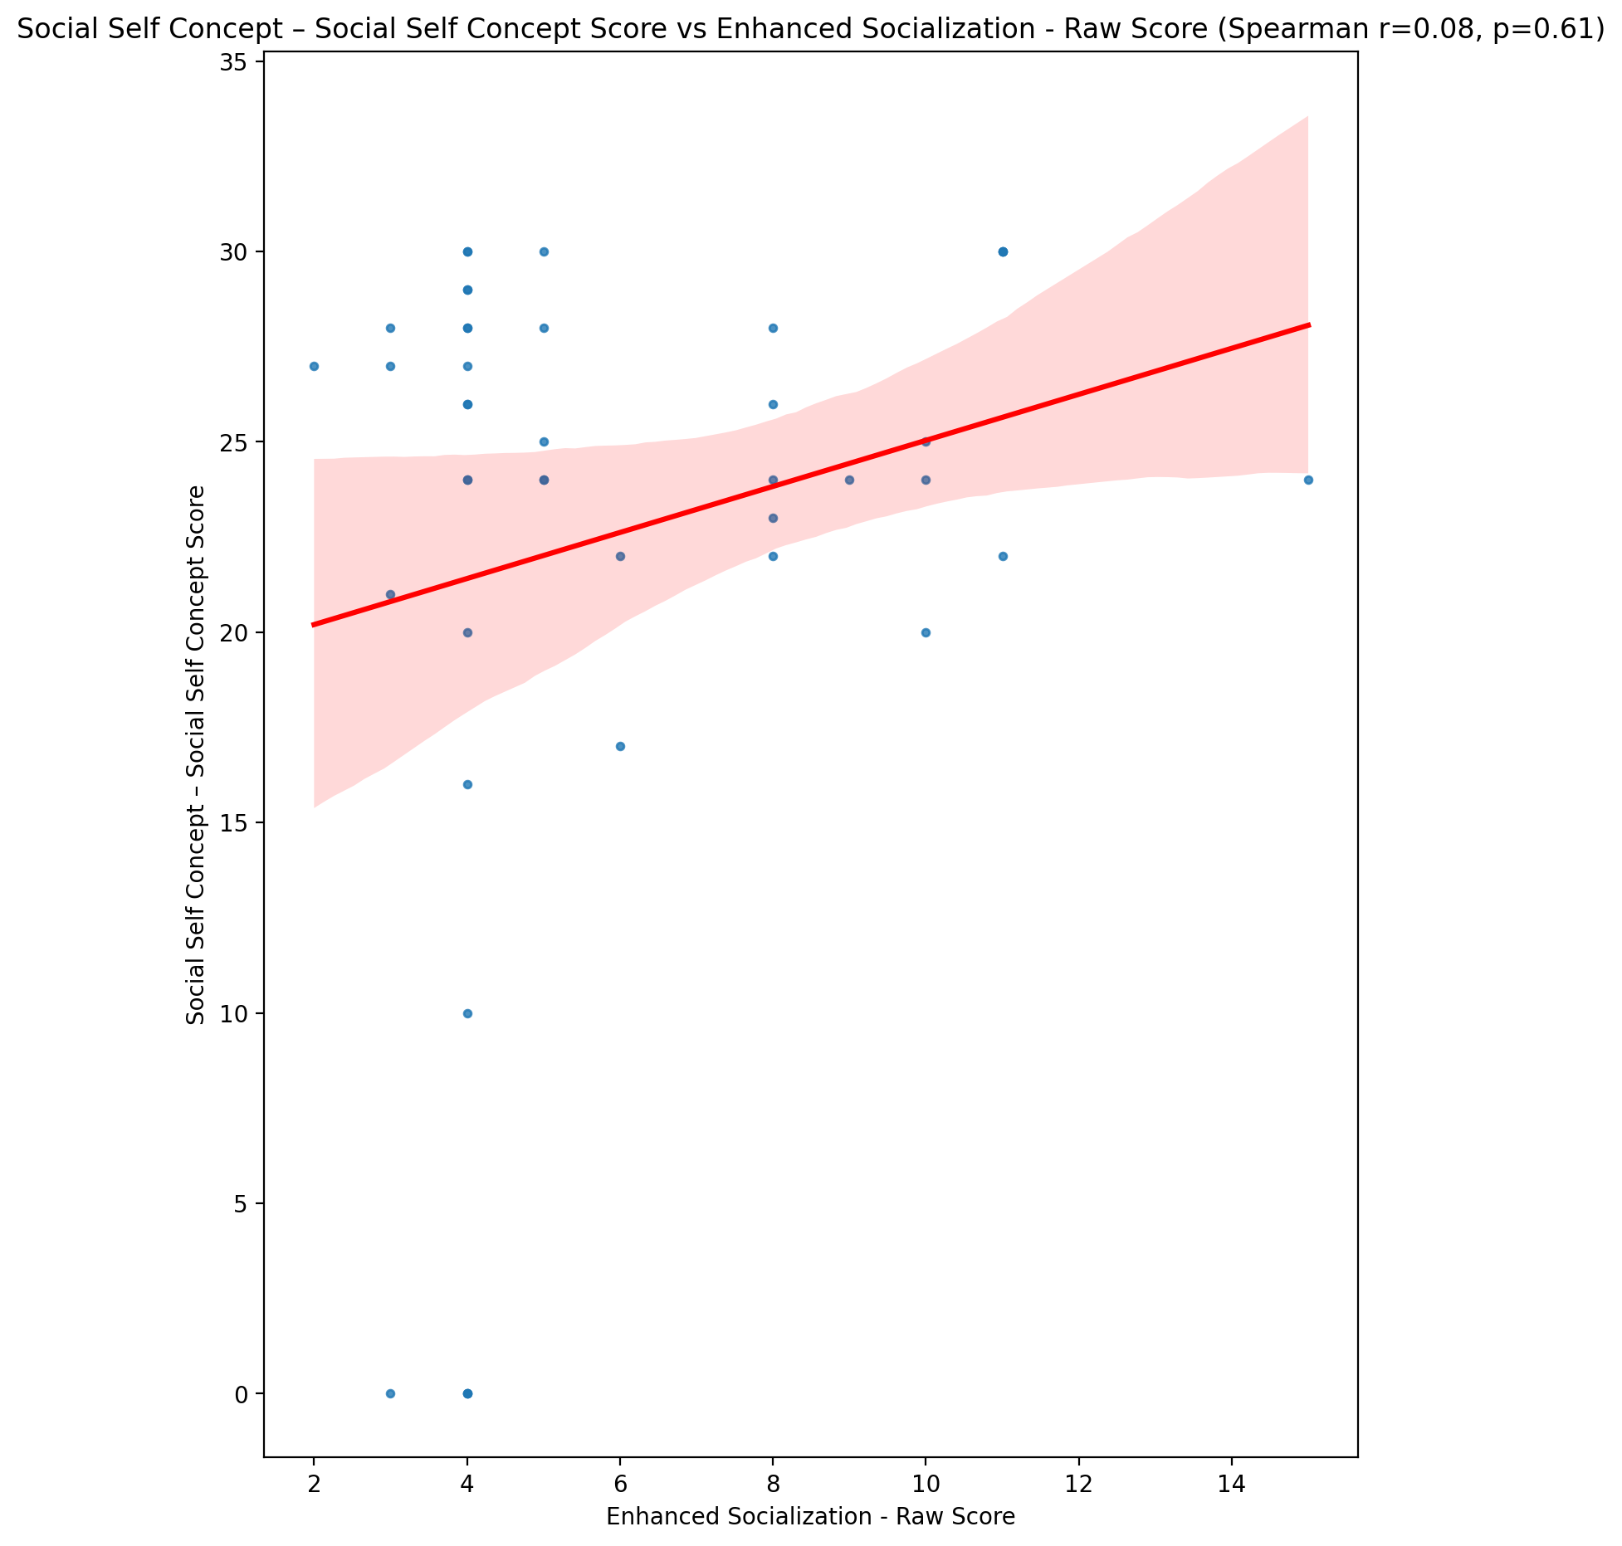

## Ability Self Concept - Real Self Concept Score vs Enhanced Socialization - Raw Score

Test: spearman; statistic: 0.11601373940948183; p-value: 0.45878874506151857;

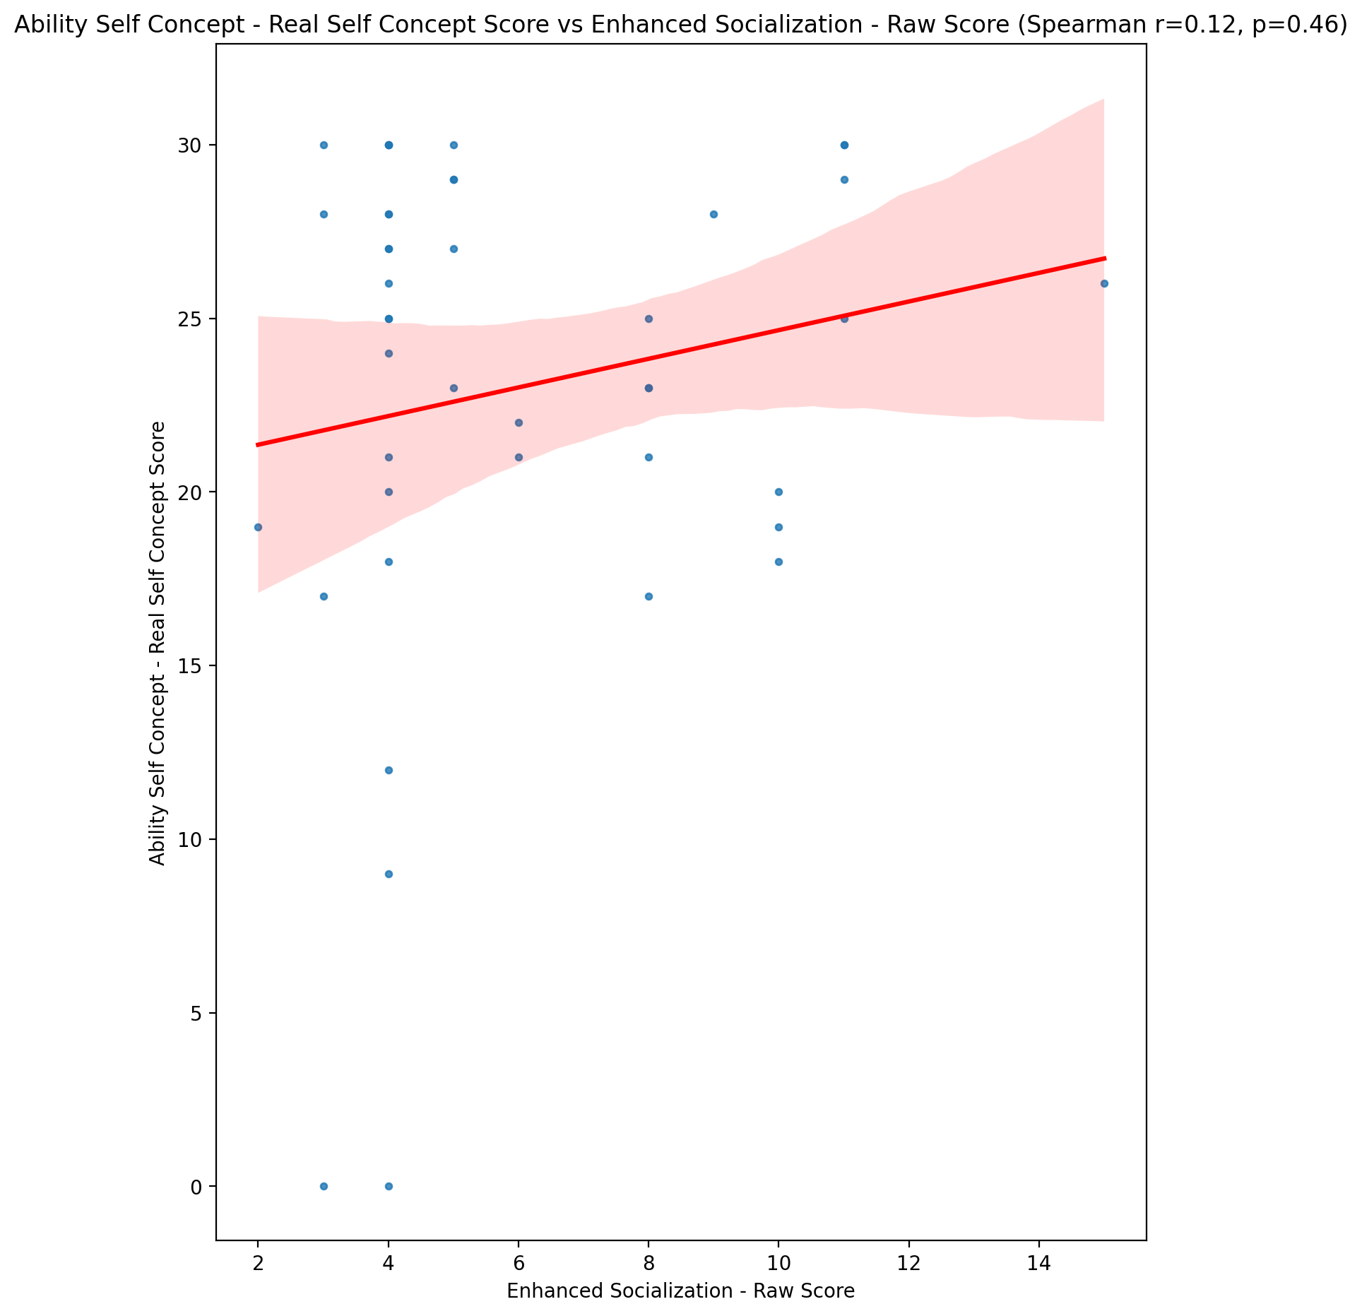

## Ability Self Concept - Ideal Self Concept Score vs Enhanced Socialization - Raw Score

Test: spearman; statistic: 0.21186096565165966; p-value: 0.17260918669826517;

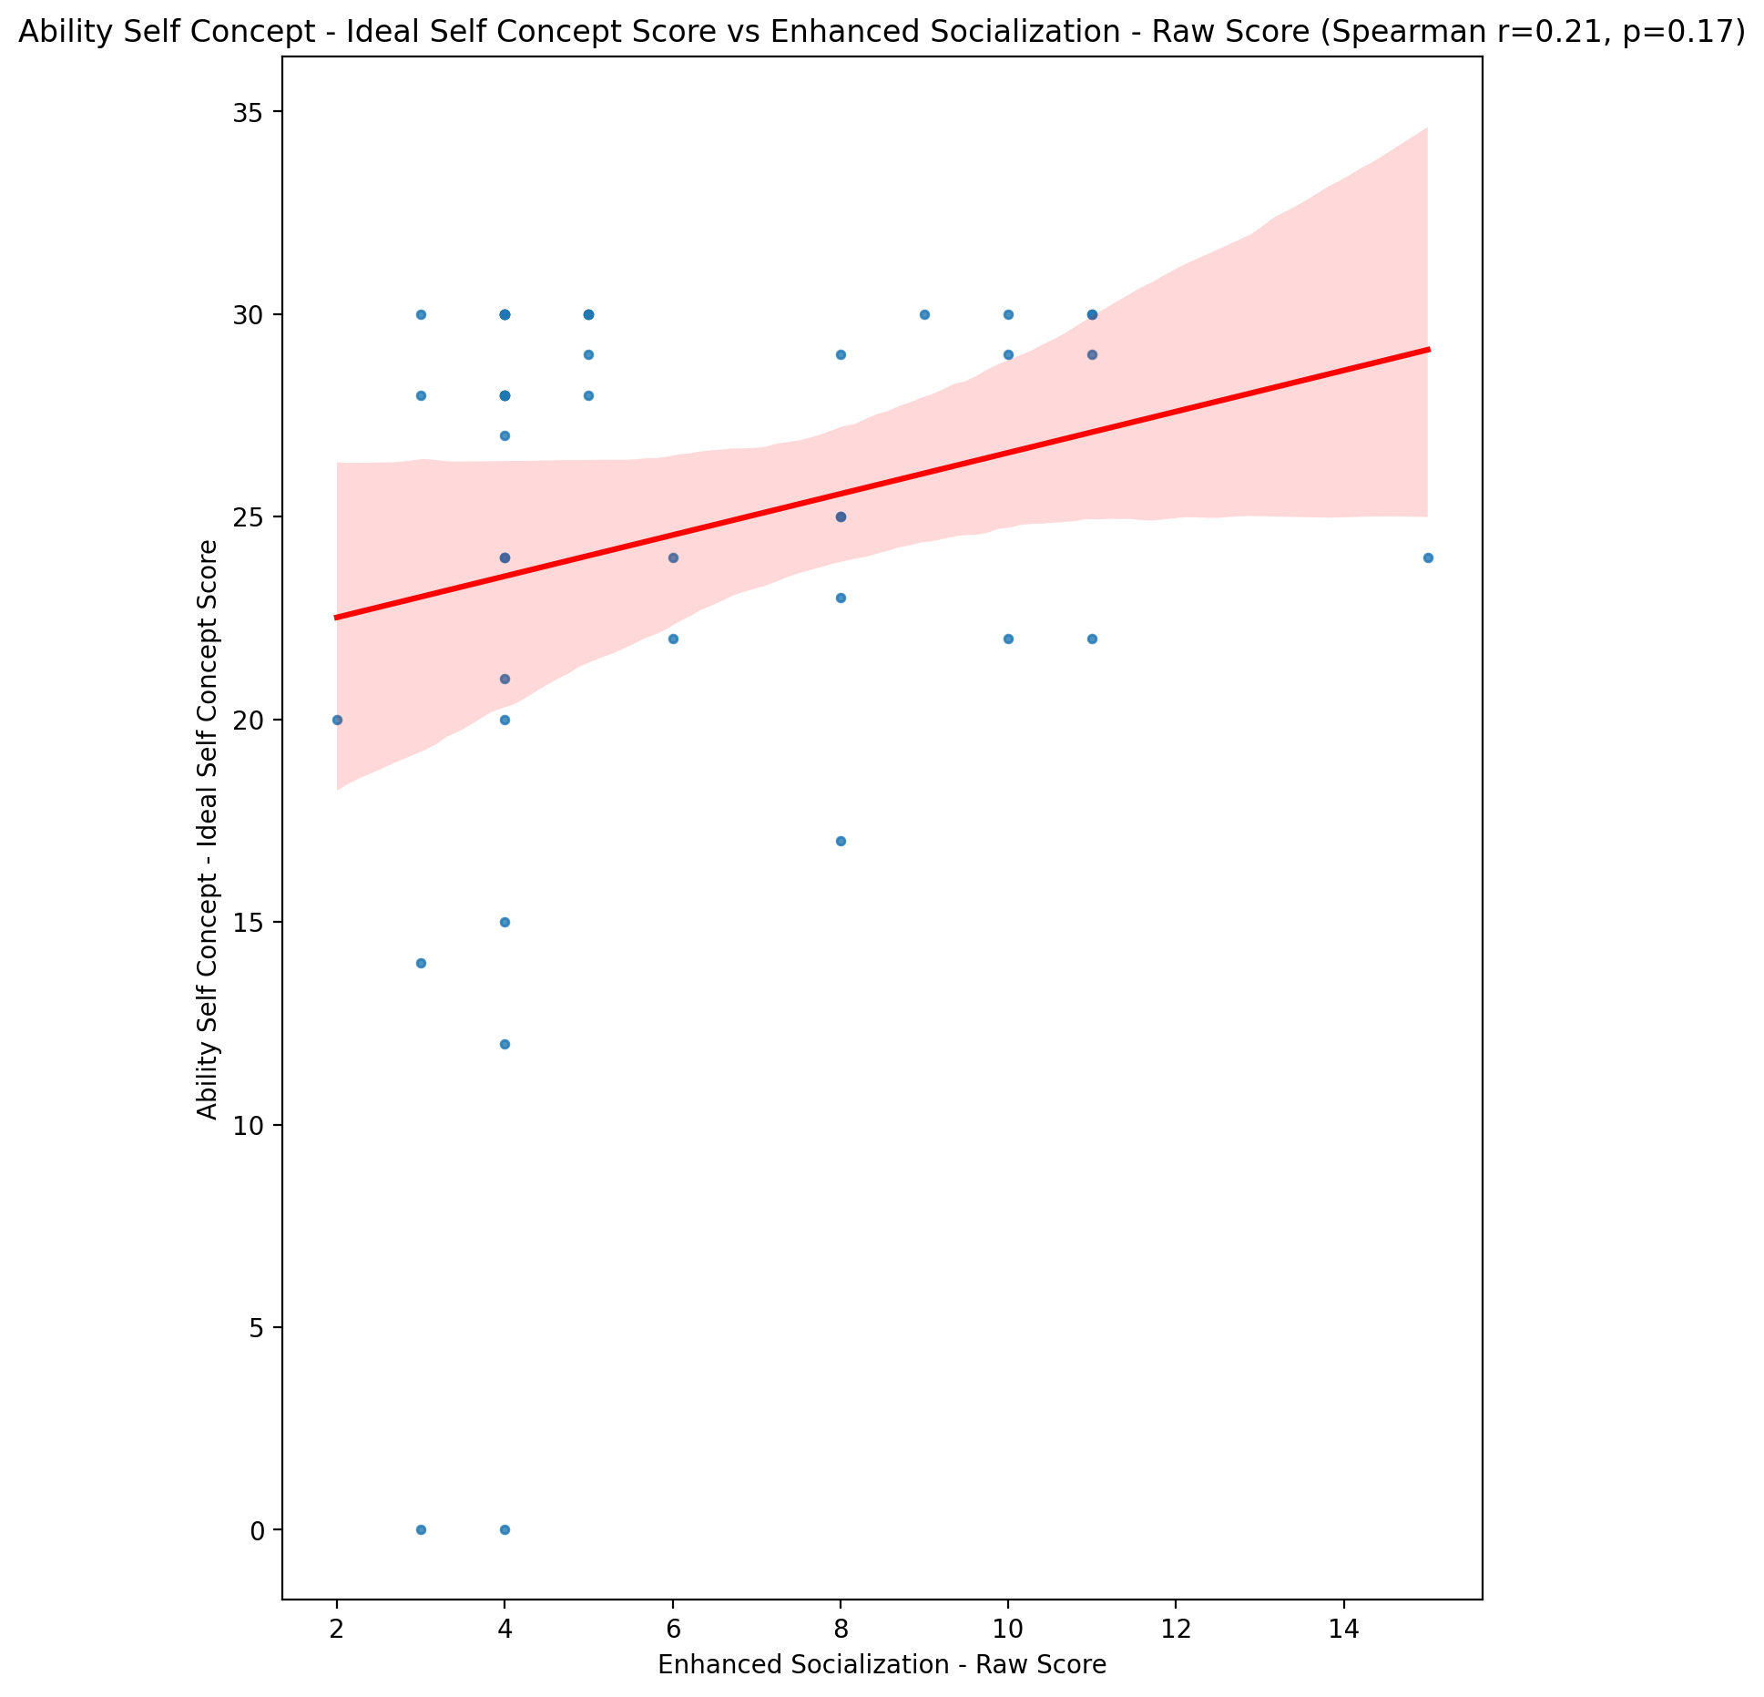

## Ability Self Concept – Social Self Concept Score vs Enhanced Socialization - Raw Score

Test: spearman; statistic: 0.1799920942358072; p-value: 0.2481026717896879;

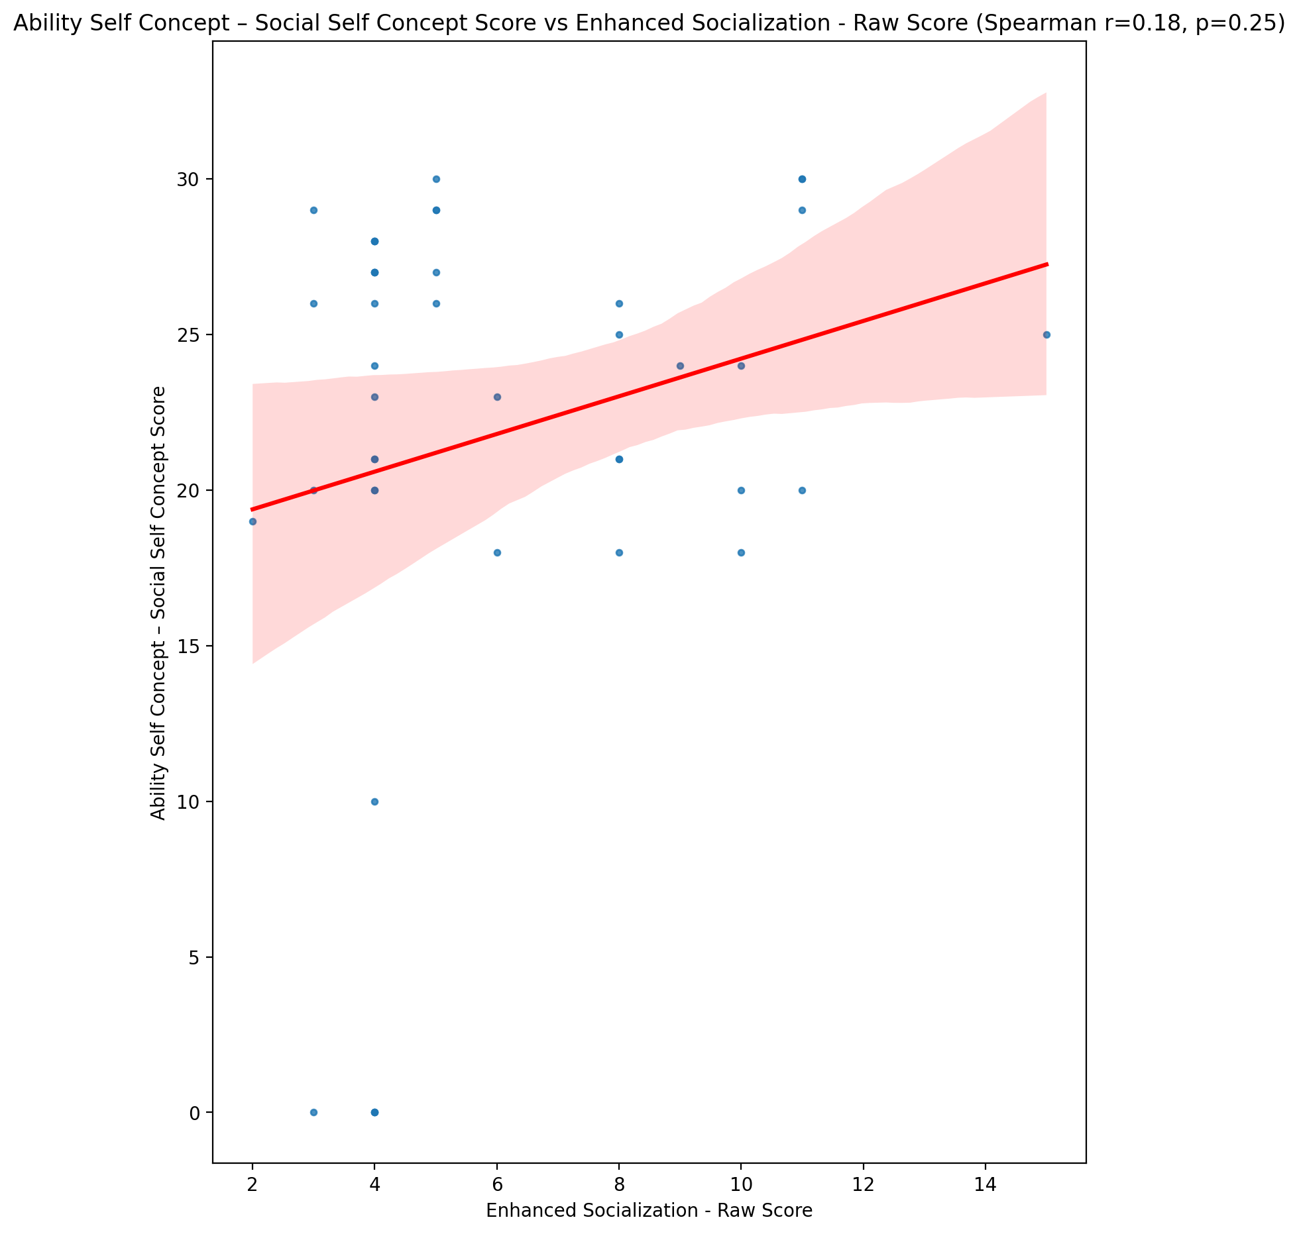

## Physical Self Concept - Real Self Concept Score vs Enhanced Socialization - Raw Score

Test: spearman; statistic: -0.005262133203879373; p-value: 0.9732842241526314;

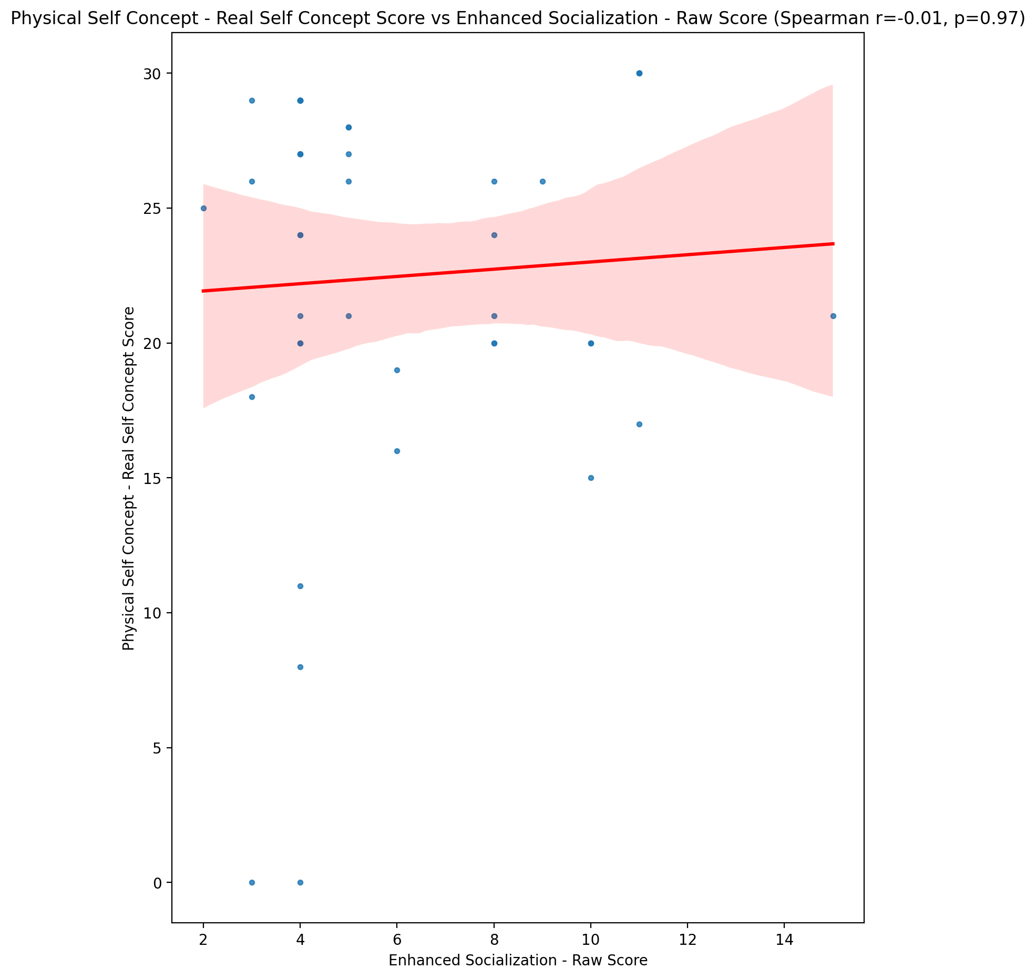

## Physical Self Concept – Ideal Self Concept Score vs Enhanced Socialization - Raw Score

Test: spearman; statistic: 0.16237043239785168; p-value: 0.29820858580576337;

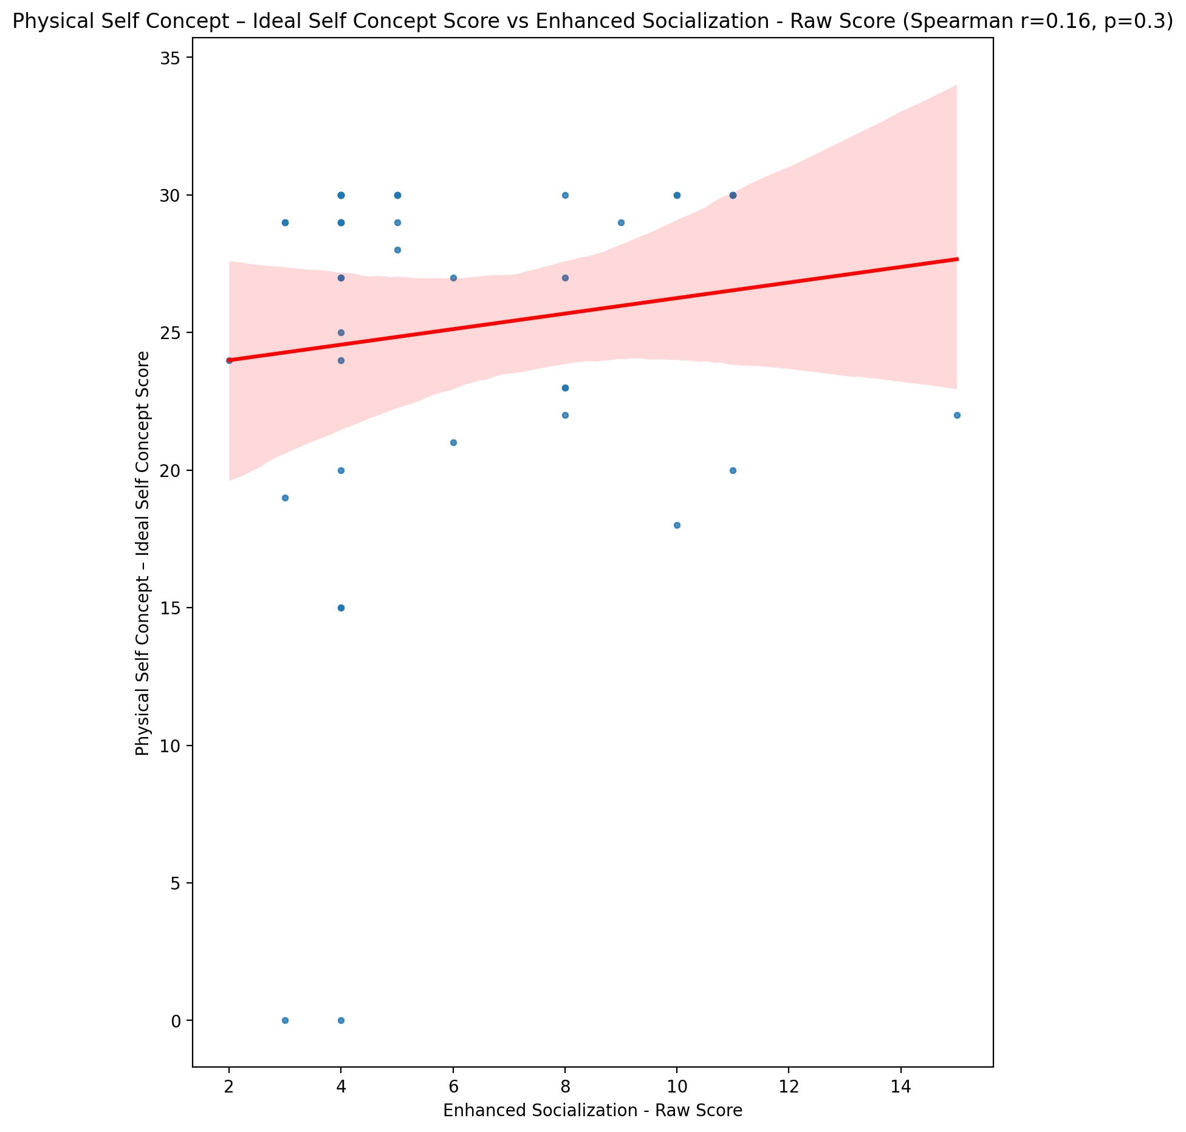

## Physical Self Concept – Social Self Concept Score vs Enhanced Socialization - Raw Score

Test: spearman; statistic: 0.17707114107259336; p-value: 0.25598919950910703;

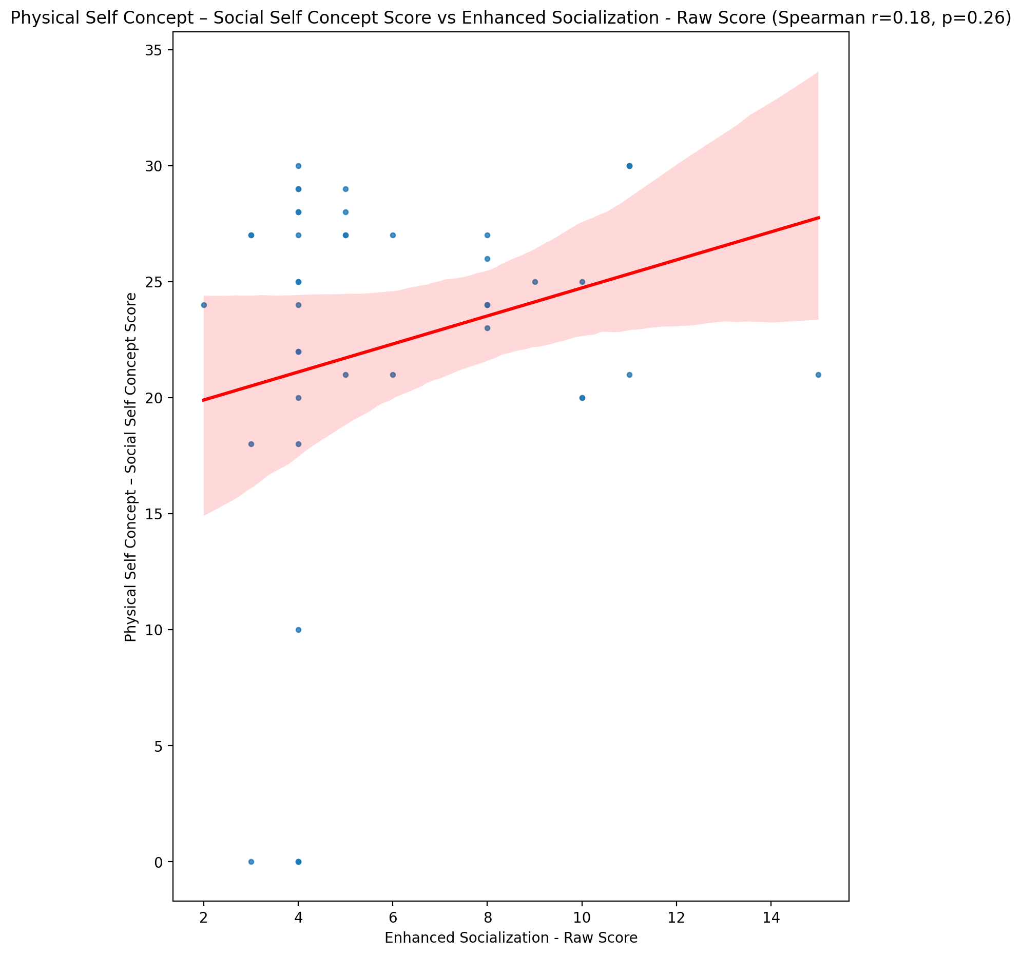

## Psychological Self Concept - Real Self Concept Score vs Enhanced Socialization - Raw Score

Test: spearman; statistic: 0.10328273125148017; p-value: 0.5098449820555843;

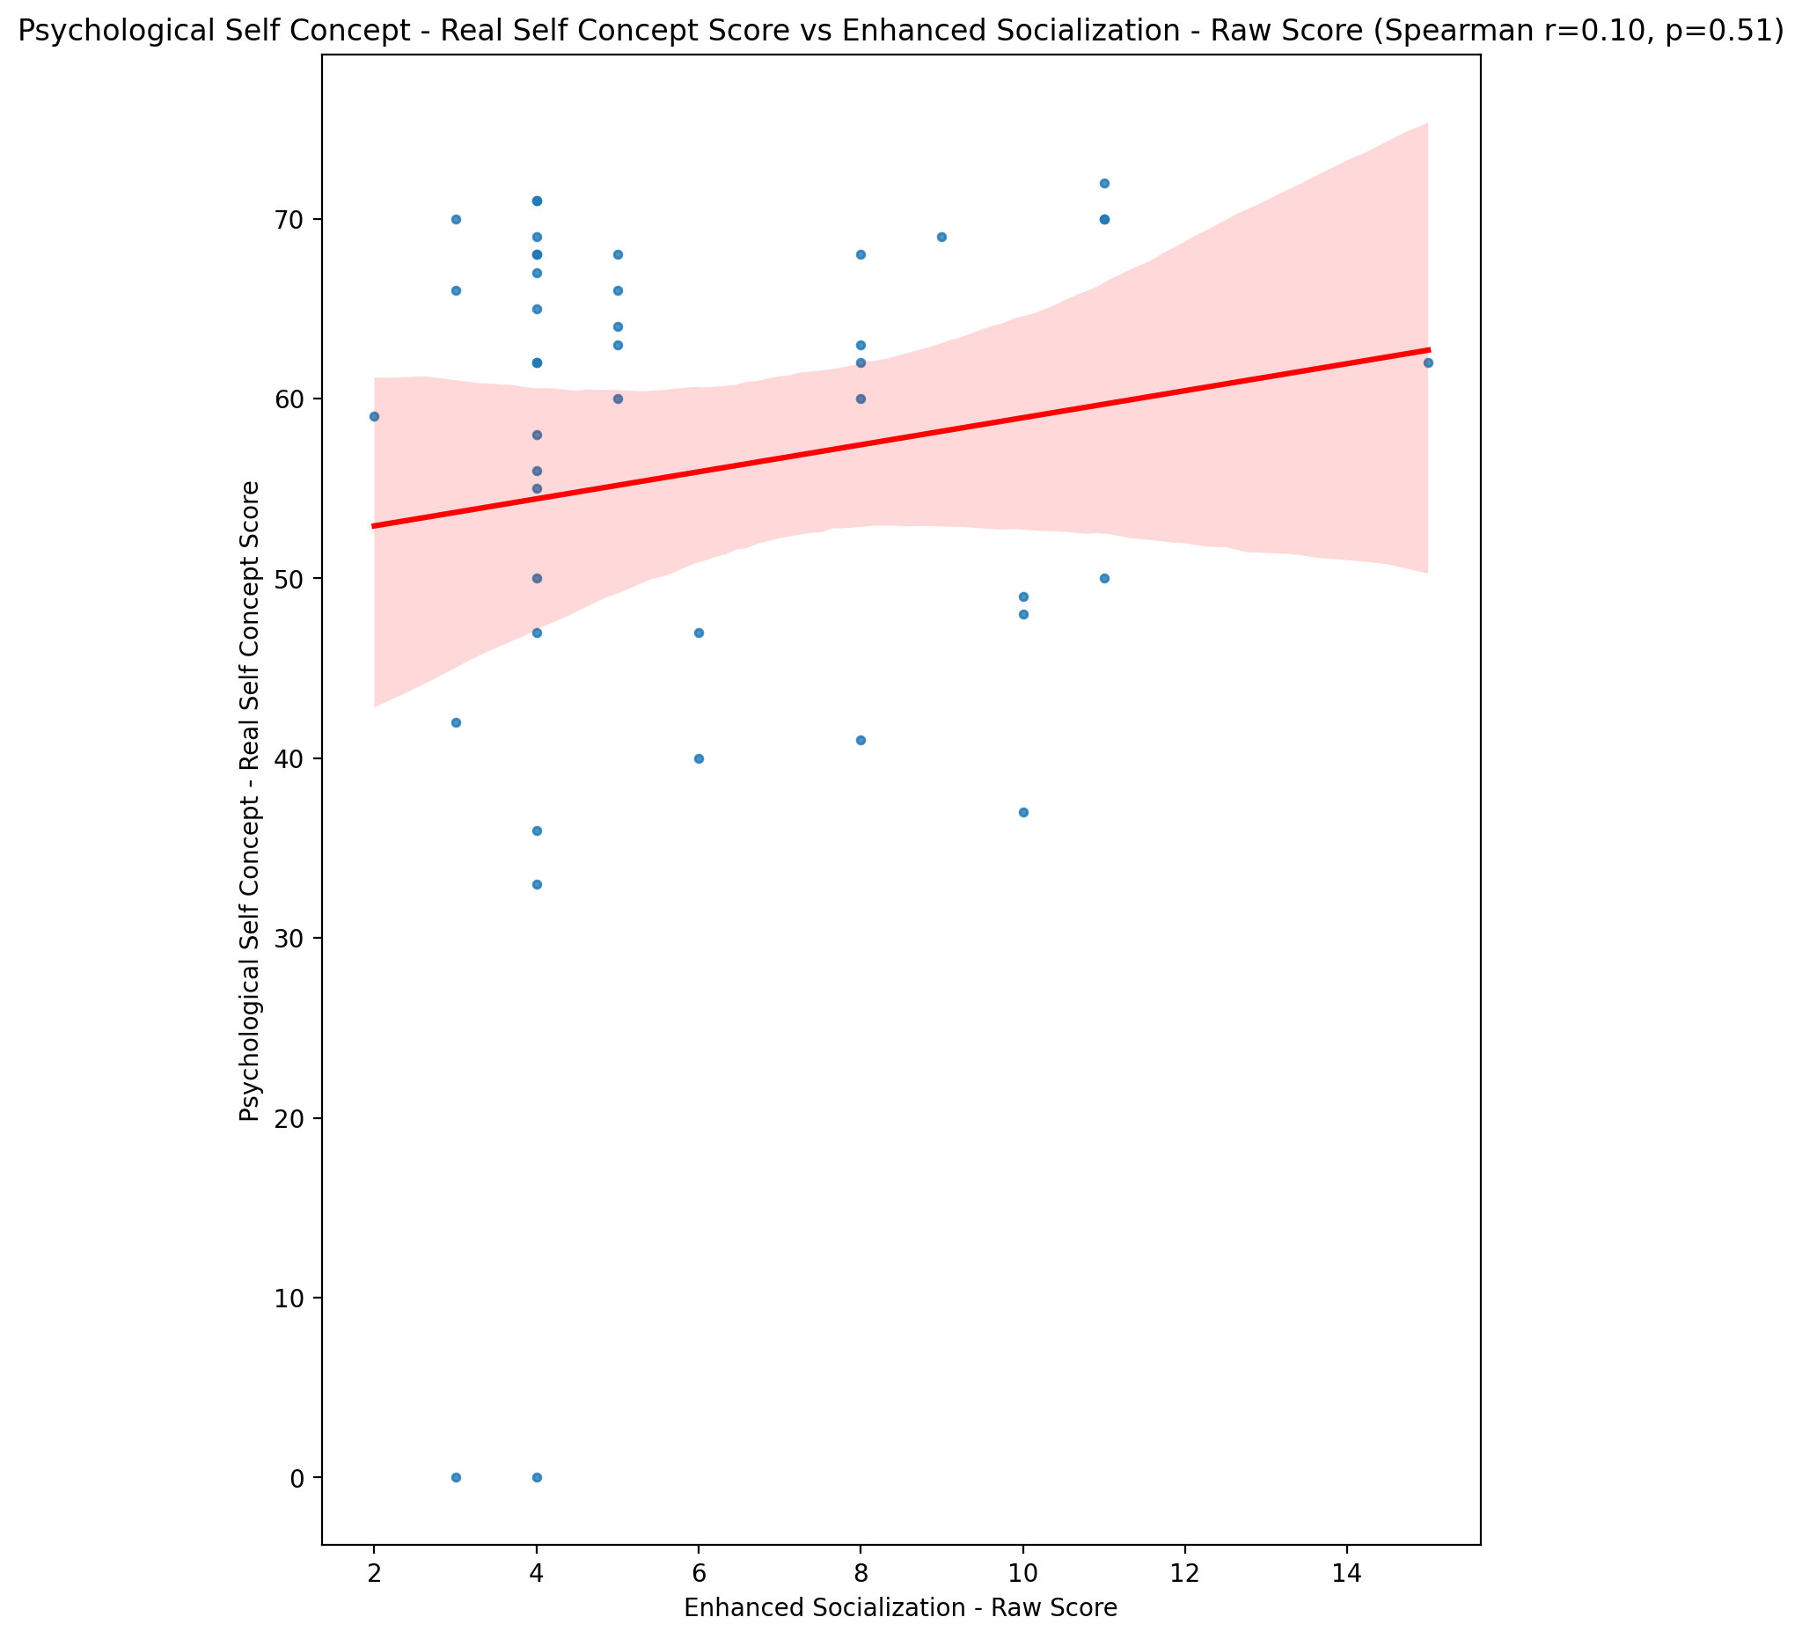

## Psychological Self Concept – Ideal Self Concept Score vs Enhanced Socialization - Raw Score

Test: spearman; statistic: 0.17271283695526152; p-value: 0.2680652387136632;

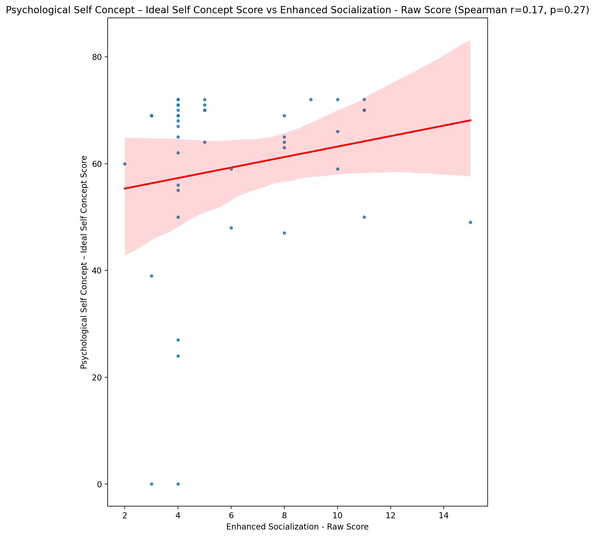

## Psychological Self Concept – Social Self Concept Score vs Enhanced Socialization - Raw Score

Test: spearman; statistic: 0.08649945632373103; p-value: 0.5812661627475975;

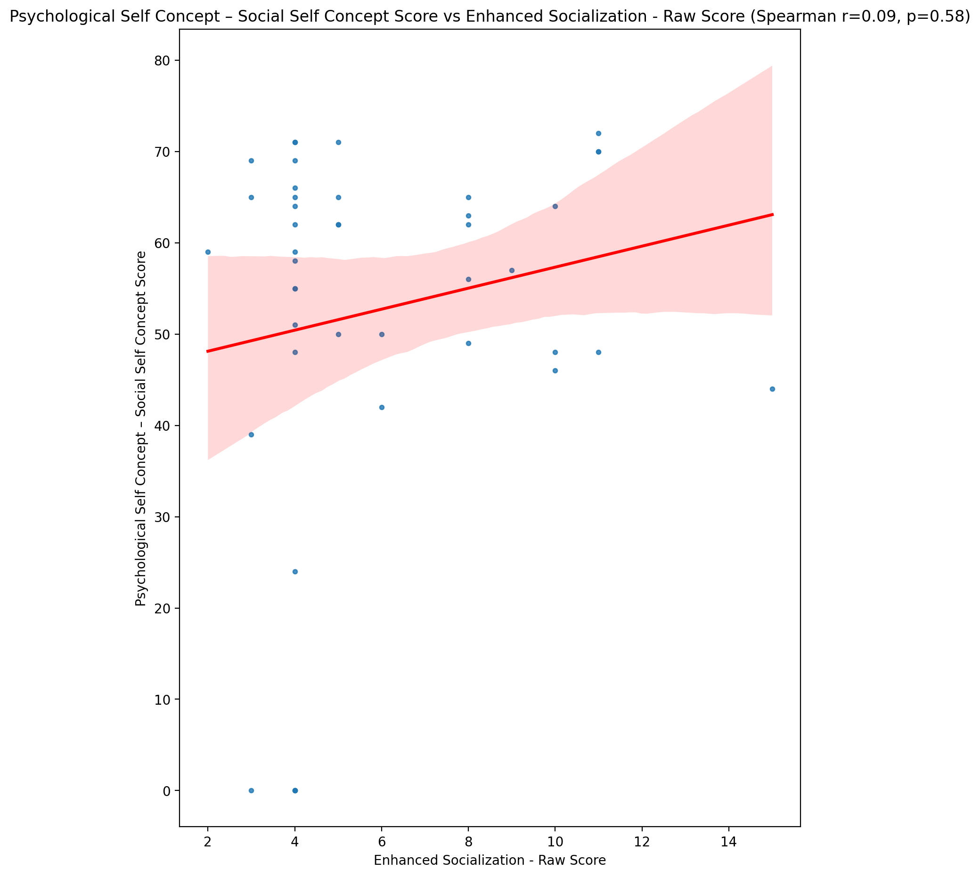

## Real Self Concept Total Score vs Enhanced Socialization - Raw Score

Test: spearman; statistic: 0.04749759297573872; p-value: 0.762304932217799;

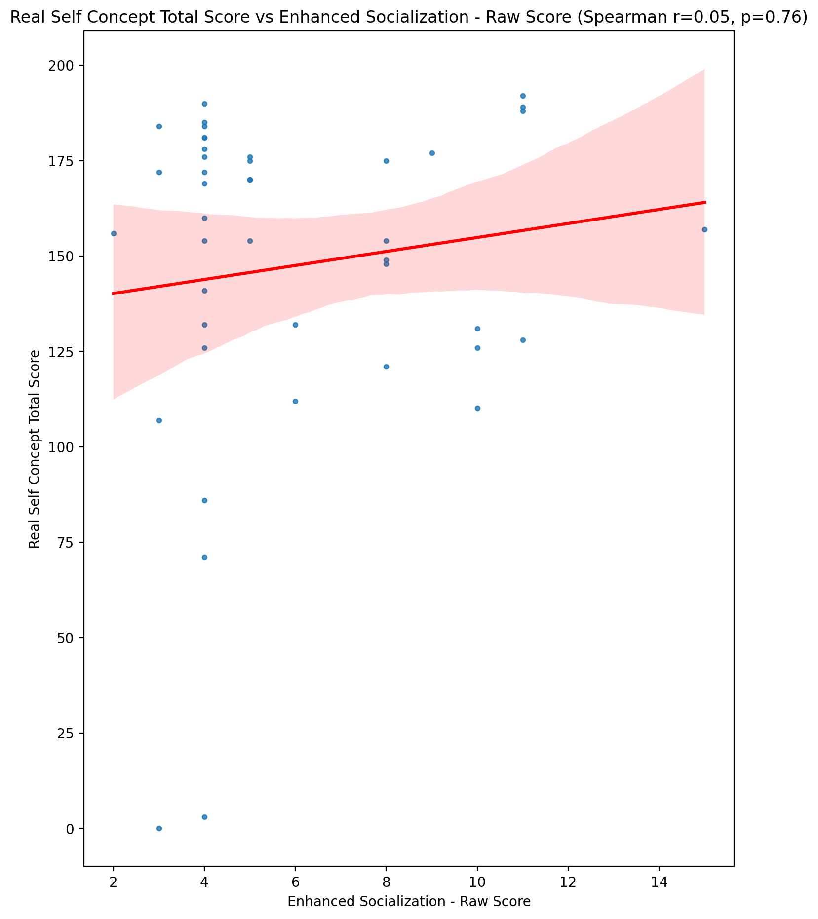

## Ideal Self Concept Total Score vs Enhanced Socialization - Raw Score

Test: spearman; statistic: 0.21330572374984502; p-value: 0.1696317247352769;

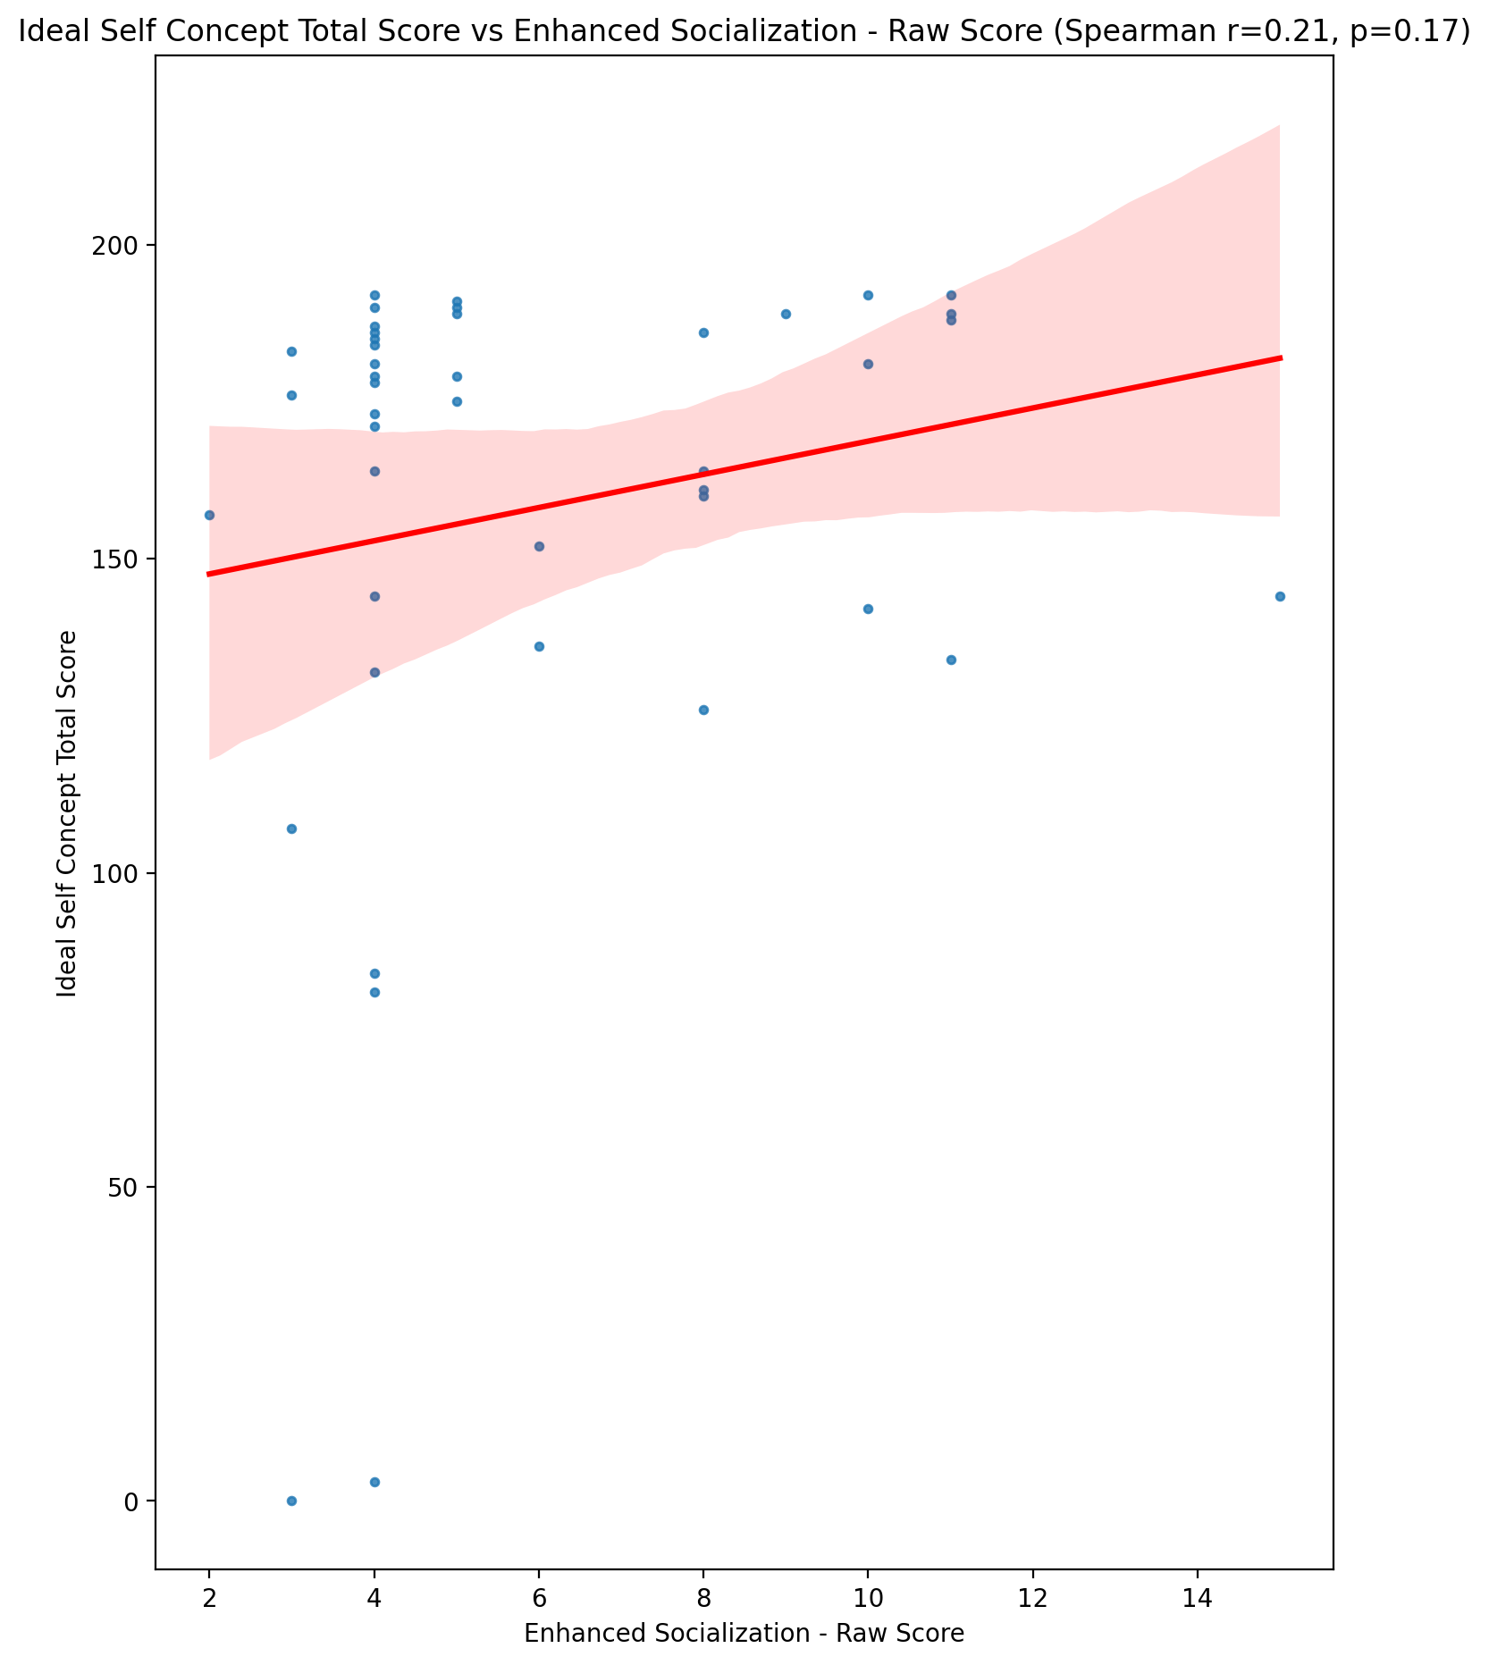

## Social Self Concept Total Score vs Enhanced Socialization - Raw Score

Test: spearman; statistic: 0.10597622150585224; p-value: 0.49880990998763786;

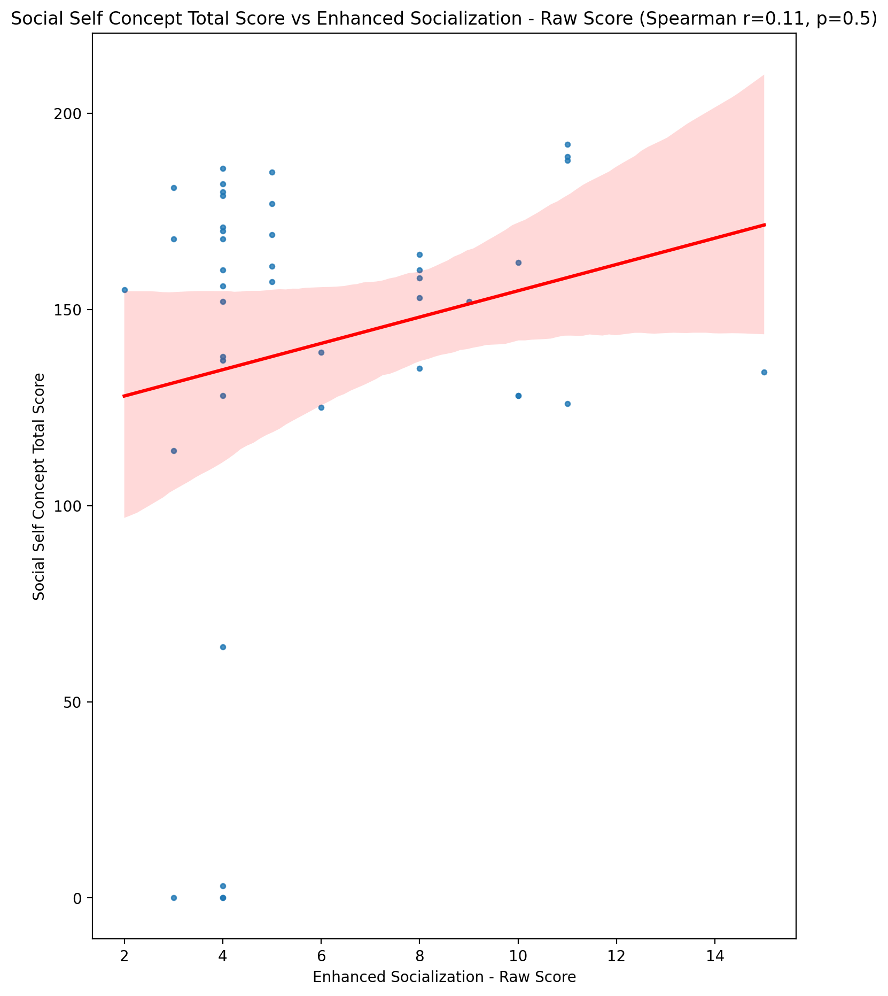

## Ideal Self Concept Total Category vs Enhanced Socialization - Raw Score

Test: None; statistic: None; p-value: None; Test not run: unsupported type combination.



## Perceived Social Stress Score vs Enhanced Socialization - Raw Score

Test: spearman; statistic: 0.03366385036201253; p-value: 0.8303096461031055;

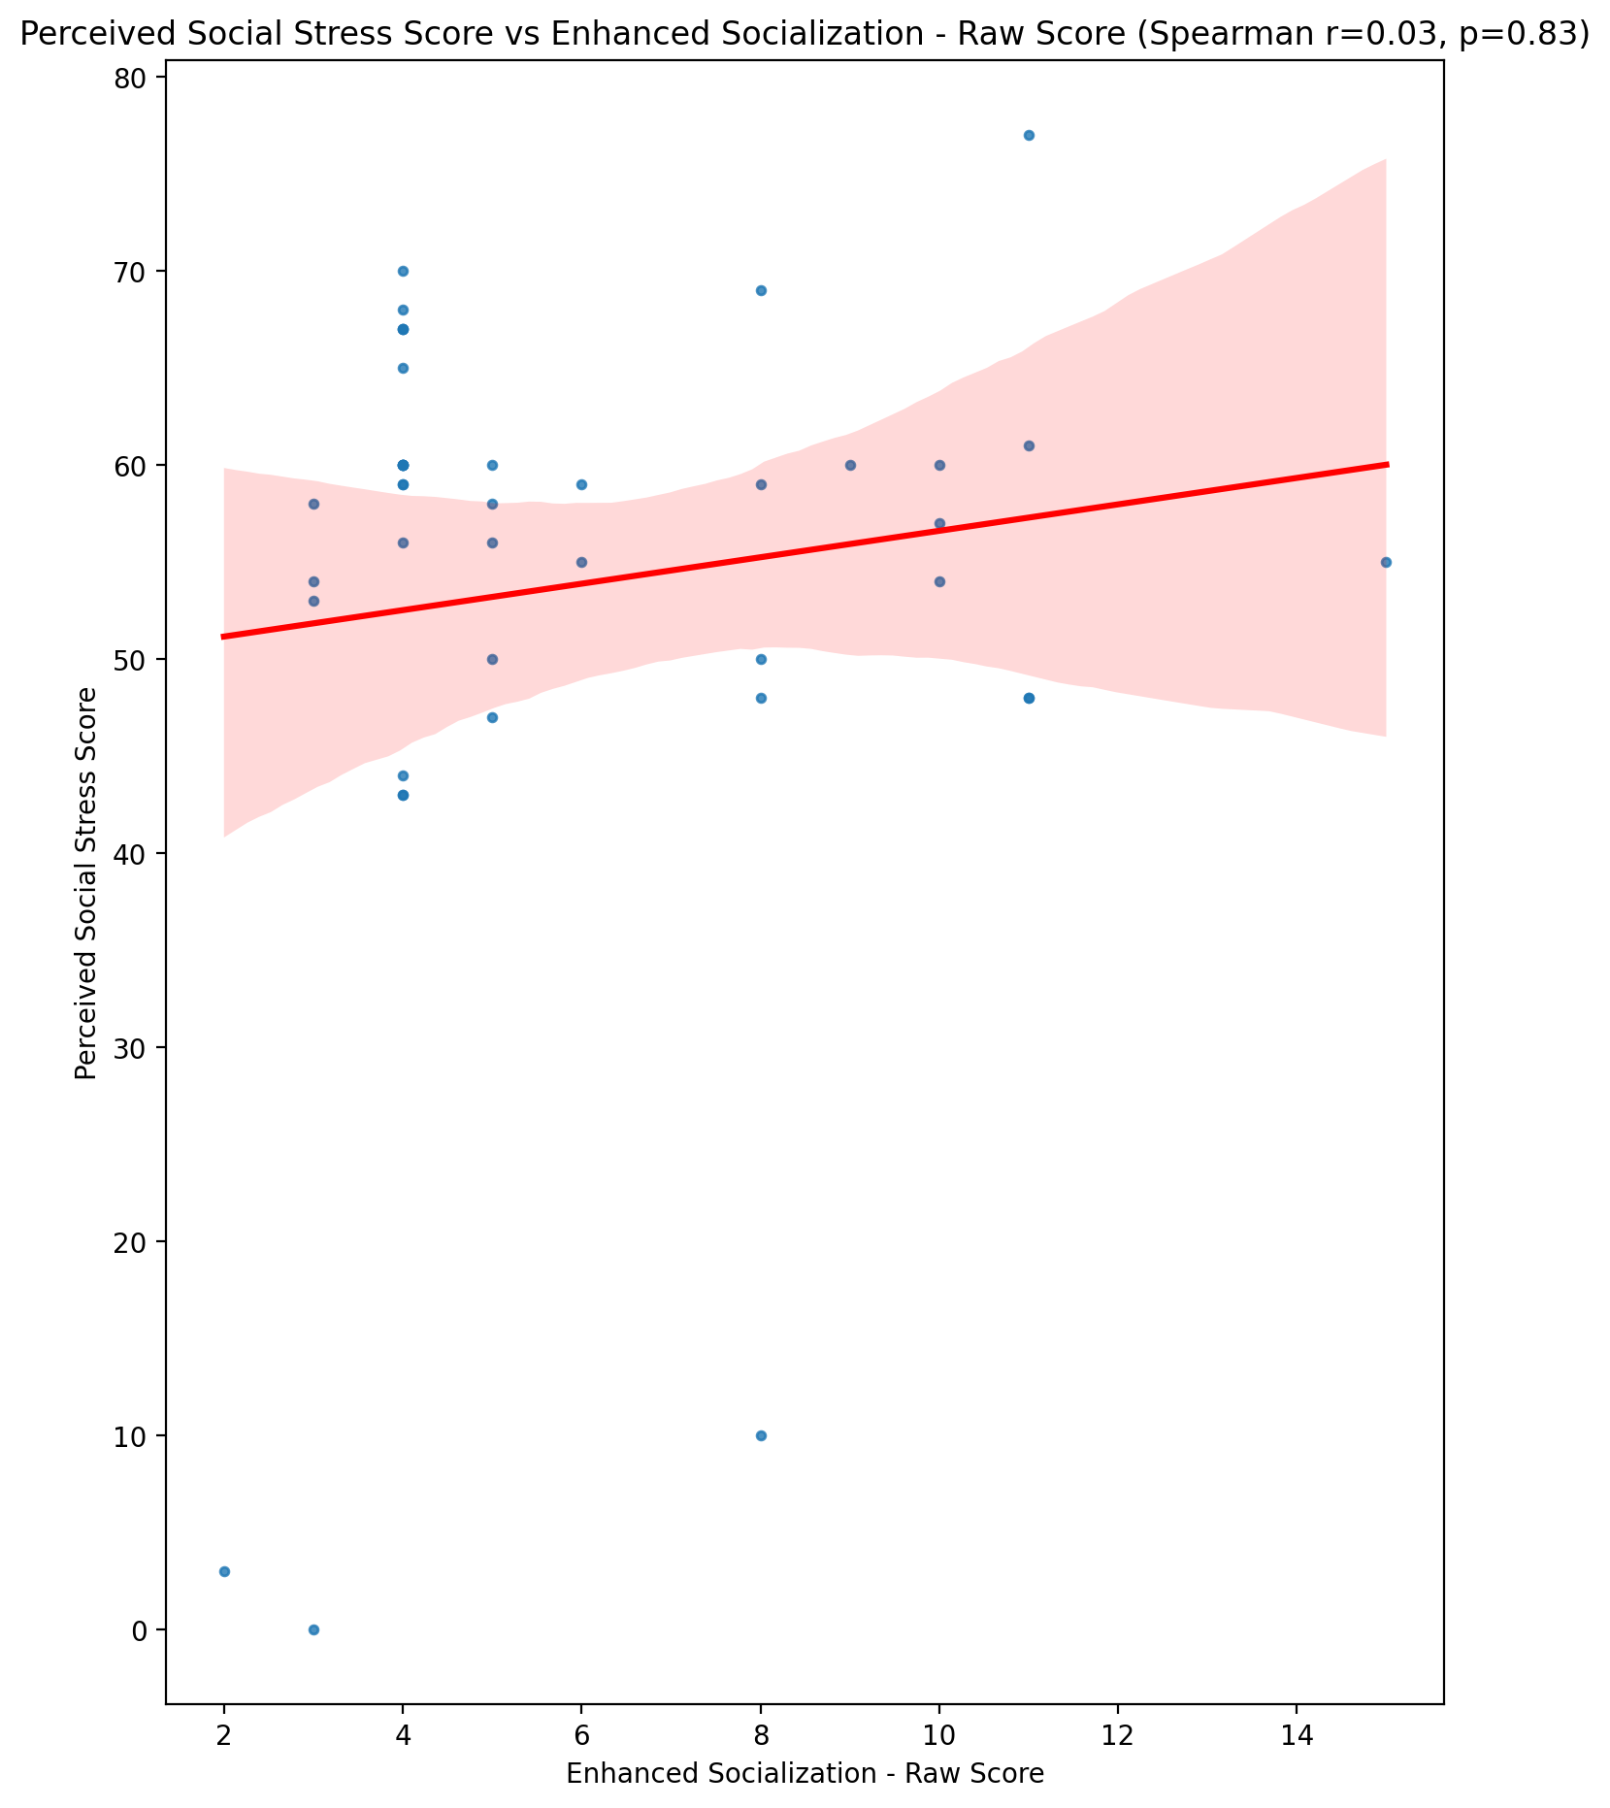

## Perceived Social Stress Category vs Enhanced Socialization - Raw Score

Test: None; statistic: None; p-value: None; Test not run: unsupported type combination.



## Emotional Support - Raw Score vs Perceived Control of Internet Use - Raw Score

Test: spearman; statistic: -0.003218792862282383; p-value: 0.9836563934664863;

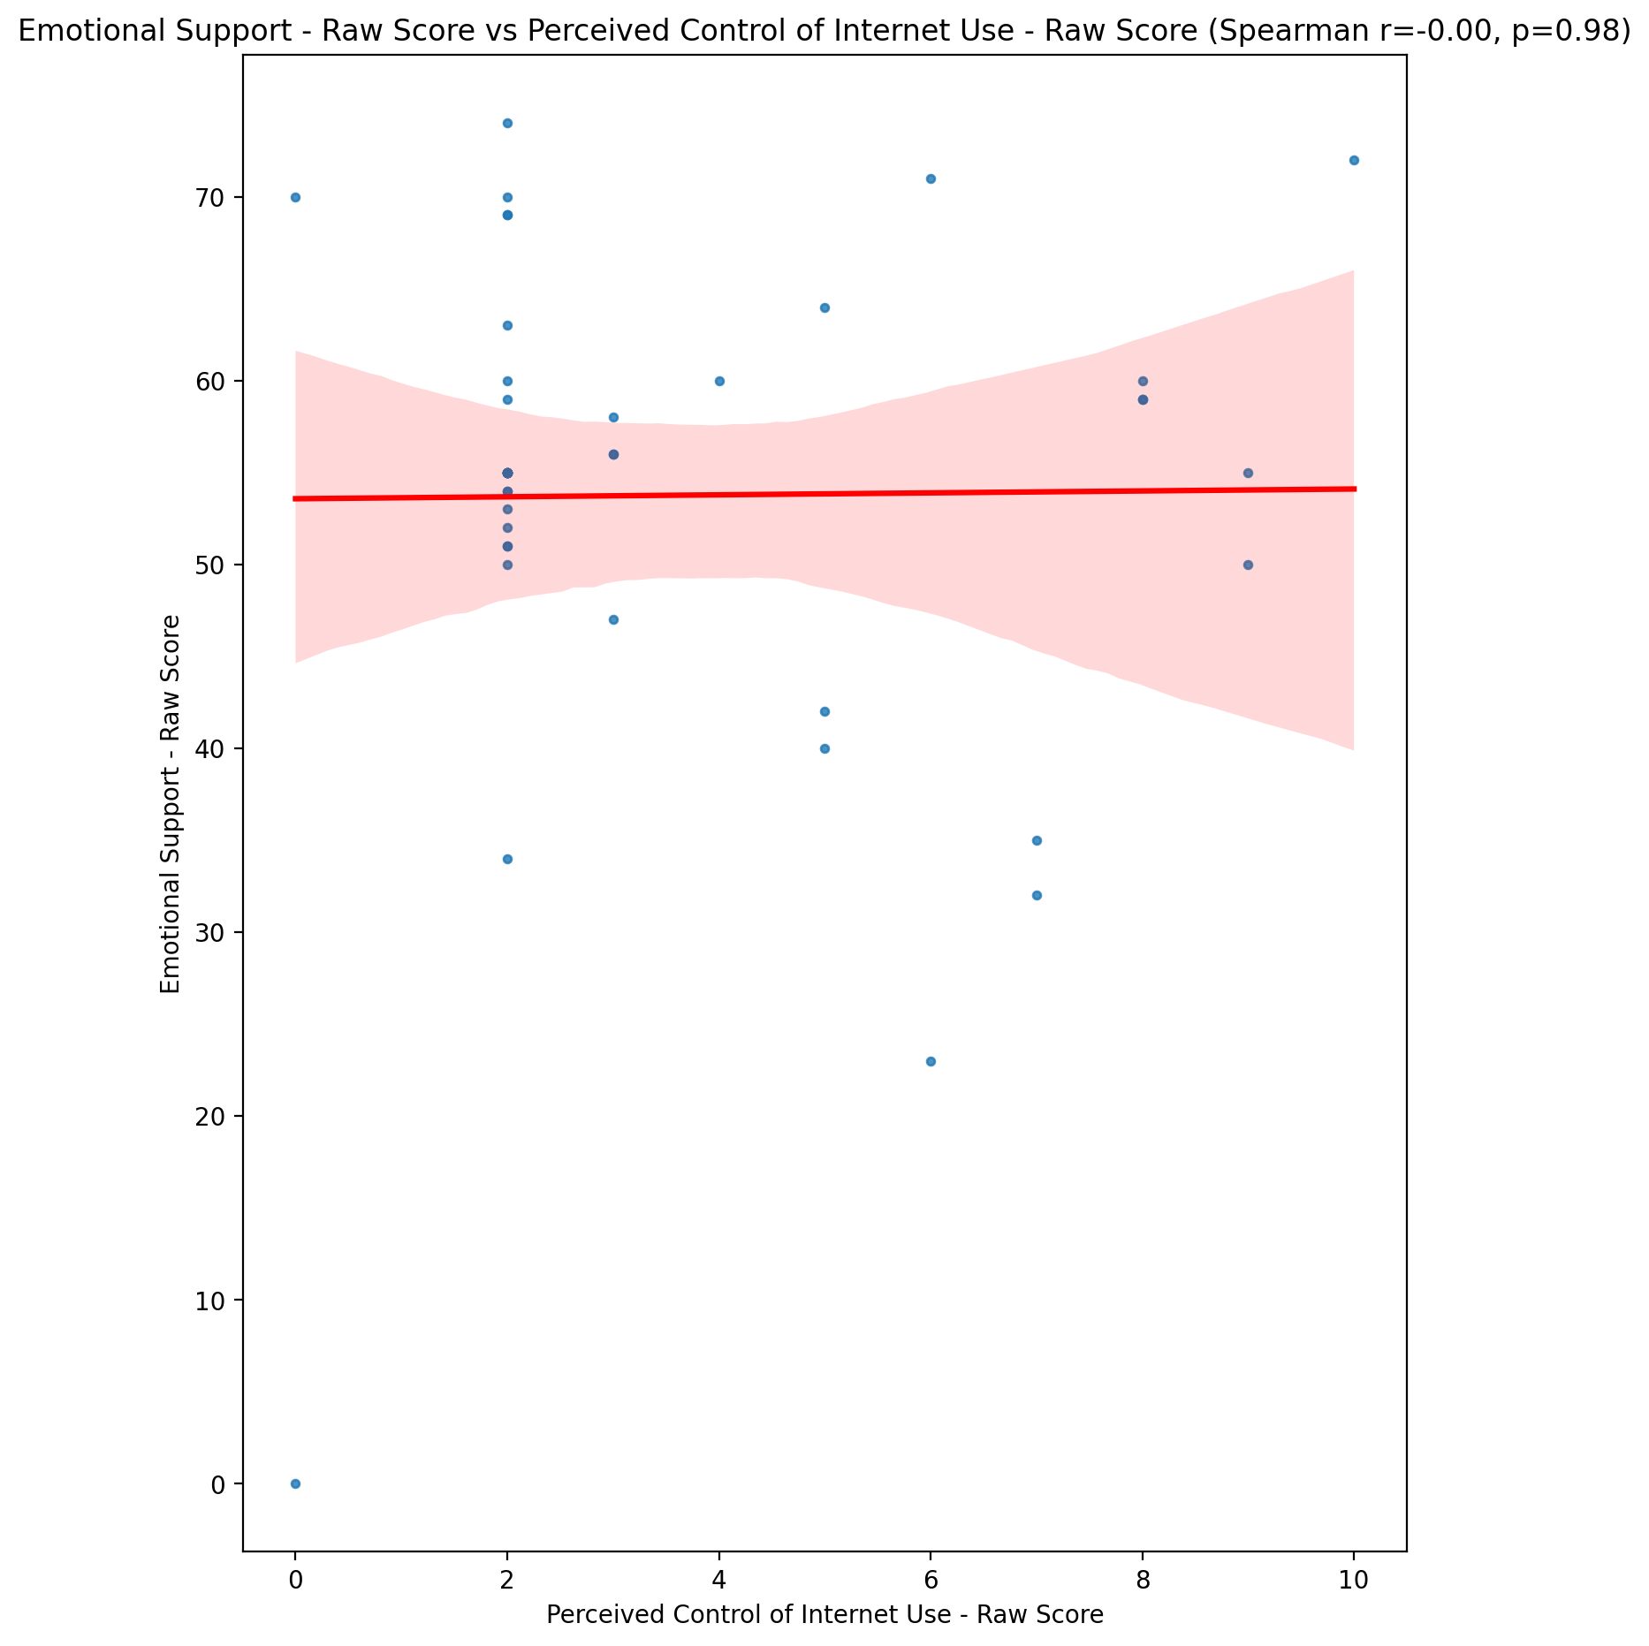

## Informational Support - Raw Score vs Perceived Control of Internet Use - Raw Score

Test: spearman; statistic: -0.09134187691359409; p-value: 0.5602037869356875;

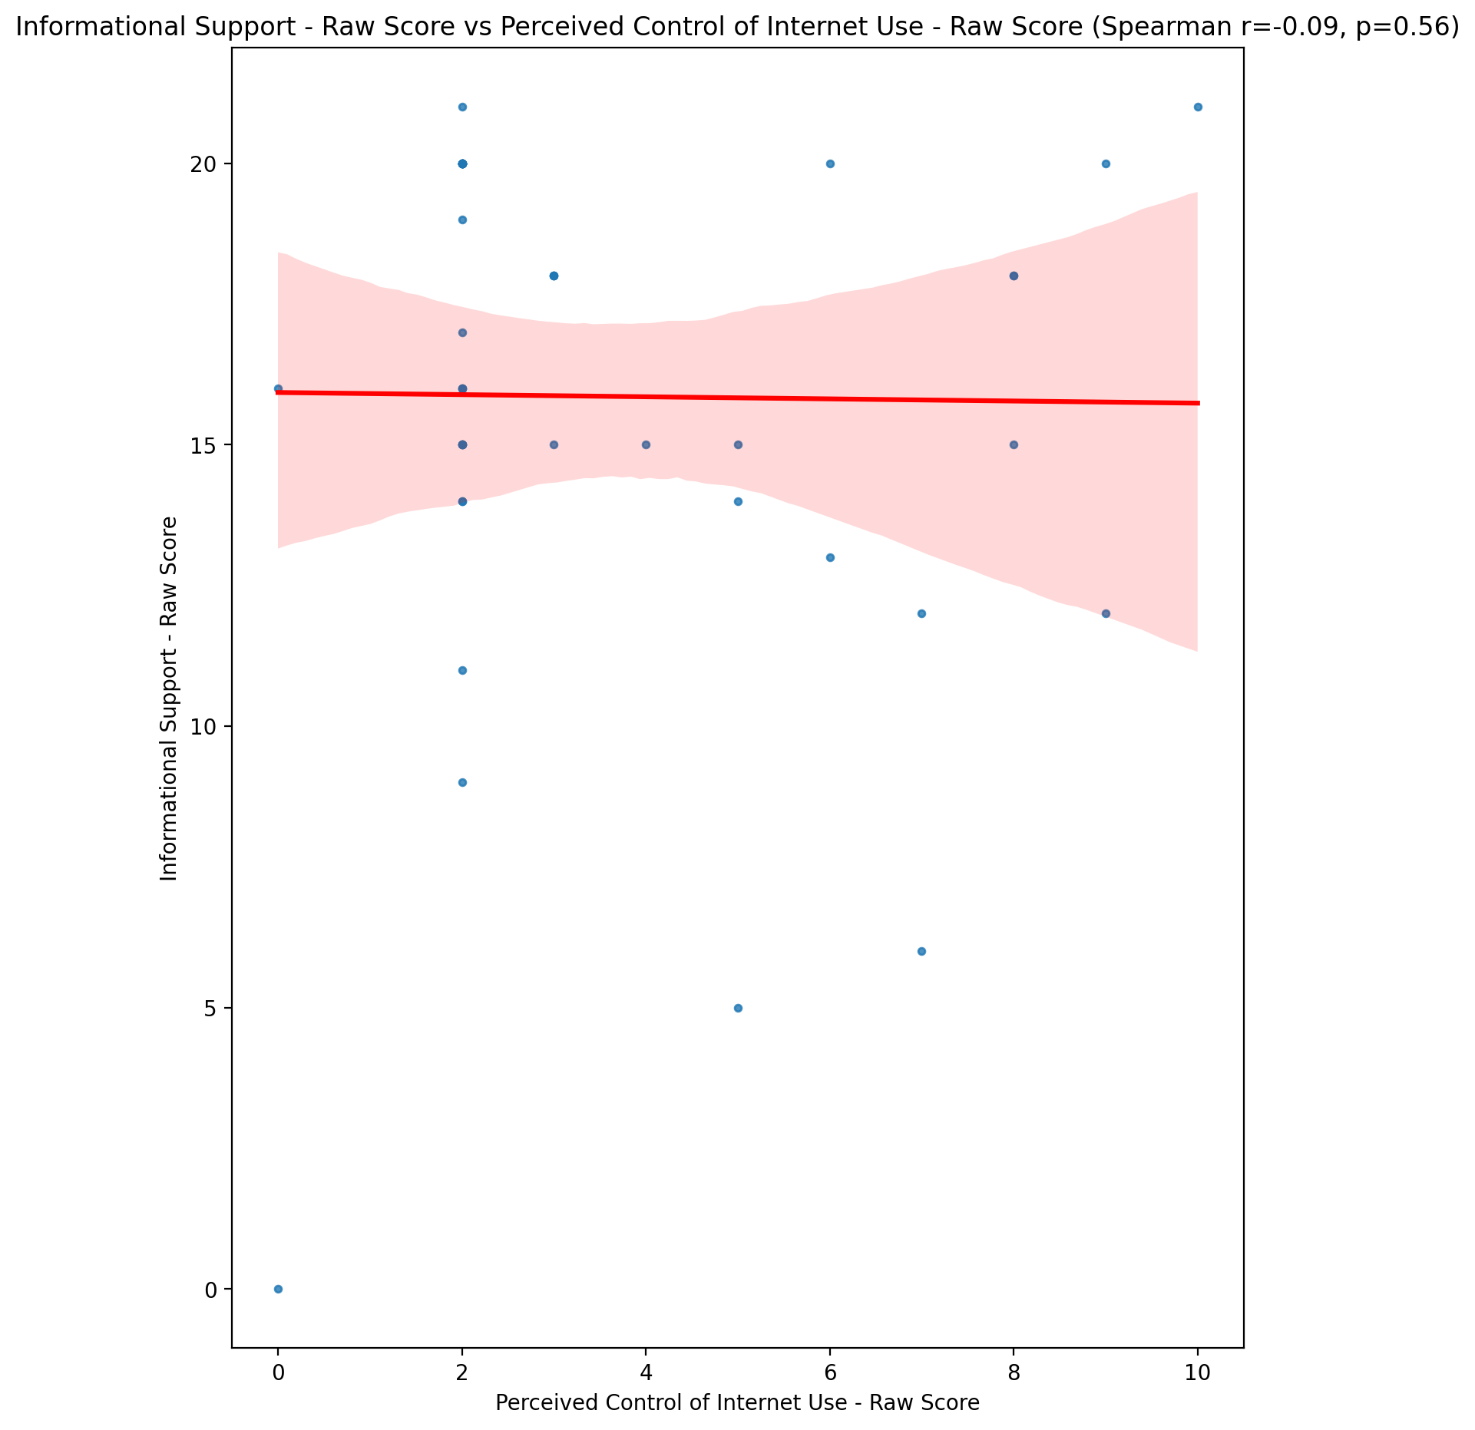

## Instrumental Support - Raw Score vs Perceived Control of Internet Use - Raw Score

Test: spearman; statistic: 0.011842095985470289; p-value: 0.9399217951075212;

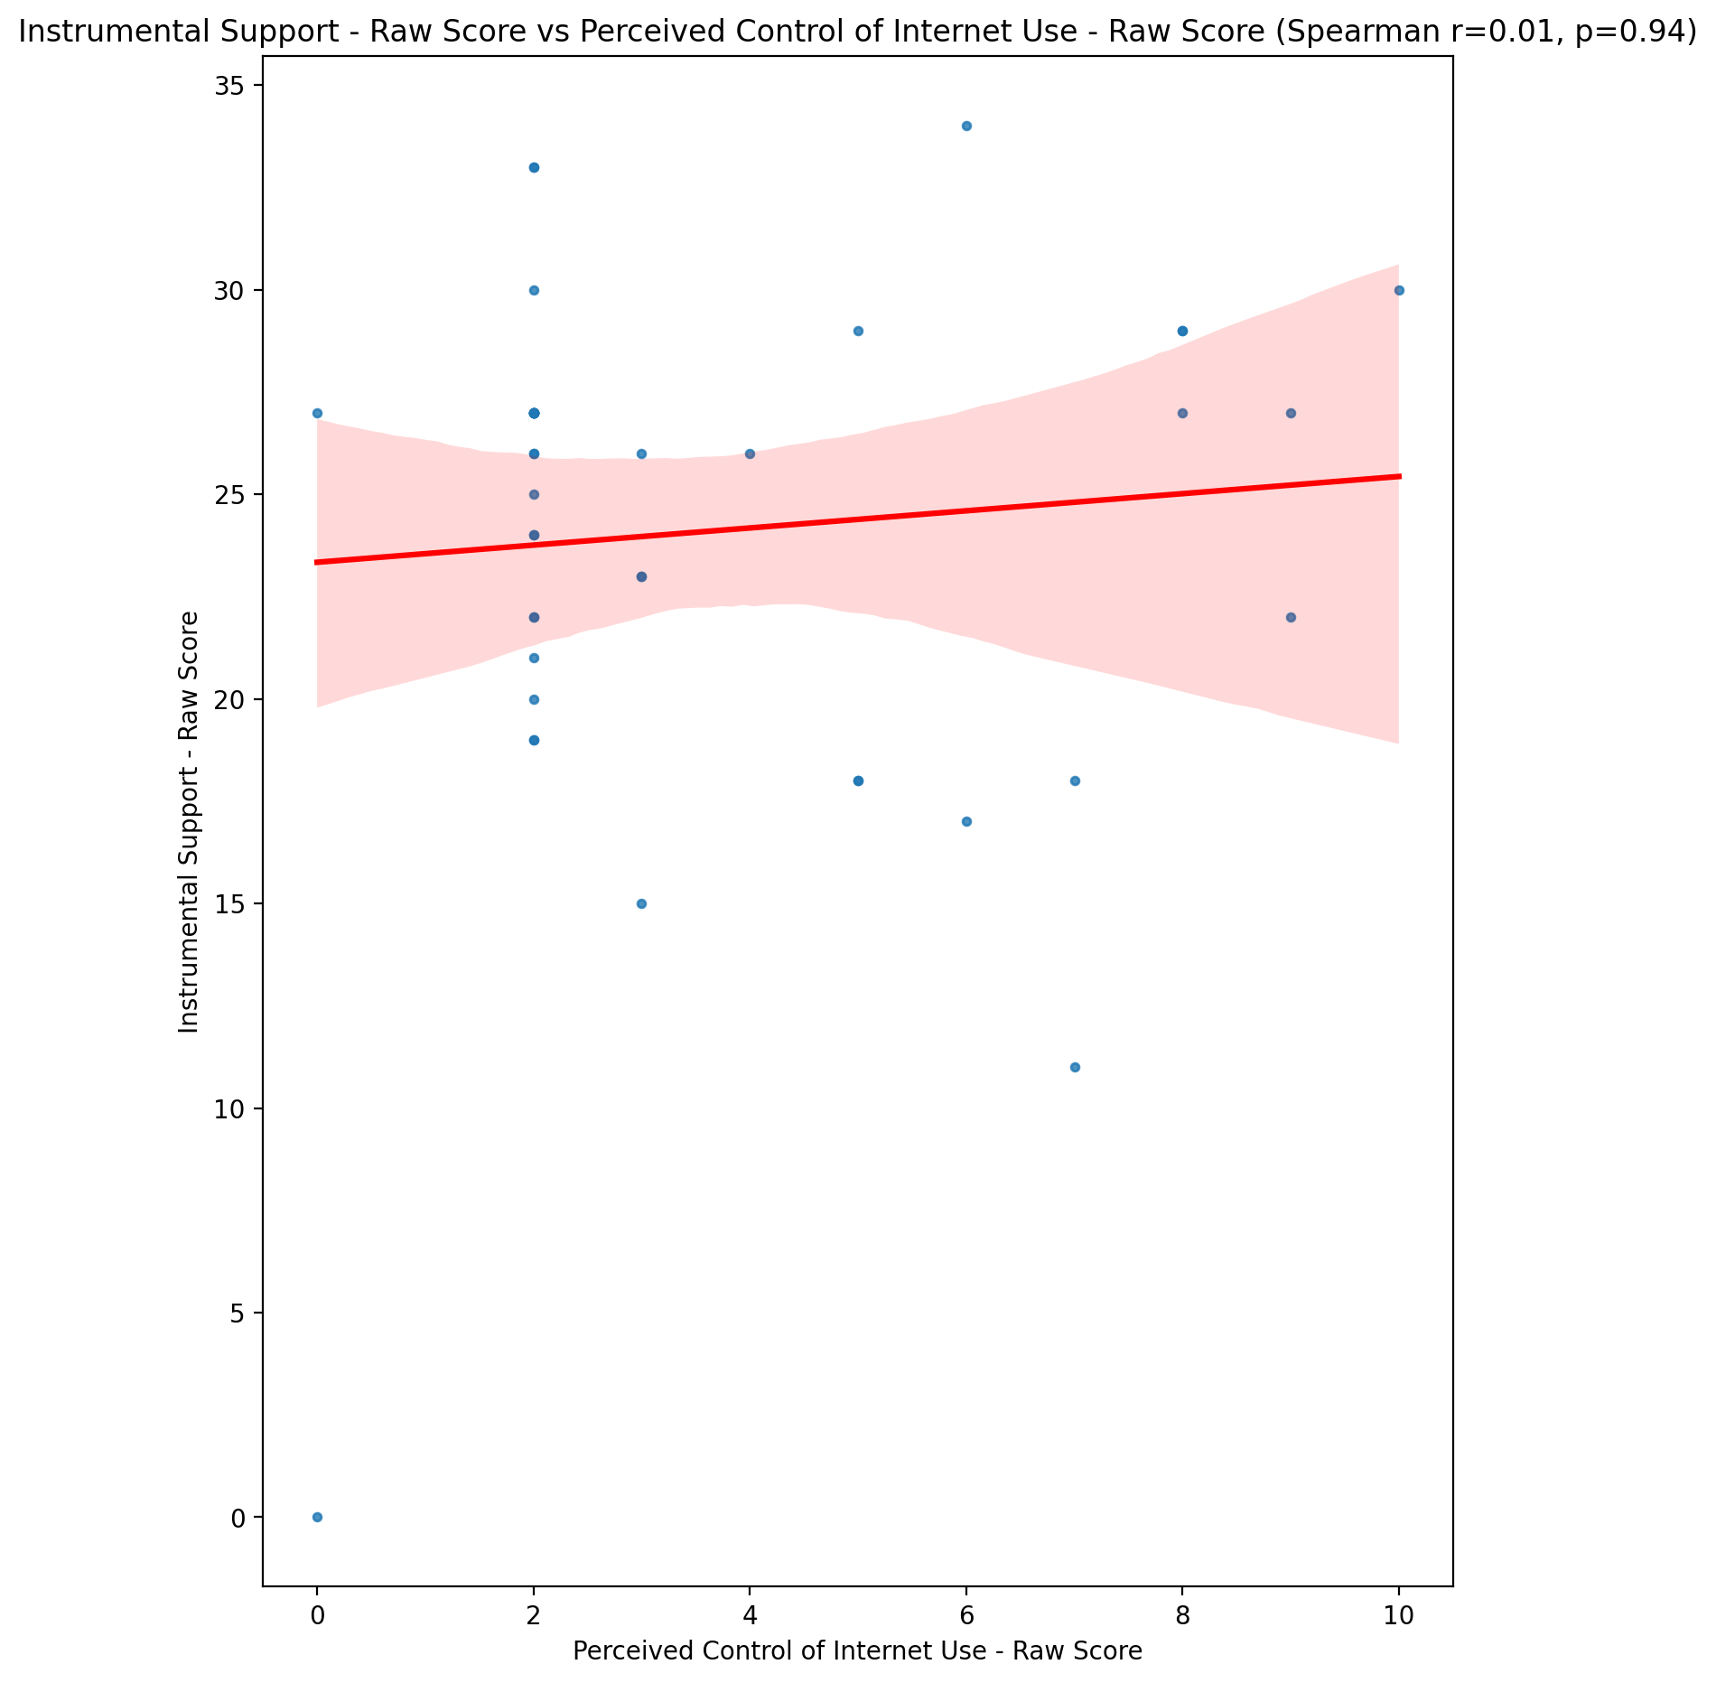

## Emotional Support - T Score vs Perceived Control of Internet Use - Raw Score

Test: spearman; statistic: 0.05018781239242274; p-value: 0.7492660638410549;

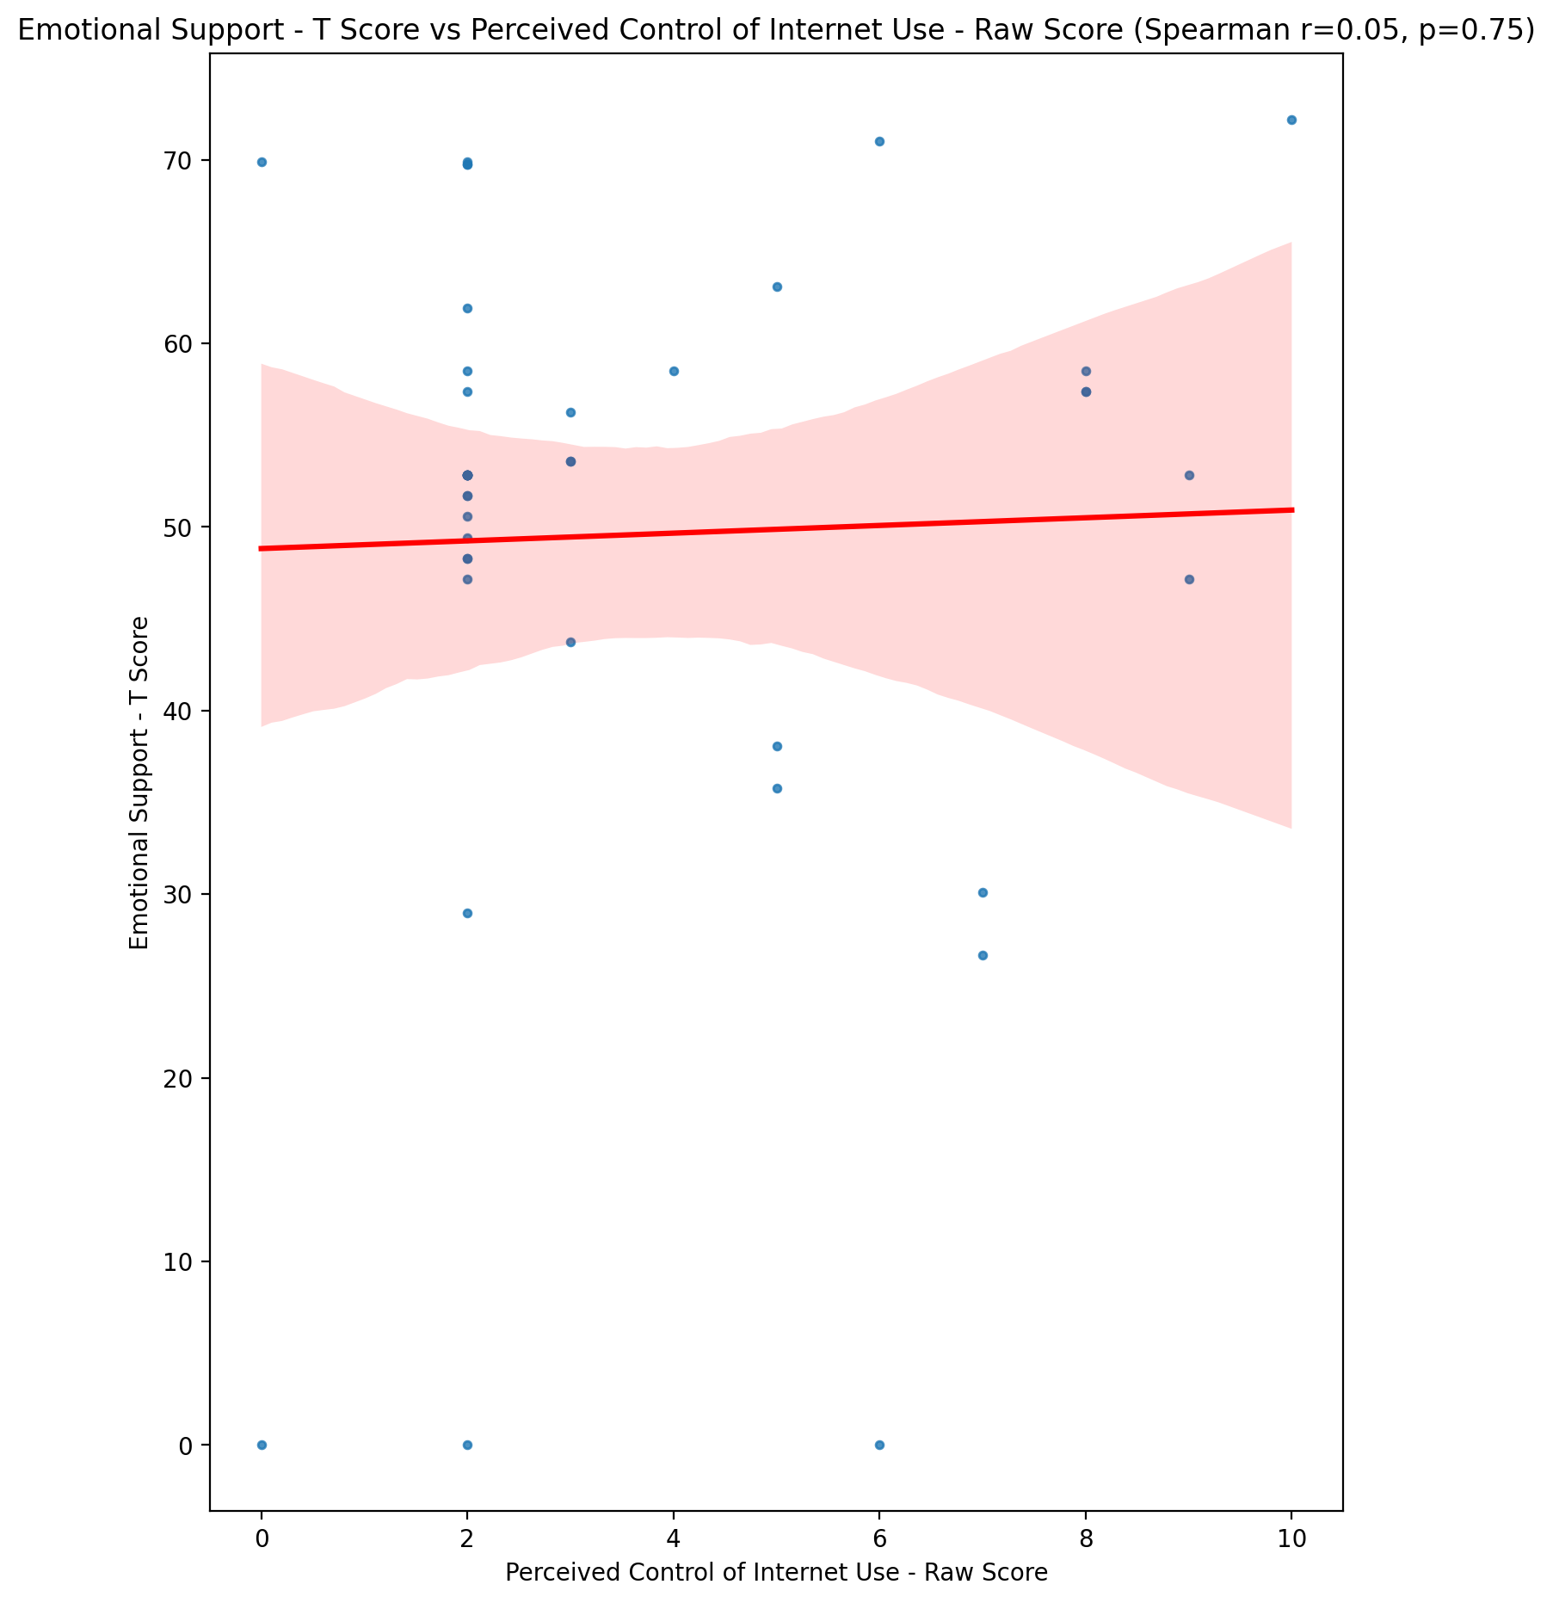

## Informational Support - T Score vs Perceived Control of Internet Use - Raw Score

Test: spearman; statistic: -0.0971801927337139; p-value: 0.5352938163088803;

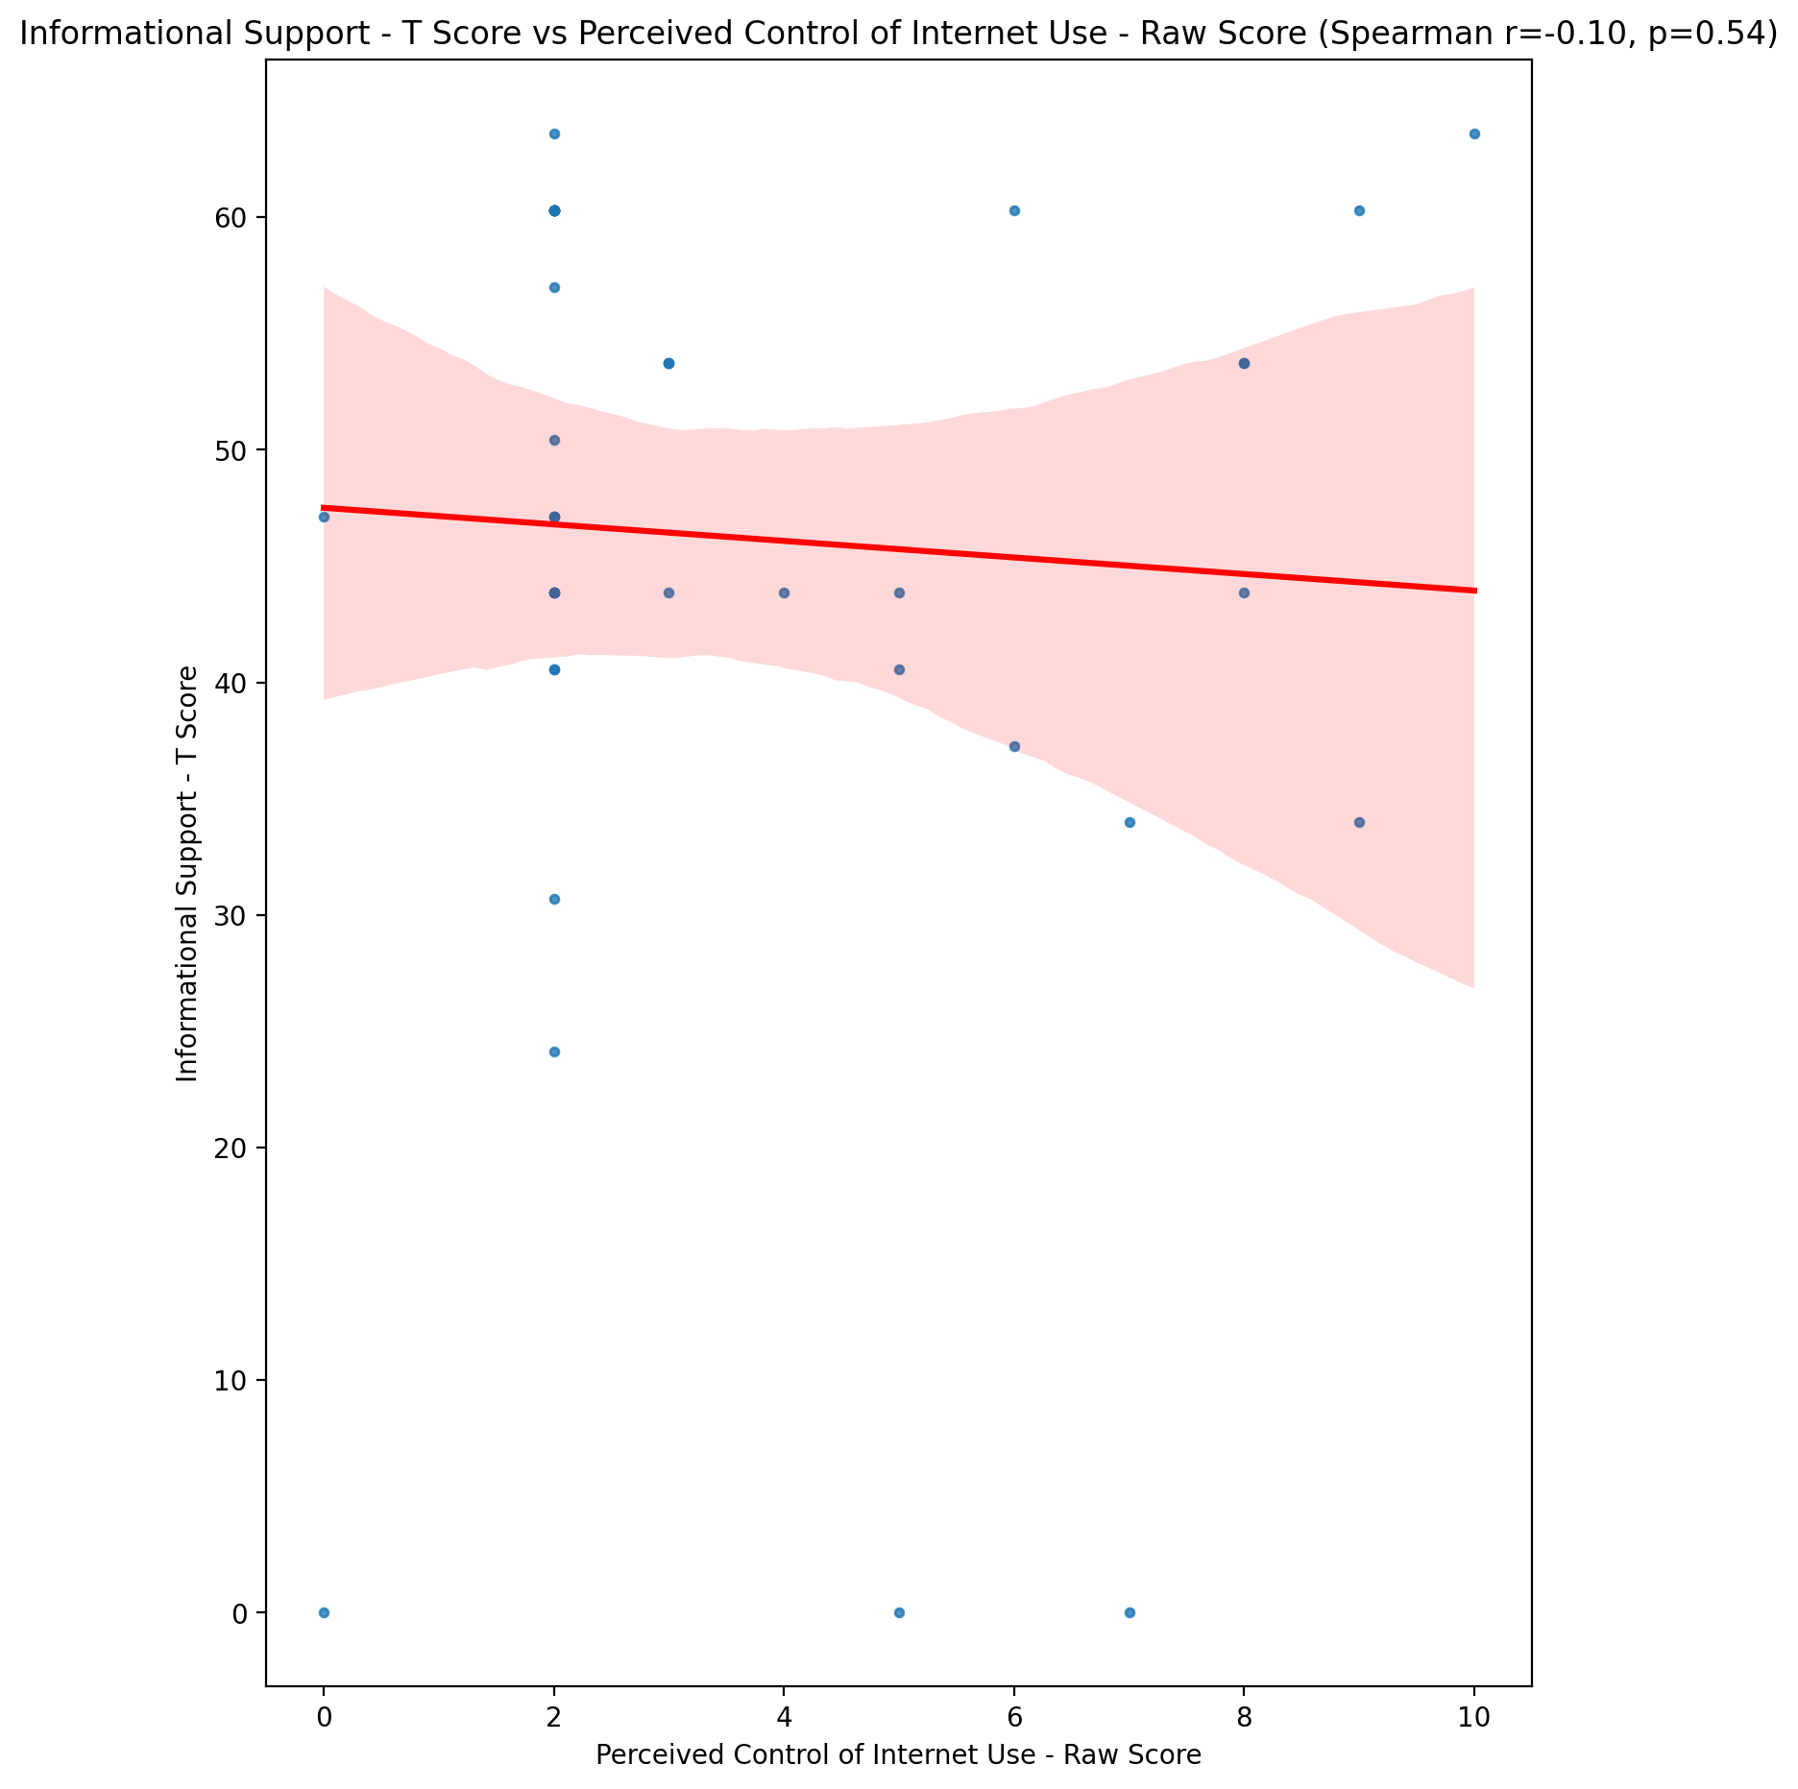

## Instrumental Support - T Score vs Perceived Control of Internet Use - Raw Score

Test: spearman; statistic: 0.008933856456632536; p-value: 0.9546582979008393;

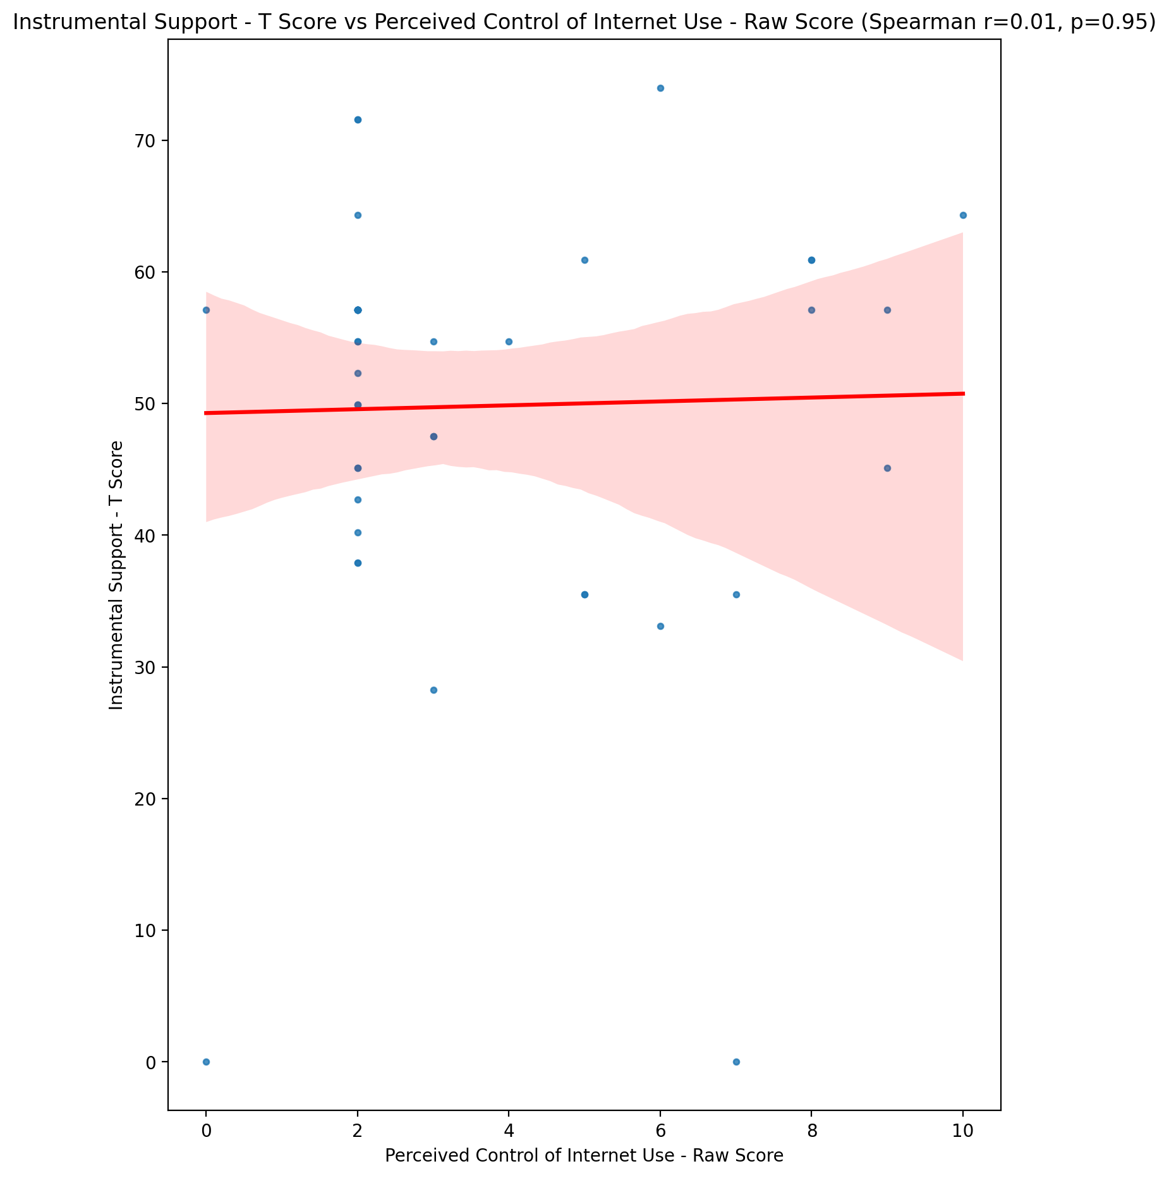

## Perceived Social Support Total T Score vs Perceived Control of Internet Use - Raw Score

Test: spearman; statistic: -0.048309978214460675; p-value: 0.7583604541952784;

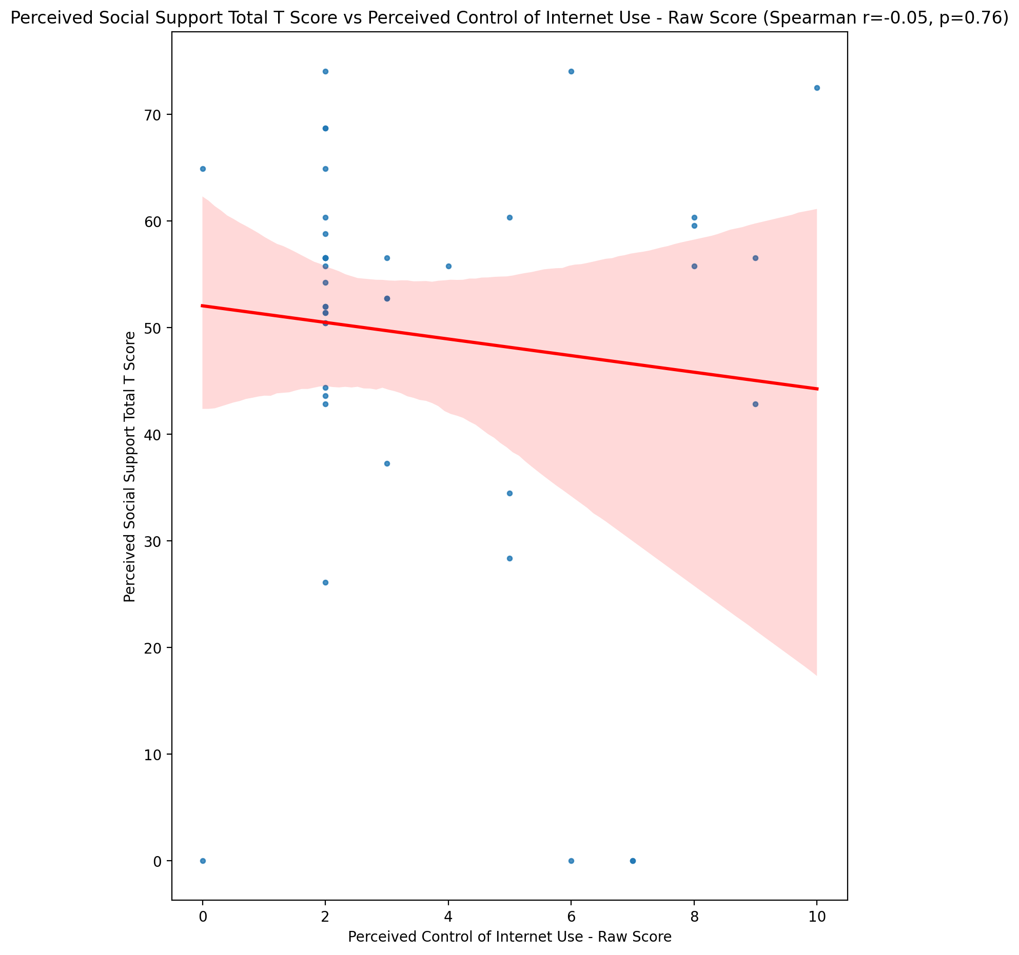

## Emotional Support - Rank vs Perceived Control of Internet Use - Raw Score

Test: None; statistic: None; p-value: None; Test not run: unsupported type combination.



## Informational Support - Rank vs Perceived Control of Internet Use - Raw Score

Test: None; statistic: None; p-value: None; Test not run: unsupported type combination.



## Instrumental Support - Rank vs Perceived Control of Internet Use - Raw Score

Test: None; statistic: None; p-value: None; Test not run: unsupported type combination.



## Perceived Social Support TOTAL - Rank vs Perceived Control of Internet Use - Raw Score

Test: None; statistic: None; p-value: None; Test not run: unsupported type combination.



## Power Self Concept - Real Self Concept Score vs Perceived Control of Internet Use - Raw Score

Test: spearman; statistic: -0.15367137148507706; p-value: 0.32518591381205486;

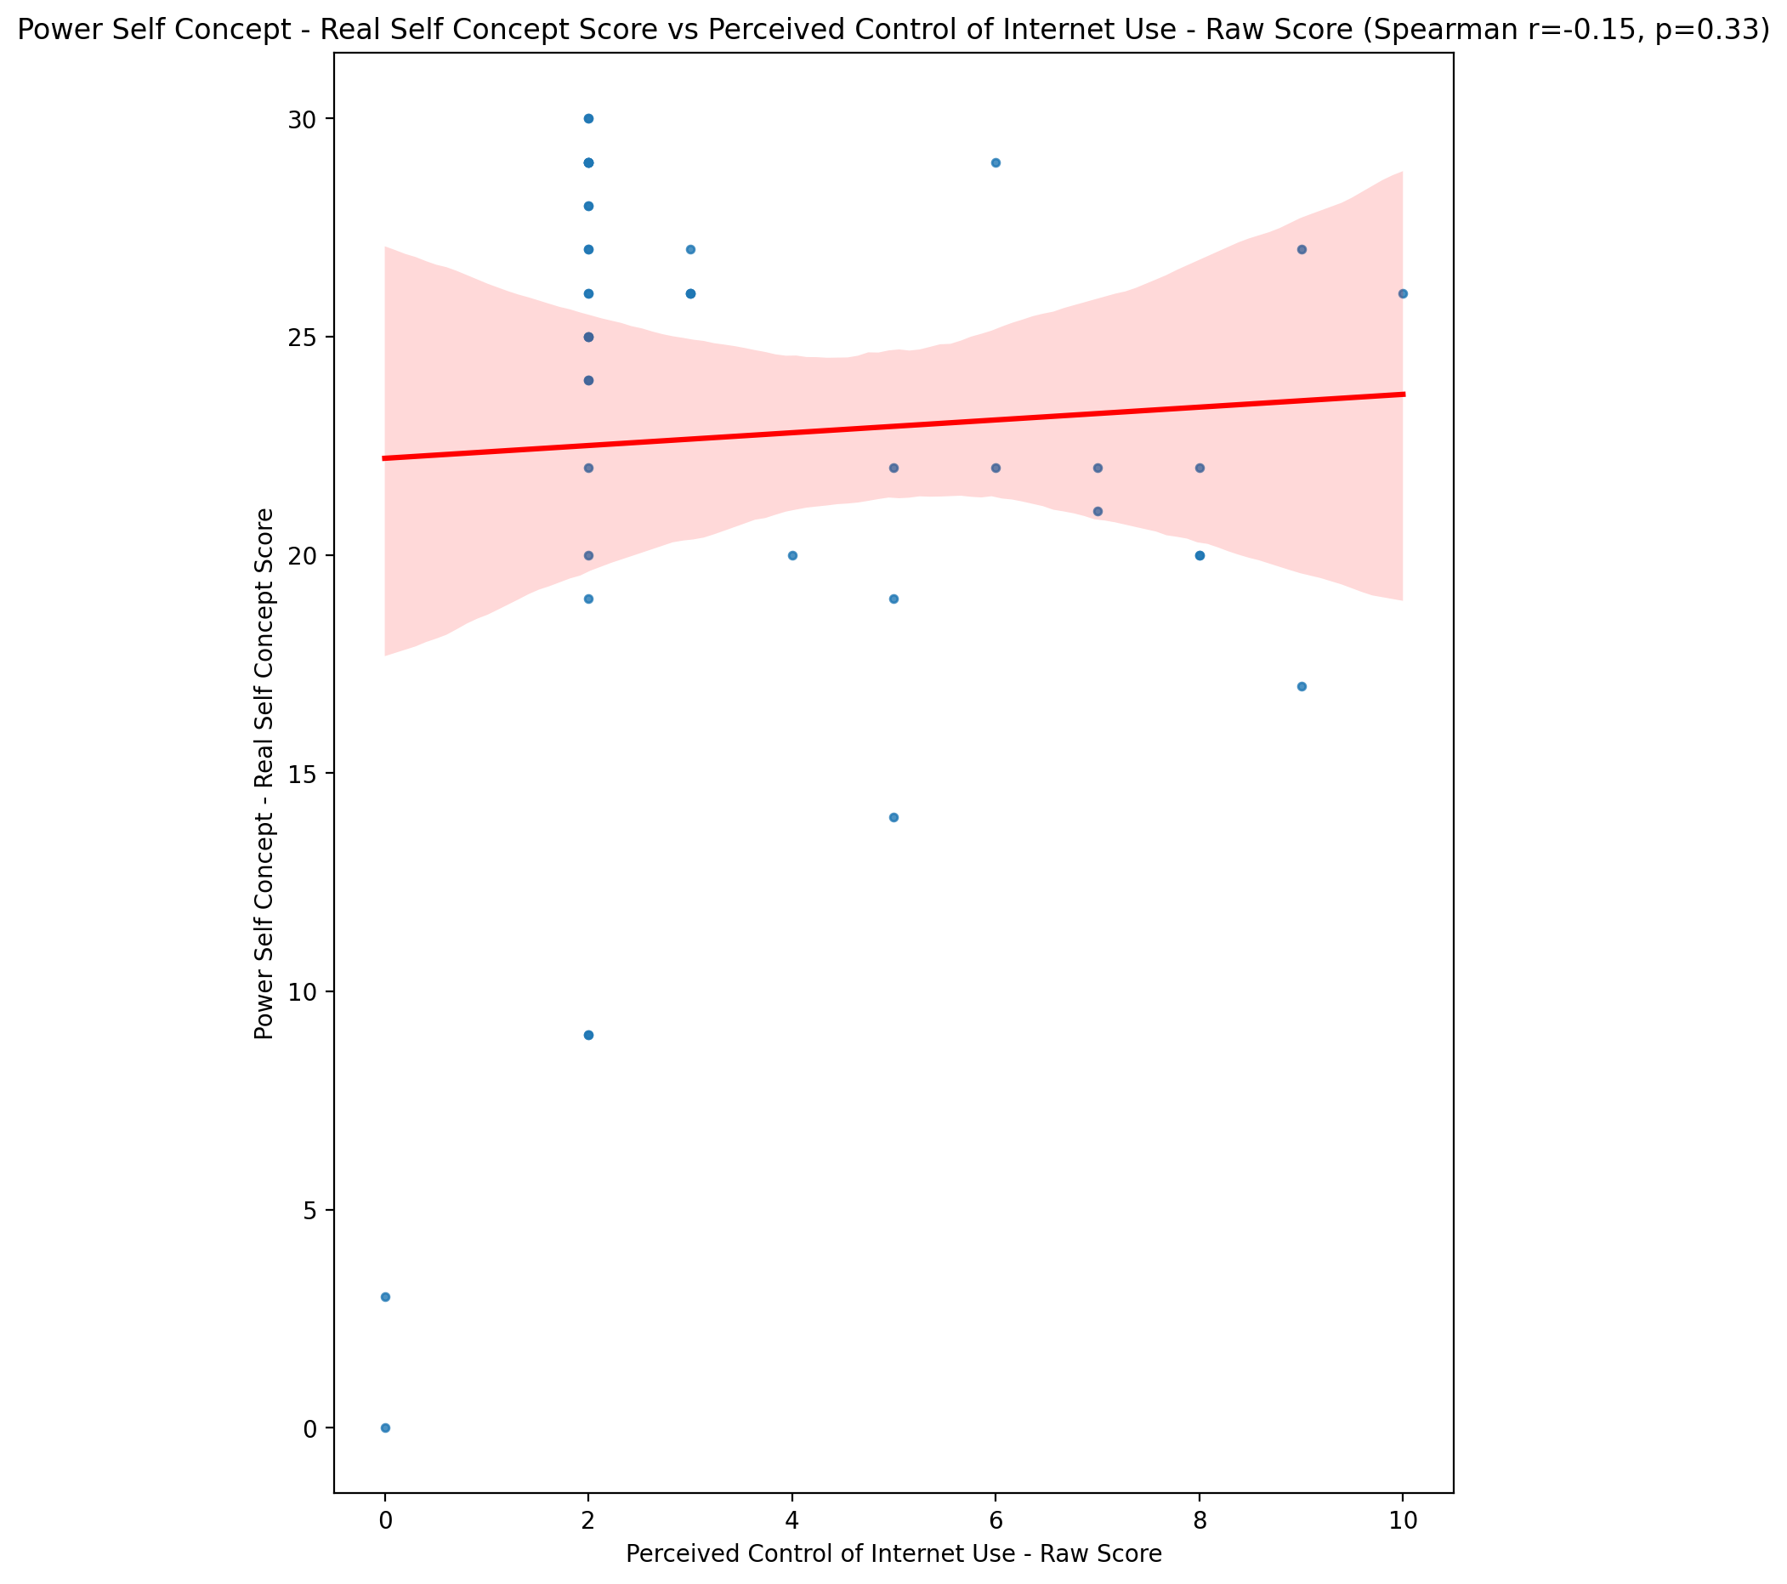

## Power Self Concept - Ideal Self Concept score vs Perceived Control of Internet Use - Raw Score

Test: spearman; statistic: -0.0016952950632546312; p-value: 0.9913916225851913;

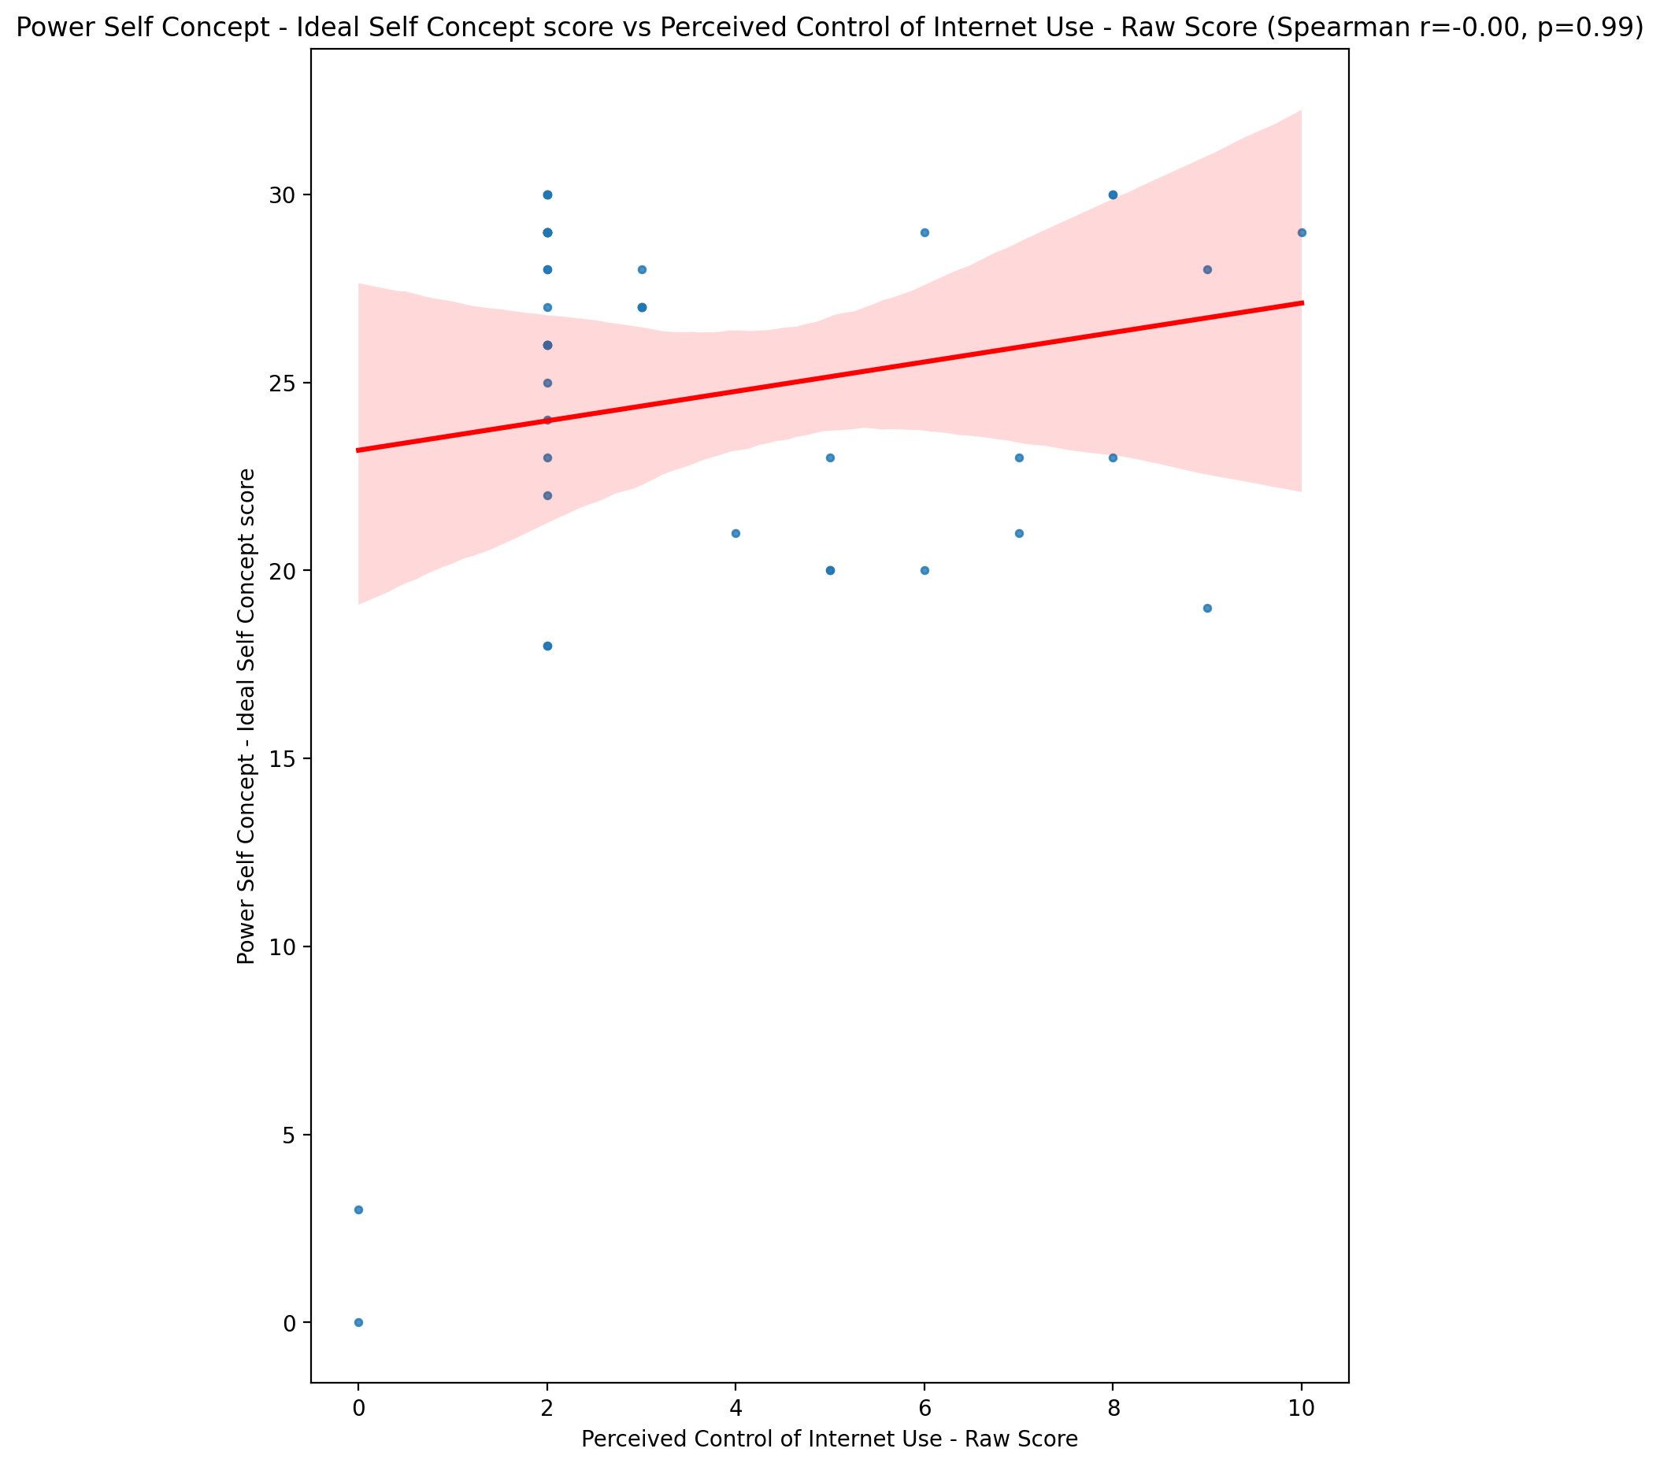

## Power Self Concept – Social Self Concept Score vs Perceived Control of Internet Use - Raw Score

Test: spearman; statistic: -0.06372040550545453; p-value: 0.6847844656348847;

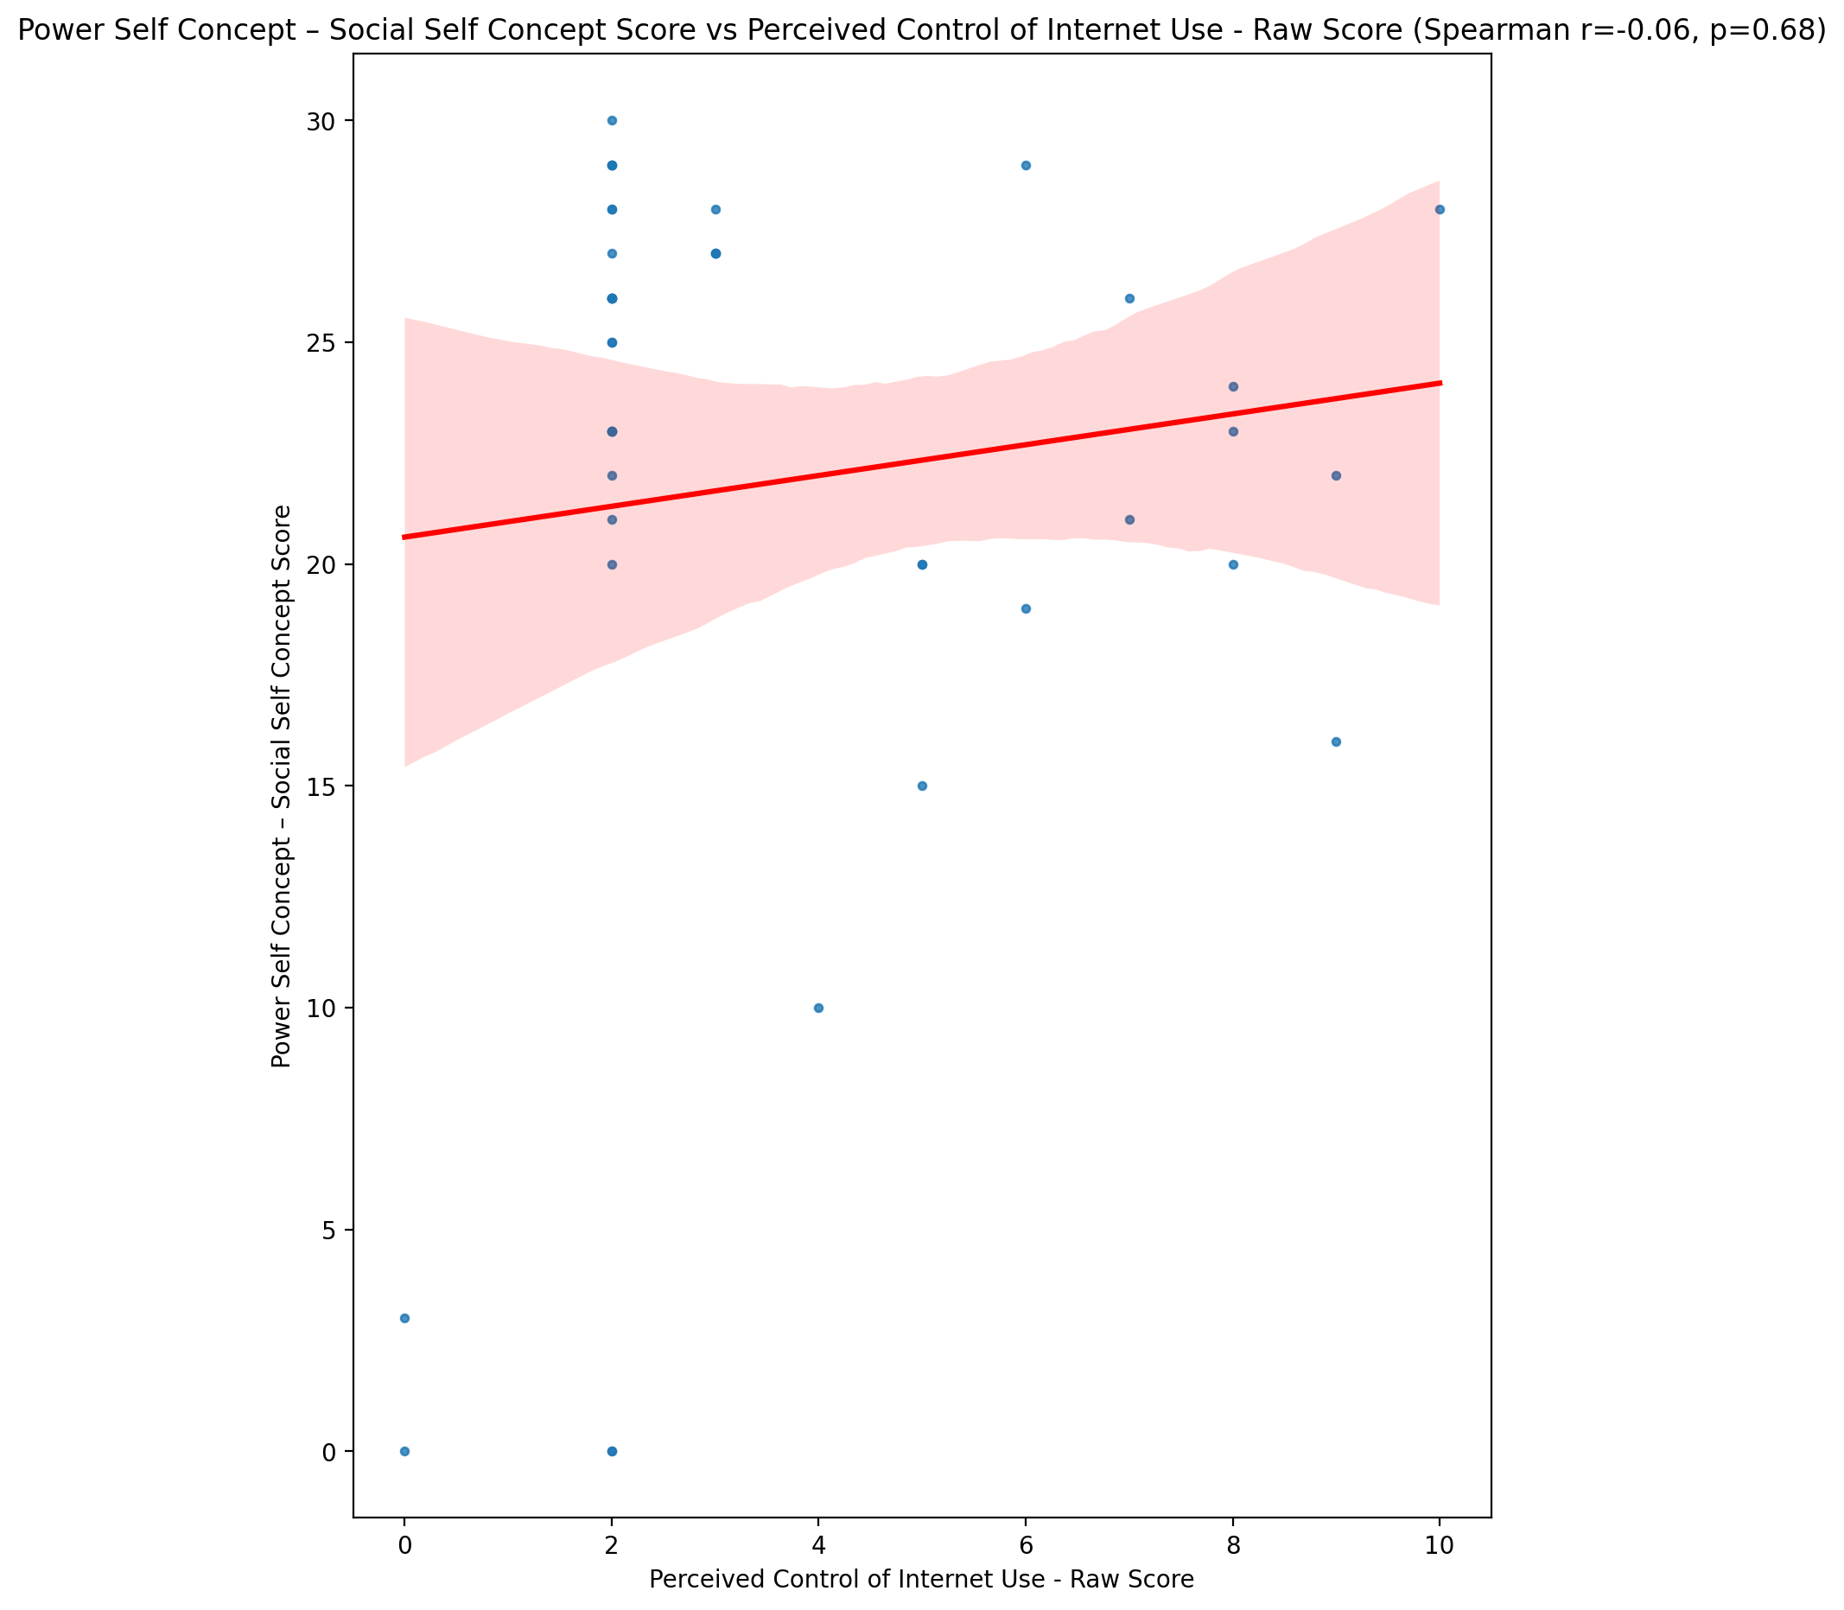

## Social Self Concept - Real Self Concept Score vs Perceived Control of Internet Use - Raw Score

Test: spearman; statistic: -0.1024043480477656; p-value: 0.5134700704801298;

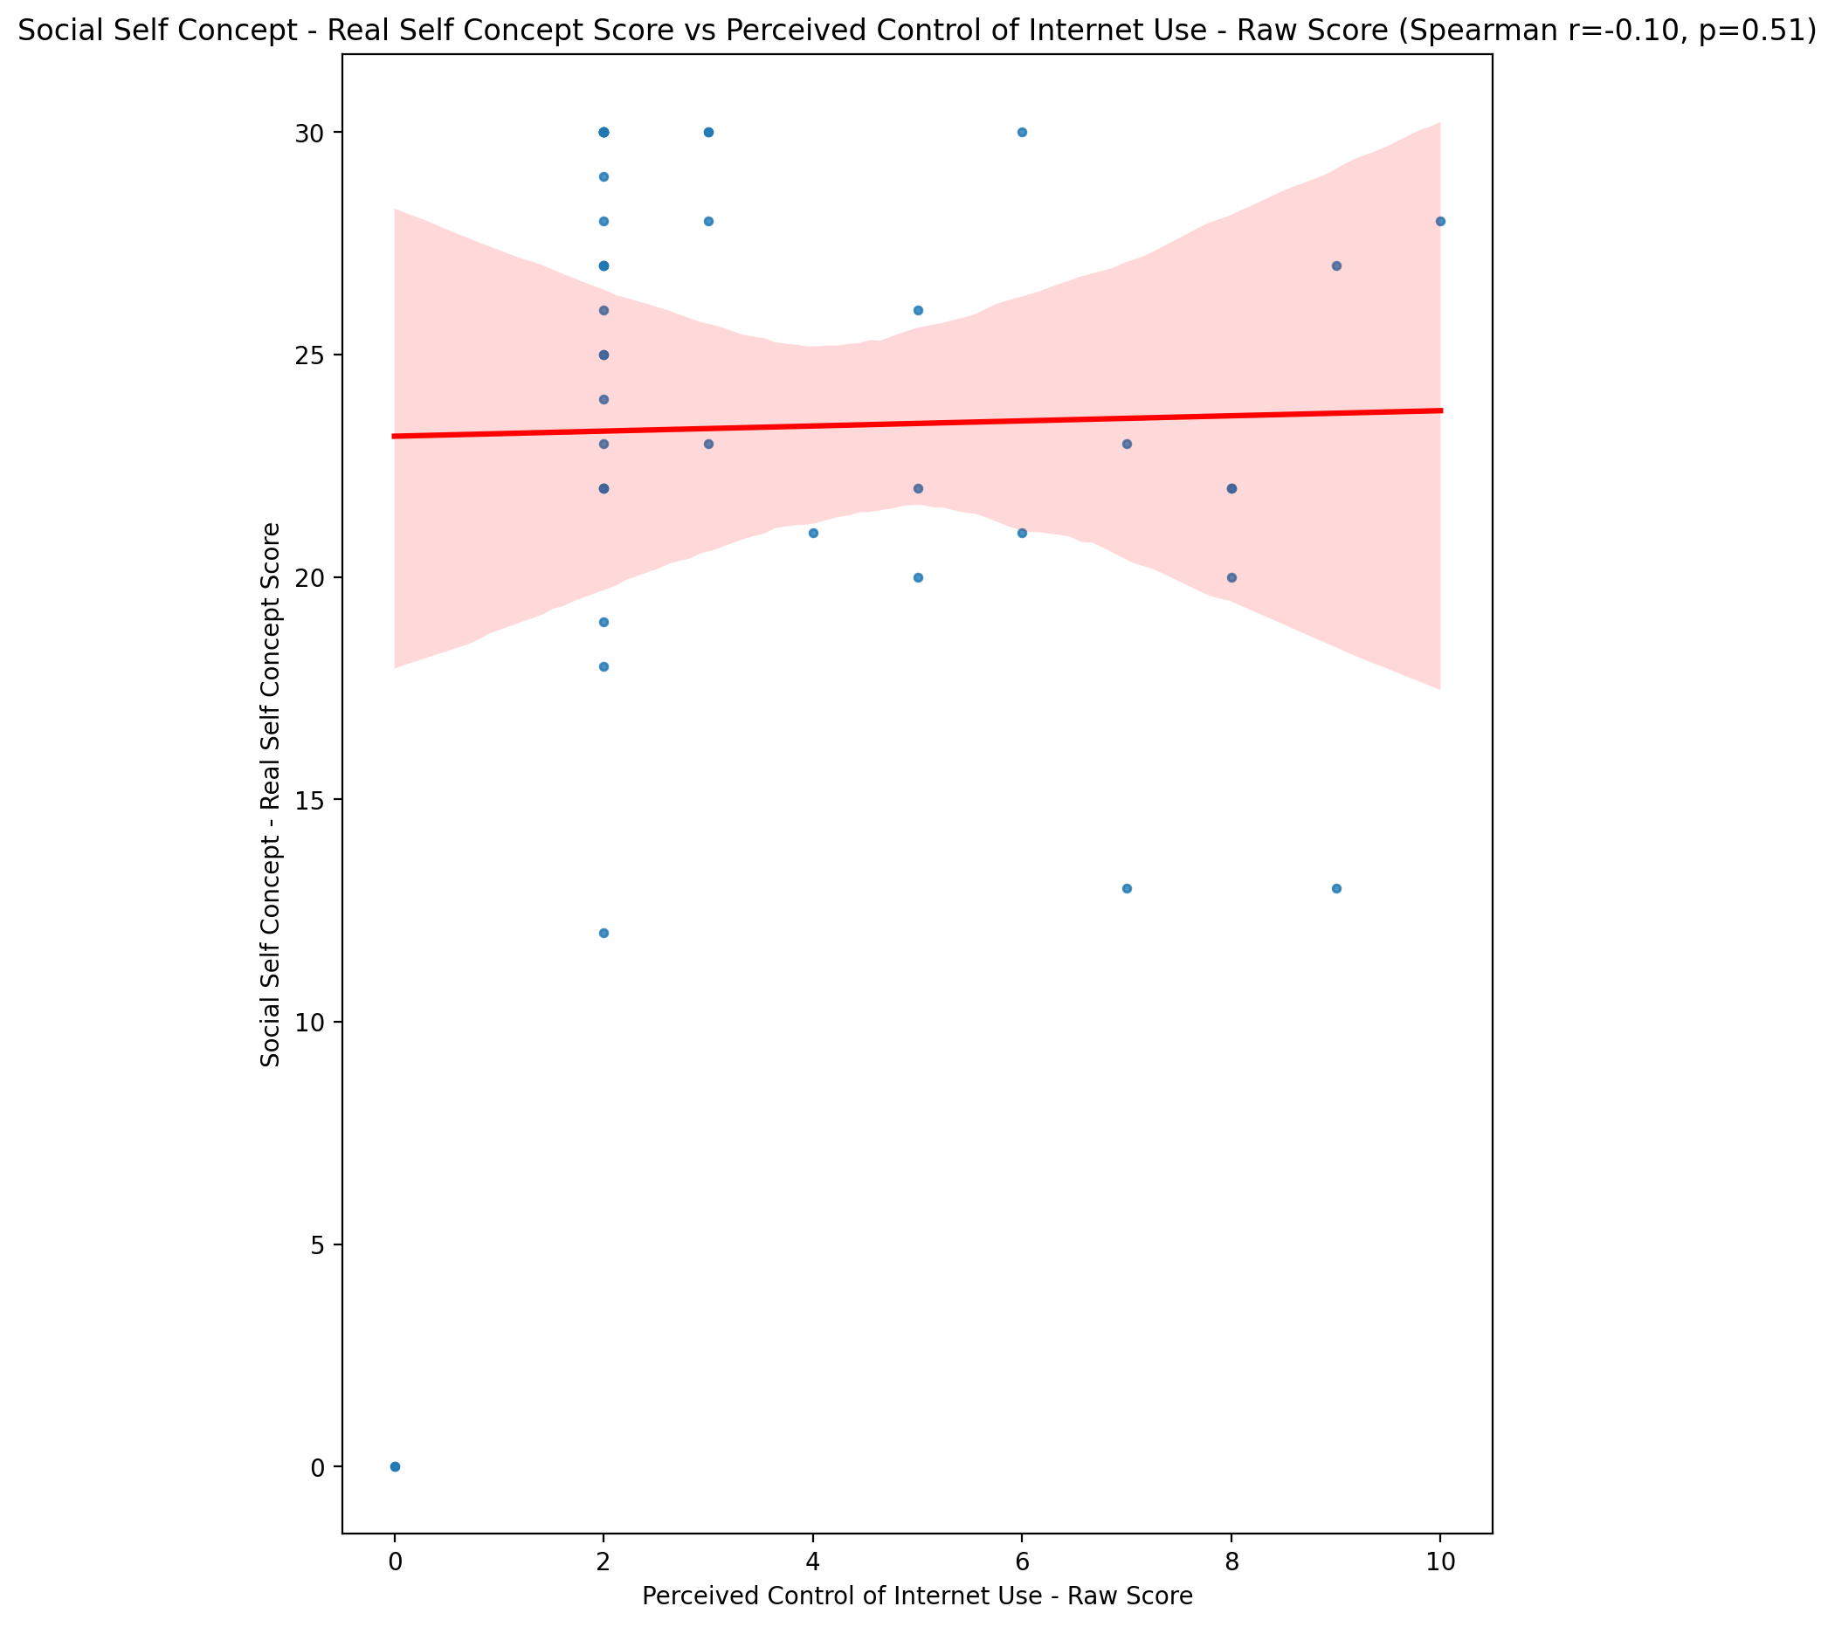

## Social Self Concept – Social Self Concept Score vs Perceived Control of Internet Use - Raw Score

Test: spearman; statistic: -0.00045445259317994786; p-value: 0.9976923384282754;

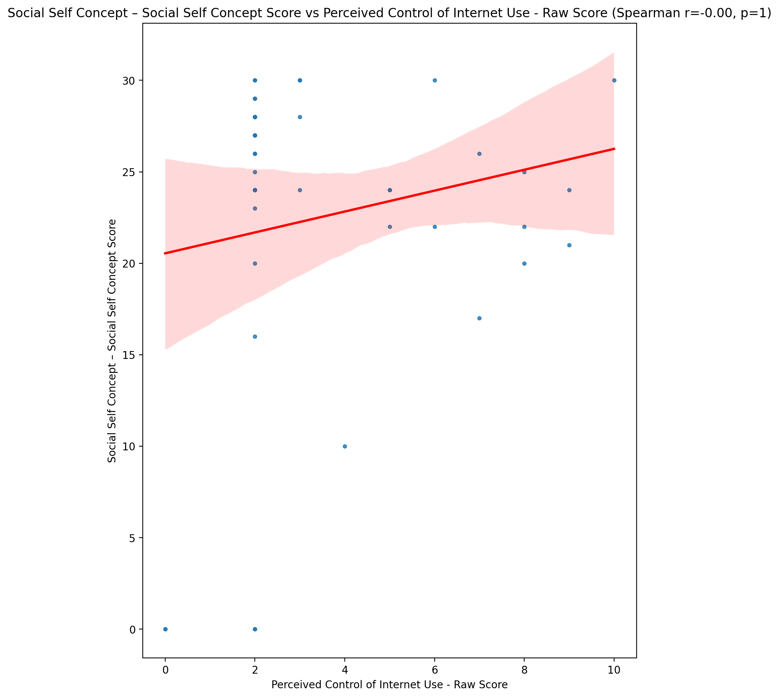

## Ability Self Concept - Real Self Concept Score vs Perceived Control of Internet Use - Raw Score

Test: spearman; statistic: -0.0844393569339897; p-value: 0.5903334776397295;

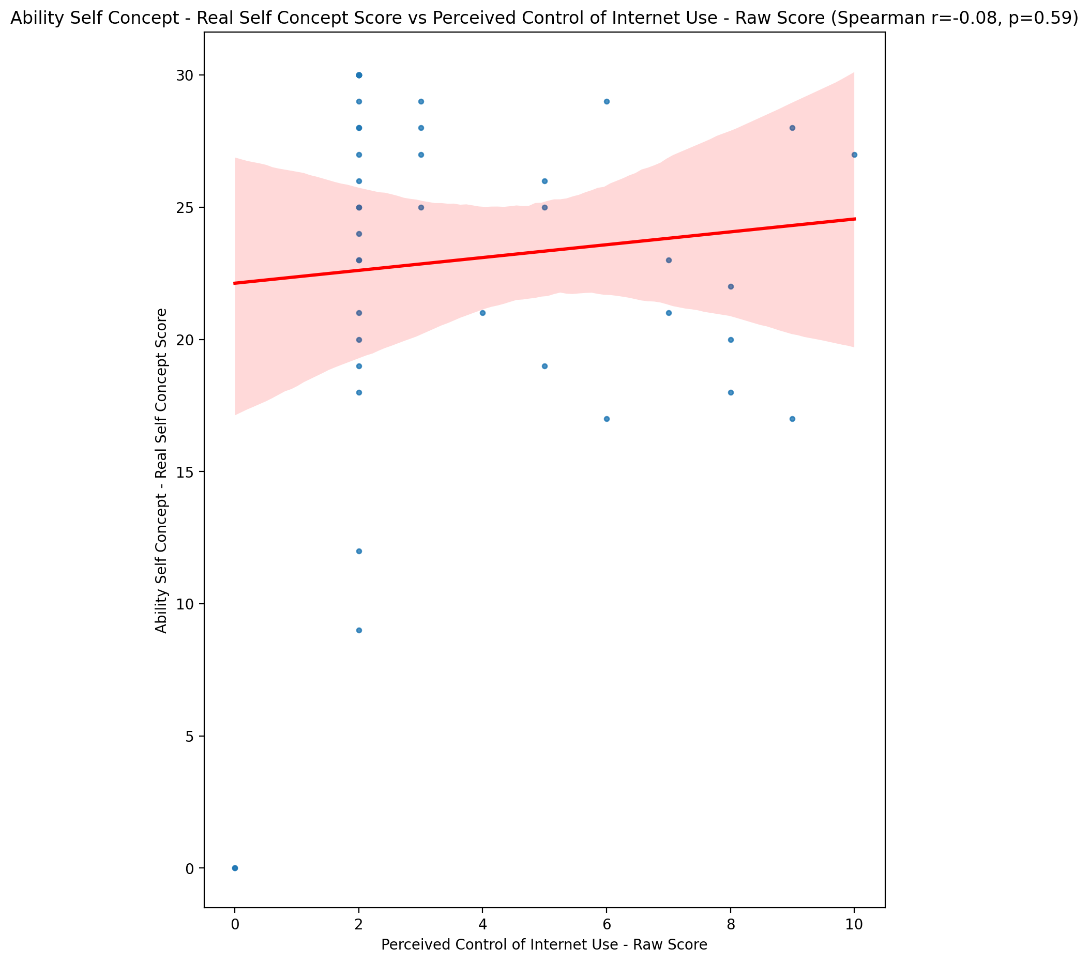

## Ability Self Concept - Ideal Self Concept Score vs Perceived Control of Internet Use - Raw Score

Test: spearman; statistic: 0.030966601433946556; p-value: 0.8437296269690043;

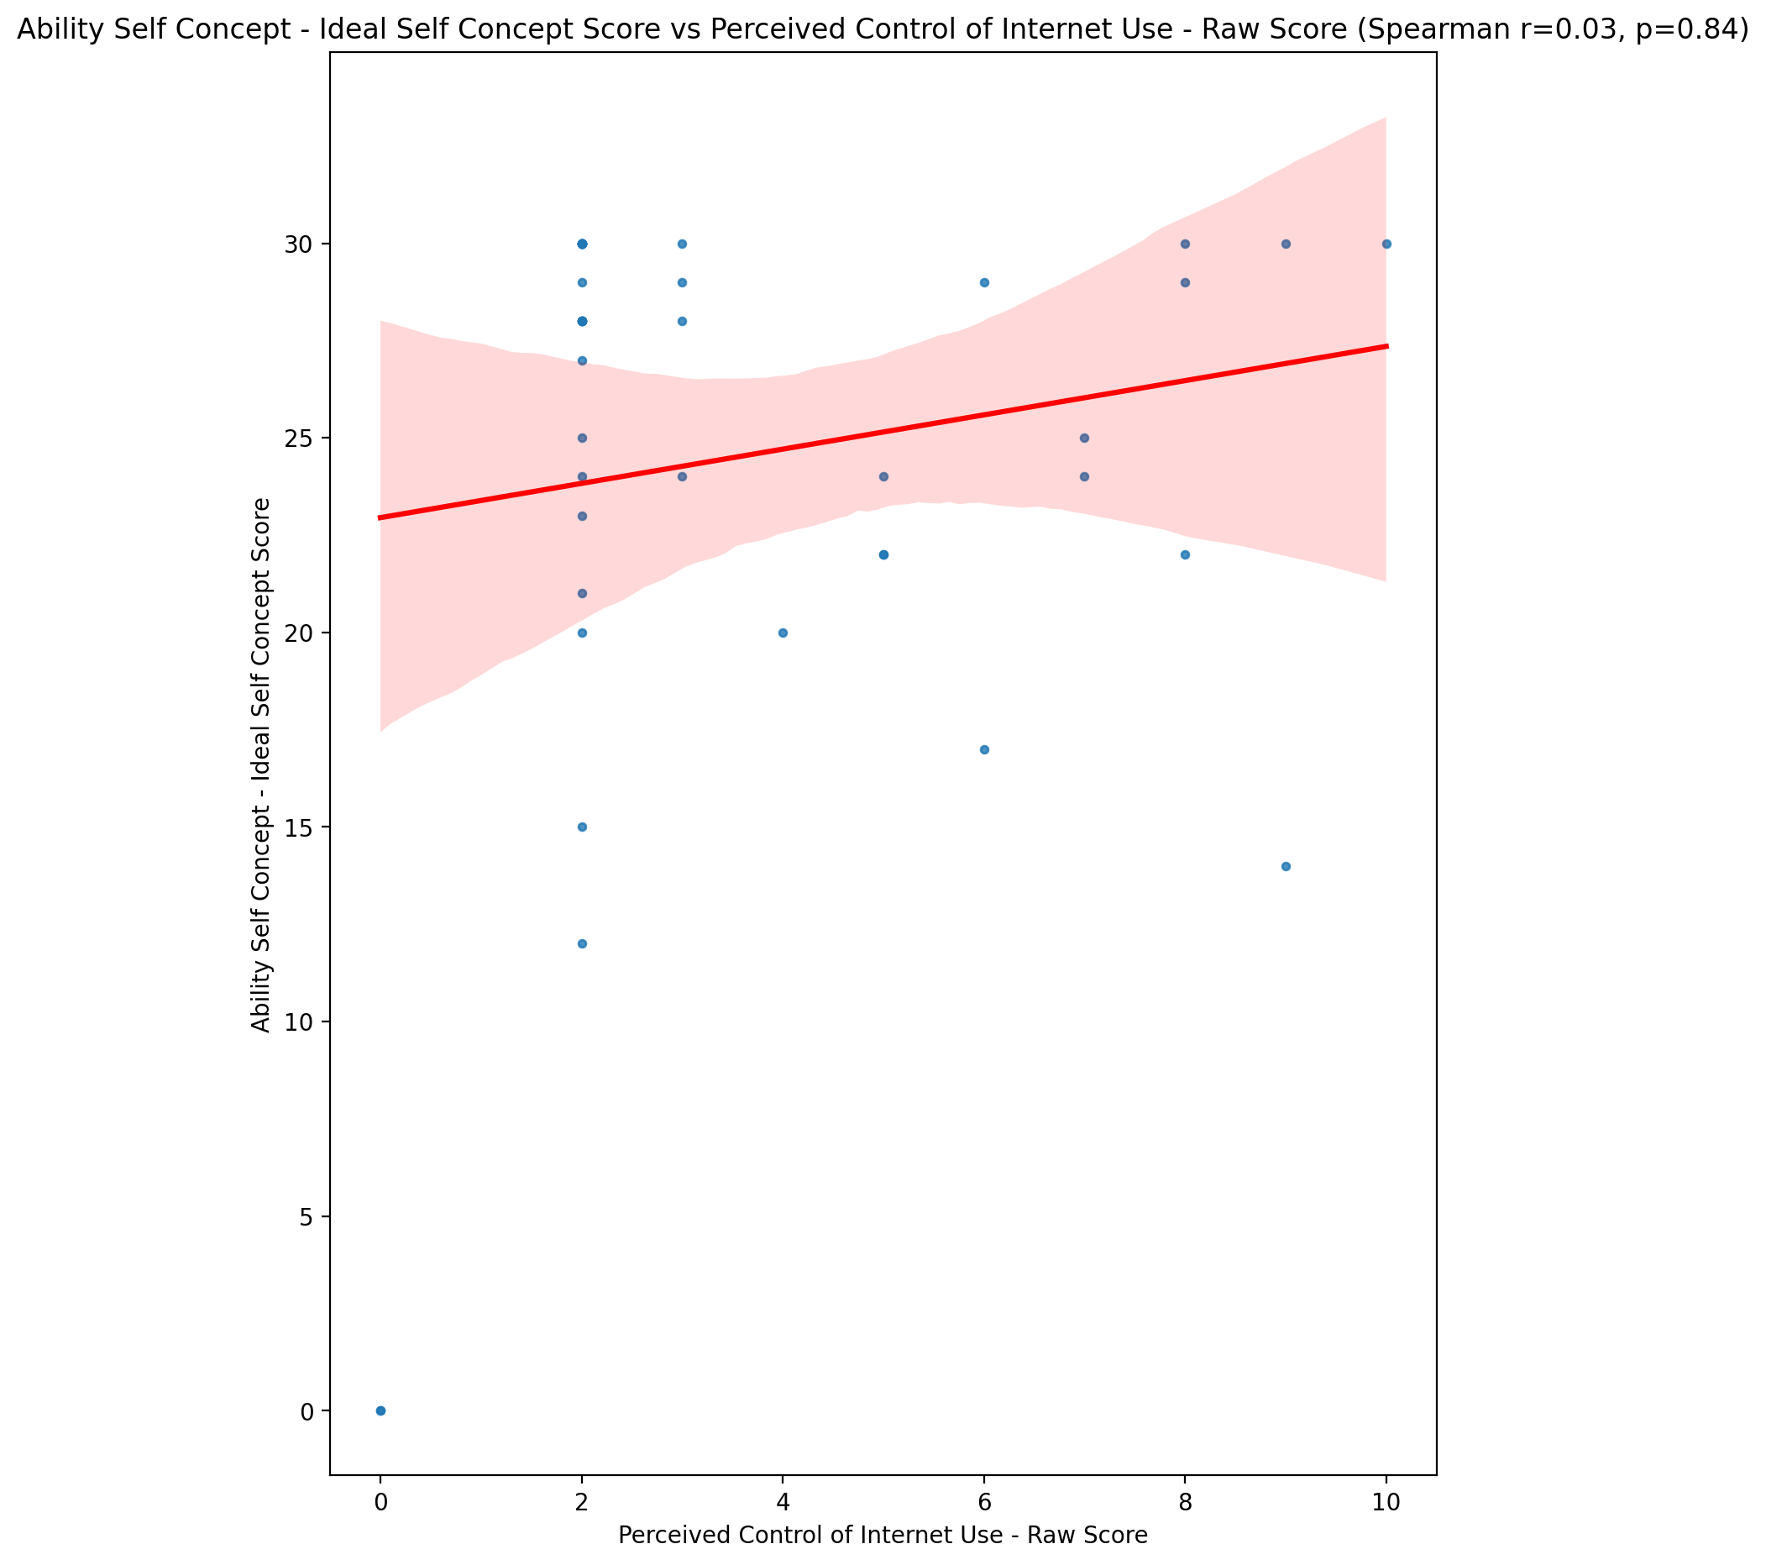

## Ability Self Concept – Social Self Concept Score vs Perceived Control of Internet Use - Raw Score

Test: spearman; statistic: -0.012605476492196576; p-value: 0.9360567081443997;

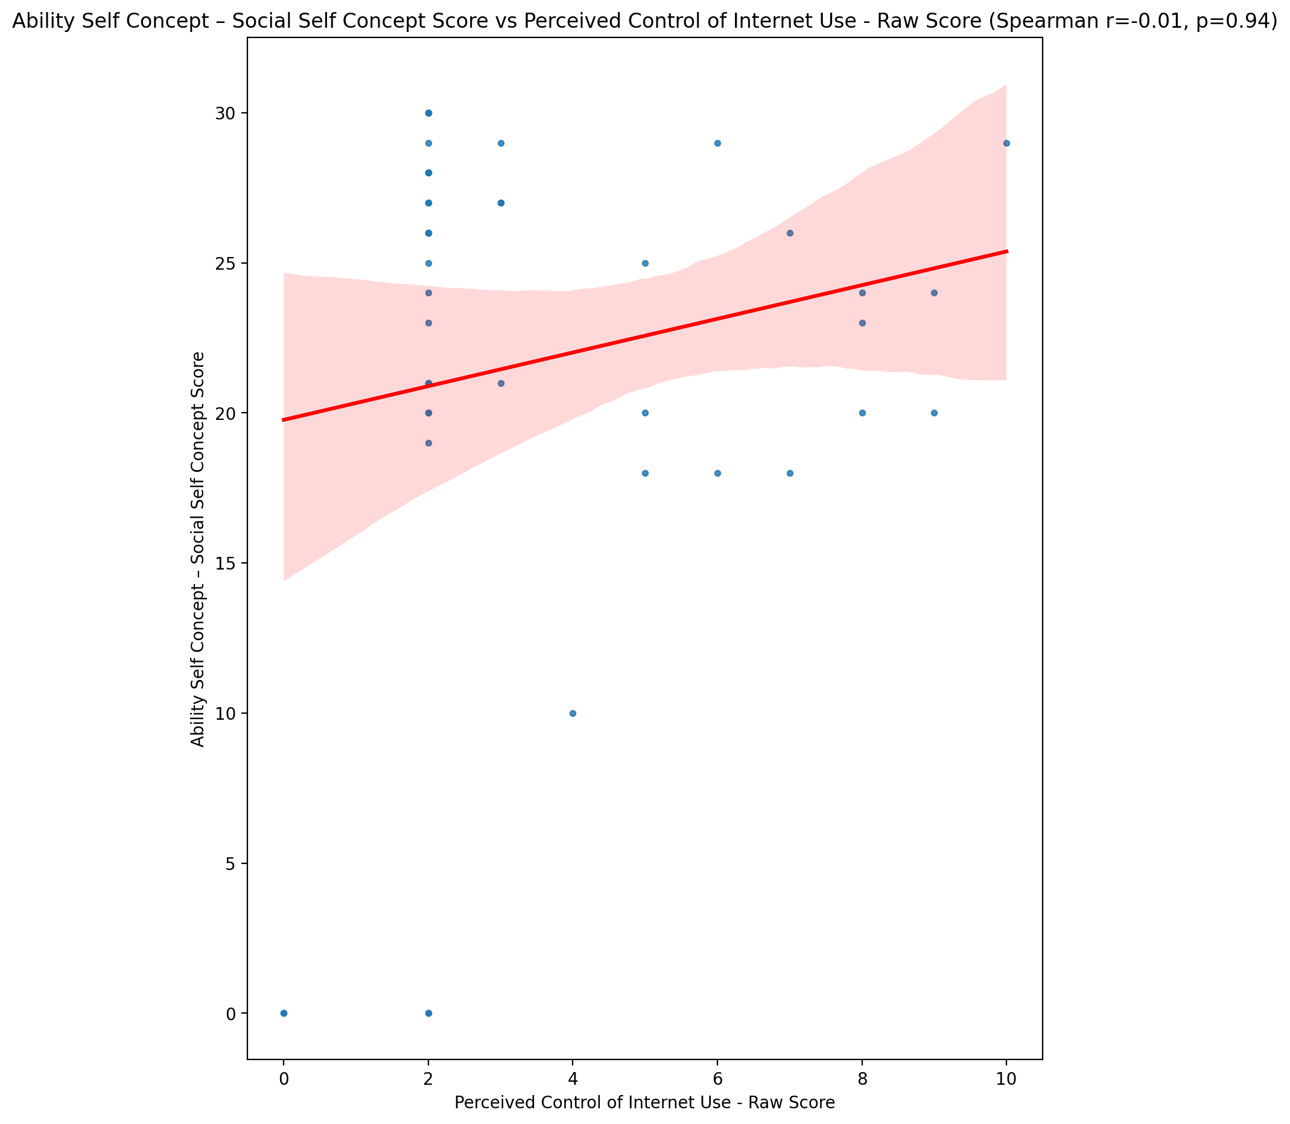

## Physical Self Concept - Real Self Concept Score vs Perceived Control of Internet Use - Raw Score

Test: spearman; statistic: -0.13550392982183748; p-value: 0.38628110707530405;

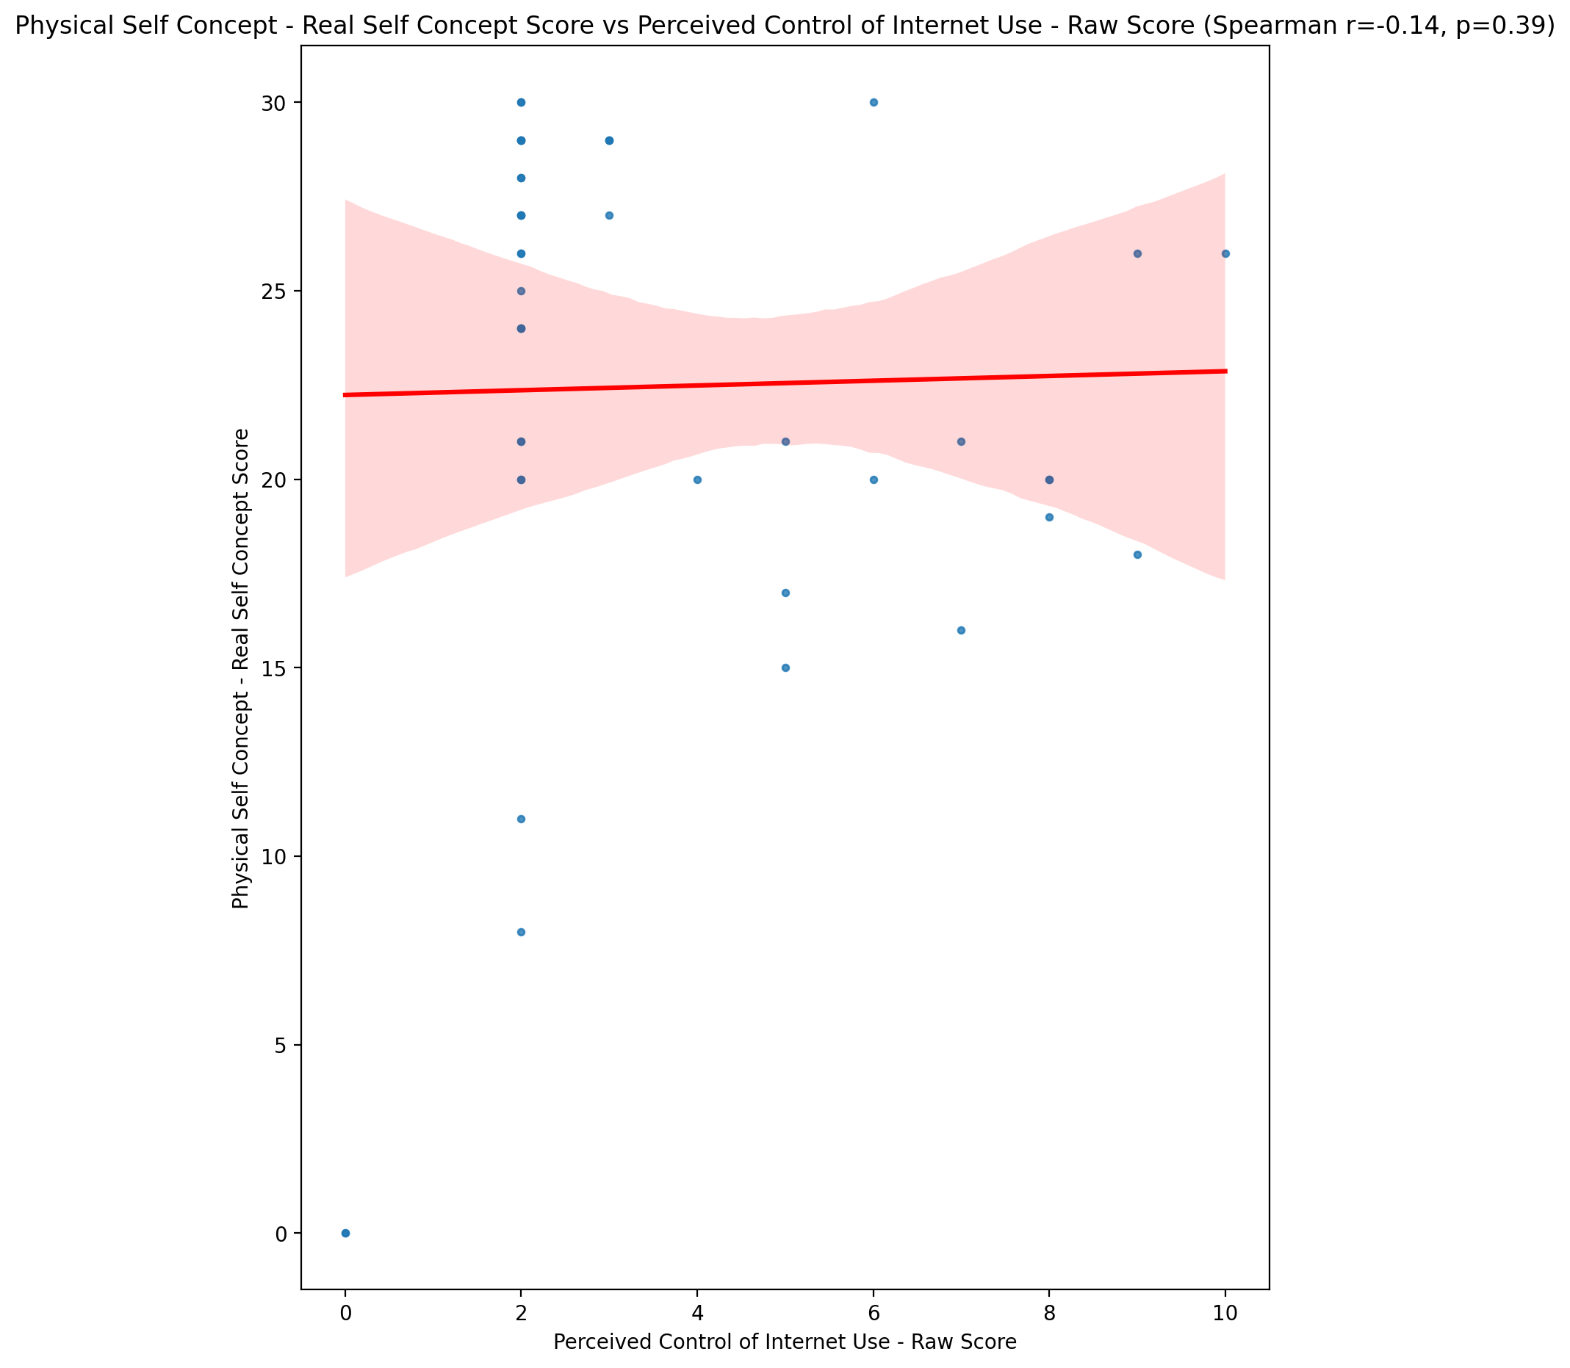

## Physical Self Concept – Ideal Self Concept Score vs Perceived Control of Internet Use - Raw Score

Test: spearman; statistic: 0.04076914172694024; p-value: 0.7951945186446454;

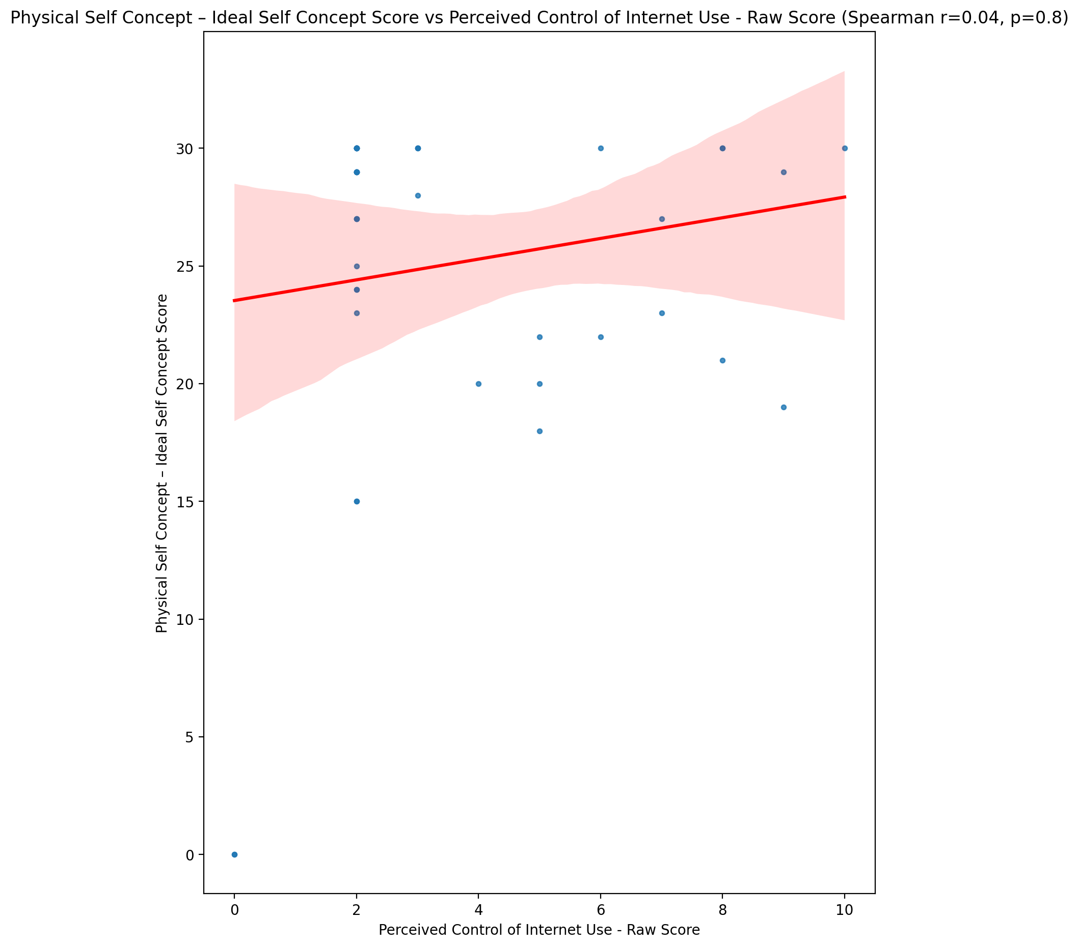

## Physical Self Concept – Social Self Concept Score vs Perceived Control of Internet Use - Raw Score

Test: spearman; statistic: 0.0920578551687013; p-value: 0.5571201013919023;

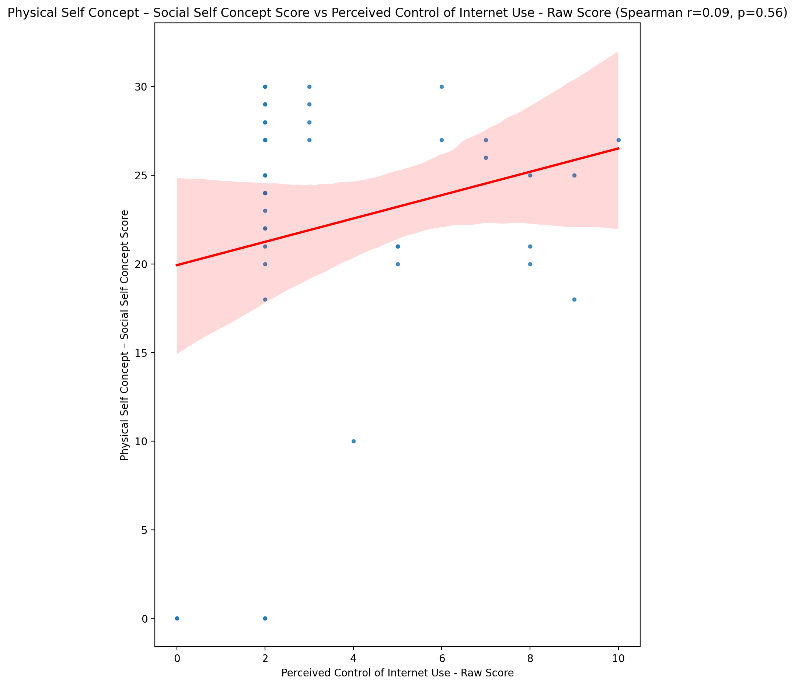

## Psychological Self Concept - Real Self Concept Score vs Perceived Control of Internet Use - Raw Score

Test: spearman; statistic: -0.08558471630671152; p-value: 0.5852845519307904;

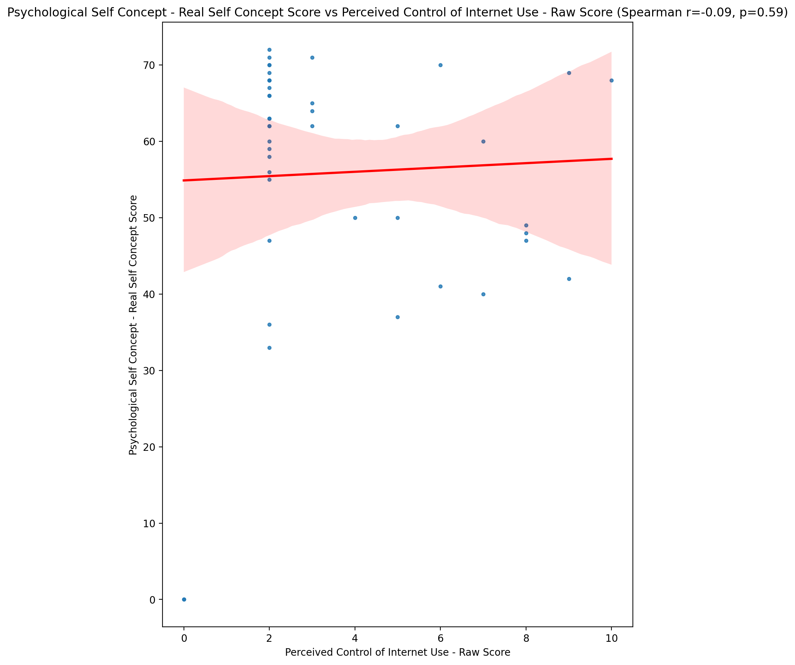

## Psychological Self Concept – Ideal Self Concept Score vs Perceived Control of Internet Use - Raw Score

Test: spearman; statistic: 0.04036434447149694; p-value: 0.7971850701044233;

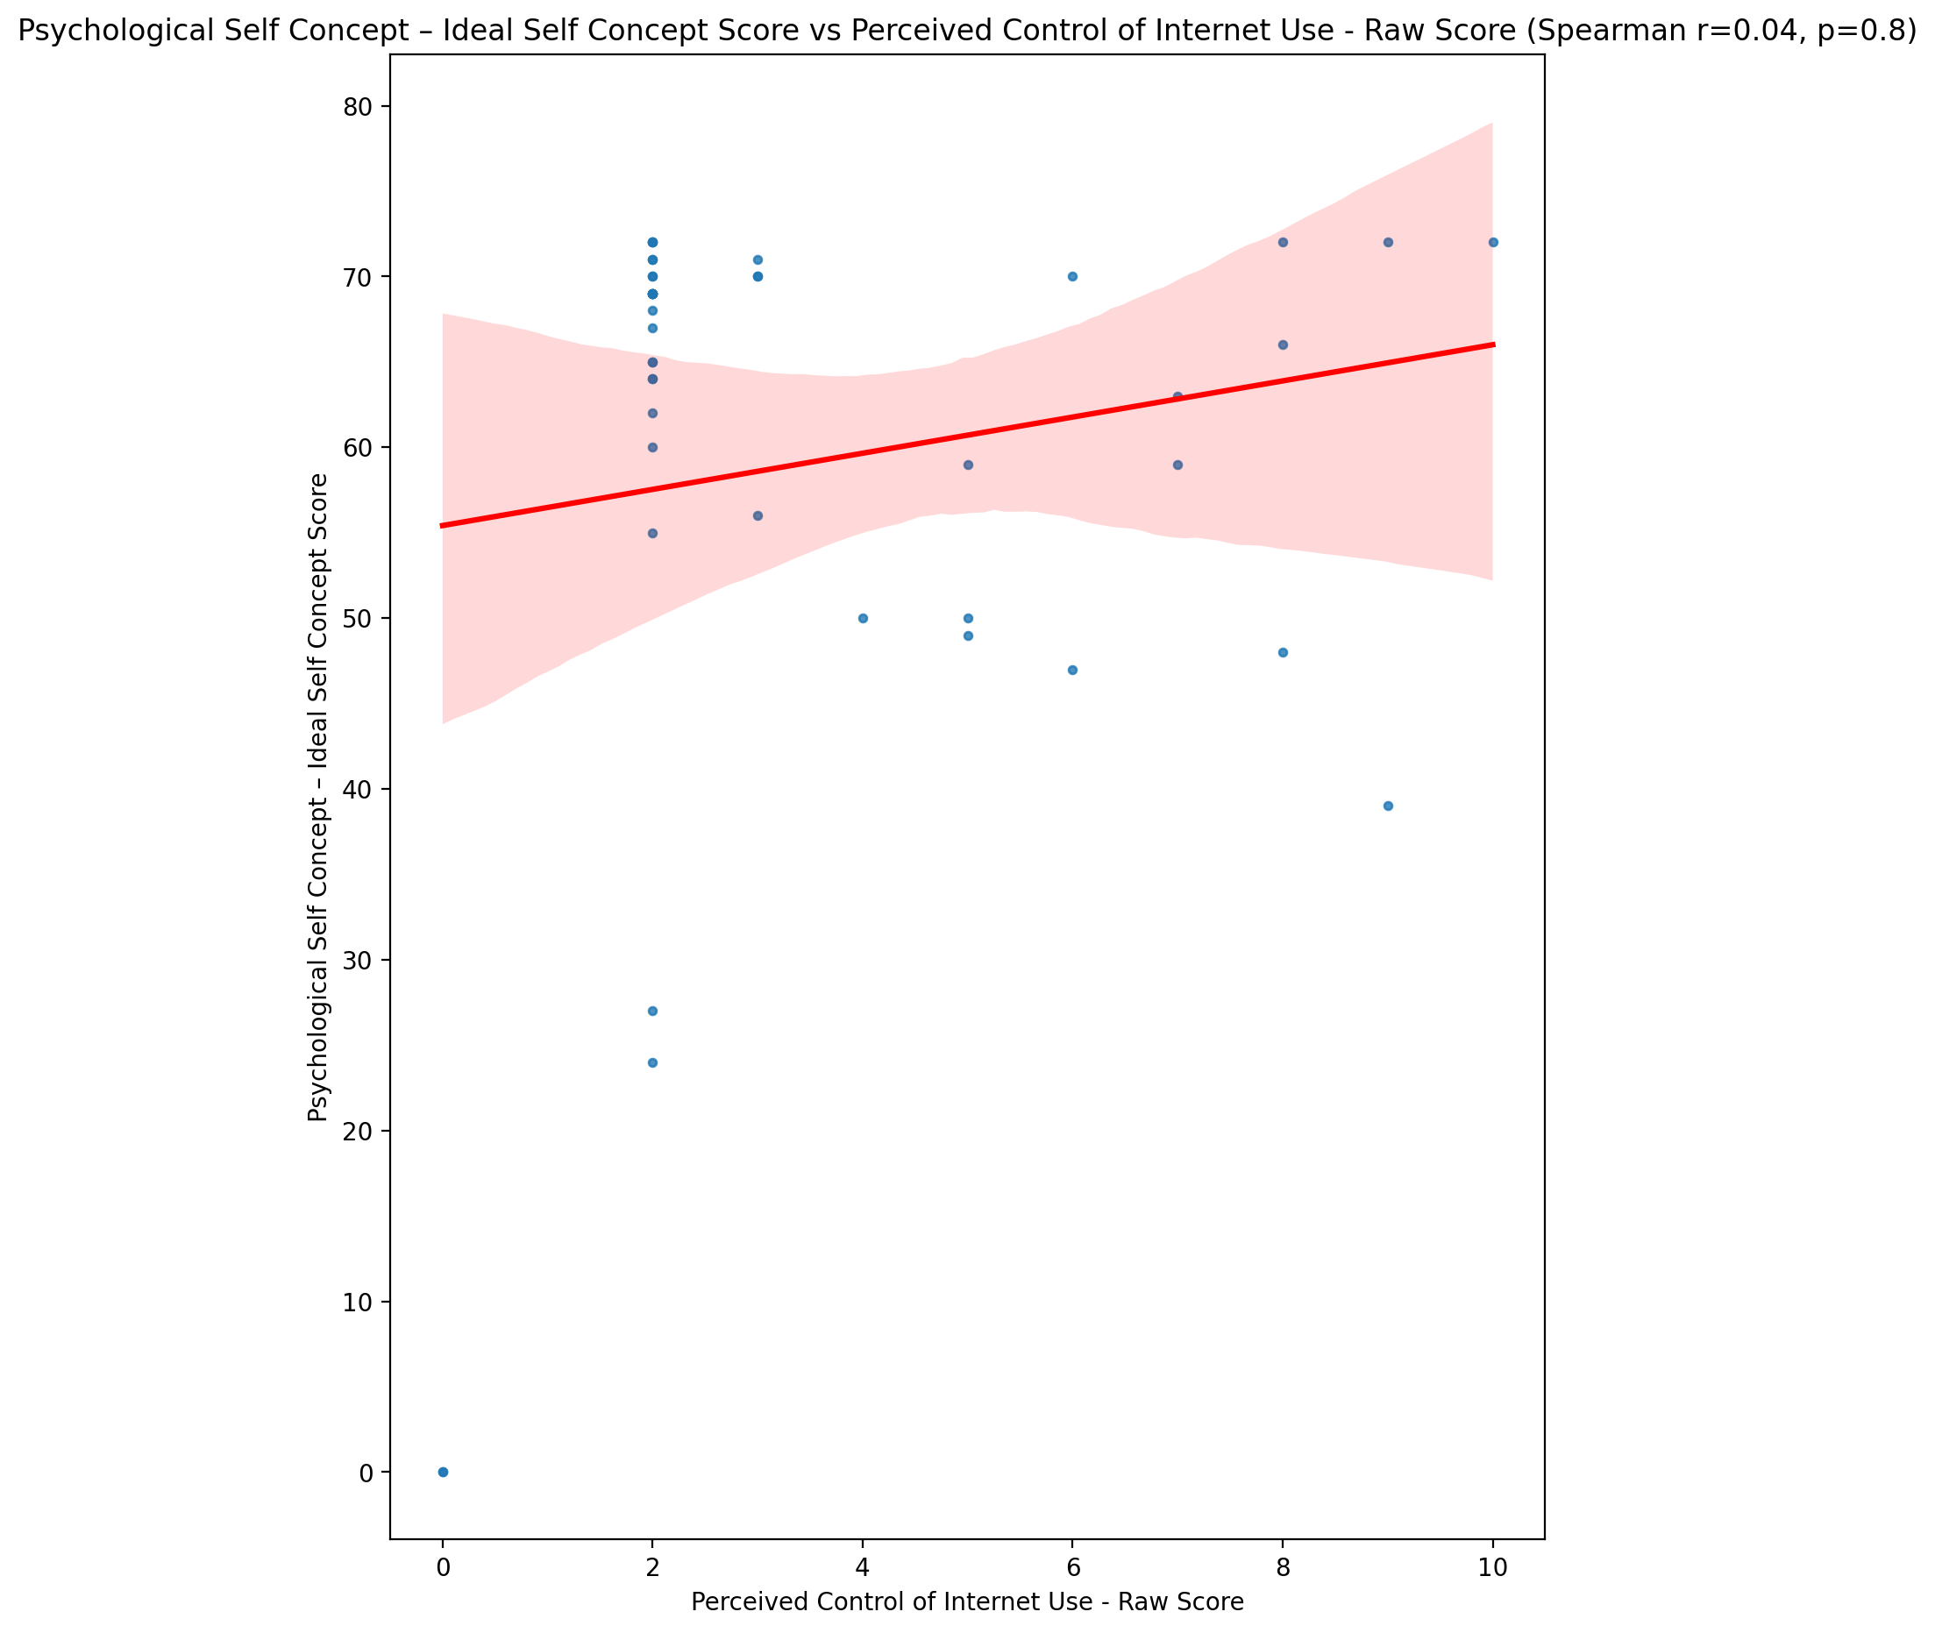

## Psychological Self Concept – Social Self Concept Score vs Perceived Control of Internet Use - Raw Score

Test: spearman; statistic: -0.05893306079518881; p-value: 0.7073712357287121;

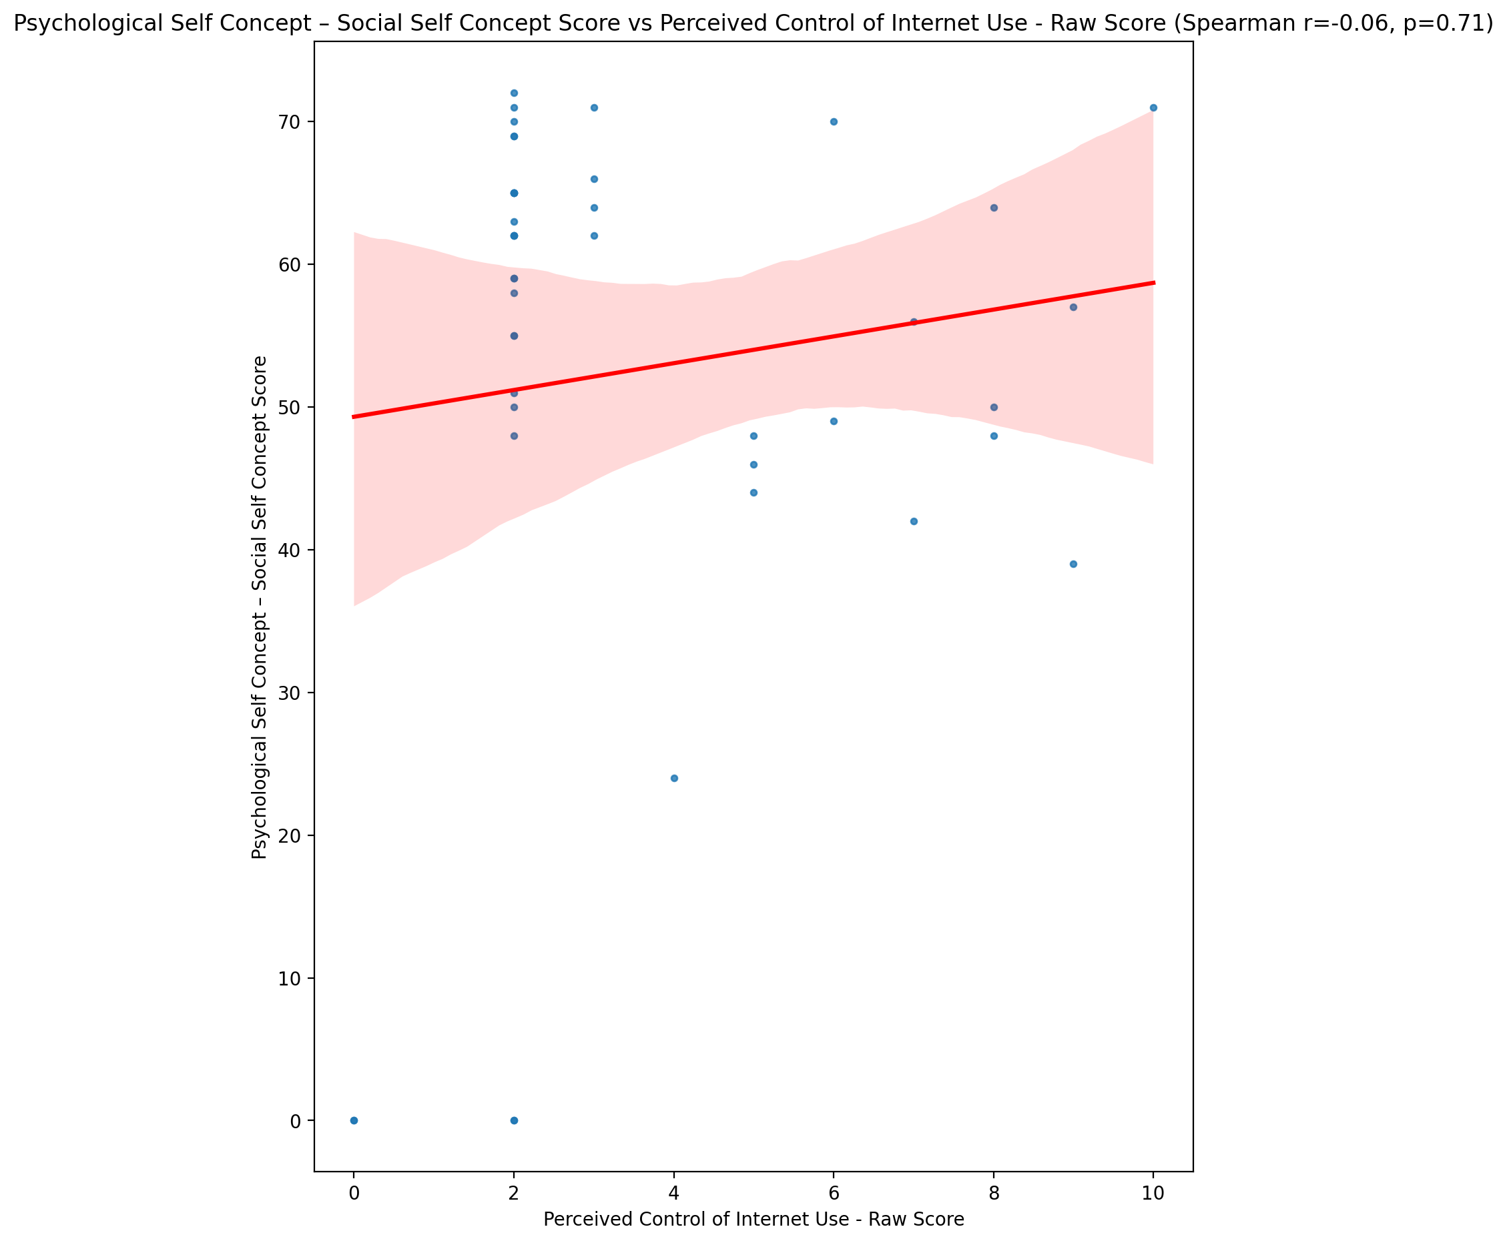

## Real Self Concept Total Score vs Perceived Control of Internet Use - Raw Score

Test: spearman; statistic: -0.12433673176811239; p-value: 0.4269656211985404;

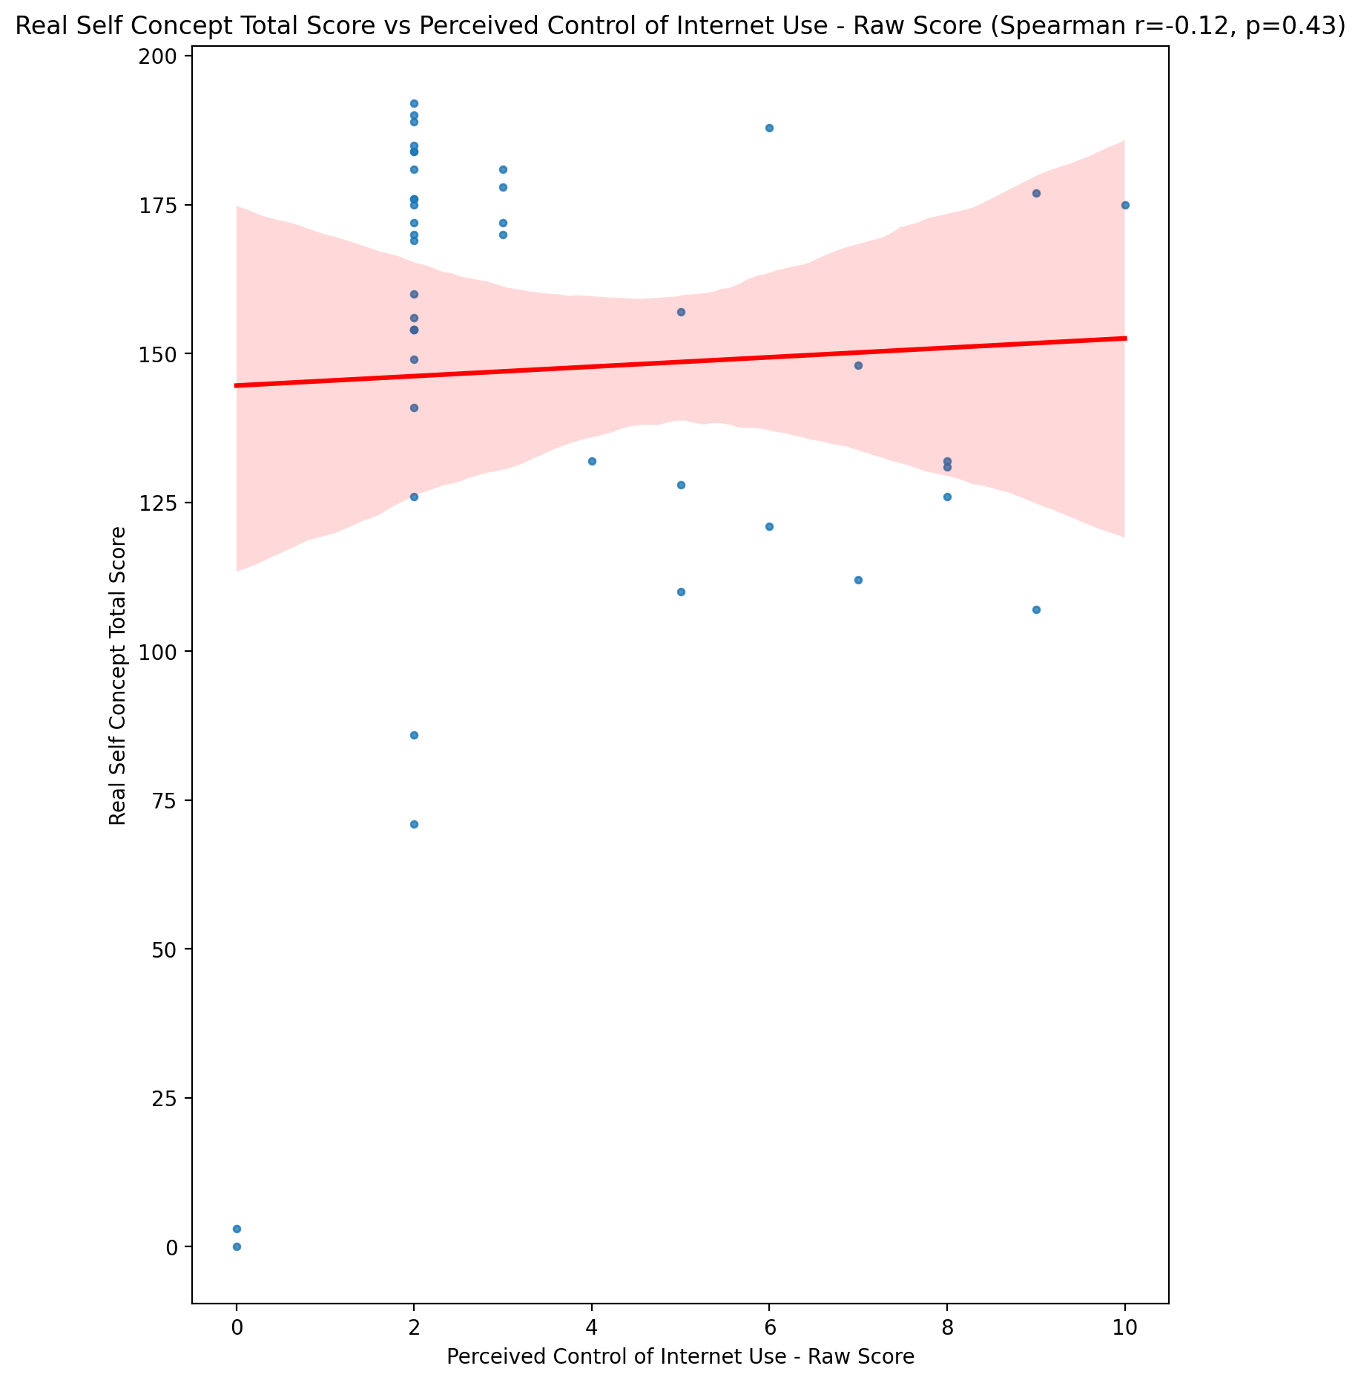

## Ideal Self Concept Total Score vs Perceived Control of Internet Use - Raw Score

Test: spearman; statistic: 0.006942350804761672; p-value: 0.964758480001638;

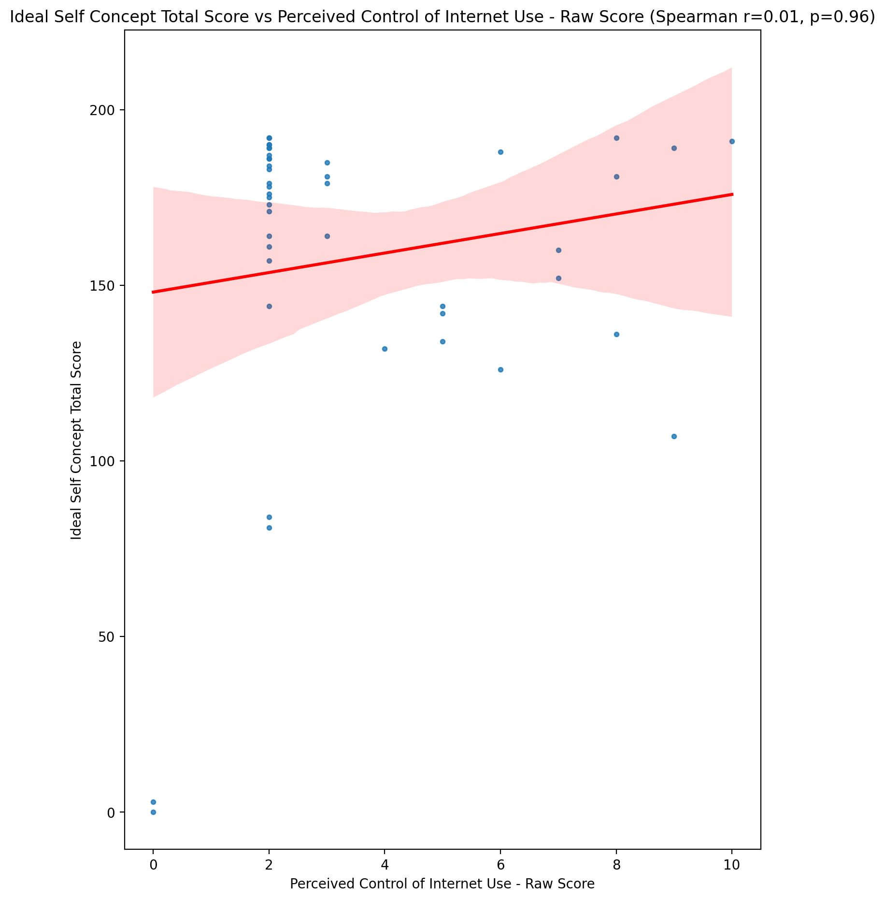

## Social Self Concept Total Score vs Perceived Control of Internet Use - Raw Score

Test: spearman; statistic: -0.03975996320489842; p-value: 0.8001594183648348;

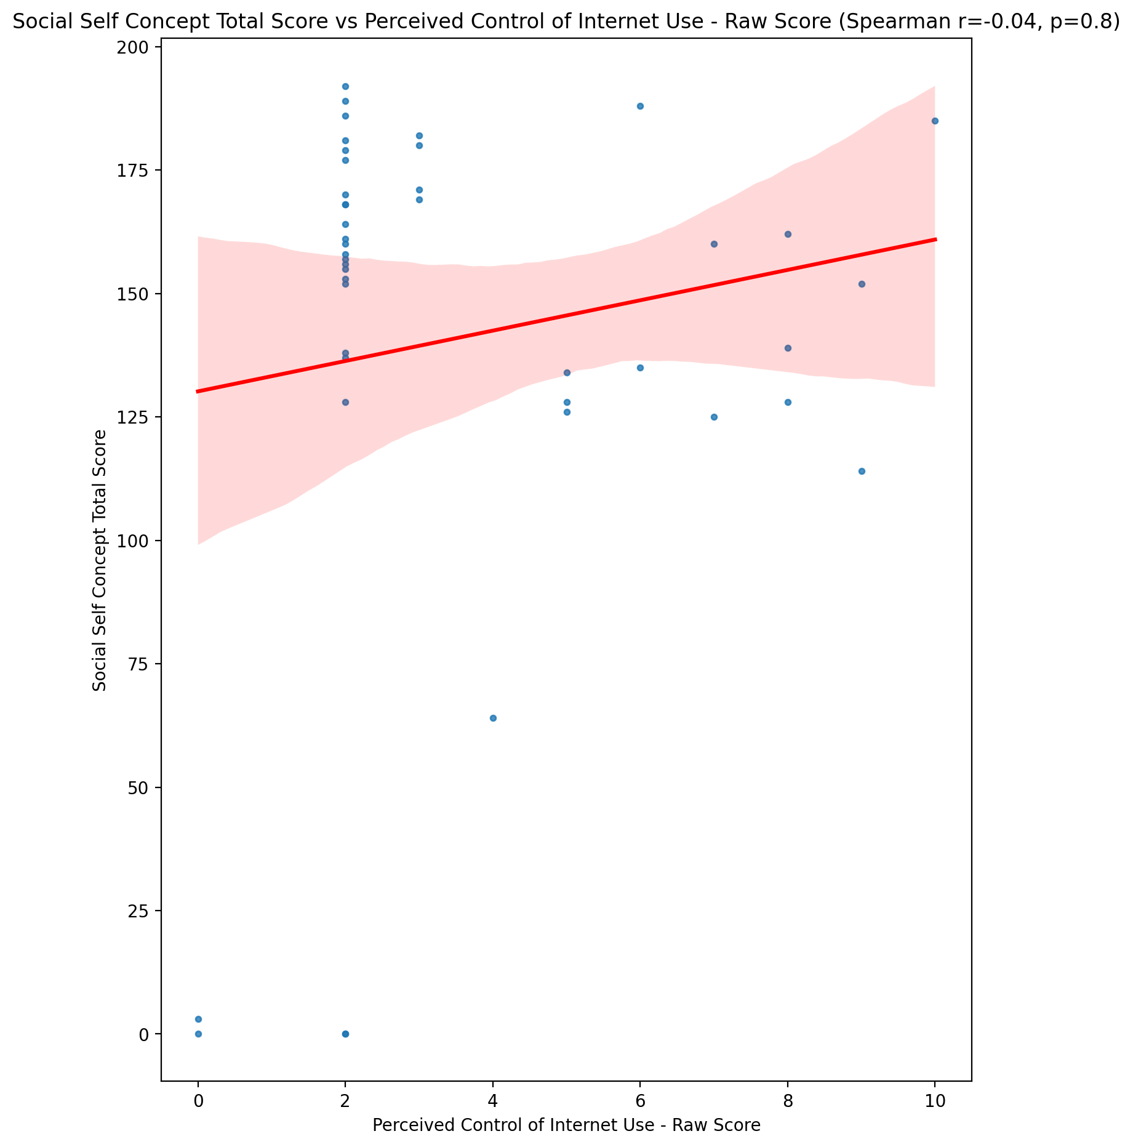

## Ideal Self Concept Total Category vs Perceived Control of Internet Use - Raw Score

Test: None; statistic: None; p-value: None; Test not run: unsupported type combination.



## Perceived Social Stress Score vs Perceived Control of Internet Use - Raw Score

Test: spearman; statistic: 0.2606289739996829; p-value: 0.09140912894875221;

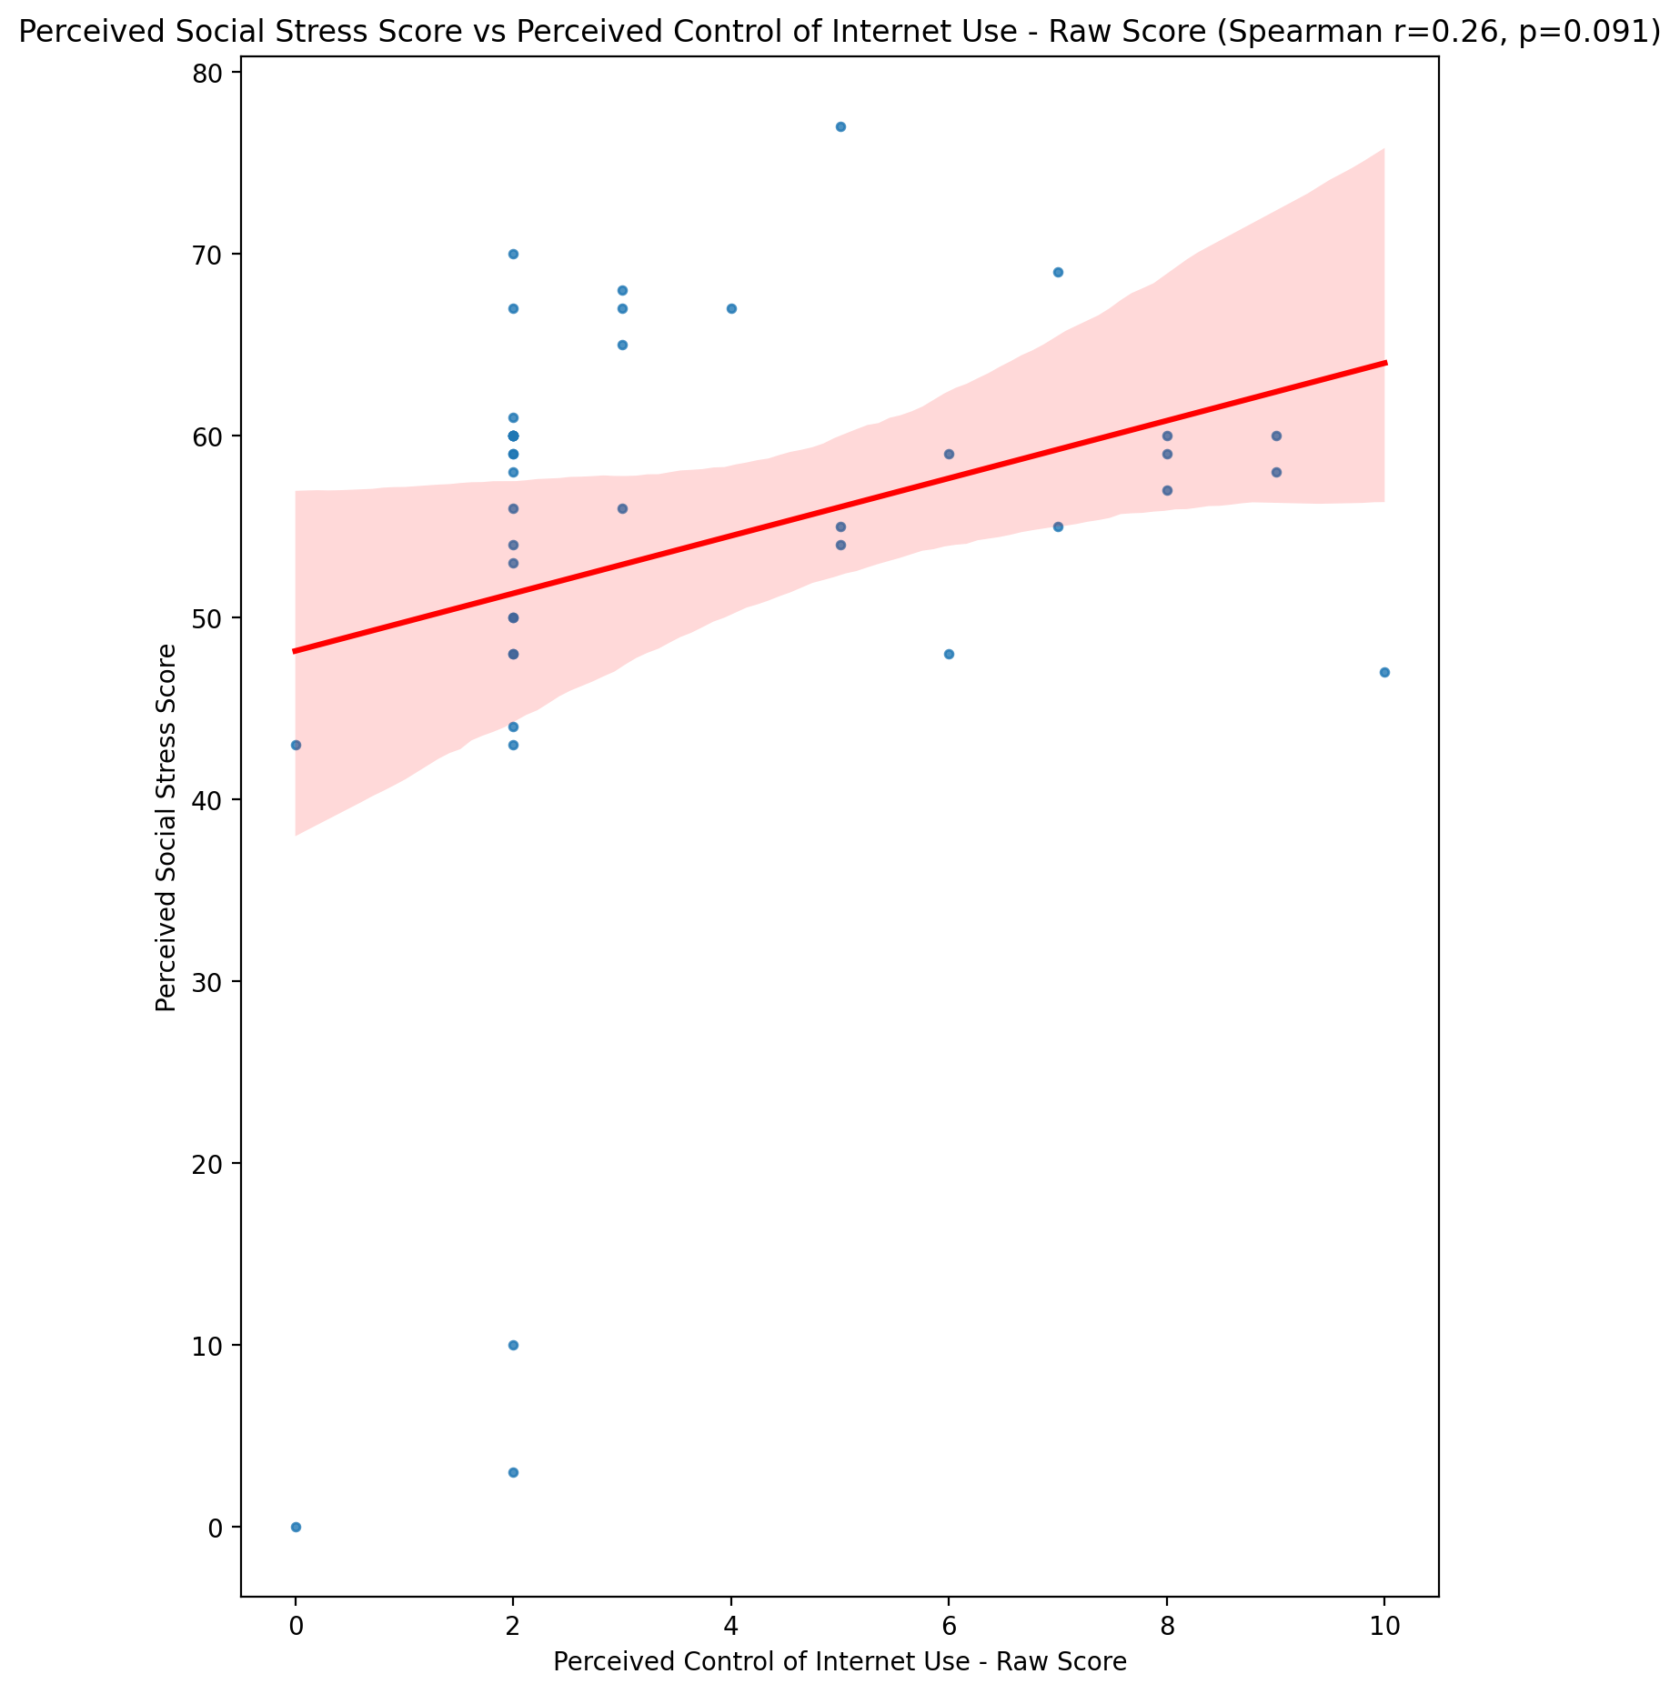

## Perceived Social Stress Category vs Perceived Control of Internet Use - Raw Score

Test: None; statistic: None; p-value: None; Test not run: unsupported type combination.



## Emotional Support - Raw Score vs Functional Impairment - Weighted Score

Test: spearman; statistic: -0.17245800872346576; p-value: 0.2687827867971684;

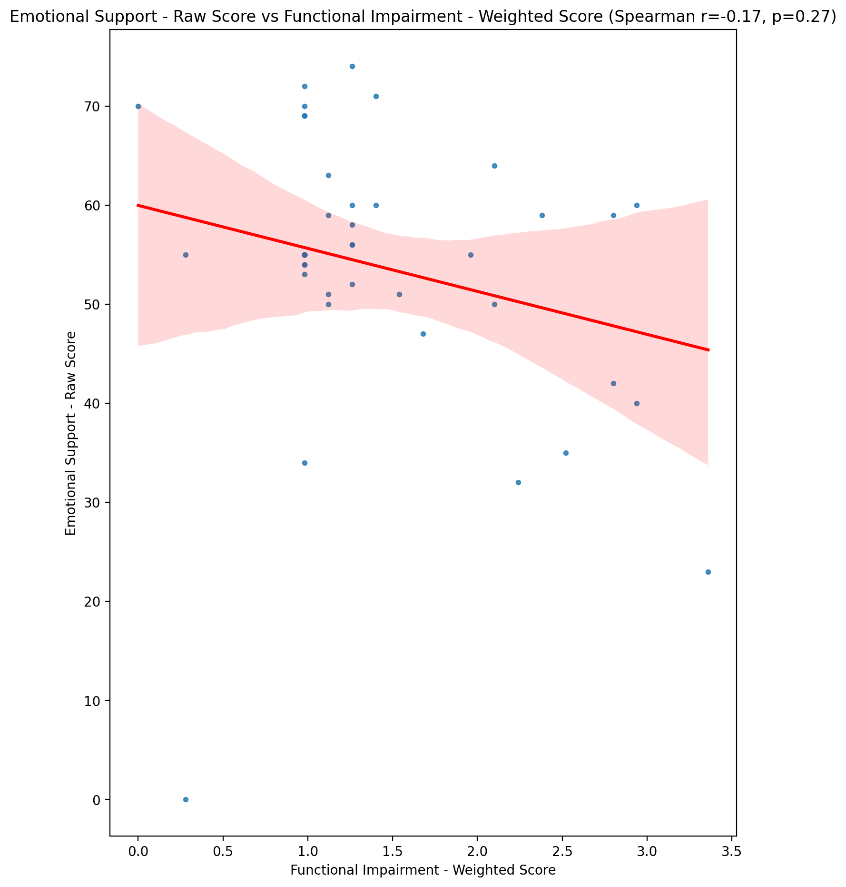

## Informational Support - Raw Score vs Functional Impairment - Weighted Score

Test: spearman; statistic: -0.3116314824699502; p-value: 0.041925812303801865;

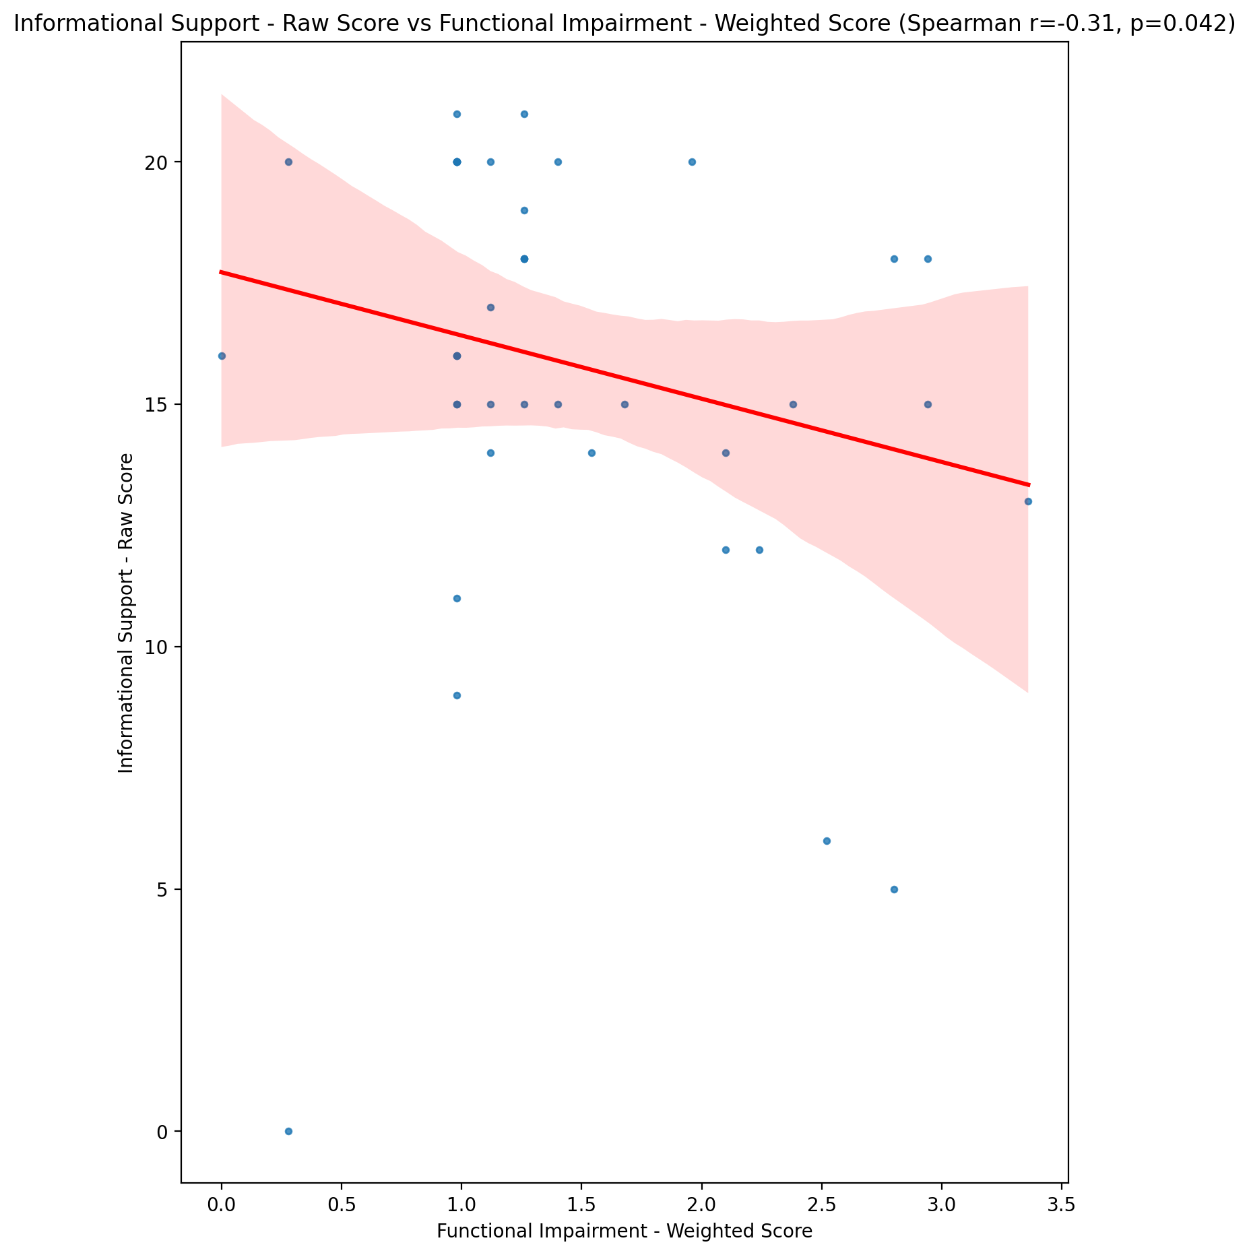

## Instrumental Support - Raw Score vs Functional Impairment - Weighted Score

Test: spearman; statistic: -0.20771986577237836; p-value: 0.18135159644023977;

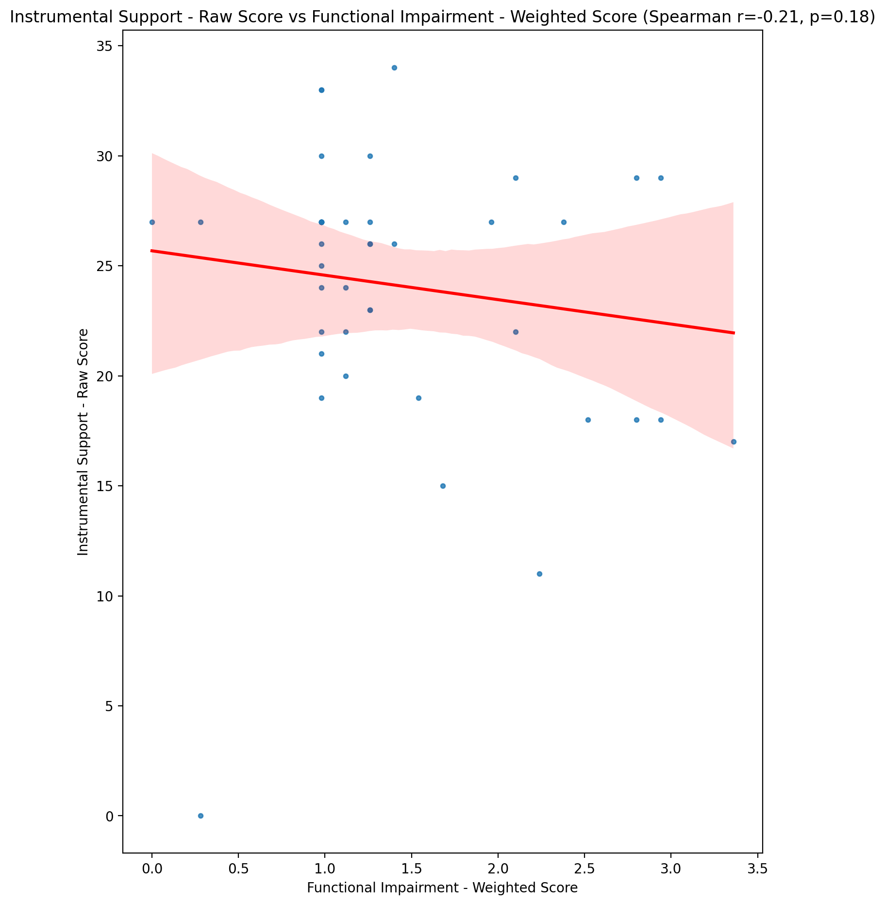

## Emotional Support - T Score vs Functional Impairment - Weighted Score

Test: spearman; statistic: -0.19859594066748693; p-value: 0.20171979643099933;

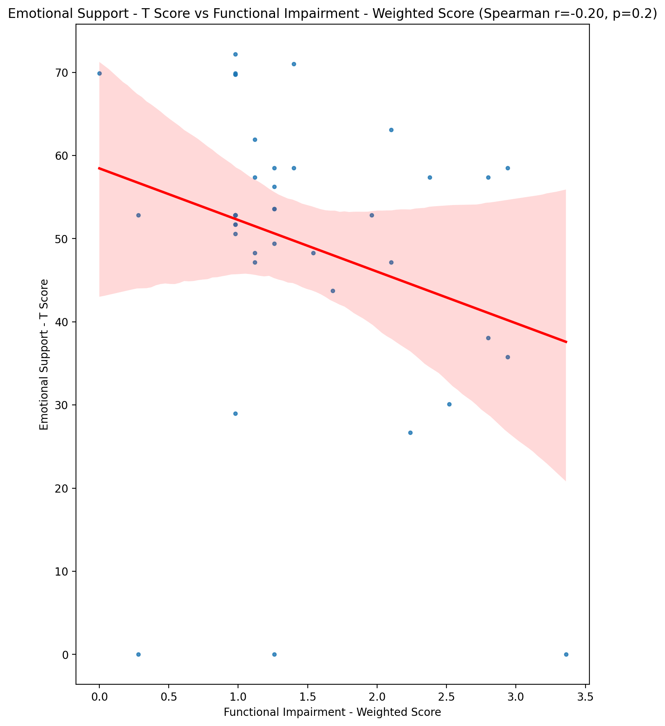

## Informational Support - T Score vs Functional Impairment - Weighted Score

Test: spearman; statistic: -0.3172413079716049; p-value: 0.0381841741256046;

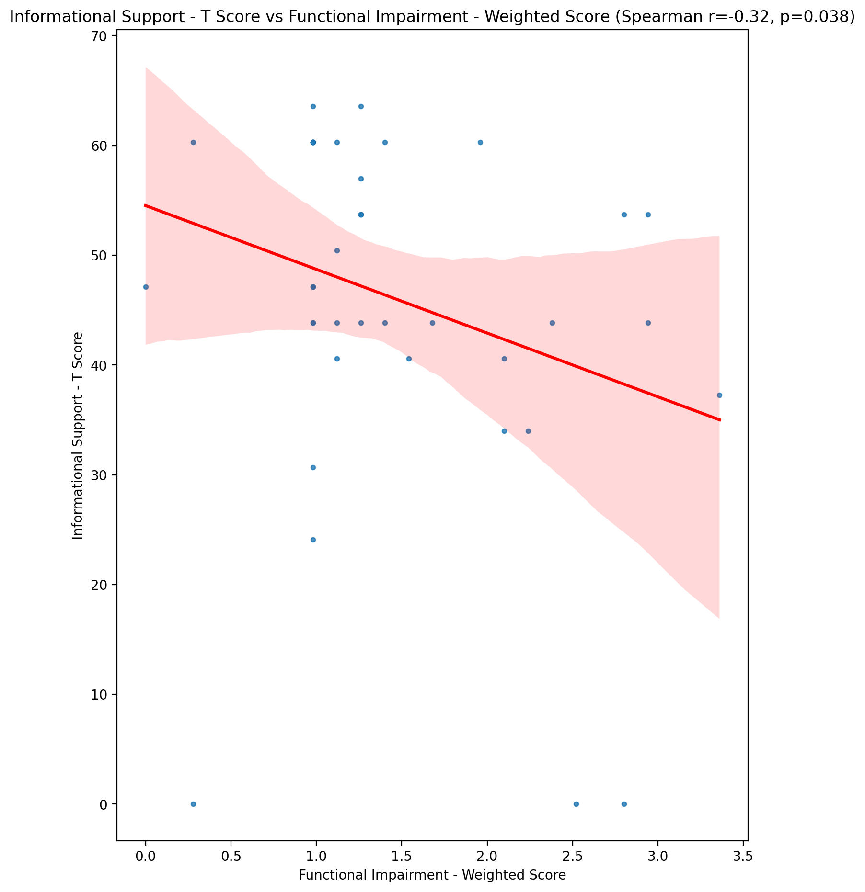

## Instrumental Support - T Score vs Functional Impairment - Weighted Score

Test: spearman; statistic: -0.21034894690283396; p-value: 0.17576536981943017;

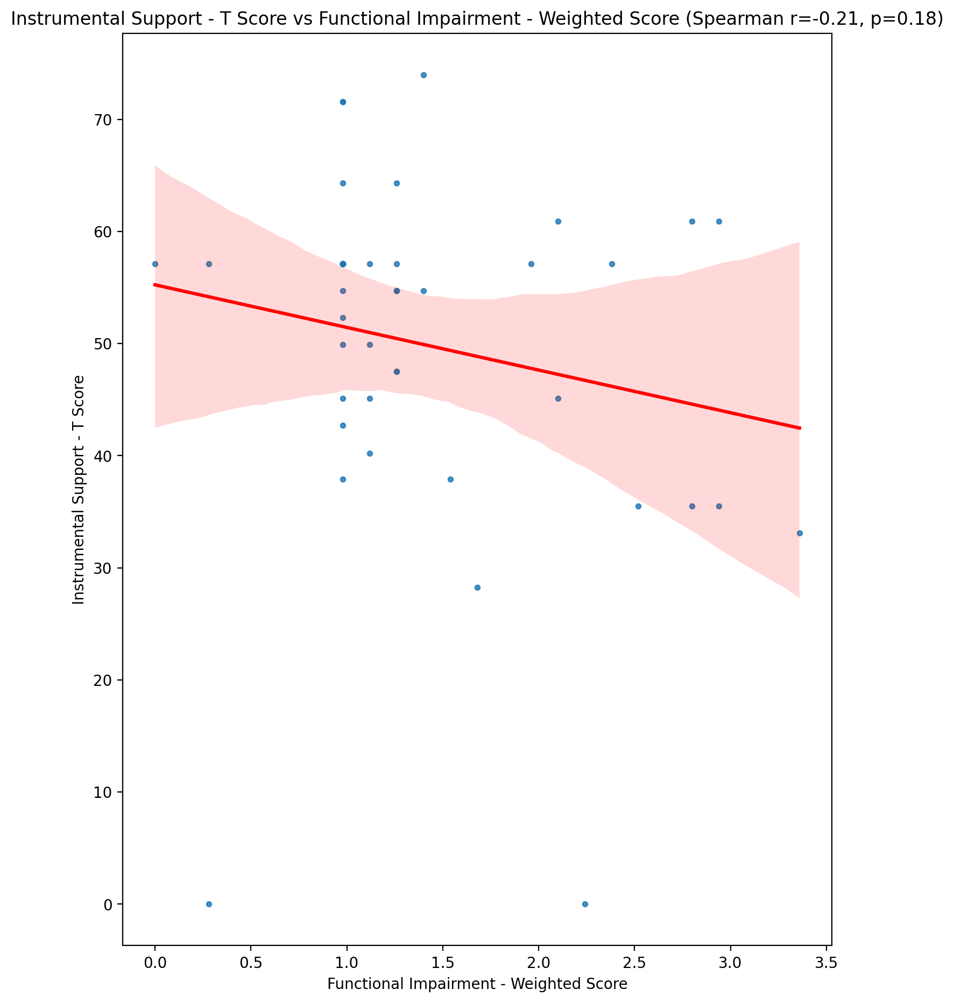

## Perceived Social Support Total T Score vs Functional Impairment - Weighted Score

Test: spearman; statistic: -0.2526890052932903; p-value: 0.10208706920347223;

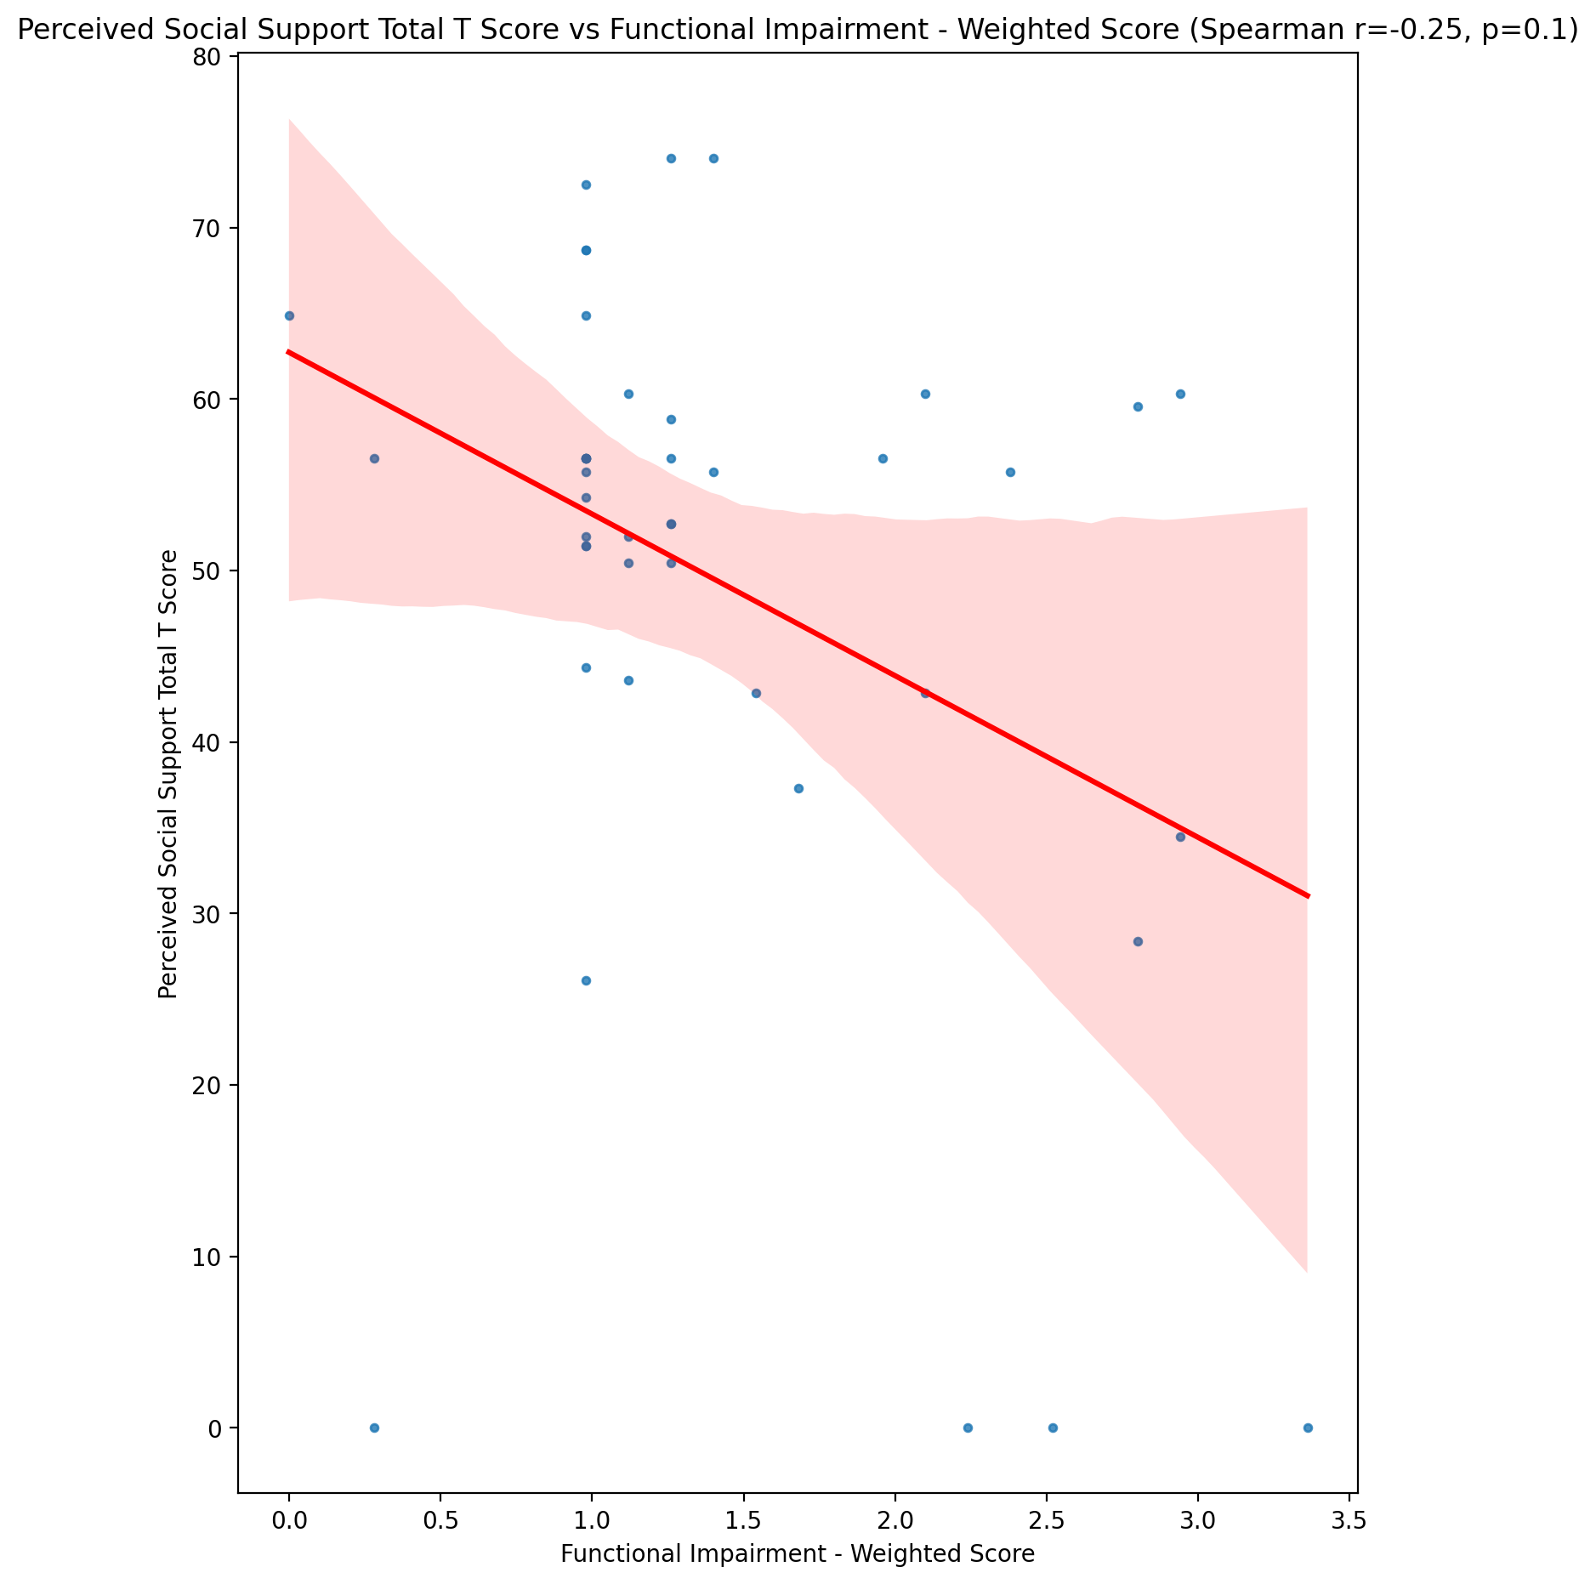

## Emotional Support - Rank vs Functional Impairment - Weighted Score

Test: None; statistic: None; p-value: None; Test not run: unsupported type combination.



## Informational Support - Rank vs Functional Impairment - Weighted Score

Test: None; statistic: None; p-value: None; Test not run: unsupported type combination.



## Instrumental Support - Rank vs Functional Impairment - Weighted Score

Test: None; statistic: None; p-value: None; Test not run: unsupported type combination.



## Perceived Social Support TOTAL - Rank vs Functional Impairment - Weighted Score

Test: None; statistic: None; p-value: None; Test not run: unsupported type combination.



## Power Self Concept - Real Self Concept Score vs Functional Impairment - Weighted Score

Test: spearman; statistic: -0.2314563146683522; p-value: 0.13533259027513964;

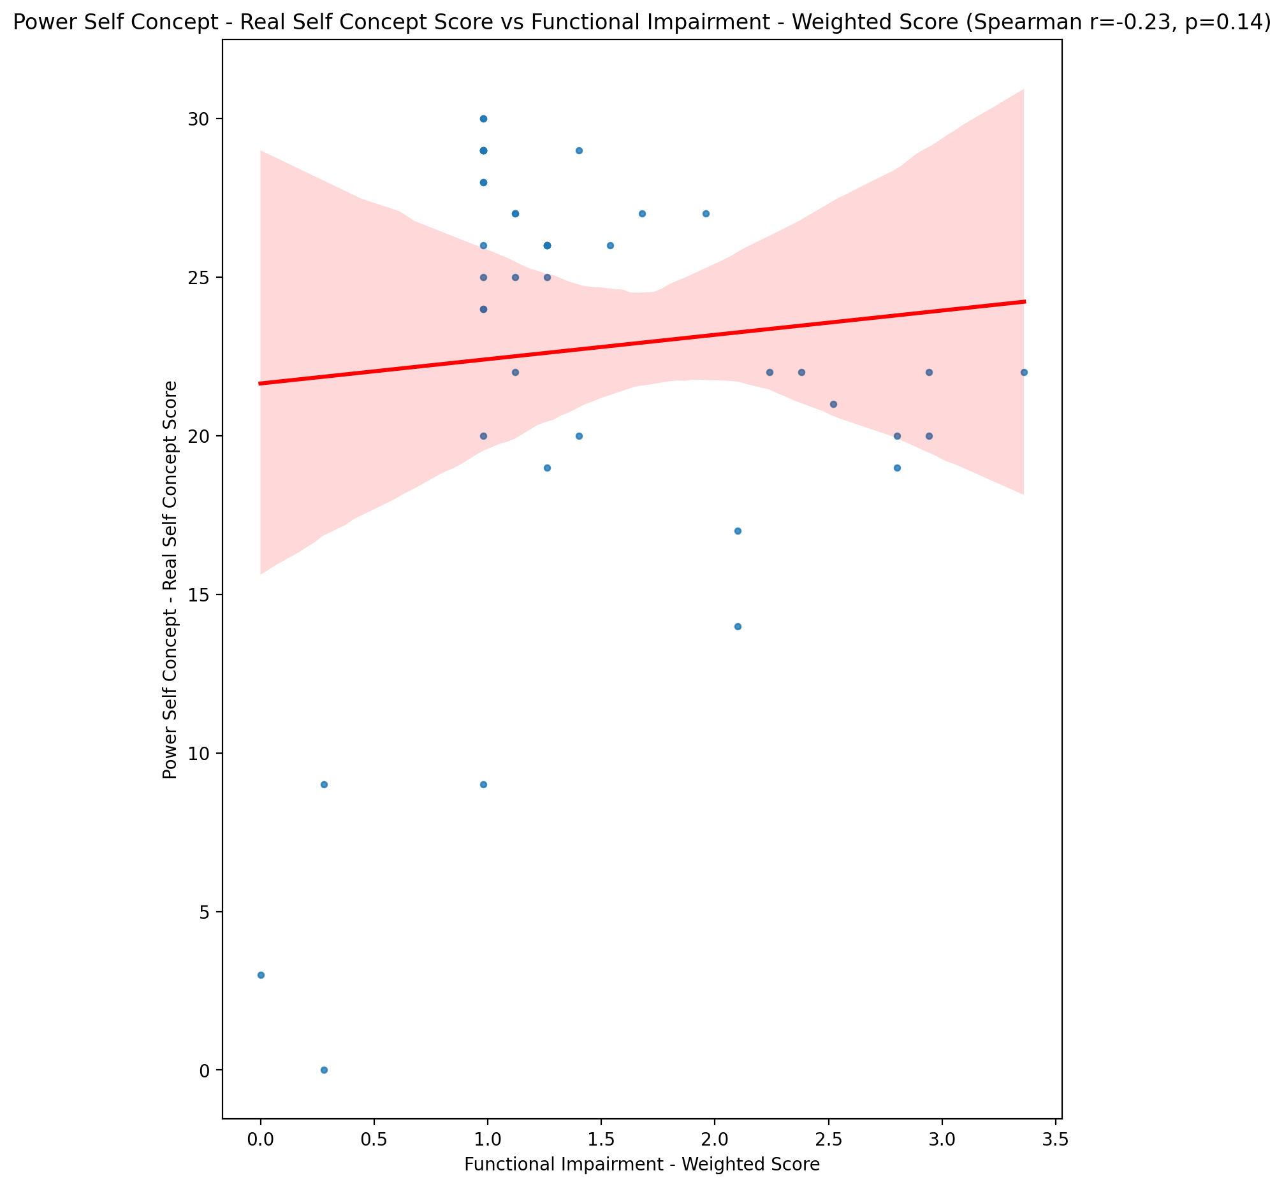

## Power Self Concept - Ideal Self Concept score vs Functional Impairment - Weighted Score

Test: spearman; statistic: -0.12830643520535062; p-value: 0.4122353439802954;

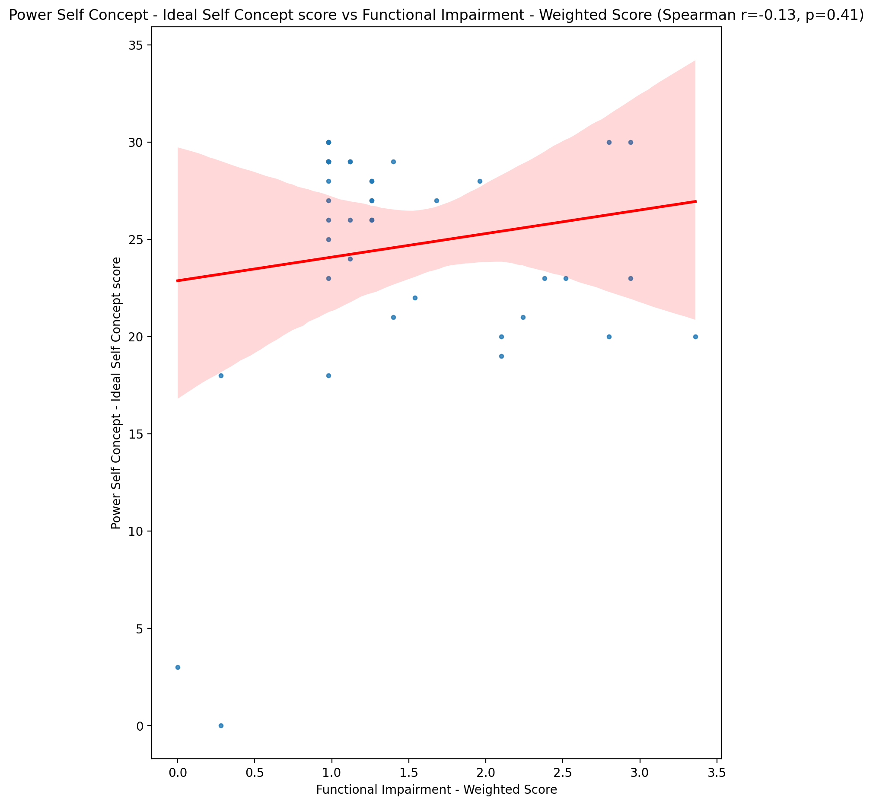

## Power Self Concept – Social Self Concept Score vs Functional Impairment - Weighted Score

Test: spearman; statistic: -0.1517597675179289; p-value: 0.33131271433069887;

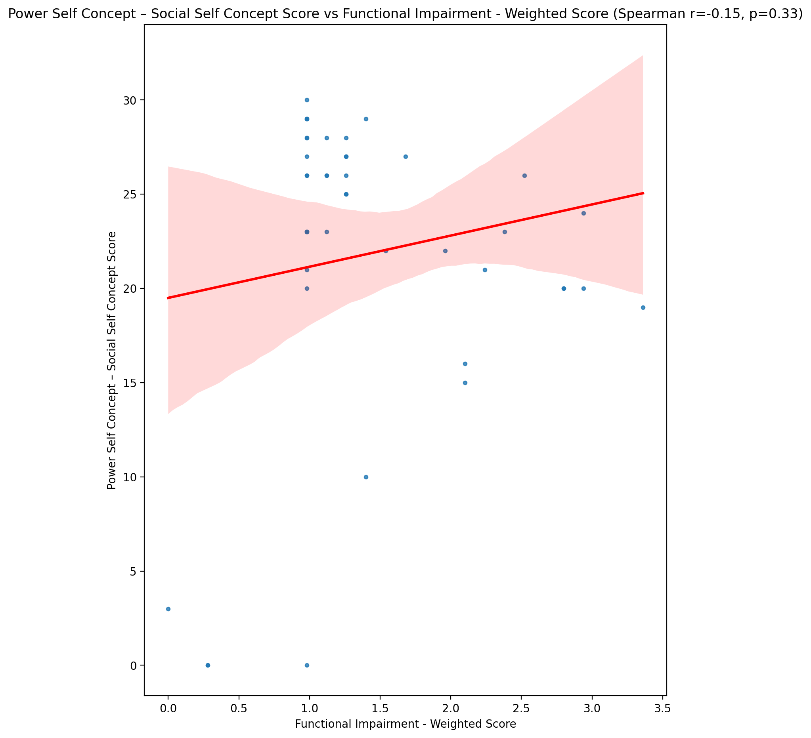

## Social Self Concept - Real Self Concept Score vs Functional Impairment - Weighted Score

Test: spearman; statistic: -0.1806940343265327; p-value: 0.24623211250843802;

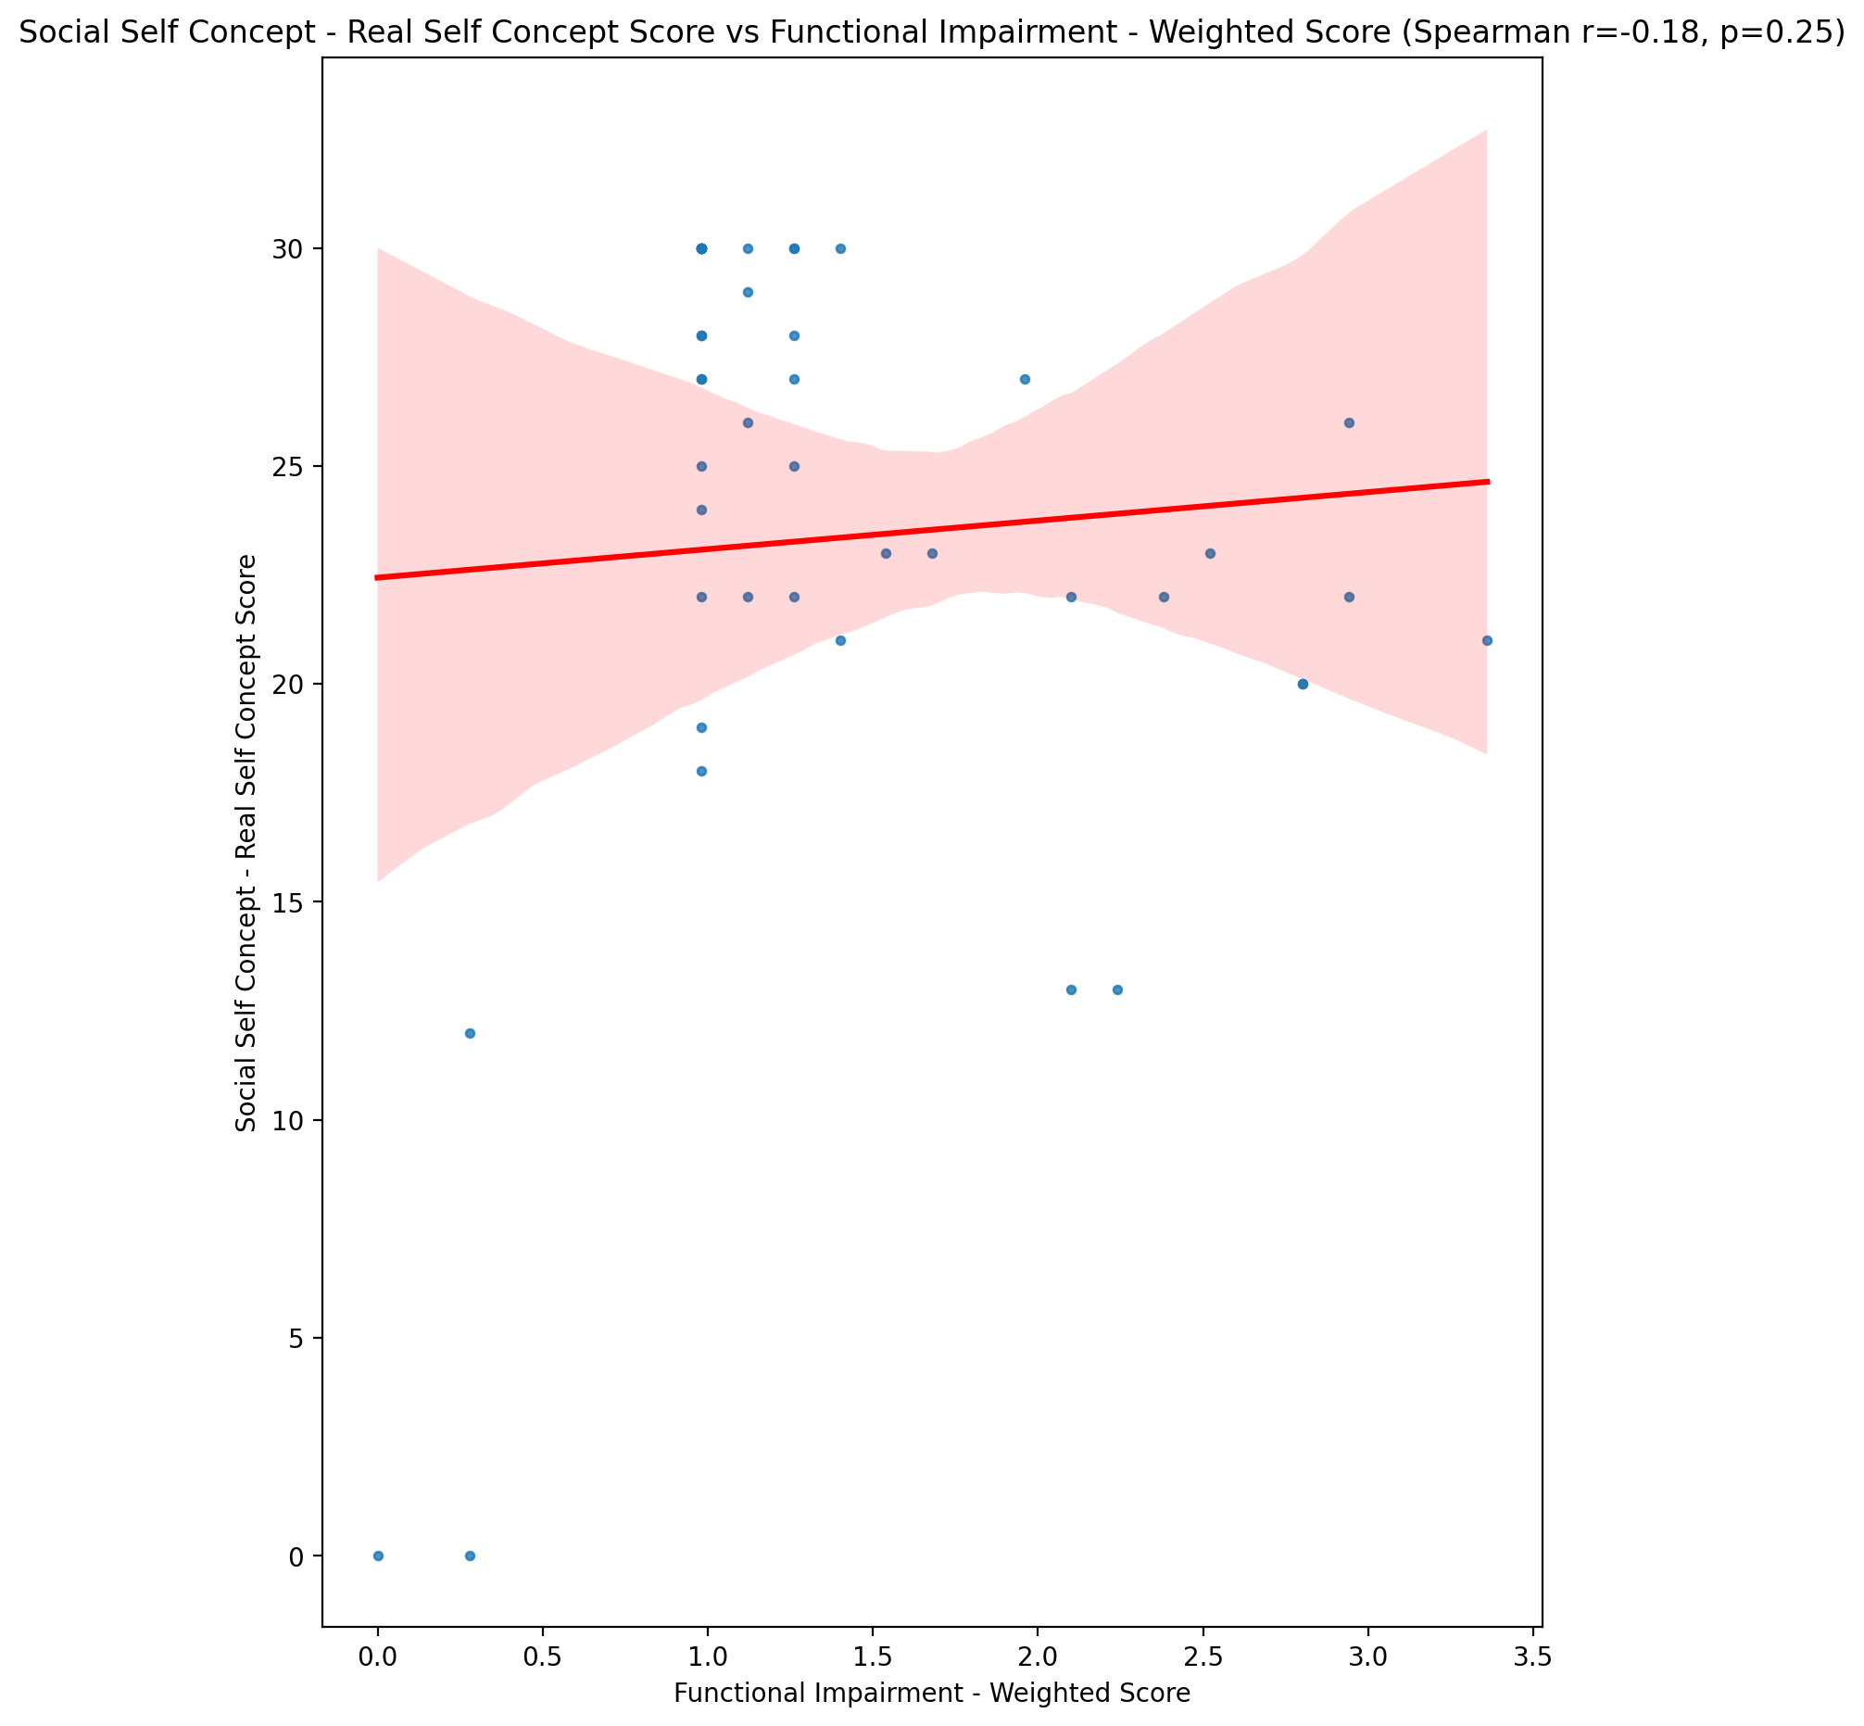

## Social Self Concept – Social Self Concept Score vs Functional Impairment - Weighted Score

Test: spearman; statistic: -0.097626881657345; p-value: 0.5334103455854657;

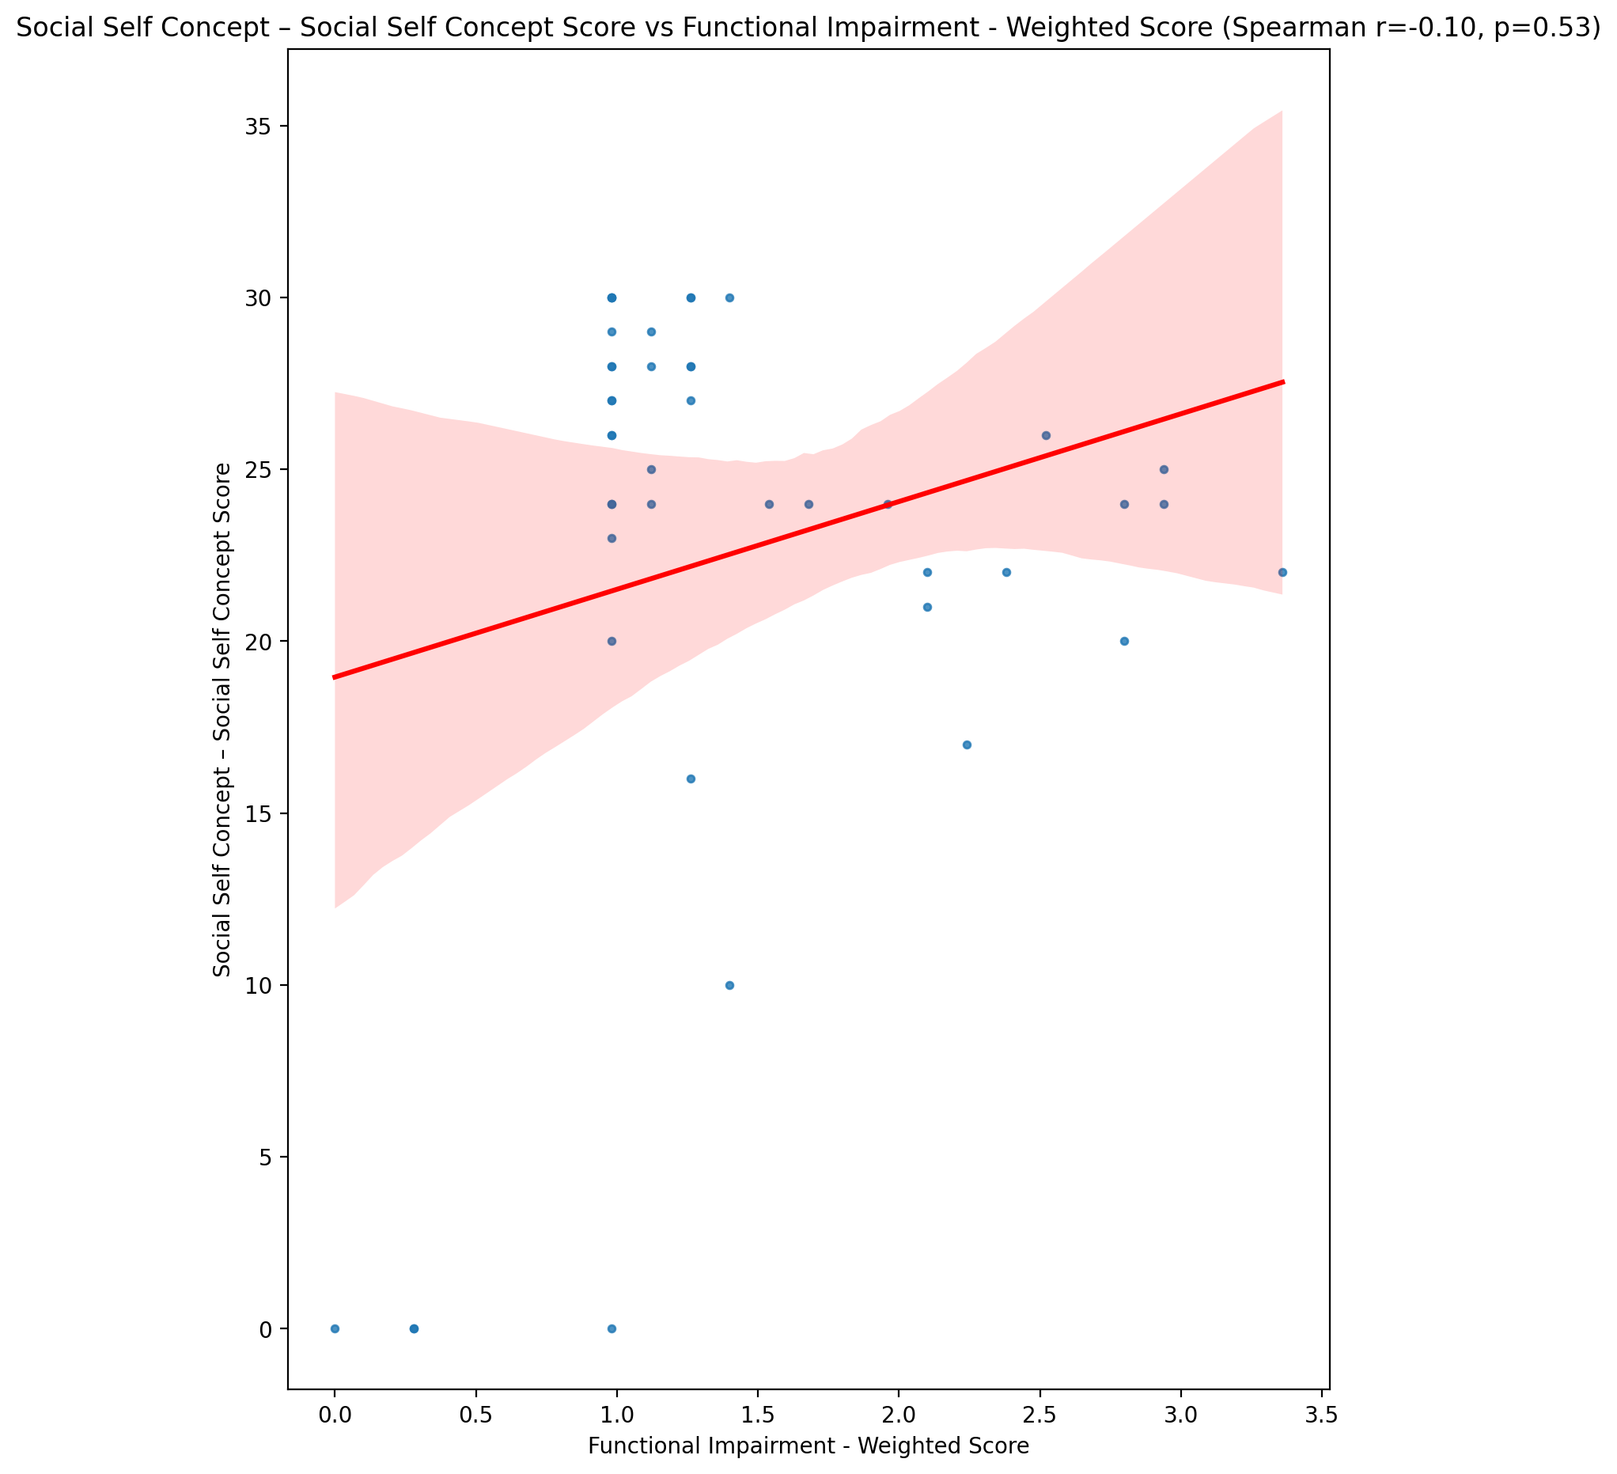

## Ability Self Concept - Real Self Concept Score vs Functional Impairment - Weighted Score

Test: spearman; statistic: -0.20481153669651098; p-value: 0.18767768325350956;

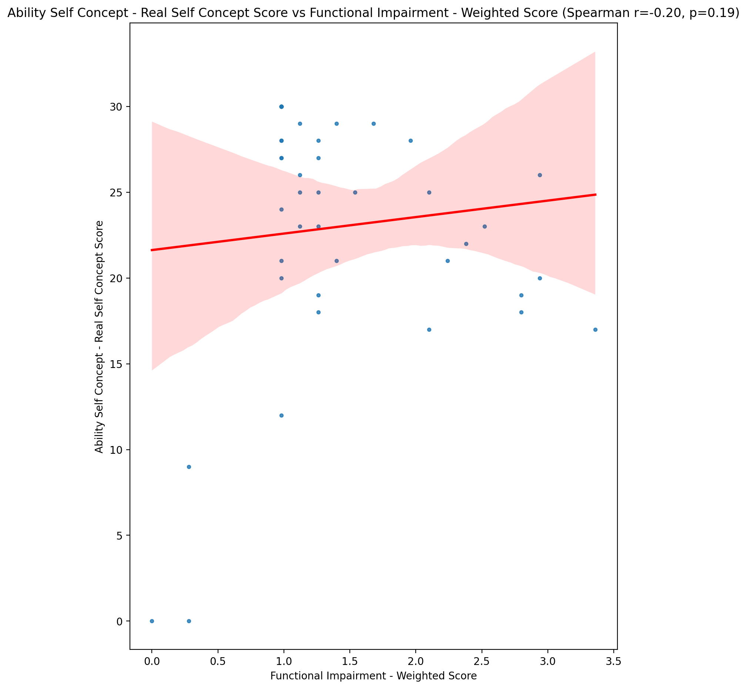

## Ability Self Concept - Ideal Self Concept Score vs Functional Impairment - Weighted Score

Test: spearman; statistic: -0.15335148493835193; p-value: 0.32620619198970924;

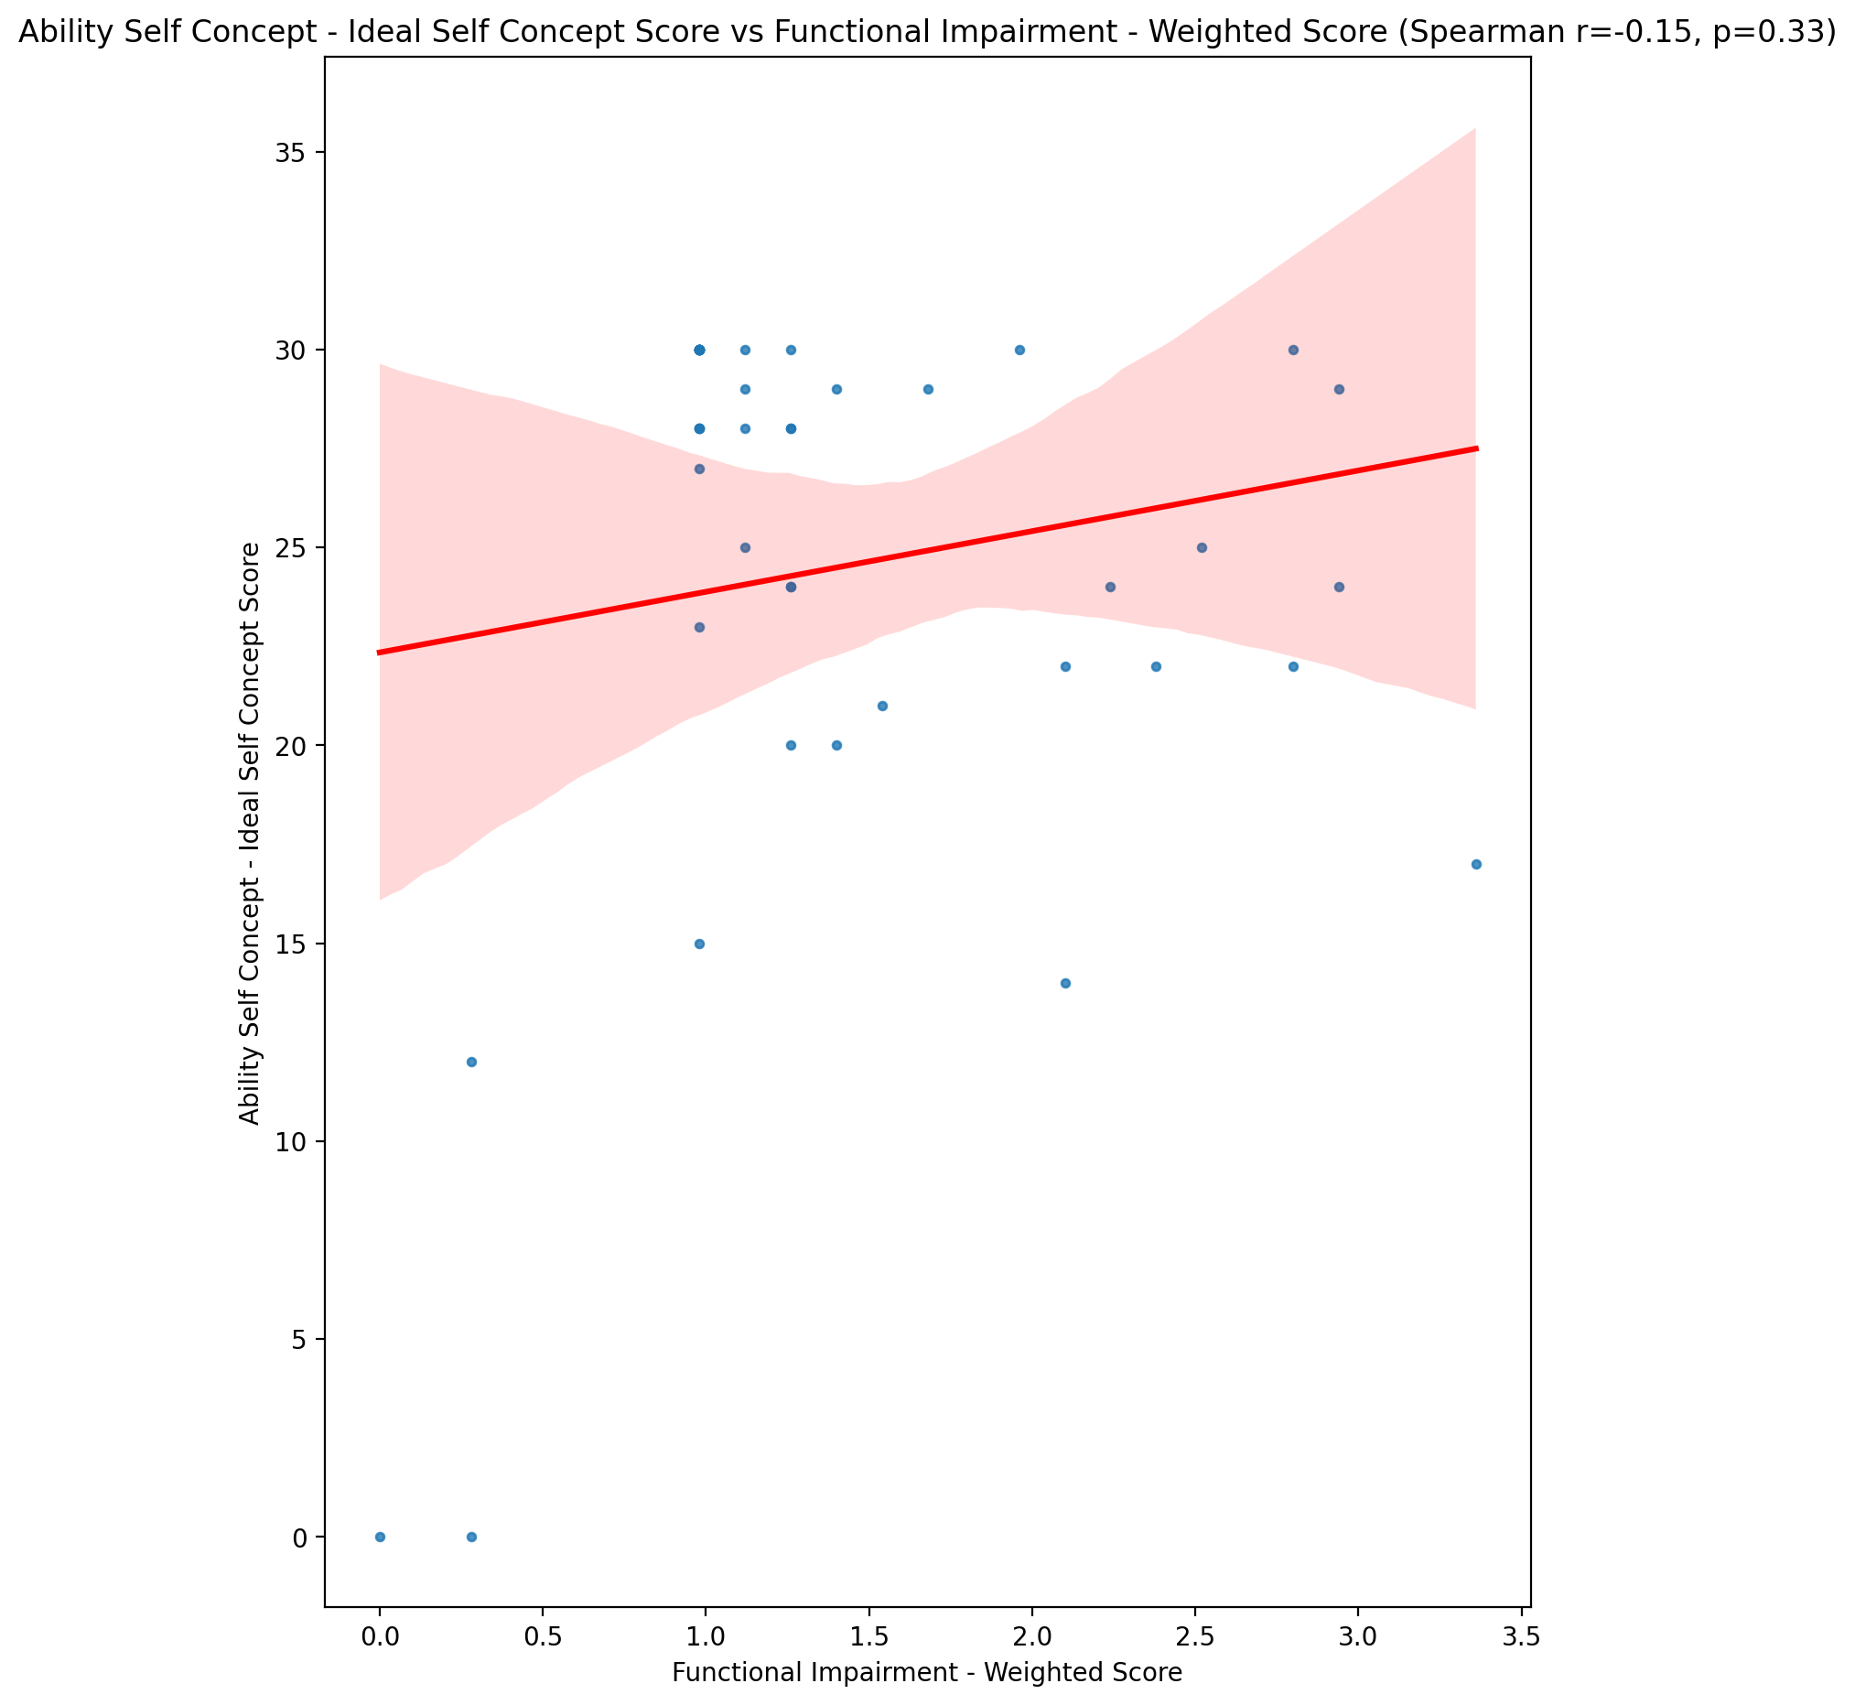

## Ability Self Concept – Social Self Concept Score vs Functional Impairment - Weighted Score

Test: spearman; statistic: -0.08136602869460163; p-value: 0.6039756232492337;

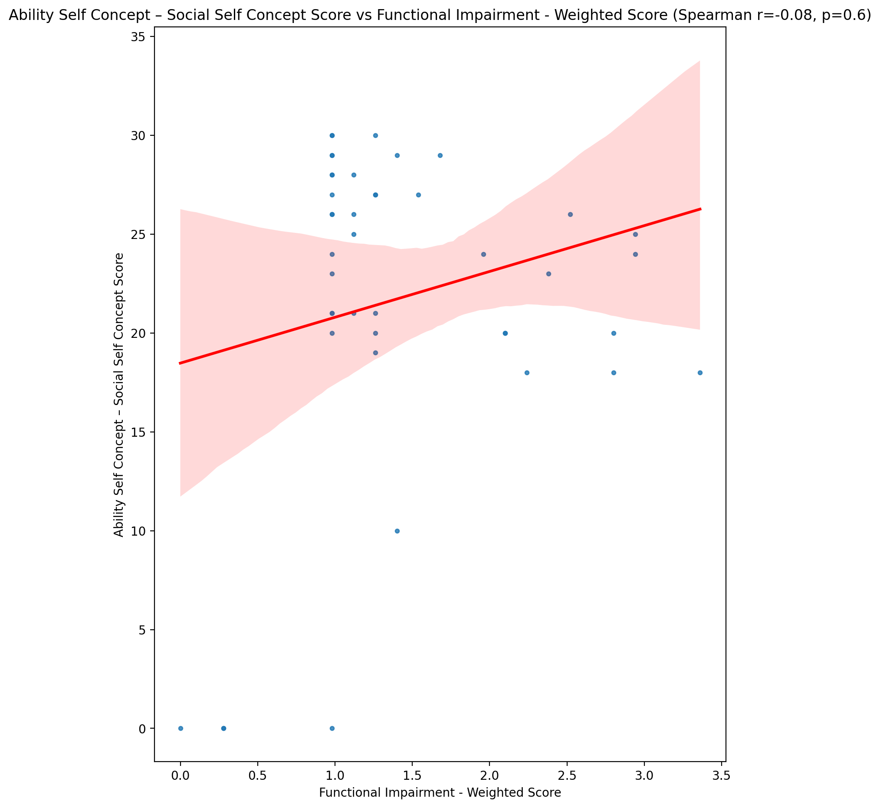

## Physical Self Concept - Real Self Concept Score vs Functional Impairment - Weighted Score

Test: spearman; statistic: -0.22177295357725055; p-value: 0.15292437789781033;

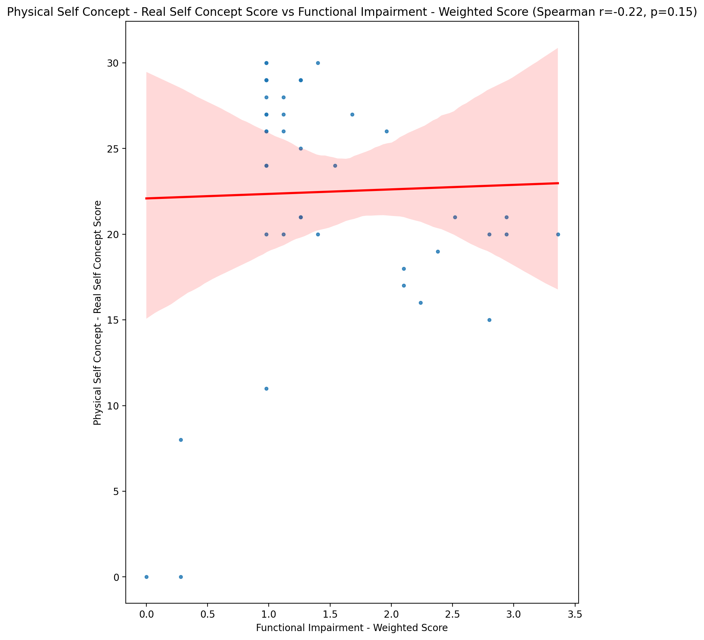

## Physical Self Concept – Ideal Self Concept Score vs Functional Impairment - Weighted Score

Test: spearman; statistic: -0.11954373547919851; p-value: 0.44513805290969877;

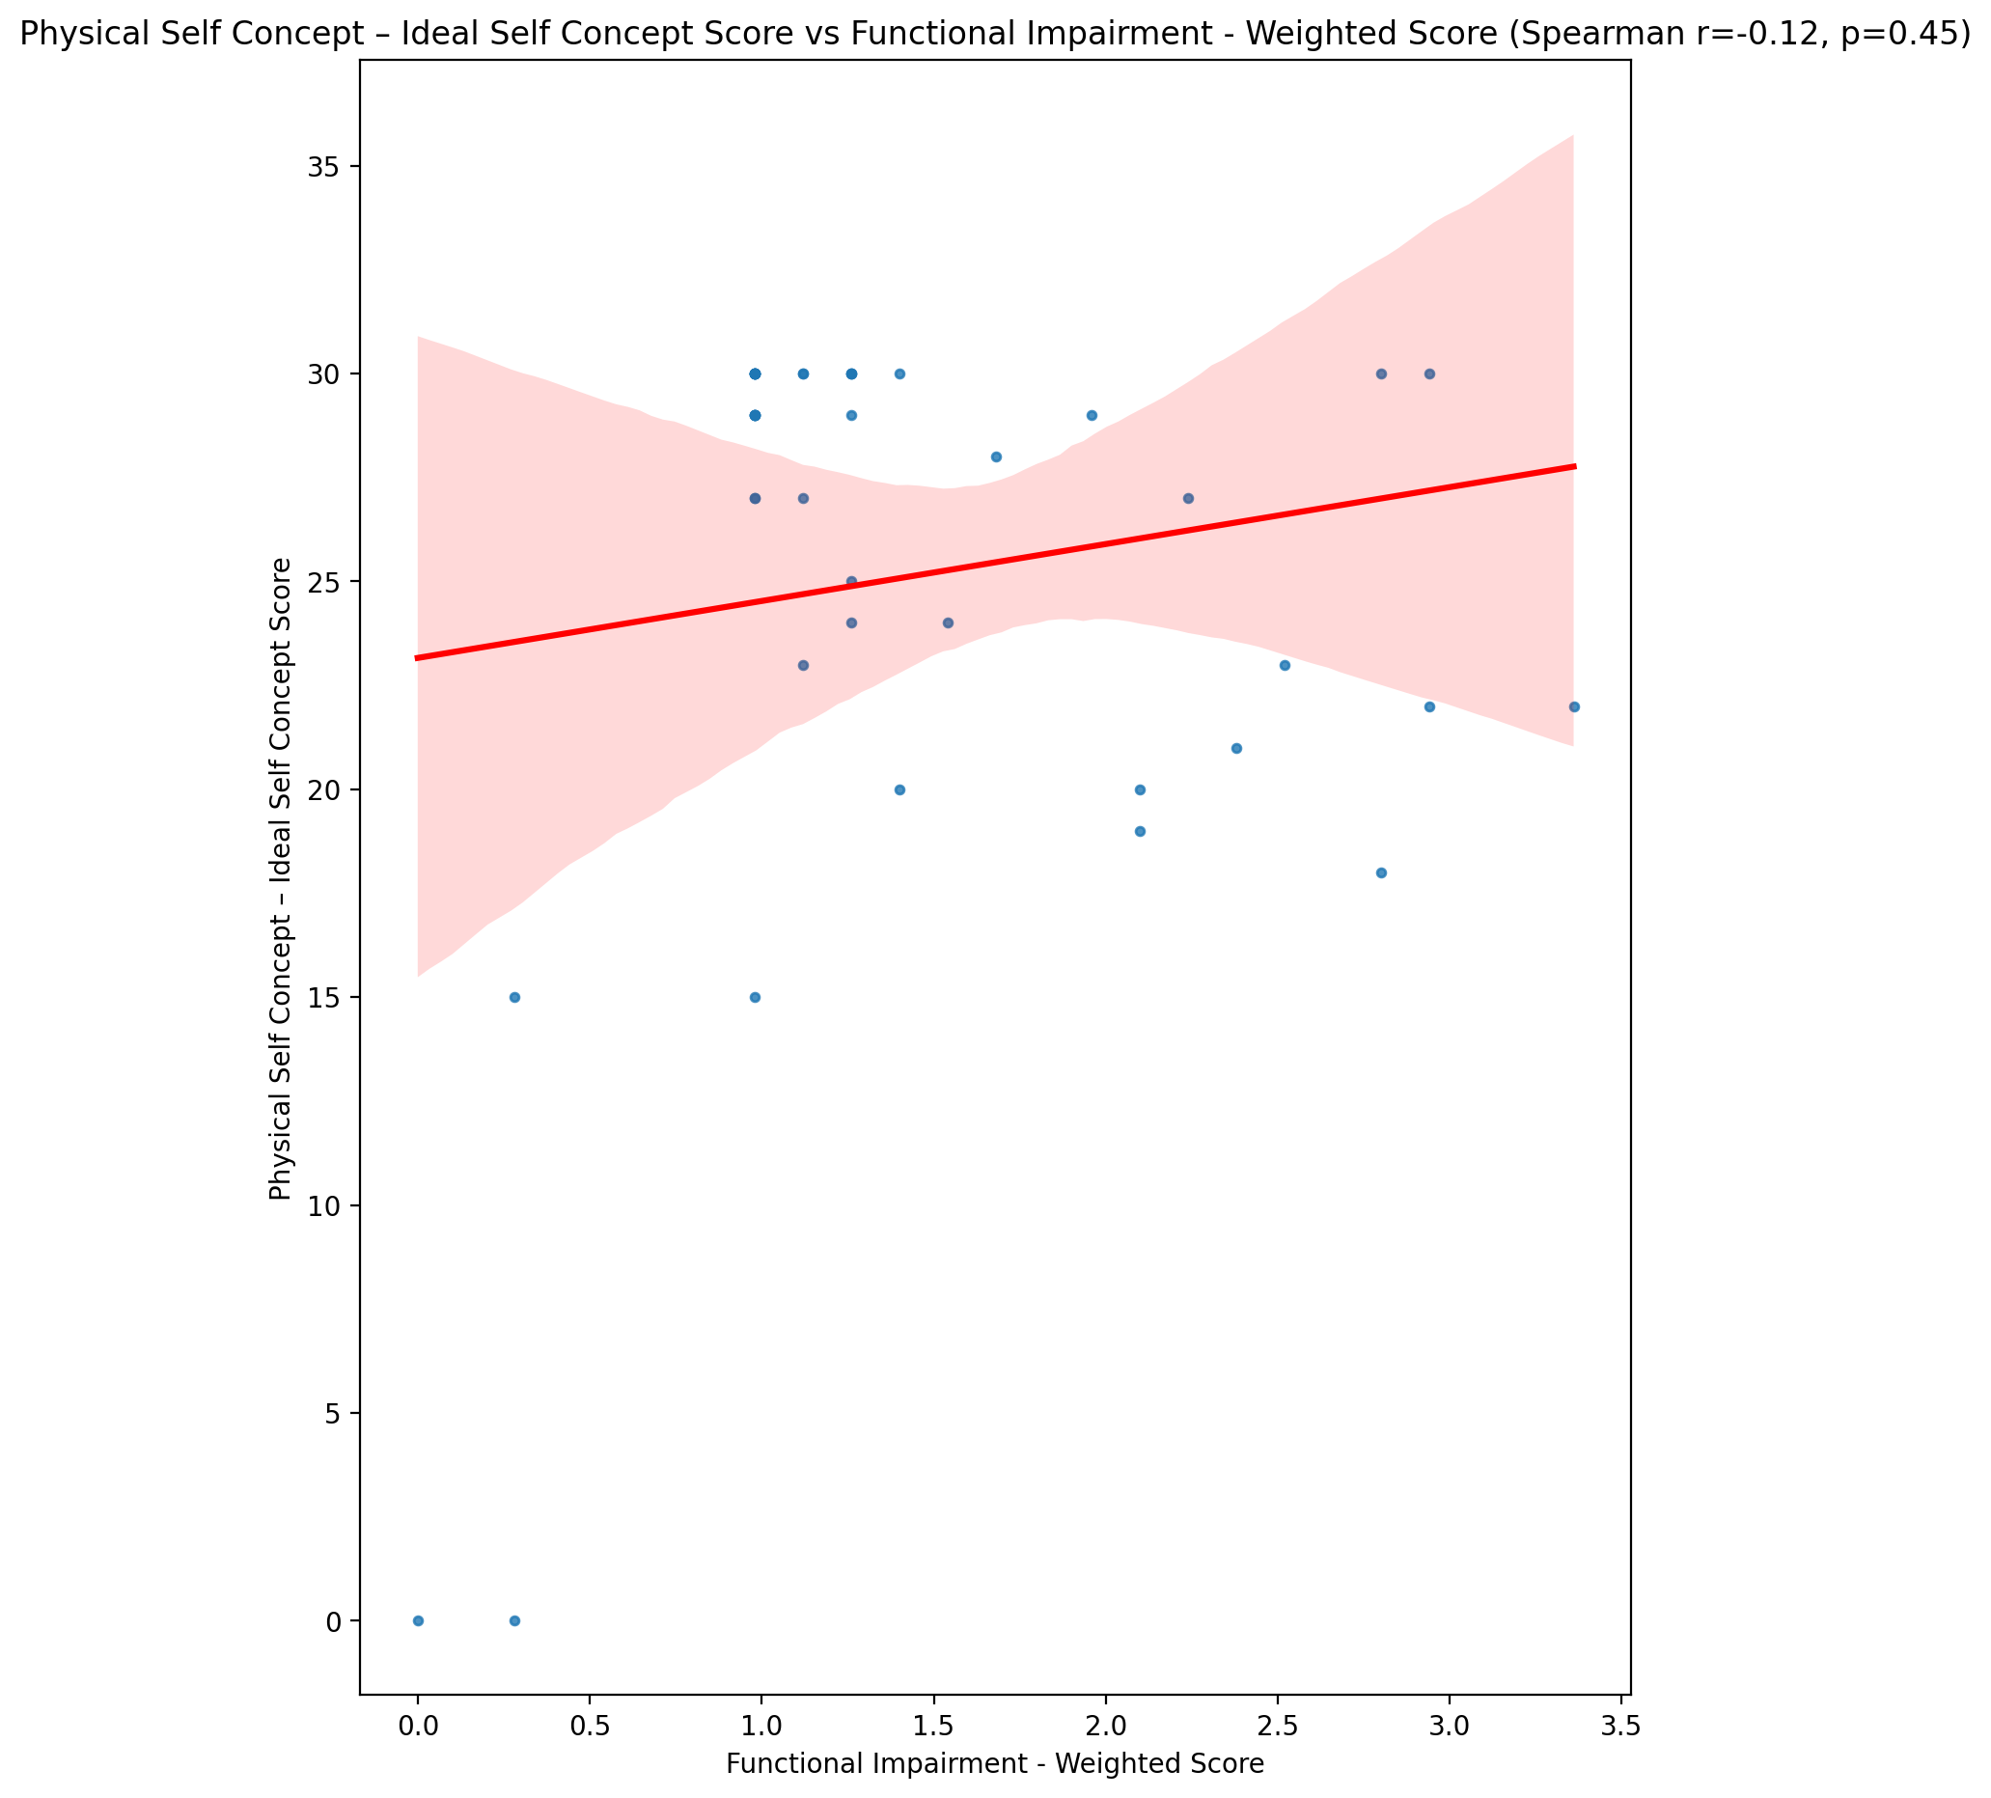

## Physical Self Concept – Social Self Concept Score vs Functional Impairment - Weighted Score

Test: spearman; statistic: 0.11047111258527531; p-value: 0.4806705999283336;

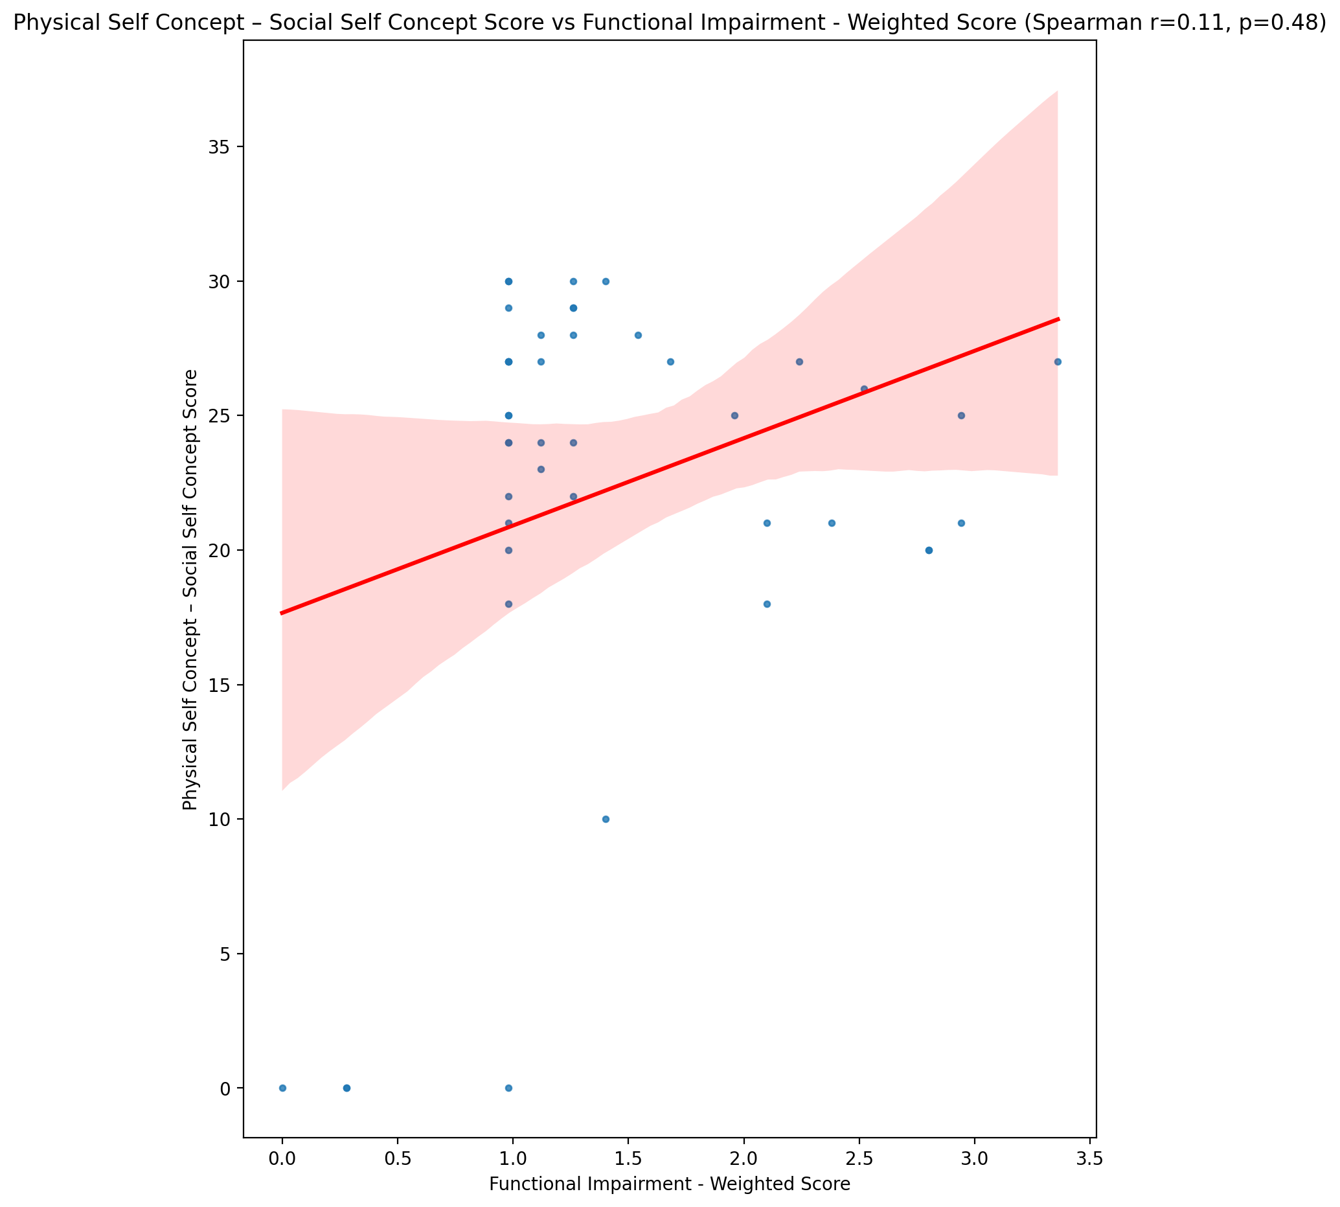

## Psychological Self Concept - Real Self Concept Score vs Functional Impairment - Weighted Score

Test: spearman; statistic: -0.21072359634881188; p-value: 0.17497949377036925;

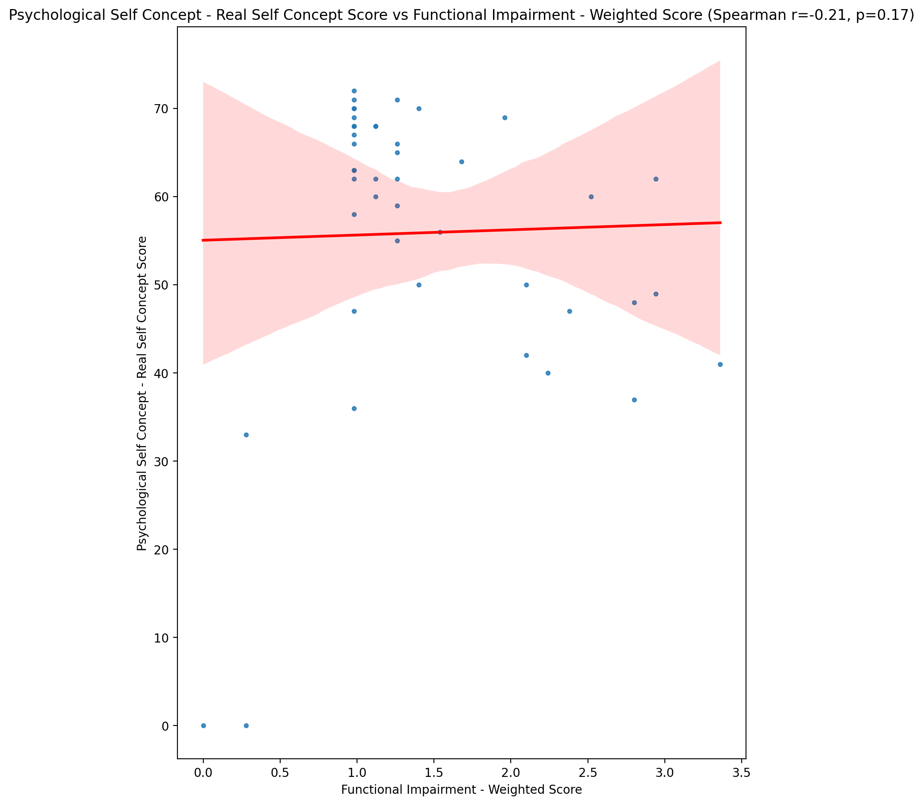

## Psychological Self Concept – Ideal Self Concept Score vs Functional Impairment - Weighted Score

Test: spearman; statistic: -0.14770071445535338; p-value: 0.3445587052318506;

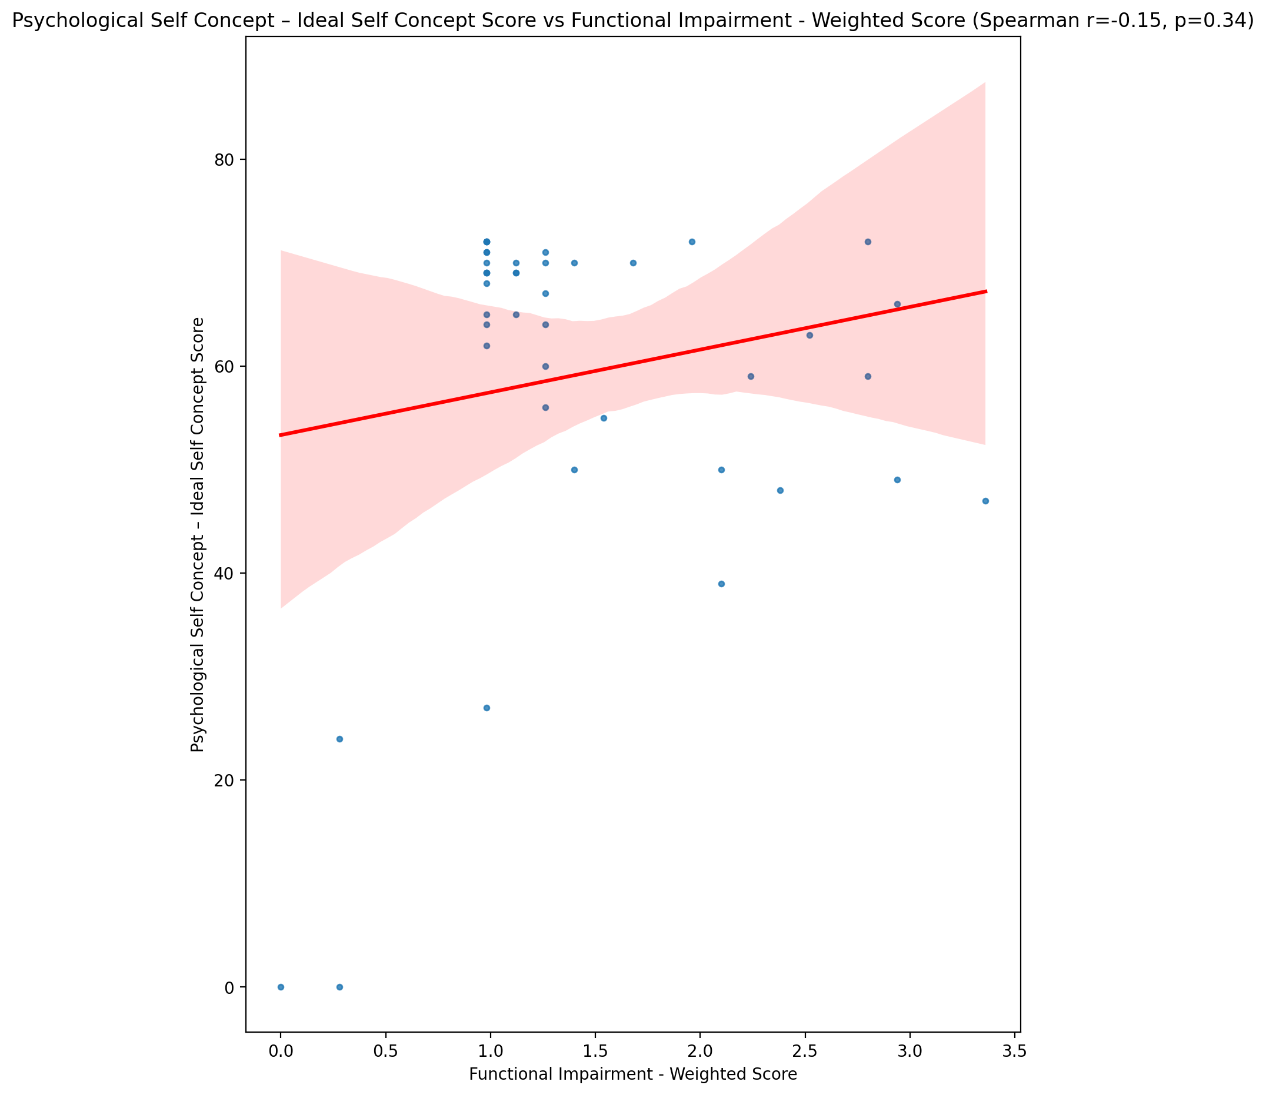

## Psychological Self Concept – Social Self Concept Score vs Functional Impairment - Weighted Score

Test: spearman; statistic: -0.15622701739246533; p-value: 0.31710658043125867;

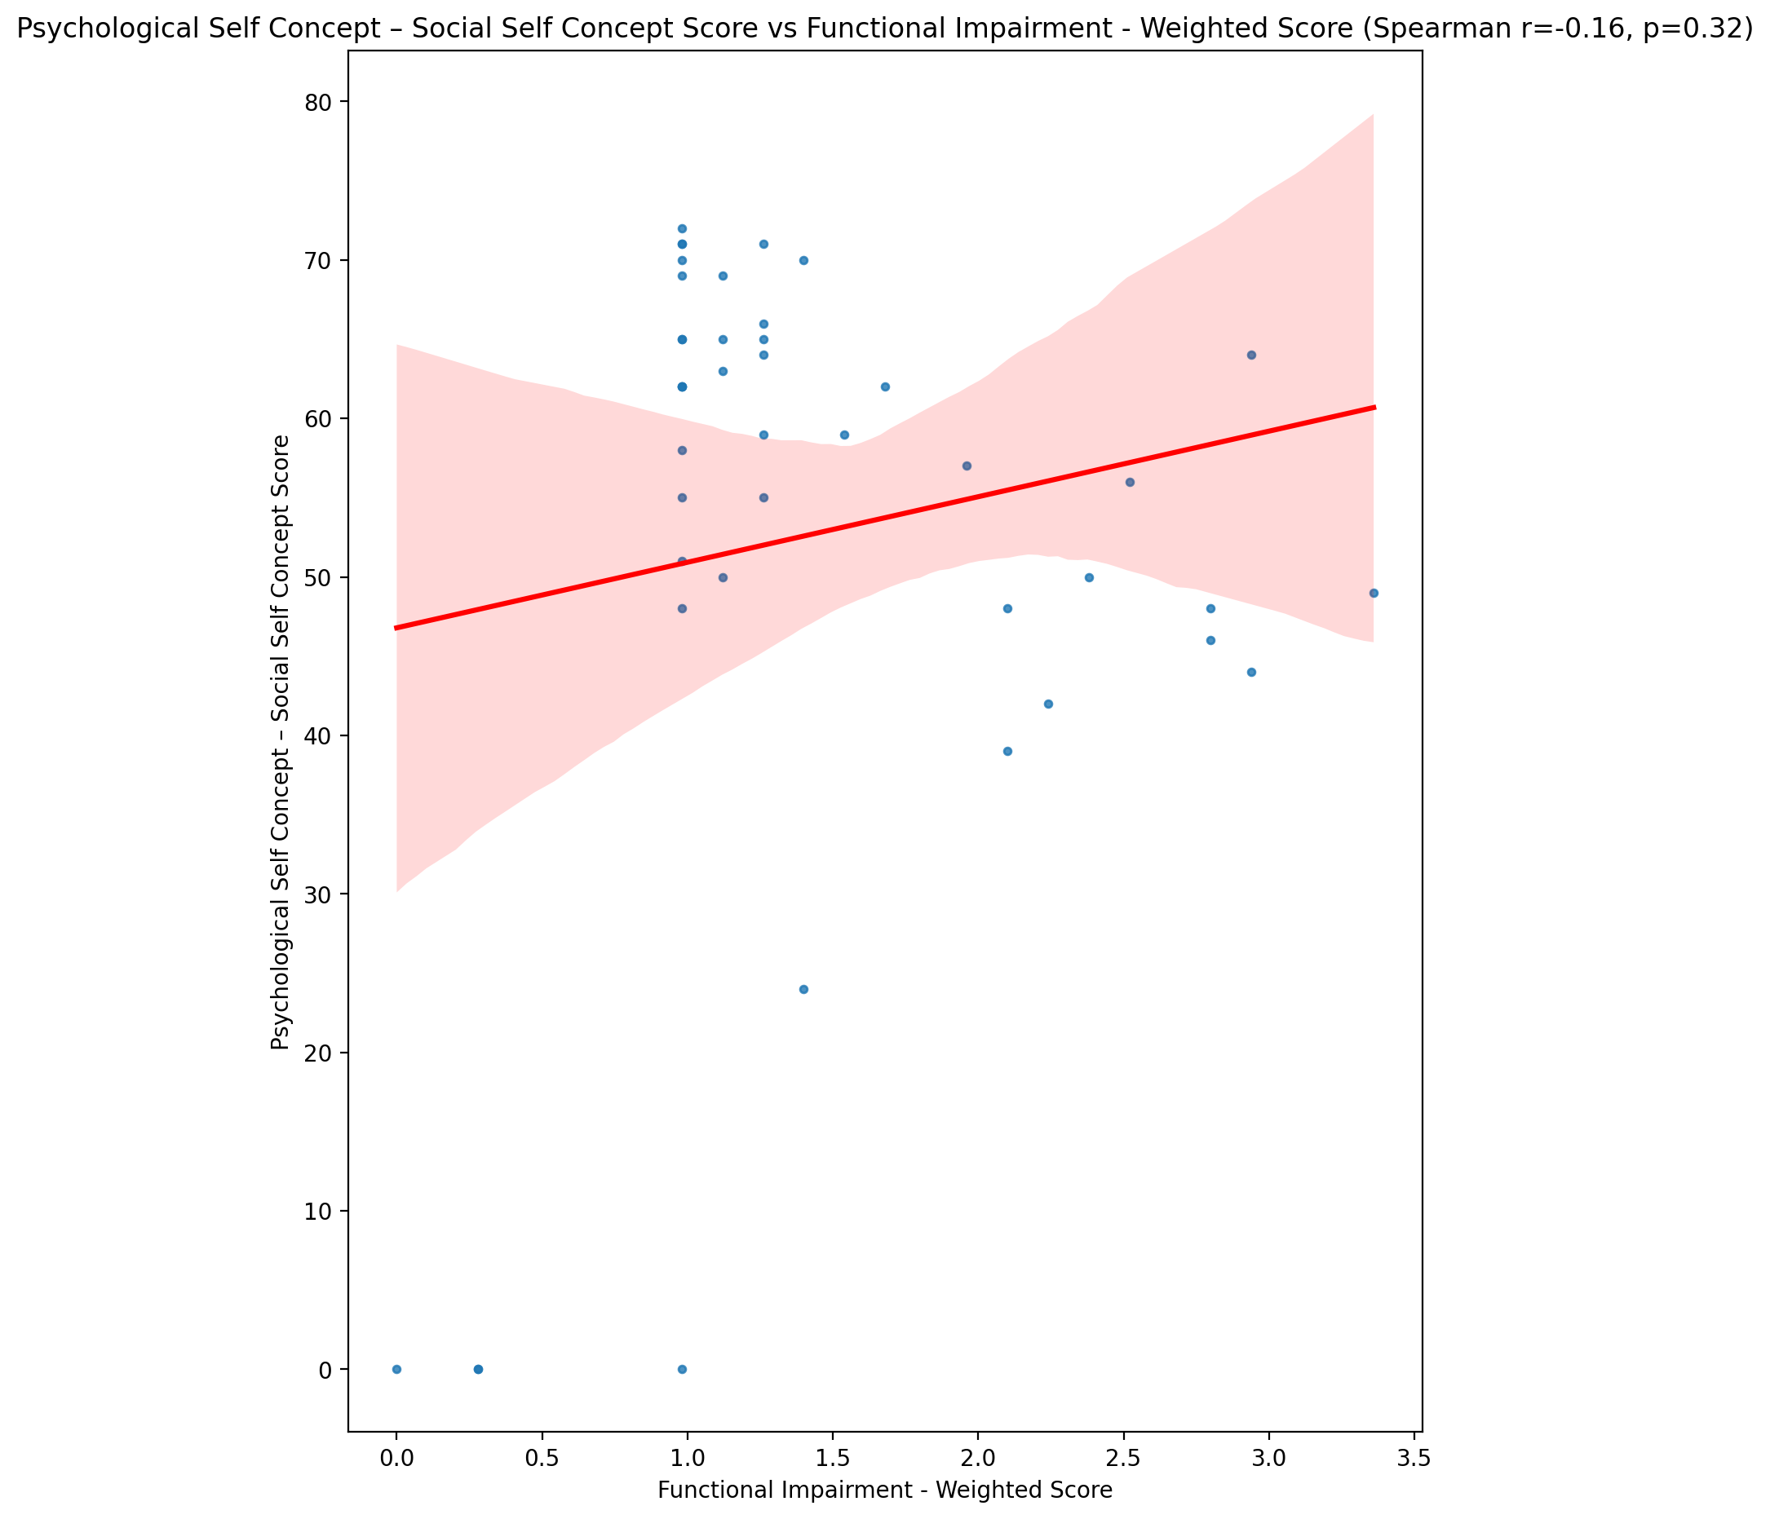

## Real Self Concept Total Score vs Functional Impairment - Weighted Score

Test: spearman; statistic: -0.24328005601815872; p-value: 0.11594893159456786;

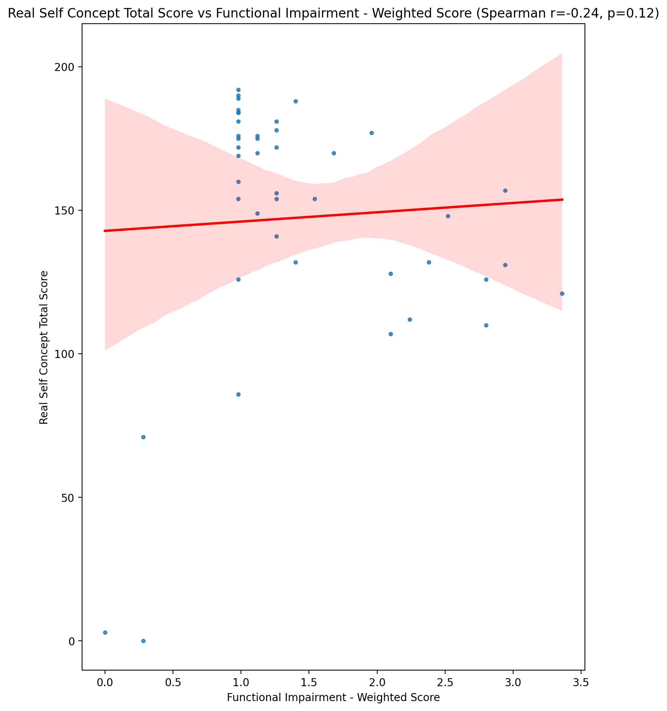

## Ideal Self Concept Total Score vs Functional Impairment - Weighted Score

Test: spearman; statistic: -0.18261886056352908; p-value: 0.24115167879772037;

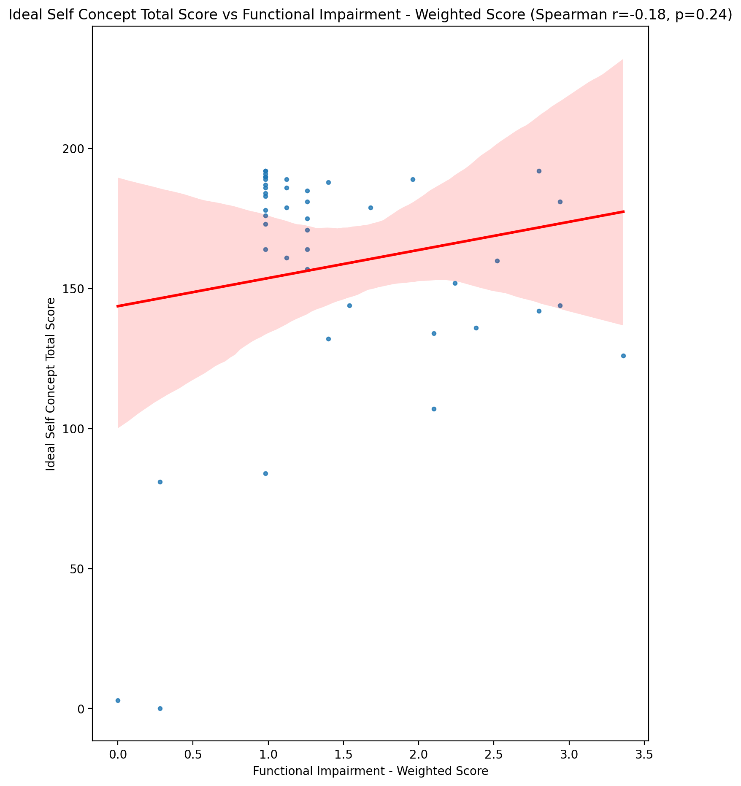

## Social Self Concept Total Score vs Functional Impairment - Weighted Score

Test: spearman; statistic: -0.11879321144463471; p-value: 0.44802155808784183;

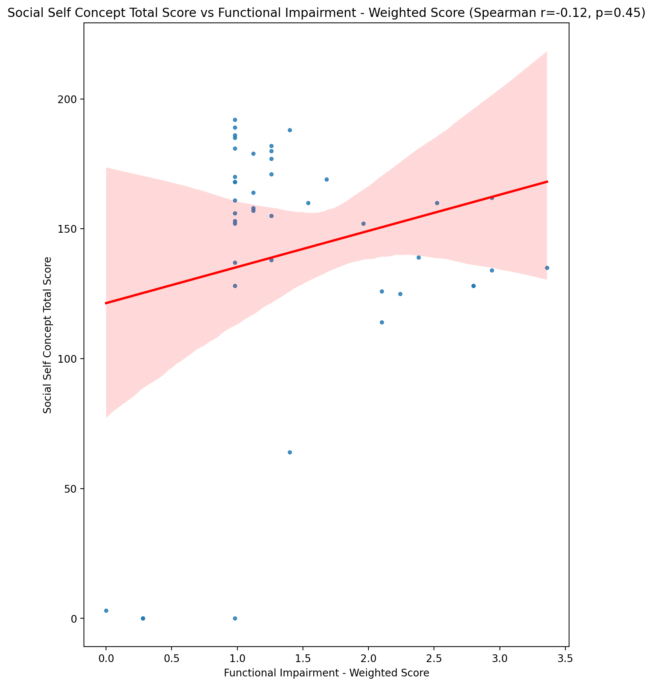

## Ideal Self Concept Total Category vs Functional Impairment - Weighted Score

Test: None; statistic: None; p-value: None; Test not run: unsupported type combination.



## Perceived Social Stress Score vs Functional Impairment - Weighted Score

Test: spearman; statistic: 0.21552401634450297; p-value: 0.16513255640877514;

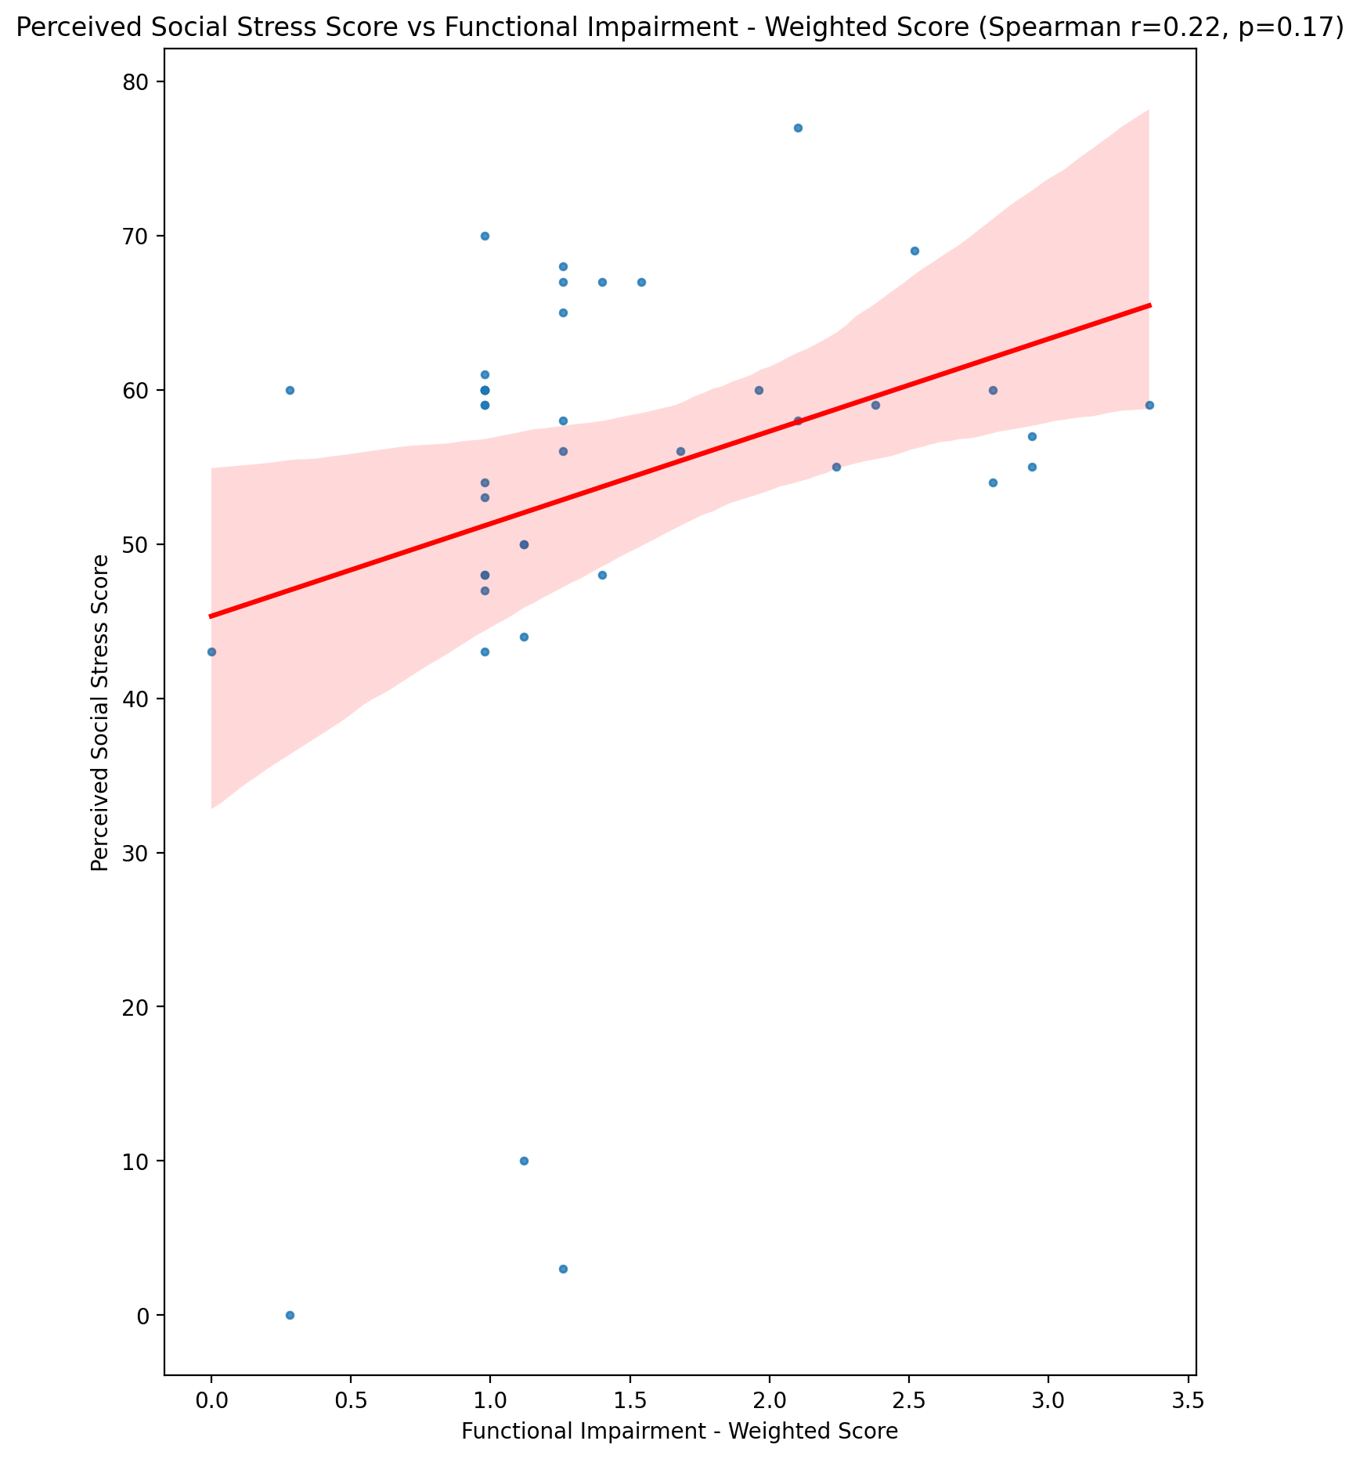

## Perceived Social Stress Category vs Functional Impairment - Weighted Score

Test: None; statistic: None; p-value: None; Test not run: unsupported type combination.



## Emotional Support - Raw Score vs Withdrawl - Weighted Score

Test: spearman; statistic: -0.47760400271309816; p-value: 0.0012006509334110576;

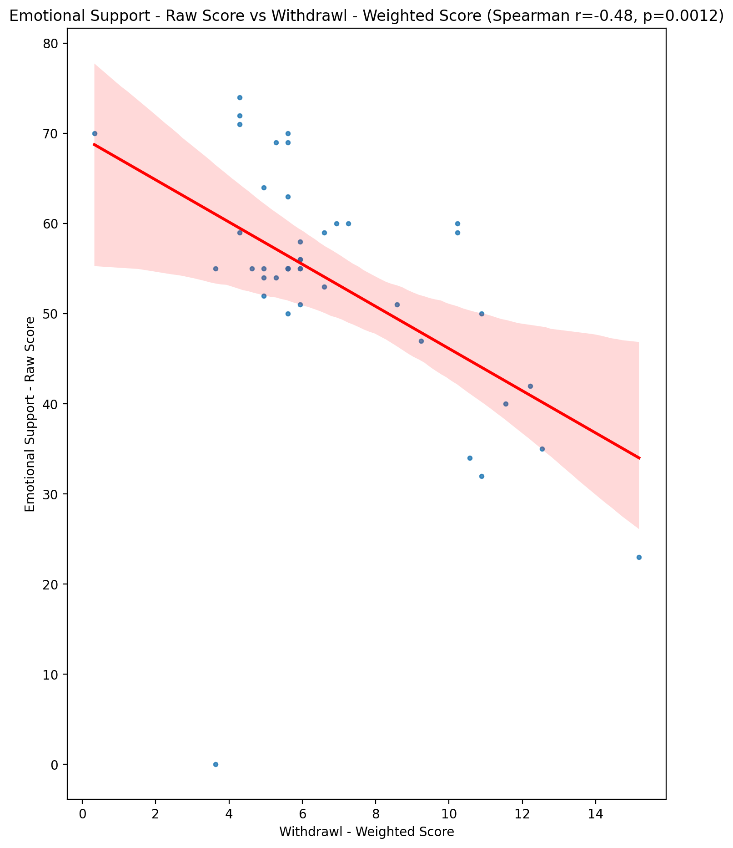

## Informational Support - Raw Score vs Withdrawl - Weighted Score

Test: spearman; statistic: -0.44190610756242815; p-value: 0.0030094142949537695;

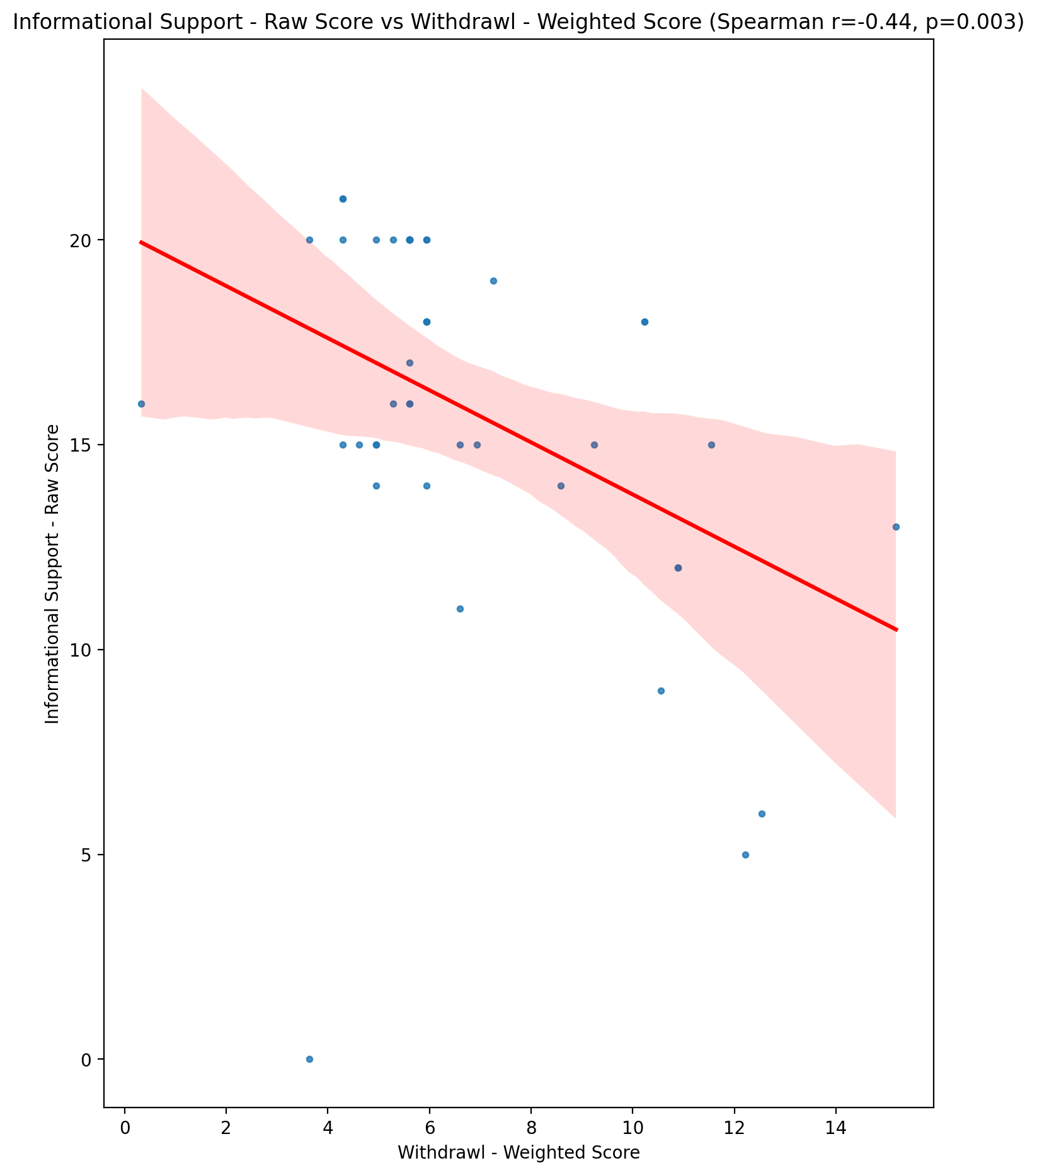

## Instrumental Support - Raw Score vs Withdrawl - Weighted Score

Test: spearman; statistic: -0.539867702828622; p-value: 0.00018673550745538443;

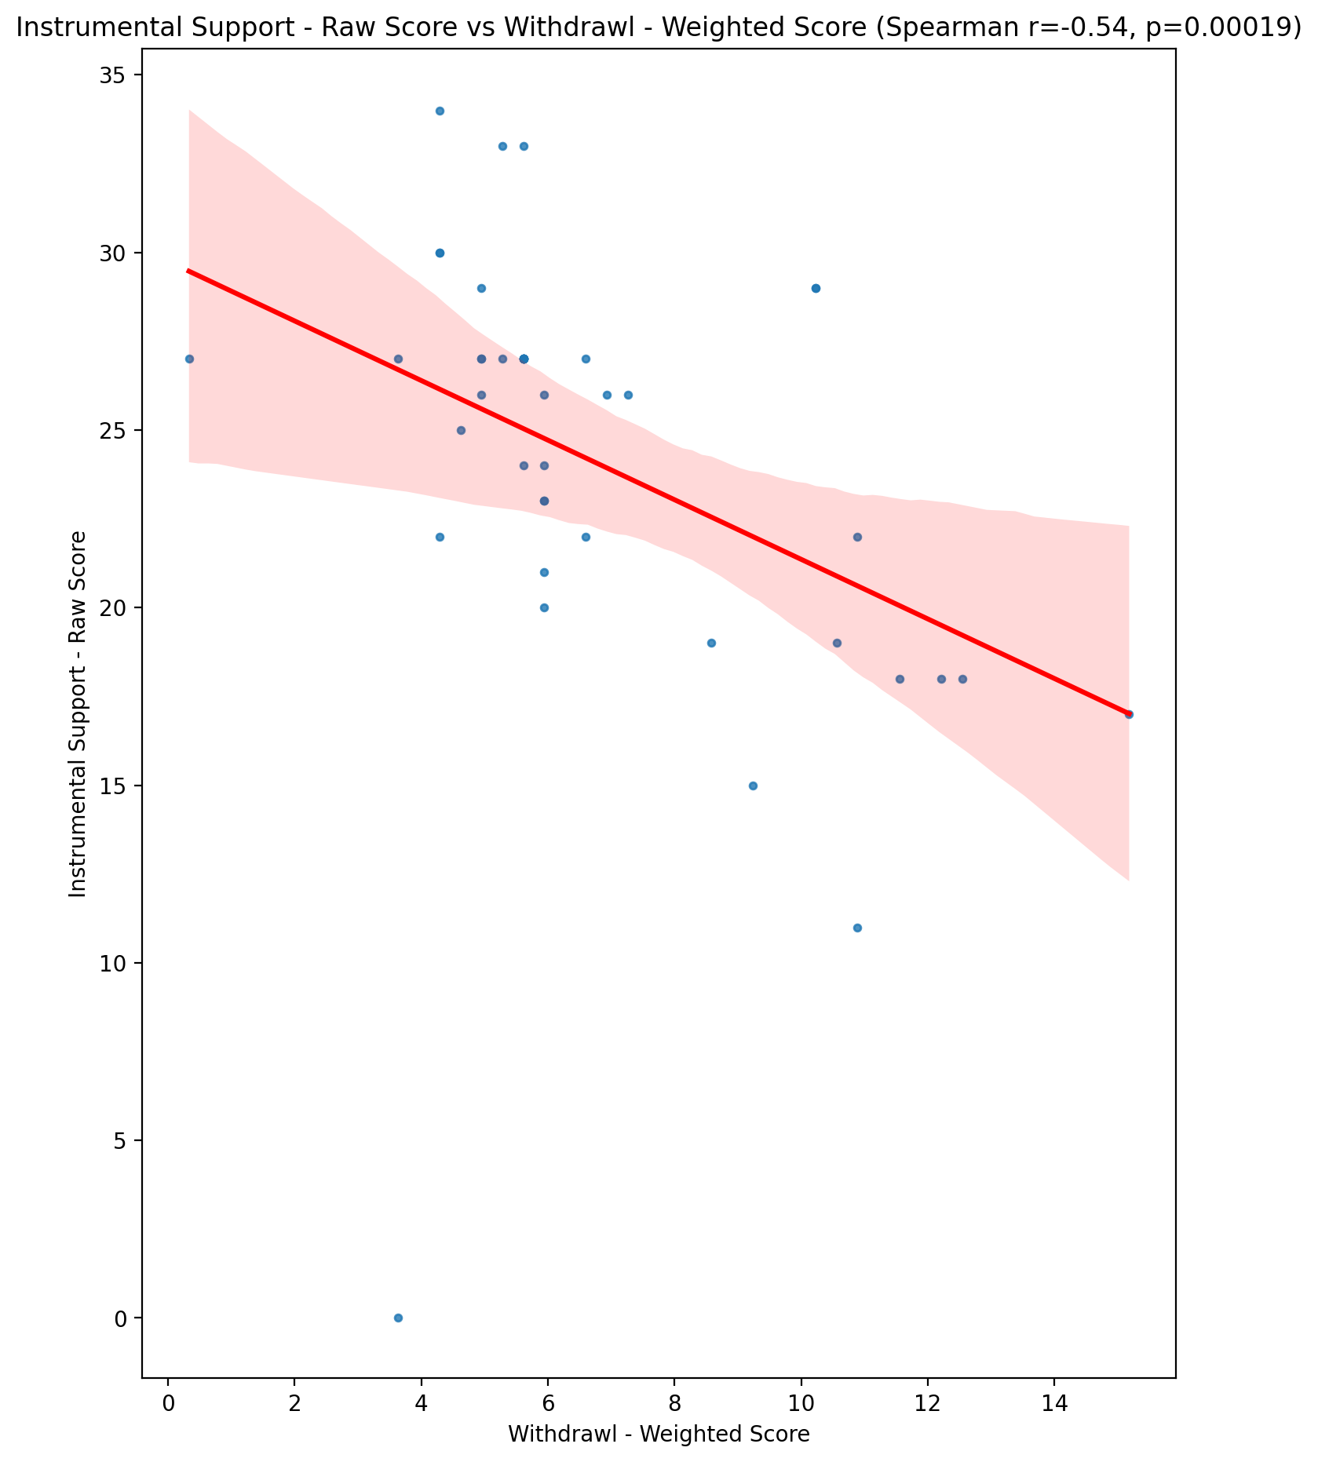

## Emotional Support - T Score vs Withdrawl - Weighted Score

Test: spearman; statistic: -0.3751049476320953; p-value: 0.01319402827664035;

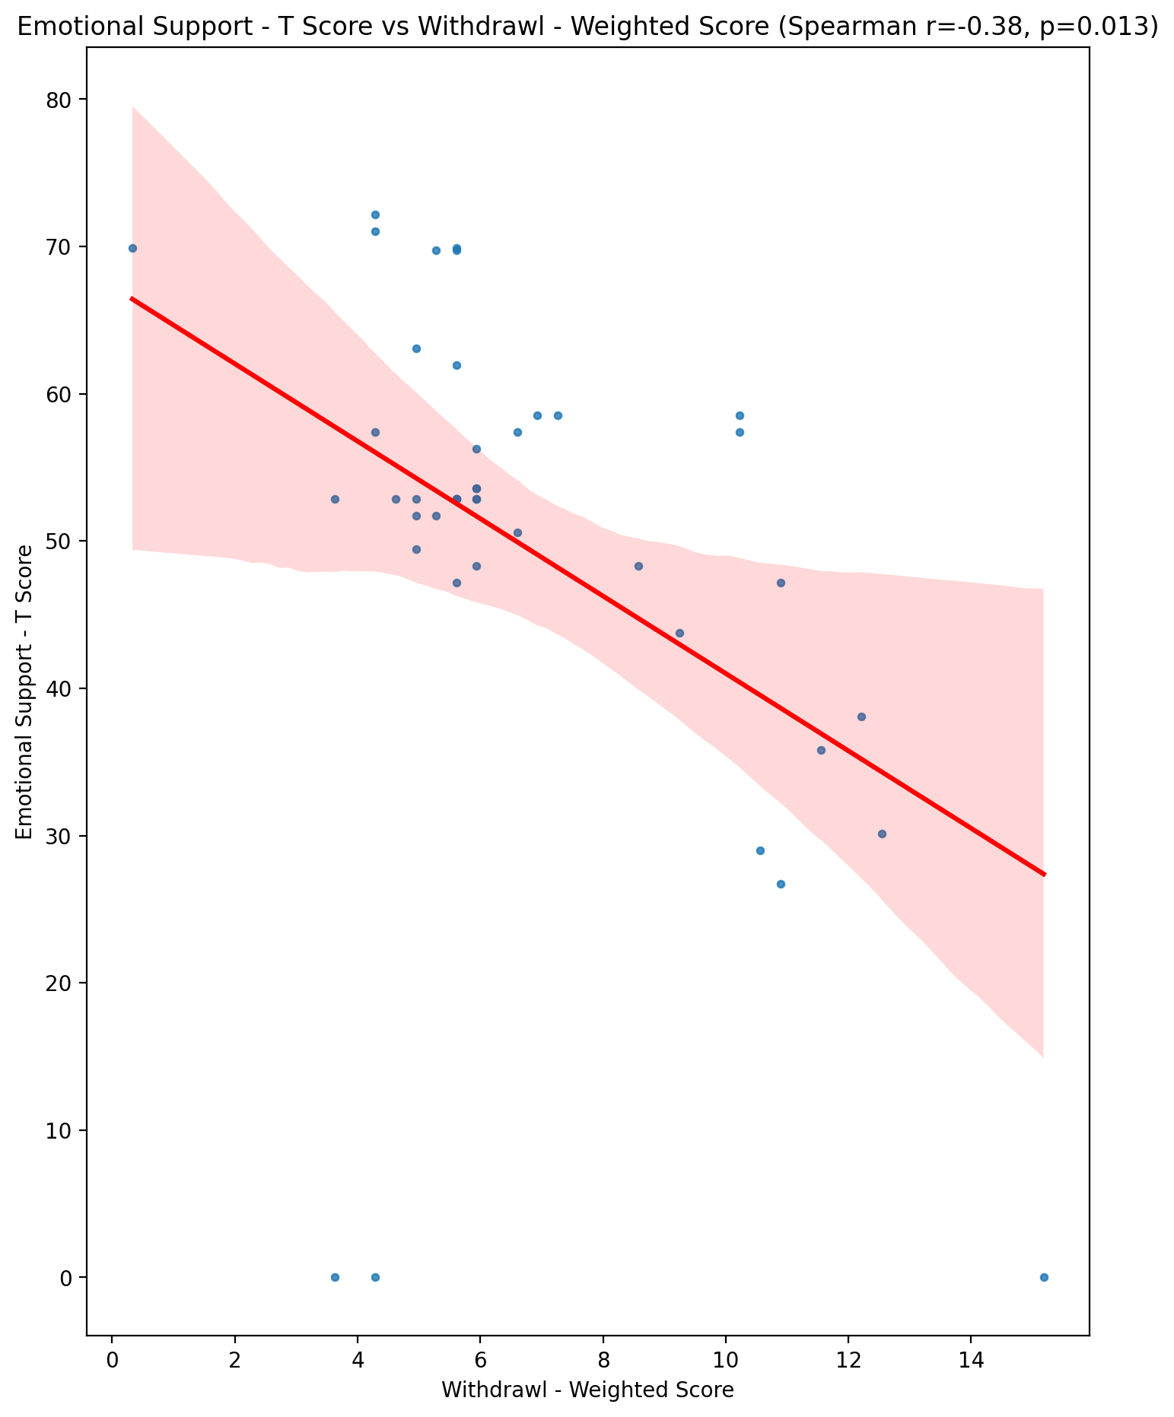

## Informational Support - T Score vs Withdrawl - Weighted Score

Test: spearman; statistic: -0.44805171770254093; p-value: 0.002586887954592931;

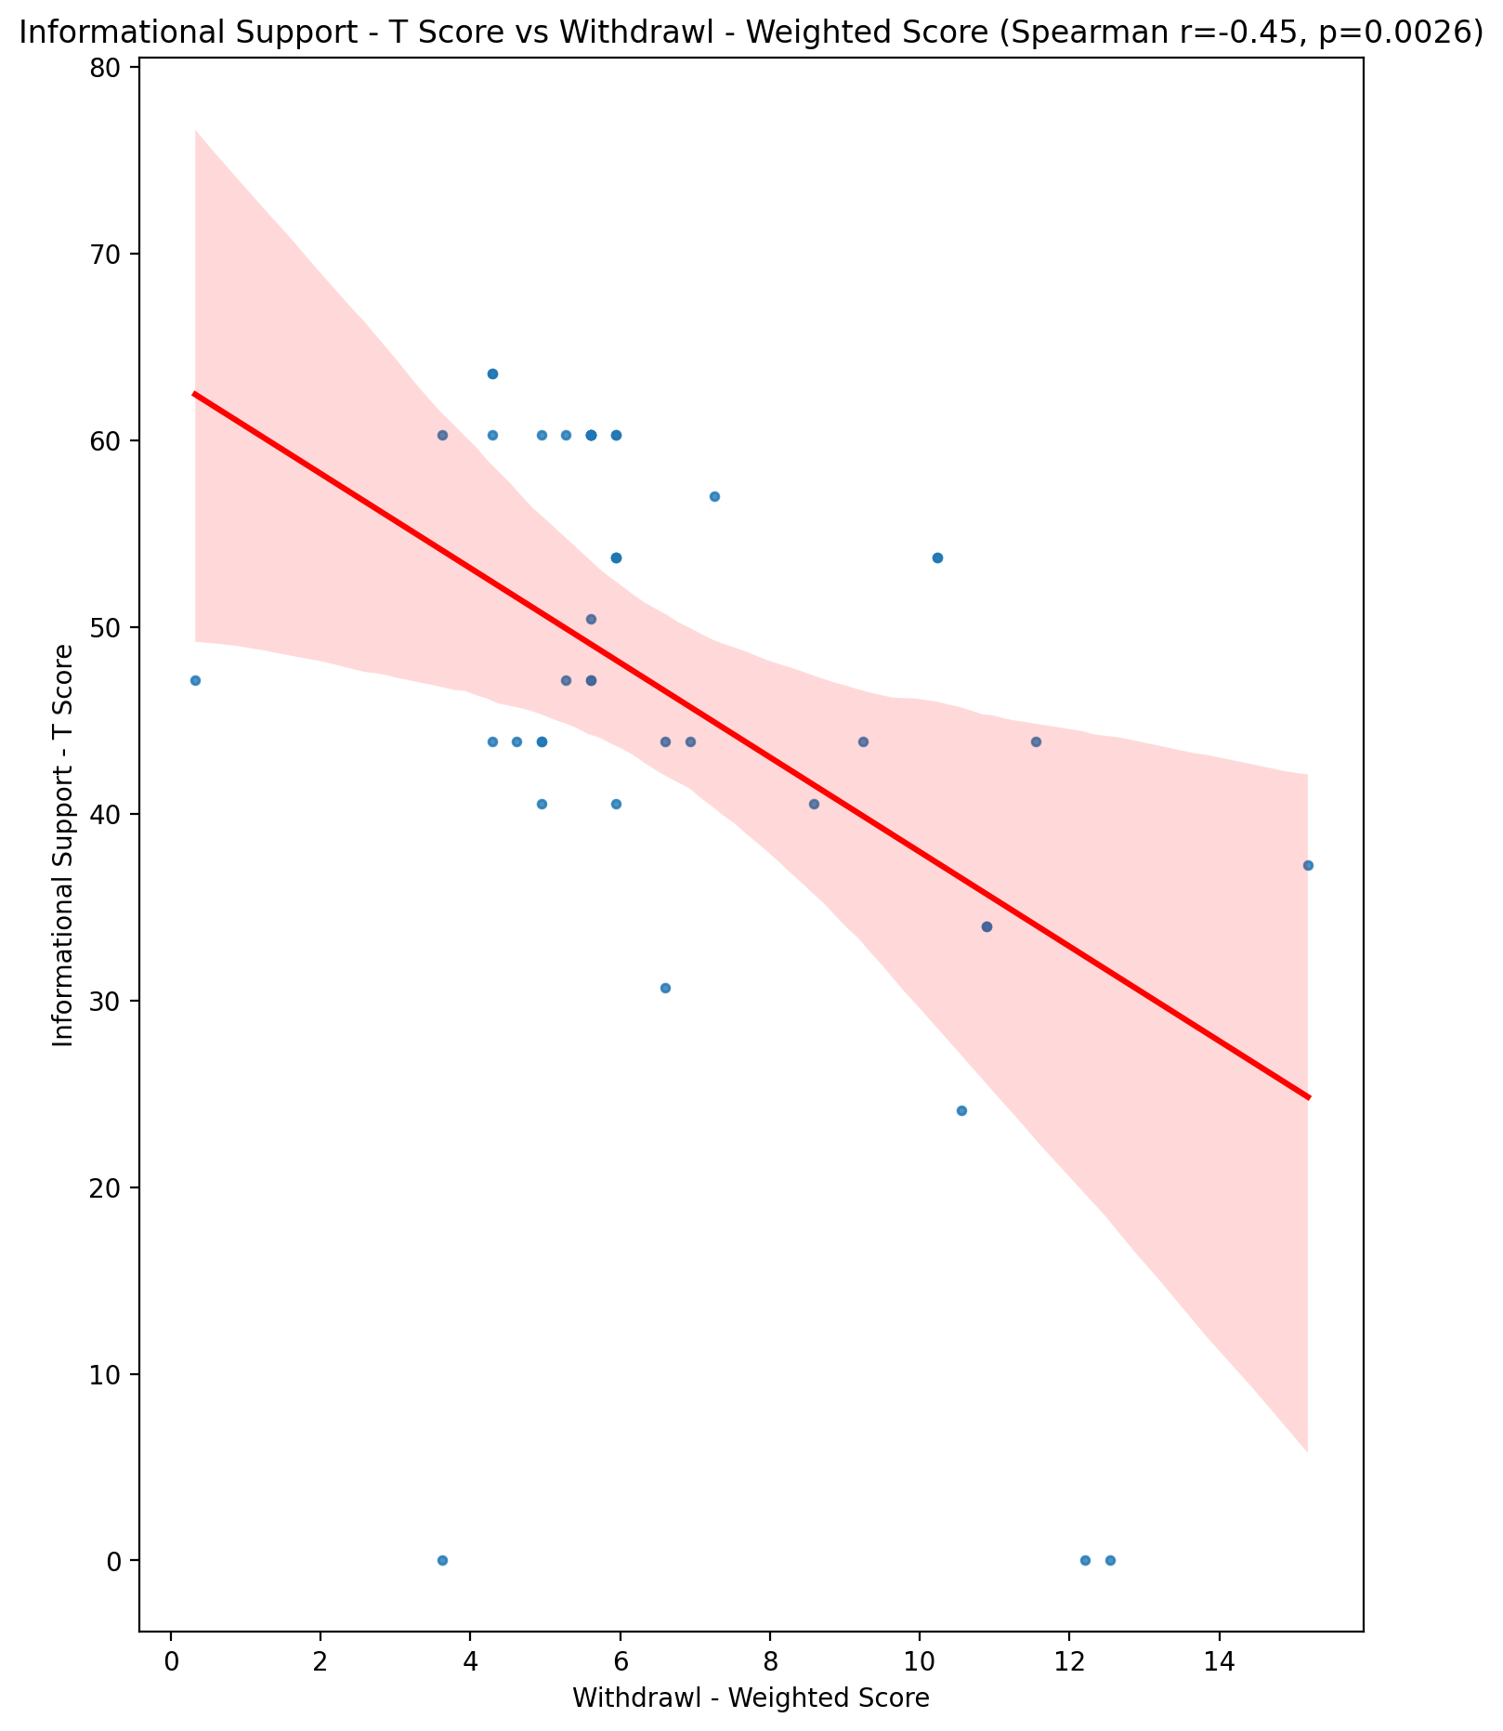

## Instrumental Support - T Score vs Withdrawl - Weighted Score

Test: spearman; statistic: -0.5426546771569922; p-value: 0.00017032802889979944;

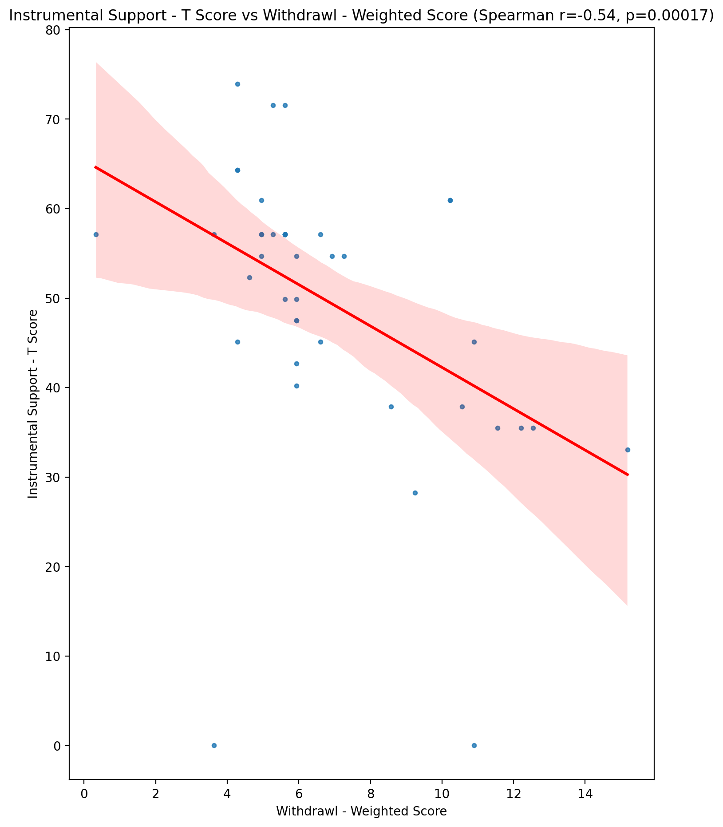

## Perceived Social Support Total T Score vs Withdrawl - Weighted Score

Test: spearman; statistic: -0.5264274817972828; p-value: 0.00028775713848645454;

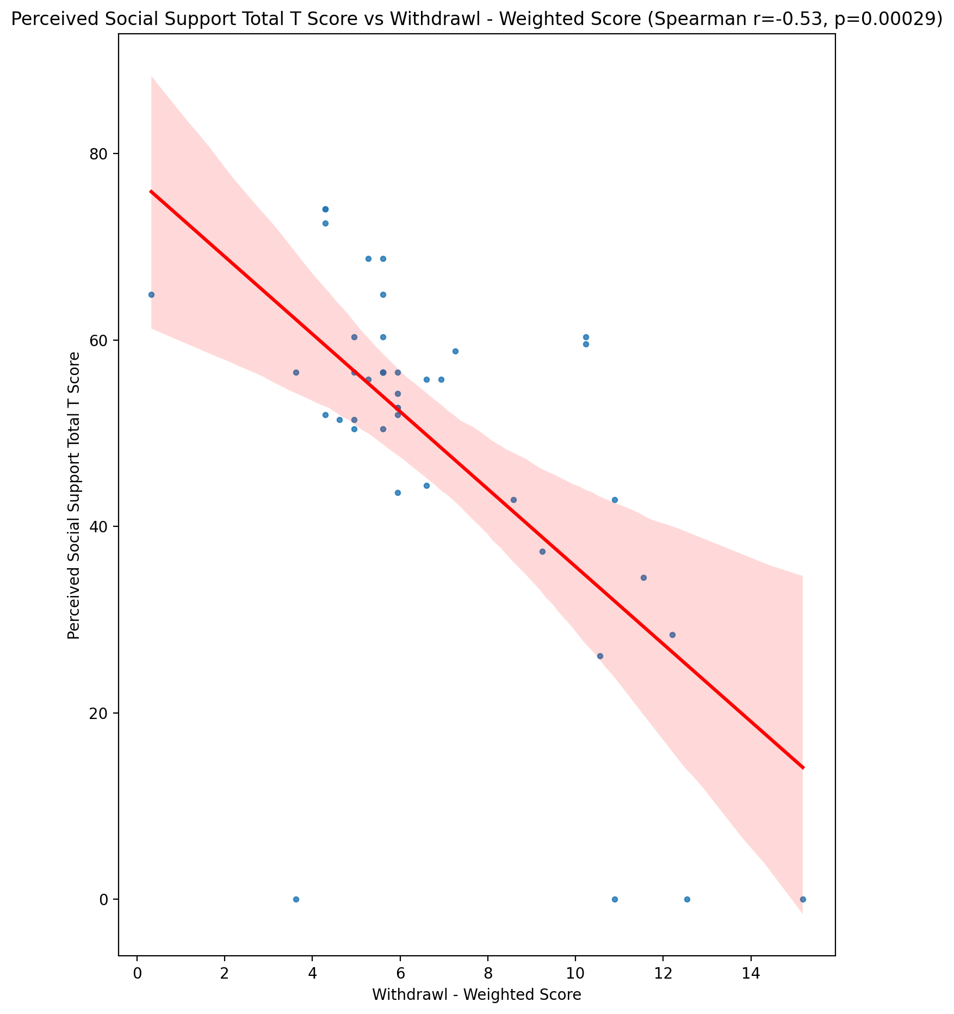

## Emotional Support - Rank vs Withdrawl - Weighted Score

Test: None; statistic: None; p-value: None; Test not run: unsupported type combination.



## Informational Support - Rank vs Withdrawl - Weighted Score

Test: None; statistic: None; p-value: None; Test not run: unsupported type combination.



## Instrumental Support - Rank vs Withdrawl - Weighted Score

Test: None; statistic: None; p-value: None; Test not run: unsupported type combination.



## Perceived Social Support TOTAL - Rank vs Withdrawl - Weighted Score

Test: None; statistic: None; p-value: None; Test not run: unsupported type combination.



## Power Self Concept - Real Self Concept Score vs Withdrawl - Weighted Score

Test: spearman; statistic: -0.12667307948334663; p-value: 0.4182607367776221;

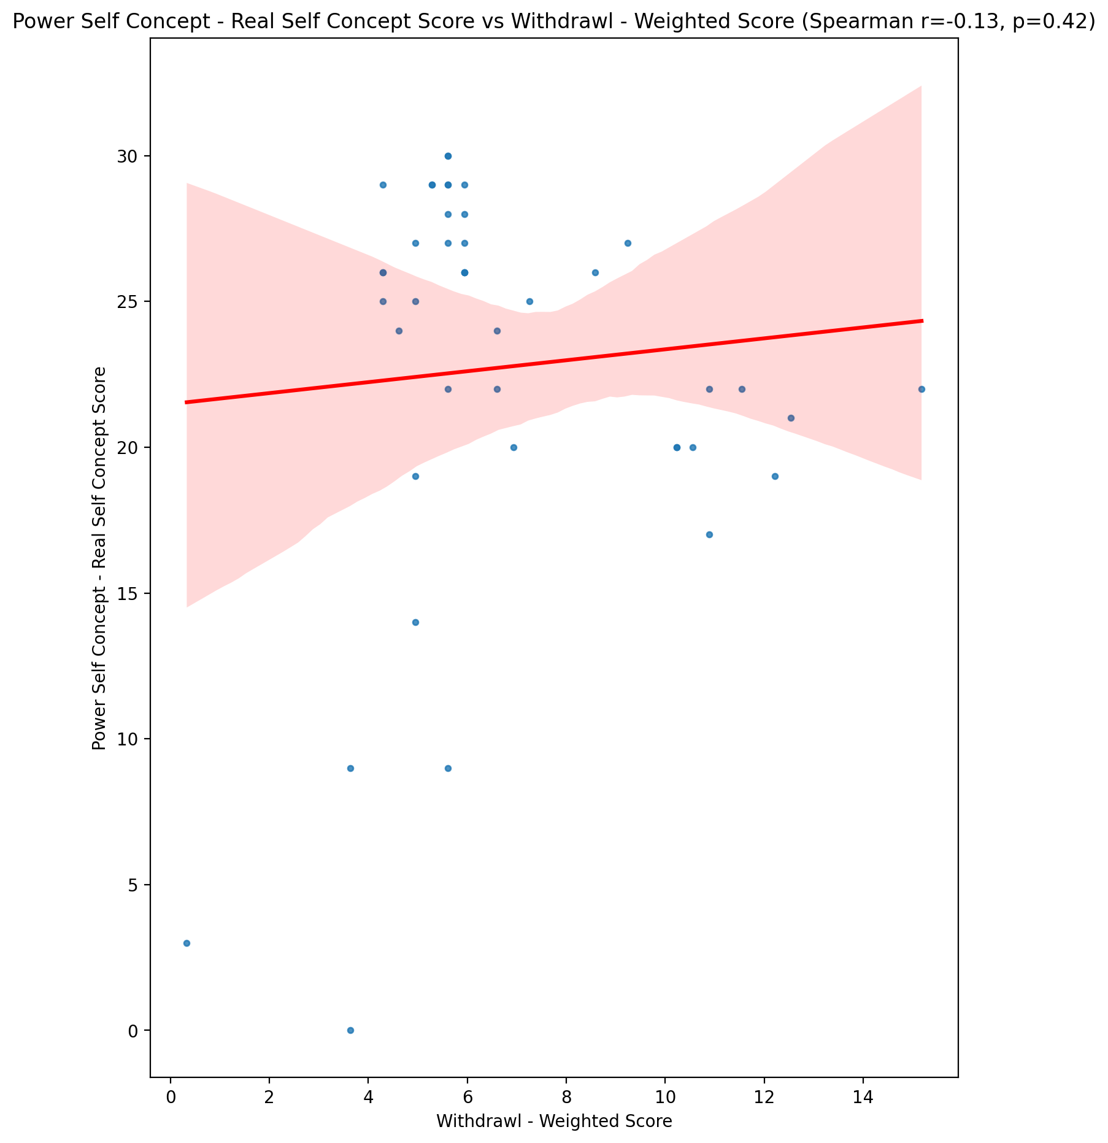

## Power Self Concept - Ideal Self Concept score vs Withdrawl - Weighted Score

Test: spearman; statistic: 0.019191094391355624; p-value: 0.9027823624452951;

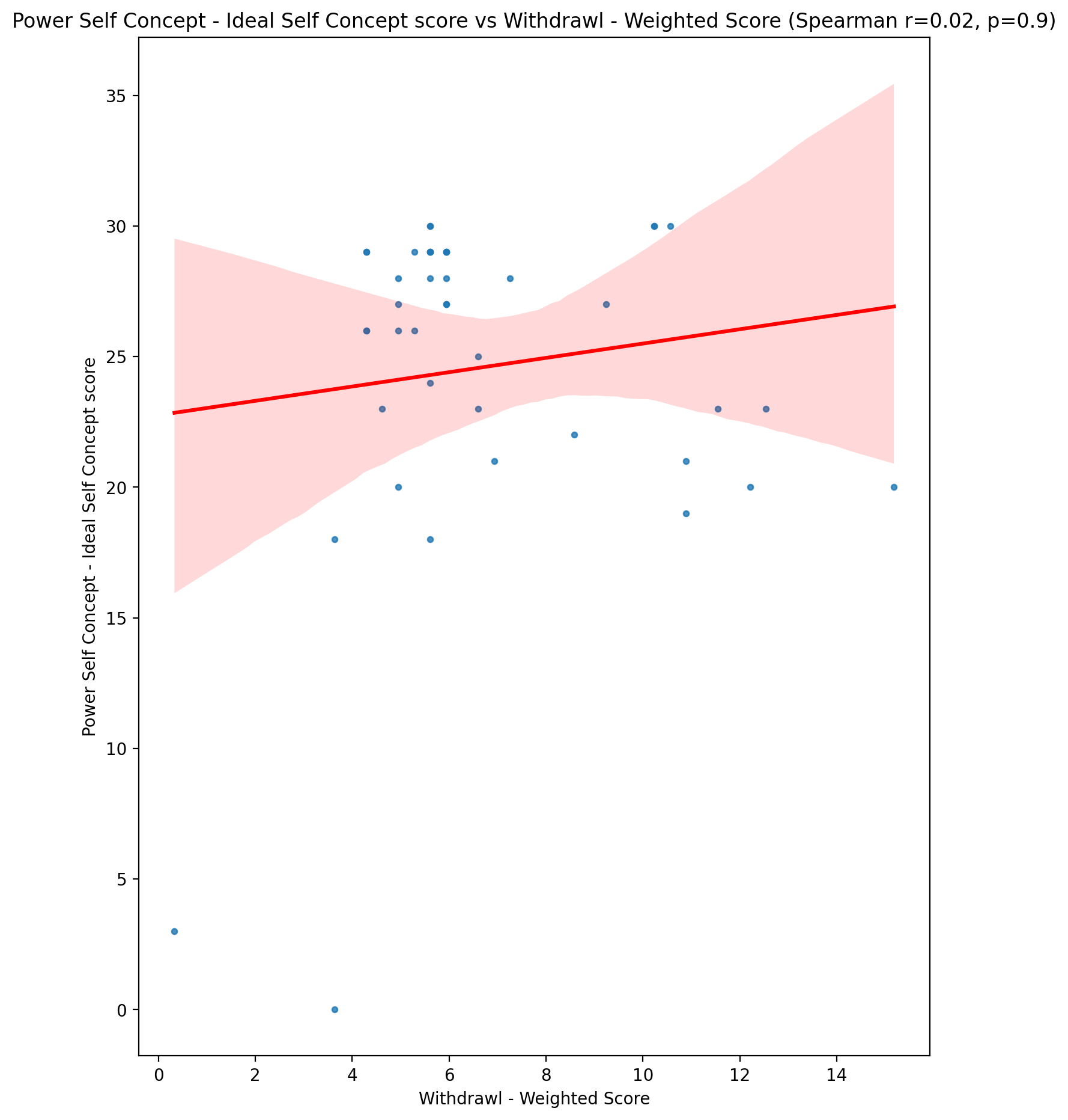

## Power Self Concept – Social Self Concept Score vs Withdrawl - Weighted Score

Test: spearman; statistic: -0.1427865558682239; p-value: 0.36102380034346504;

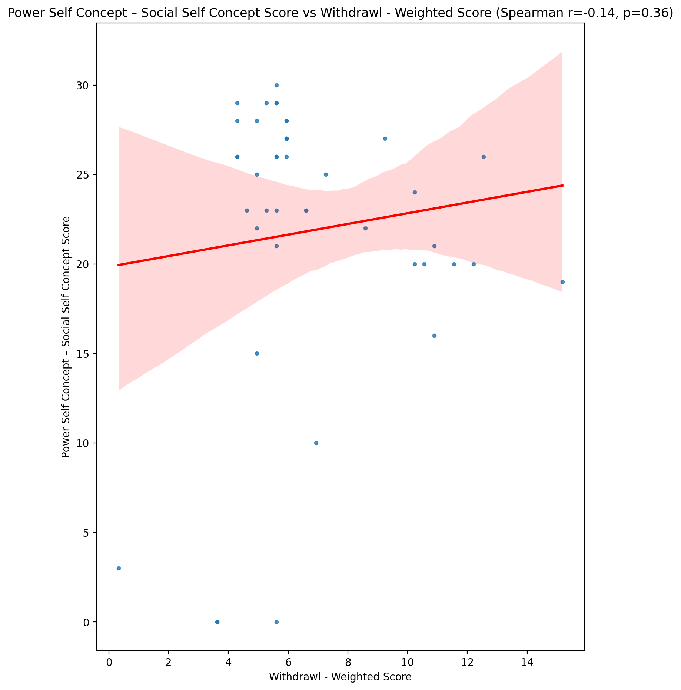

## Social Self Concept - Real Self Concept Score vs Withdrawl - Weighted Score

Test: spearman; statistic: -0.309342951690406; p-value: 0.04353559625988234;

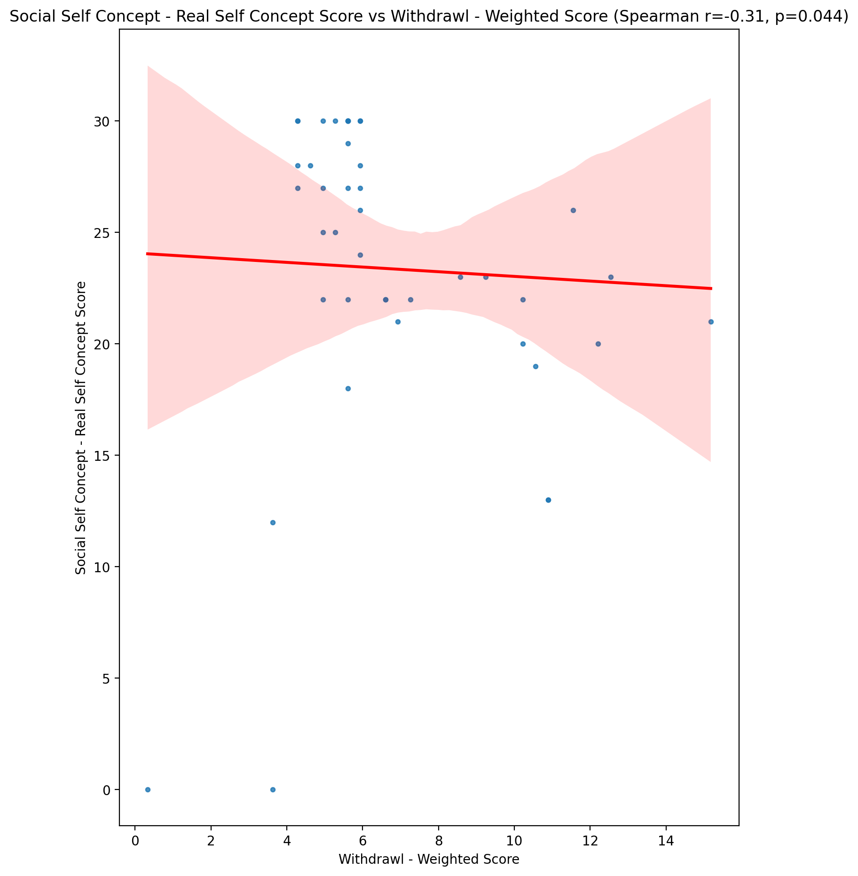

## Social Self Concept – Social Self Concept Score vs Withdrawl - Weighted Score

Test: spearman; statistic: -0.2585180280721134; p-value: 0.09415970402266327;

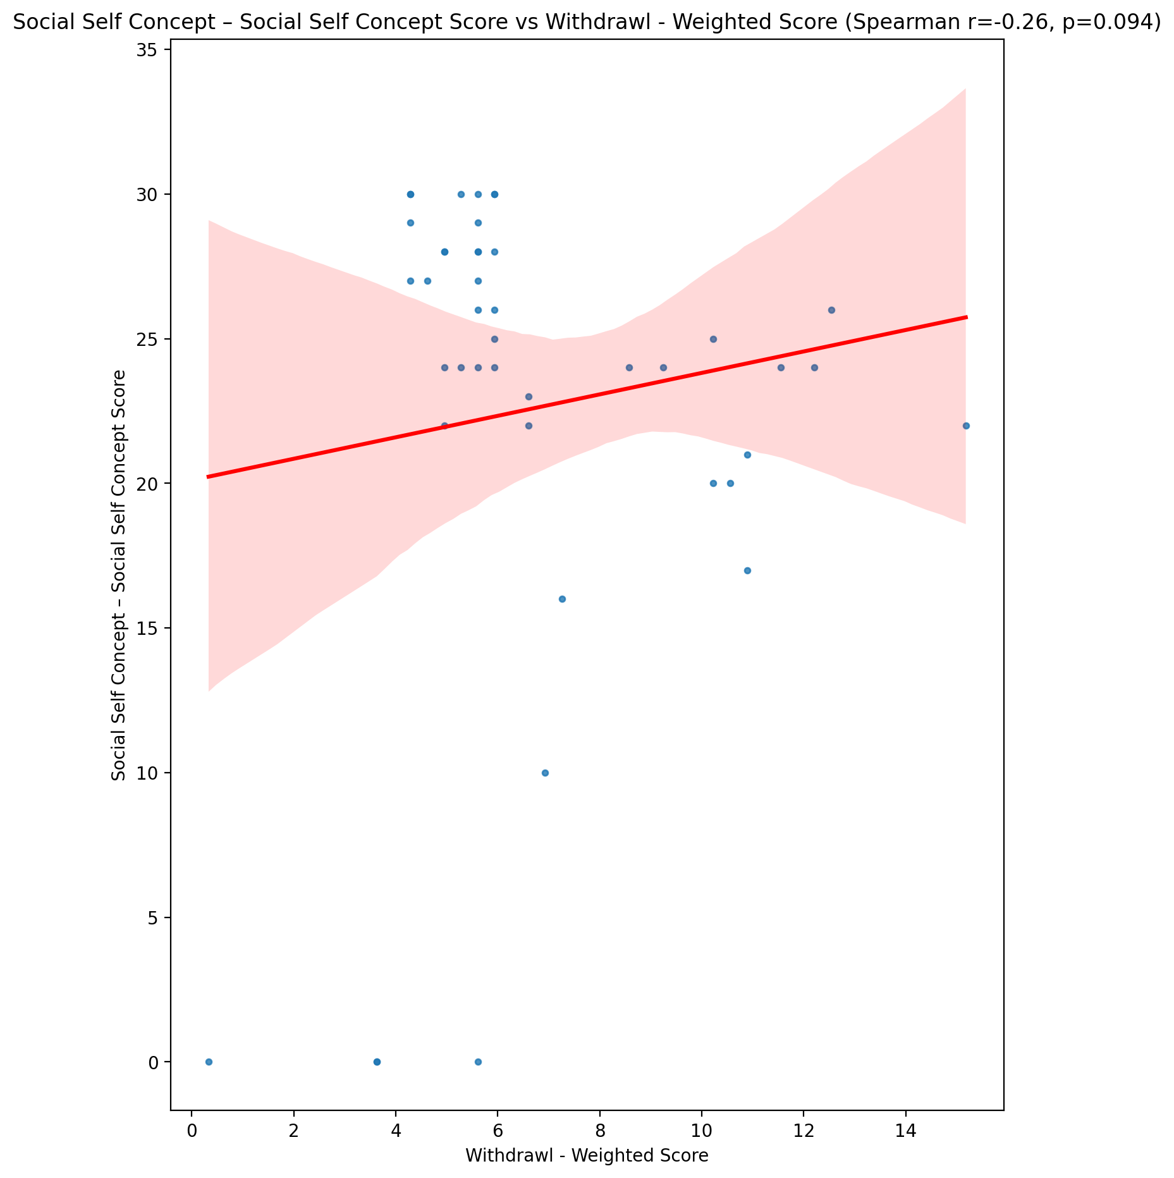

## Ability Self Concept - Real Self Concept Score vs Withdrawl - Weighted Score

Test: spearman; statistic: -0.18204706768603213; p-value: 0.24265340421702655;

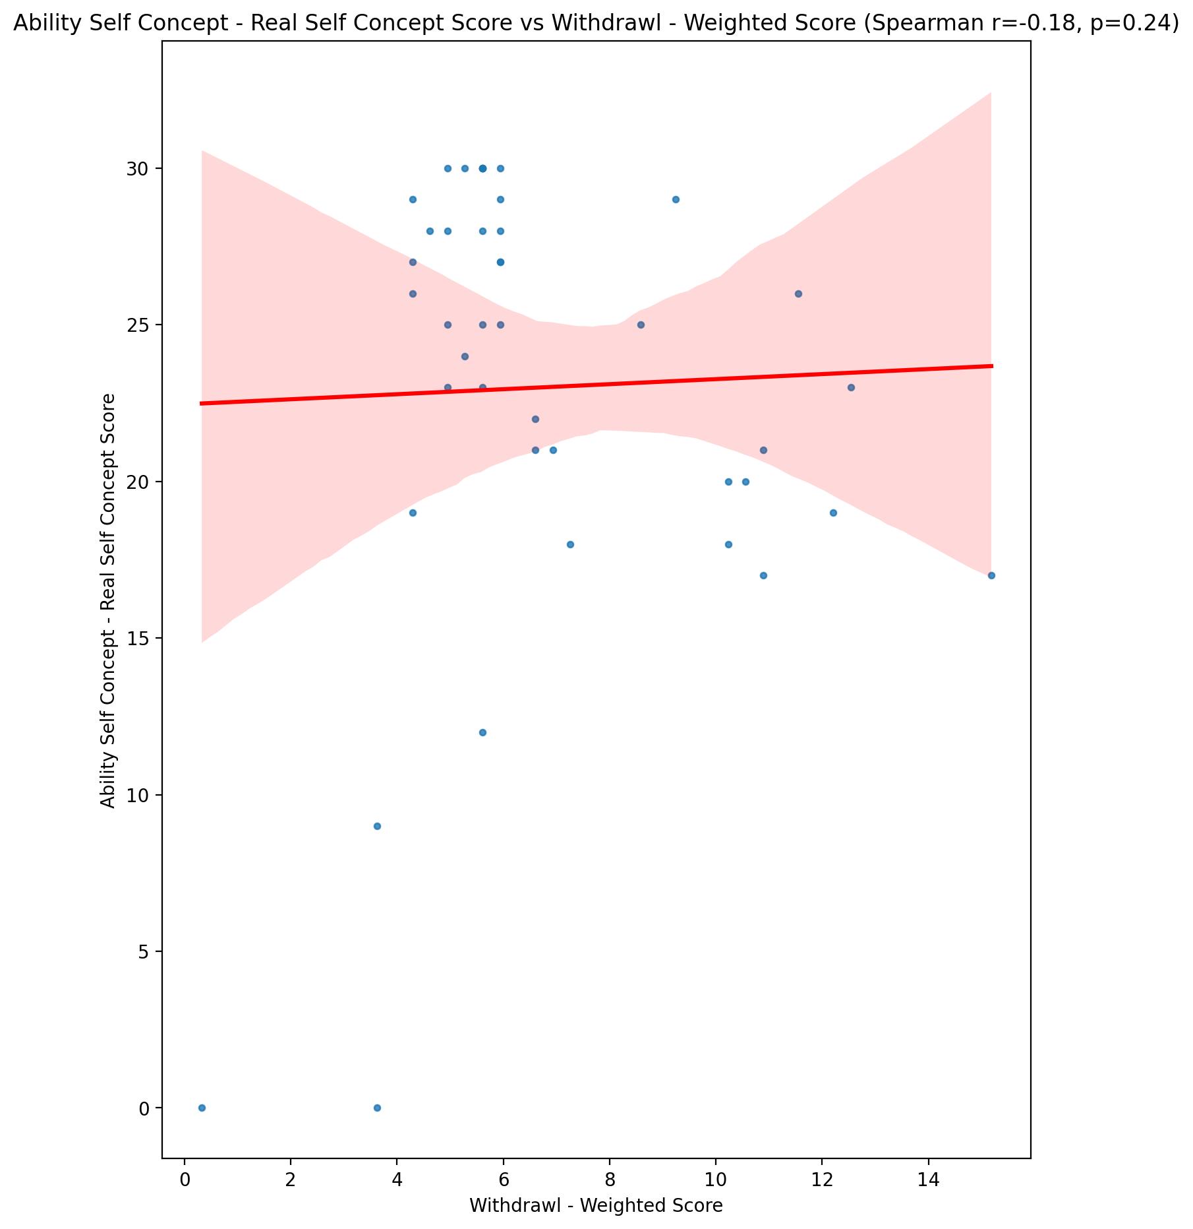

## Ability Self Concept - Ideal Self Concept Score vs Withdrawl - Weighted Score

Test: spearman; statistic: -0.04356303858500495; p-value: 0.7814914232725052;

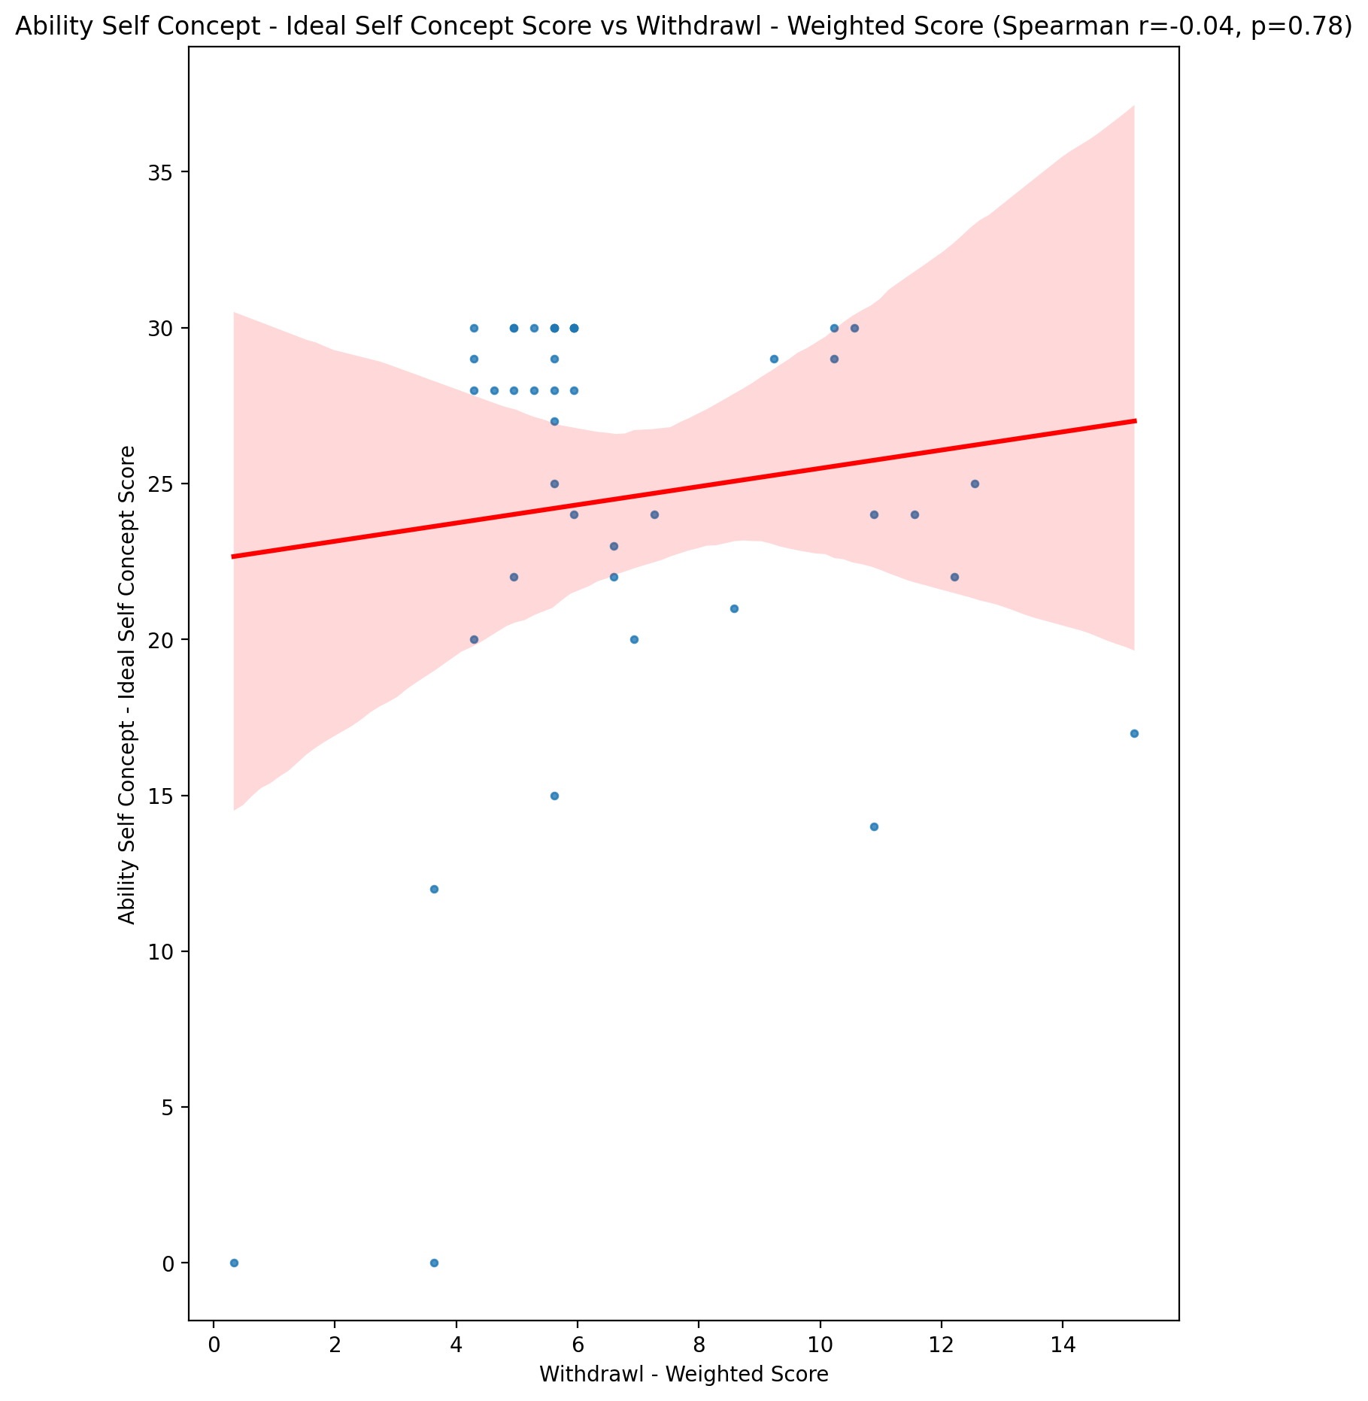

## Ability Self Concept – Social Self Concept Score vs Withdrawl - Weighted Score

Test: spearman; statistic: -0.1562313120846687; p-value: 0.317093110960217;

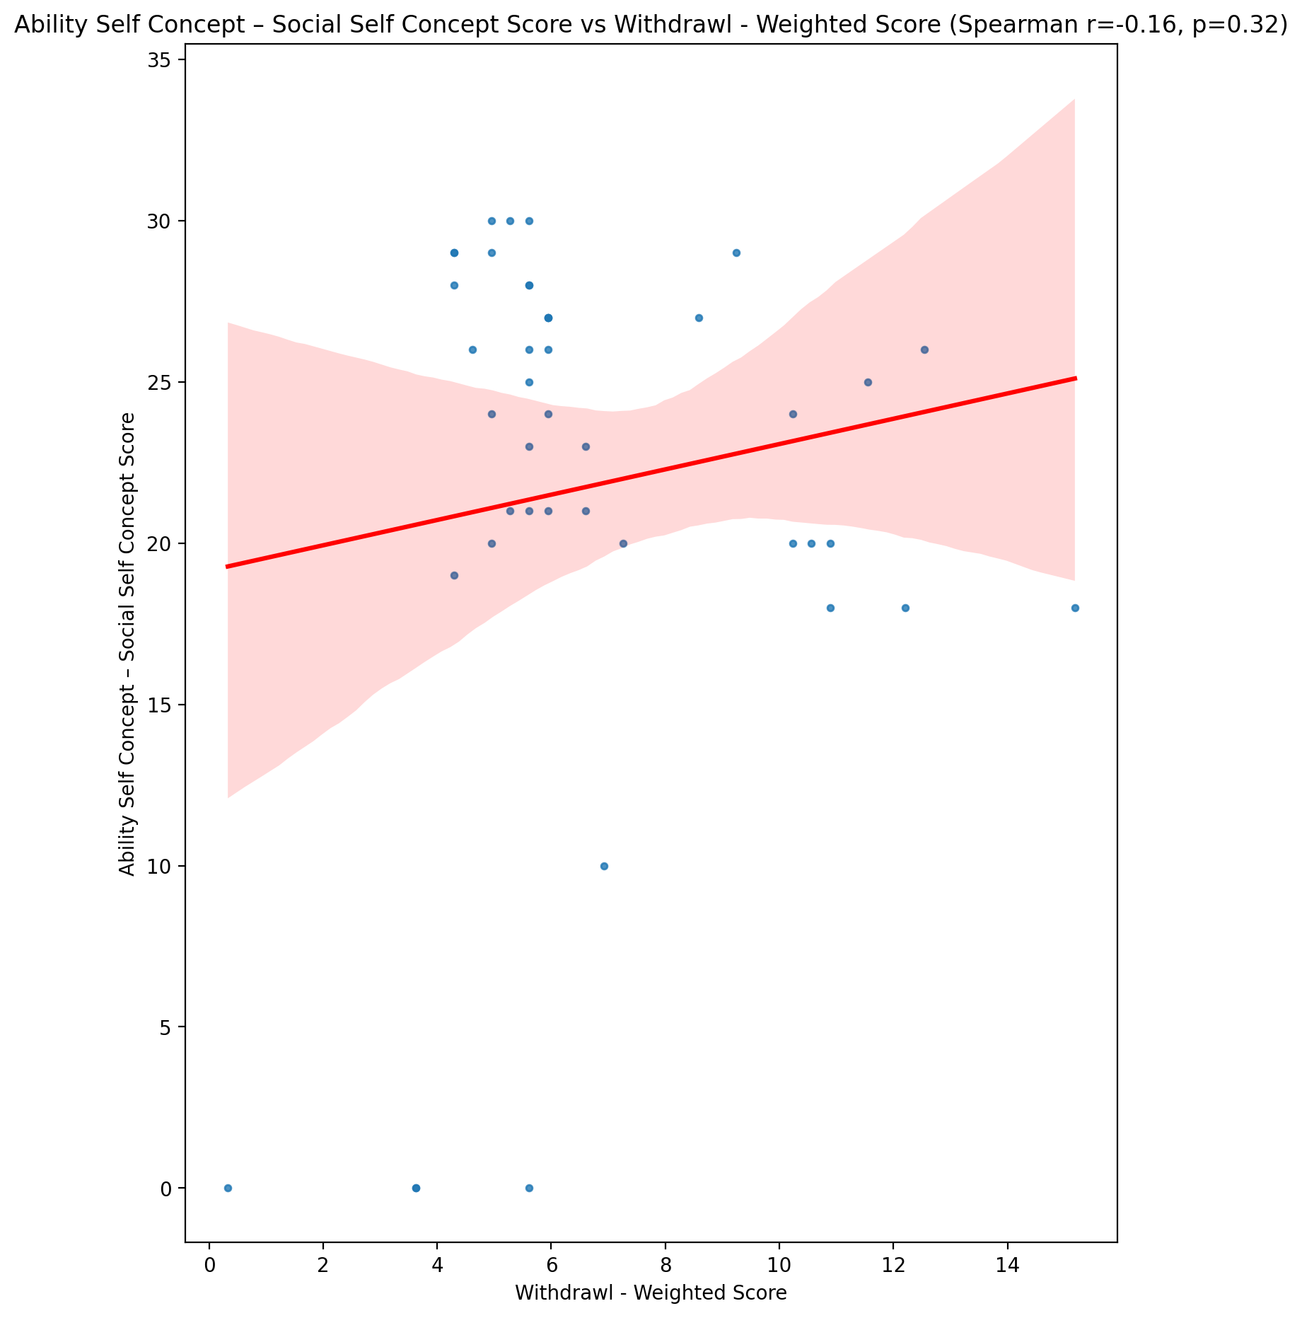

## Physical Self Concept - Real Self Concept Score vs Withdrawl - Weighted Score

Test: spearman; statistic: -0.18048298866224532; p-value: 0.24679351234820598;

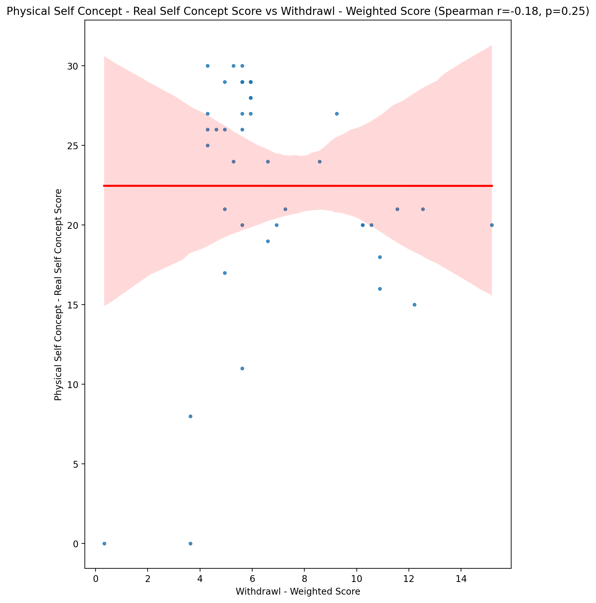

## Physical Self Concept – Ideal Self Concept Score vs Withdrawl - Weighted Score

Test: spearman; statistic: -0.03158627445854503; p-value: 0.8406424741059877;

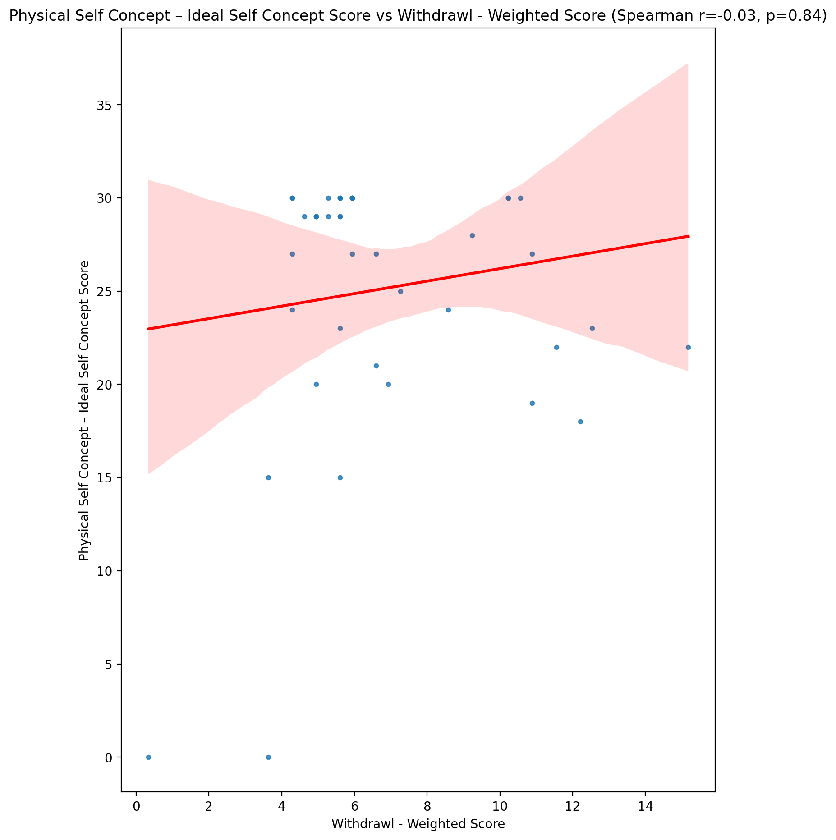

## Physical Self Concept – Social Self Concept Score vs Withdrawl - Weighted Score

Test: spearman; statistic: -0.03565437734774918; p-value: 0.8204361653809452;

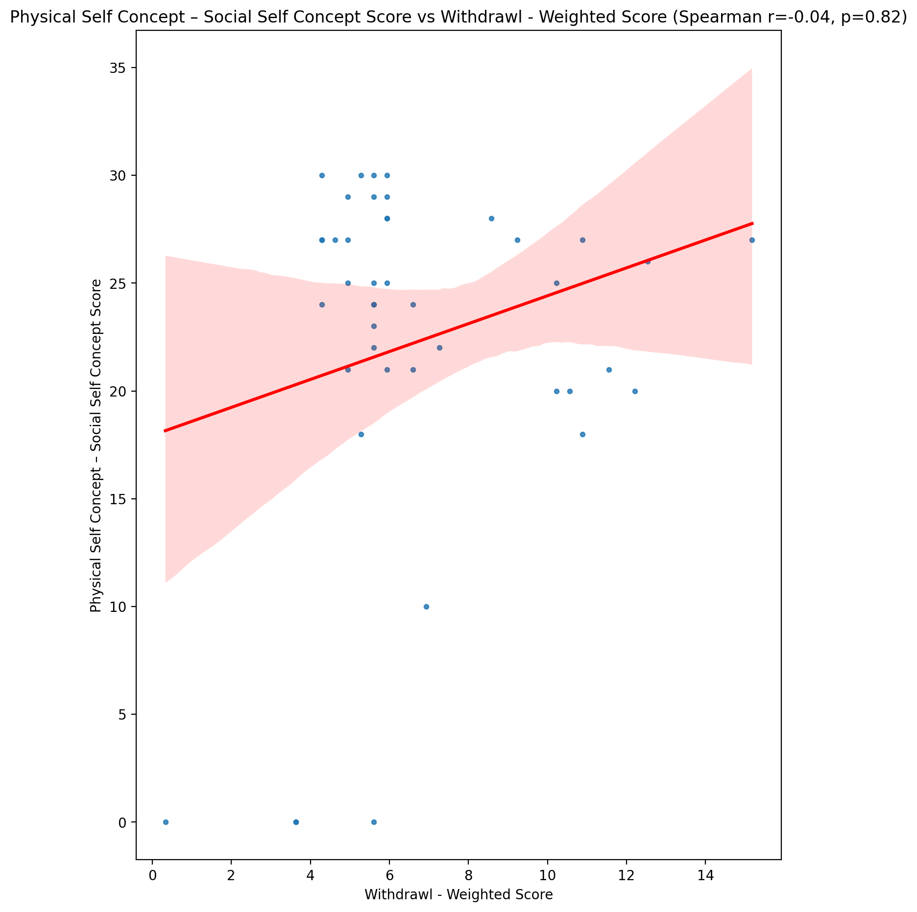

## Psychological Self Concept - Real Self Concept Score vs Withdrawl - Weighted Score

Test: spearman; statistic: -0.29842167585870255; p-value: 0.05192390607502403;

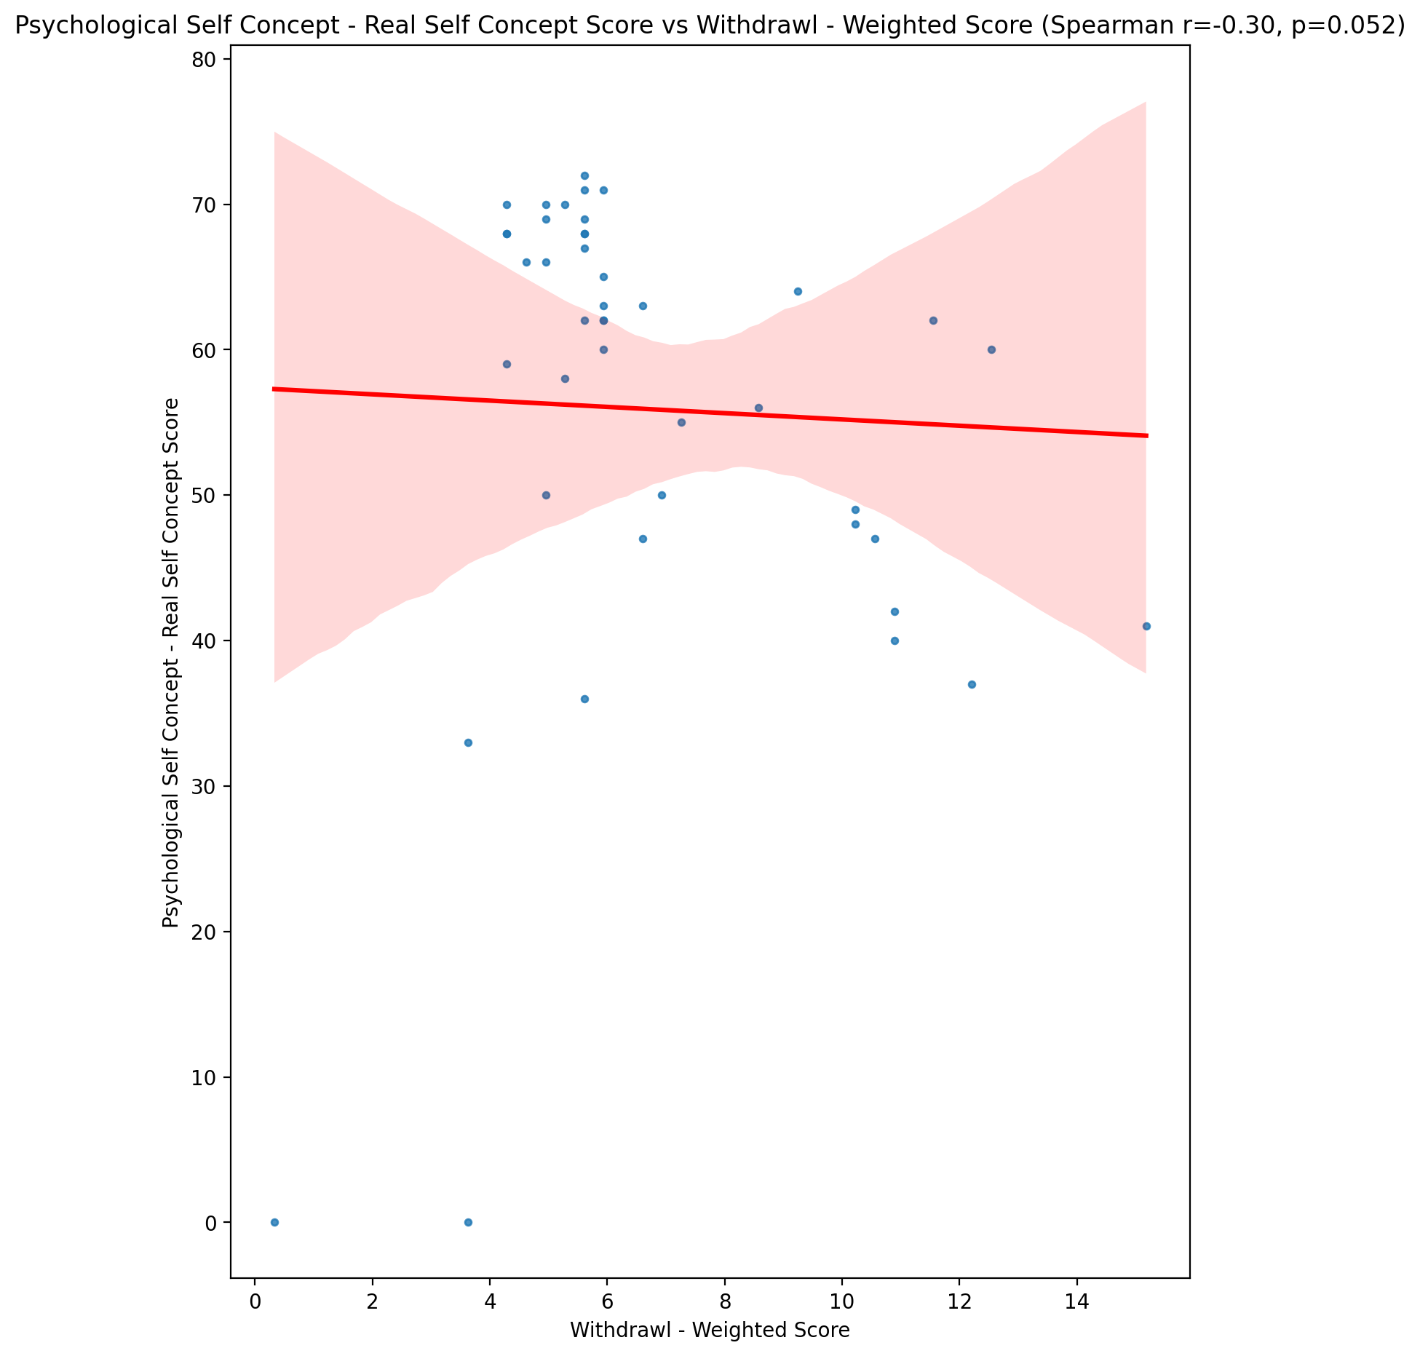

## Psychological Self Concept – Ideal Self Concept Score vs Withdrawl - Weighted Score

Test: spearman; statistic: -0.06648913014182746; p-value: 0.671842890433694;

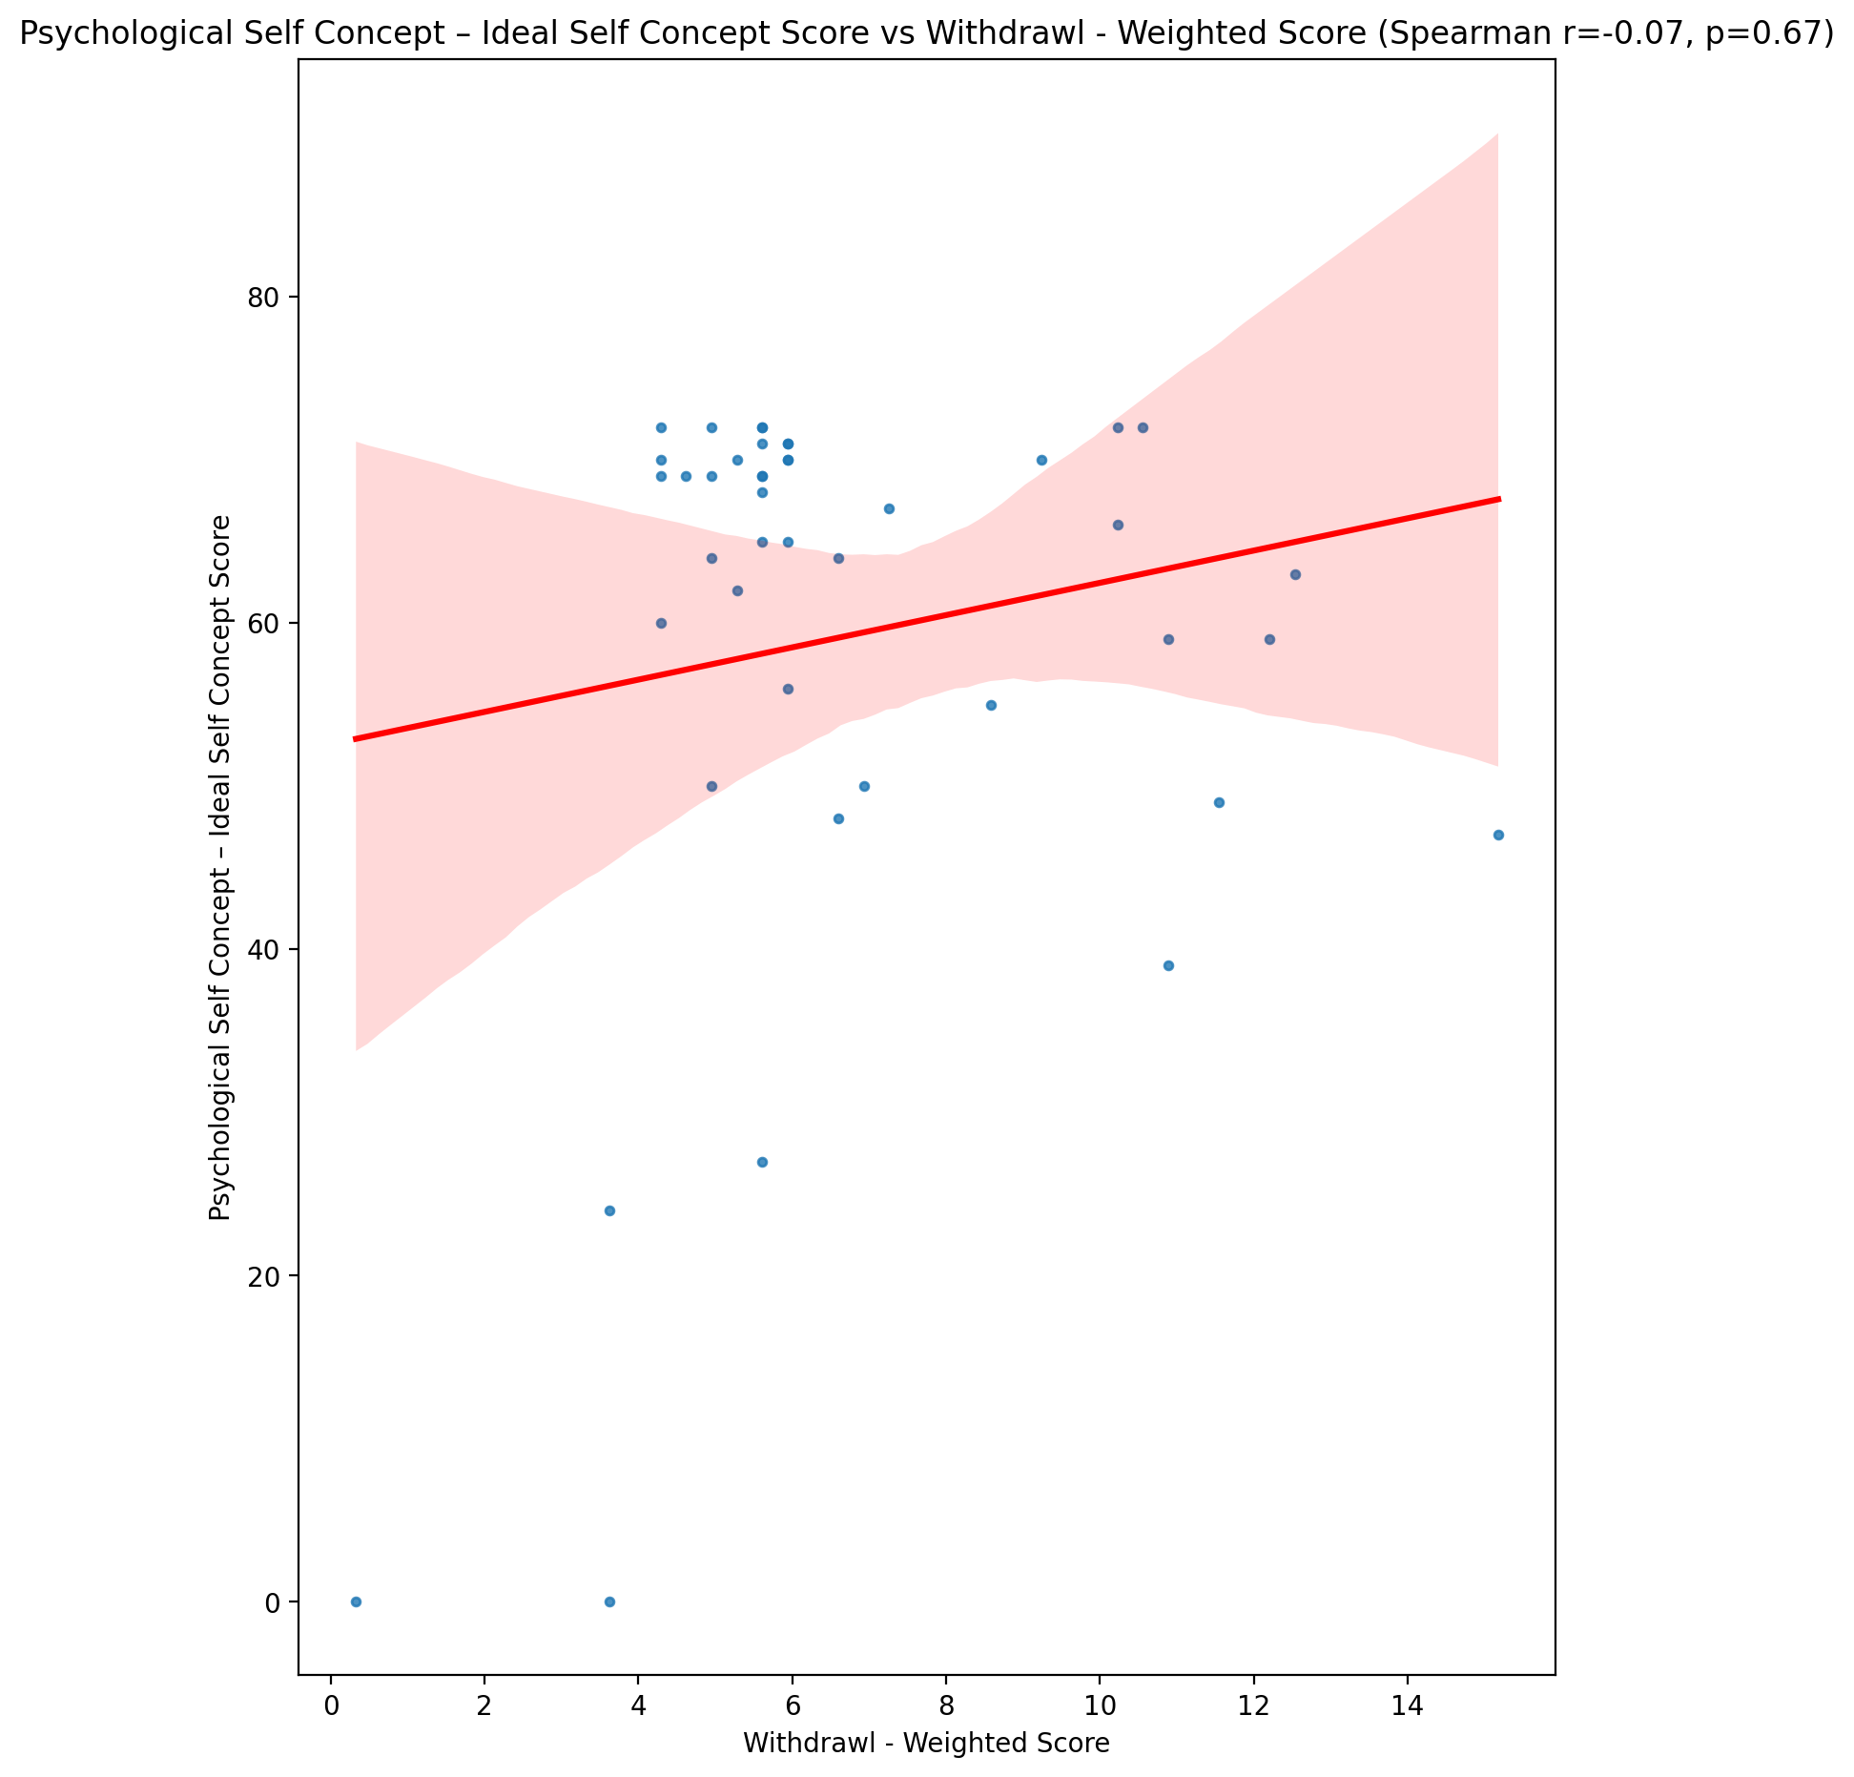

## Psychological Self Concept – Social Self Concept Score vs Withdrawl - Weighted Score

Test: spearman; statistic: -0.26711219703308187; p-value: 0.08334906203200844;

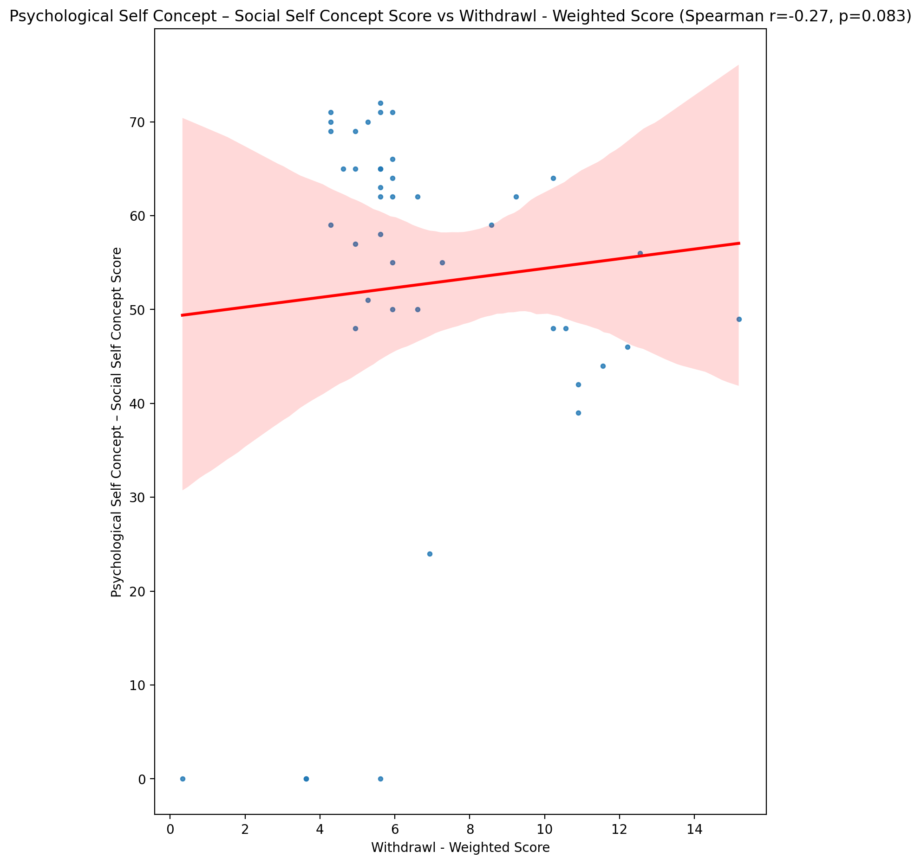

## Real Self Concept Total Score vs Withdrawl - Weighted Score

Test: spearman; statistic: -0.2737388184588309; p-value: 0.07569471857054497;

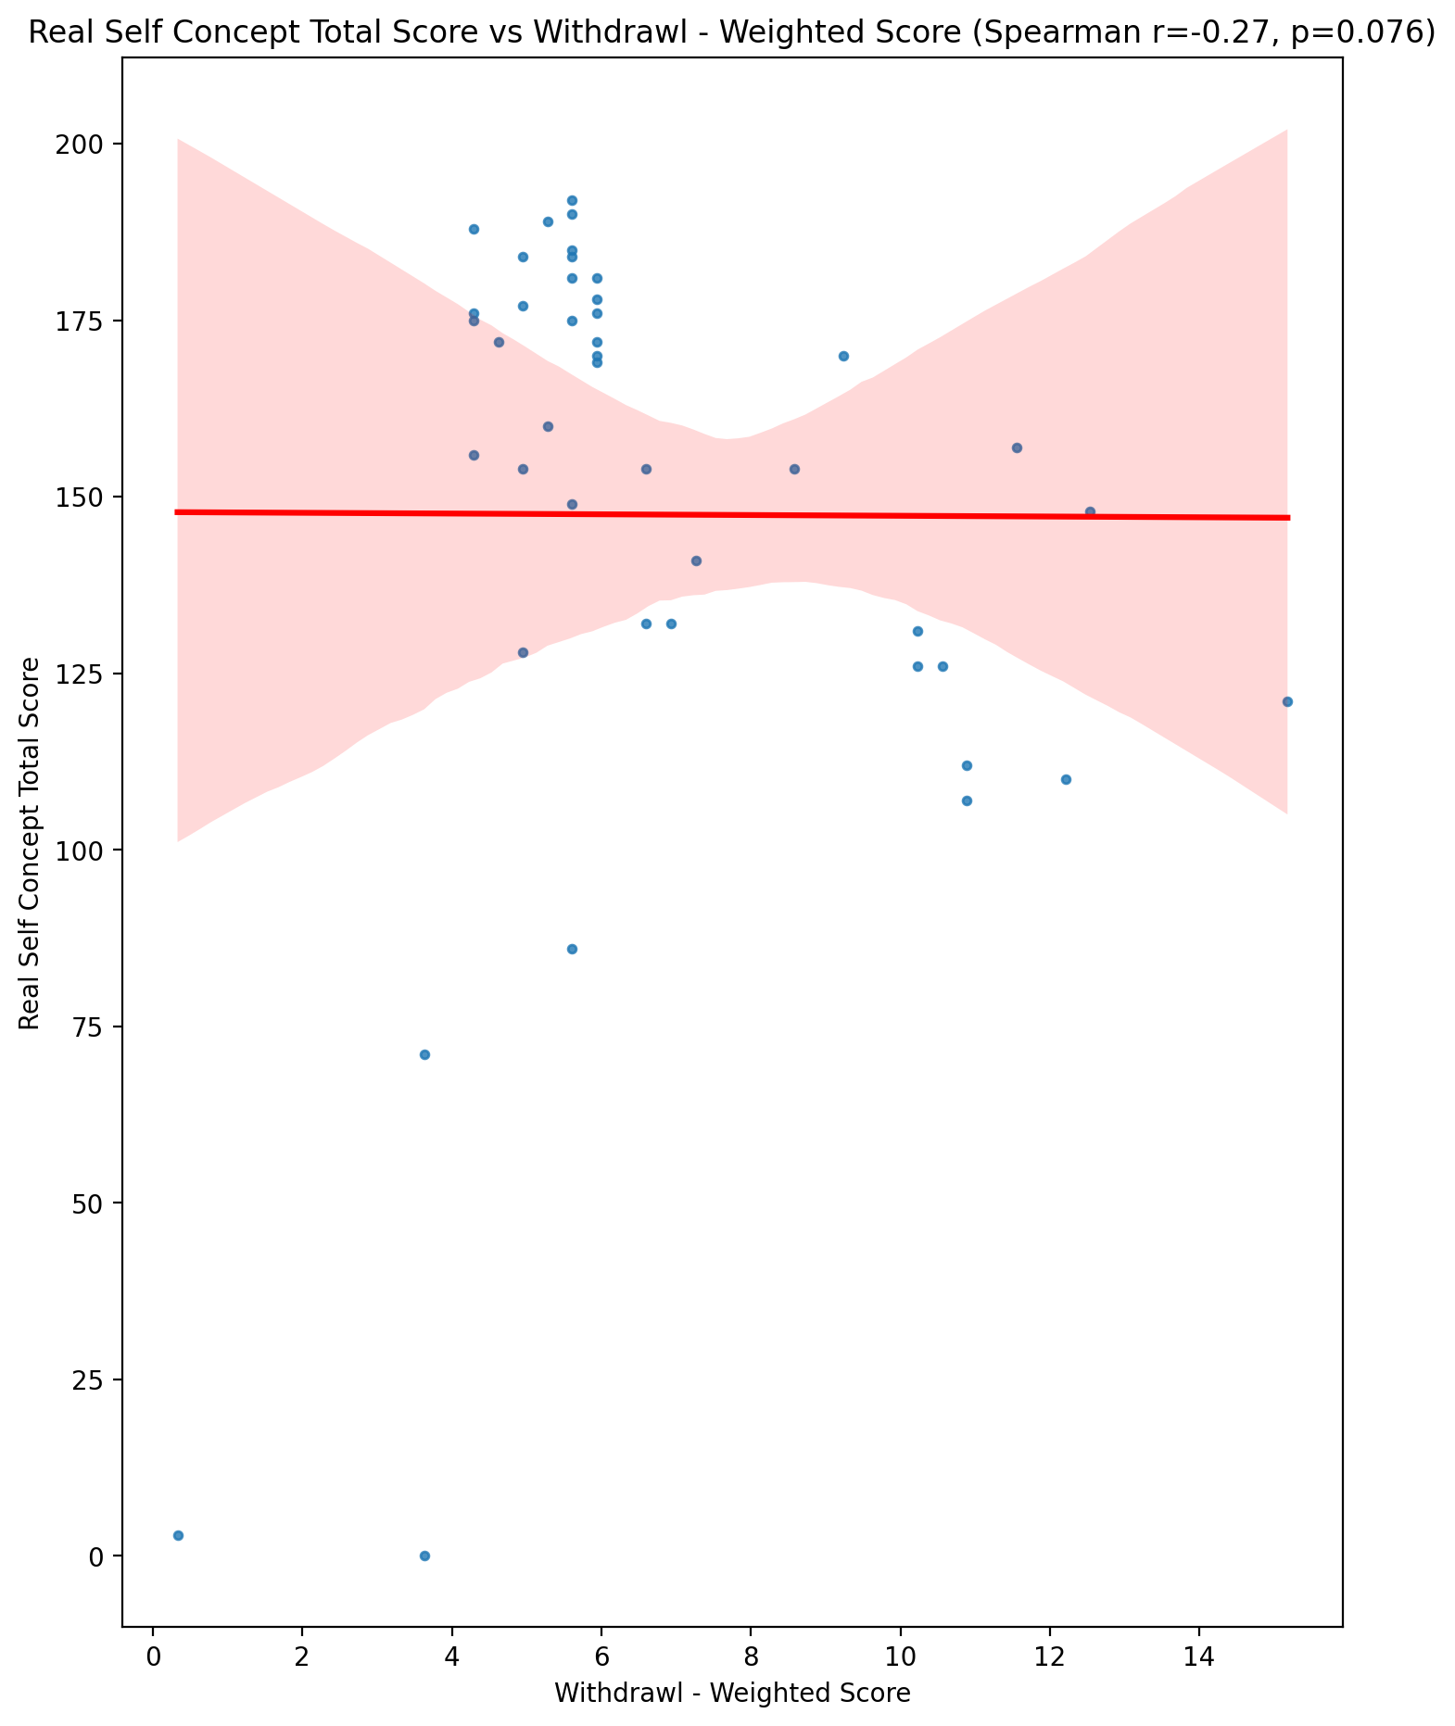

## Ideal Self Concept Total Score vs Withdrawl - Weighted Score

Test: spearman; statistic: -0.07166817320054929; p-value: 0.6478871493839404;

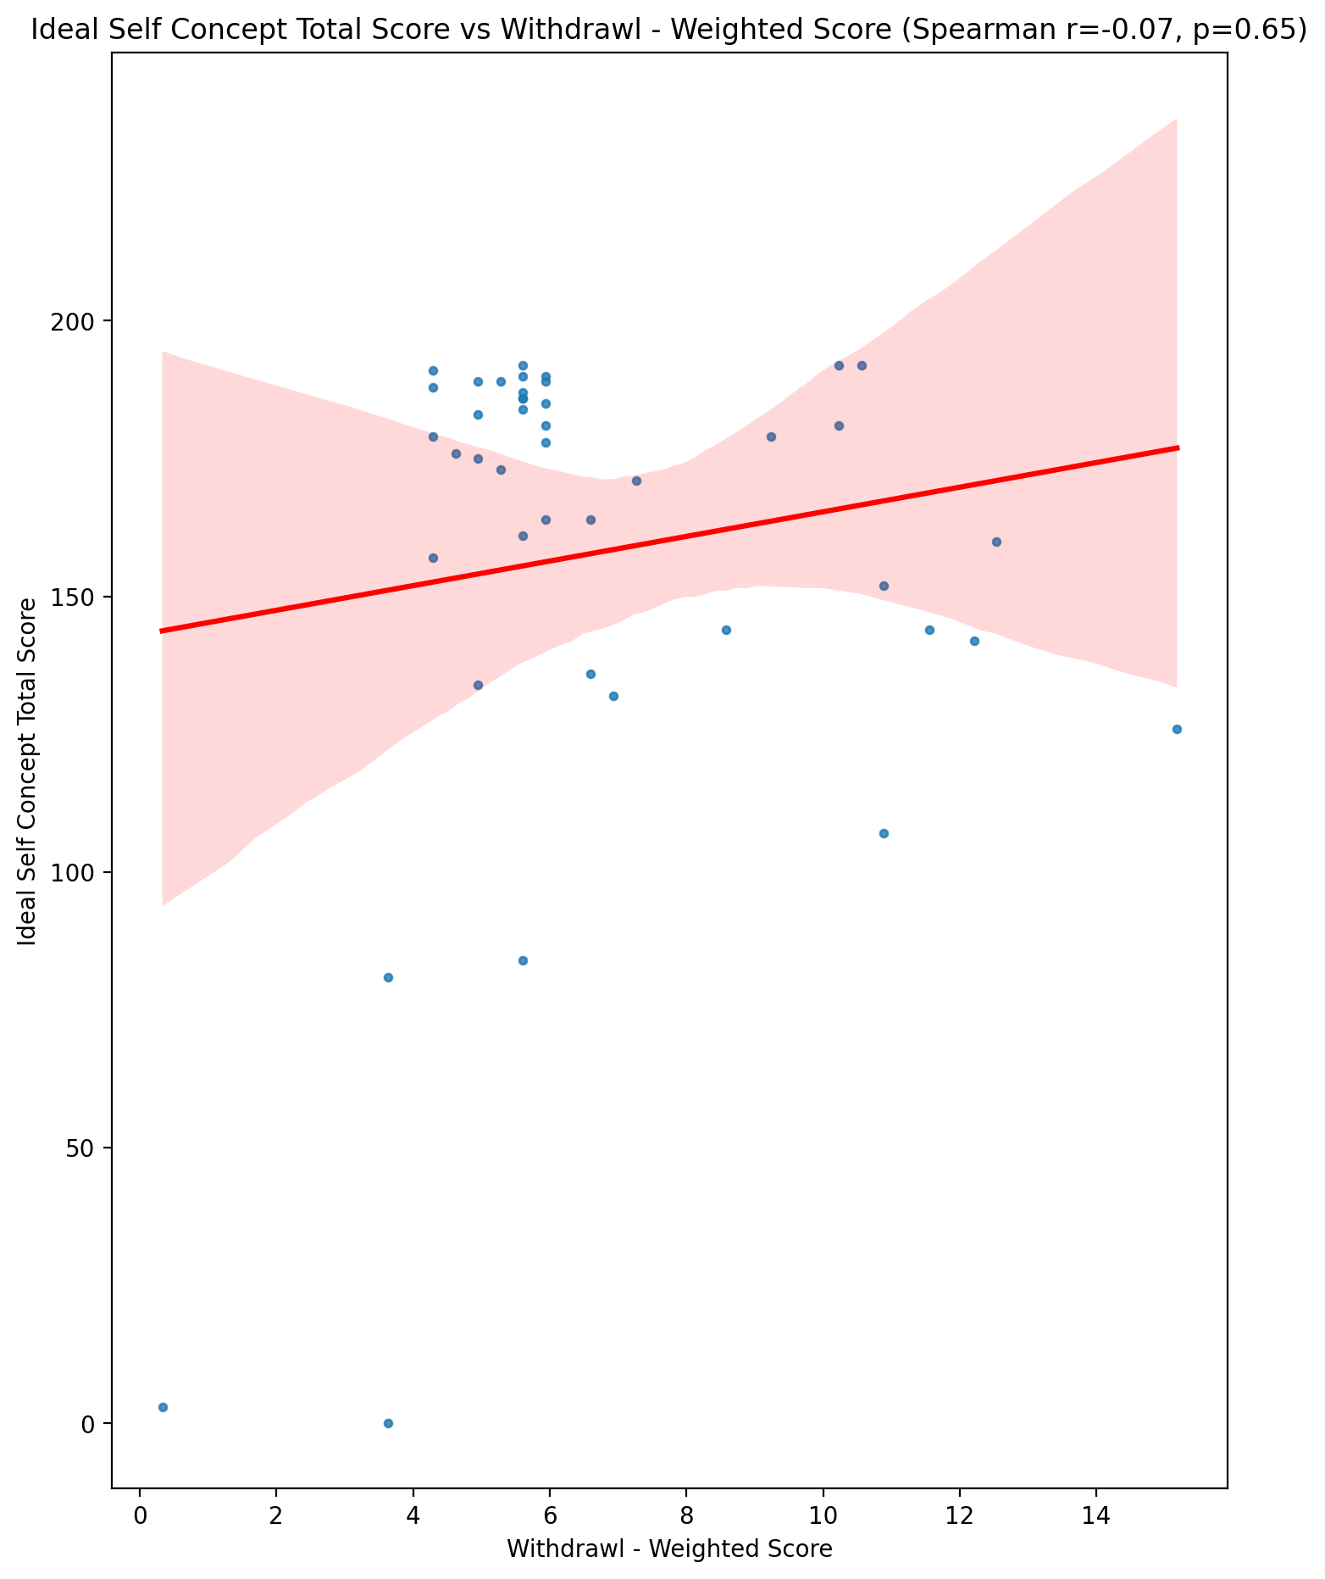

## Social Self Concept Total Score vs Withdrawl - Weighted Score

Test: spearman; statistic: -0.21156233844147287; p-value: 0.1732292830418637;

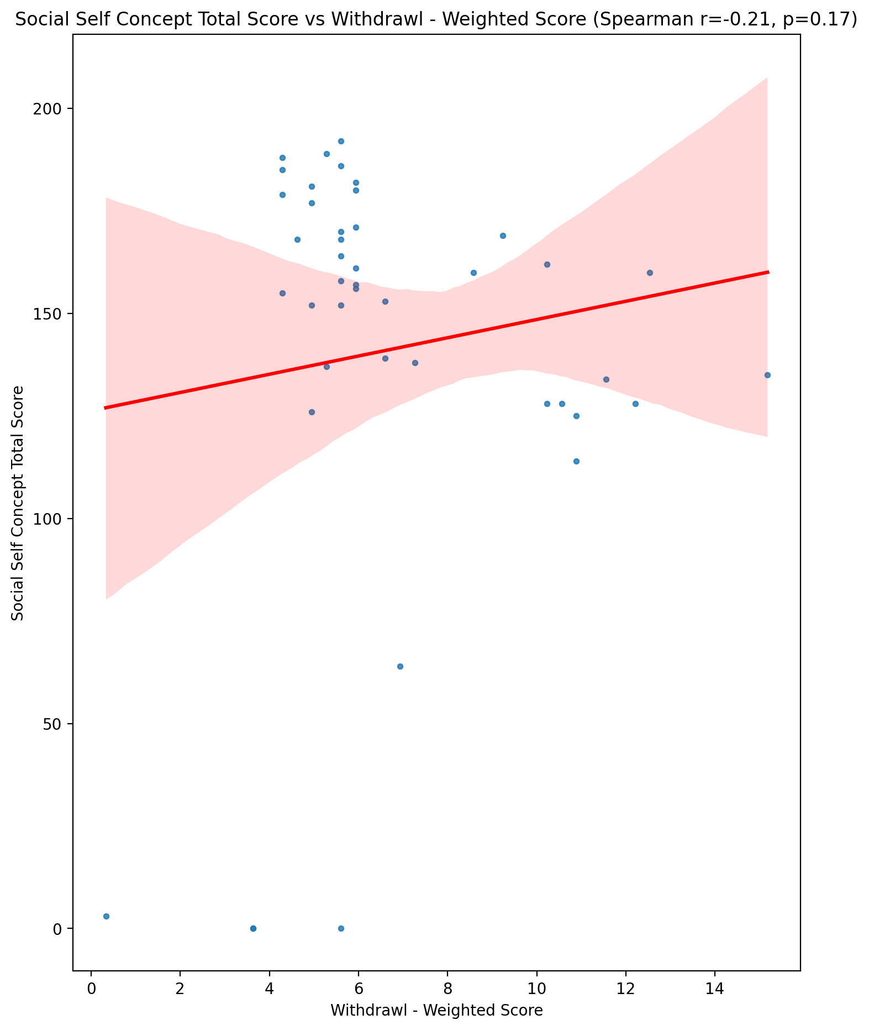

## Ideal Self Concept Total Category vs Withdrawl - Weighted Score

Test: None; statistic: None; p-value: None; Test not run: unsupported type combination.



## Perceived Social Stress Score vs Withdrawl - Weighted Score

Test: spearman; statistic: 0.35939201389643727; p-value: 0.017936155835435293;

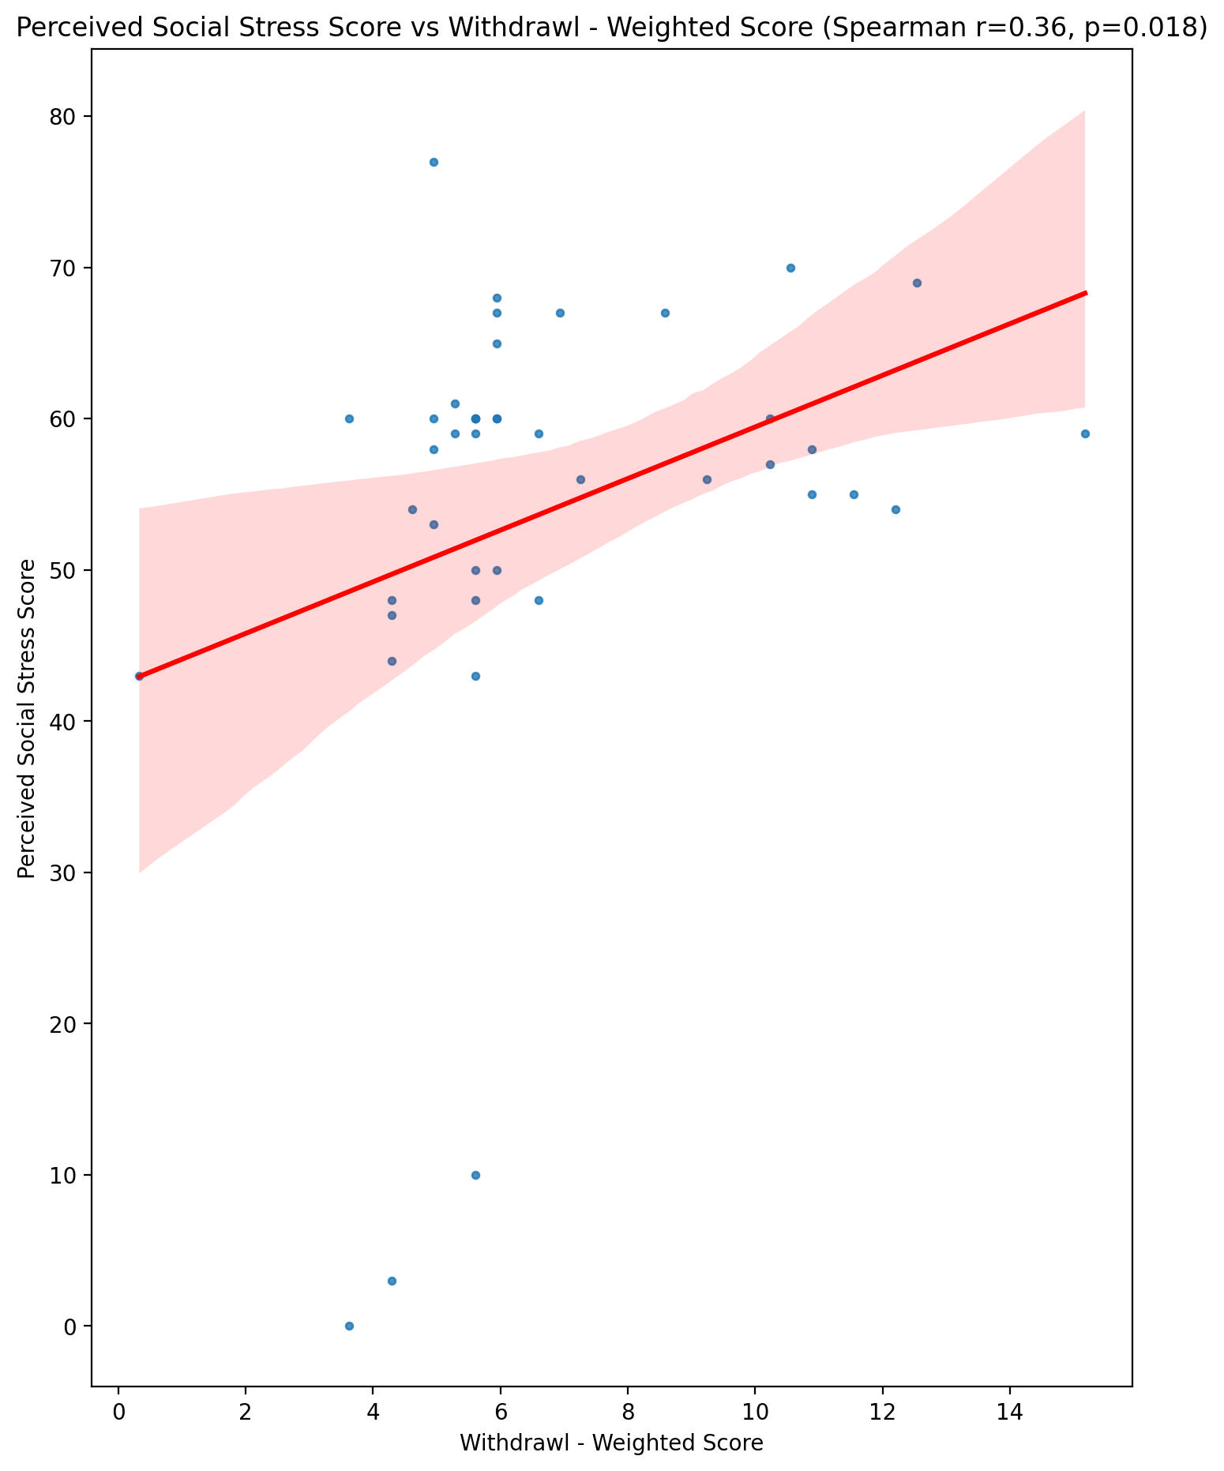

## Perceived Social Stress Category vs Withdrawl - Weighted Score

Test: None; statistic: None; p-value: None; Test not run: unsupported type combination.



## Emotional Support - Raw Score vs Occupational & Relationship Consequences - Weighted Score

Test: spearman; statistic: -0.41468092186861494; p-value: 0.005695587125398835;

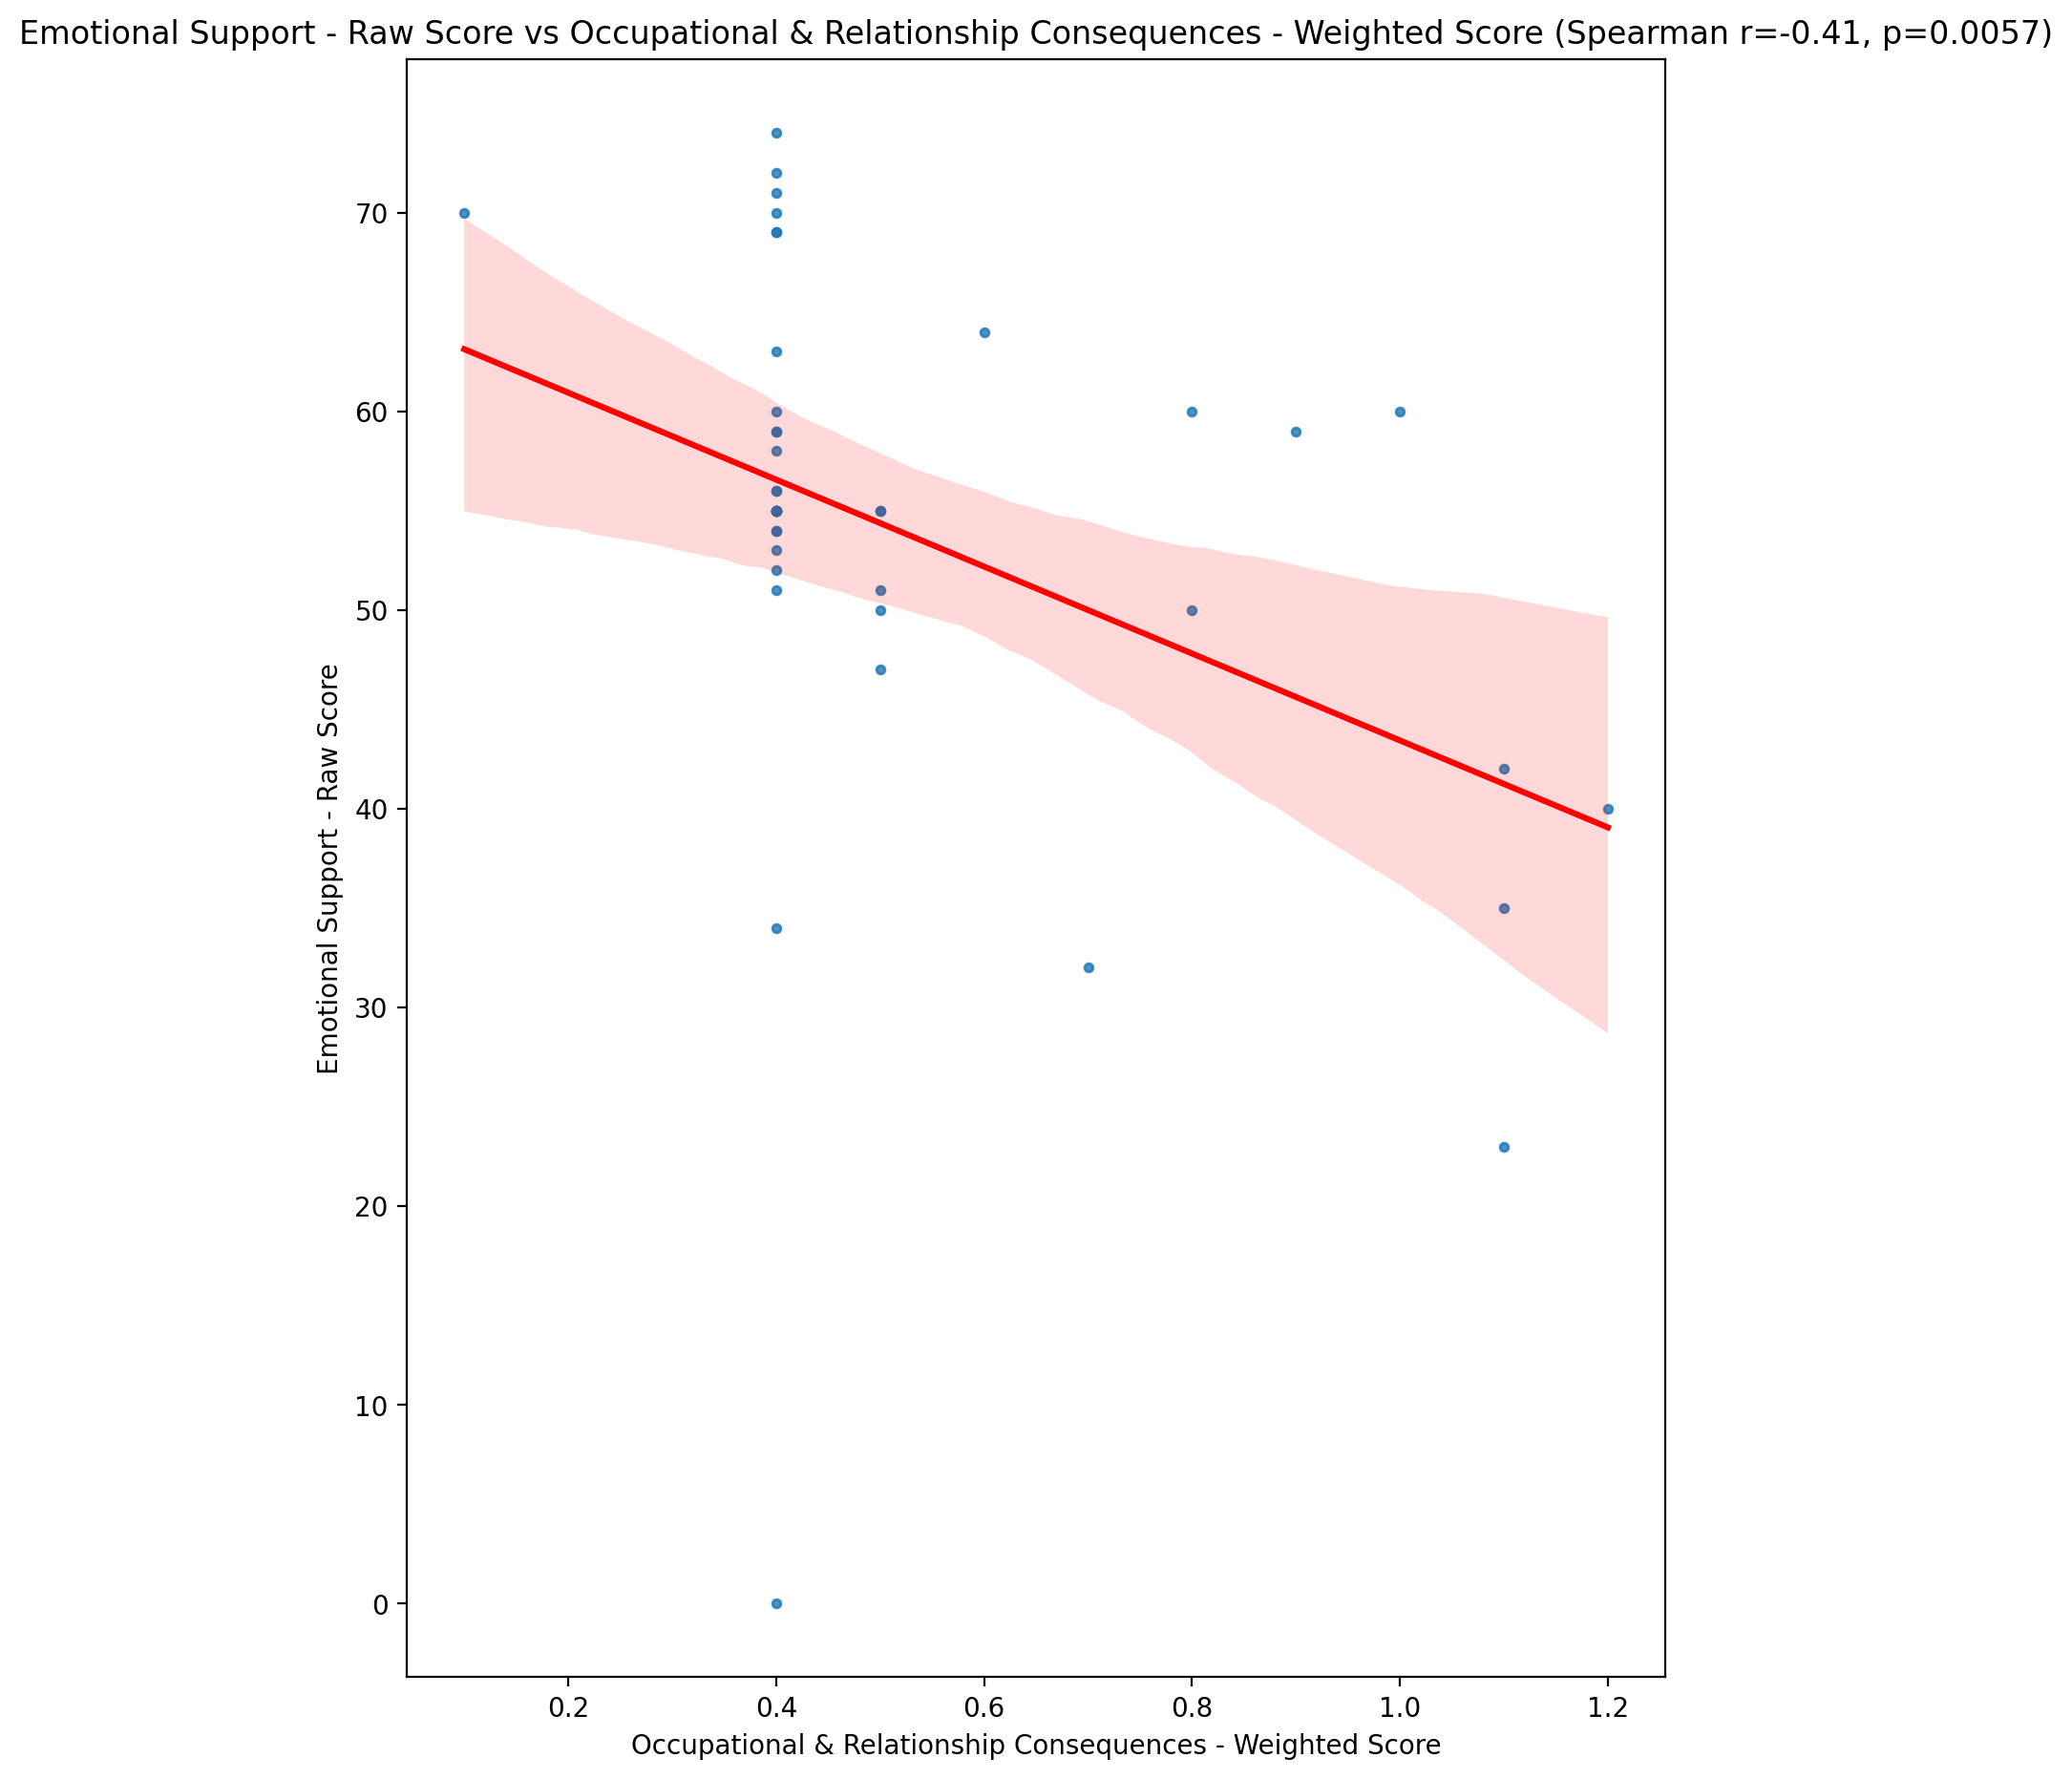

## Informational Support - Raw Score vs Occupational & Relationship Consequences - Weighted Score

Test: spearman; statistic: -0.3838121279816235; p-value: 0.011059816868540852;

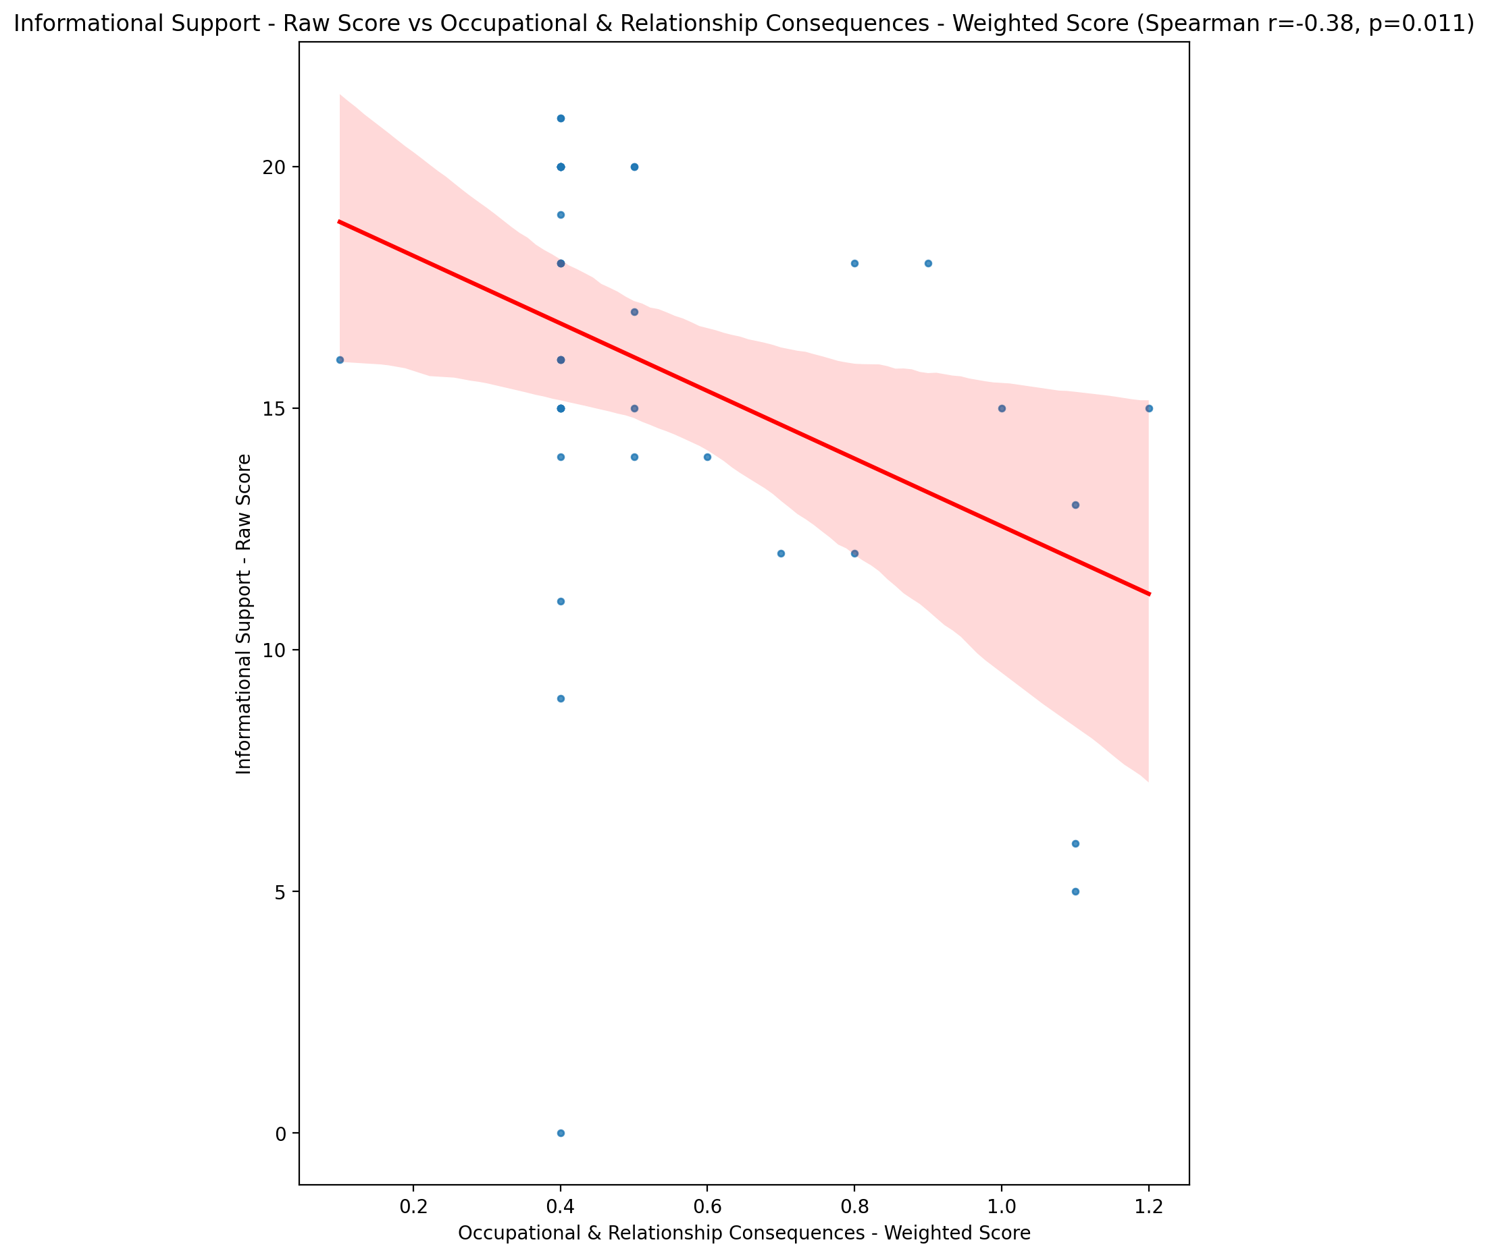

## Instrumental Support - Raw Score vs Occupational & Relationship Consequences - Weighted Score

Test: spearman; statistic: -0.2896198824189484; p-value: 0.059592252653171196;

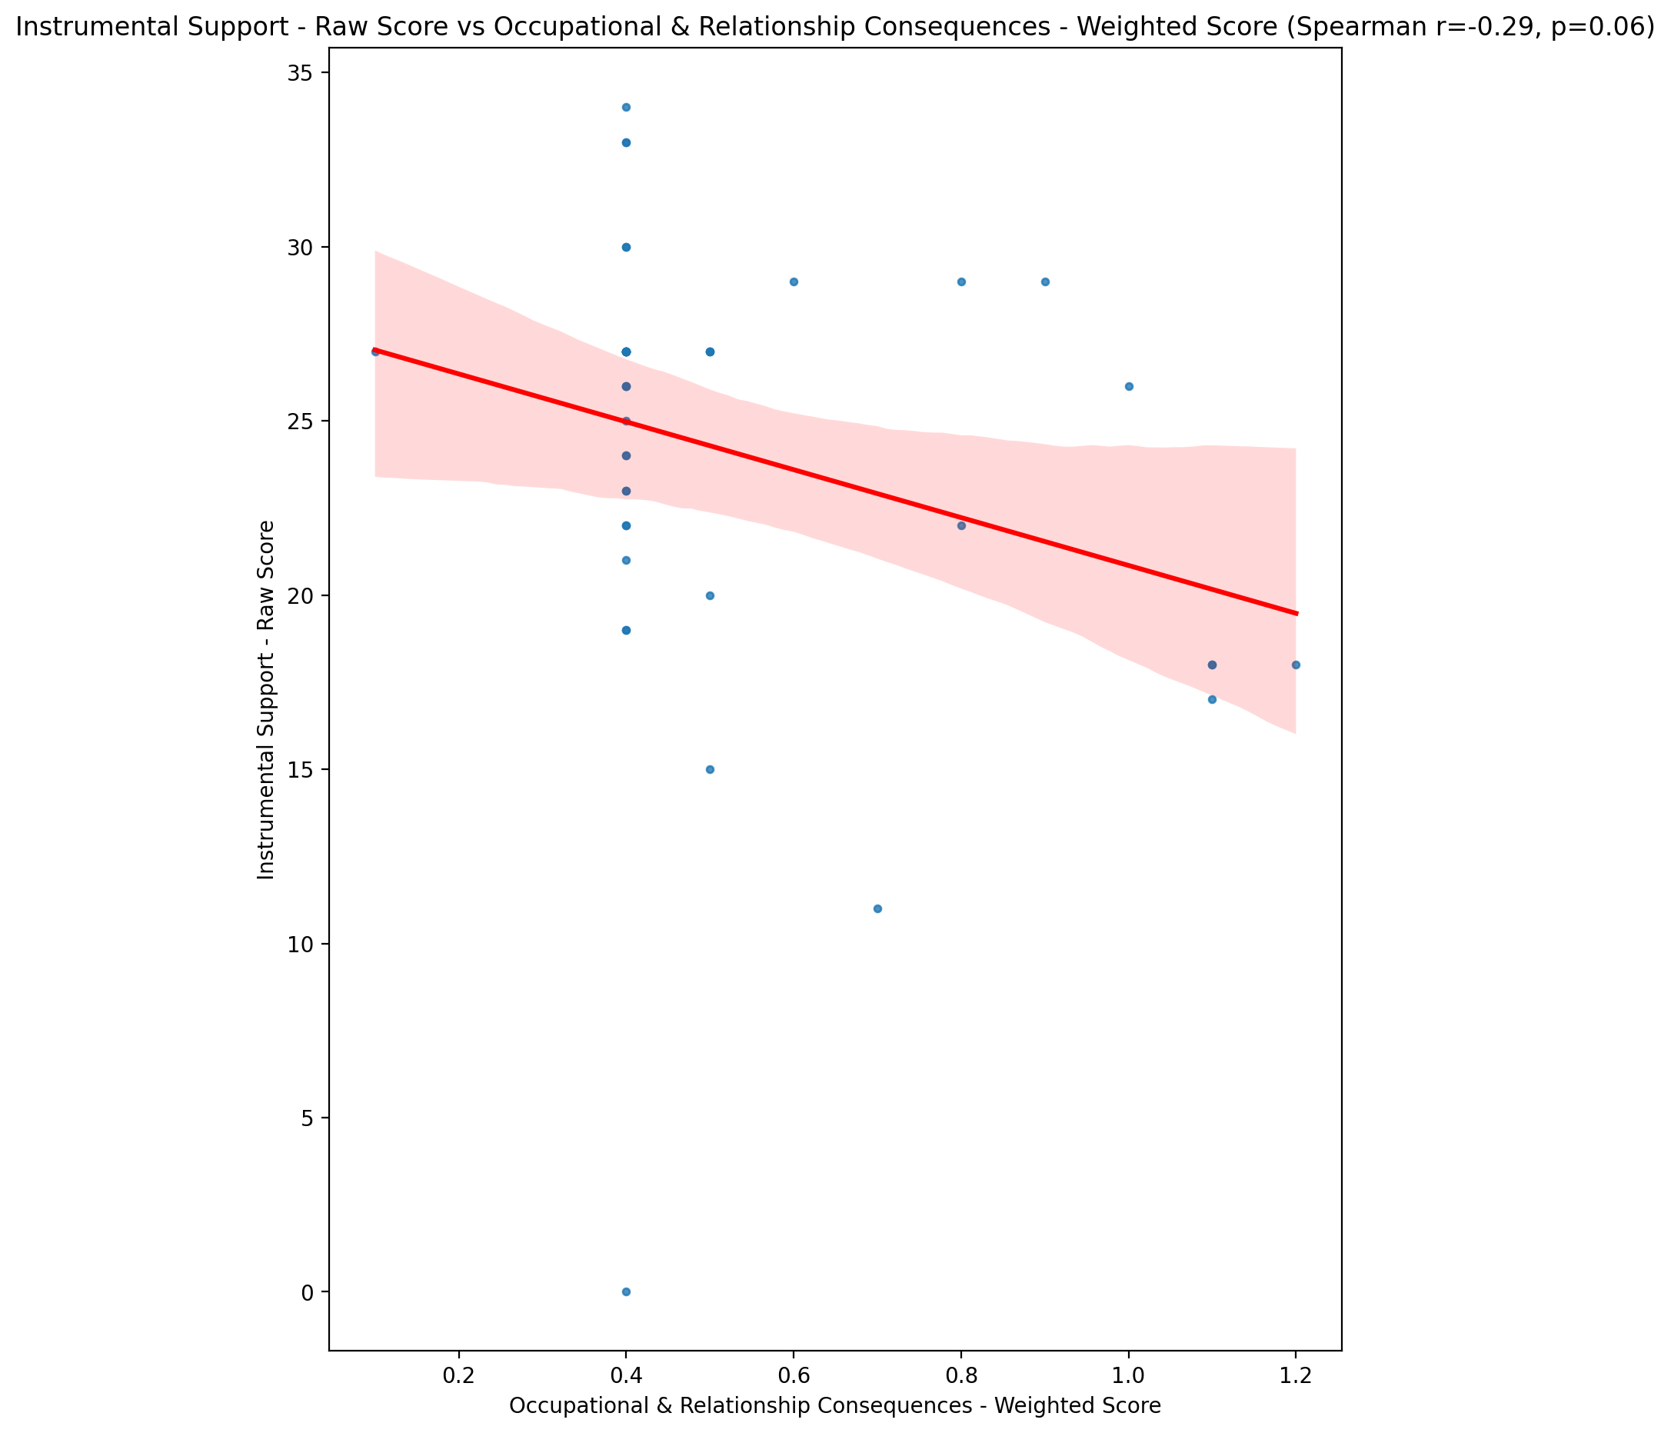

## Emotional Support - T Score vs Occupational & Relationship Consequences - Weighted Score

Test: spearman; statistic: -0.3665639660027575; p-value: 0.015618449768578433;

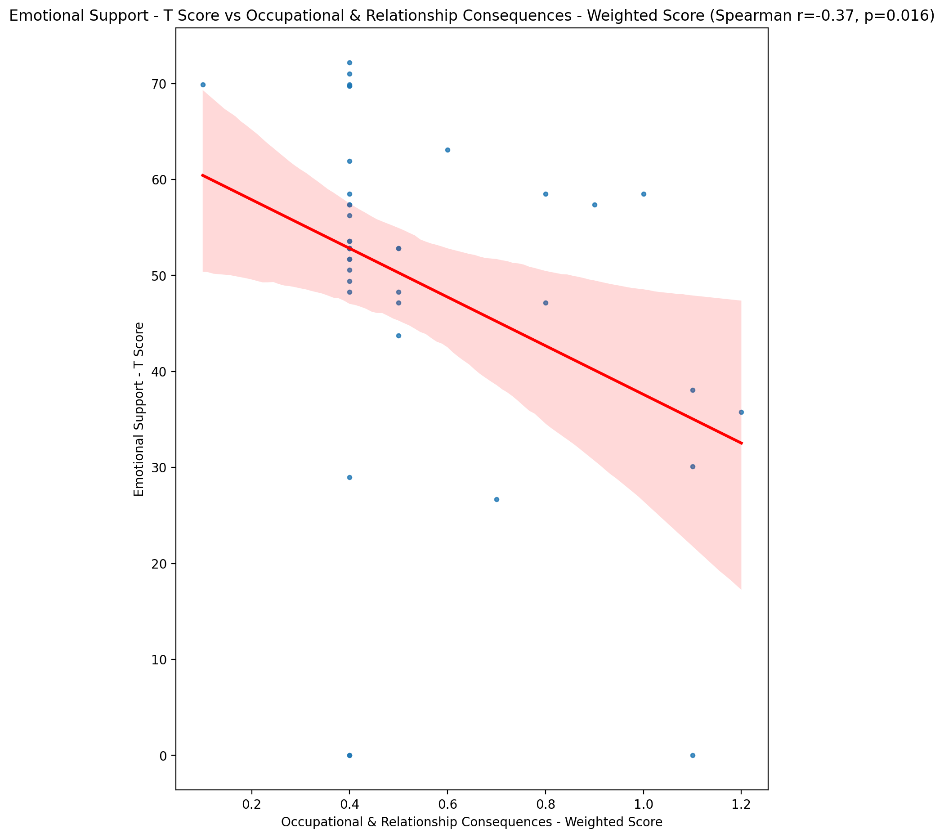

## Informational Support - T Score vs Occupational & Relationship Consequences - Weighted Score

Test: spearman; statistic: -0.3884630781687879; p-value: 0.010046061881725271;

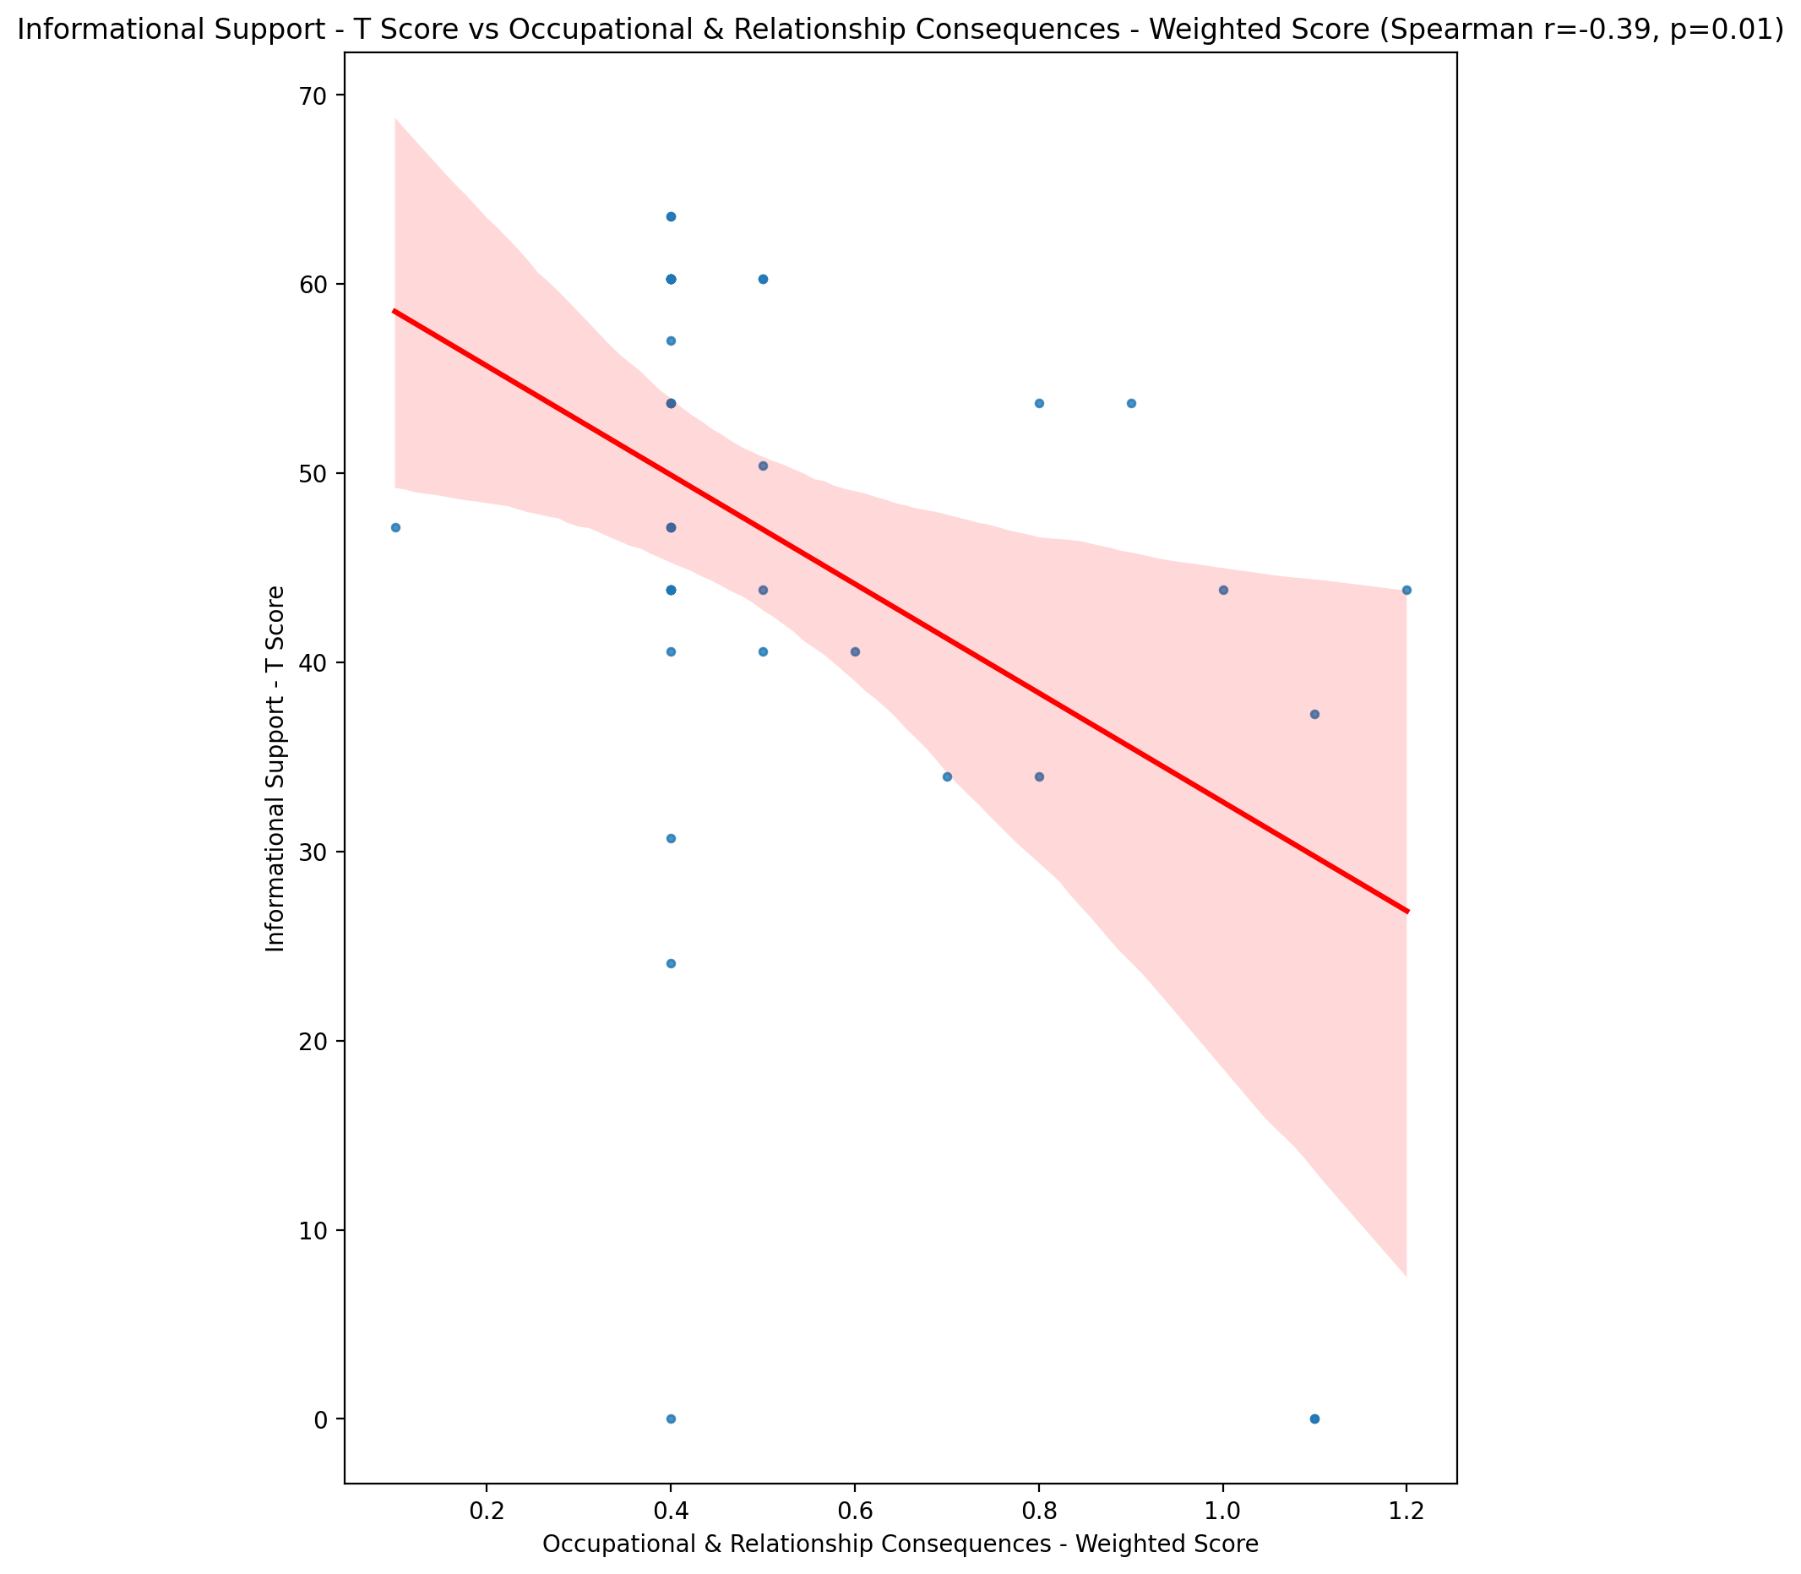

## Instrumental Support - T Score vs Occupational & Relationship Consequences - Weighted Score

Test: spearman; statistic: -0.29139497382721635; p-value: 0.05797706218823278;

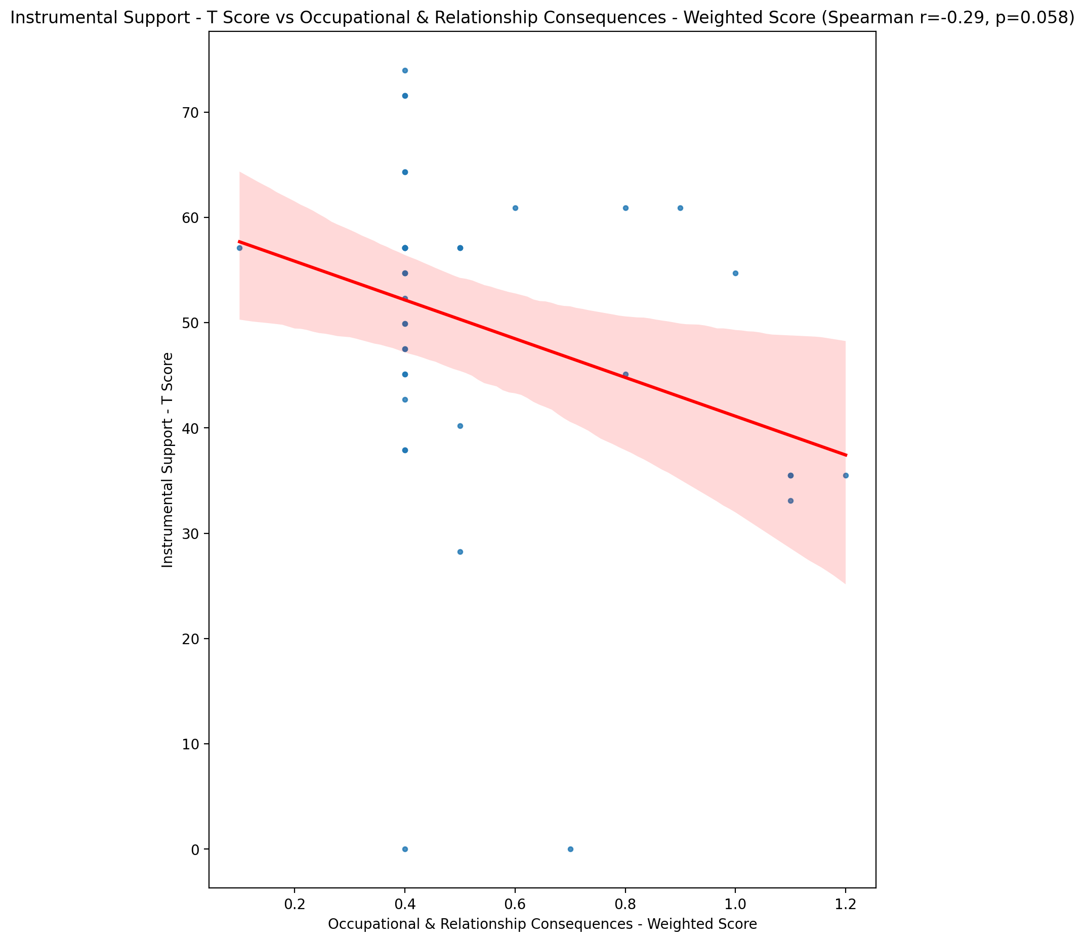

## Perceived Social Support Total T Score vs Occupational & Relationship Consequences - Weighted Score

Test: spearman; statistic: -0.3962033559663377; p-value: 0.008535299101304832;

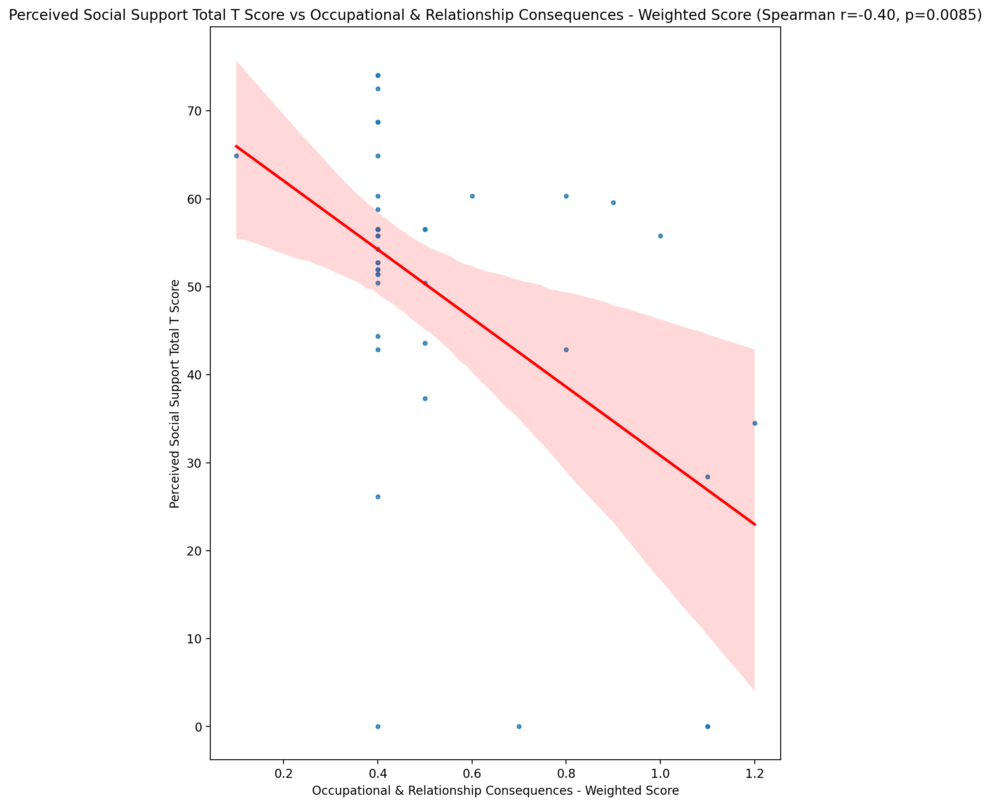

## Emotional Support - Rank vs Occupational & Relationship Consequences - Weighted Score

Test: None; statistic: None; p-value: None; Test not run: unsupported type combination.



## Informational Support - Rank vs Occupational & Relationship Consequences - Weighted Score

Test: None; statistic: None; p-value: None; Test not run: unsupported type combination.



## Instrumental Support - Rank vs Occupational & Relationship Consequences - Weighted Score

Test: None; statistic: None; p-value: None; Test not run: unsupported type combination.



## Perceived Social Support TOTAL - Rank vs Occupational & Relationship Consequences - Weighted Score

Test: None; statistic: None; p-value: None; Test not run: unsupported type combination.



## Power Self Concept - Real Self Concept Score vs Occupational & Relationship Consequences - Weighted Score

Test: spearman; statistic: -0.33574813684723254; p-value: 0.027728643387694537;

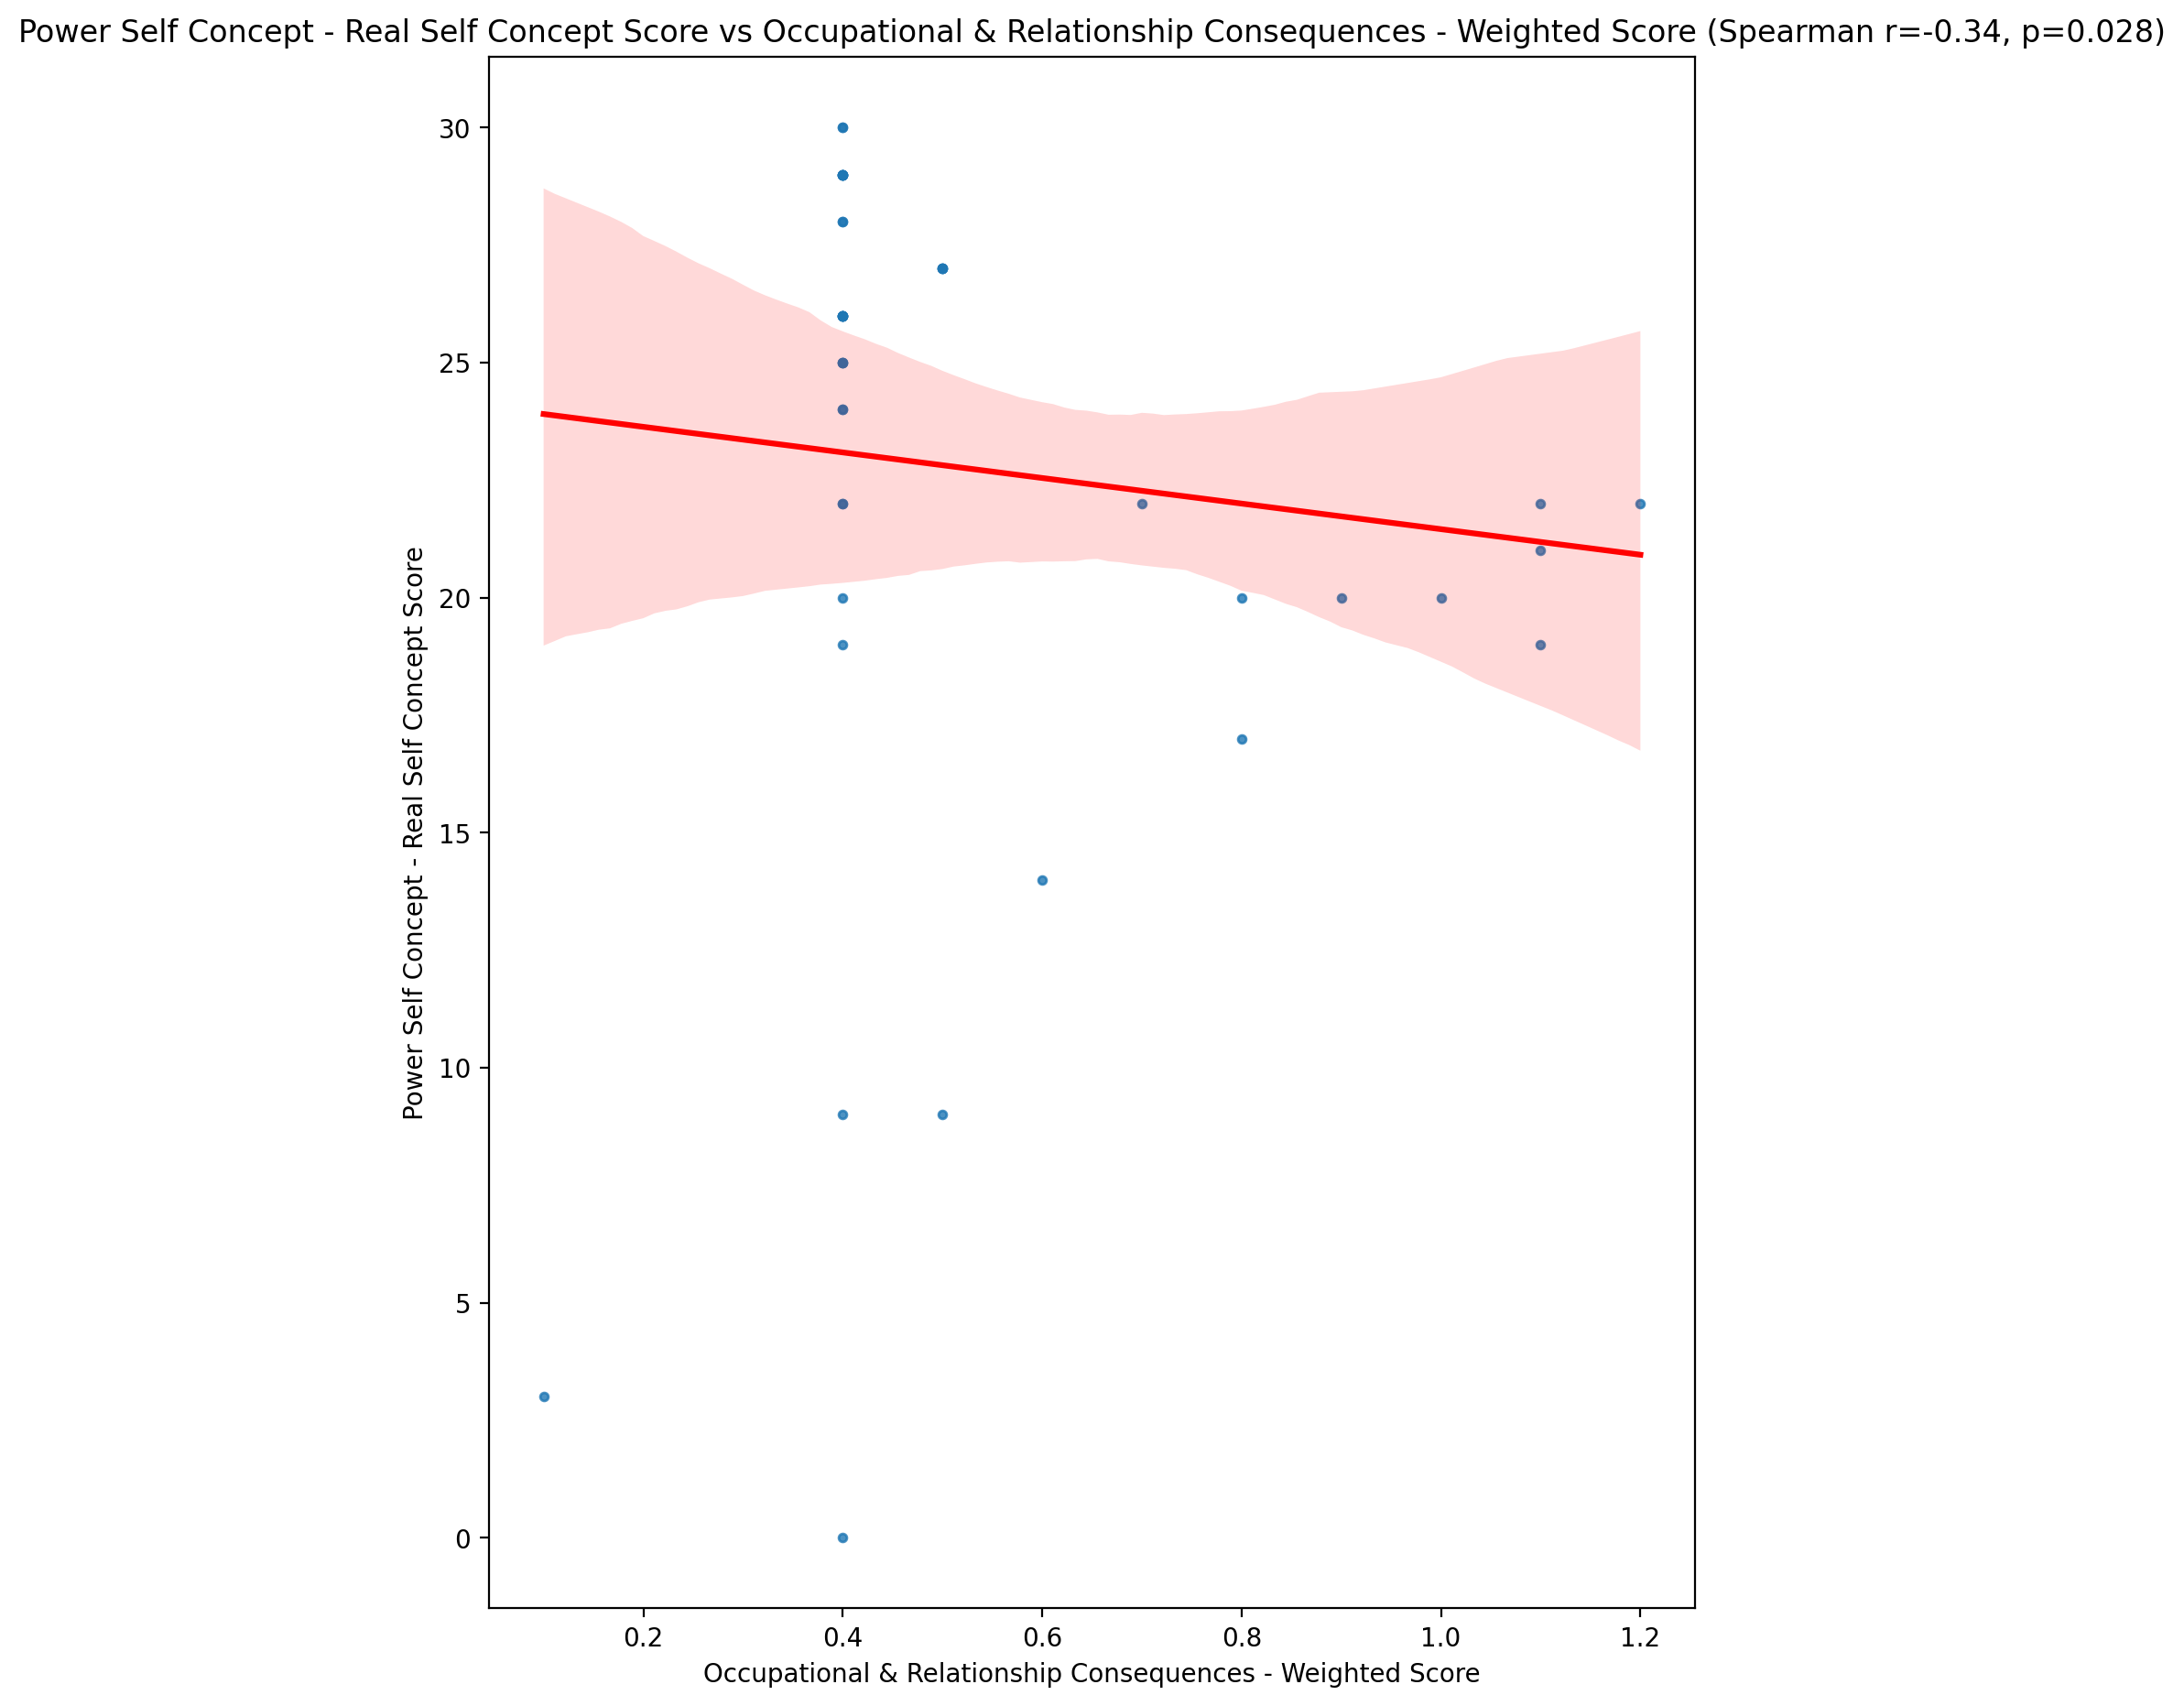

## Power Self Concept - Ideal Self Concept score vs Occupational & Relationship Consequences - Weighted Score

Test: spearman; statistic: -0.19553213154824348; p-value: 0.20890627214205487;

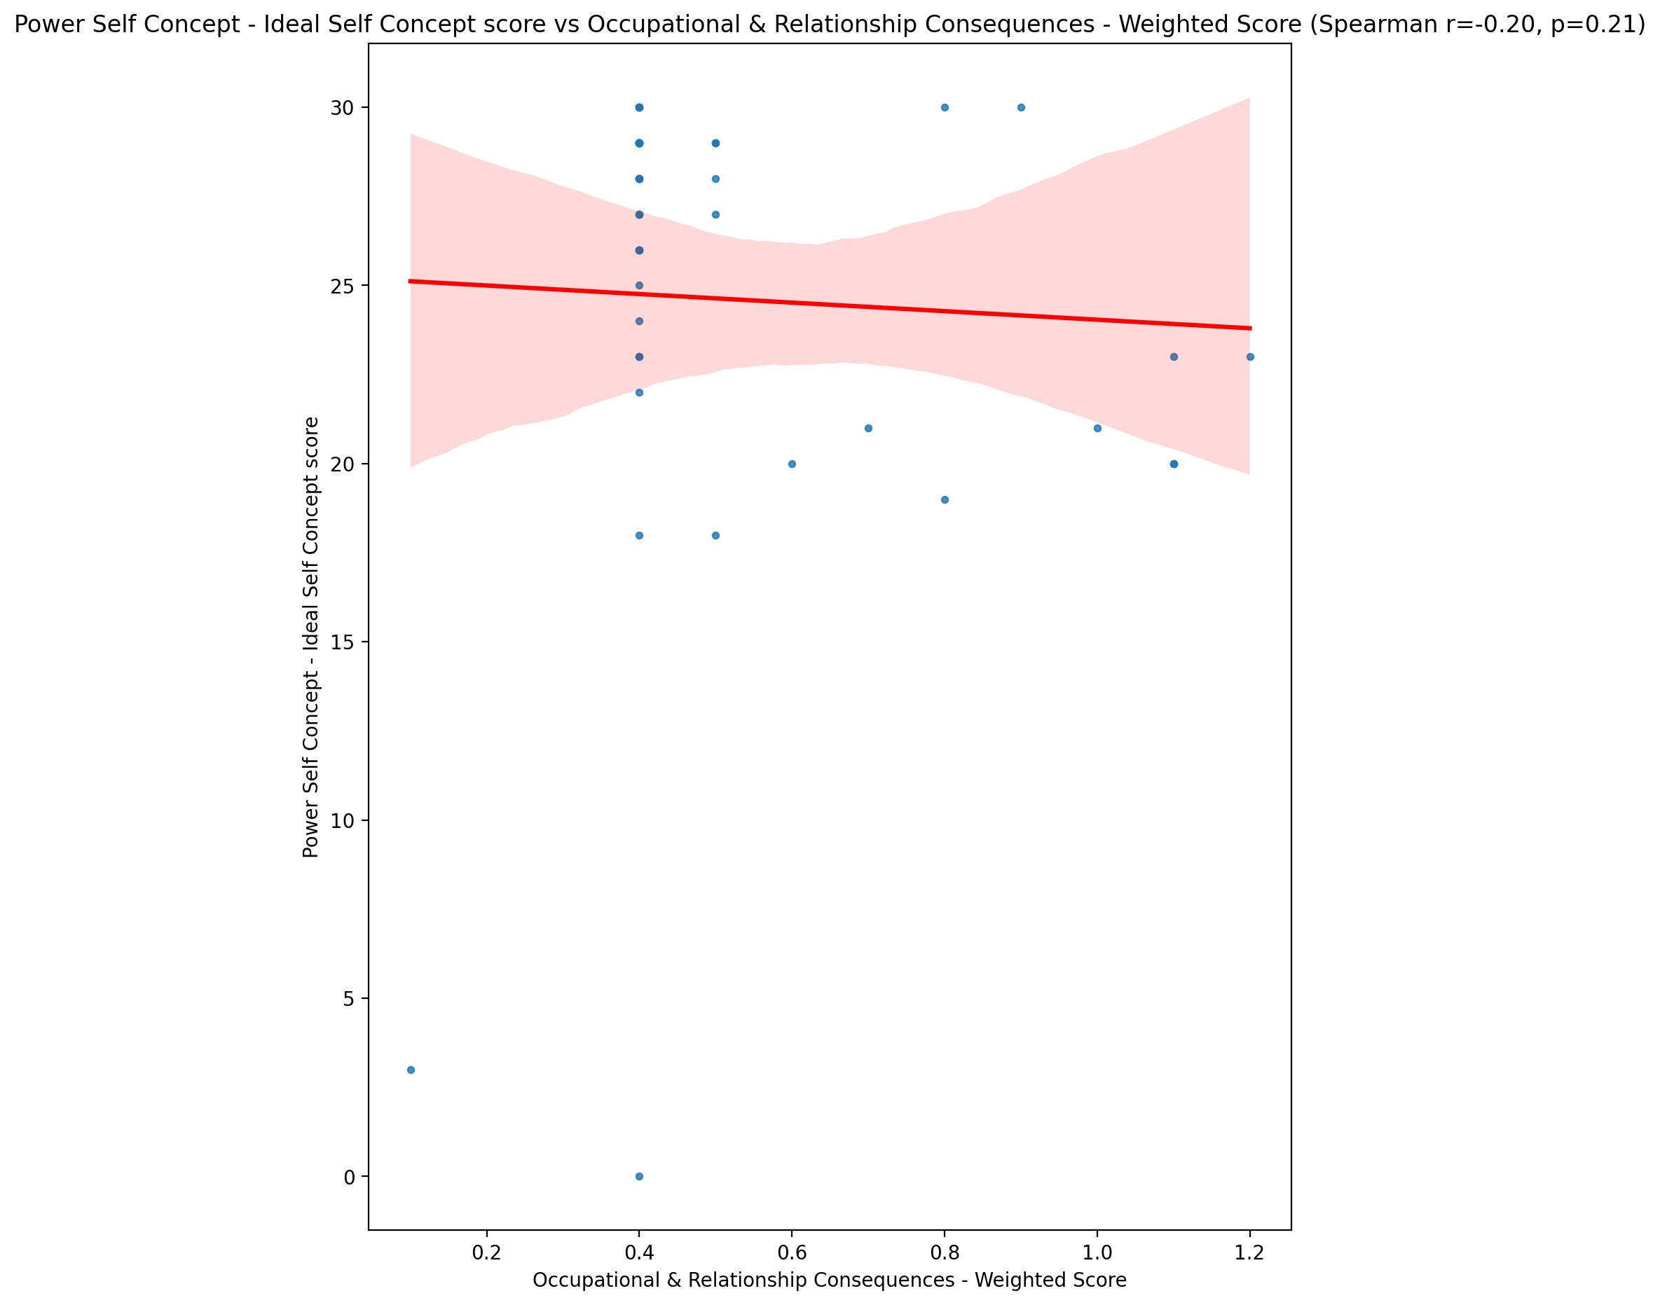

## Power Self Concept – Social Self Concept Score vs Occupational & Relationship Consequences - Weighted Score

Test: spearman; statistic: -0.3728412834027946; p-value: 0.013803082537748807;

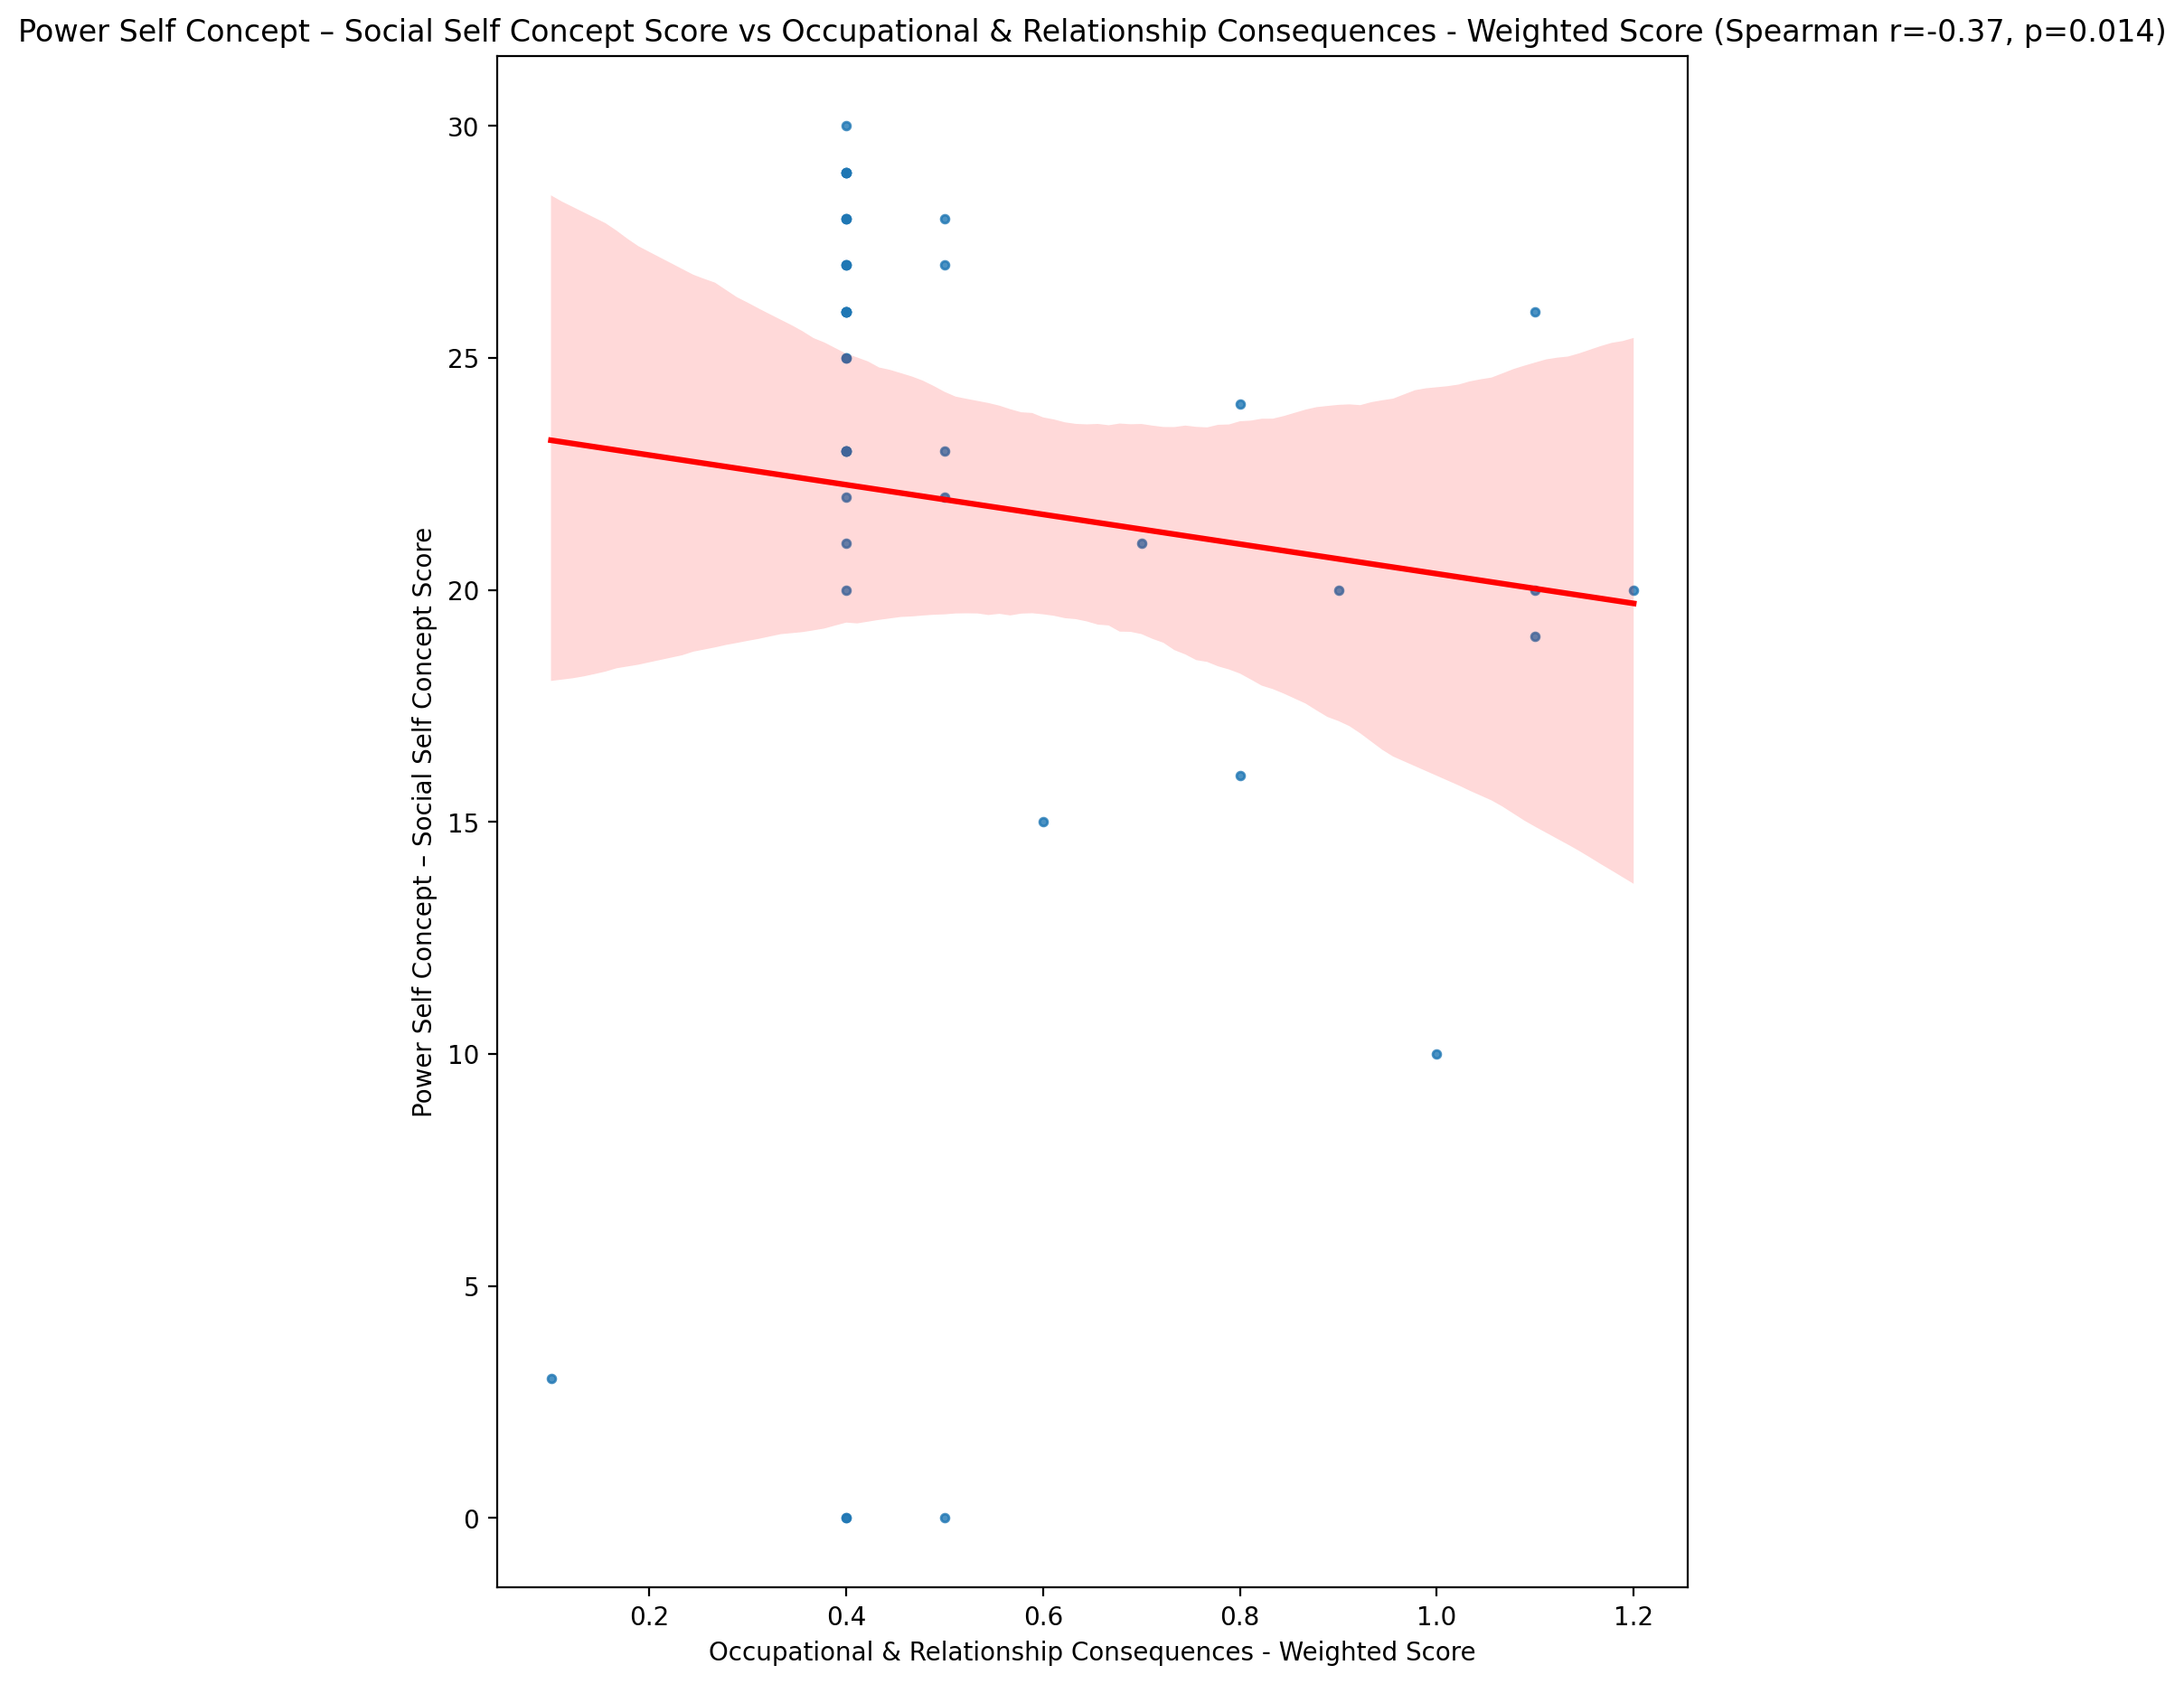

## Social Self Concept - Real Self Concept Score vs Occupational & Relationship Consequences - Weighted Score

Test: spearman; statistic: -0.35779716124007993; p-value: 0.018489190847792988;

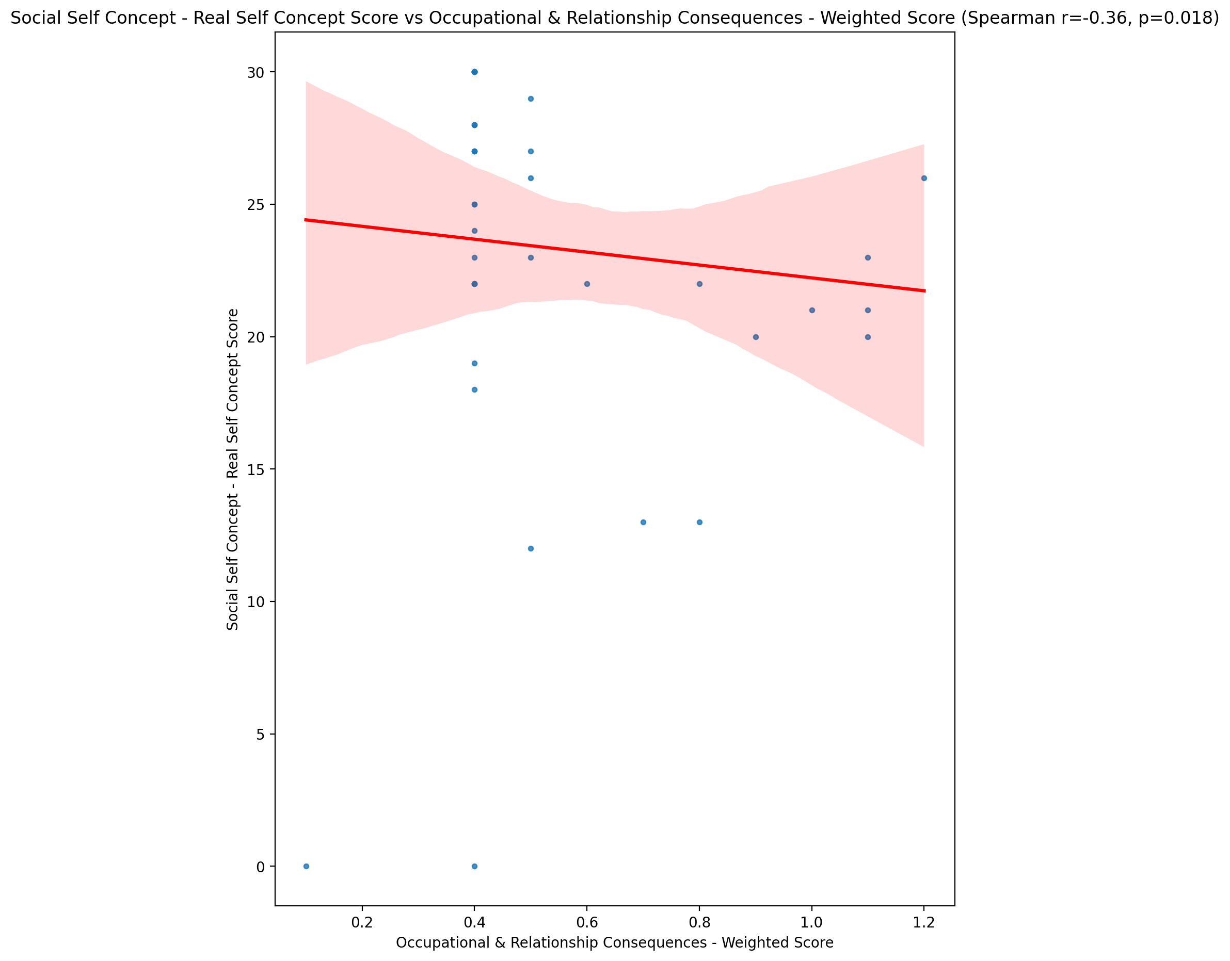

## Social Self Concept – Social Self Concept Score vs Occupational & Relationship Consequences - Weighted Score

Test: spearman; statistic: -0.3034423980617438; p-value: 0.047918966401283014;

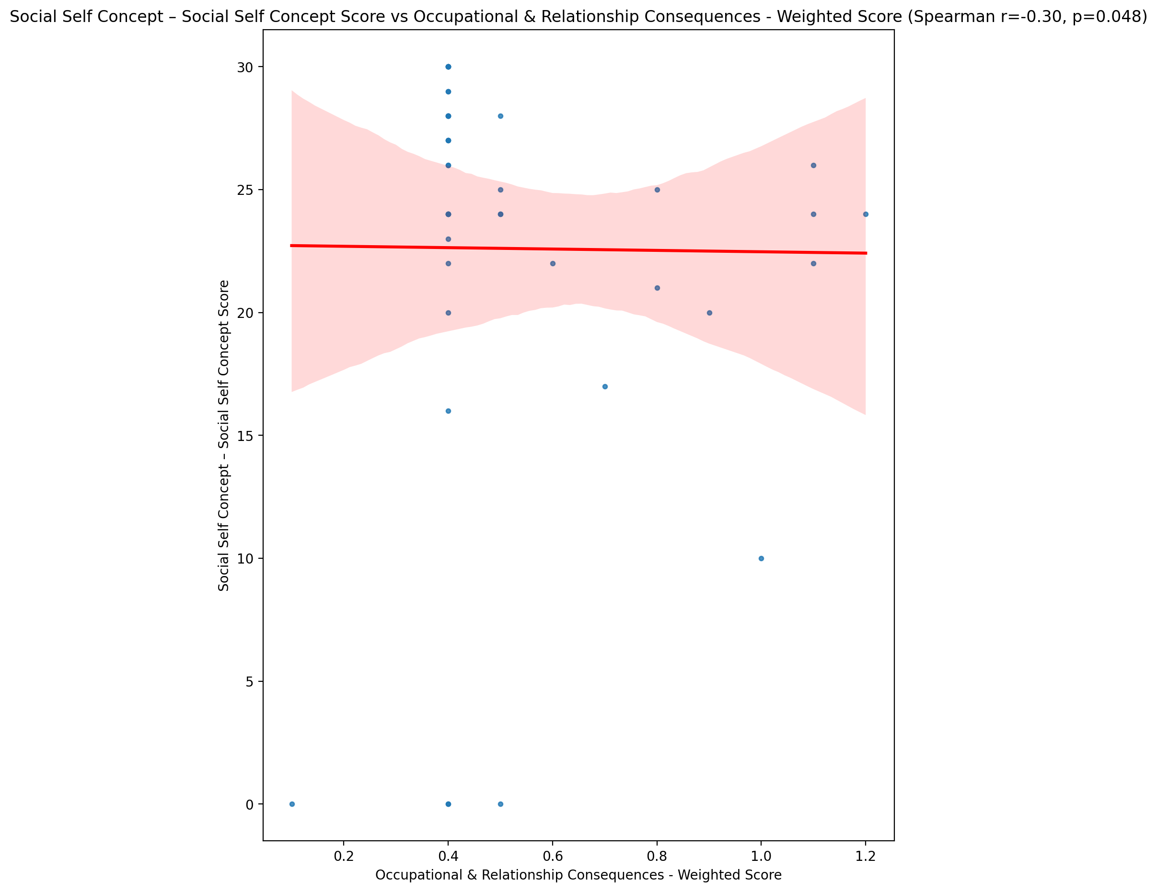

## Ability Self Concept - Real Self Concept Score vs Occupational & Relationship Consequences - Weighted Score

Test: spearman; statistic: -0.2549664431133226; p-value: 0.09893106366366773;

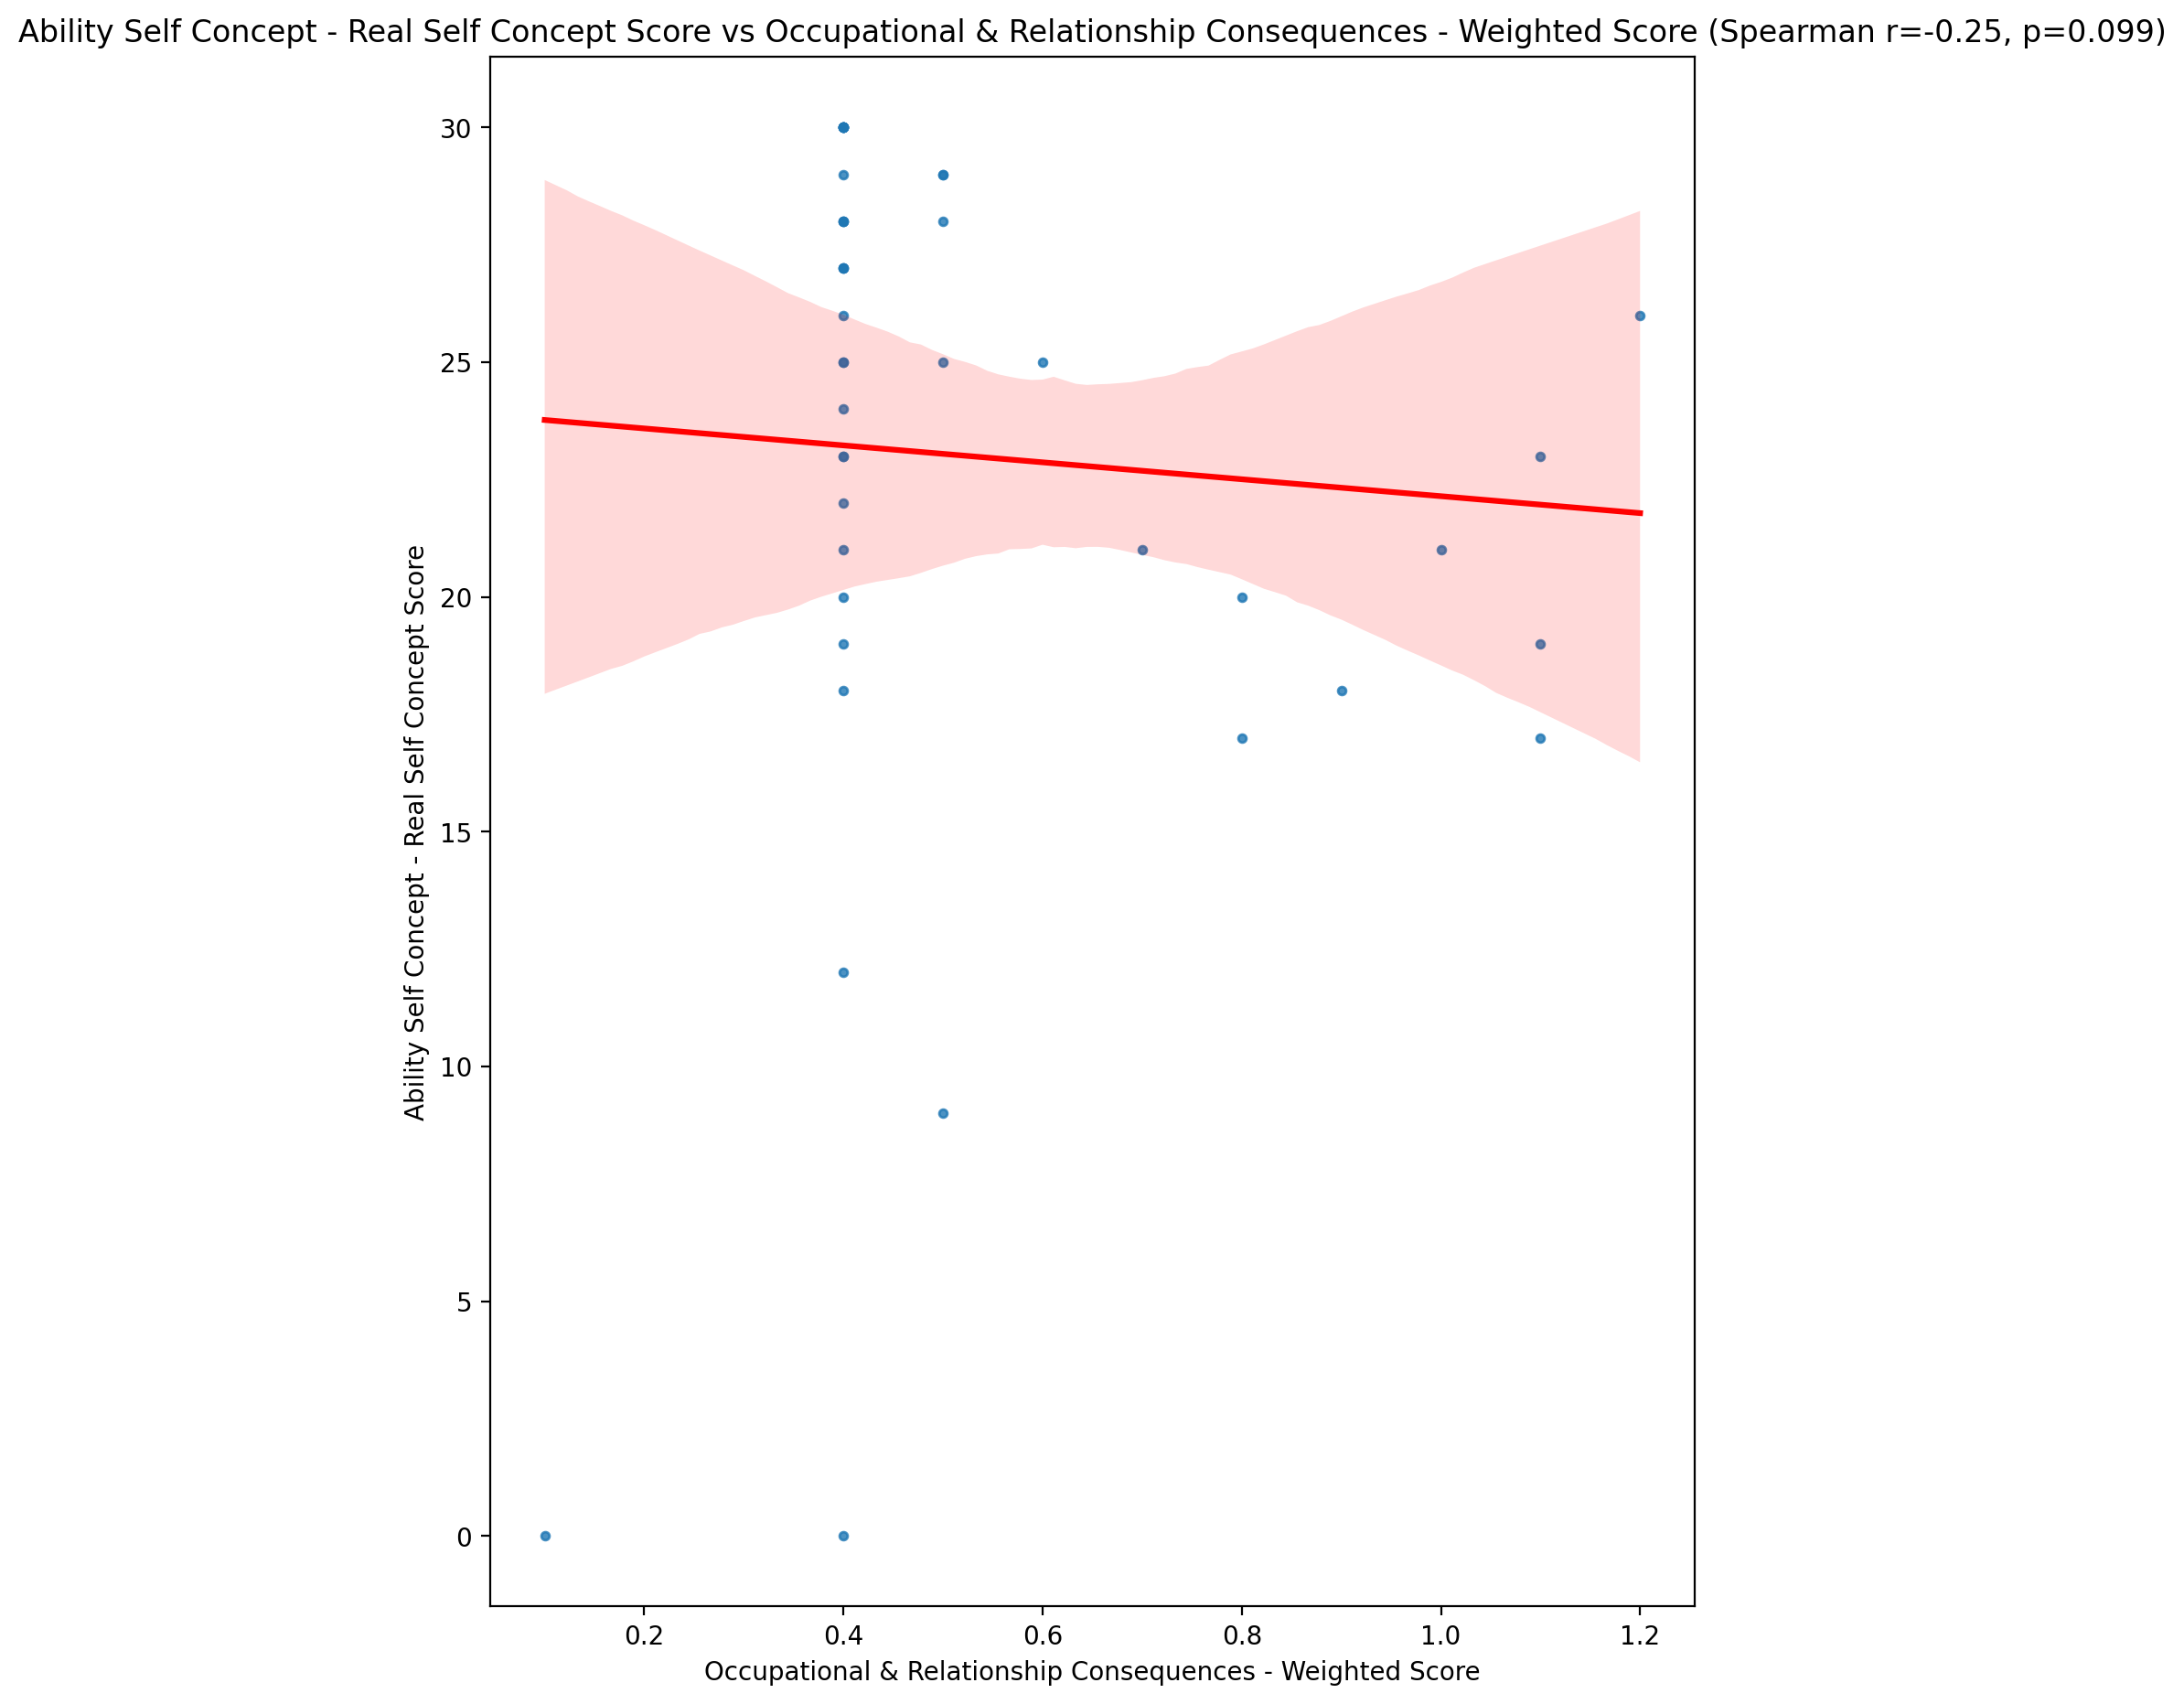

## Ability Self Concept - Ideal Self Concept Score vs Occupational & Relationship Consequences - Weighted Score

Test: spearman; statistic: -0.15824651963006953; p-value: 0.3108126716940432;

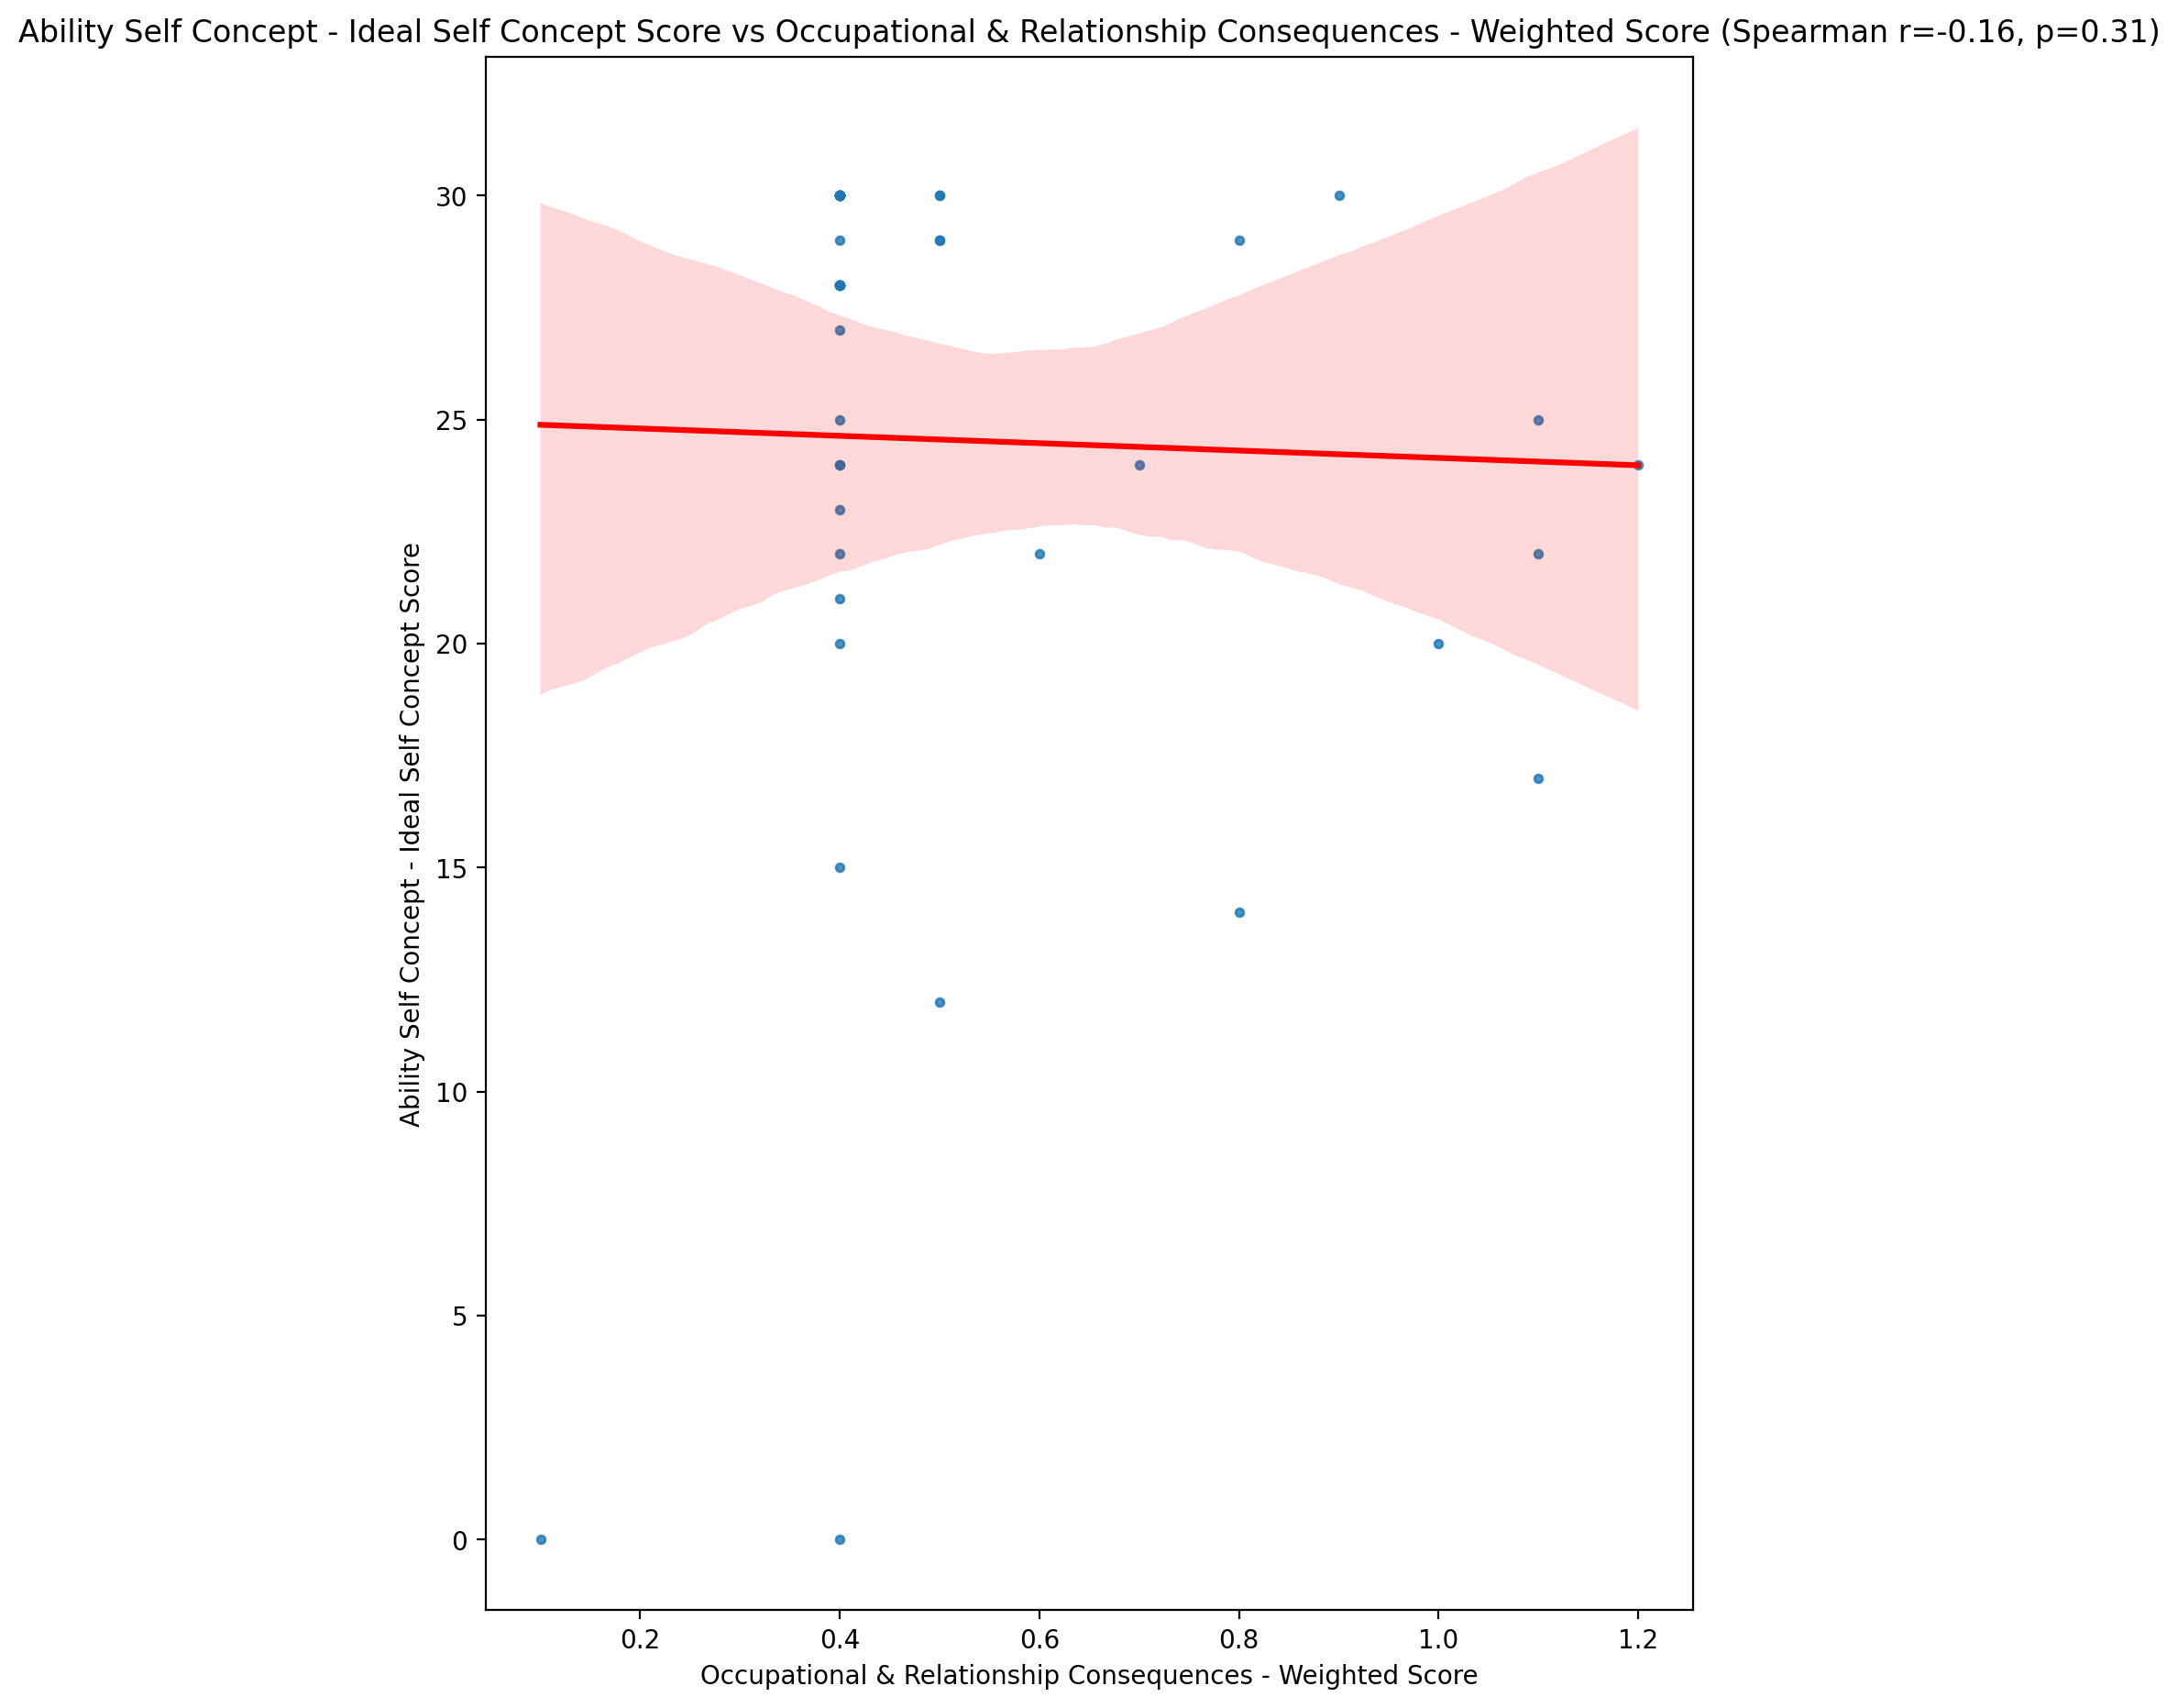

## Ability Self Concept – Social Self Concept Score vs Occupational & Relationship Consequences - Weighted Score

Test: spearman; statistic: -0.2946519019424563; p-value: 0.05510472700025707;

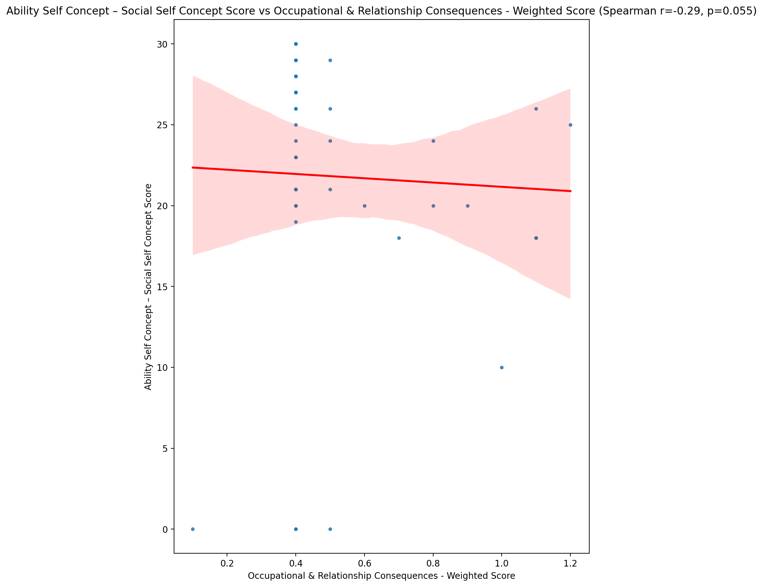

## Physical Self Concept - Real Self Concept Score vs Occupational & Relationship Consequences - Weighted Score

Test: spearman; statistic: -0.3688306931079416; p-value: 0.014940892192700114;

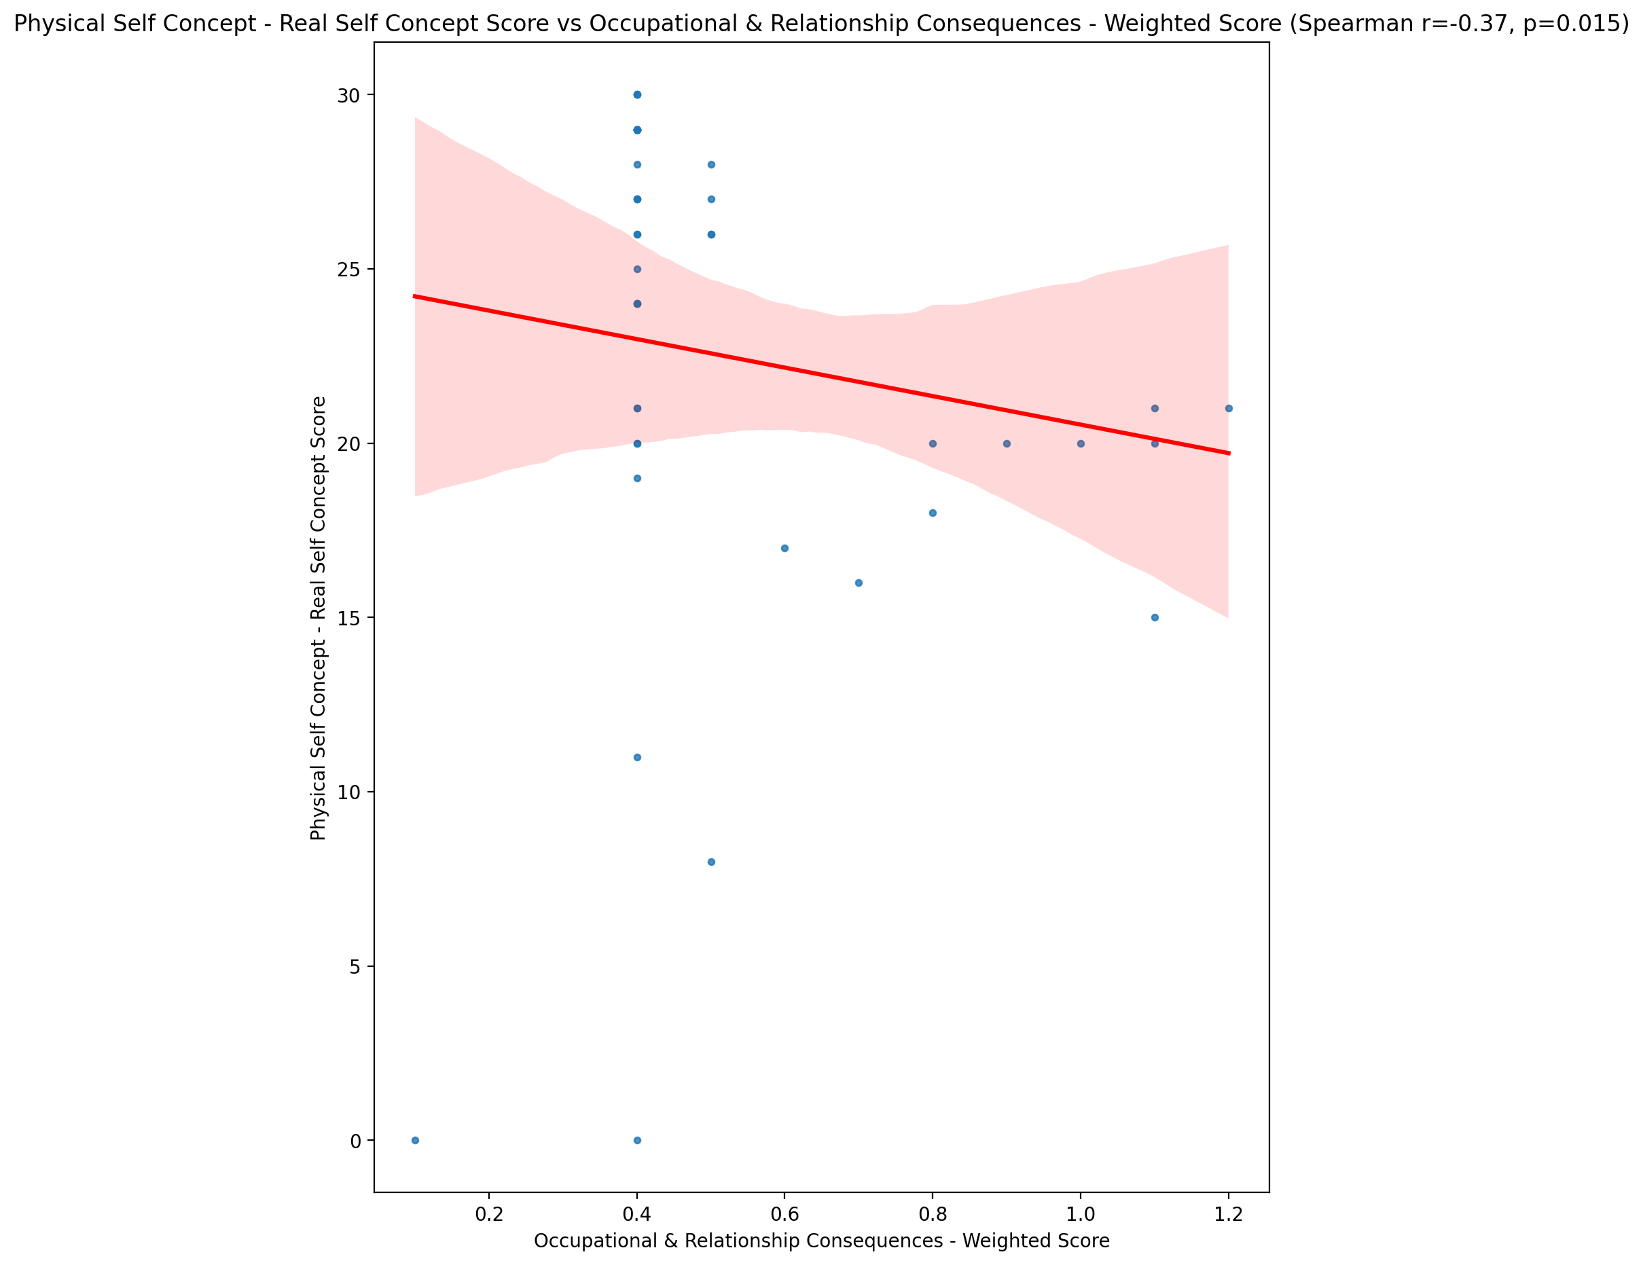

## Physical Self Concept – Ideal Self Concept Score vs Occupational & Relationship Consequences - Weighted Score

Test: spearman; statistic: -0.22387398672994838; p-value: 0.14897210242374537;

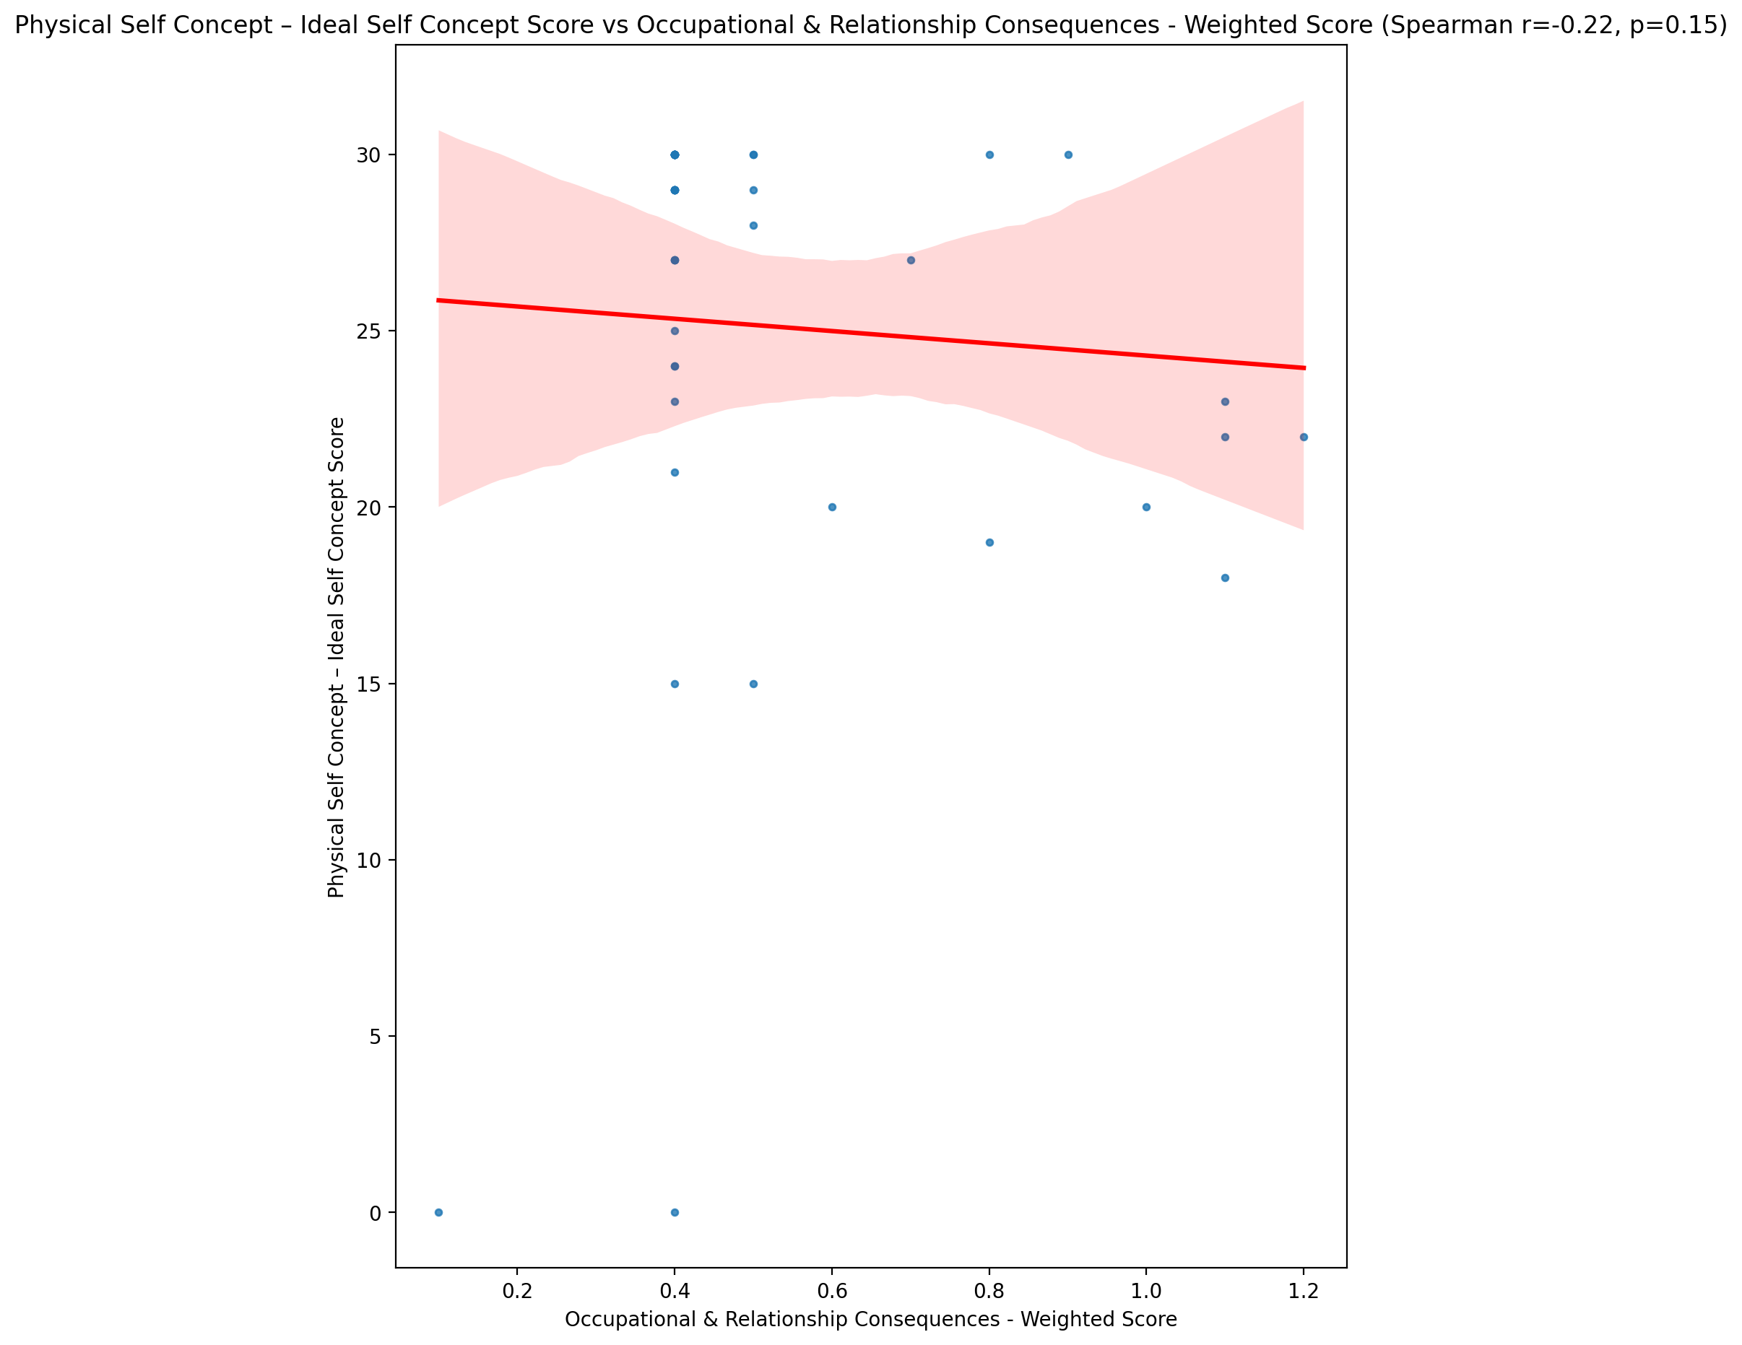

## Physical Self Concept – Social Self Concept Score vs Occupational & Relationship Consequences - Weighted Score

Test: spearman; statistic: -0.1889995681178728; p-value: 0.22482070270134685;

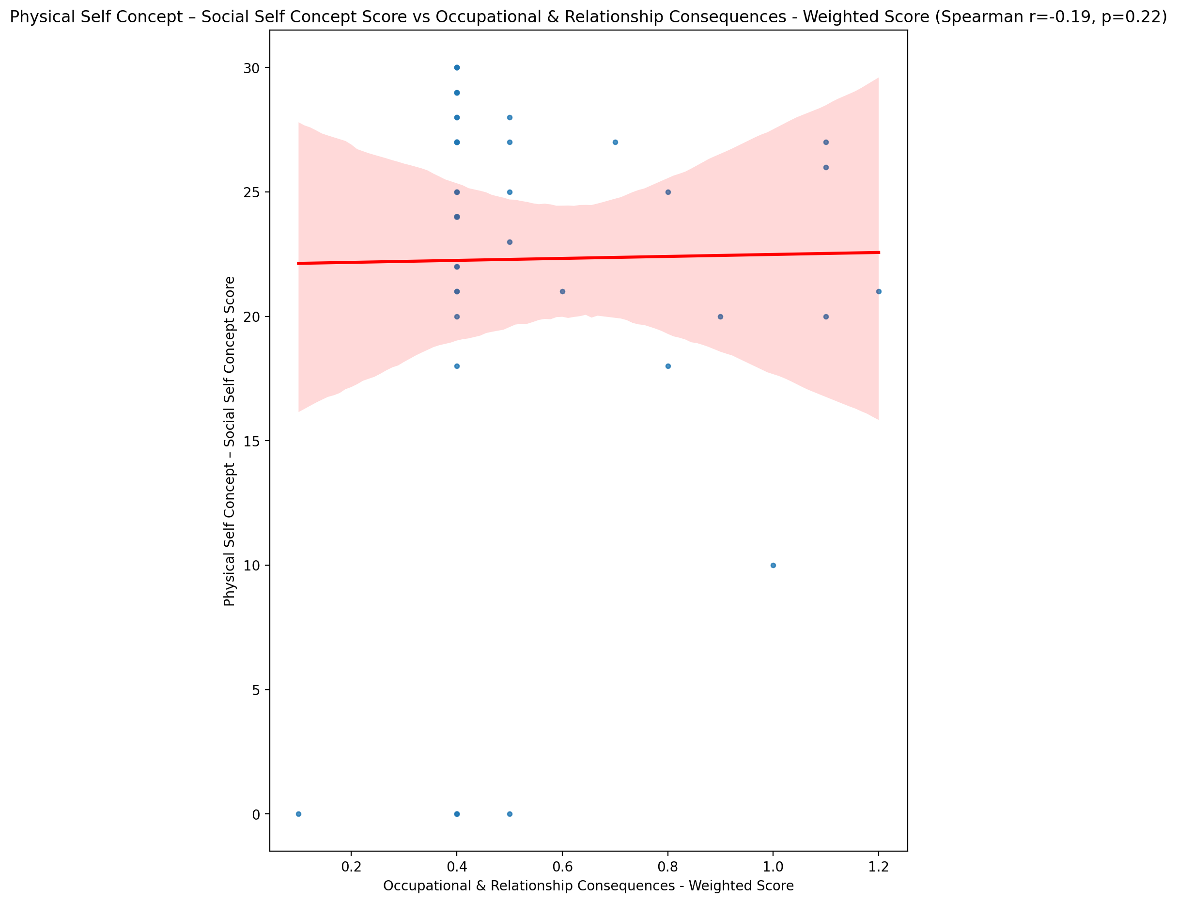

## Psychological Self Concept - Real Self Concept Score vs Occupational & Relationship Consequences - Weighted Score

Test: spearman; statistic: -0.3312818135082925; p-value: 0.03000407344696769;

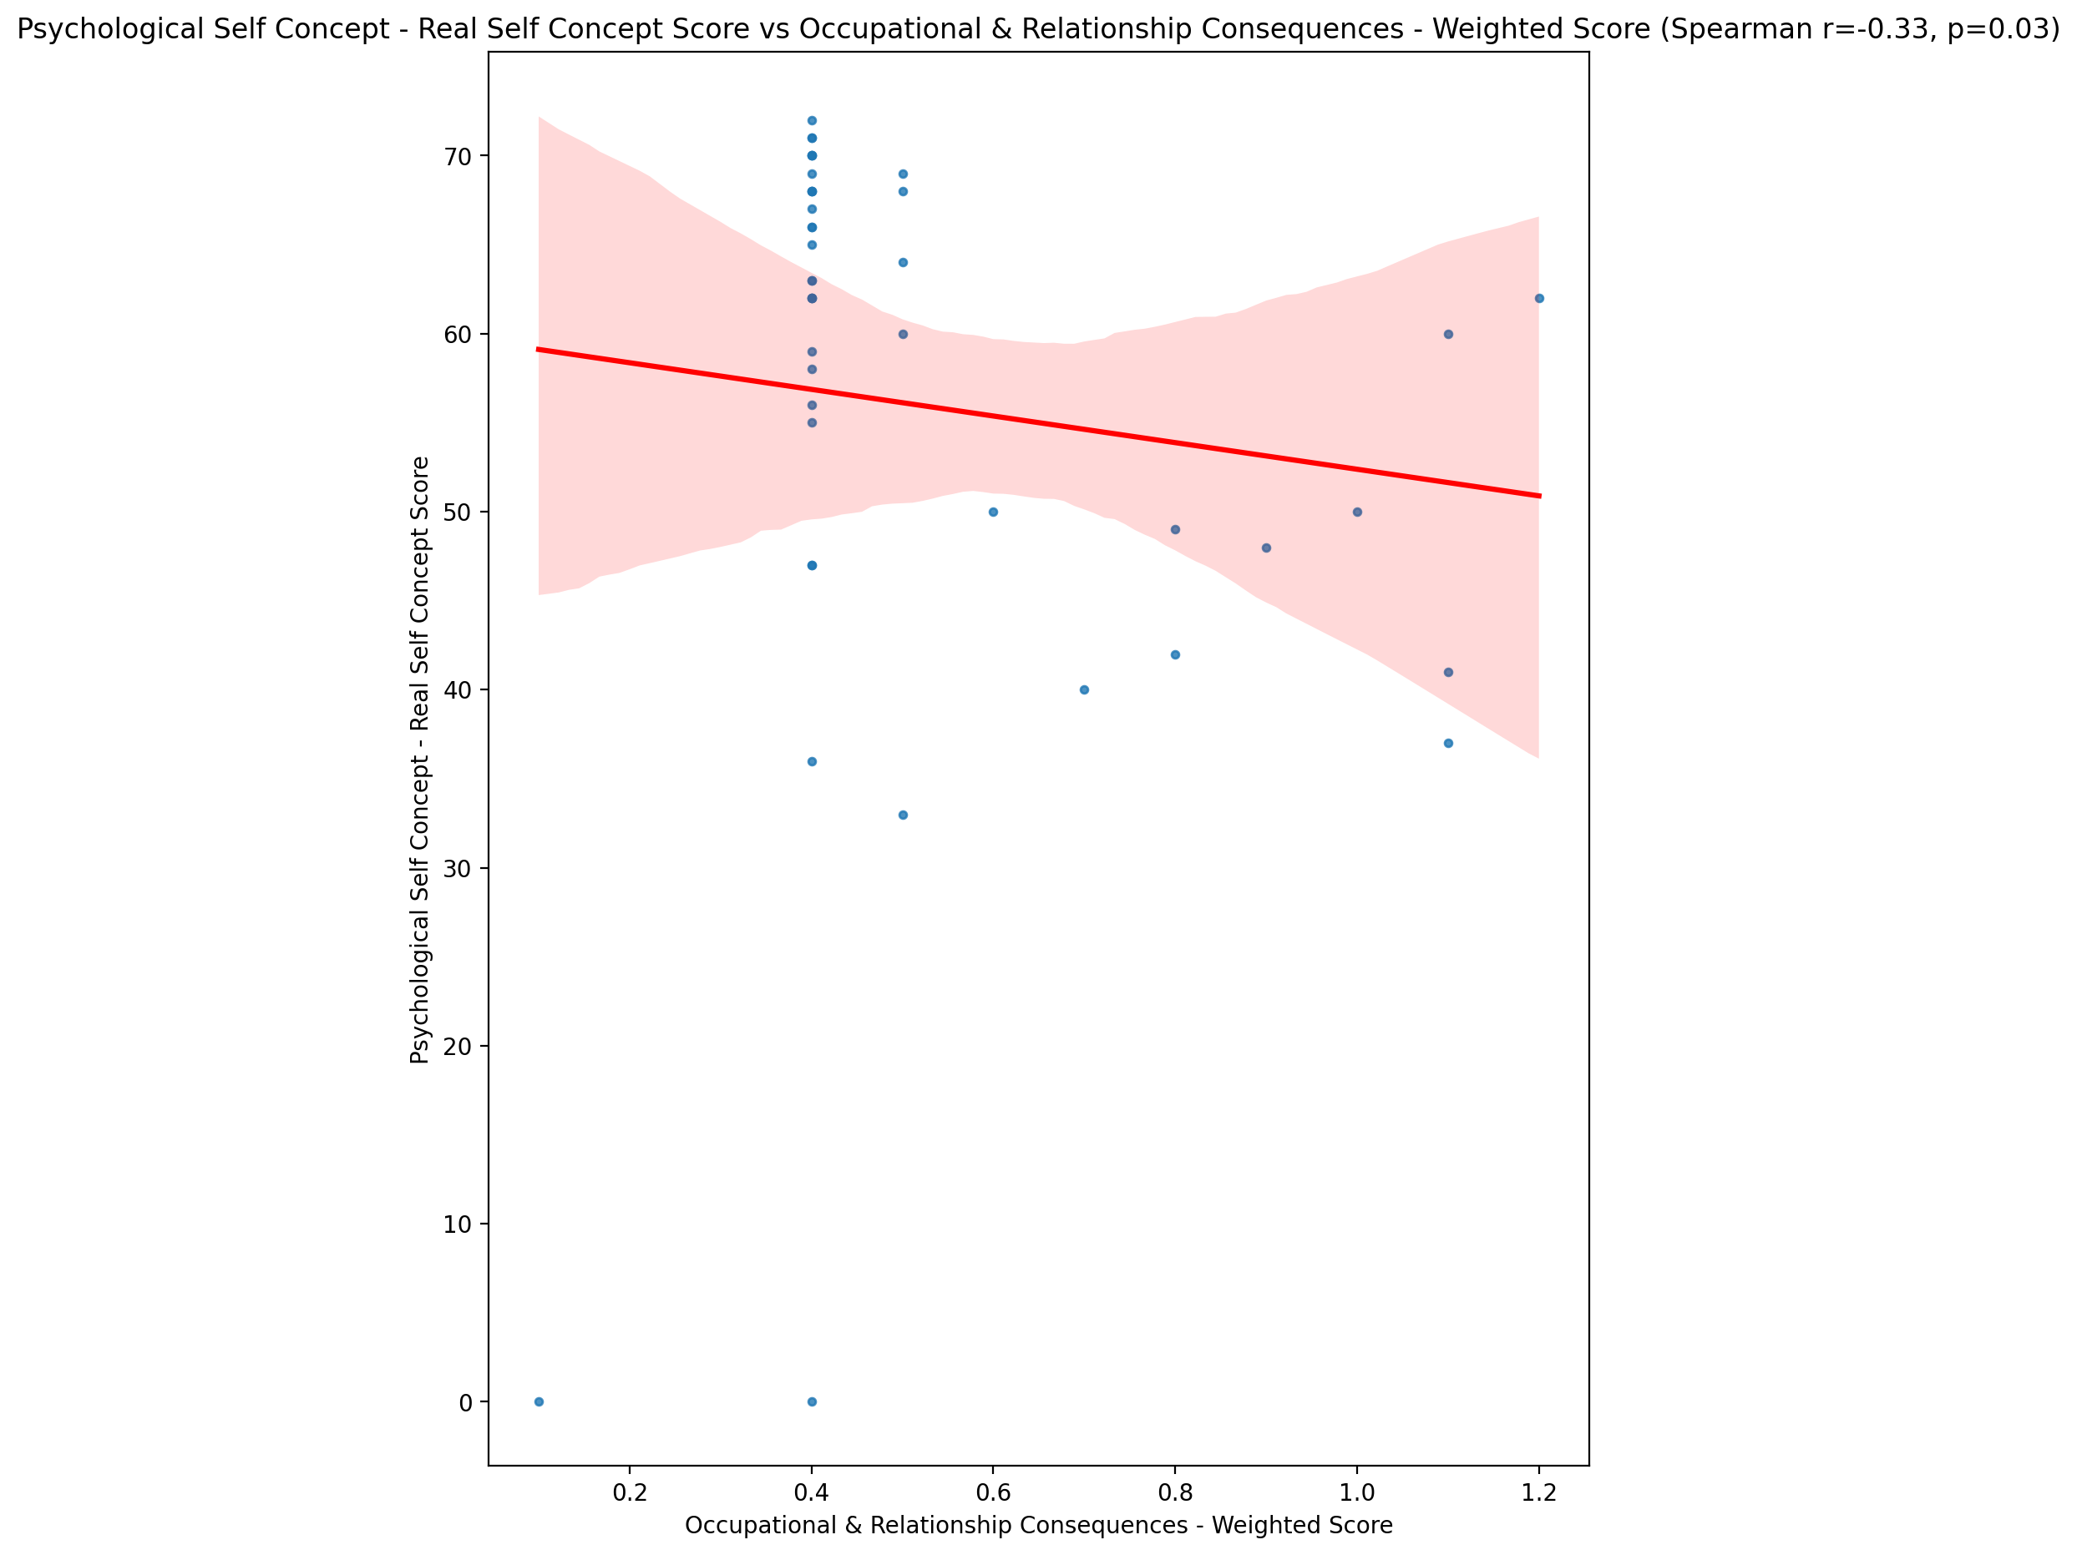

## Psychological Self Concept – Ideal Self Concept Score vs Occupational & Relationship Consequences - Weighted Score

Test: spearman; statistic: -0.1971332499930575; p-value: 0.2051287256893956;

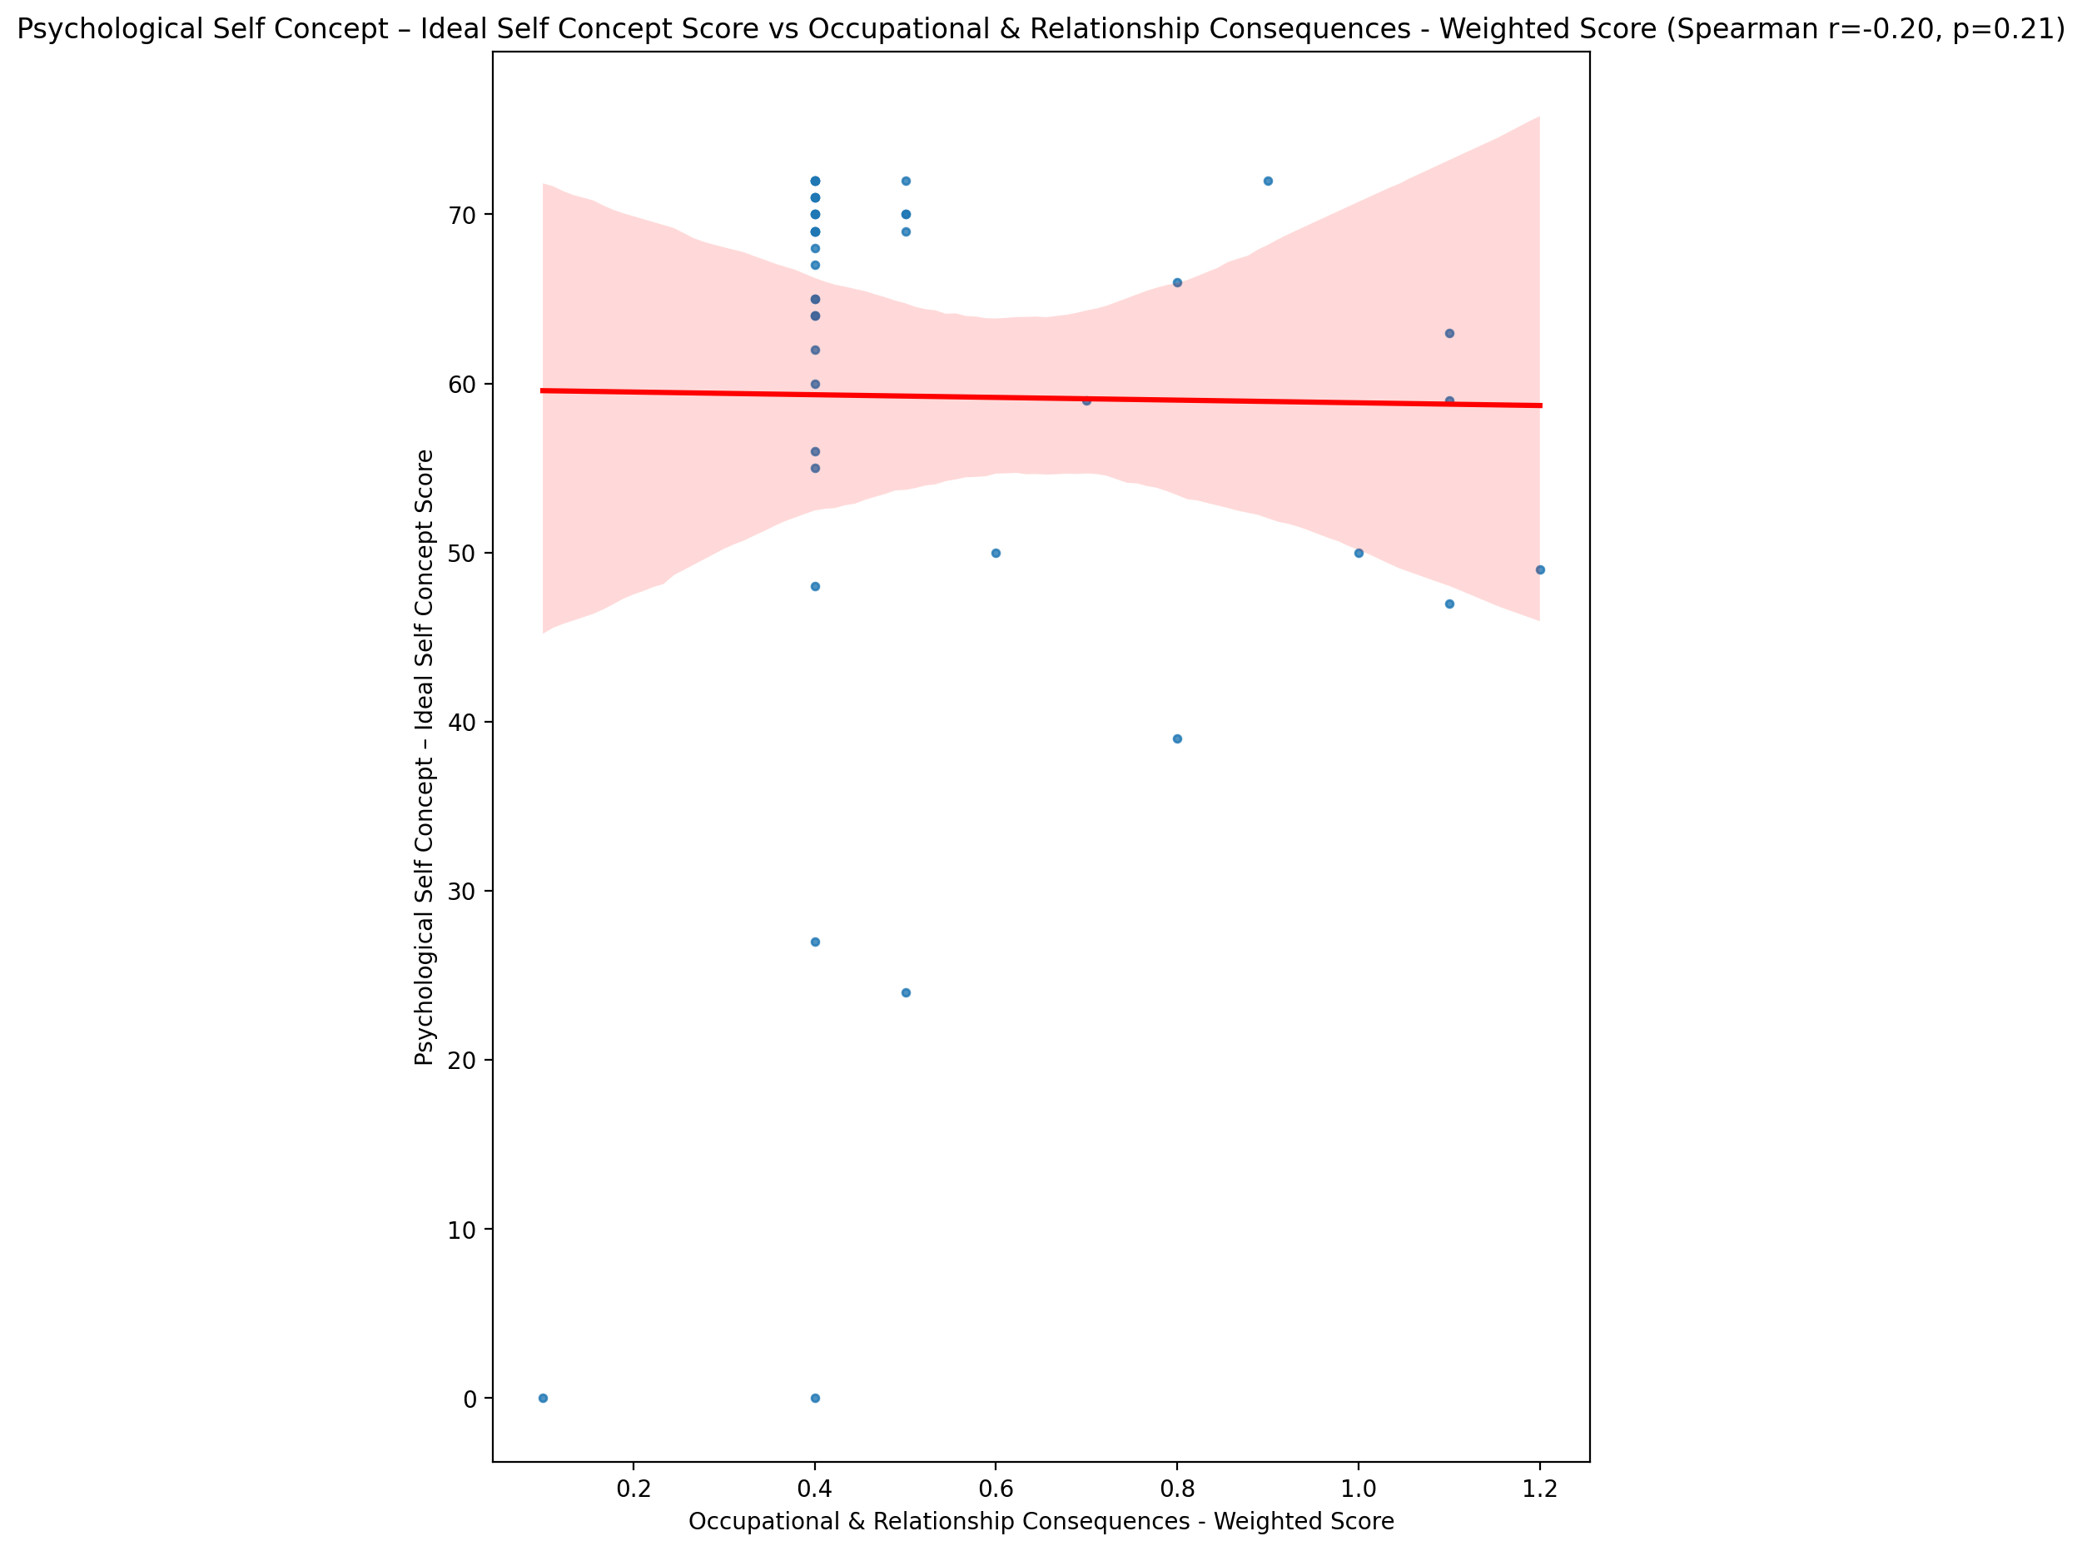

## Psychological Self Concept – Social Self Concept Score vs Occupational & Relationship Consequences - Weighted Score

Test: spearman; statistic: -0.42487411687058957; p-value: 0.0045125481575784415;

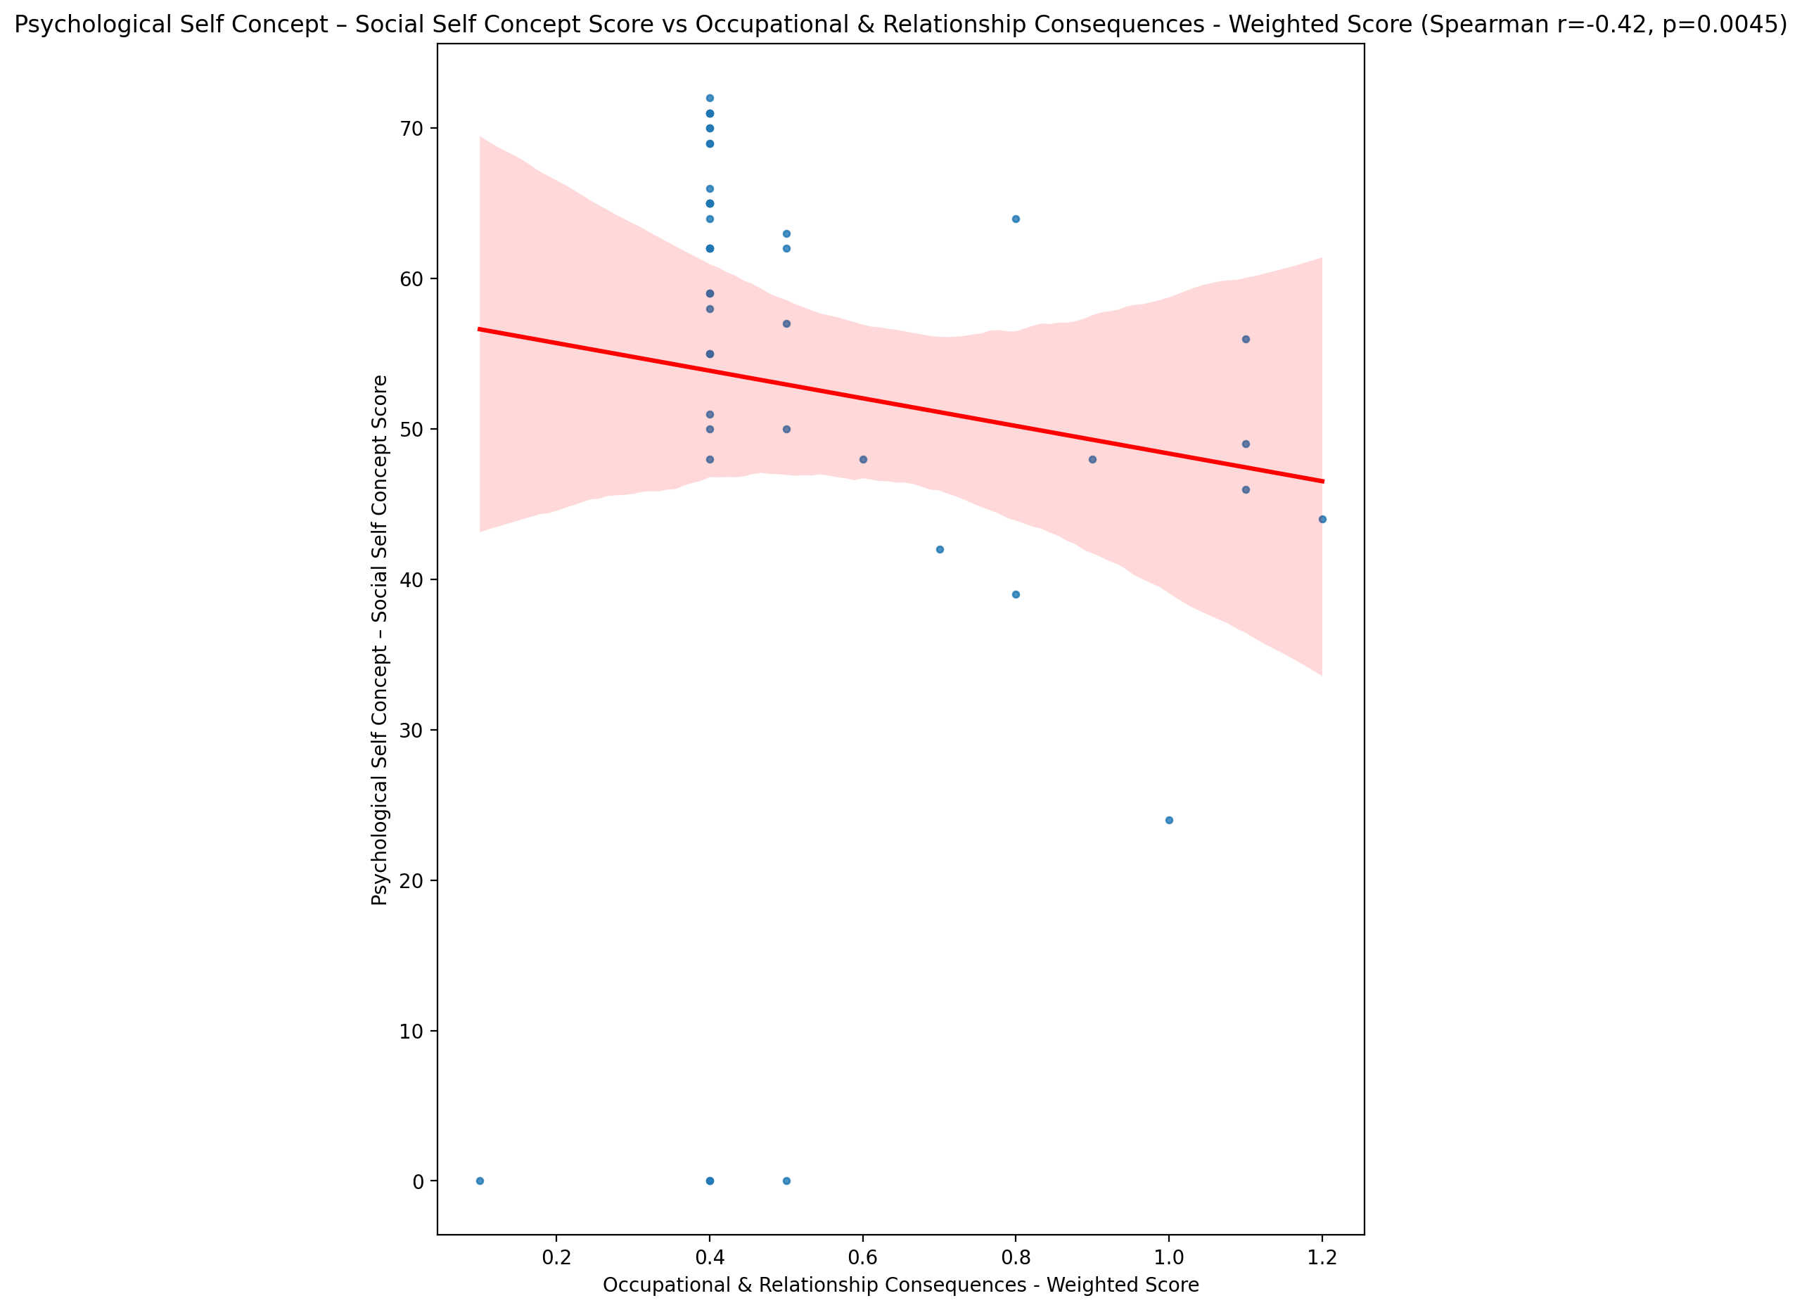

## Real Self Concept Total Score vs Occupational & Relationship Consequences - Weighted Score

Test: spearman; statistic: -0.3719198733647318; p-value: 0.014057750191810282;

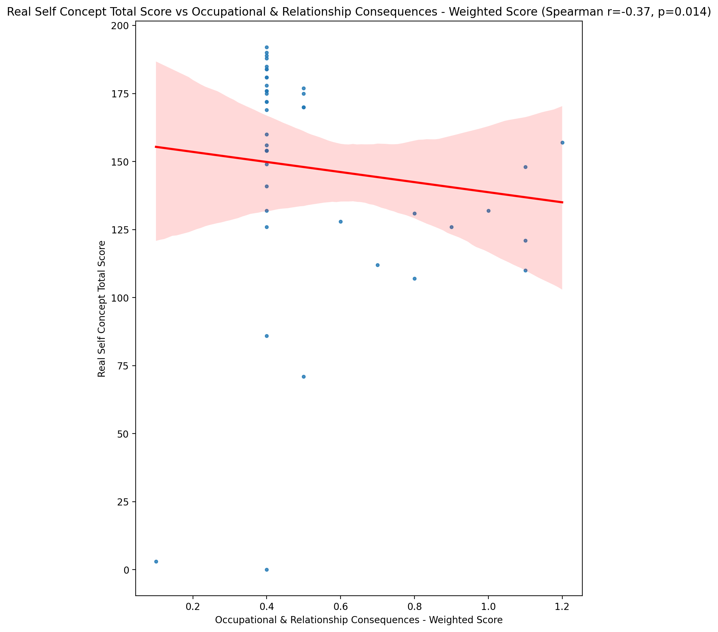

## Ideal Self Concept Total Score vs Occupational & Relationship Consequences - Weighted Score

Test: spearman; statistic: -0.20973297606571795; p-value: 0.17706295247949416;

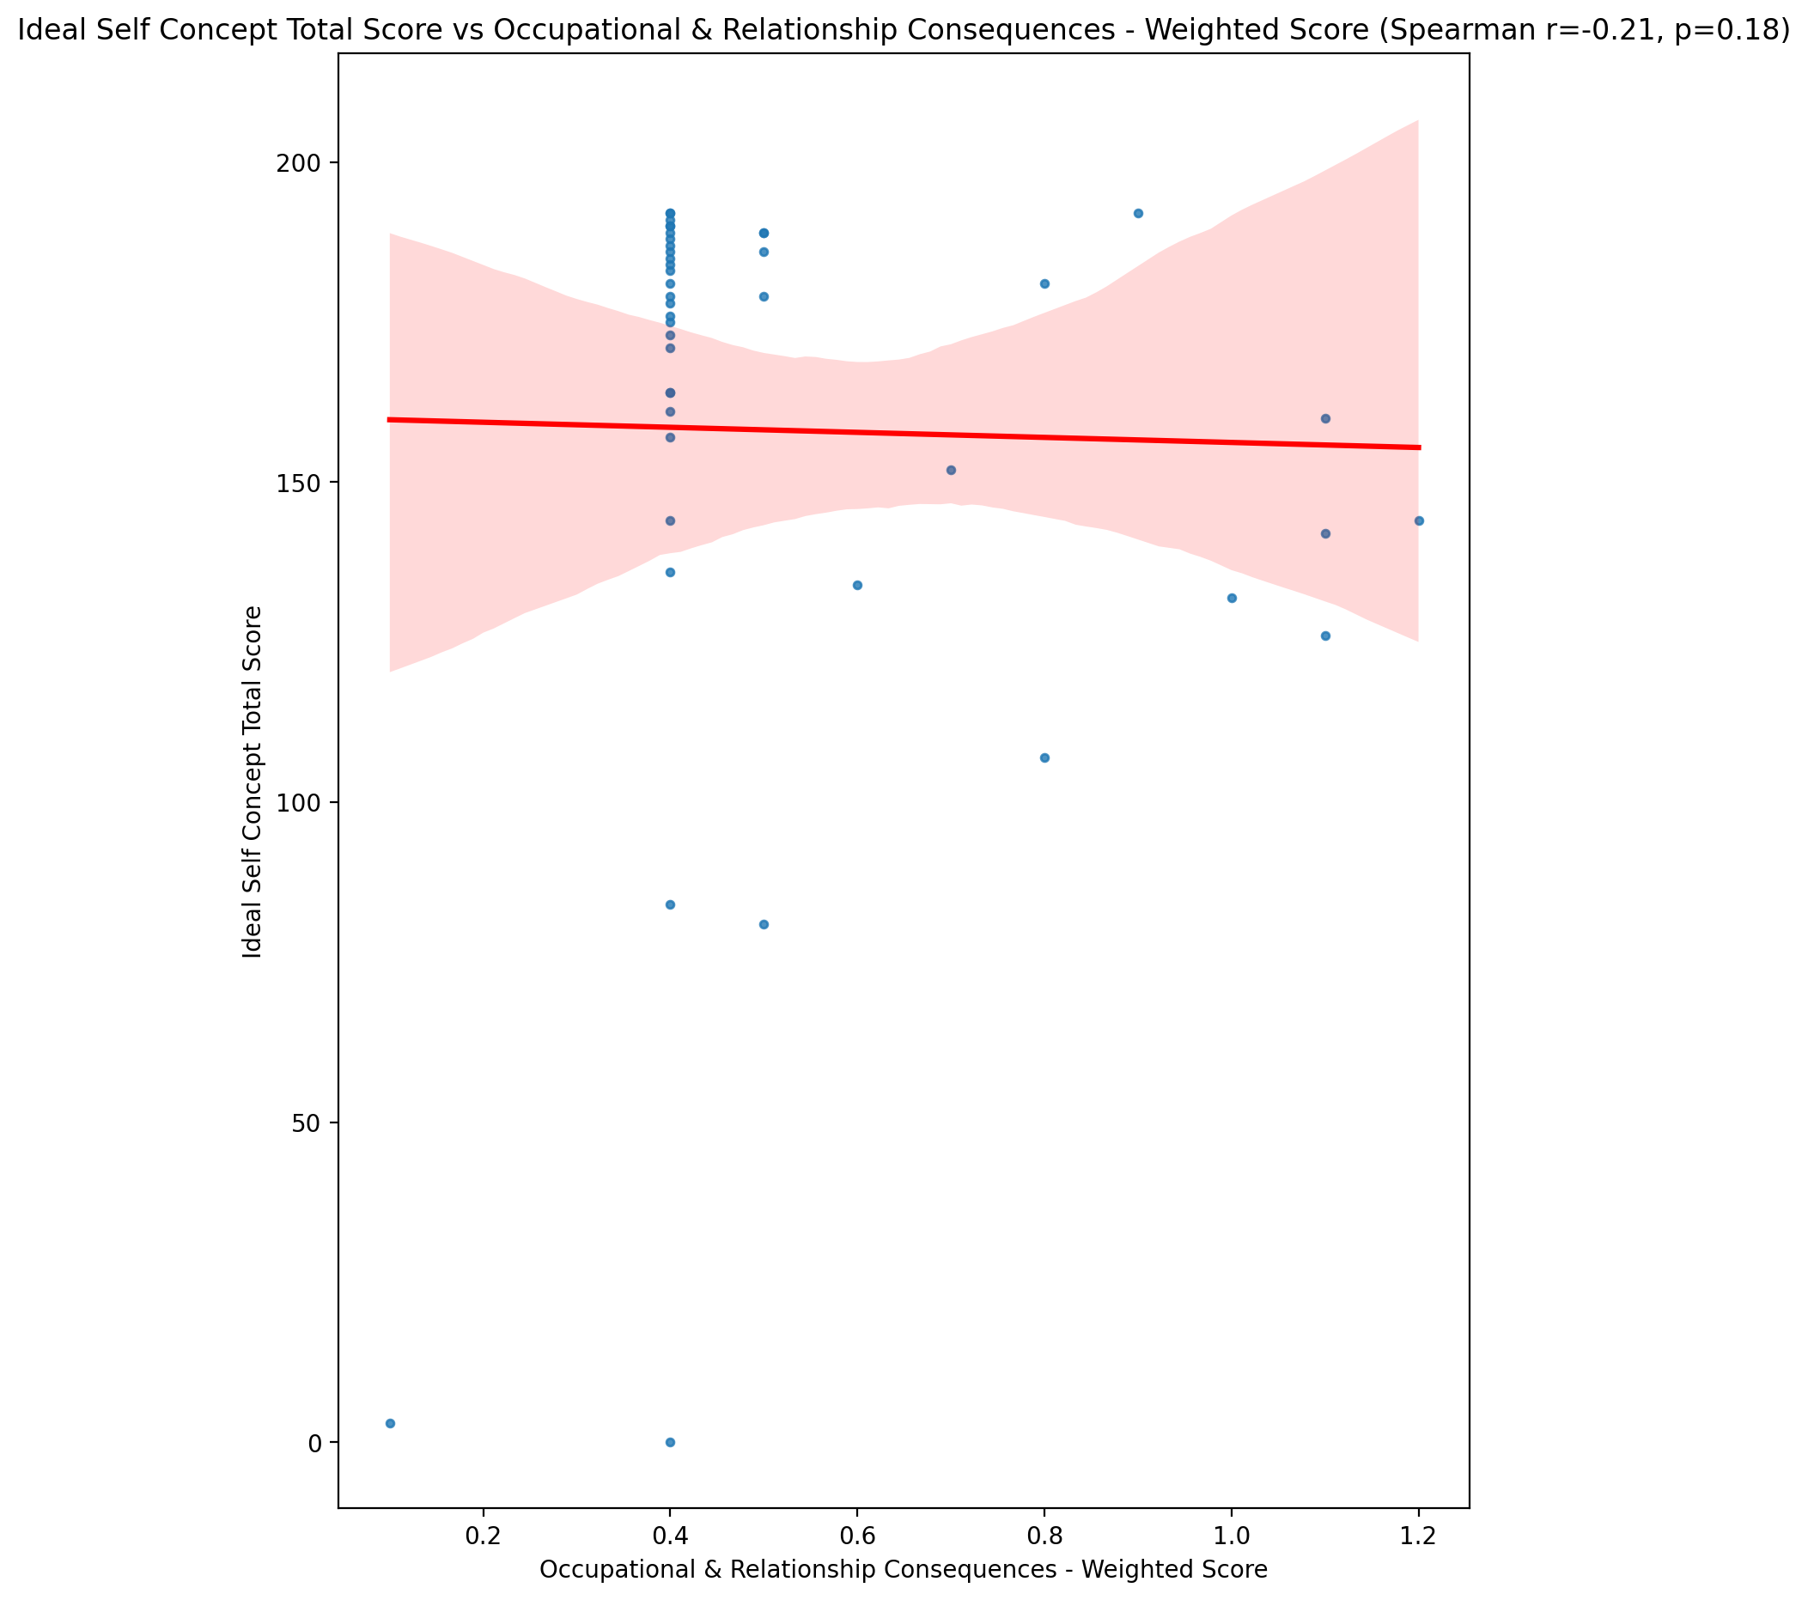

## Social Self Concept Total Score vs Occupational & Relationship Consequences - Weighted Score

Test: spearman; statistic: -0.38838266049950243; p-value: 0.010062888972597134;

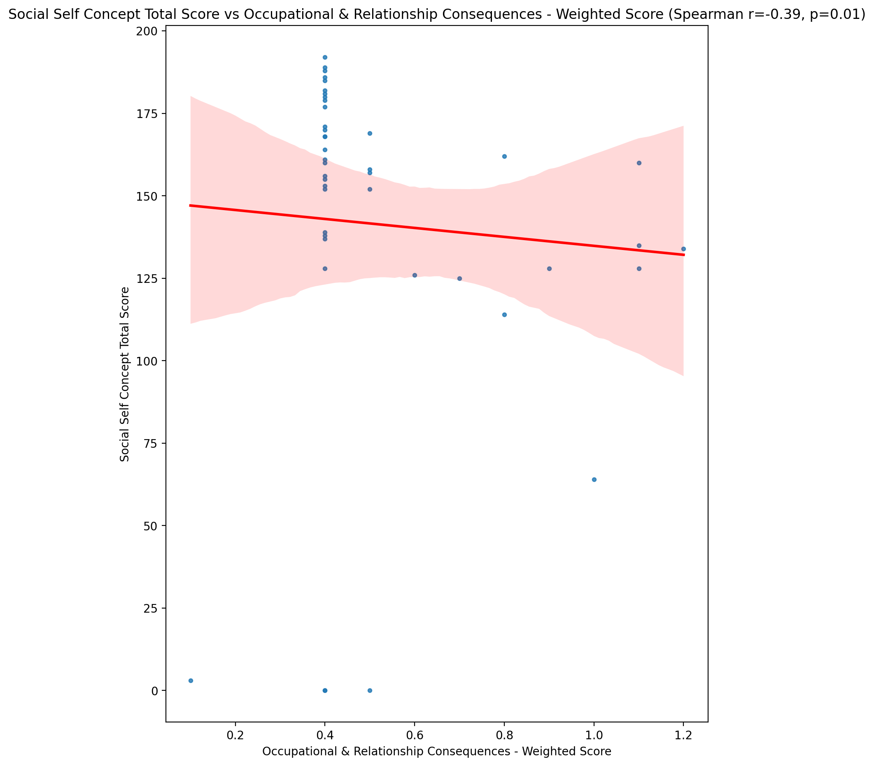

## Ideal Self Concept Total Category vs Occupational & Relationship Consequences - Weighted Score

Test: None; statistic: None; p-value: None; Test not run: unsupported type combination.



## Perceived Social Stress Score vs Occupational & Relationship Consequences - Weighted Score

Test: spearman; statistic: 0.20120701785774708; p-value: 0.19573370799409667;

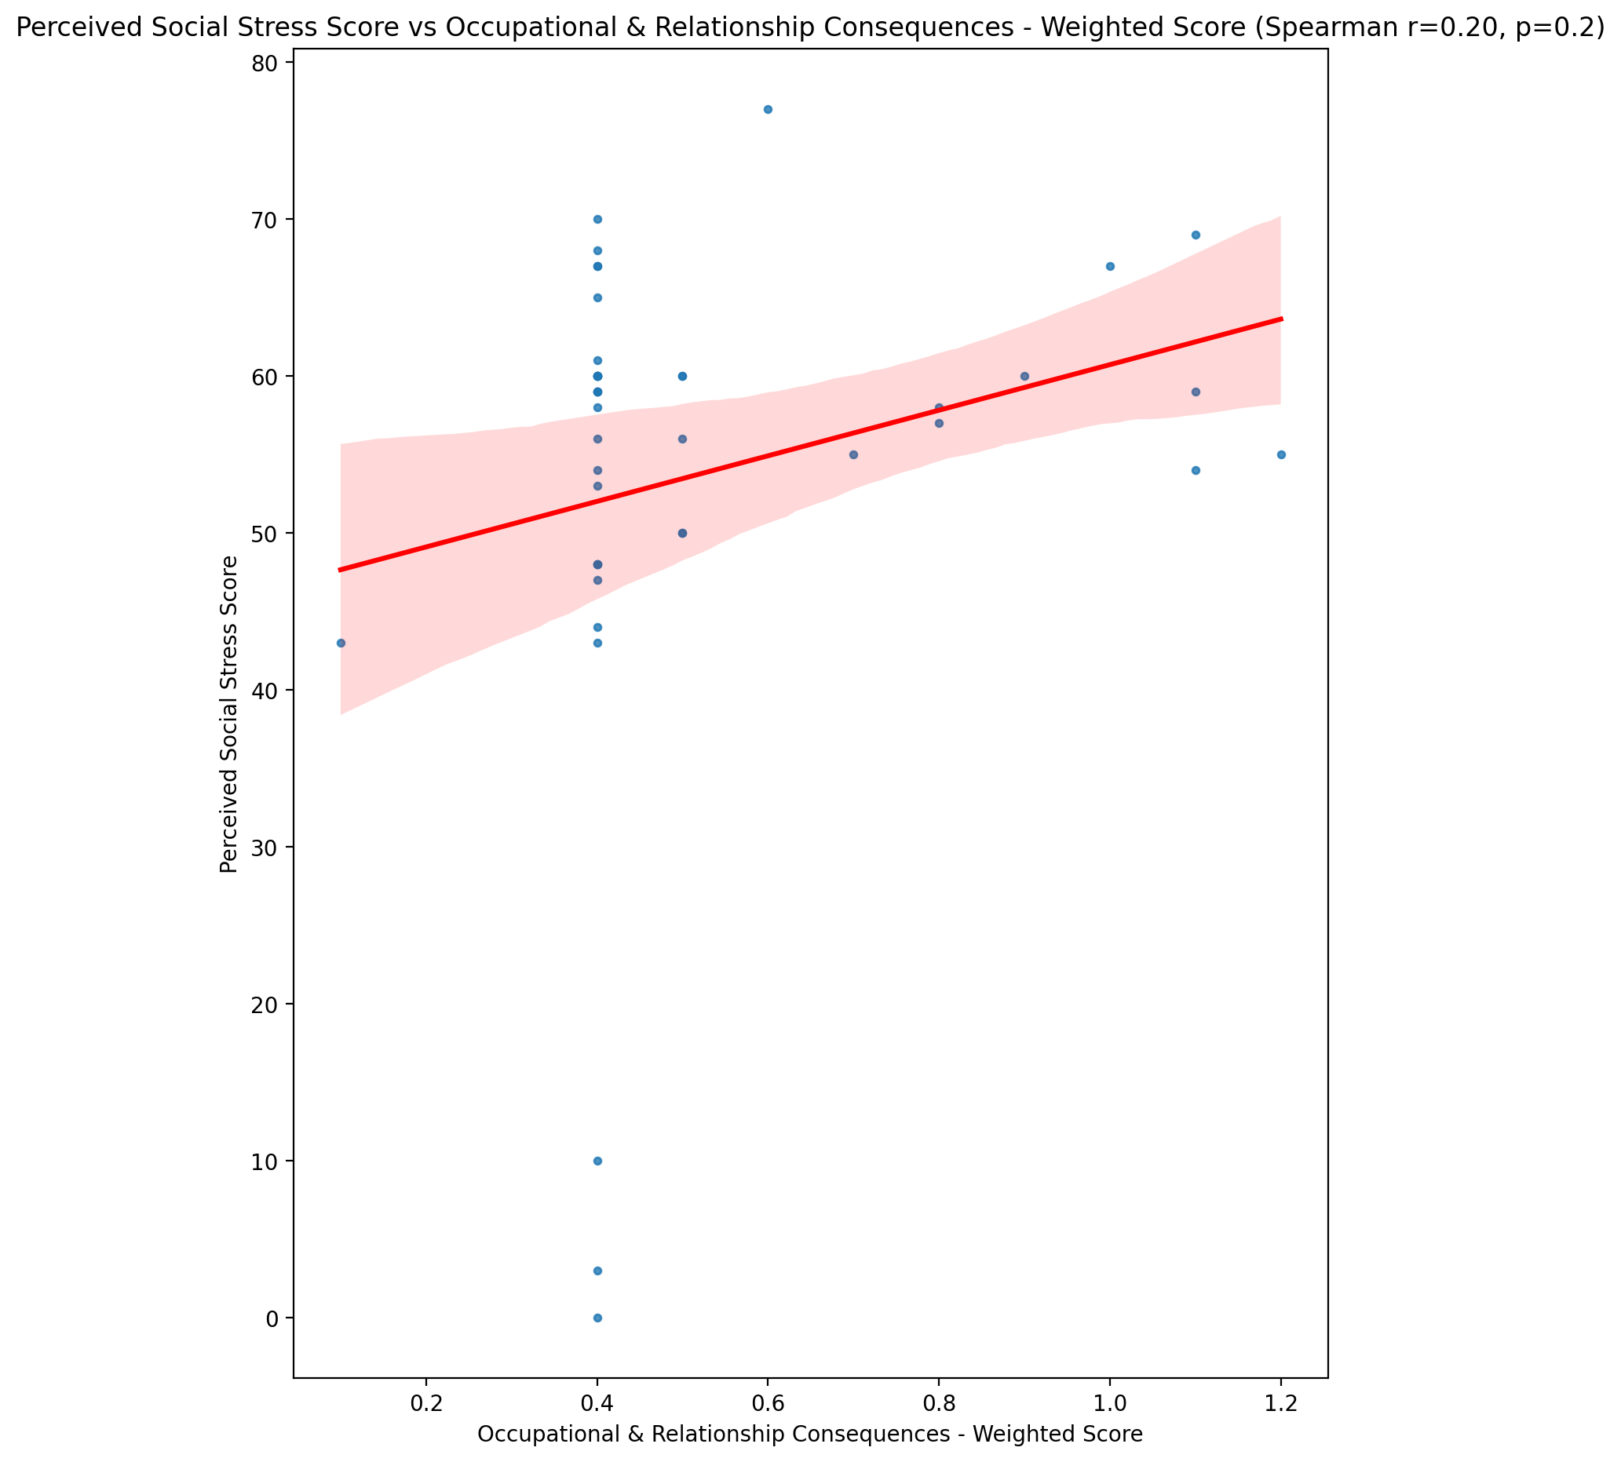

## Perceived Social Stress Category vs Occupational & Relationship Consequences - Weighted Score

Test: None; statistic: None; p-value: None; Test not run: unsupported type combination.



## Emotional Support - Raw Score vs Compulsive Behaviour - Weighted Score

Test: spearman; statistic: -0.4529405229410867; p-value: 0.002288989637193242;

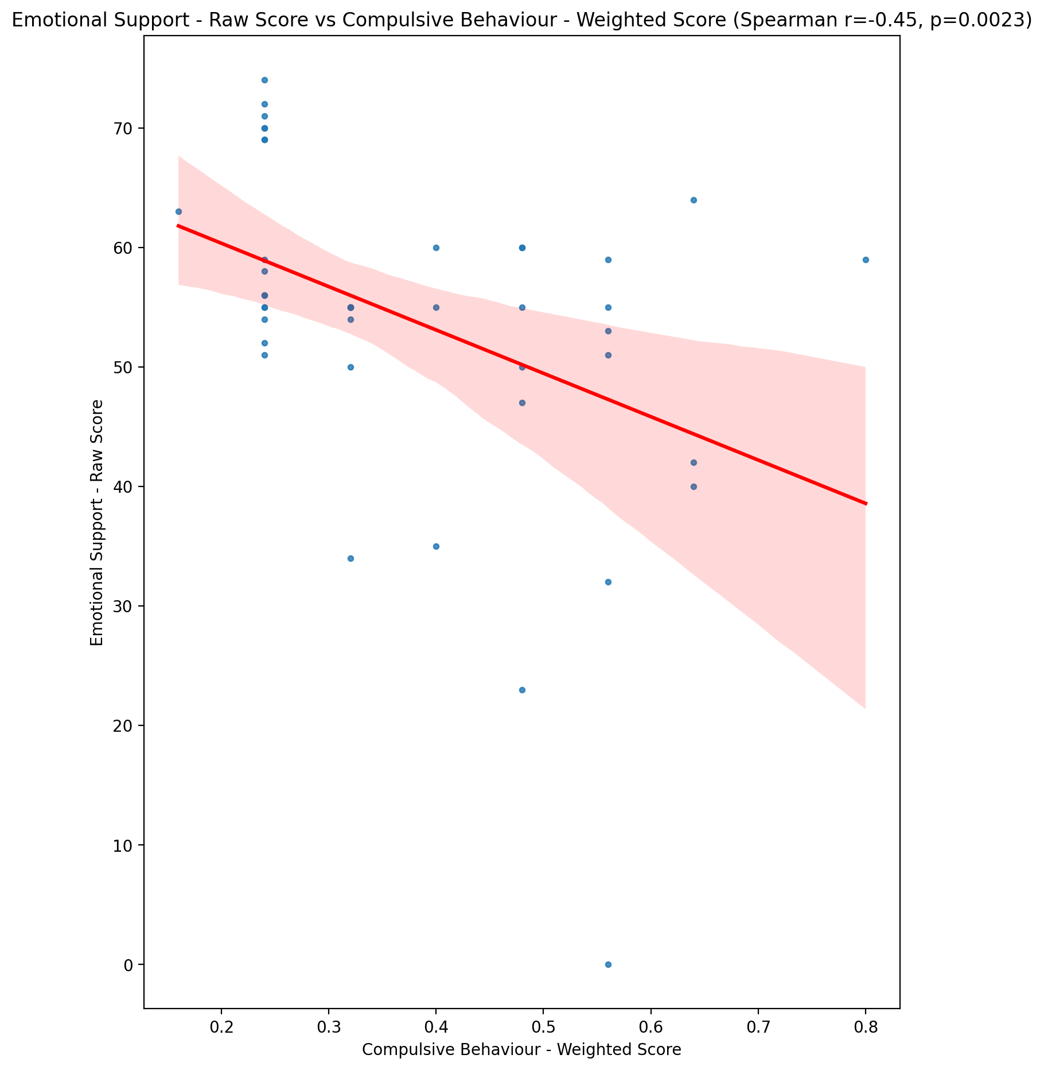

## Informational Support - Raw Score vs Compulsive Behaviour - Weighted Score

Test: spearman; statistic: -0.4128771995166683; p-value: 0.005930825523191863;

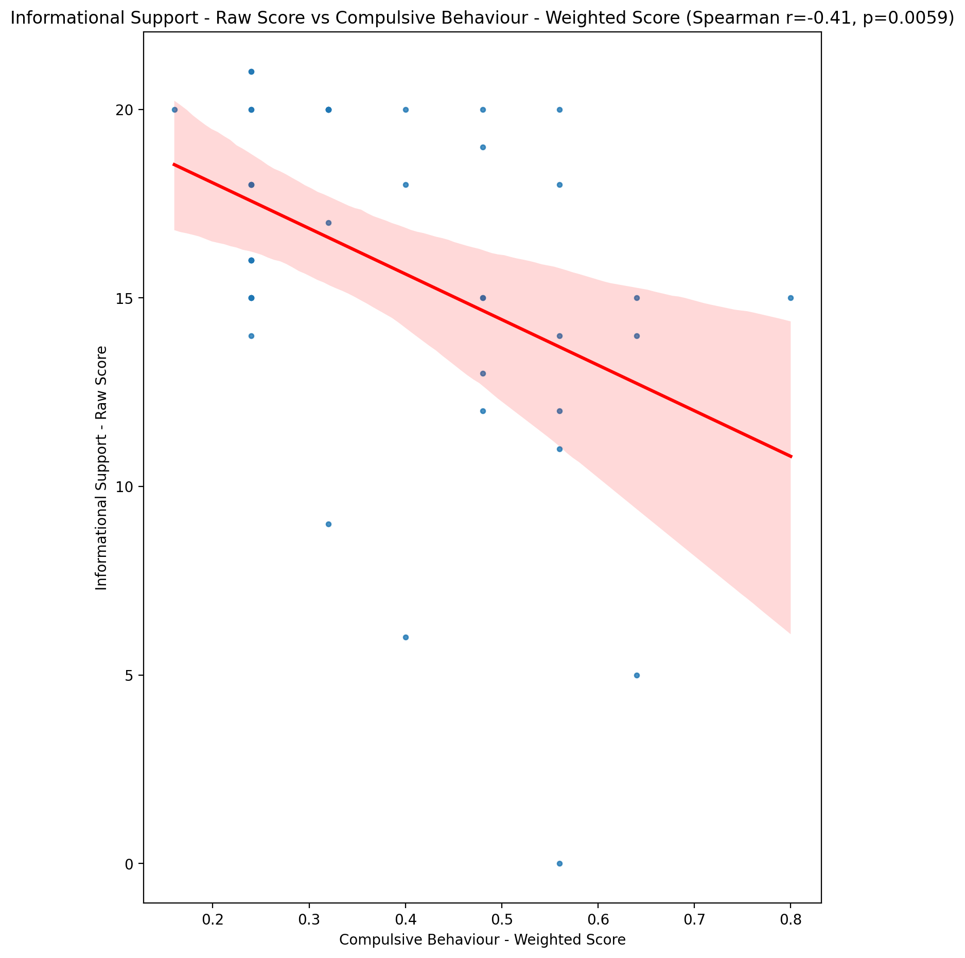

## Instrumental Support - Raw Score vs Compulsive Behaviour - Weighted Score

Test: spearman; statistic: -0.30998517924373703; p-value: 0.04307885353652257;

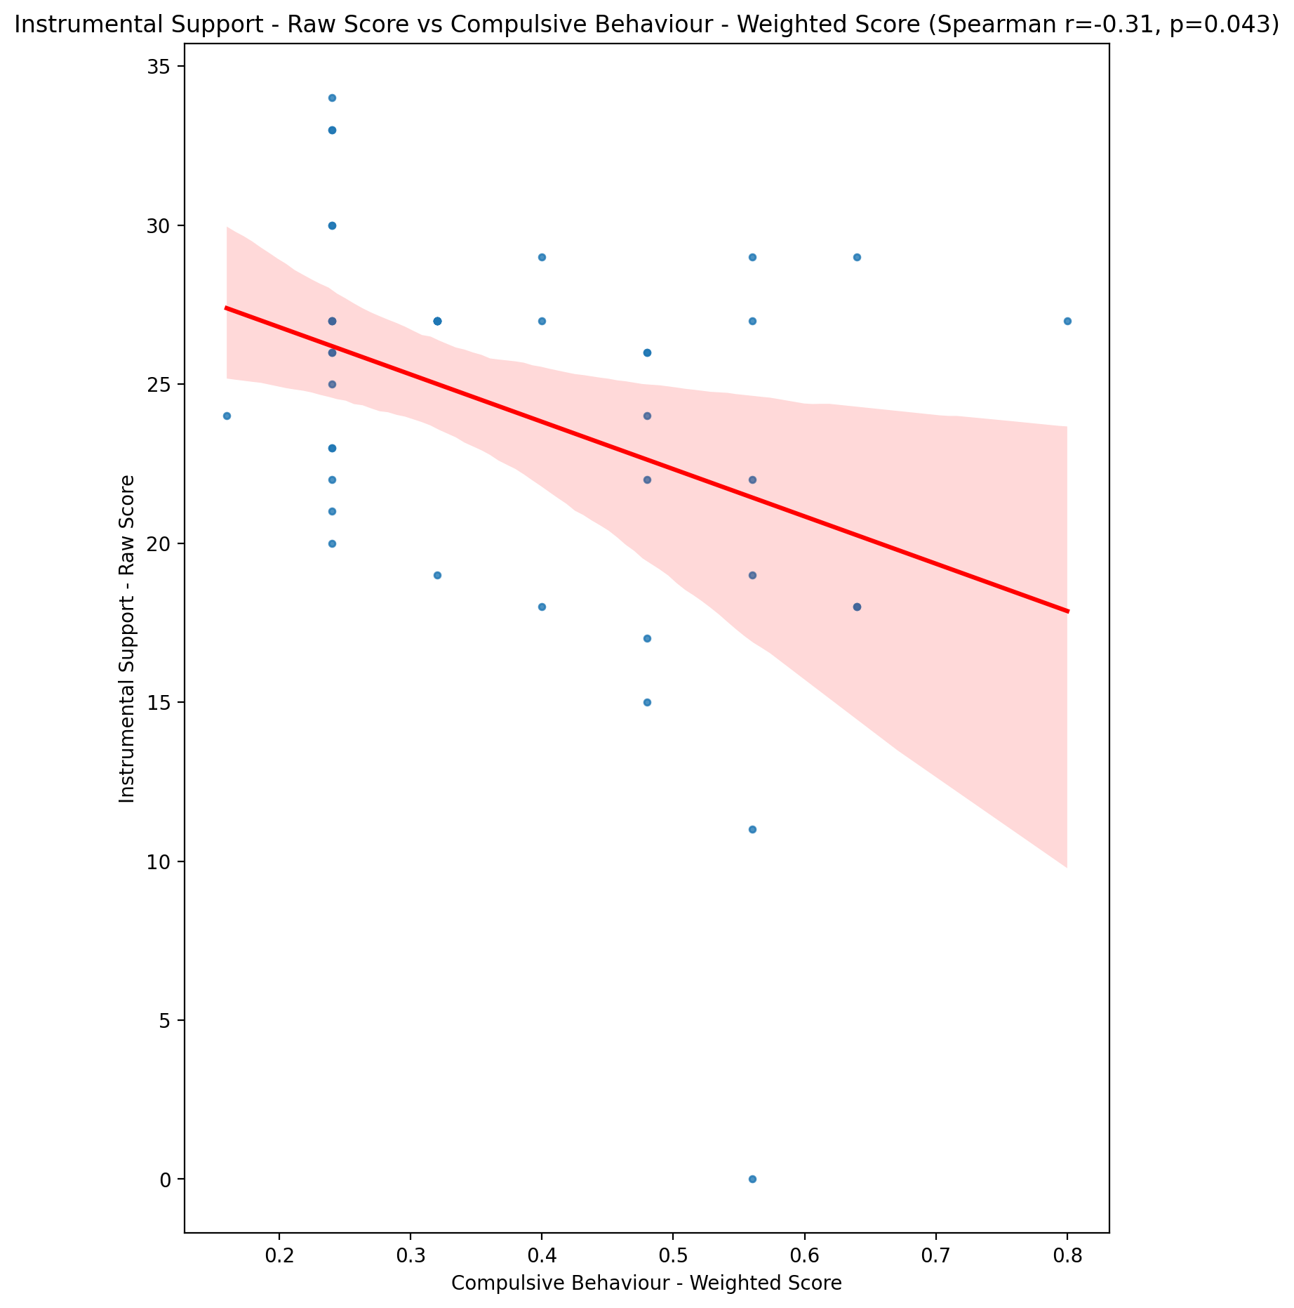

## Emotional Support - T Score vs Compulsive Behaviour - Weighted Score

Test: spearman; statistic: -0.3720758850275539; p-value: 0.014014351662463856;

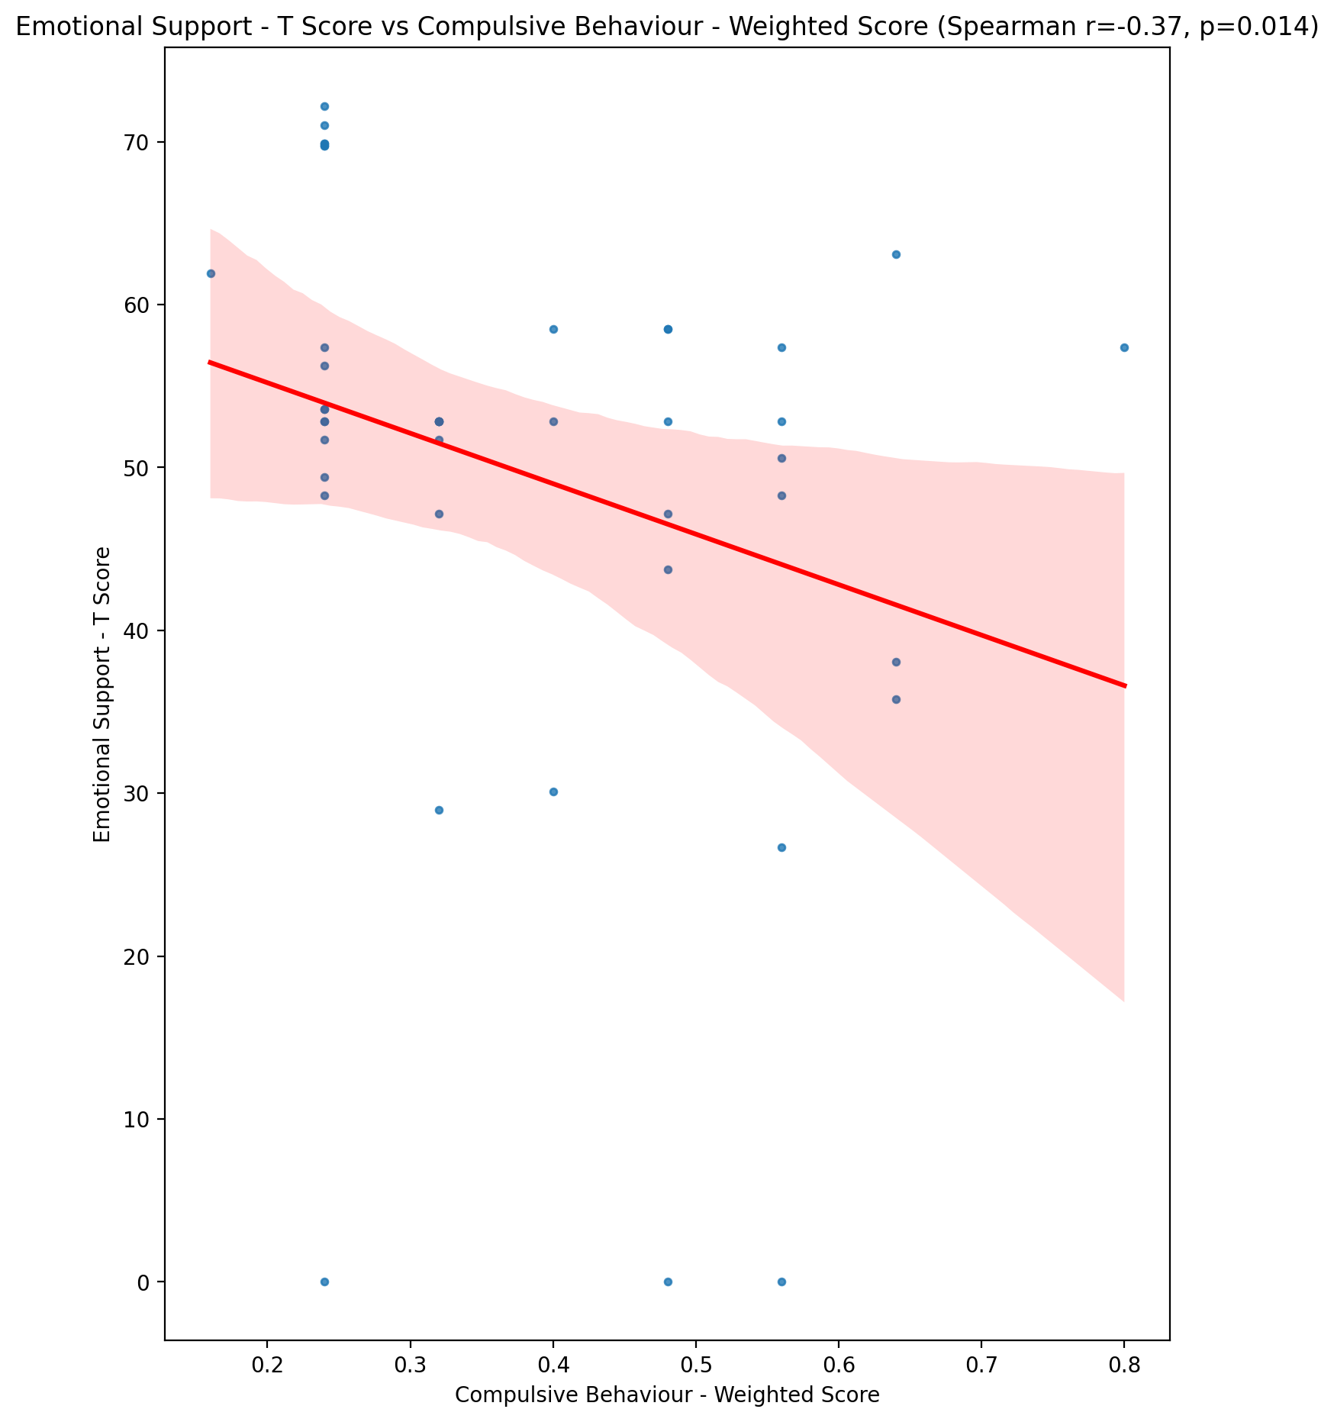

## Informational Support - T Score vs Compulsive Behaviour - Weighted Score

Test: spearman; statistic: -0.4112828081044108; p-value: 0.006145734809020281;

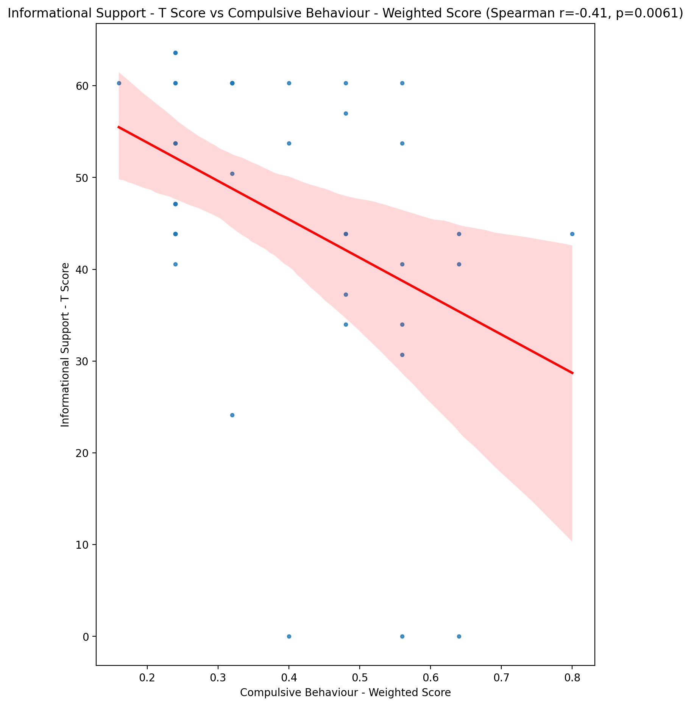

## Instrumental Support - T Score vs Compulsive Behaviour - Weighted Score

Test: spearman; statistic: -0.3099971660645394; p-value: 0.043070365896757175;

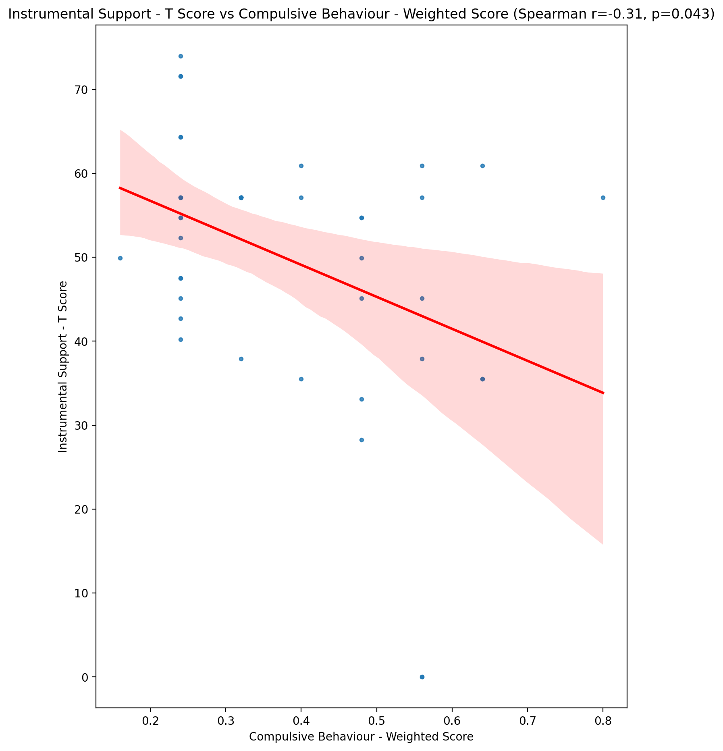

## Perceived Social Support Total T Score vs Compulsive Behaviour - Weighted Score

Test: spearman; statistic: -0.4089669498611764; p-value: 0.006469902585841442;

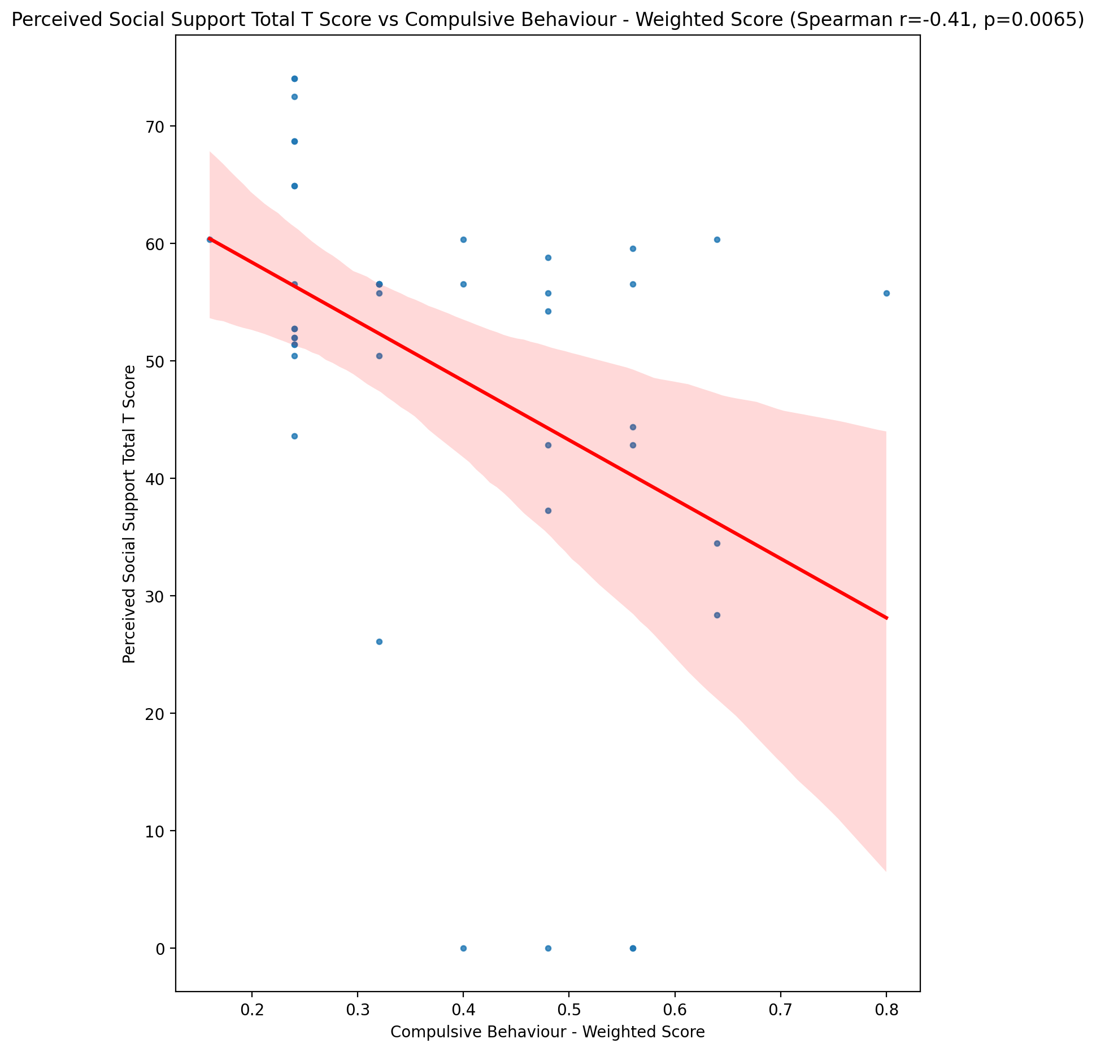

## Emotional Support - Rank vs Compulsive Behaviour - Weighted Score

Test: None; statistic: None; p-value: None; Test not run: unsupported type combination.



## Informational Support - Rank vs Compulsive Behaviour - Weighted Score

Test: None; statistic: None; p-value: None; Test not run: unsupported type combination.



## Instrumental Support - Rank vs Compulsive Behaviour - Weighted Score

Test: None; statistic: None; p-value: None; Test not run: unsupported type combination.



## Perceived Social Support TOTAL - Rank vs Compulsive Behaviour - Weighted Score

Test: None; statistic: None; p-value: None; Test not run: unsupported type combination.



## Power Self Concept - Real Self Concept Score vs Compulsive Behaviour - Weighted Score

Test: spearman; statistic: -0.3487104741064729; p-value: 0.021921452365185296;

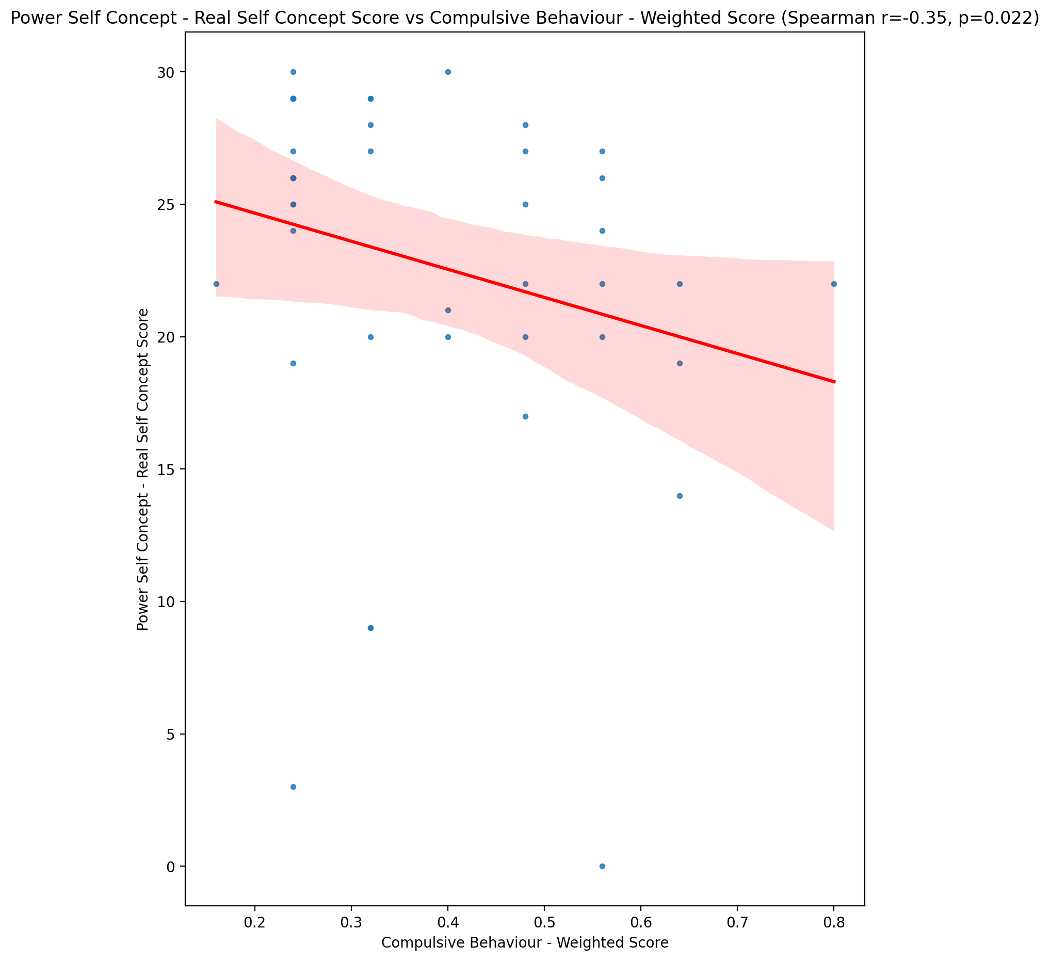

## Power Self Concept - Ideal Self Concept score vs Compulsive Behaviour - Weighted Score

Test: spearman; statistic: -0.32444721119617764; p-value: 0.03378354881234858;

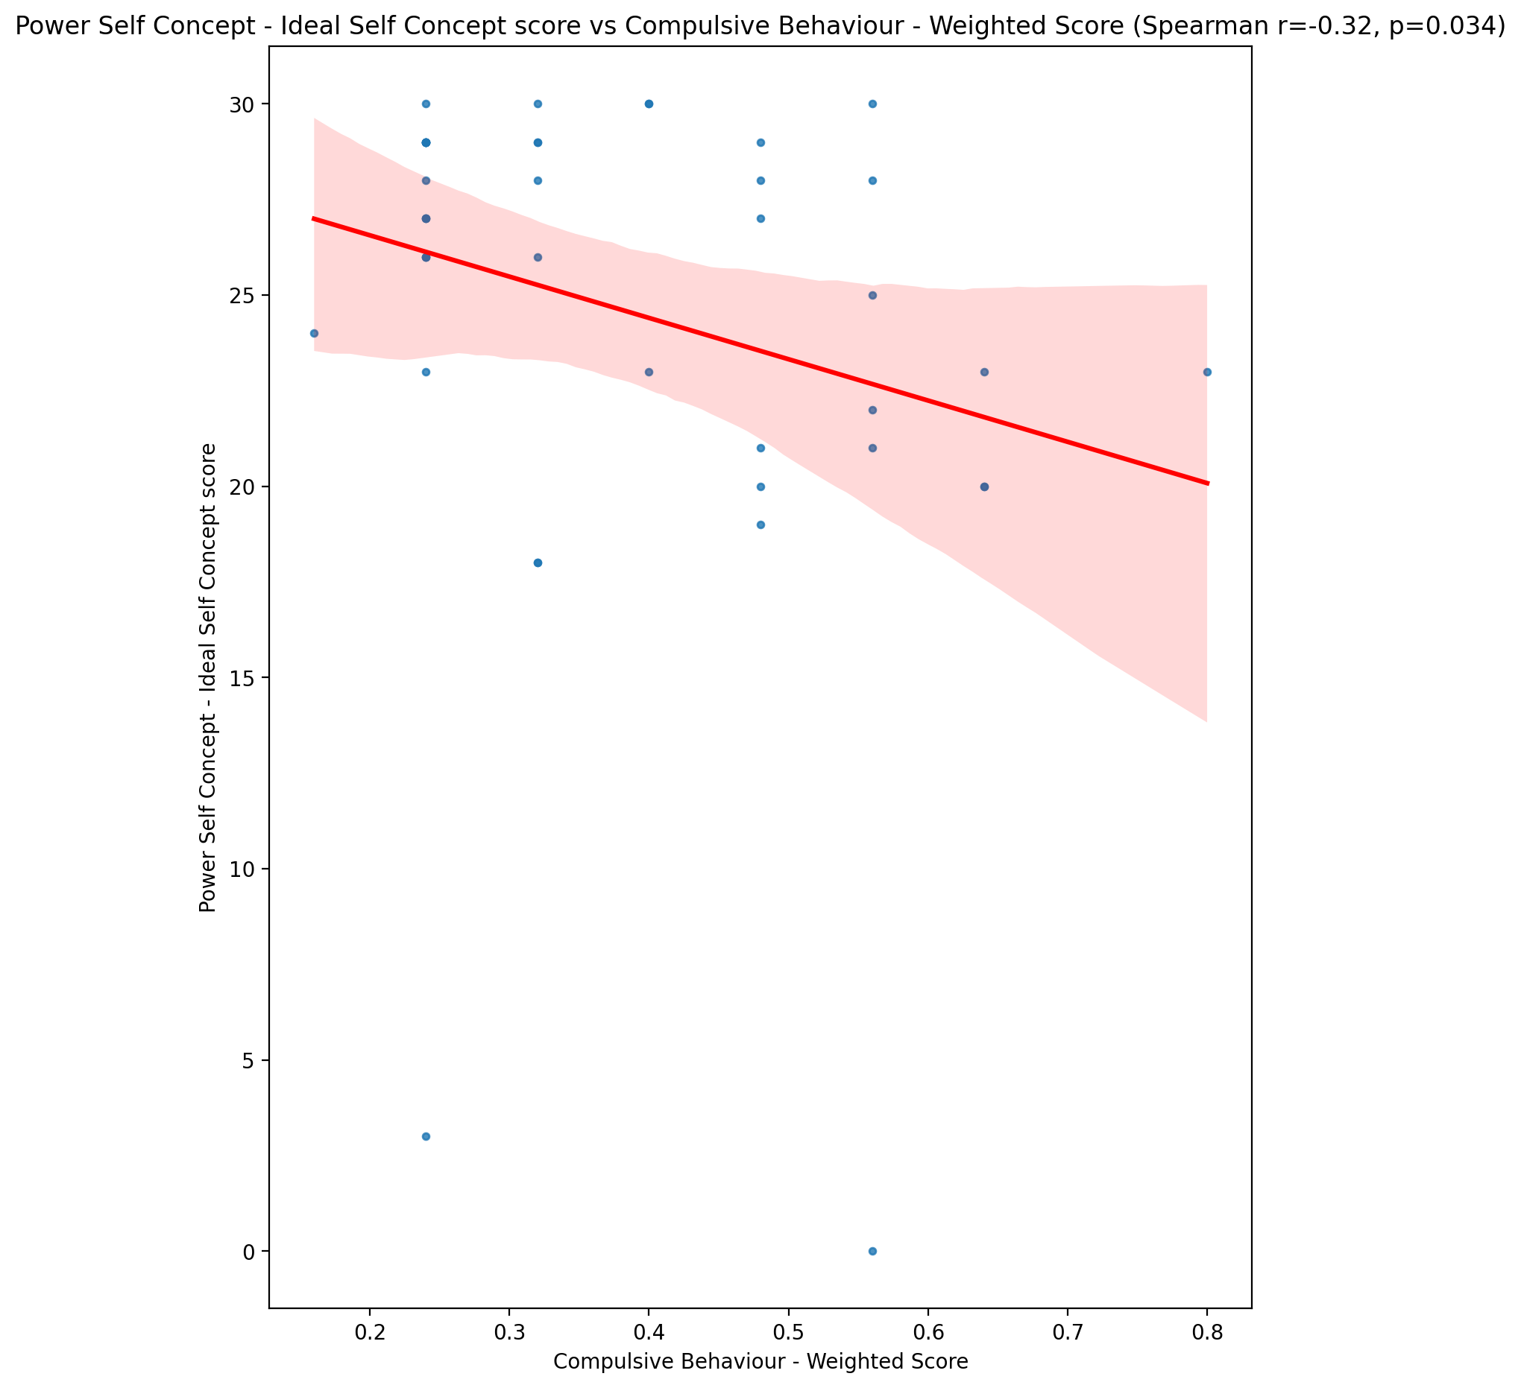

## Power Self Concept – Social Self Concept Score vs Compulsive Behaviour - Weighted Score

Test: spearman; statistic: -0.5971343656320519; p-value: 2.3682389705624092e-05;

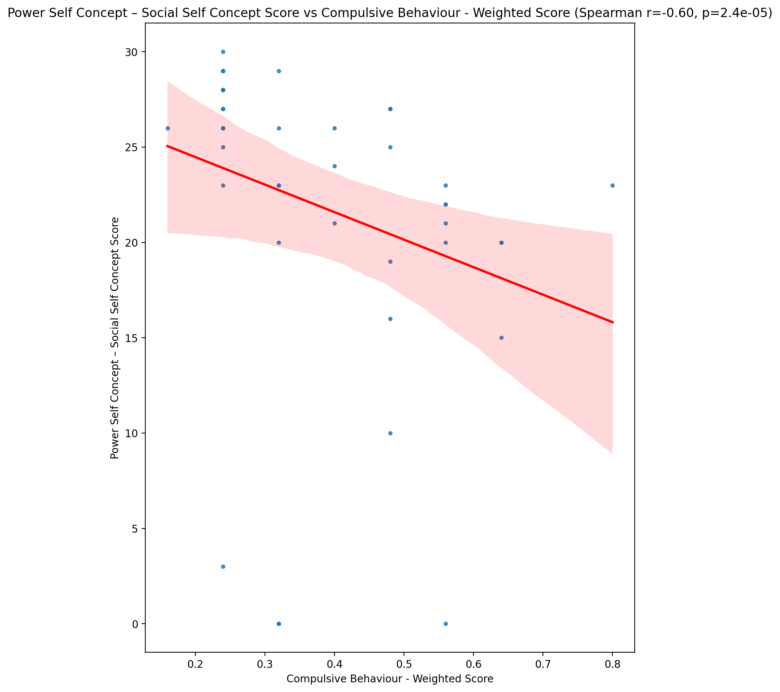

## Social Self Concept - Real Self Concept Score vs Compulsive Behaviour - Weighted Score

Test: spearman; statistic: -0.5055189649580306; p-value: 0.0005445879070848674;

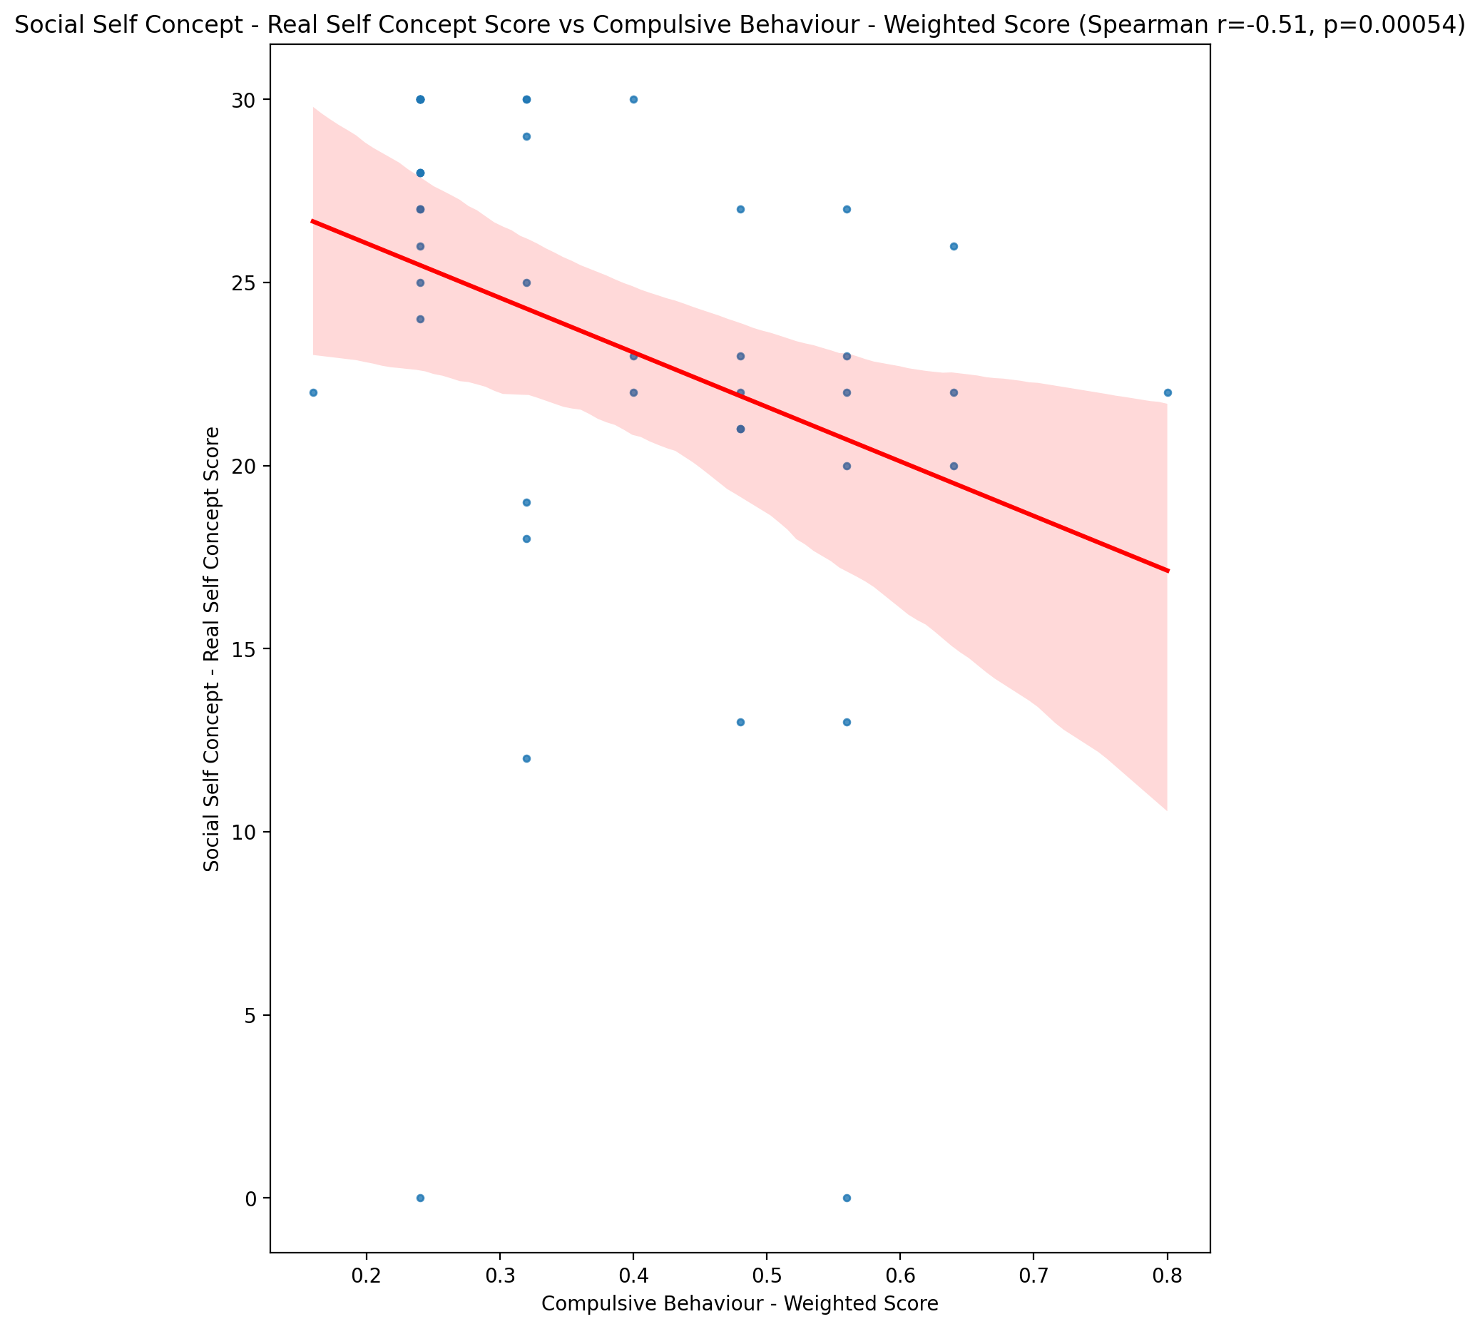

## Social Self Concept – Social Self Concept Score vs Compulsive Behaviour - Weighted Score

Test: spearman; statistic: -0.6270165899242539; p-value: 6.828912421620542e-06;

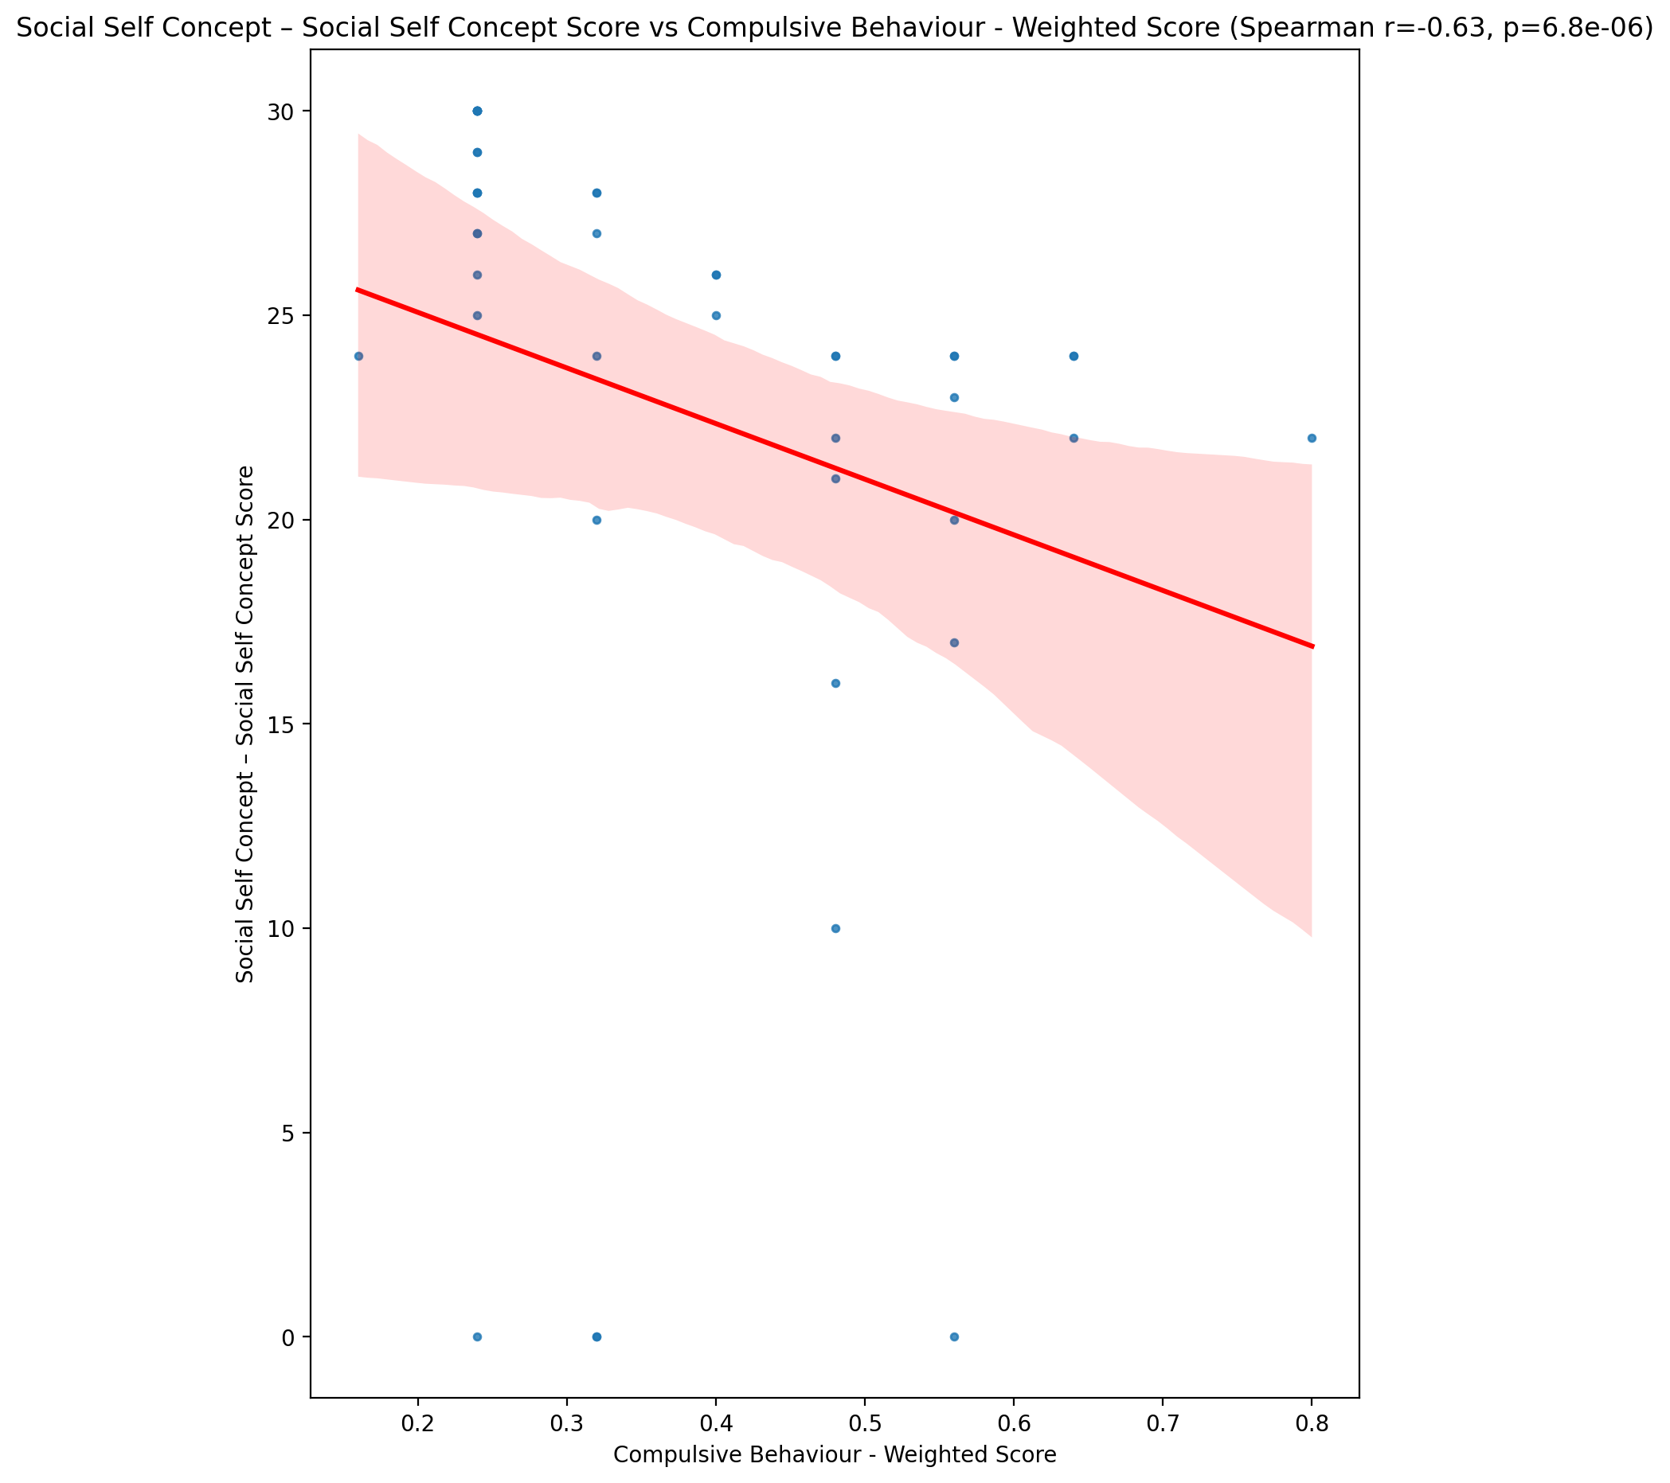

## Ability Self Concept - Real Self Concept Score vs Compulsive Behaviour - Weighted Score

Test: spearman; statistic: -0.3360716625116638; p-value: 0.027569541782305203;

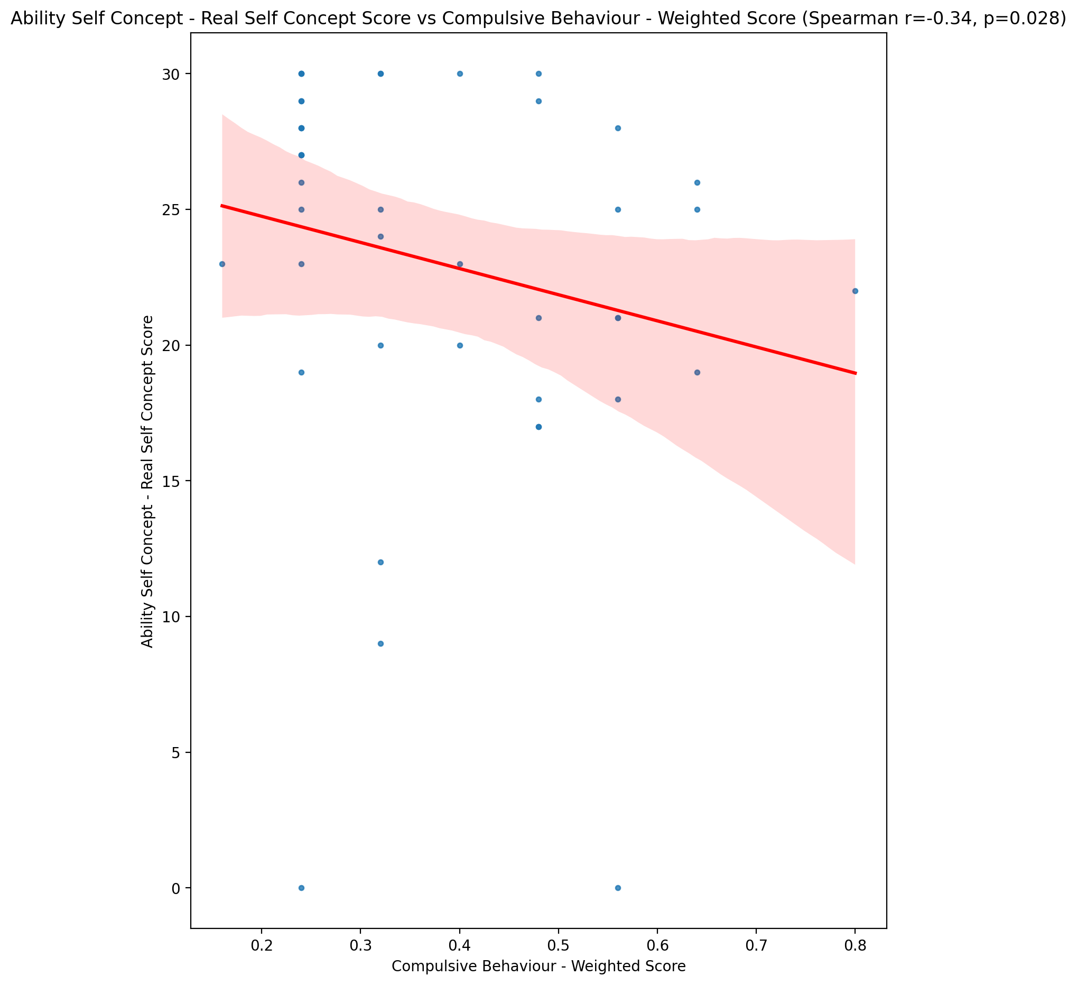

## Ability Self Concept - Ideal Self Concept Score vs Compulsive Behaviour - Weighted Score

Test: spearman; statistic: -0.355079953434253; p-value: 0.01946449691650352;

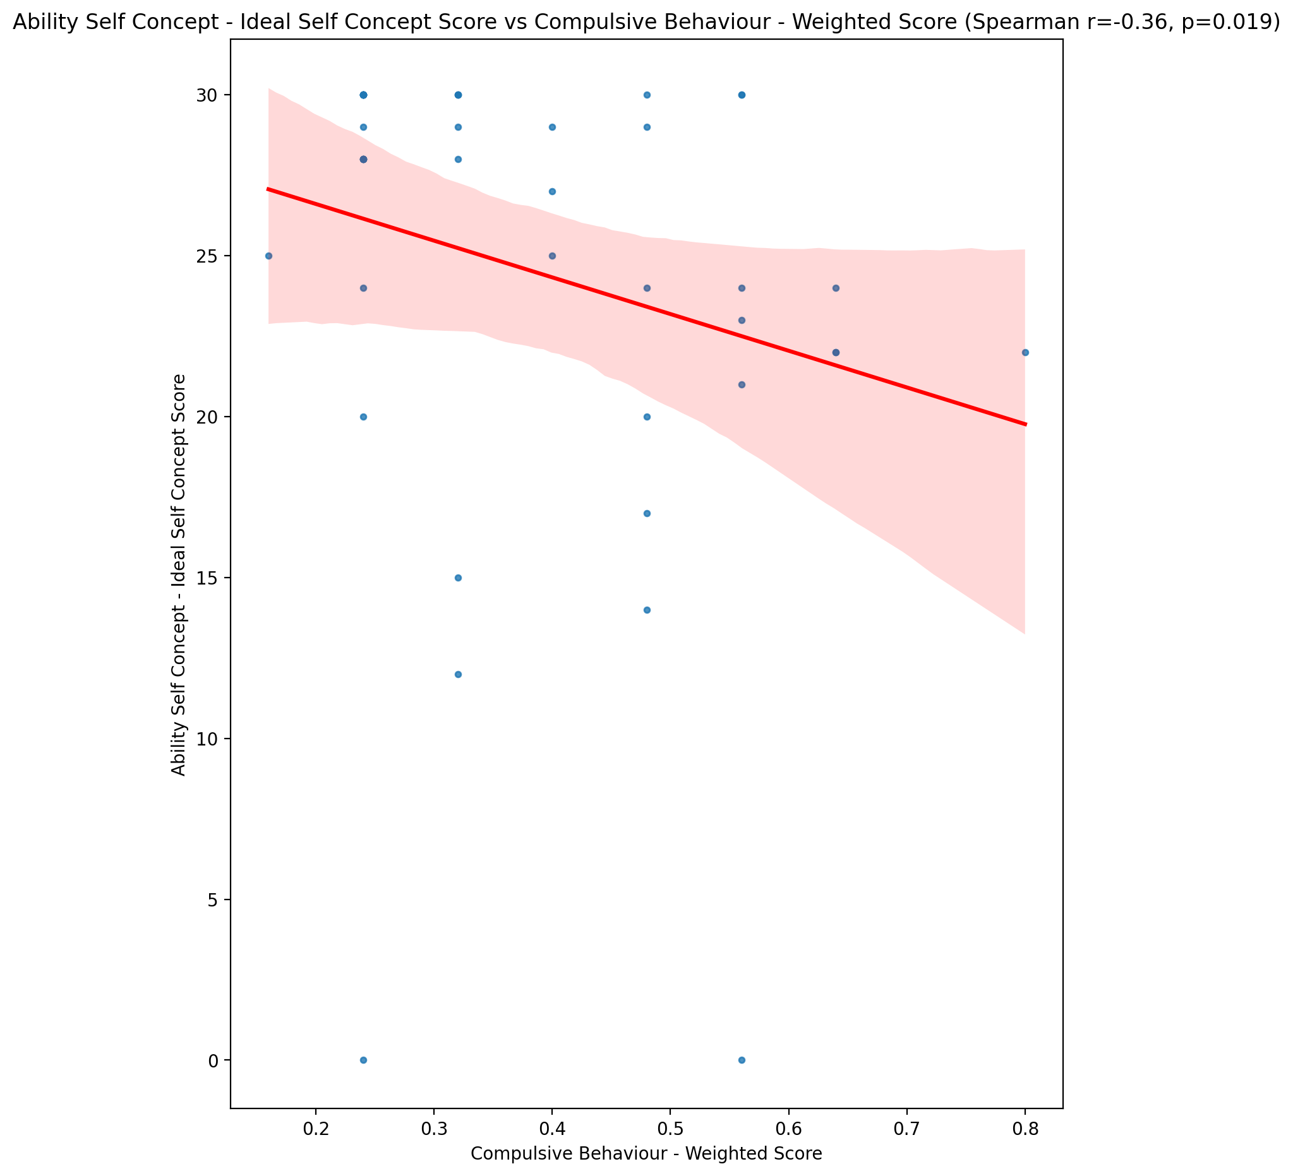

## Ability Self Concept – Social Self Concept Score vs Compulsive Behaviour - Weighted Score

Test: spearman; statistic: -0.4505839907915589; p-value: 0.0024285800870769737;

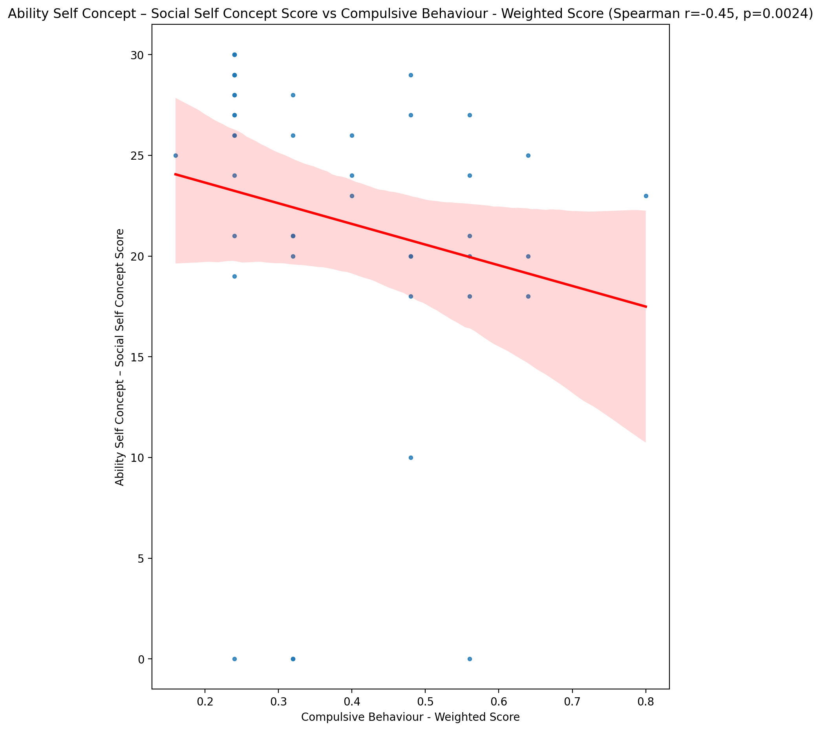

## Physical Self Concept - Real Self Concept Score vs Compulsive Behaviour - Weighted Score

Test: spearman; statistic: -0.5242057554693758; p-value: 0.00030854626694123245;

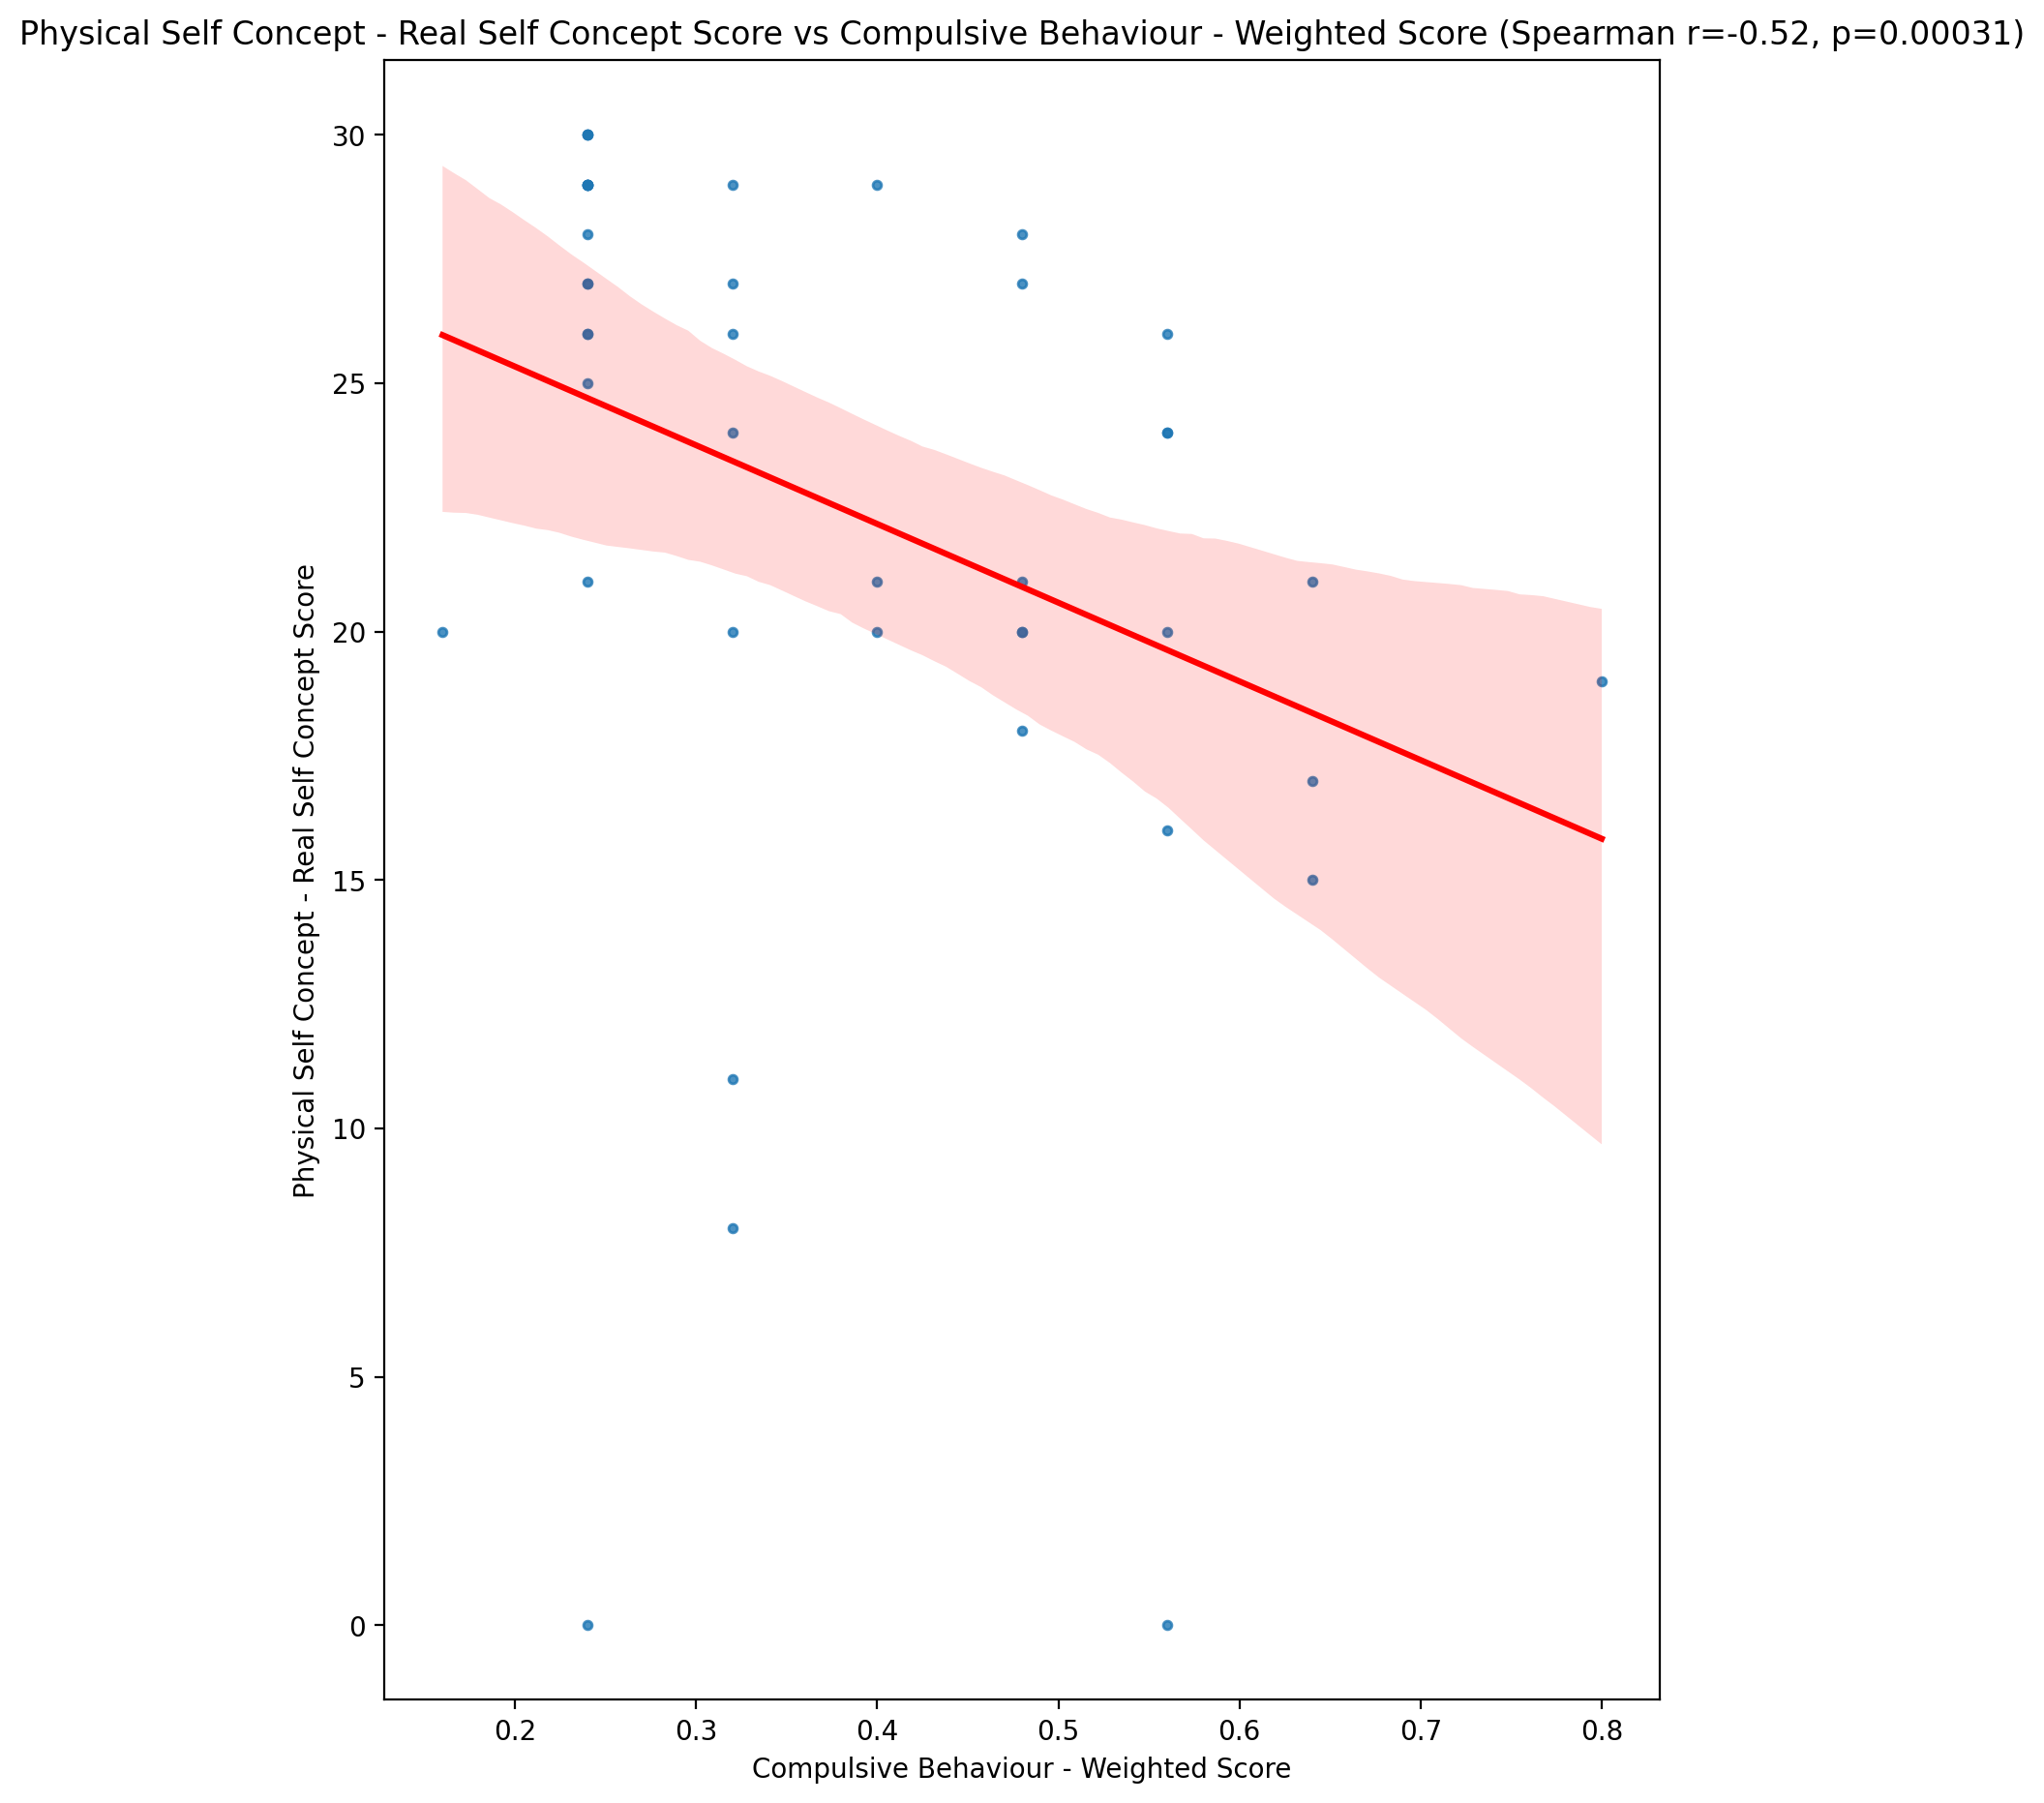

## Physical Self Concept – Ideal Self Concept Score vs Compulsive Behaviour - Weighted Score

Test: spearman; statistic: -0.4280921304432696; p-value: 0.004186571191357492;

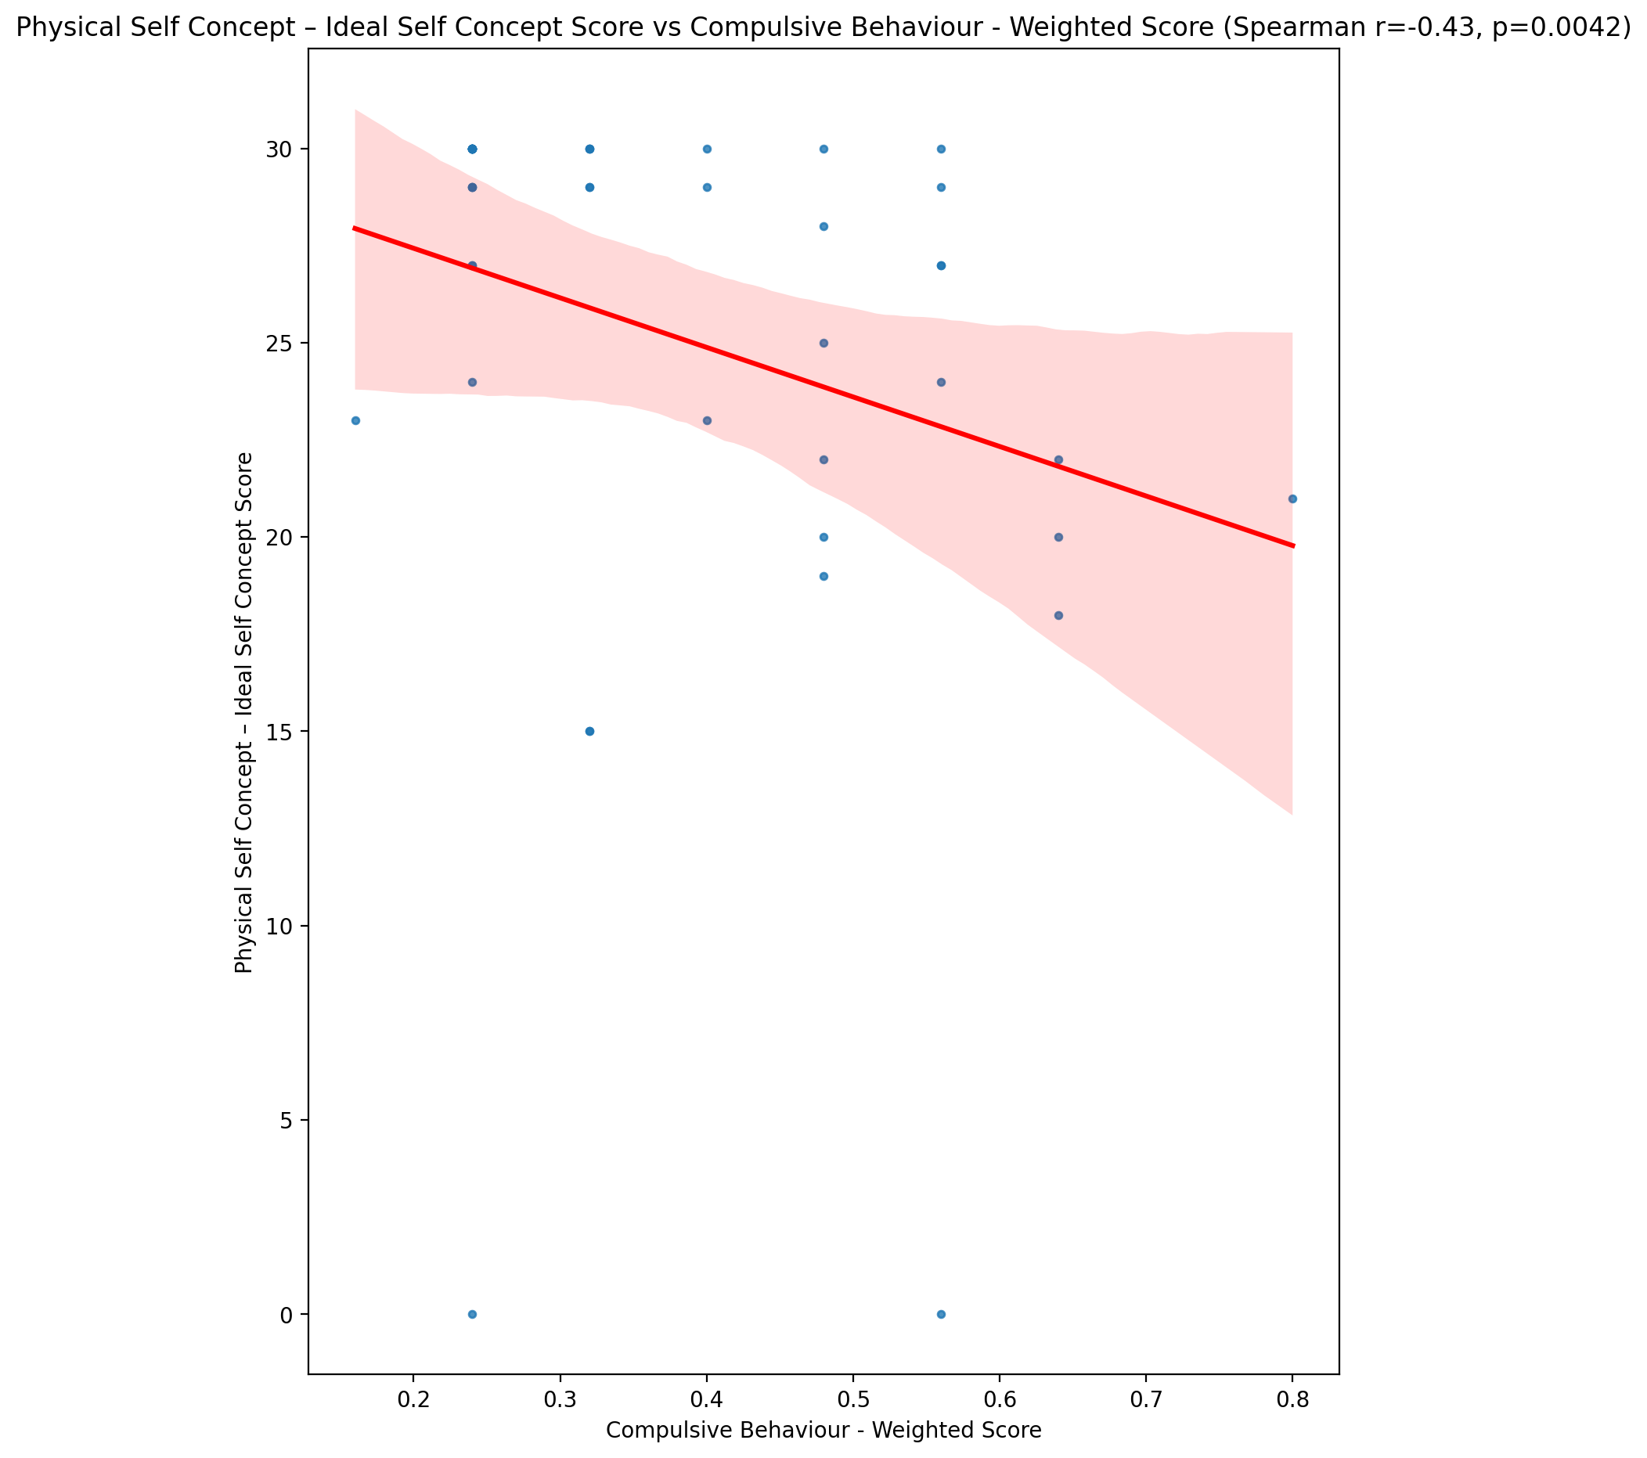

## Physical Self Concept – Social Self Concept Score vs Compulsive Behaviour - Weighted Score

Test: spearman; statistic: -0.4958782954863421; p-value: 0.0007210223433888703;

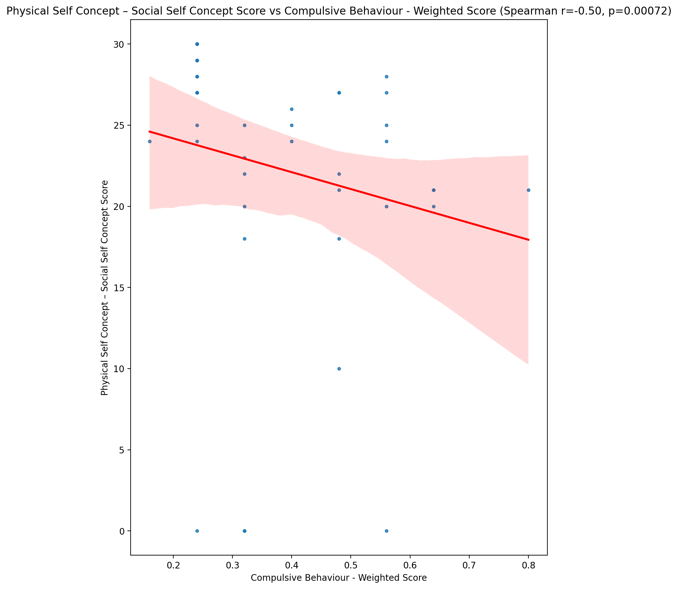

## Psychological Self Concept - Real Self Concept Score vs Compulsive Behaviour - Weighted Score

Test: spearman; statistic: -0.4734672436687013; p-value: 0.0013423863796327615;

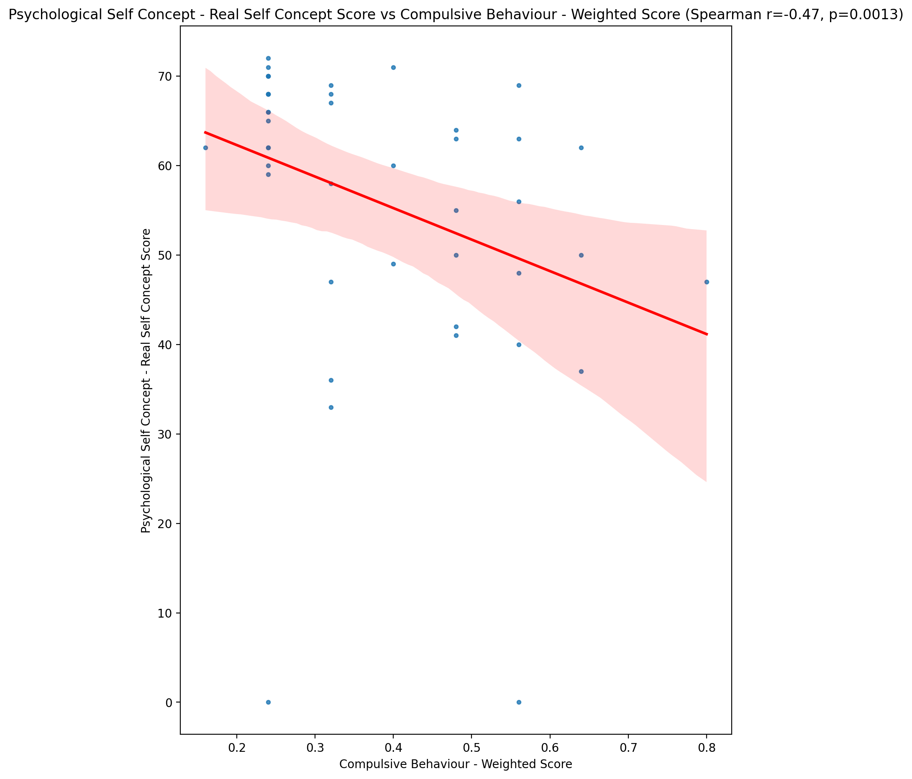

## Psychological Self Concept – Ideal Self Concept Score vs Compulsive Behaviour - Weighted Score

Test: spearman; statistic: -0.34195237300647446; p-value: 0.02480711638465881;

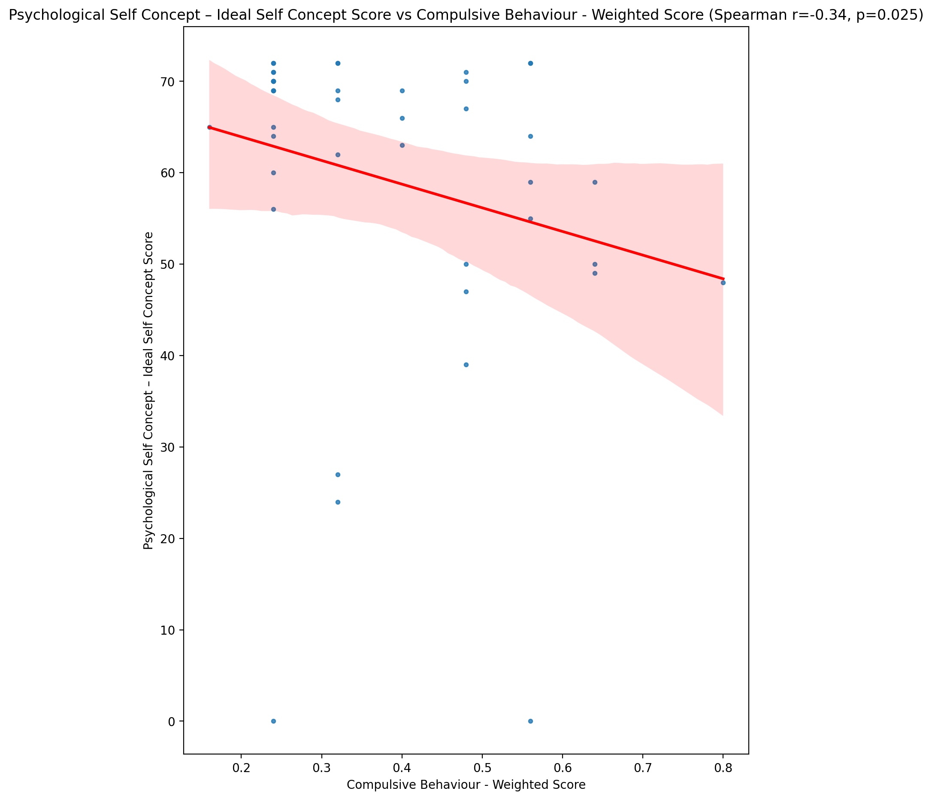

## Psychological Self Concept – Social Self Concept Score vs Compulsive Behaviour - Weighted Score

Test: spearman; statistic: -0.608585283071328; p-value: 1.4926275763752764e-05;

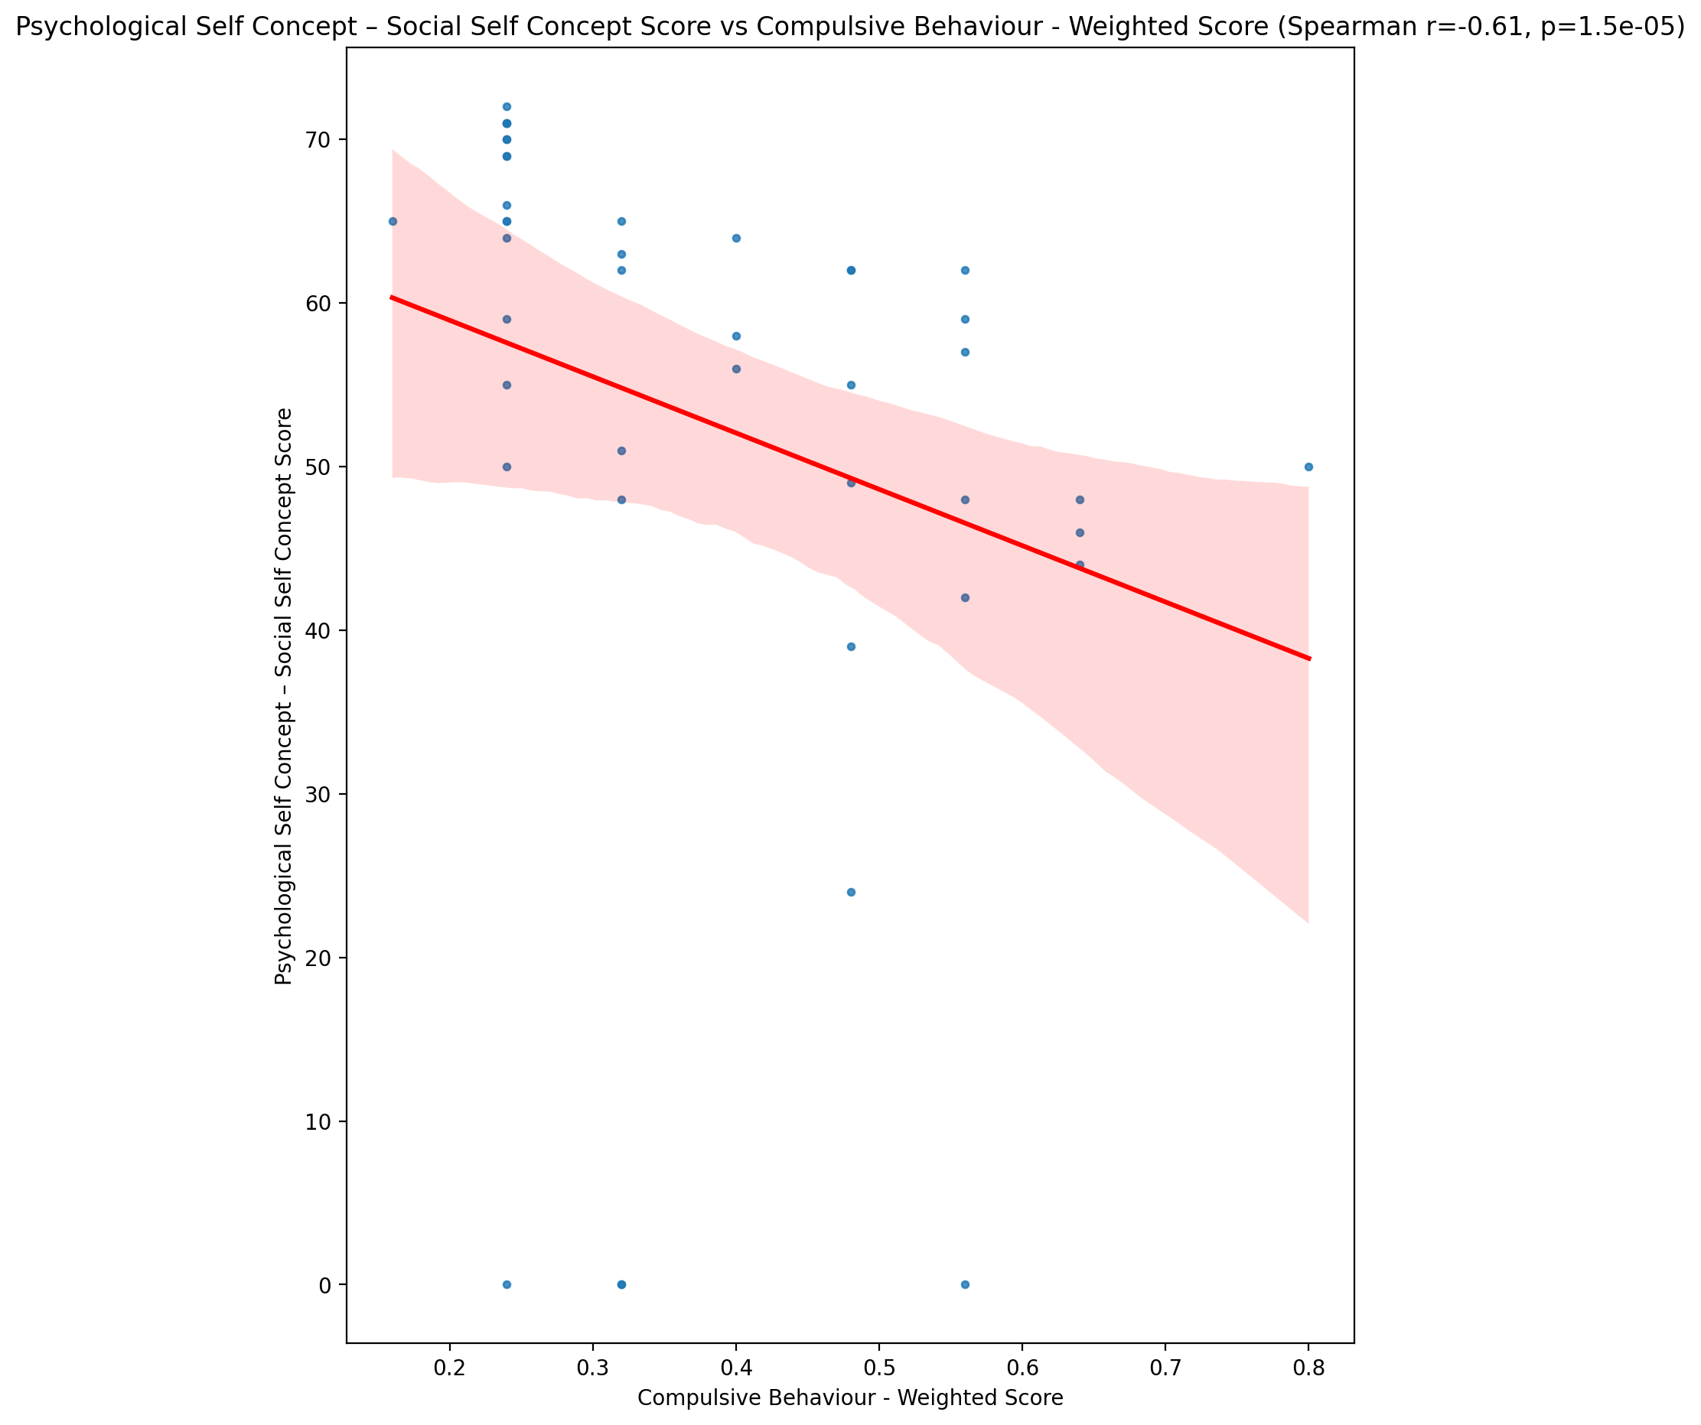

## Real Self Concept Total Score vs Compulsive Behaviour - Weighted Score

Test: spearman; statistic: -0.46823589244308544; p-value: 0.001542782226918845;

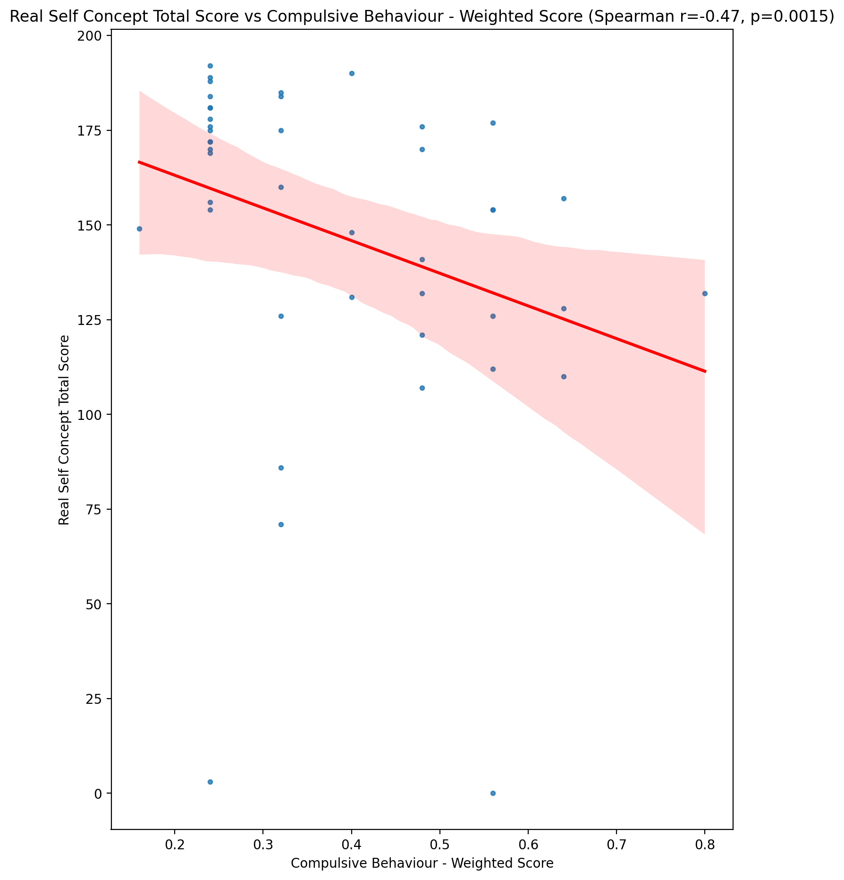

## Ideal Self Concept Total Score vs Compulsive Behaviour - Weighted Score

Test: spearman; statistic: -0.3492344614984102; p-value: 0.021709980074278795;

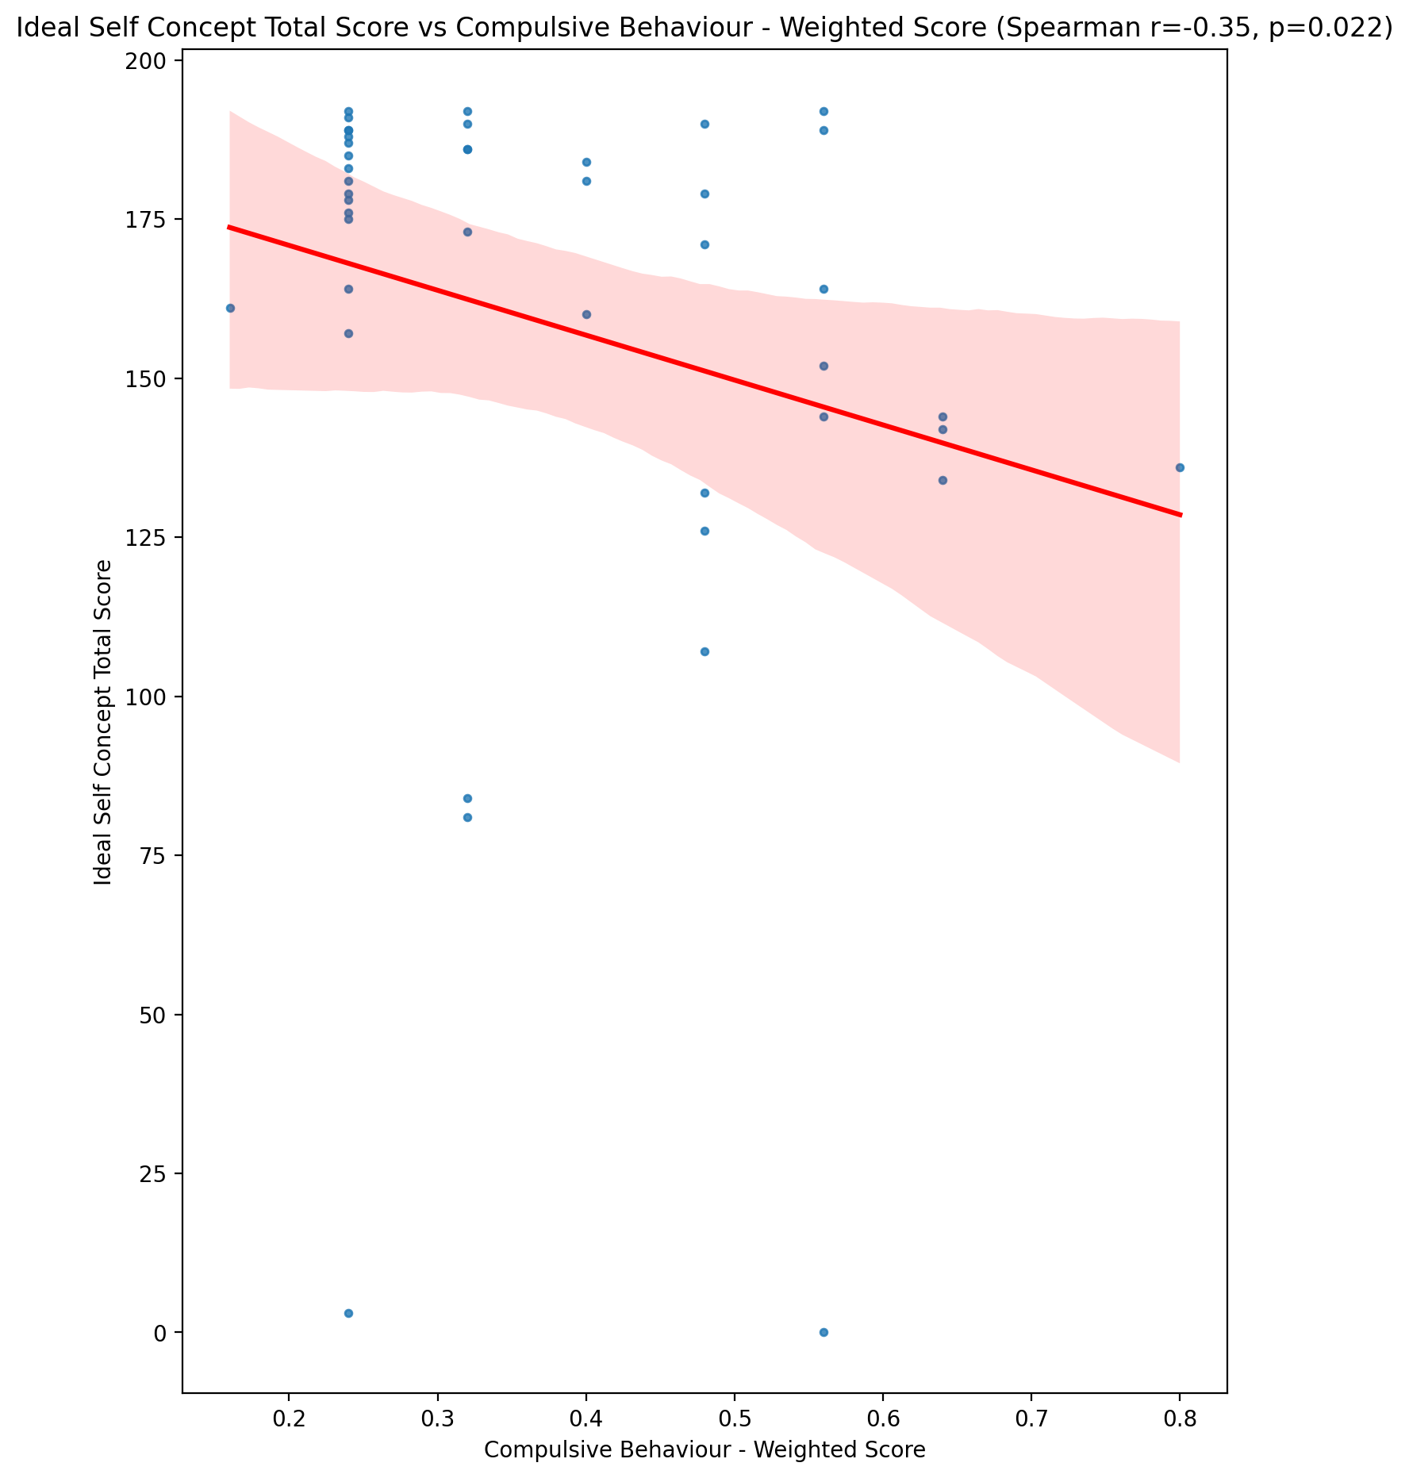

## Social Self Concept Total Score vs Compulsive Behaviour - Weighted Score

Test: spearman; statistic: -0.6196776262346355; p-value: 9.379232048271658e-06;

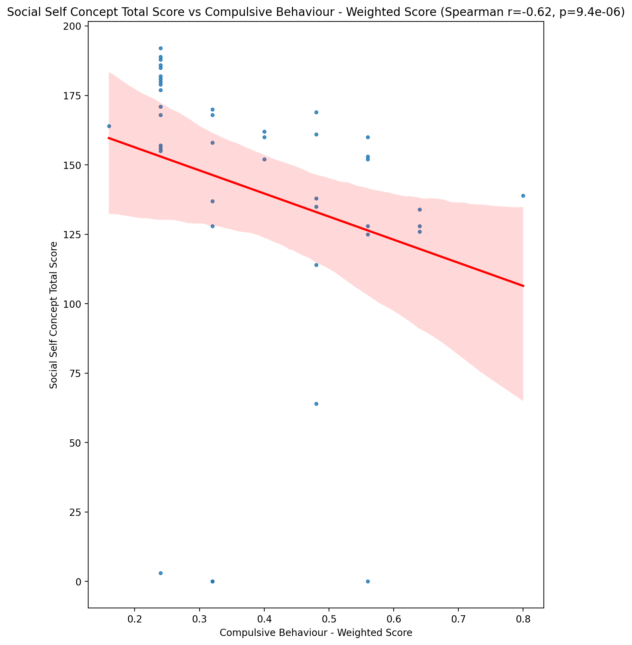

## Ideal Self Concept Total Category vs Compulsive Behaviour - Weighted Score

Test: None; statistic: None; p-value: None; Test not run: unsupported type combination.



## Perceived Social Stress Score vs Compulsive Behaviour - Weighted Score

Test: spearman; statistic: 0.2523061861850142; p-value: 0.10262505775971162;

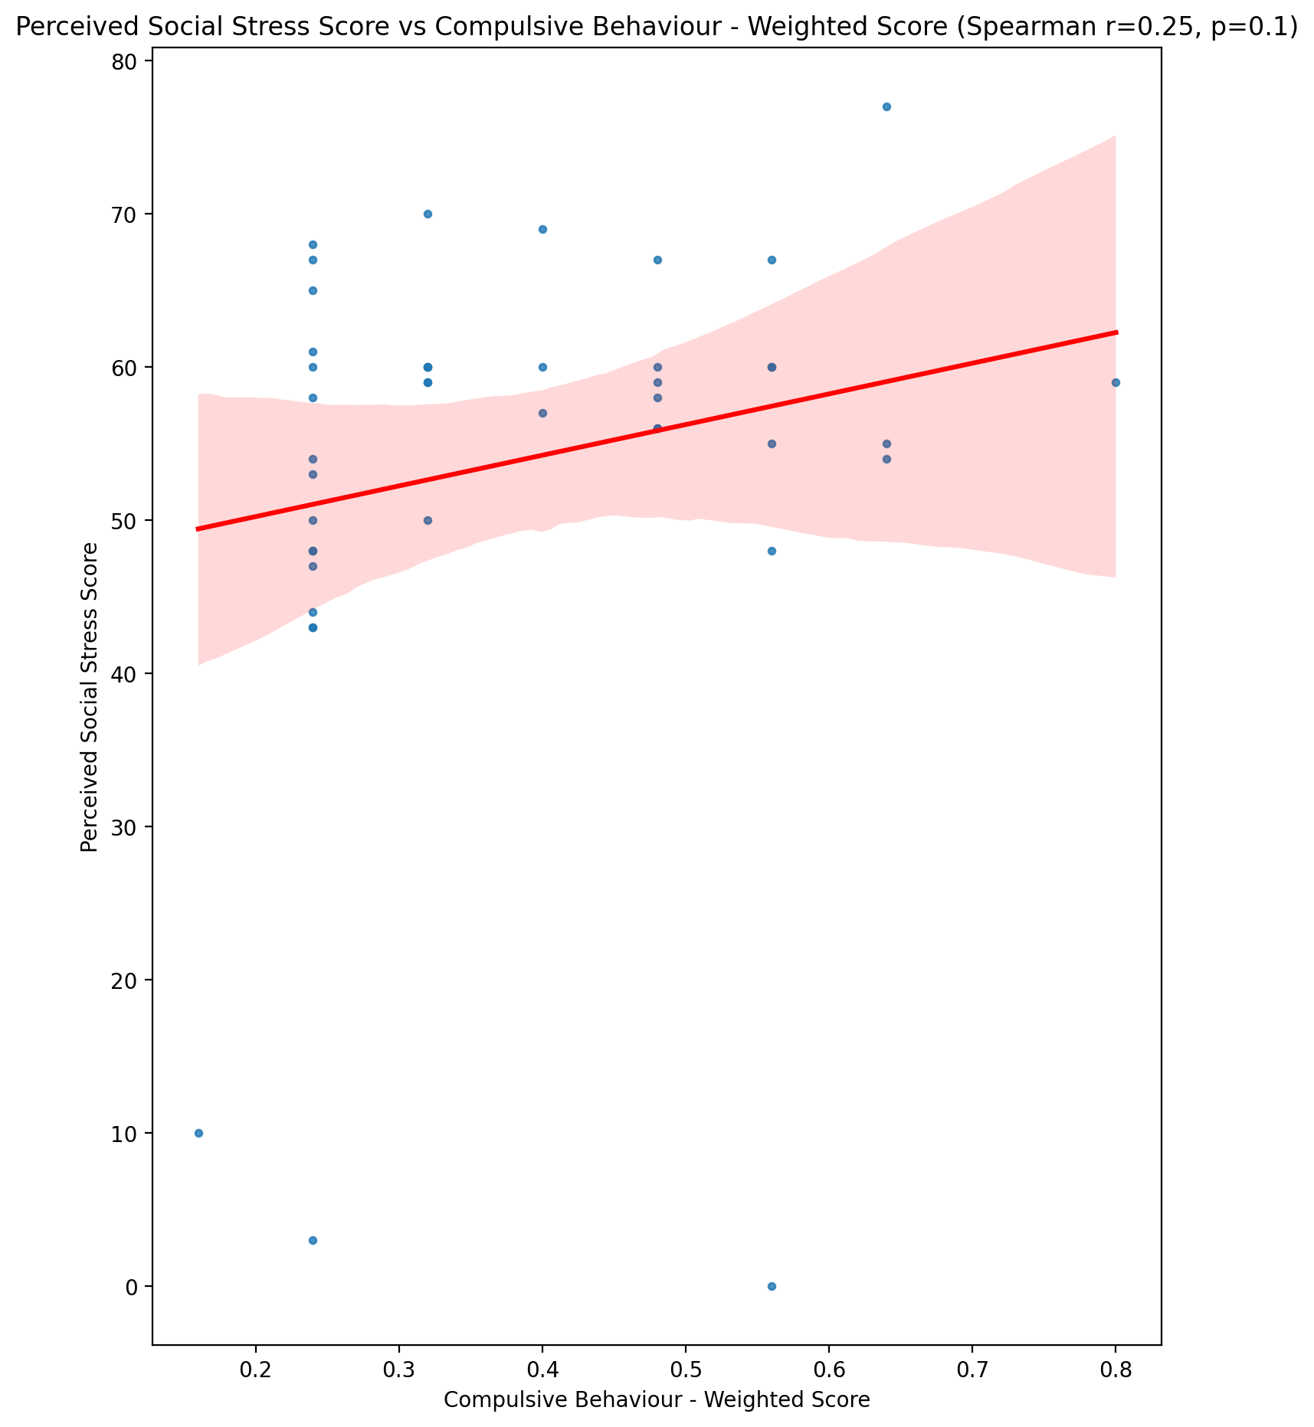

## Perceived Social Stress Category vs Compulsive Behaviour - Weighted Score

Test: None; statistic: None; p-value: None; Test not run: unsupported type combination.



## Emotional Support - Raw Score vs Obsession with Internet - Weighted Score

Test: spearman; statistic: -0.3511736478542488; p-value: 0.02094216580811693;

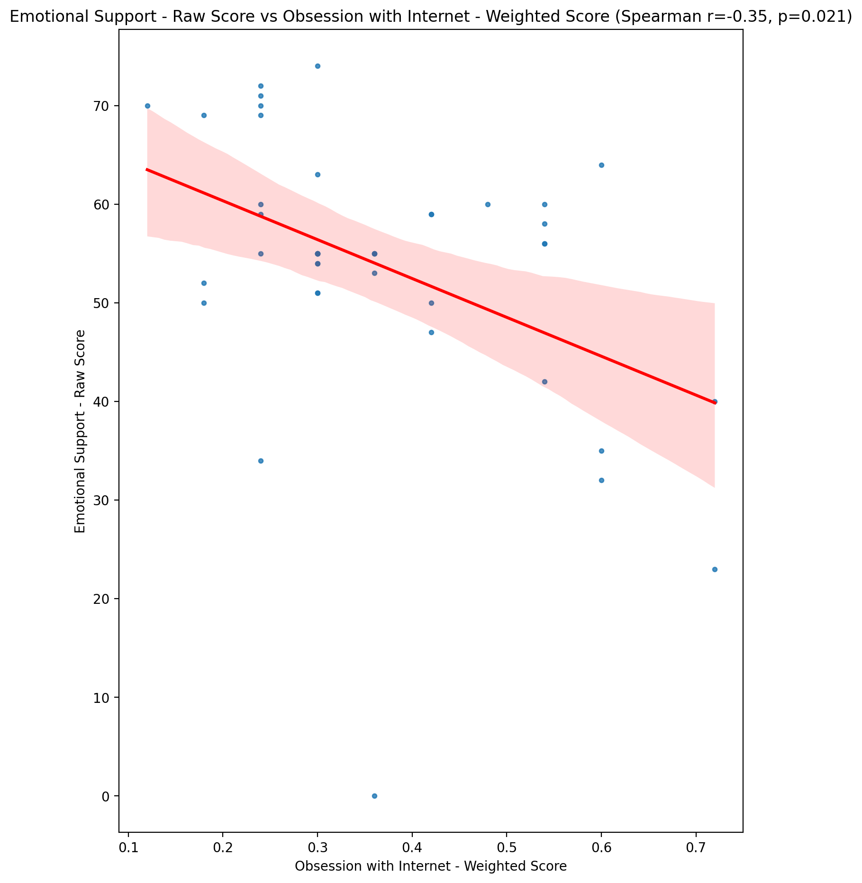

## Informational Support - Raw Score vs Obsession with Internet - Weighted Score

Test: spearman; statistic: -0.34446397259950884; p-value: 0.02369975294394006;

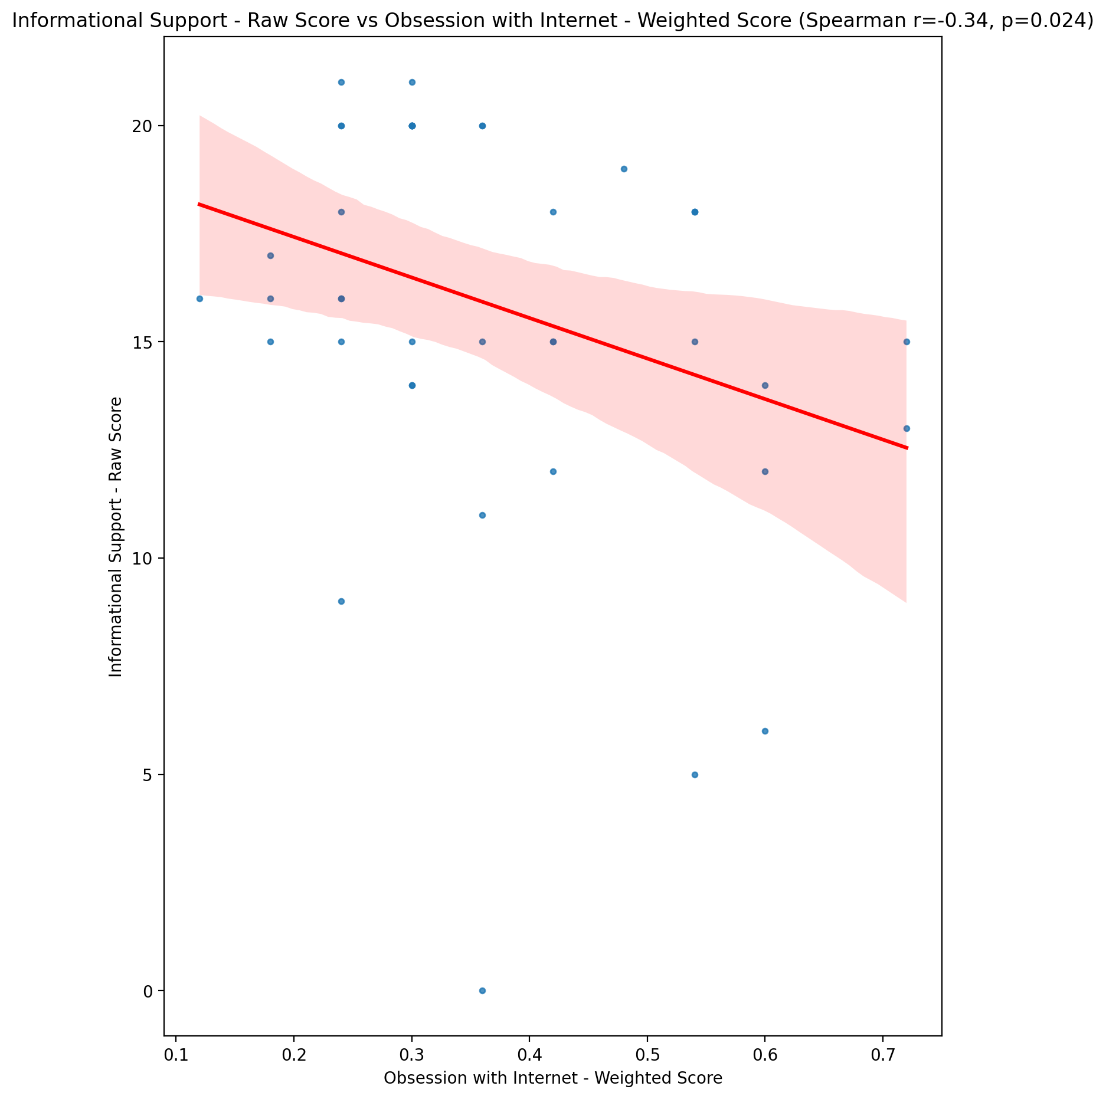

## Instrumental Support - Raw Score vs Obsession with Internet - Weighted Score

Test: spearman; statistic: -0.5148777674746023; p-value: 0.000411399798192268;

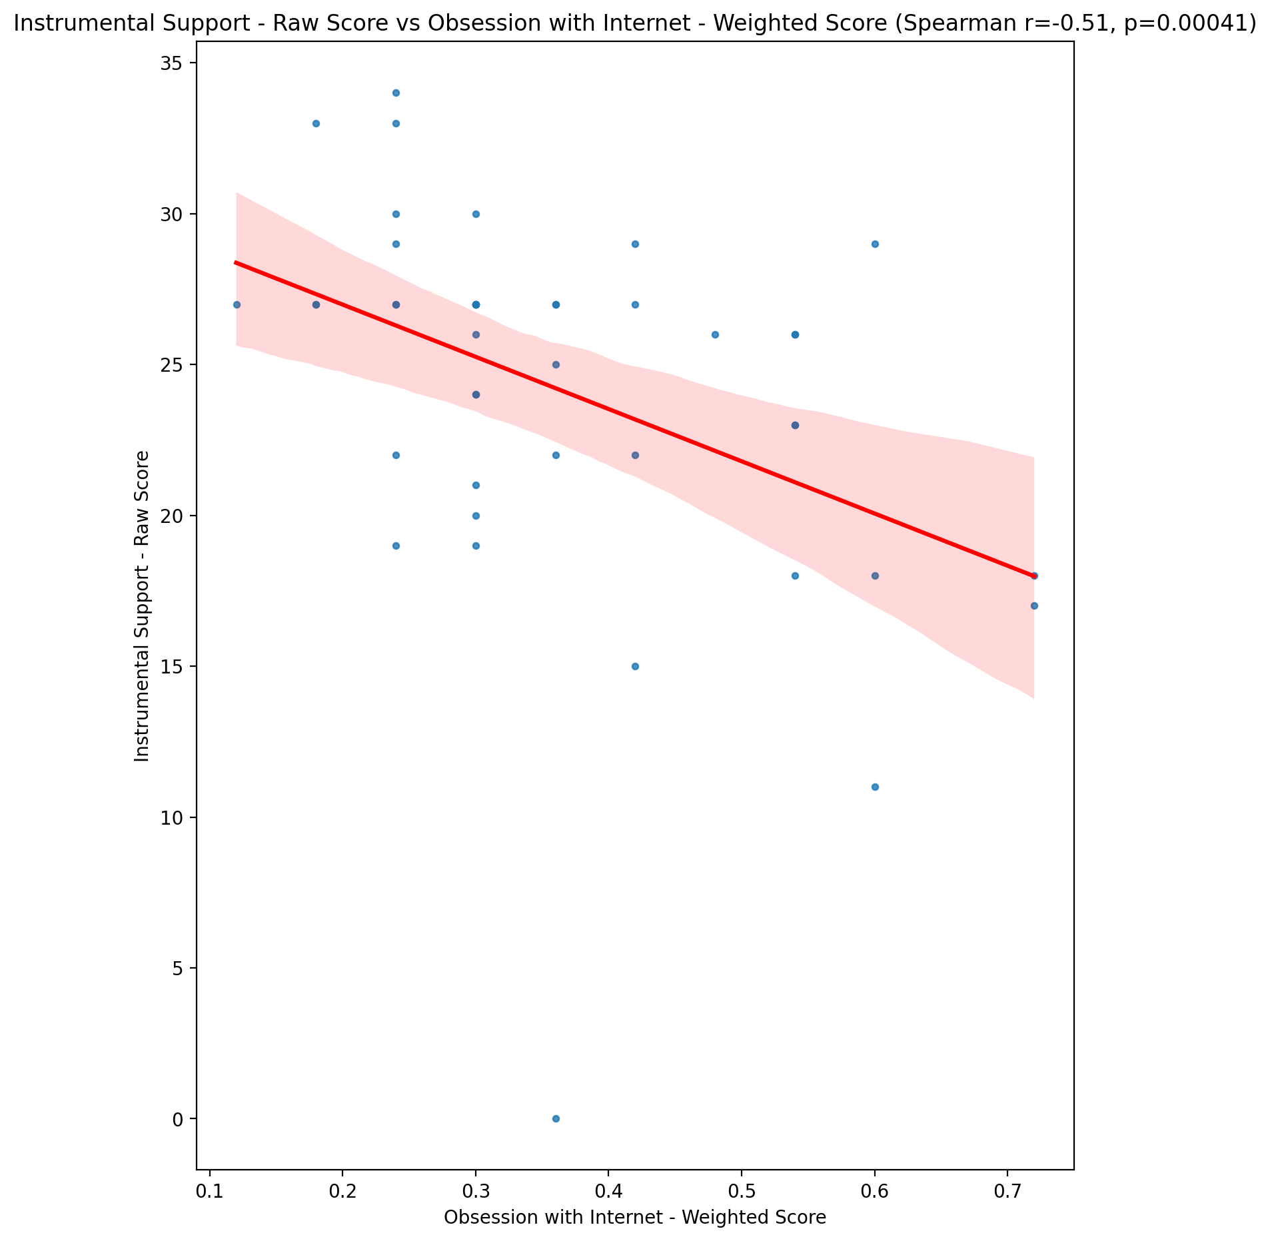

## Emotional Support - T Score vs Obsession with Internet - Weighted Score

Test: spearman; statistic: -0.3285227229699166; p-value: 0.031485396679064005;

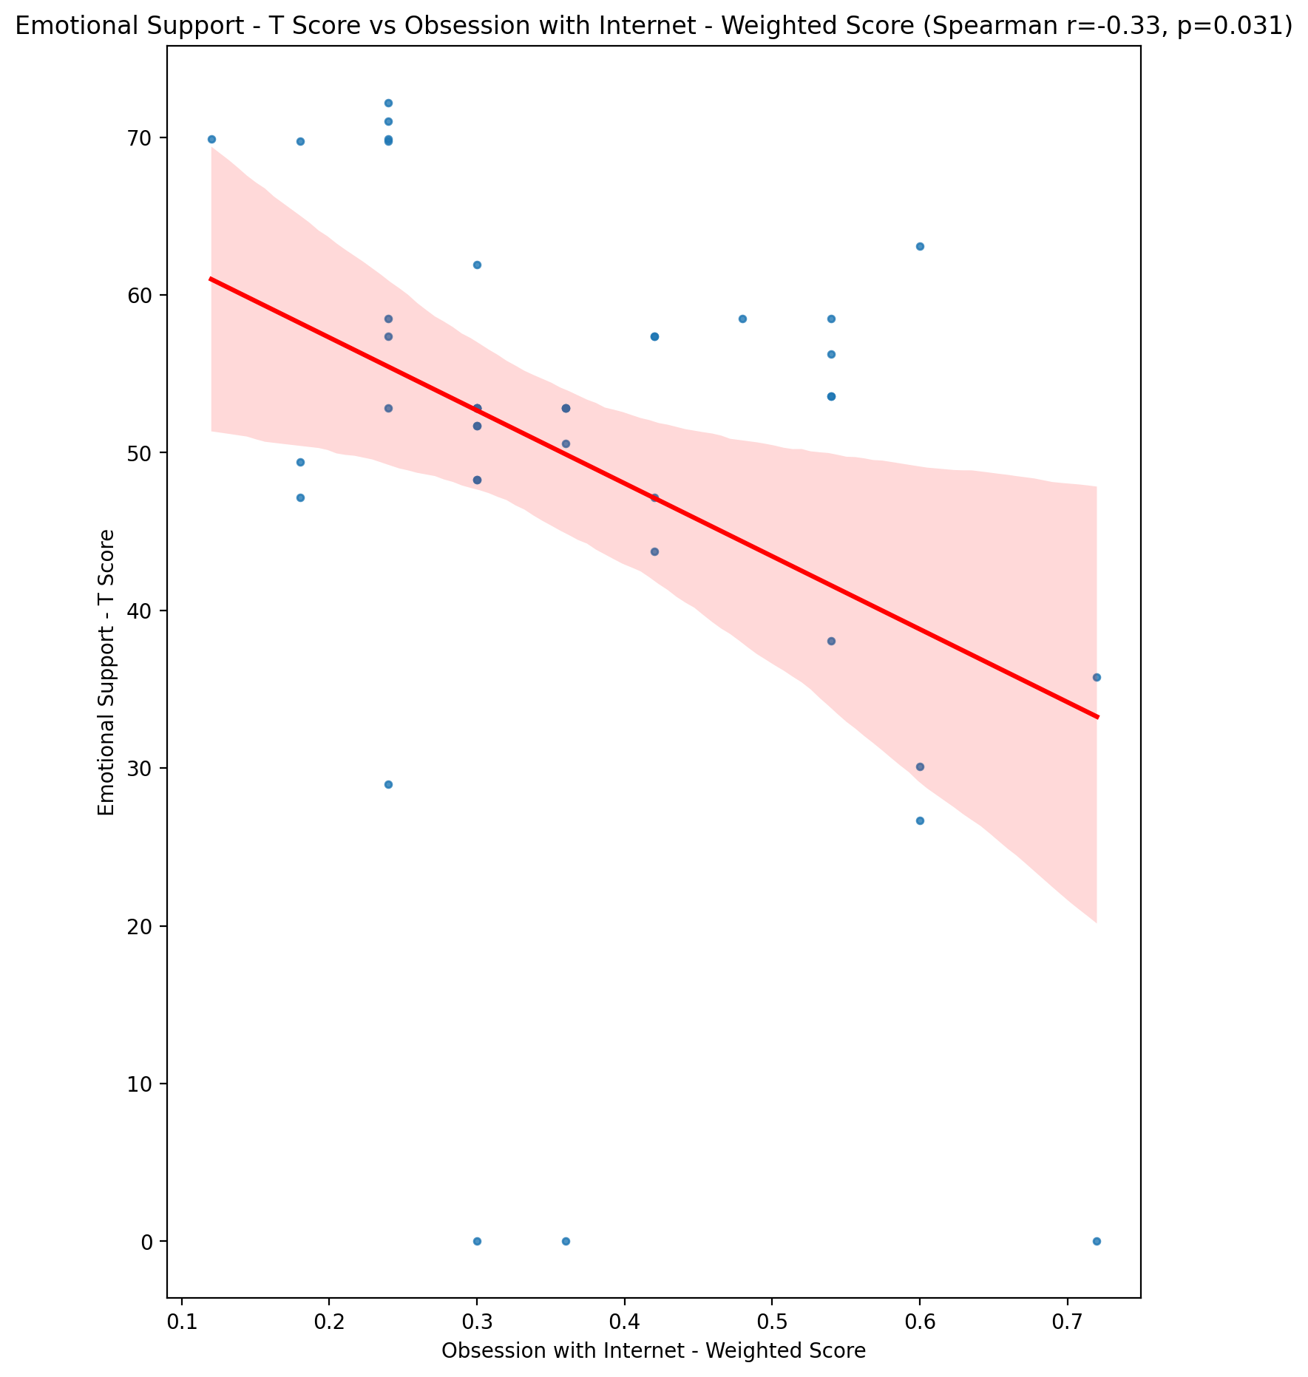

## Informational Support - T Score vs Obsession with Internet - Weighted Score

Test: spearman; statistic: -0.3466895165924795; p-value: 0.022753305329379036;

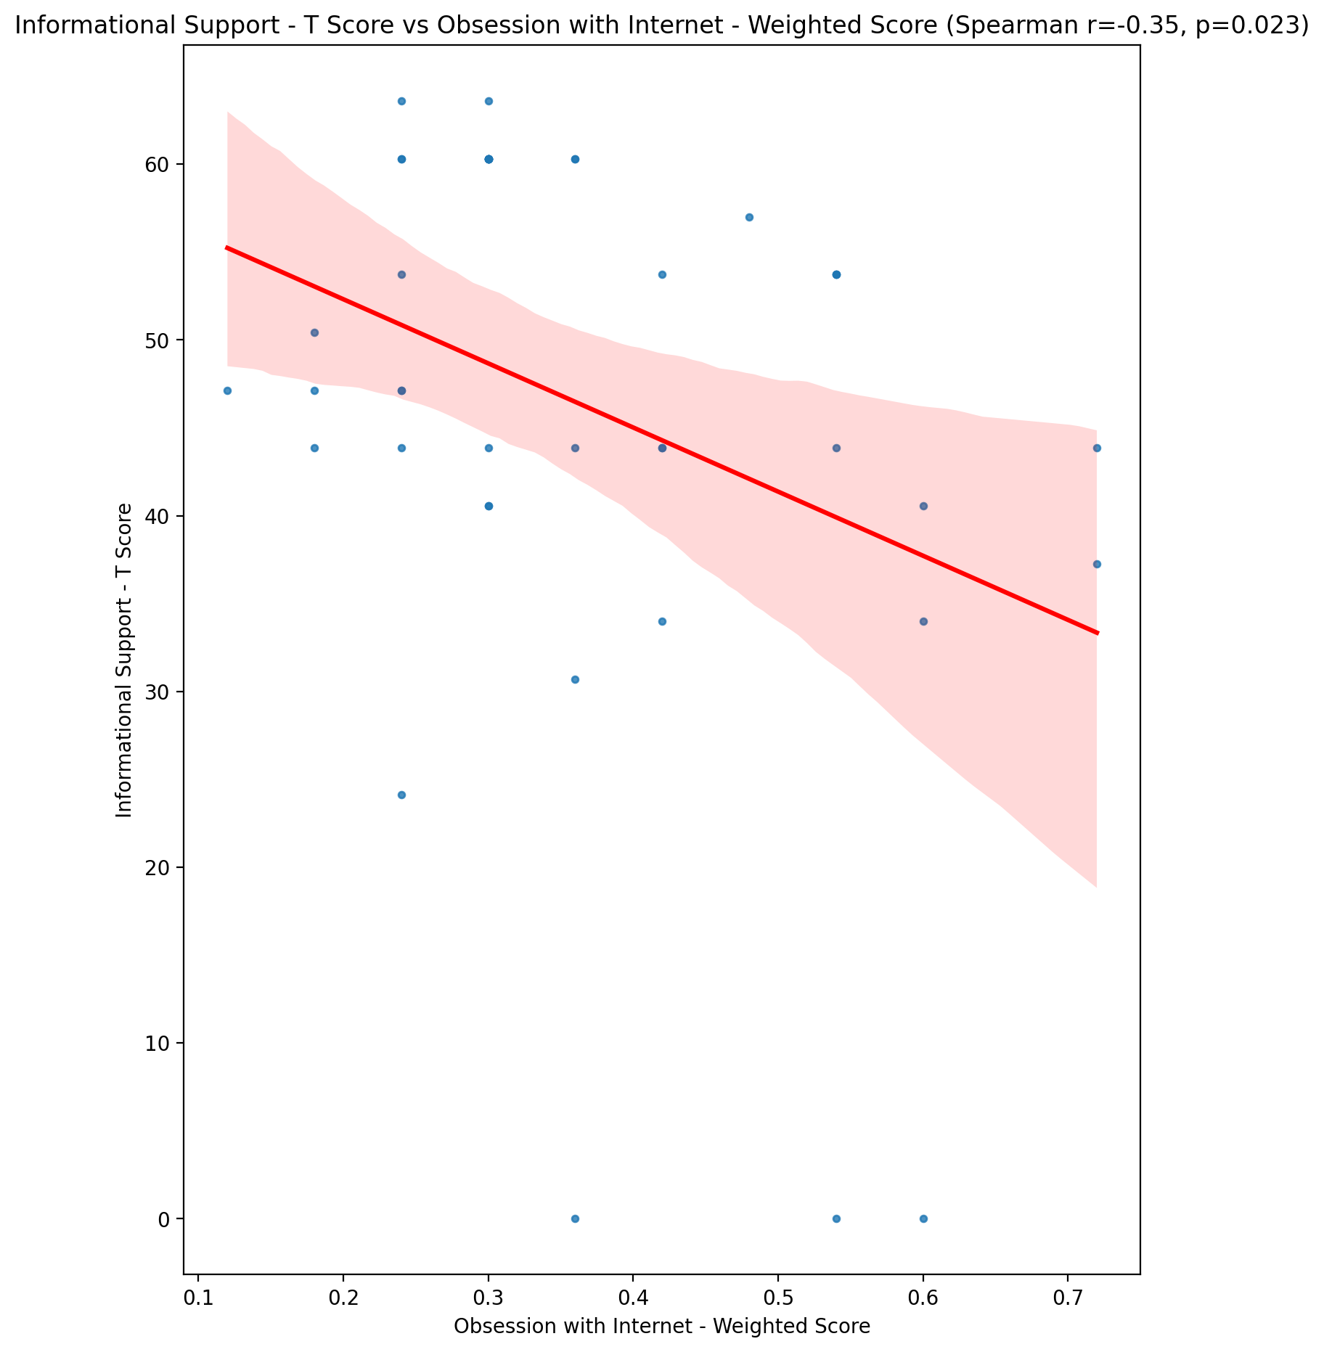

## Instrumental Support - T Score vs Obsession with Internet - Weighted Score

Test: spearman; statistic: -0.51598248804675; p-value: 0.0003977900078102026;

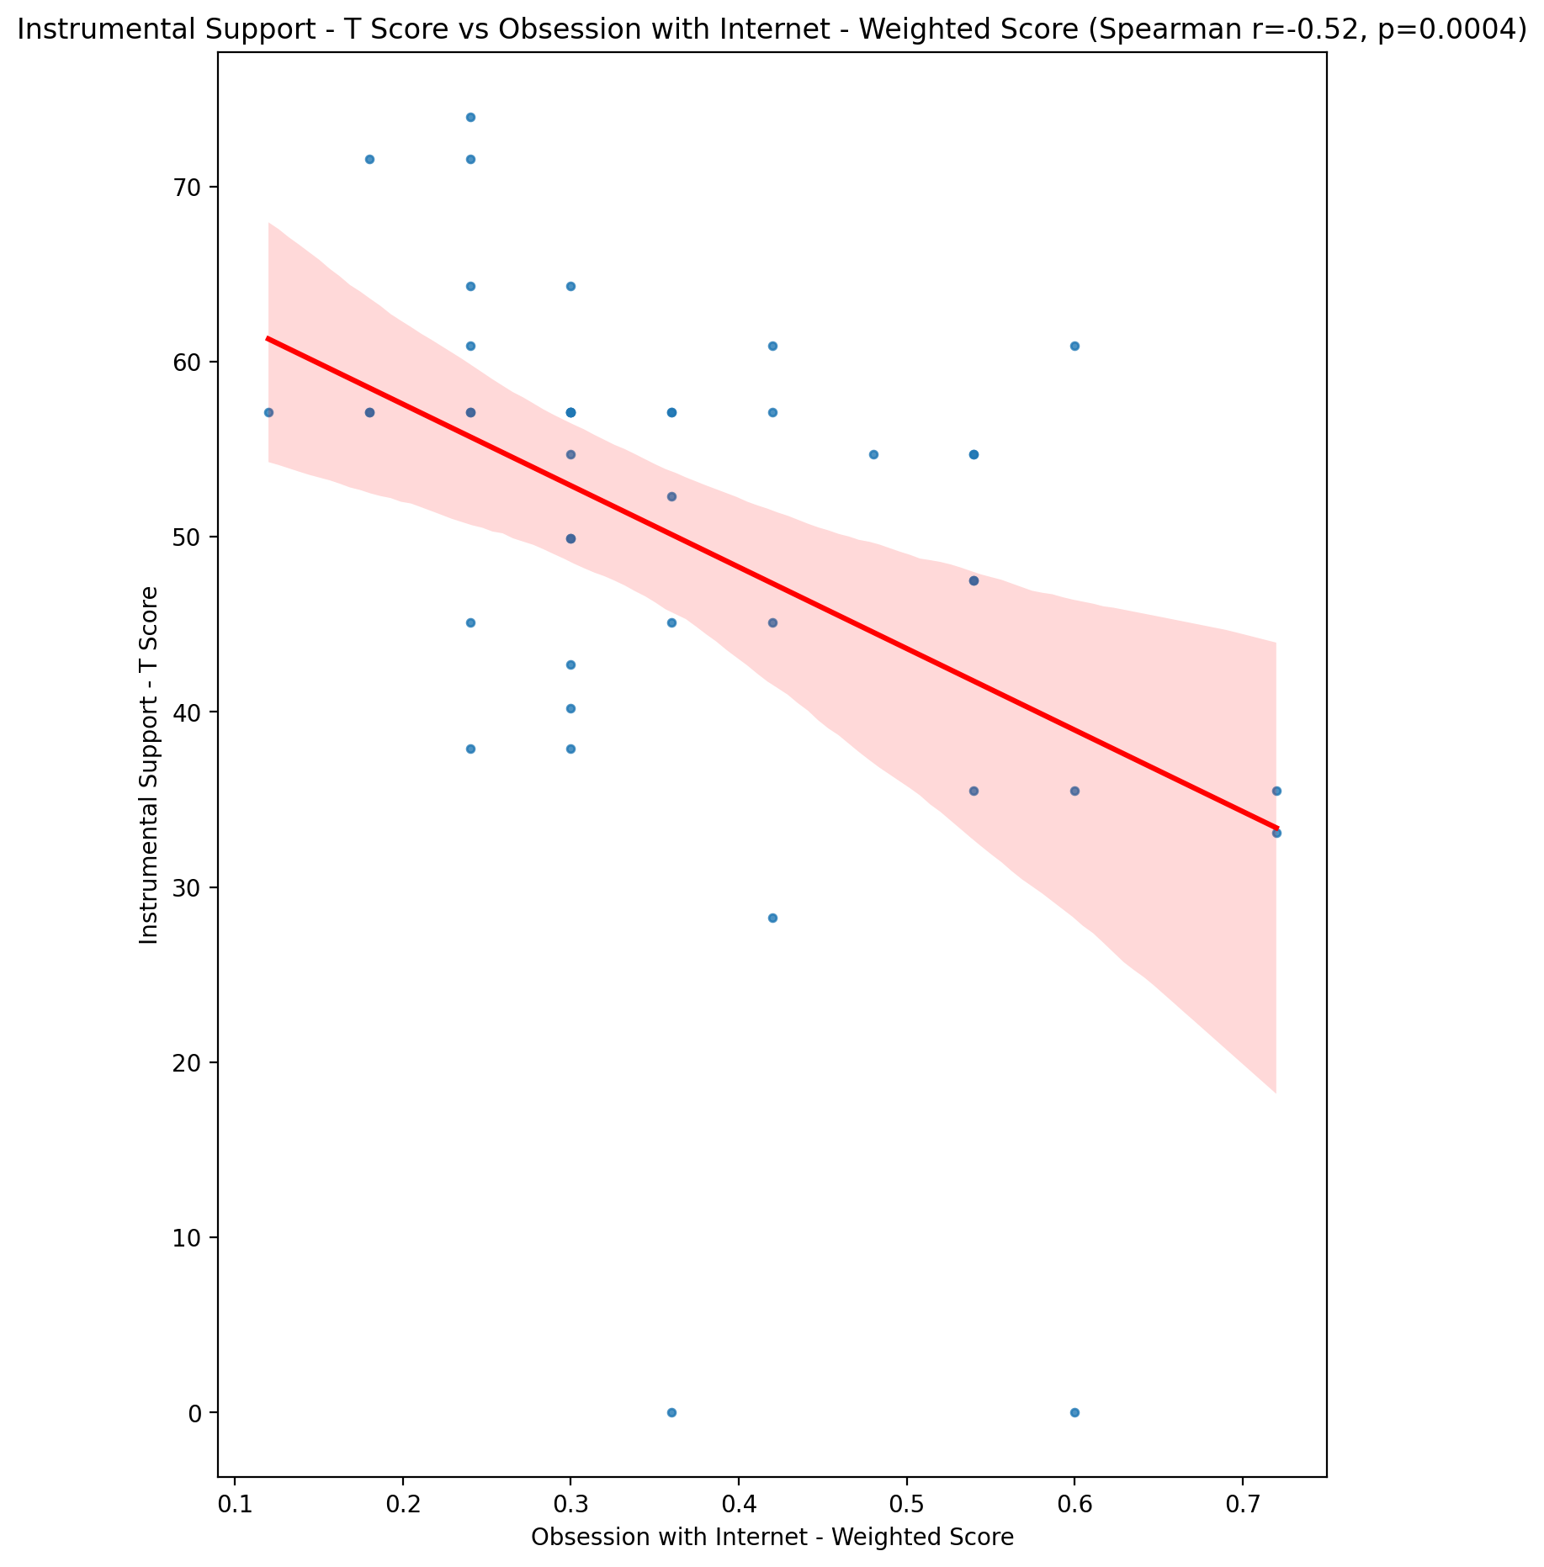

## Perceived Social Support Total T Score vs Obsession with Internet - Weighted Score

Test: spearman; statistic: -0.4344606477761861; p-value: 0.0036015556022022327;

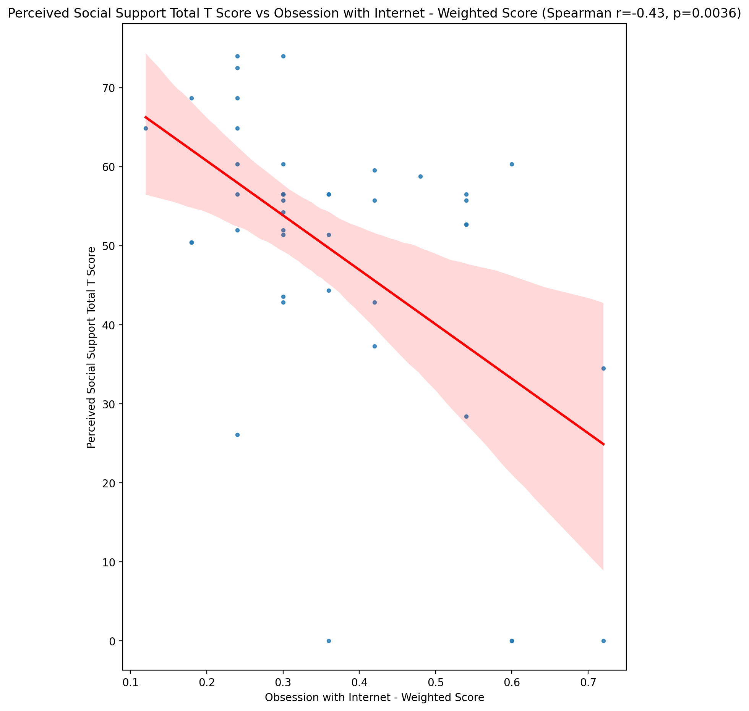

## Emotional Support - Rank vs Obsession with Internet - Weighted Score

Test: None; statistic: None; p-value: None; Test not run: unsupported type combination.



## Informational Support - Rank vs Obsession with Internet - Weighted Score

Test: None; statistic: None; p-value: None; Test not run: unsupported type combination.



## Instrumental Support - Rank vs Obsession with Internet - Weighted Score

Test: None; statistic: None; p-value: None; Test not run: unsupported type combination.



## Perceived Social Support TOTAL - Rank vs Obsession with Internet - Weighted Score

Test: None; statistic: None; p-value: None; Test not run: unsupported type combination.



## Power Self Concept - Real Self Concept Score vs Obsession with Internet - Weighted Score

Test: spearman; statistic: -0.282216528830968; p-value: 0.06672003918924052;

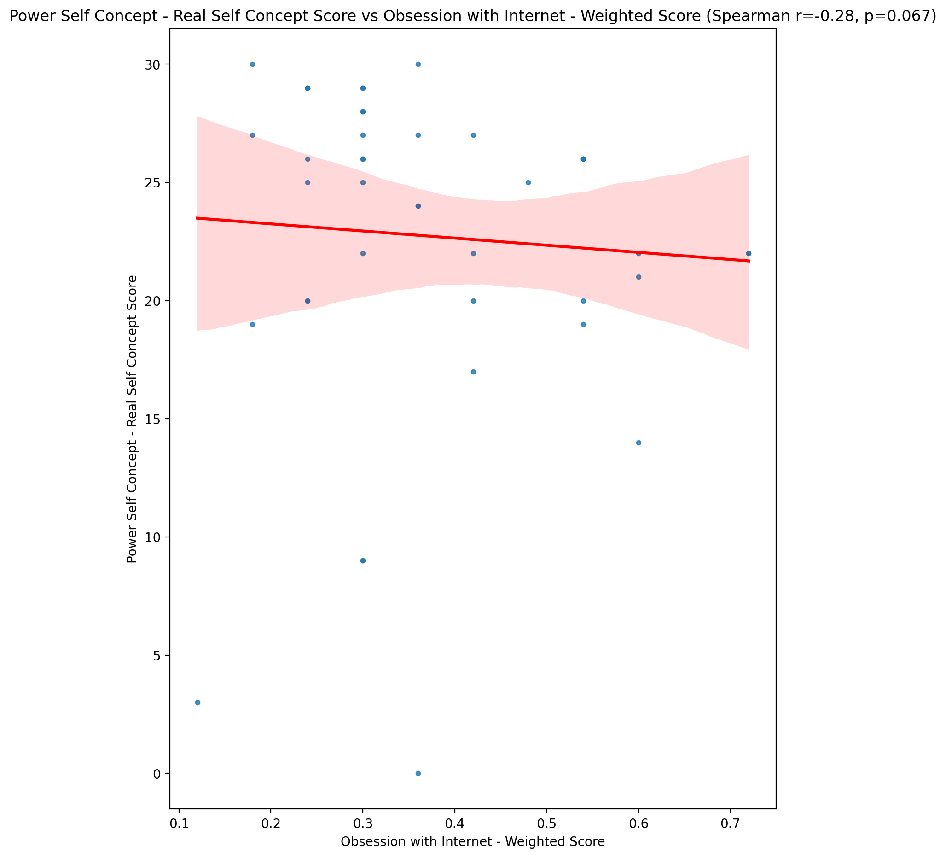

## Power Self Concept - Ideal Self Concept score vs Obsession with Internet - Weighted Score

Test: spearman; statistic: -0.4263178015843611; p-value: 0.004363666481693572;

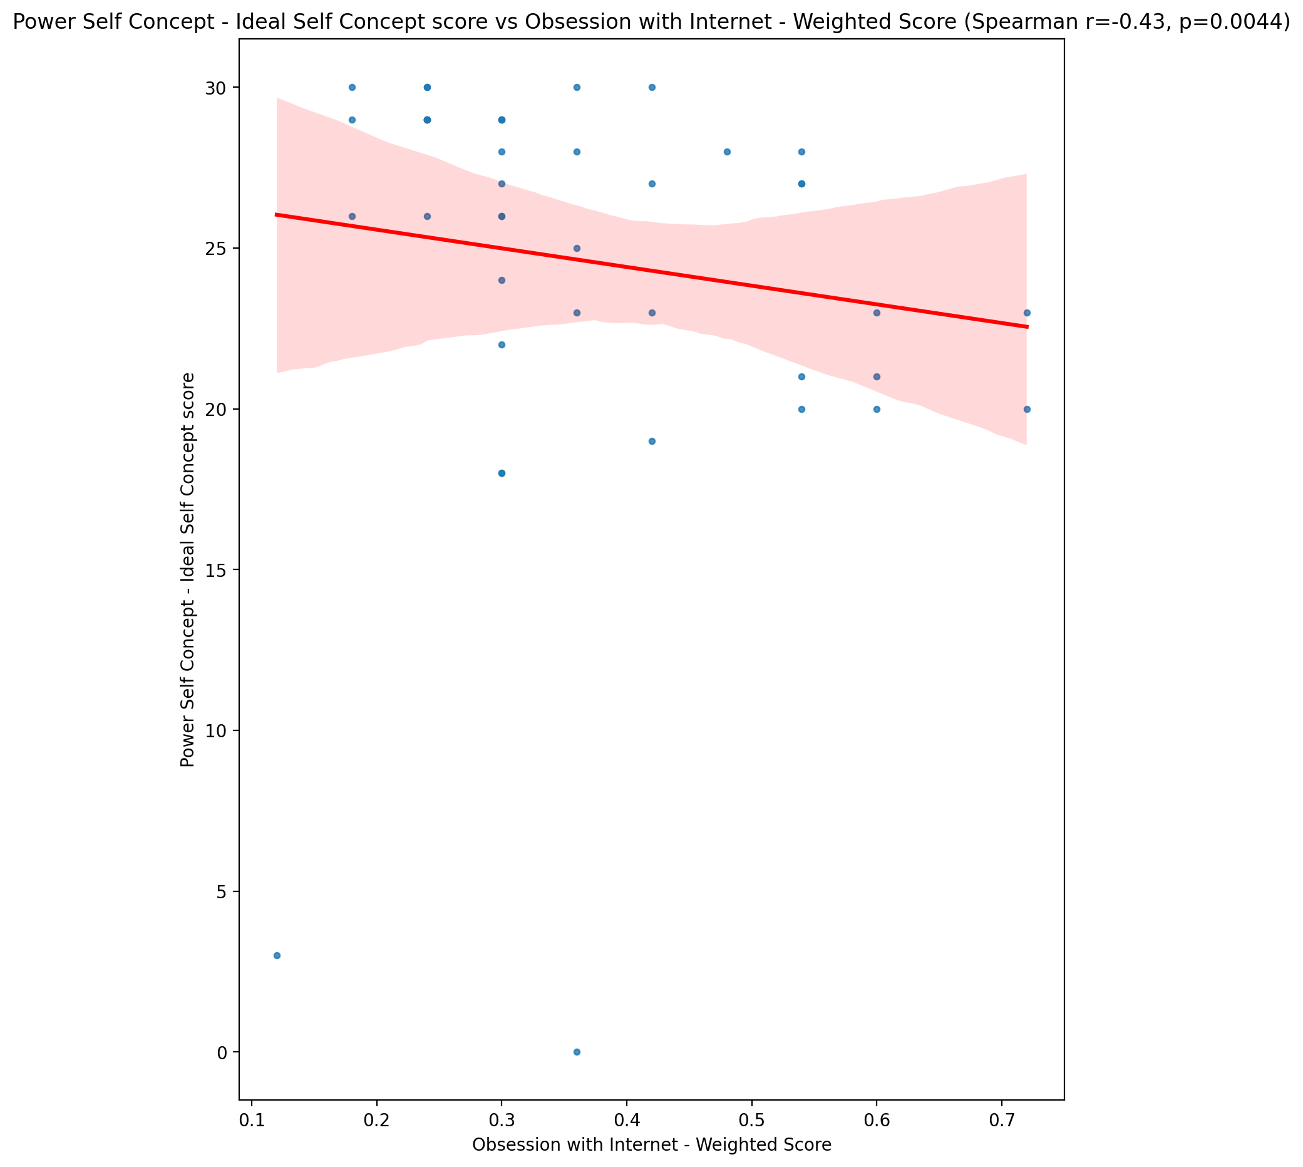

## Power Self Concept – Social Self Concept Score vs Obsession with Internet - Weighted Score

Test: spearman; statistic: -0.34279094174817737; p-value: 0.024432691882672494;

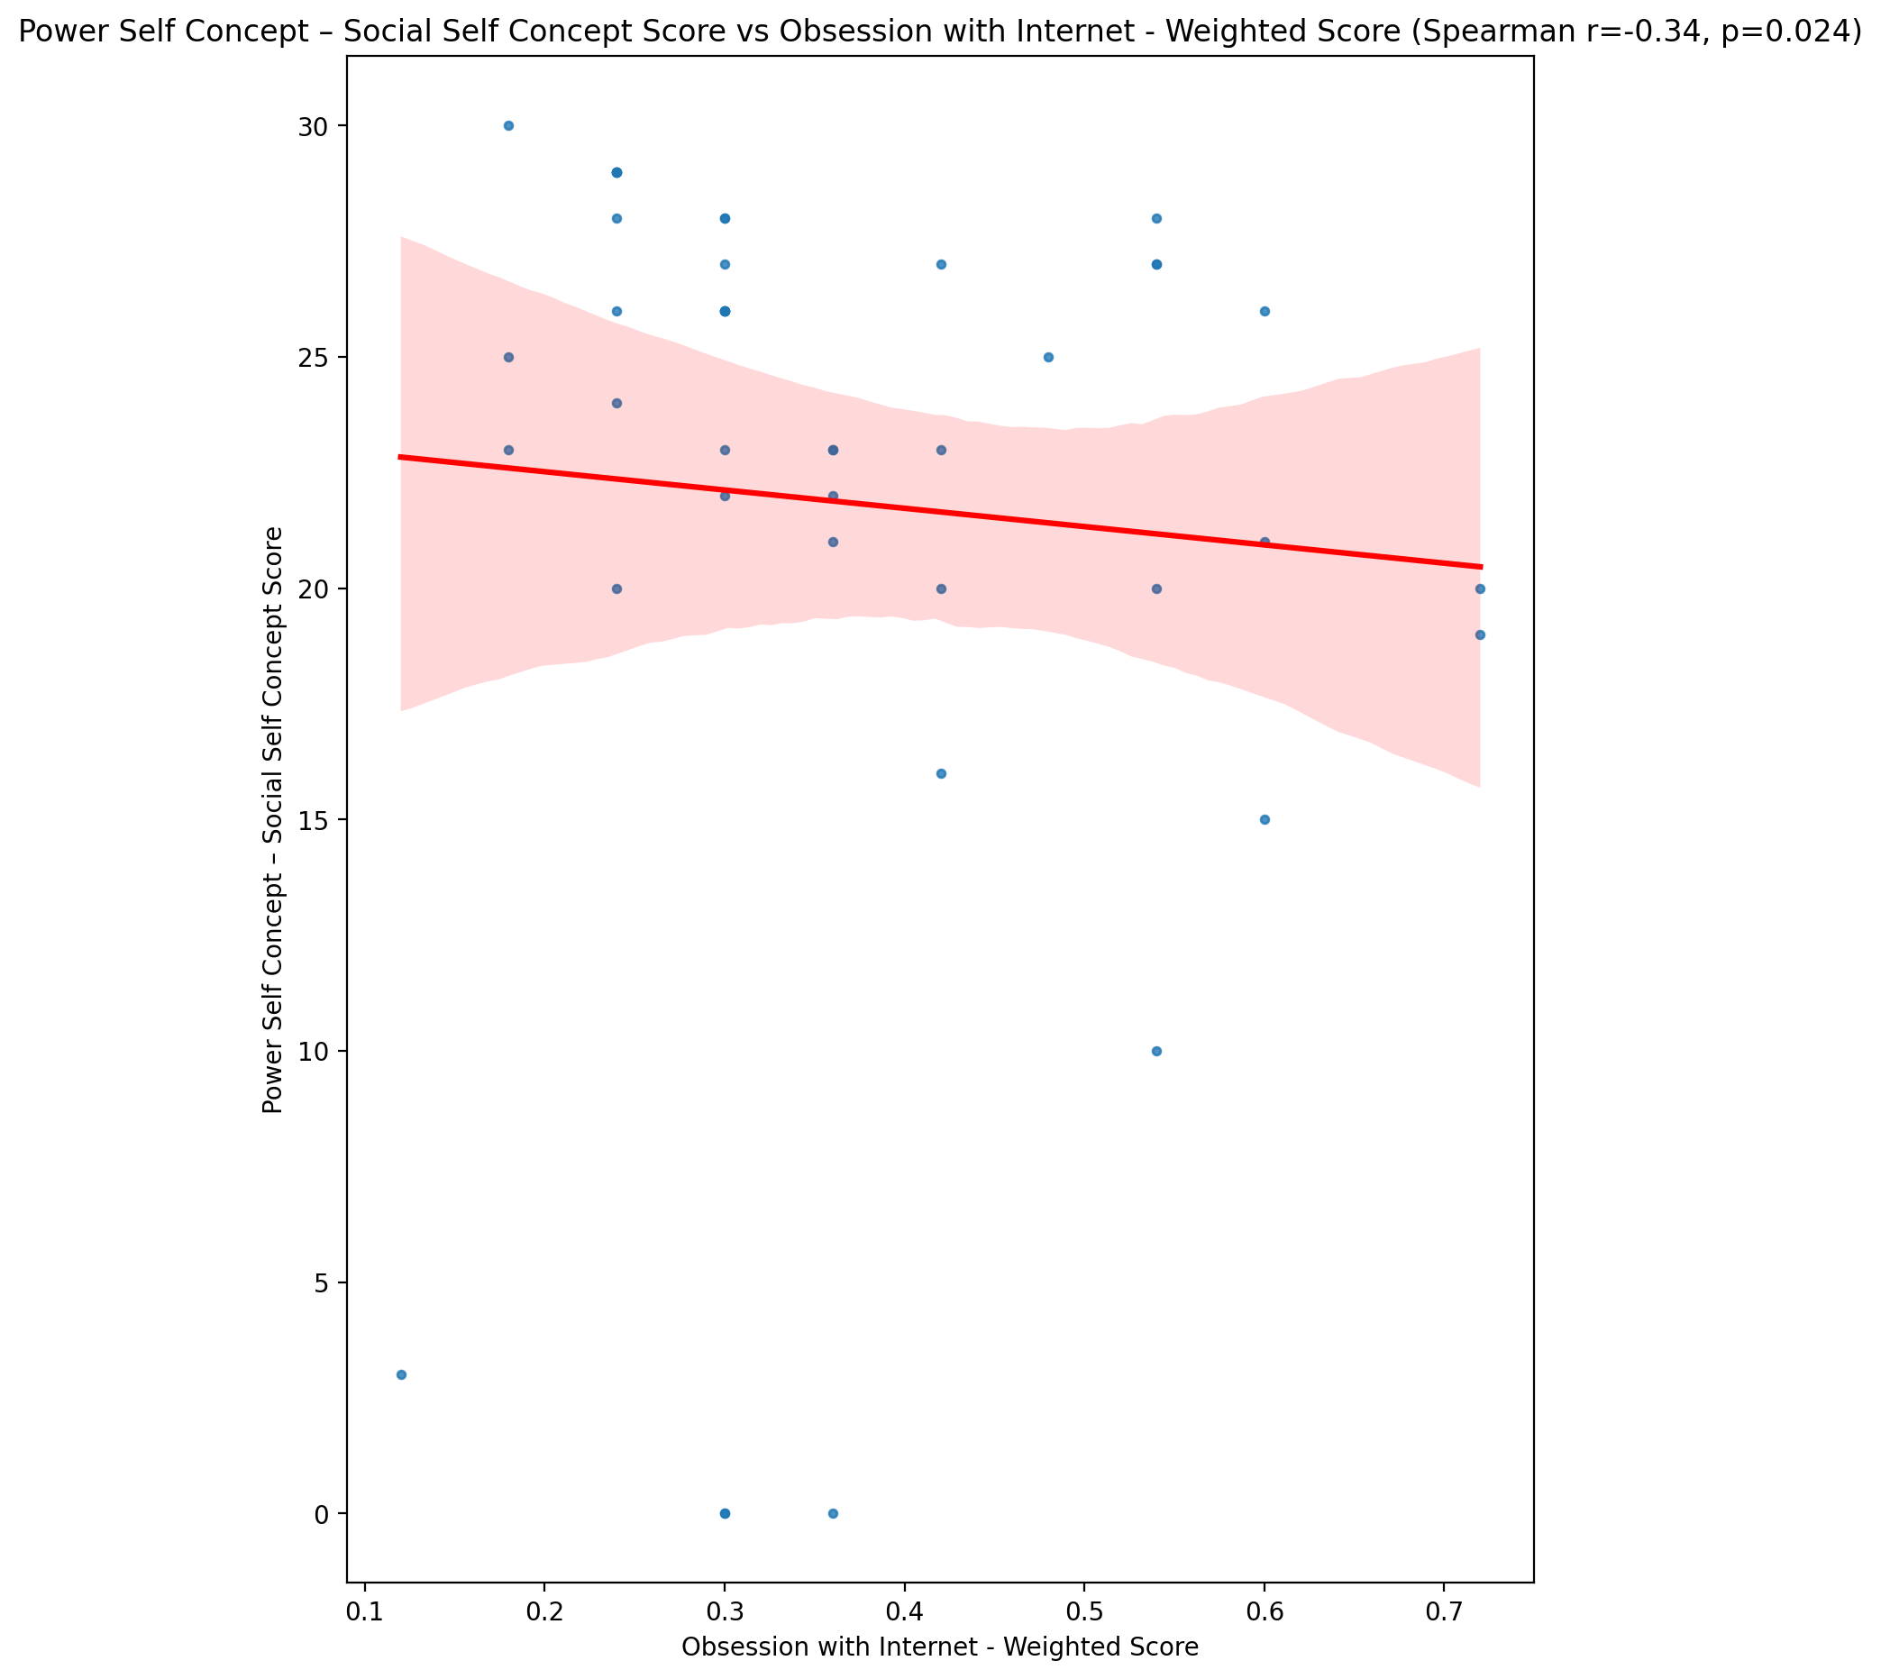

## Social Self Concept - Real Self Concept Score vs Obsession with Internet - Weighted Score

Test: spearman; statistic: -0.27184670064999056; p-value: 0.07782162087460472;

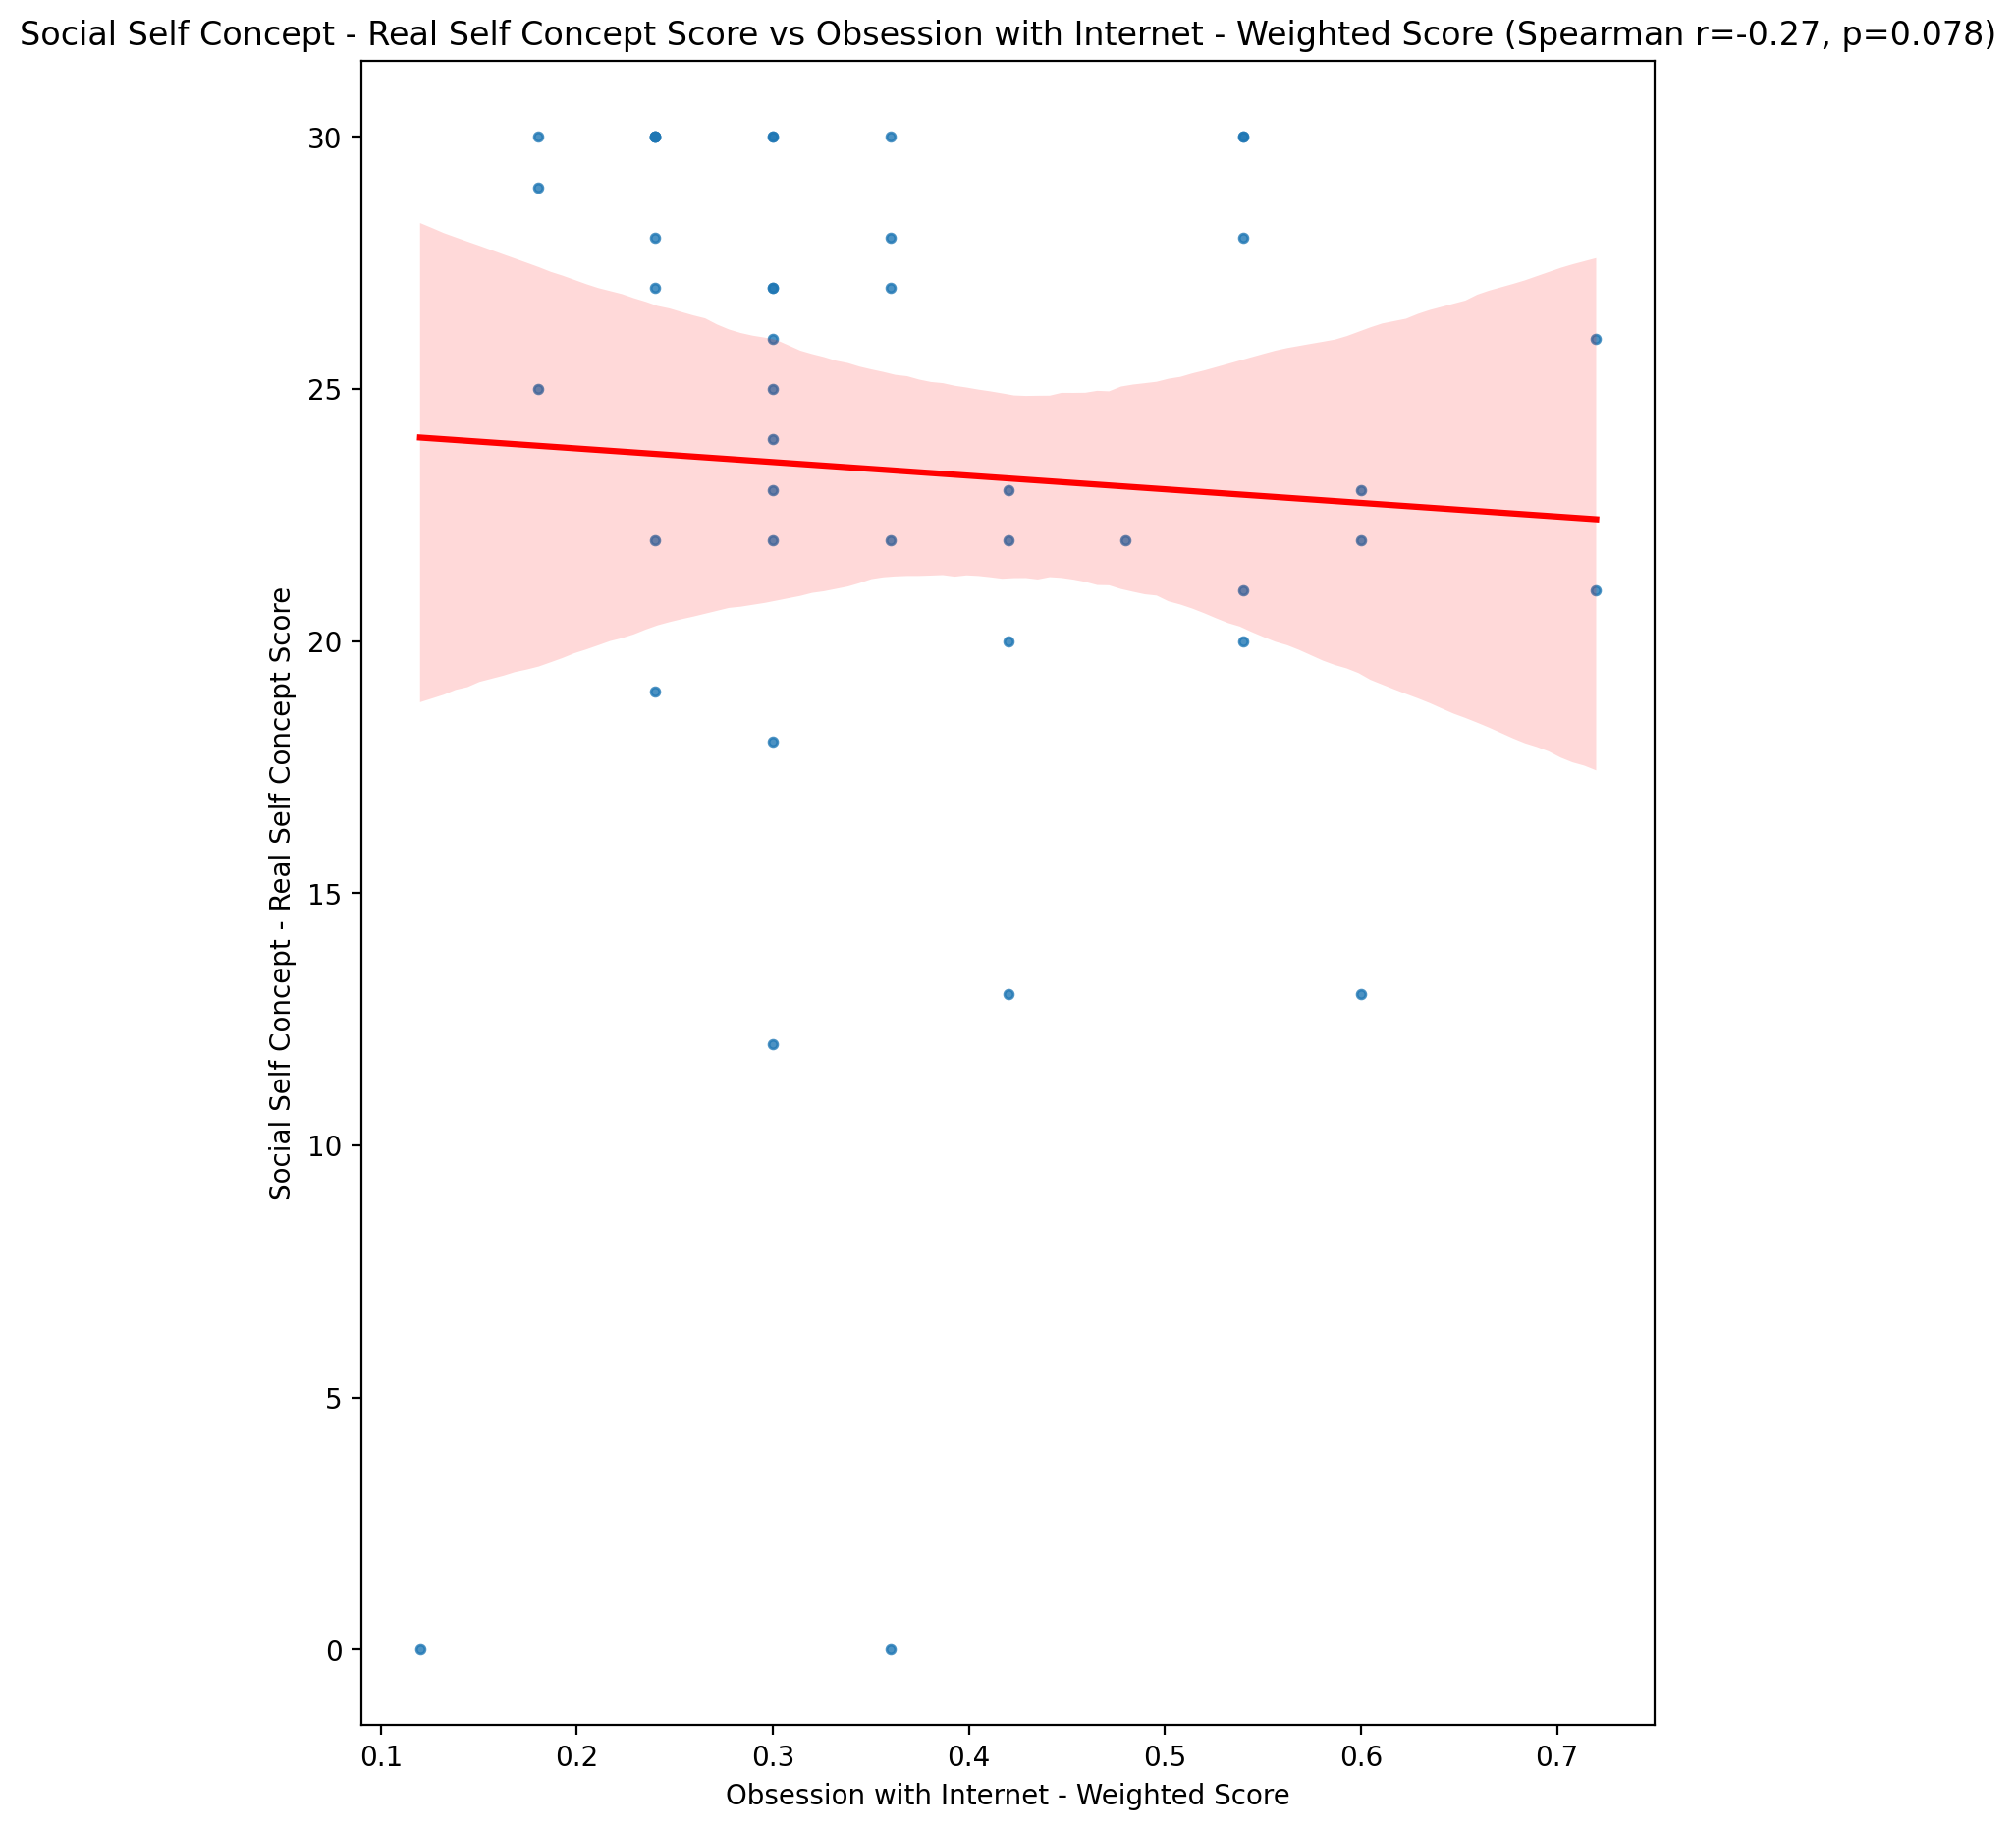

## Social Self Concept – Social Self Concept Score vs Obsession with Internet - Weighted Score

Test: spearman; statistic: -0.34737741031736036; p-value: 0.022467244399430313;

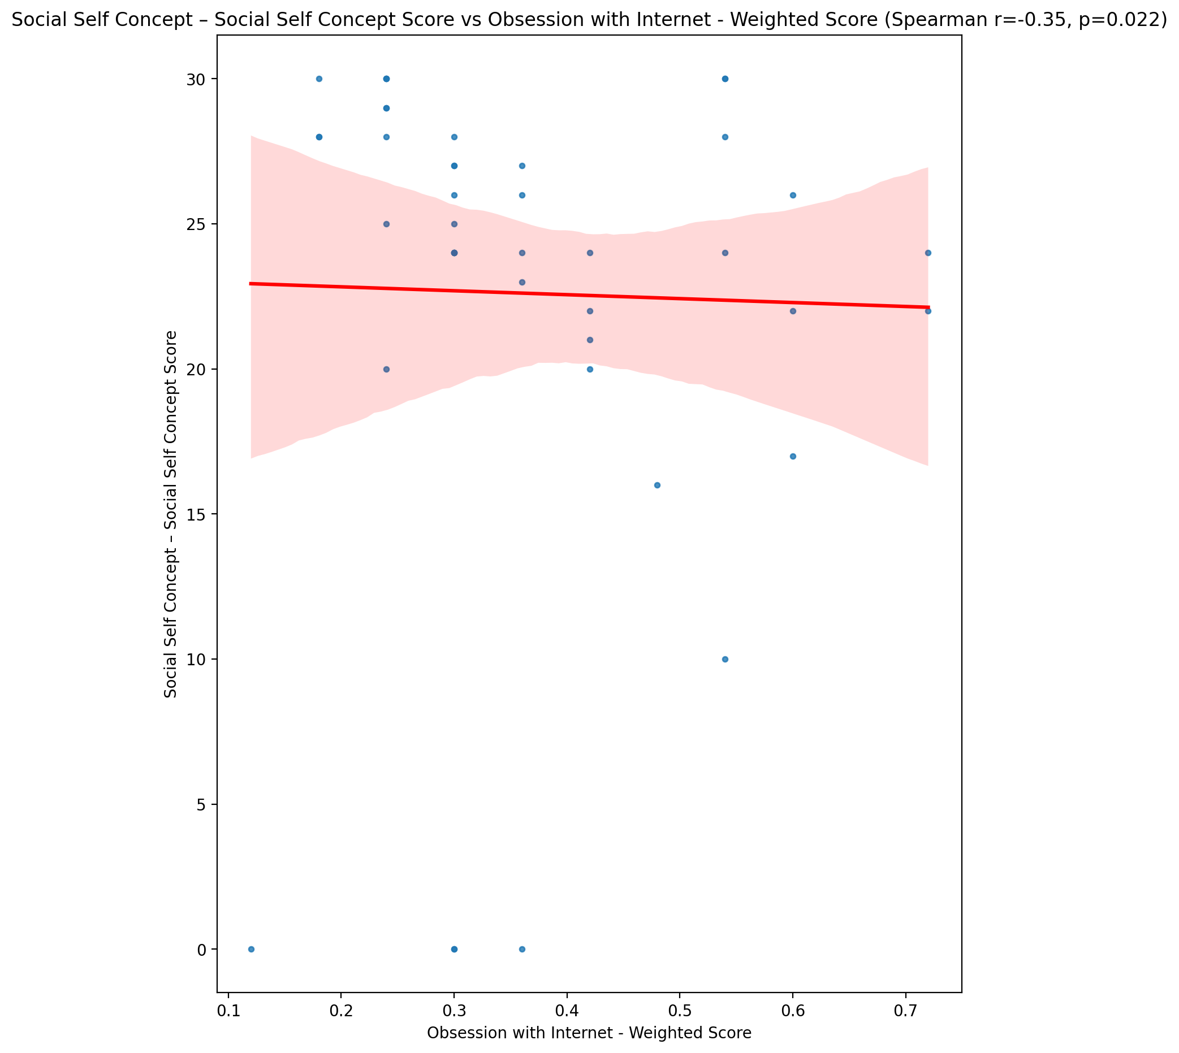

## Ability Self Concept - Real Self Concept Score vs Obsession with Internet - Weighted Score

Test: spearman; statistic: -0.21786198643036786; p-value: 0.16048494056622883;

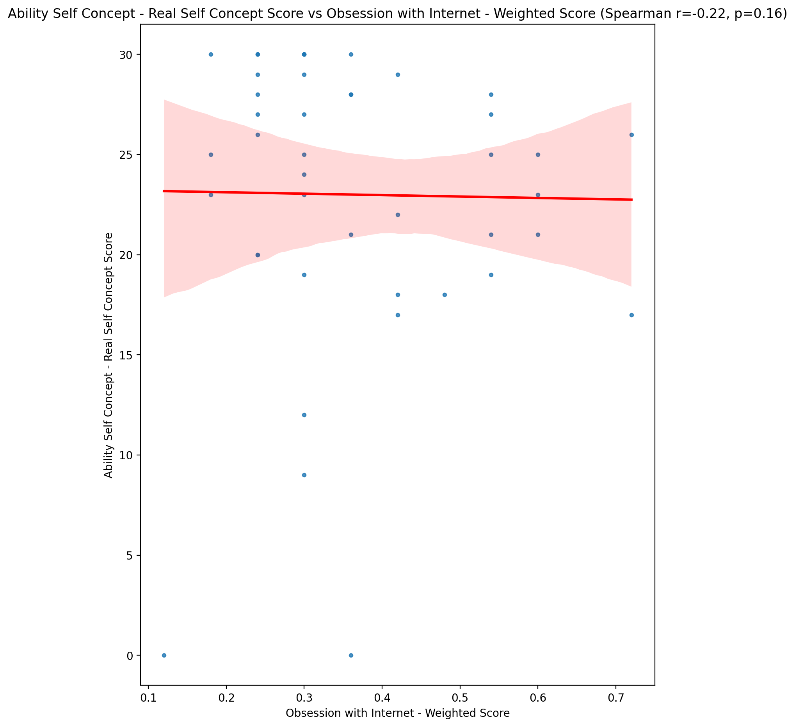

## Ability Self Concept - Ideal Self Concept Score vs Obsession with Internet - Weighted Score

Test: spearman; statistic: -0.36141592703631936; p-value: 0.01725448111957257;

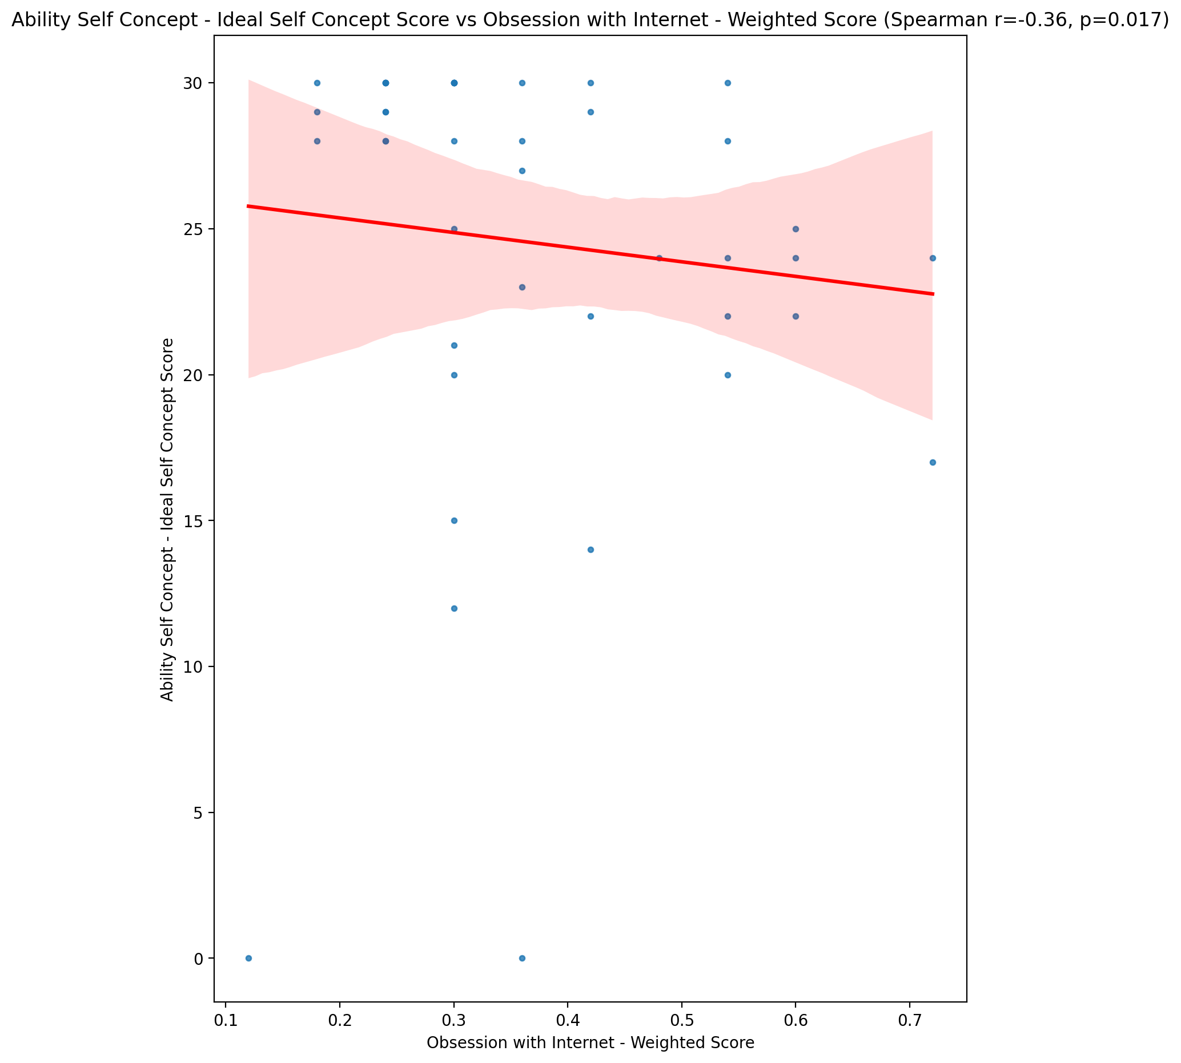

## Ability Self Concept – Social Self Concept Score vs Obsession with Internet - Weighted Score

Test: spearman; statistic: -0.36304210340356075; p-value: 0.016722738038630832;

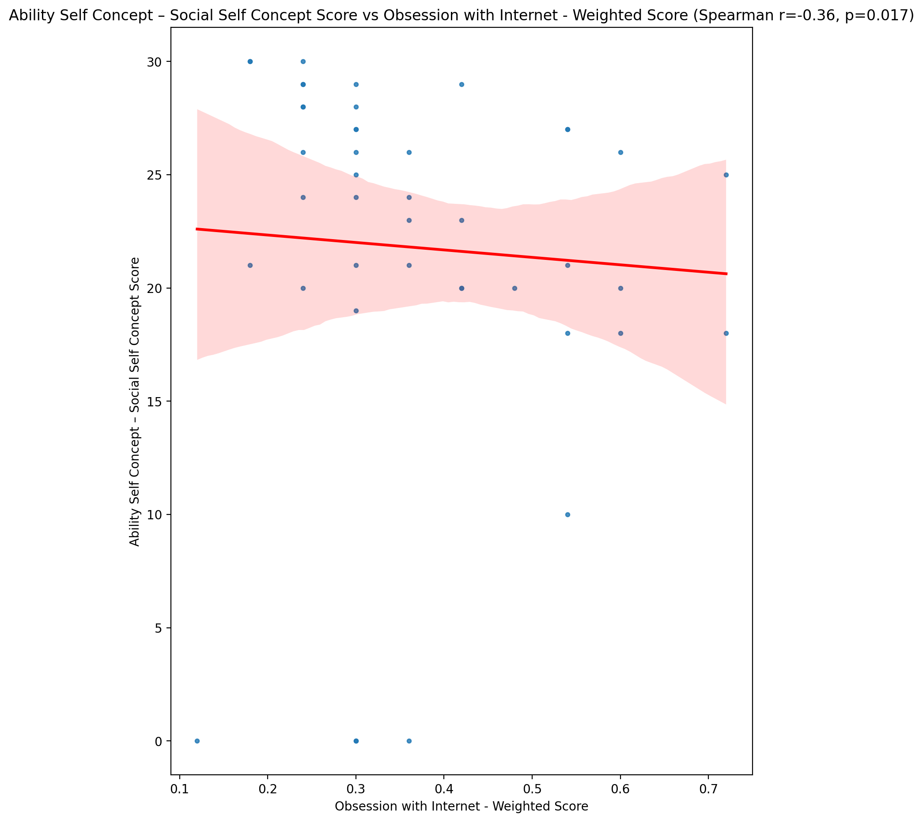

## Physical Self Concept - Real Self Concept Score vs Obsession with Internet - Weighted Score

Test: spearman; statistic: -0.2571849762631024; p-value: 0.09592931155248646;

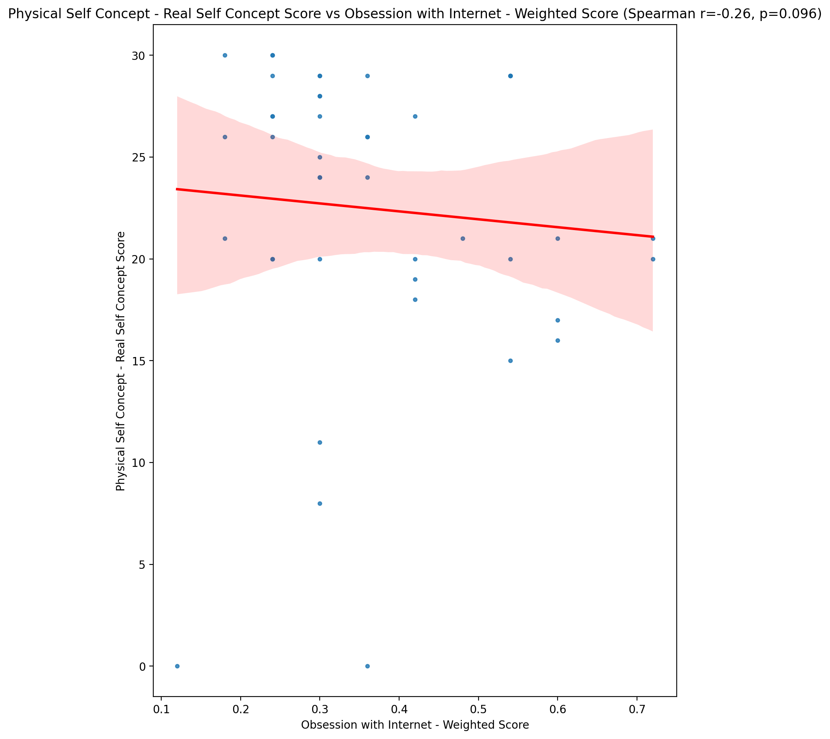

## Physical Self Concept – Ideal Self Concept Score vs Obsession with Internet - Weighted Score

Test: spearman; statistic: -0.3607857864217857; p-value: 0.01746433355251005;

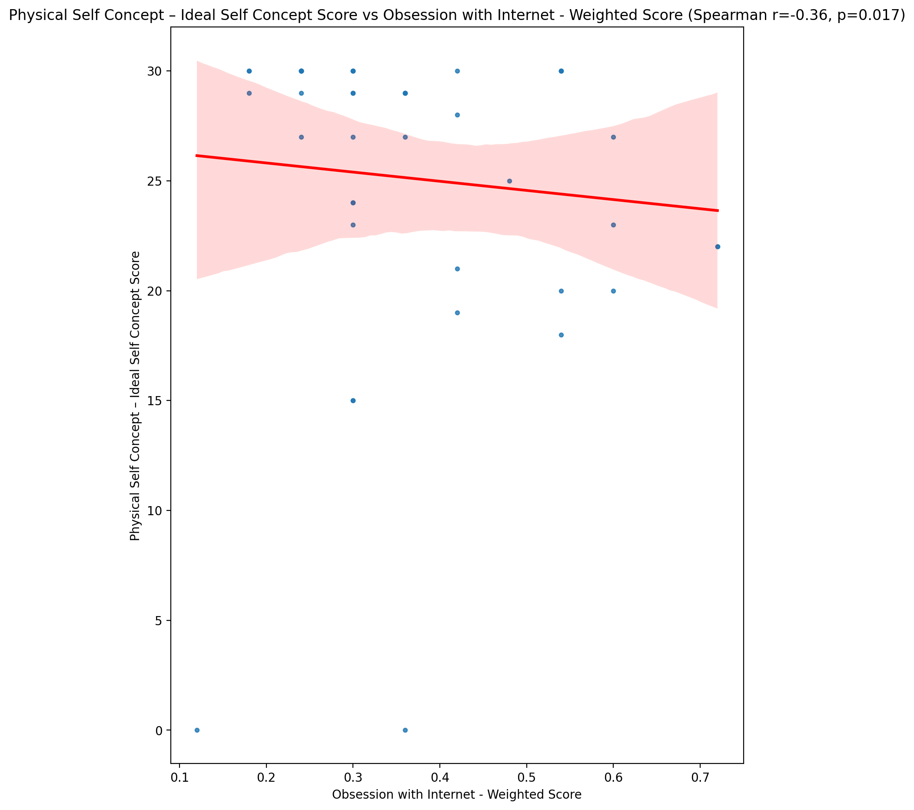

## Physical Self Concept – Social Self Concept Score vs Obsession with Internet - Weighted Score

Test: spearman; statistic: -0.13394162939908513; p-value: 0.3918315349939382;

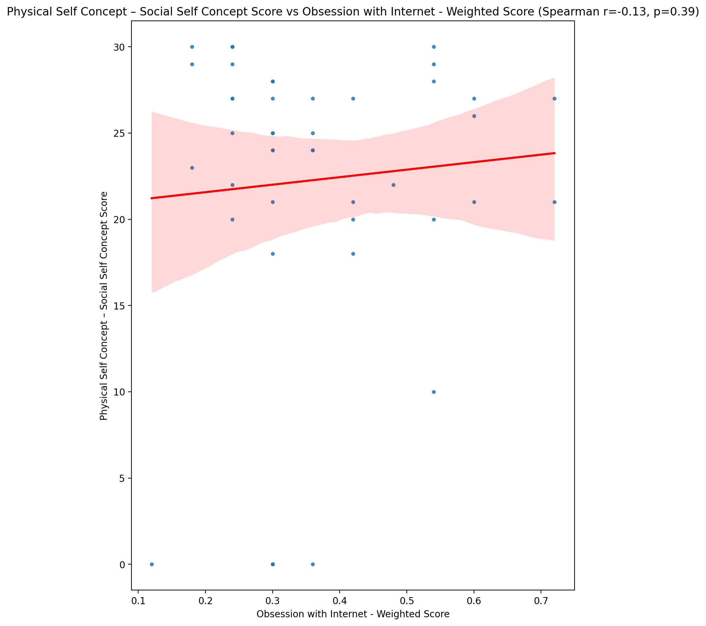

## Psychological Self Concept - Real Self Concept Score vs Obsession with Internet - Weighted Score

Test: spearman; statistic: -0.3191534154028172; p-value: 0.03697310689478427;

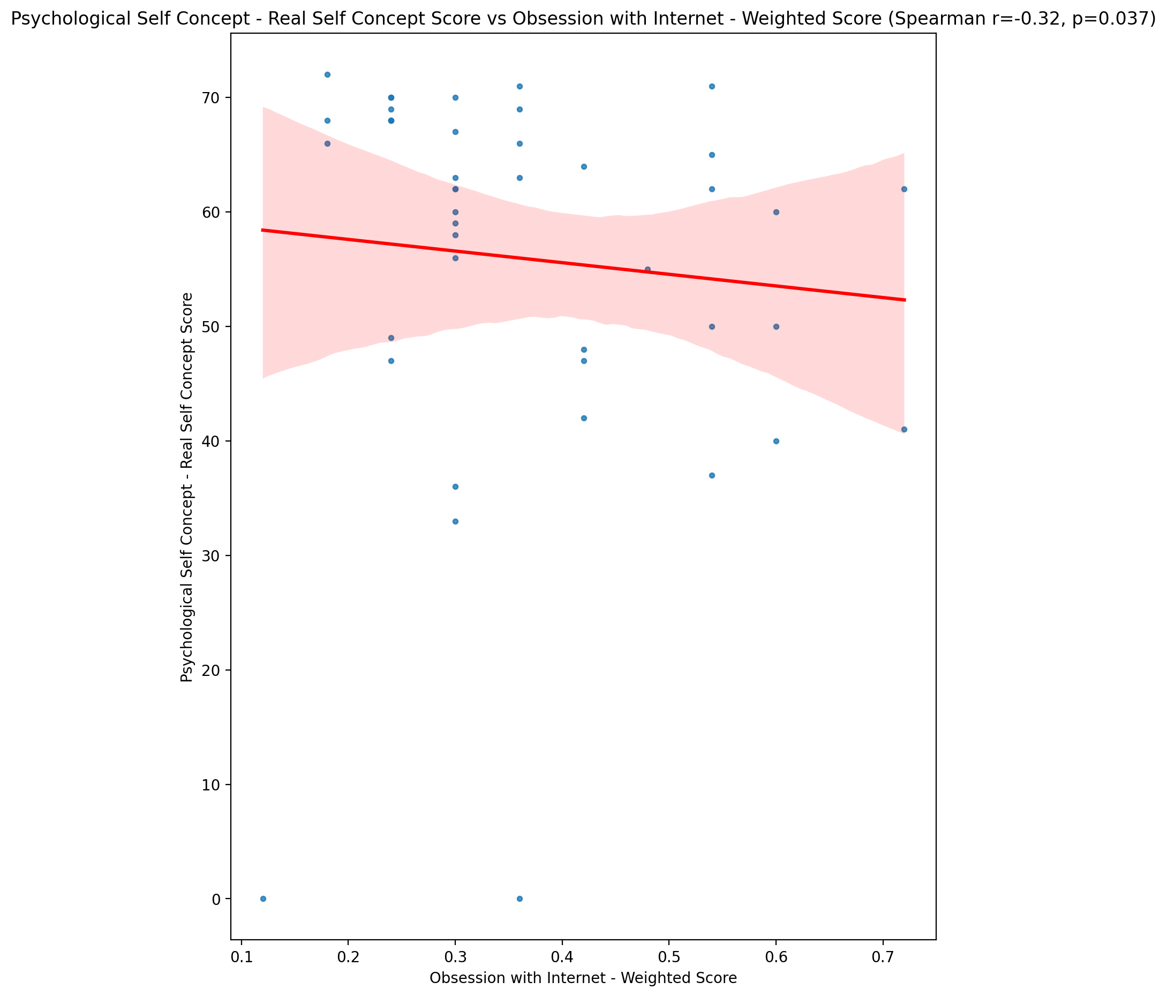

## Psychological Self Concept – Ideal Self Concept Score vs Obsession with Internet - Weighted Score

Test: spearman; statistic: -0.34946900373571294; p-value: 0.021615878126869503;

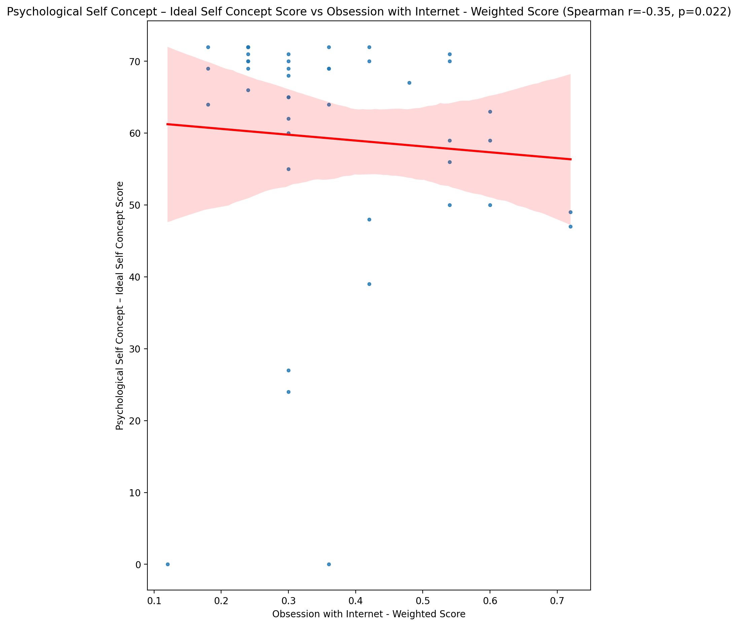

## Psychological Self Concept – Social Self Concept Score vs Obsession with Internet - Weighted Score

Test: spearman; statistic: -0.40848882083480065; p-value: 0.006538643197391726;

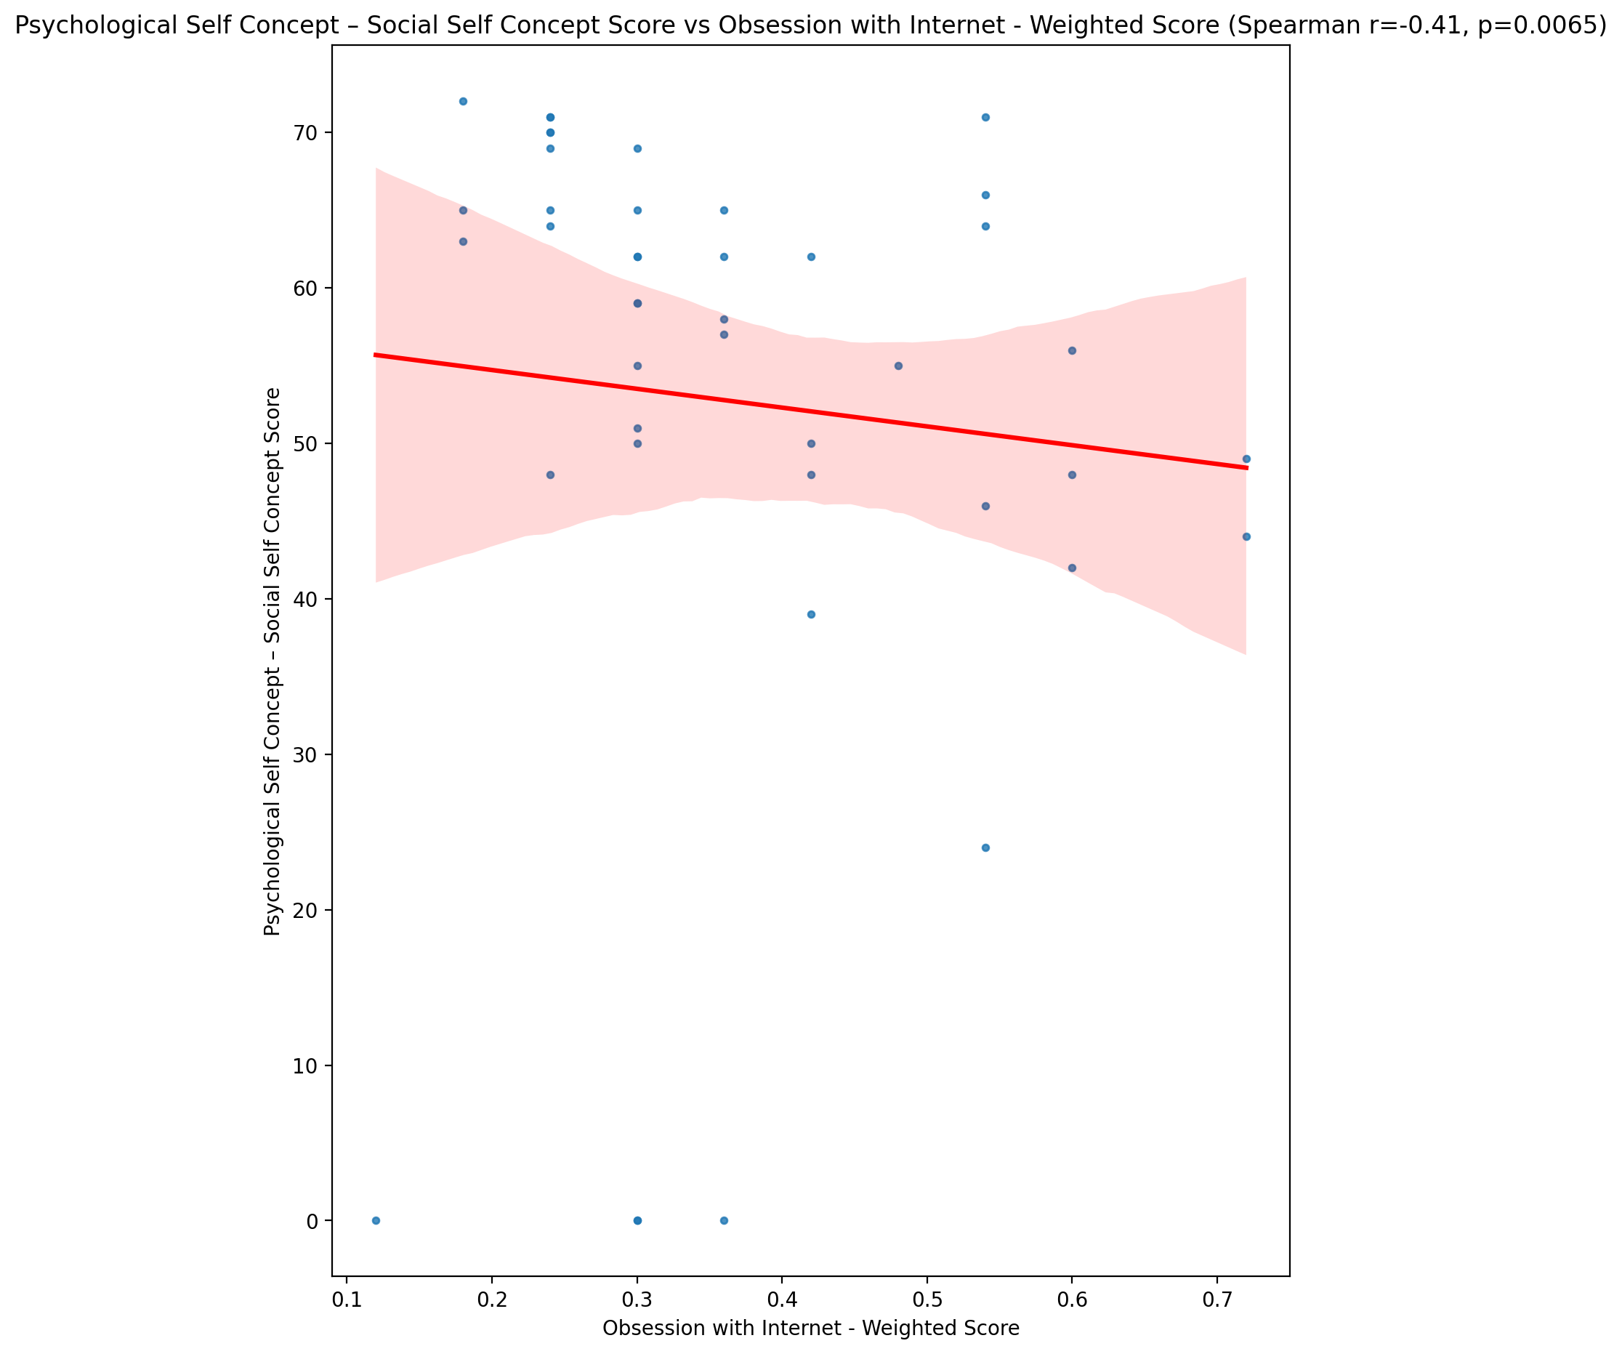

## Real Self Concept Total Score vs Obsession with Internet - Weighted Score

Test: spearman; statistic: -0.3060438091821561; p-value: 0.04594436729663131;

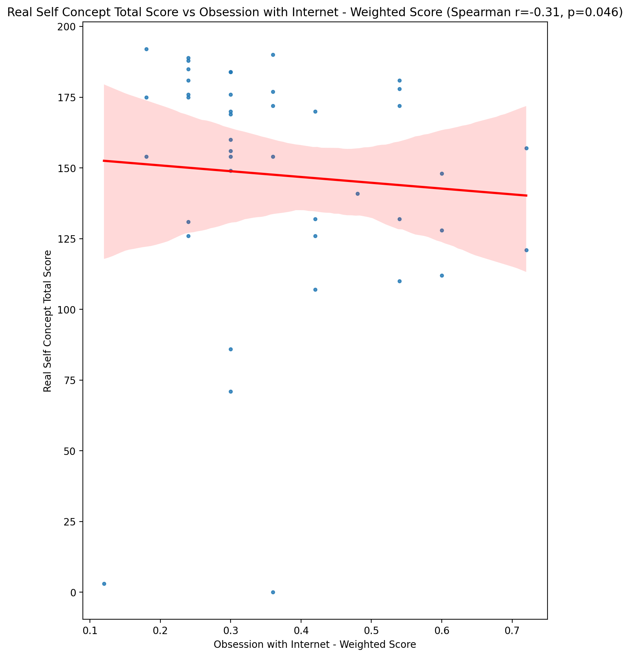

## Ideal Self Concept Total Score vs Obsession with Internet - Weighted Score

Test: spearman; statistic: -0.4365217025537612; p-value: 0.003428218471280108;

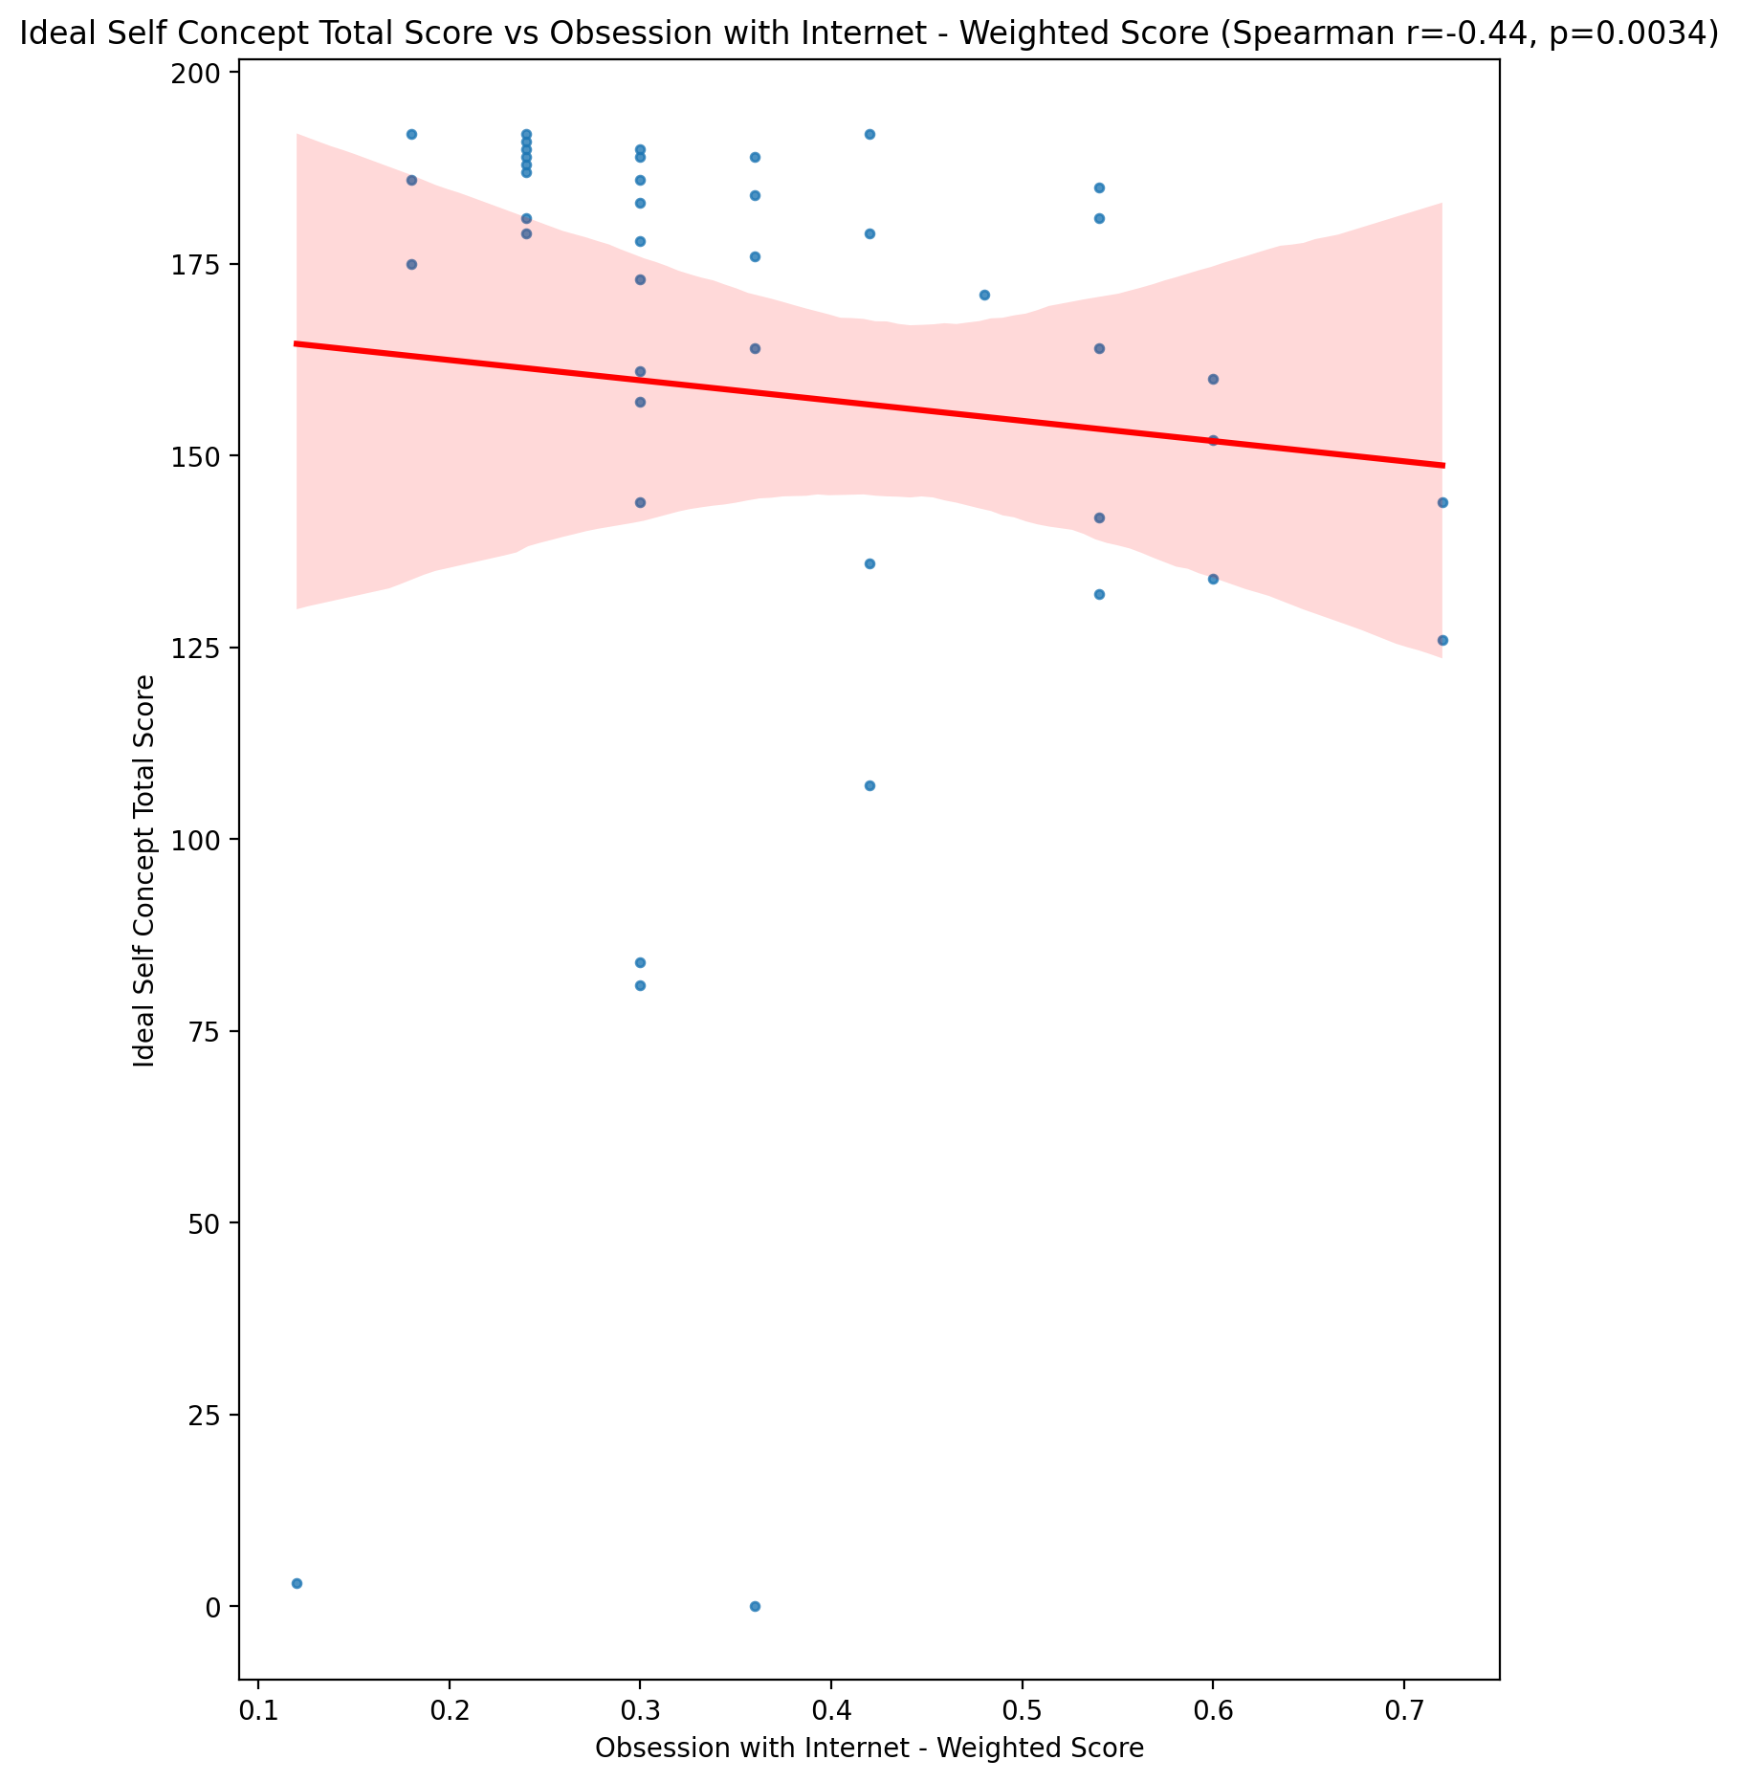

## Social Self Concept Total Score vs Obsession with Internet - Weighted Score

Test: spearman; statistic: -0.38373709147154644; p-value: 0.011076864074891264;

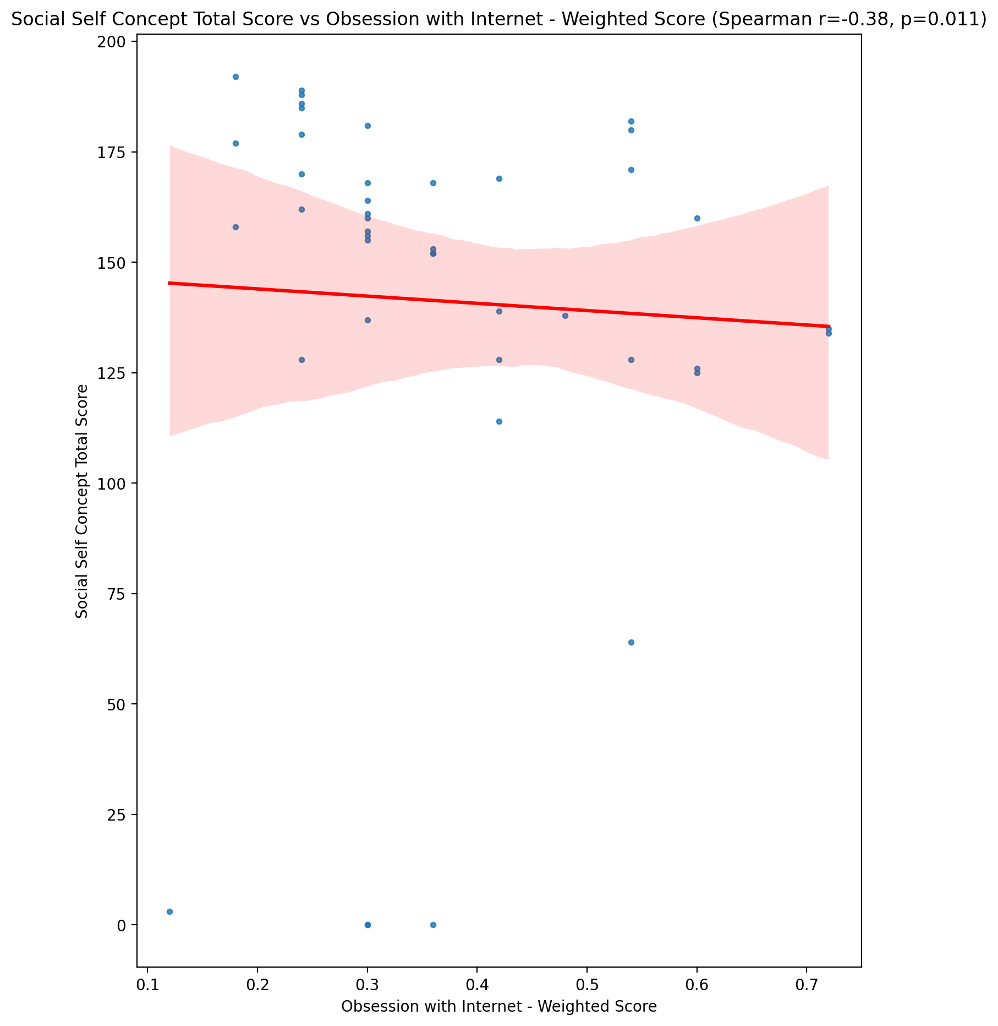

## Ideal Self Concept Total Category vs Obsession with Internet - Weighted Score

Test: None; statistic: None; p-value: None; Test not run: unsupported type combination.



## Perceived Social Stress Score vs Obsession with Internet - Weighted Score

Test: spearman; statistic: 0.3702372557621648; p-value: 0.014533114214474318;

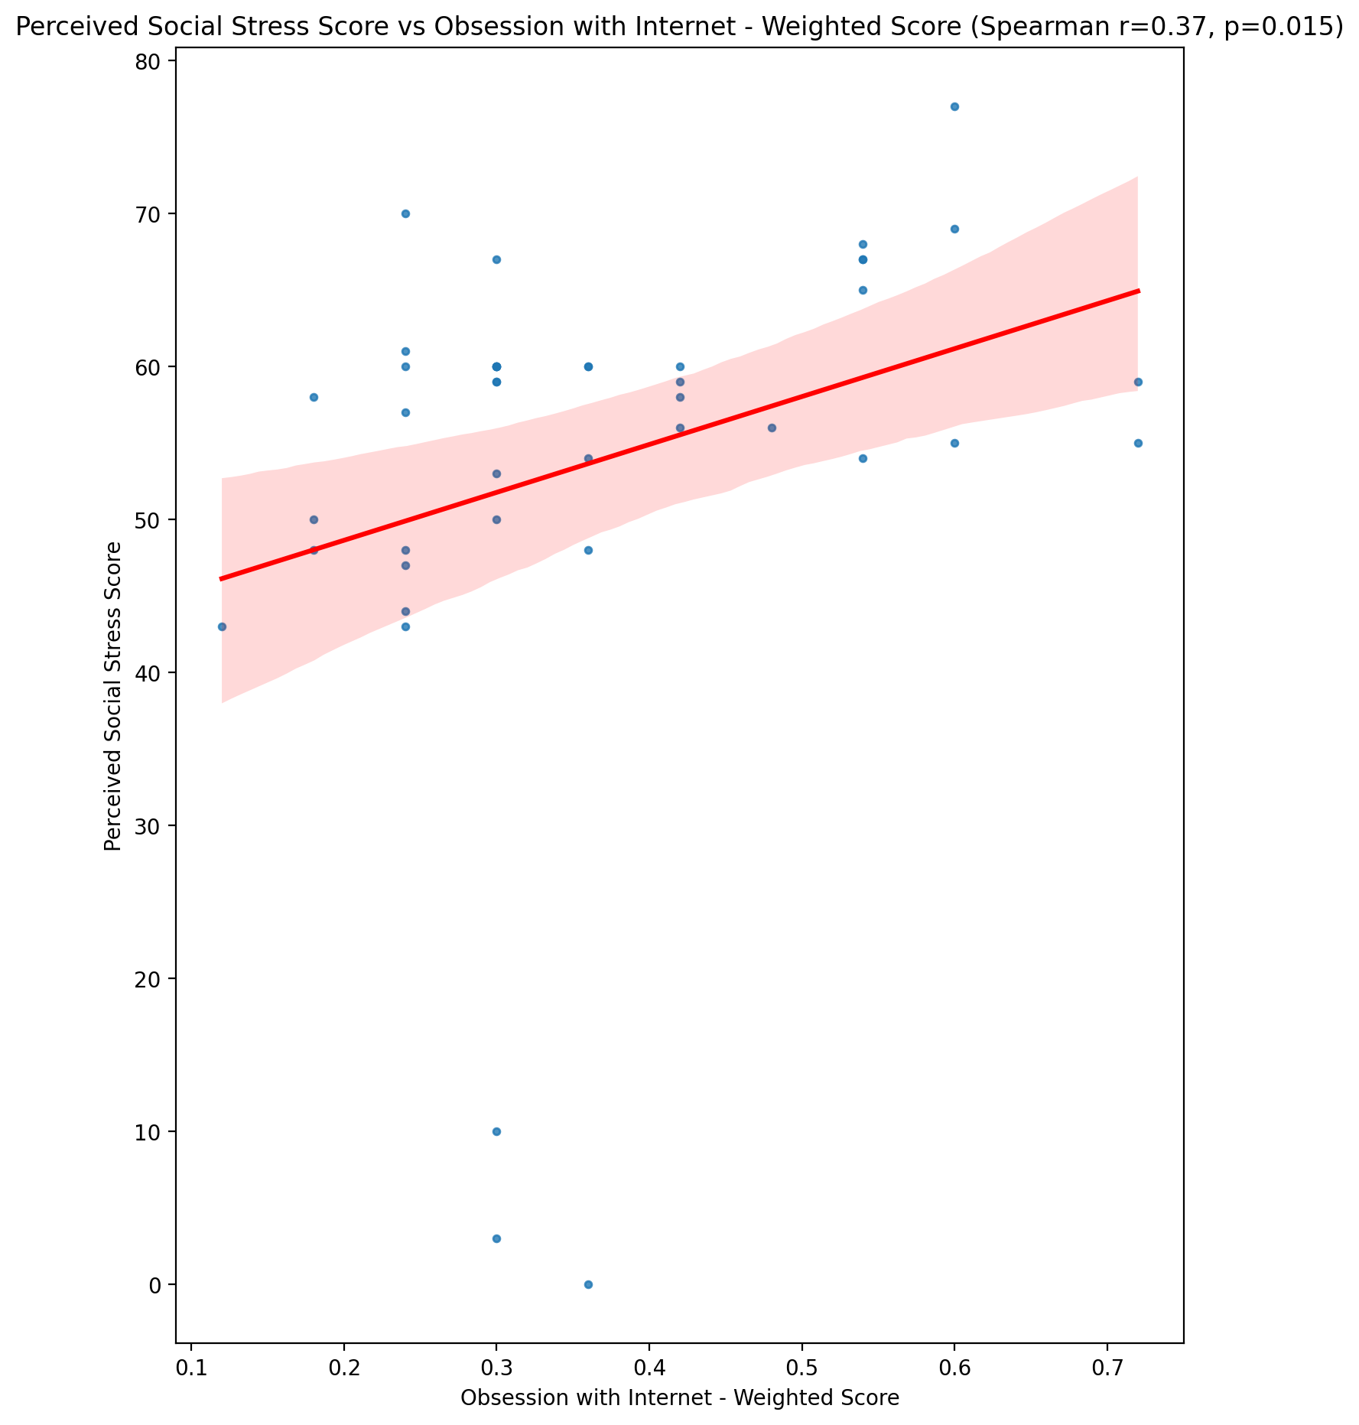

## Perceived Social Stress Category vs Obsession with Internet - Weighted Score

Test: None; statistic: None; p-value: None; Test not run: unsupported type combination.



## Emotional Support - Raw Score vs Internet as a Source of Recreation - Weighted Score

Test: spearman; statistic: -0.17493638815120915; p-value: 0.261857929909766;

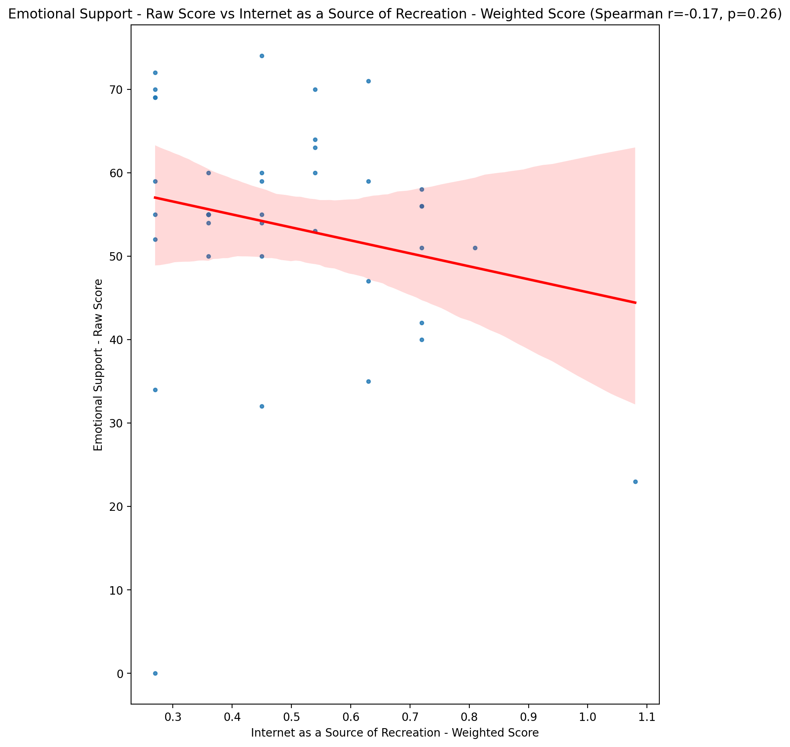

## Informational Support - Raw Score vs Internet as a Source of Recreation - Weighted Score

Test: spearman; statistic: -0.1874374896623847; p-value: 0.2287465098906379;

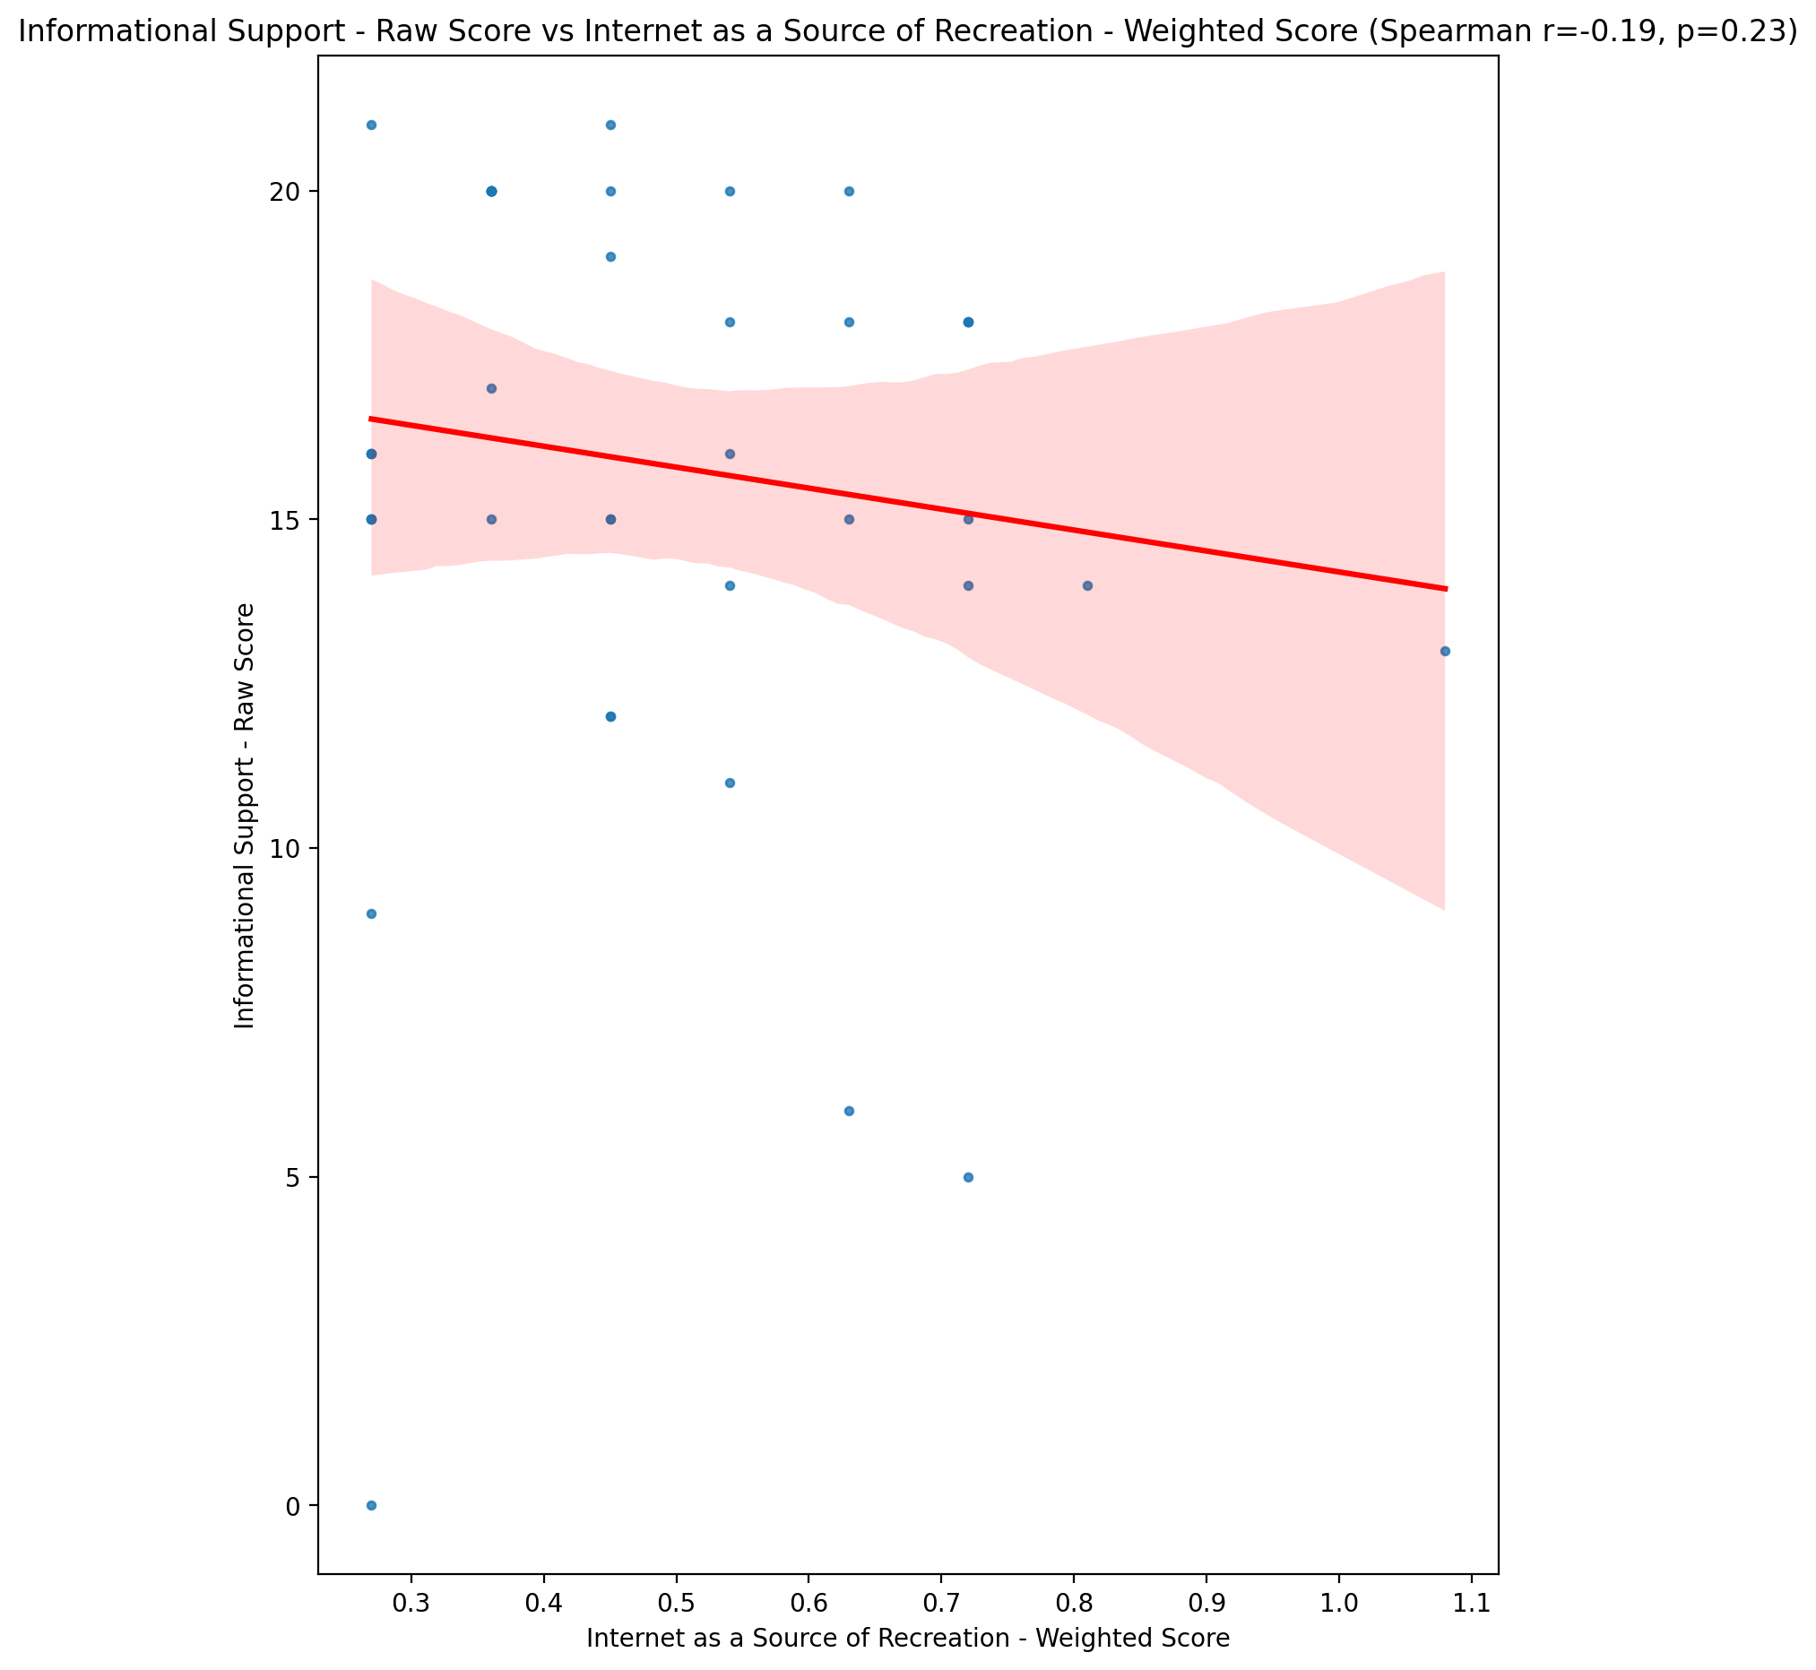

## Instrumental Support - Raw Score vs Internet as a Source of Recreation - Weighted Score

Test: spearman; statistic: -0.3733580137517788; p-value: 0.013661987975401297;

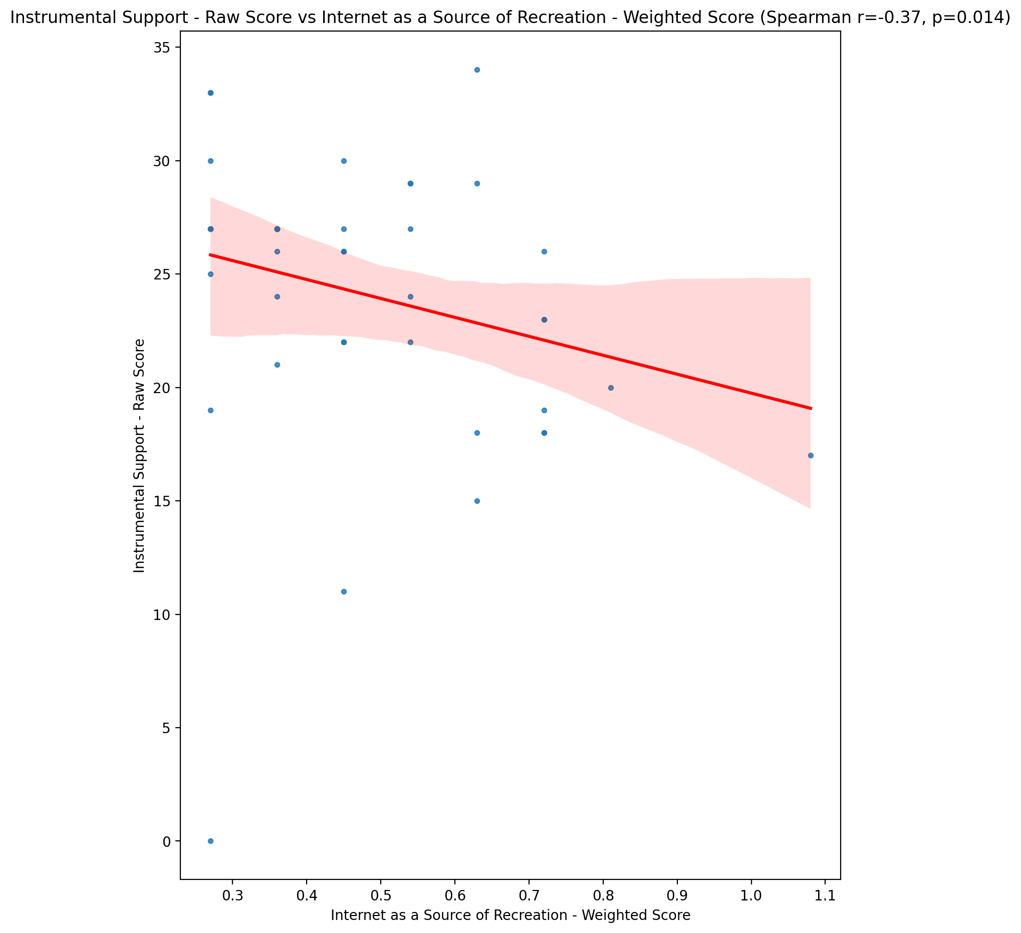

## Emotional Support - T Score vs Internet as a Source of Recreation - Weighted Score

Test: spearman; statistic: -0.18467682850483877; p-value: 0.23579895664035888;

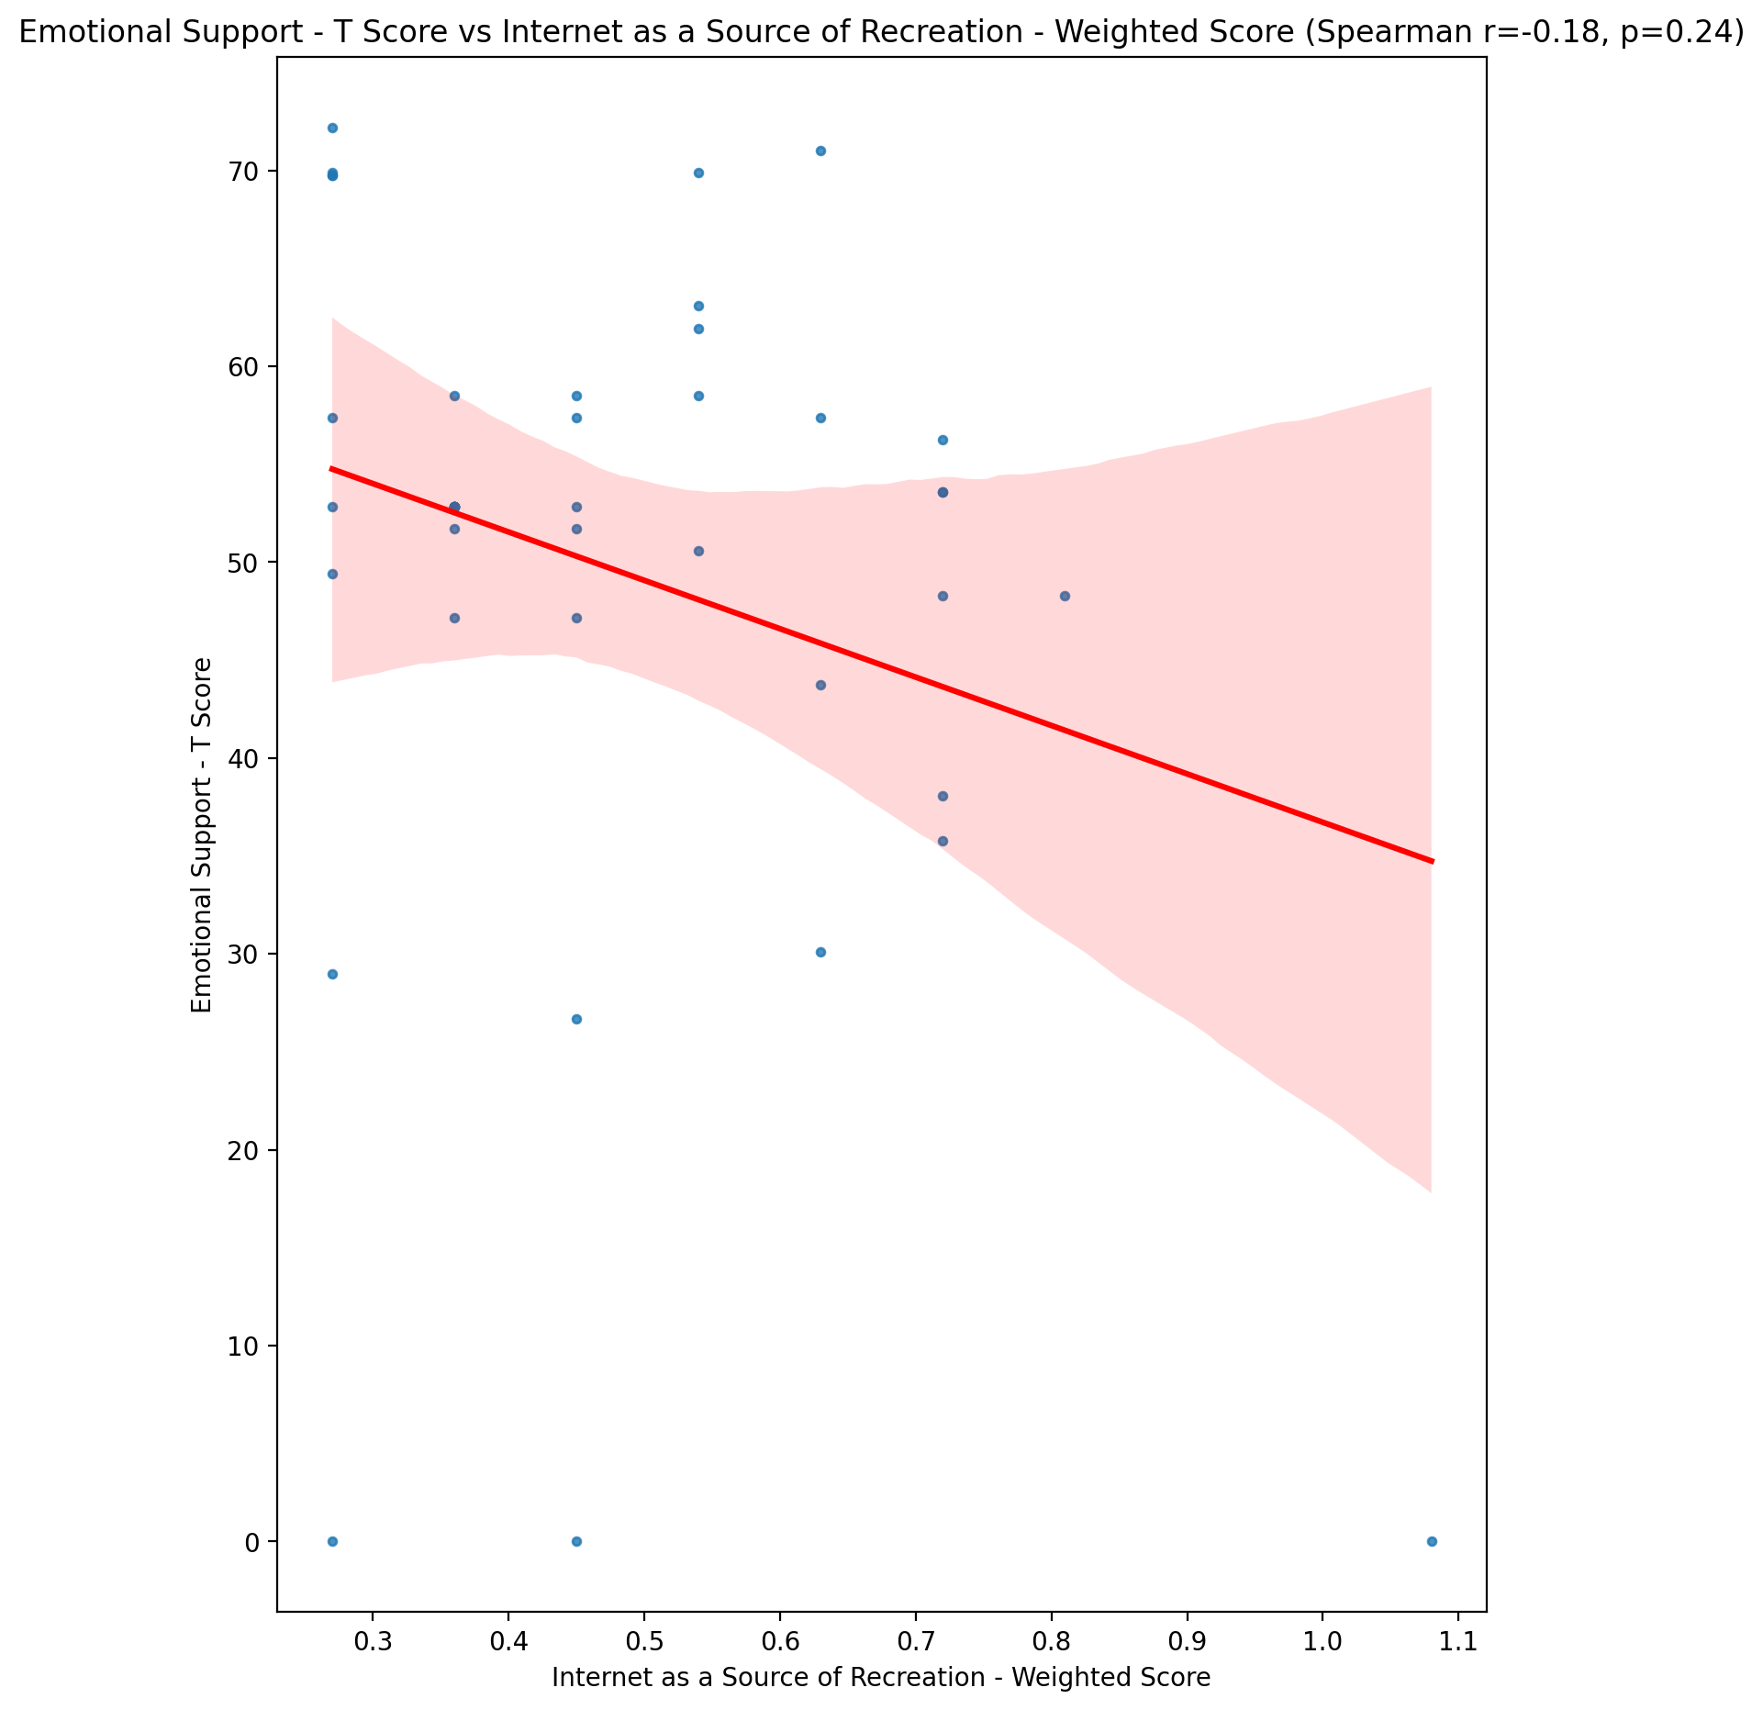

## Informational Support - T Score vs Internet as a Source of Recreation - Weighted Score

Test: spearman; statistic: -0.1918958089187597; p-value: 0.21766506668152202;

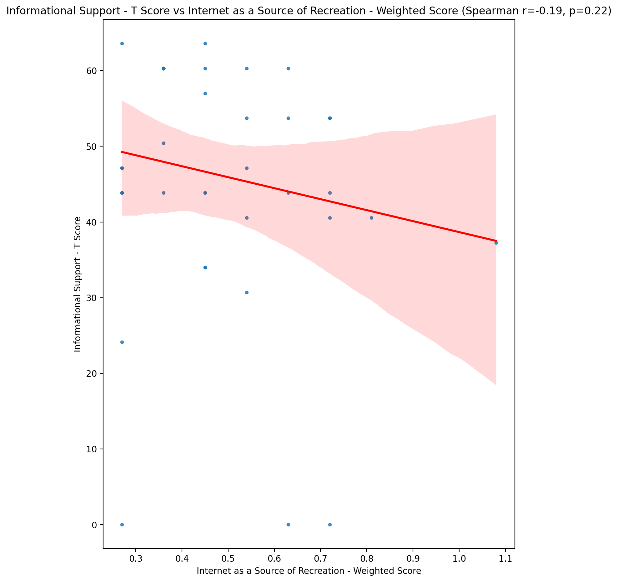

## Instrumental Support - T Score vs Internet as a Source of Recreation - Weighted Score

Test: spearman; statistic: -0.3747695416936914; p-value: 0.01328280151216645;

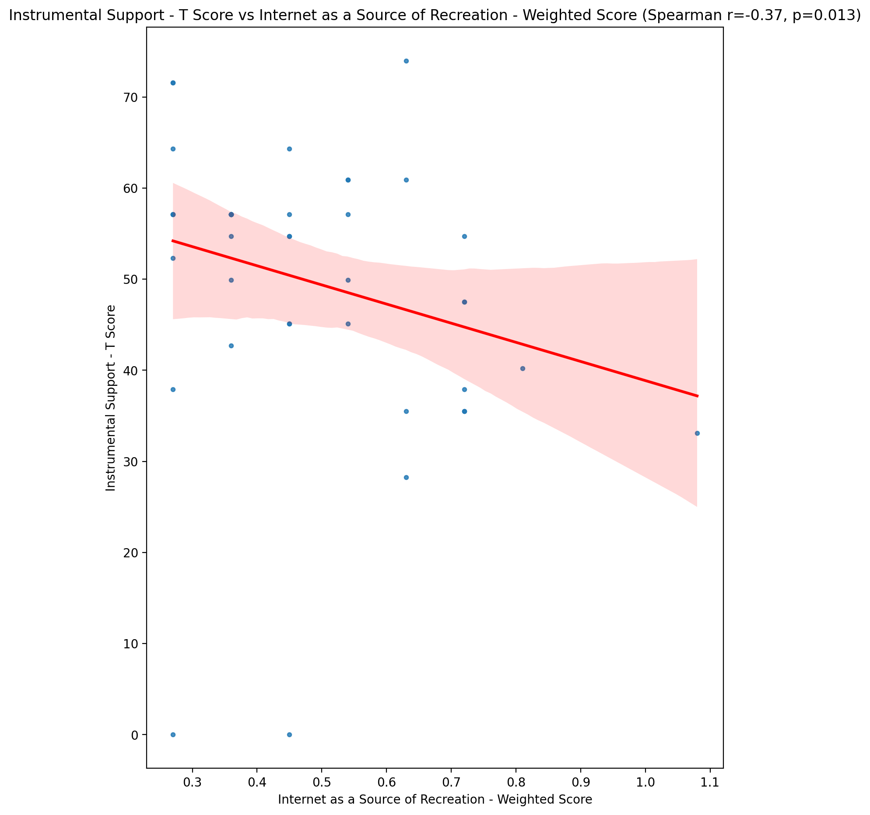

## Perceived Social Support Total T Score vs Internet as a Source of Recreation - Weighted Score

Test: spearman; statistic: -0.2318256931056376; p-value: 0.13469271107024694;

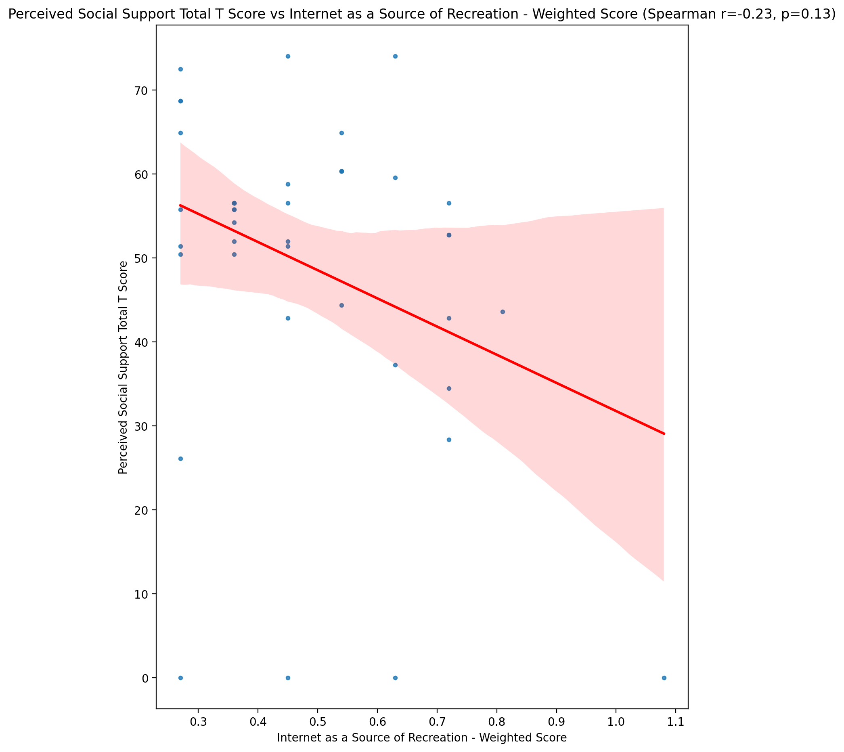

## Emotional Support - Rank vs Internet as a Source of Recreation - Weighted Score

Test: None; statistic: None; p-value: None; Test not run: unsupported type combination.



## Informational Support - Rank vs Internet as a Source of Recreation - Weighted Score

Test: None; statistic: None; p-value: None; Test not run: unsupported type combination.



## Instrumental Support - Rank vs Internet as a Source of Recreation - Weighted Score

Test: None; statistic: None; p-value: None; Test not run: unsupported type combination.



## Perceived Social Support TOTAL - Rank vs Internet as a Source of Recreation - Weighted Score

Test: None; statistic: None; p-value: None; Test not run: unsupported type combination.



## Power Self Concept - Real Self Concept Score vs Internet as a Source of Recreation - Weighted Score

Test: spearman; statistic: 0.028657915524797437; p-value: 0.8552512910512309;

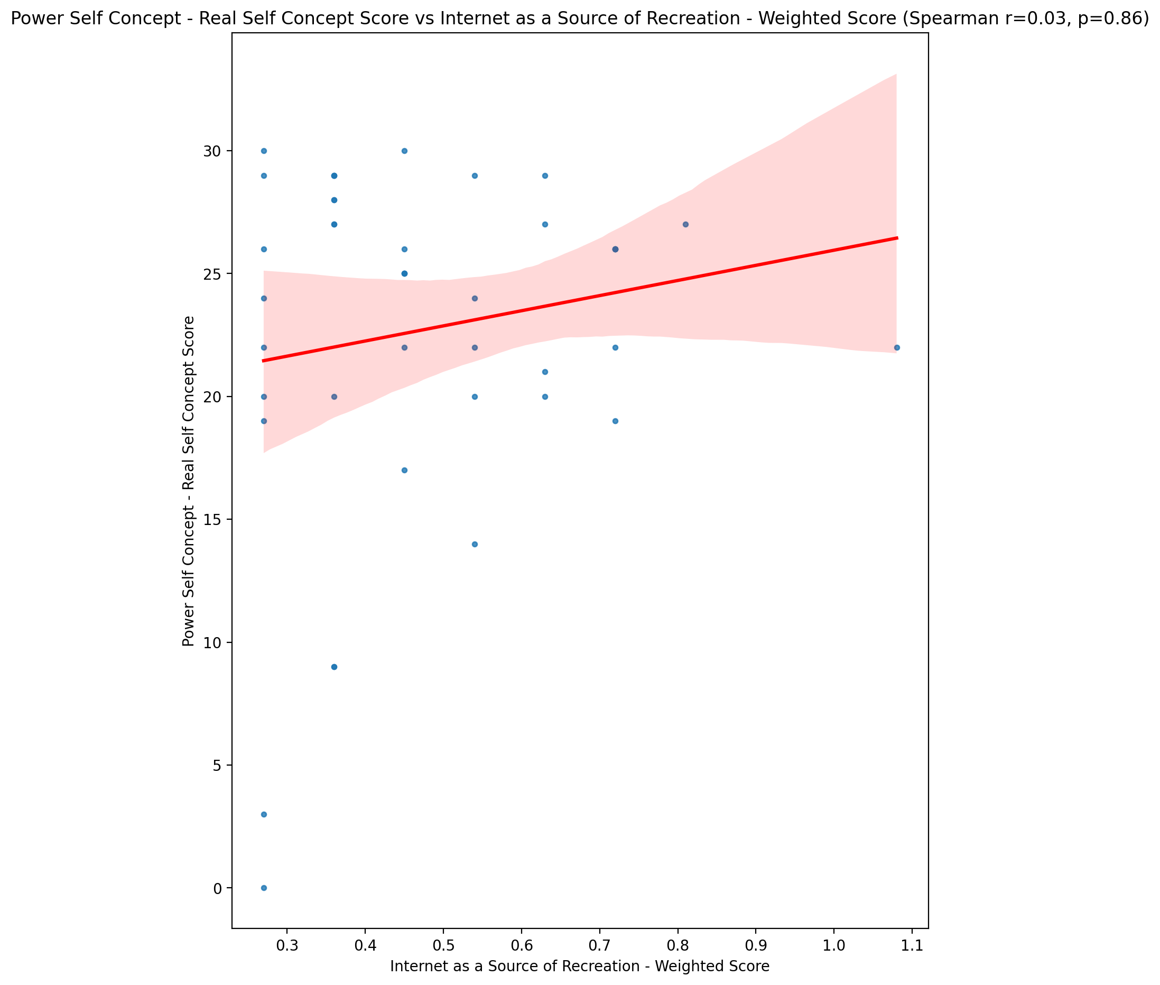

## Power Self Concept - Ideal Self Concept score vs Internet as a Source of Recreation - Weighted Score

Test: spearman; statistic: -0.04317424881746125; p-value: 0.7833944965048469;

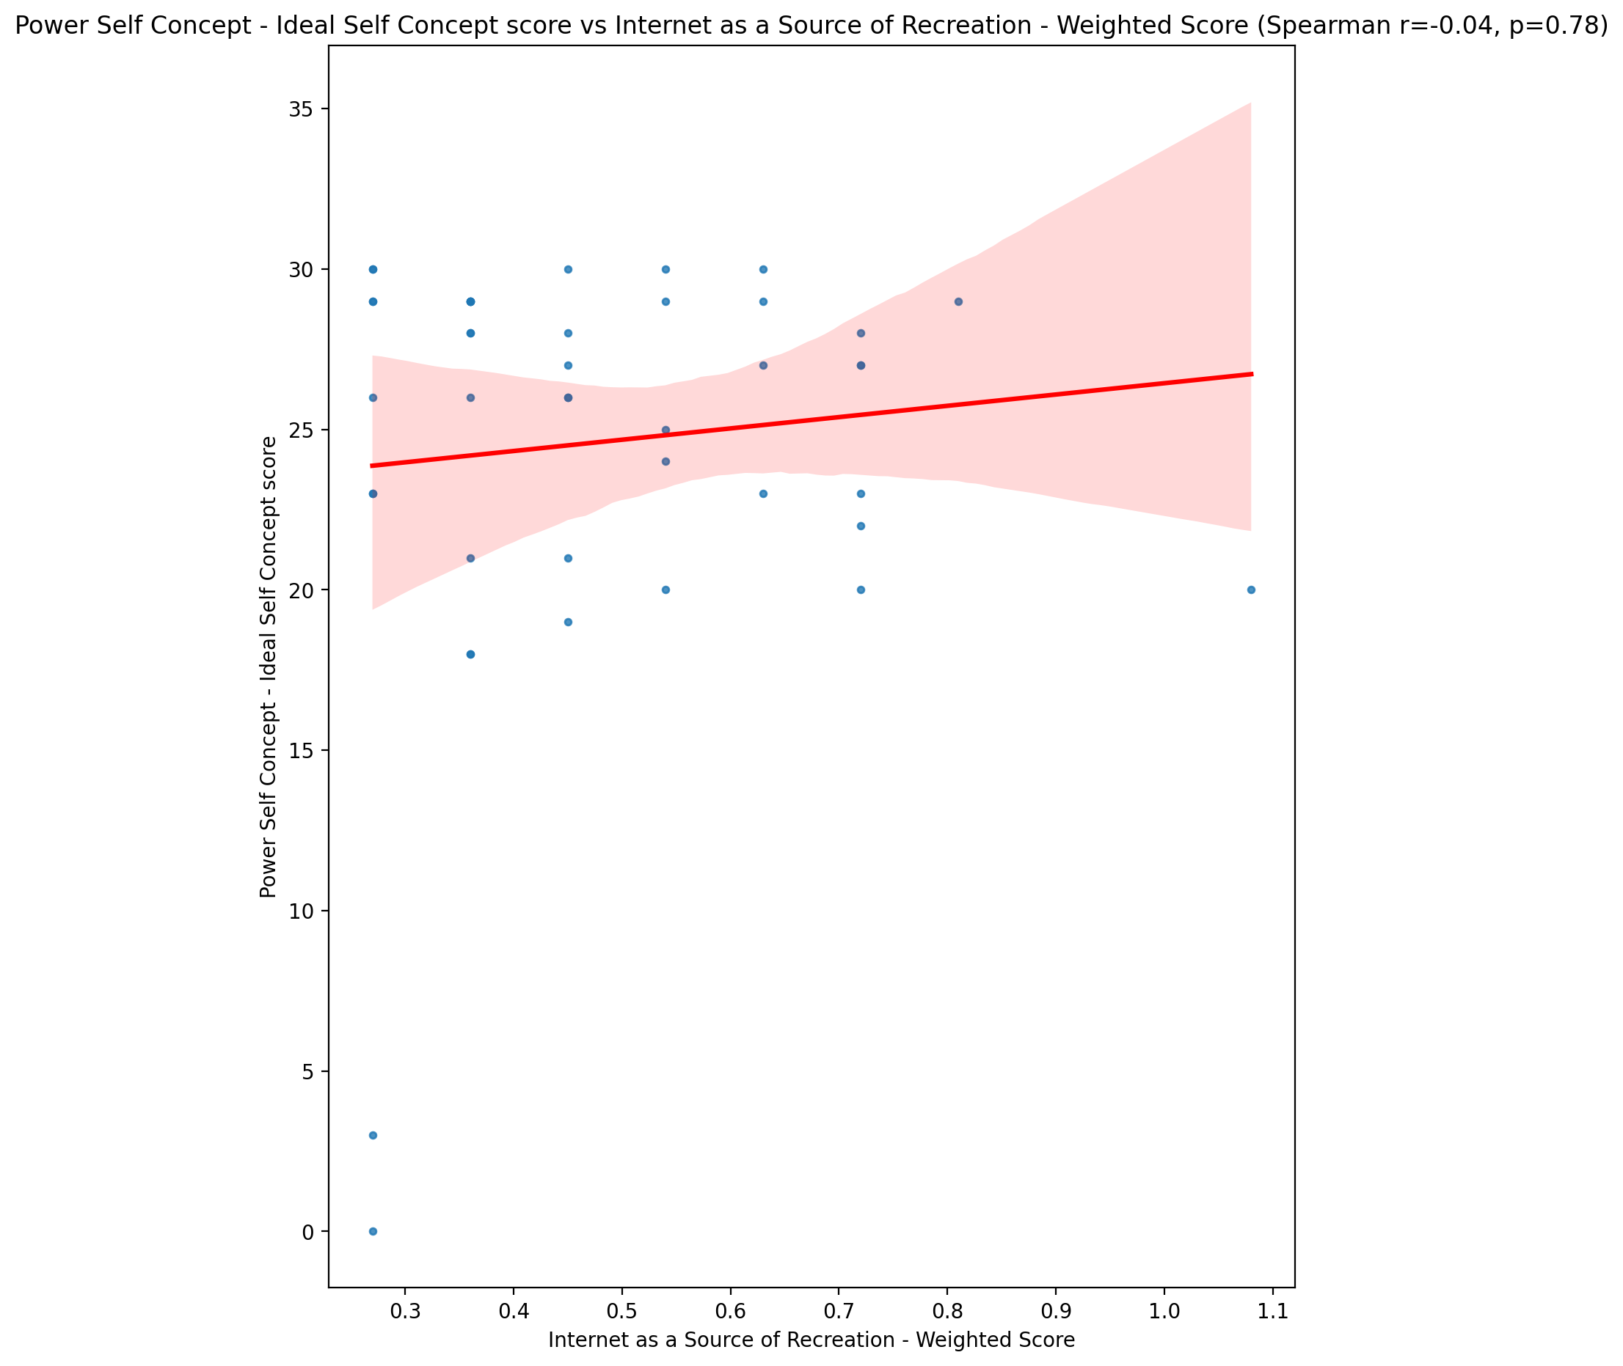

## Power Self Concept – Social Self Concept Score vs Internet as a Source of Recreation - Weighted Score

Test: spearman; statistic: 0.09404031045883596; p-value: 0.5486235464780913;

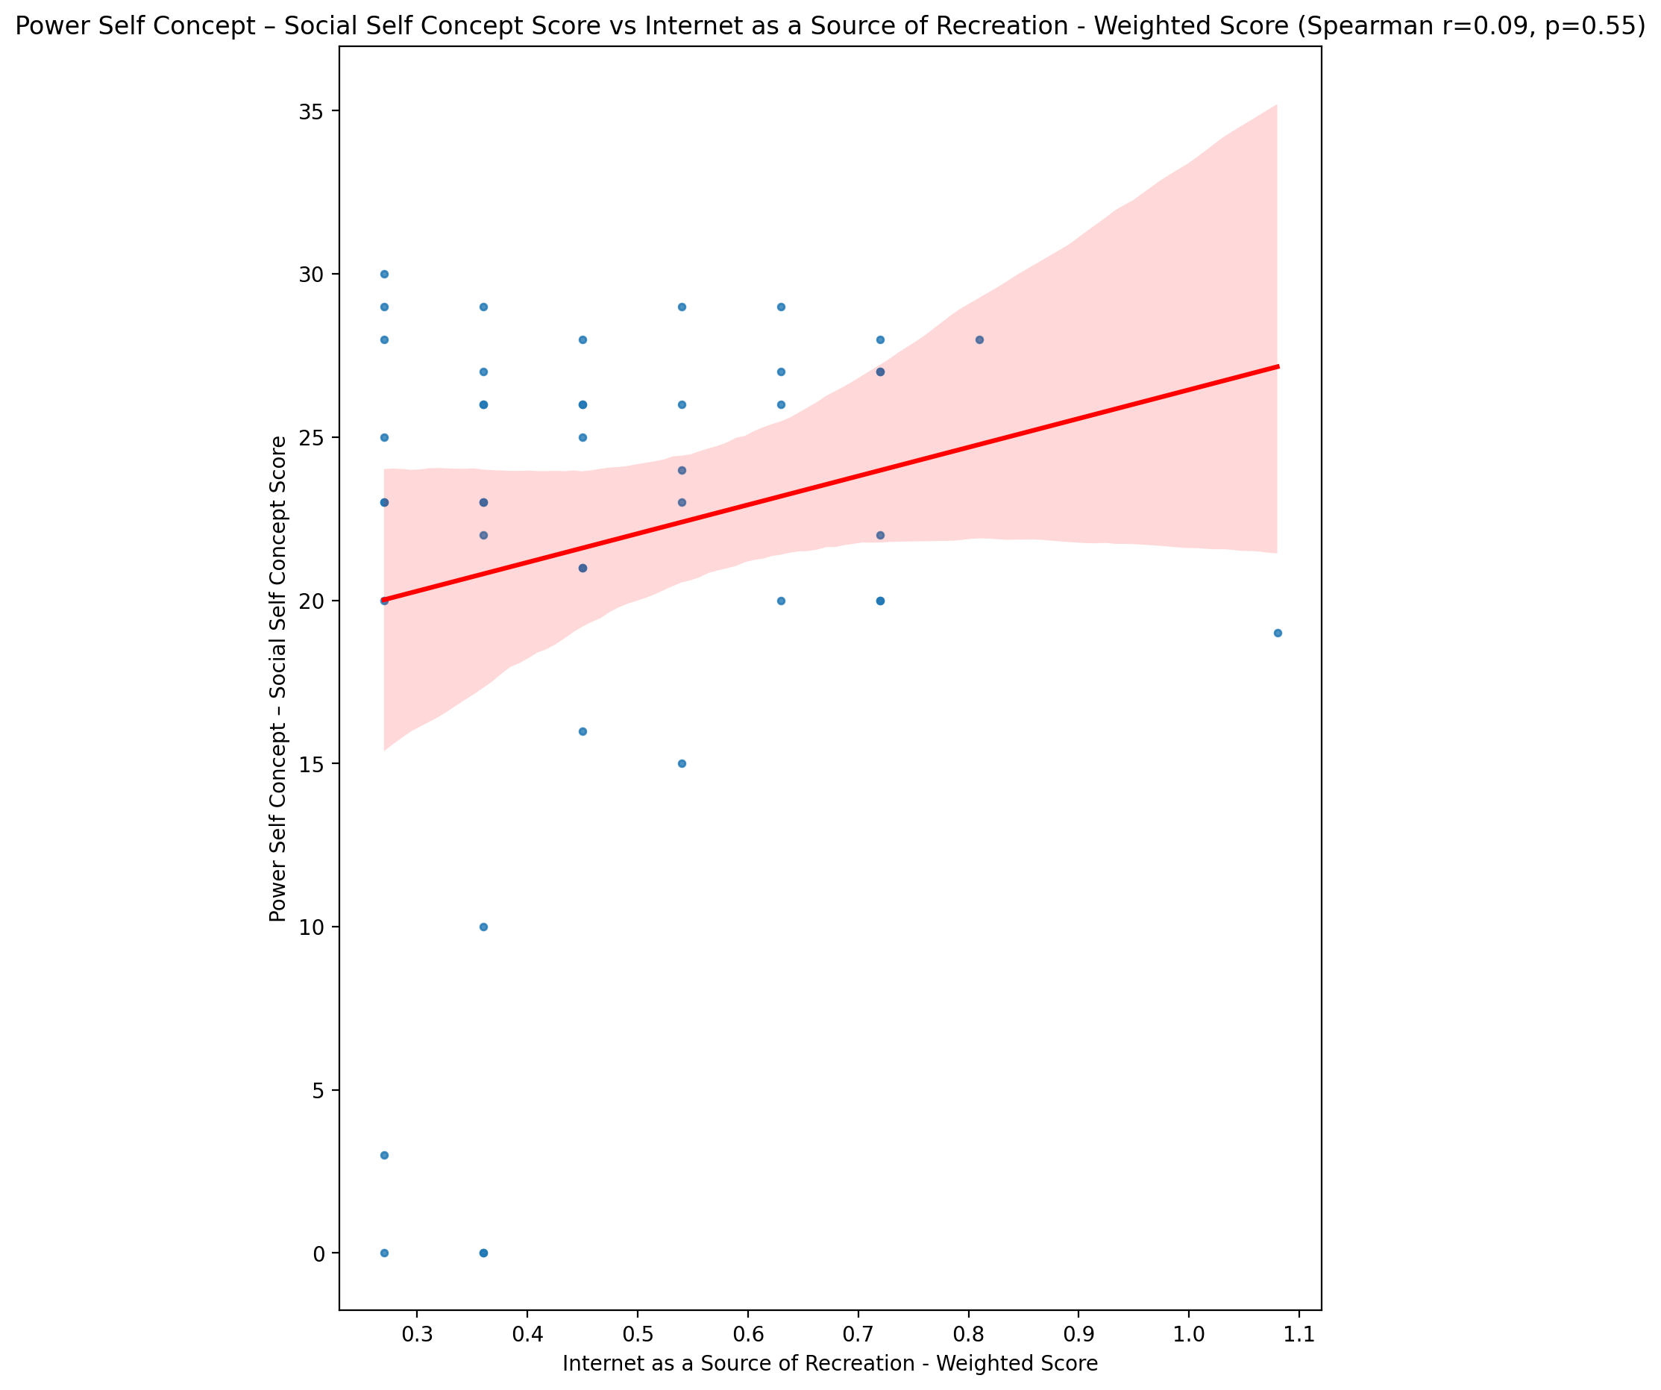

## Social Self Concept - Real Self Concept Score vs Internet as a Source of Recreation - Weighted Score

Test: spearman; statistic: 0.03418755887299381; p-value: 0.8277093618872541;

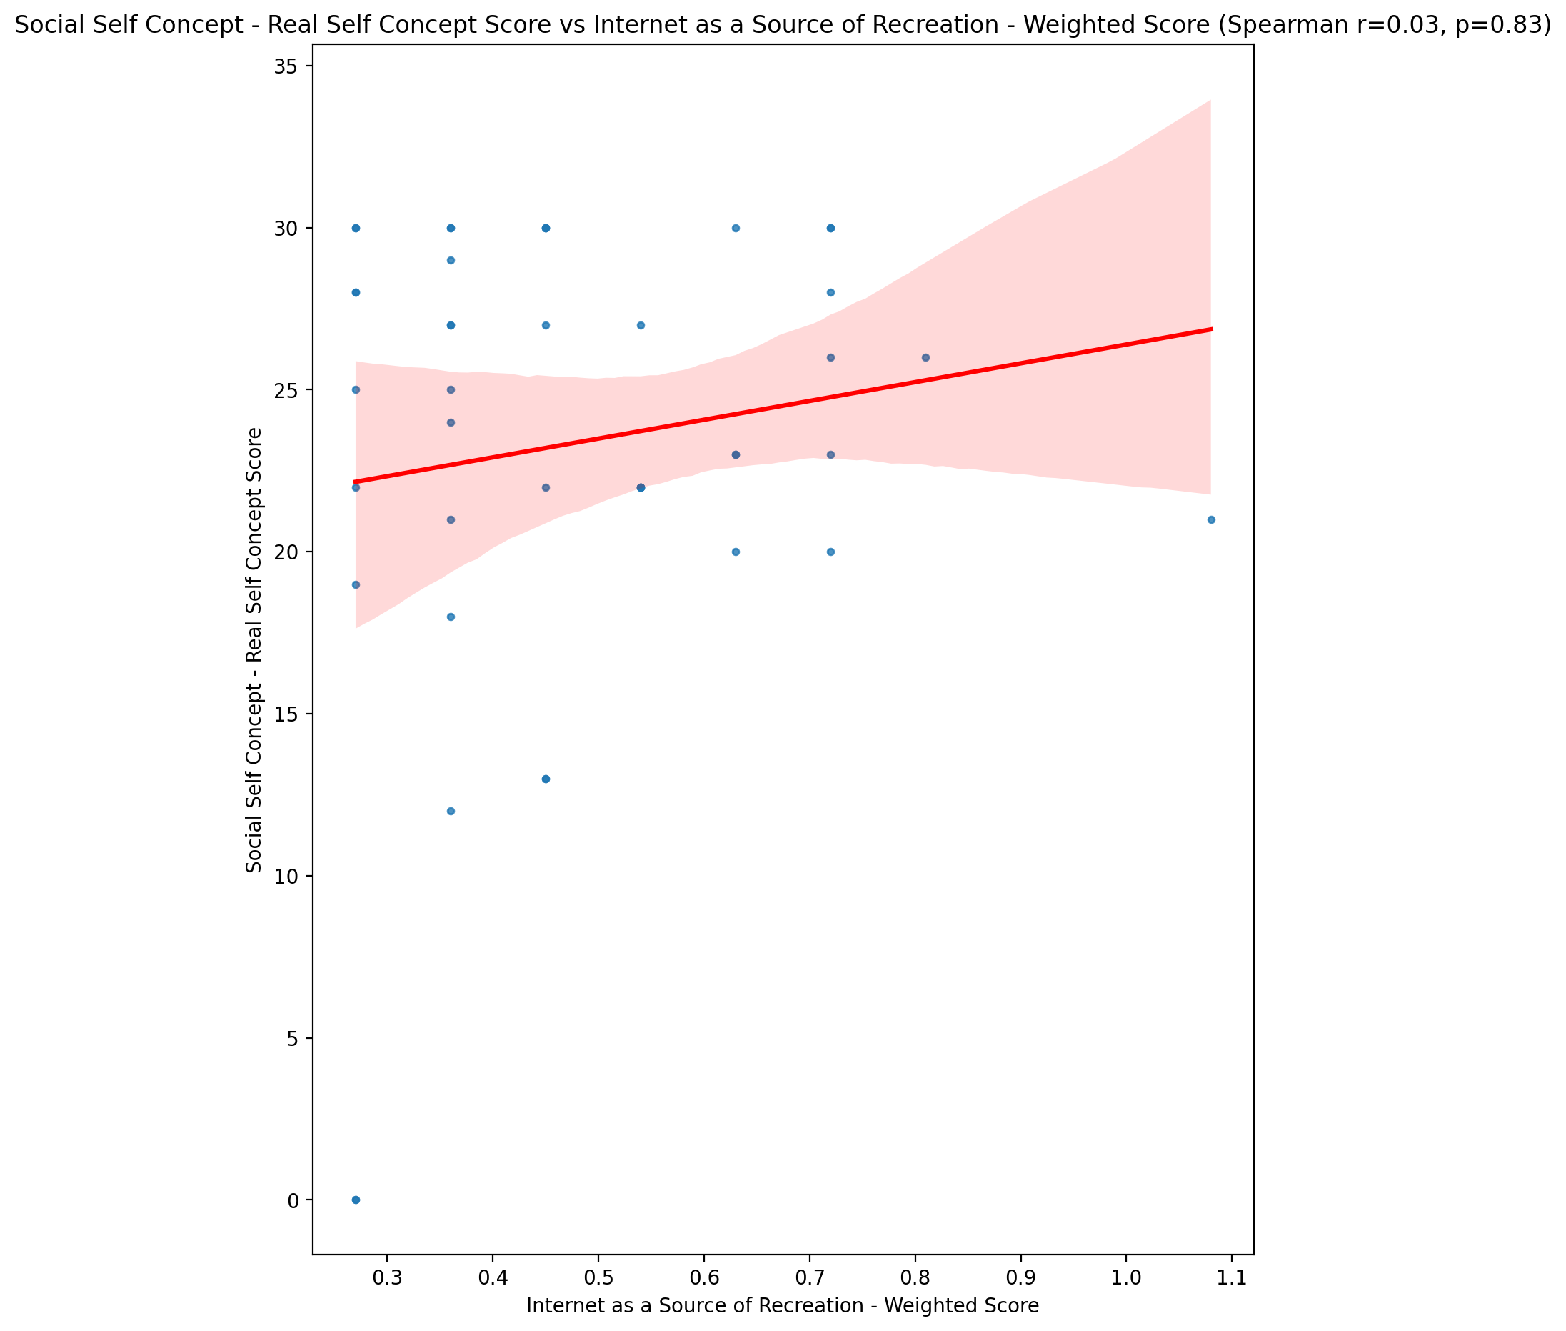

## Social Self Concept – Social Self Concept Score vs Internet as a Source of Recreation - Weighted Score

Test: spearman; statistic: 0.08044952902899703; p-value: 0.6080700844730174;

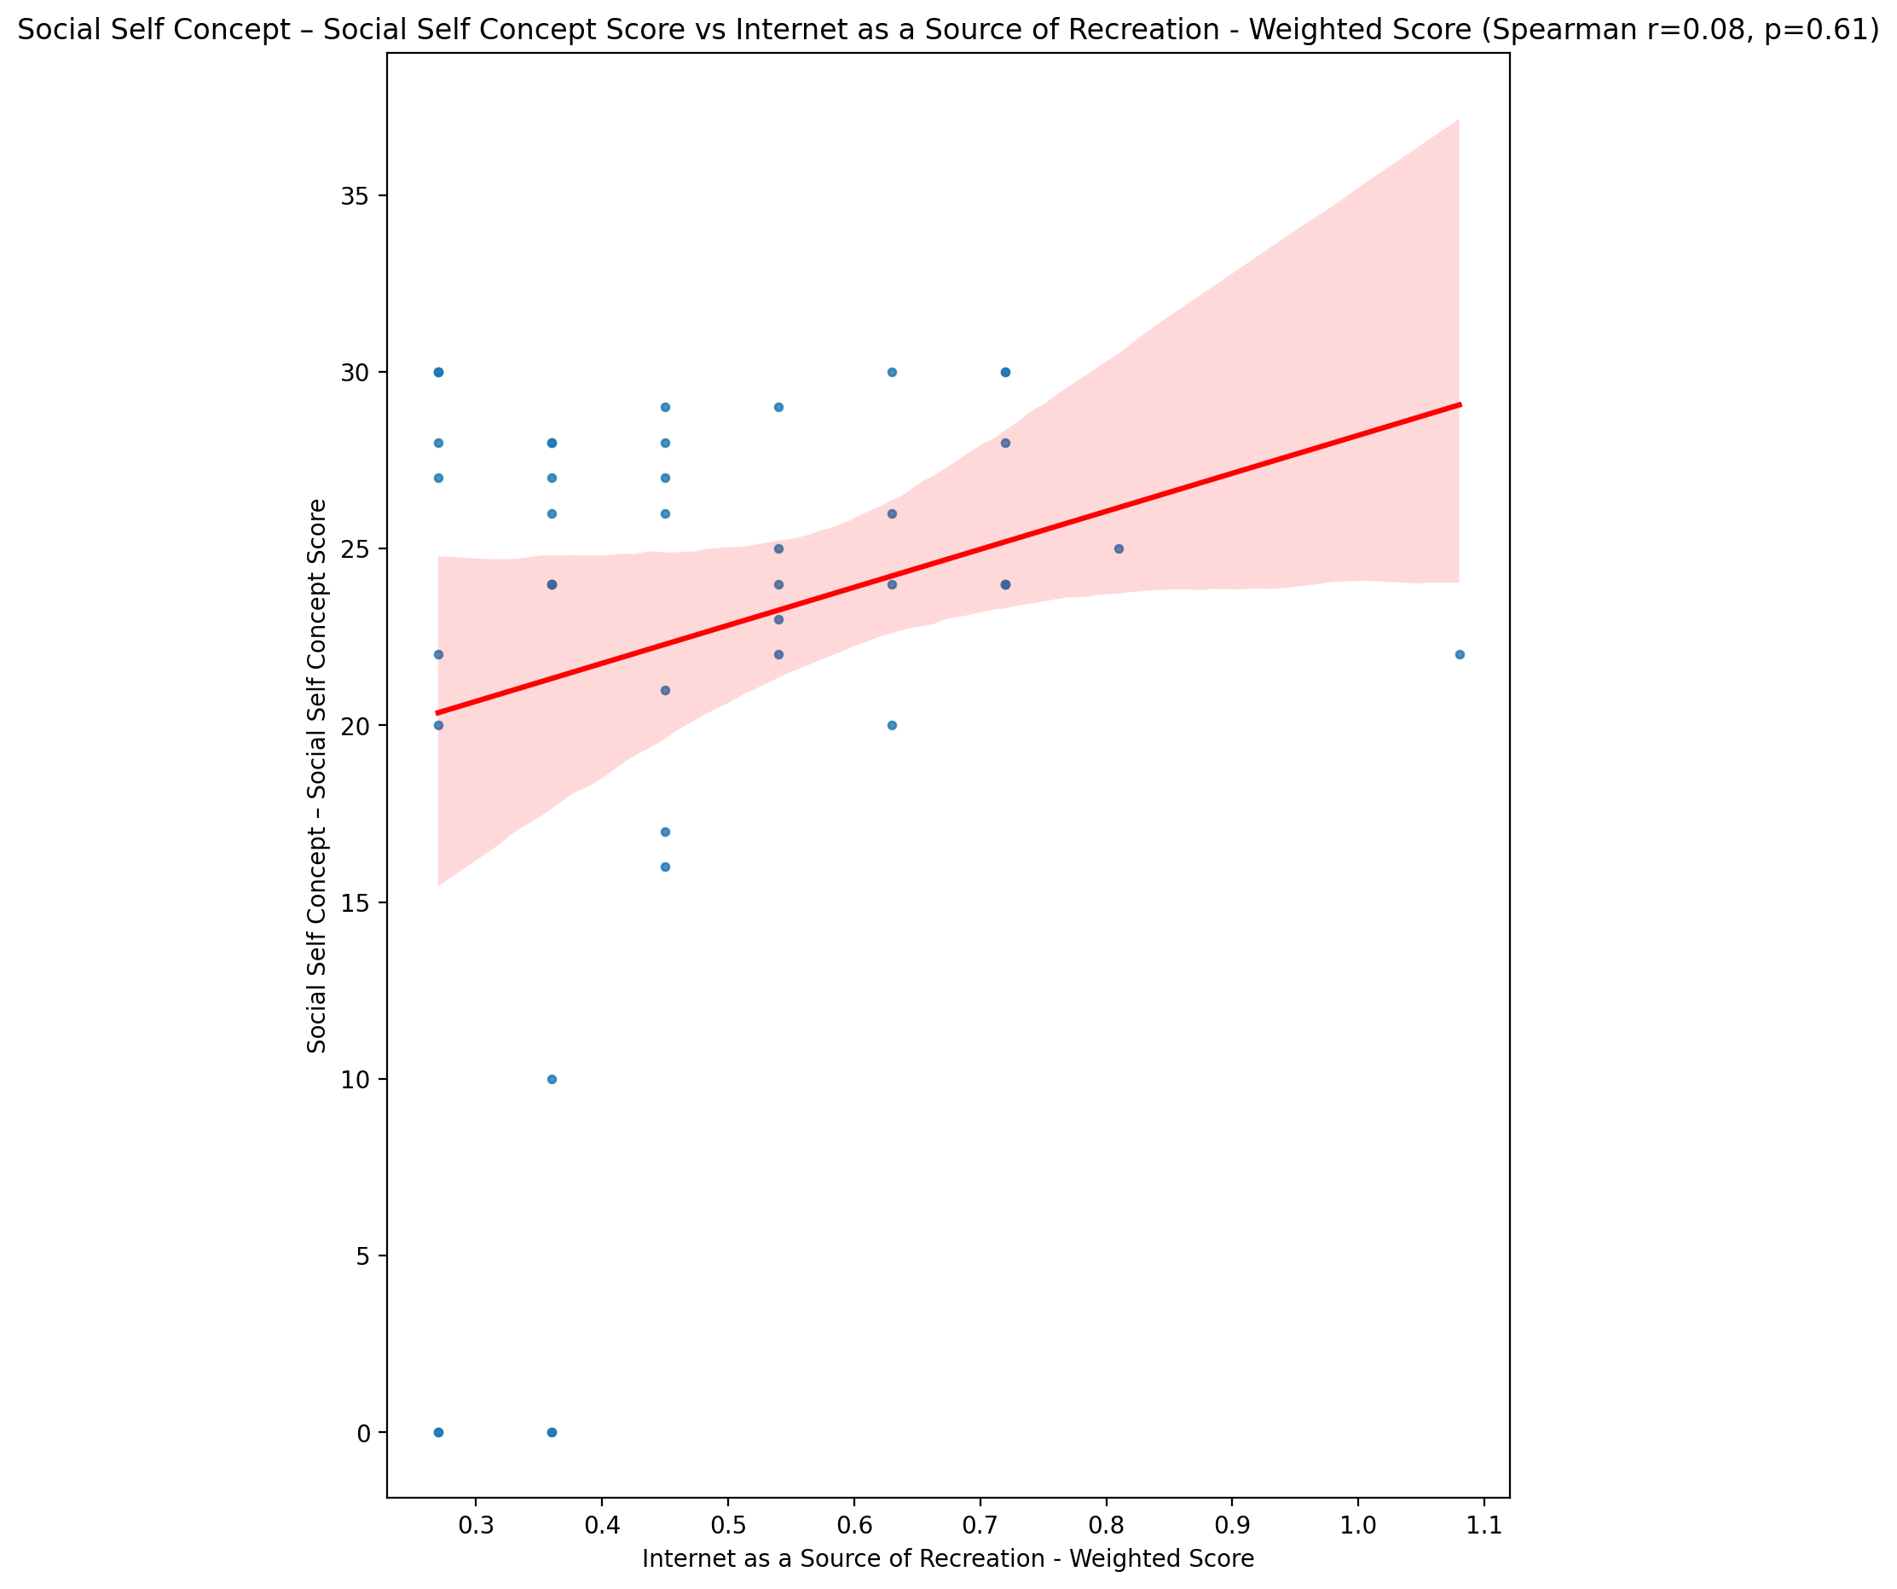

## Ability Self Concept - Real Self Concept Score vs Internet as a Source of Recreation - Weighted Score

Test: spearman; statistic: 0.0033099616040211375; p-value: 0.9831935439381864;

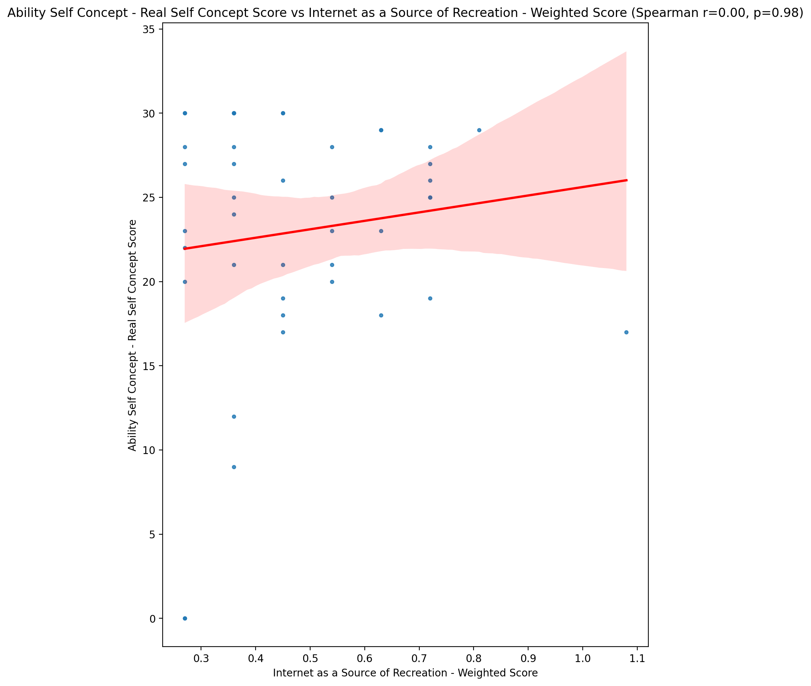

## Ability Self Concept - Ideal Self Concept Score vs Internet as a Source of Recreation - Weighted Score

Test: spearman; statistic: -0.1033286874607685; p-value: 0.5096556764037723;

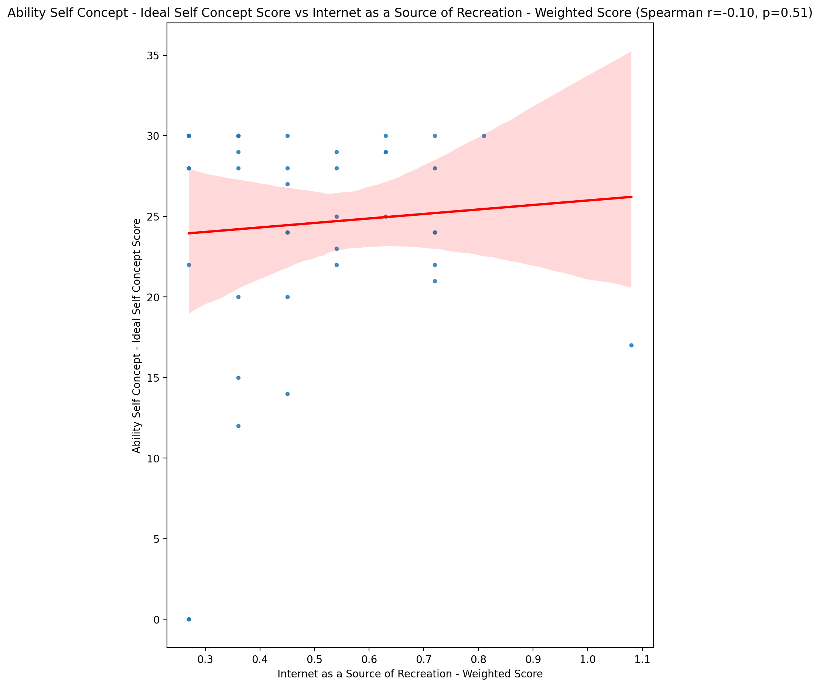

## Ability Self Concept – Social Self Concept Score vs Internet as a Source of Recreation - Weighted Score

Test: spearman; statistic: 0.007540765884555703; p-value: 0.9617228958414423;

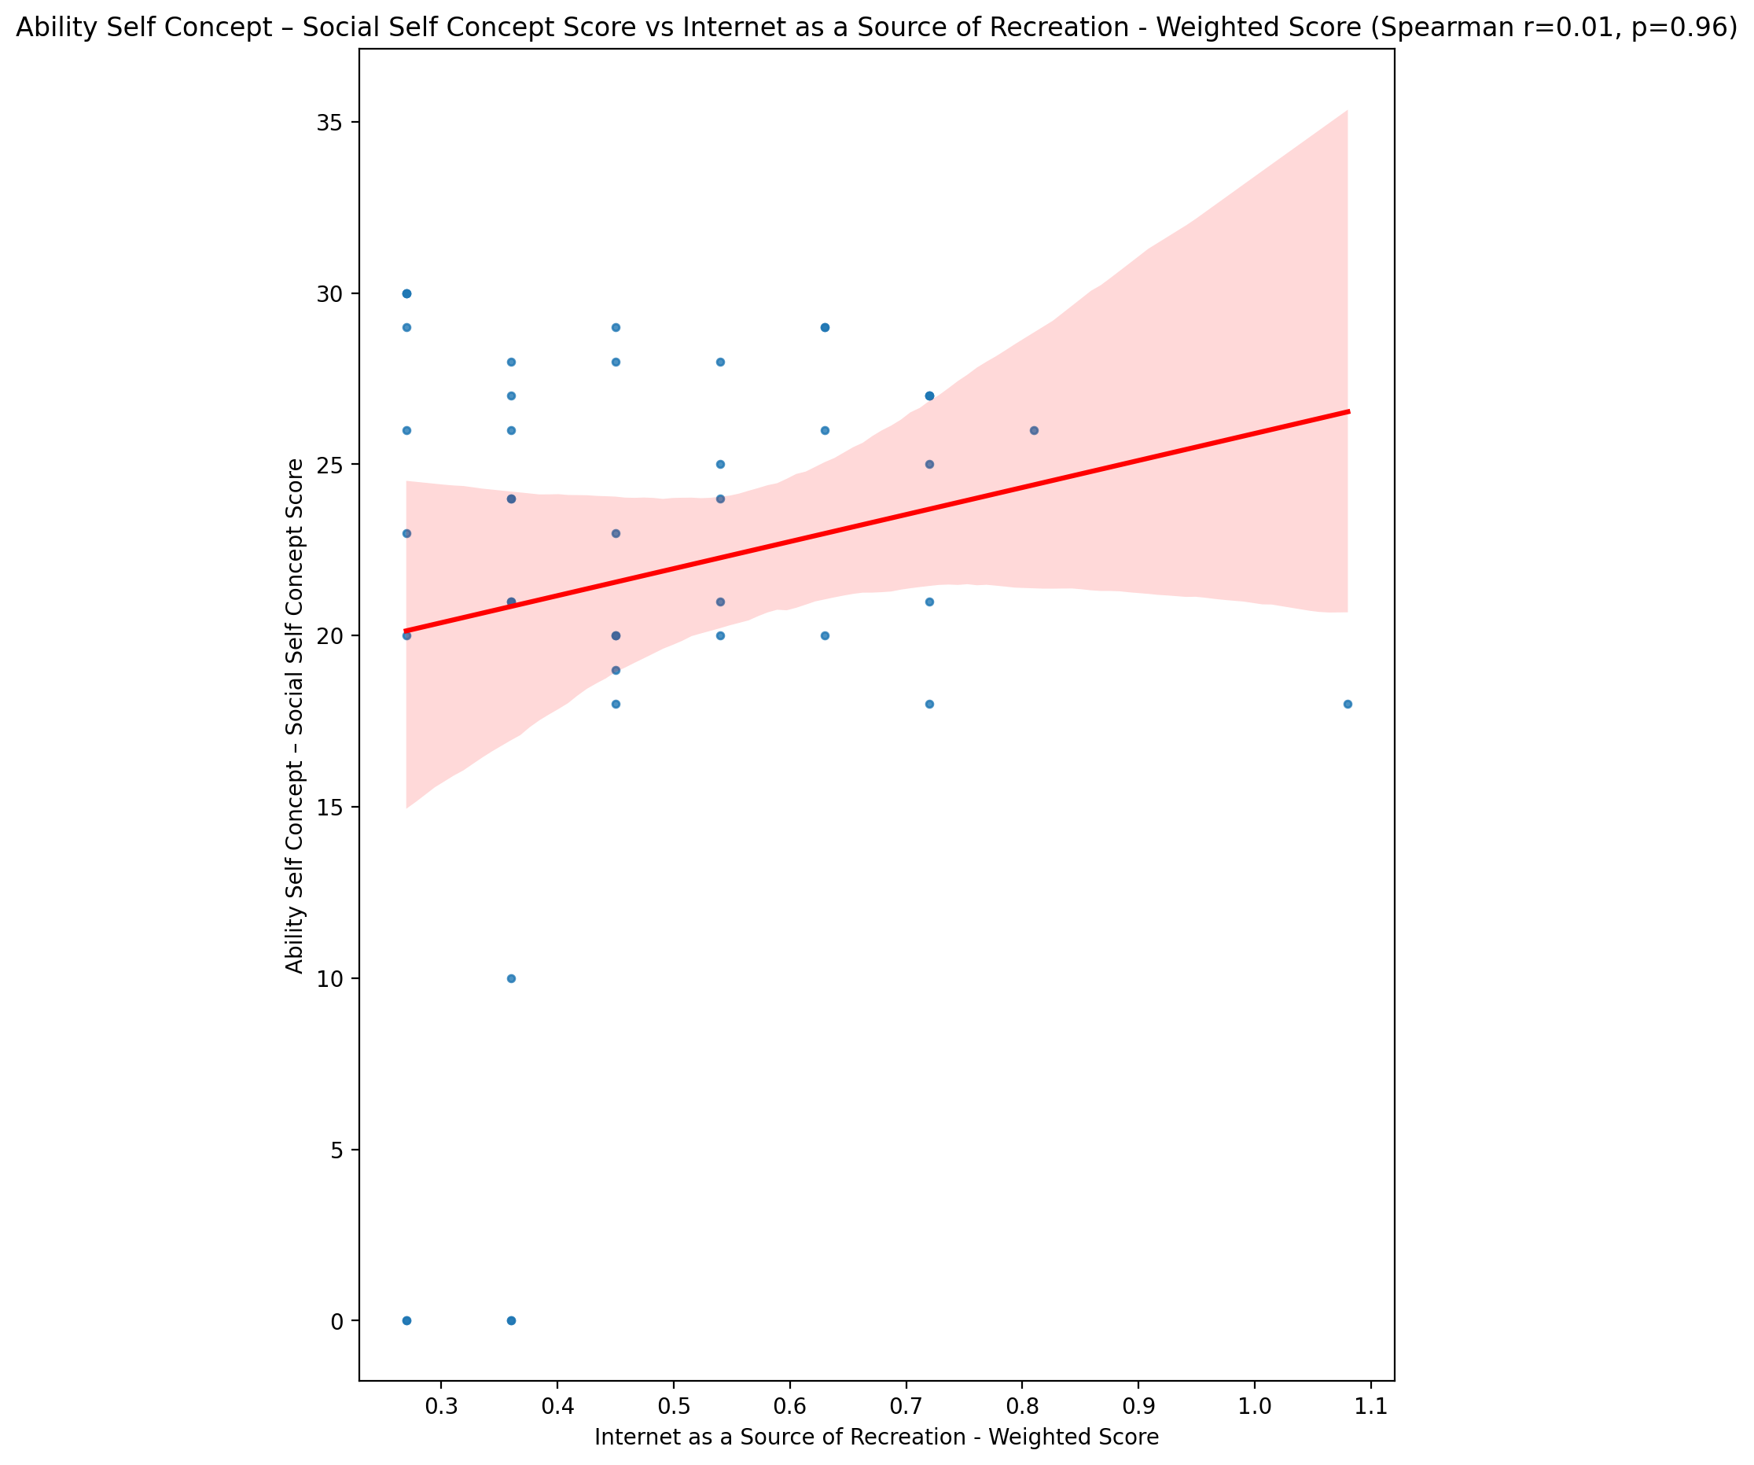

## Physical Self Concept - Real Self Concept Score vs Internet as a Source of Recreation - Weighted Score

Test: spearman; statistic: 0.11684213526622754; p-value: 0.4555651618730615;

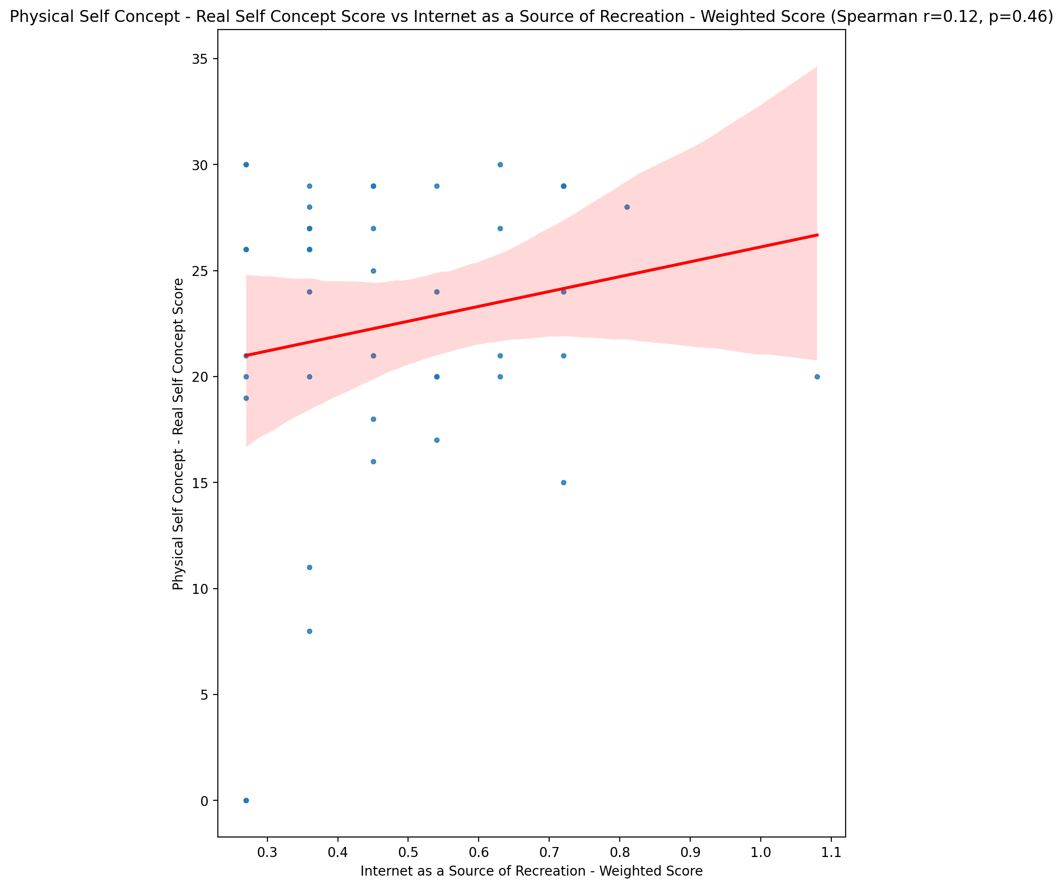

## Physical Self Concept – Ideal Self Concept Score vs Internet as a Source of Recreation - Weighted Score

Test: spearman; statistic: 0.032339192599353646; p-value: 0.8368946839773562;

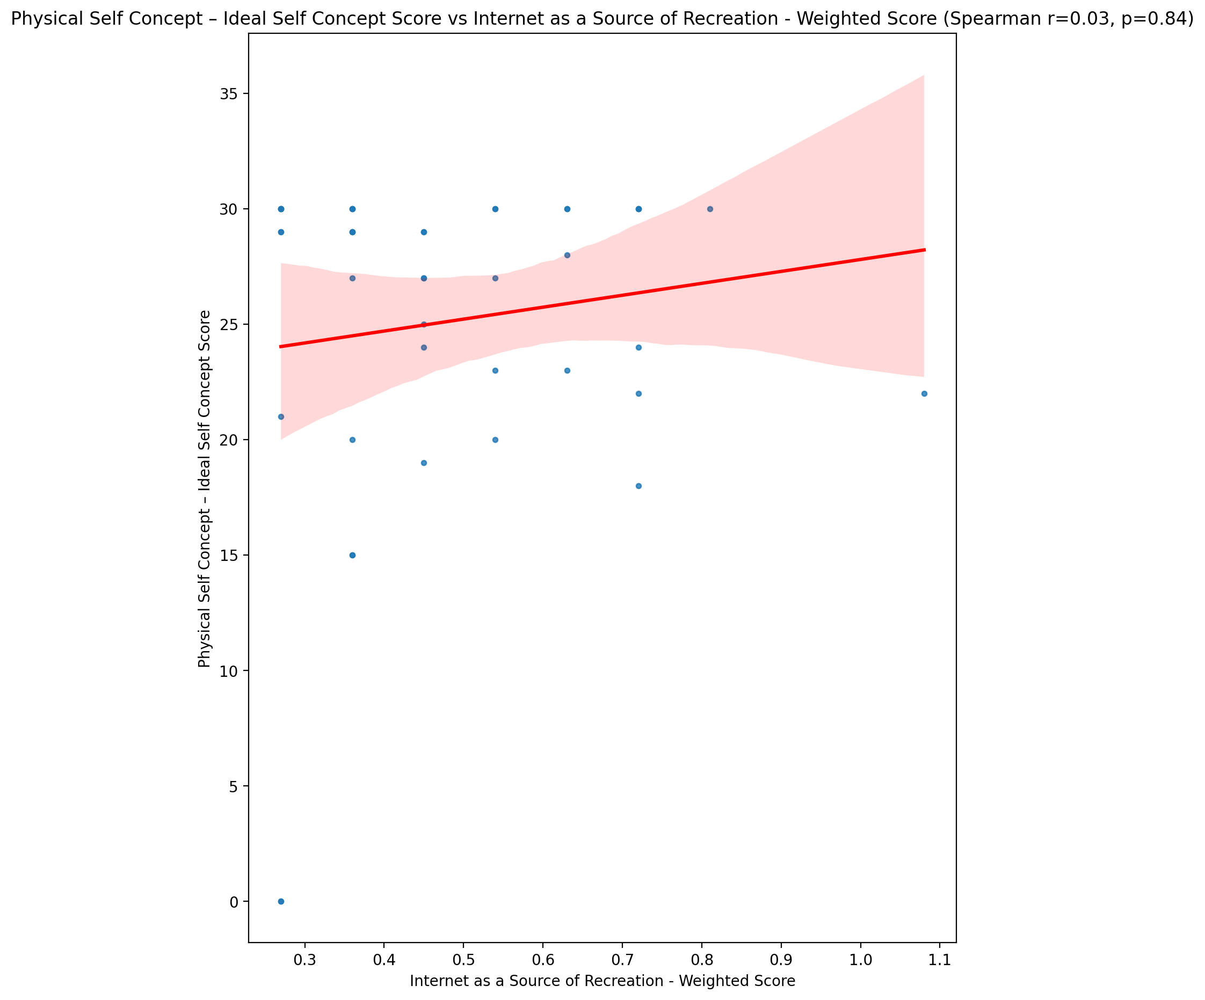

## Physical Self Concept – Social Self Concept Score vs Internet as a Source of Recreation - Weighted Score

Test: spearman; statistic: 0.27746079261629114; p-value: 0.07164436798682039;

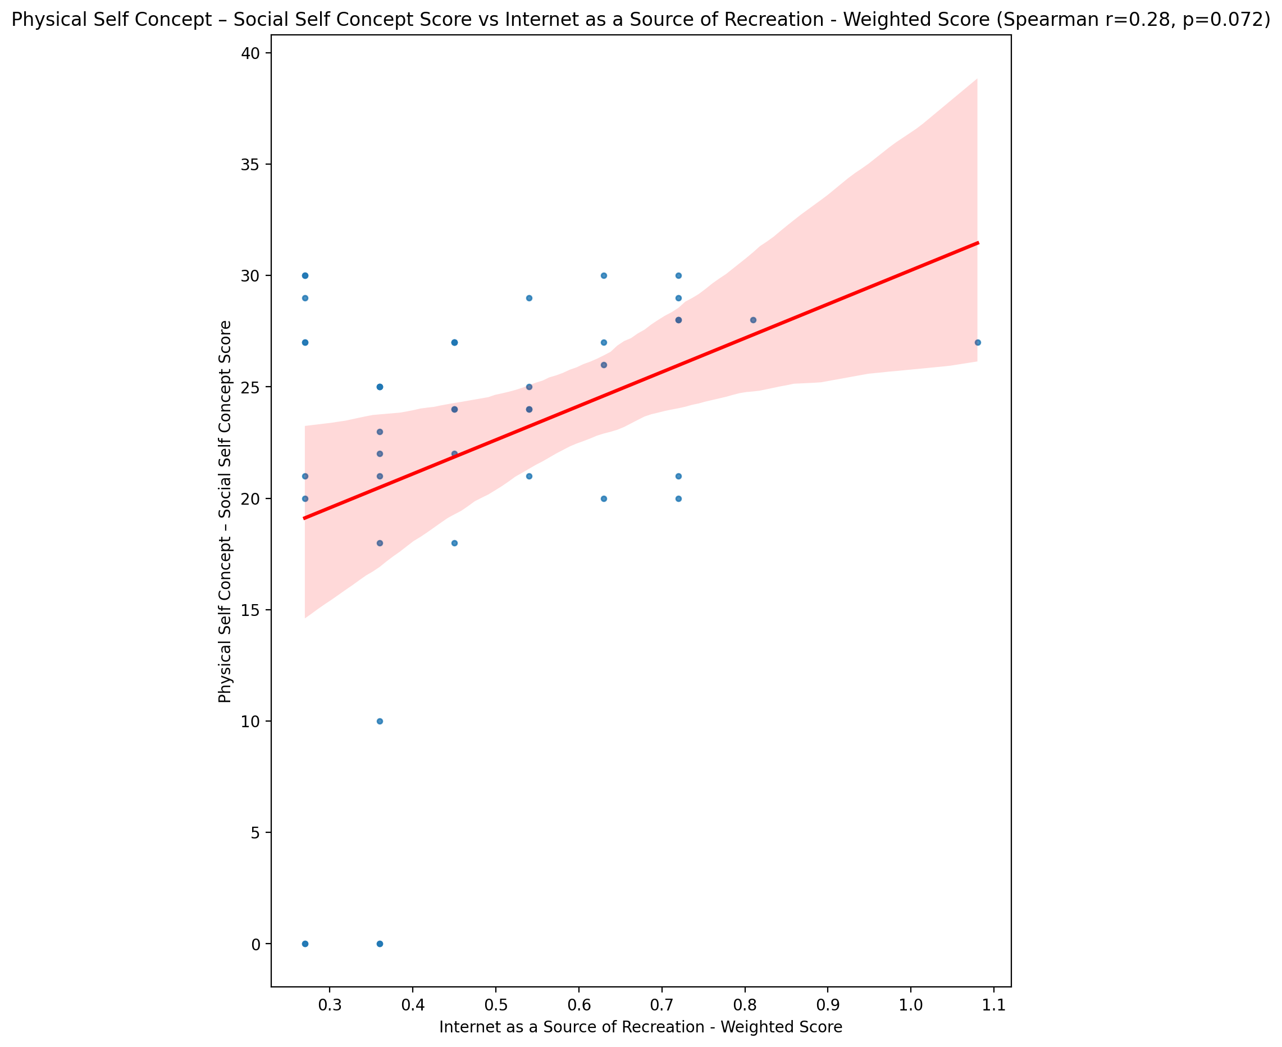

## Psychological Self Concept - Real Self Concept Score vs Internet as a Source of Recreation - Weighted Score

Test: spearman; statistic: -0.03386145545370039; p-value: 0.8293282980797692;

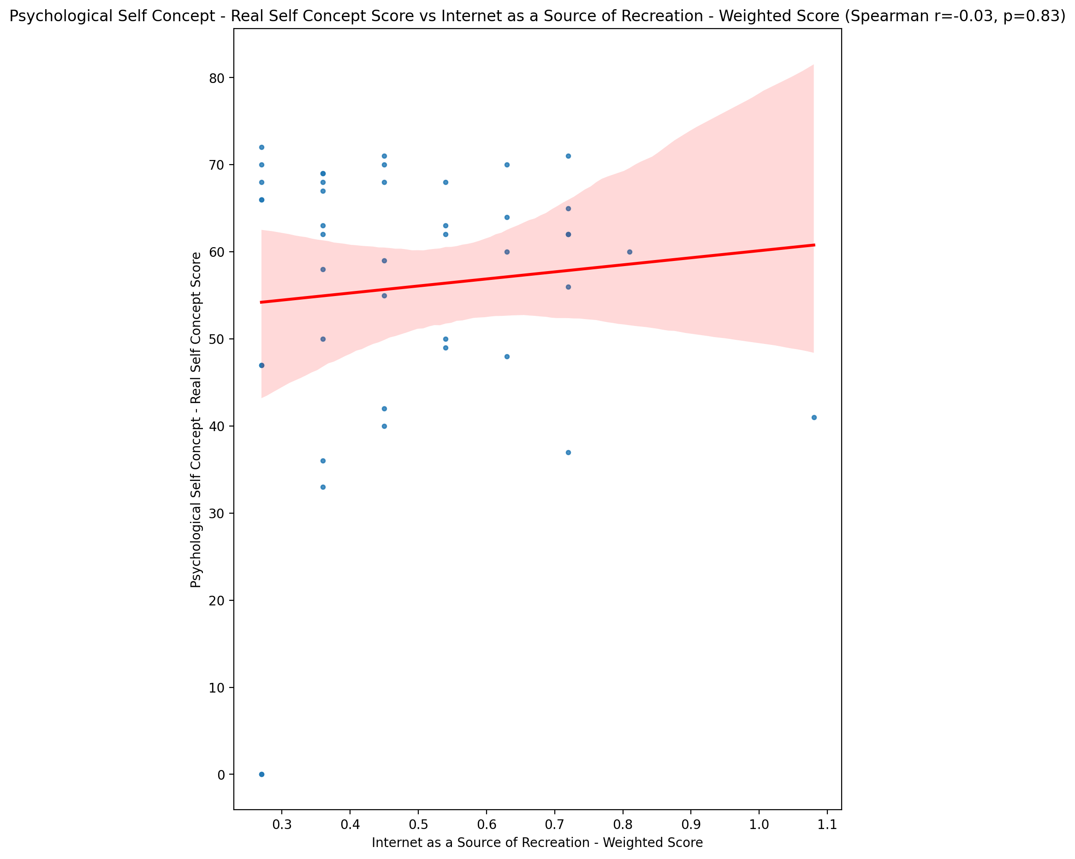

## Psychological Self Concept – Ideal Self Concept Score vs Internet as a Source of Recreation - Weighted Score

Test: spearman; statistic: -0.04739189578770143; p-value: 0.7628185770020213;

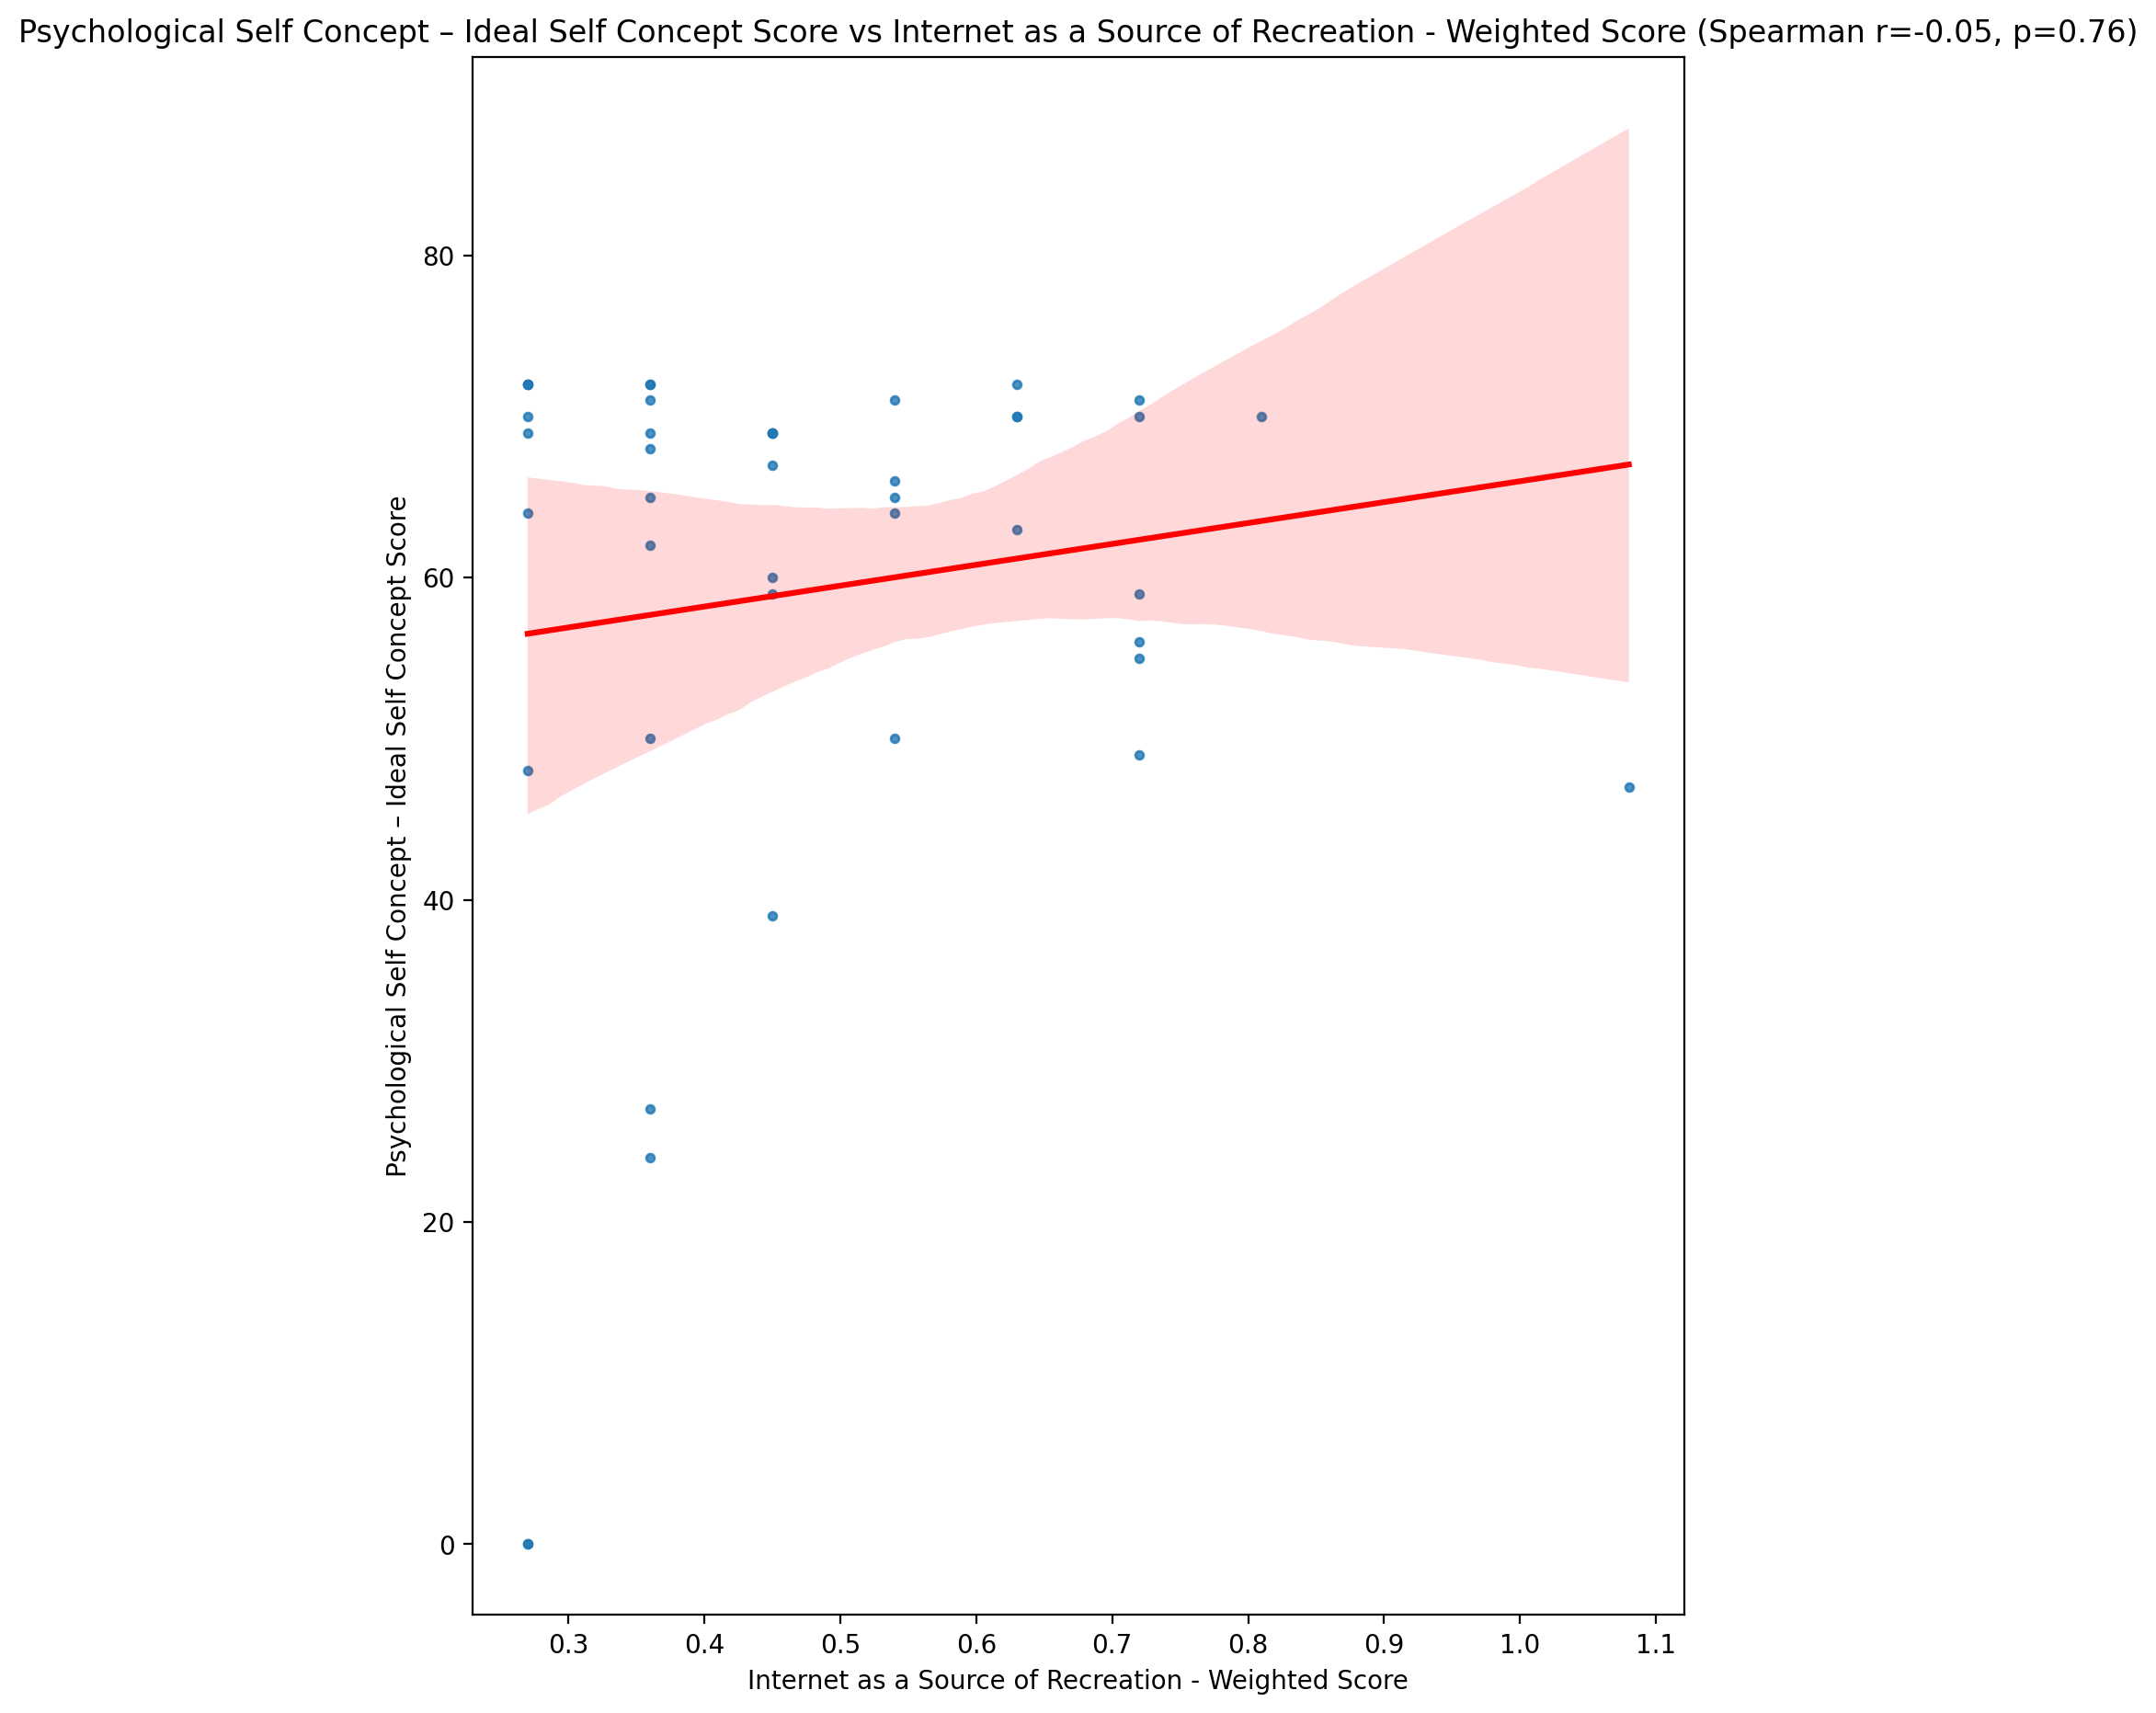

## Psychological Self Concept – Social Self Concept Score vs Internet as a Source of Recreation - Weighted Score

Test: spearman; statistic: 0.021739561719696356; p-value: 0.8899469163352334;

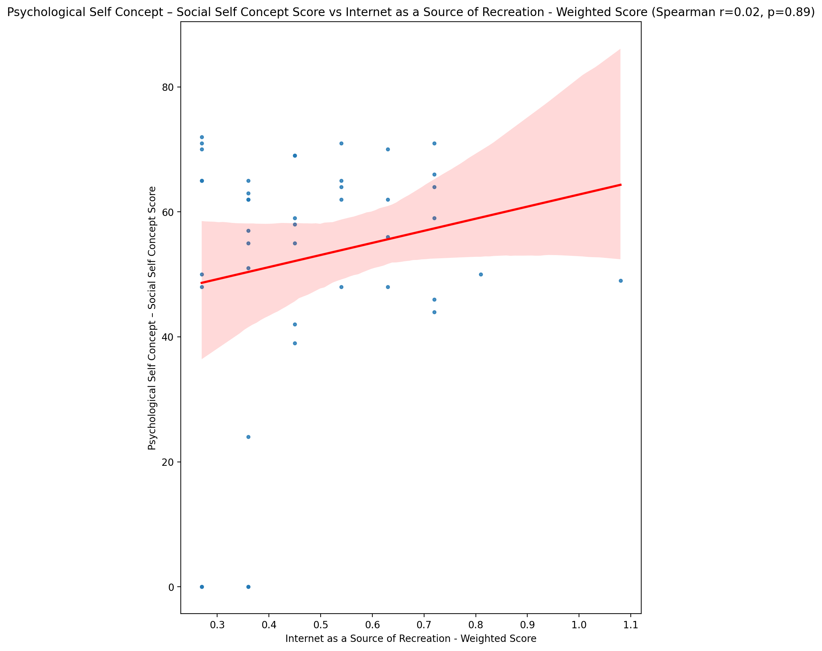

## Real Self Concept Total Score vs Internet as a Source of Recreation - Weighted Score

Test: spearman; statistic: -0.003989715351959766; p-value: 0.9797427217292121;

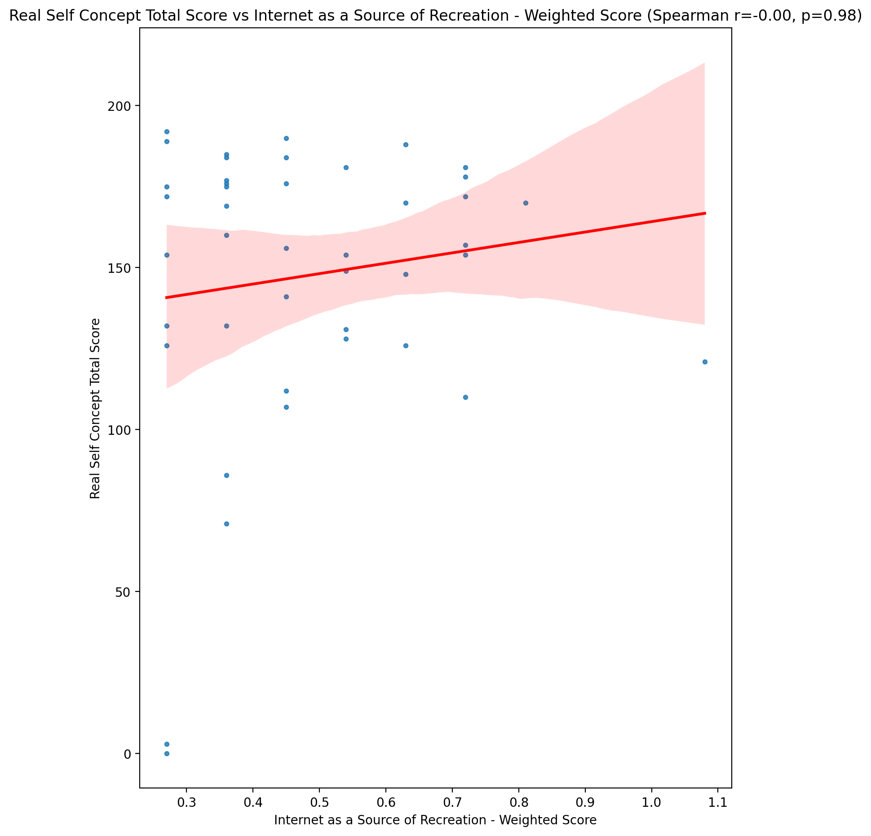

## Ideal Self Concept Total Score vs Internet as a Source of Recreation - Weighted Score

Test: spearman; statistic: -0.09564530911086642; p-value: 0.541790172267296;

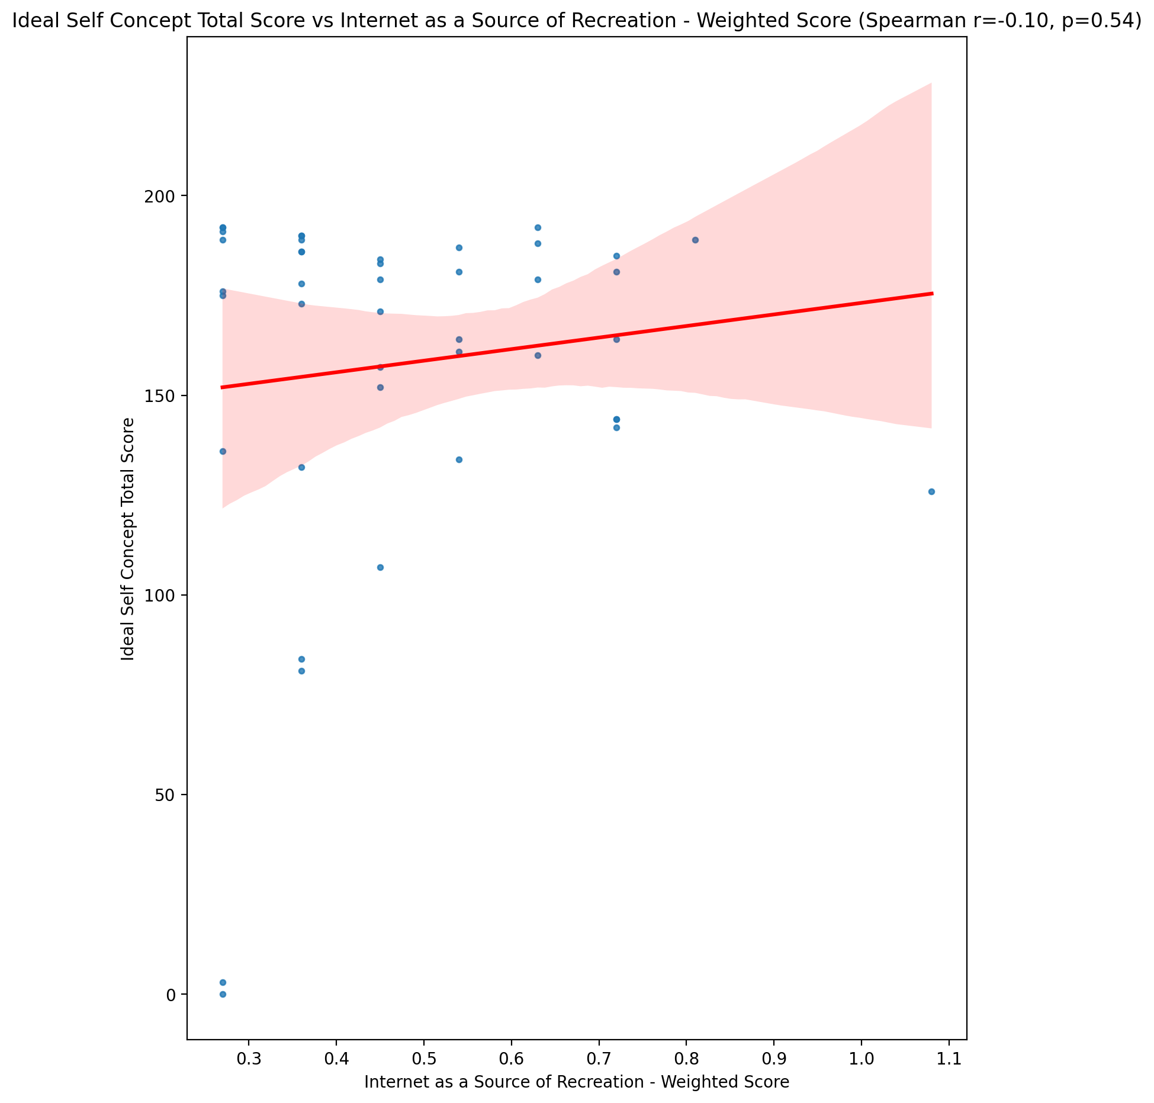

## Social Self Concept Total Score vs Internet as a Source of Recreation - Weighted Score

Test: spearman; statistic: 0.0675924310183484; p-value: 0.6667115705385394;

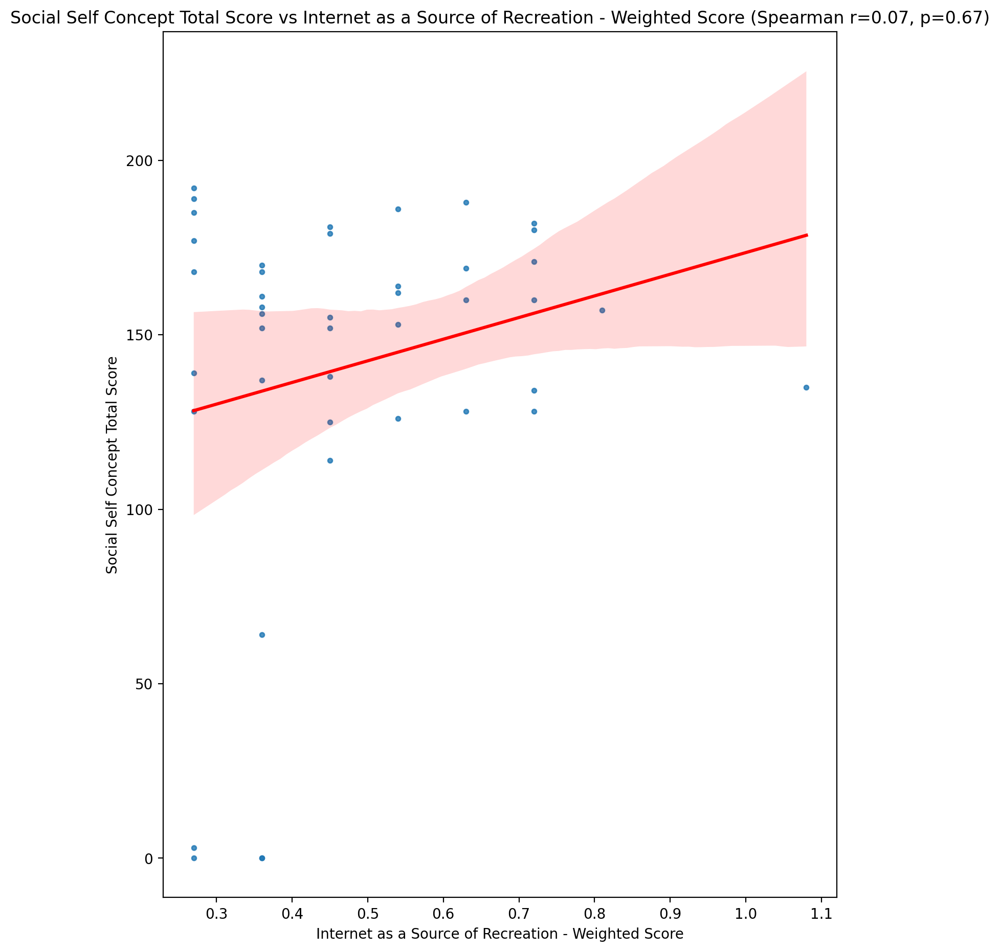

## Ideal Self Concept Total Category vs Internet as a Source of Recreation - Weighted Score

Test: None; statistic: None; p-value: None; Test not run: unsupported type combination.



## Perceived Social Stress Score vs Internet as a Source of Recreation - Weighted Score

Test: spearman; statistic: 0.11593124618923642; p-value: 0.4591104280595484;

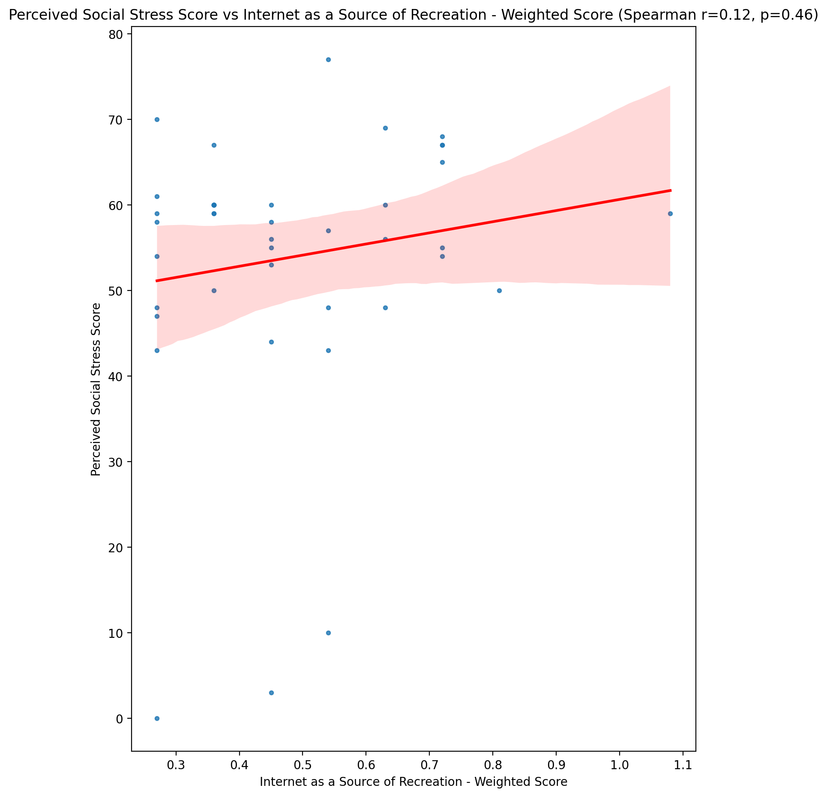

## Perceived Social Stress Category vs Internet as a Source of Recreation - Weighted Score

Test: None; statistic: None; p-value: None; Test not run: unsupported type combination.



## Emotional Support - Raw Score vs Enhanced Socialization - Weighted Score

Test: spearman; statistic: 0.05349138360126138; p-value: 0.7333486767938792;

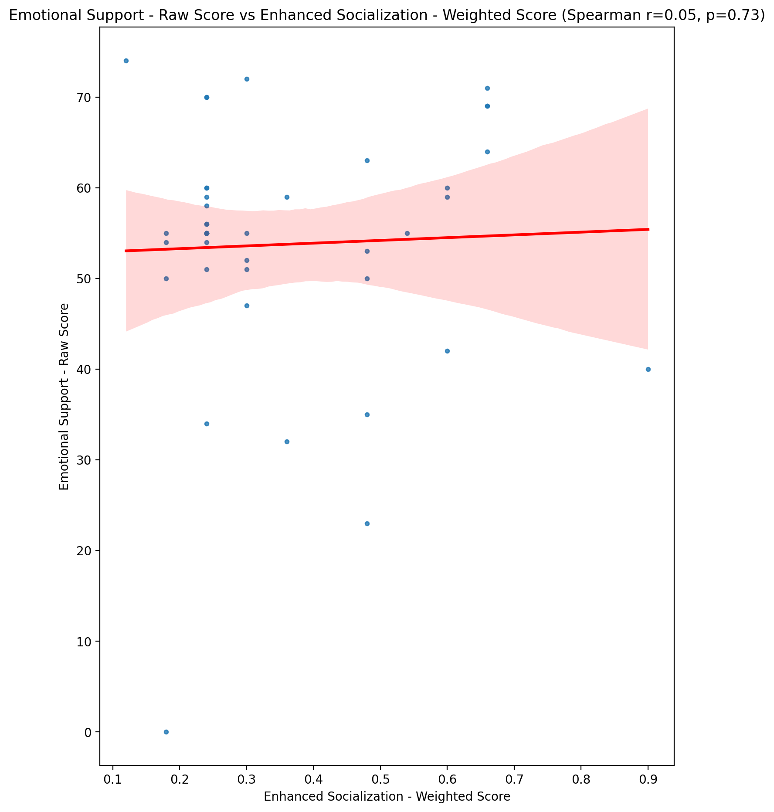

## Informational Support - Raw Score vs Enhanced Socialization - Weighted Score

Test: spearman; statistic: -0.1062894555748394; p-value: 0.4975345925450423;

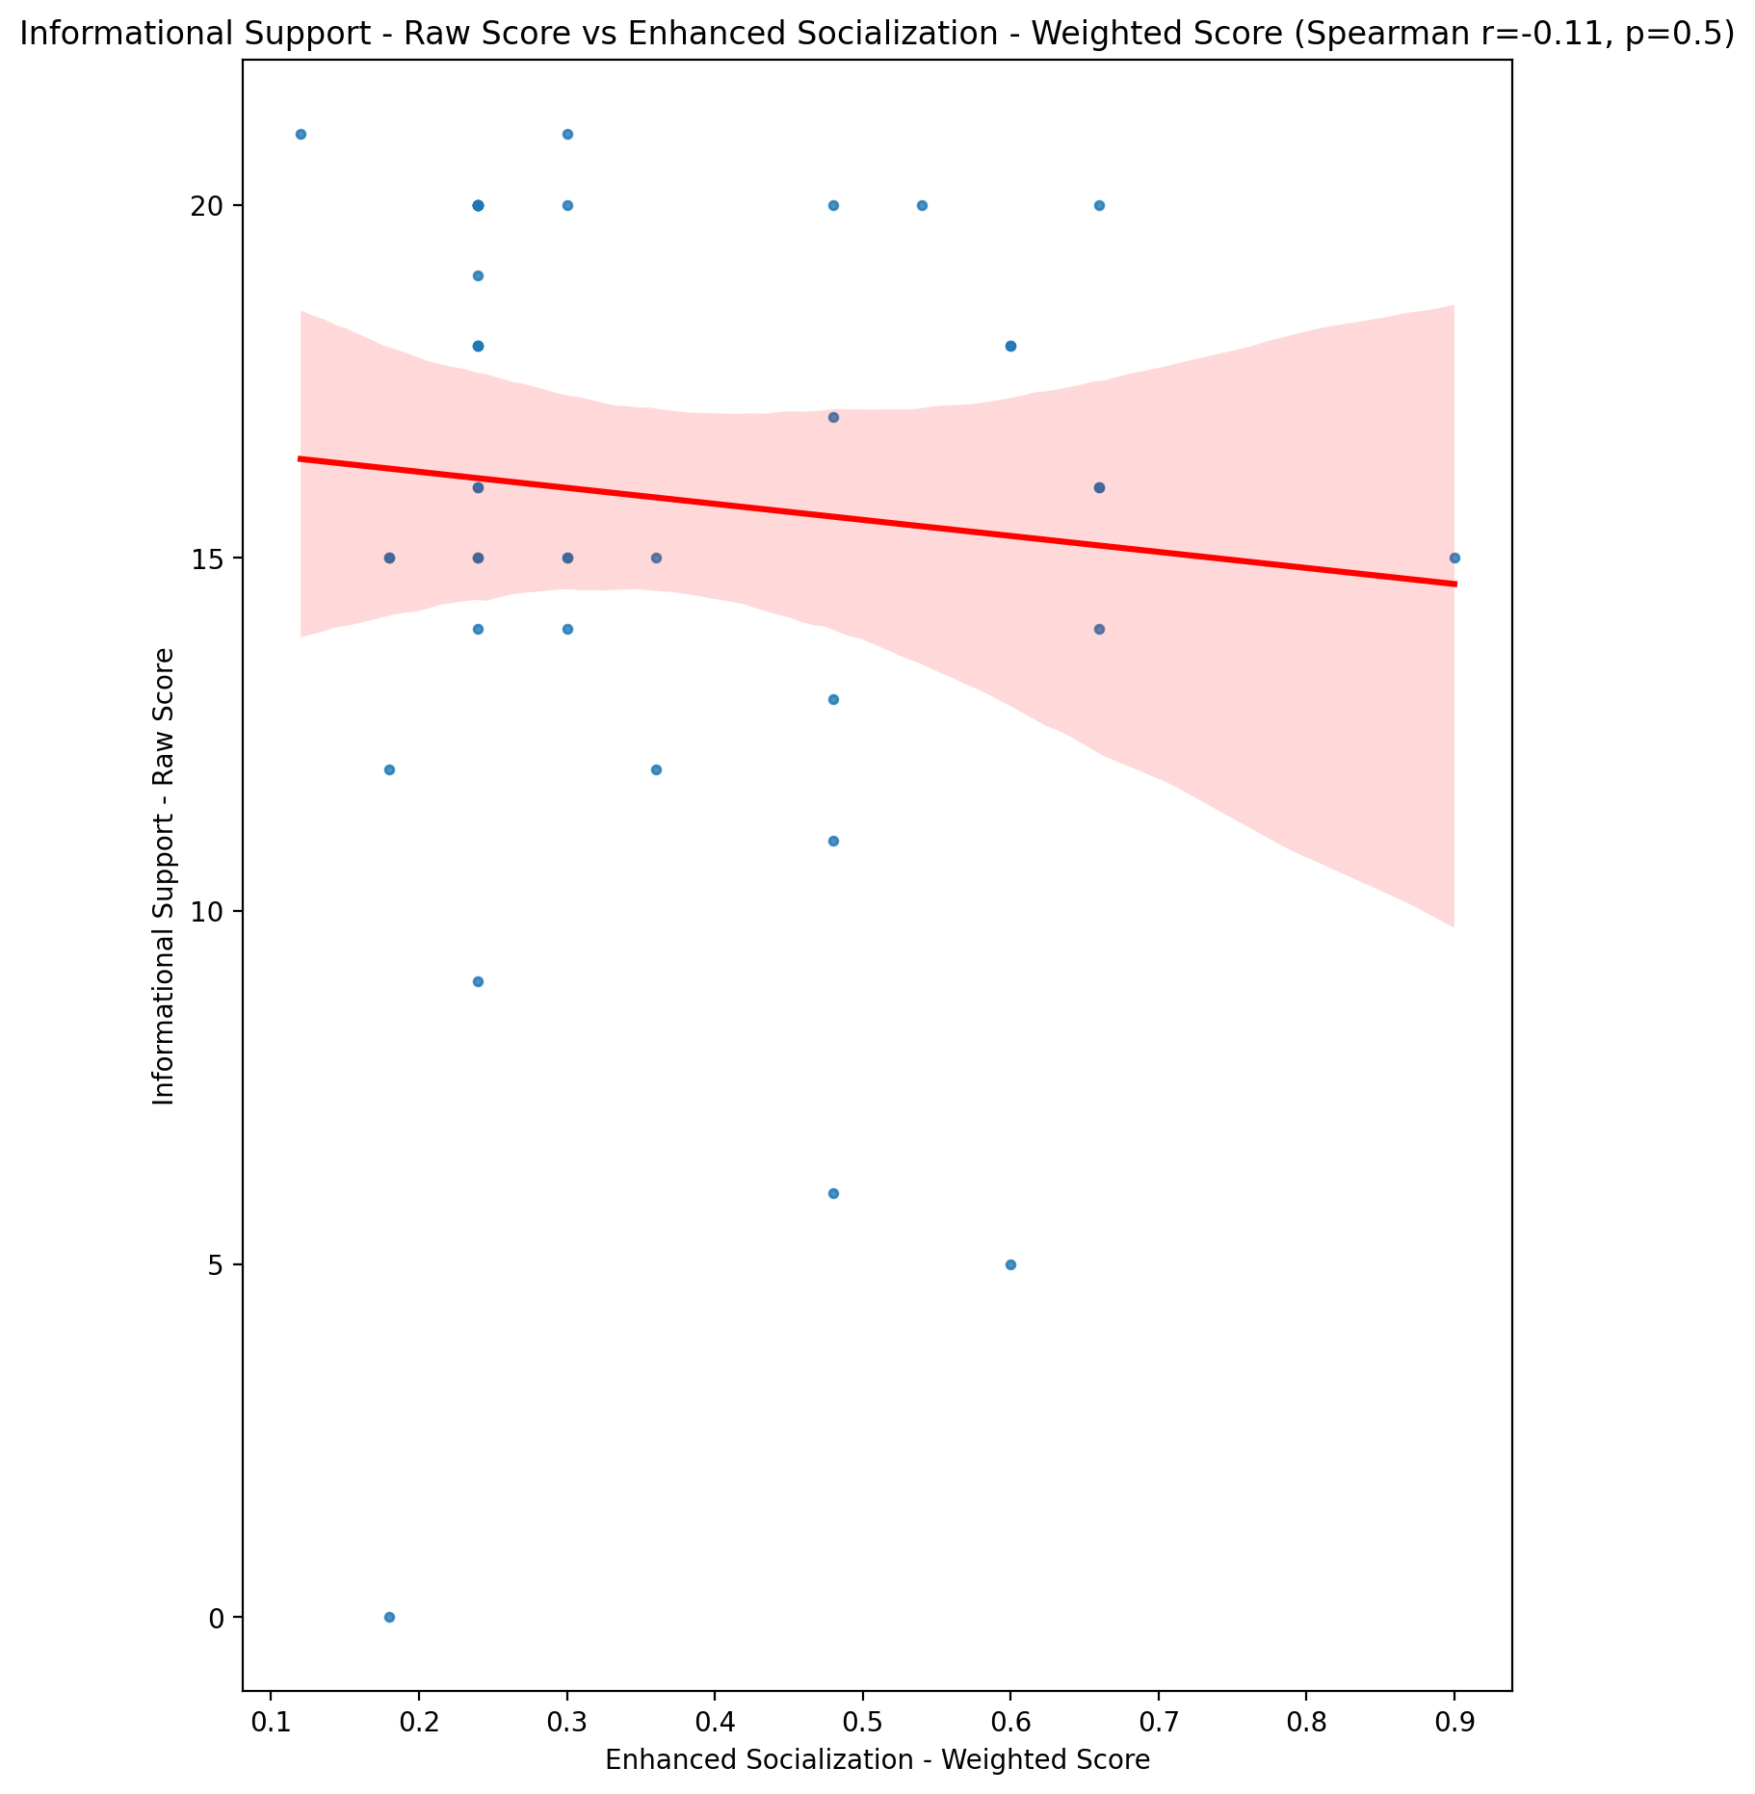

## Instrumental Support - Raw Score vs Enhanced Socialization - Weighted Score

Test: spearman; statistic: 0.17565906553277713; p-value: 0.25986125272489935;

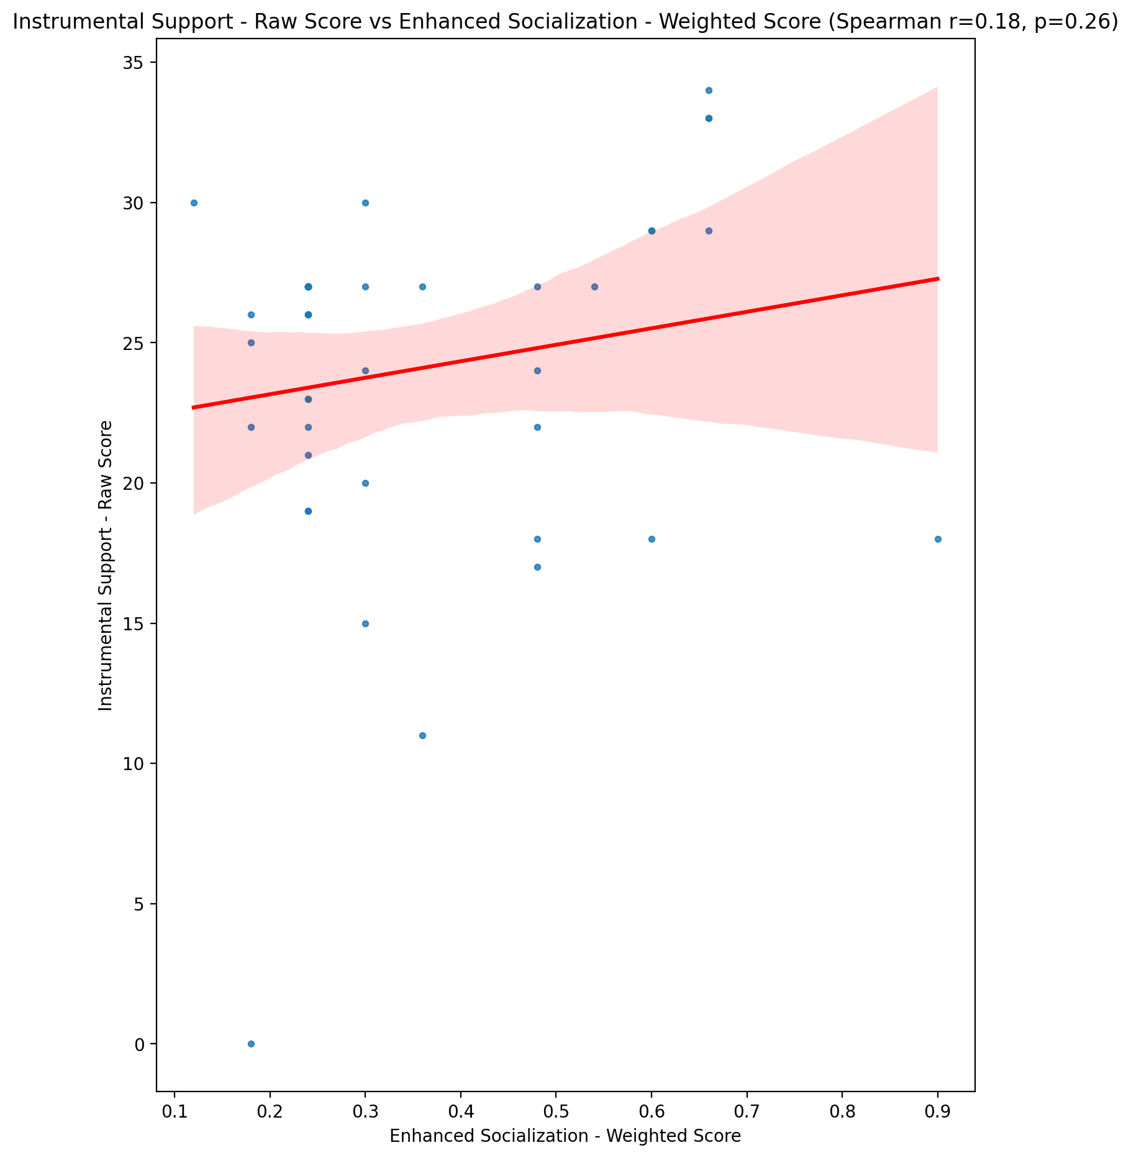

## Emotional Support - T Score vs Enhanced Socialization - Weighted Score

Test: spearman; statistic: 0.19050866184782705; p-value: 0.22107231128747729;

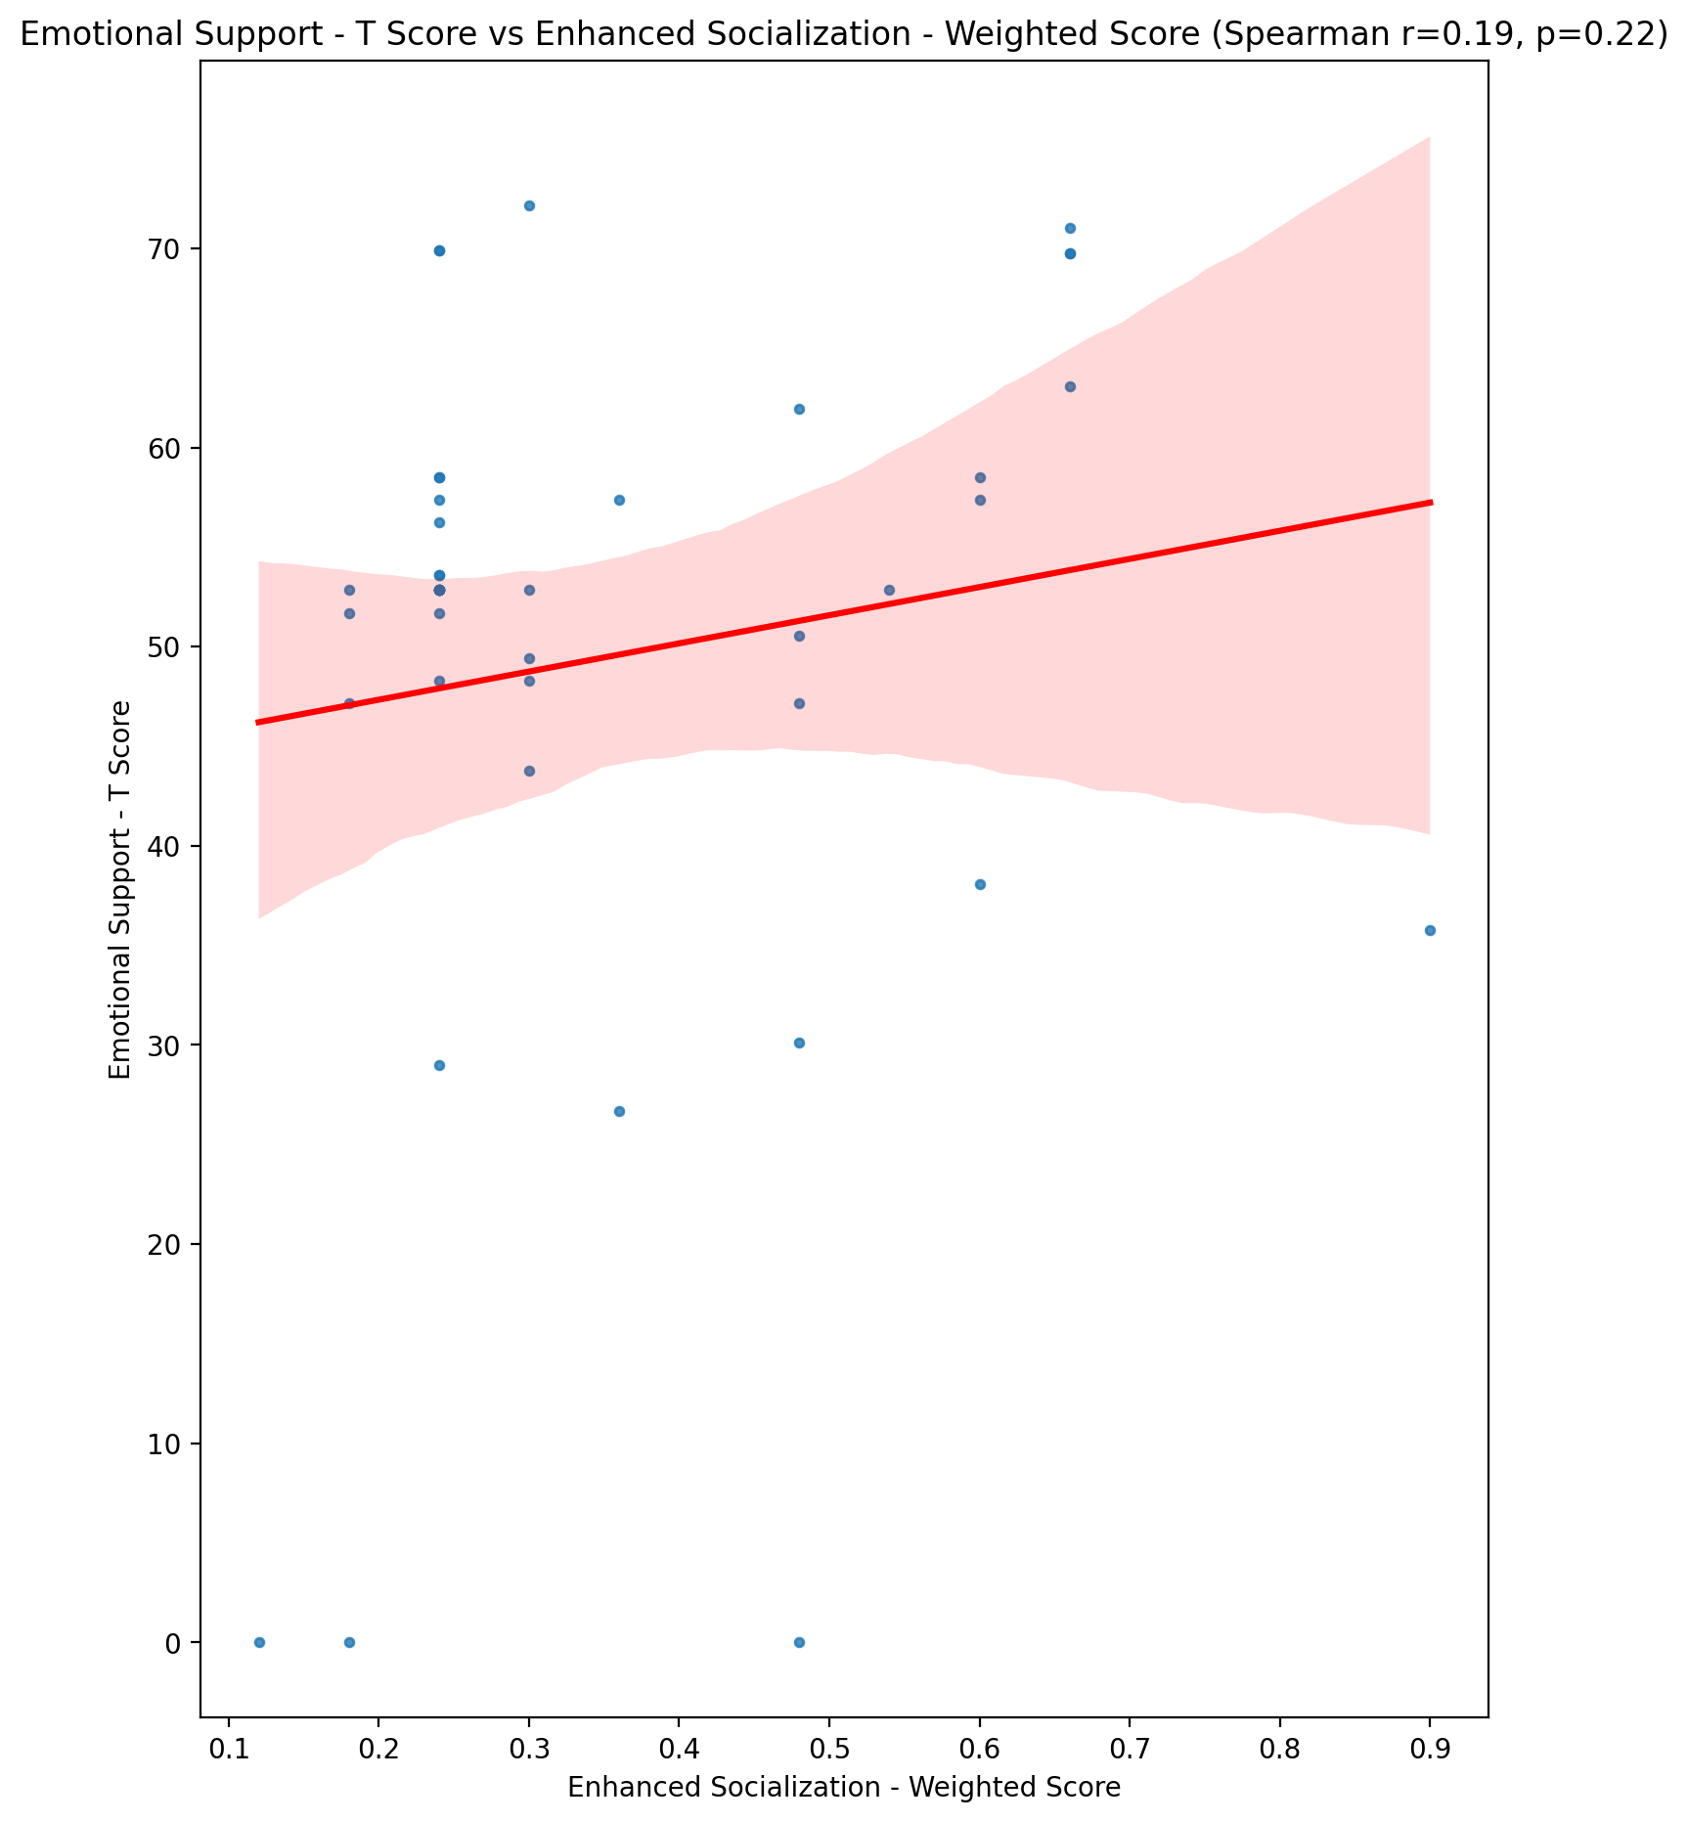

## Informational Support - T Score vs Enhanced Socialization - Weighted Score

Test: spearman; statistic: -0.11081948128826706; p-value: 0.47927934804673067;

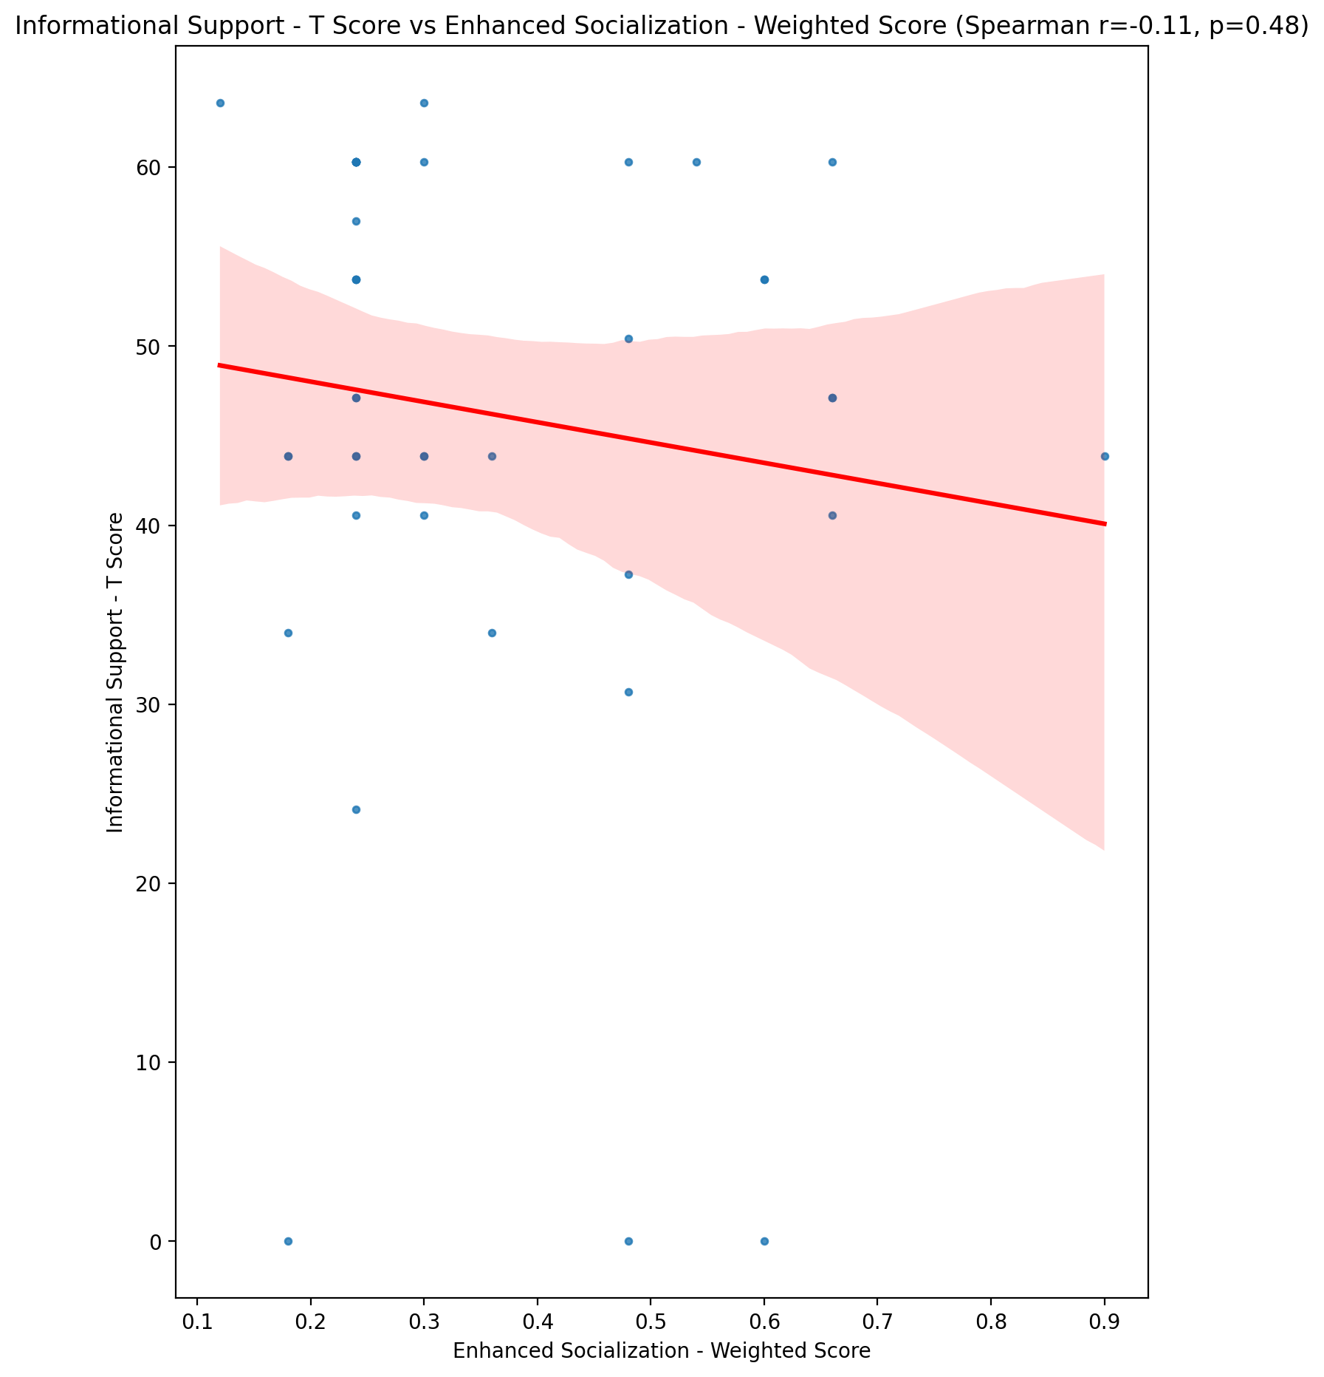

## Instrumental Support - T Score vs Enhanced Socialization - Weighted Score

Test: spearman; statistic: 0.17368852966118373; p-value: 0.26532959590622435;

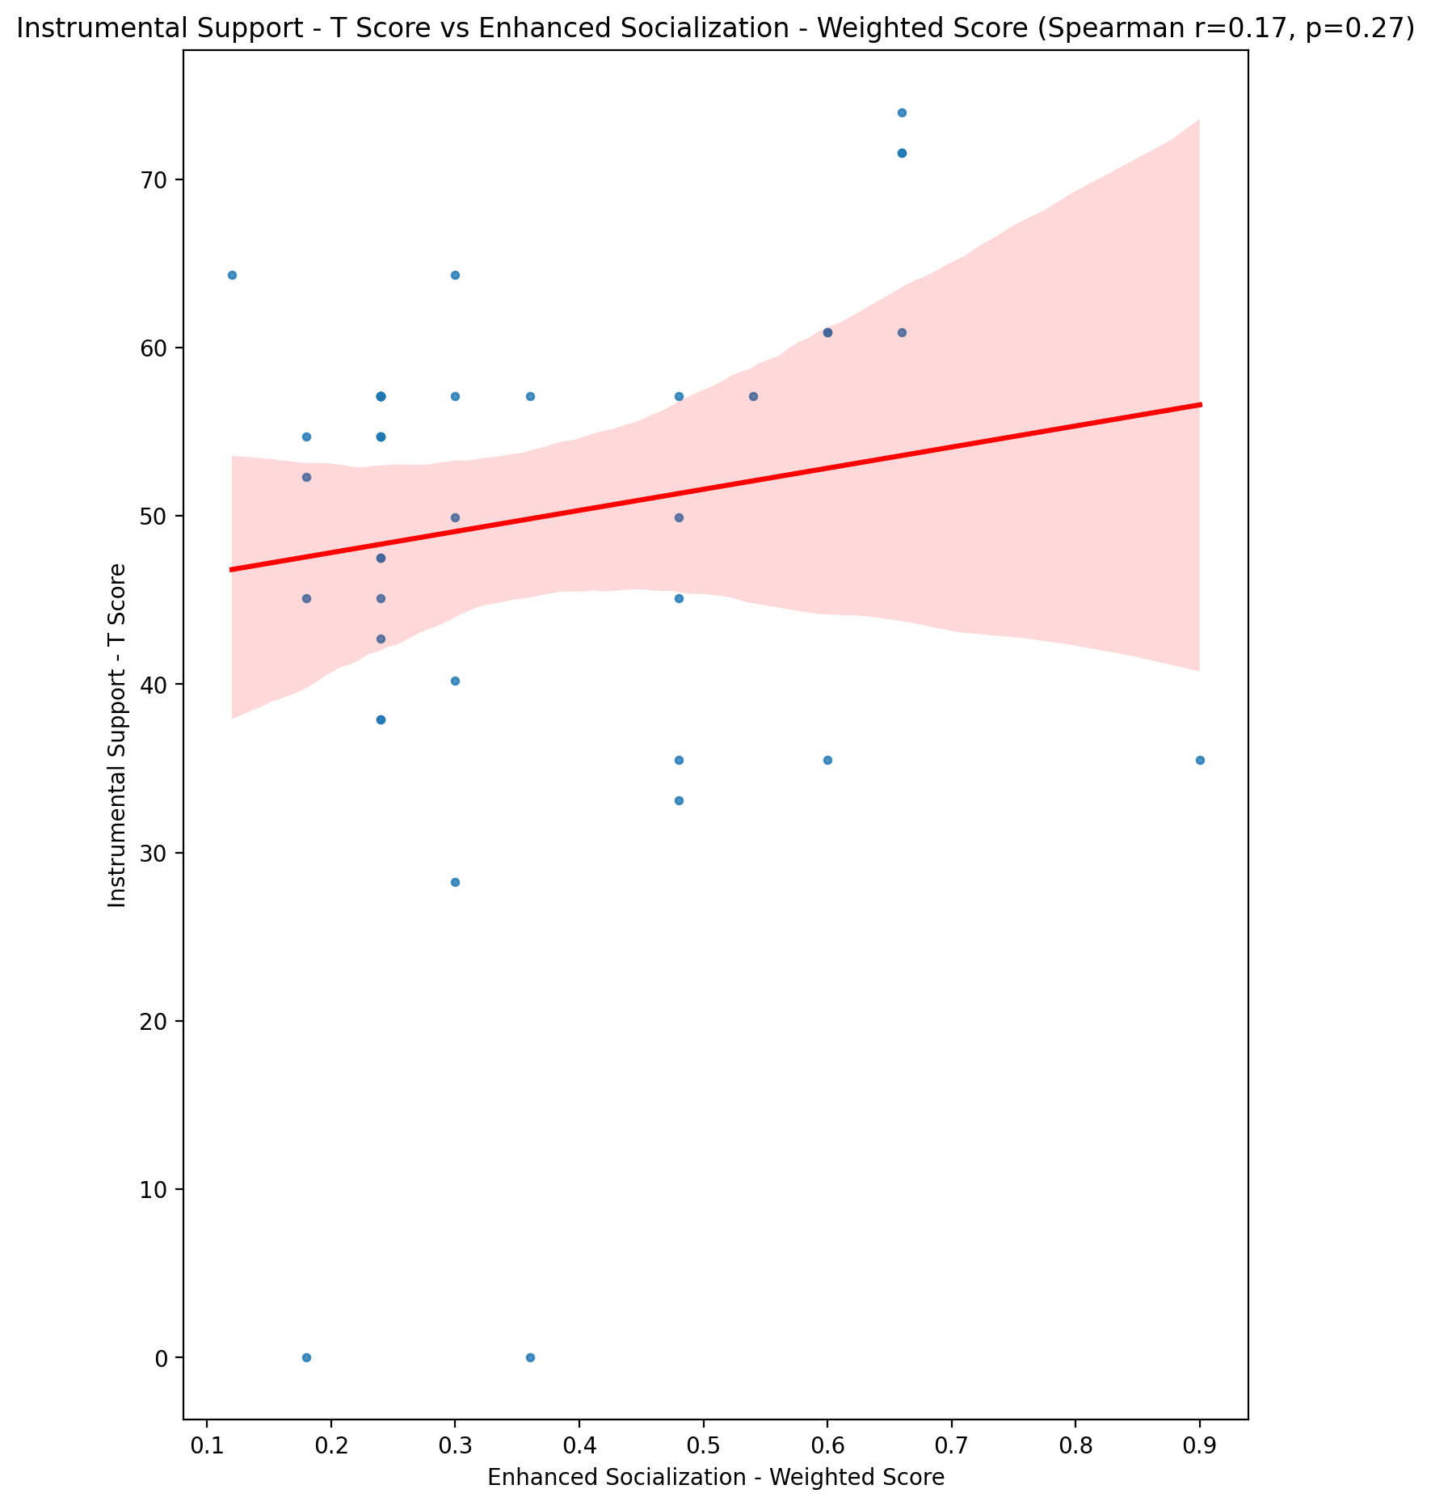

## Perceived Social Support Total T Score vs Enhanced Socialization - Weighted Score

Test: spearman; statistic: 0.10292997048327963; p-value: 0.5112992748401081;

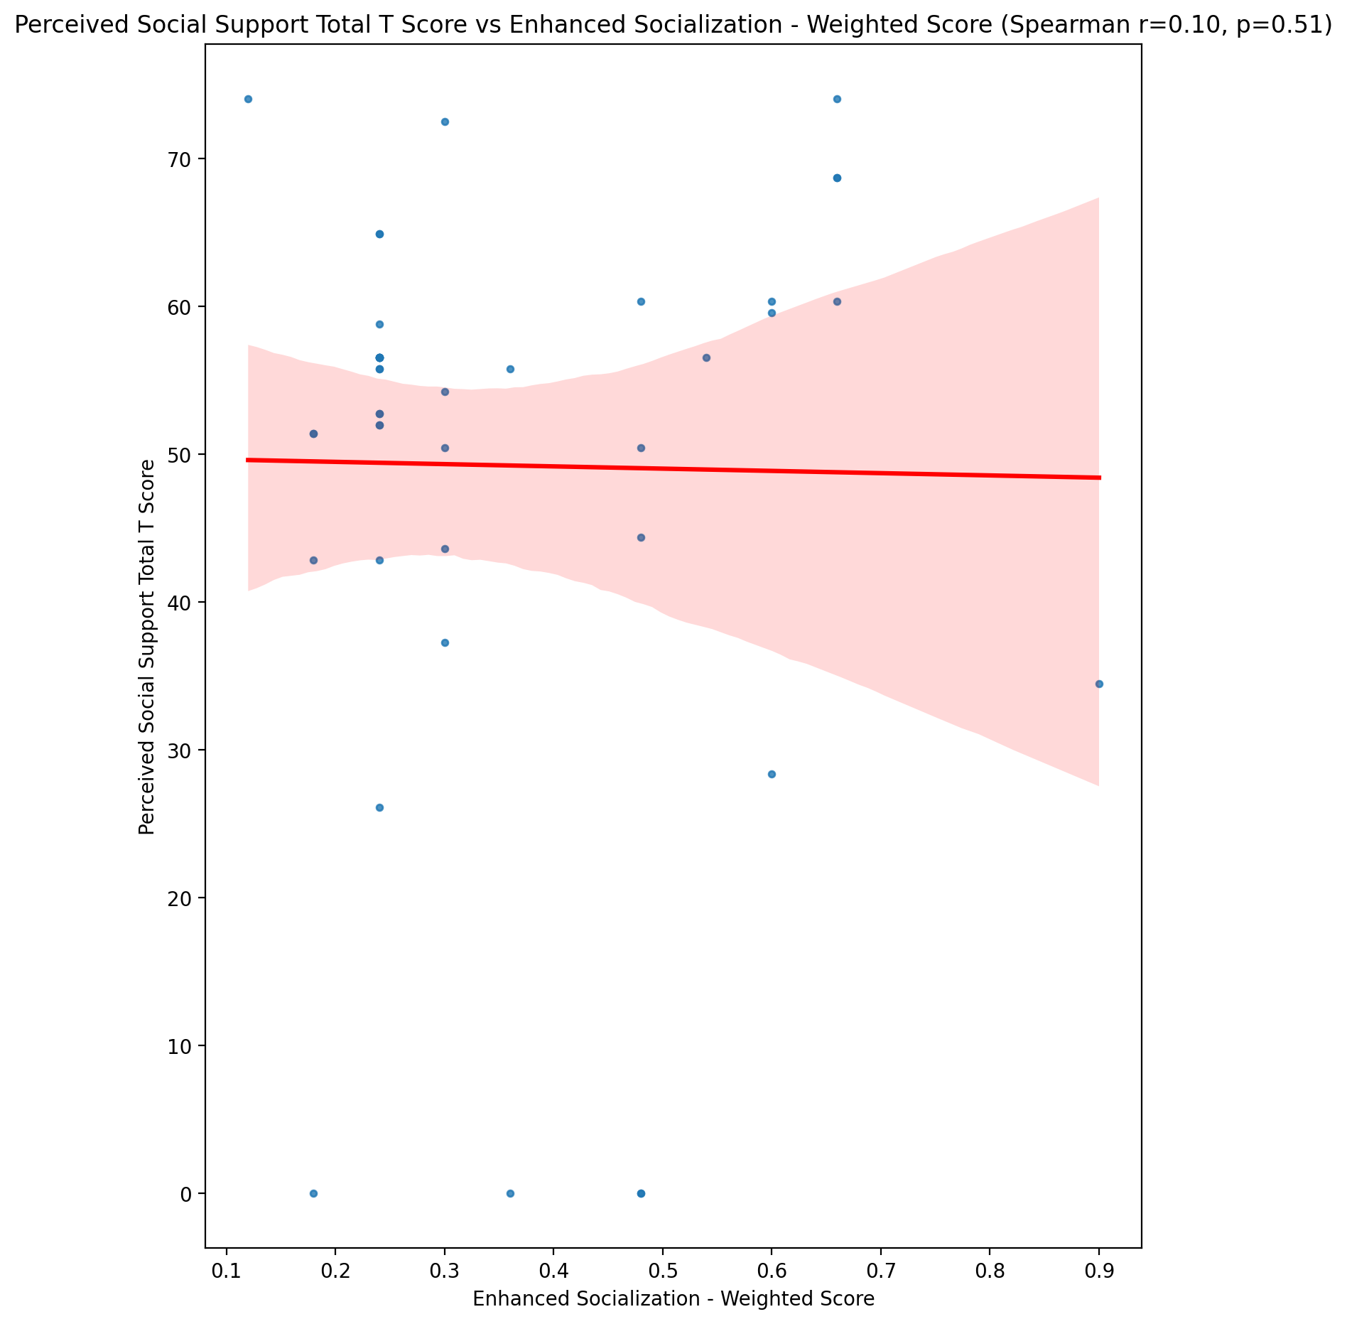

## Emotional Support - Rank vs Enhanced Socialization - Weighted Score

Test: None; statistic: None; p-value: None; Test not run: unsupported type combination.



## Informational Support - Rank vs Enhanced Socialization - Weighted Score

Test: None; statistic: None; p-value: None; Test not run: unsupported type combination.



## Instrumental Support - Rank vs Enhanced Socialization - Weighted Score

Test: None; statistic: None; p-value: None; Test not run: unsupported type combination.



## Perceived Social Support TOTAL - Rank vs Enhanced Socialization - Weighted Score

Test: None; statistic: None; p-value: None; Test not run: unsupported type combination.



## Power Self Concept - Real Self Concept Score vs Enhanced Socialization - Weighted Score

Test: spearman; statistic: 0.04663101345769567; p-value: 0.7665191072041266;

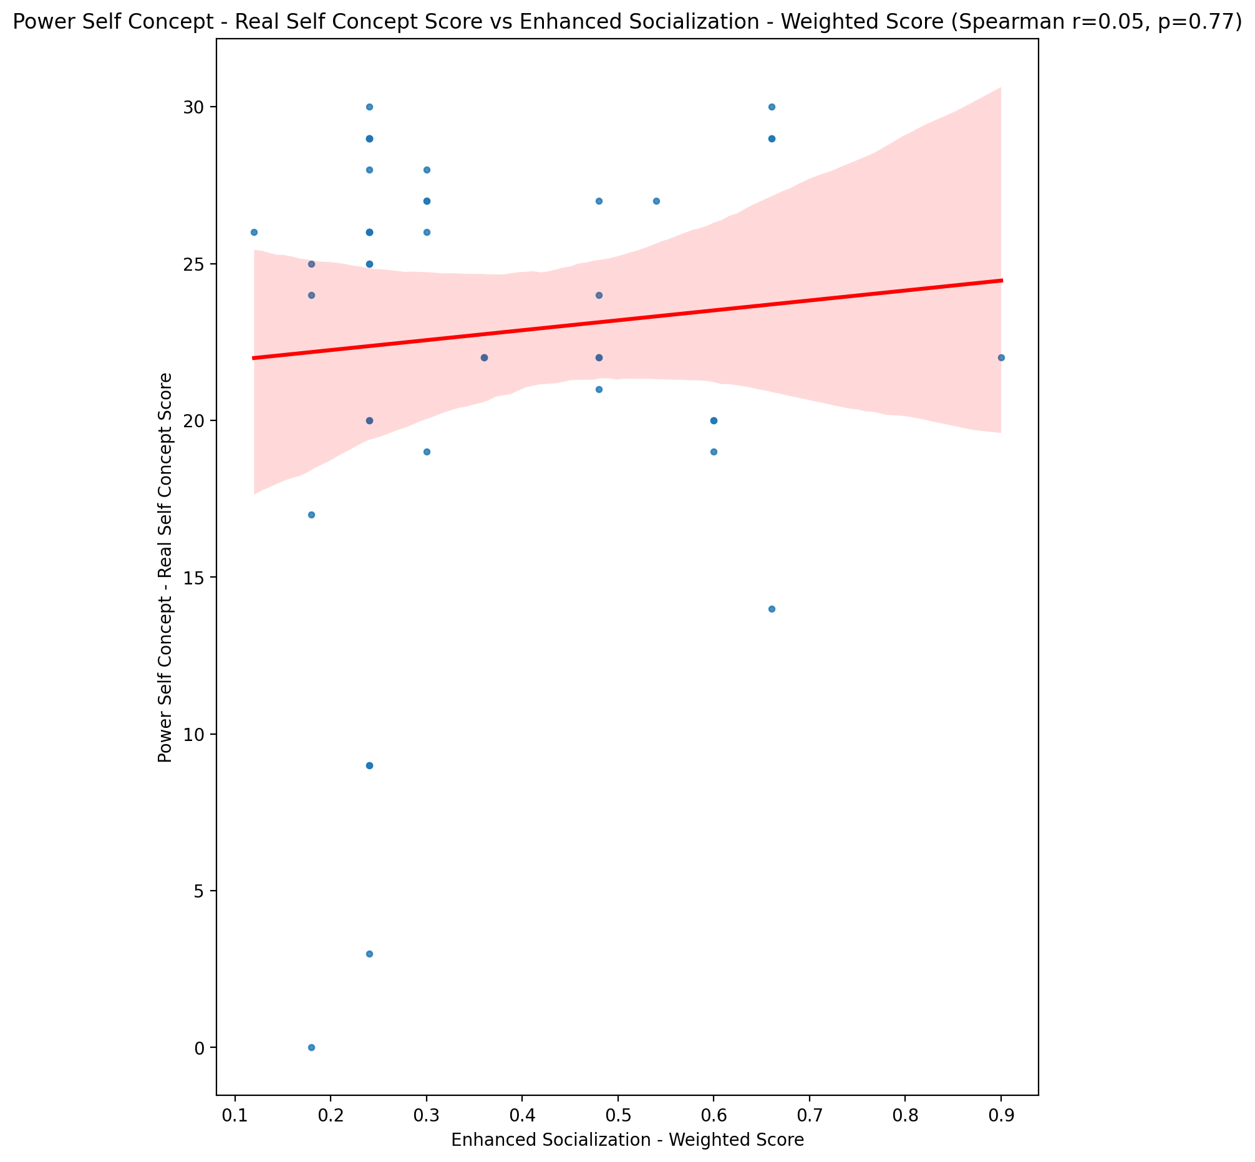

## Power Self Concept - Ideal Self Concept score vs Enhanced Socialization - Weighted Score

Test: spearman; statistic: 0.2078586653855768; p-value: 0.18105354295775994;

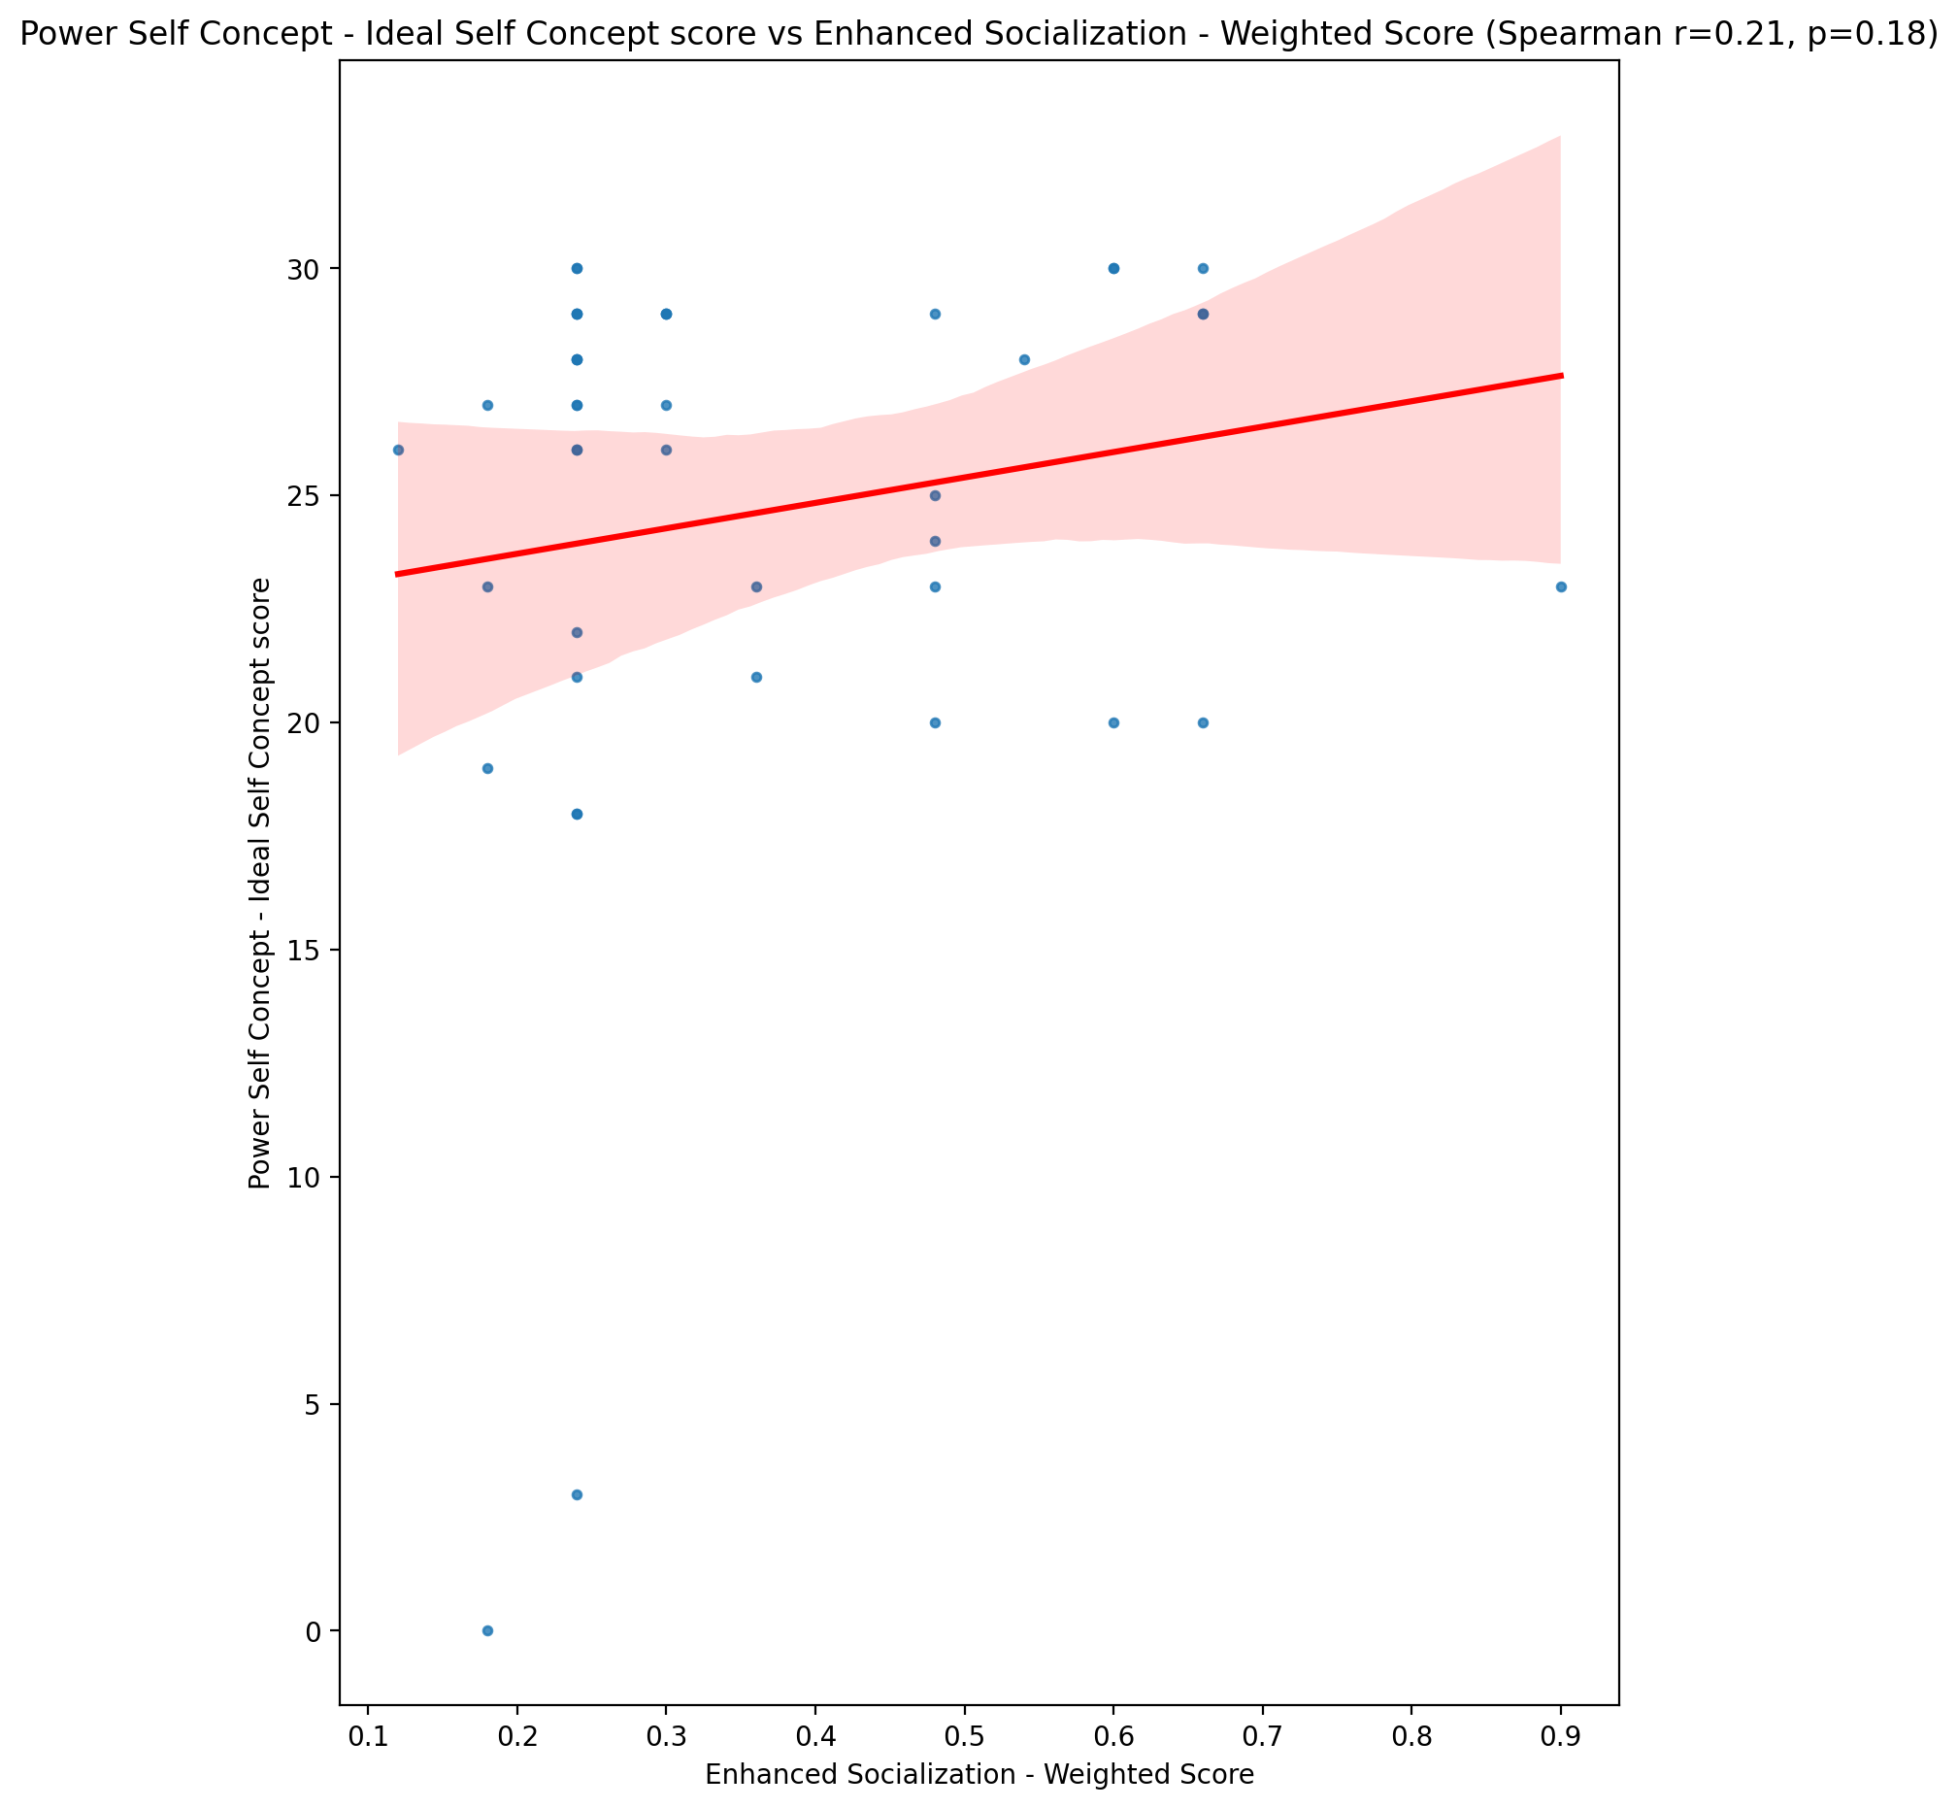

## Power Self Concept – Social Self Concept Score vs Enhanced Socialization - Weighted Score

Test: spearman; statistic: 0.08268903903342358; p-value: 0.5980862133335951;

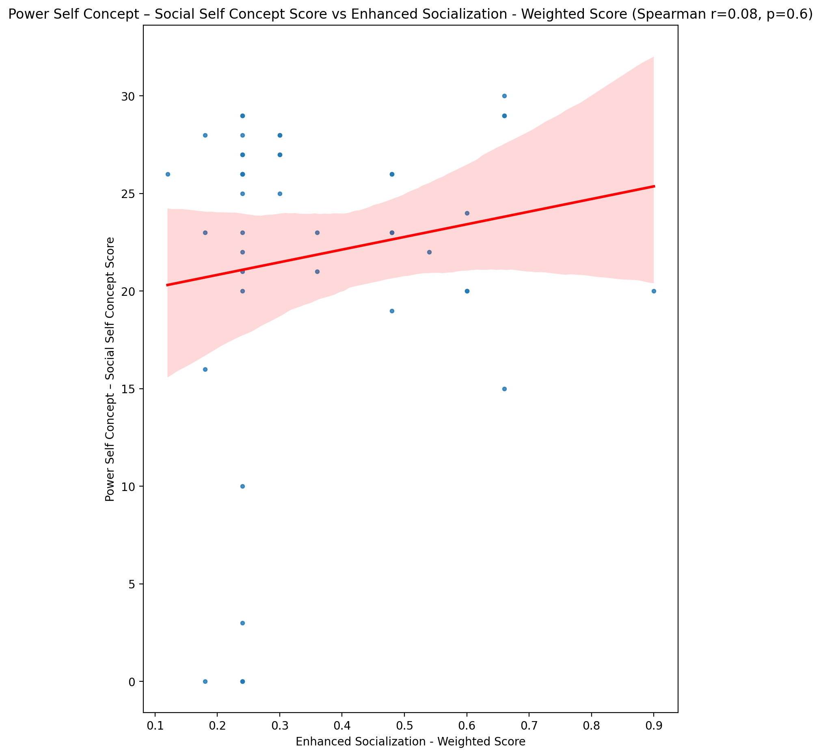

## Social Self Concept - Real Self Concept Score vs Enhanced Socialization - Weighted Score

Test: spearman; statistic: 0.004926206246782106; p-value: 0.9749891642316082;

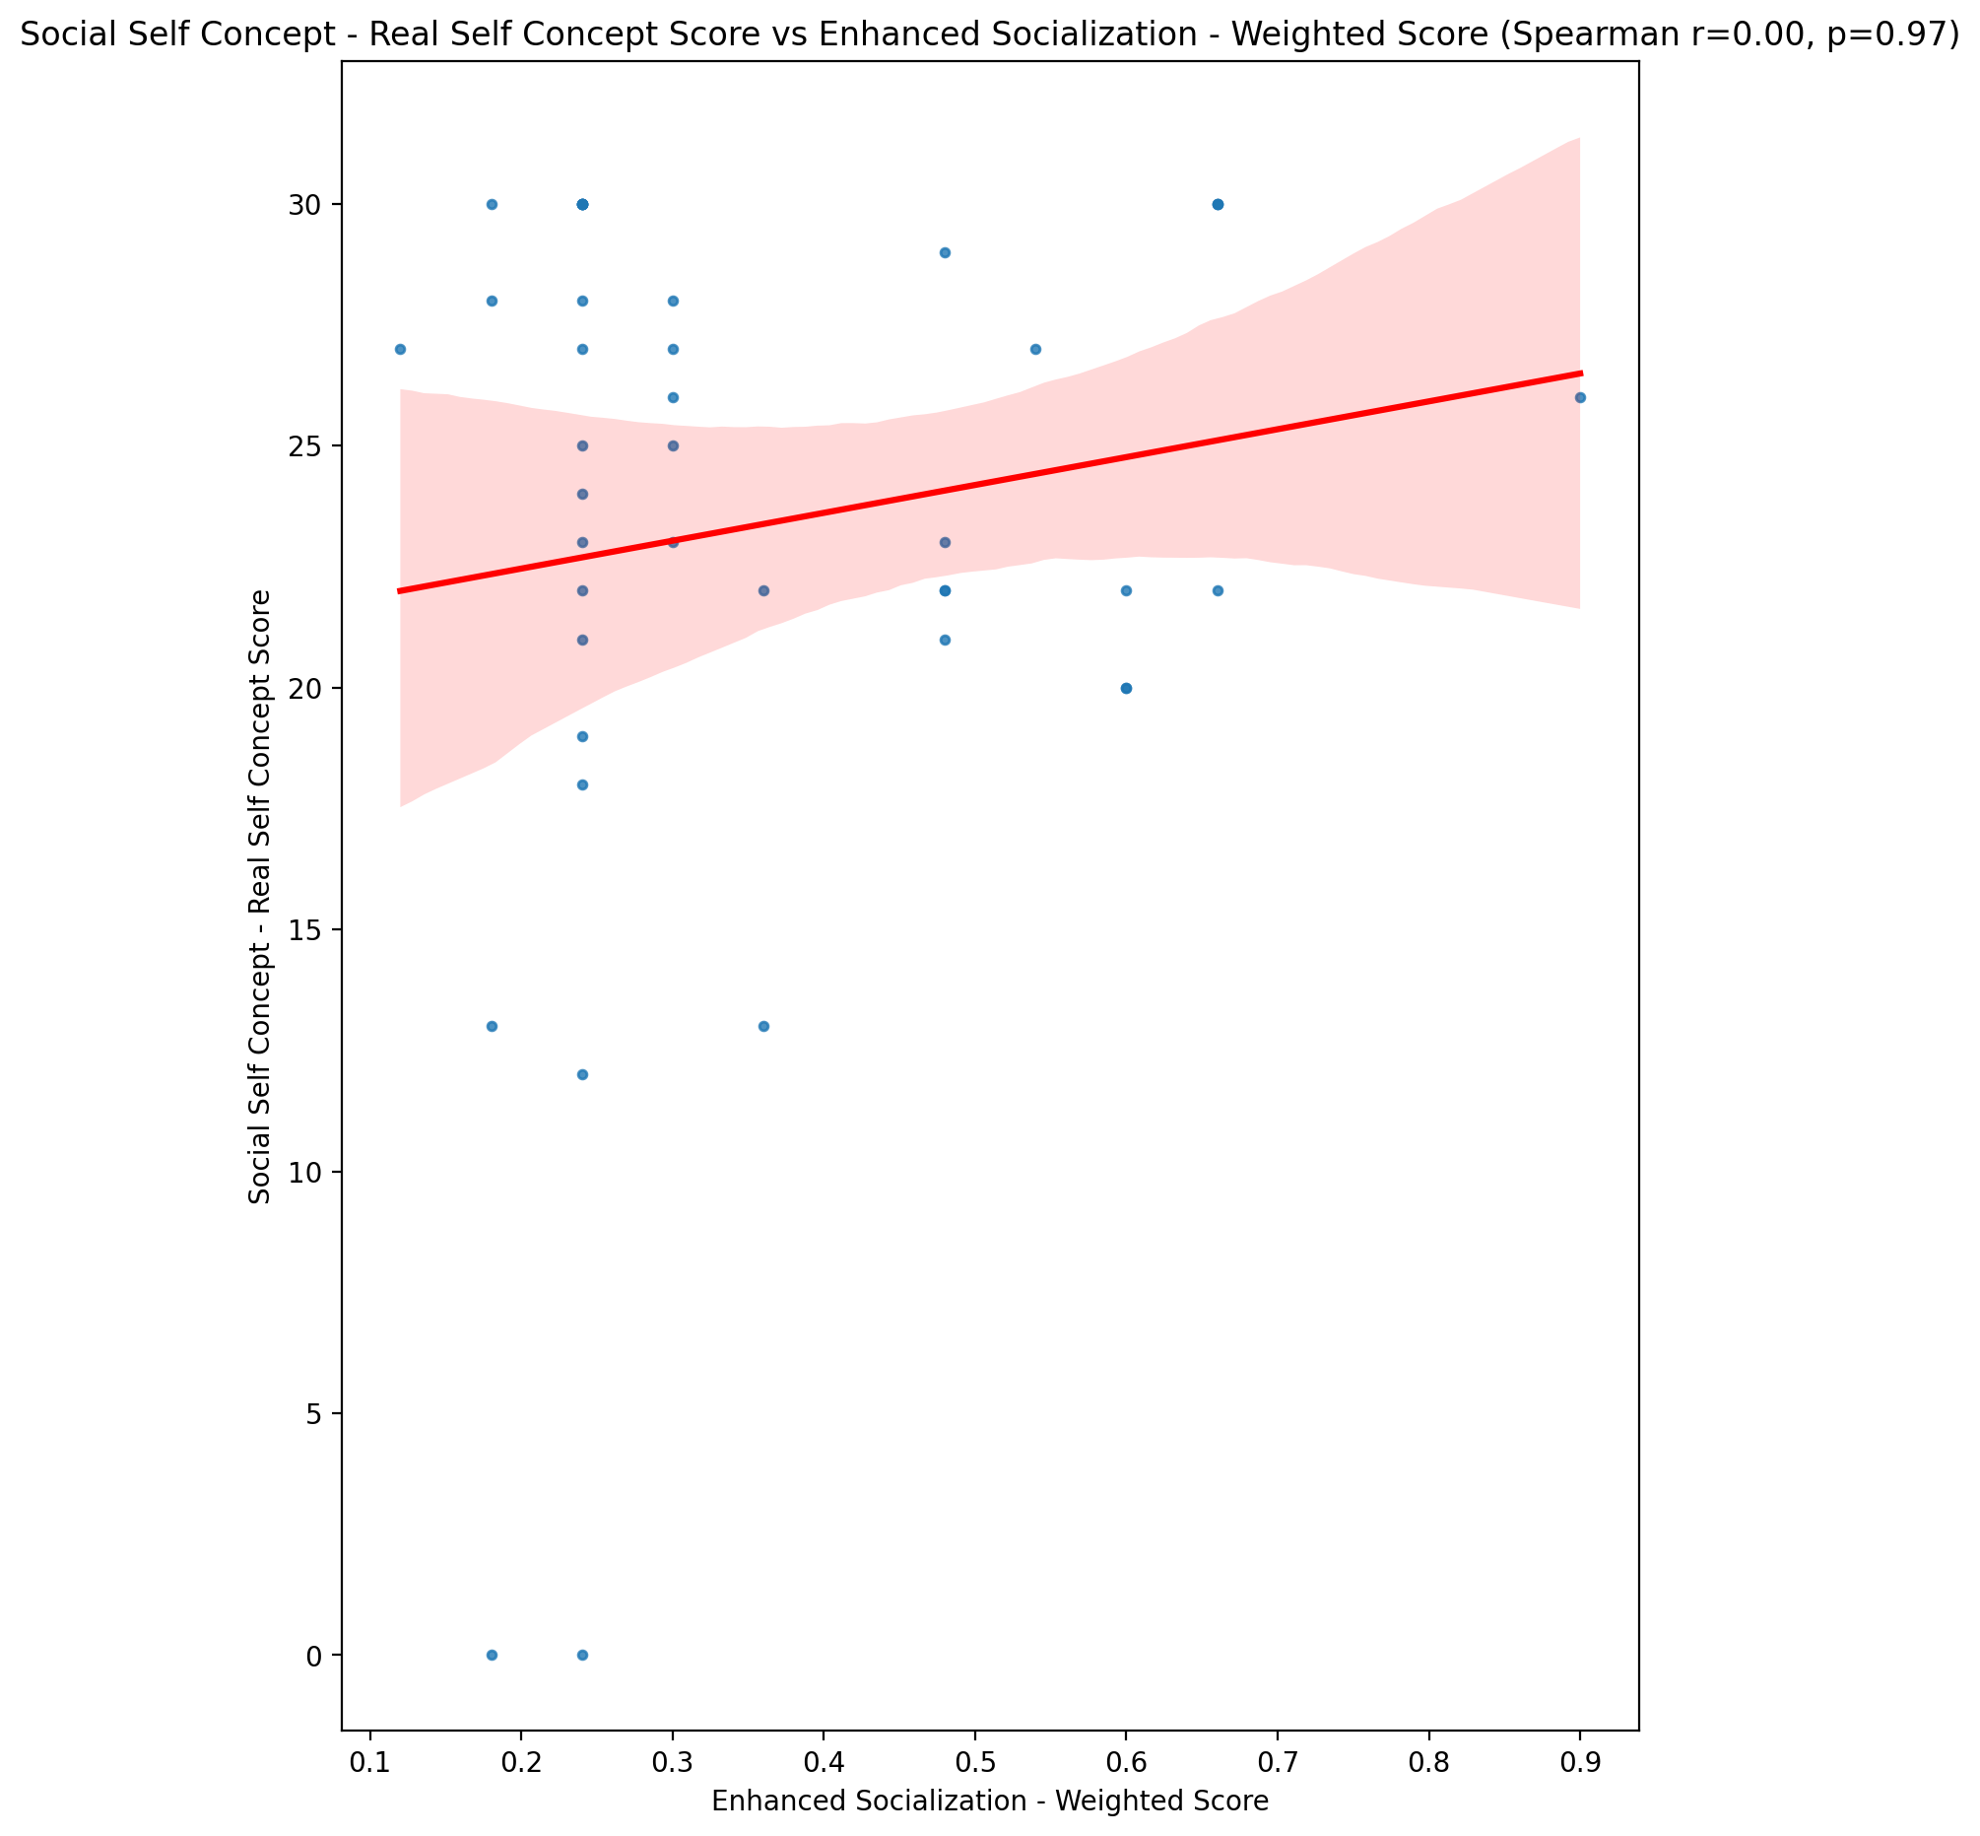

## Social Self Concept – Social Self Concept Score vs Enhanced Socialization - Weighted Score

Test: spearman; statistic: 0.0801324419112808; p-value: 0.6094894392663204;

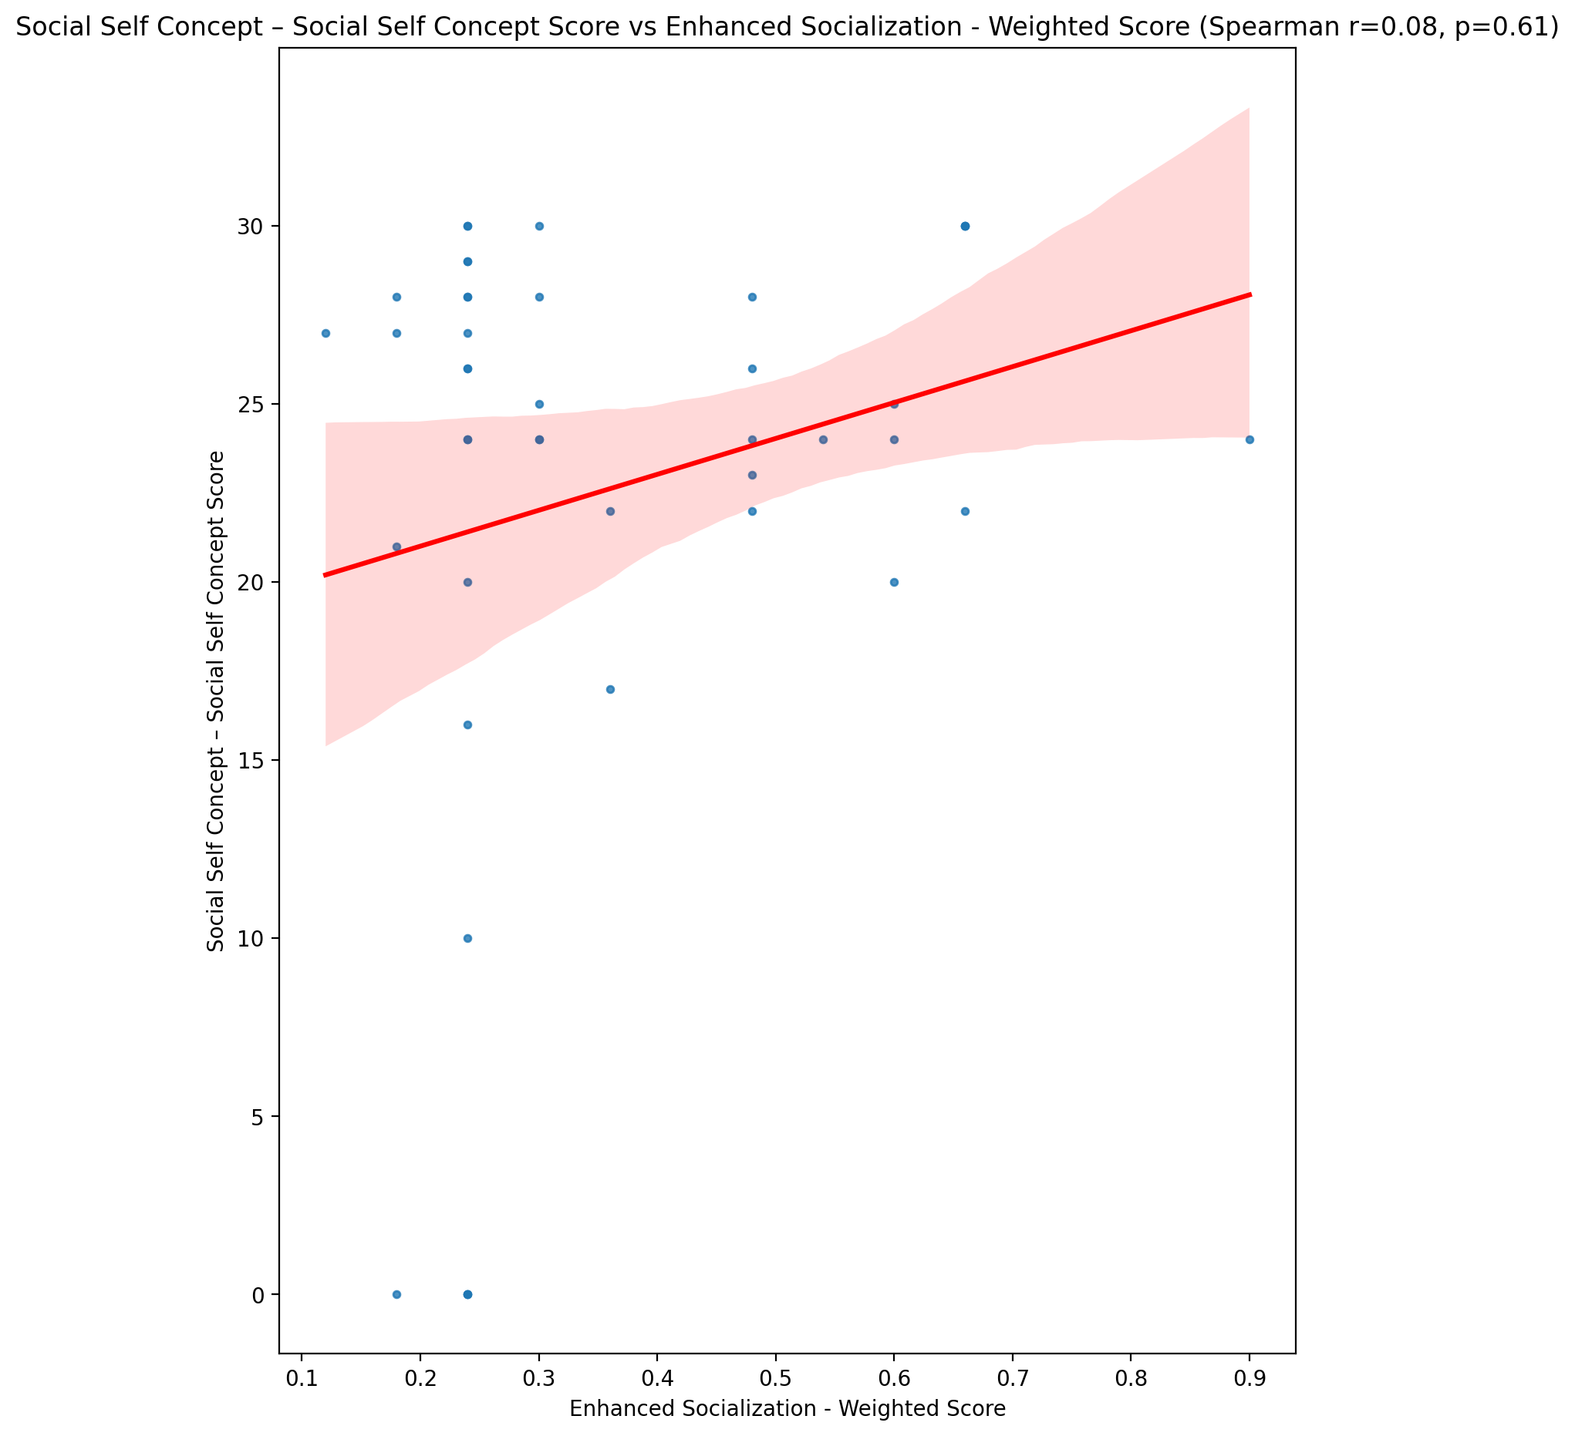

## Ability Self Concept - Real Self Concept Score vs Enhanced Socialization - Weighted Score

Test: spearman; statistic: 0.11601373940948183; p-value: 0.45878874506151857;

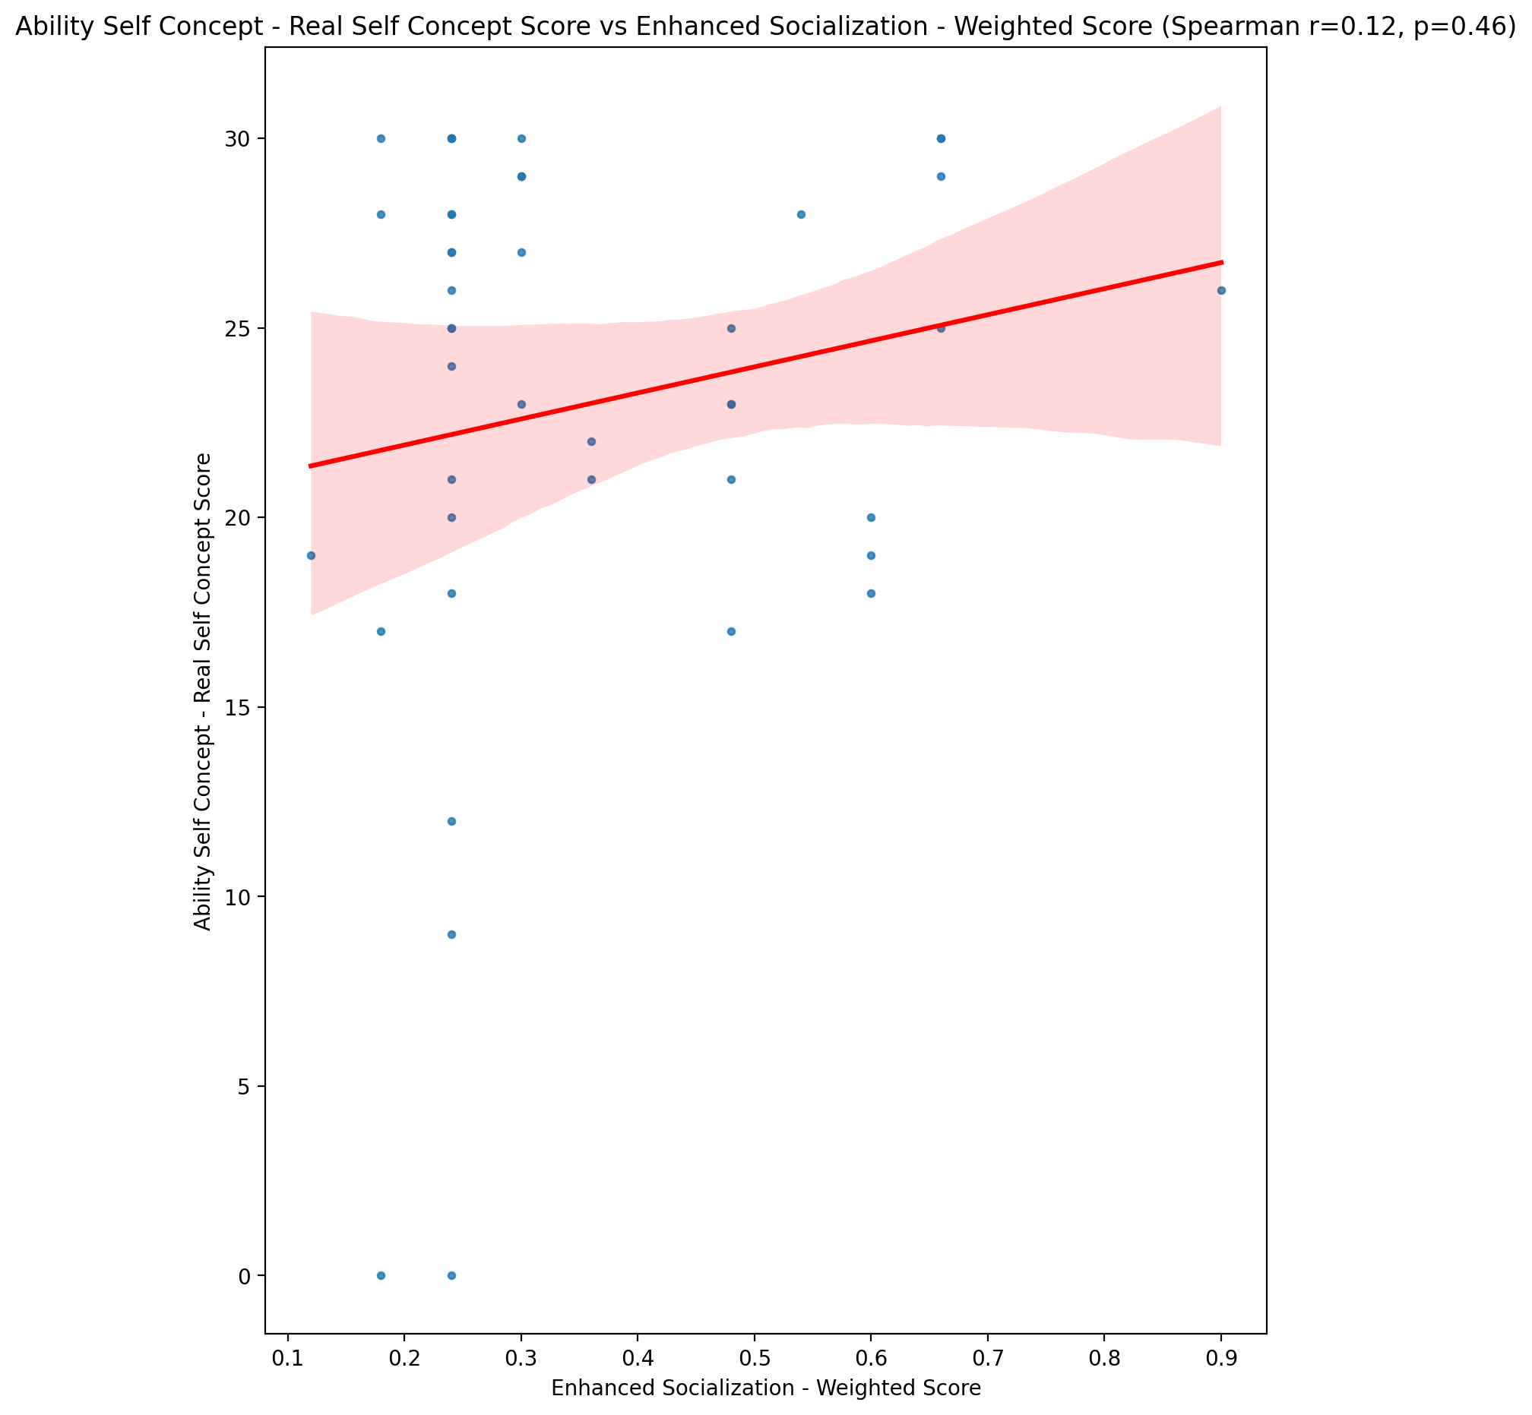

## Ability Self Concept - Ideal Self Concept Score vs Enhanced Socialization - Weighted Score

Test: spearman; statistic: 0.21186096565165966; p-value: 0.17260918669826517;

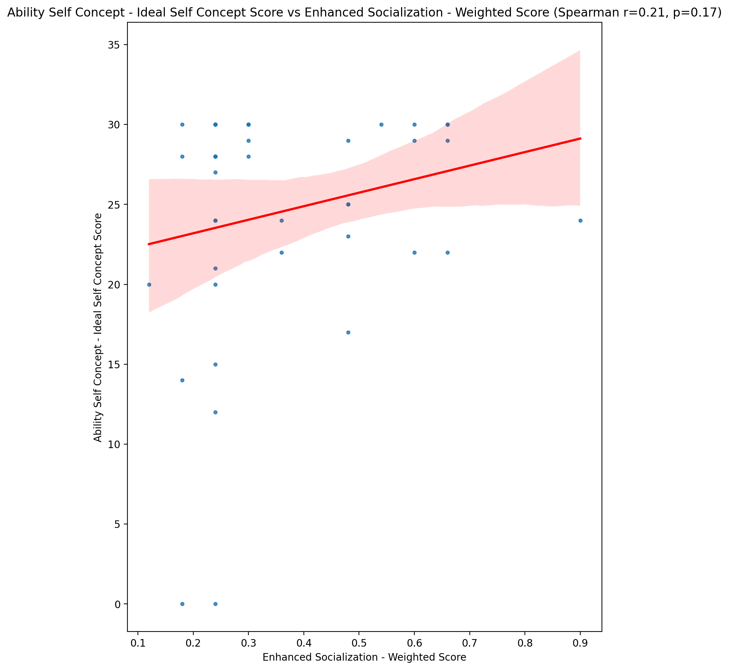

## Ability Self Concept – Social Self Concept Score vs Enhanced Socialization - Weighted Score

Test: spearman; statistic: 0.1799920942358072; p-value: 0.2481026717896879;

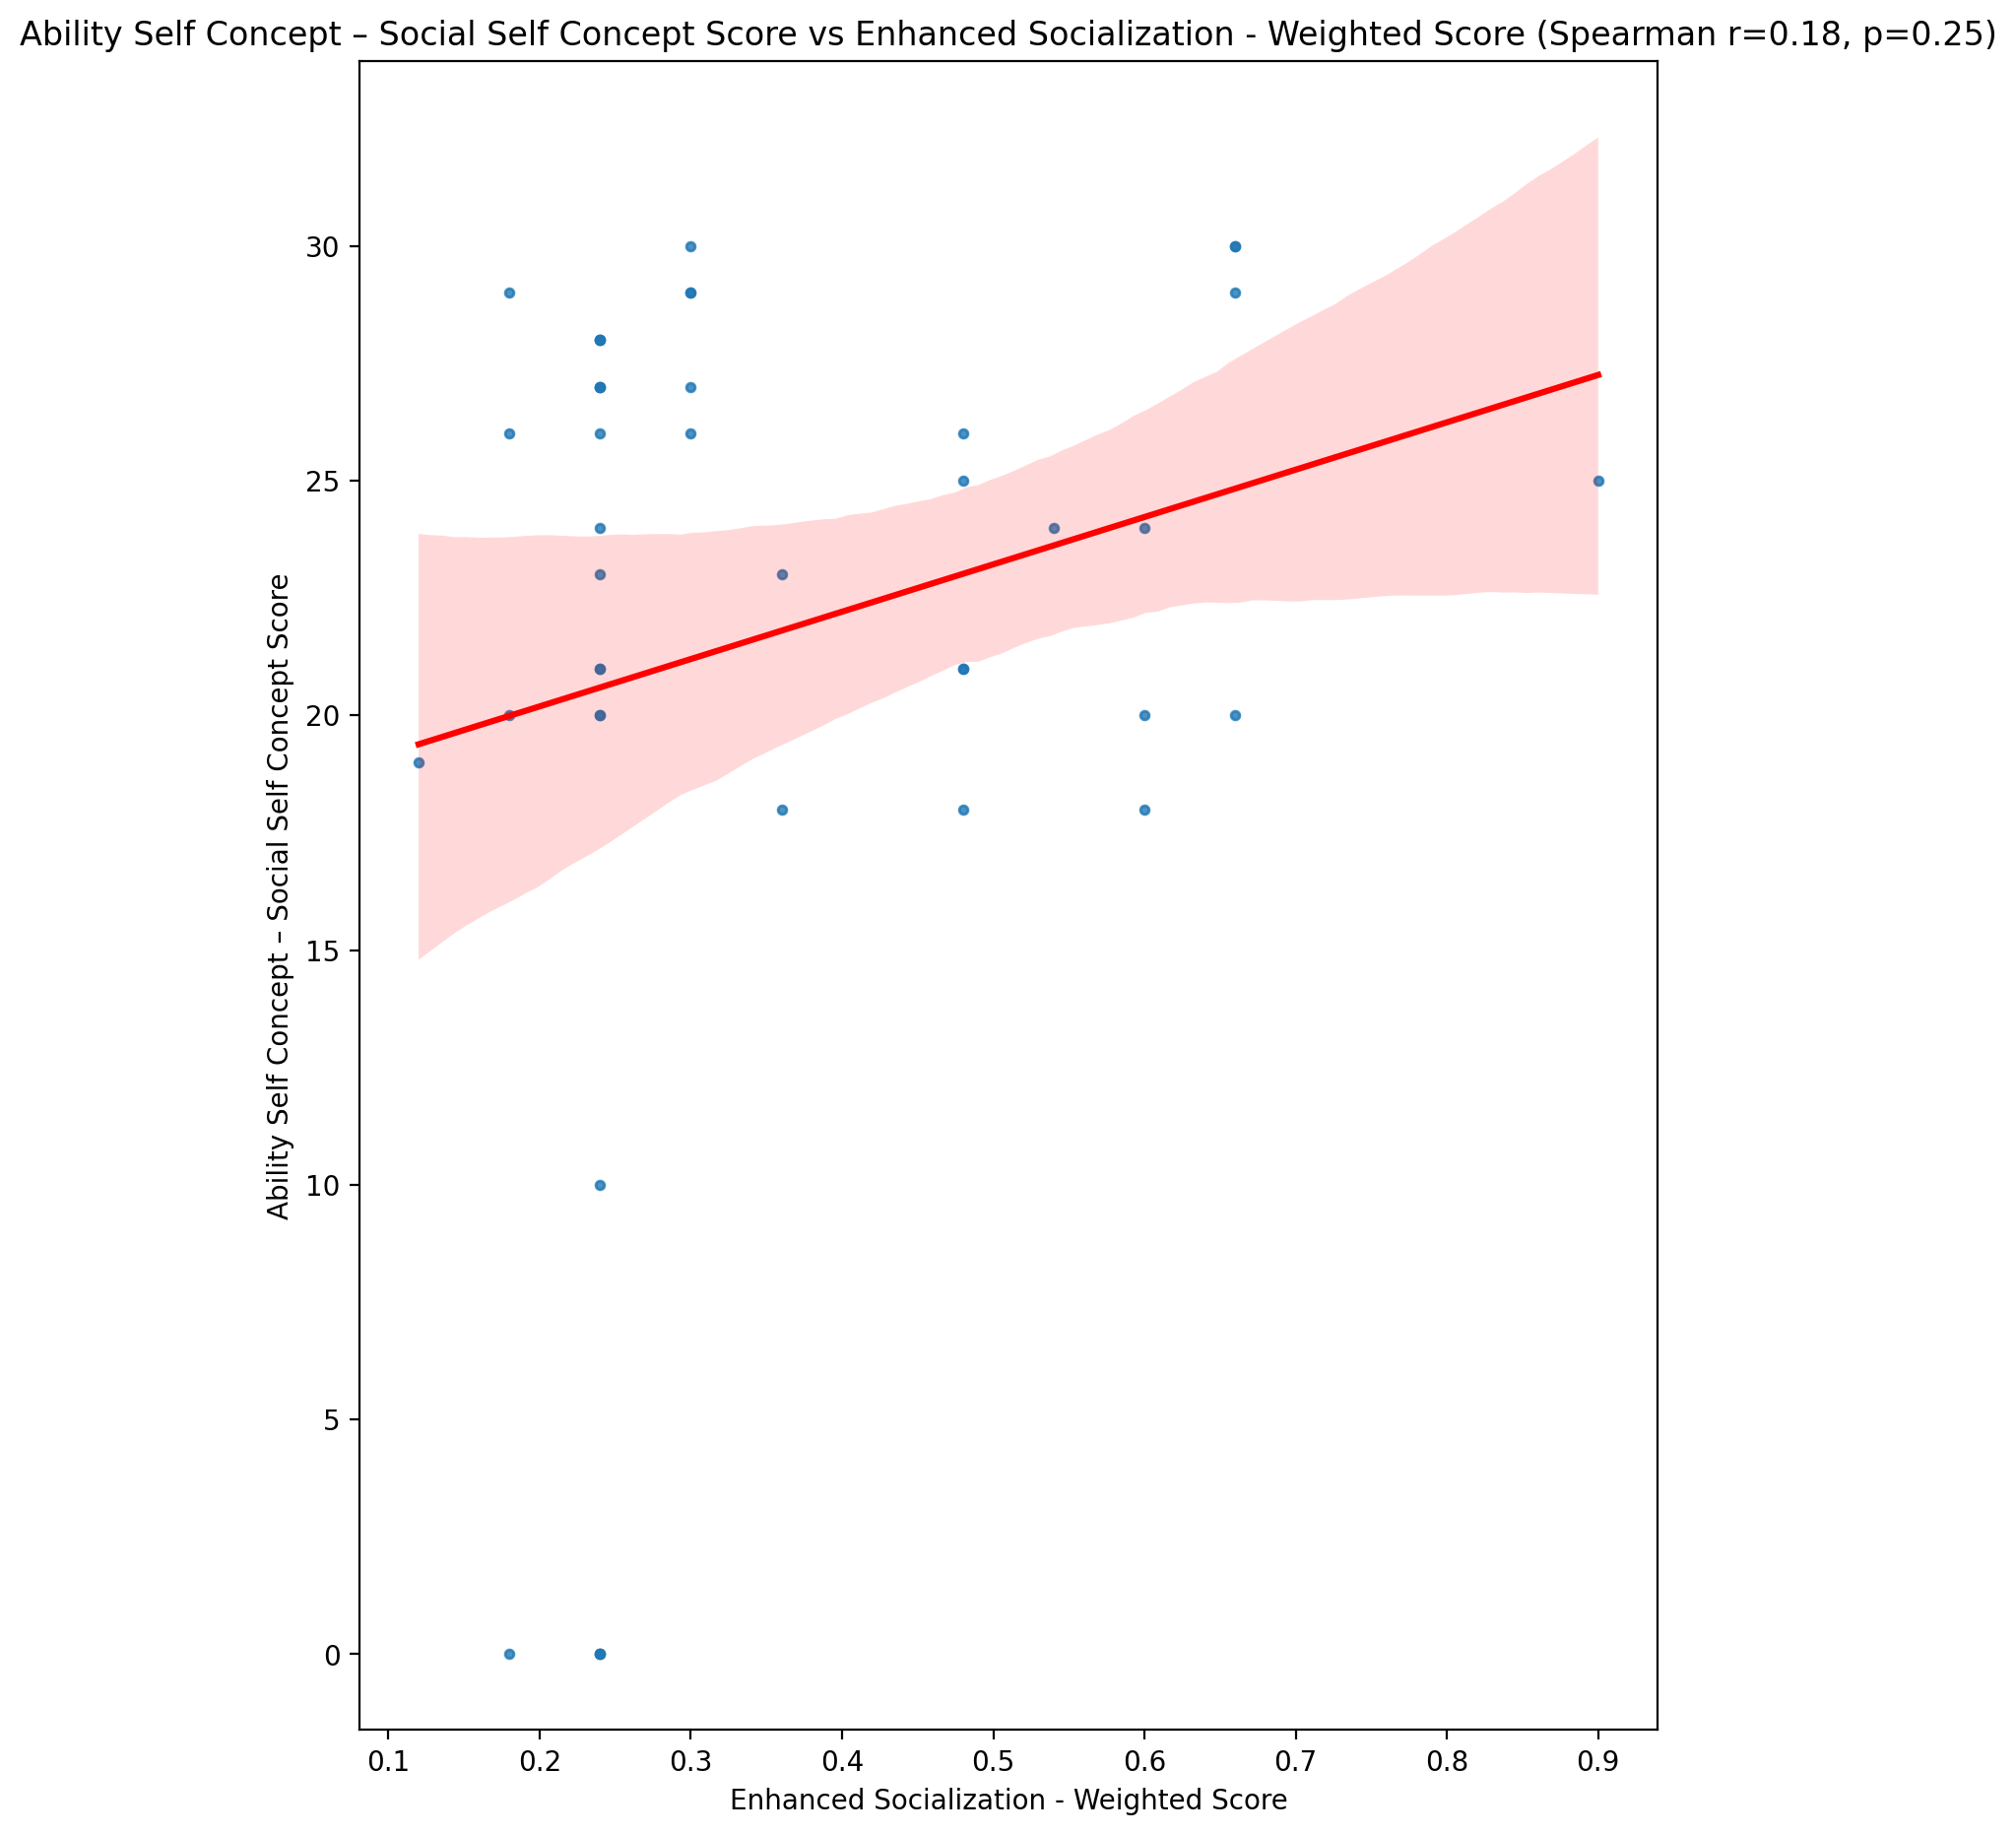

## Physical Self Concept - Real Self Concept Score vs Enhanced Socialization - Weighted Score

Test: spearman; statistic: -0.005262133203879373; p-value: 0.9732842241526314;

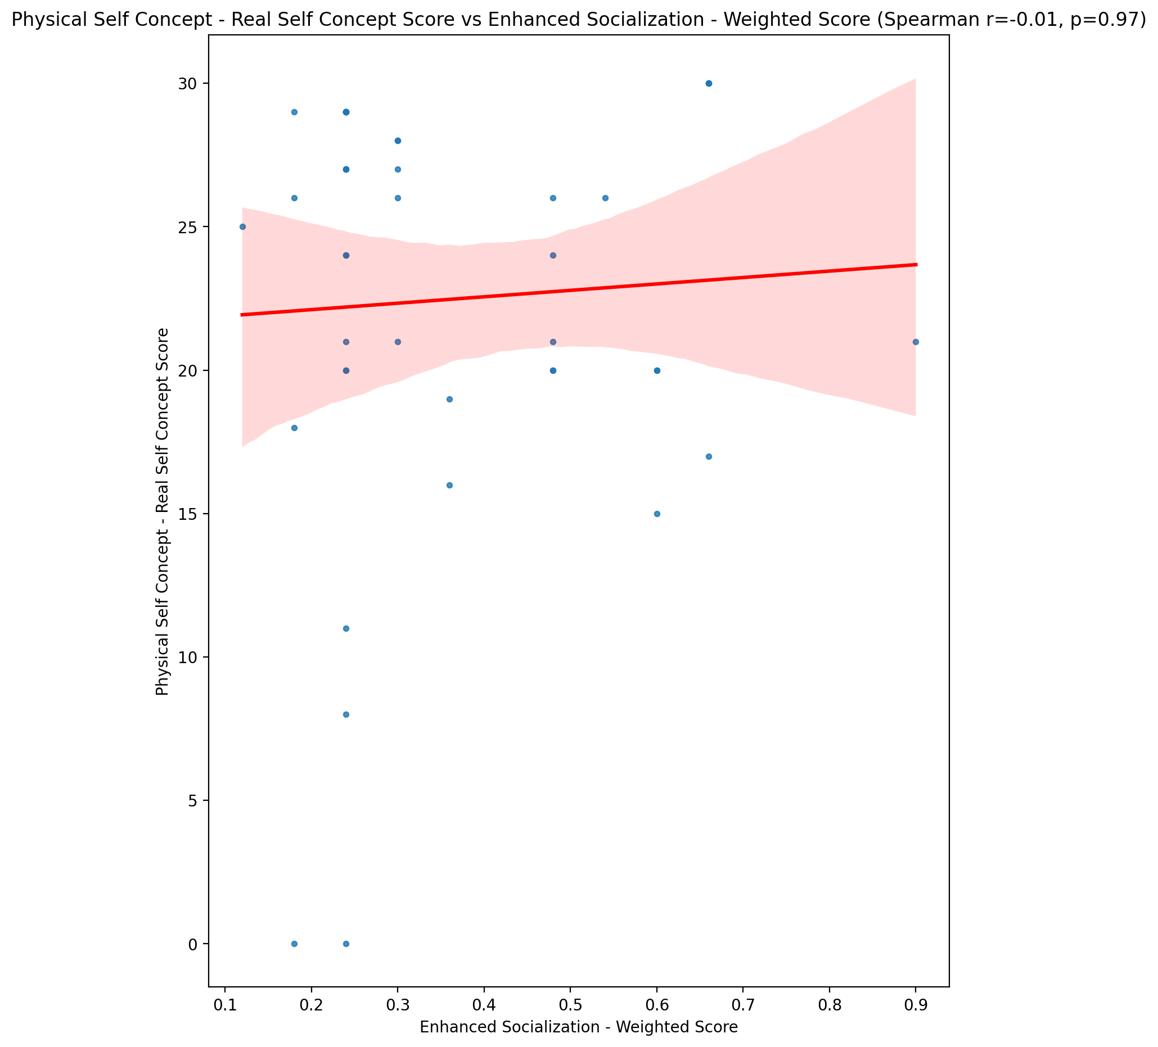

## Physical Self Concept – Ideal Self Concept Score vs Enhanced Socialization - Weighted Score

Test: spearman; statistic: 0.16237043239785168; p-value: 0.29820858580576337;

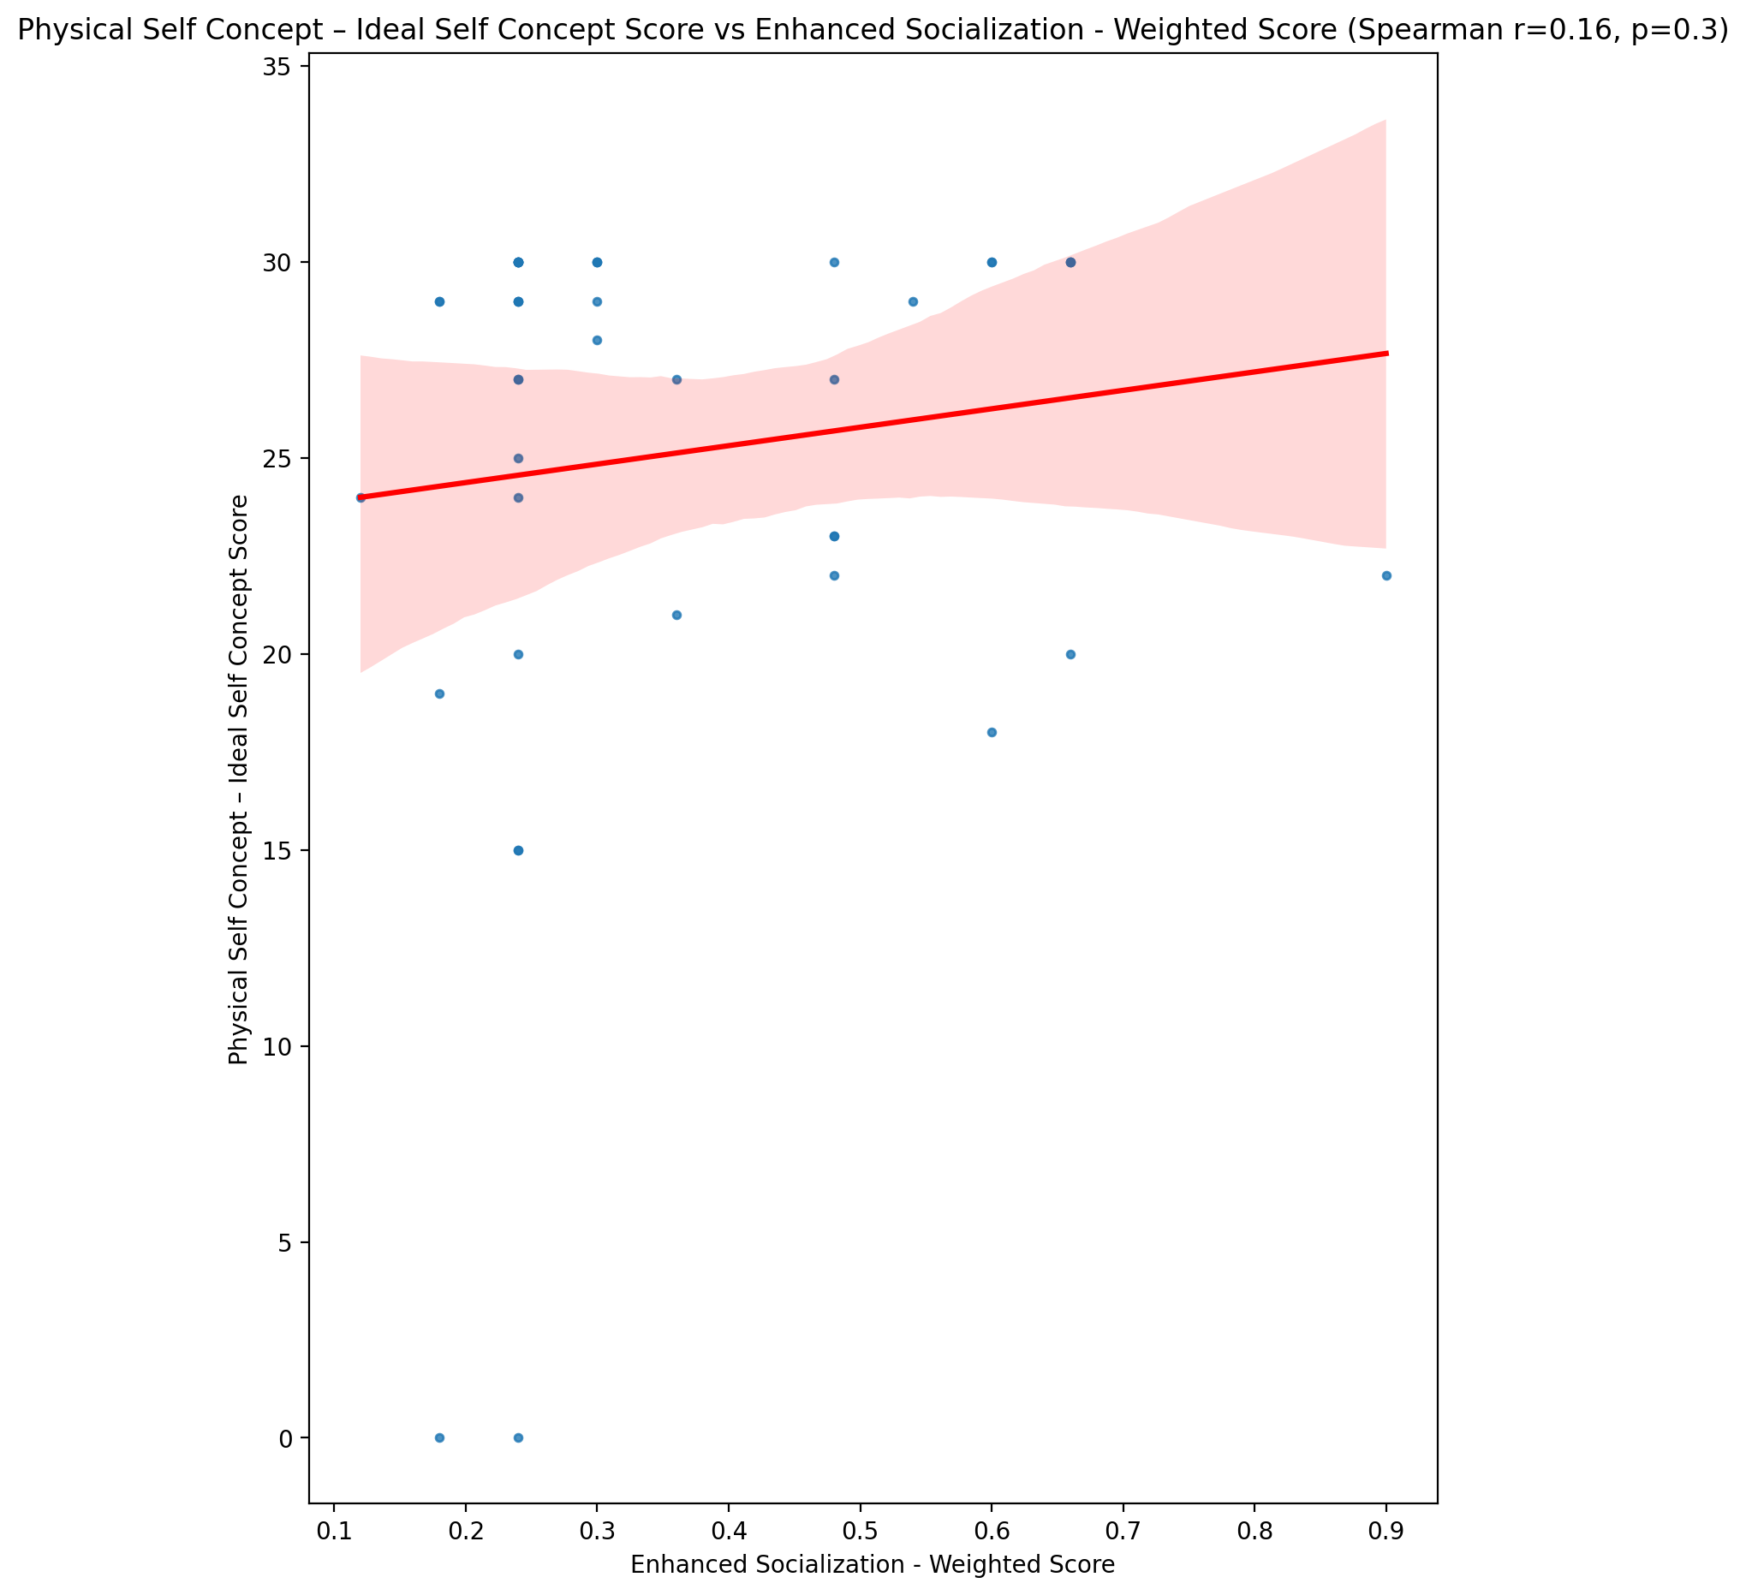

## Physical Self Concept – Social Self Concept Score vs Enhanced Socialization - Weighted Score

Test: spearman; statistic: 0.17707114107259336; p-value: 0.25598919950910703;

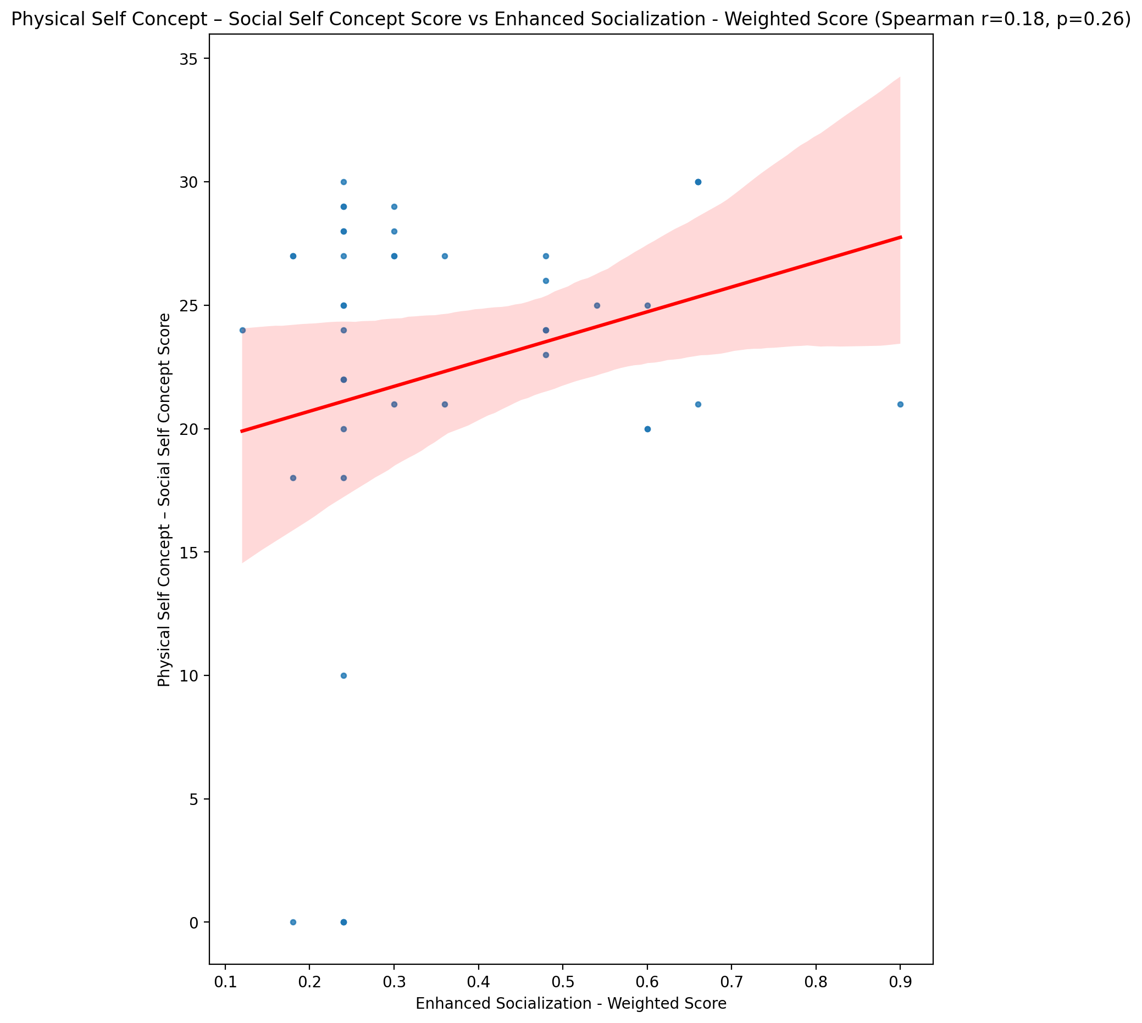

## Psychological Self Concept - Real Self Concept Score vs Enhanced Socialization - Weighted Score

Test: spearman; statistic: 0.10328273125148017; p-value: 0.5098449820555843;

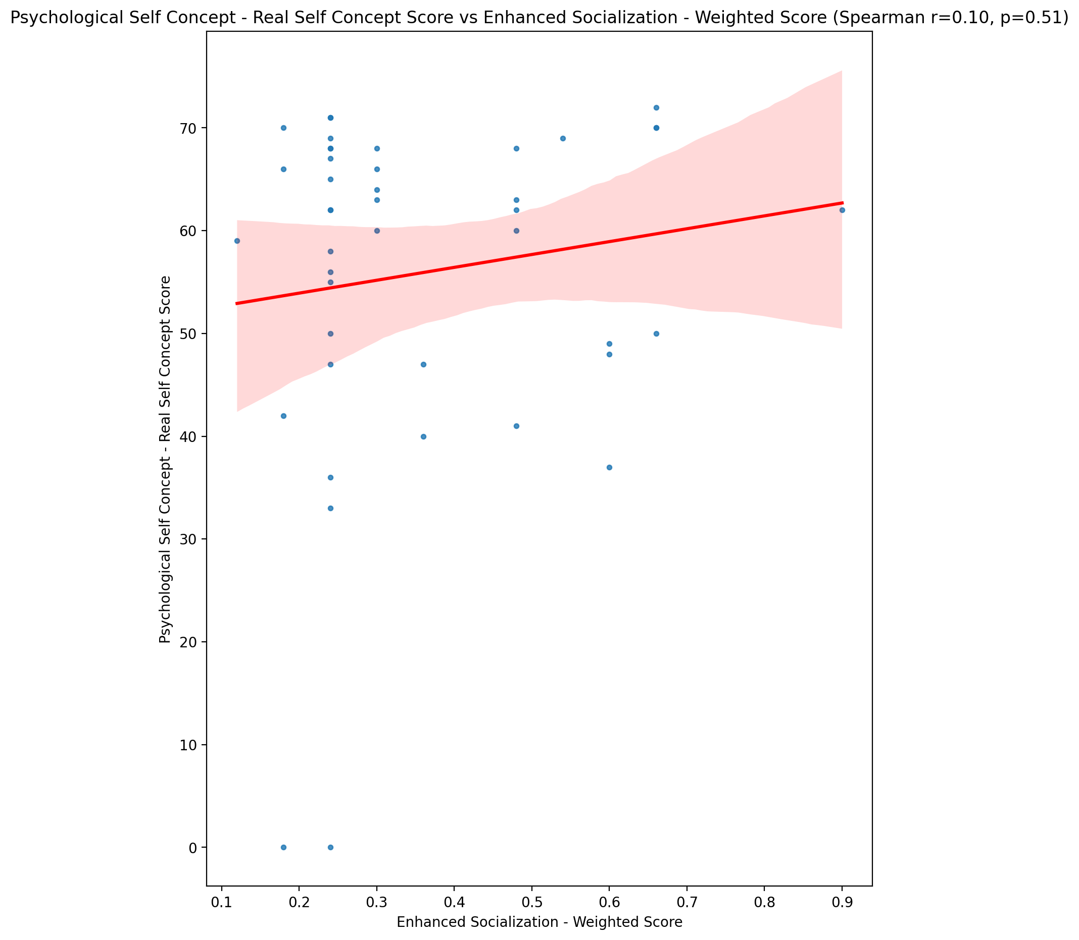

## Psychological Self Concept – Ideal Self Concept Score vs Enhanced Socialization - Weighted Score

Test: spearman; statistic: 0.17271283695526152; p-value: 0.2680652387136632;

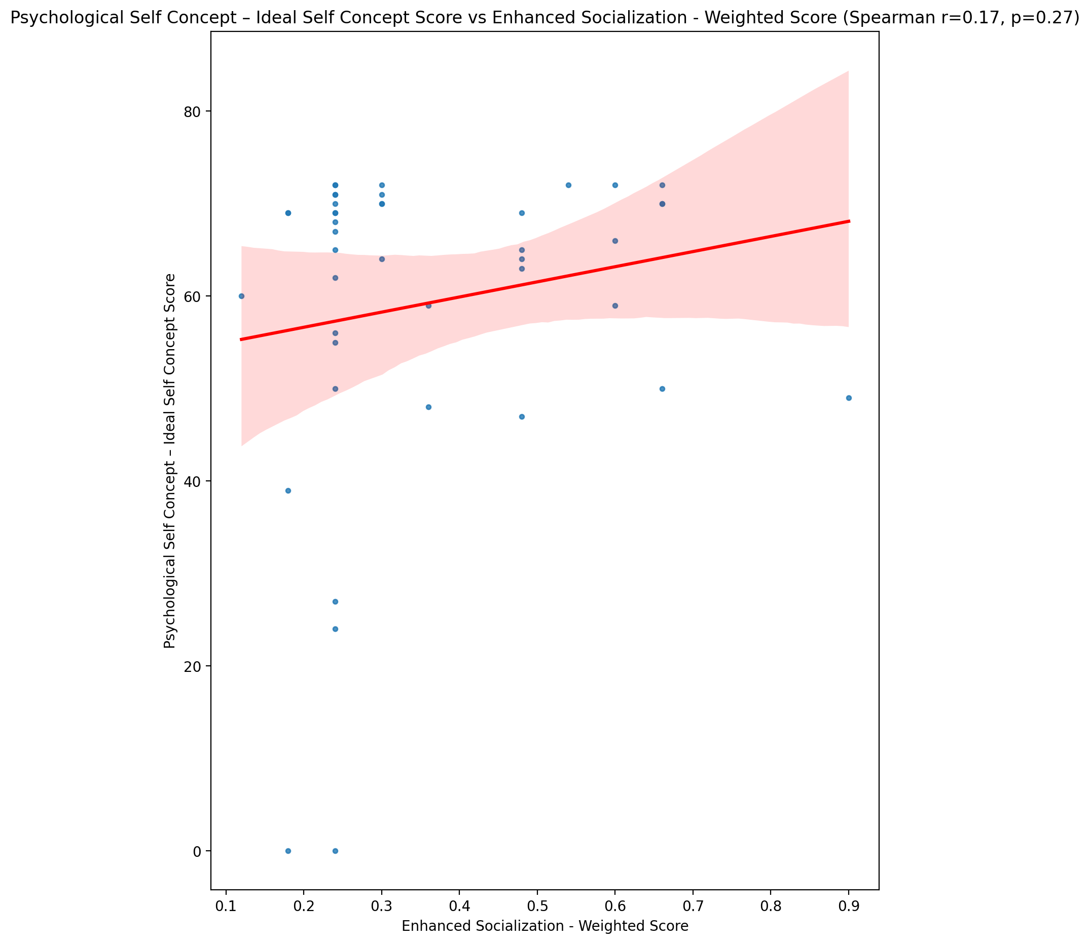

## Psychological Self Concept – Social Self Concept Score vs Enhanced Socialization - Weighted Score

Test: spearman; statistic: 0.08649945632373103; p-value: 0.5812661627475975;

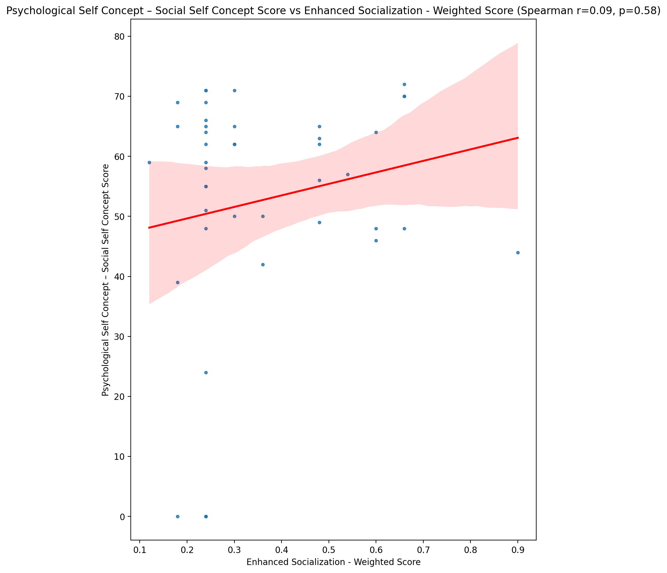

## Real Self Concept Total Score vs Enhanced Socialization - Weighted Score

Test: spearman; statistic: 0.04749759297573872; p-value: 0.762304932217799;

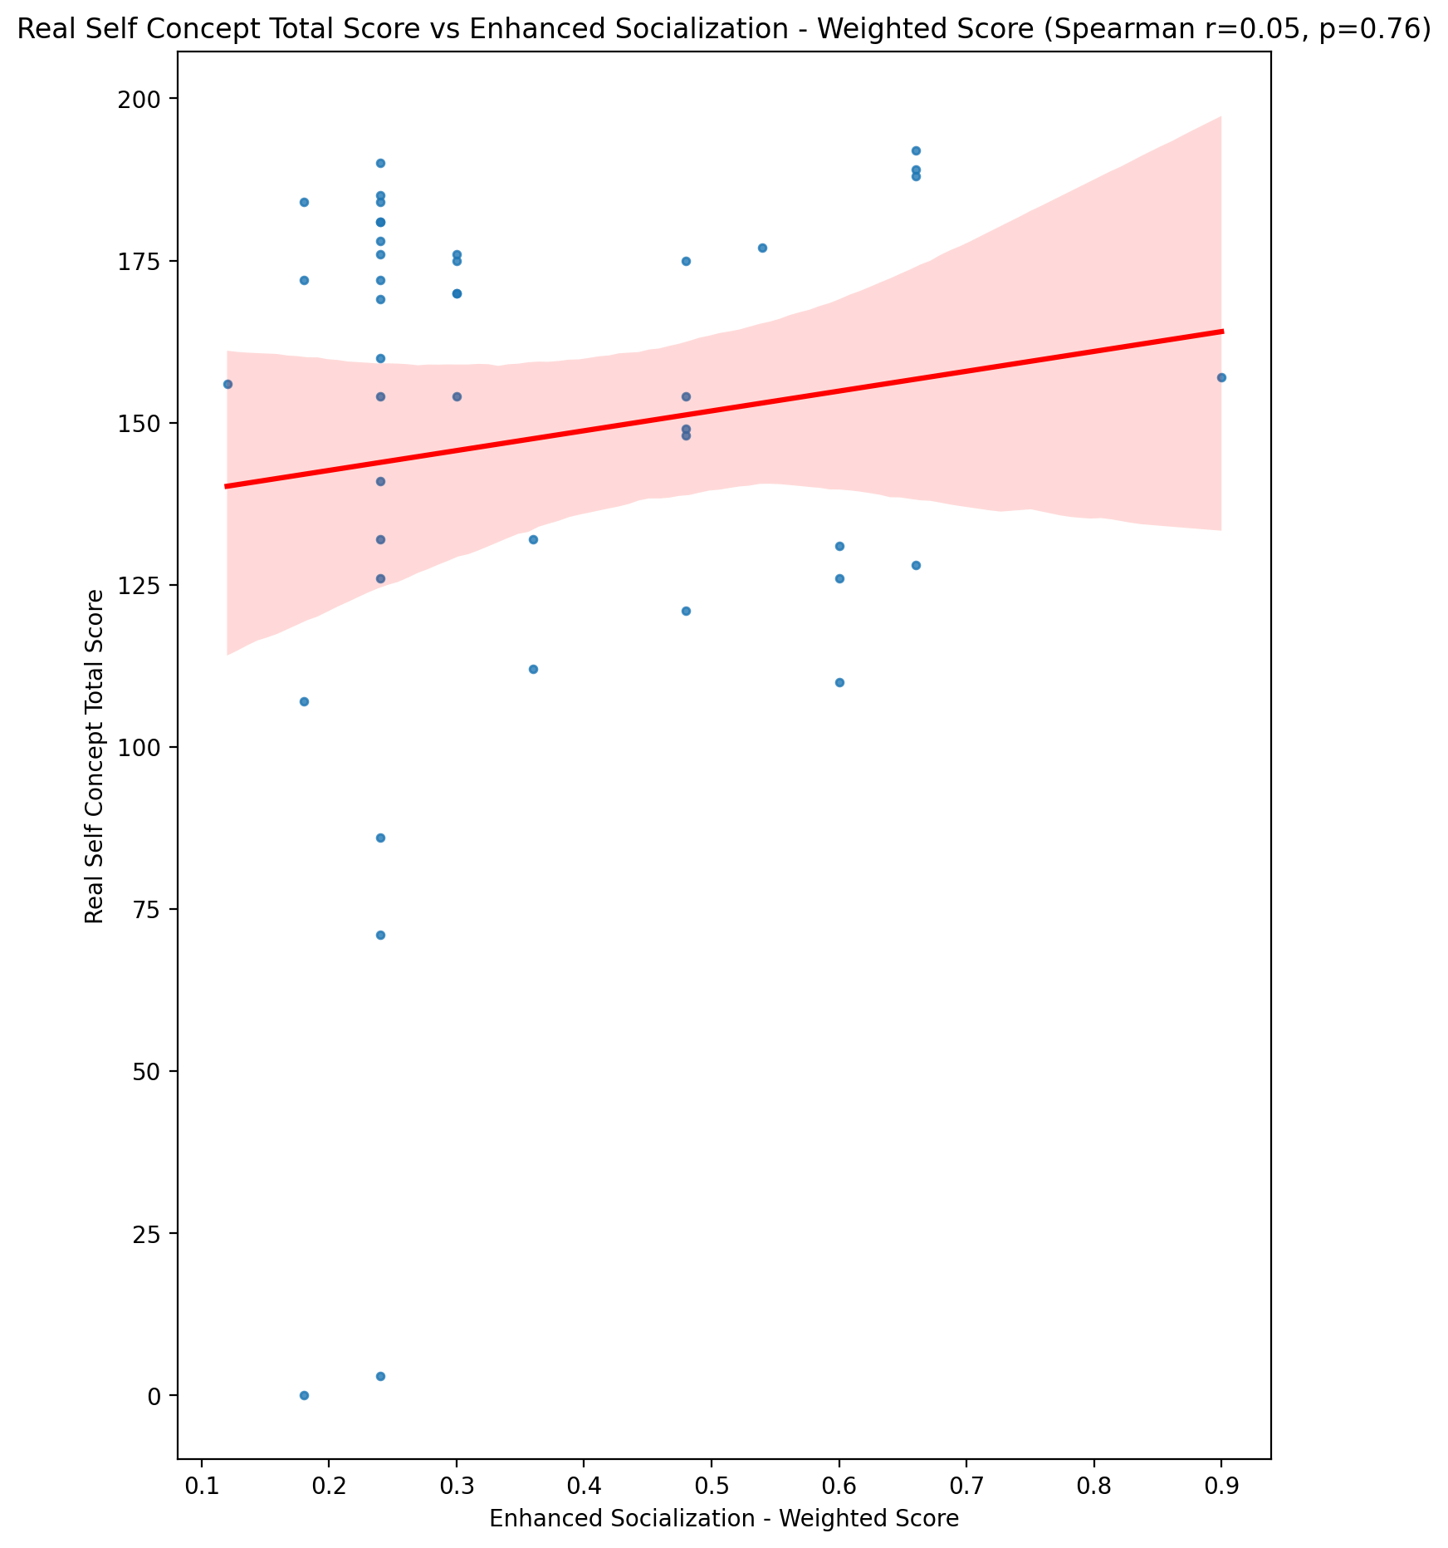

## Ideal Self Concept Total Score vs Enhanced Socialization - Weighted Score

Test: spearman; statistic: 0.21330572374984502; p-value: 0.1696317247352769;

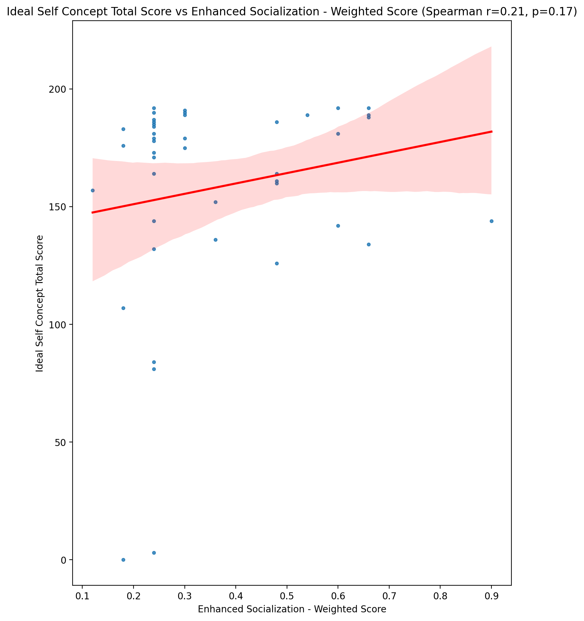

## Social Self Concept Total Score vs Enhanced Socialization - Weighted Score

Test: spearman; statistic: 0.10597622150585224; p-value: 0.49880990998763786;

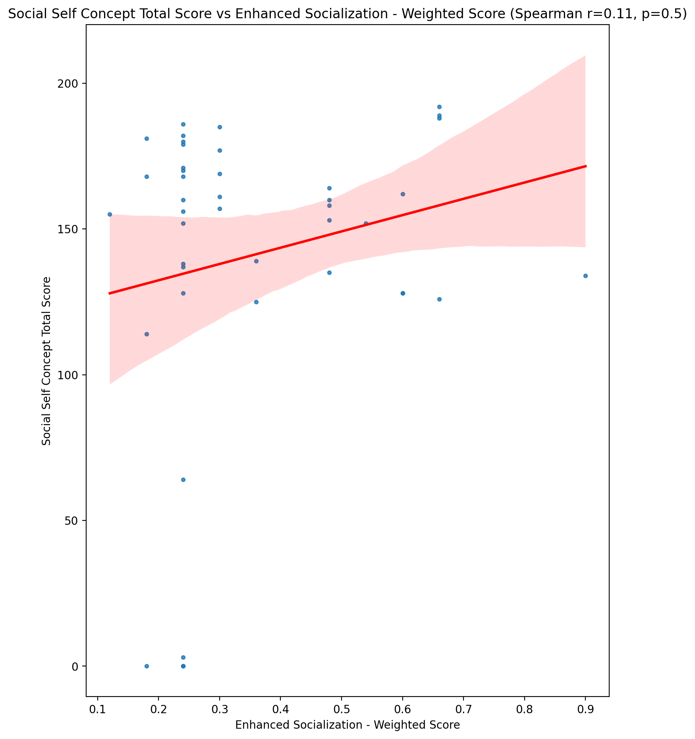

## Ideal Self Concept Total Category vs Enhanced Socialization - Weighted Score

Test: None; statistic: None; p-value: None; Test not run: unsupported type combination.



## Perceived Social Stress Score vs Enhanced Socialization - Weighted Score

Test: spearman; statistic: 0.03366385036201253; p-value: 0.8303096461031055;

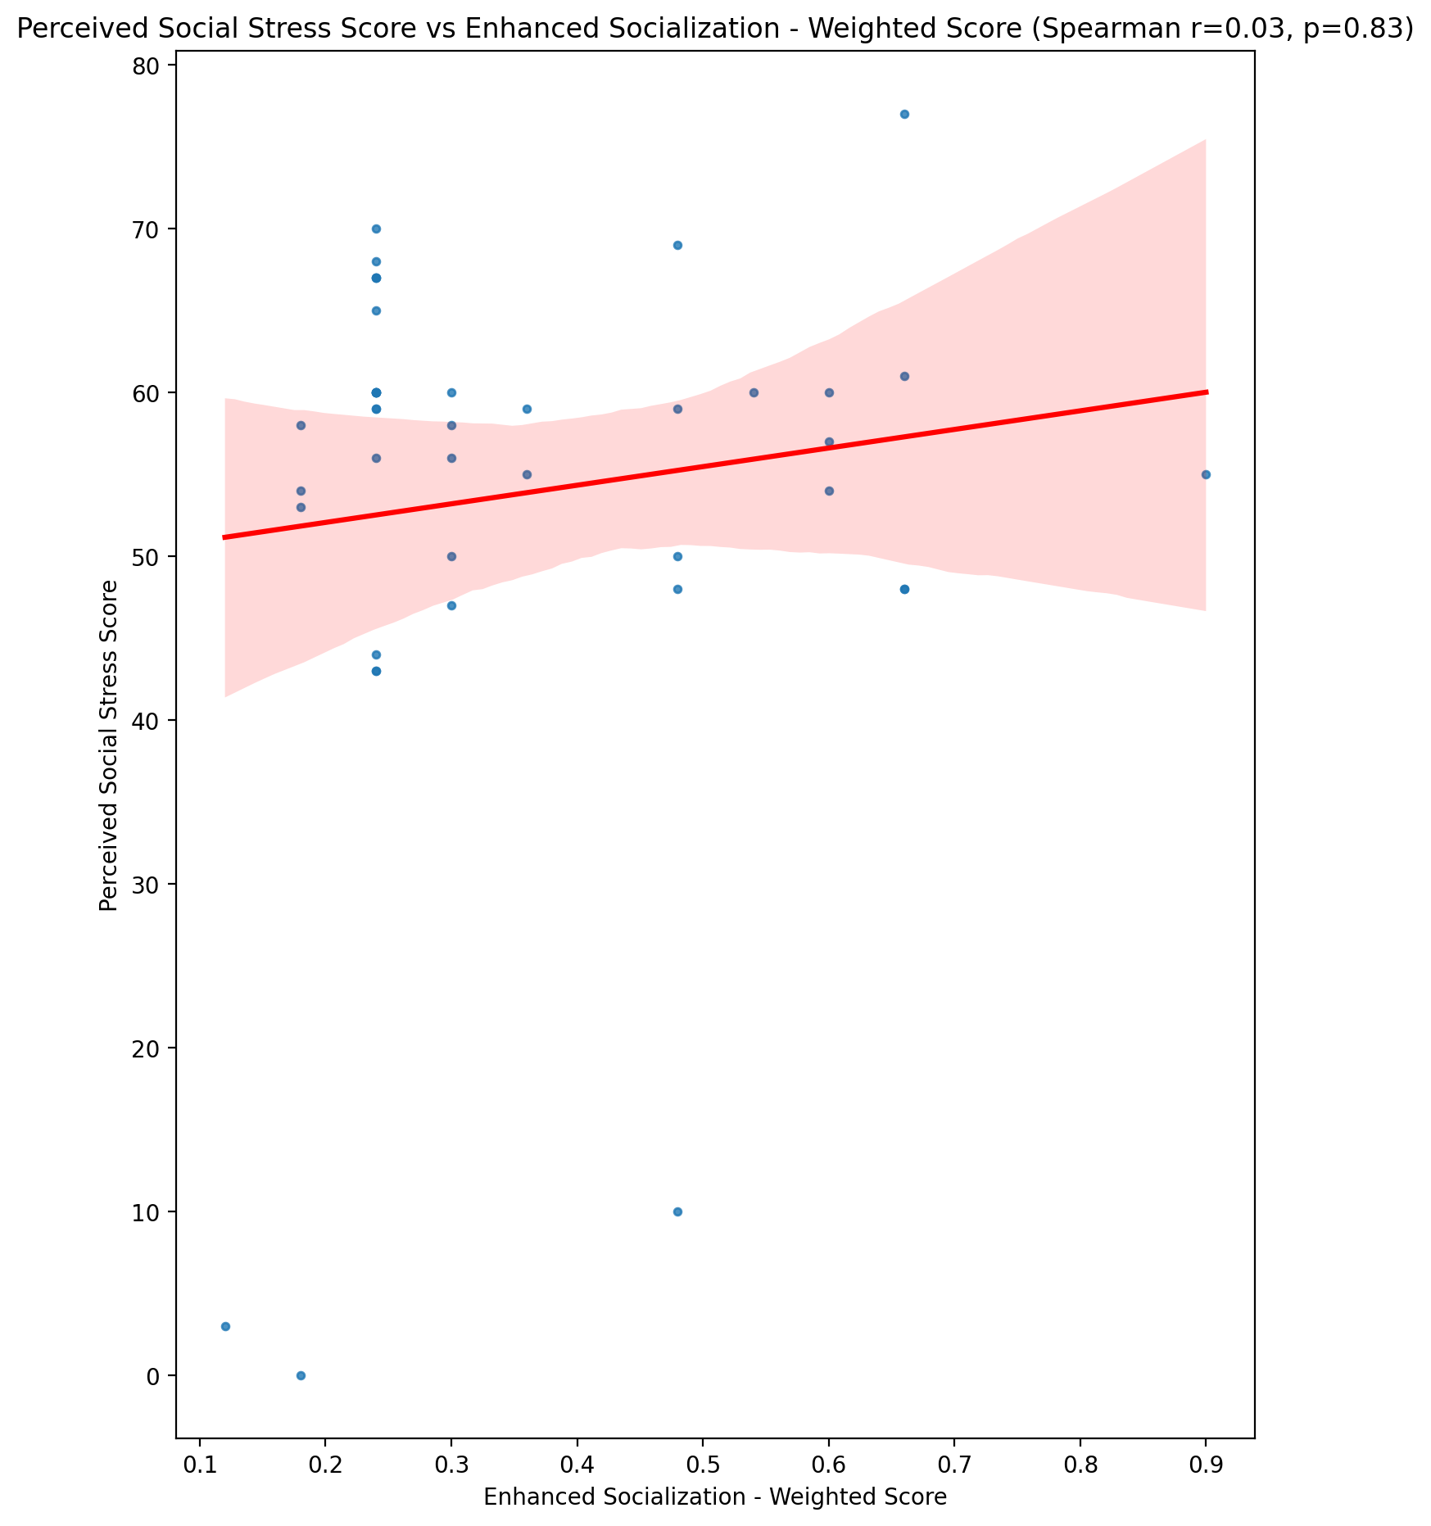

## Perceived Social Stress Category vs Enhanced Socialization - Weighted Score

Test: None; statistic: None; p-value: None; Test not run: unsupported type combination.



## Emotional Support - Raw Score vs Perceived Control of Internet Use - Weighted Score

Test: spearman; statistic: -0.003218792862282383; p-value: 0.9836563934664863;

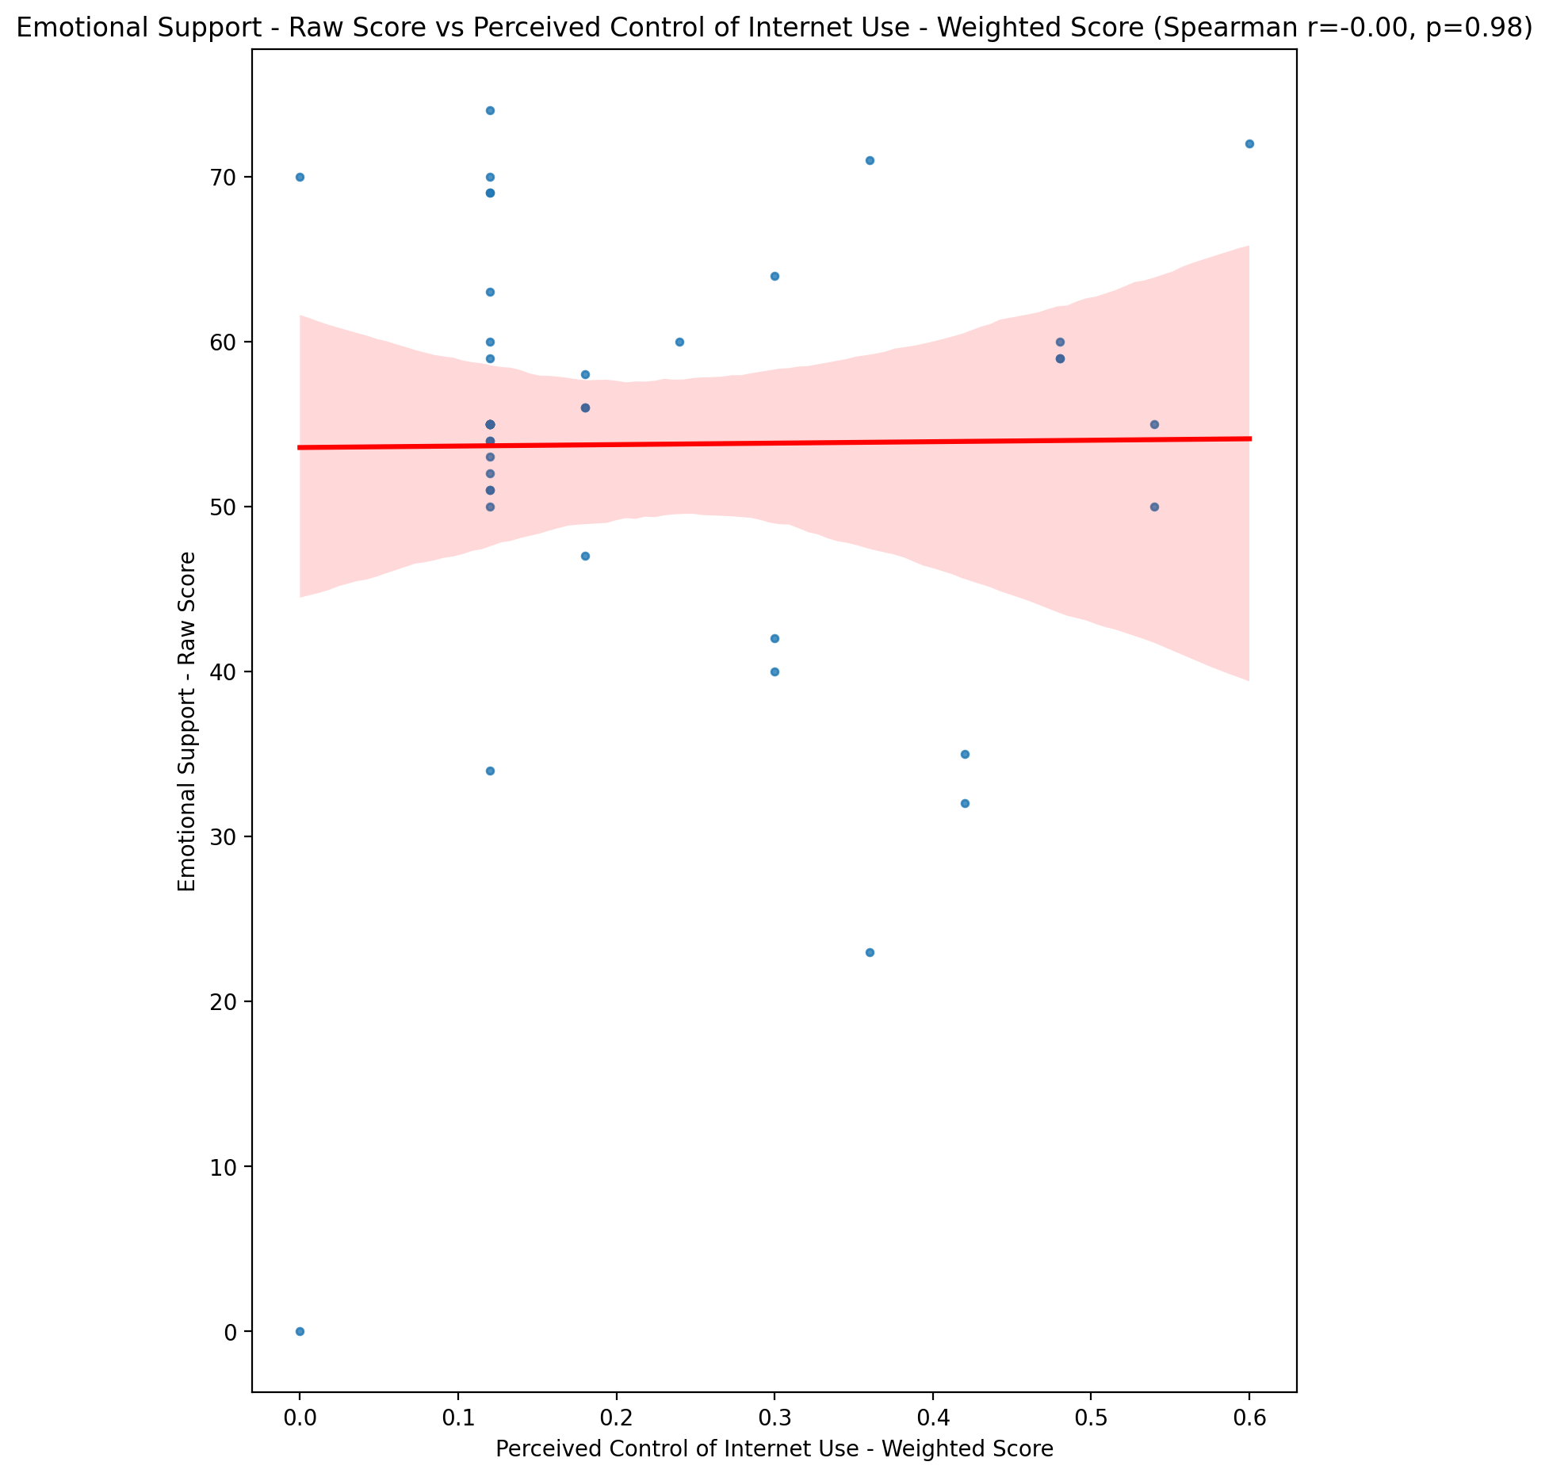

## Informational Support - Raw Score vs Perceived Control of Internet Use - Weighted Score

Test: spearman; statistic: -0.09134187691359409; p-value: 0.5602037869356875;

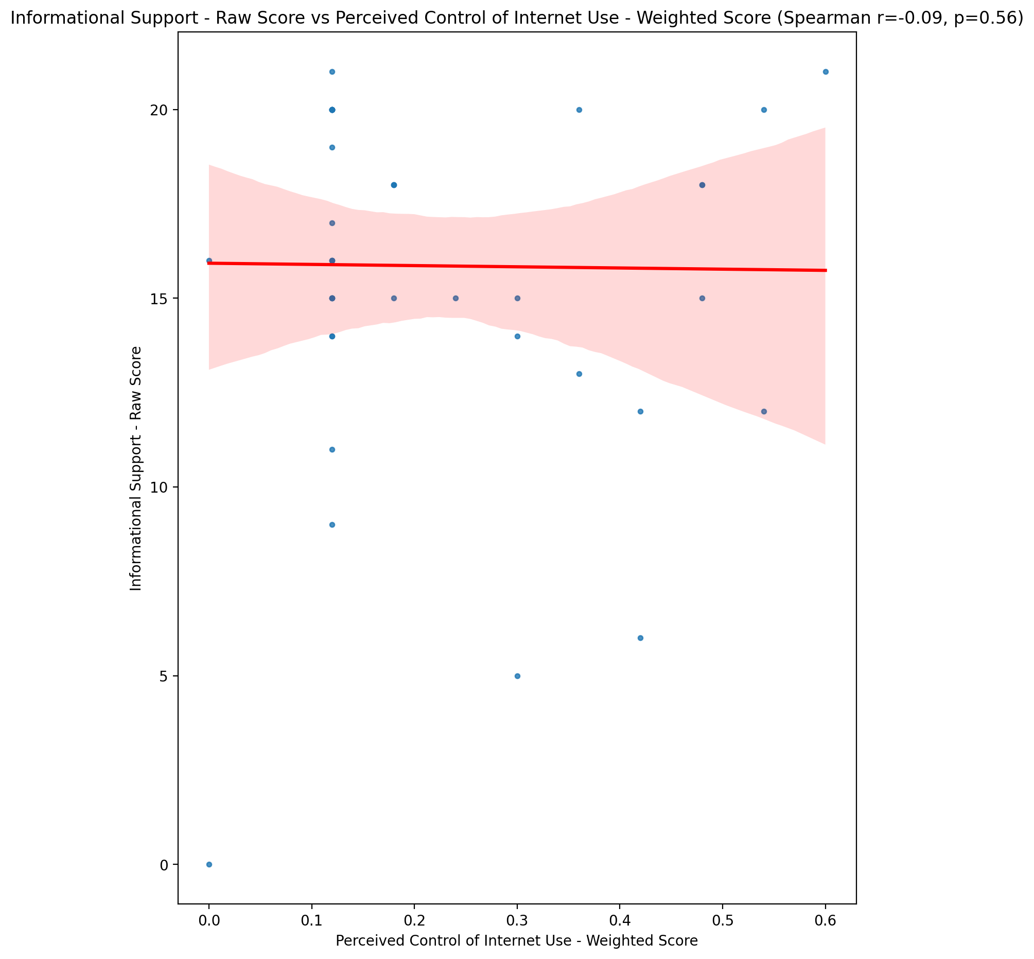

## Instrumental Support - Raw Score vs Perceived Control of Internet Use - Weighted Score

Test: spearman; statistic: 0.011842095985470289; p-value: 0.9399217951075212;

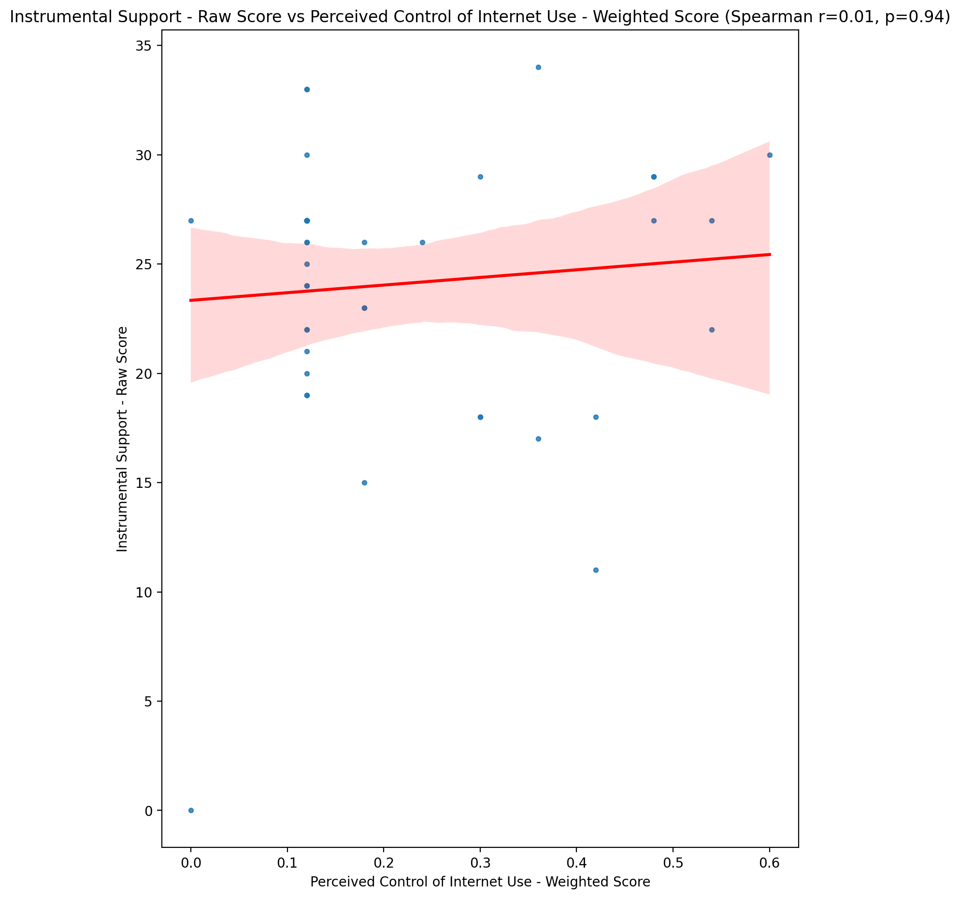

## Emotional Support - T Score vs Perceived Control of Internet Use - Weighted Score

Test: spearman; statistic: 0.05018781239242274; p-value: 0.7492660638410549;

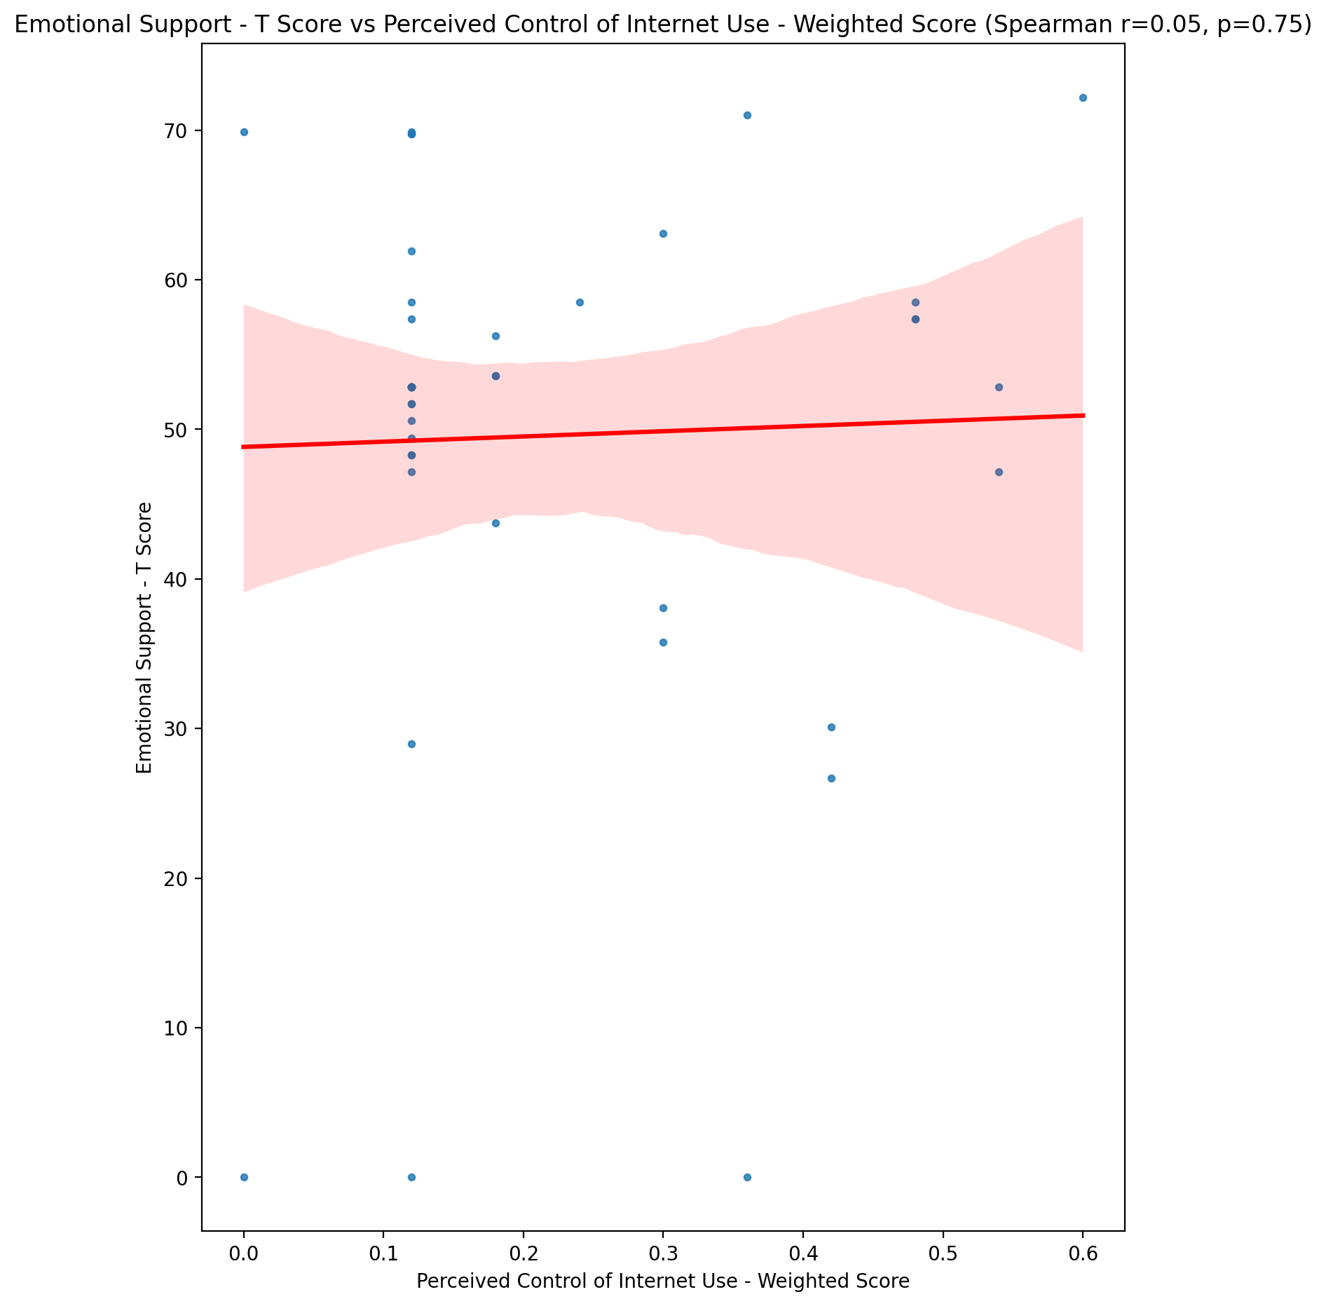

## Informational Support - T Score vs Perceived Control of Internet Use - Weighted Score

Test: spearman; statistic: -0.0971801927337139; p-value: 0.5352938163088803;

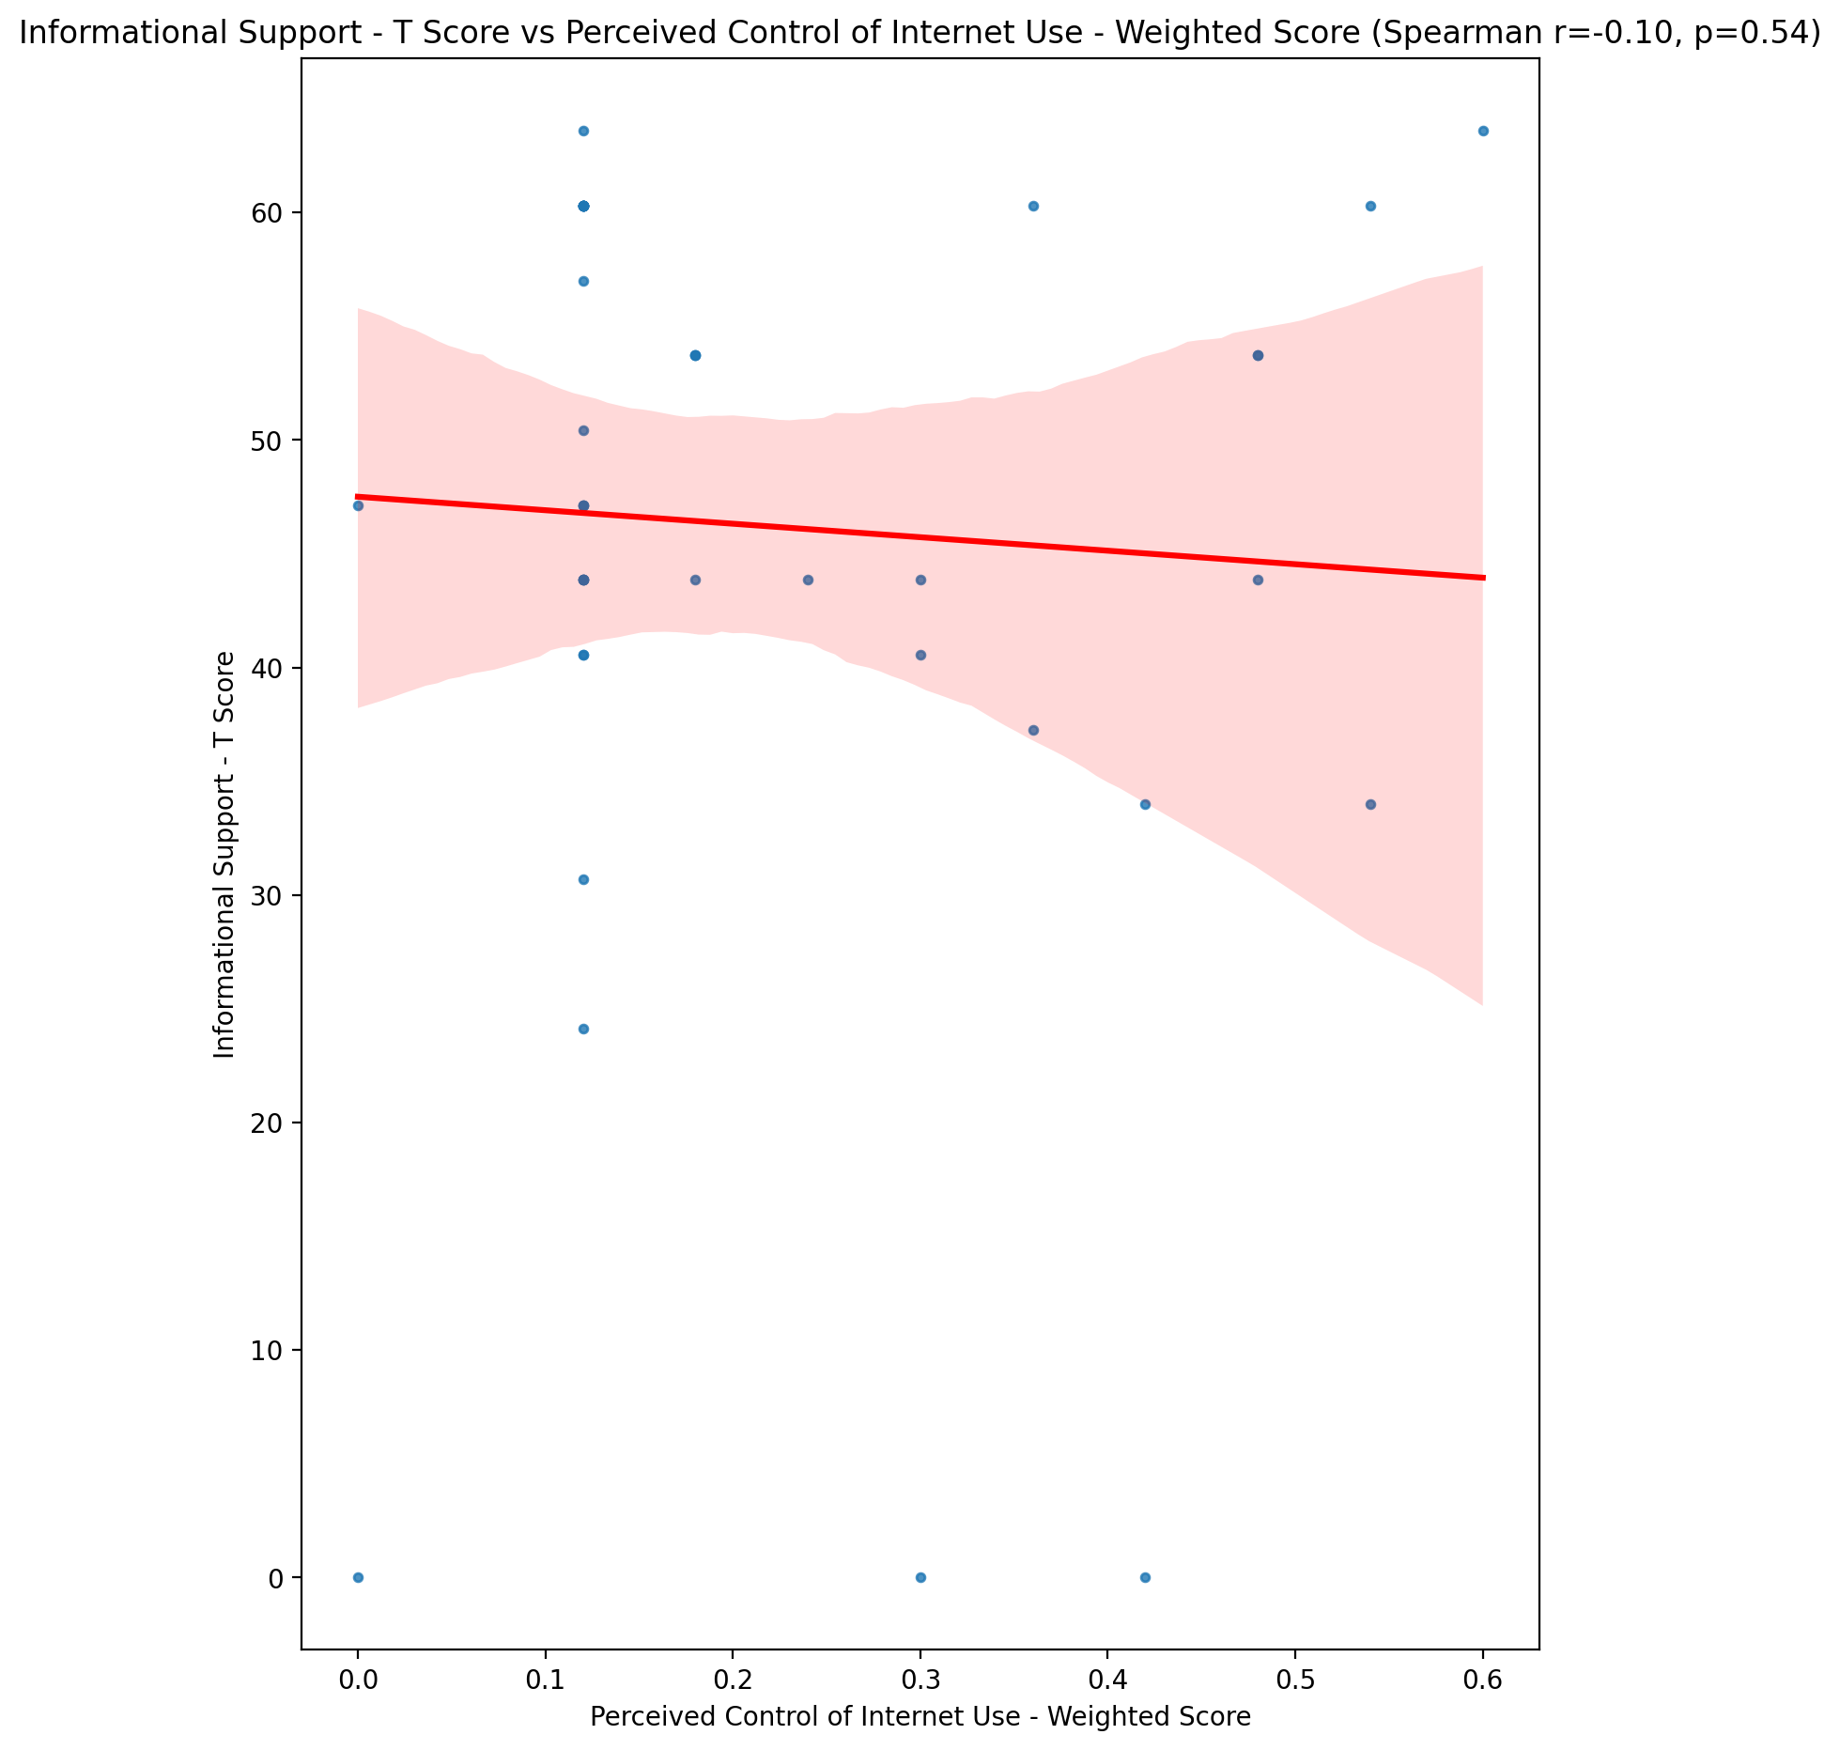

## Instrumental Support - T Score vs Perceived Control of Internet Use - Weighted Score

Test: spearman; statistic: 0.008933856456632536; p-value: 0.9546582979008393;

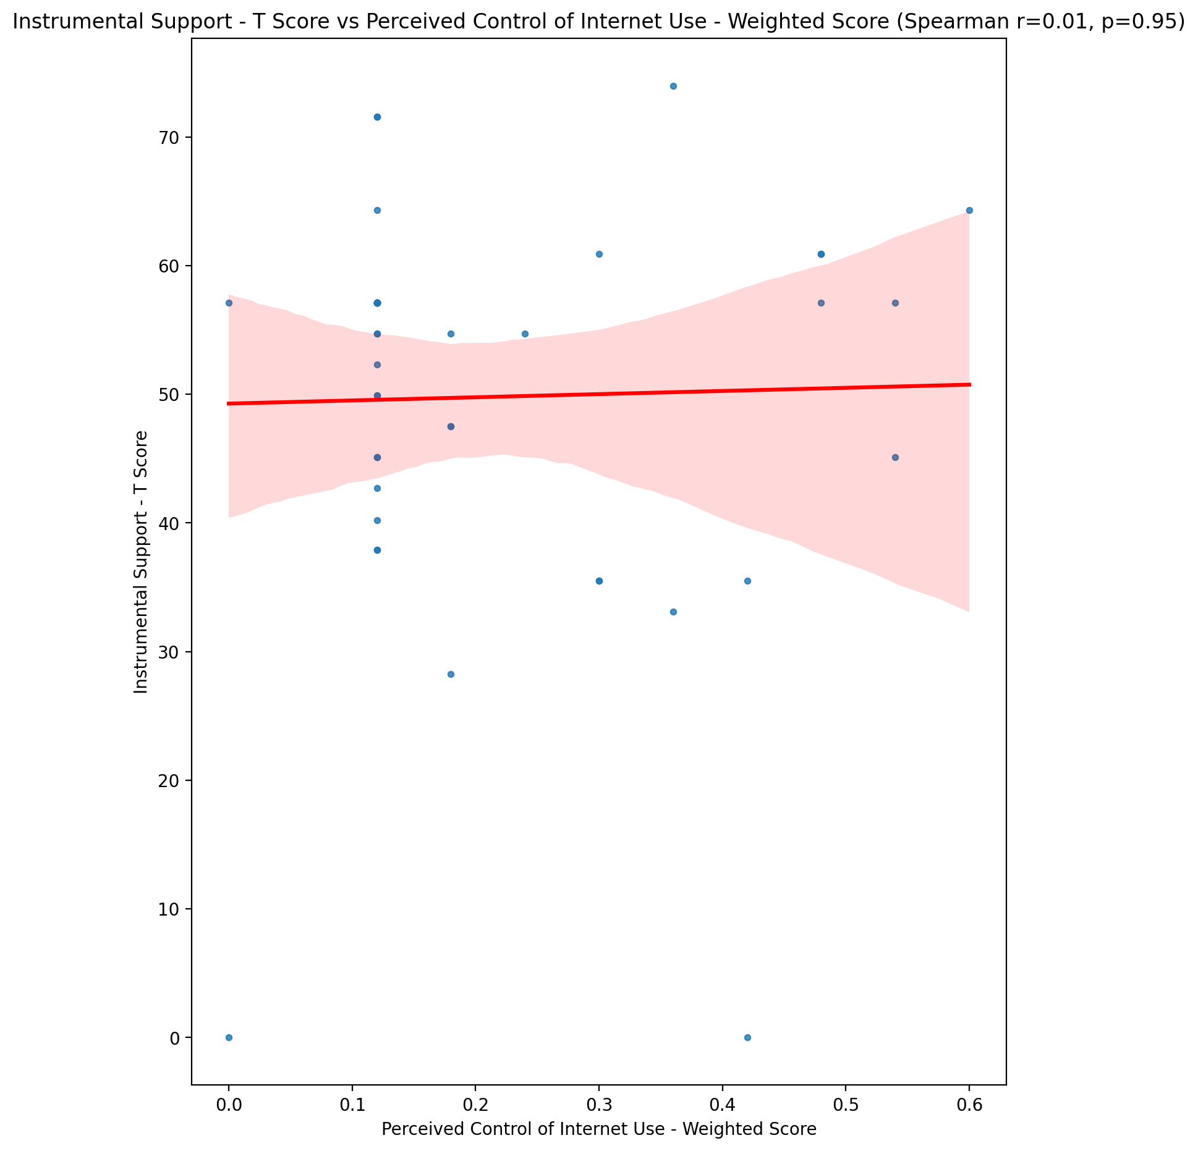

## Perceived Social Support Total T Score vs Perceived Control of Internet Use - Weighted Score

Test: spearman; statistic: -0.048309978214460675; p-value: 0.7583604541952784;

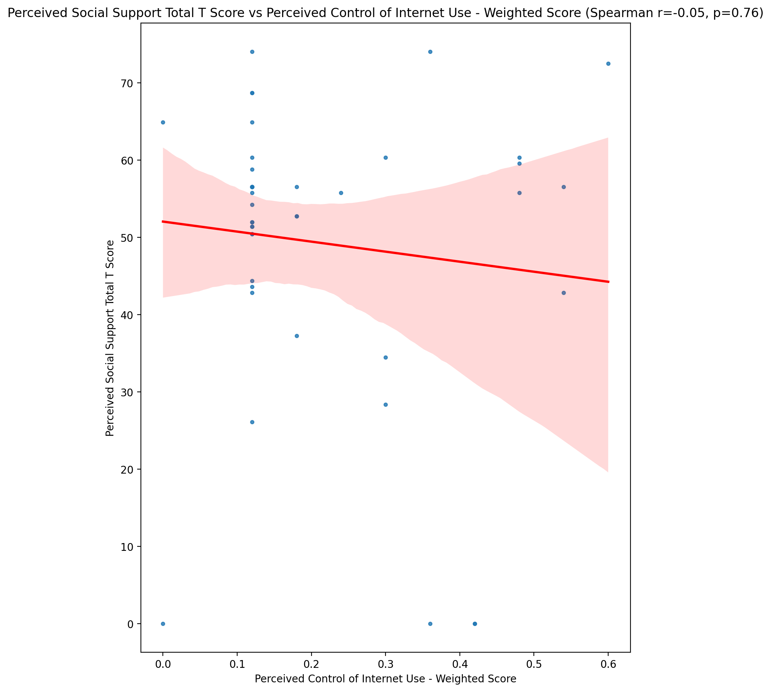

## Emotional Support - Rank vs Perceived Control of Internet Use - Weighted Score

Test: None; statistic: None; p-value: None; Test not run: unsupported type combination.



## Informational Support - Rank vs Perceived Control of Internet Use - Weighted Score

Test: None; statistic: None; p-value: None; Test not run: unsupported type combination.



## Instrumental Support - Rank vs Perceived Control of Internet Use - Weighted Score

Test: None; statistic: None; p-value: None; Test not run: unsupported type combination.



## Perceived Social Support TOTAL - Rank vs Perceived Control of Internet Use - Weighted Score

Test: None; statistic: None; p-value: None; Test not run: unsupported type combination.



## Power Self Concept - Real Self Concept Score vs Perceived Control of Internet Use - Weighted Score

Test: spearman; statistic: -0.15367137148507706; p-value: 0.32518591381205486;

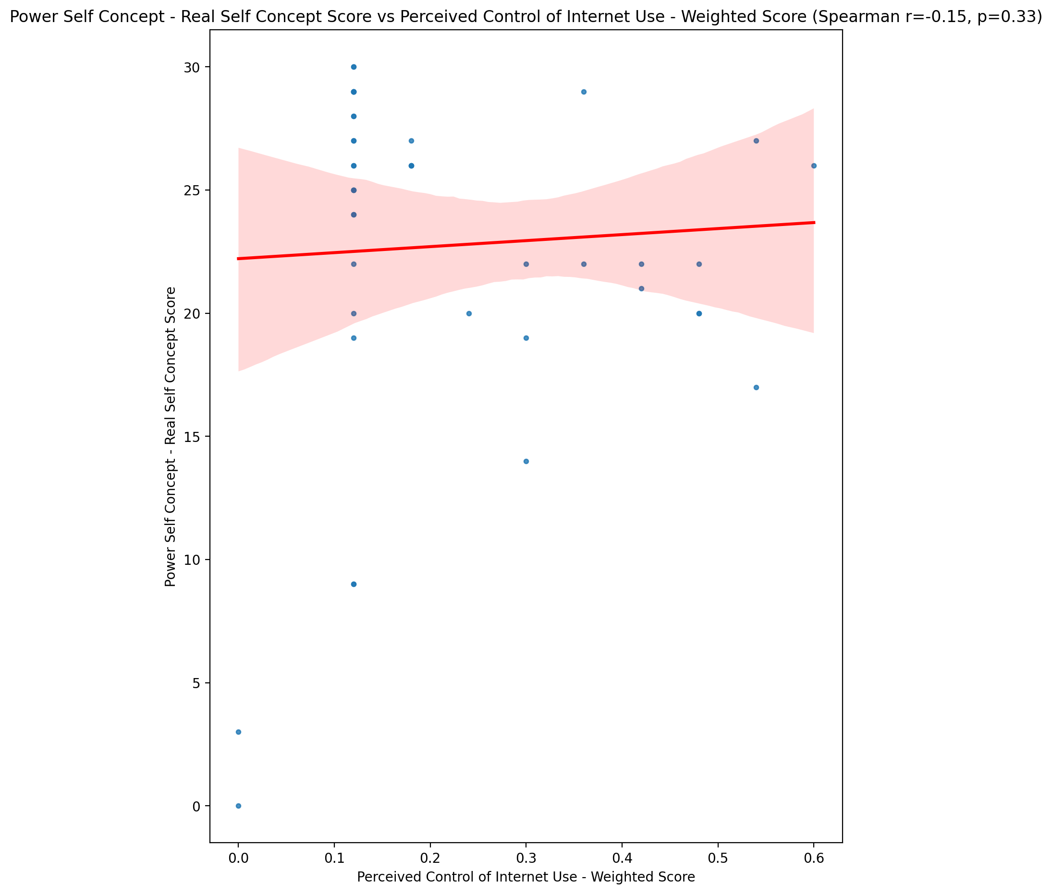

## Power Self Concept - Ideal Self Concept score vs Perceived Control of Internet Use - Weighted Score

Test: spearman; statistic: -0.0016952950632546312; p-value: 0.9913916225851913;

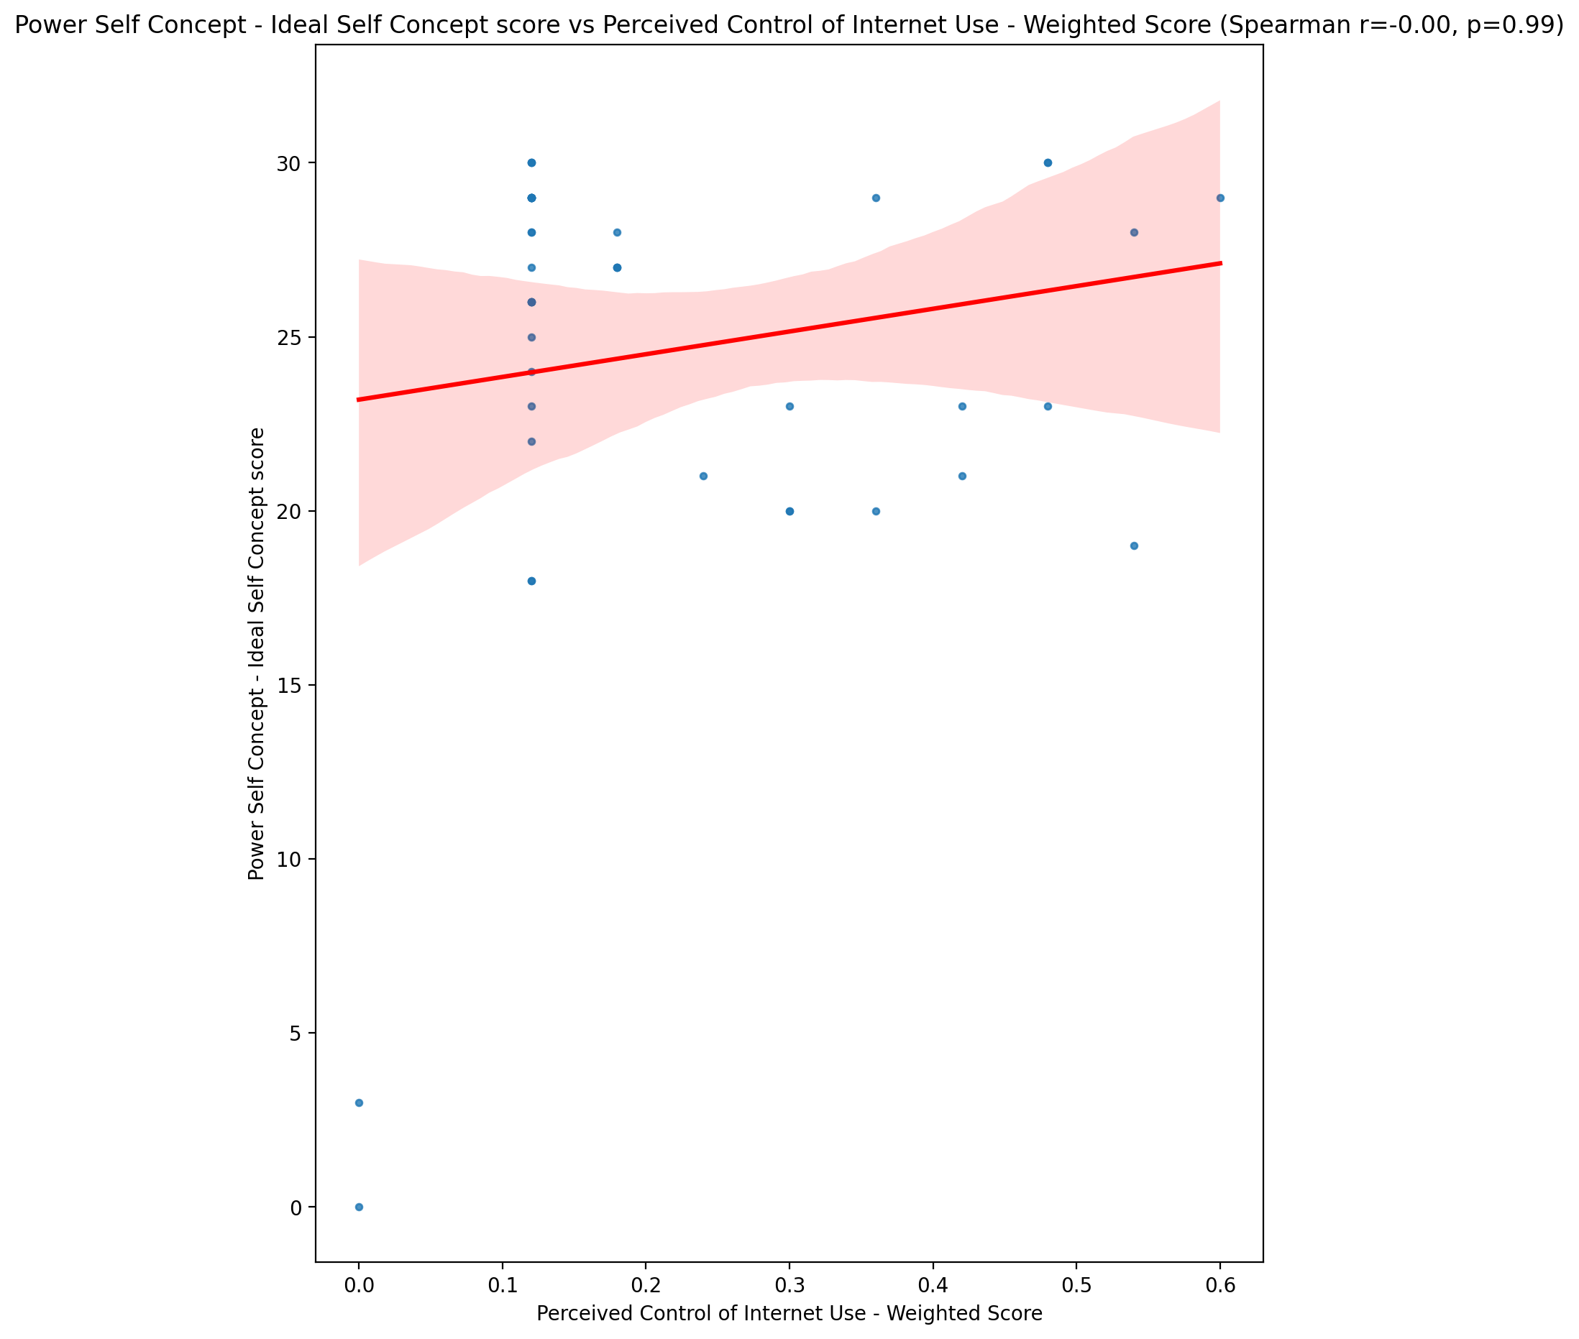

## Power Self Concept – Social Self Concept Score vs Perceived Control of Internet Use - Weighted Score

Test: spearman; statistic: -0.06372040550545453; p-value: 0.6847844656348847;

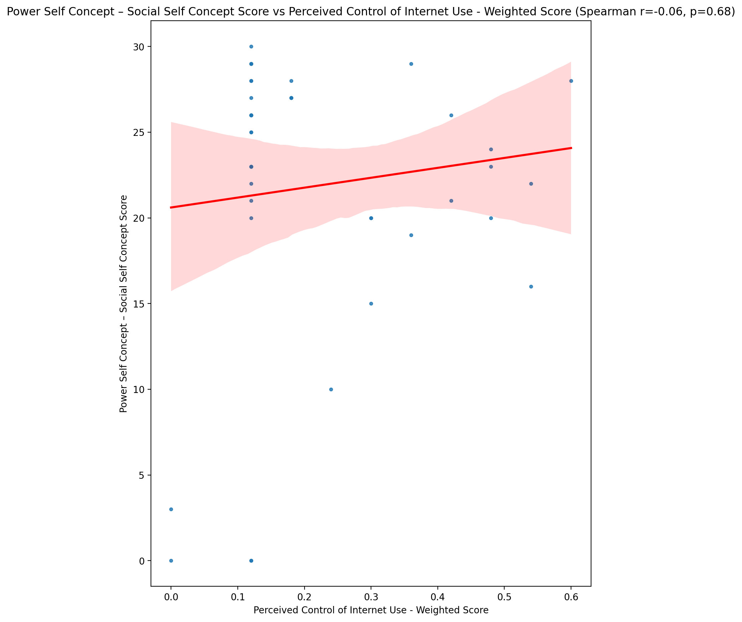

## Social Self Concept - Real Self Concept Score vs Perceived Control of Internet Use - Weighted Score

Test: spearman; statistic: -0.1024043480477656; p-value: 0.5134700704801298;

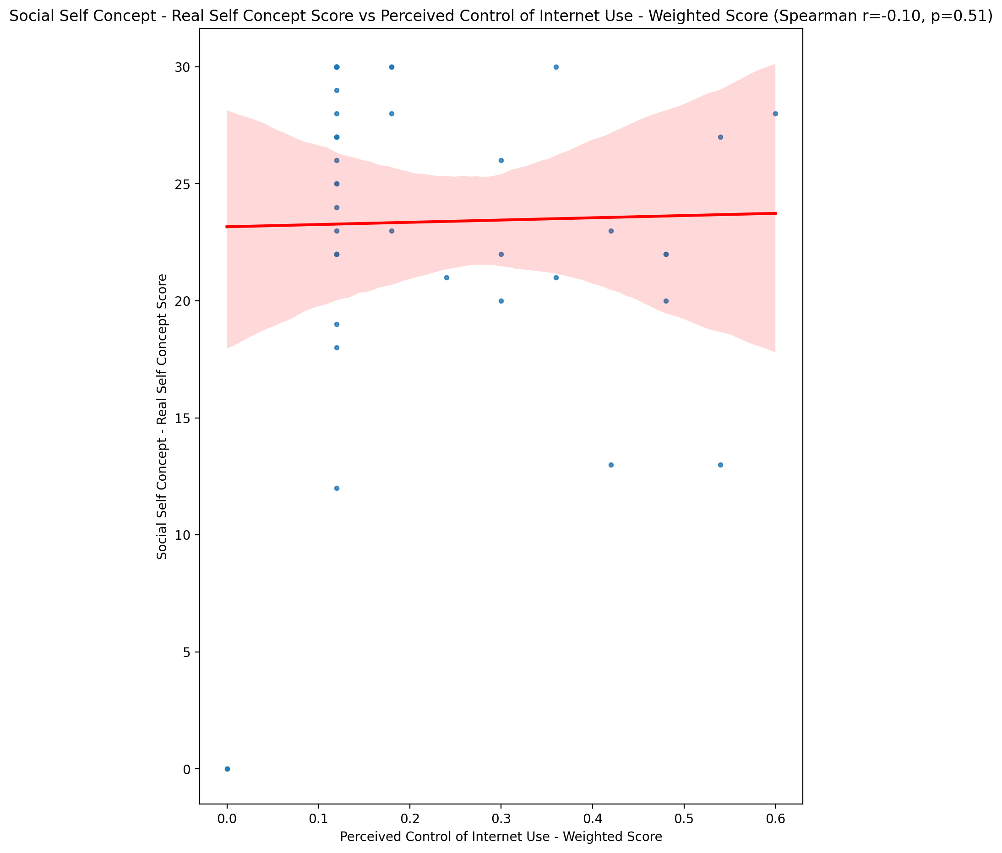

## Social Self Concept – Social Self Concept Score vs Perceived Control of Internet Use - Weighted Score

Test: spearman; statistic: -0.00045445259317994786; p-value: 0.9976923384282754;

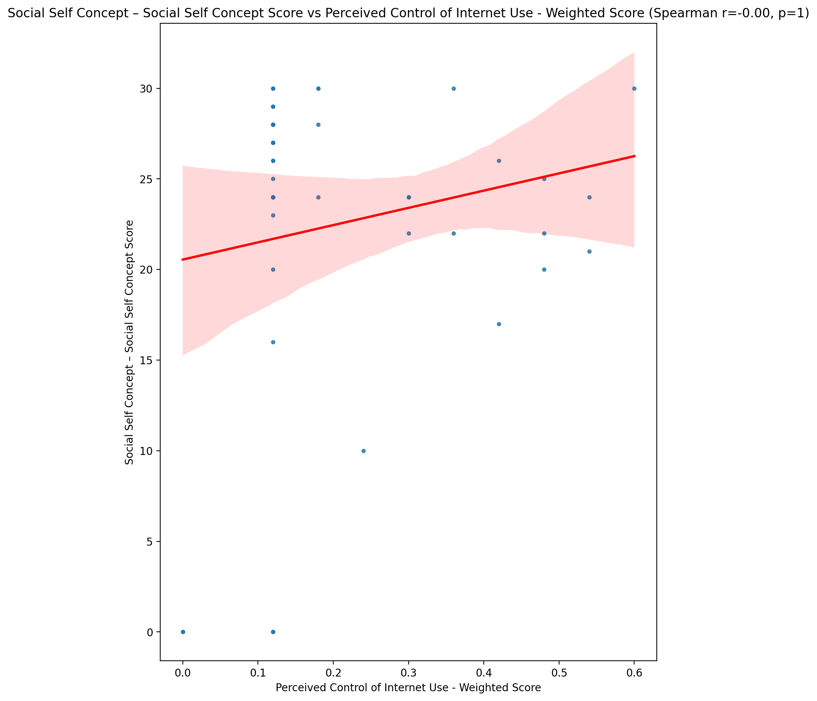

## Ability Self Concept - Real Self Concept Score vs Perceived Control of Internet Use - Weighted Score

Test: spearman; statistic: -0.0844393569339897; p-value: 0.5903334776397295;

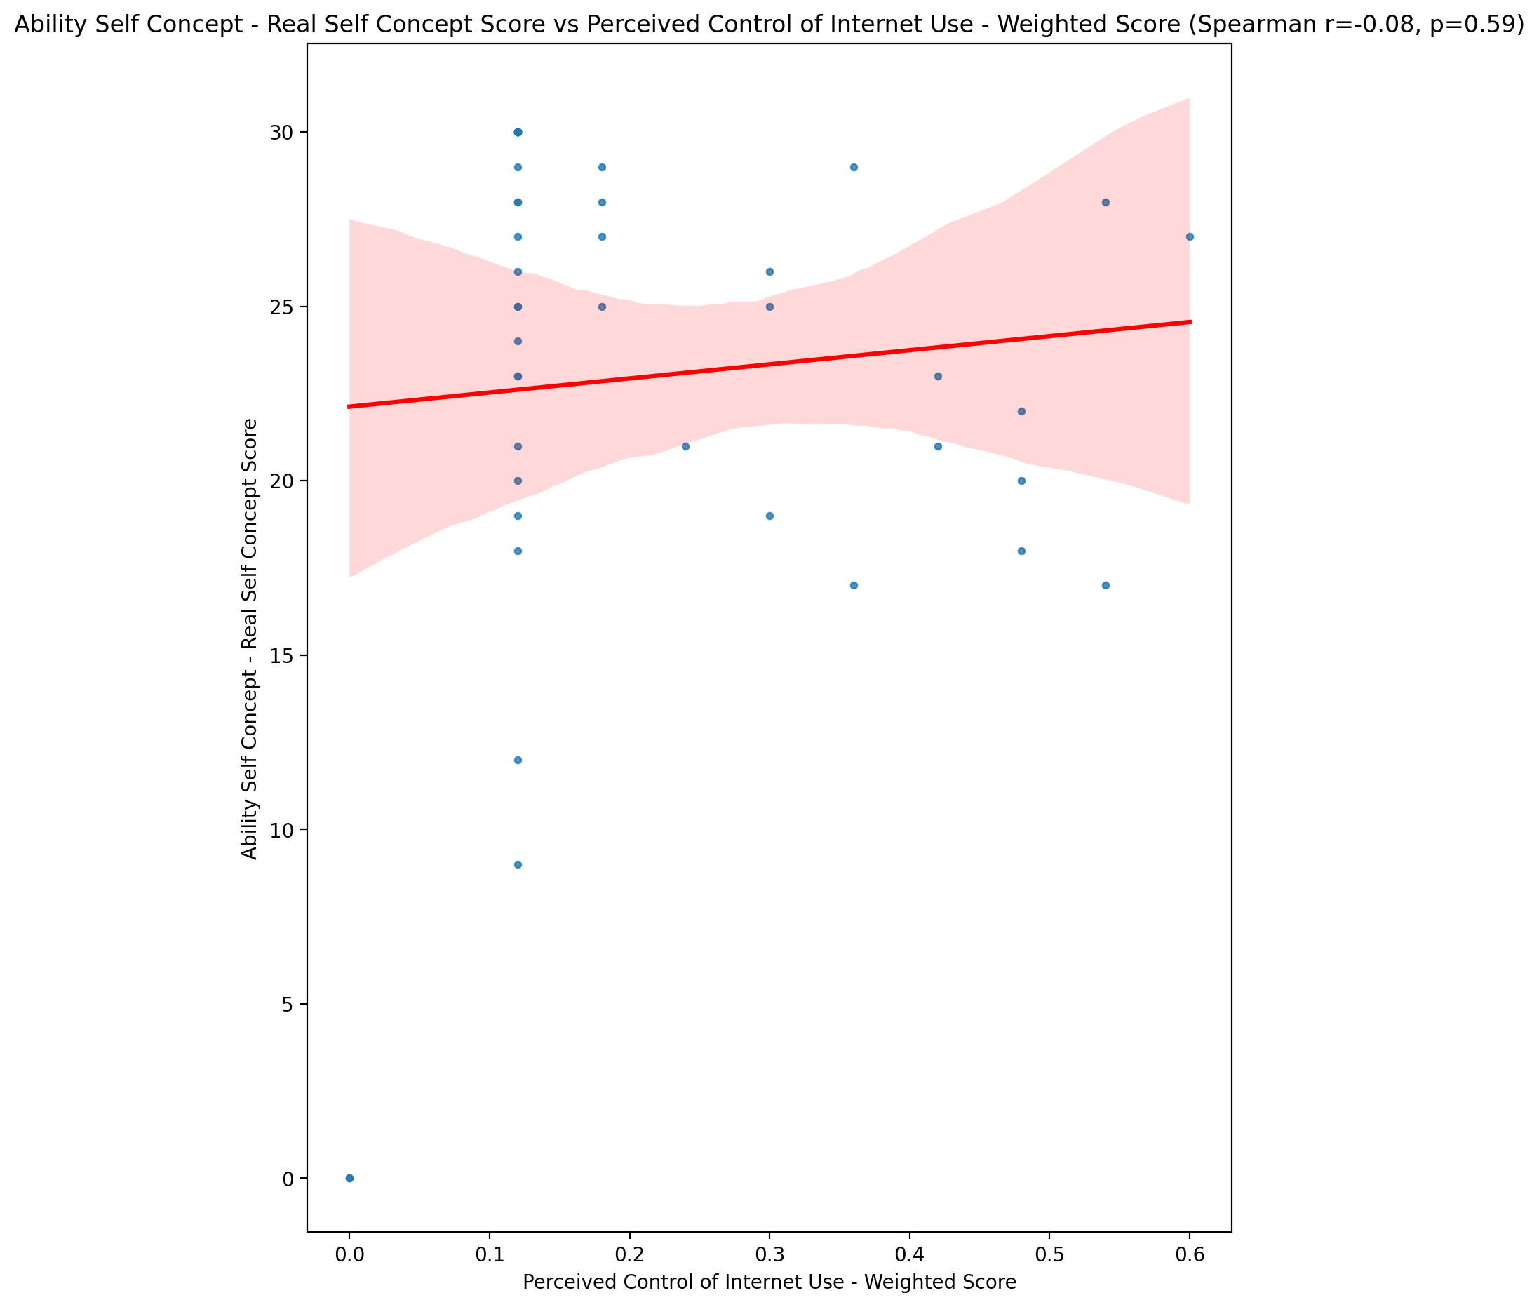

## Ability Self Concept - Ideal Self Concept Score vs Perceived Control of Internet Use - Weighted Score

Test: spearman; statistic: 0.030966601433946556; p-value: 0.8437296269690043;

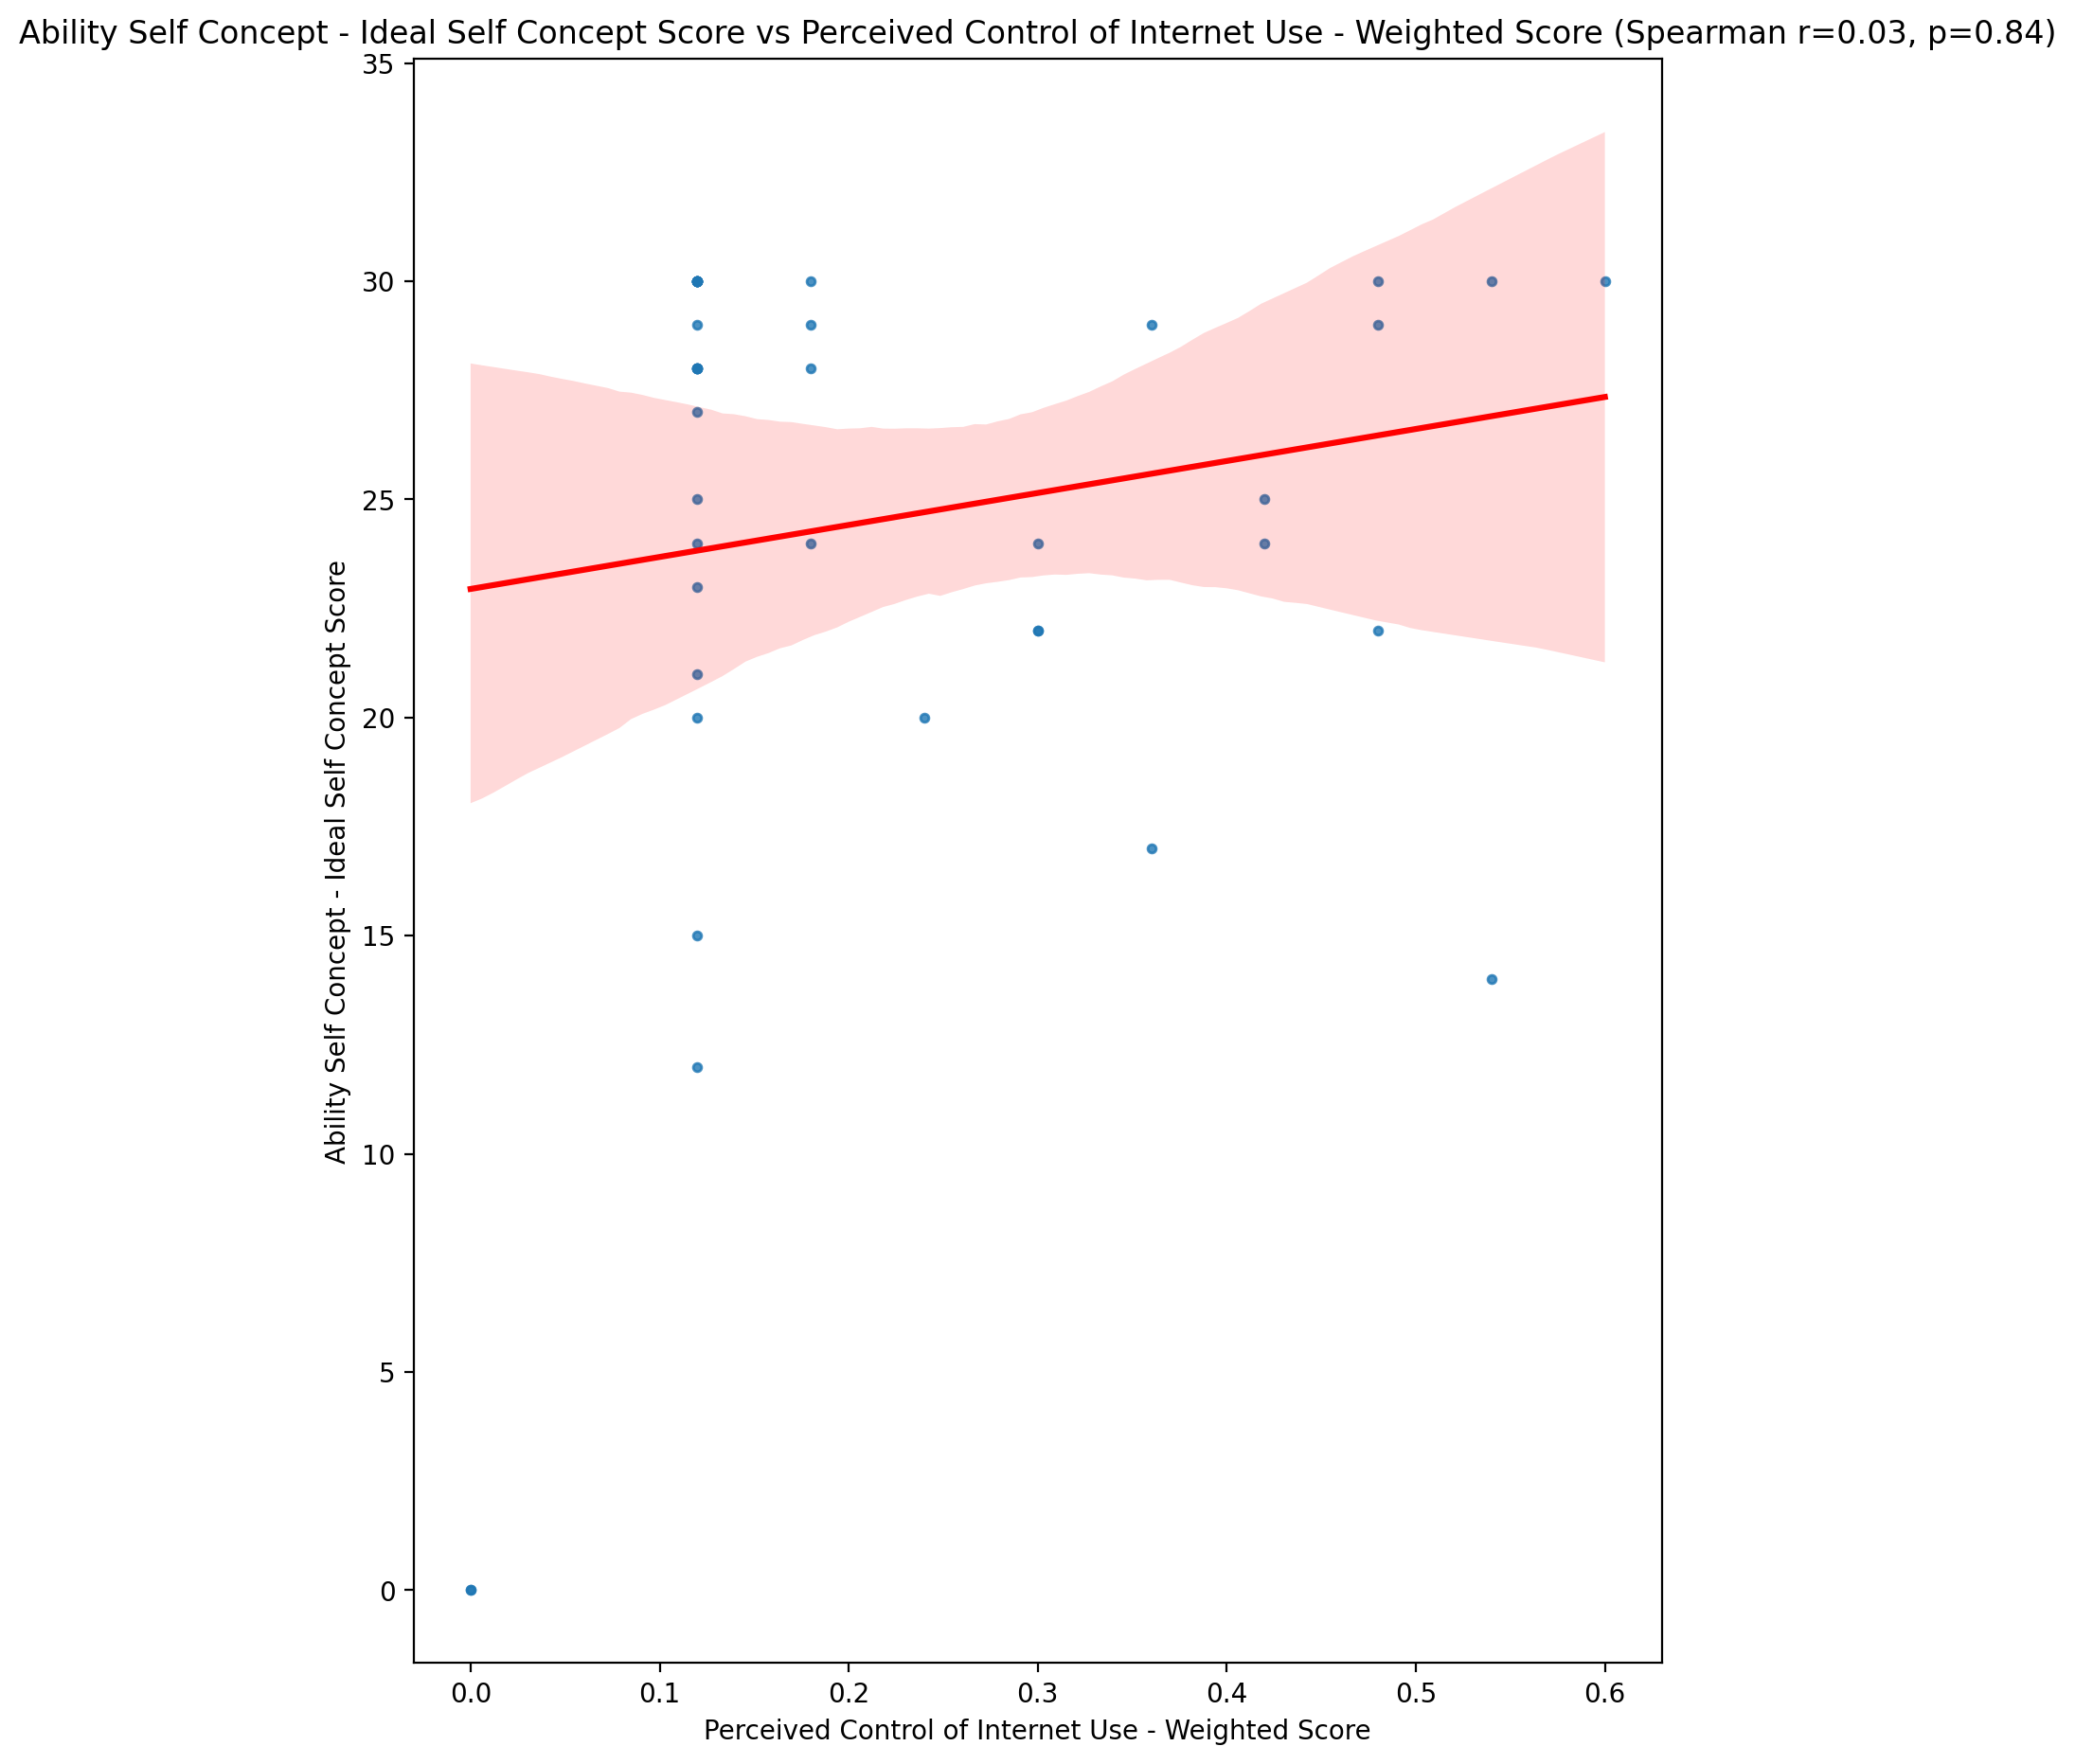

## Ability Self Concept – Social Self Concept Score vs Perceived Control of Internet Use - Weighted Score

Test: spearman; statistic: -0.012605476492196576; p-value: 0.9360567081443997;

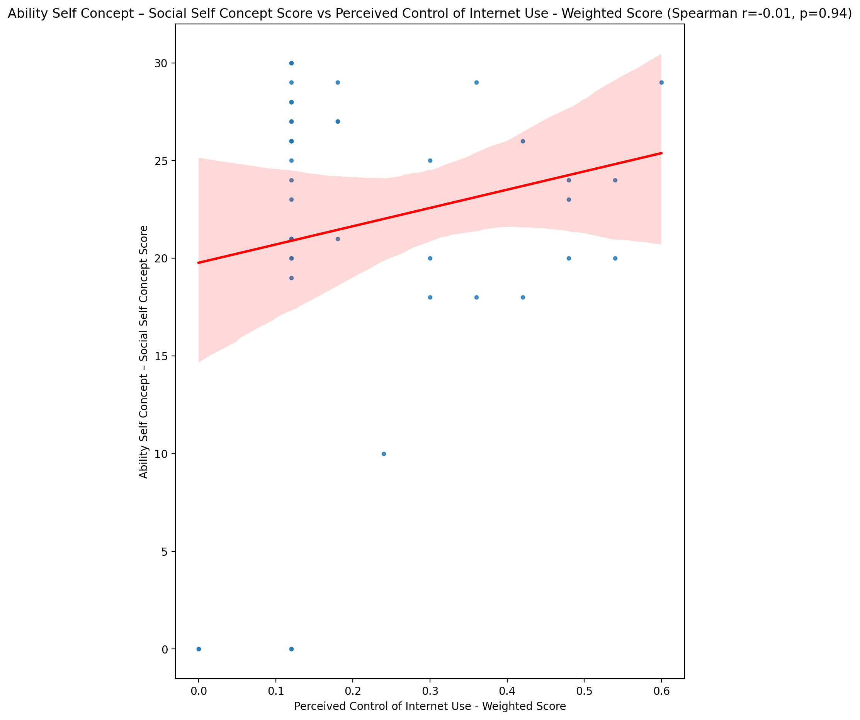

## Physical Self Concept - Real Self Concept Score vs Perceived Control of Internet Use - Weighted Score

Test: spearman; statistic: -0.13550392982183748; p-value: 0.38628110707530405;

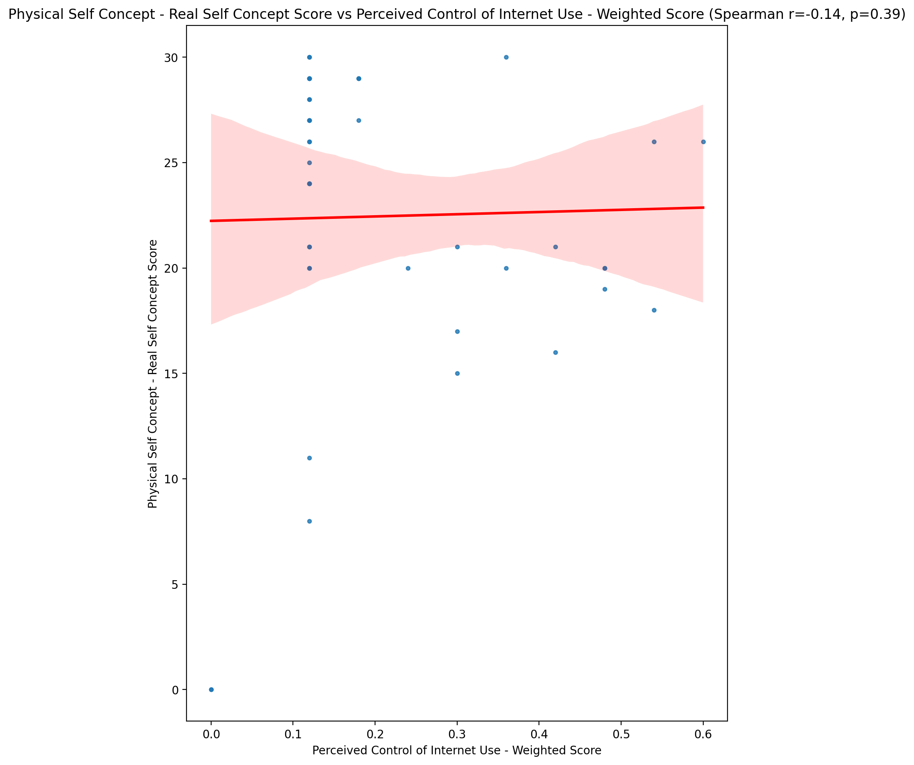

## Physical Self Concept – Ideal Self Concept Score vs Perceived Control of Internet Use - Weighted Score

Test: spearman; statistic: 0.04076914172694024; p-value: 0.7951945186446454;

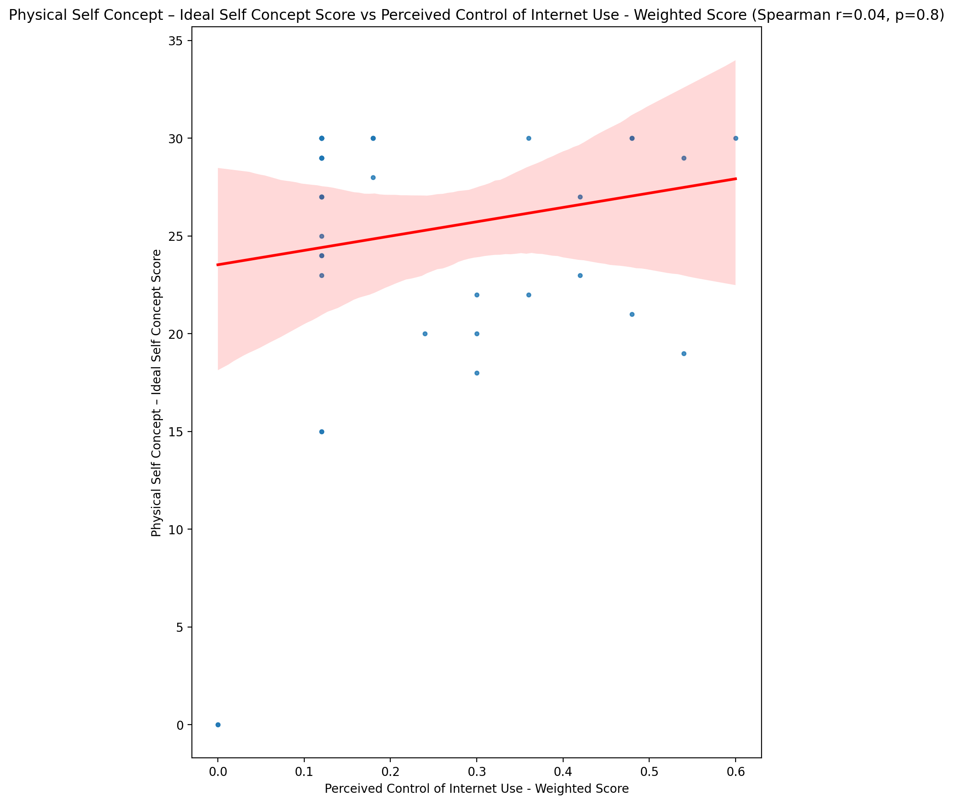

## Physical Self Concept – Social Self Concept Score vs Perceived Control of Internet Use - Weighted Score

Test: spearman; statistic: 0.0920578551687013; p-value: 0.5571201013919023;

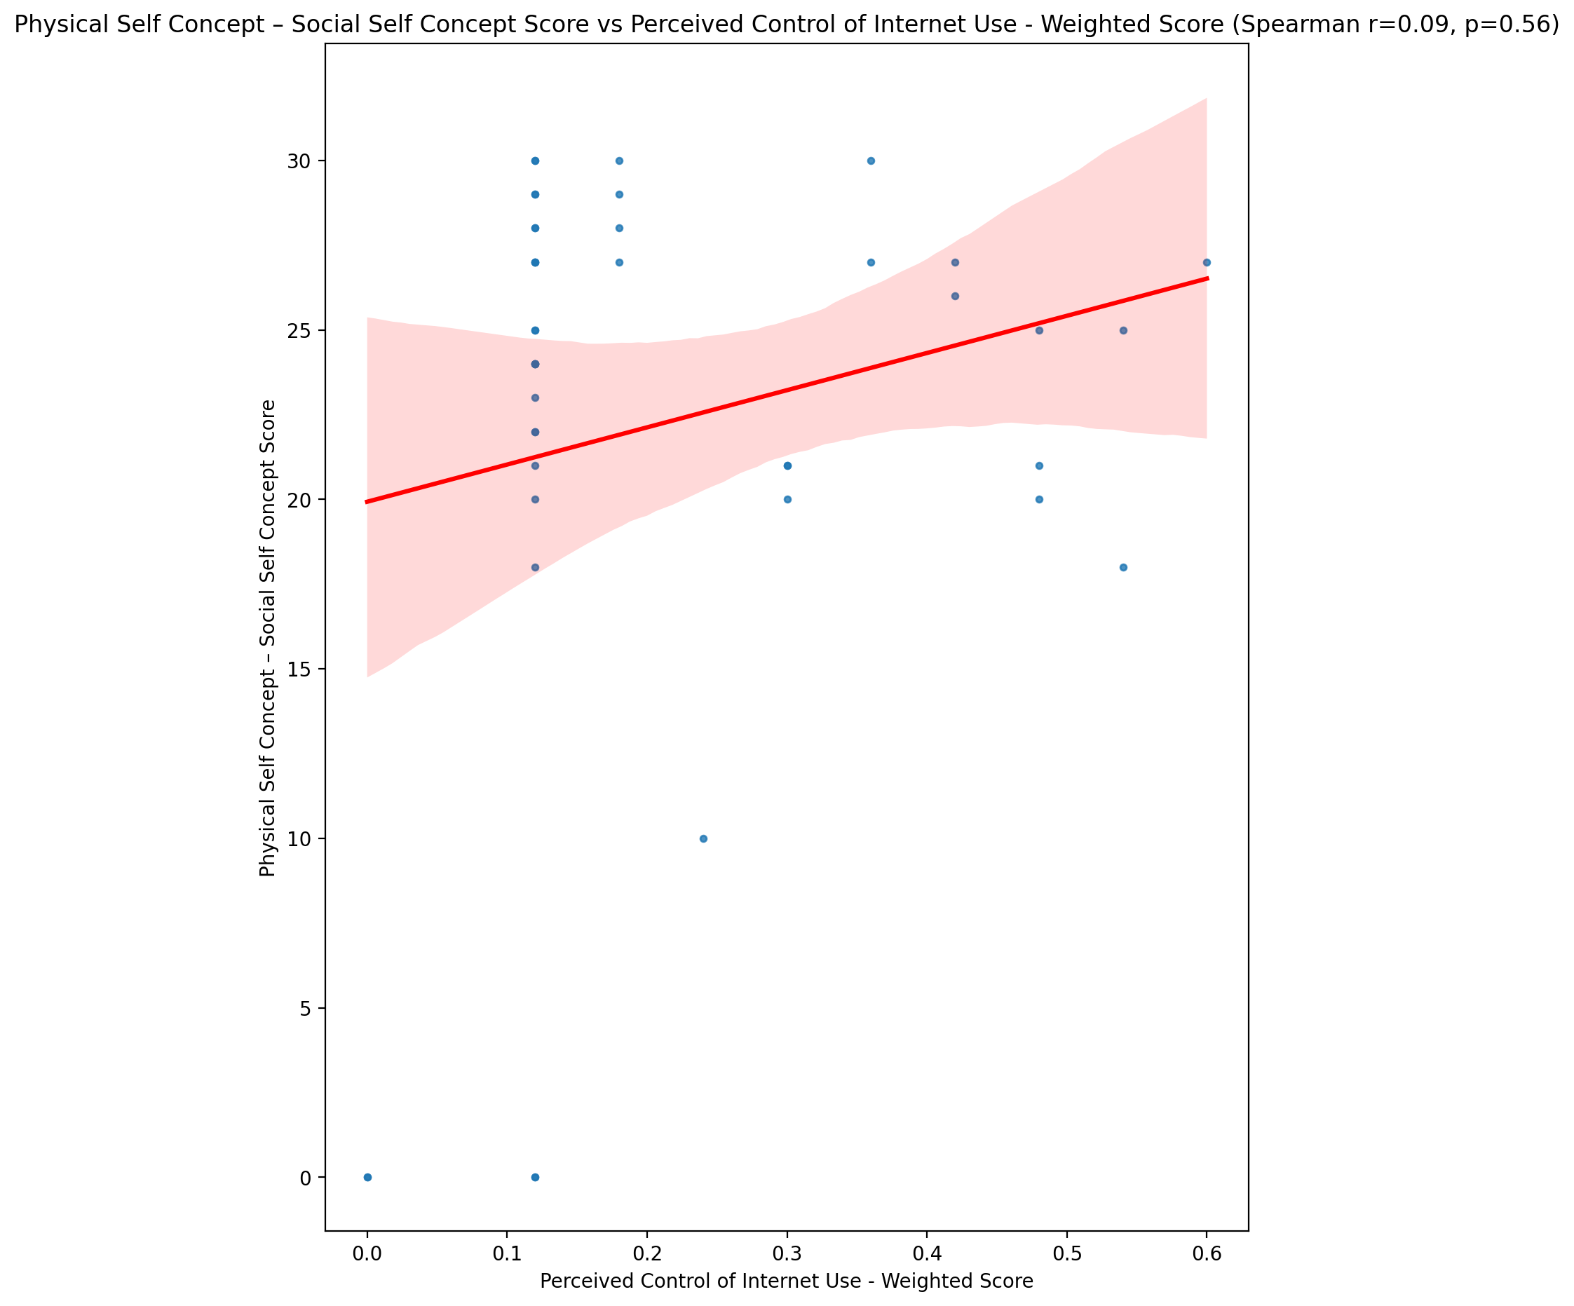

## Psychological Self Concept - Real Self Concept Score vs Perceived Control of Internet Use - Weighted Score

Test: spearman; statistic: -0.08558471630671152; p-value: 0.5852845519307904;

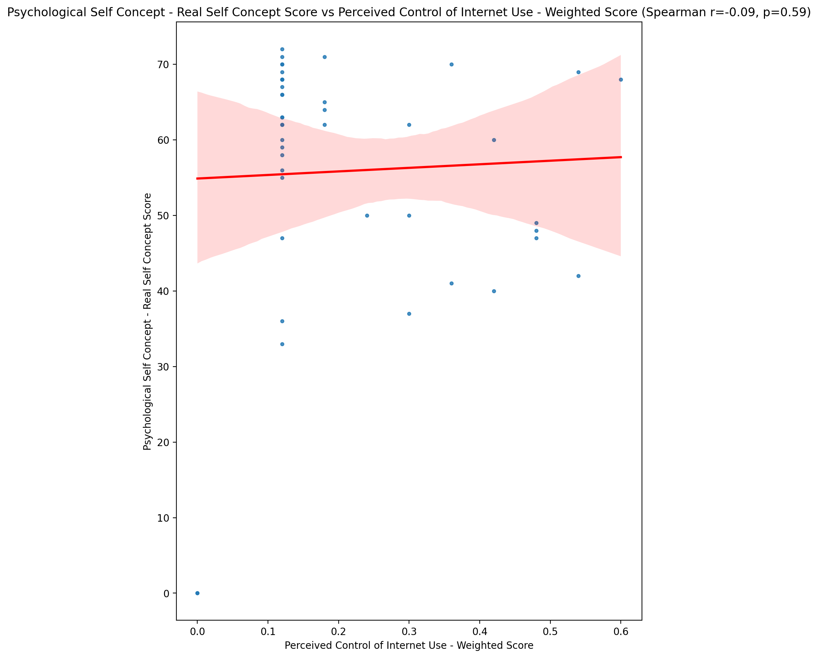

## Psychological Self Concept – Ideal Self Concept Score vs Perceived Control of Internet Use - Weighted Score

Test: spearman; statistic: 0.04036434447149694; p-value: 0.7971850701044233;

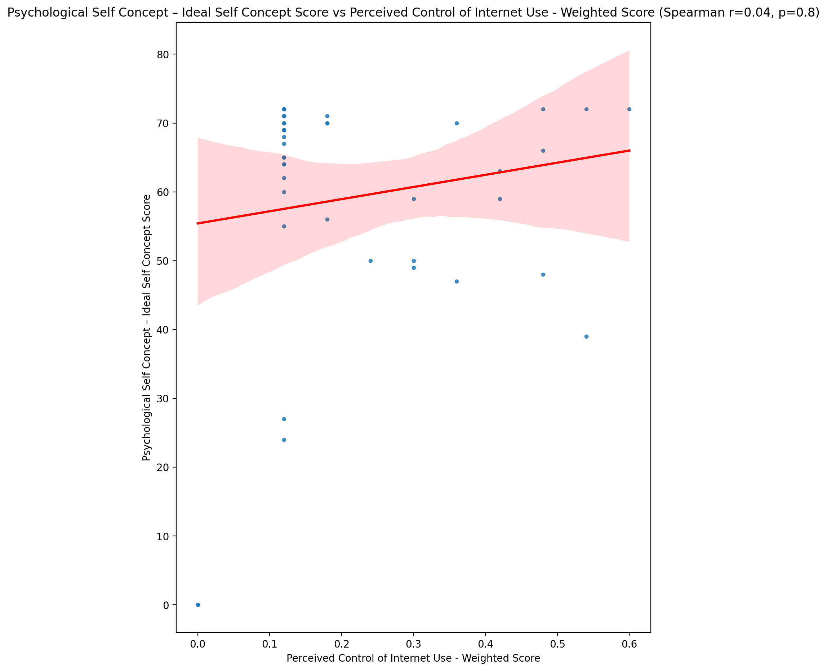

## Psychological Self Concept – Social Self Concept Score vs Perceived Control of Internet Use - Weighted Score

Test: spearman; statistic: -0.05893306079518881; p-value: 0.7073712357287121;

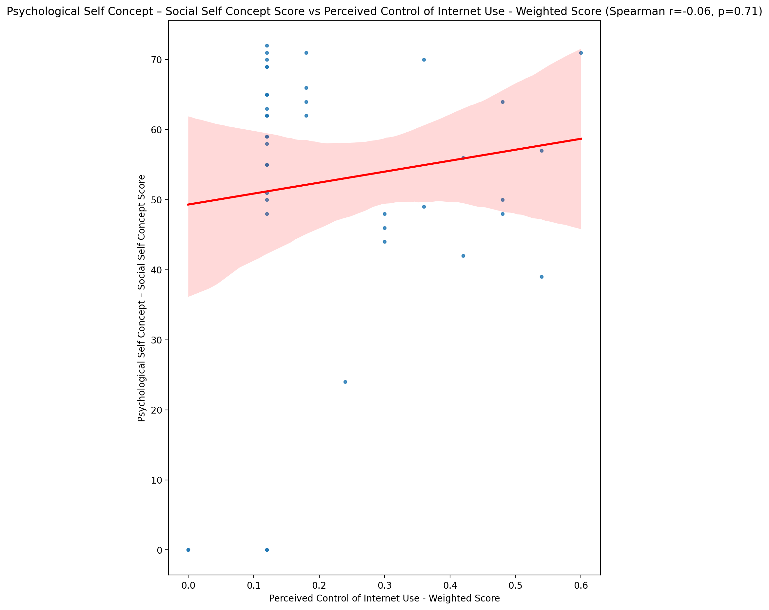

## Real Self Concept Total Score vs Perceived Control of Internet Use - Weighted Score

Test: spearman; statistic: -0.12433673176811239; p-value: 0.4269656211985404;

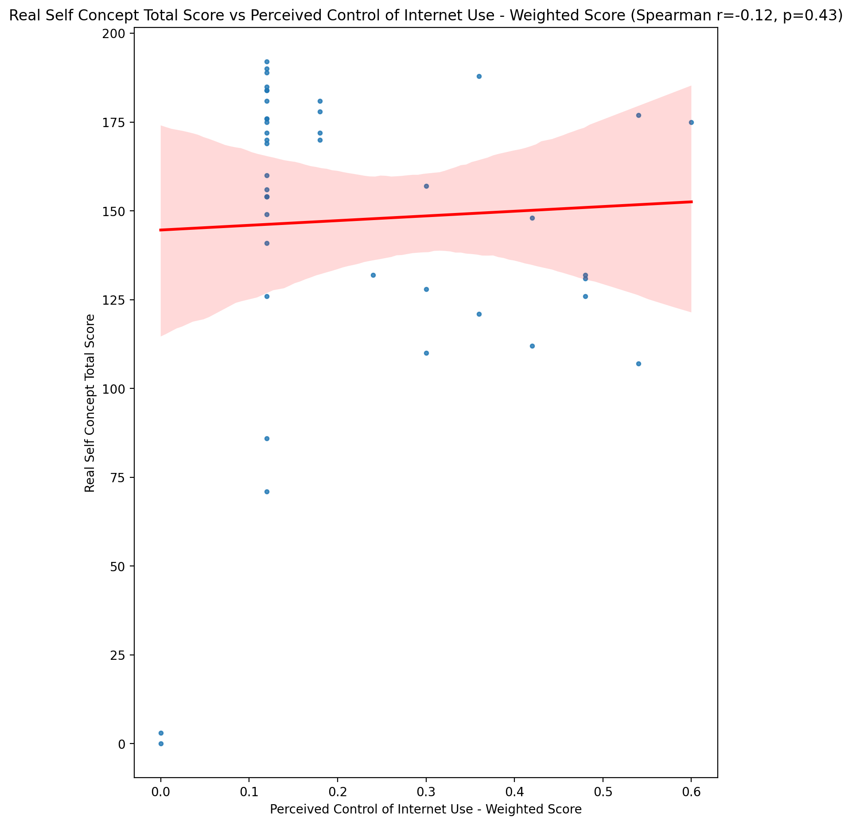

## Ideal Self Concept Total Score vs Perceived Control of Internet Use - Weighted Score

Test: spearman; statistic: 0.006942350804761672; p-value: 0.964758480001638;

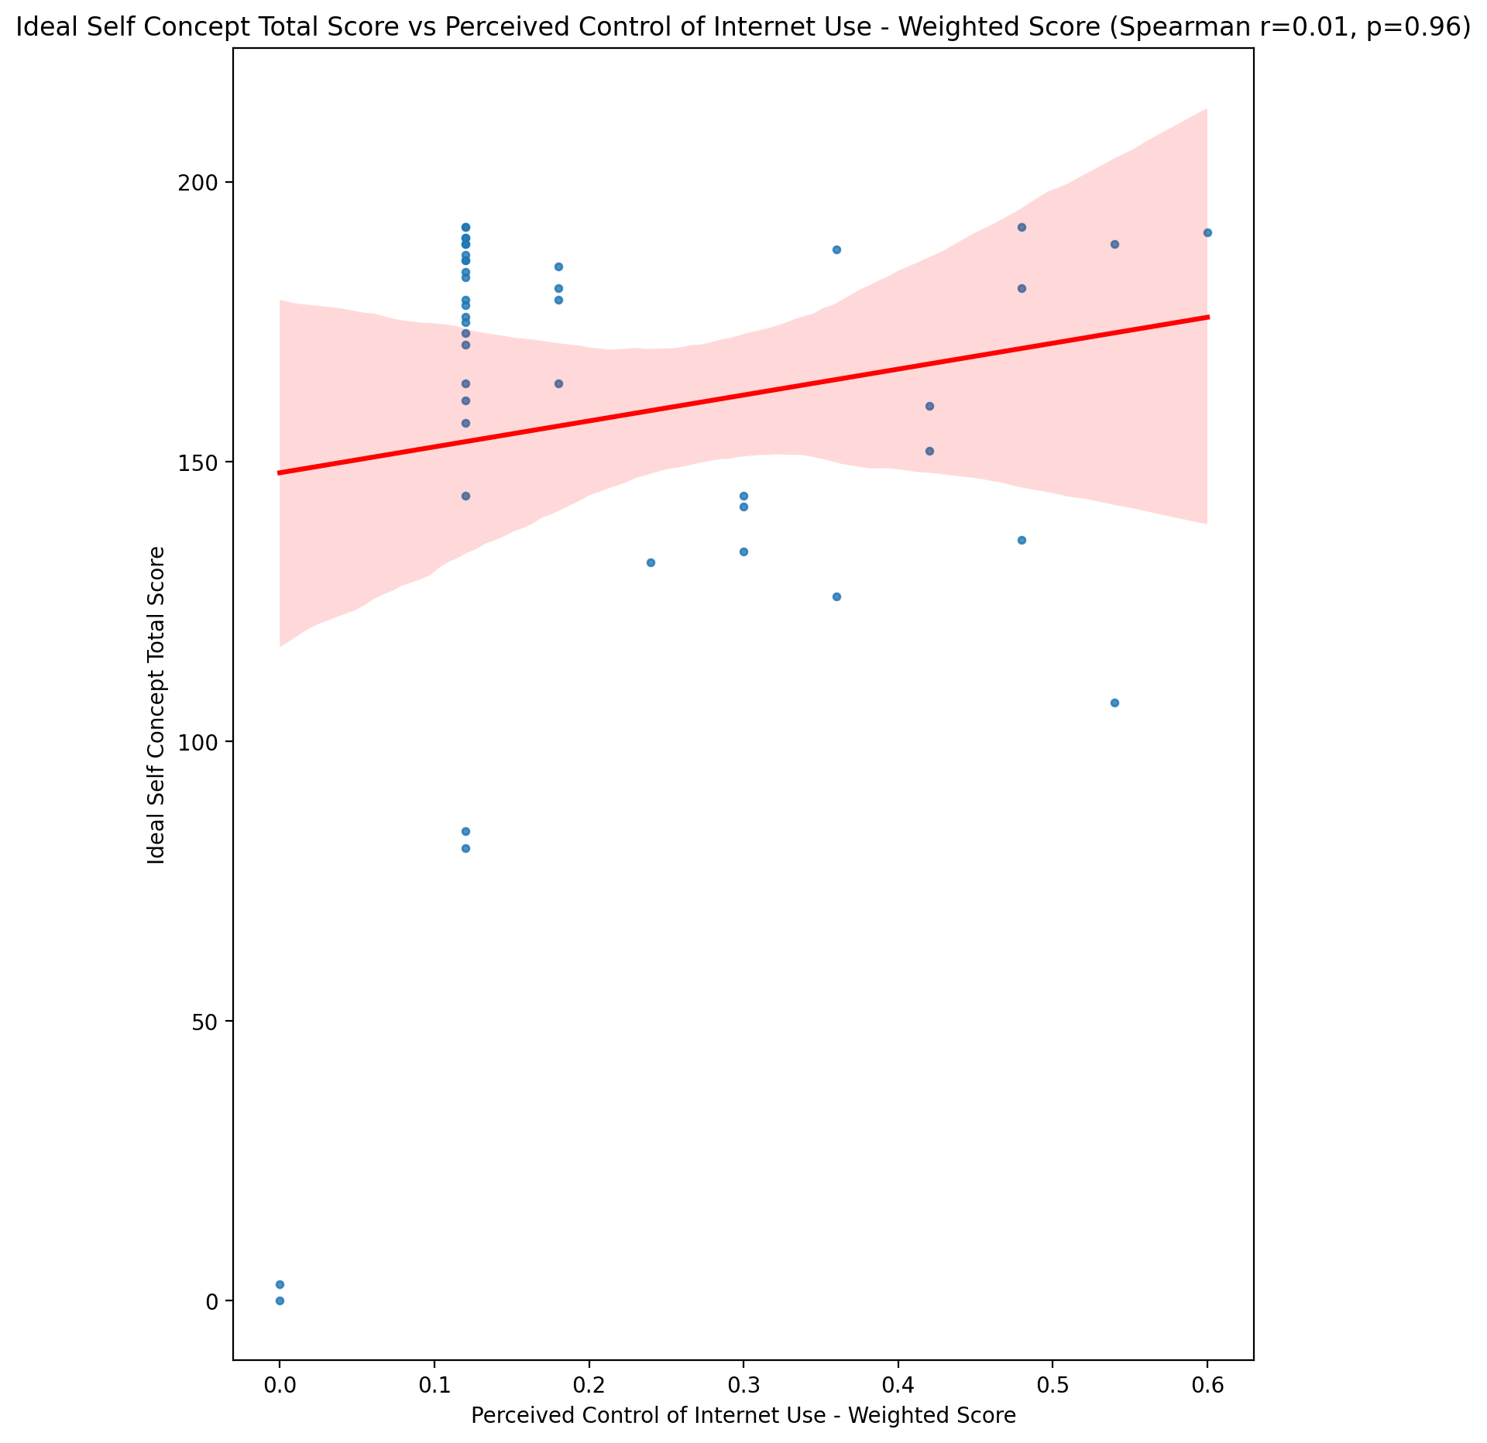

## Social Self Concept Total Score vs Perceived Control of Internet Use - Weighted Score

Test: spearman; statistic: -0.03975996320489842; p-value: 0.8001594183648348;

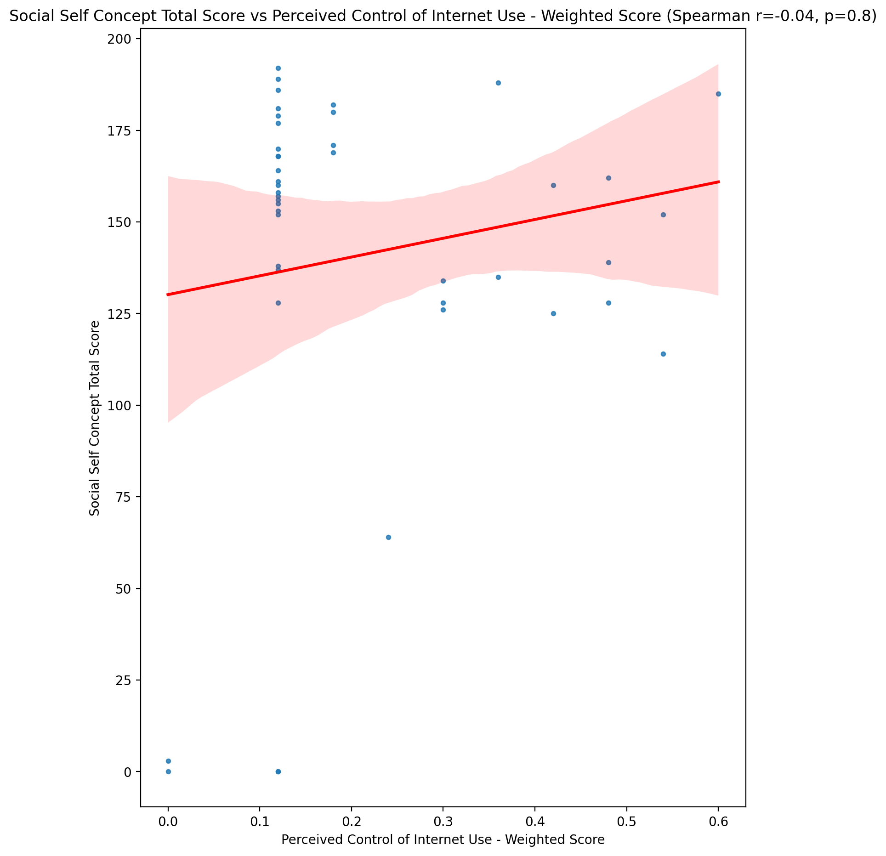

## Ideal Self Concept Total Category vs Perceived Control of Internet Use - Weighted Score

Test: None; statistic: None; p-value: None; Test not run: unsupported type combination.



## Perceived Social Stress Score vs Perceived Control of Internet Use - Weighted Score

Test: spearman; statistic: 0.2606289739996829; p-value: 0.09140912894875221;

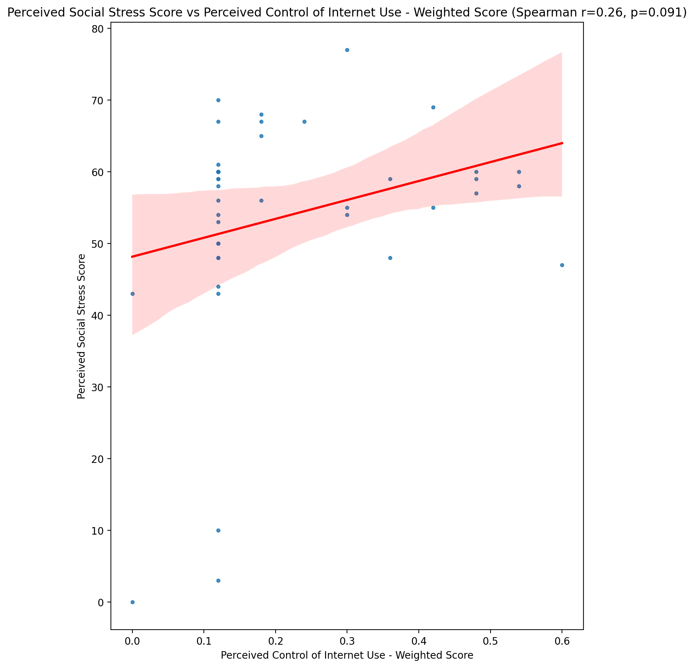

## Perceived Social Stress Category vs Perceived Control of Internet Use - Weighted Score

Test: None; statistic: None; p-value: None; Test not run: unsupported type combination.



## Emotional Support - Raw Score vs Internet Usage Total Score (Weighted)

Test: spearman; statistic: -0.38734382012039725; p-value: 0.010282443811188362;

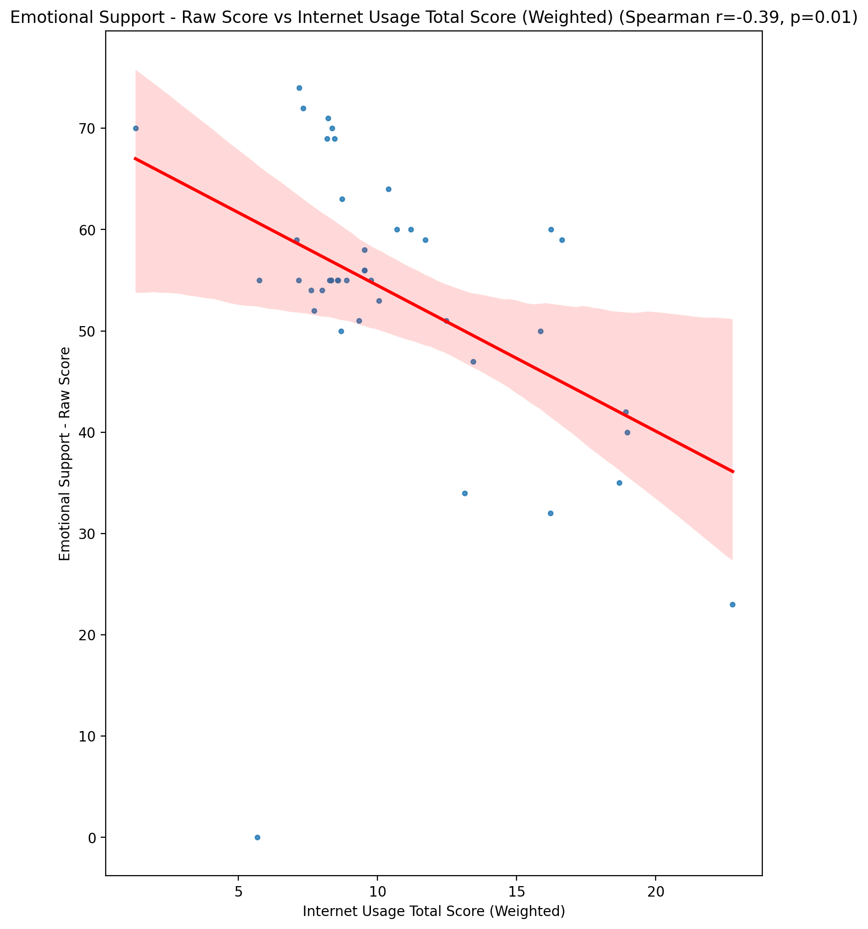

## Informational Support - Raw Score vs Internet Usage Total Score (Weighted)

Test: spearman; statistic: -0.4318910237980547; p-value: 0.0038283747576860045;

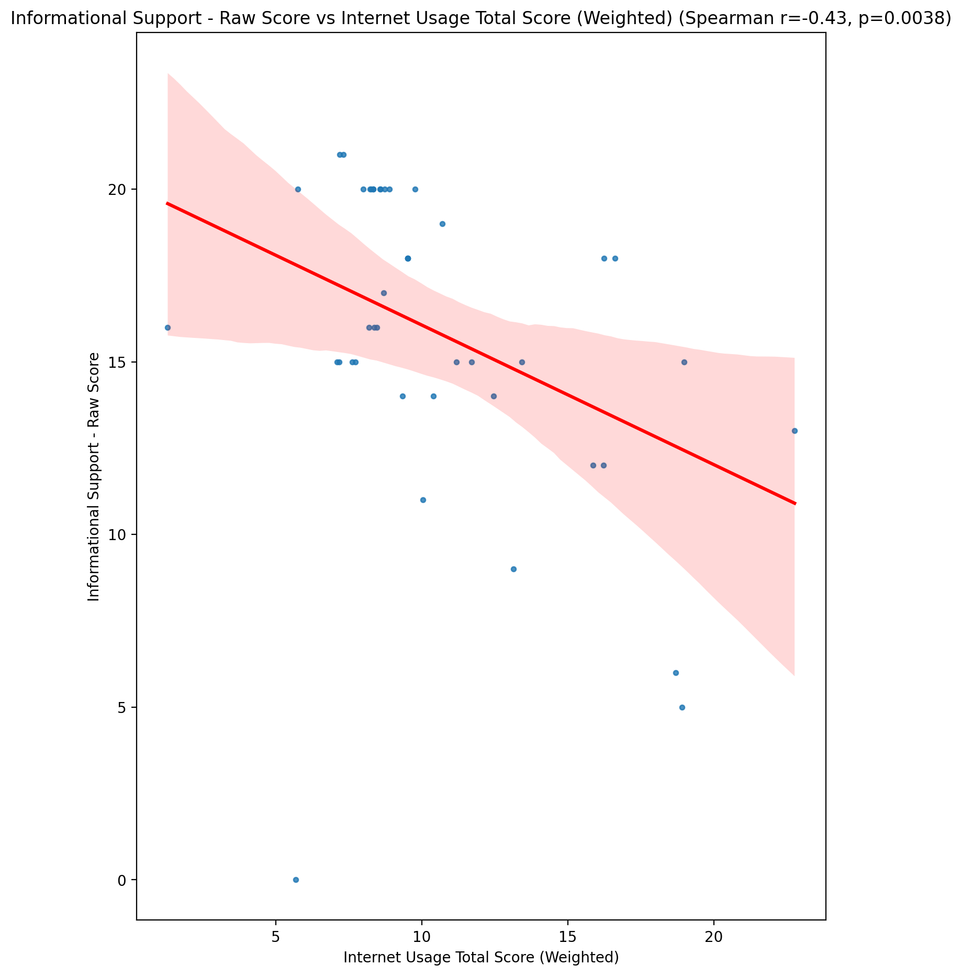

## Instrumental Support - Raw Score vs Internet Usage Total Score (Weighted)

Test: spearman; statistic: -0.4311341780368763; p-value: 0.0038975192443607754;

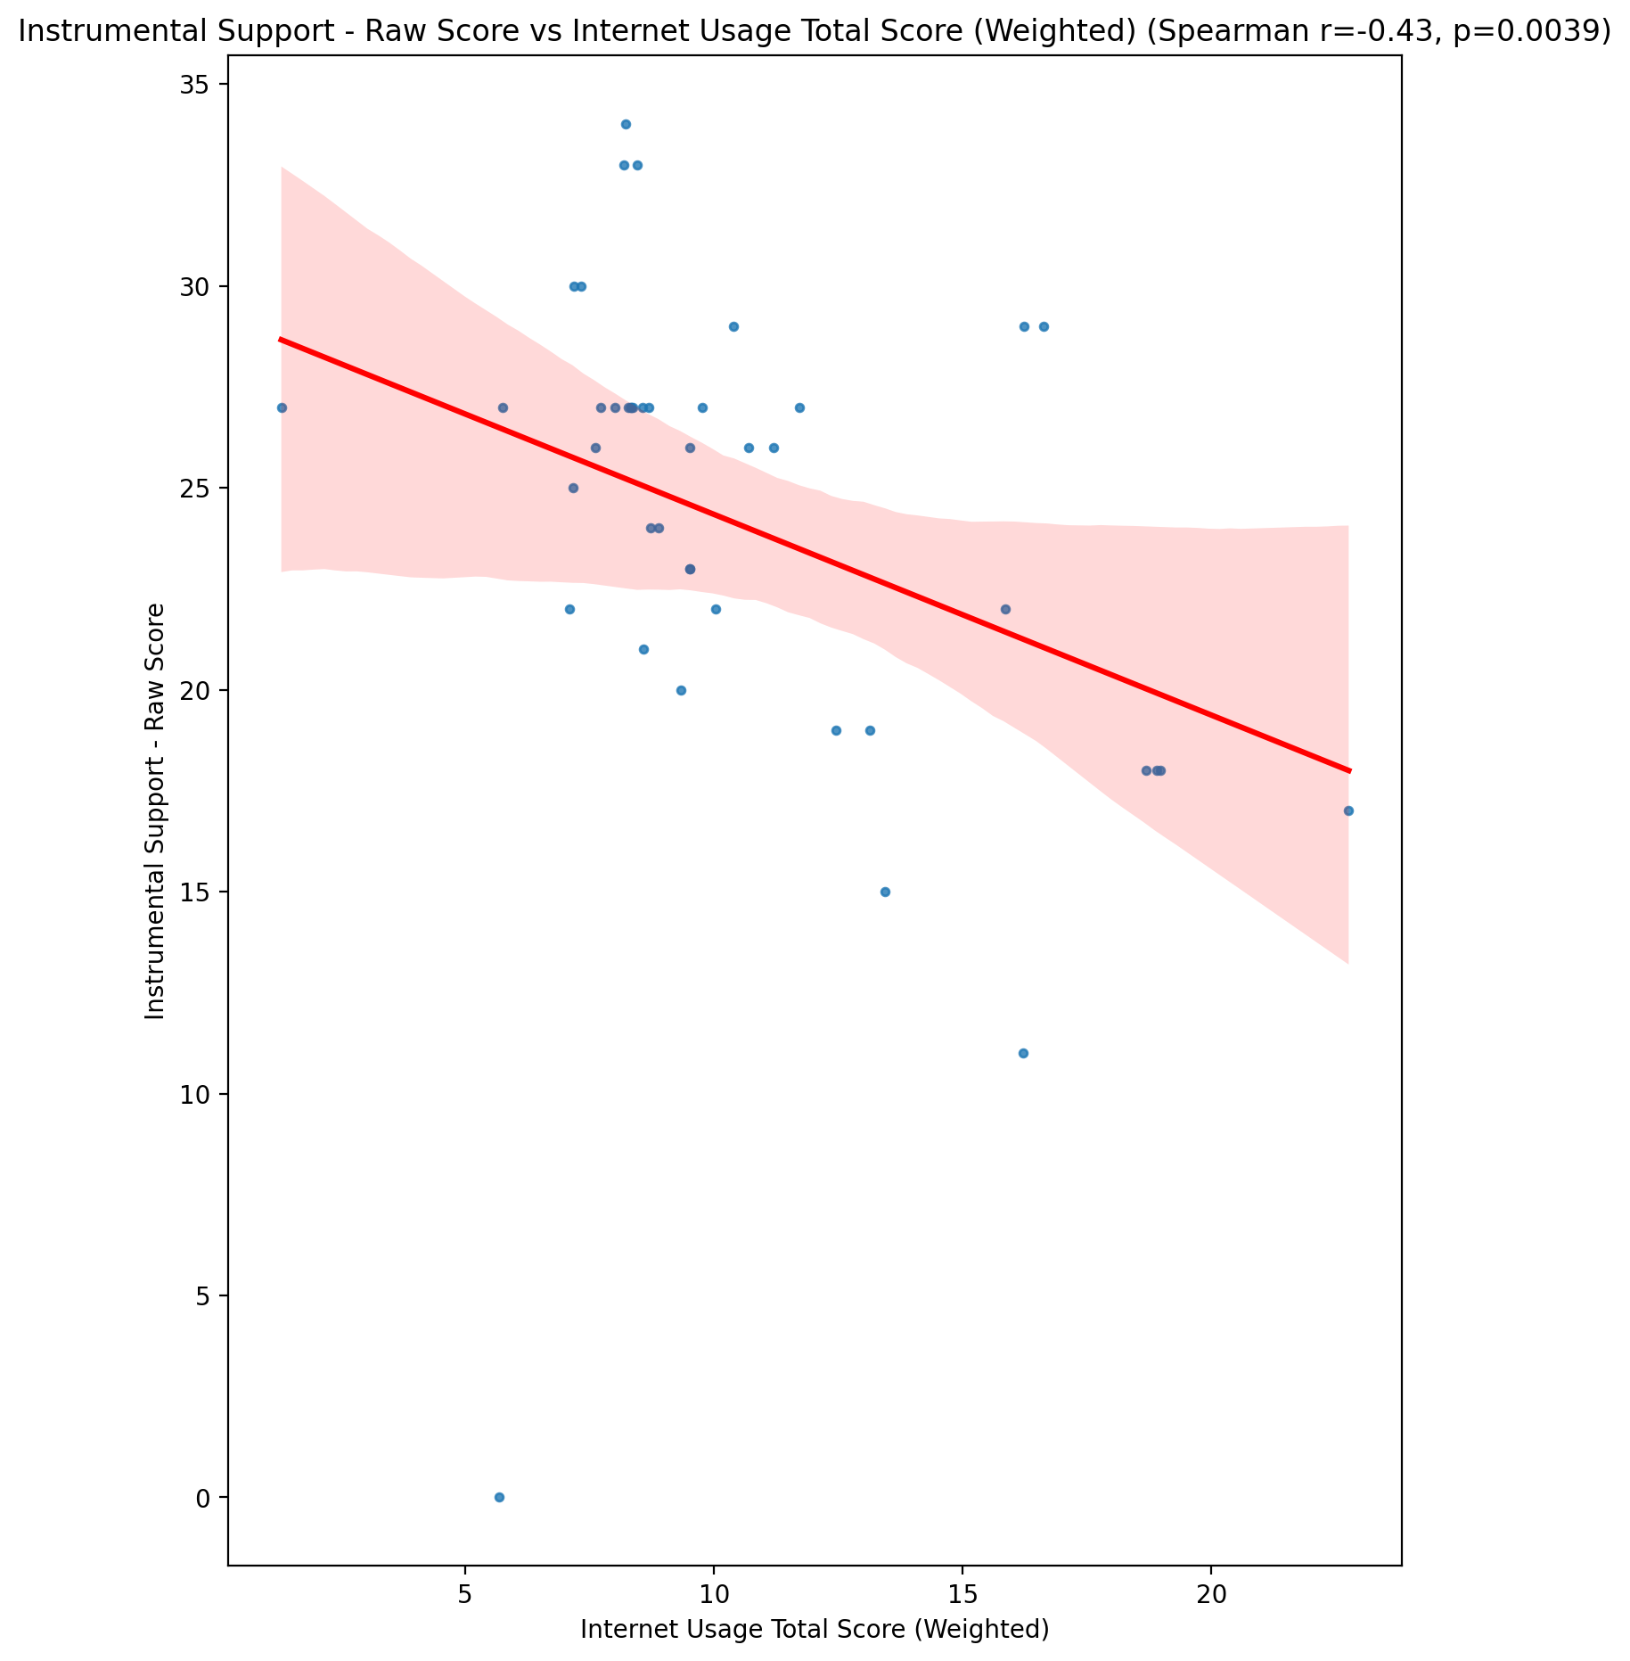

## Emotional Support - T Score vs Internet Usage Total Score (Weighted)

Test: spearman; statistic: -0.28855938034910067; p-value: 0.06057424472989126;

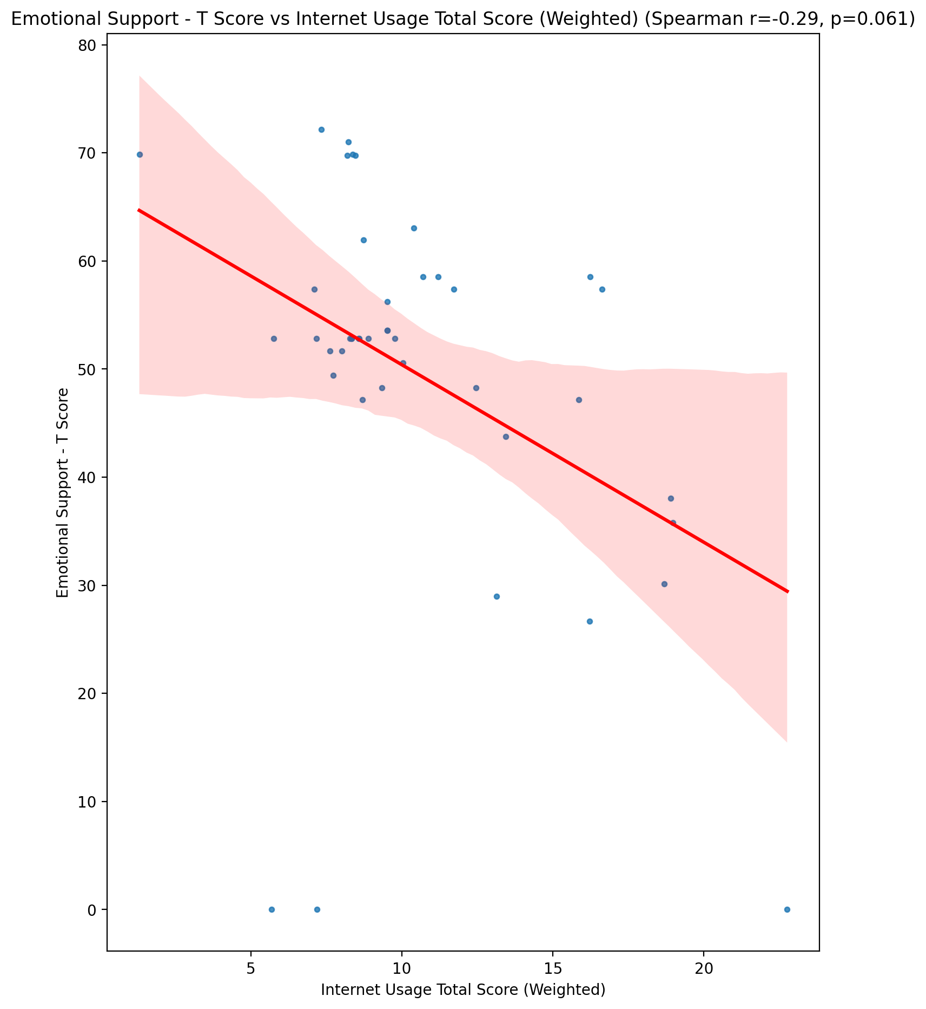

## Informational Support - T Score vs Internet Usage Total Score (Weighted)

Test: spearman; statistic: -0.437773533171212; p-value: 0.003326544431228074;

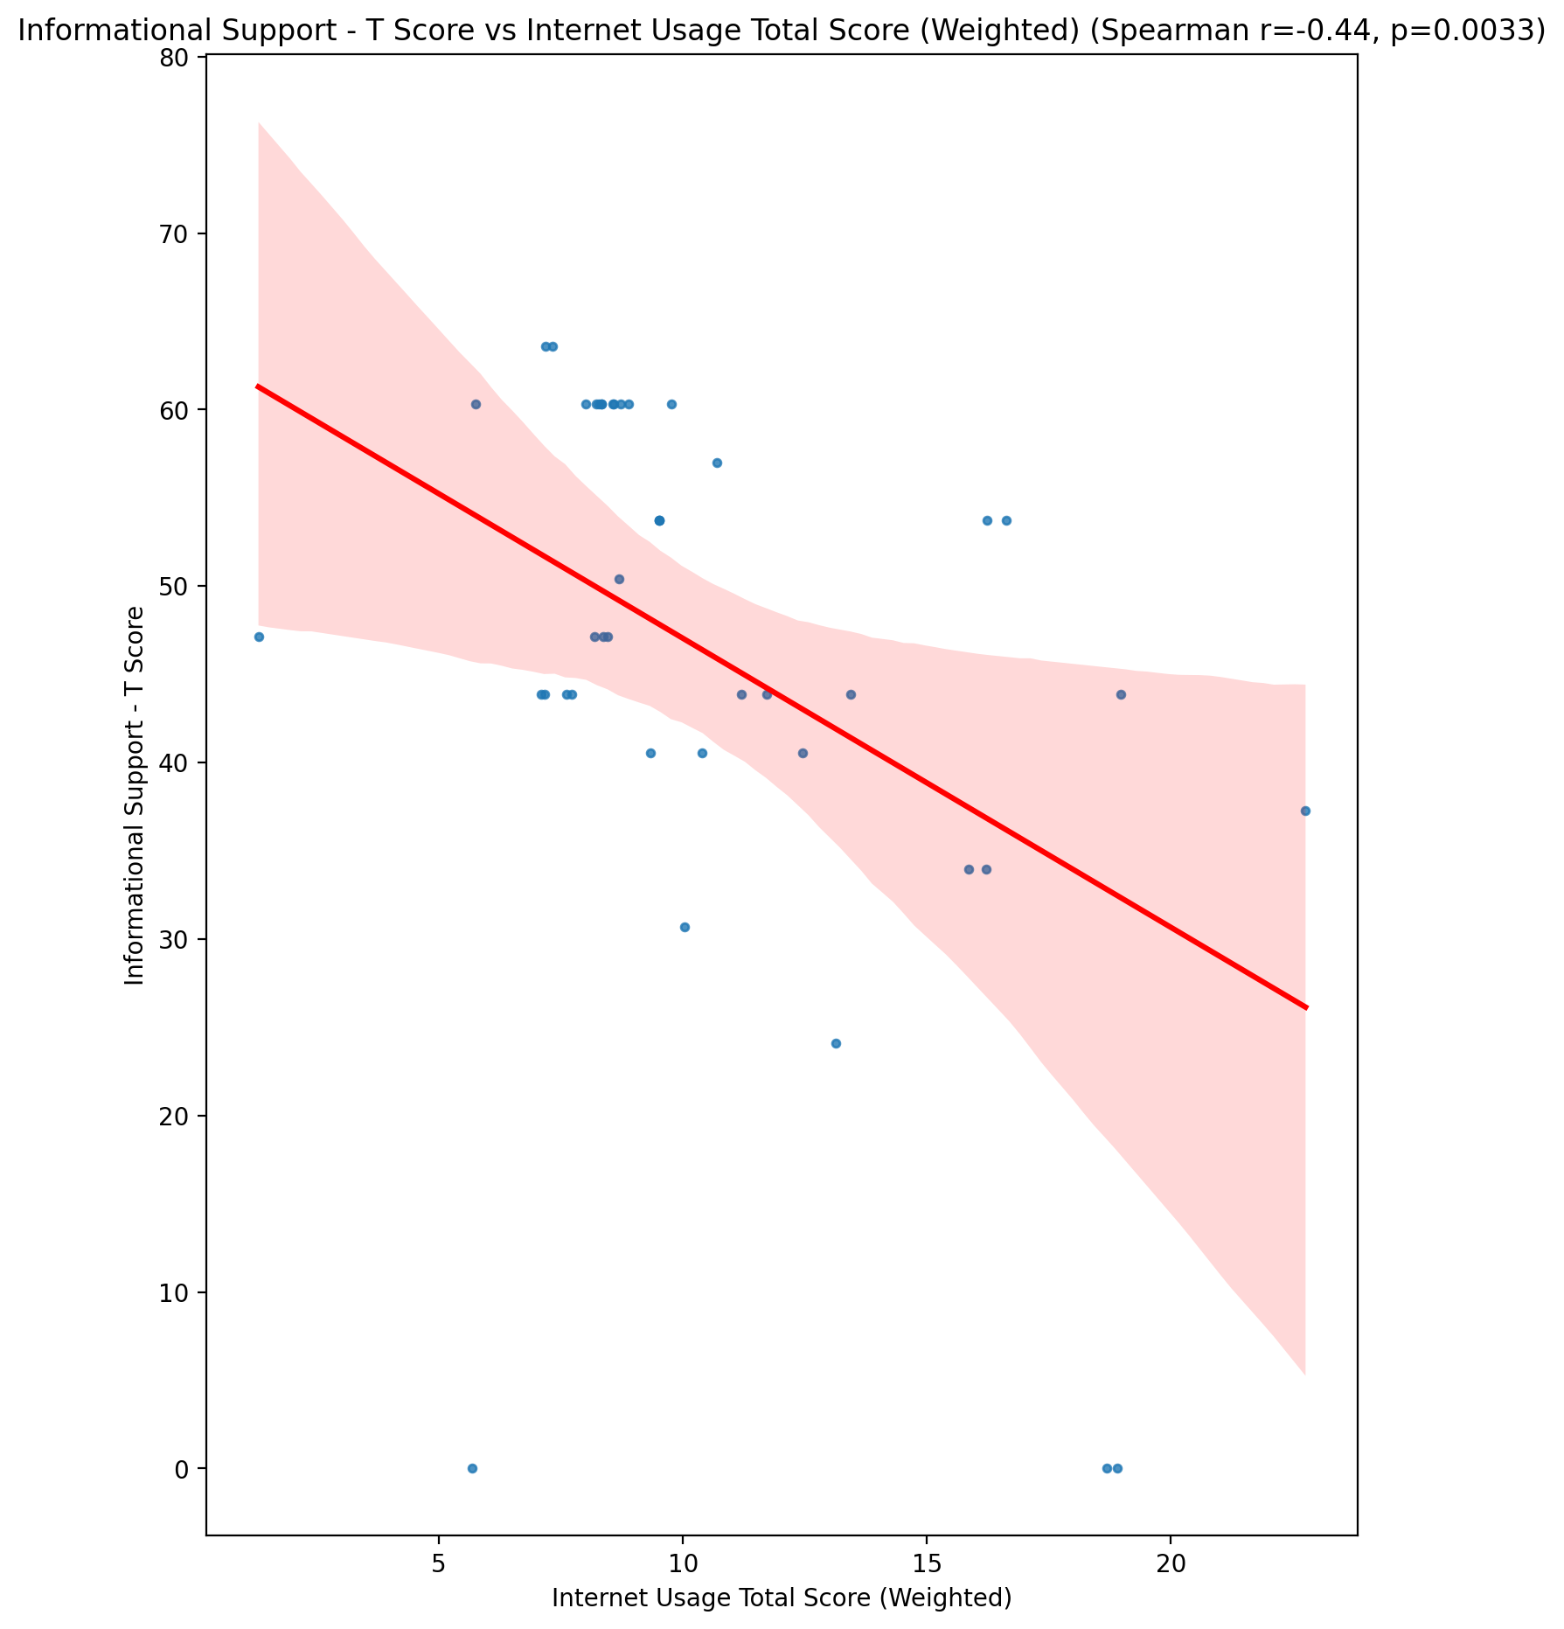

## Instrumental Support - T Score vs Internet Usage Total Score (Weighted)

Test: spearman; statistic: -0.4338259567733398; p-value: 0.0036564565456498367;

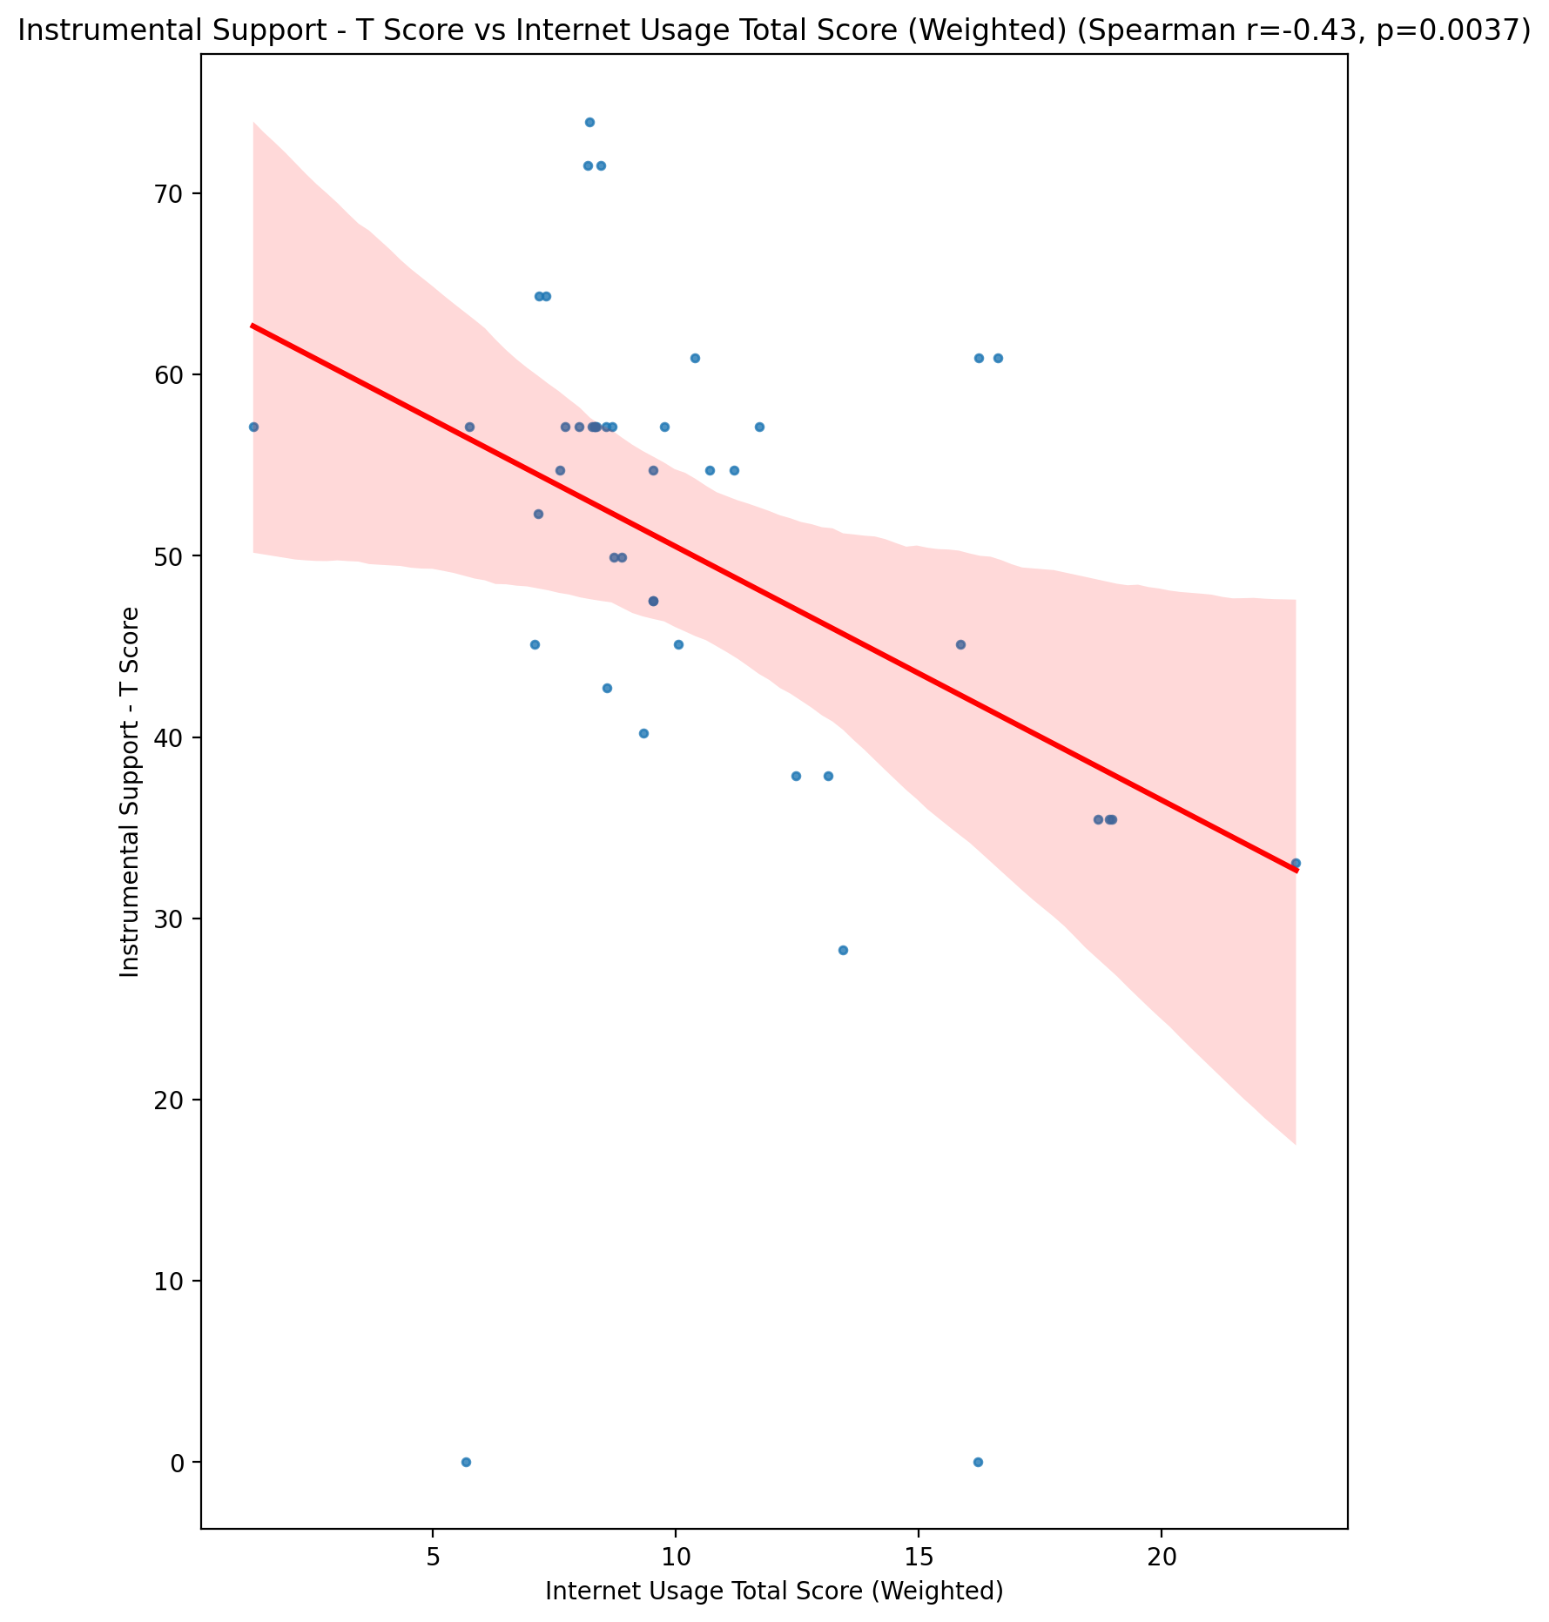

## Perceived Social Support Total T Score vs Internet Usage Total Score (Weighted)

Test: spearman; statistic: -0.427031095425139; p-value: 0.004291702317150872;

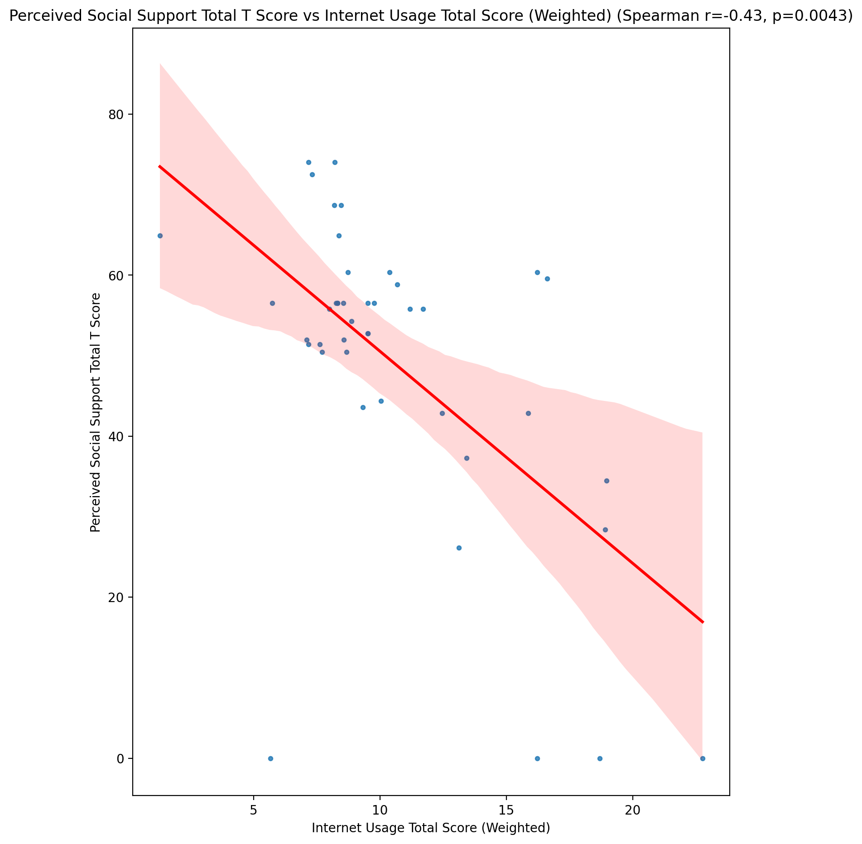

## Emotional Support - Rank vs Internet Usage Total Score (Weighted)

Test: None; statistic: None; p-value: None; Test not run: unsupported type combination.



## Informational Support - Rank vs Internet Usage Total Score (Weighted)

Test: None; statistic: None; p-value: None; Test not run: unsupported type combination.



## Instrumental Support - Rank vs Internet Usage Total Score (Weighted)

Test: None; statistic: None; p-value: None; Test not run: unsupported type combination.



## Perceived Social Support TOTAL - Rank vs Internet Usage Total Score (Weighted)

Test: None; statistic: None; p-value: None; Test not run: unsupported type combination.



## Power Self Concept - Real Self Concept Score vs Internet Usage Total Score (Weighted)

Test: spearman; statistic: -0.19010949996114473; p-value: 0.22205955420829052;

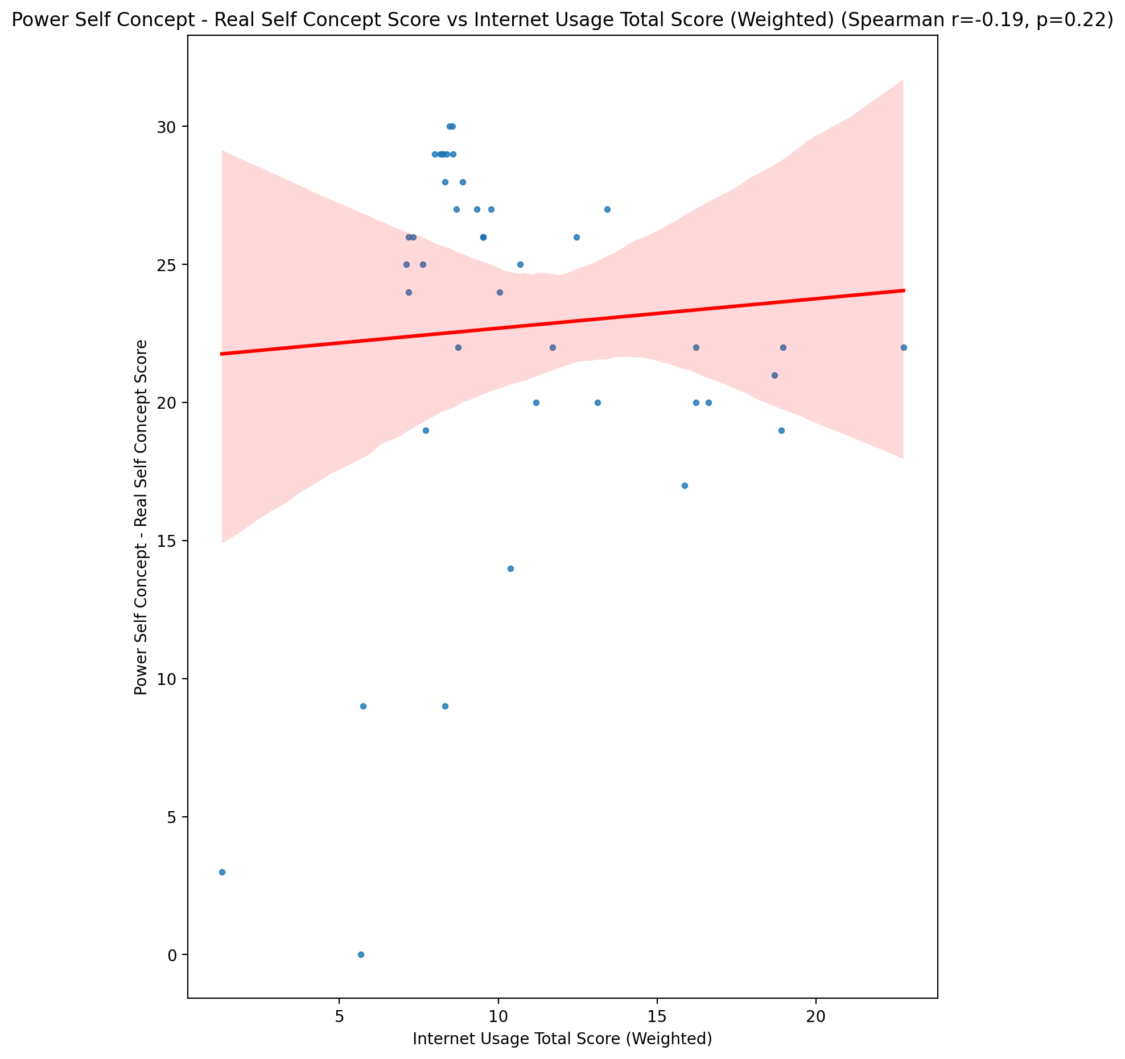

## Power Self Concept - Ideal Self Concept score vs Internet Usage Total Score (Weighted)

Test: spearman; statistic: -0.014526715931591022; p-value: 0.9263358568682732;

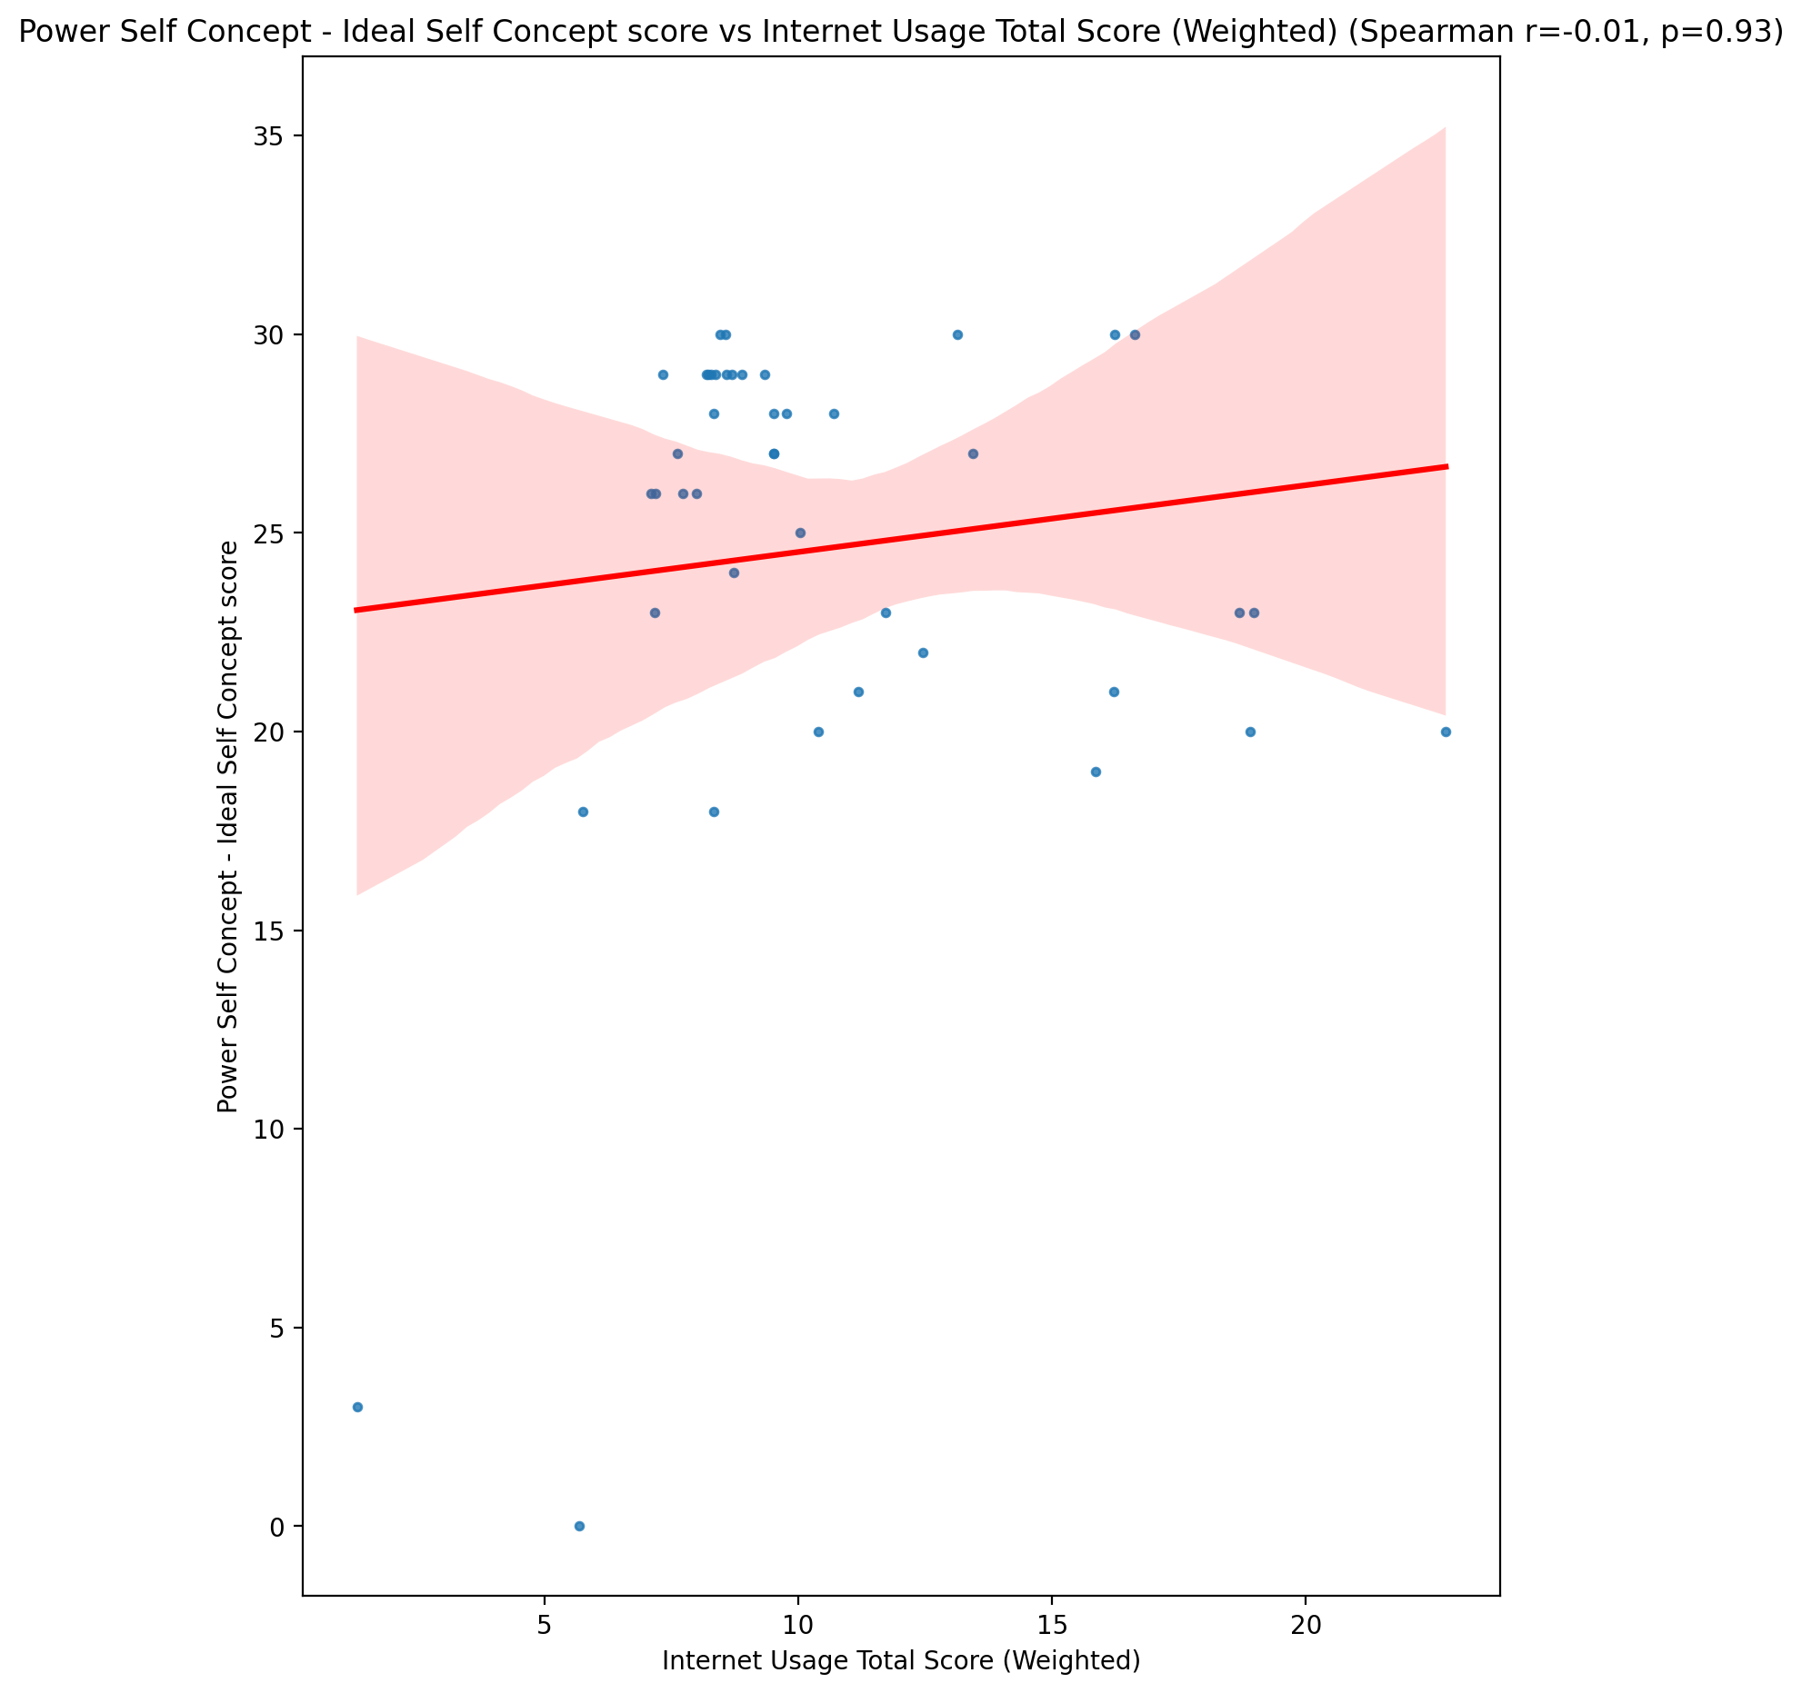

## Power Self Concept – Social Self Concept Score vs Internet Usage Total Score (Weighted)

Test: spearman; statistic: -0.22565635272470386; p-value: 0.14567856715483896;

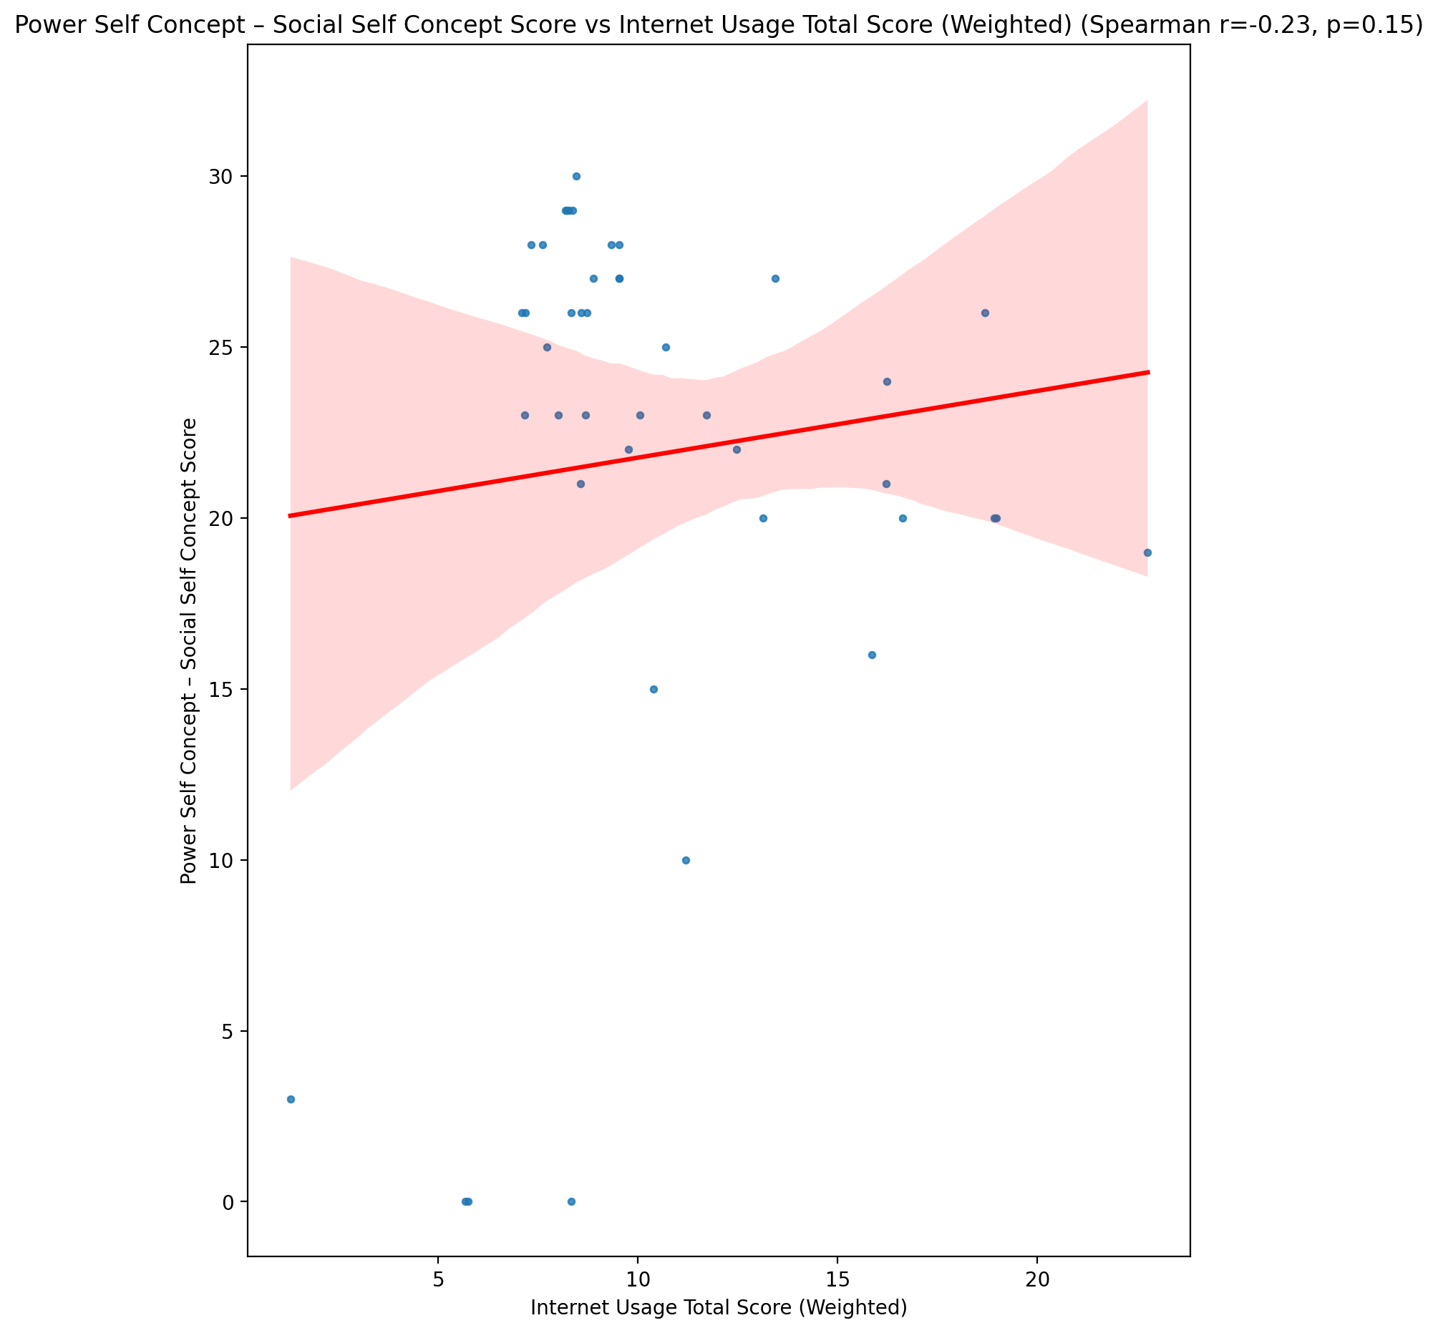

## Social Self Concept - Real Self Concept Score vs Internet Usage Total Score (Weighted)

Test: spearman; statistic: -0.3347920997533109; p-value: 0.02820325790232008;

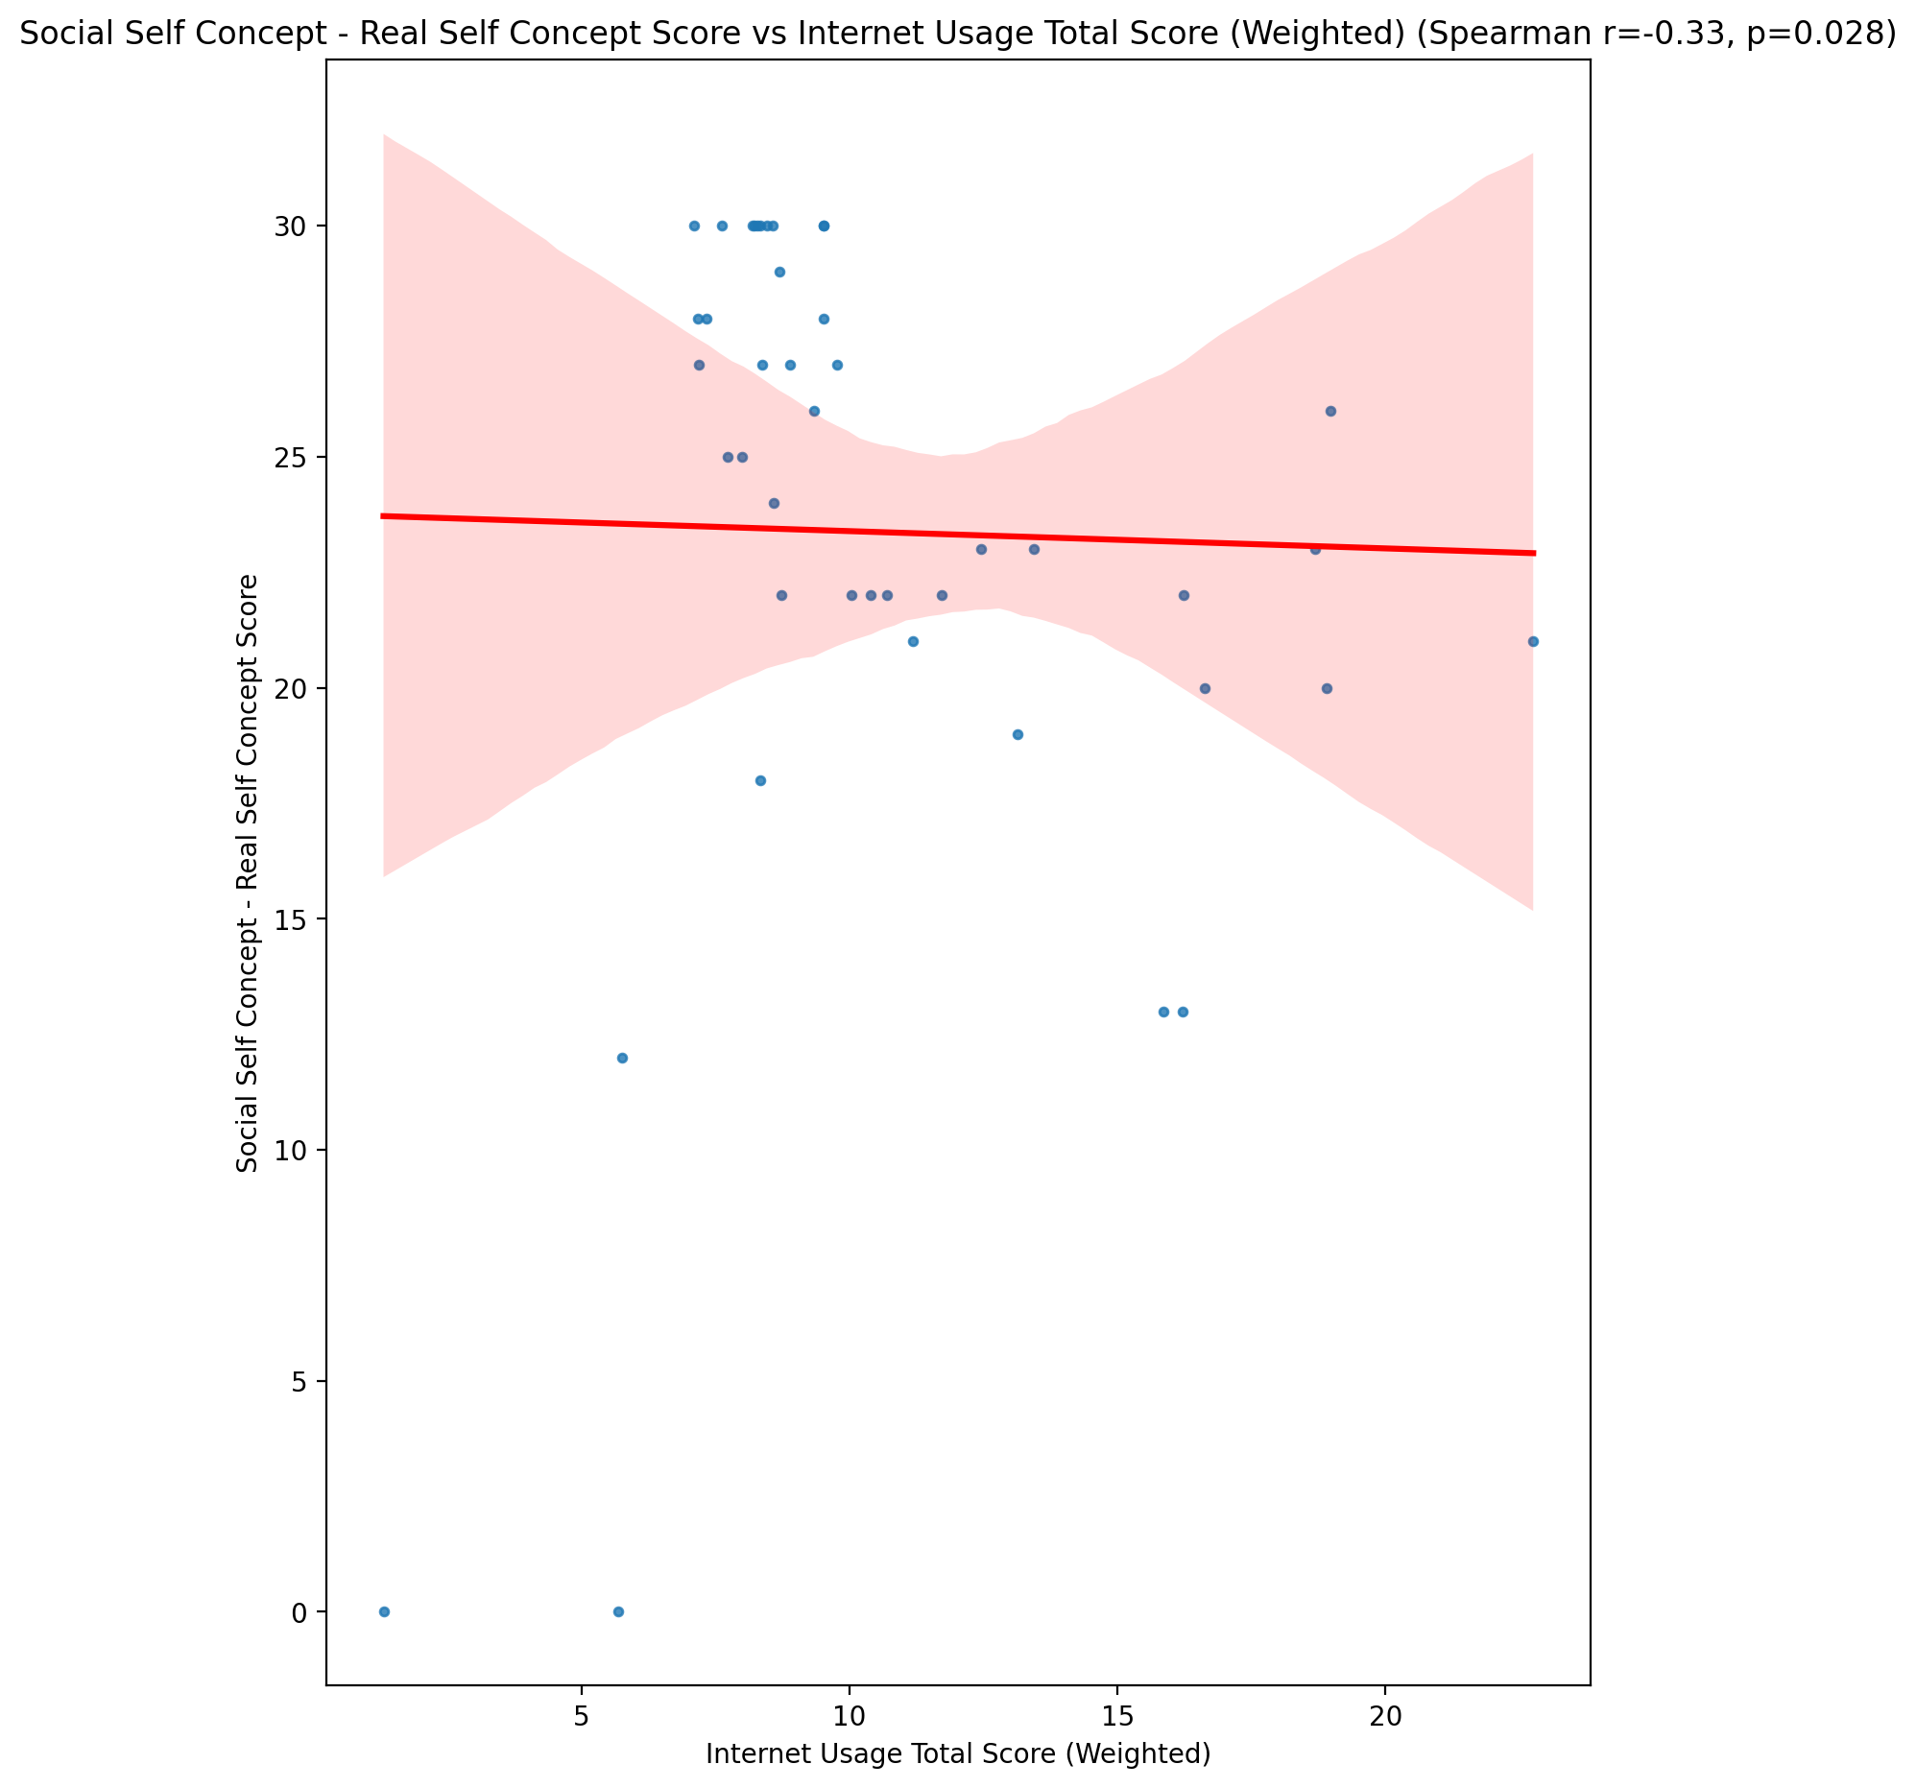

## Social Self Concept – Social Self Concept Score vs Internet Usage Total Score (Weighted)

Test: spearman; statistic: -0.2985350272363038; p-value: 0.051830604523028824;

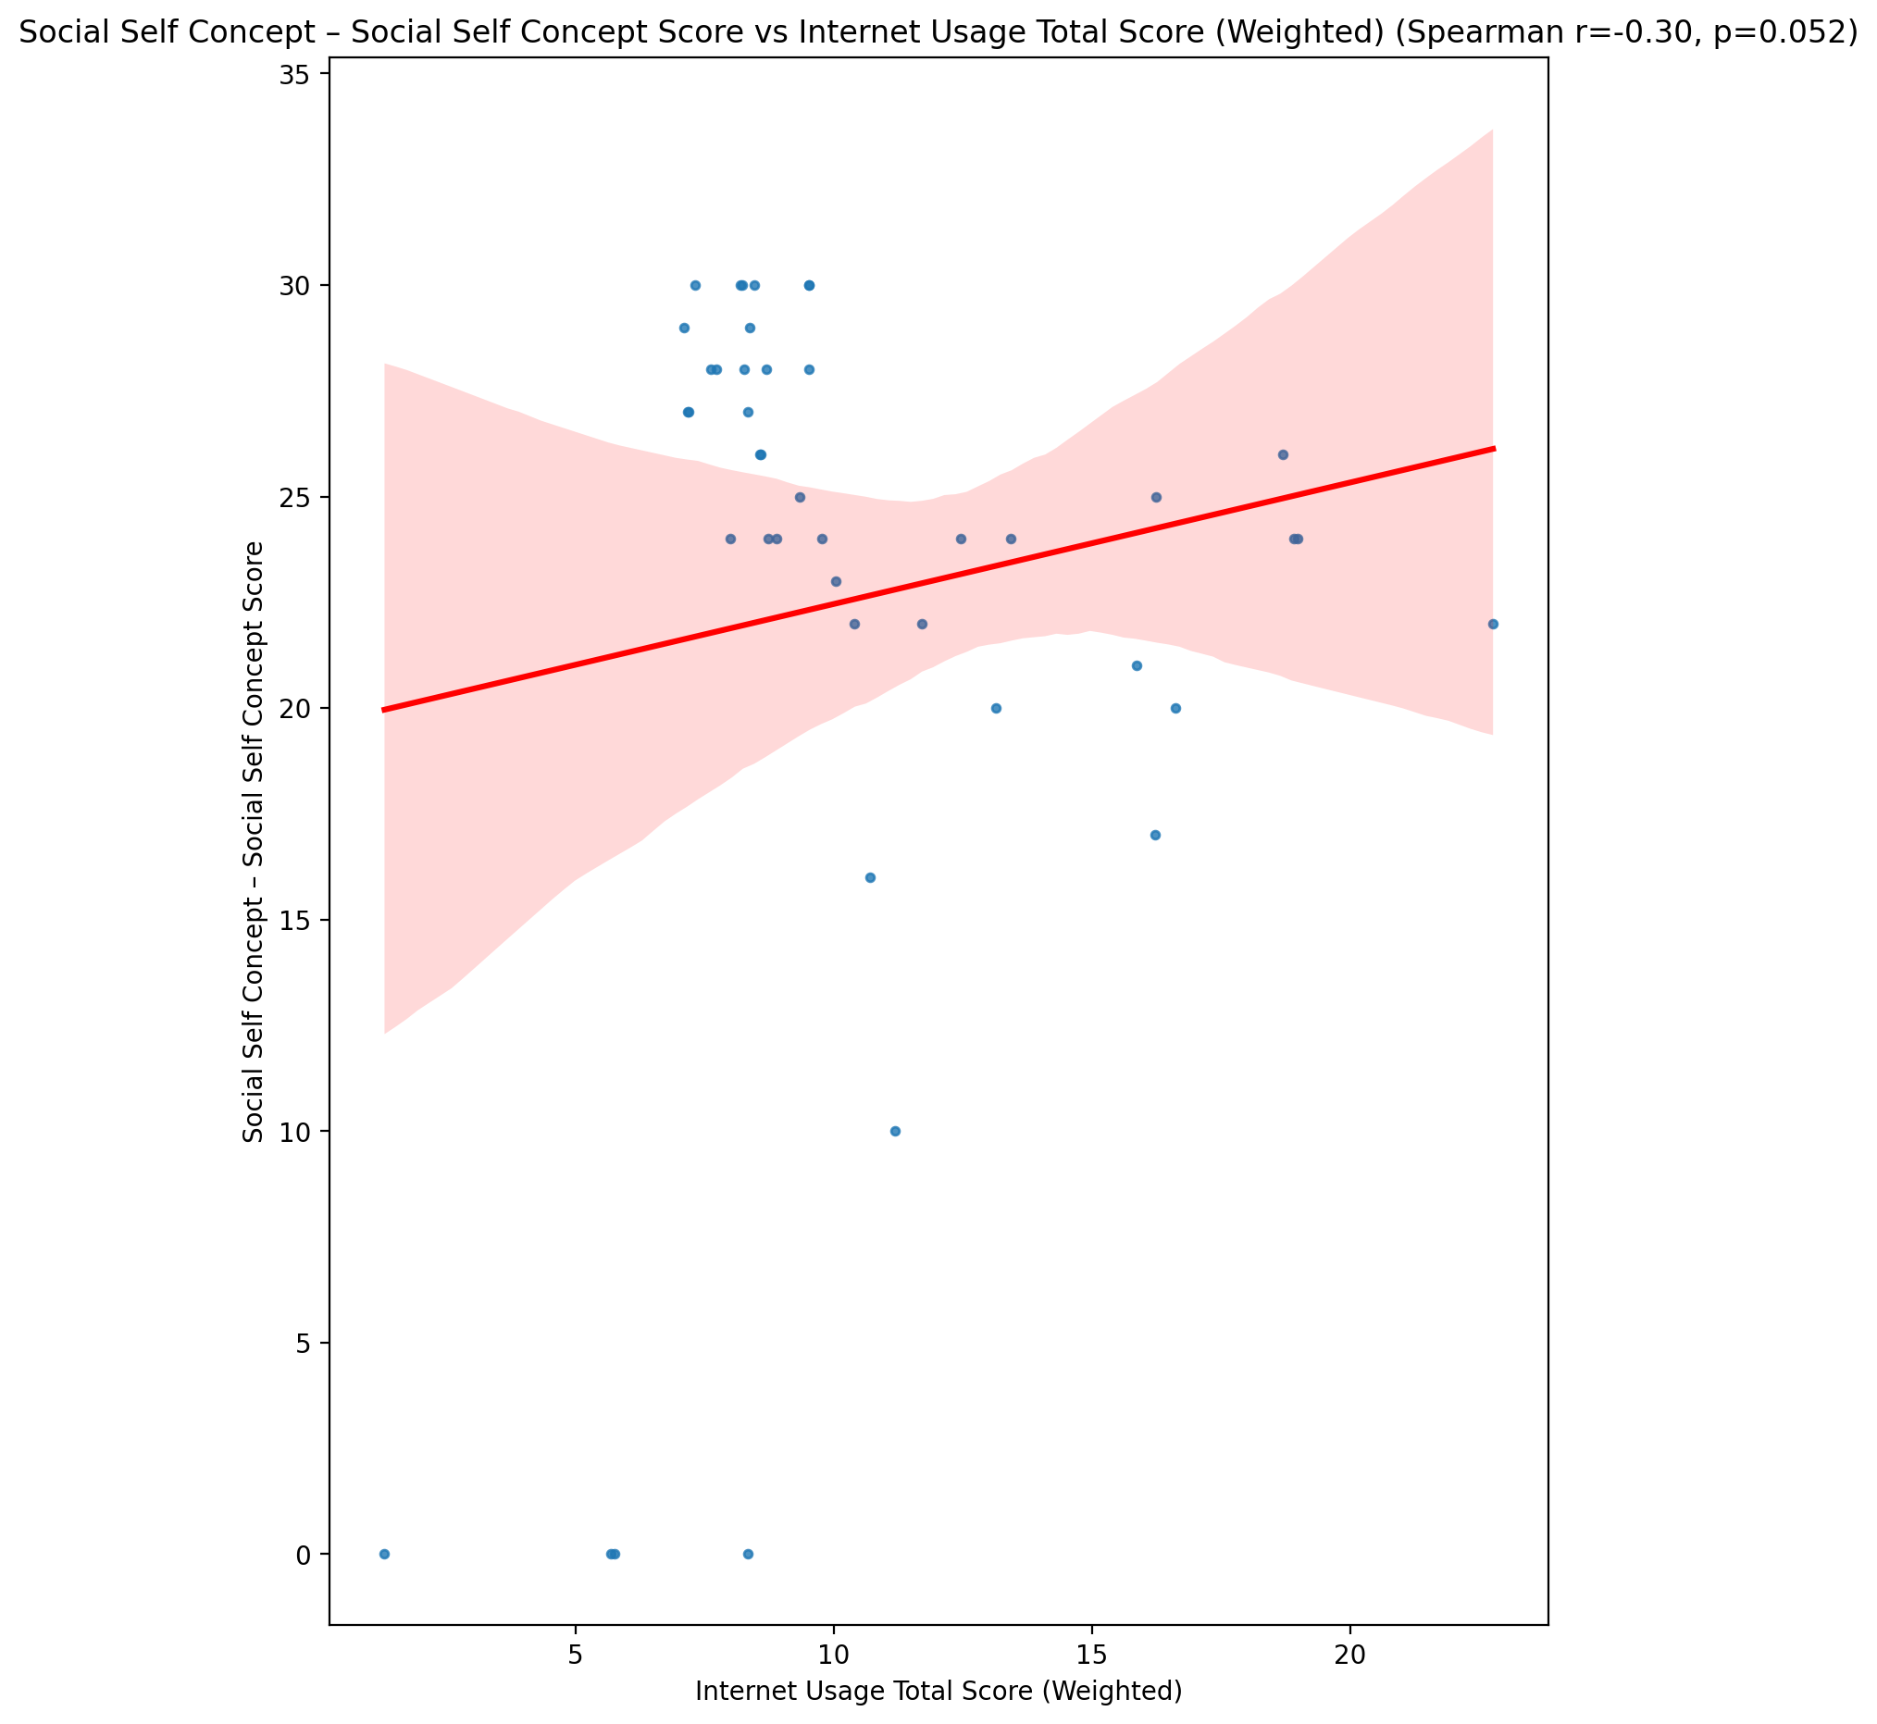

## Ability Self Concept - Real Self Concept Score vs Internet Usage Total Score (Weighted)

Test: spearman; statistic: -0.19708289944954868; p-value: 0.2052467854946027;

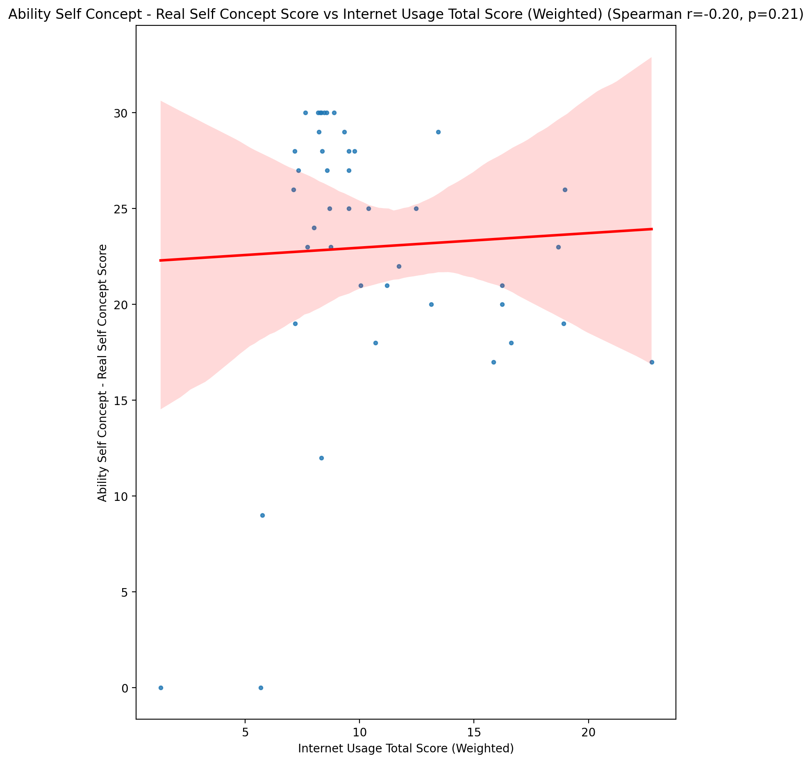

## Ability Self Concept - Ideal Self Concept Score vs Internet Usage Total Score (Weighted)

Test: spearman; statistic: -0.0740780580169423; p-value: 0.6368569319229838;

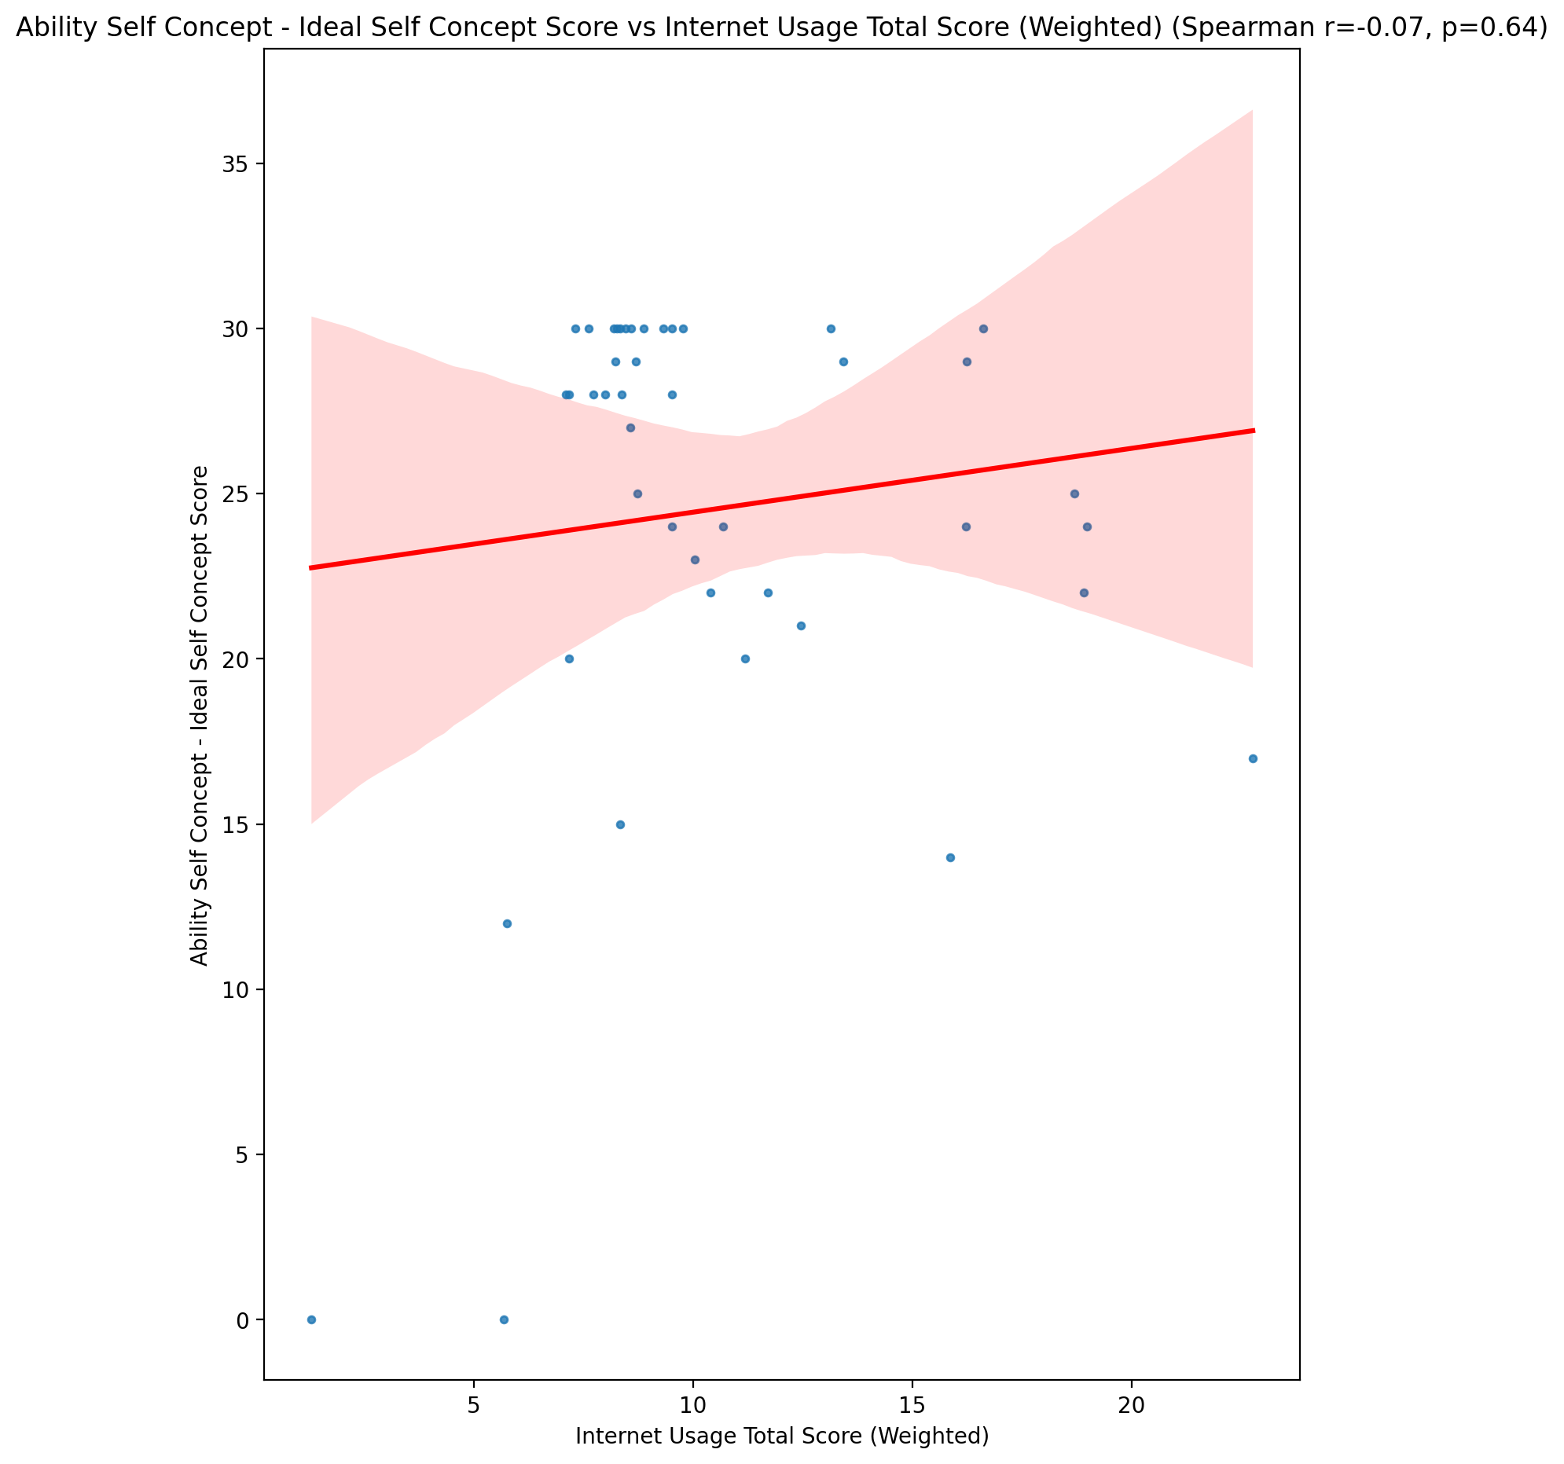

## Ability Self Concept – Social Self Concept Score vs Internet Usage Total Score (Weighted)

Test: spearman; statistic: -0.1923479864037935; p-value: 0.21656228408639502;

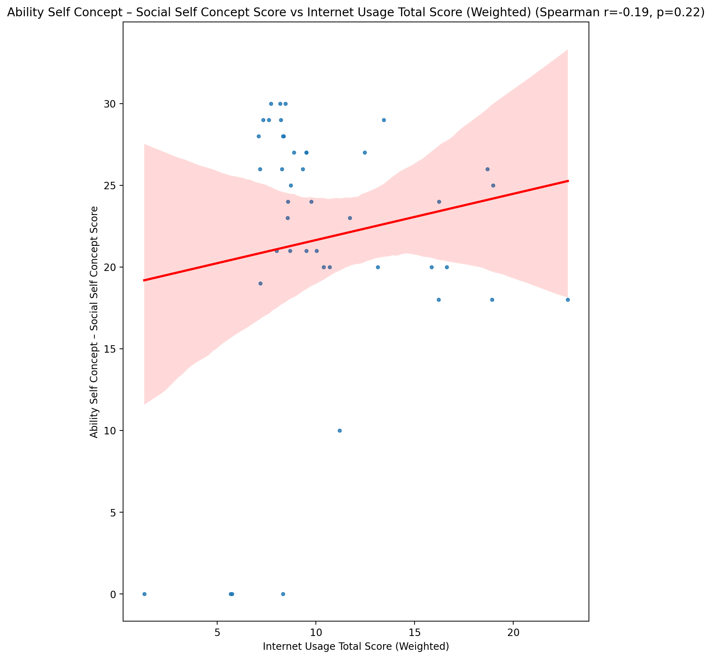

## Physical Self Concept - Real Self Concept Score vs Internet Usage Total Score (Weighted)

Test: spearman; statistic: -0.24377935010448742; p-value: 0.11517930931579623;

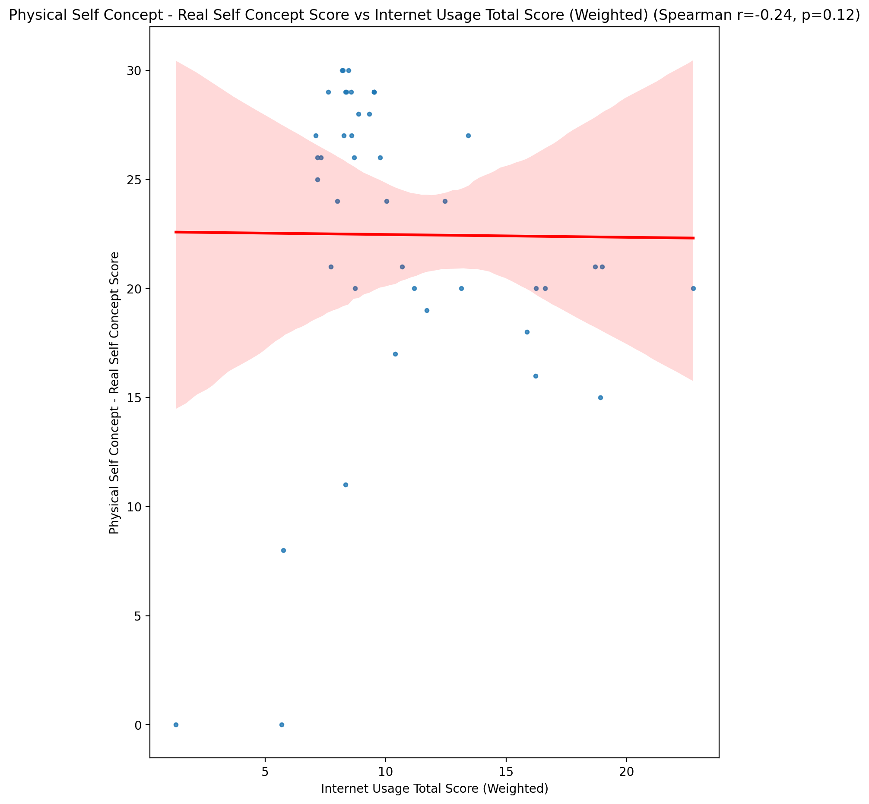

## Physical Self Concept – Ideal Self Concept Score vs Internet Usage Total Score (Weighted)

Test: spearman; statistic: -0.0693020398745336; p-value: 0.6587900296648111;

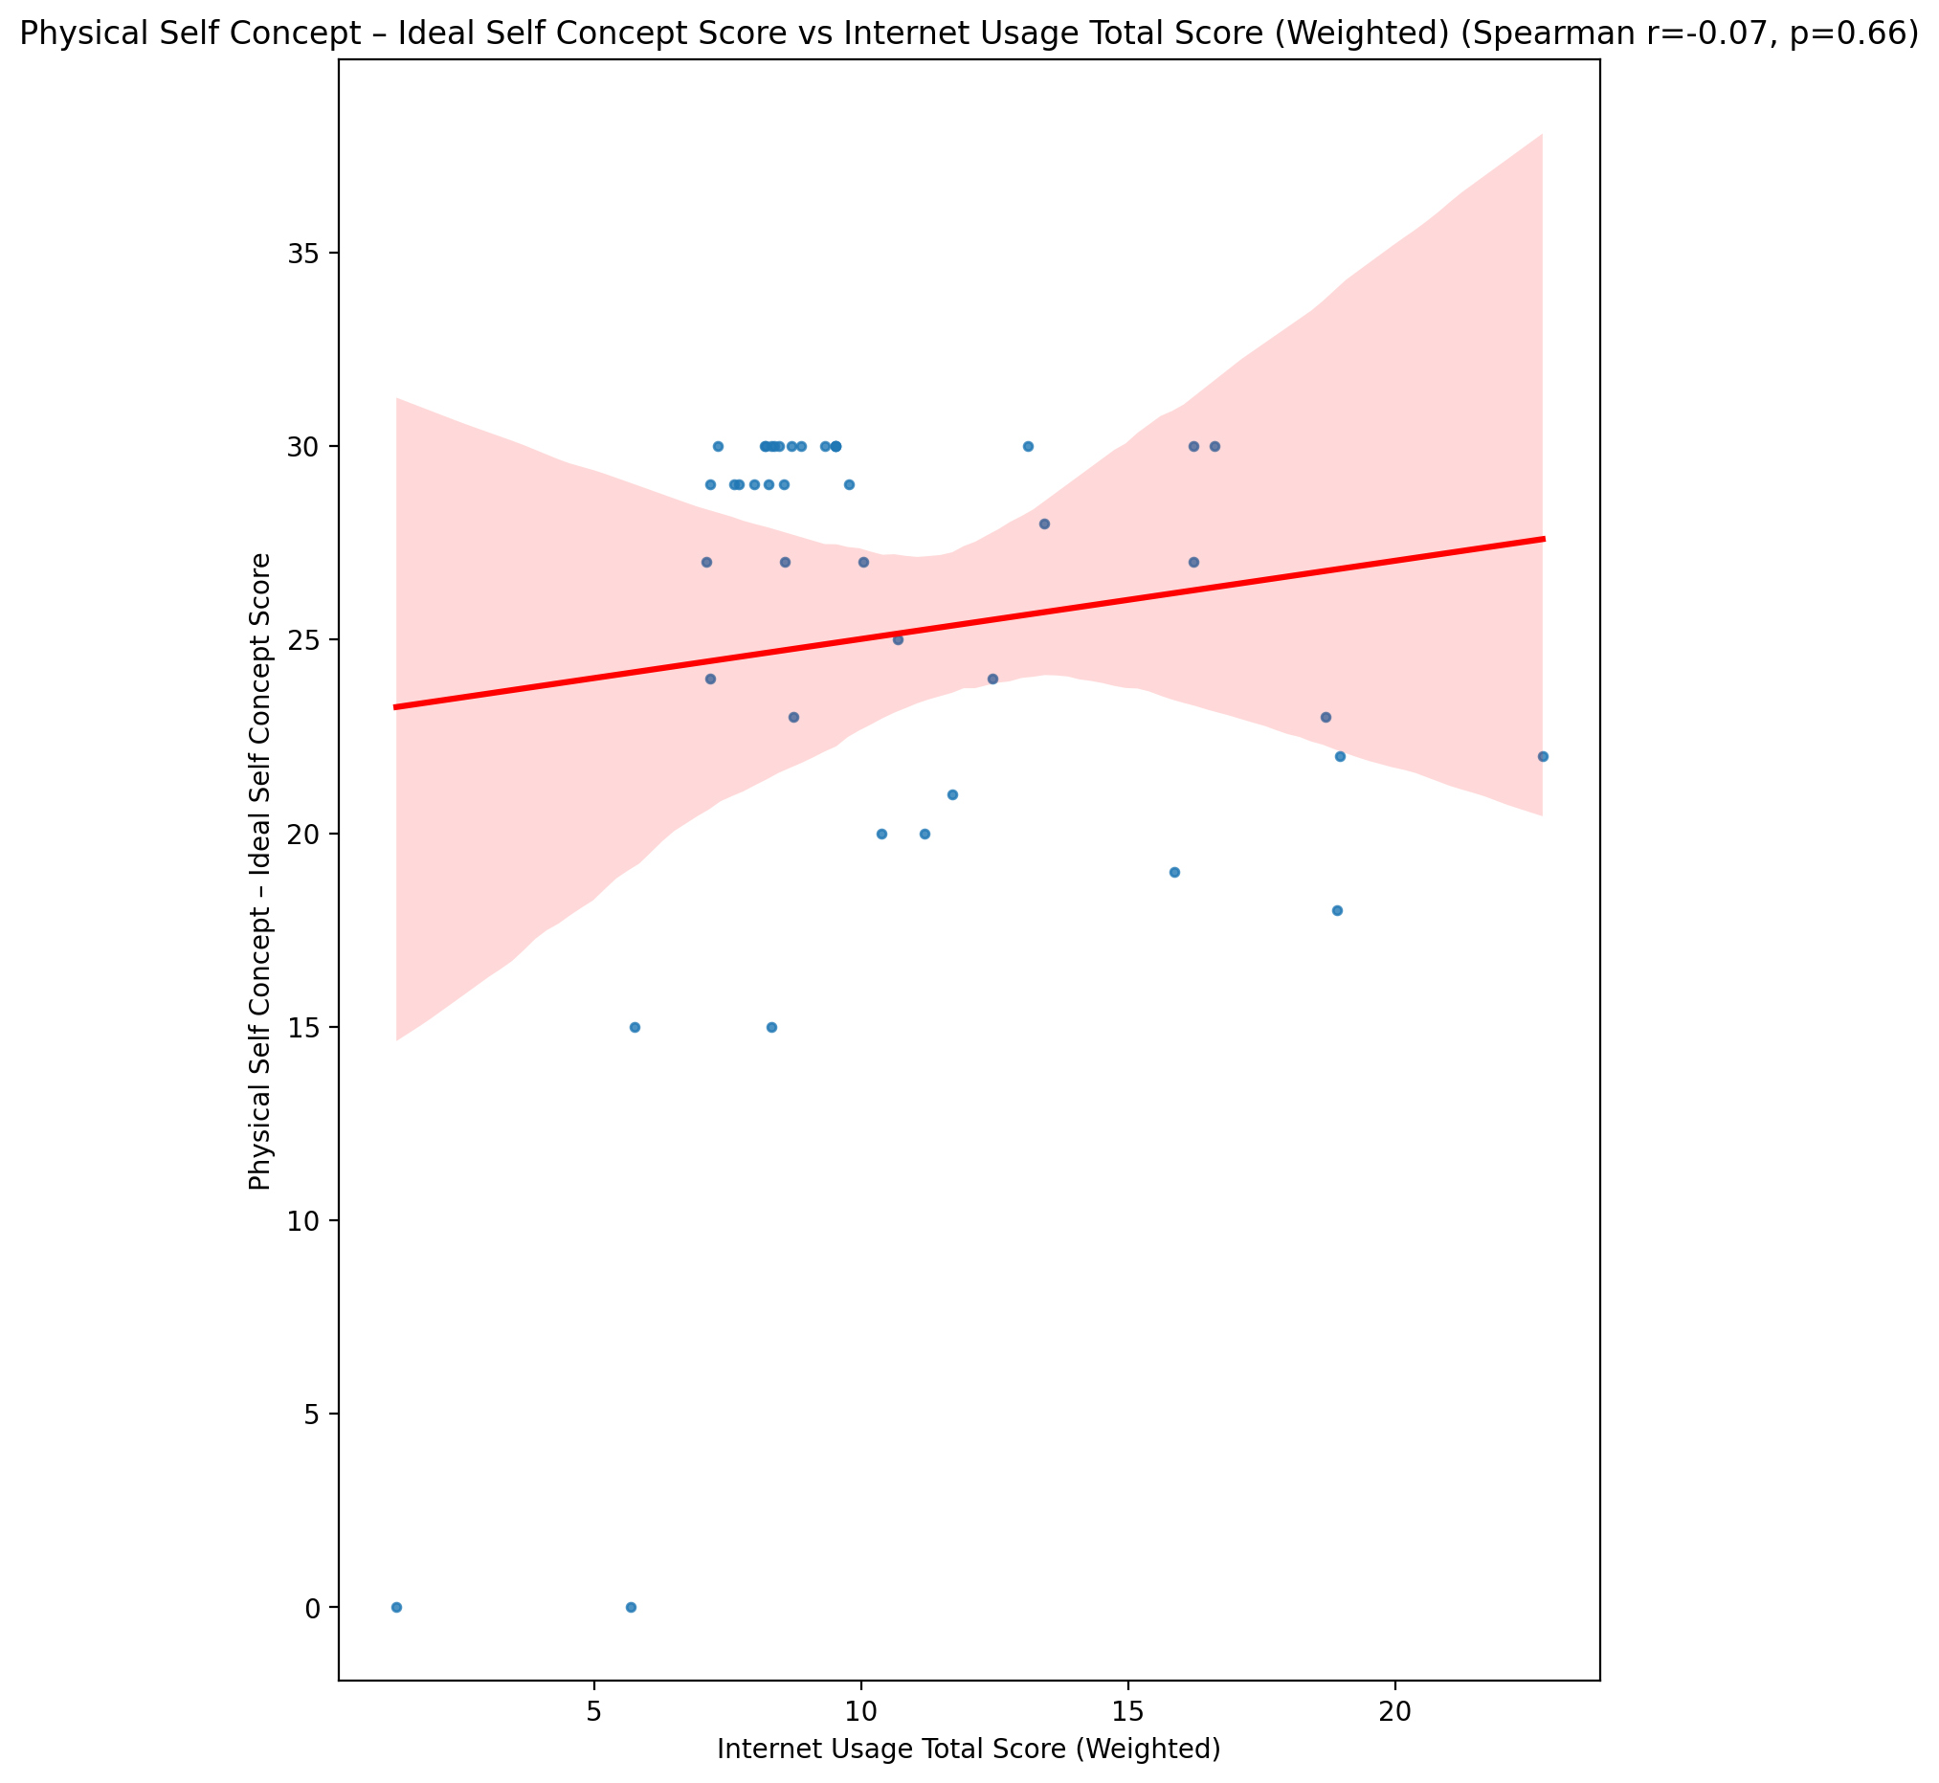

## Physical Self Concept – Social Self Concept Score vs Internet Usage Total Score (Weighted)

Test: spearman; statistic: -0.05022237974014052; p-value: 0.7490989635051797;

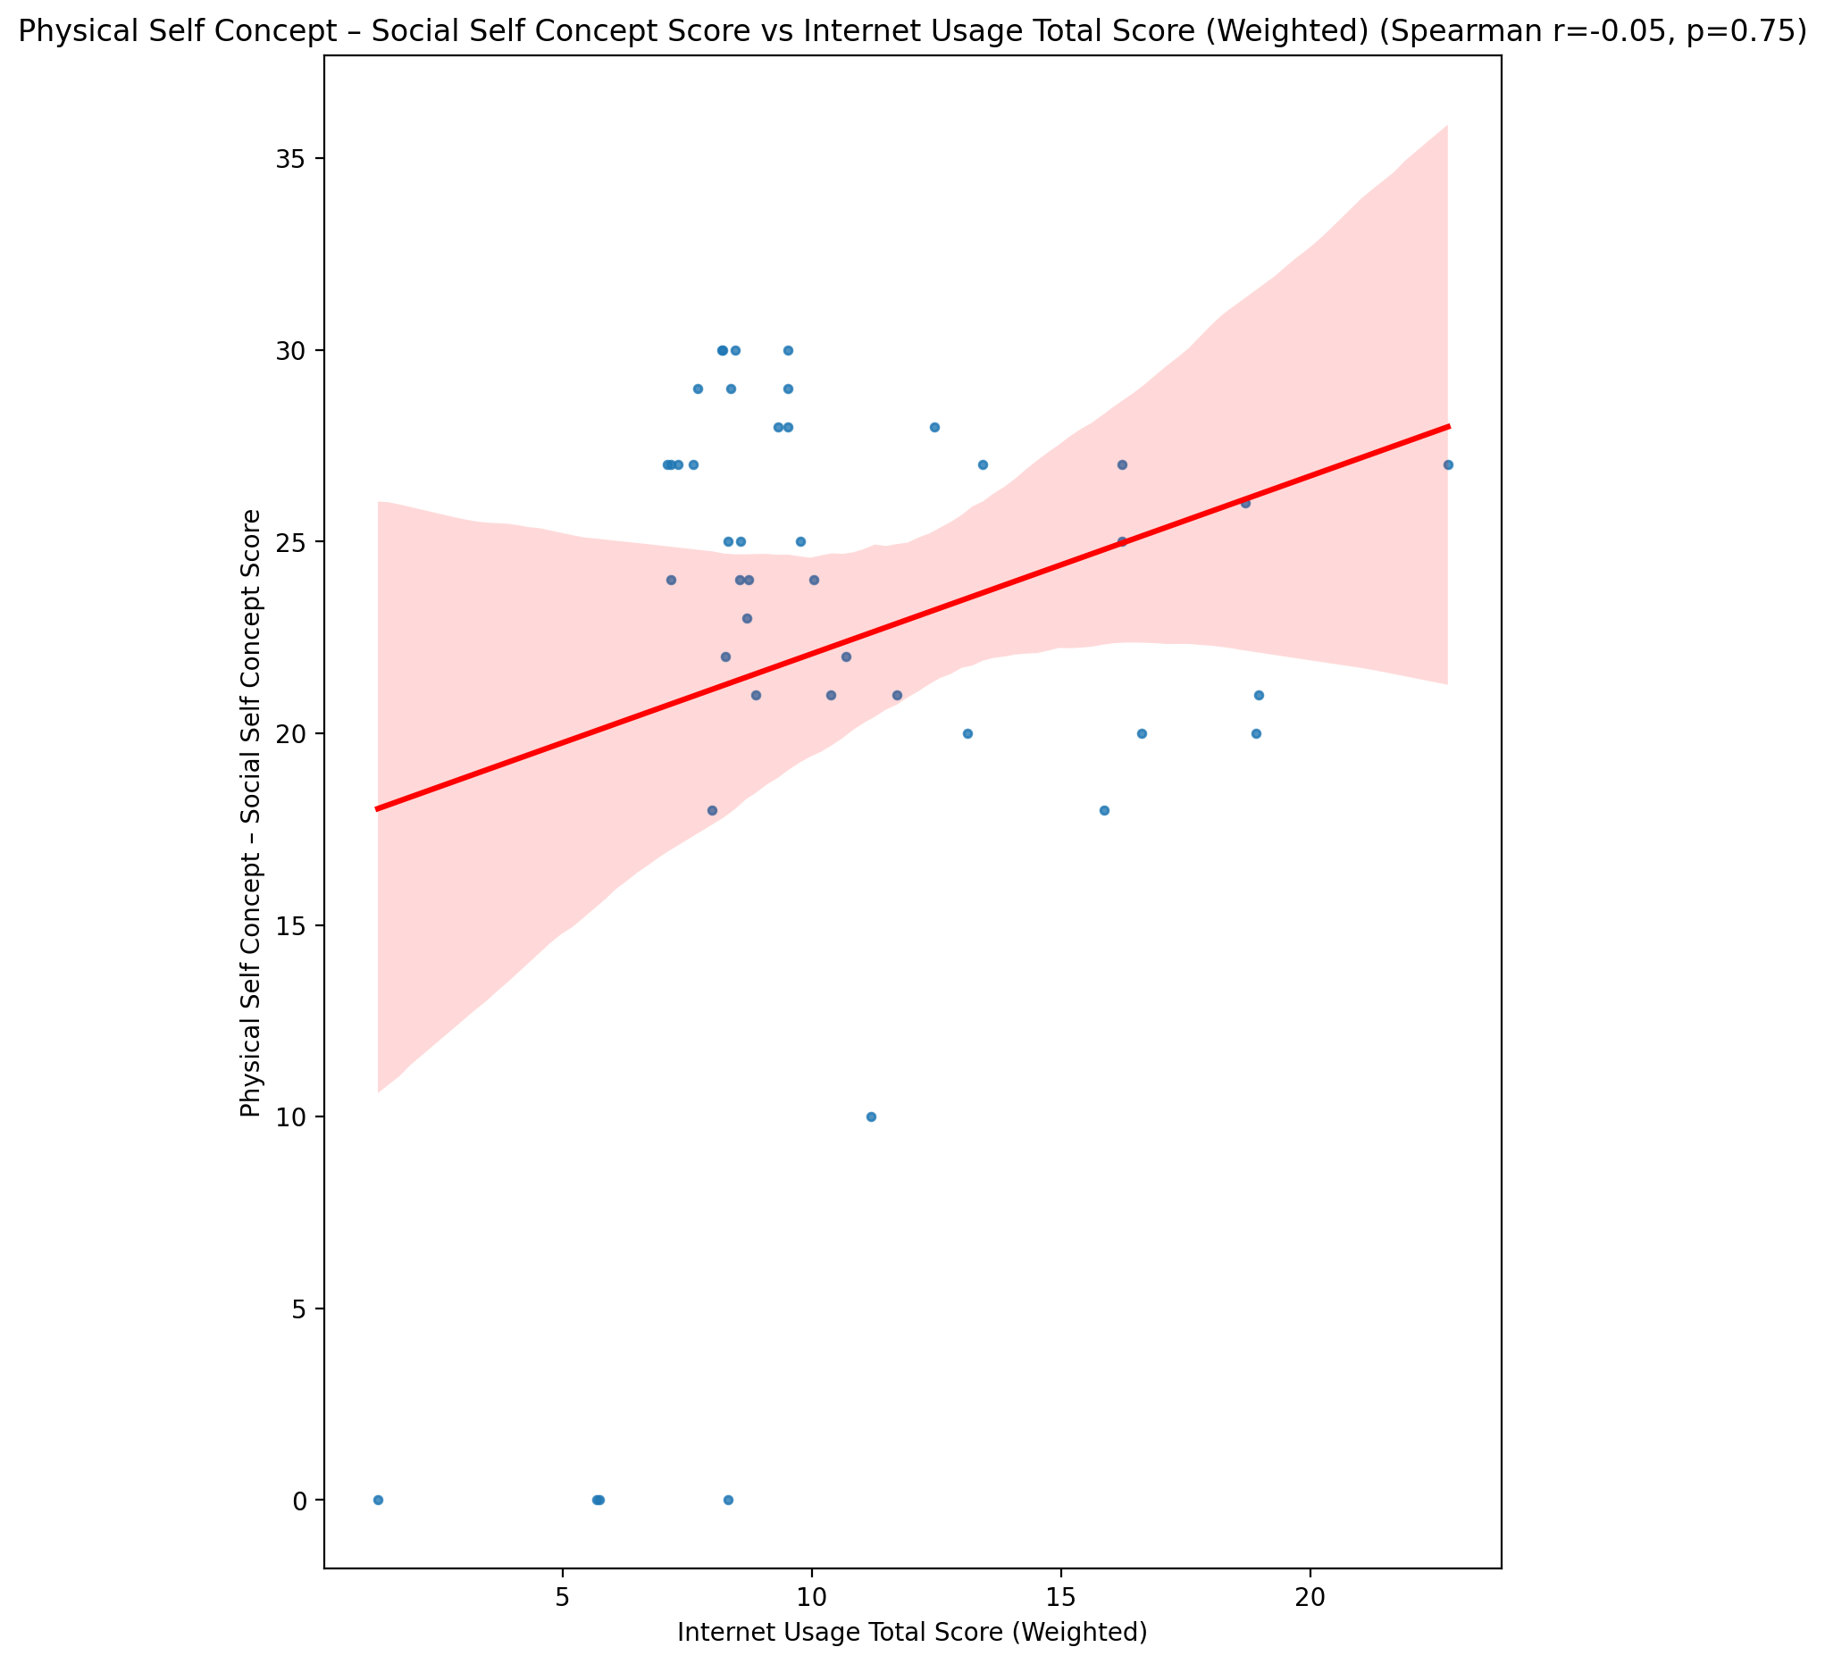

## Psychological Self Concept - Real Self Concept Score vs Internet Usage Total Score (Weighted)

Test: spearman; statistic: -0.2977582739090713; p-value: 0.0524726799793401;

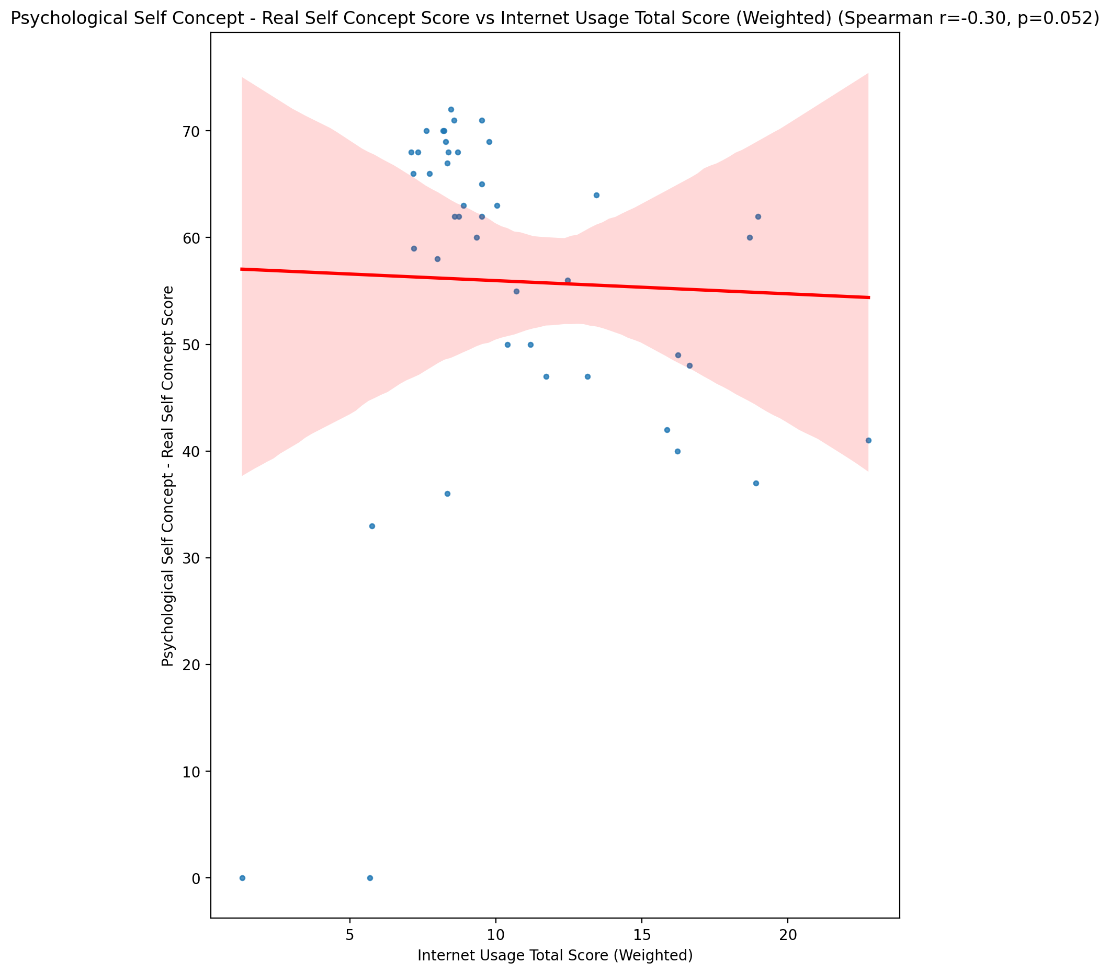

## Psychological Self Concept – Ideal Self Concept Score vs Internet Usage Total Score (Weighted)

Test: spearman; statistic: -0.0688665532938878; p-value: 0.660804420623714;

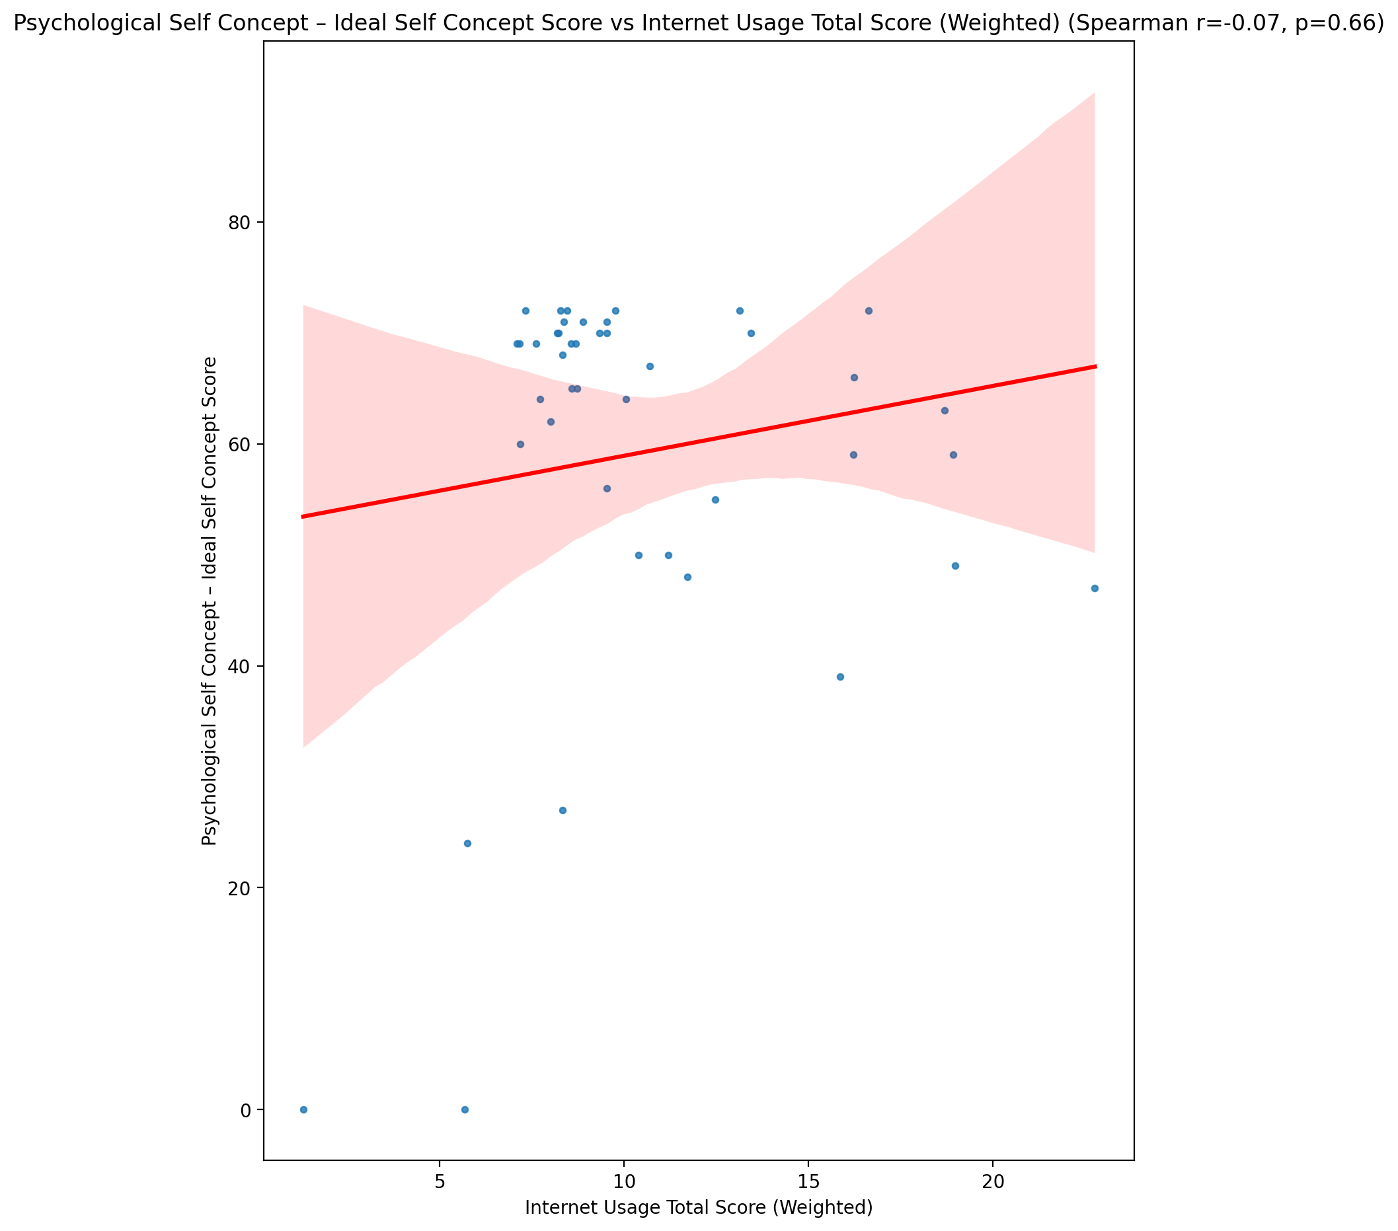

## Psychological Self Concept – Social Self Concept Score vs Internet Usage Total Score (Weighted)

Test: spearman; statistic: -0.29668325329620215; p-value: 0.05337185260789967;

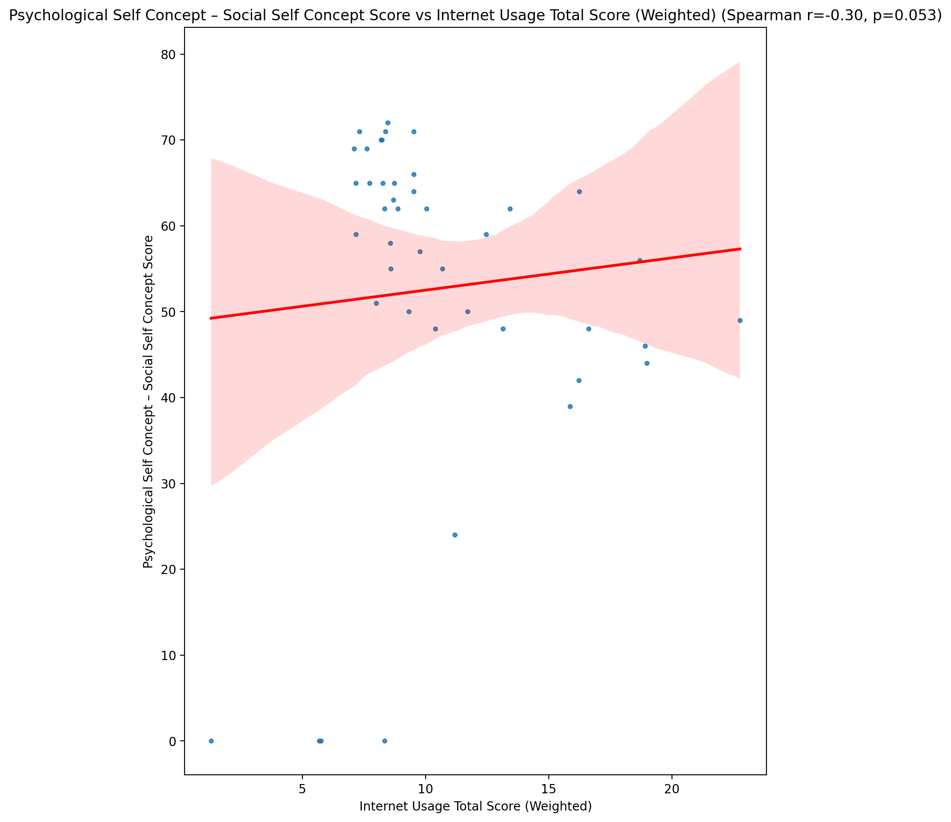

## Real Self Concept Total Score vs Internet Usage Total Score (Weighted)

Test: spearman; statistic: -0.3014997649900059; p-value: 0.049437847827453;

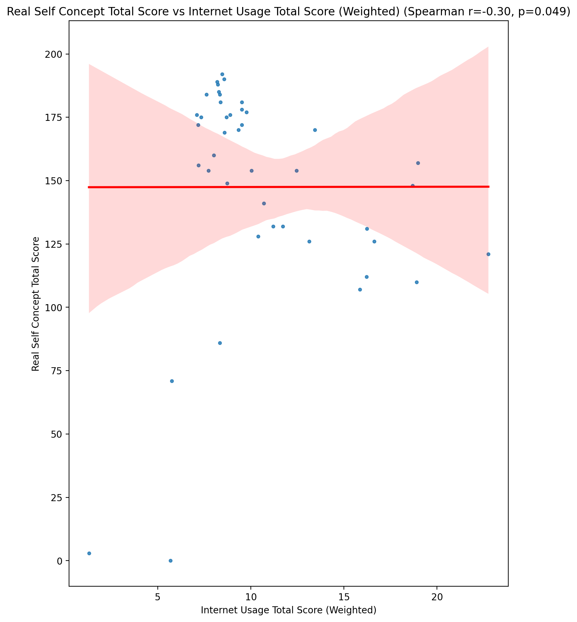

## Ideal Self Concept Total Score vs Internet Usage Total Score (Weighted)

Test: spearman; statistic: -0.0924477744324903; p-value: 0.5554440923353332;

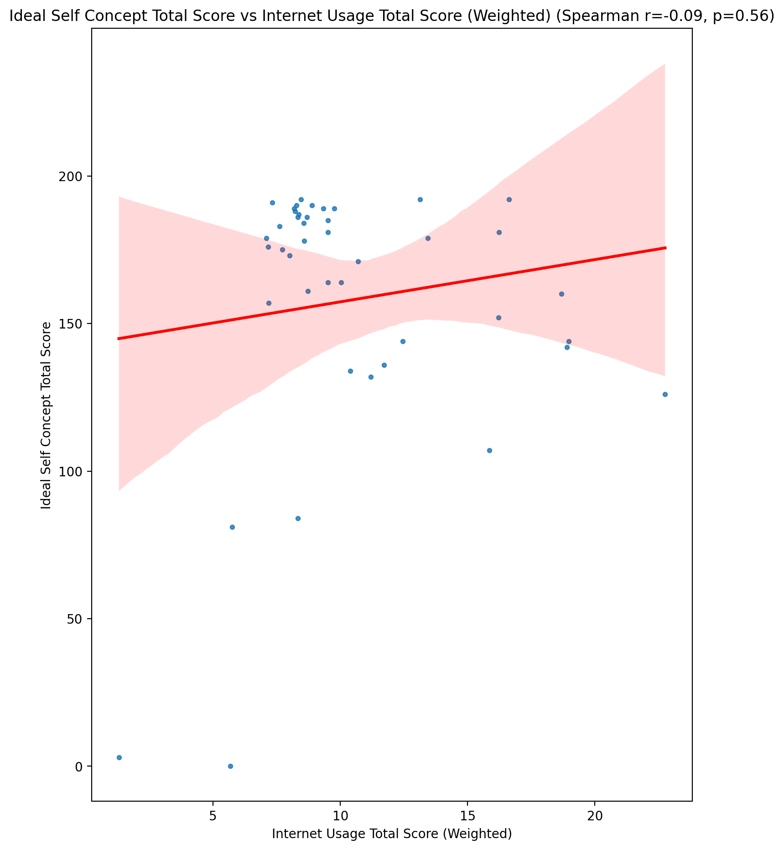

## Social Self Concept Total Score vs Internet Usage Total Score (Weighted)

Test: spearman; statistic: -0.2616727175101224; p-value: 0.09007230497716608;

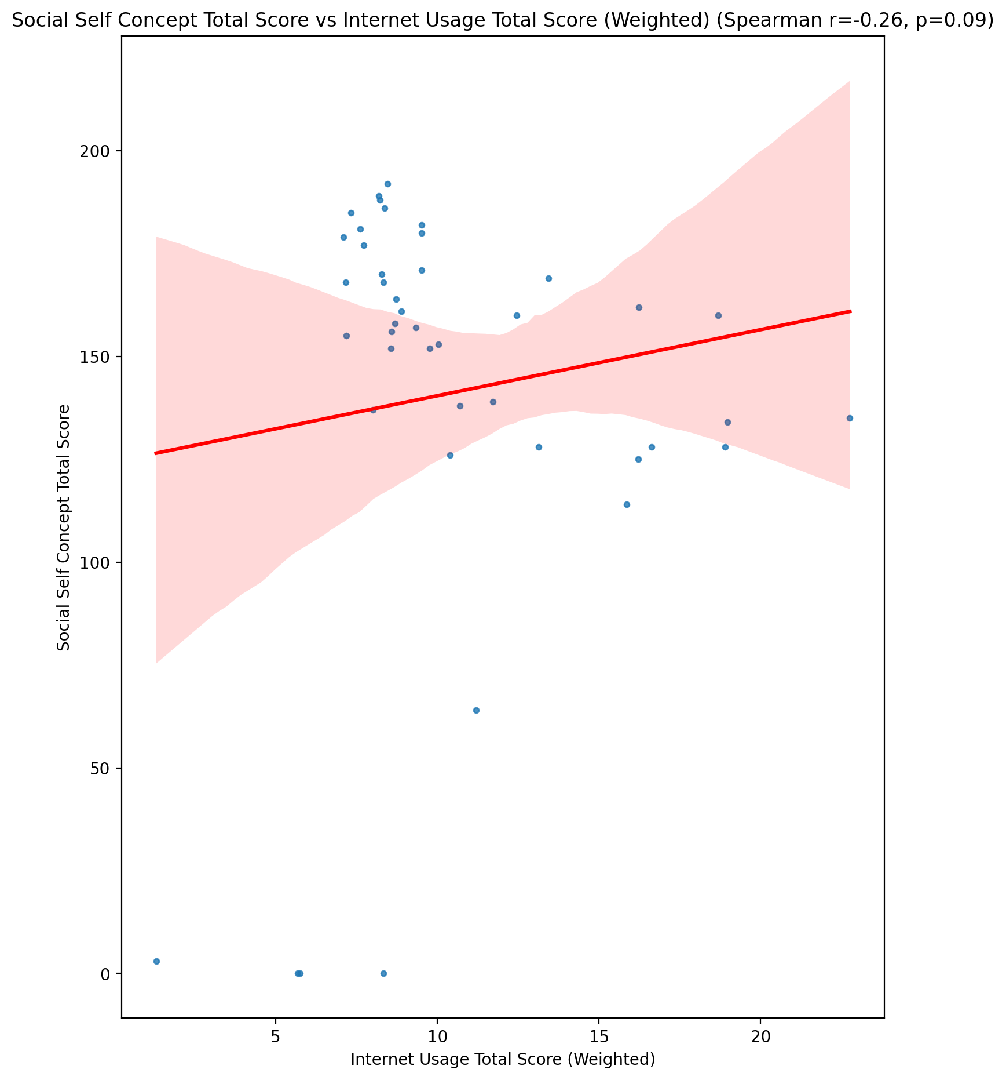

## Ideal Self Concept Total Category vs Internet Usage Total Score (Weighted)

Test: None; statistic: None; p-value: None; Test not run: unsupported type combination.



## Perceived Social Stress Score vs Internet Usage Total Score (Weighted)

Test: spearman; statistic: 0.3926475438475684; p-value: 0.009203121895303482;

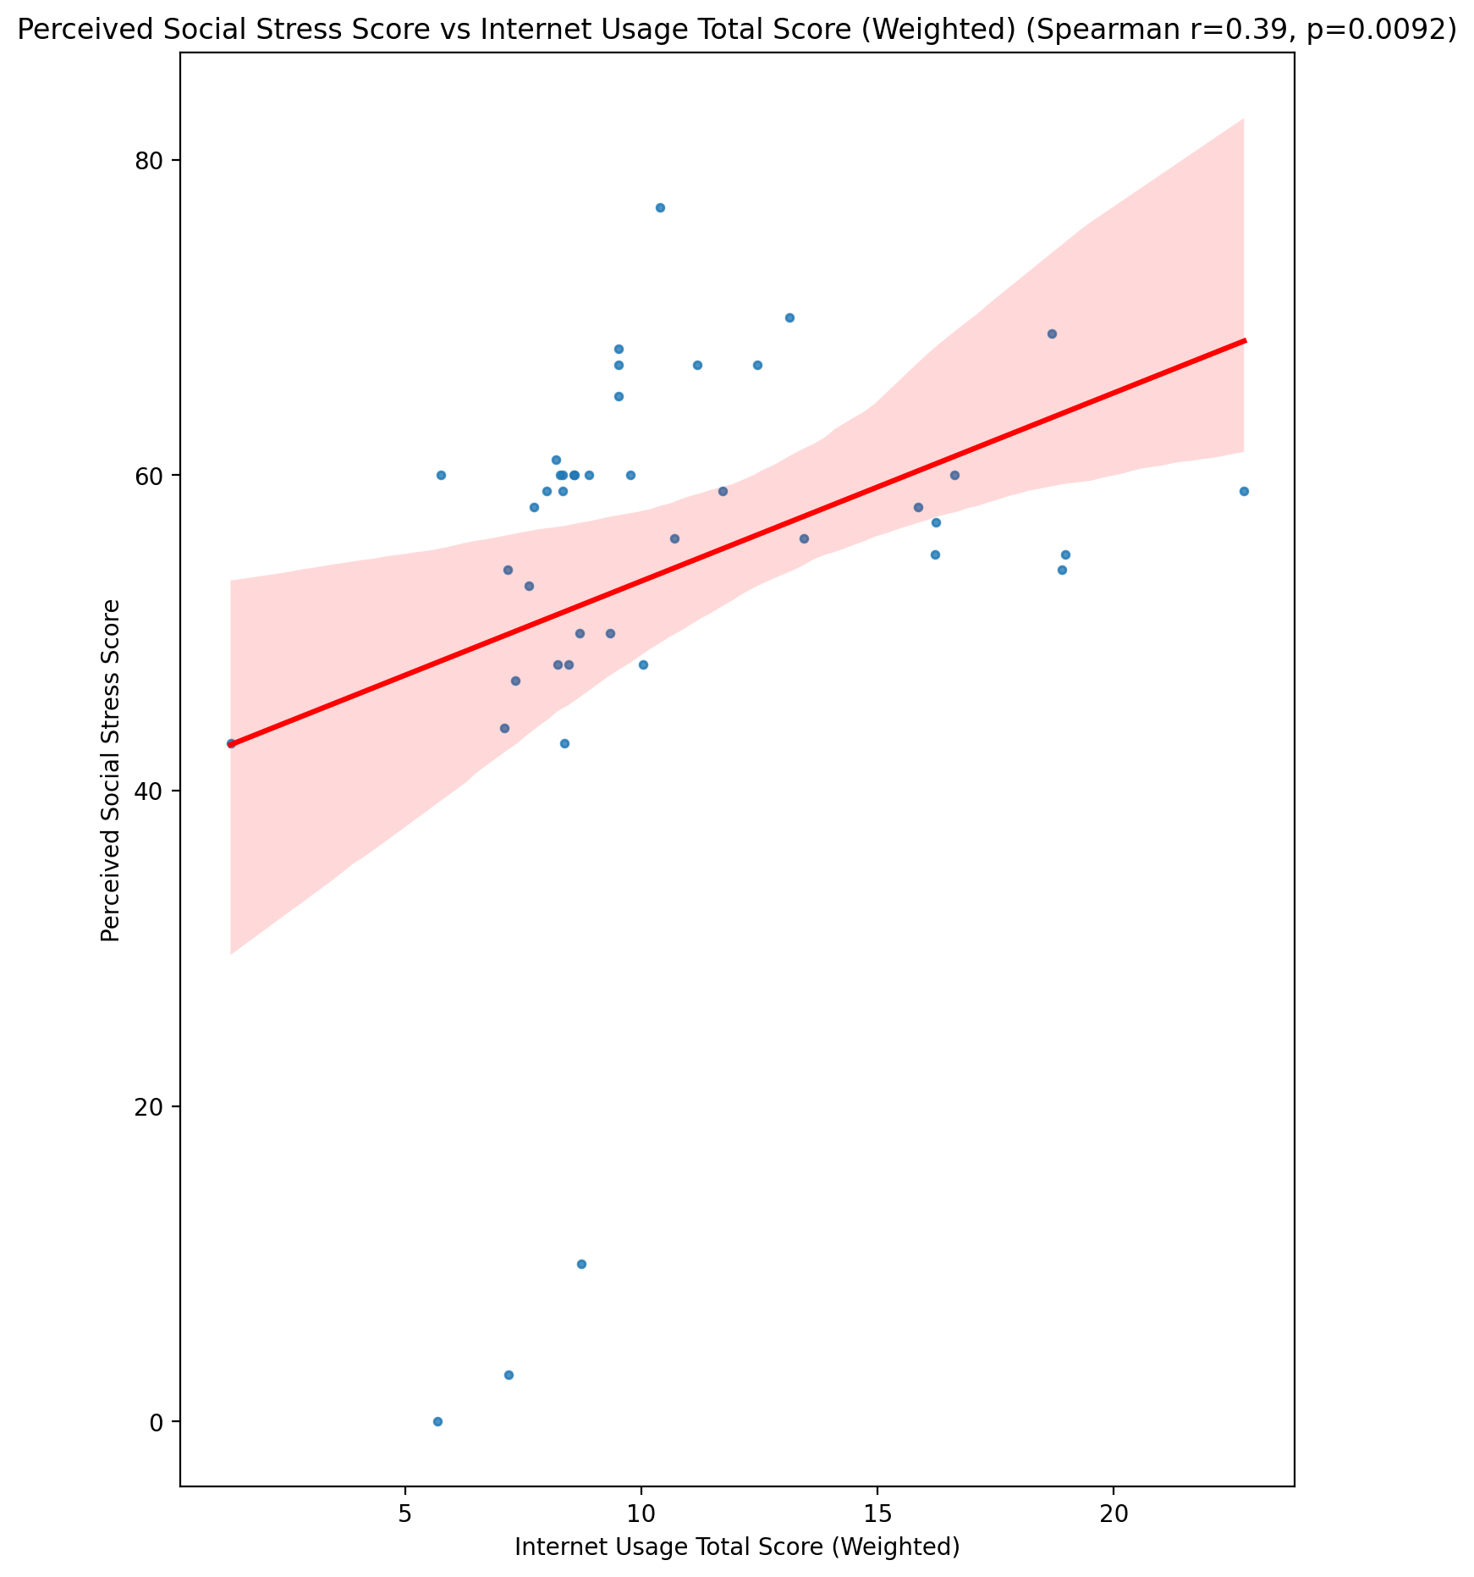

## Perceived Social Stress Category vs Internet Usage Total Score (Weighted)

Test: None; statistic: None; p-value: None; Test not run: unsupported type combination.



## Emotional Support - Raw Score vs Functional Impairment - Category

Test: anova; statistic: 0.8585072613938557; p-value: 0.4706976640000383;

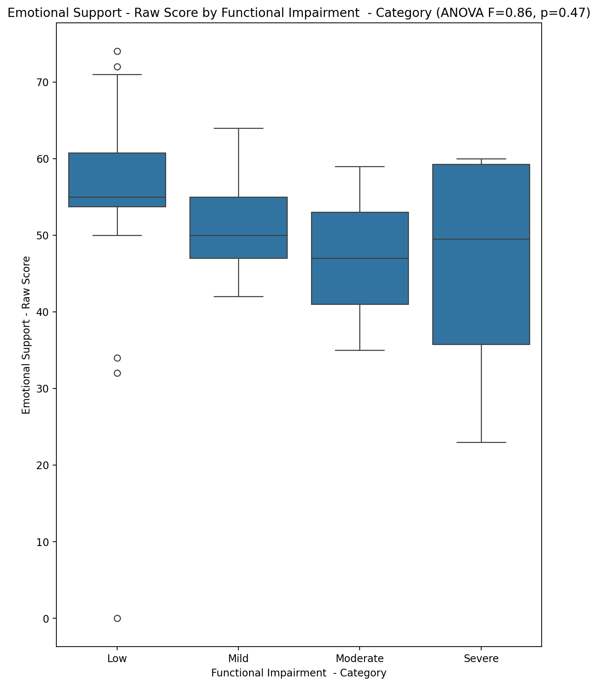

## Informational Support - Raw Score vs Functional Impairment - Category

Test: anova; statistic: 1.8914624361282568; p-value: 0.1469939239404799;

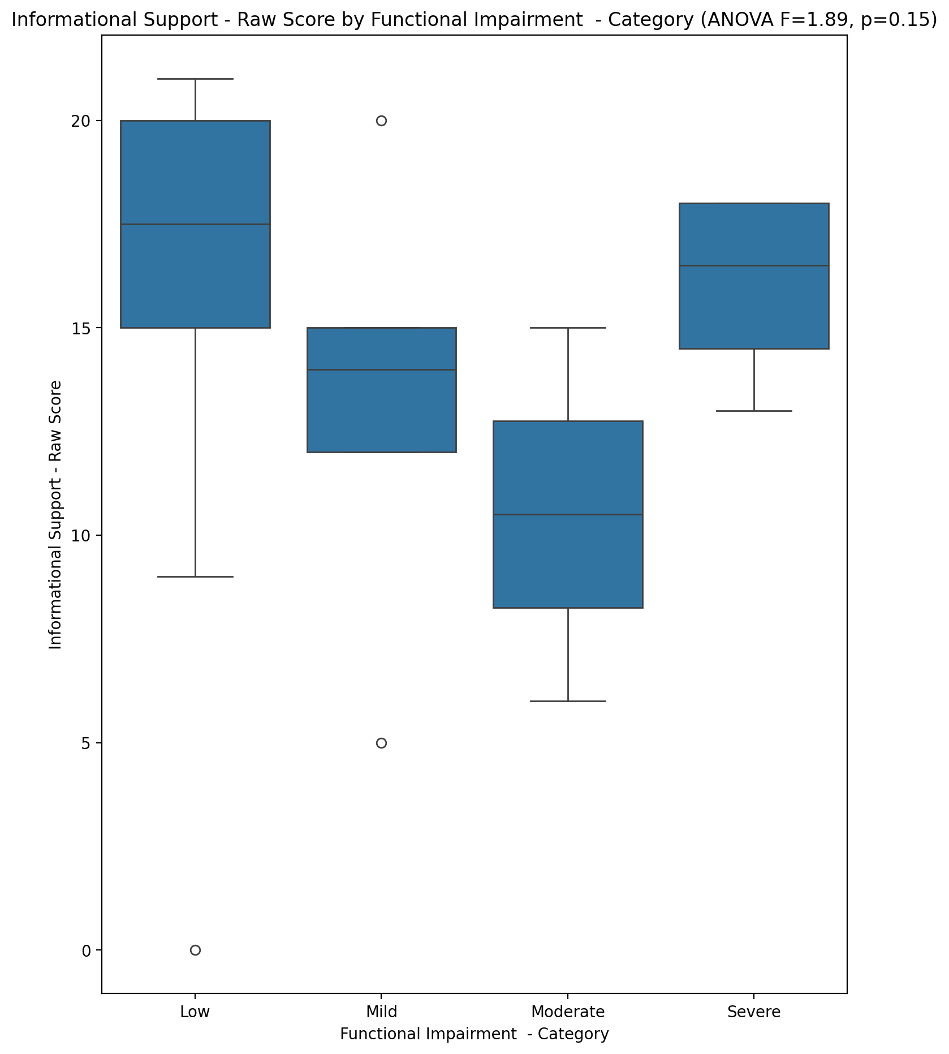

## Instrumental Support - Raw Score vs Functional Impairment - Category

Test: anova; statistic: 0.2800469475536234; p-value: 0.8394583266633103;

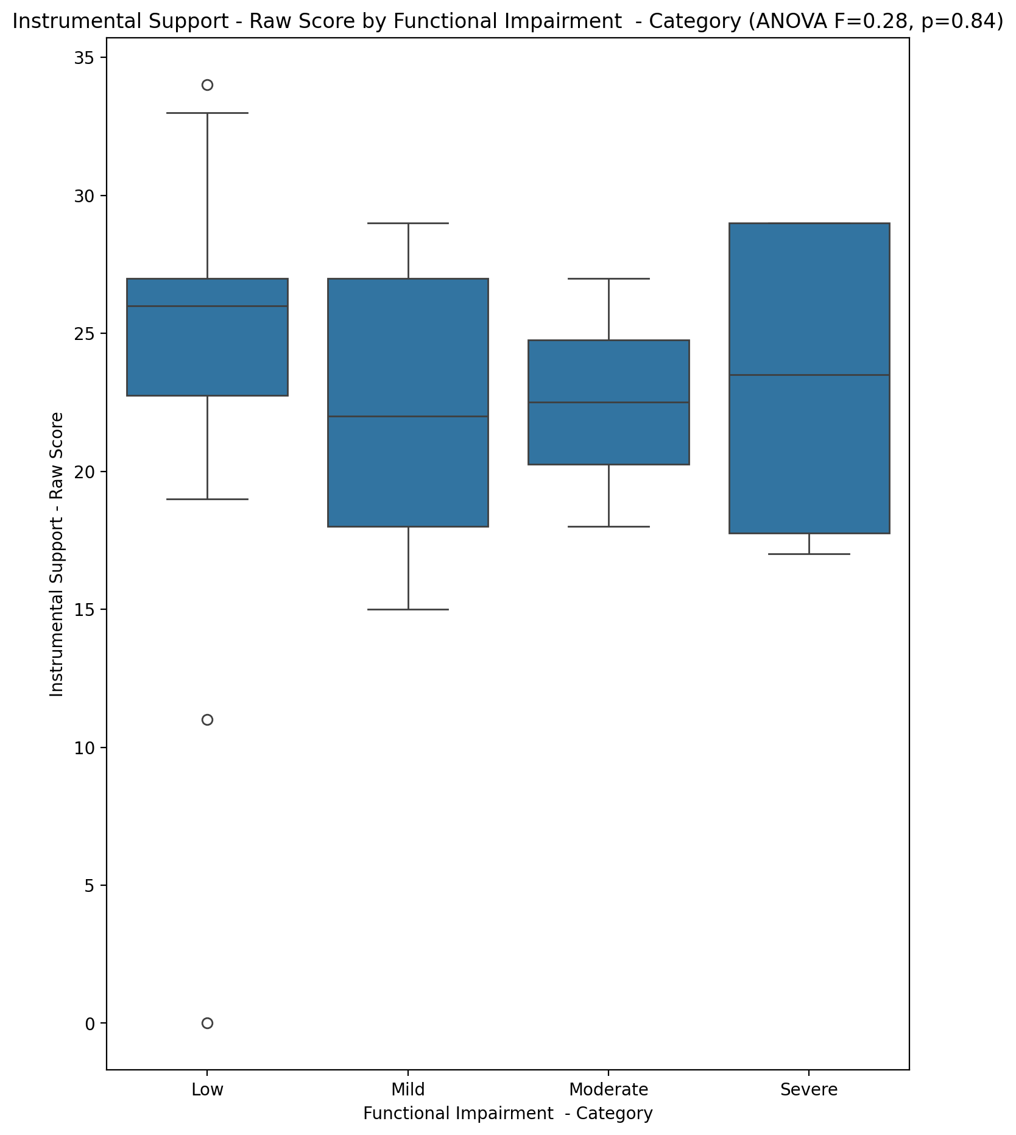

## Emotional Support - T Score vs Functional Impairment - Category

Test: anova; statistic: 0.7982183515669544; p-value: 0.5023780215040944;

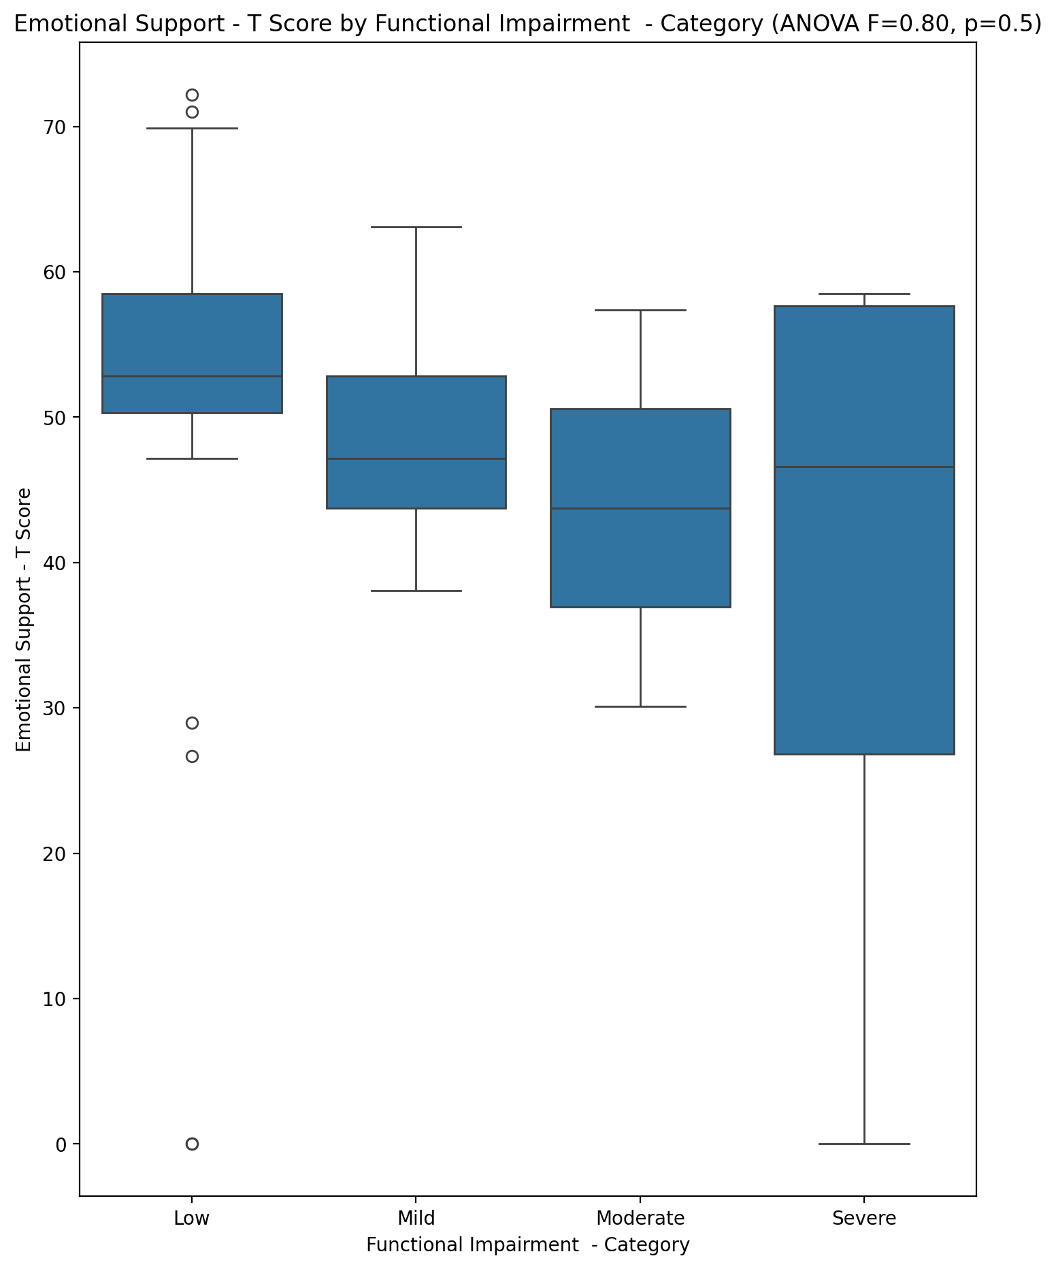

## Informational Support - T Score vs Functional Impairment - Category

Test: anova; statistic: 2.9877827360276403; p-value: 0.04265067987209111;

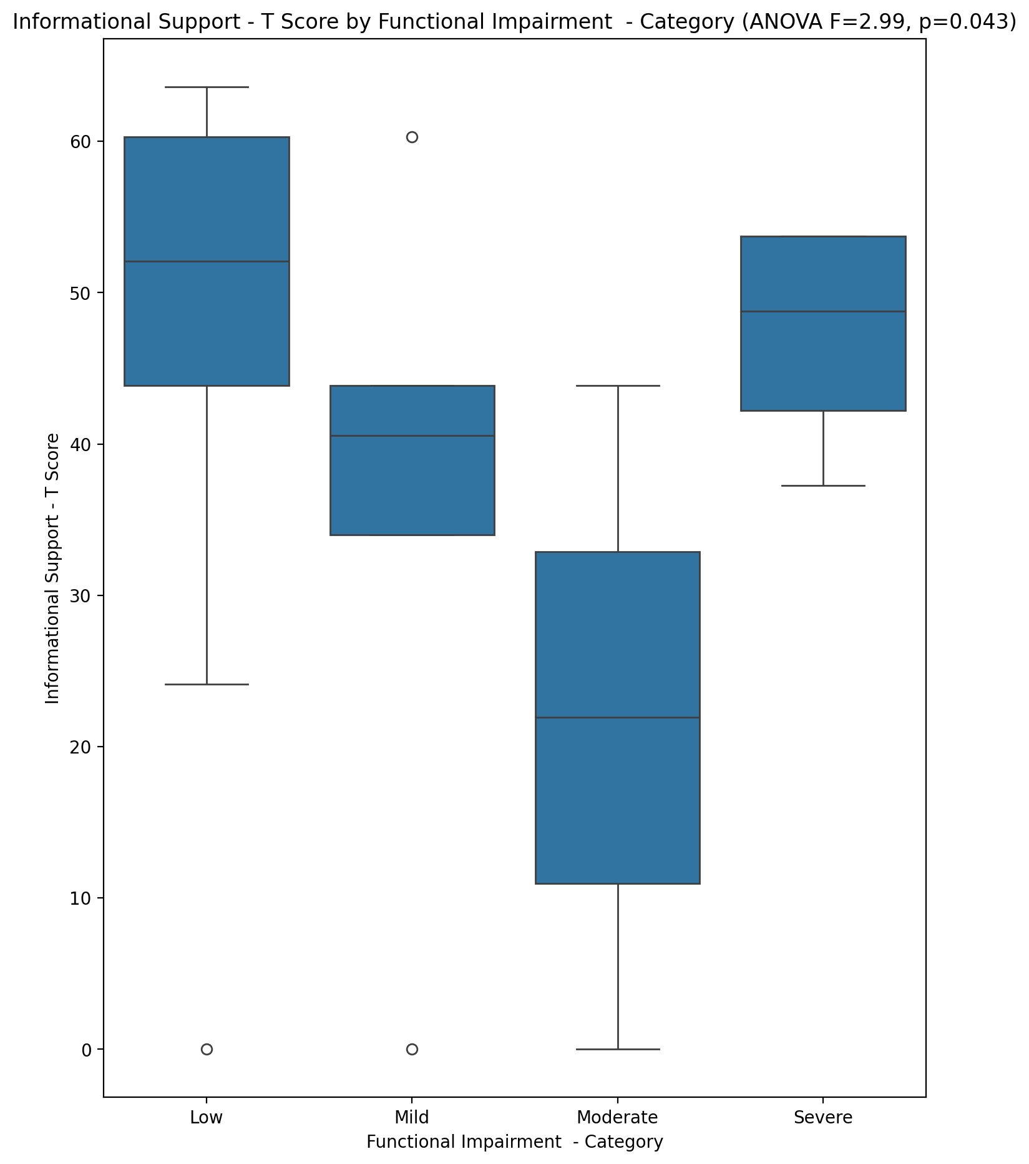

## Instrumental Support - T Score vs Functional Impairment - Category

Test: anova; statistic: 0.2504286290815191; p-value: 0.860538142079904;

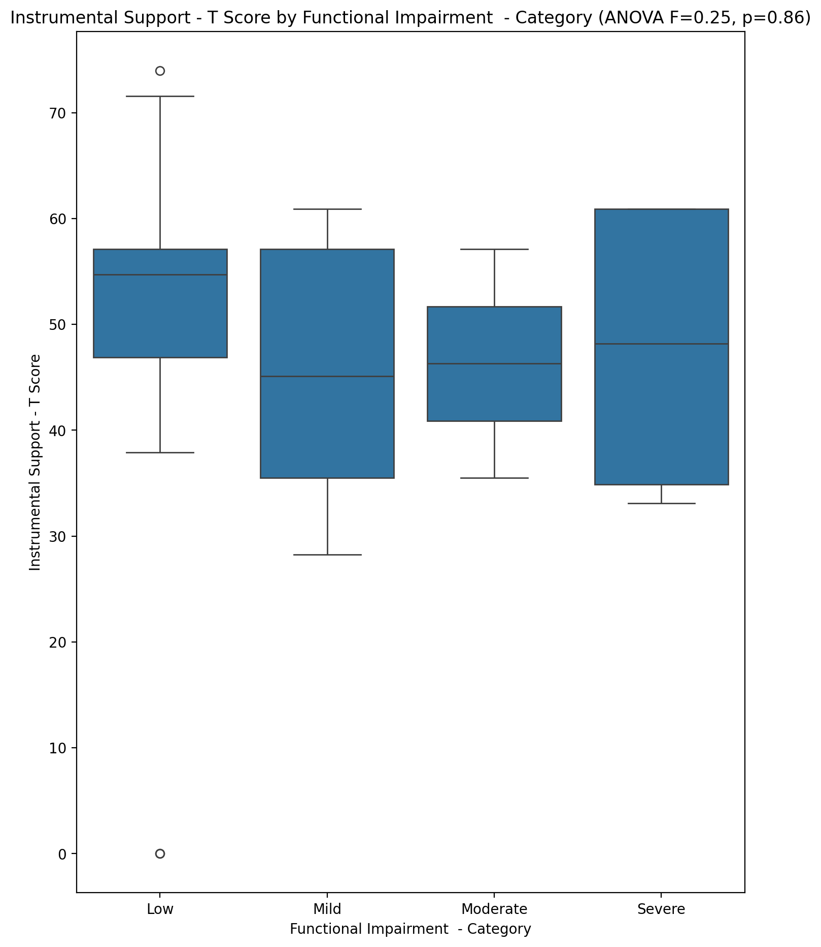

## Perceived Social Support Total T Score vs Functional Impairment - Category

Test: anova; statistic: 1.7347841896220209; p-value: 0.17575538356900877;

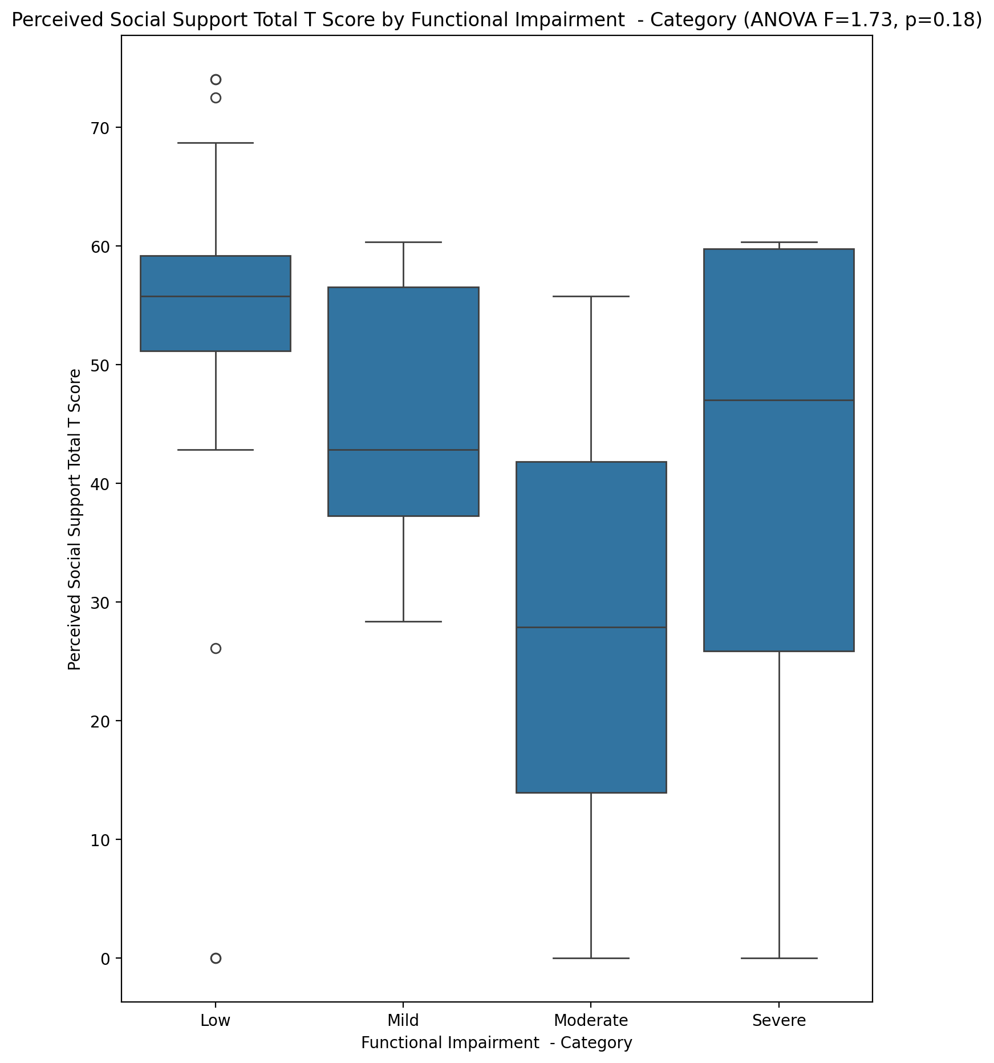

## Emotional Support - Rank vs Functional Impairment - Category

Test: chi2; statistic: 24.384583333333335; p-value: 0.018023996138110215;

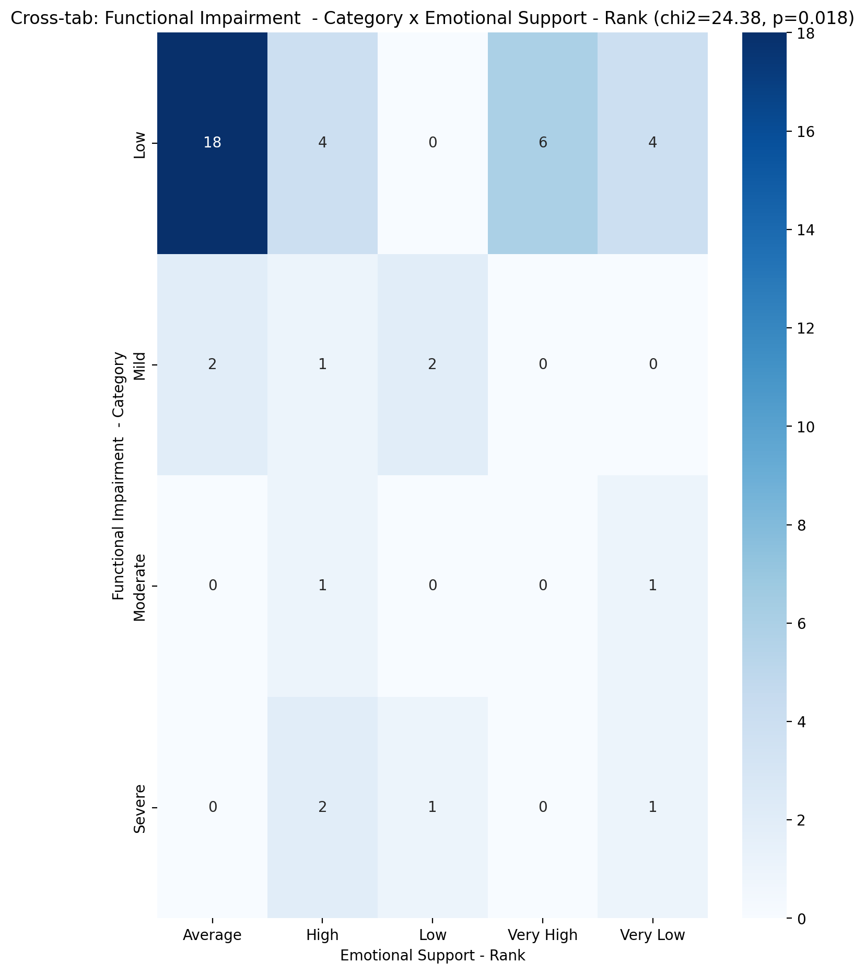

## Informational Support - Rank vs Functional Impairment - Category

Test: chi2; statistic: 11.452589285714286; p-value: 0.24595653862746103;

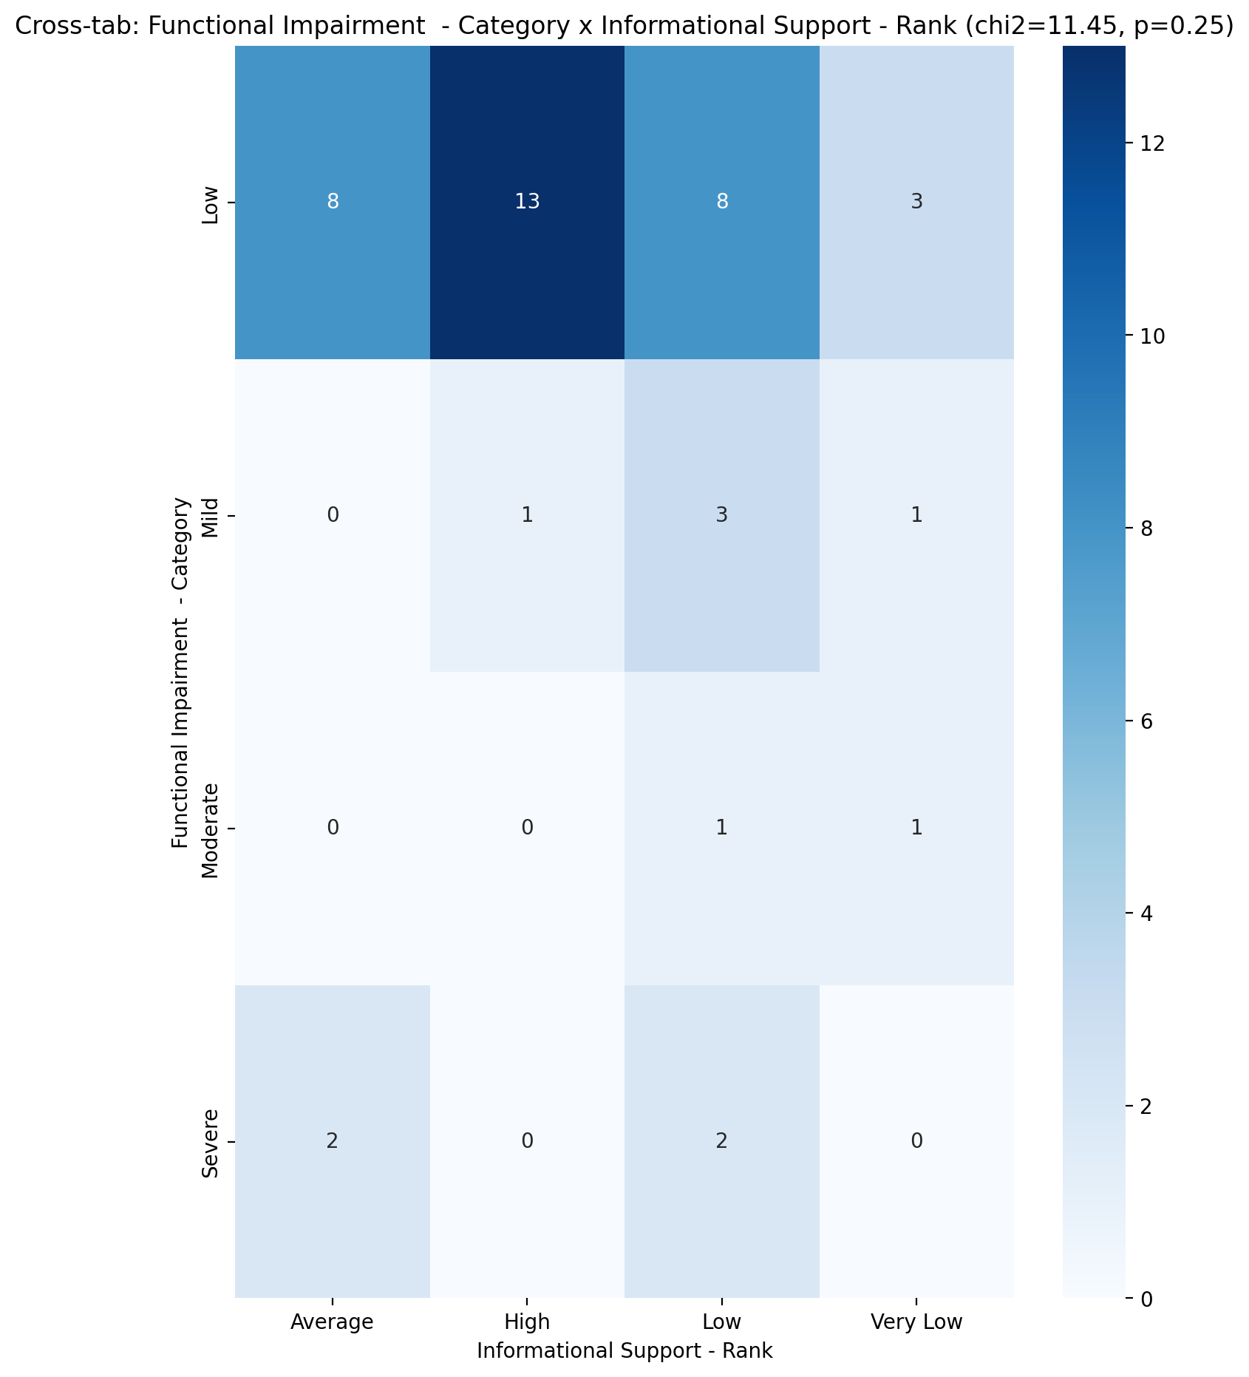

## Instrumental Support - Rank vs Functional Impairment - Category

Test: chi2; statistic: 8.980729166666668; p-value: 0.7045755357452975;

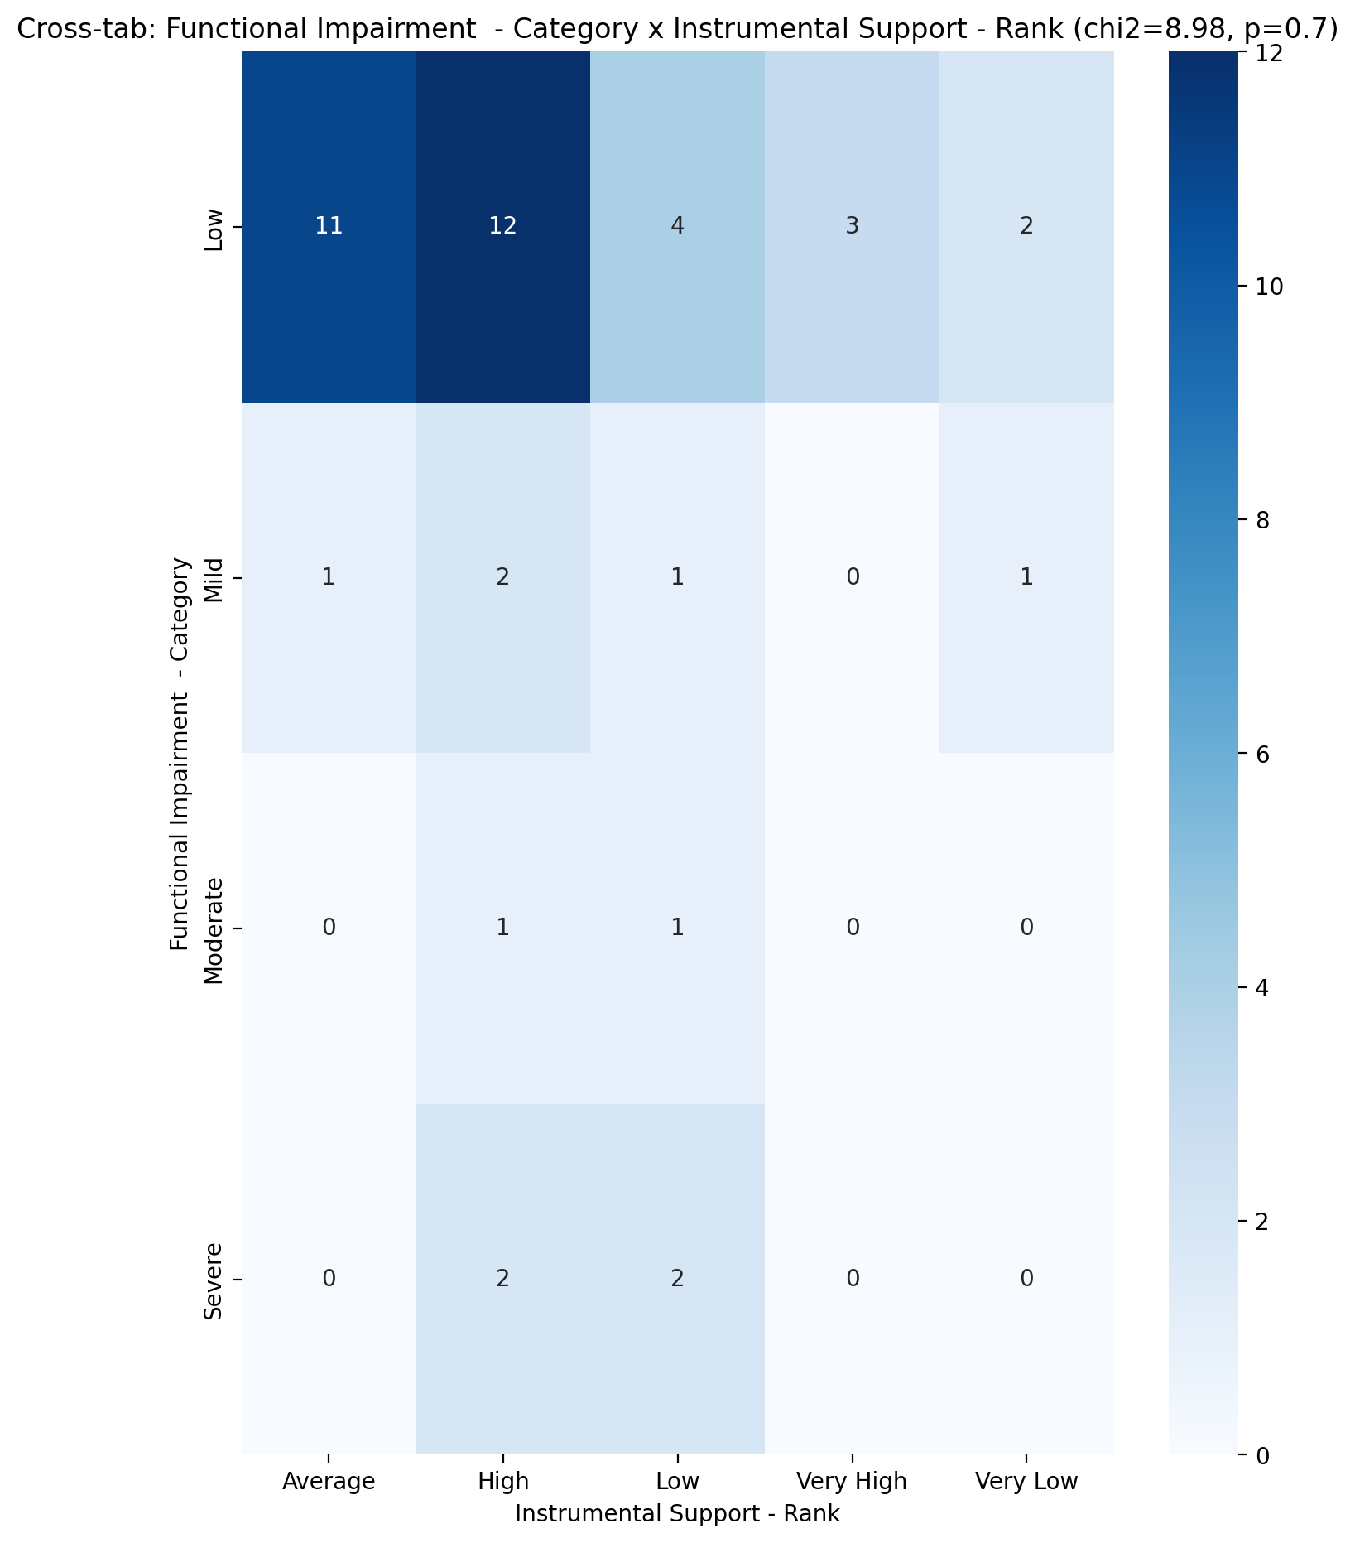

## Perceived Social Support TOTAL - Rank vs Functional Impairment - Category

Test: chi2; statistic: 14.342291666666666; p-value: 0.27938628074817584;

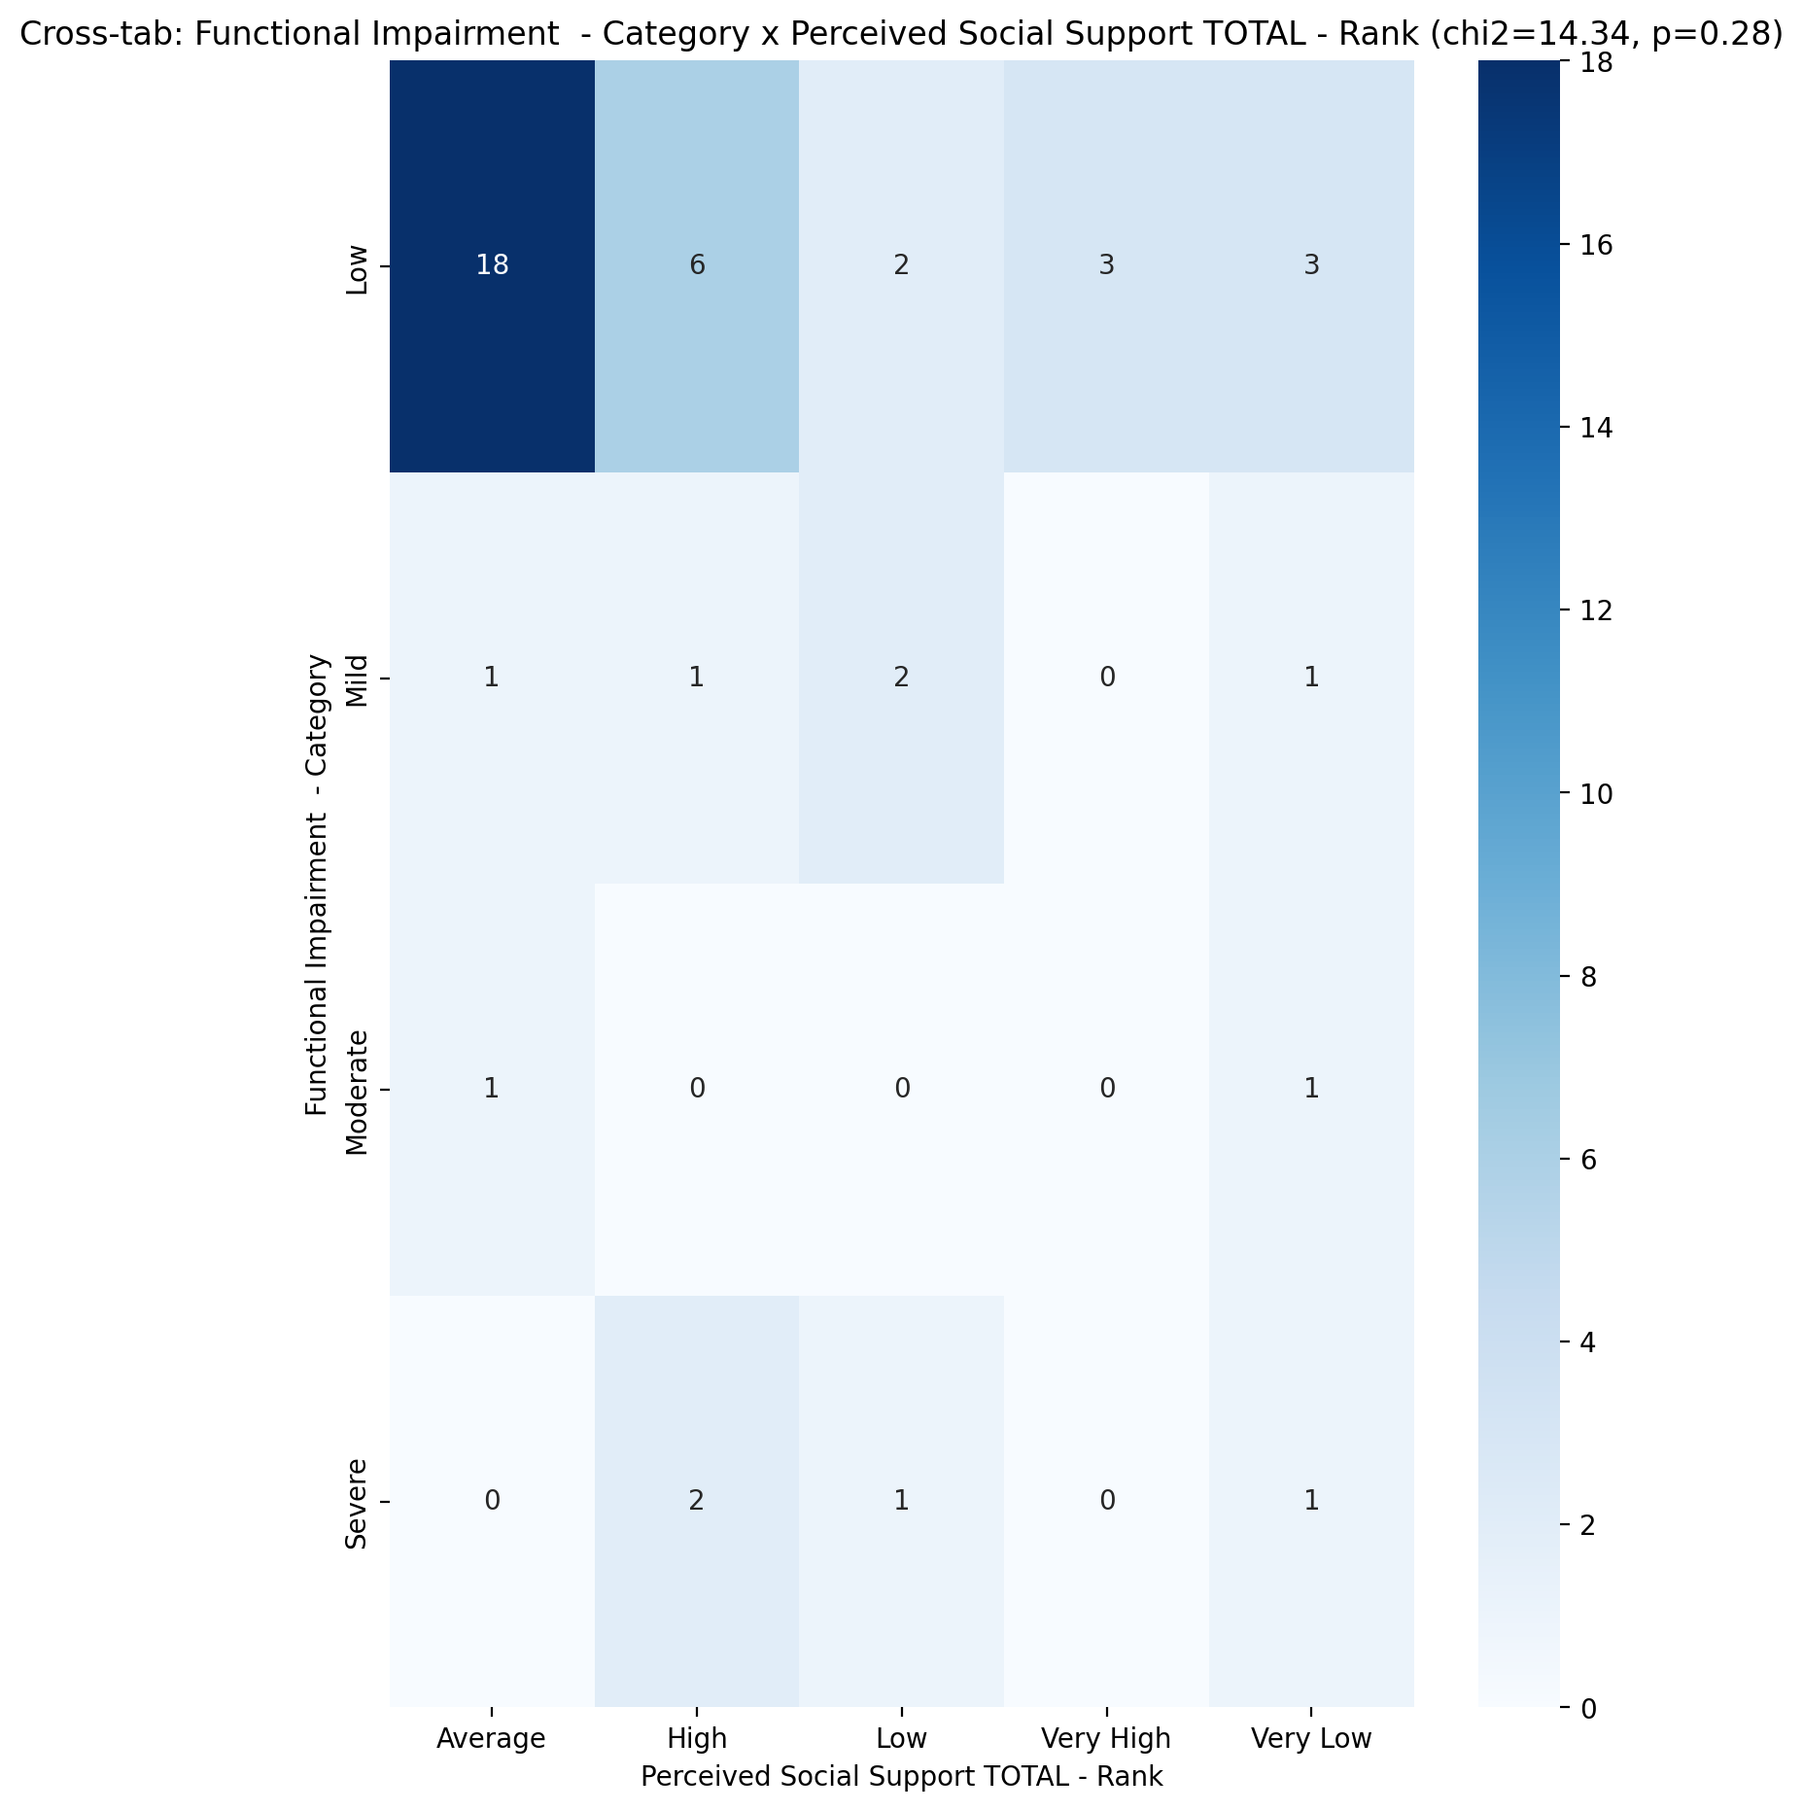

## Power Self Concept - Real Self Concept Score vs Functional Impairment - Category

Test: anova; statistic: 0.30250658988667634; p-value: 0.823380898989694;

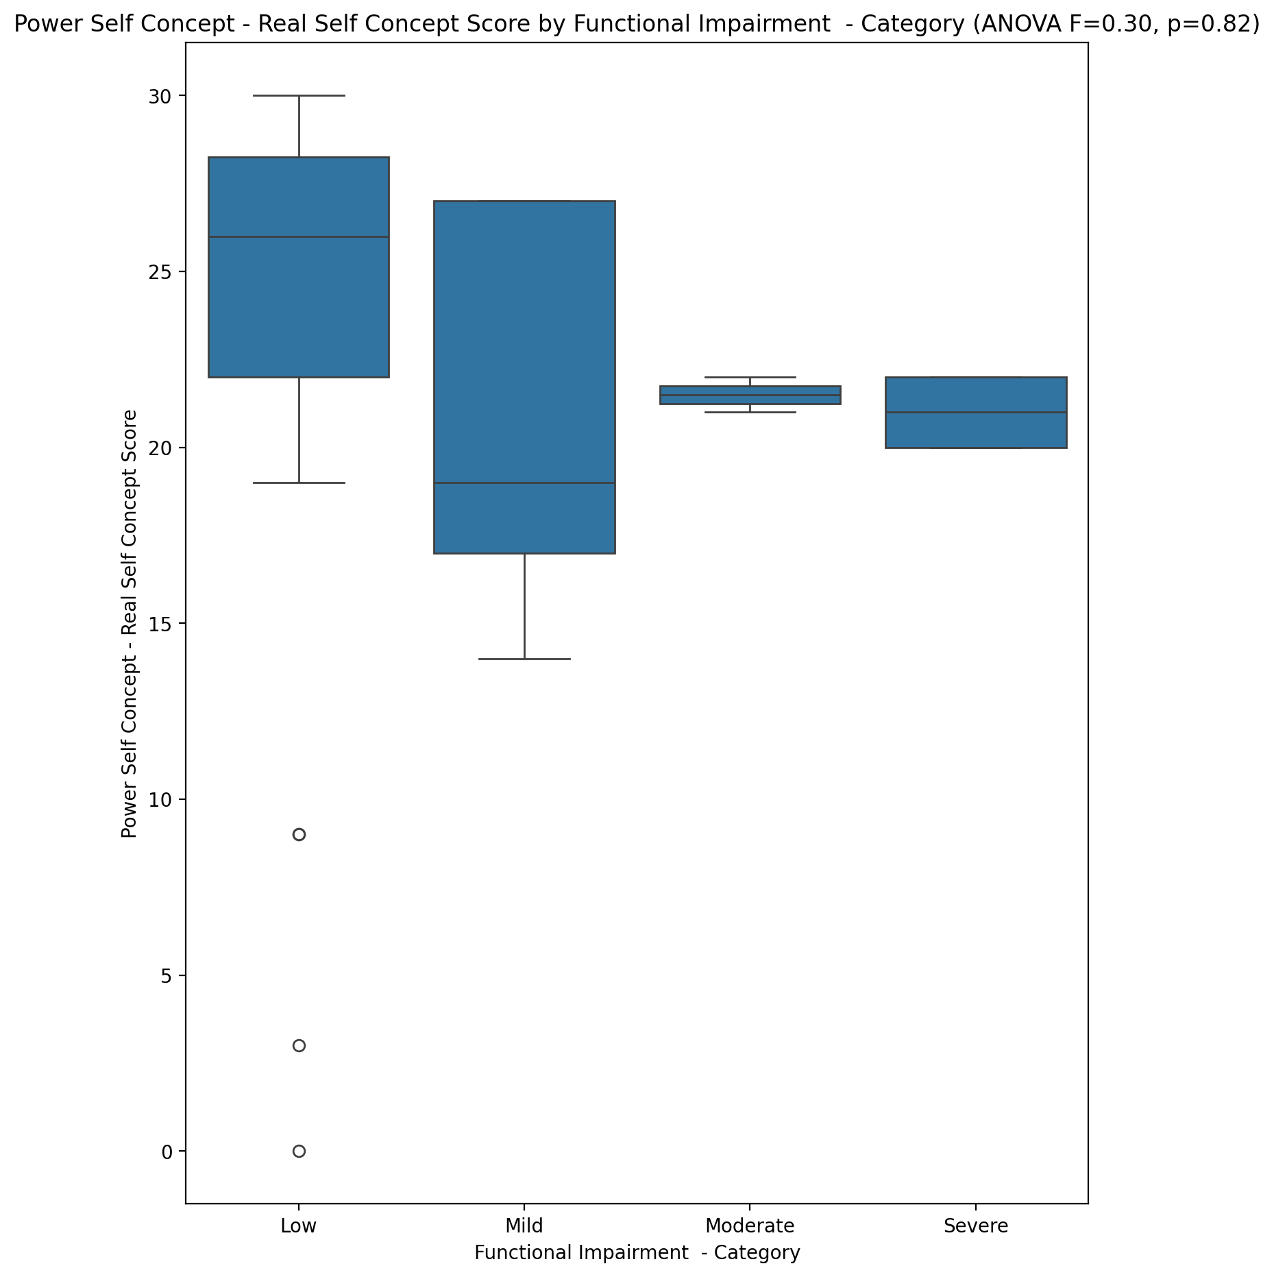

## Power Self Concept - Ideal Self Concept score vs Functional Impairment - Category

Test: anova; statistic: 0.22250036625836822; p-value: 0.8801811652051068;

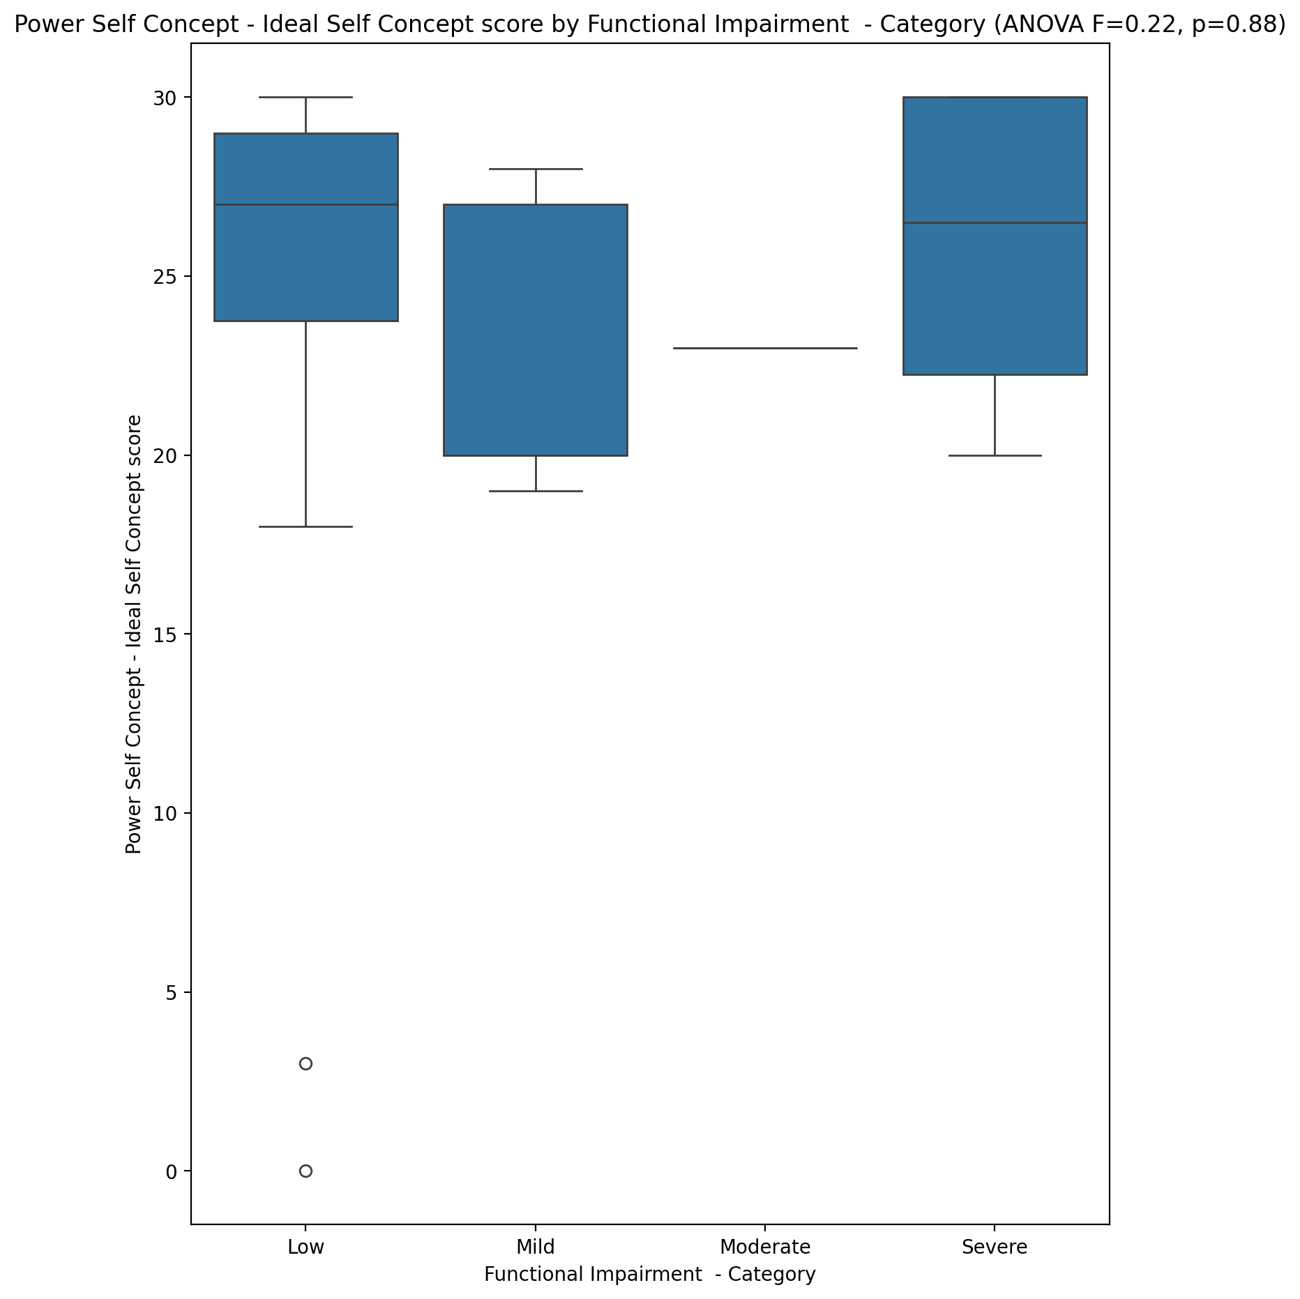

## Power Self Concept – Social Self Concept Score vs Functional Impairment - Category

Test: anova; statistic: 0.18796133586892533; p-value: 0.9039572877430363;

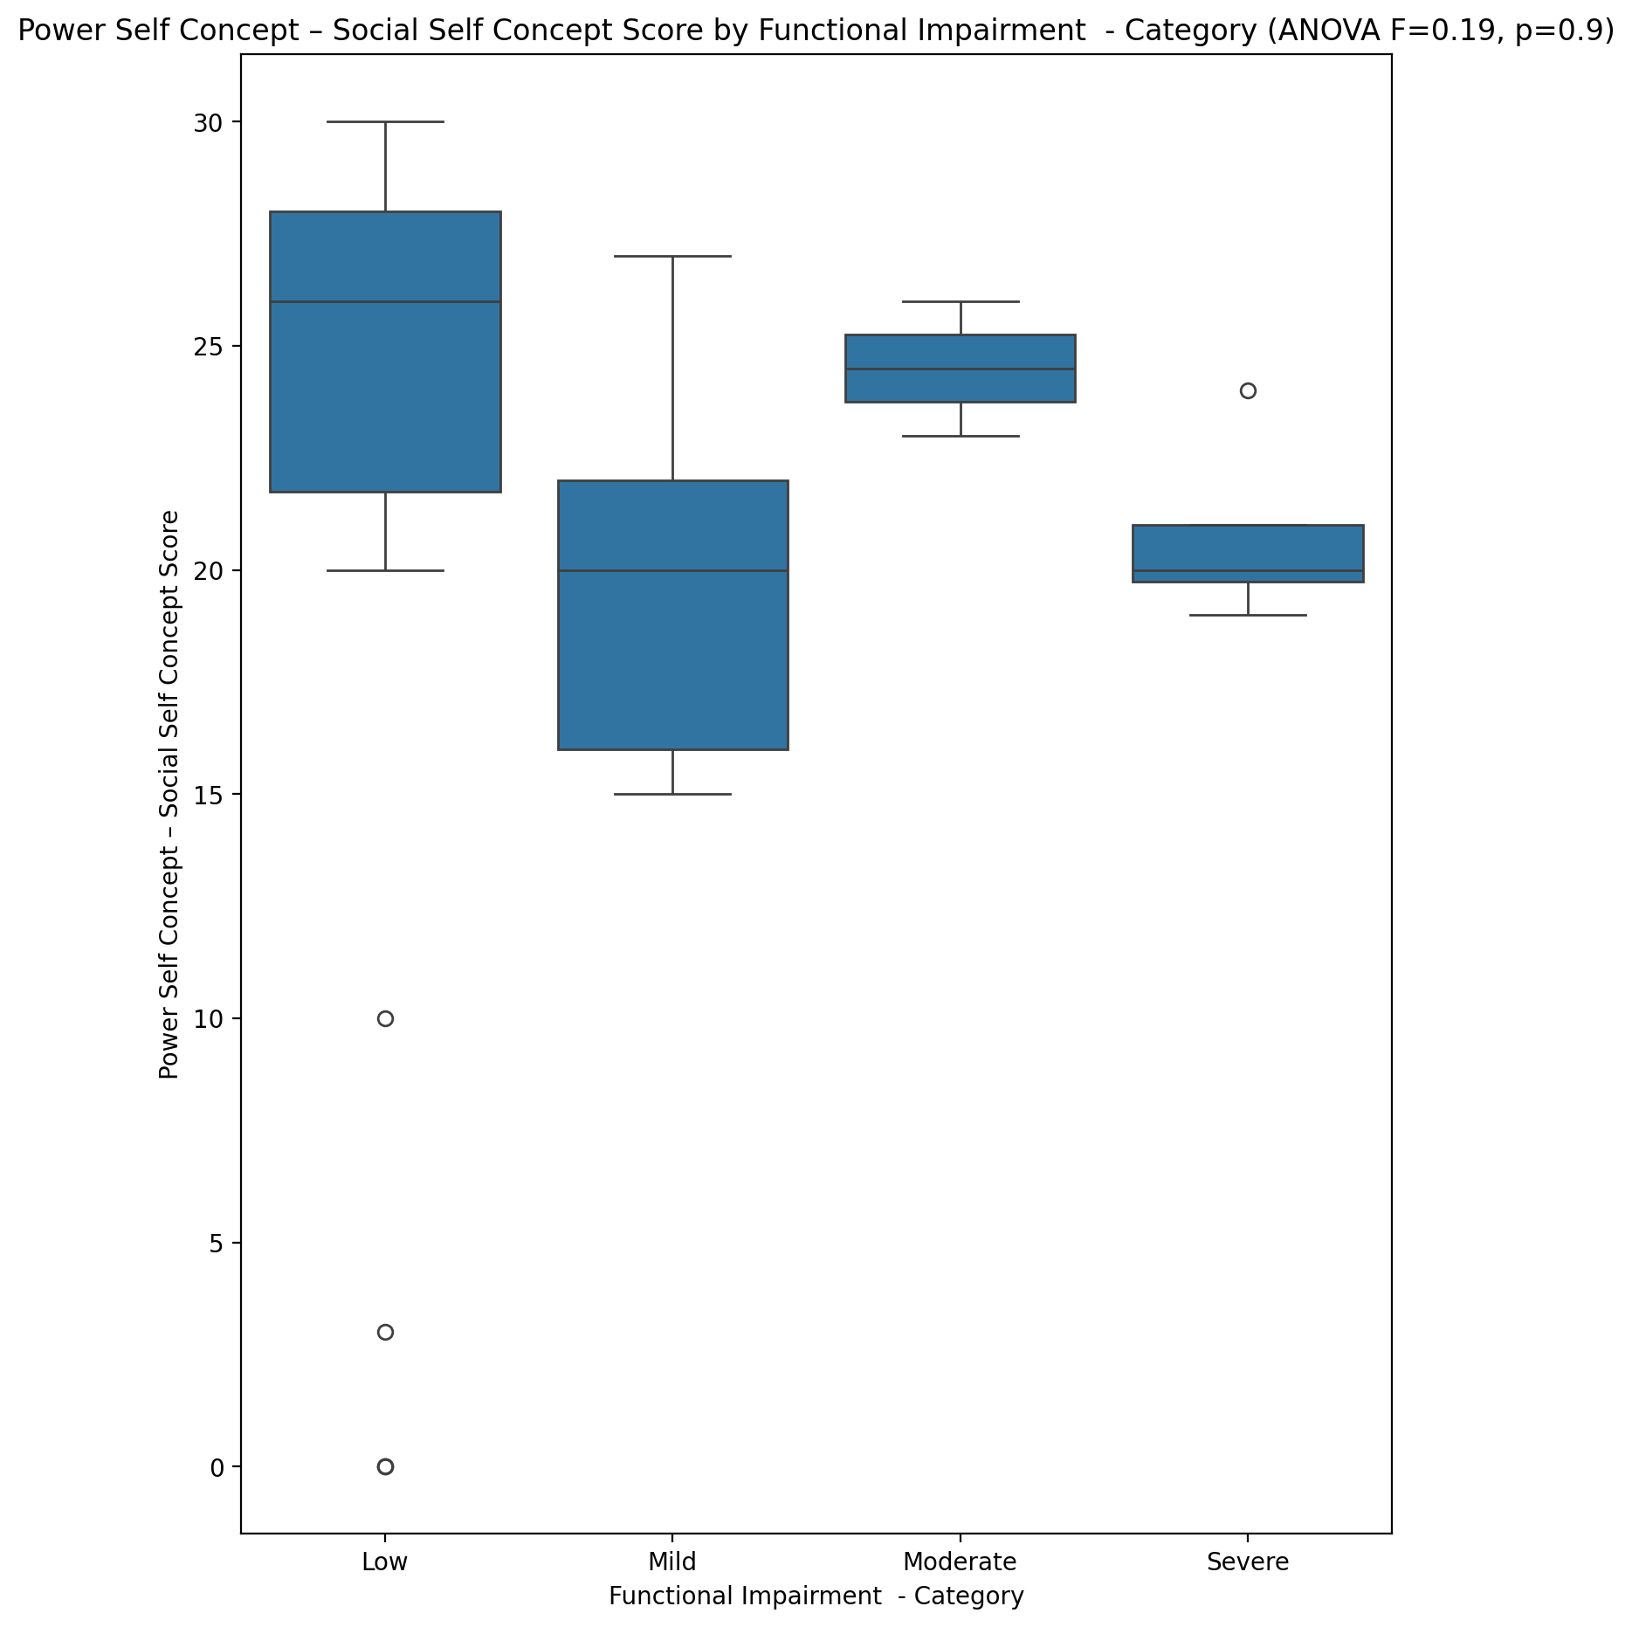

## Social Self Concept - Real Self Concept Score vs Functional Impairment - Category

Test: anova; statistic: 0.2789989375516468; p-value: 0.8402071100227909;

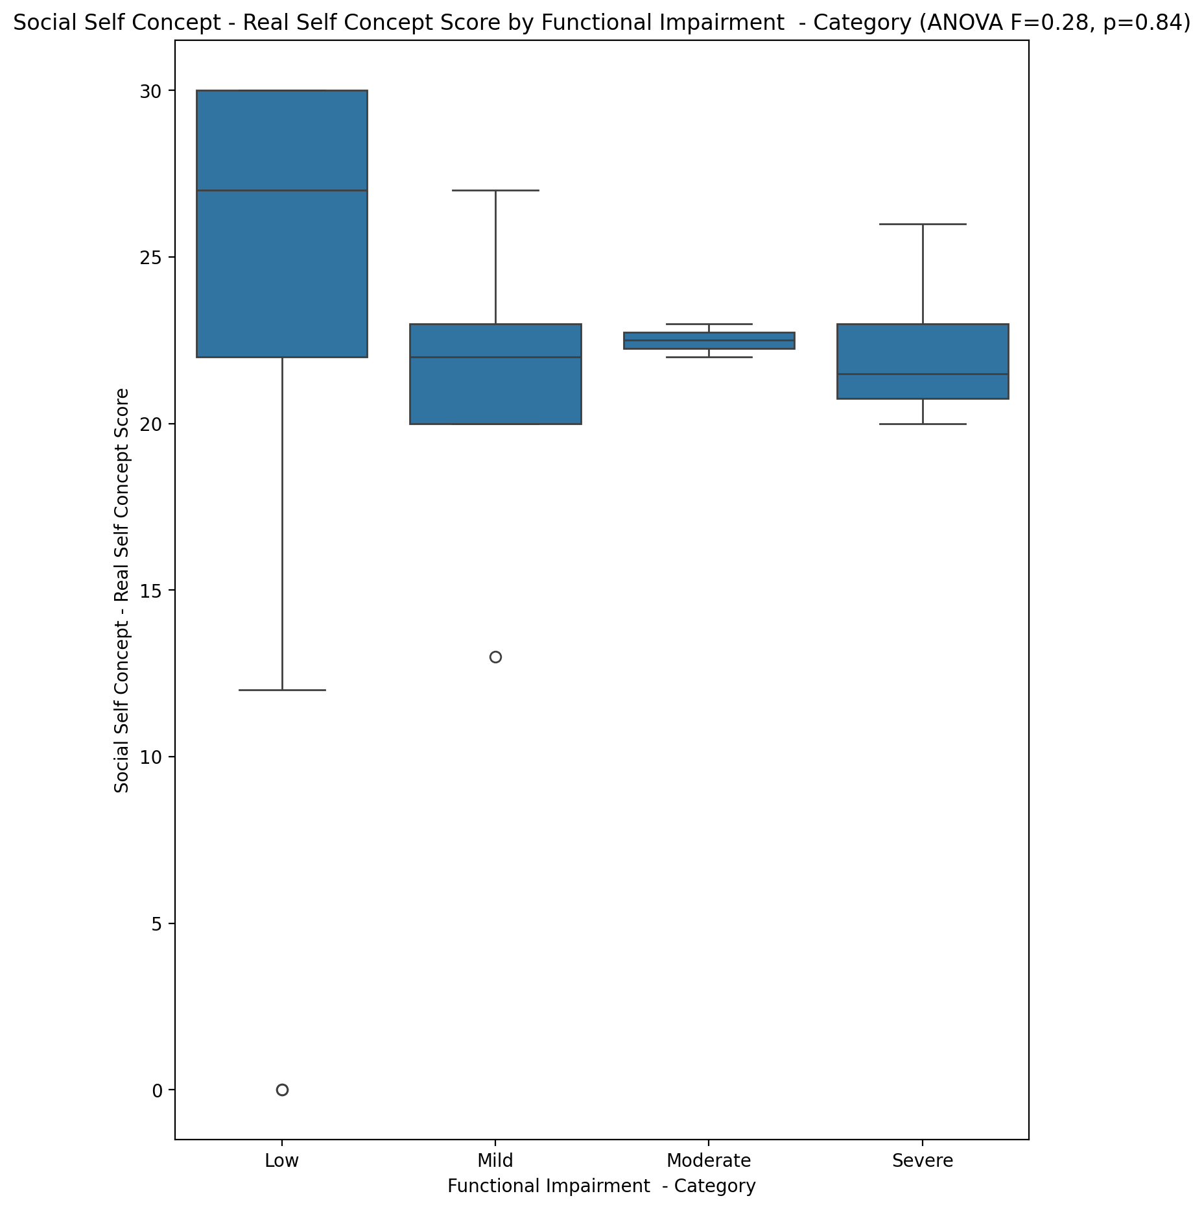

## Social Self Concept – Social Self Concept Score vs Functional Impairment - Category

Test: anova; statistic: 0.02479332359969446; p-value: 0.9946320404672817;

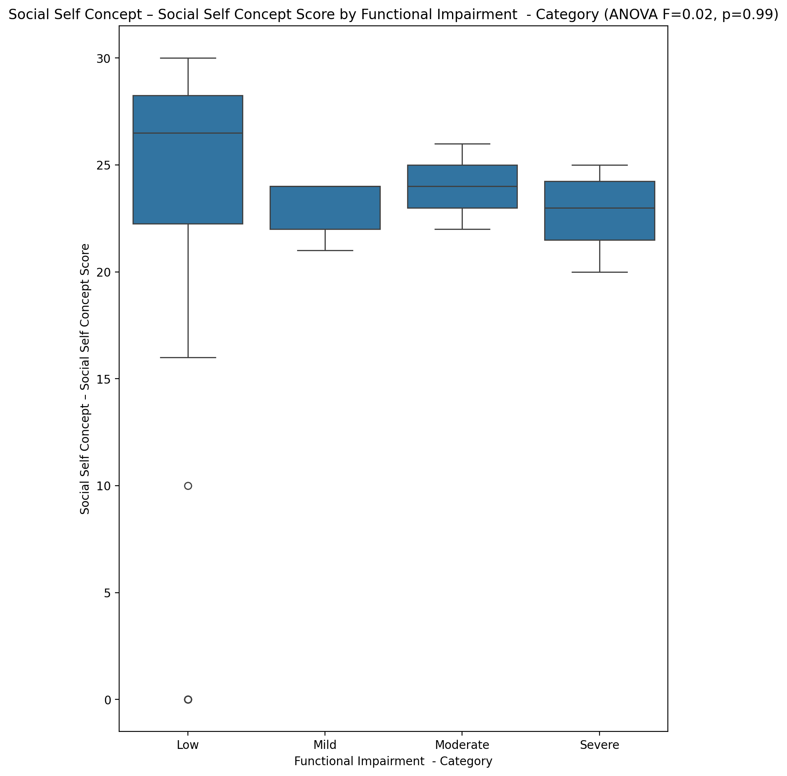

## Ability Self Concept - Real Self Concept Score vs Functional Impairment - Category

Test: anova; statistic: 0.2112428964730609; p-value: 0.8880052080445519;

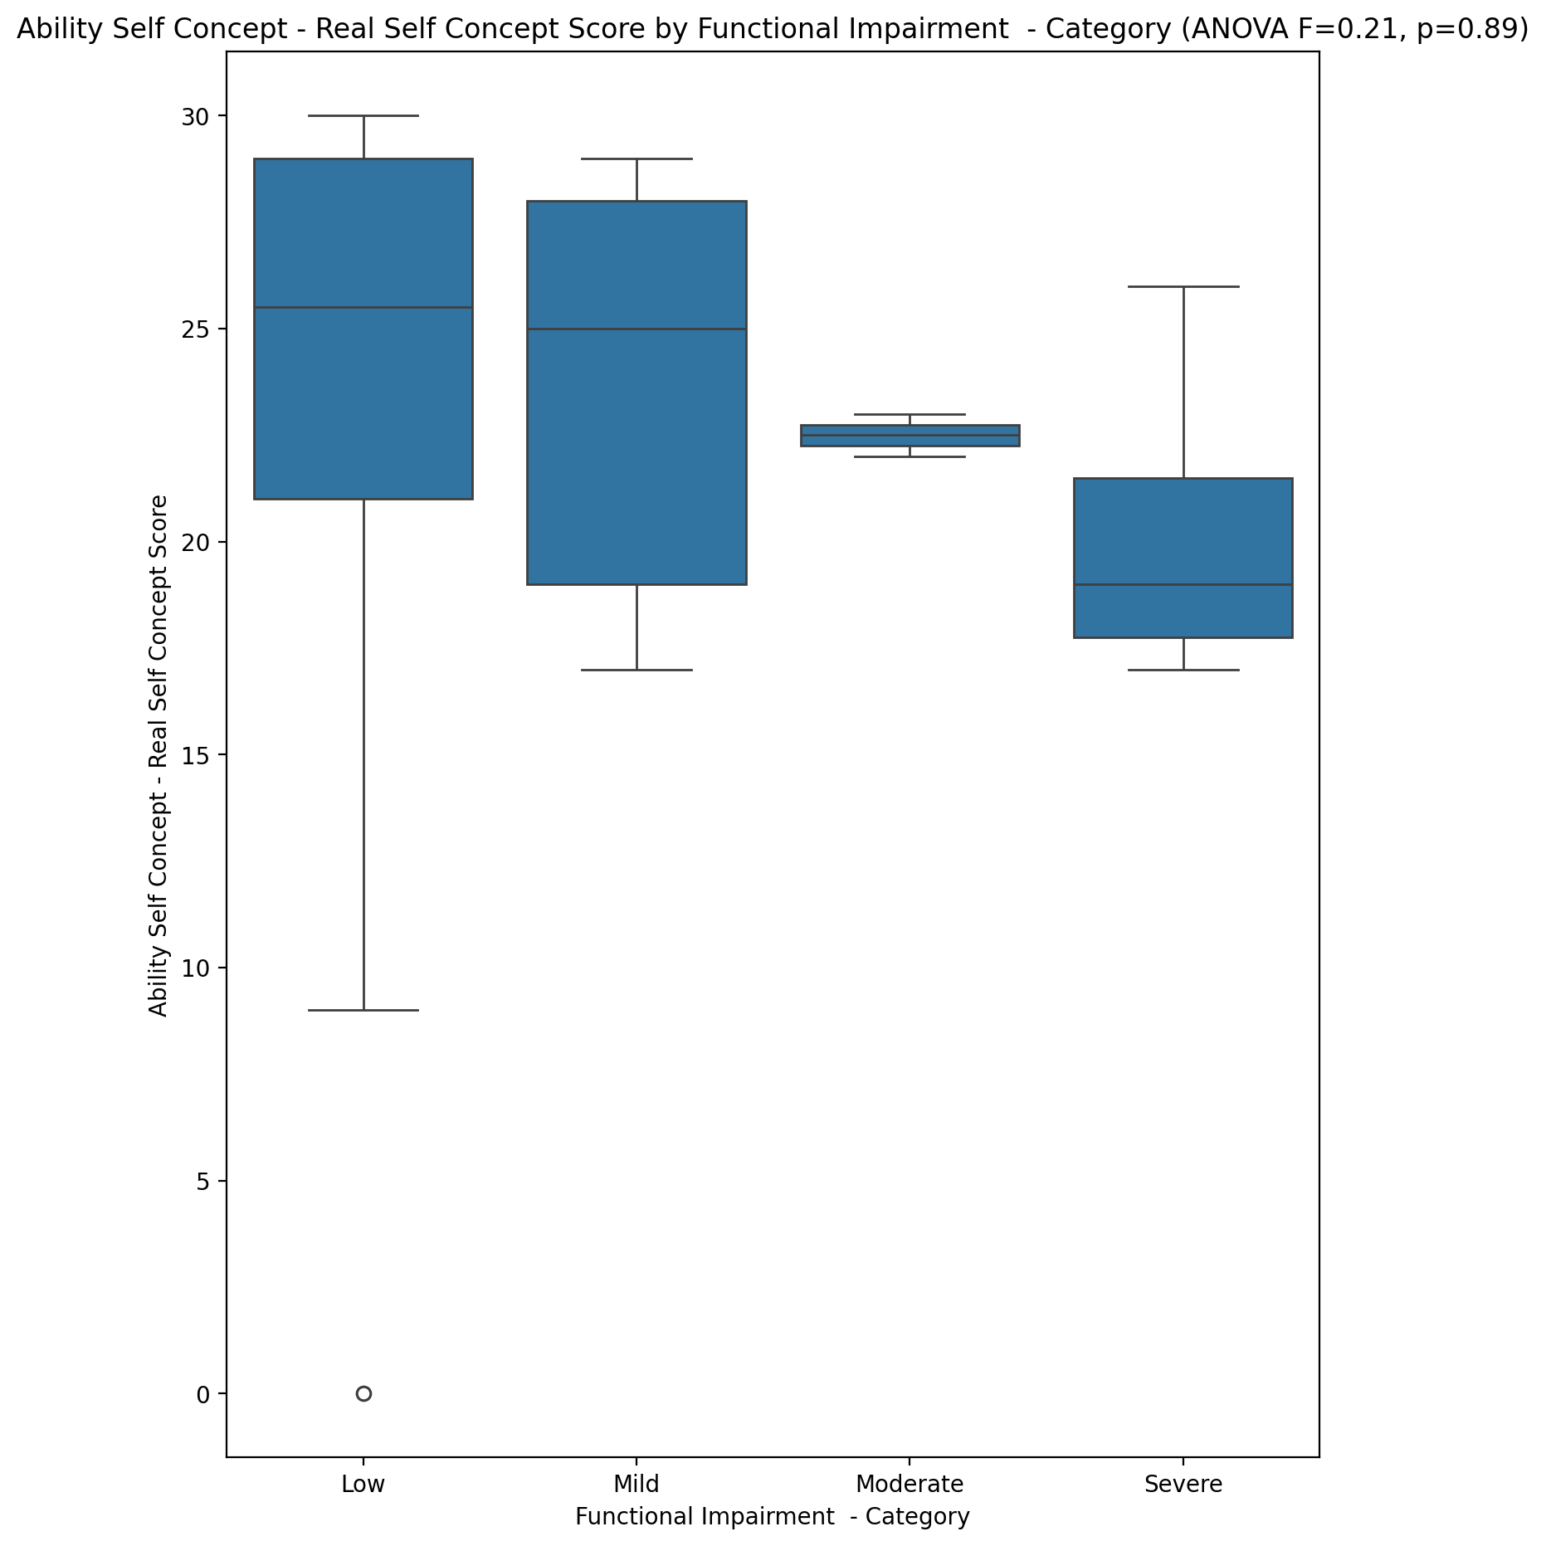

## Ability Self Concept - Ideal Self Concept Score vs Functional Impairment - Category

Test: anova; statistic: 0.061319744504917215; p-value: 0.9798399938220456;

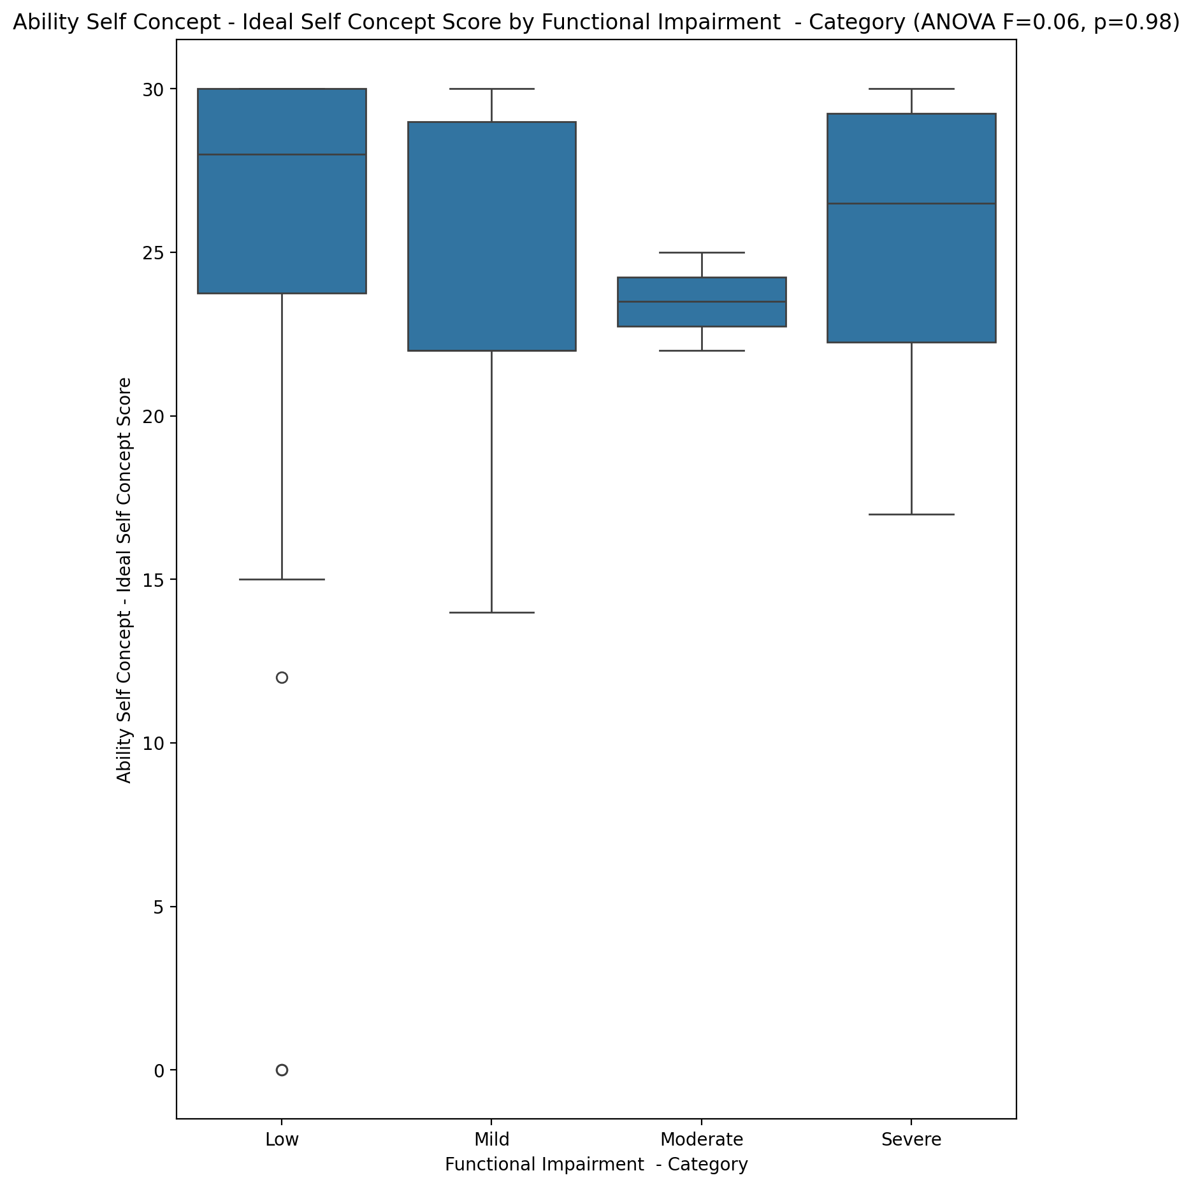

## Ability Self Concept – Social Self Concept Score vs Functional Impairment - Category

Test: anova; statistic: 0.07886116531205896; p-value: 0.9710849016255243;

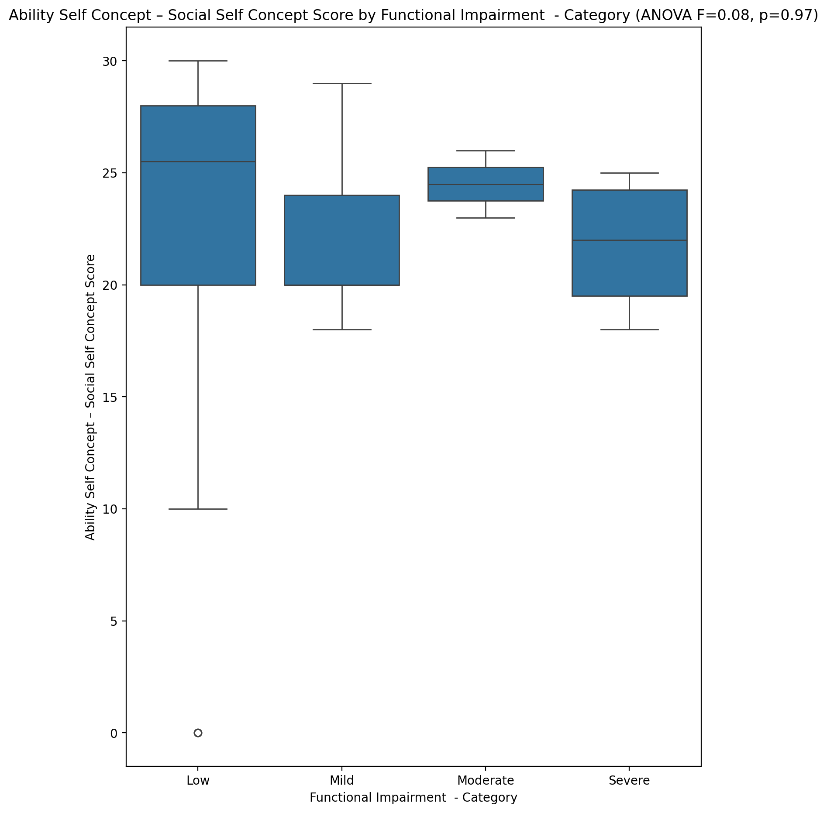

## Physical Self Concept - Real Self Concept Score vs Functional Impairment - Category

Test: anova; statistic: 0.3955722829521373; p-value: 0.7568894747031133;

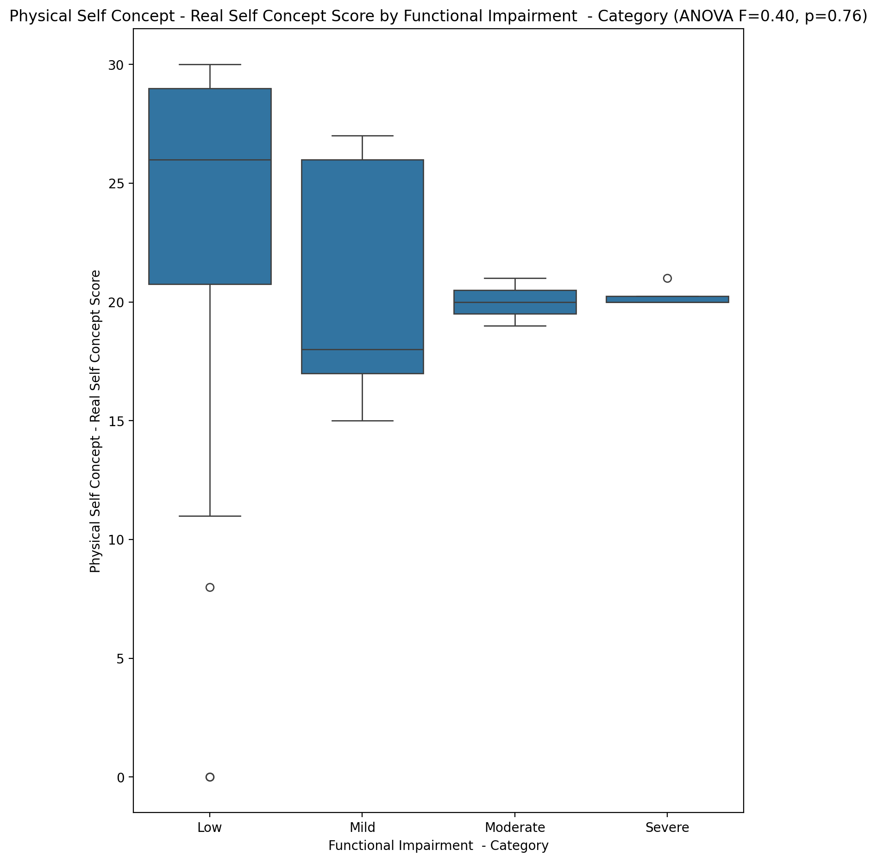

## Physical Self Concept – Ideal Self Concept Score vs Functional Impairment - Category

Test: anova; statistic: 0.3476162281723128; p-value: 0.7910481610460853;

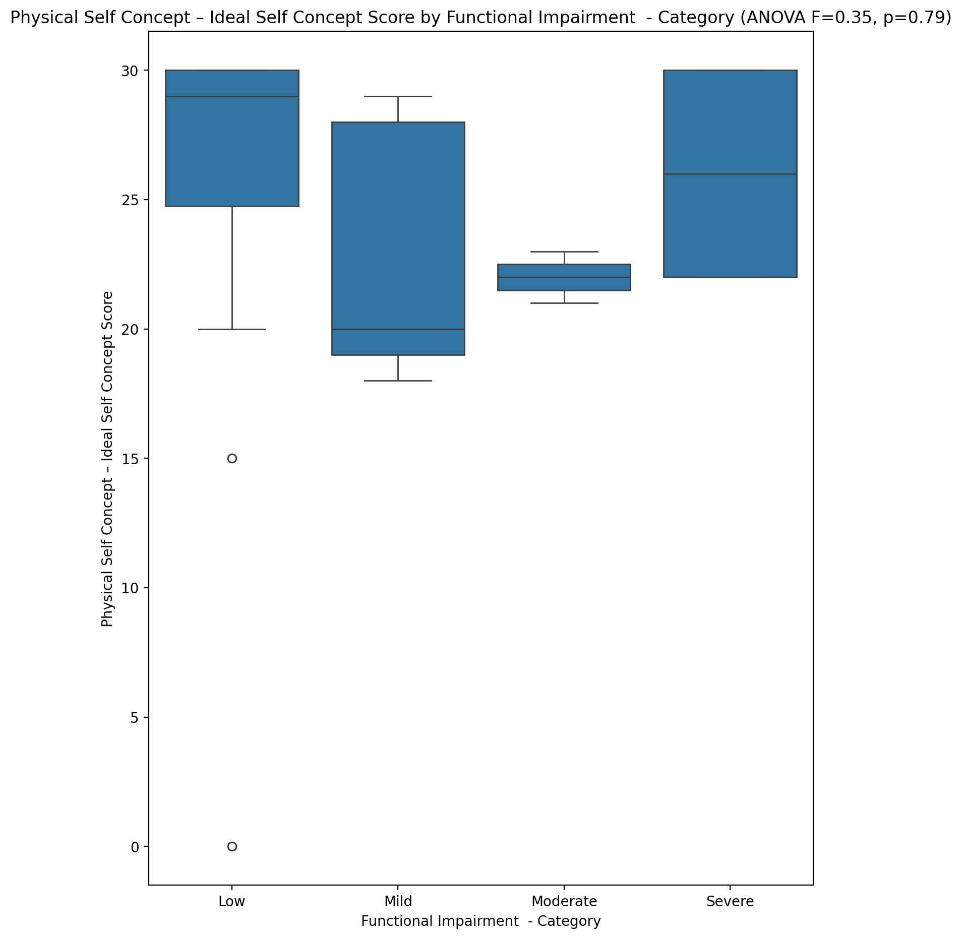

## Physical Self Concept – Social Self Concept Score vs Functional Impairment - Category

Test: anova; statistic: 0.0340432786279835; p-value: 0.9914397199306594;

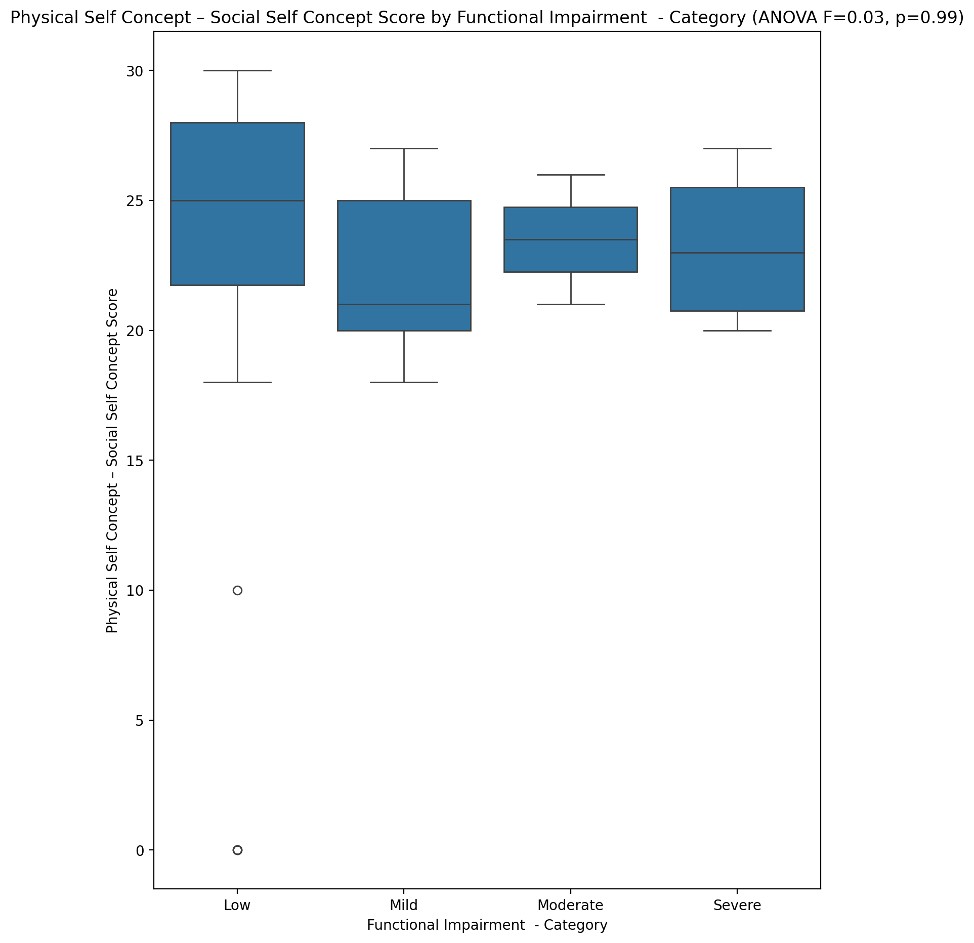

## Psychological Self Concept - Real Self Concept Score vs Functional Impairment - Category

Test: anova; statistic: 0.32152321984730553; p-value: 0.8097450310922373;

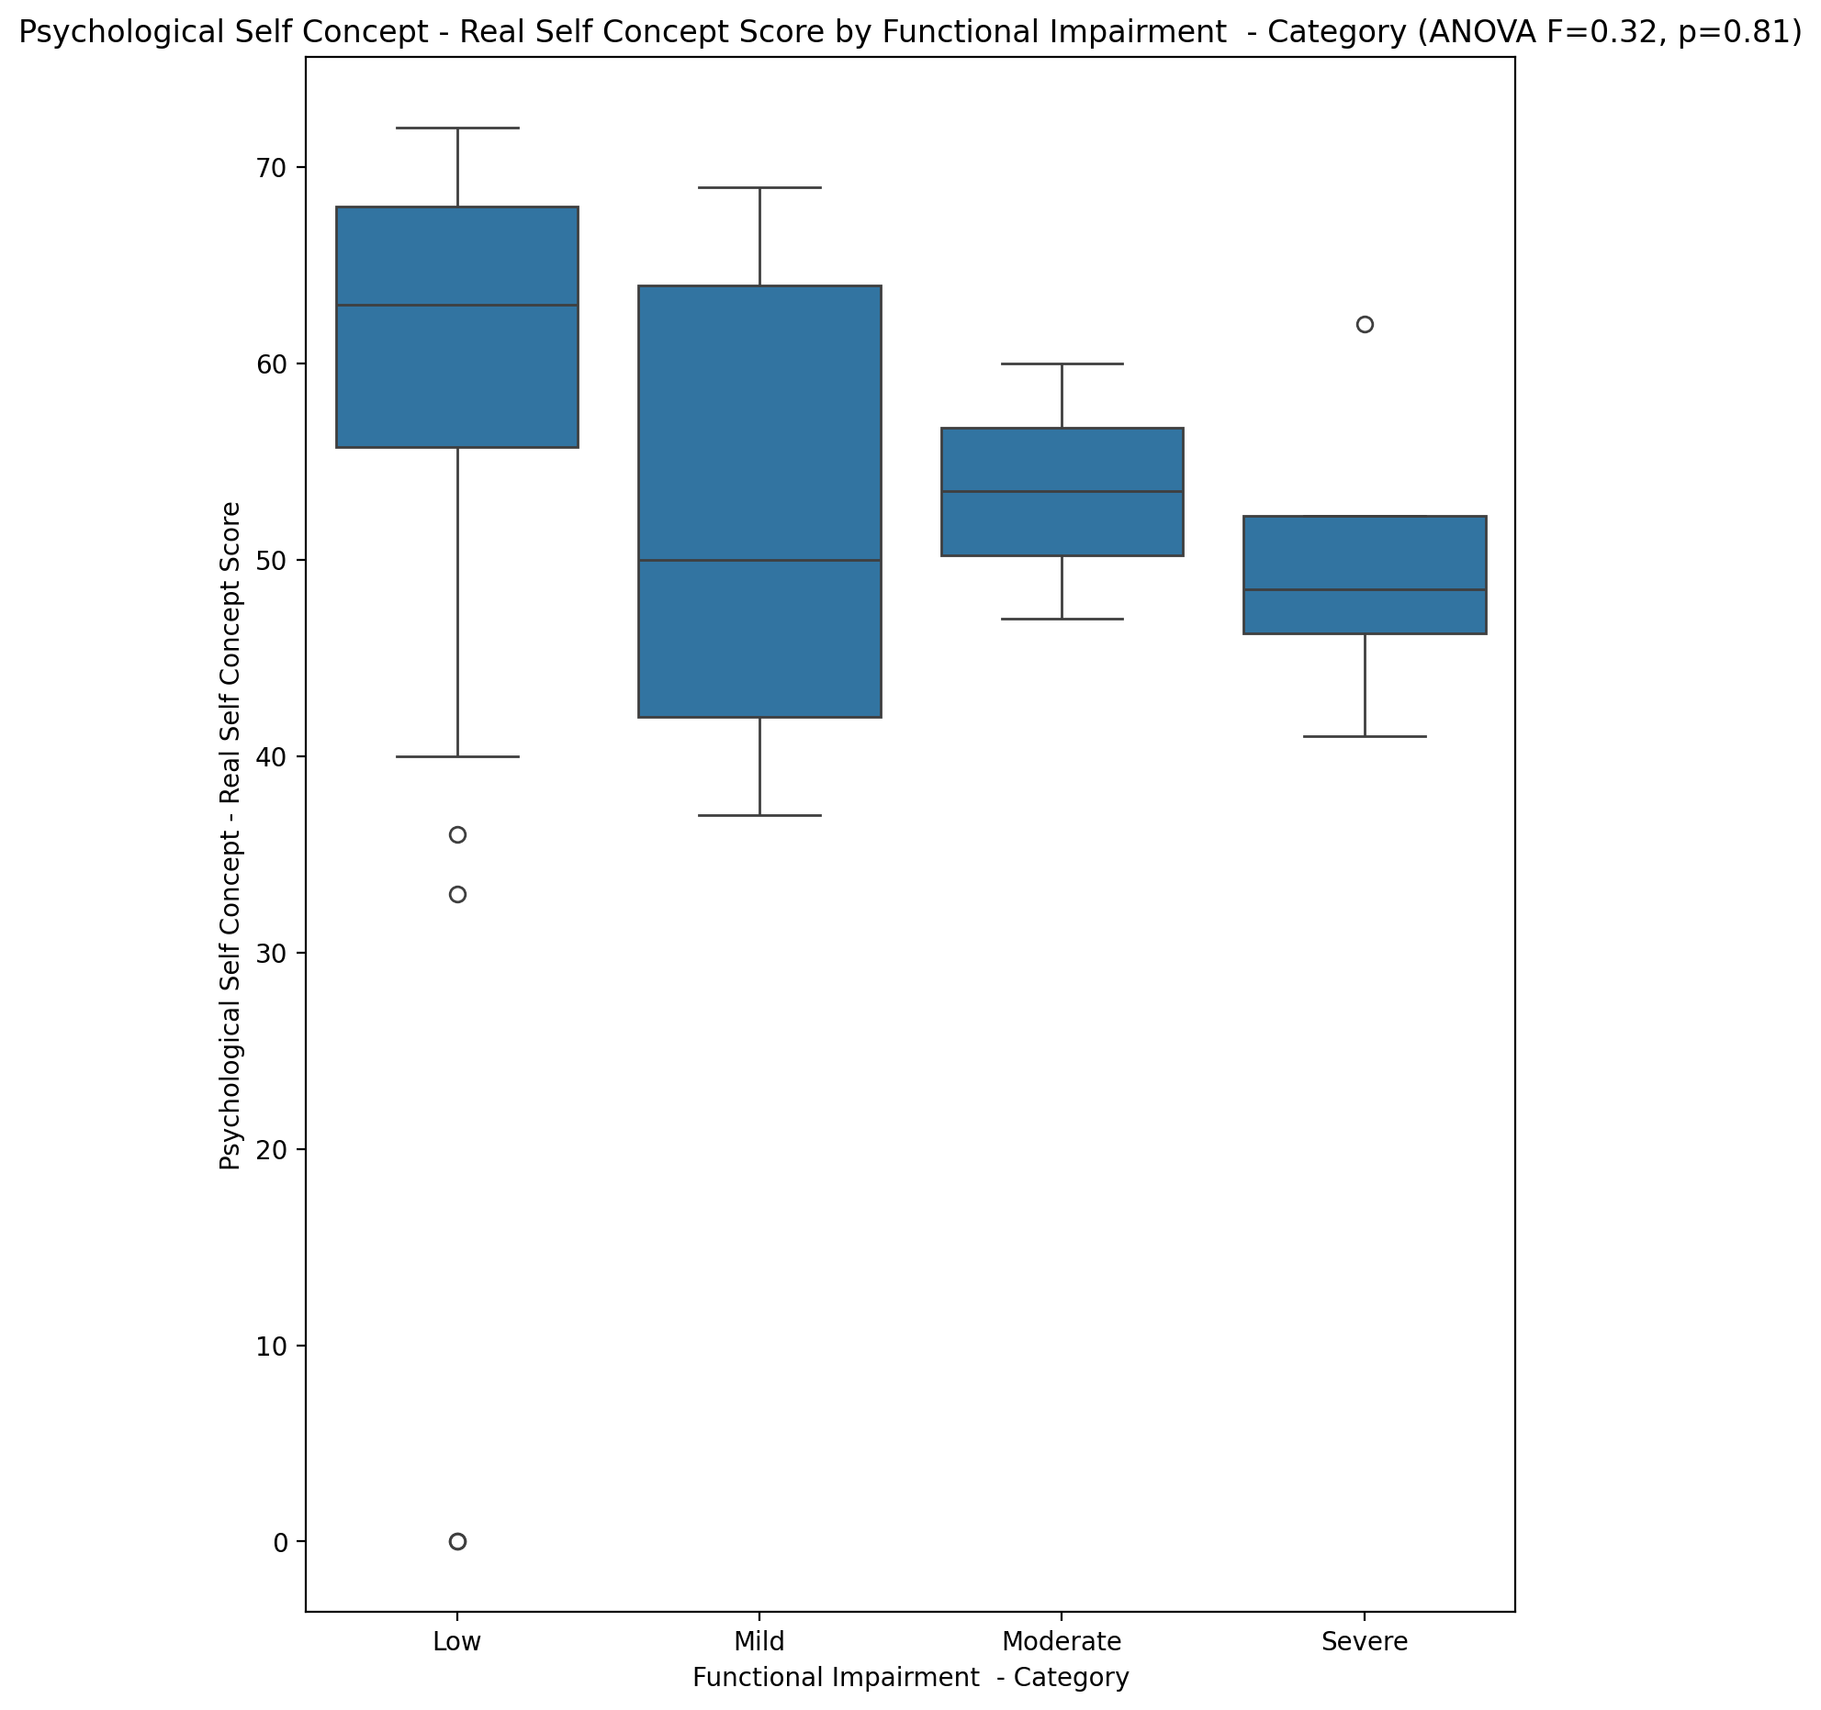

## Psychological Self Concept – Ideal Self Concept Score vs Functional Impairment - Category

Test: anova; statistic: 0.04614779487683761; p-value: 0.9866457042966756;

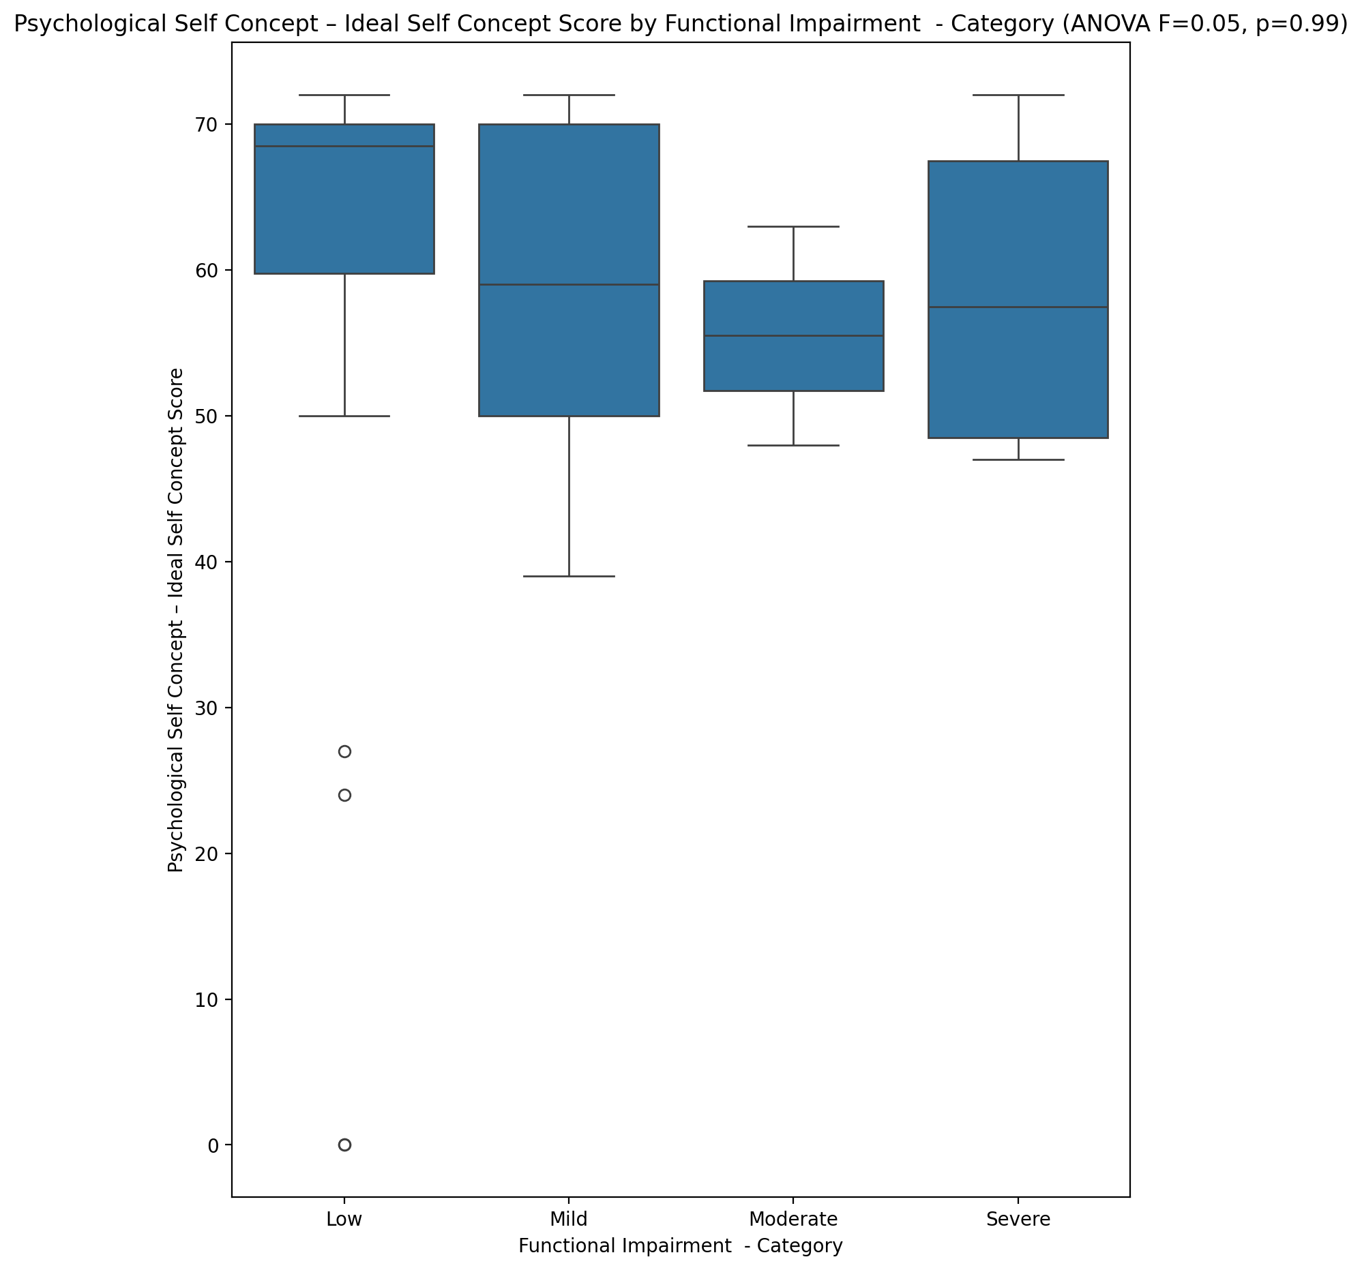

## Psychological Self Concept – Social Self Concept Score vs Functional Impairment - Category

Test: anova; statistic: 0.03428072685856426; p-value: 0.991351977628381;

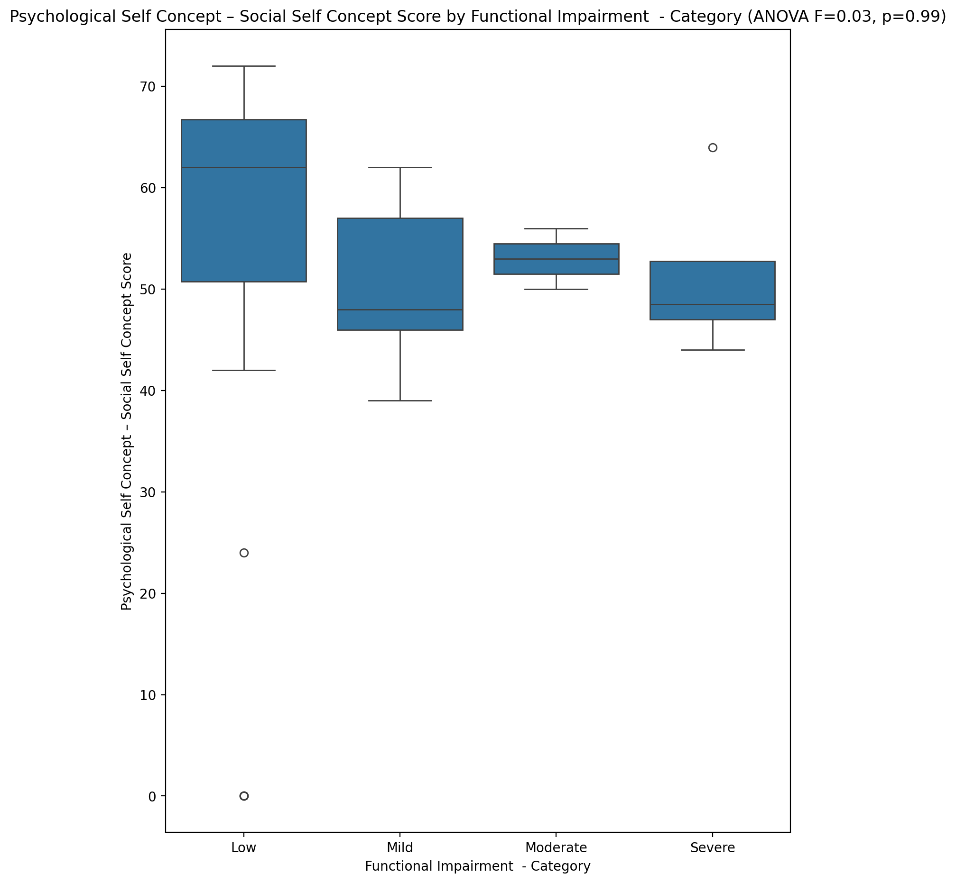

## Real Self Concept Total Score vs Functional Impairment - Category

Test: anova; statistic: 0.27836575234203326; p-value: 0.8406594291196007;

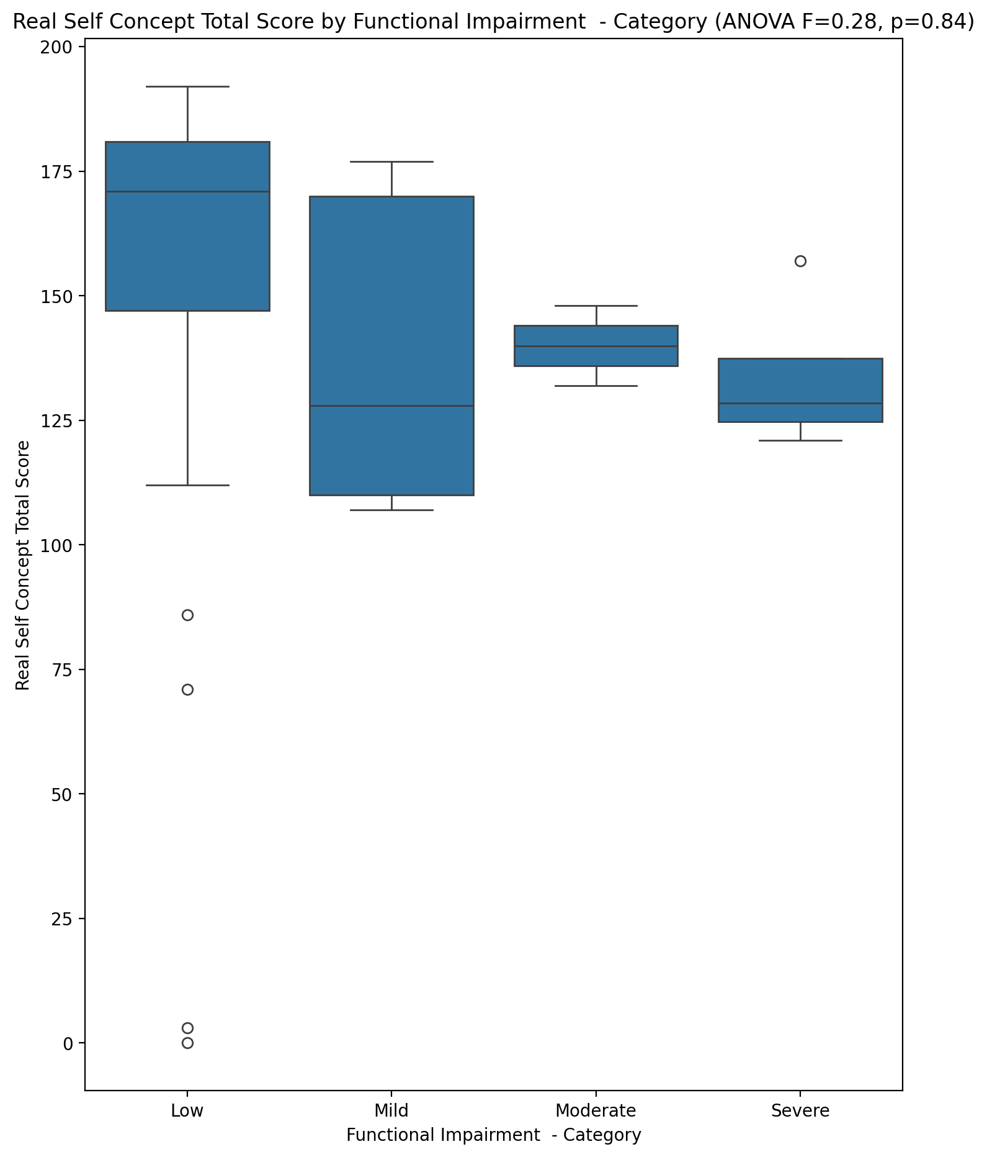

## Ideal Self Concept Total Score vs Functional Impairment - Category

Test: anova; statistic: 0.09516501247779381; p-value: 0.9622579598519269;

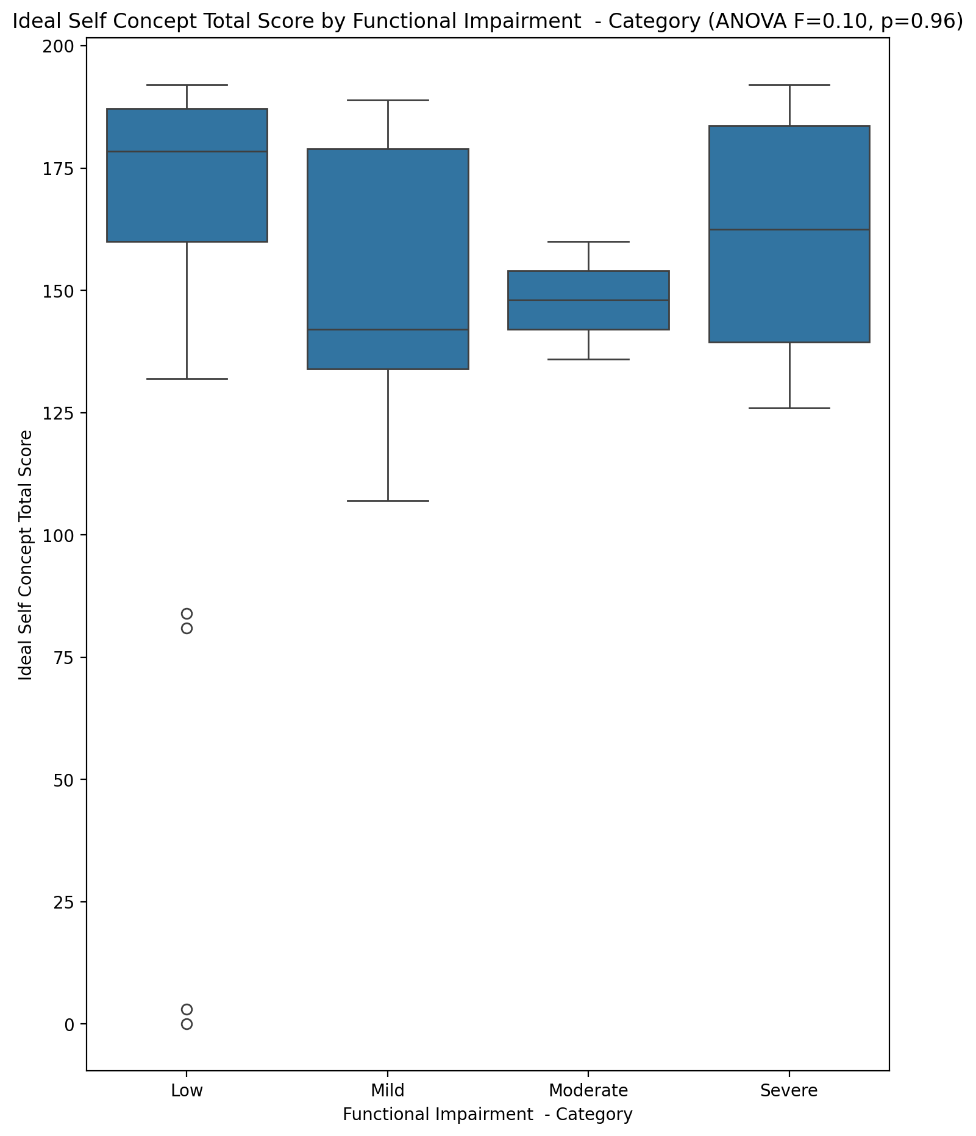

## Social Self Concept Total Score vs Functional Impairment - Category

Test: anova; statistic: 0.023870027315938003; p-value: 0.9949245697203649;

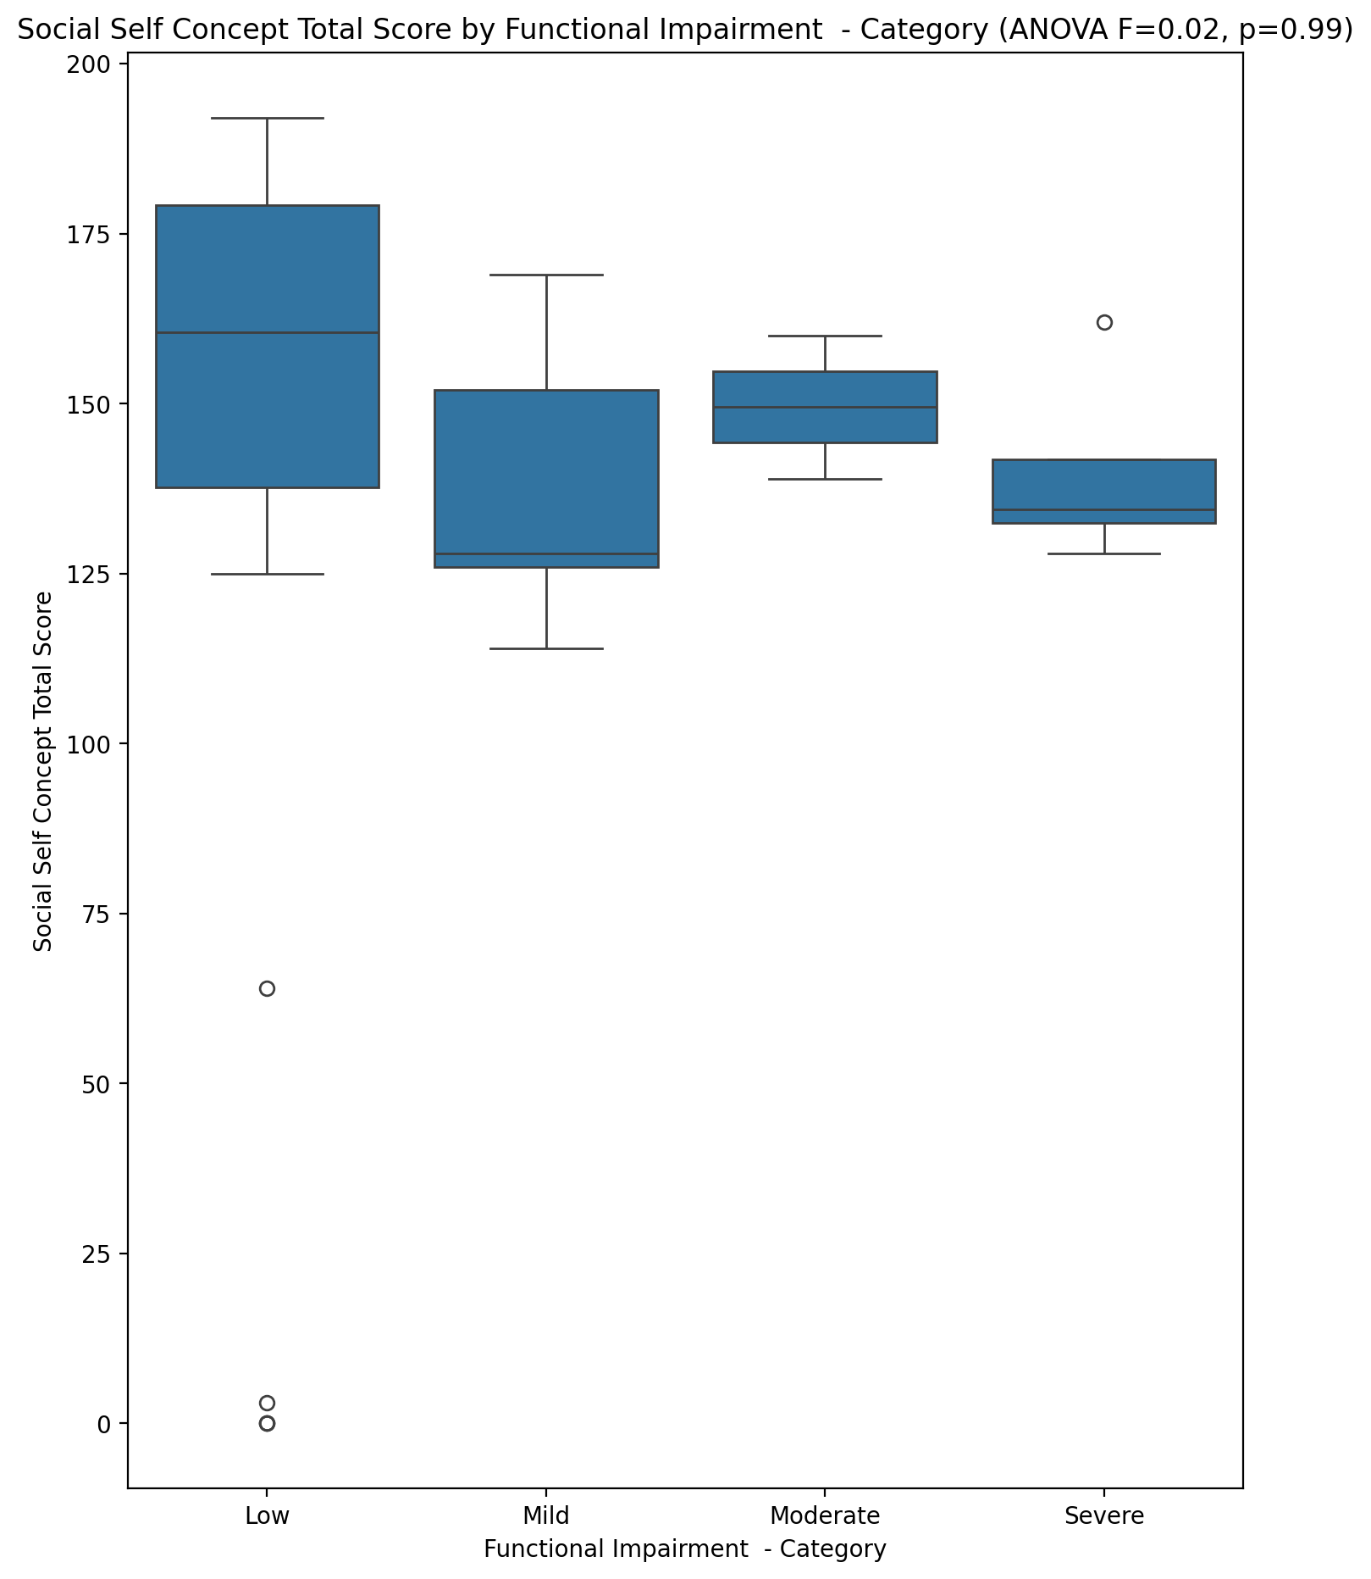

## Ideal Self Concept Total Category vs Functional Impairment - Category

Test: chi2; statistic: 13.277116935483871; p-value: 0.03884039834531372;

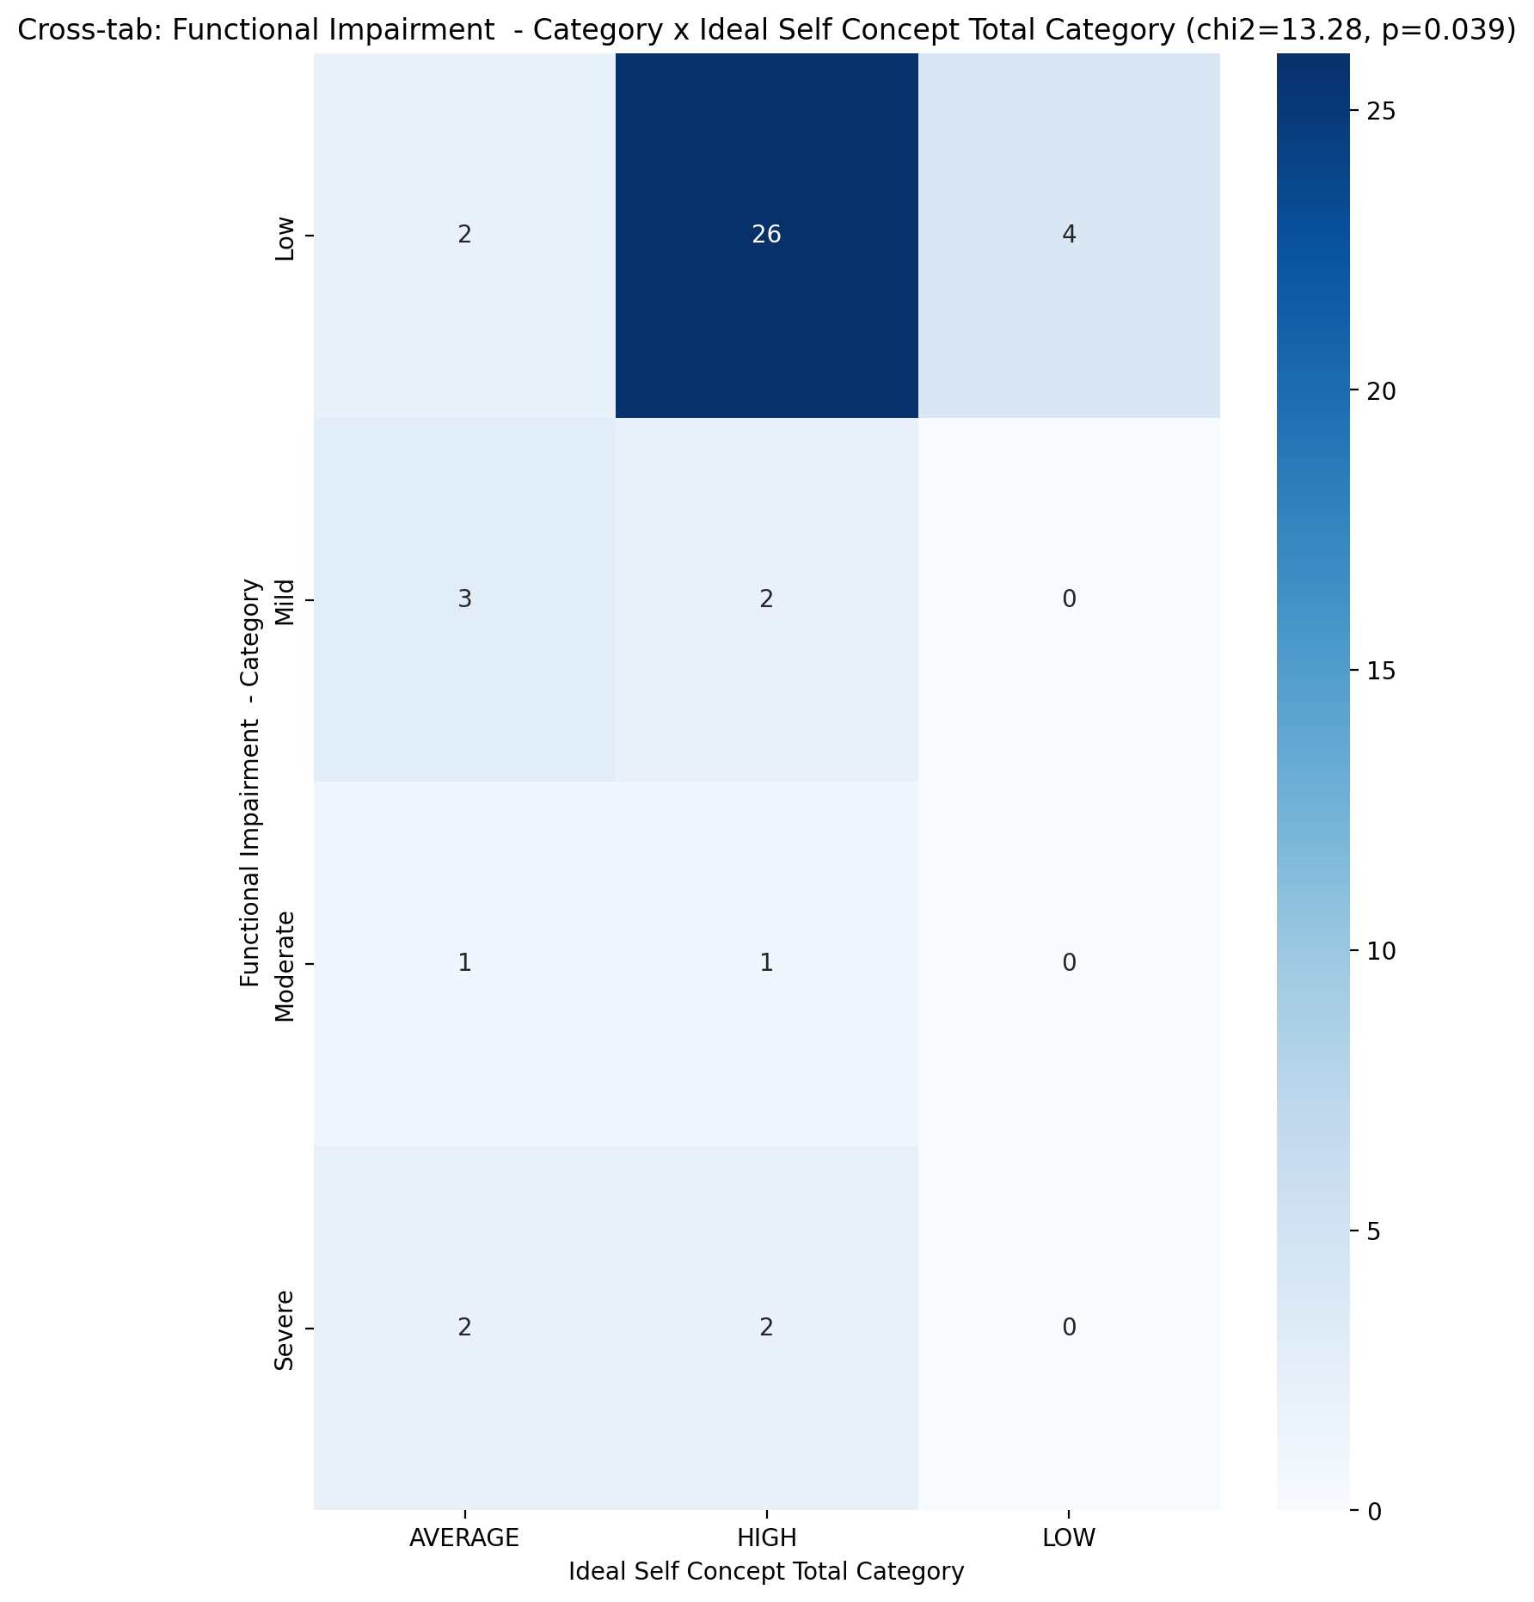

## Perceived Social Stress Score vs Functional Impairment - Category

Test: anova; statistic: 0.9131751450870611; p-value: 0.44346888209849367;

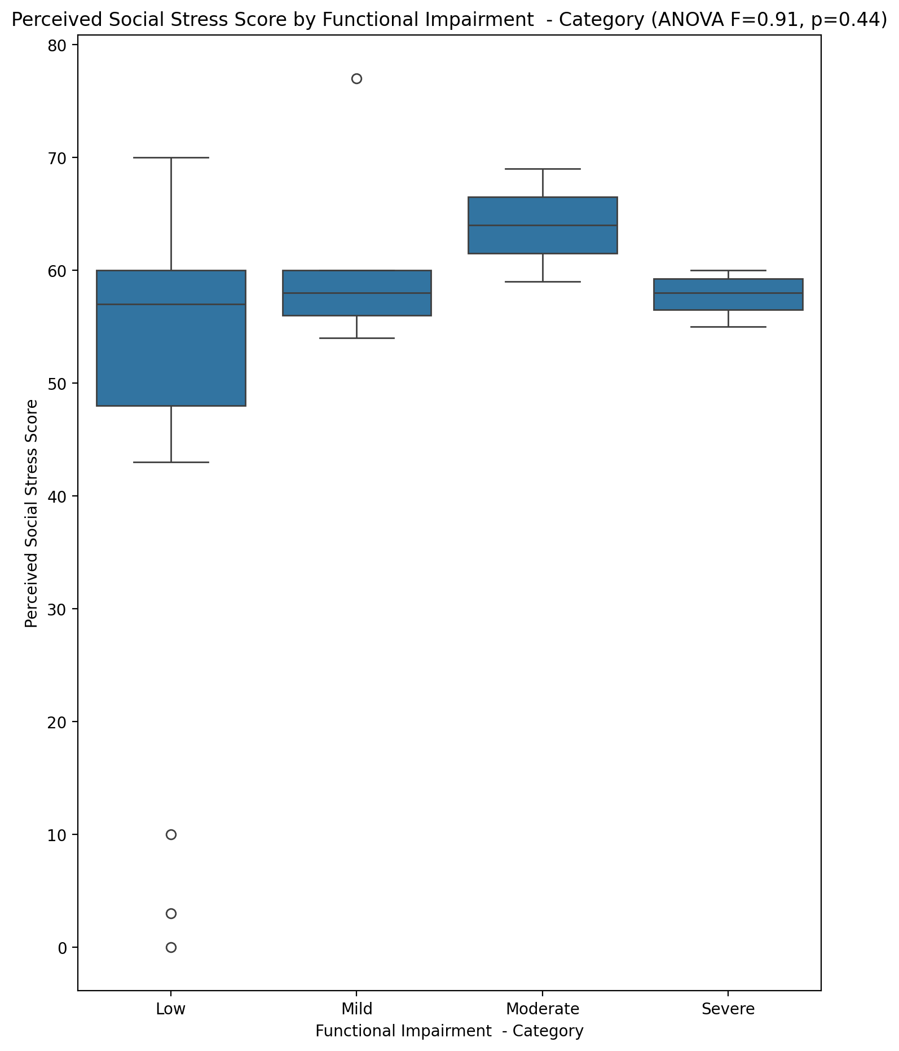

## Perceived Social Stress Category vs Functional Impairment - Category

Test: chi2; statistic: 1.1085937499999998; p-value: 0.7749999337216861;

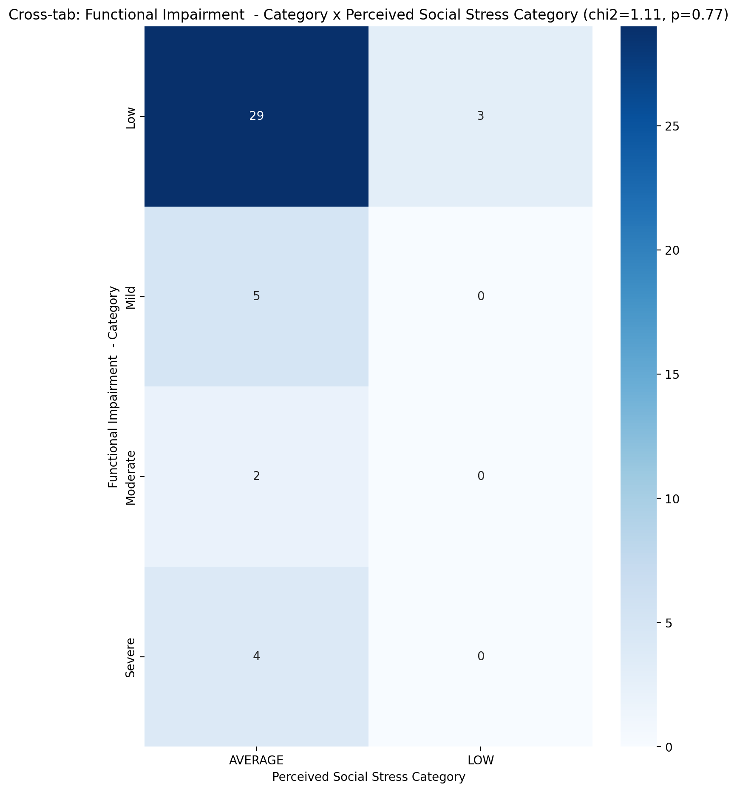

## Emotional Support - Raw Score vs Withdrawl – Category

Test: anova; statistic: 4.72458803877287; p-value: 0.014388603033732197;

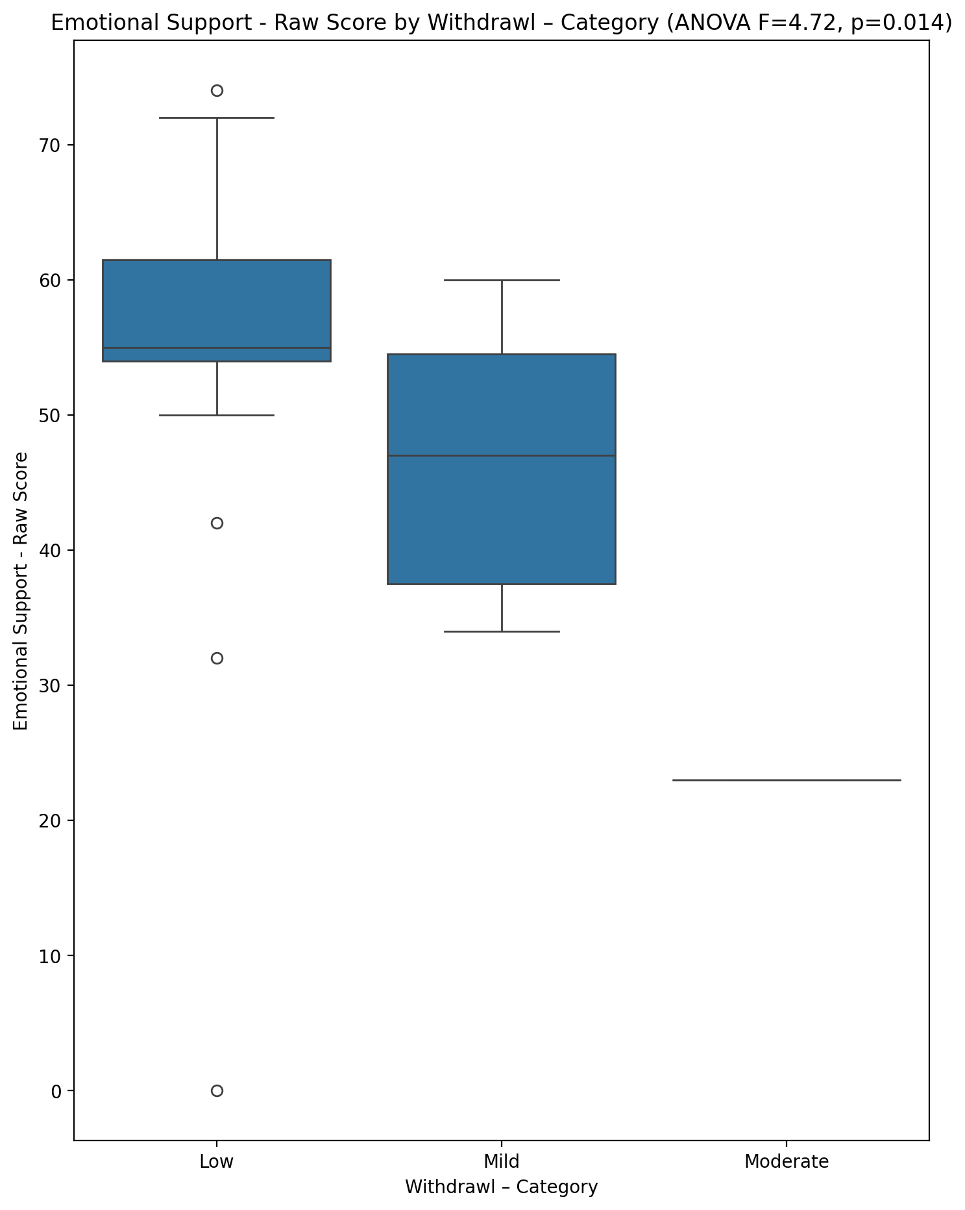

## Informational Support - Raw Score vs Withdrawl – Category

Test: anova; statistic: 1.6759731998418832; p-value: 0.19999899148400305;

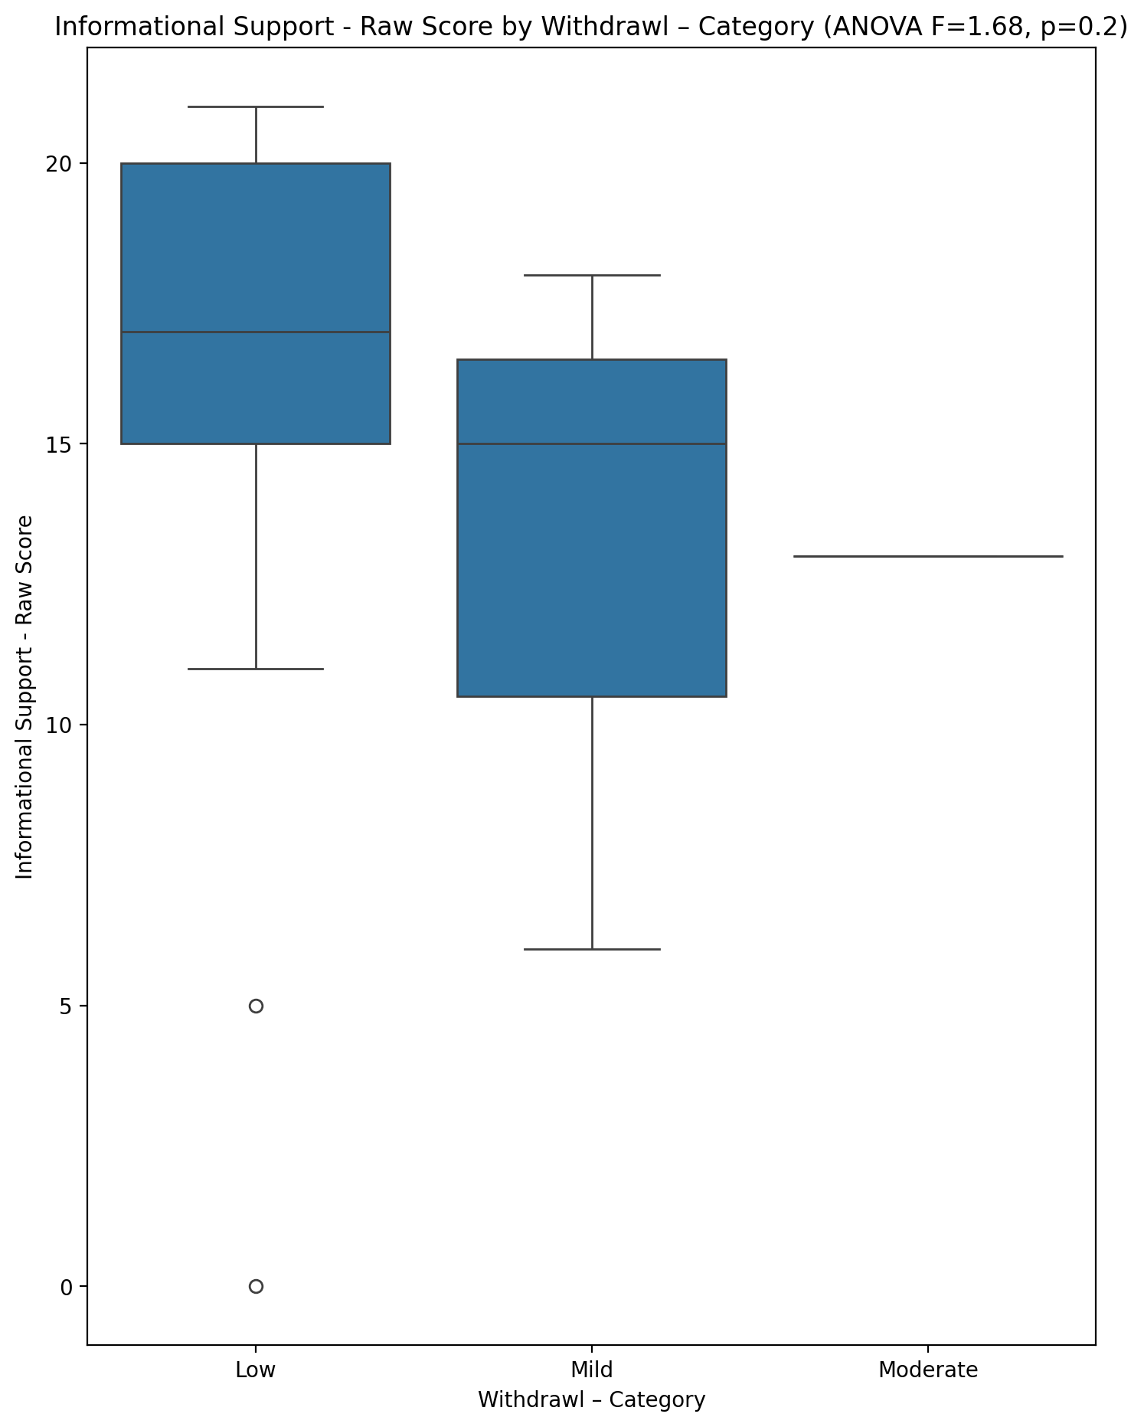

## Instrumental Support - Raw Score vs Withdrawl – Category

Test: anova; statistic: 1.600098683240207; p-value: 0.21452860435158969;

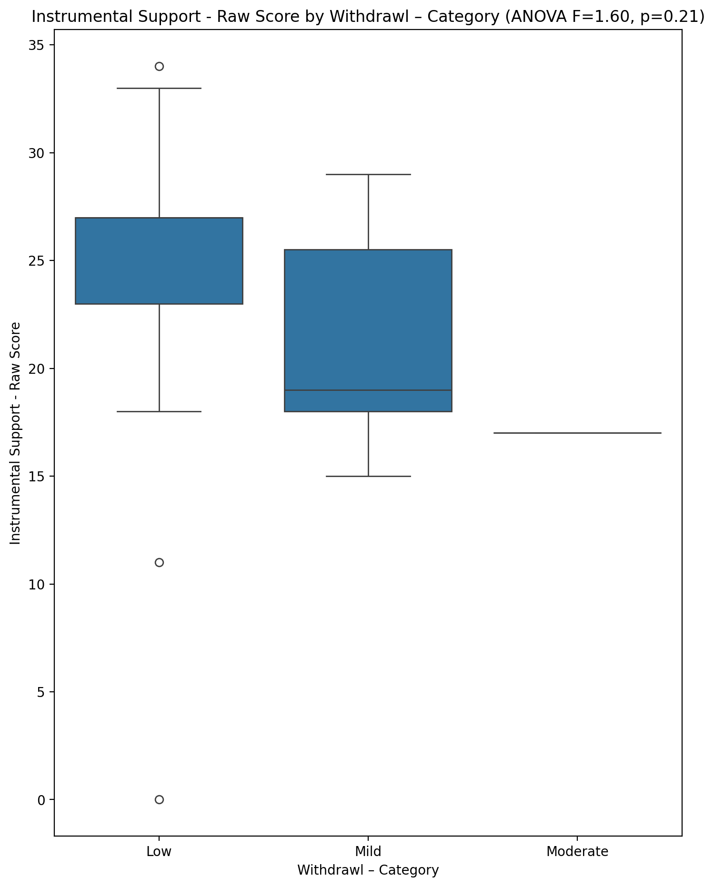

## Emotional Support - T Score vs Withdrawl – Category

Test: anova; statistic: 6.261861407242779; p-value: 0.004306156521182262;

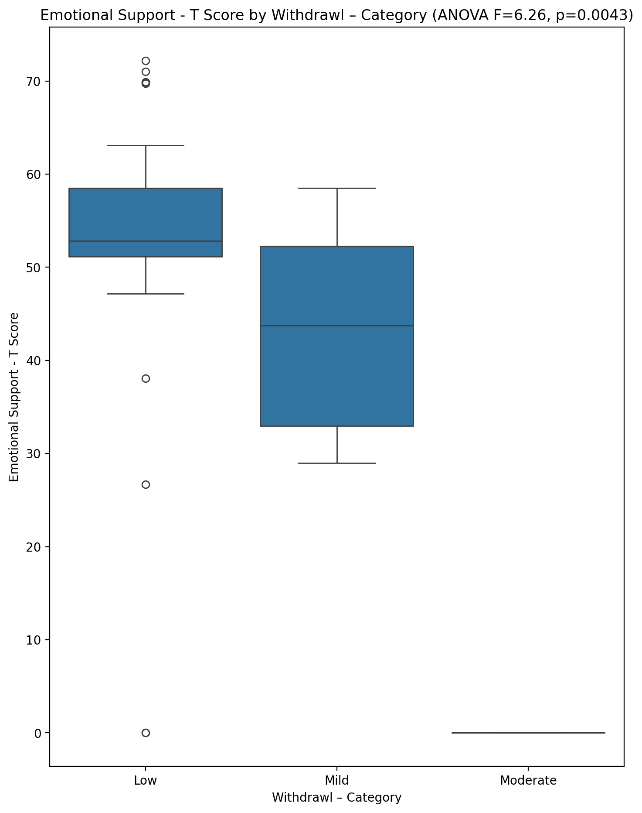

## Informational Support - T Score vs Withdrawl – Category

Test: anova; statistic: 1.9529389185208081; p-value: 0.1551481254750629;

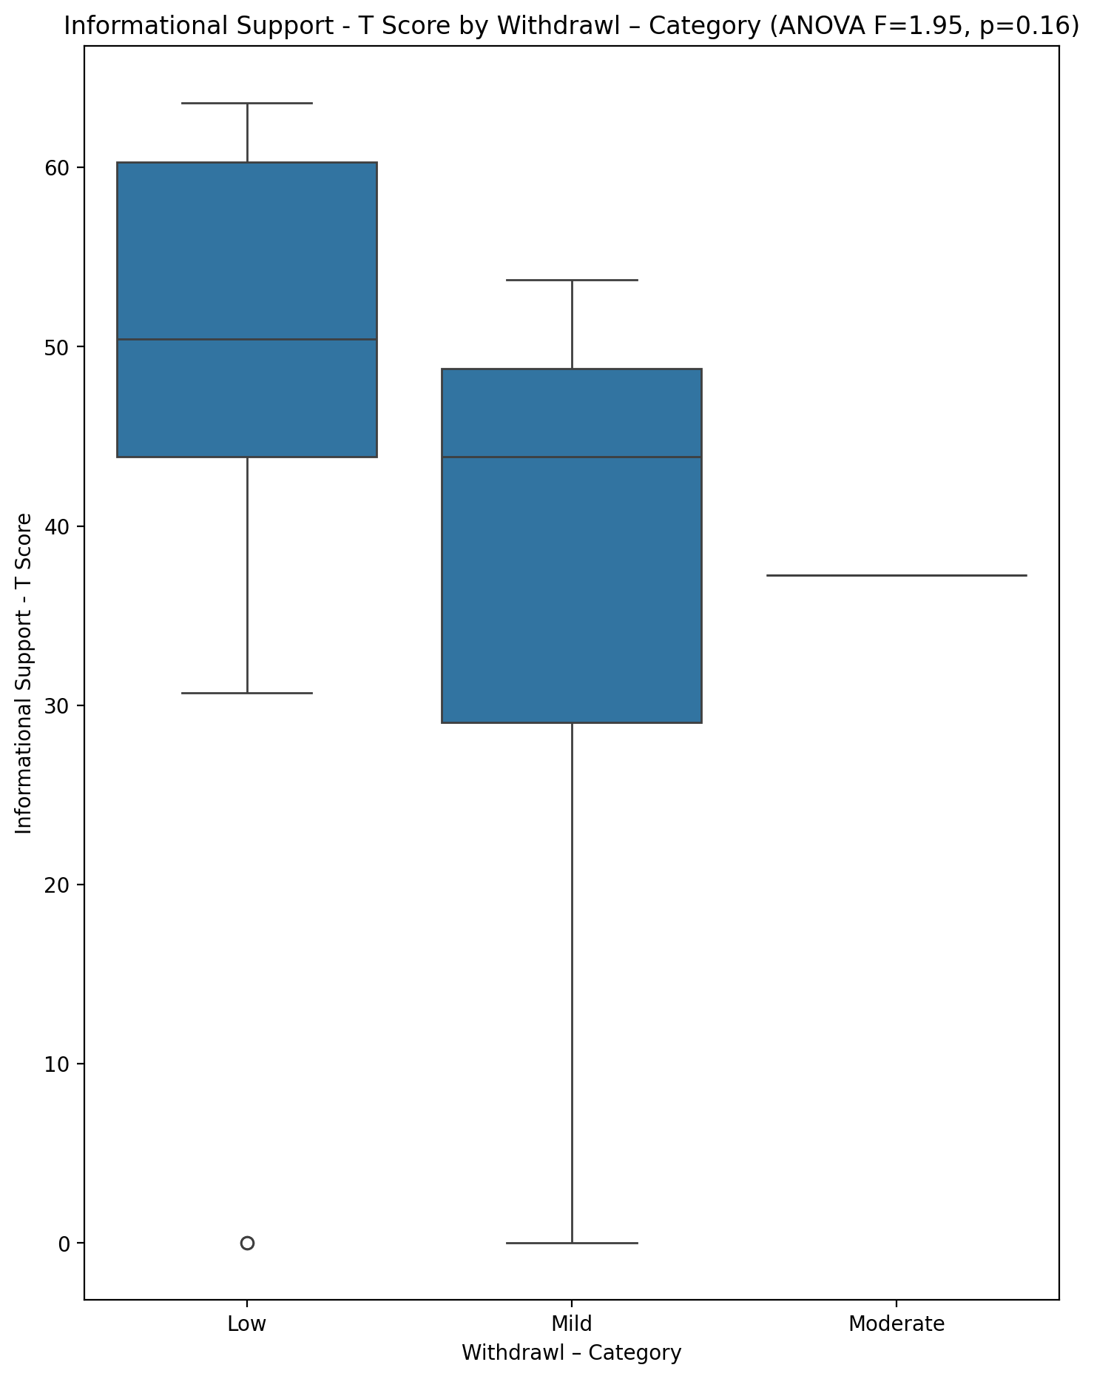

## Instrumental Support - T Score vs Withdrawl – Category

Test: anova; statistic: 1.4550002520850664; p-value: 0.2454875286634364;

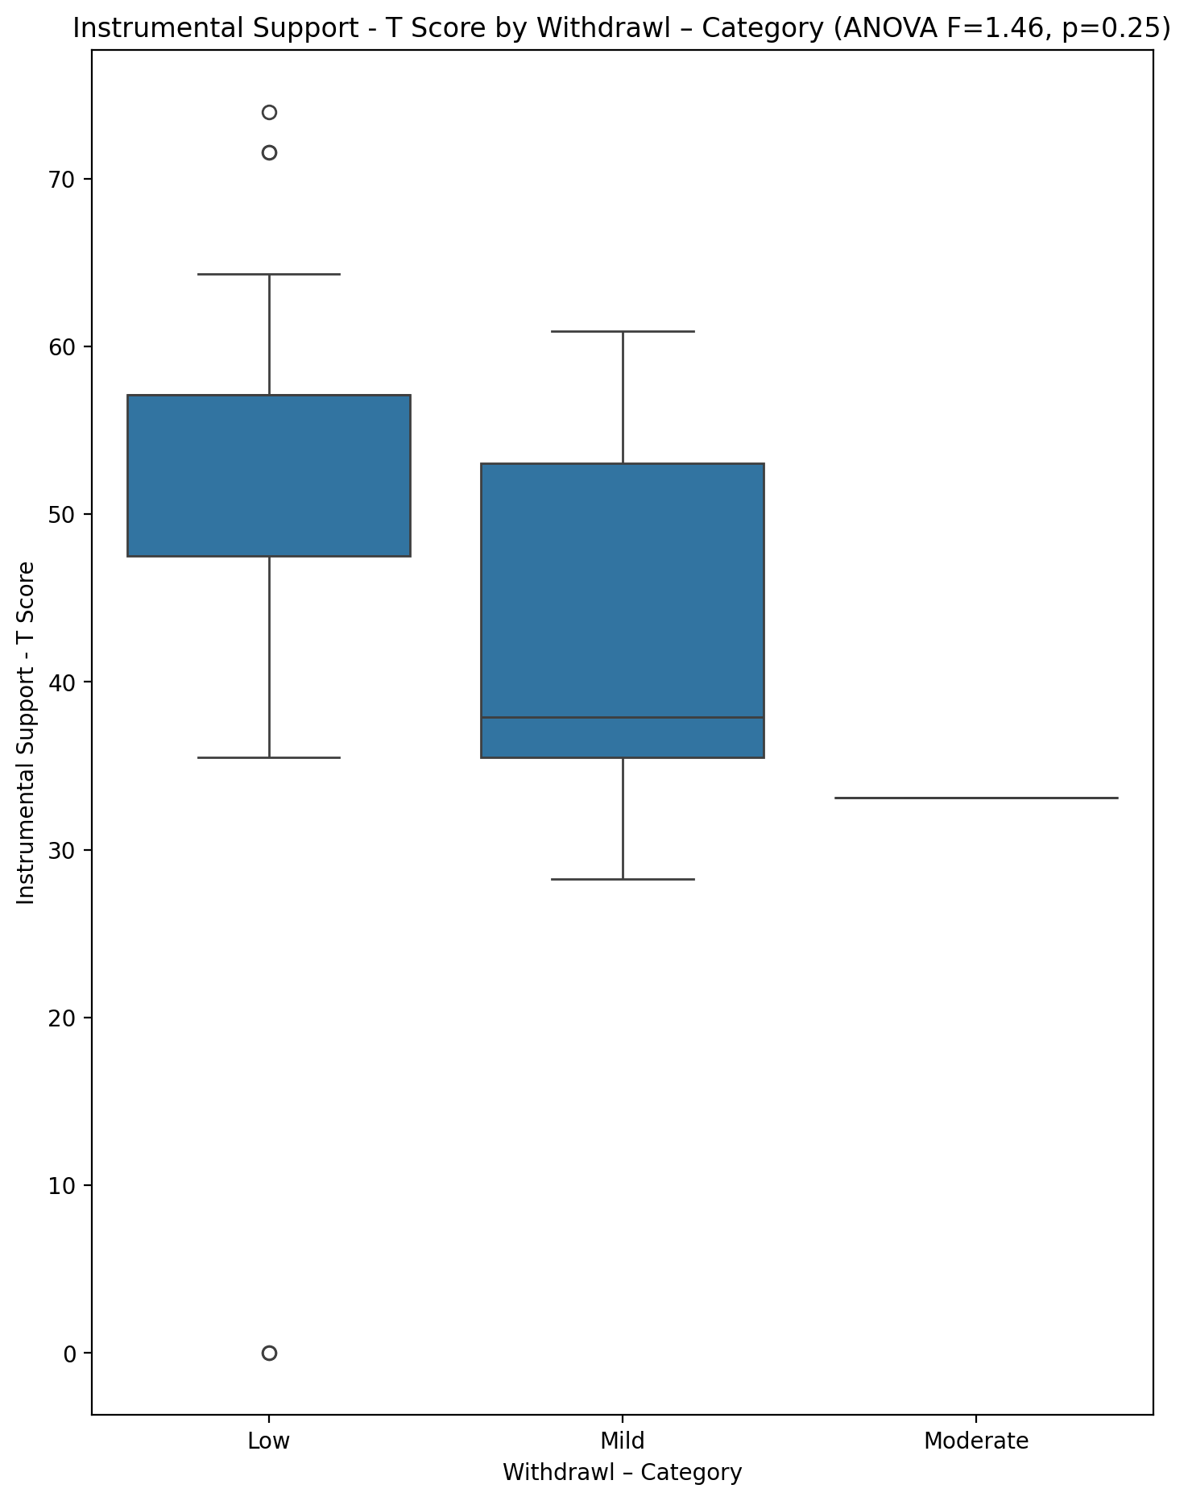

## Perceived Social Support Total T Score vs Withdrawl – Category

Test: anova; statistic: 6.926328948078901; p-value: 0.0026125040447289036;

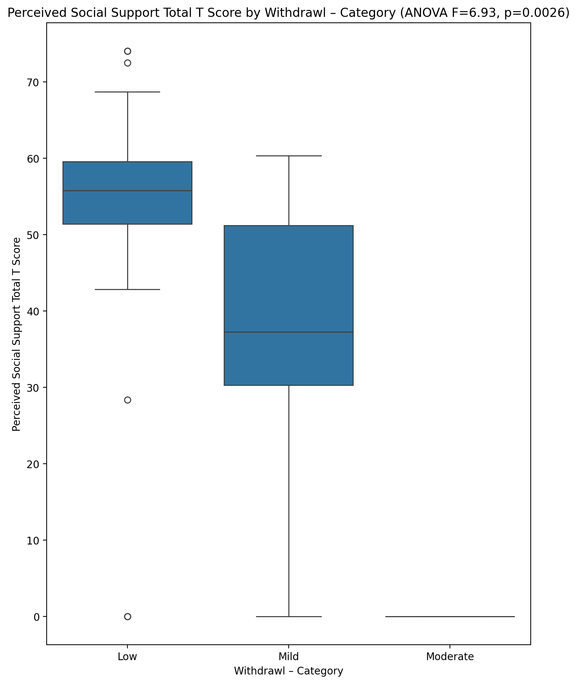

## Emotional Support - Rank vs Withdrawl – Category

Test: chi2; statistic: 17.15904761904762; p-value: 0.02849488769610385;

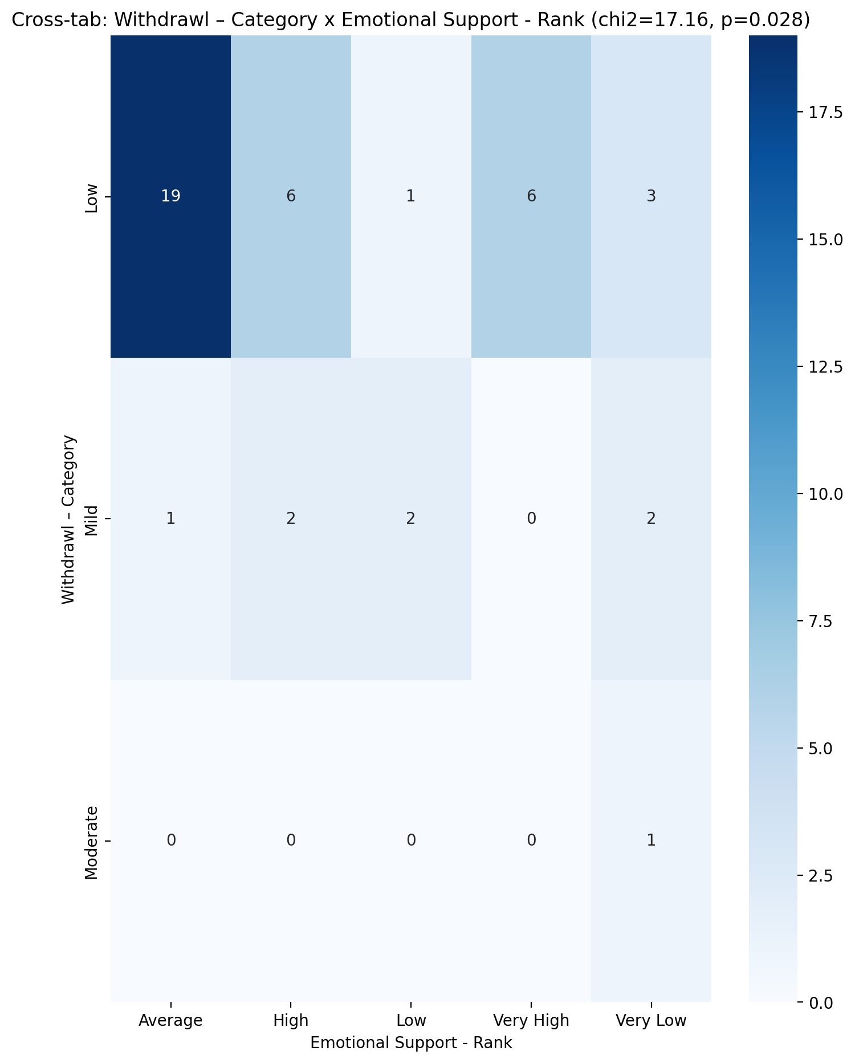

## Informational Support - Rank vs Withdrawl – Category

Test: chi2; statistic: 7.441632653061225; p-value: 0.2819271430173297;

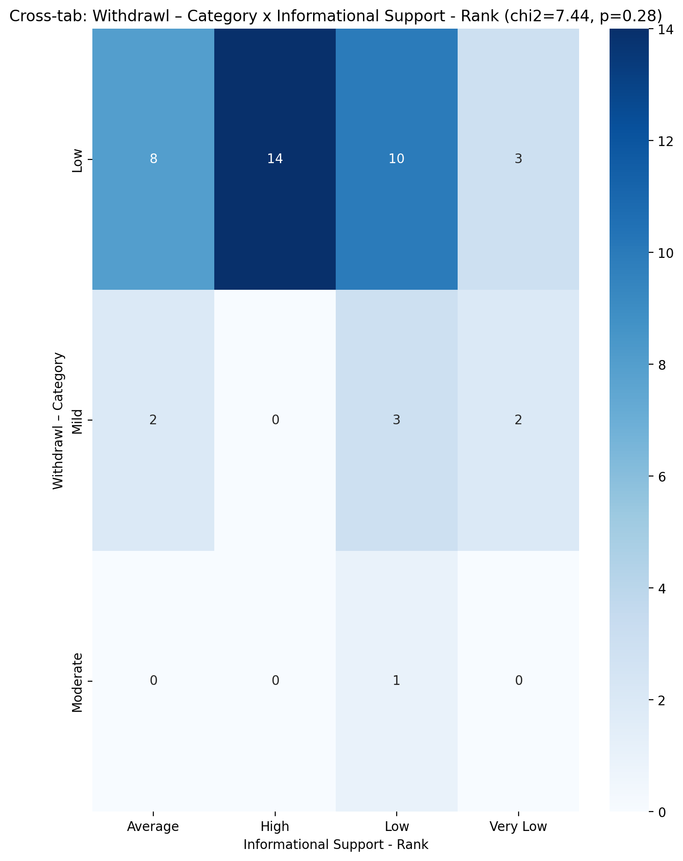

## Instrumental Support - Rank vs Withdrawl – Category

Test: chi2; statistic: 9.72016806722689; p-value: 0.2852183365920328;

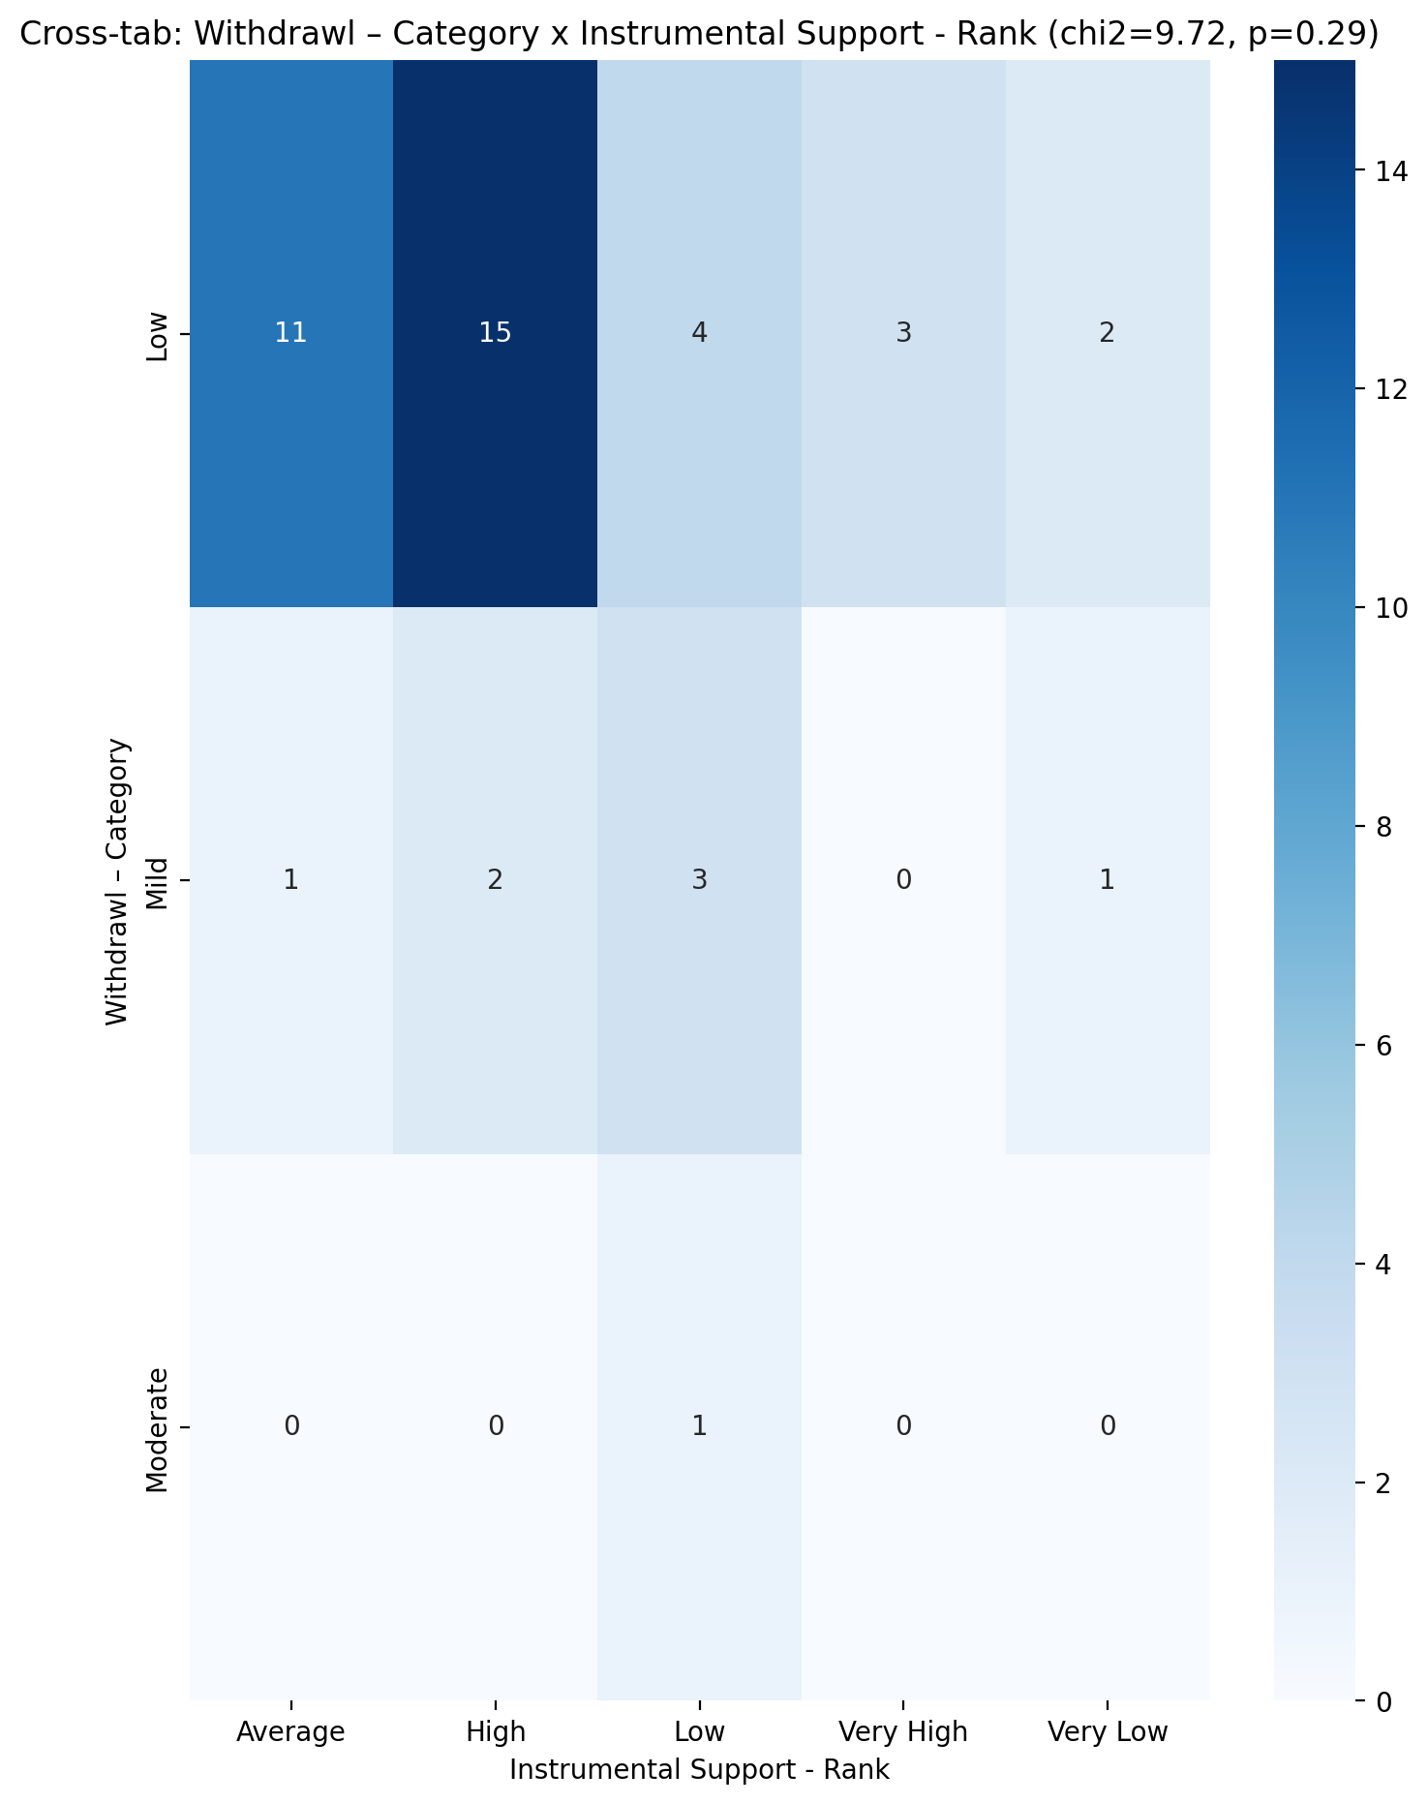

## Perceived Social Support TOTAL - Rank vs Withdrawl – Category

Test: chi2; statistic: 19.820952380952377; p-value: 0.01103509334242924;

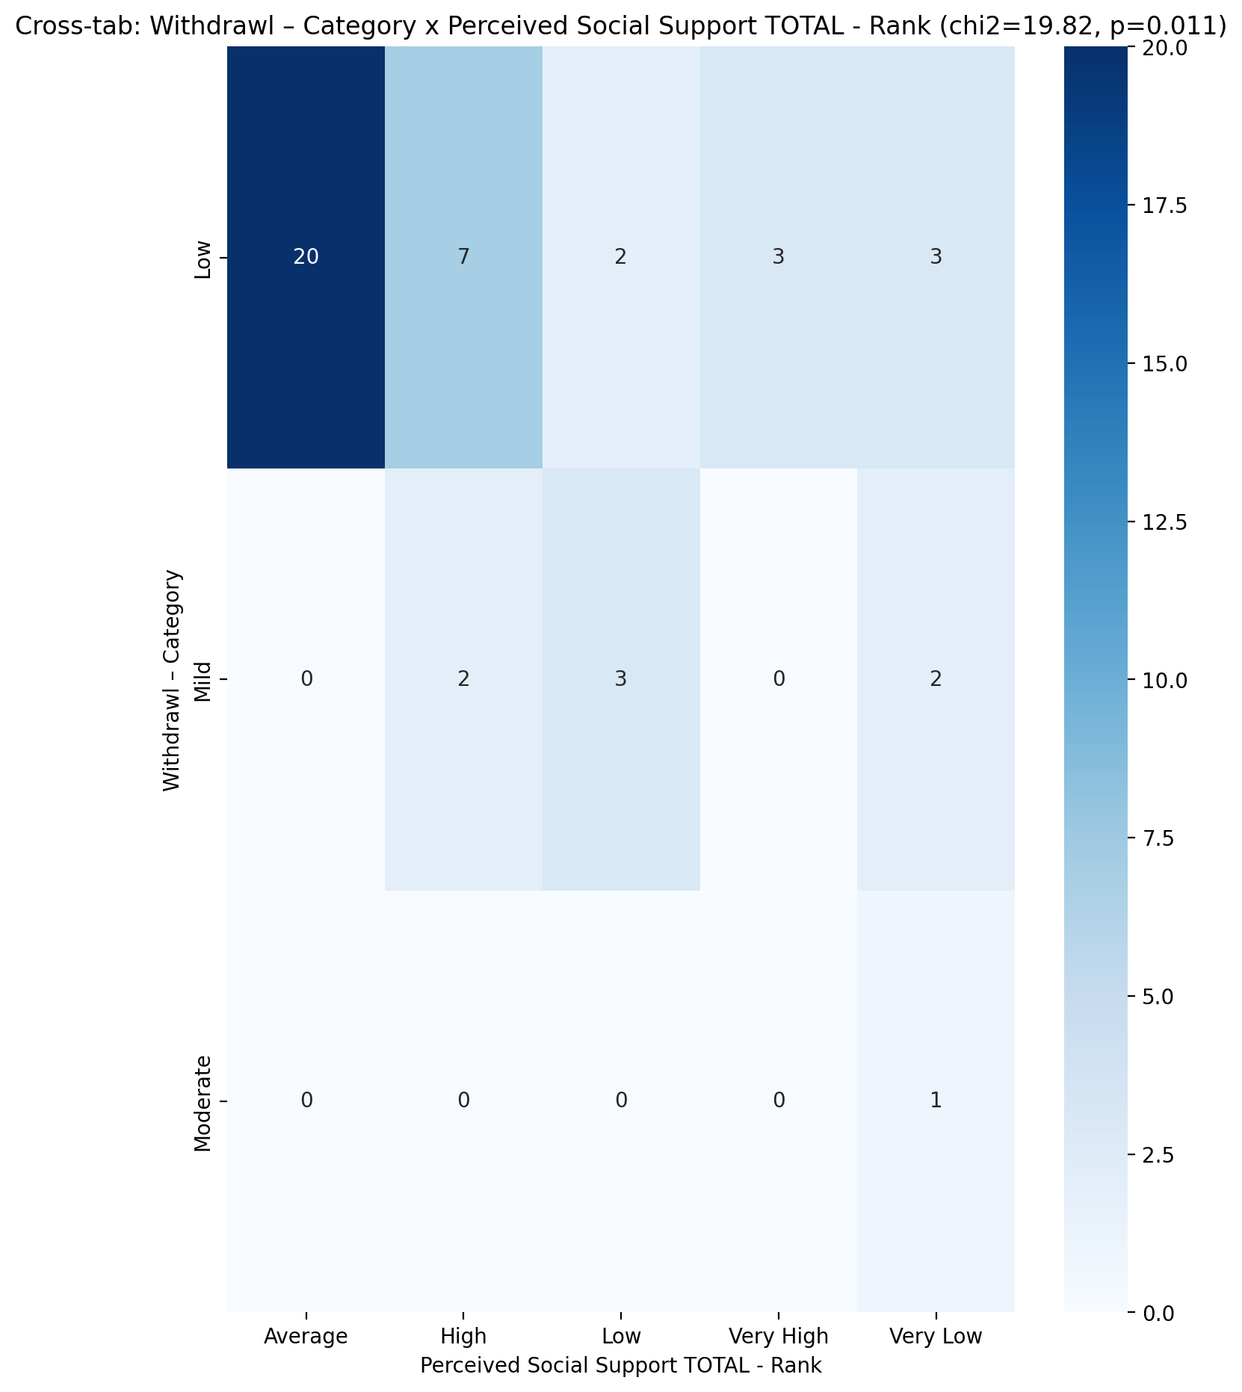

## Power Self Concept - Real Self Concept Score vs Withdrawl – Category

Test: anova; statistic: 0.2689135818862579; p-value: 0.7655798467672909;

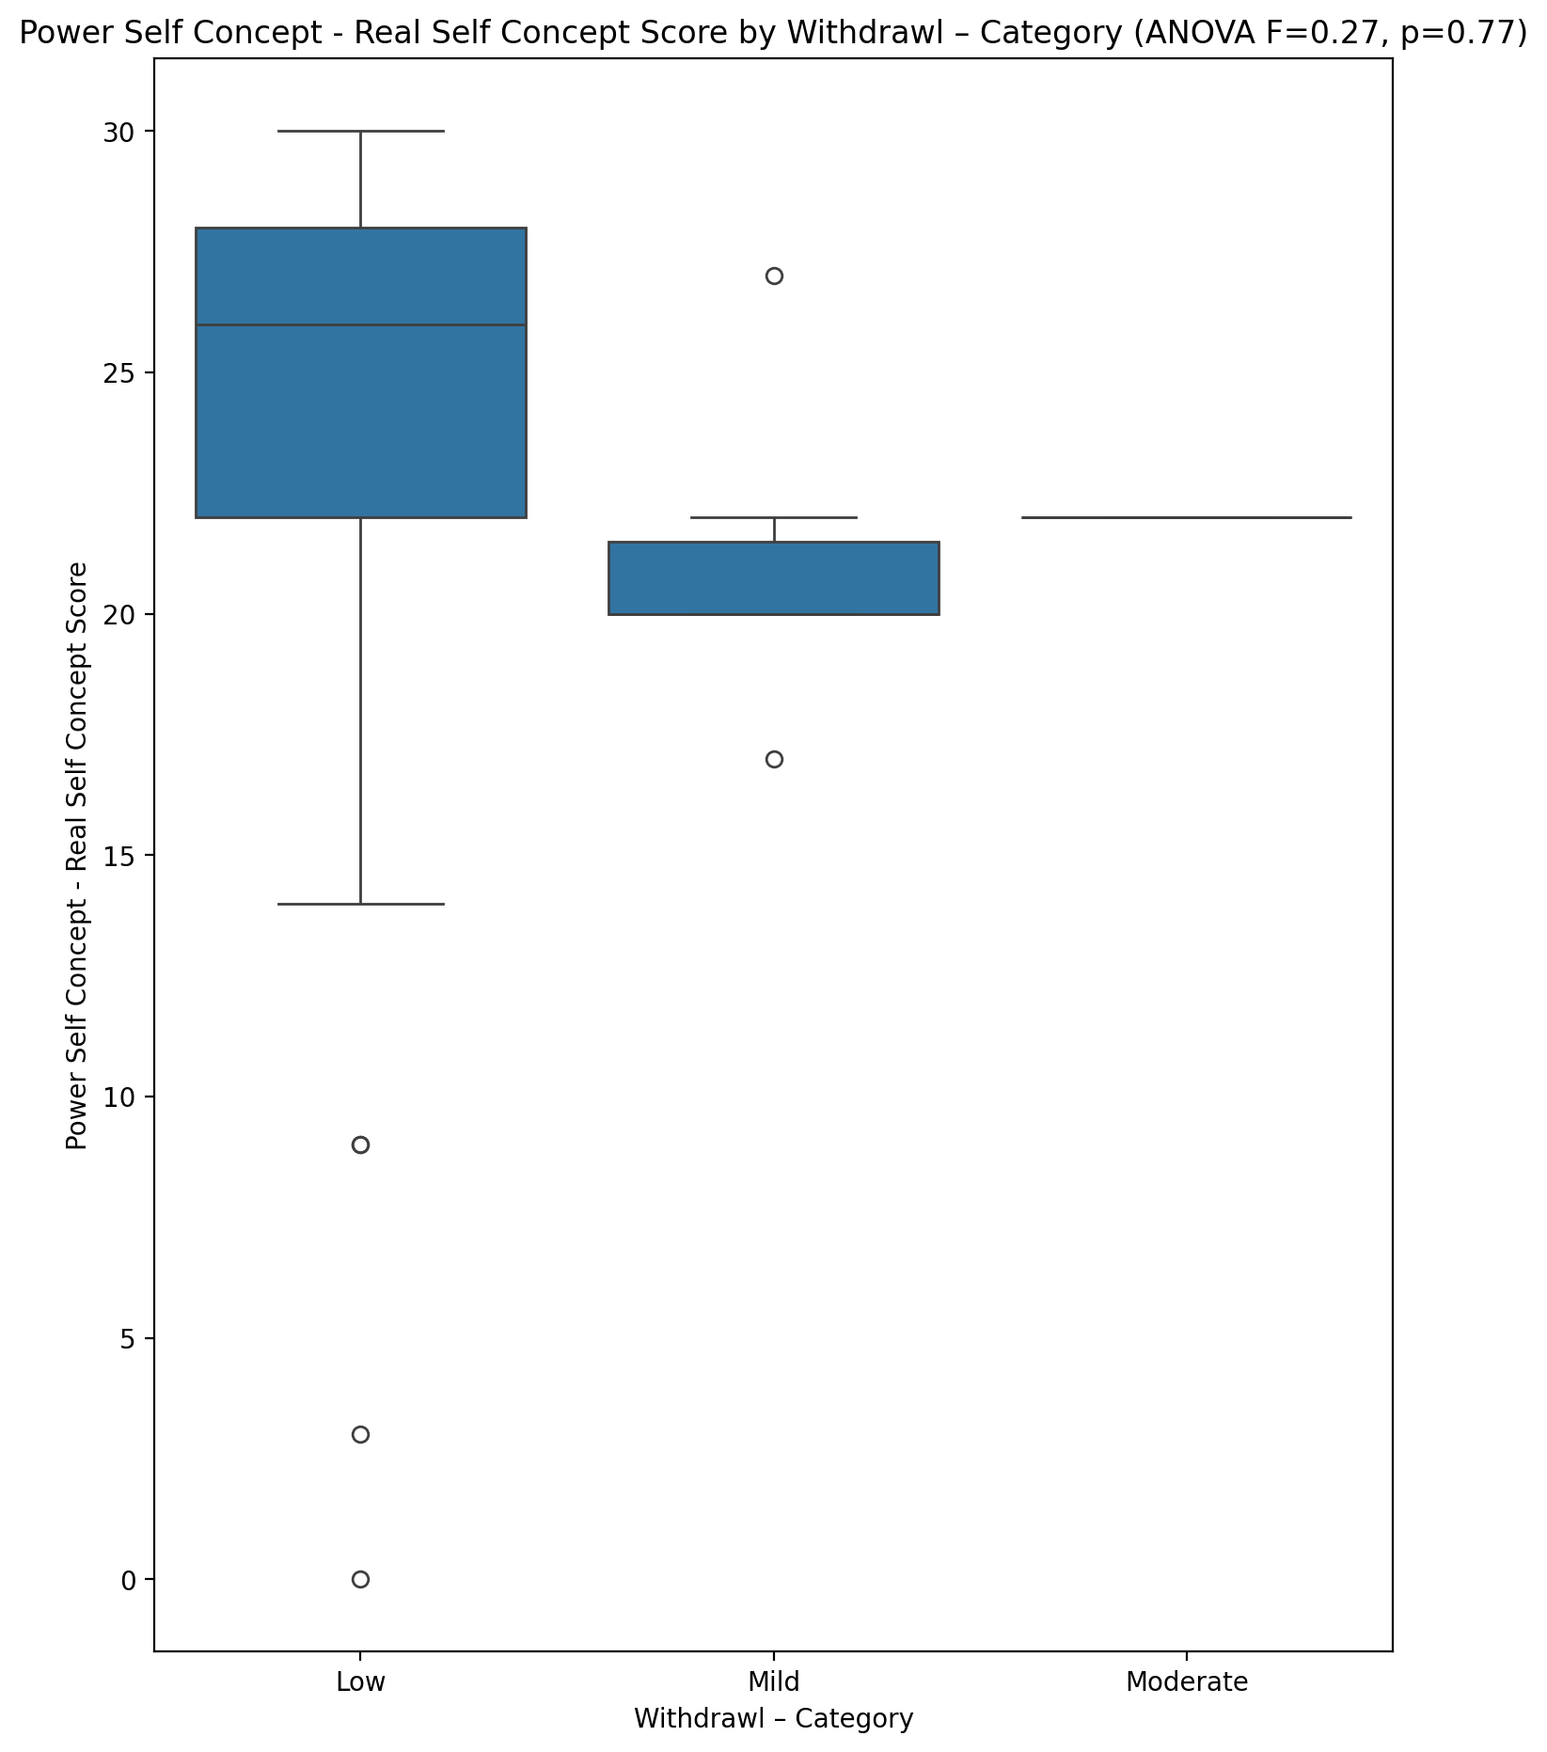

## Power Self Concept - Ideal Self Concept score vs Withdrawl – Category

Test: anova; statistic: 0.42917540285267675; p-value: 0.6540081618149952;

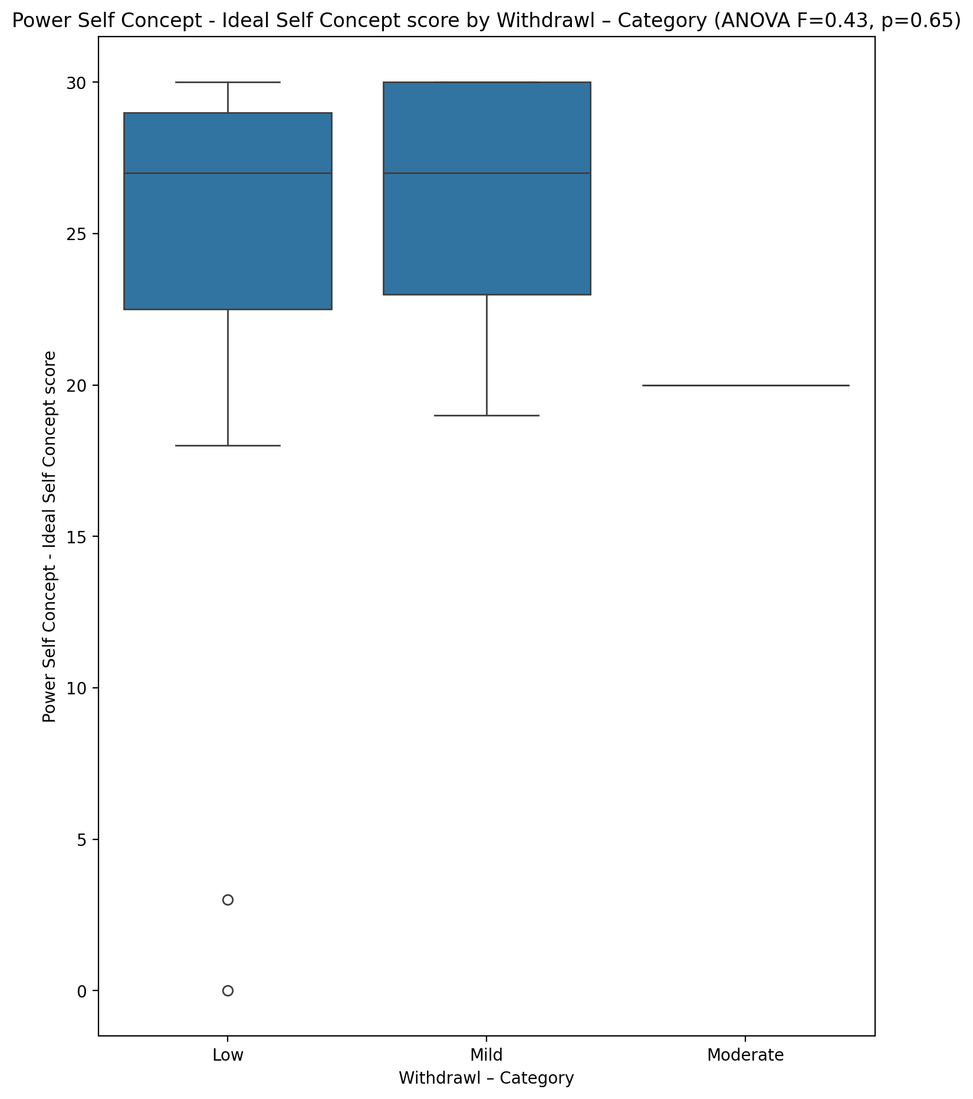

## Power Self Concept – Social Self Concept Score vs Withdrawl – Category

Test: anova; statistic: 0.06267762865681328; p-value: 0.9393382685605367;

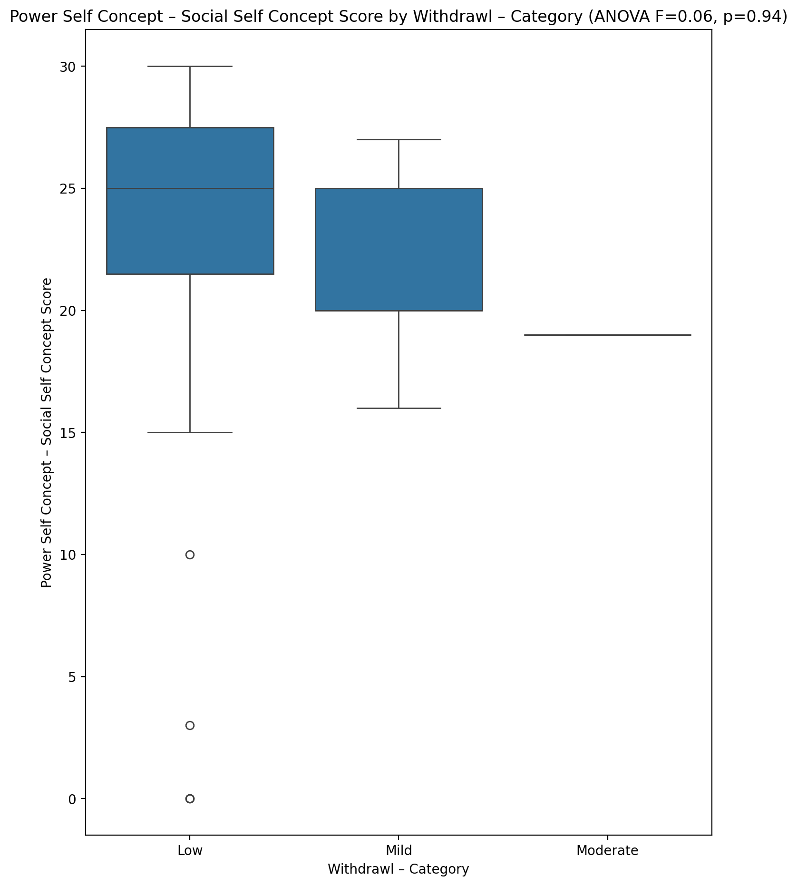

## Social Self Concept - Real Self Concept Score vs Withdrawl – Category

Test: anova; statistic: 0.5903827166102811; p-value: 0.5588709471555005;

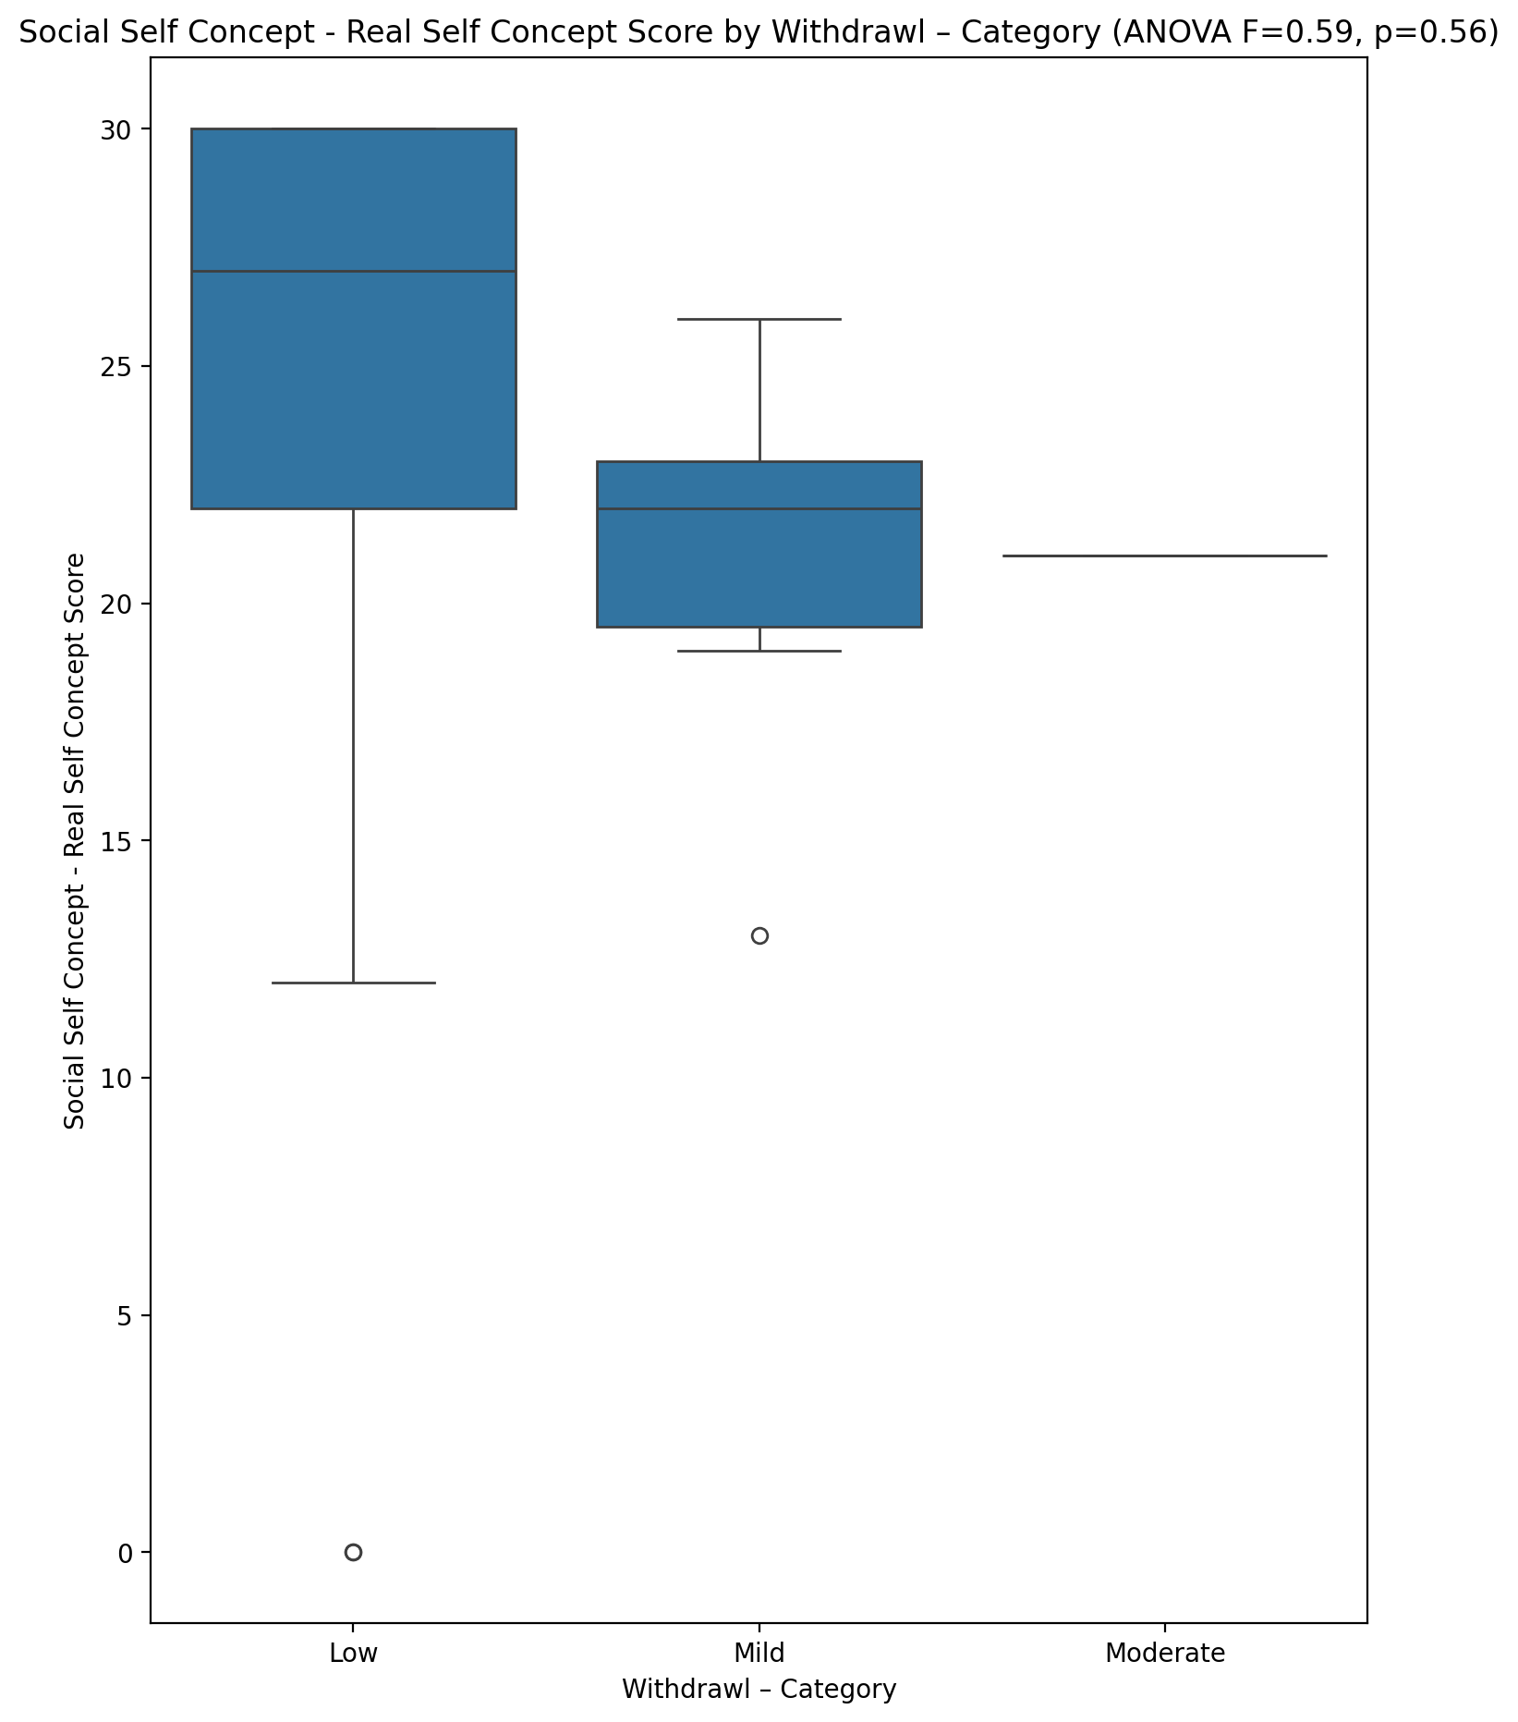

## Social Self Concept – Social Self Concept Score vs Withdrawl – Category

Test: anova; statistic: 0.005728363679489101; p-value: 0.9942888276245144;

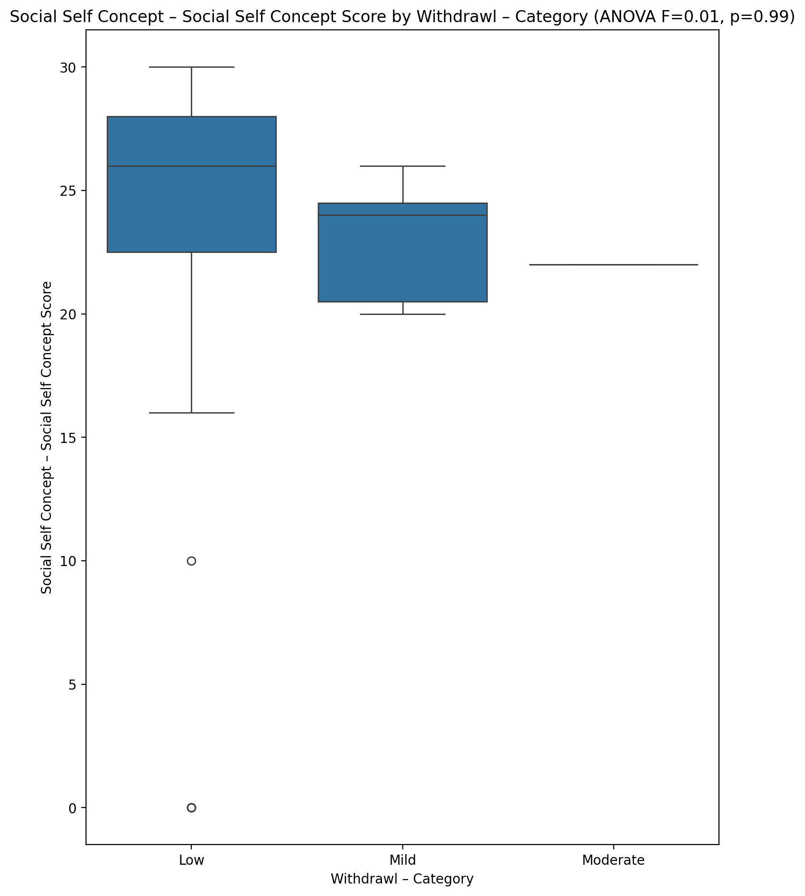

## Ability Self Concept - Real Self Concept Score vs Withdrawl – Category

Test: anova; statistic: 0.4735116111659157; p-value: 0.6262577751878022;

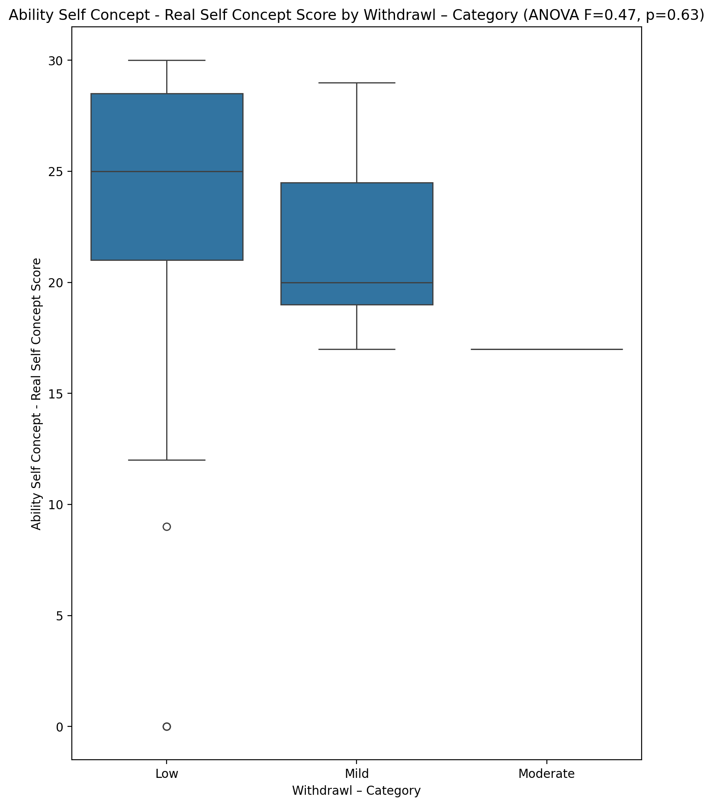

## Ability Self Concept - Ideal Self Concept Score vs Withdrawl – Category

Test: anova; statistic: 0.6357901584339773; p-value: 0.5347833211768231;

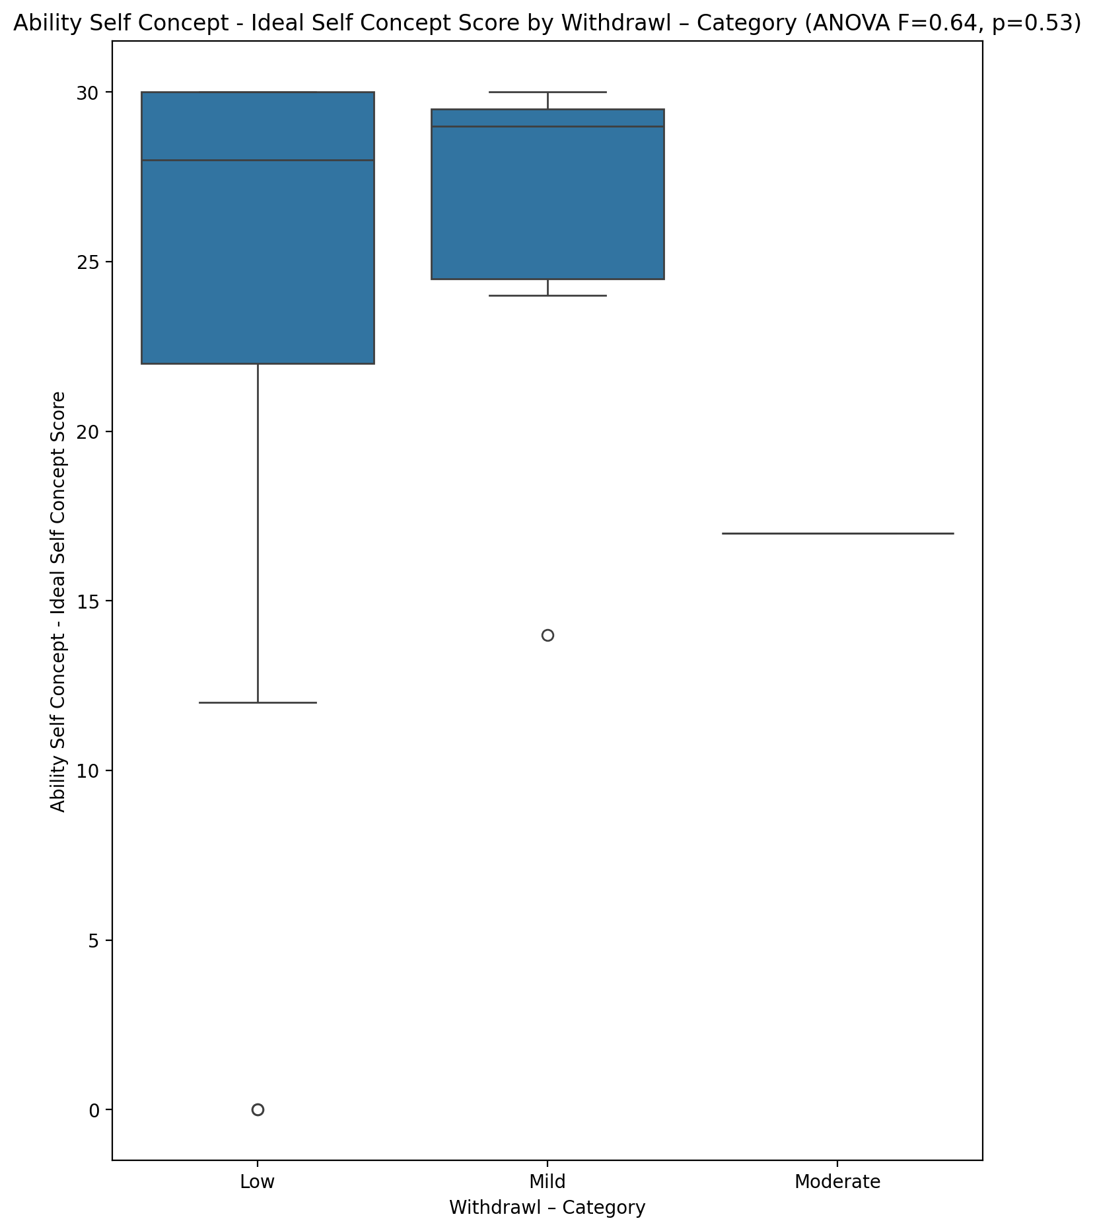

## Ability Self Concept – Social Self Concept Score vs Withdrawl – Category

Test: anova; statistic: 0.24735107384434615; p-value: 0.7820520305054424;

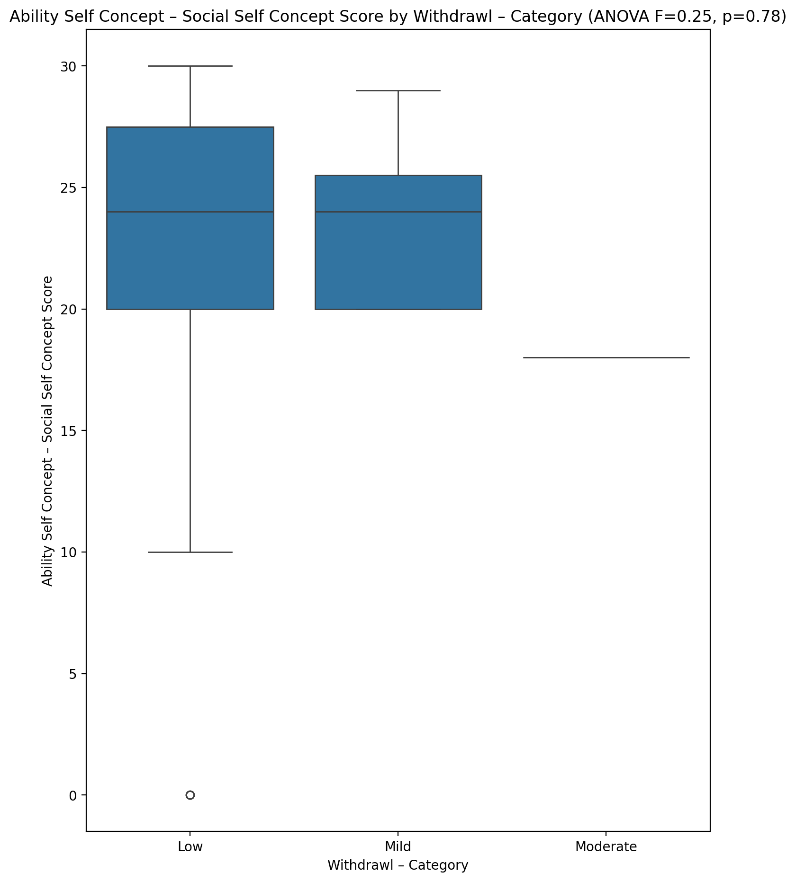

## Physical Self Concept - Real Self Concept Score vs Withdrawl – Category

Test: anova; statistic: 0.2333476571516736; p-value: 0.7929486008736519;

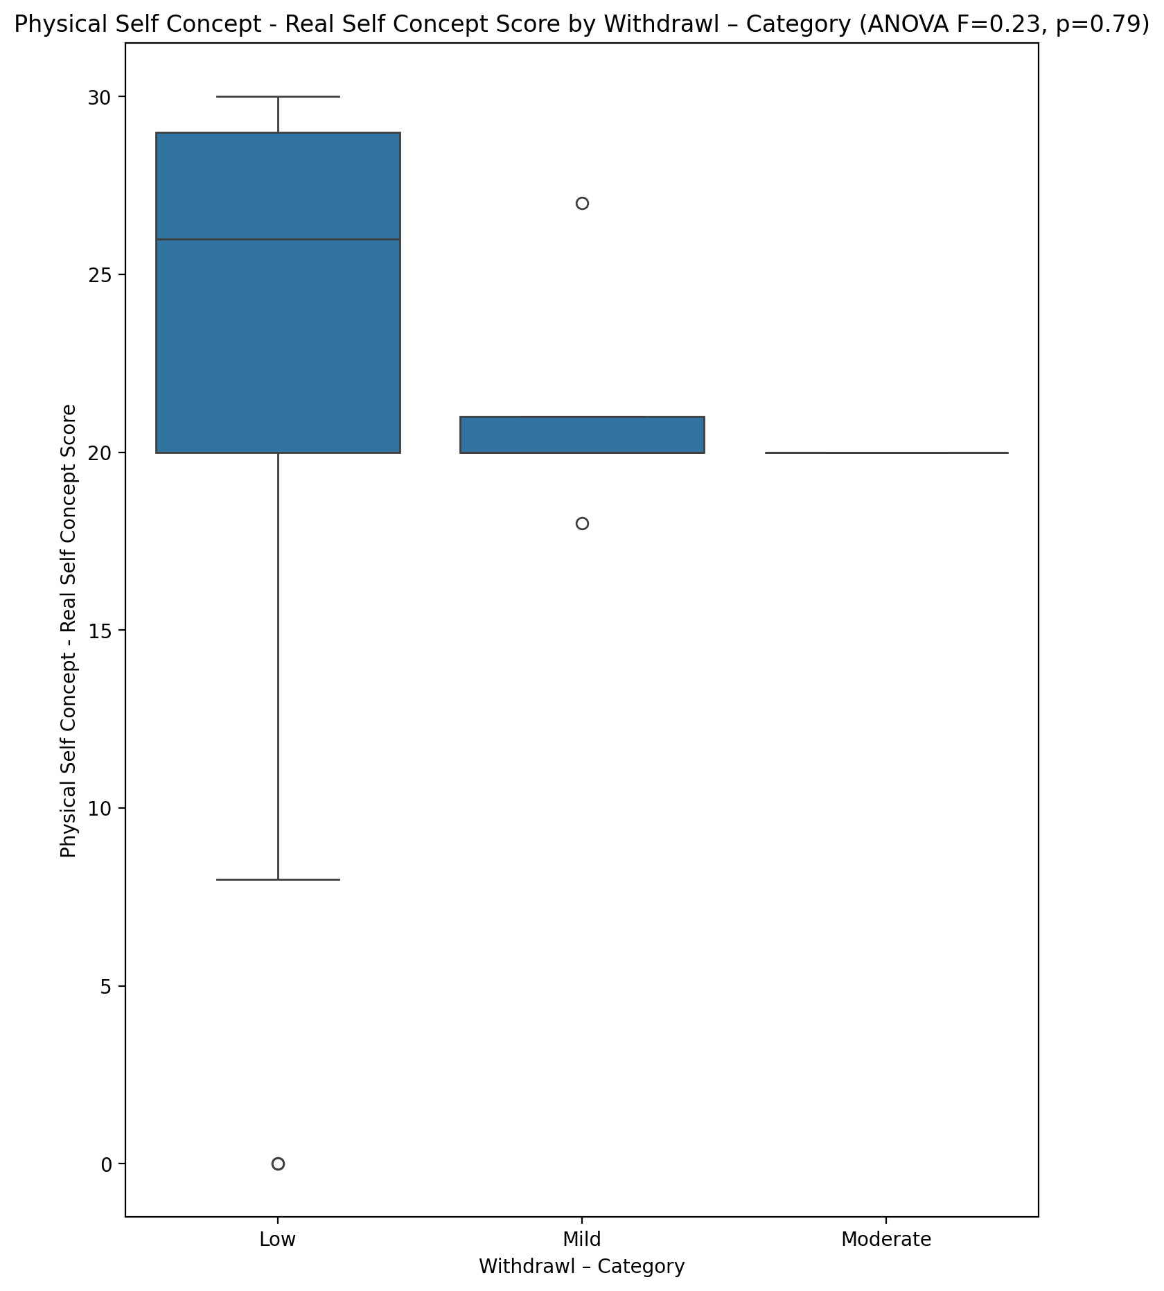

## Physical Self Concept – Ideal Self Concept Score vs Withdrawl – Category

Test: anova; statistic: 0.1453871414178873; p-value: 0.8651423207386054;

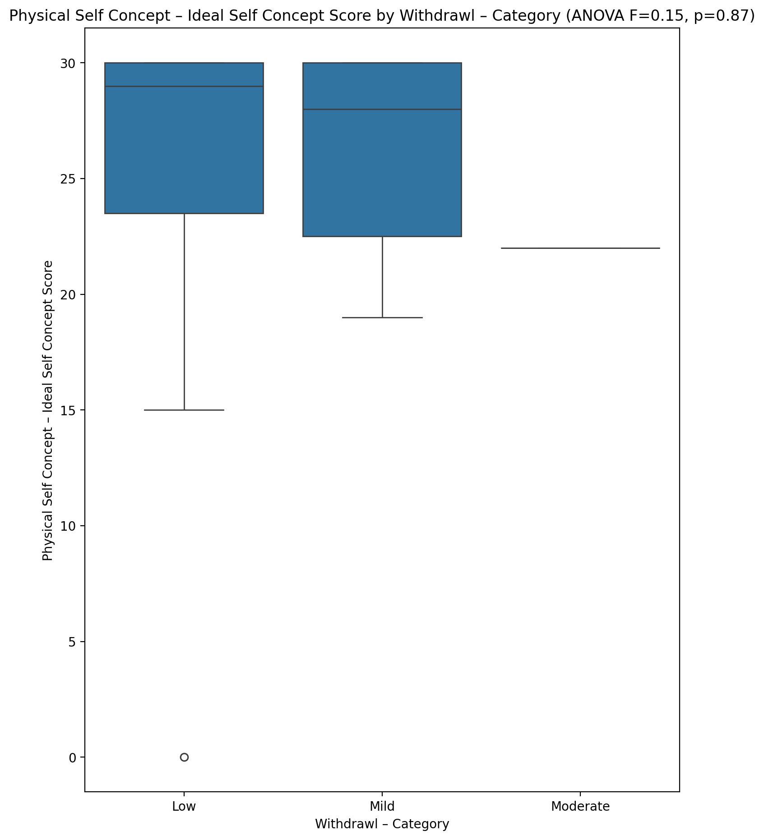

## Physical Self Concept – Social Self Concept Score vs Withdrawl – Category

Test: anova; statistic: 0.1615529932903394; p-value: 0.8513737977135498;

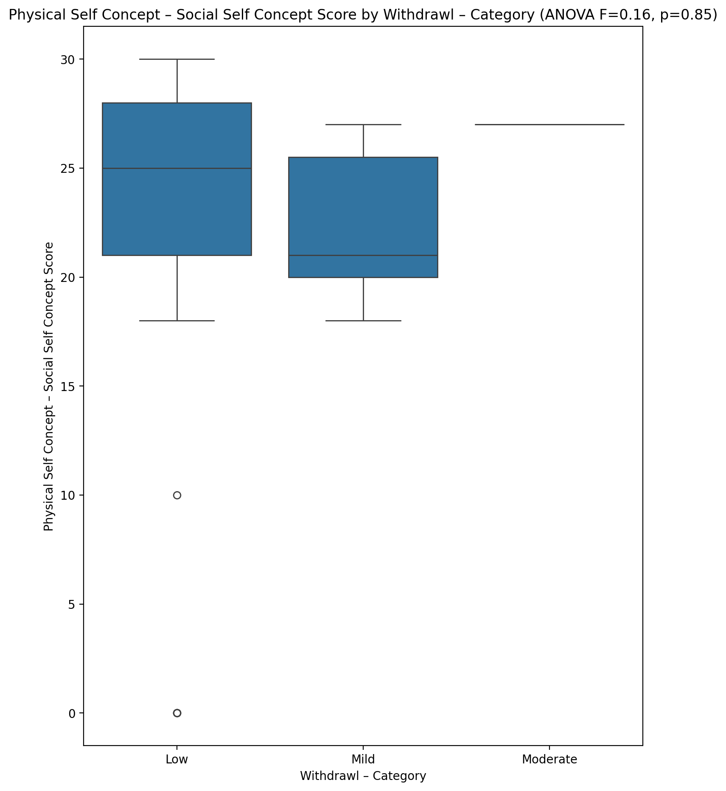

## Psychological Self Concept - Real Self Concept Score vs Withdrawl – Category

Test: anova; statistic: 0.5503059278487048; p-value: 0.5810775318271897;

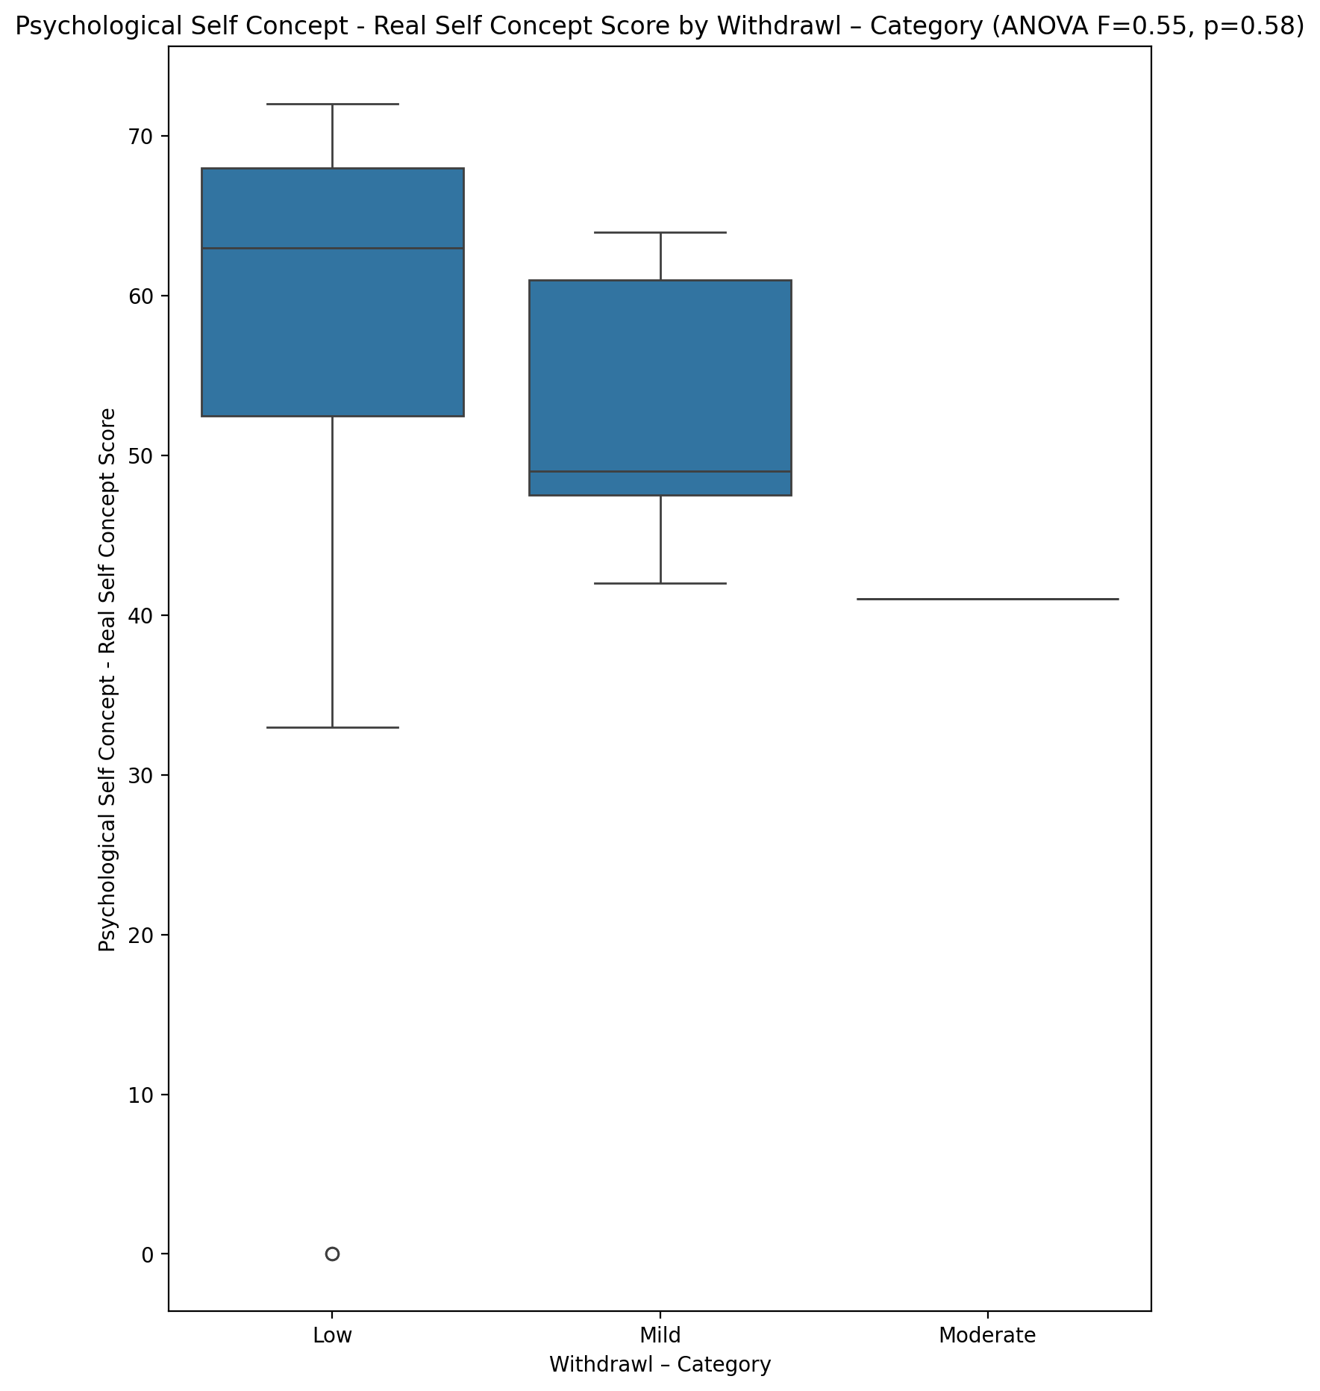

## Psychological Self Concept – Ideal Self Concept Score vs Withdrawl – Category

Test: anova; statistic: 0.2929086821278478; p-value: 0.7476767781019842;

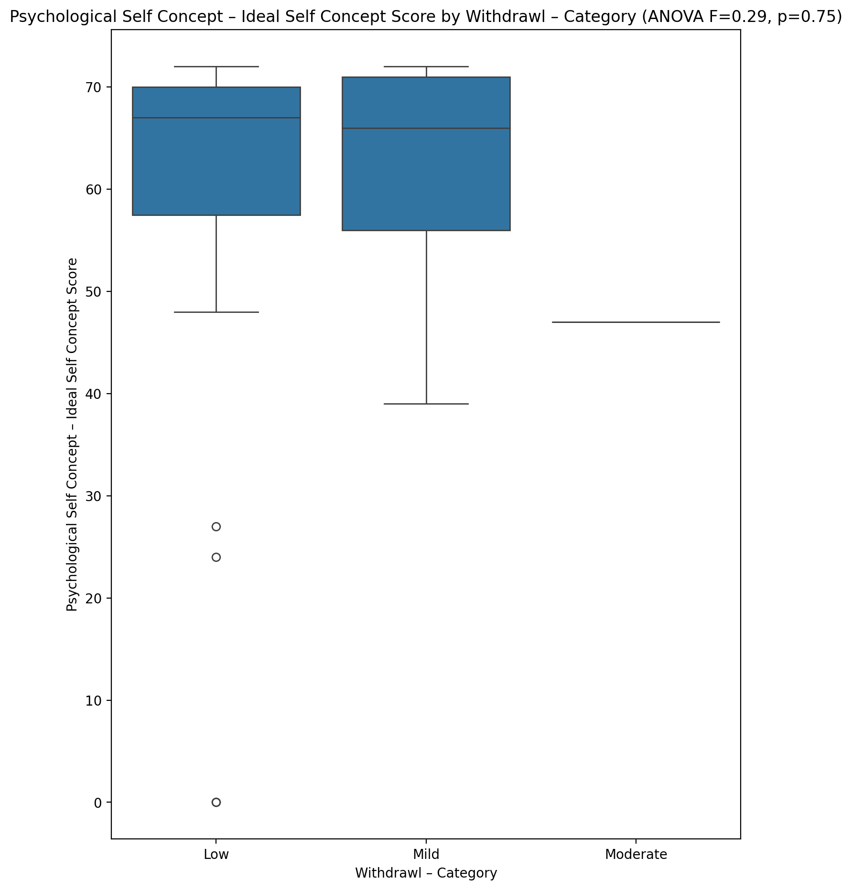

## Psychological Self Concept – Social Self Concept Score vs Withdrawl – Category

Test: anova; statistic: 0.0318442502755336; p-value: 0.9686819695642213;

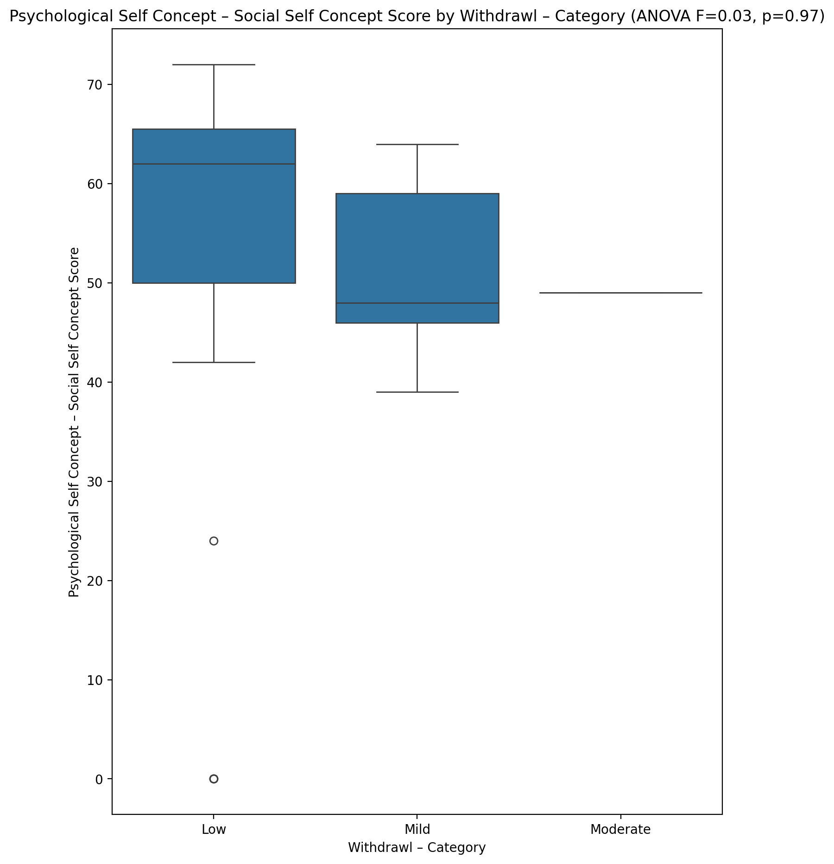

## Real Self Concept Total Score vs Withdrawl – Category

Test: anova; statistic: 0.40425691147188764; p-value: 0.6701688702787099;

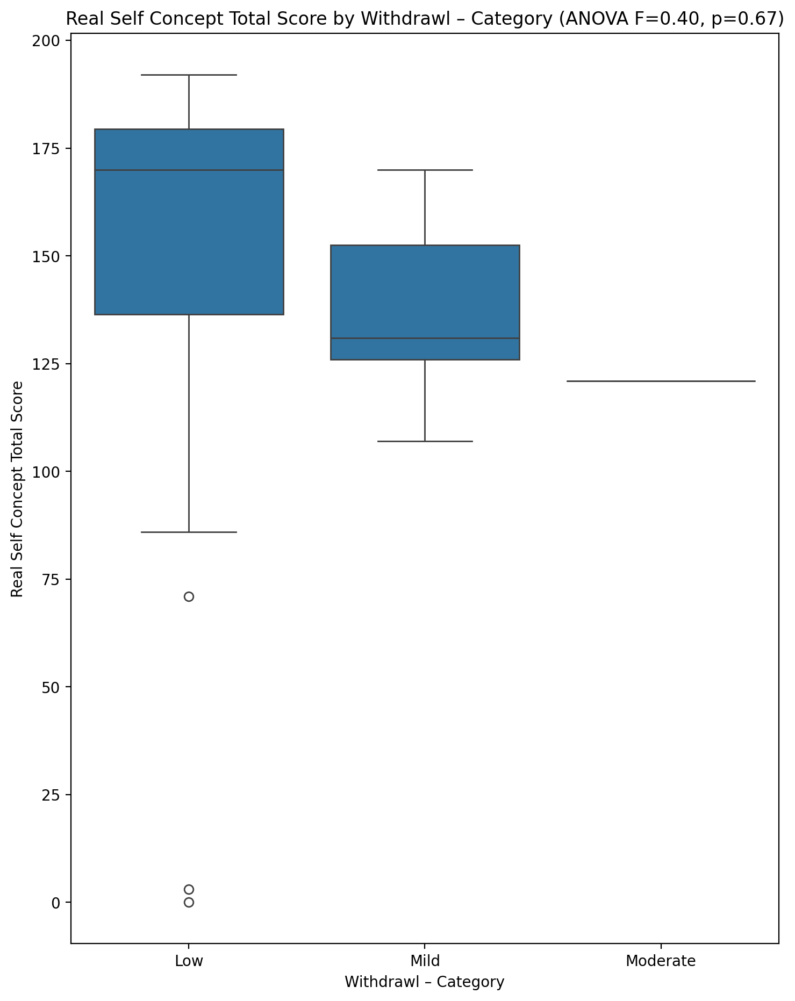

## Ideal Self Concept Total Score vs Withdrawl – Category

Test: anova; statistic: 0.3294011736195056; p-value: 0.7212871411770323;

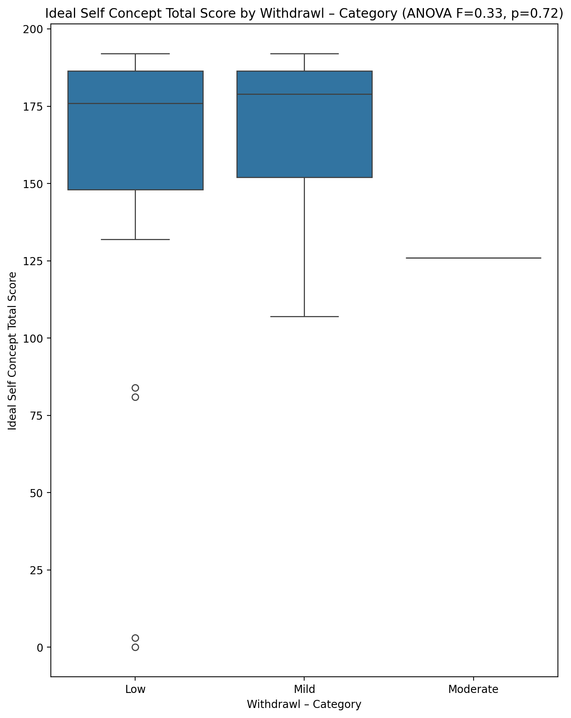

## Social Self Concept Total Score vs Withdrawl – Category

Test: anova; statistic: 0.007940551895539077; p-value: 0.992092454436294;

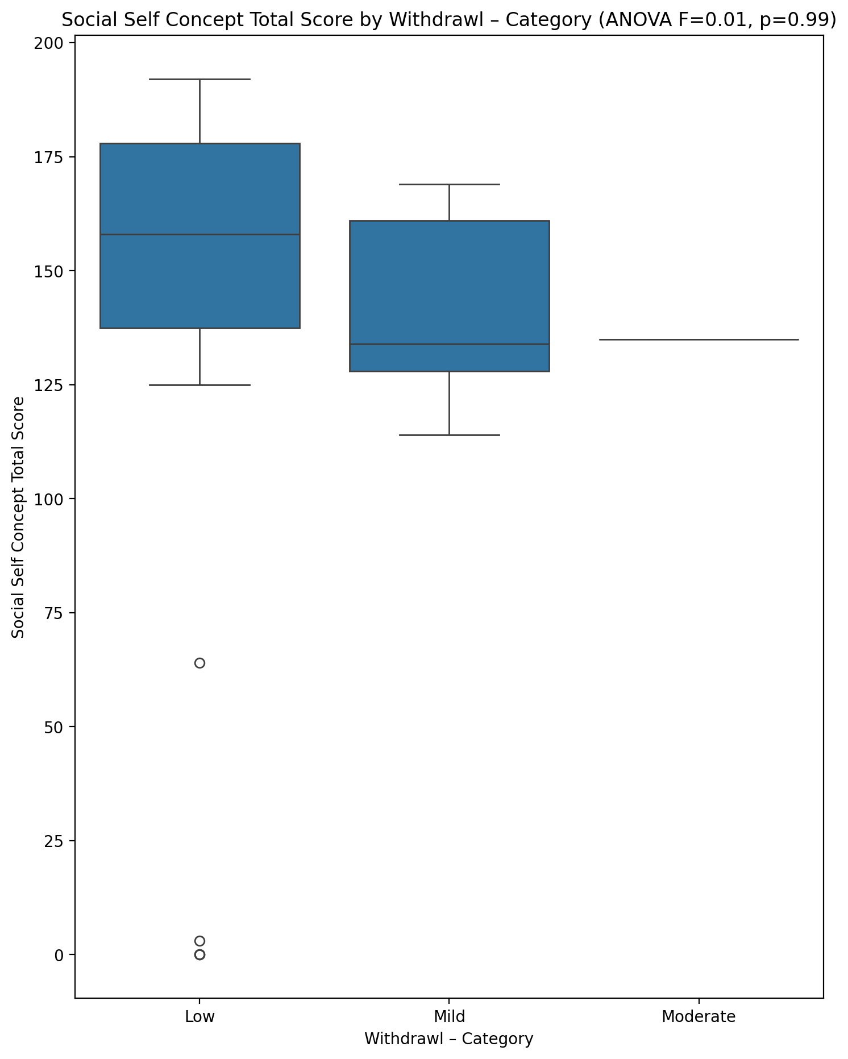

## Ideal Self Concept Total Category vs Withdrawl – Category

Test: chi2; statistic: 5.944700460829493; p-value: 0.20331631447451975;

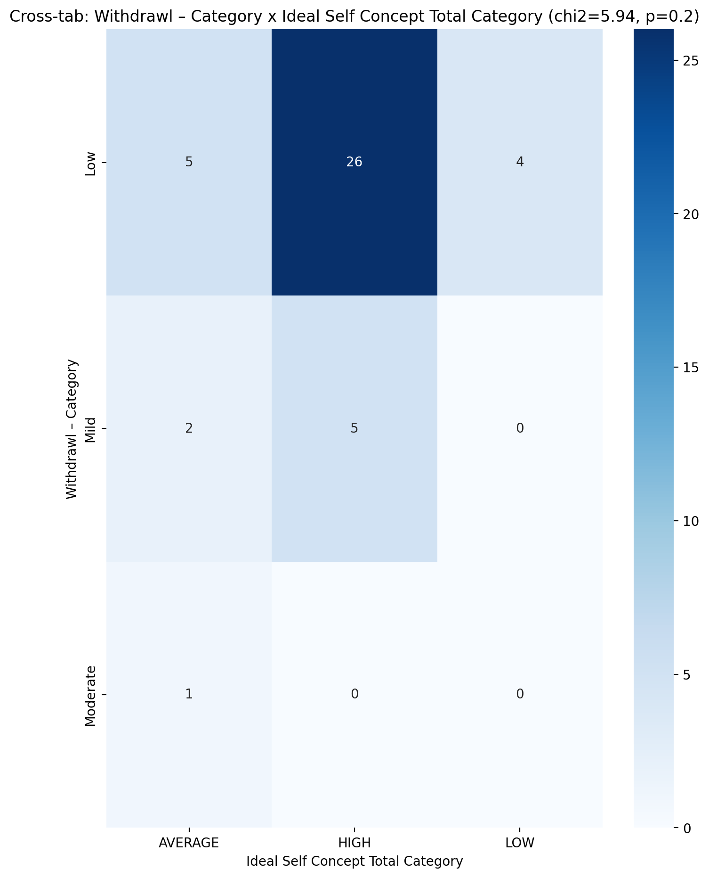

## Perceived Social Stress Score vs Withdrawl – Category

Test: anova; statistic: 0.8767189366617296; p-value: 0.4239894266188097;

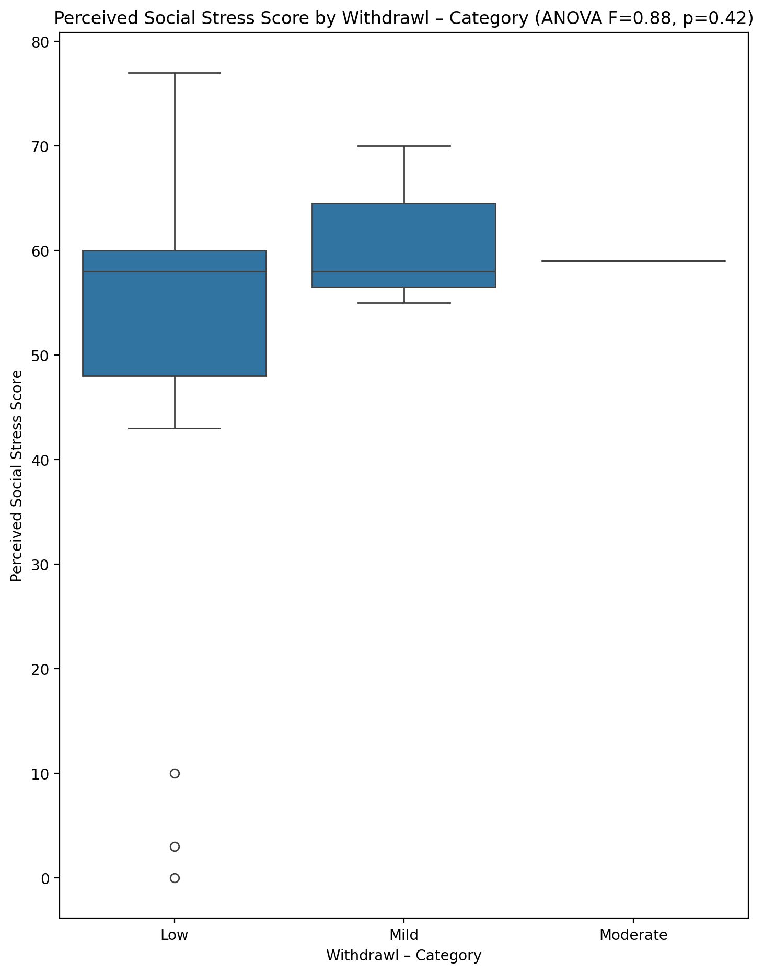

## Perceived Social Stress Category vs Withdrawl – Category

Test: chi2; statistic: 0.7371428571428572; p-value: 0.6917217991335399;

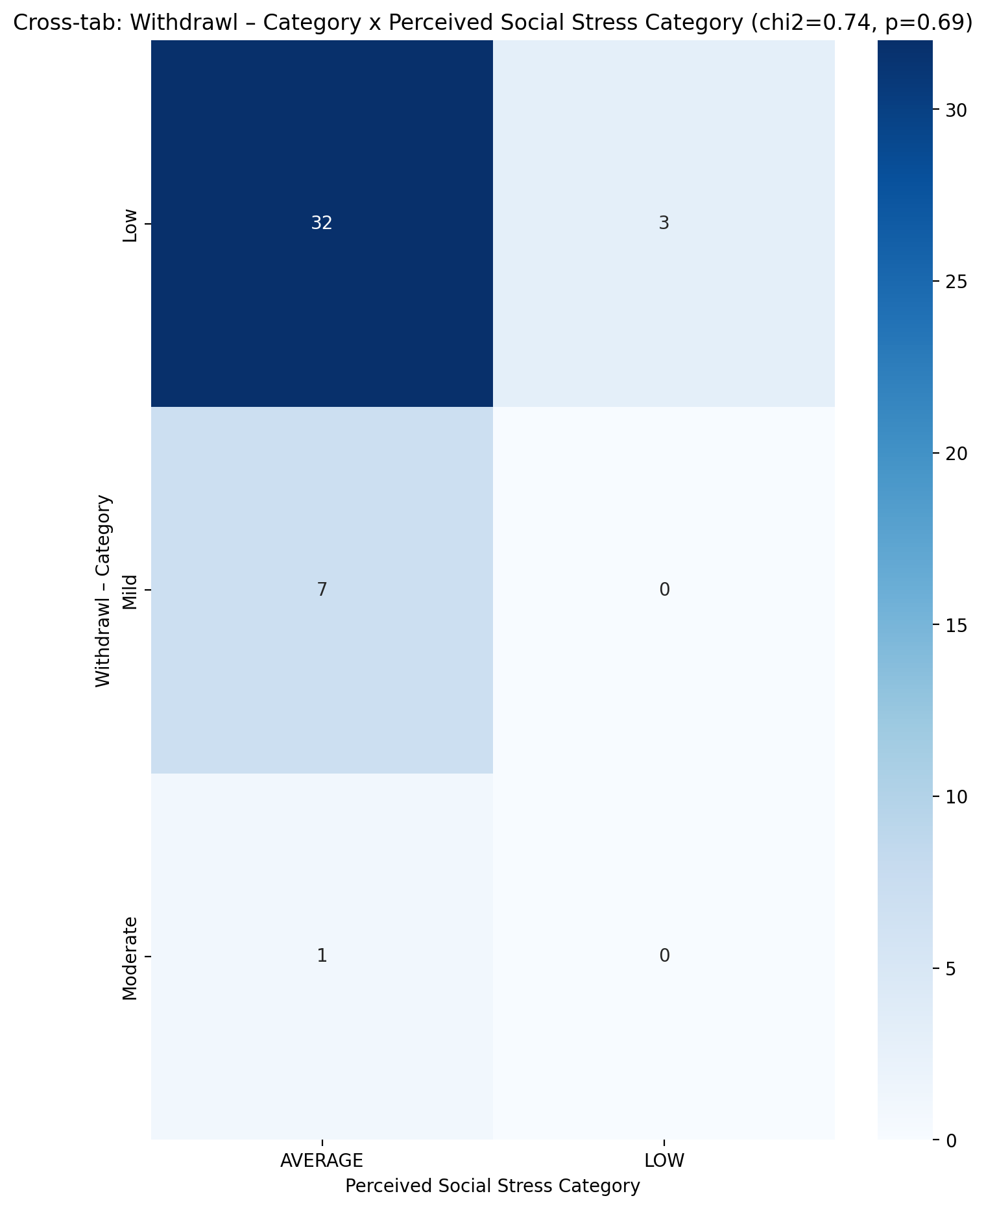

## Emotional Support - Raw Score vs Occupational & Relationship Consequences – Category

Test: anova; statistic: 2.5521613039638367; p-value: 0.09053917442693944;

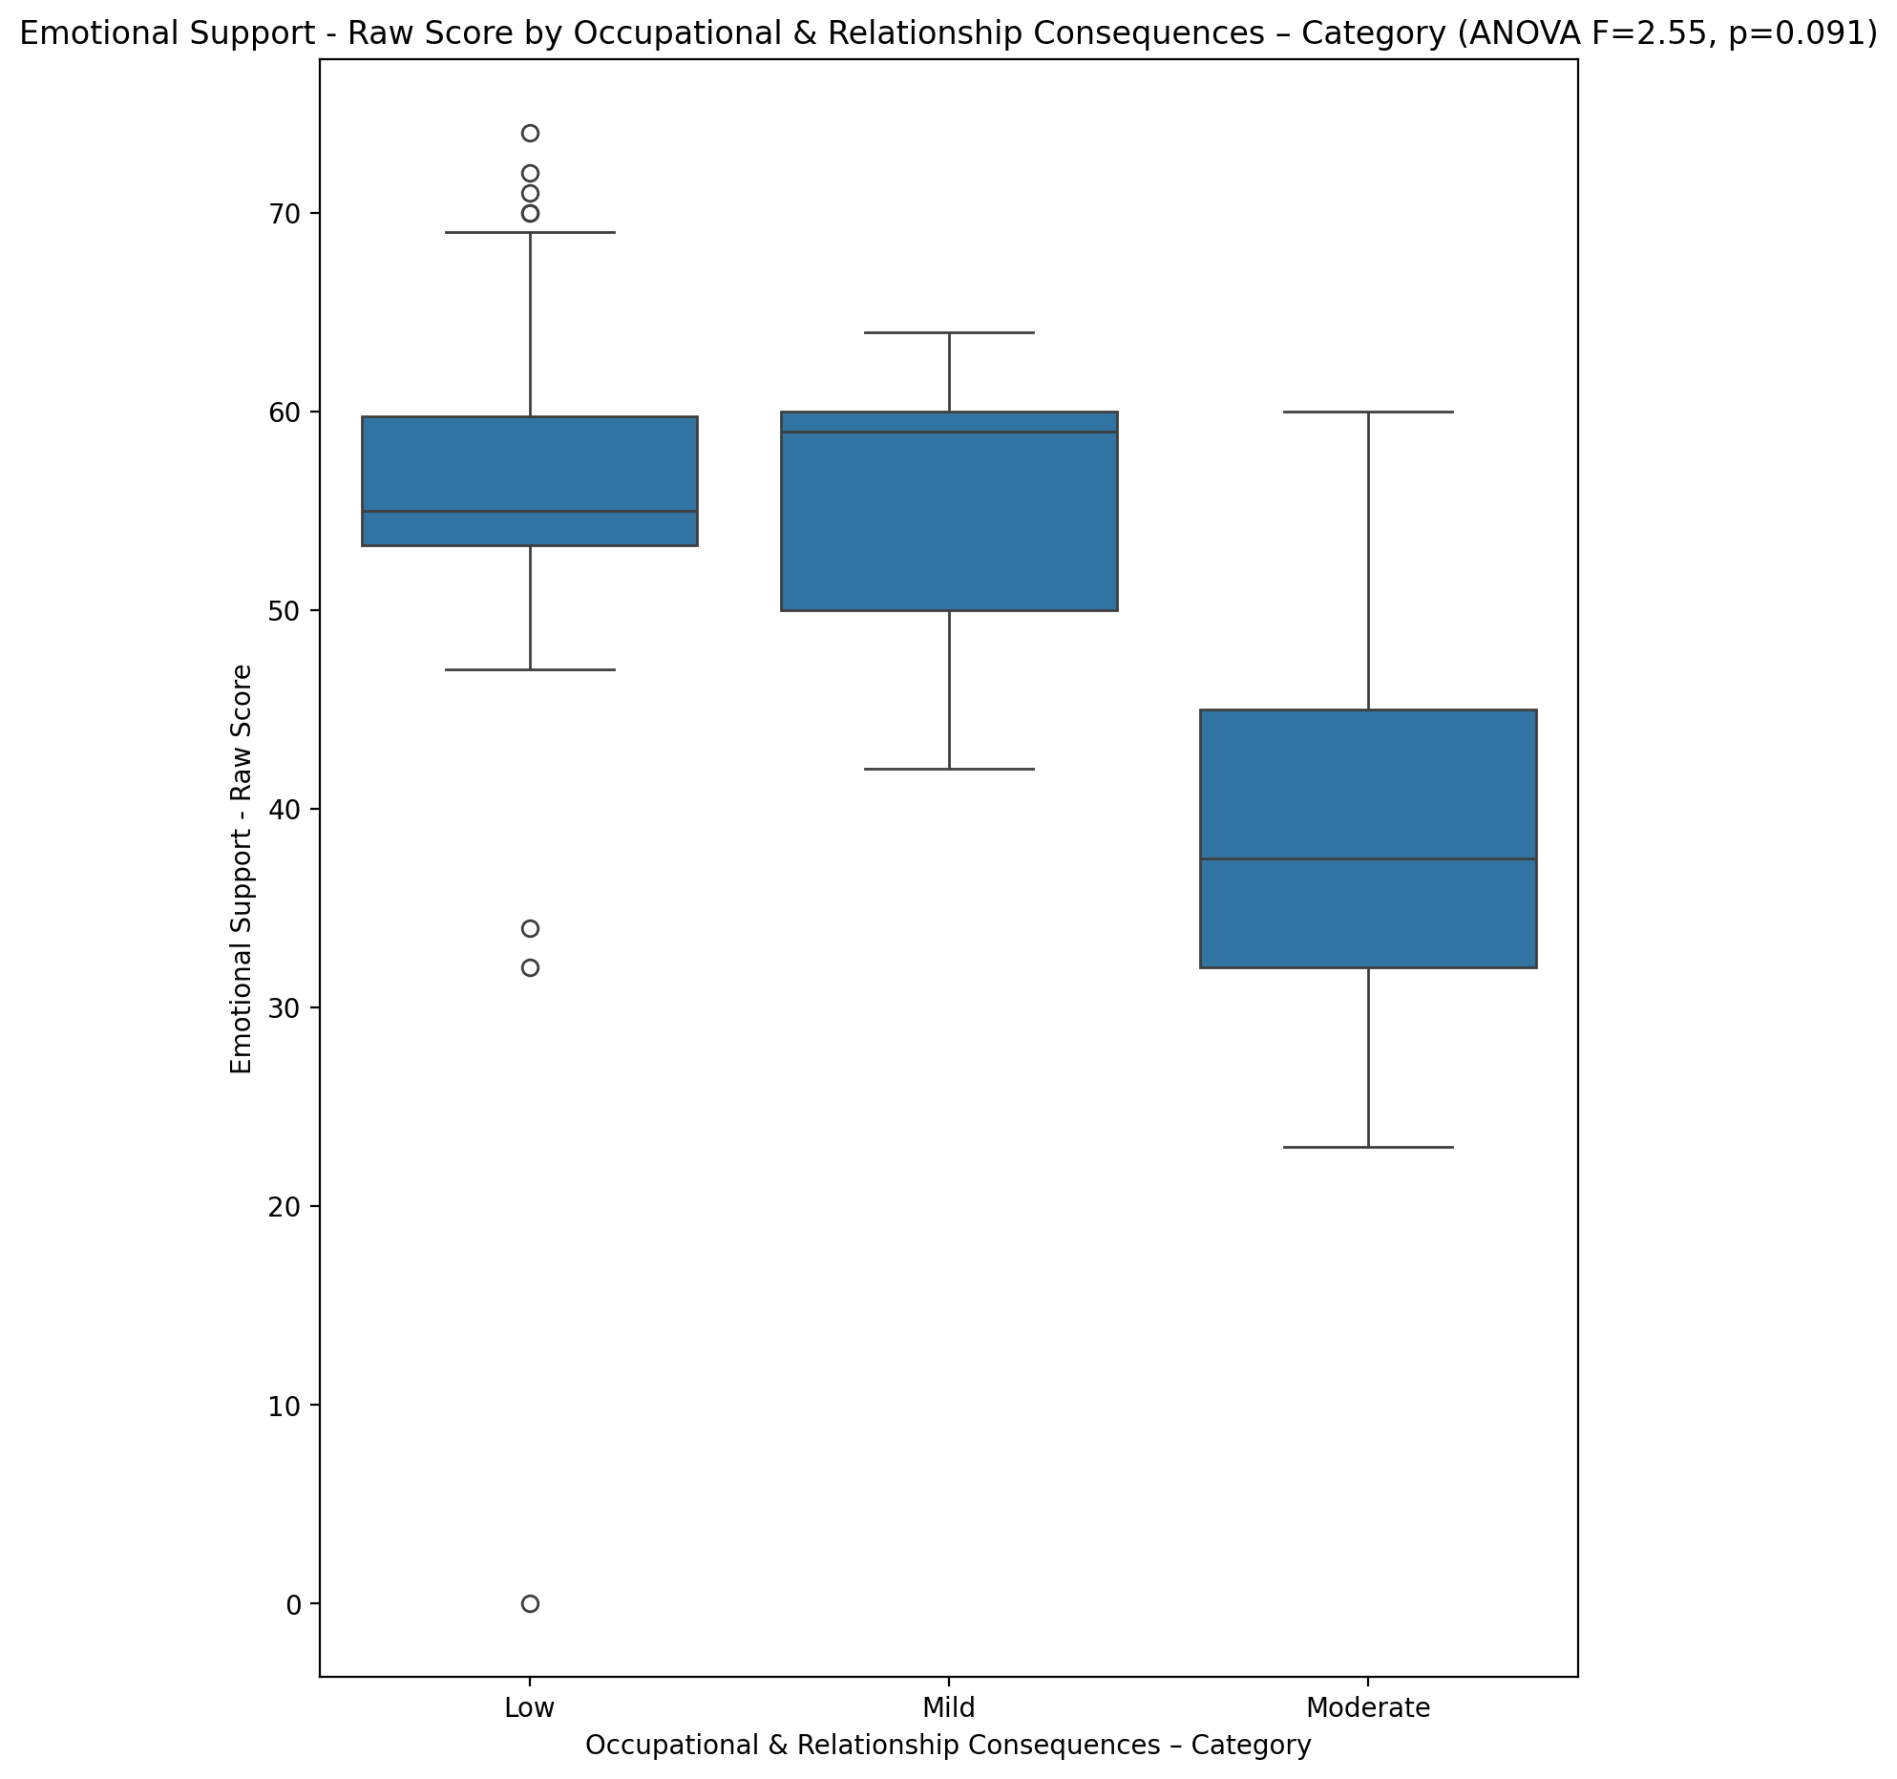

## Informational Support - Raw Score vs Occupational & Relationship Consequences – Category

Test: anova; statistic: 2.709076675322192; p-value: 0.07881527221725879;

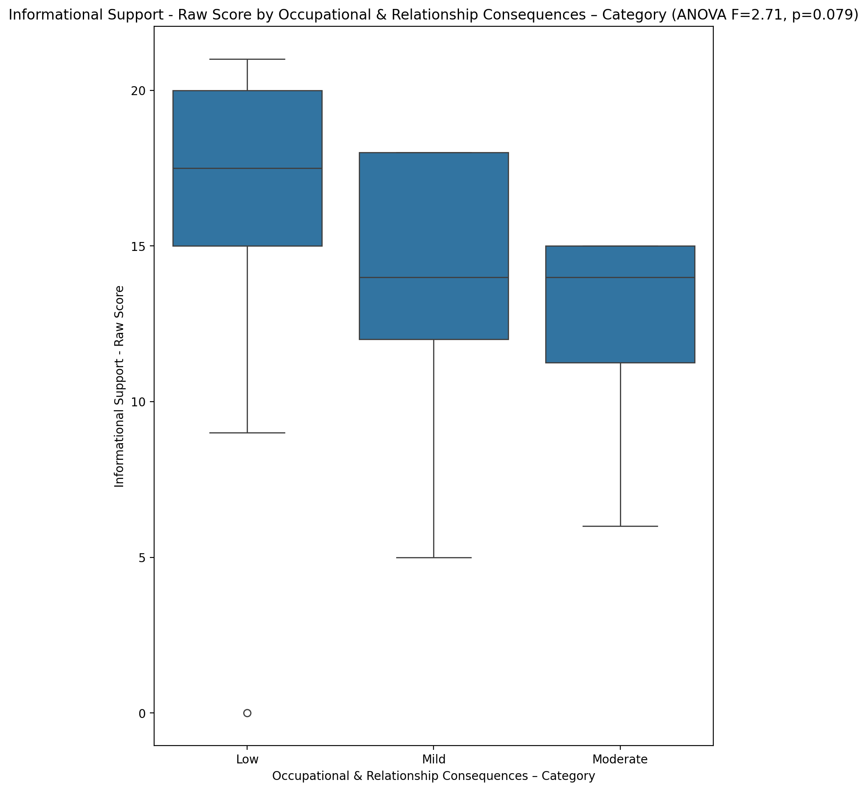

## Instrumental Support - Raw Score vs Occupational & Relationship Consequences – Category

Test: anova; statistic: 1.1519359751132068; p-value: 0.32628525518605667;

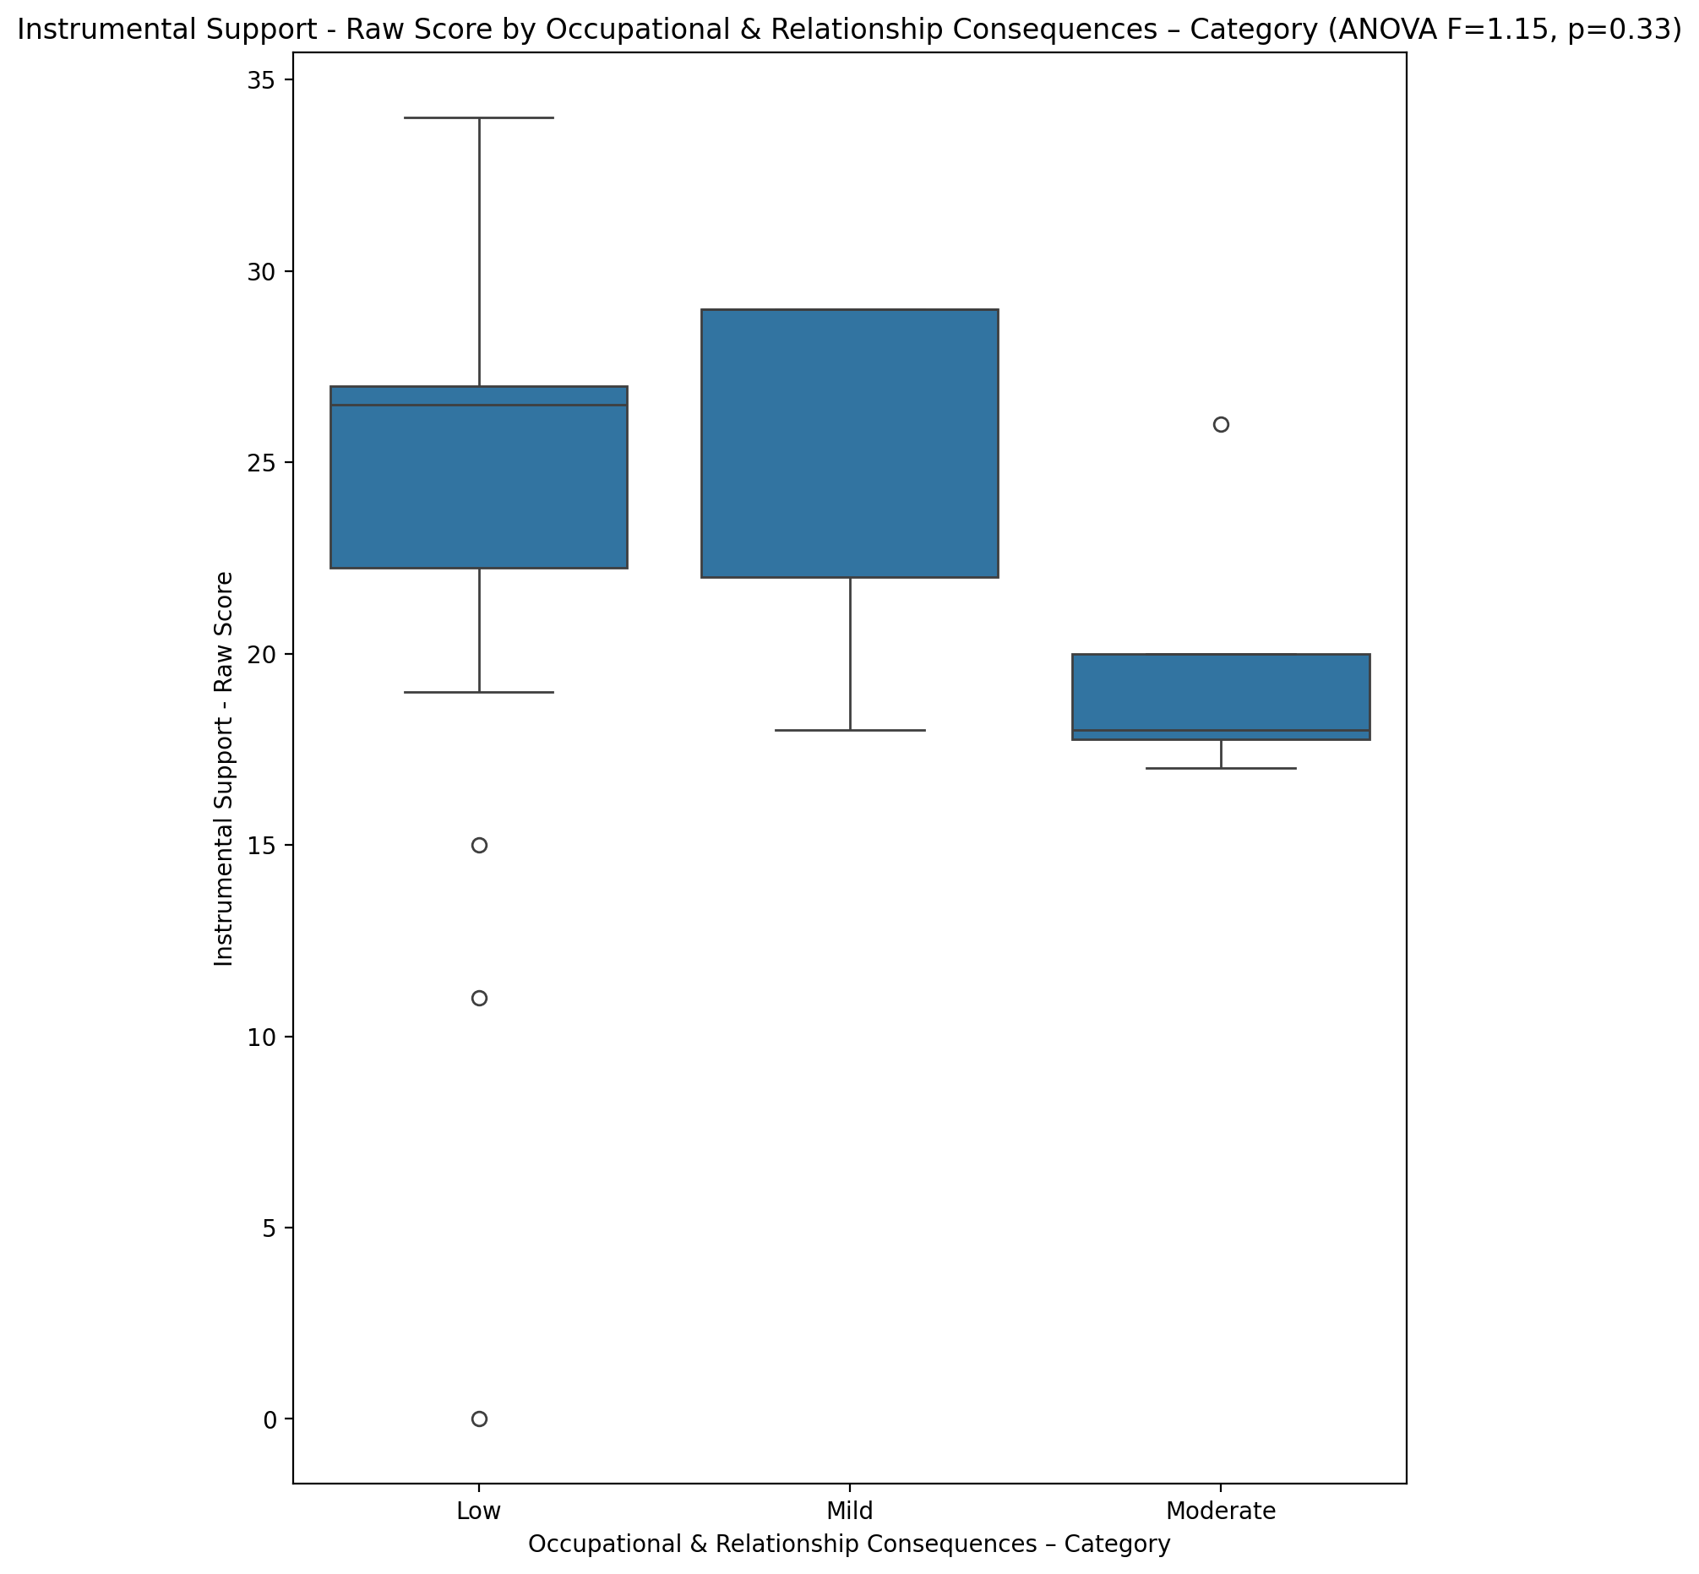

## Emotional Support - T Score vs Occupational & Relationship Consequences – Category

Test: anova; statistic: 2.72975310729035; p-value: 0.07739368850970185;

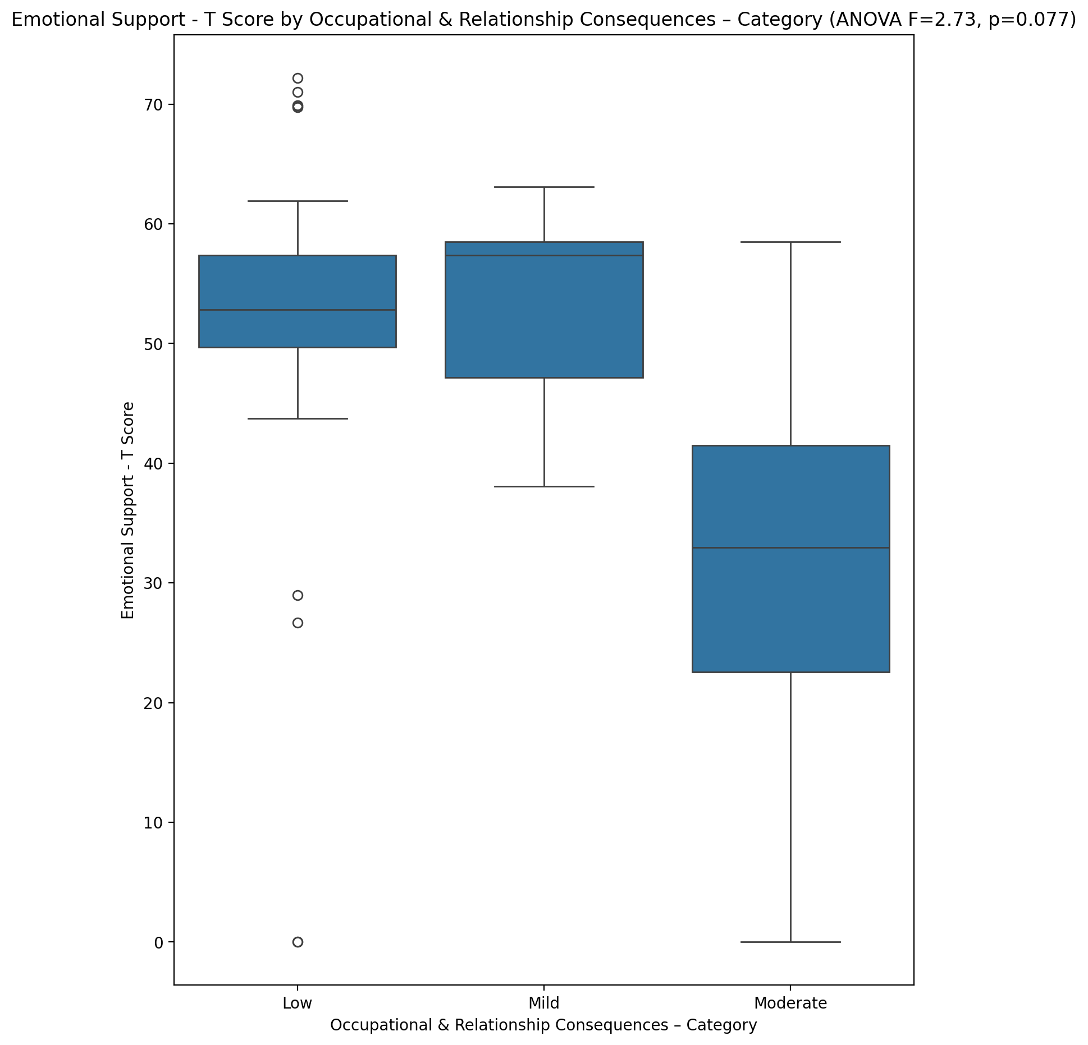

## Informational Support - T Score vs Occupational & Relationship Consequences – Category

Test: anova; statistic: 3.789344238558117; p-value: 0.03111361681379348;

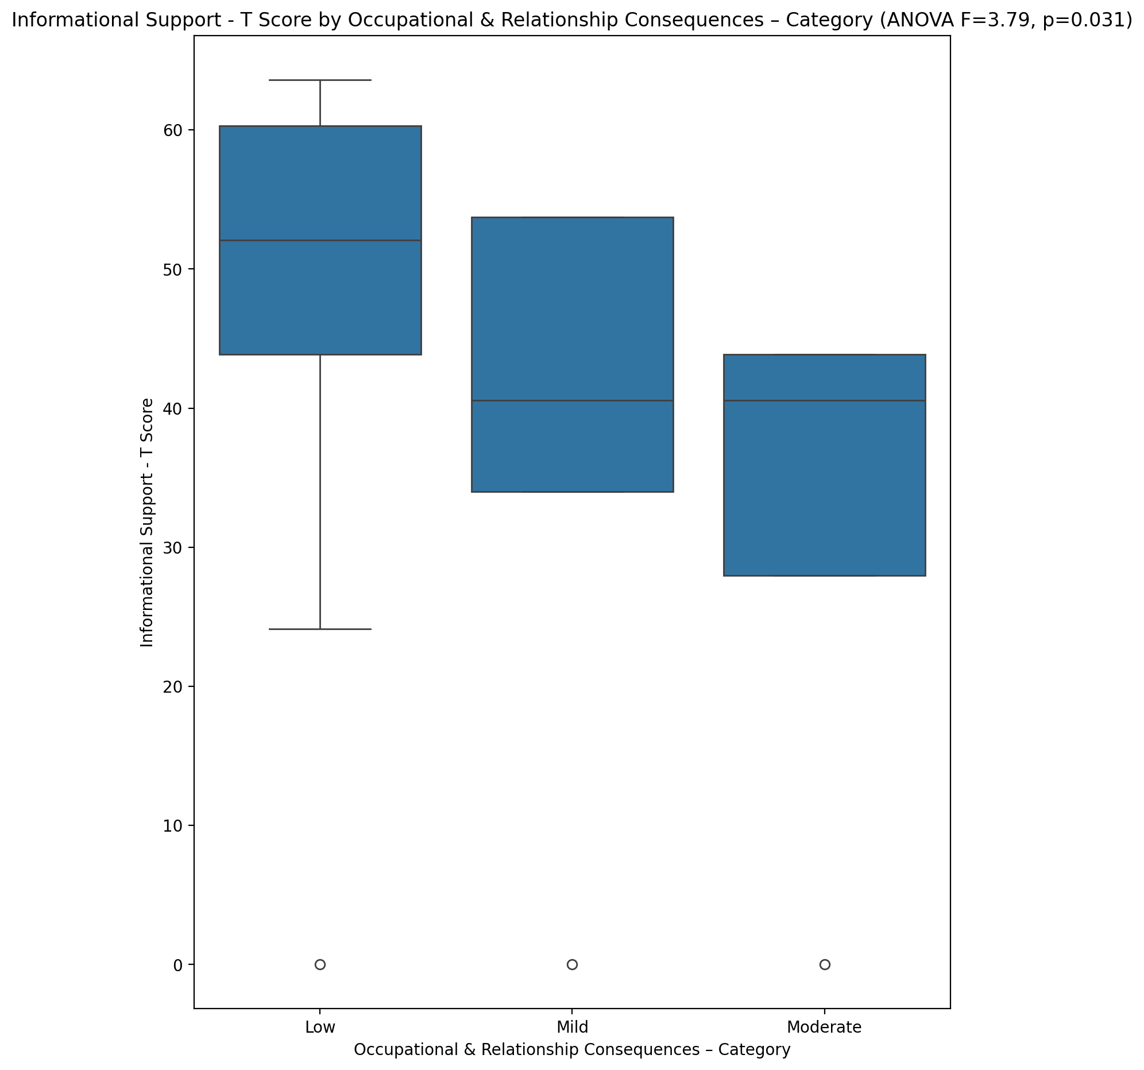

## Instrumental Support - T Score vs Occupational & Relationship Consequences – Category

Test: anova; statistic: 0.9988455567303763; p-value: 0.3773041007547908;

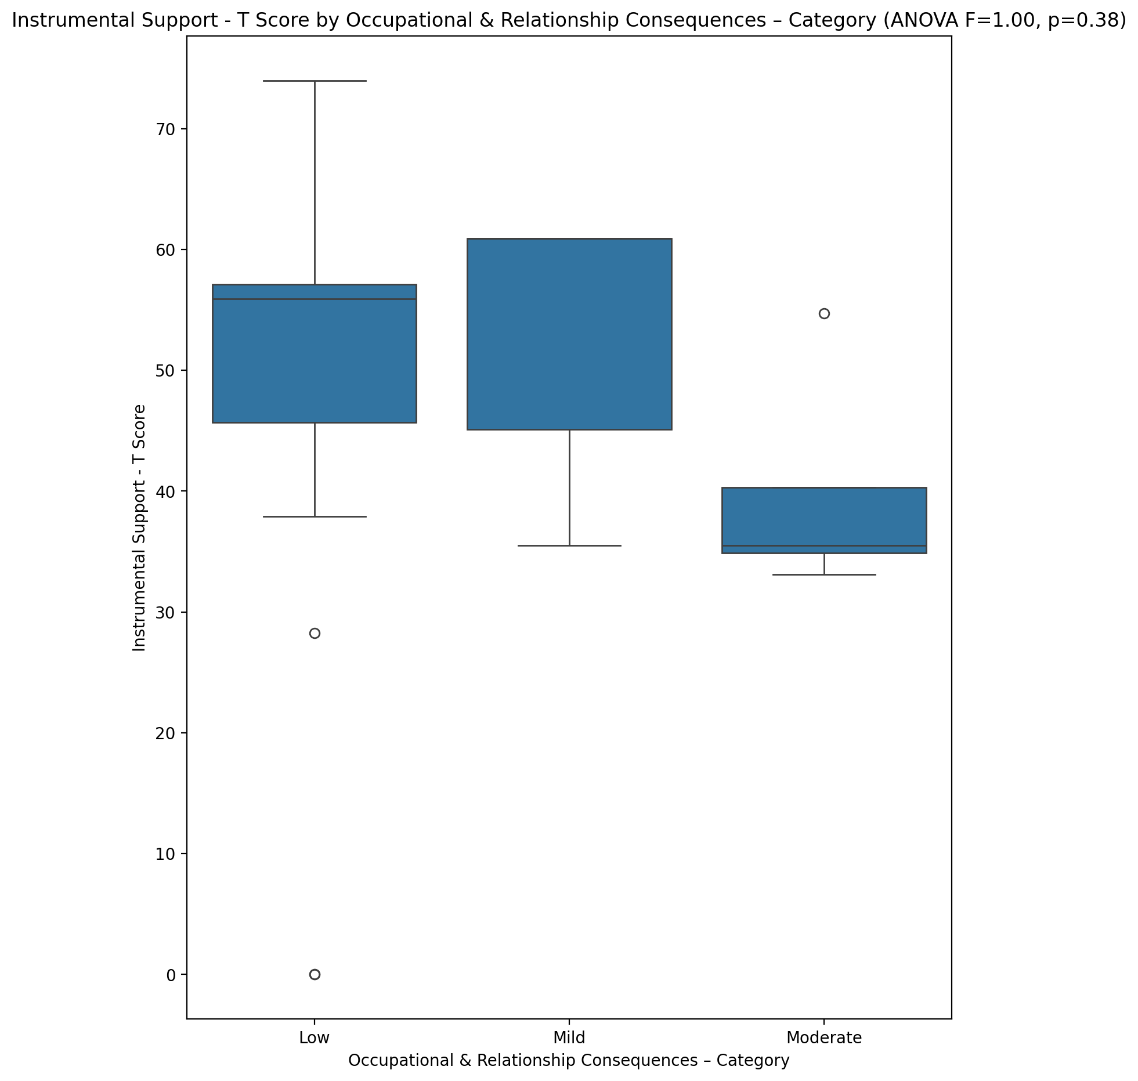

## Perceived Social Support Total T Score vs Occupational & Relationship Consequences – Category

Test: anova; statistic: 5.185165811067664; p-value: 0.009947263538411386;

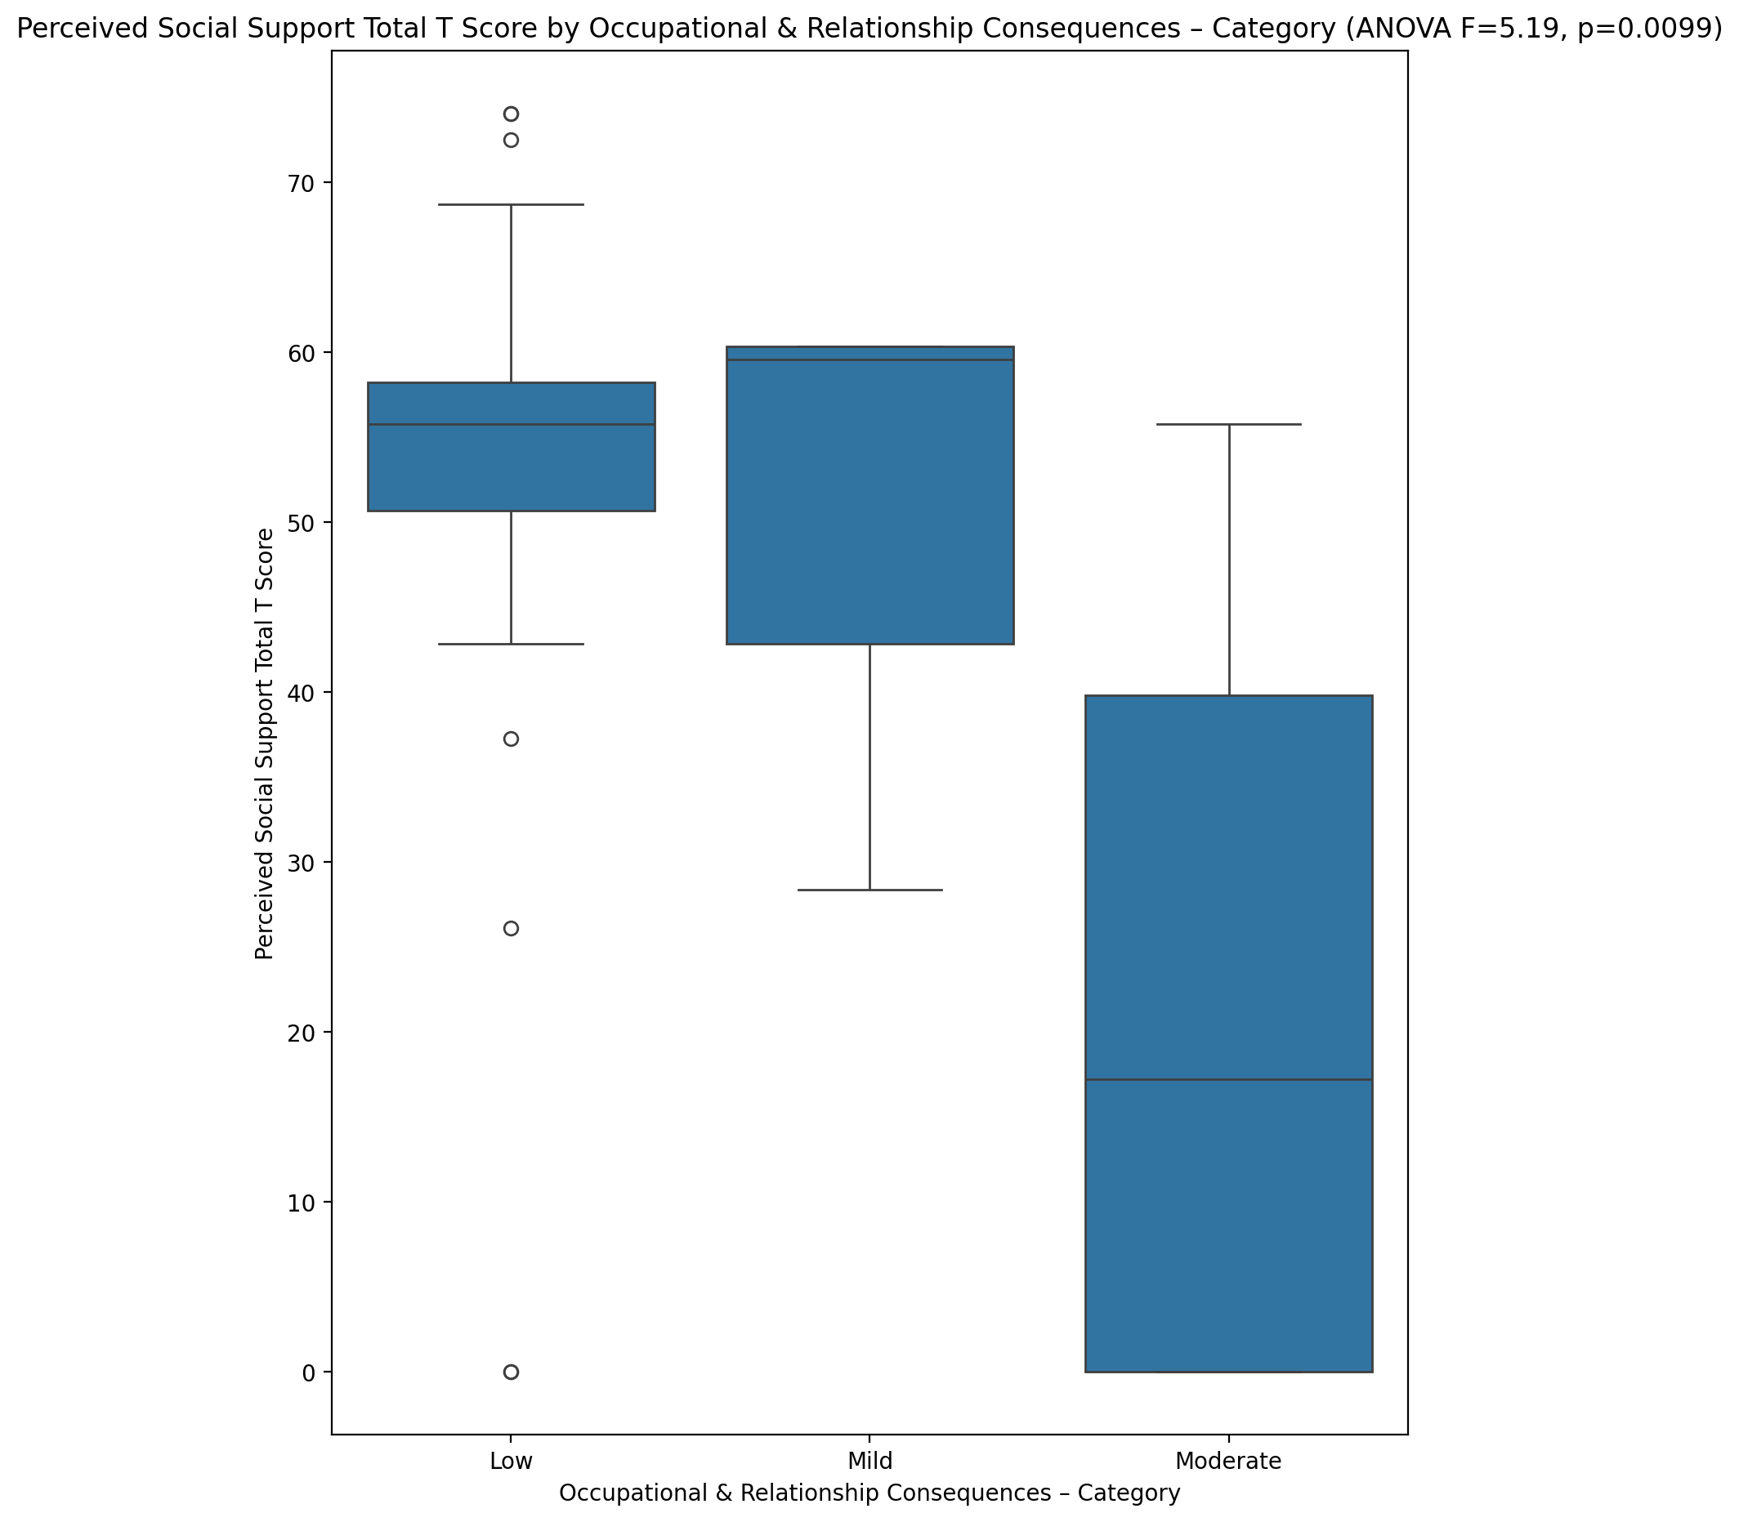

## Emotional Support - Rank vs Occupational & Relationship Consequences – Category

Test: chi2; statistic: 18.805122549019604; p-value: 0.015937322045861485;

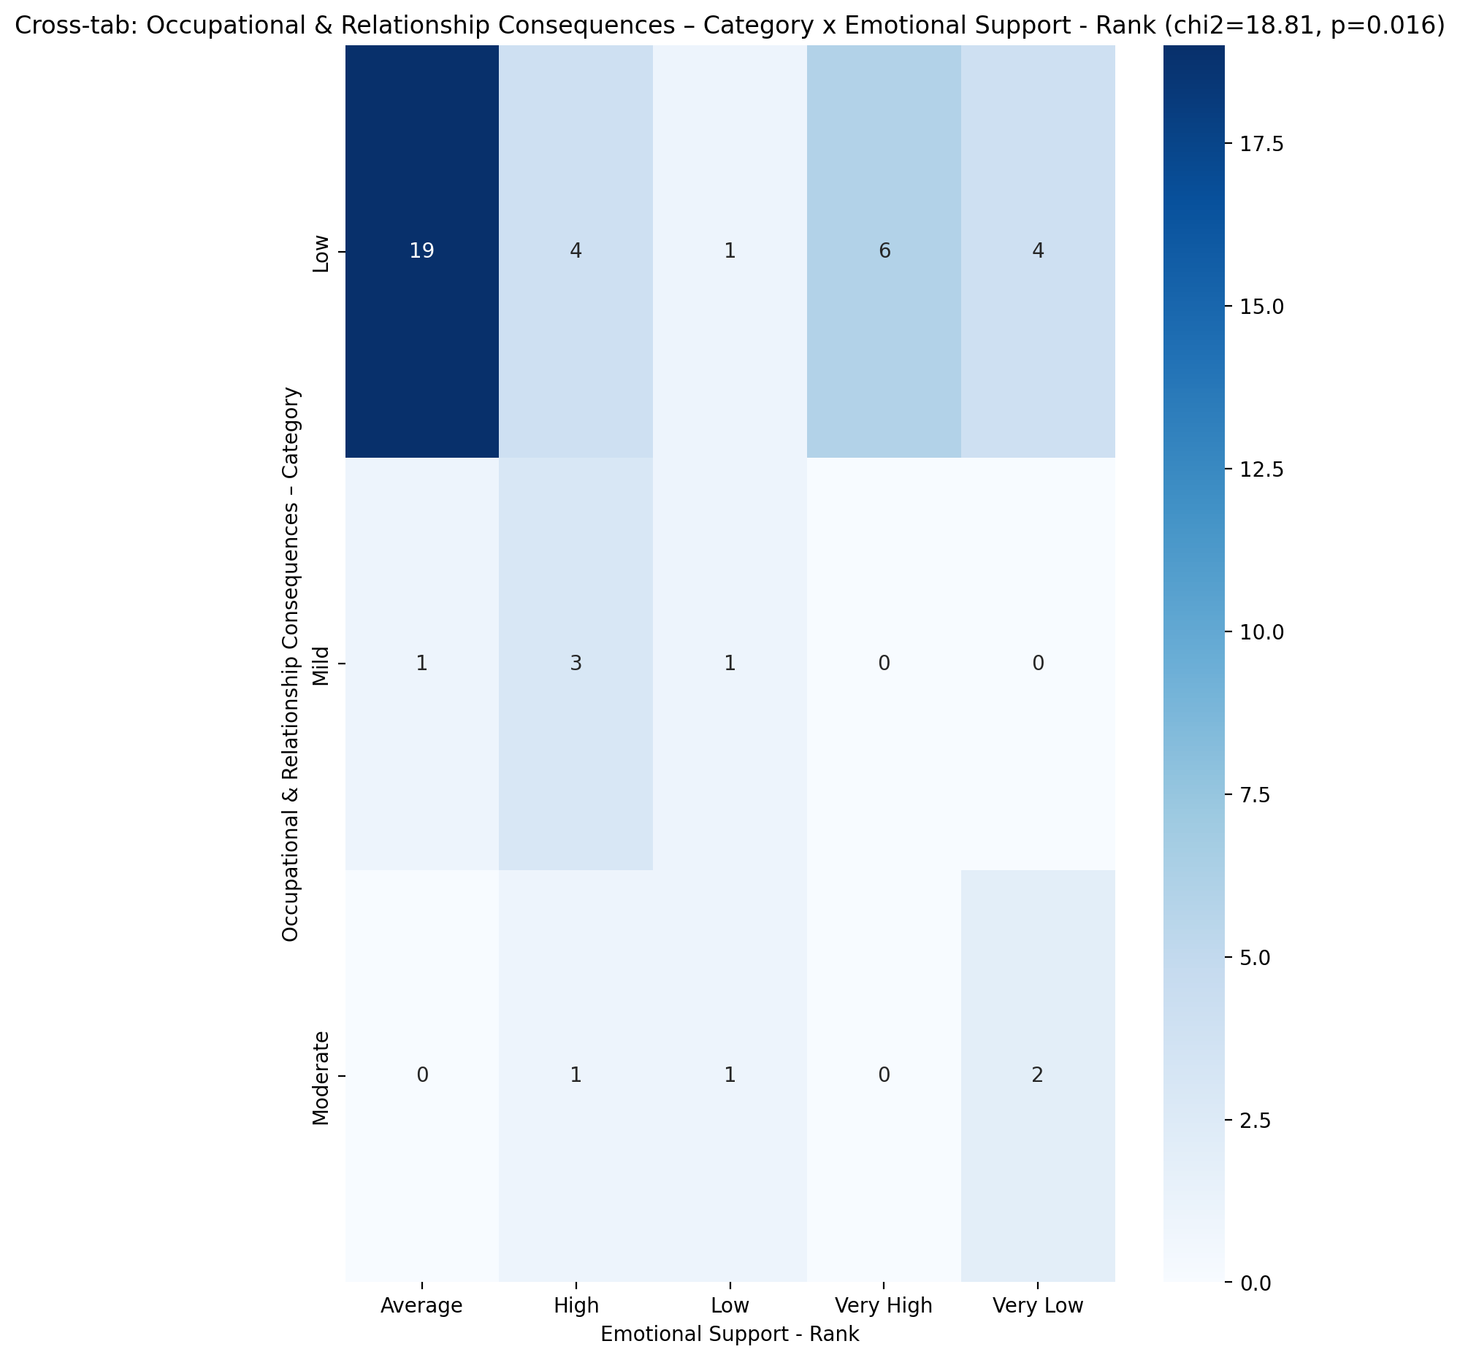

## Informational Support - Rank vs Occupational & Relationship Consequences – Category

Test: chi2; statistic: 9.071554621848739; p-value: 0.1695937018579023;

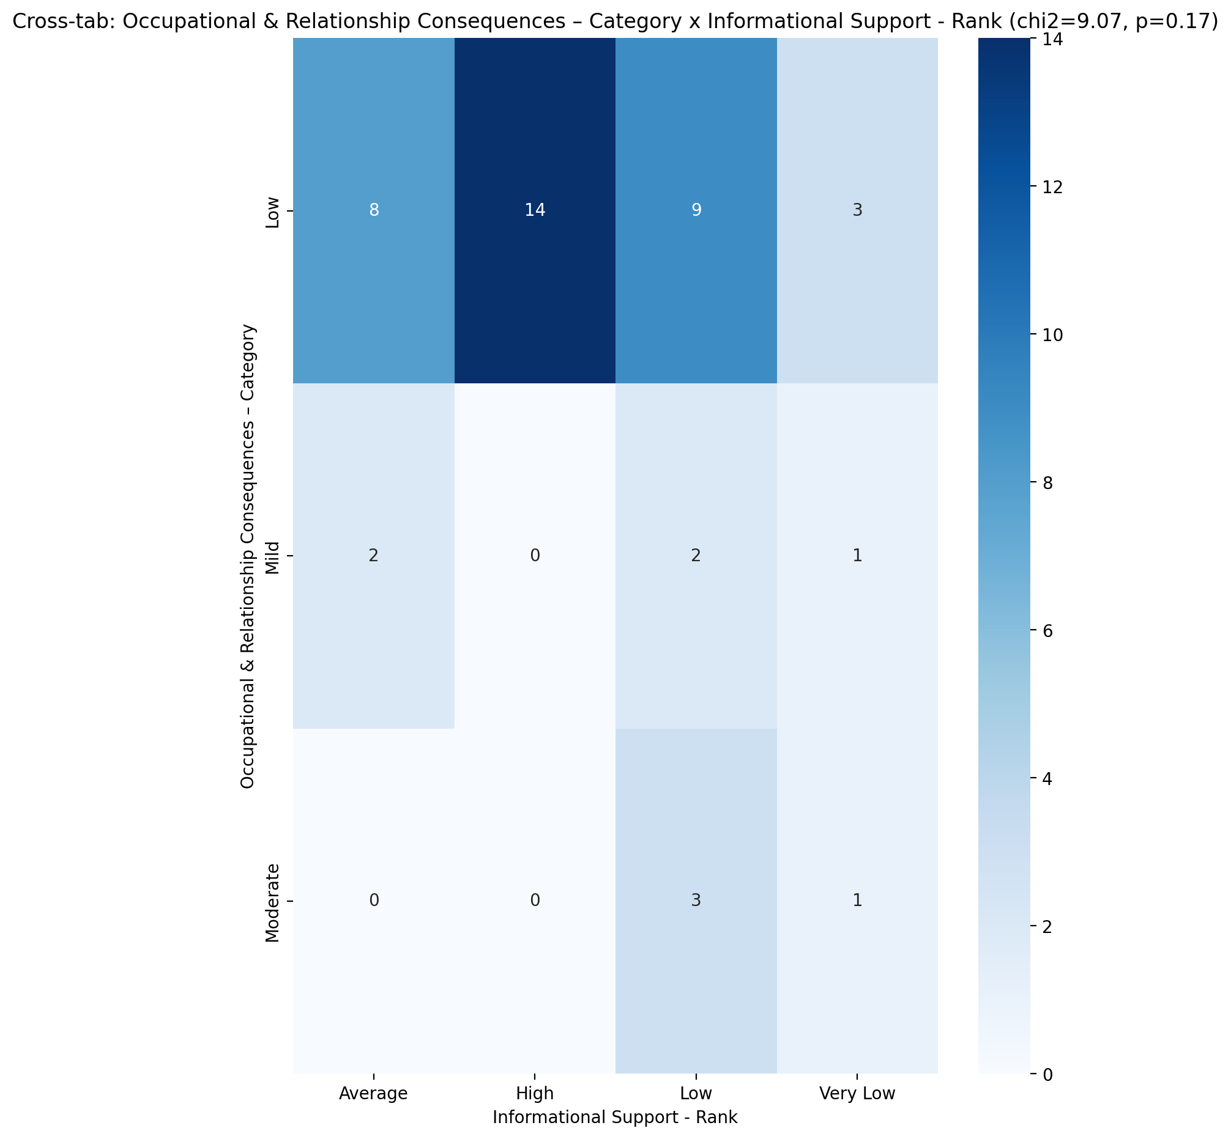

## Instrumental Support - Rank vs Occupational & Relationship Consequences – Category

Test: chi2; statistic: 11.572368800461362; p-value: 0.1713276028229266;

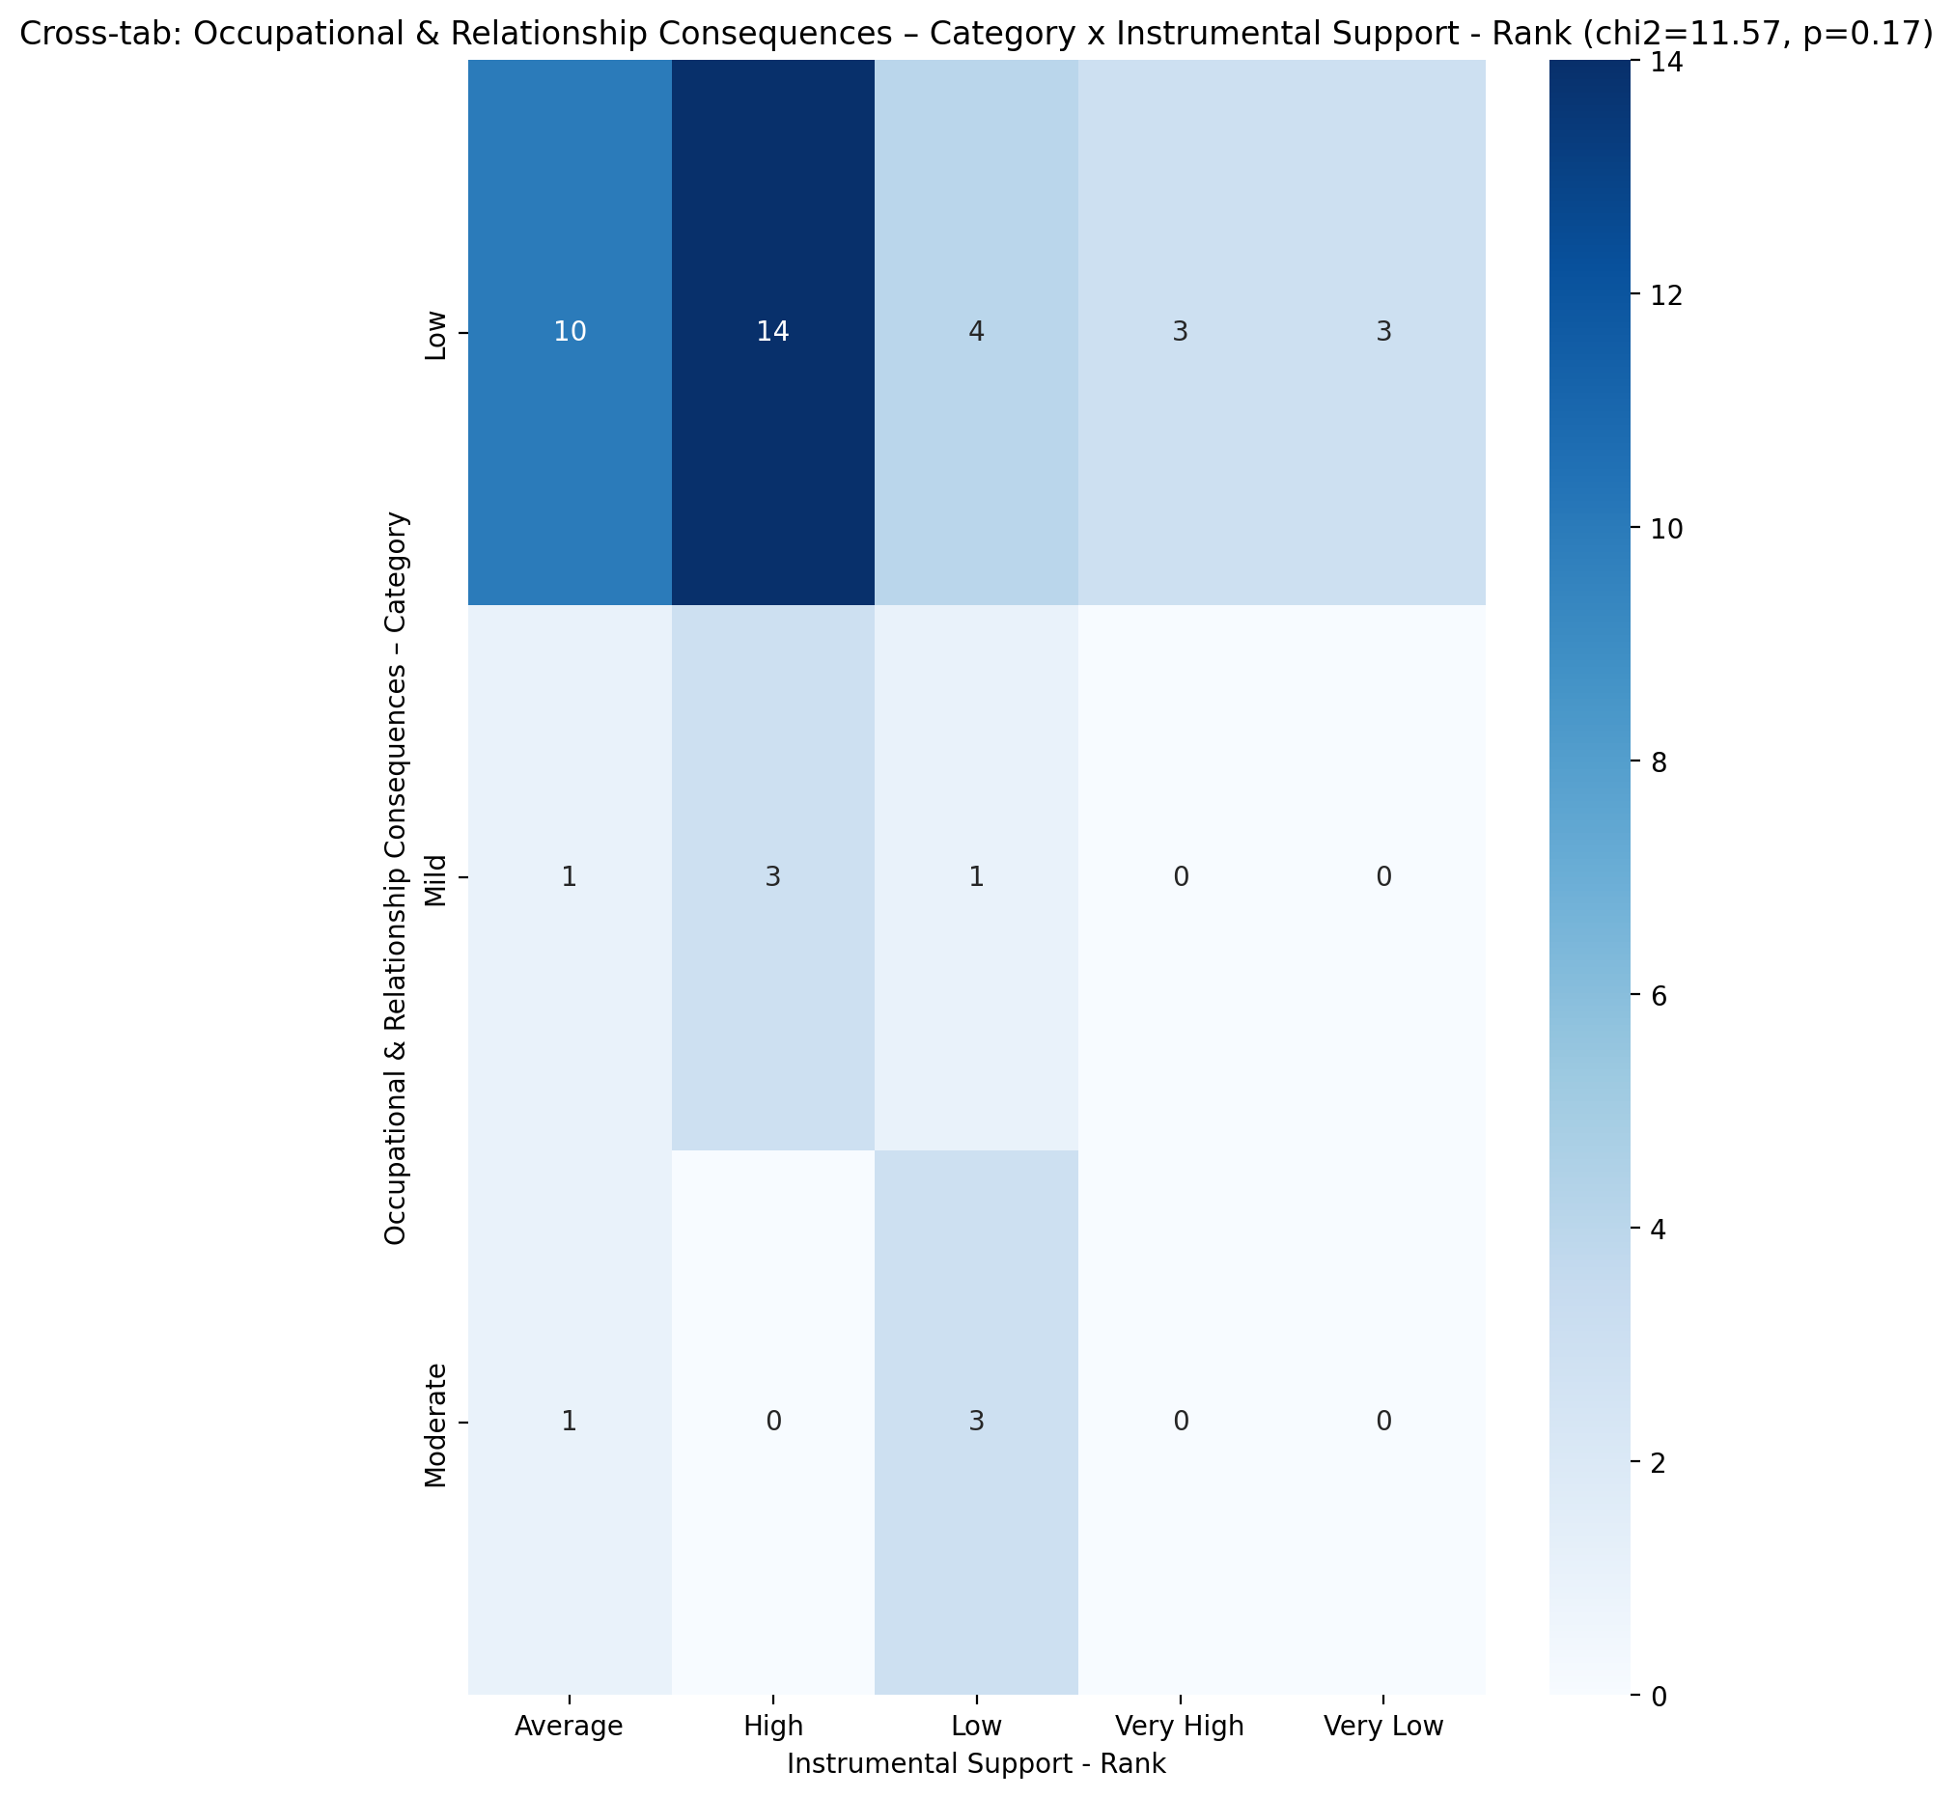

## Perceived Social Support TOTAL - Rank vs Occupational & Relationship Consequences – Category

Test: chi2; statistic: 14.461911764705881; p-value: 0.07049233085289706;

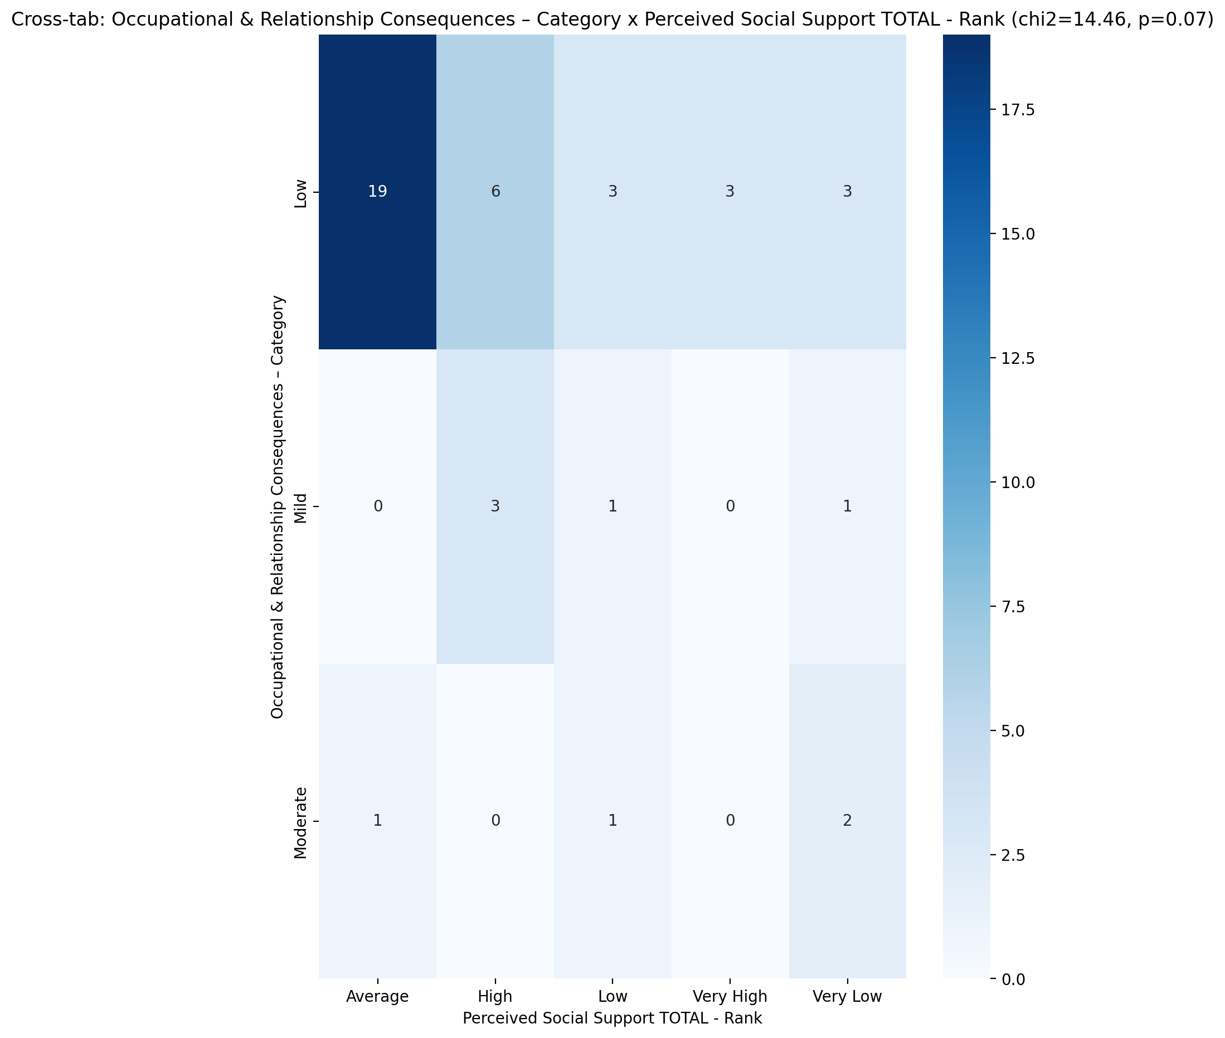

## Power Self Concept - Real Self Concept Score vs Occupational & Relationship Consequences – Category

Test: anova; statistic: 1.5843536726056757; p-value: 0.2176802071390308;

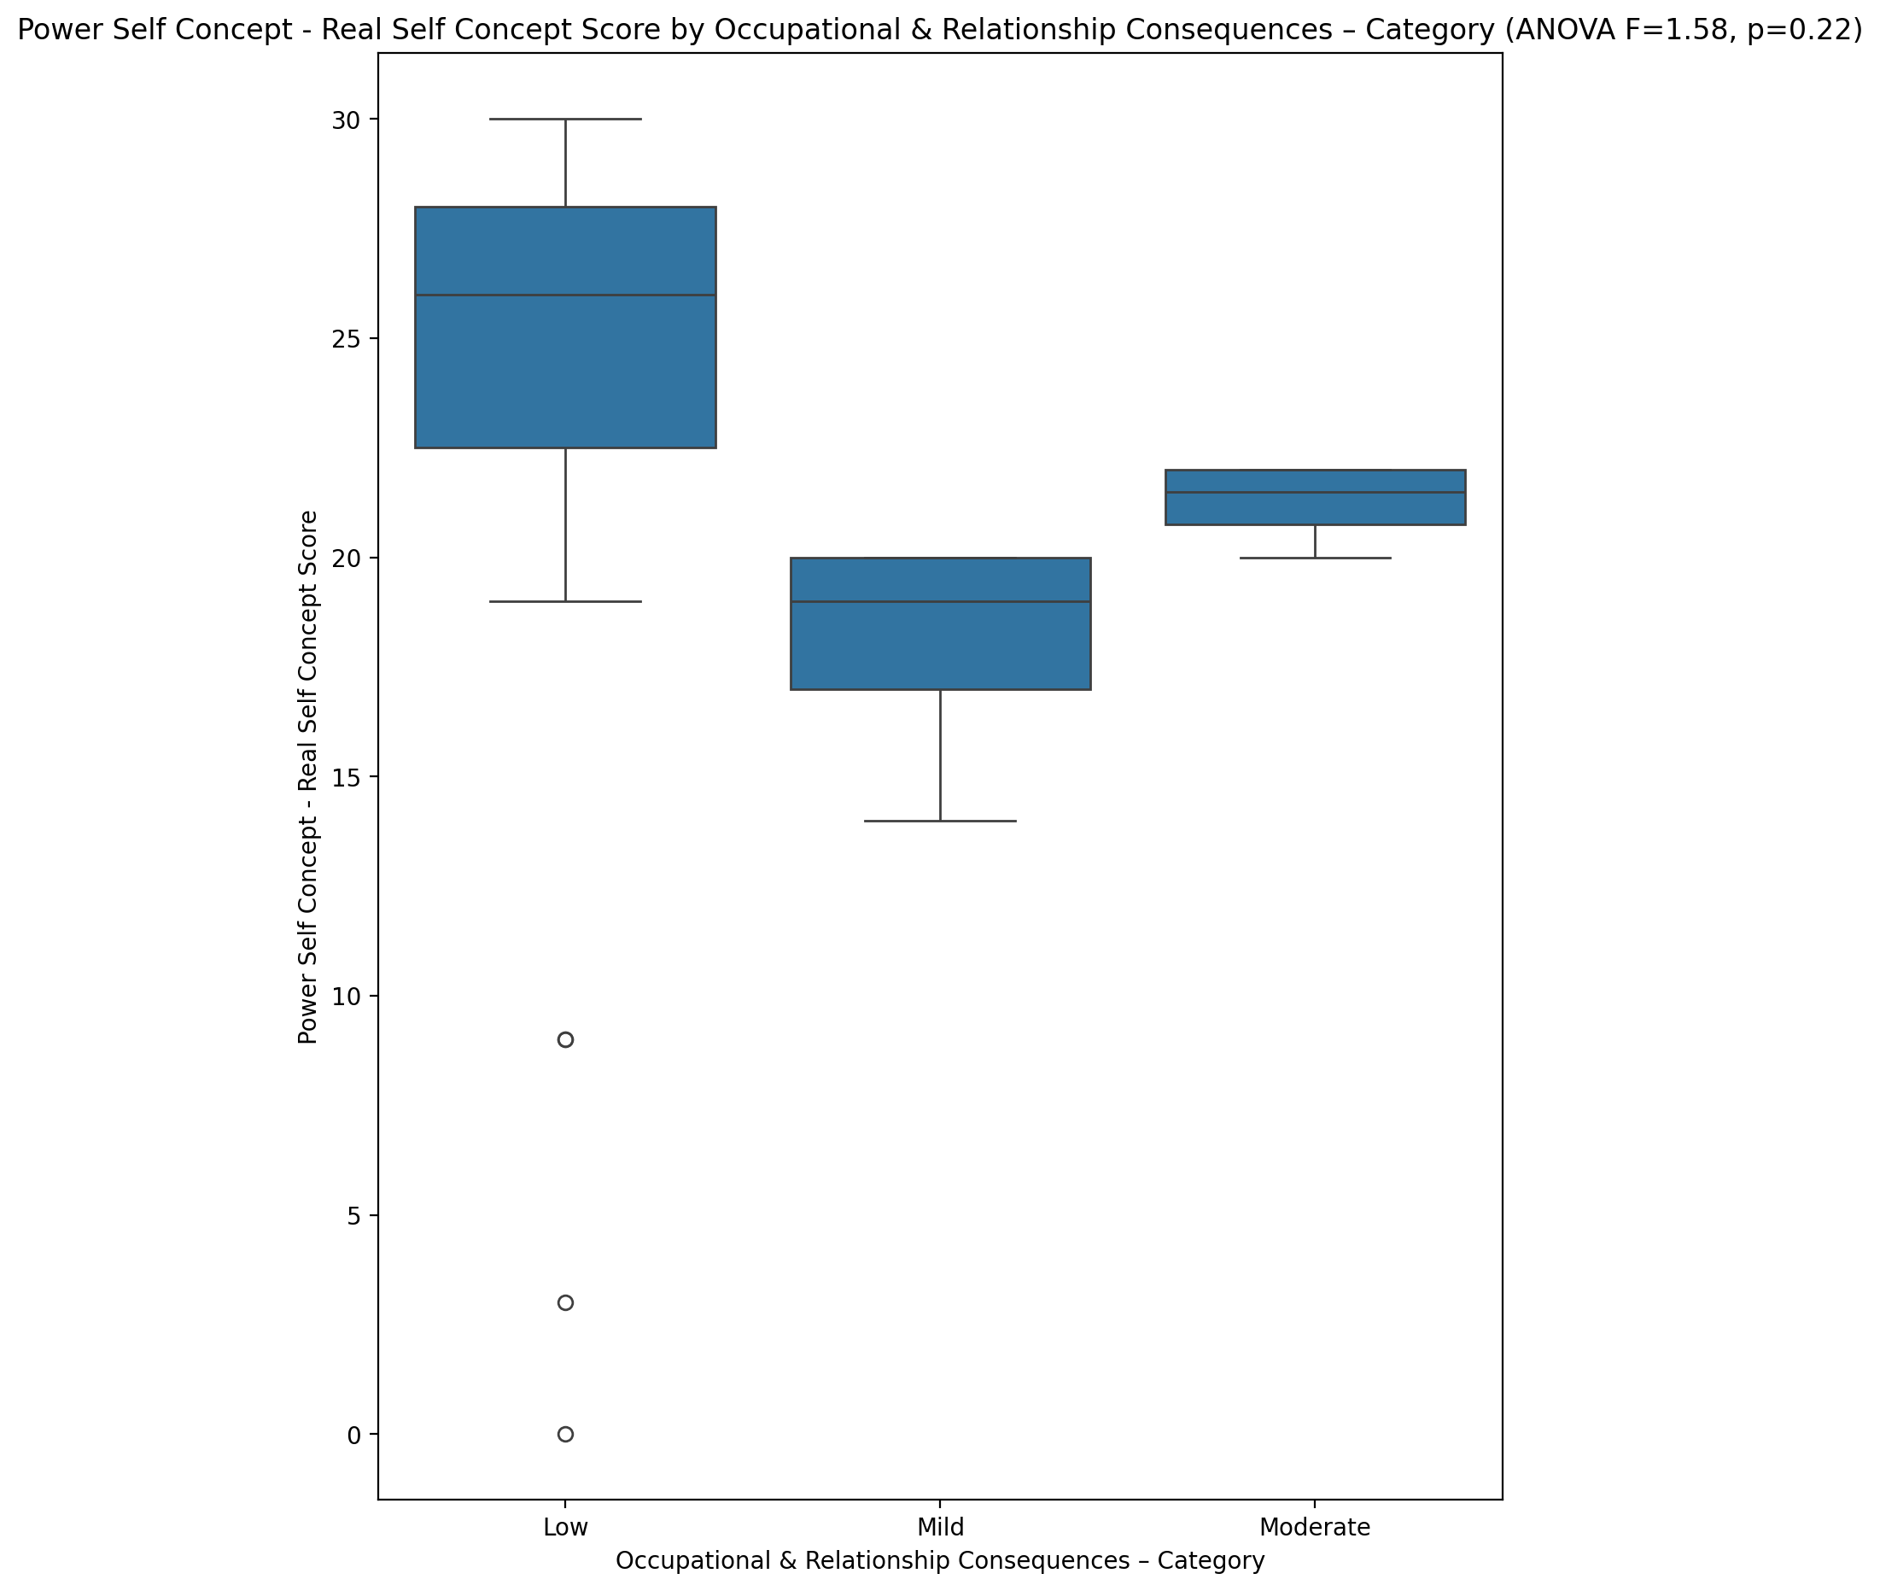

## Power Self Concept - Ideal Self Concept score vs Occupational & Relationship Consequences – Category

Test: anova; statistic: 0.5189036868504608; p-value: 0.599124189031309;

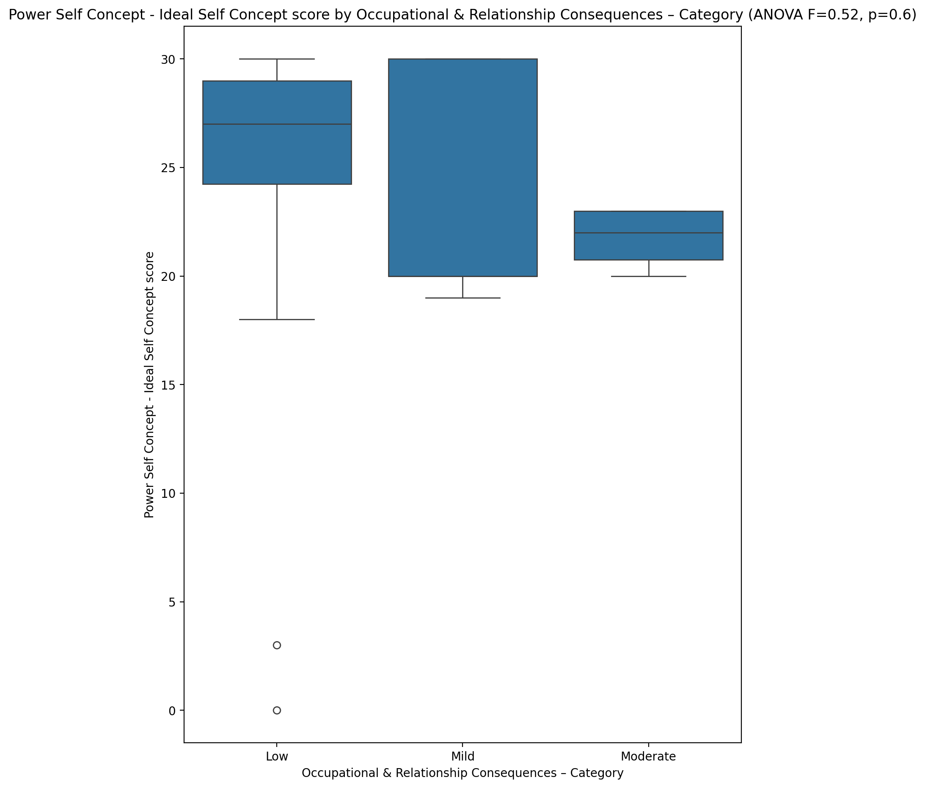

## Power Self Concept – Social Self Concept Score vs Occupational & Relationship Consequences – Category

Test: anova; statistic: 0.7758528759704423; p-value: 0.4671137911803728;

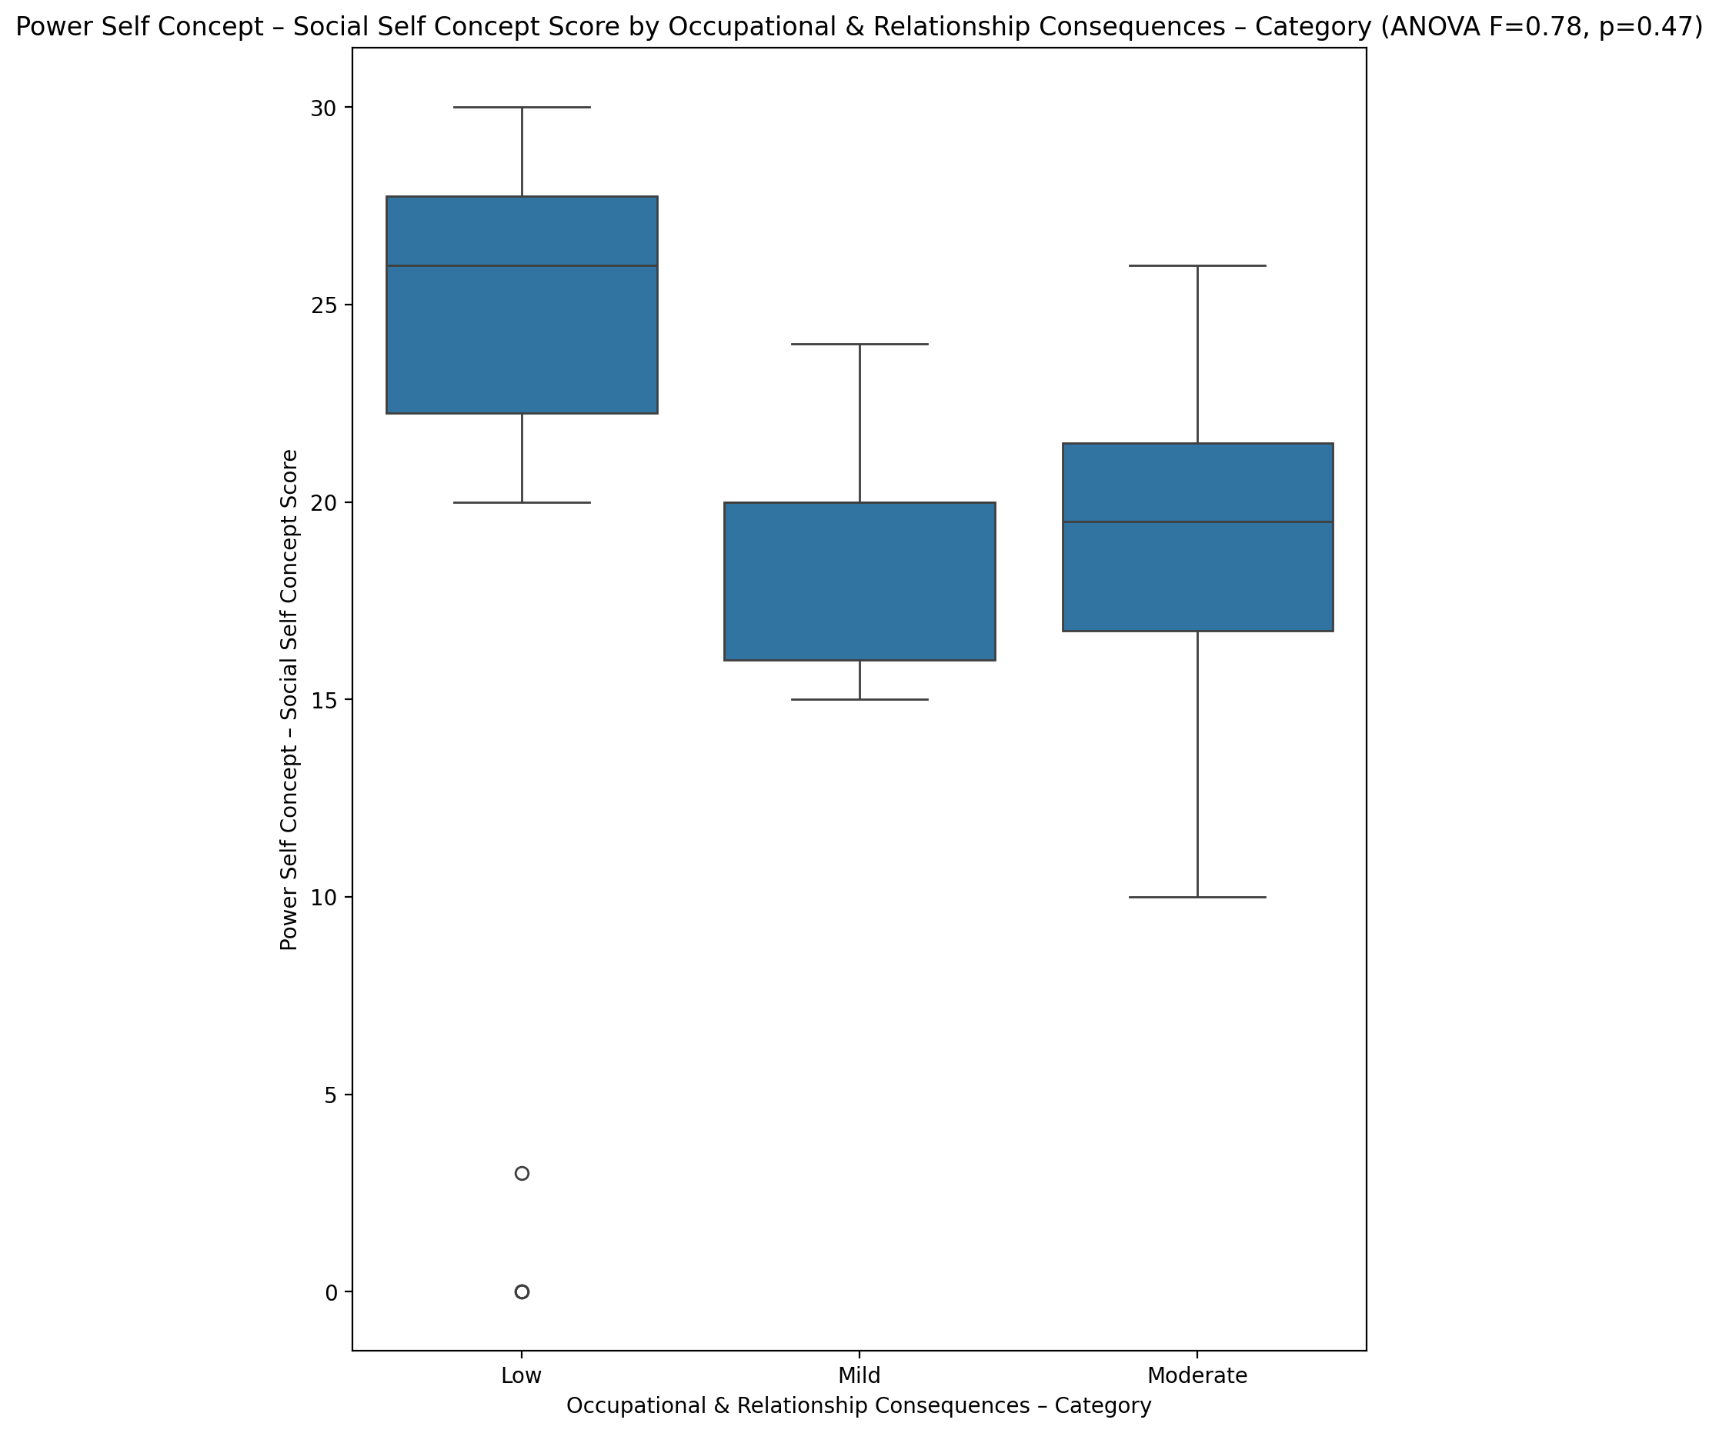

## Social Self Concept - Real Self Concept Score vs Occupational & Relationship Consequences – Category

Test: anova; statistic: 0.9312738237640859; p-value: 0.4024266463045295;

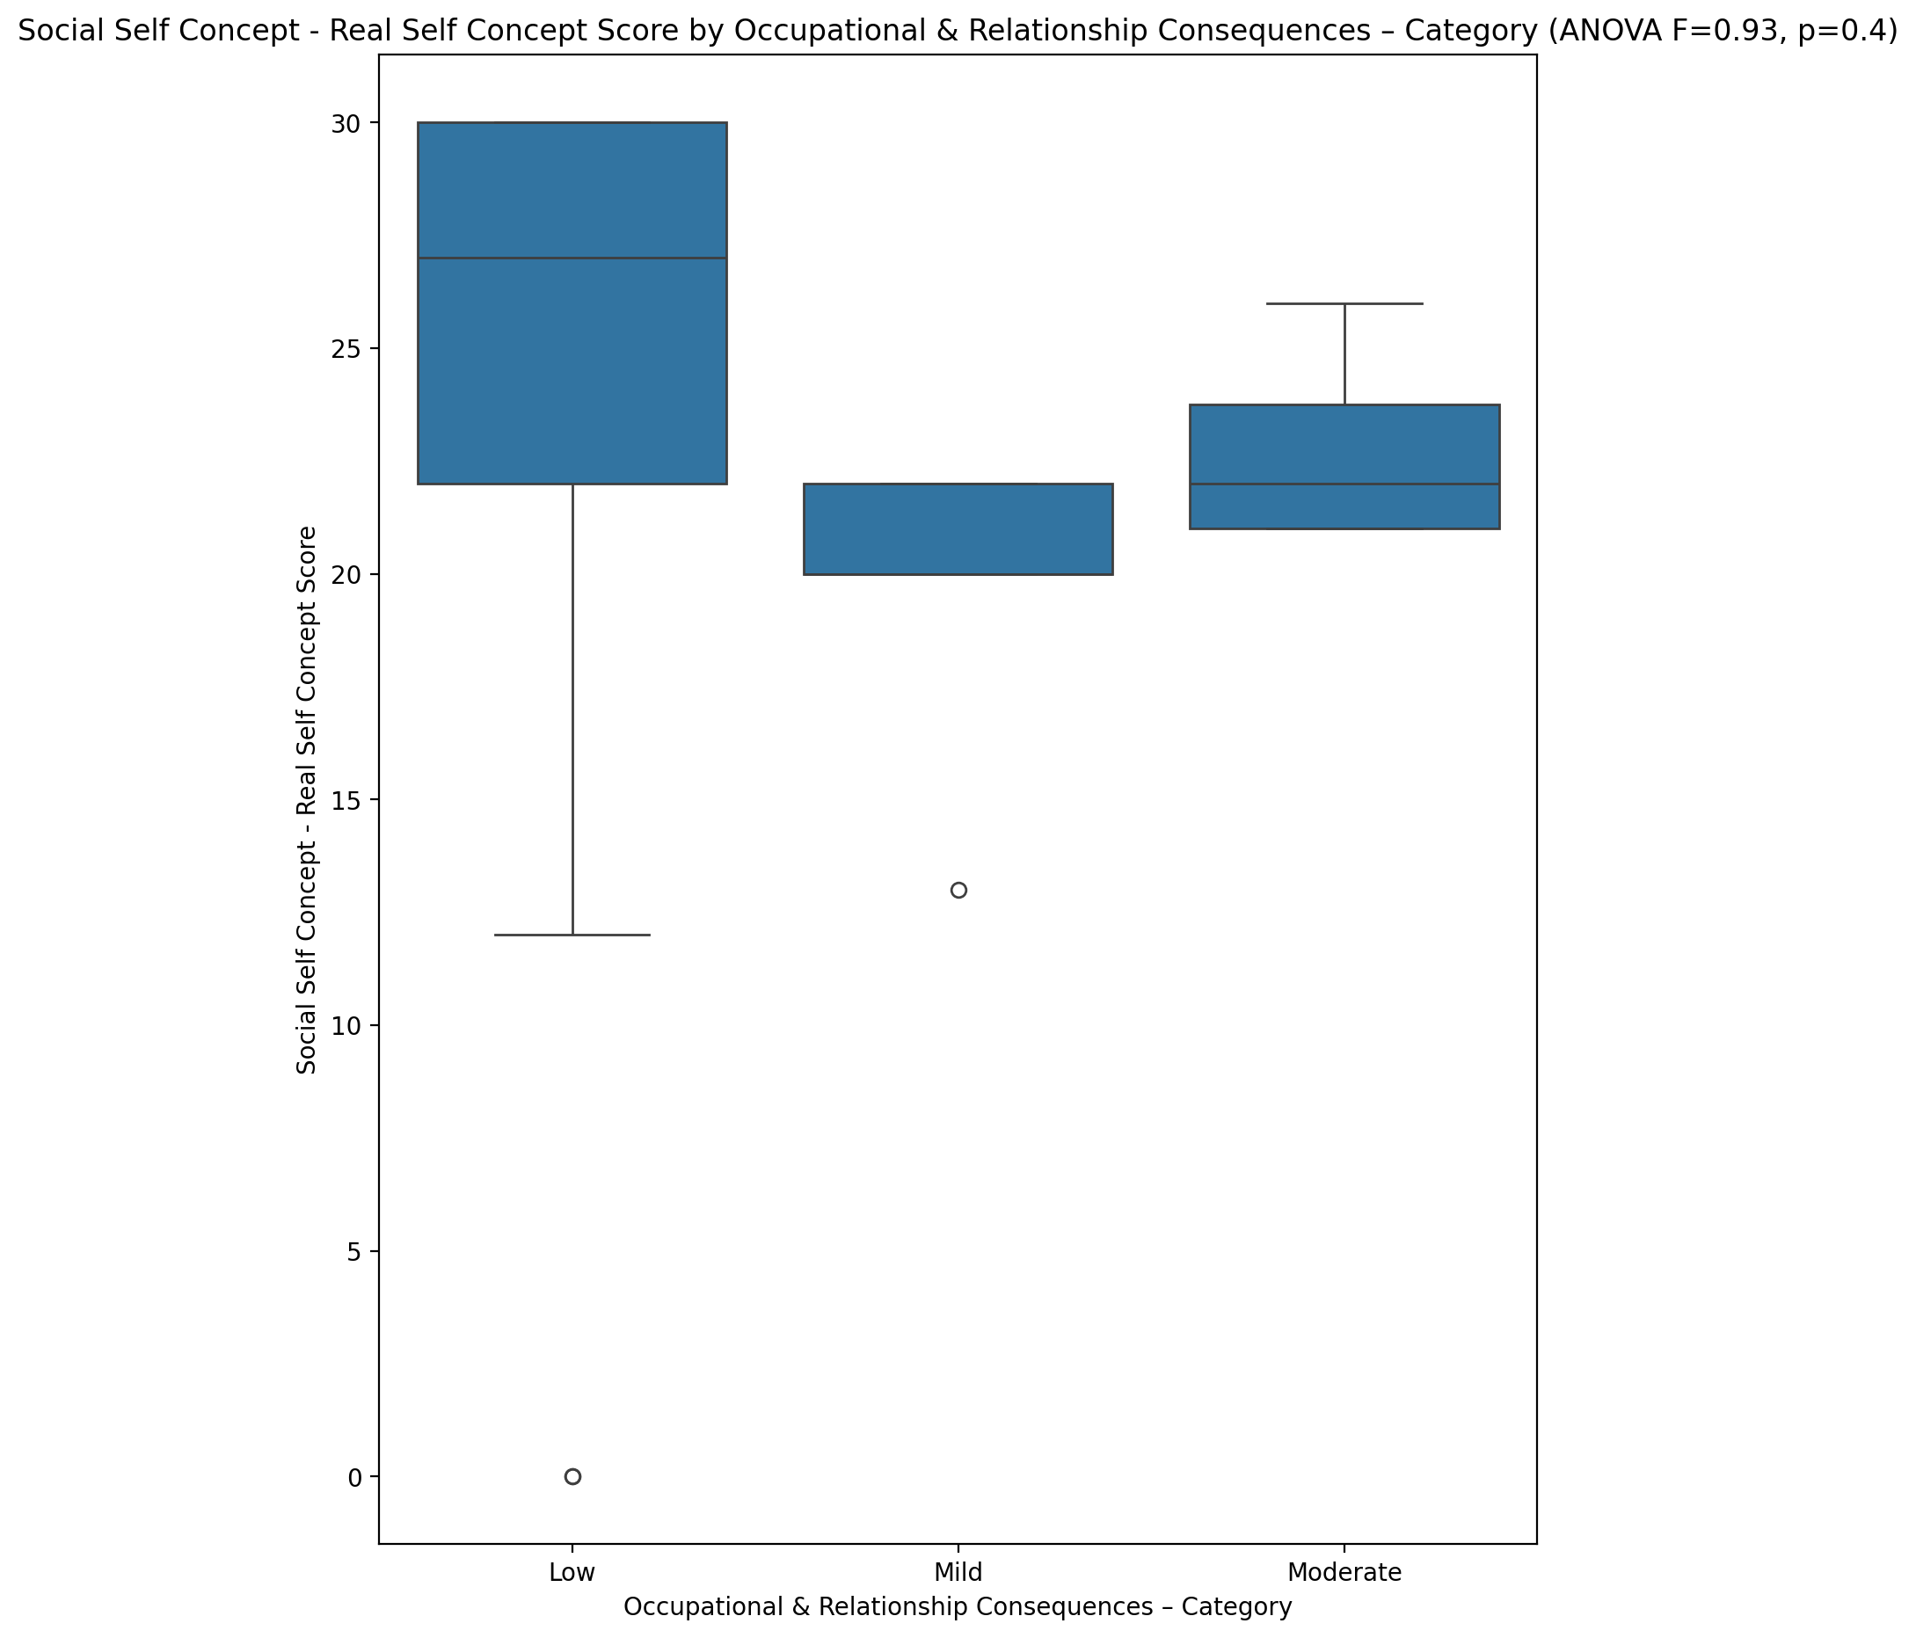

## Social Self Concept – Social Self Concept Score vs Occupational & Relationship Consequences – Category

Test: anova; statistic: 0.1393324955216278; p-value: 0.8703590952635696;

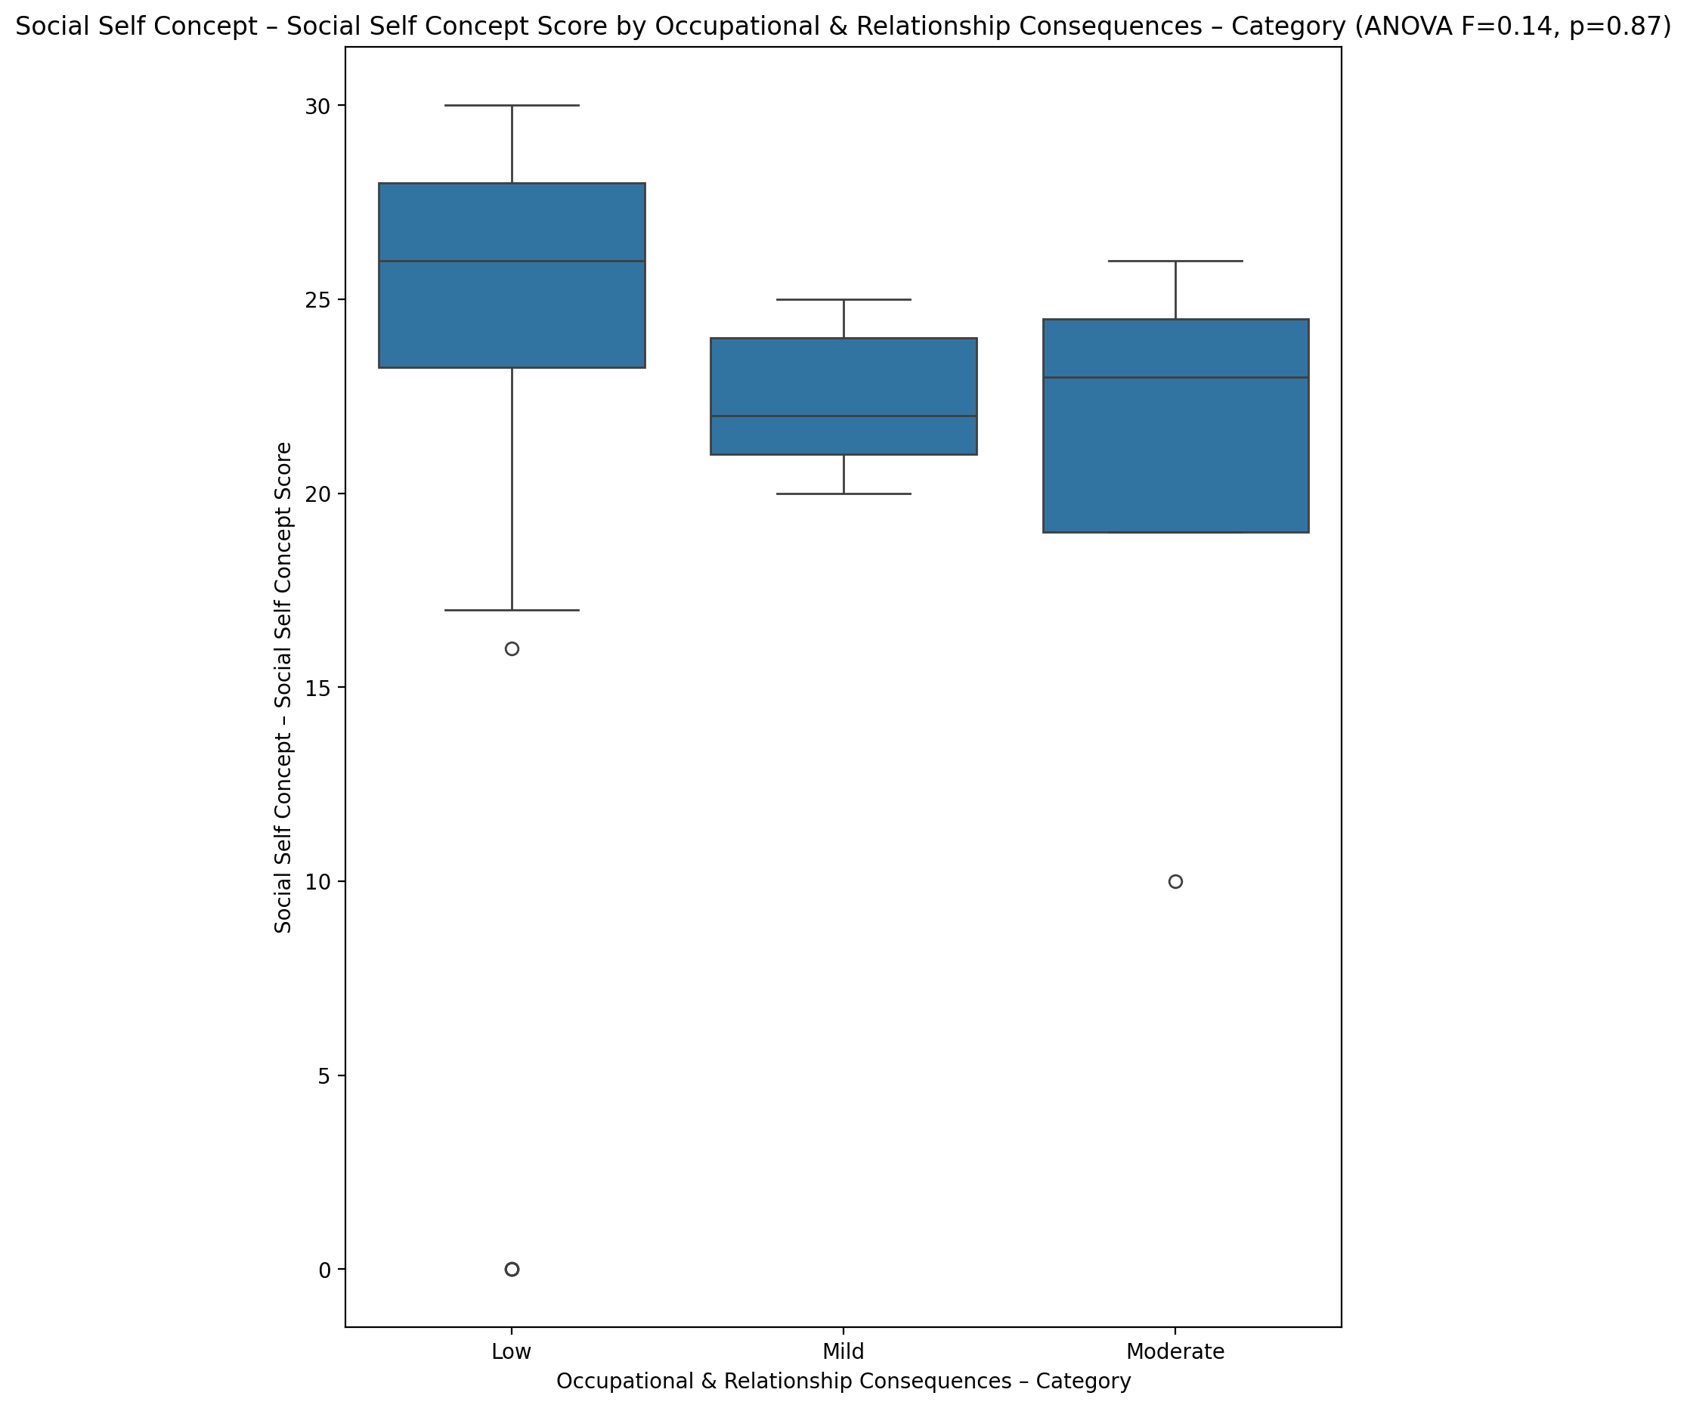

## Ability Self Concept - Real Self Concept Score vs Occupational & Relationship Consequences – Category

Test: anova; statistic: 0.6632253811198351; p-value: 0.5207600484973705;

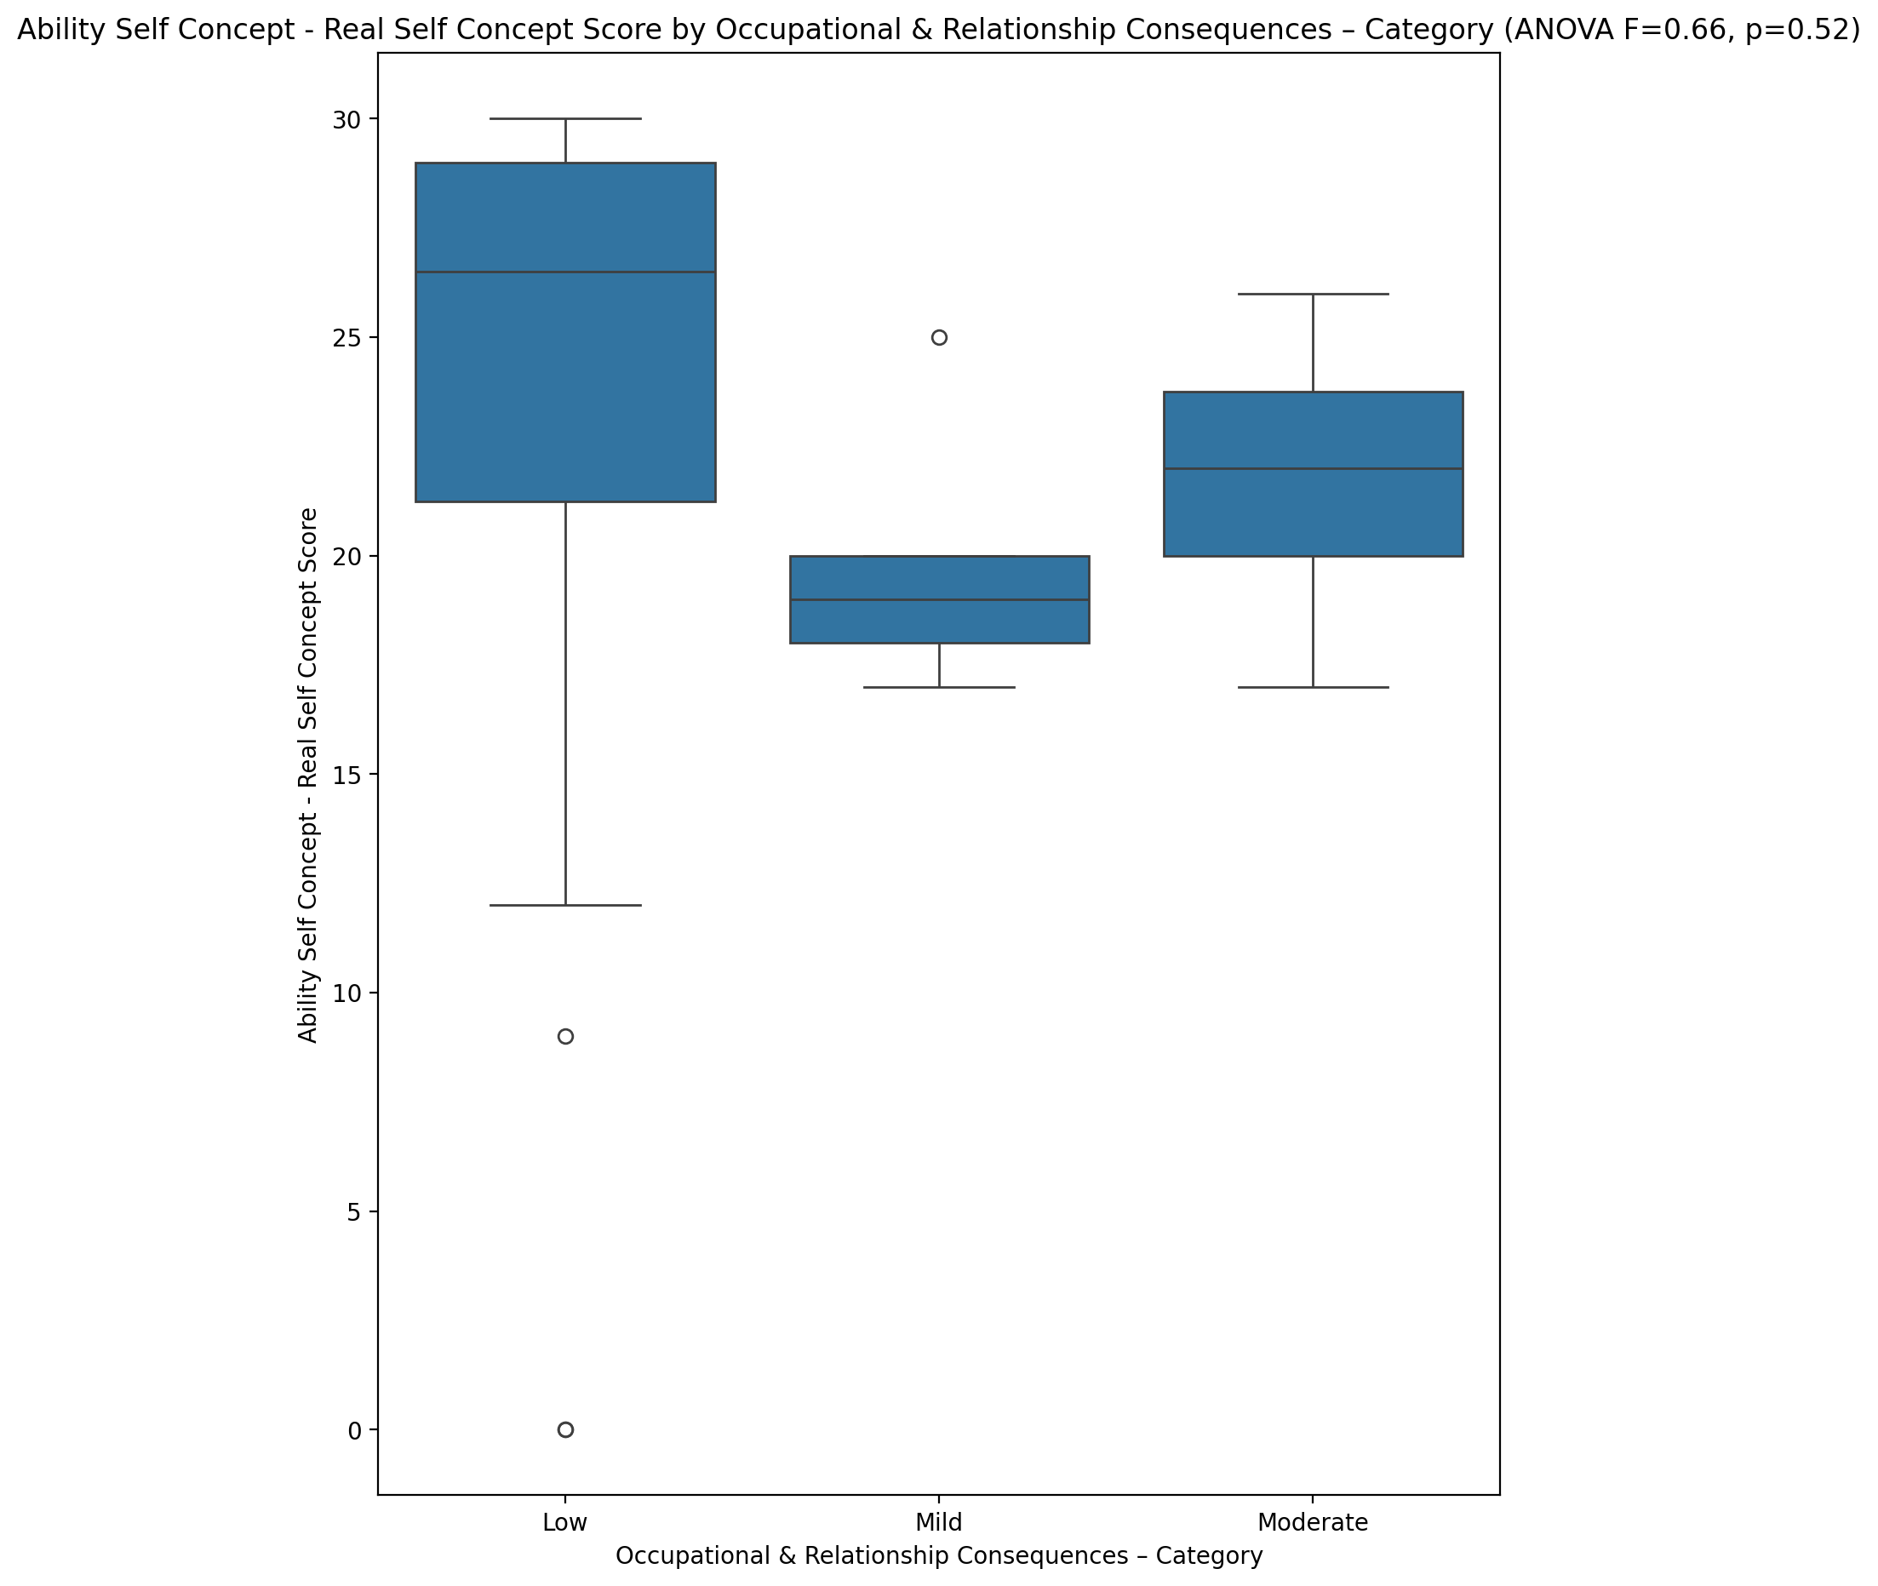

## Ability Self Concept - Ideal Self Concept Score vs Occupational & Relationship Consequences – Category

Test: anova; statistic: 0.4804871506933819; p-value: 0.622005552280159;

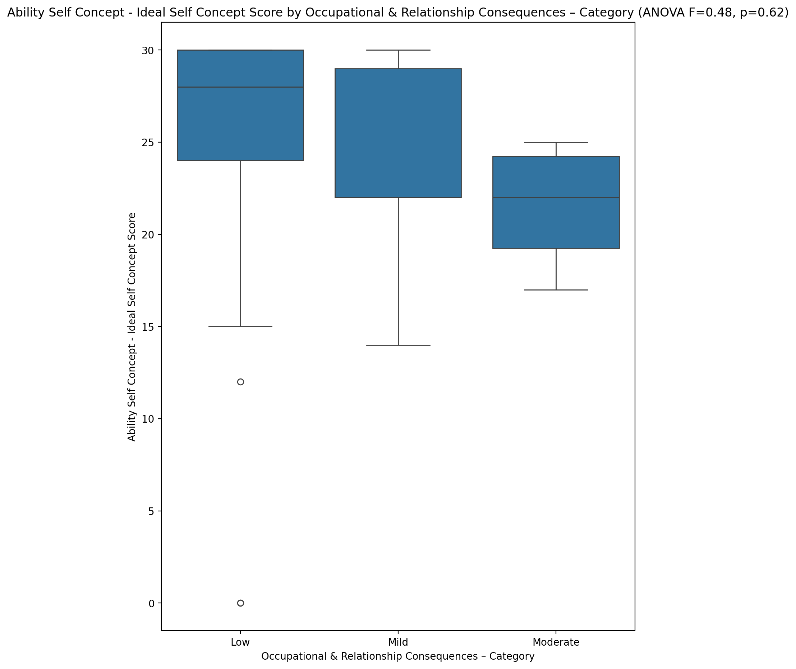

## Ability Self Concept – Social Self Concept Score vs Occupational & Relationship Consequences – Category

Test: anova; statistic: 0.2345481808815789; p-value: 0.7920082119542127;

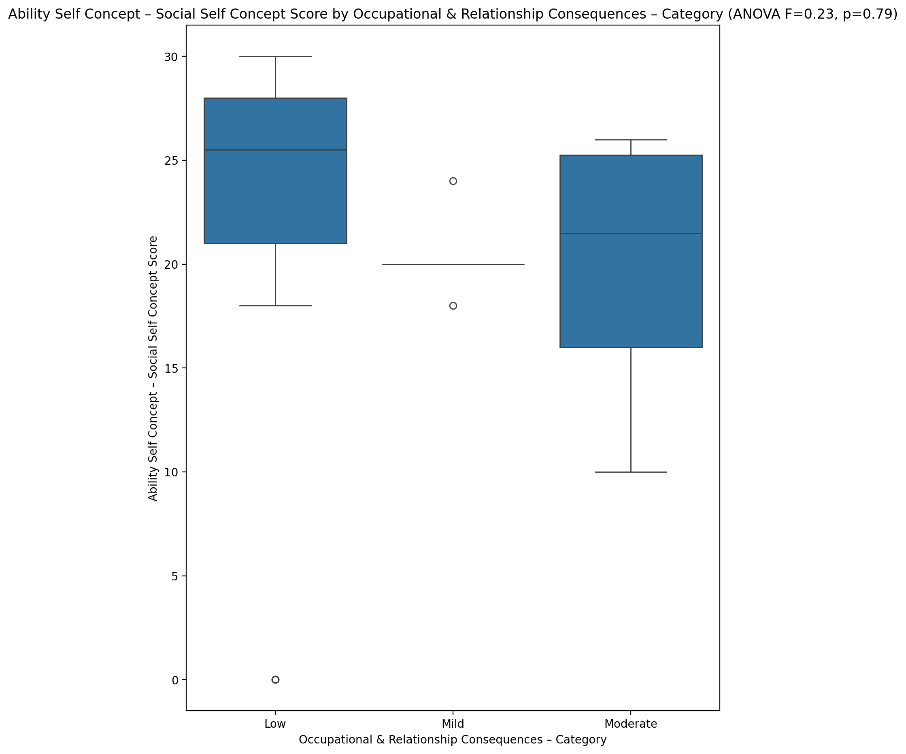

## Physical Self Concept - Real Self Concept Score vs Occupational & Relationship Consequences – Category

Test: anova; statistic: 1.3590134698900445; p-value: 0.2685196798746591;

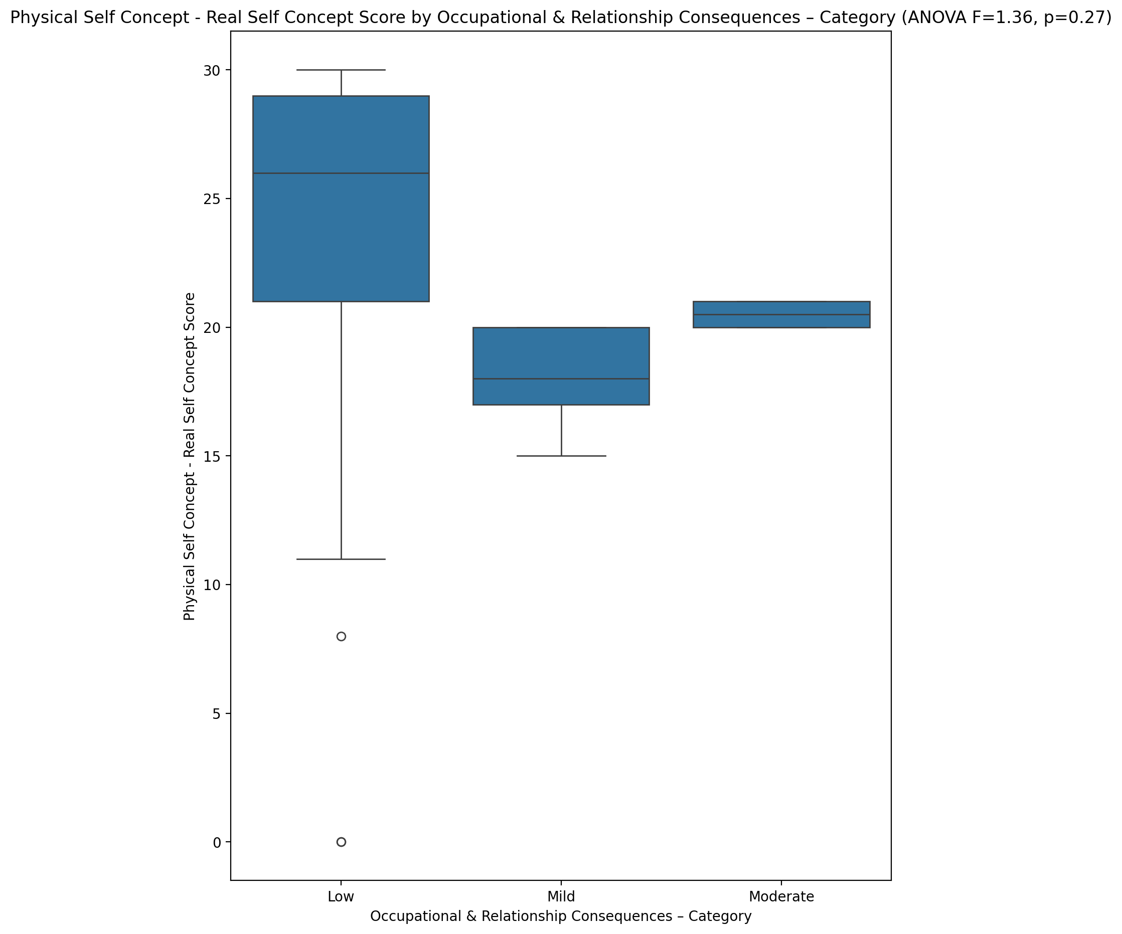

## Physical Self Concept – Ideal Self Concept Score vs Occupational & Relationship Consequences – Category

Test: anova; statistic: 0.7197340096601628; p-value: 0.4930788751049725;

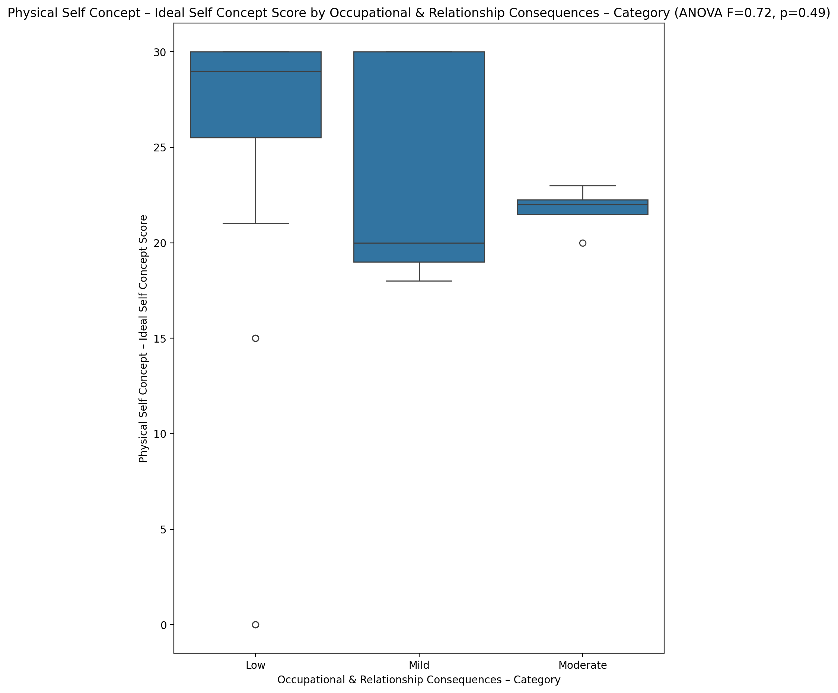

## Physical Self Concept – Social Self Concept Score vs Occupational & Relationship Consequences – Category

Test: anova; statistic: 0.15985058376254593; p-value: 0.8528128462756763;

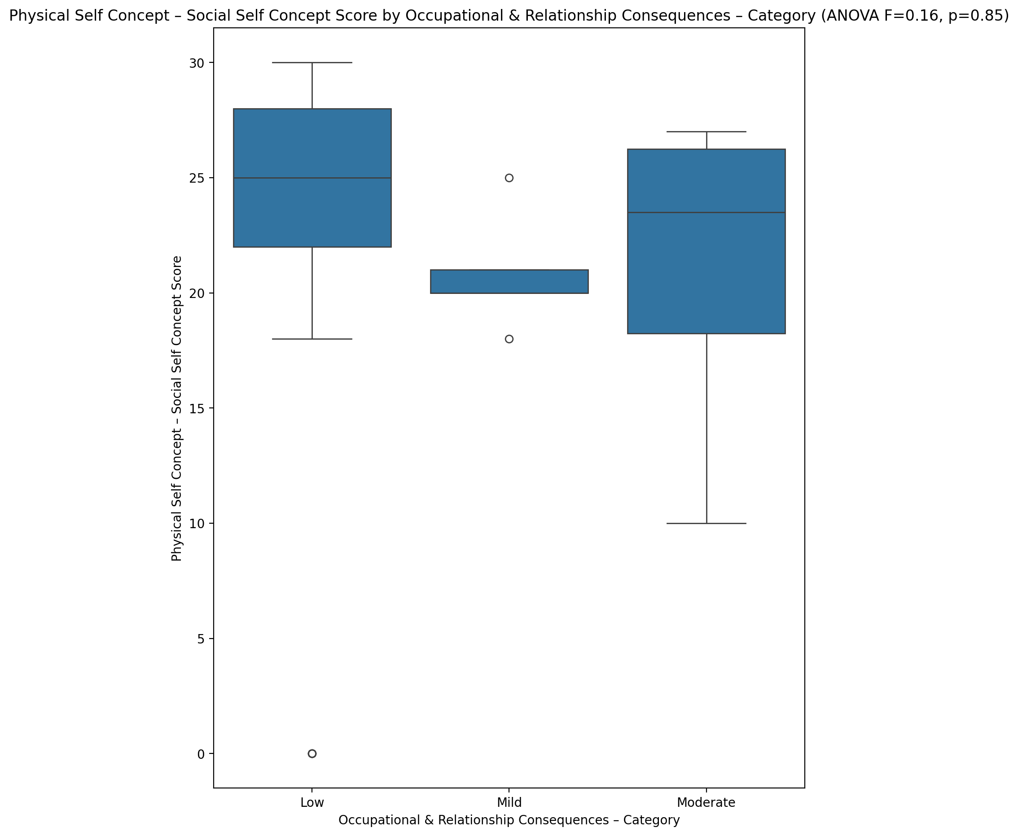

## Psychological Self Concept - Real Self Concept Score vs Occupational & Relationship Consequences – Category

Test: anova; statistic: 1.3348948176426048; p-value: 0.27465644294545144;

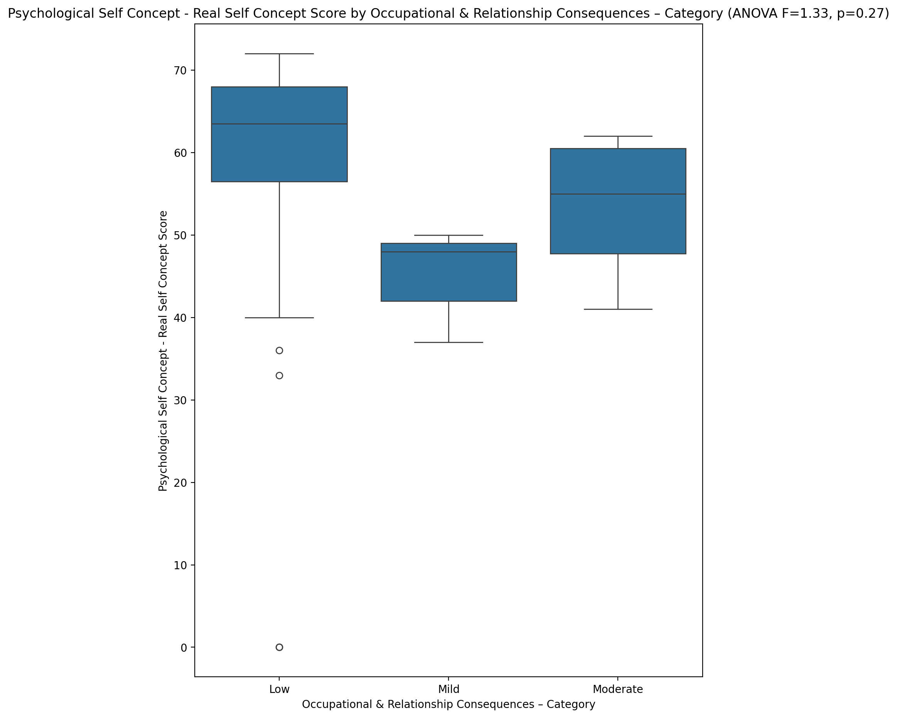

## Psychological Self Concept – Ideal Self Concept Score vs Occupational & Relationship Consequences – Category

Test: anova; statistic: 0.4038348702803274; p-value: 0.6704461656554024;

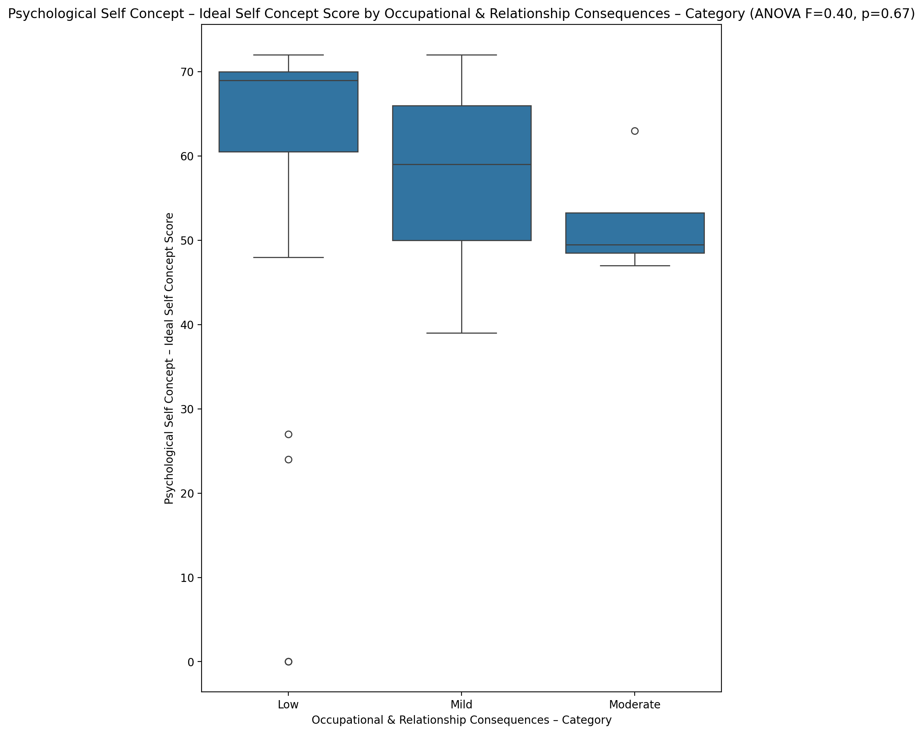

## Psychological Self Concept – Social Self Concept Score vs Occupational & Relationship Consequences – Category

Test: anova; statistic: 0.6450285627064711; p-value: 0.530017430097574;

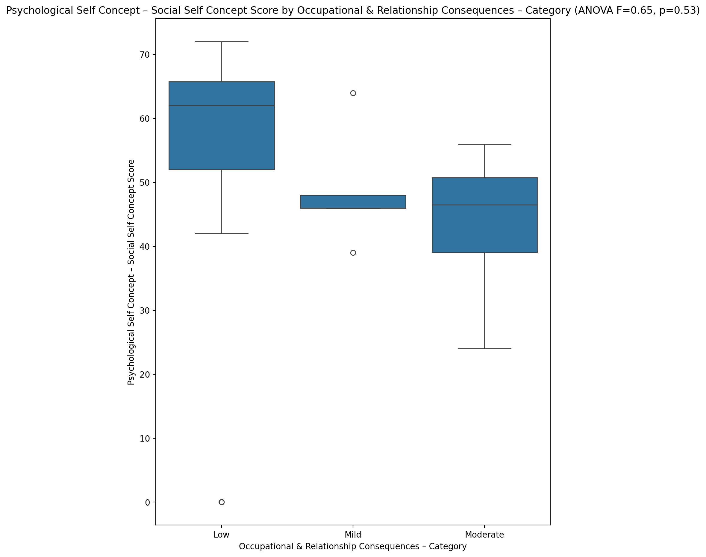

## Real Self Concept Total Score vs Occupational & Relationship Consequences – Category

Test: anova; statistic: 1.2469882219646449; p-value: 0.29829939345208245;

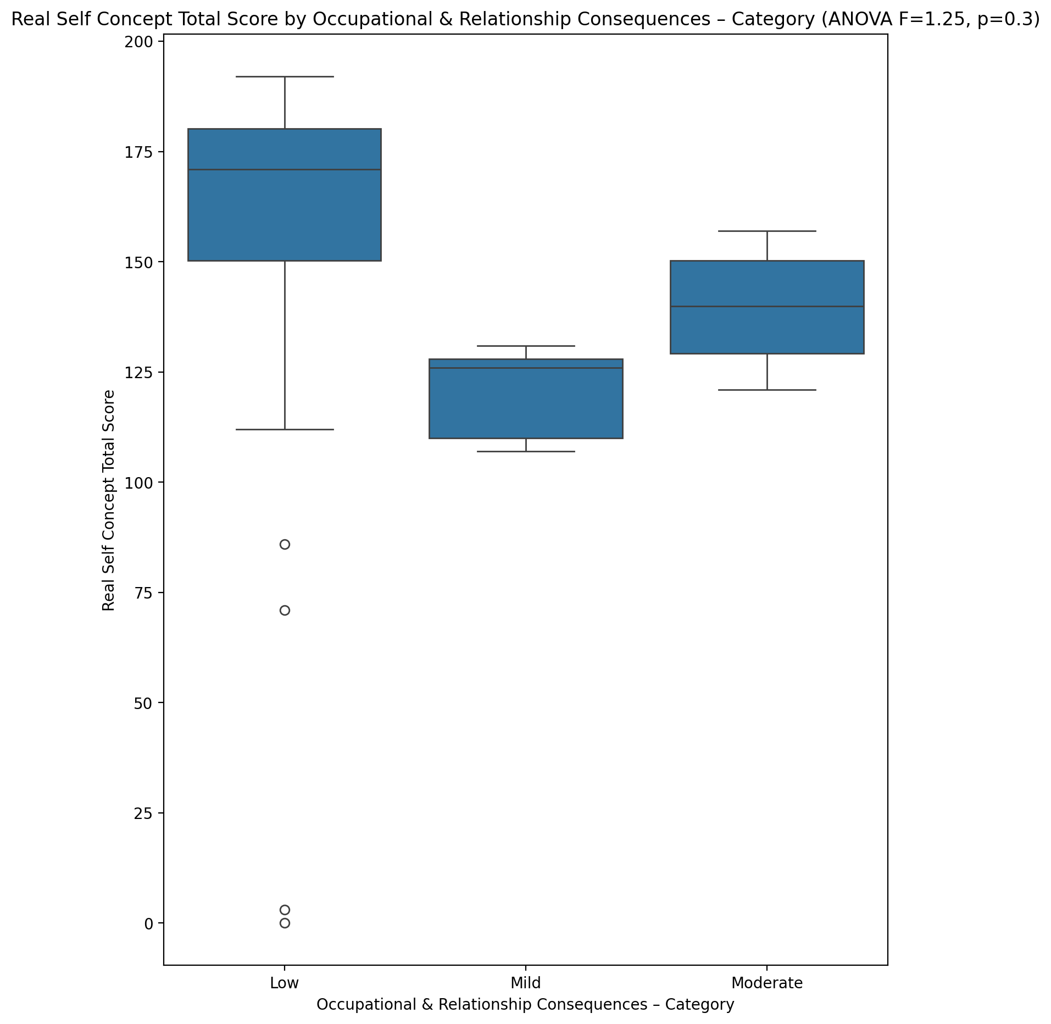

## Ideal Self Concept Total Score vs Occupational & Relationship Consequences – Category

Test: anova; statistic: 0.43247161667893474; p-value: 0.6519012702360732;

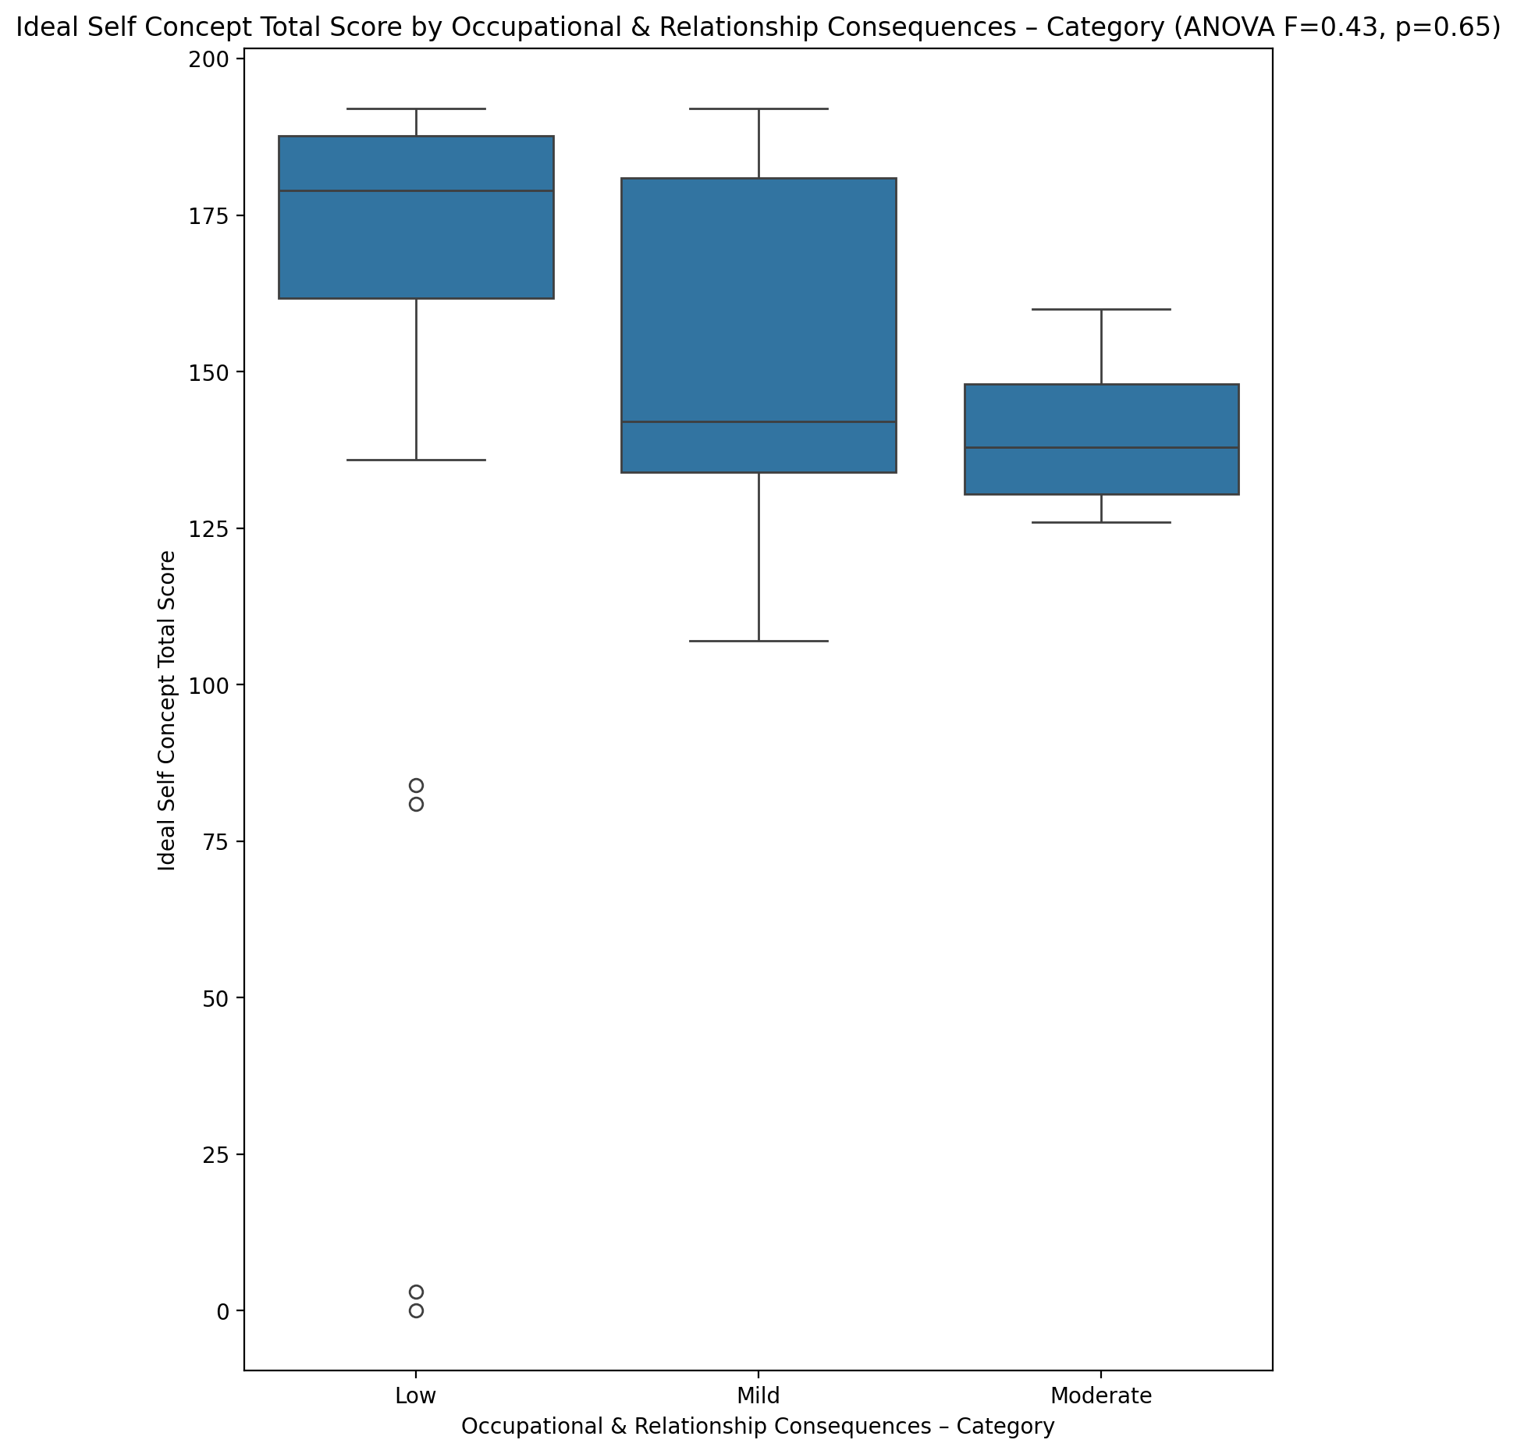

## Social Self Concept Total Score vs Occupational & Relationship Consequences – Category

Test: anova; statistic: 0.3968607378812409; p-value: 0.6750458927695361;

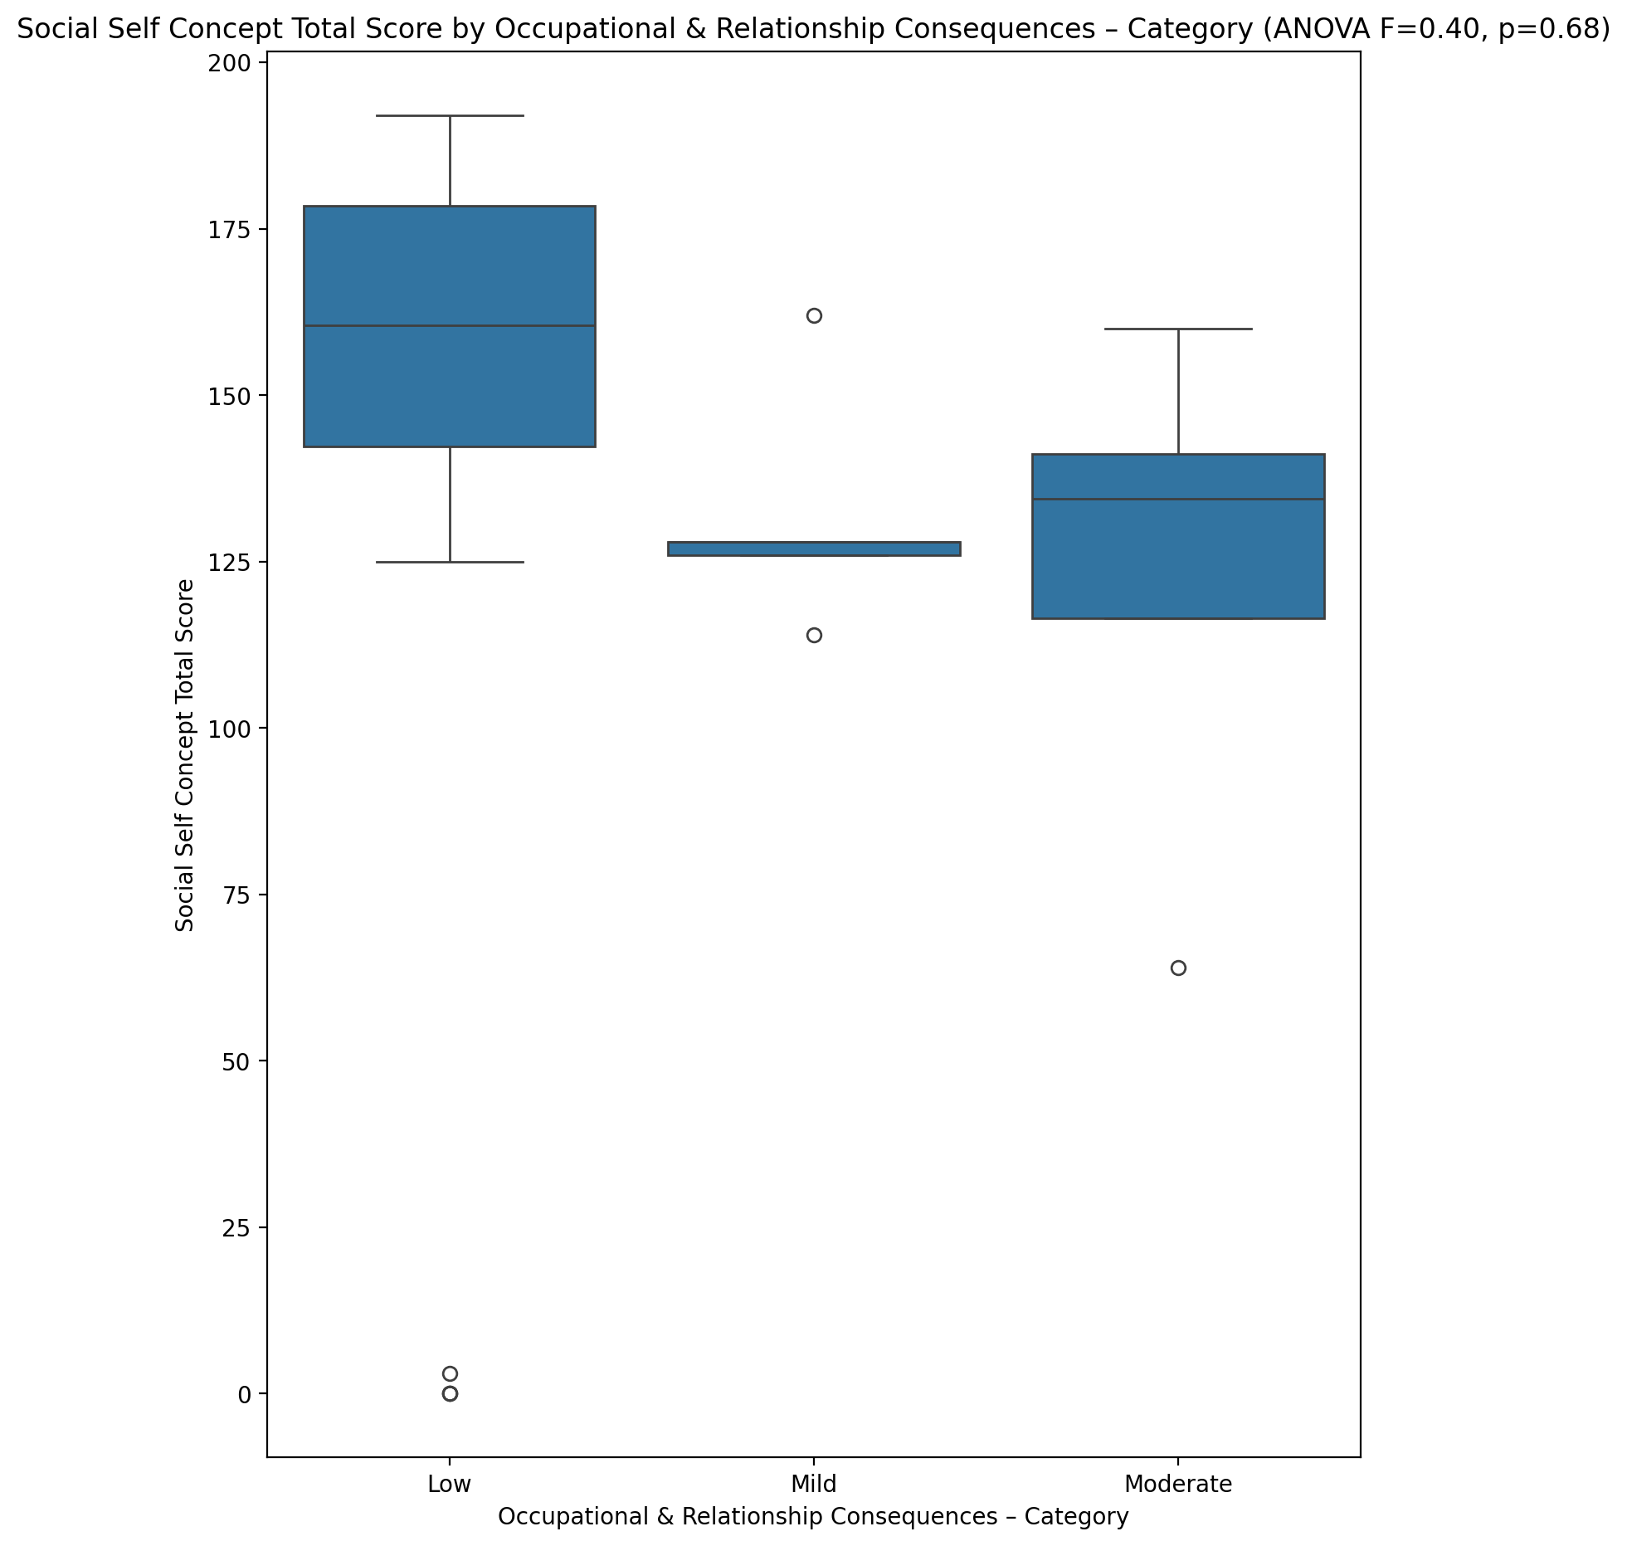

## Ideal Self Concept Total Category vs Occupational & Relationship Consequences – Category

Test: chi2; statistic: 17.901197817836813; p-value: 0.001290189505759559;

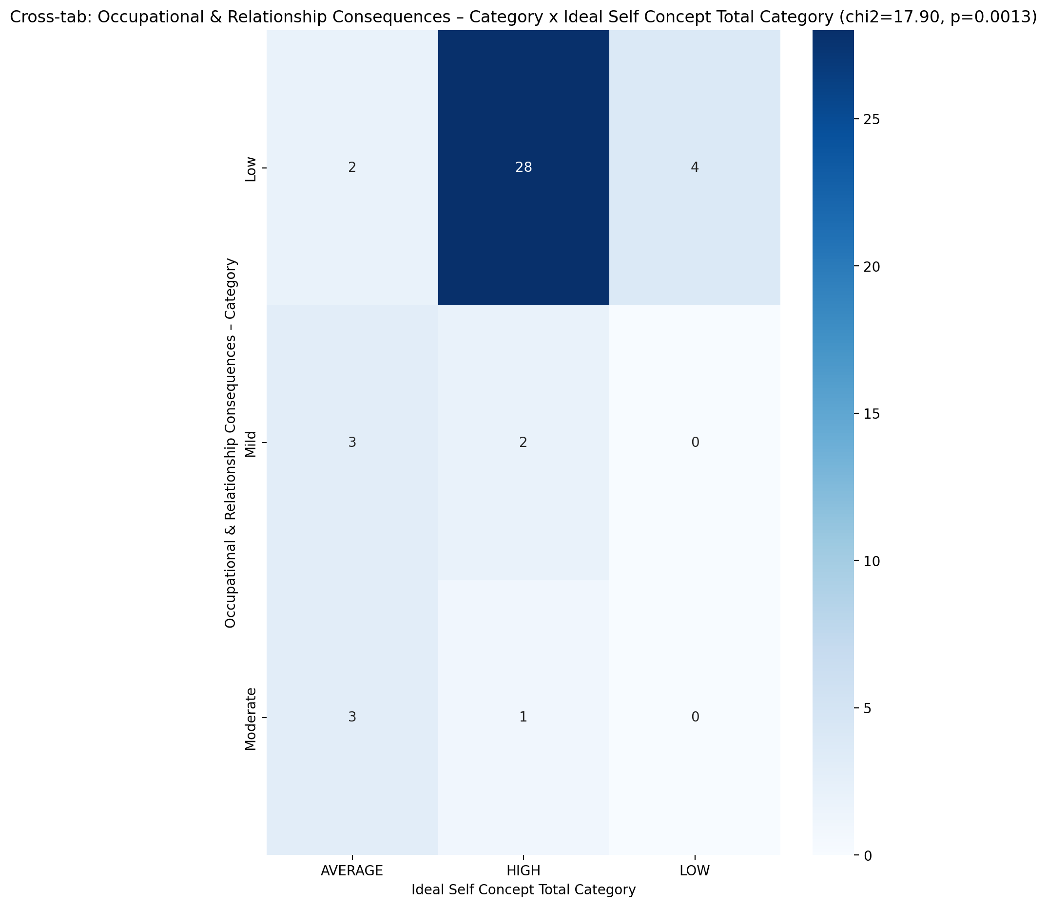

## Perceived Social Stress Score vs Occupational & Relationship Consequences – Category

Test: anova; statistic: 1.4865696034903757; p-value: 0.23837363633631645;

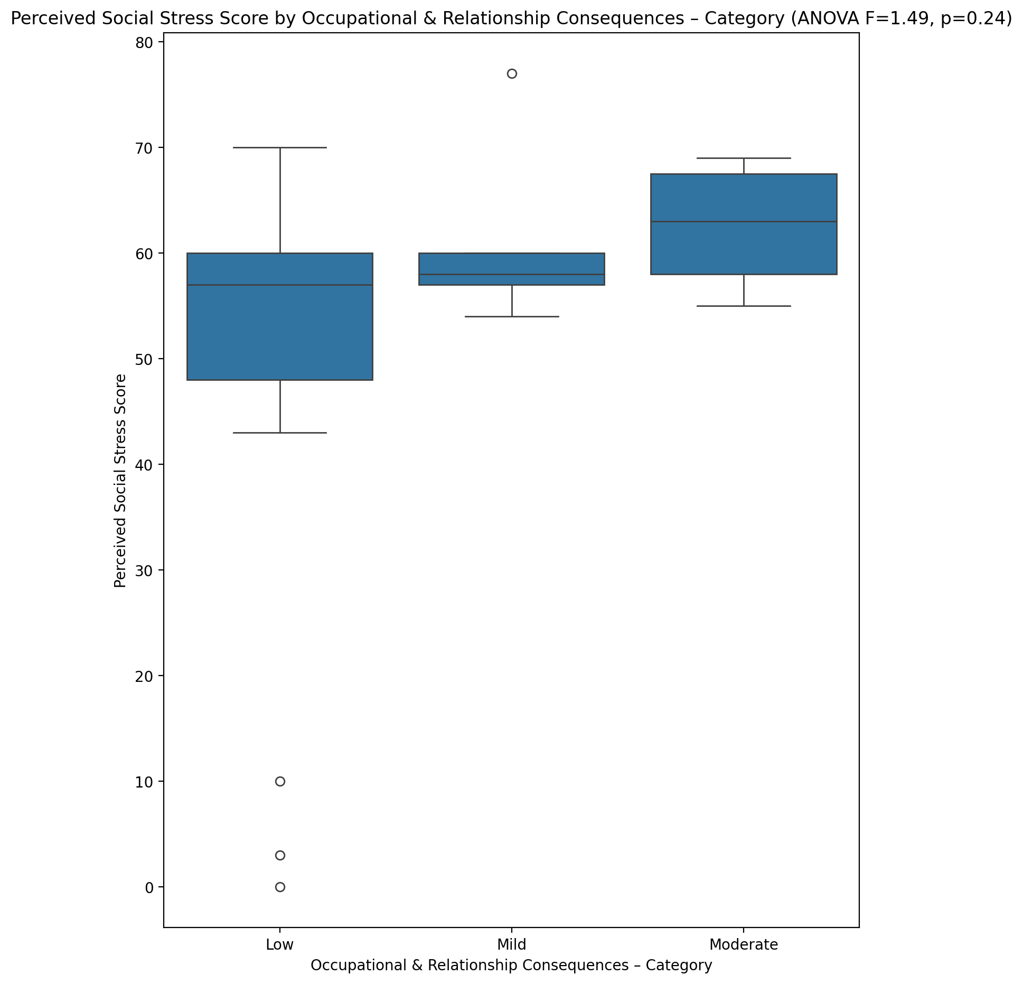

## Perceived Social Stress Category vs Occupational & Relationship Consequences – Category

Test: chi2; statistic: 0.8536764705882351; p-value: 0.6525691063397604;

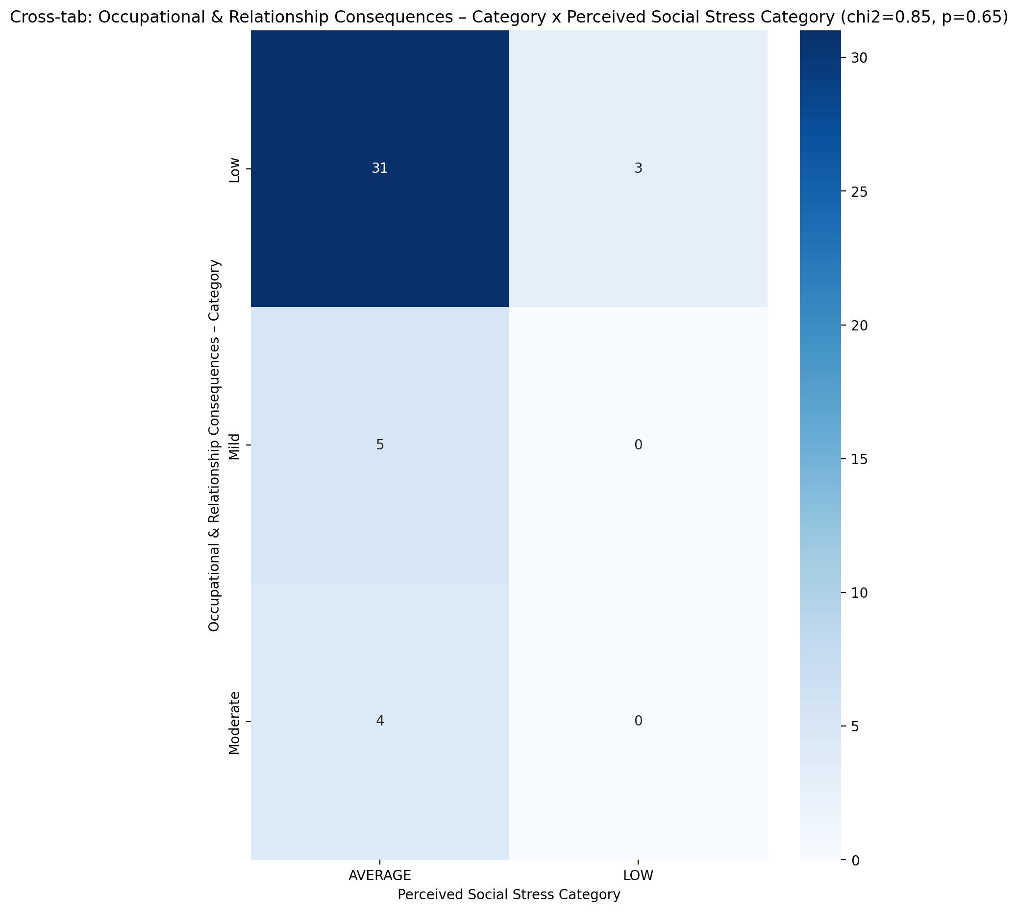

## Emotional Support - Raw Score vs Compulsive Behaviour – Category

Test: anova; statistic: 1.5172266076383583; p-value: 0.22520011675162876;

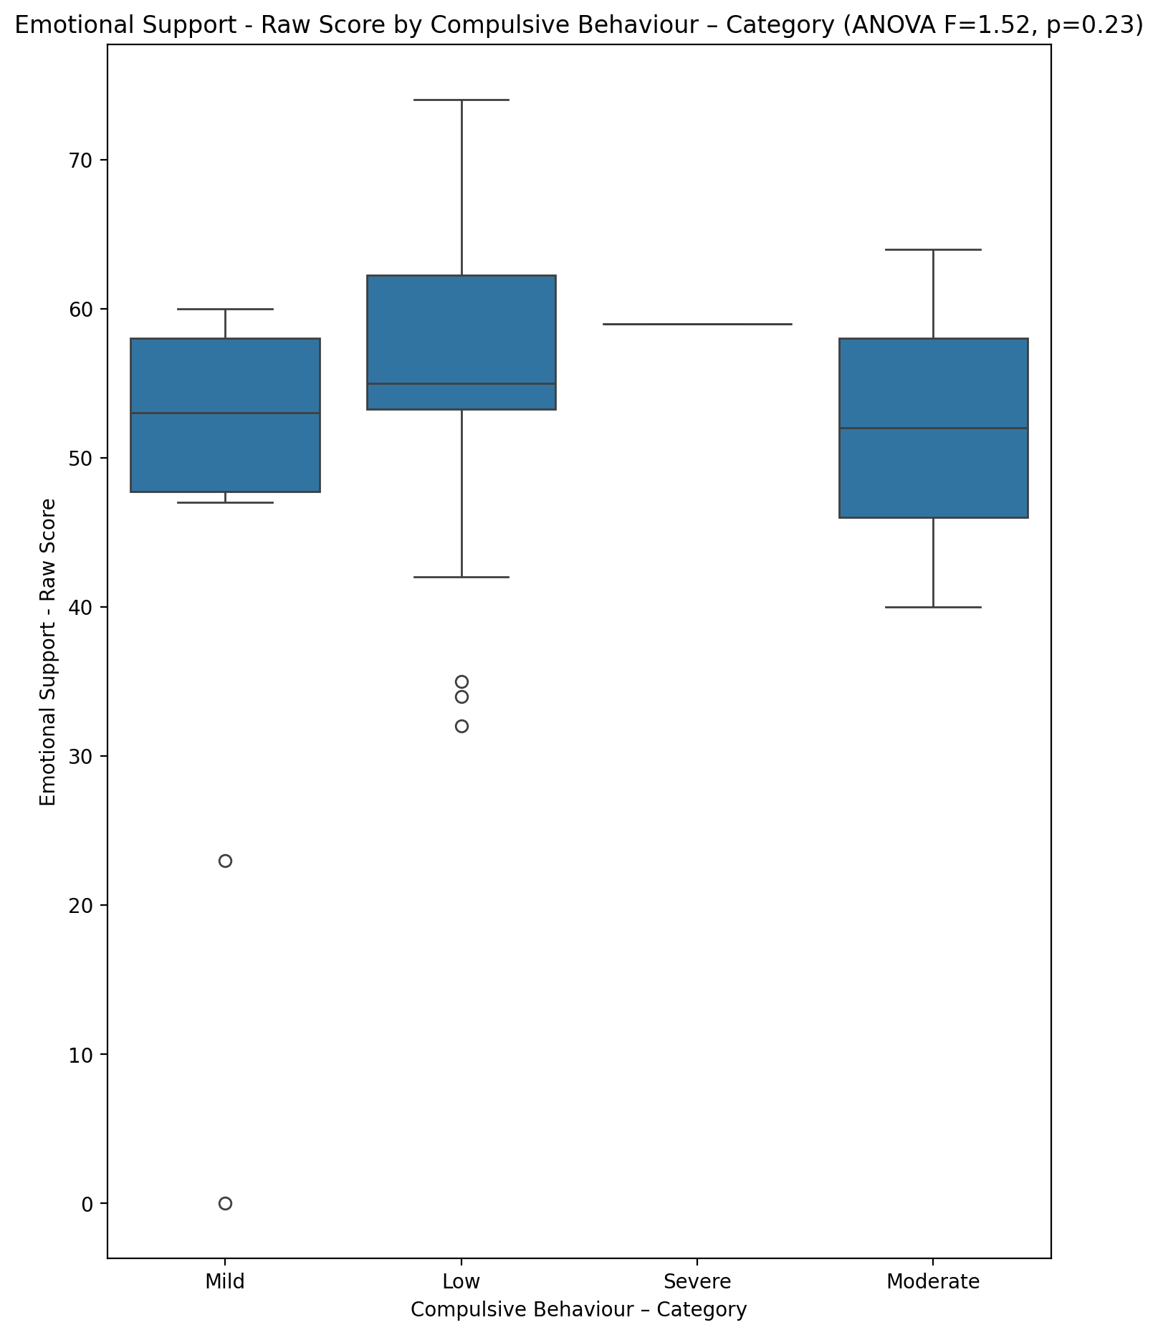

## Informational Support - Raw Score vs Compulsive Behaviour – Category

Test: anova; statistic: 0.4508009534301008; p-value: 0.7181693576345831;

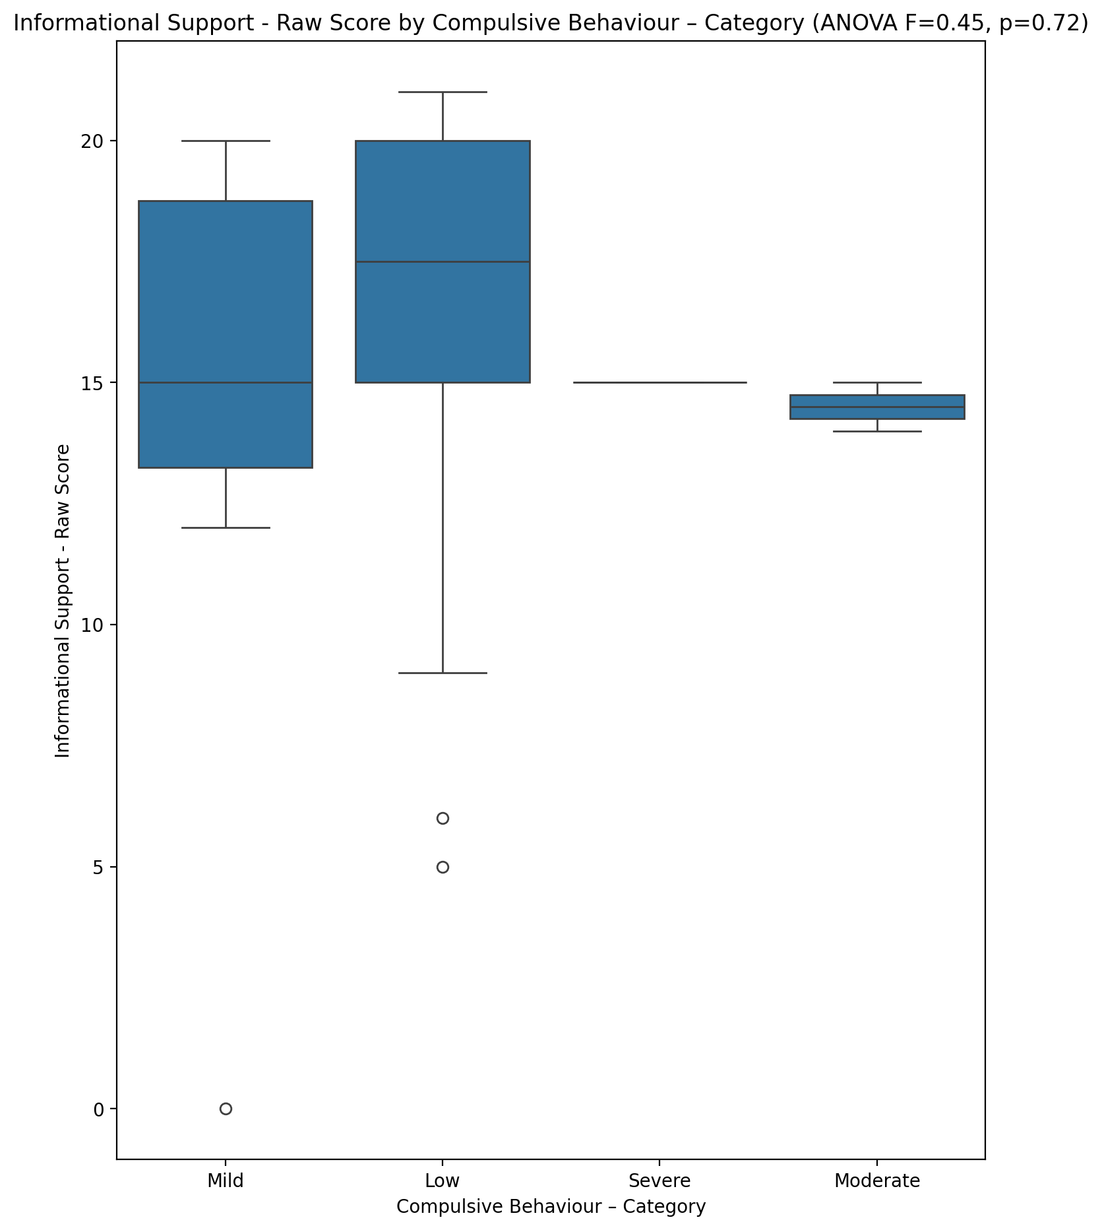

## Instrumental Support - Raw Score vs Compulsive Behaviour – Category

Test: anova; statistic: 1.6133085277106776; p-value: 0.20186257686312126;

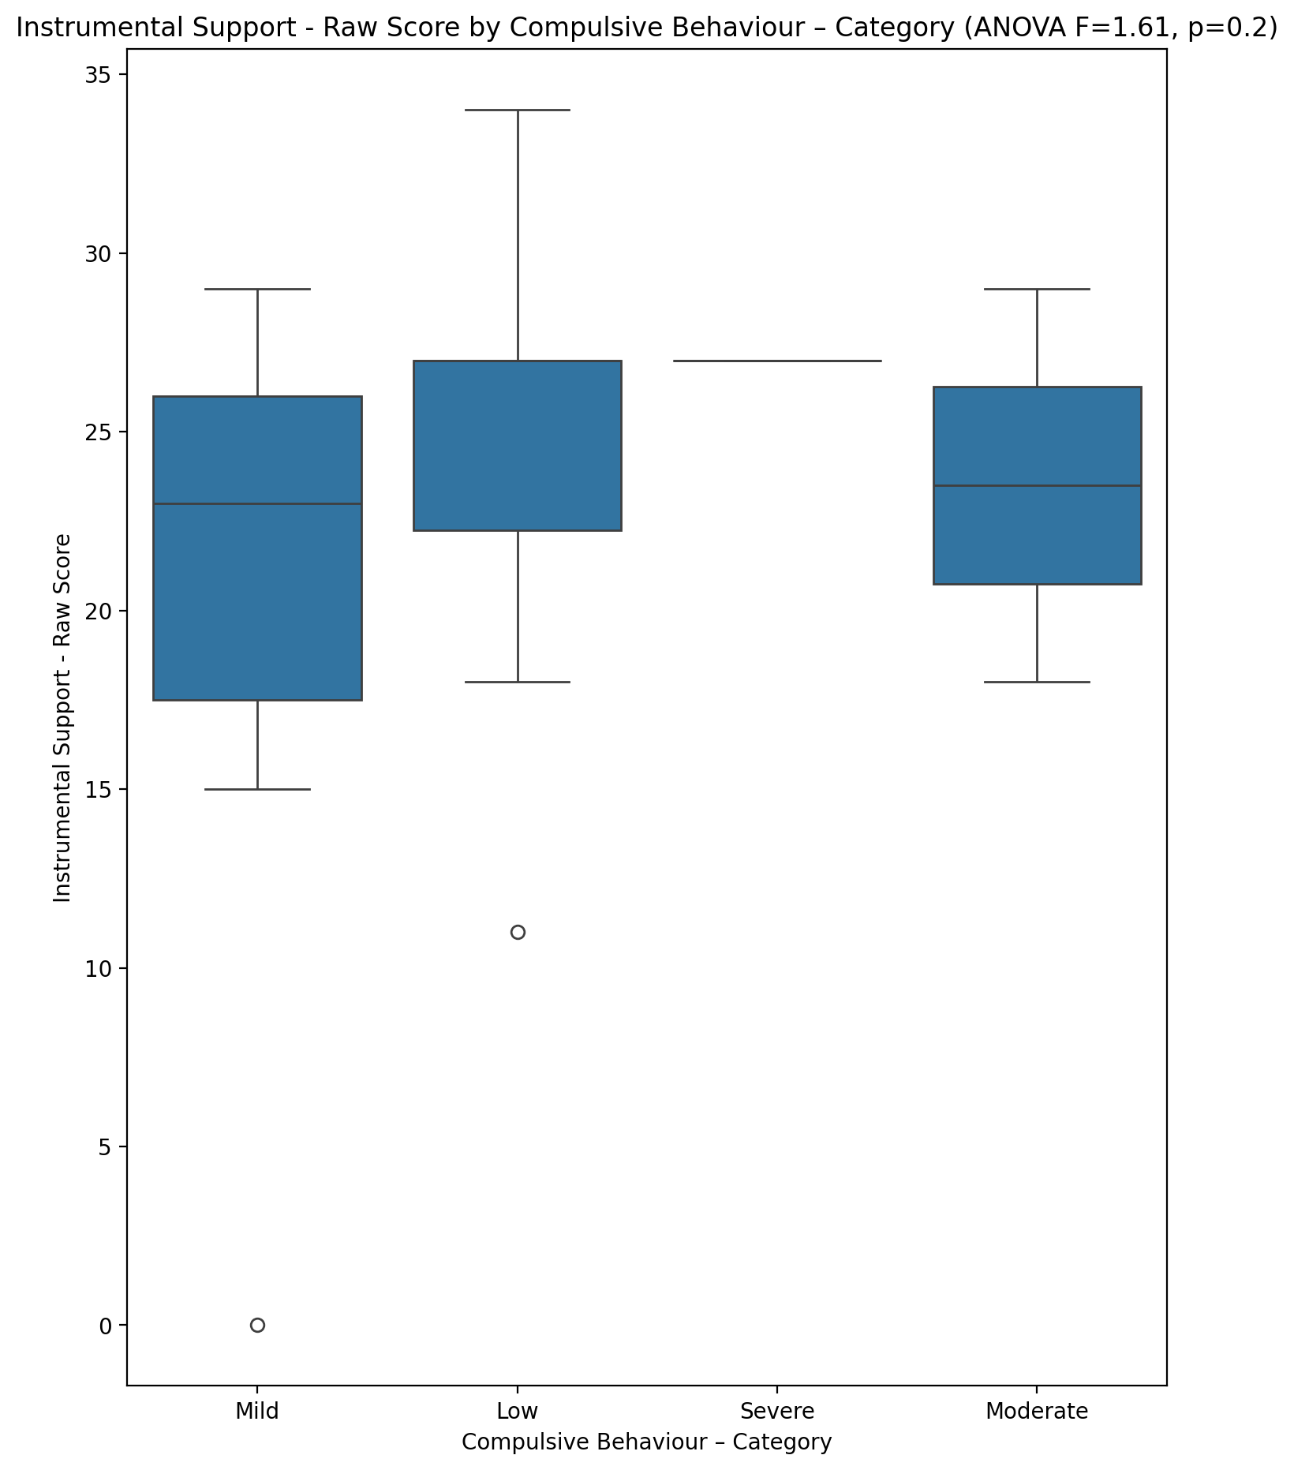

## Emotional Support - T Score vs Compulsive Behaviour – Category

Test: anova; statistic: 0.8847407667025151; p-value: 0.45745529457034484;

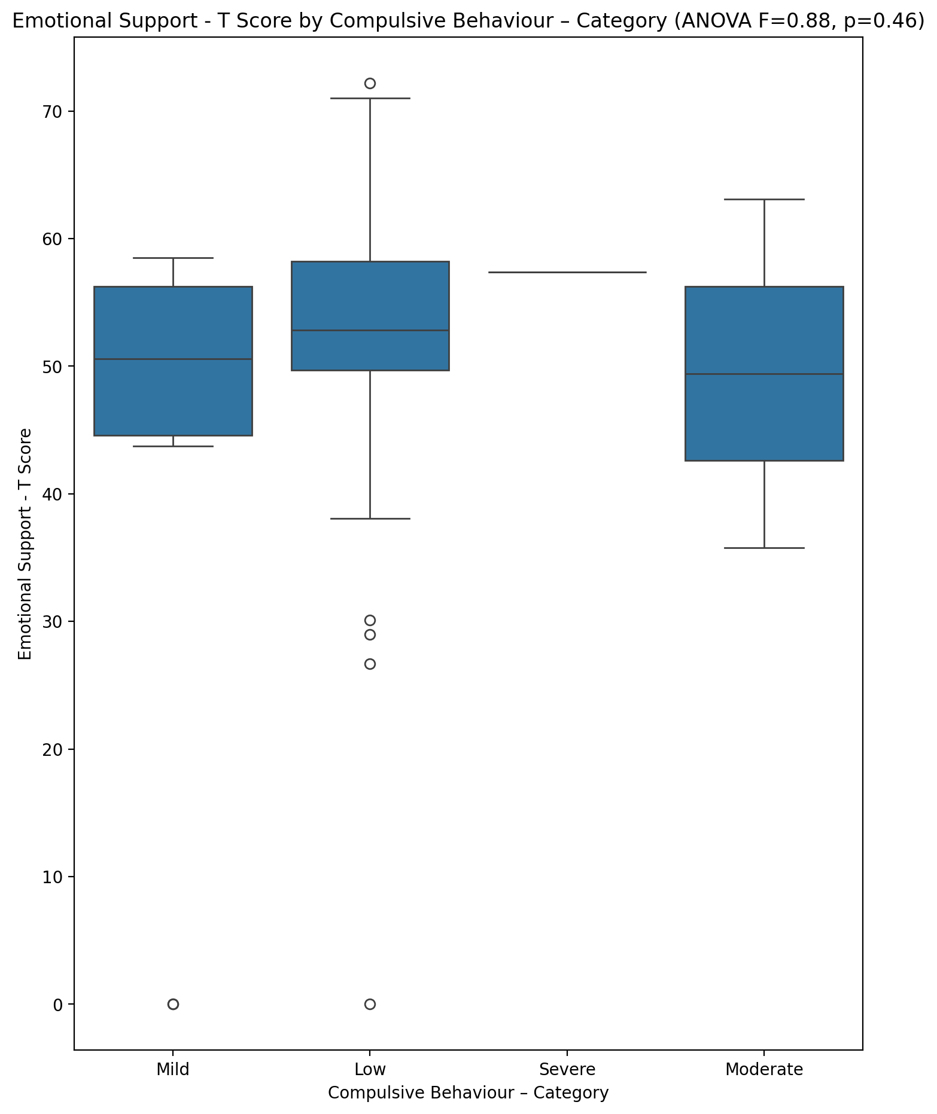

## Informational Support - T Score vs Compulsive Behaviour – Category

Test: anova; statistic: 0.2372850140225512; p-value: 0.8698185512854427;

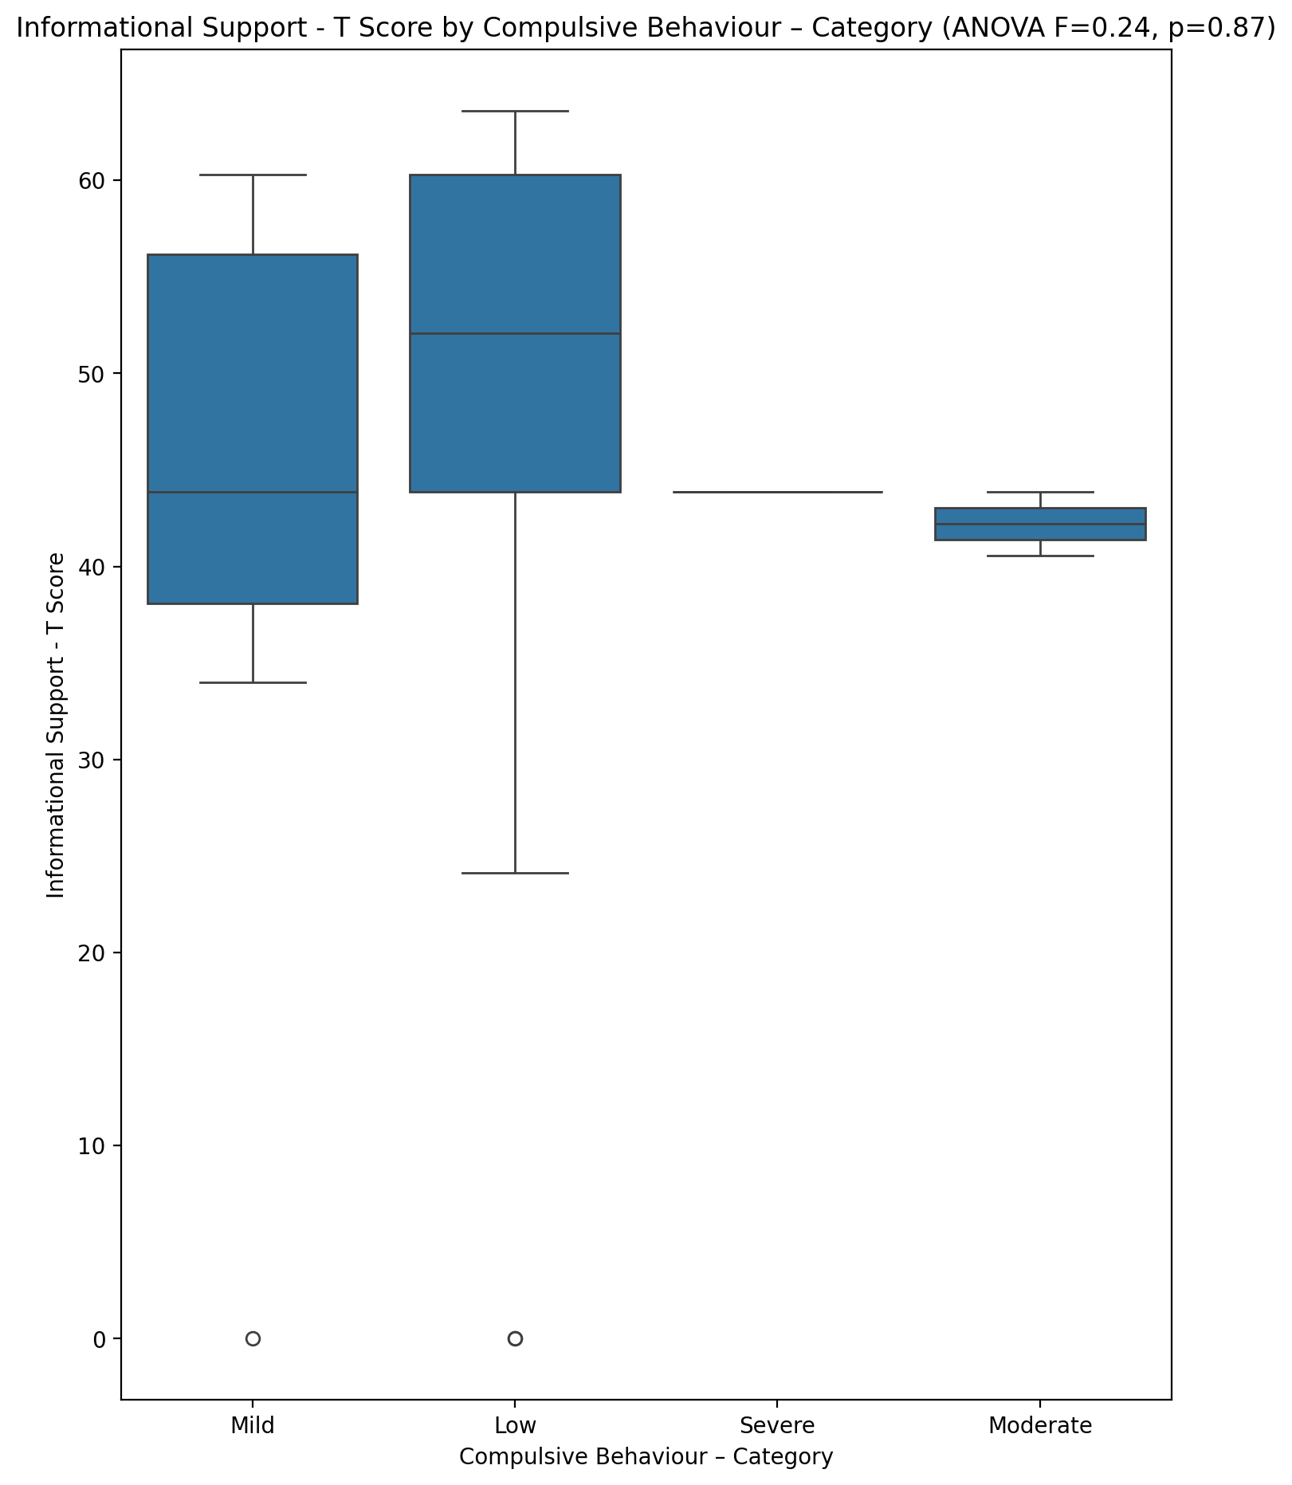

## Instrumental Support - T Score vs Compulsive Behaviour – Category

Test: anova; statistic: 1.1679680332812674; p-value: 0.3342889411820389;

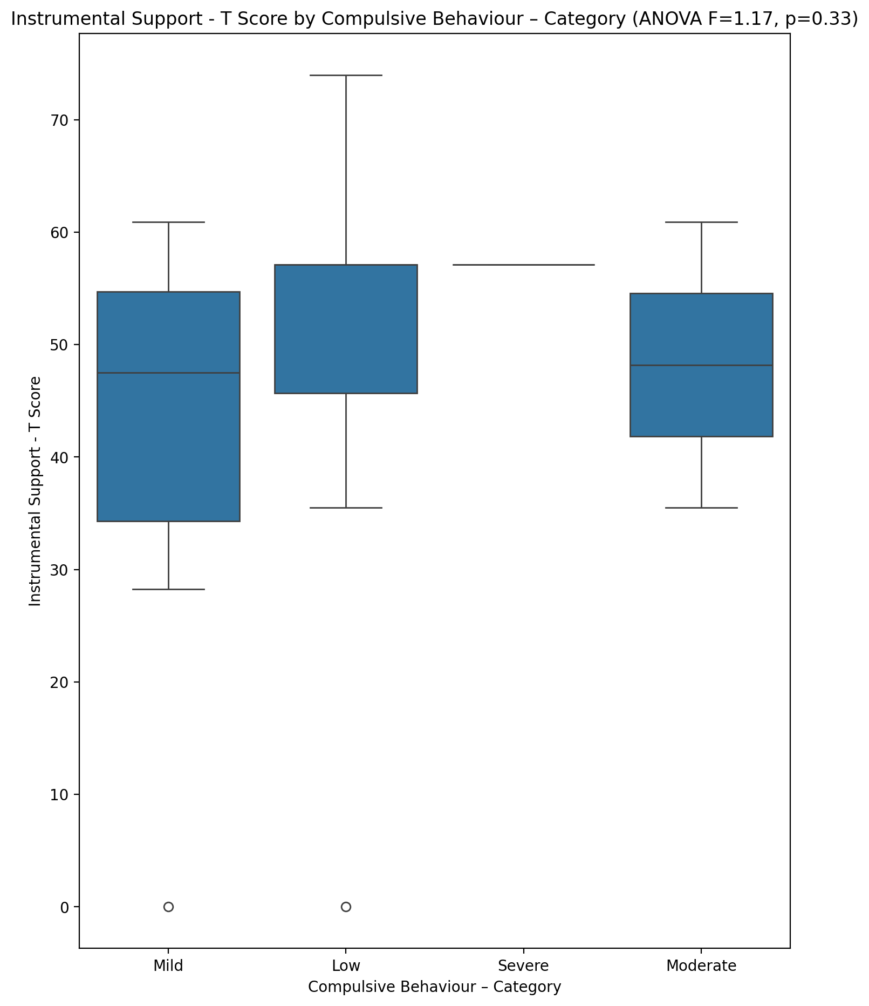

## Perceived Social Support Total T Score vs Compulsive Behaviour – Category

Test: anova; statistic: 0.8939108408614688; p-value: 0.4529031767388013;

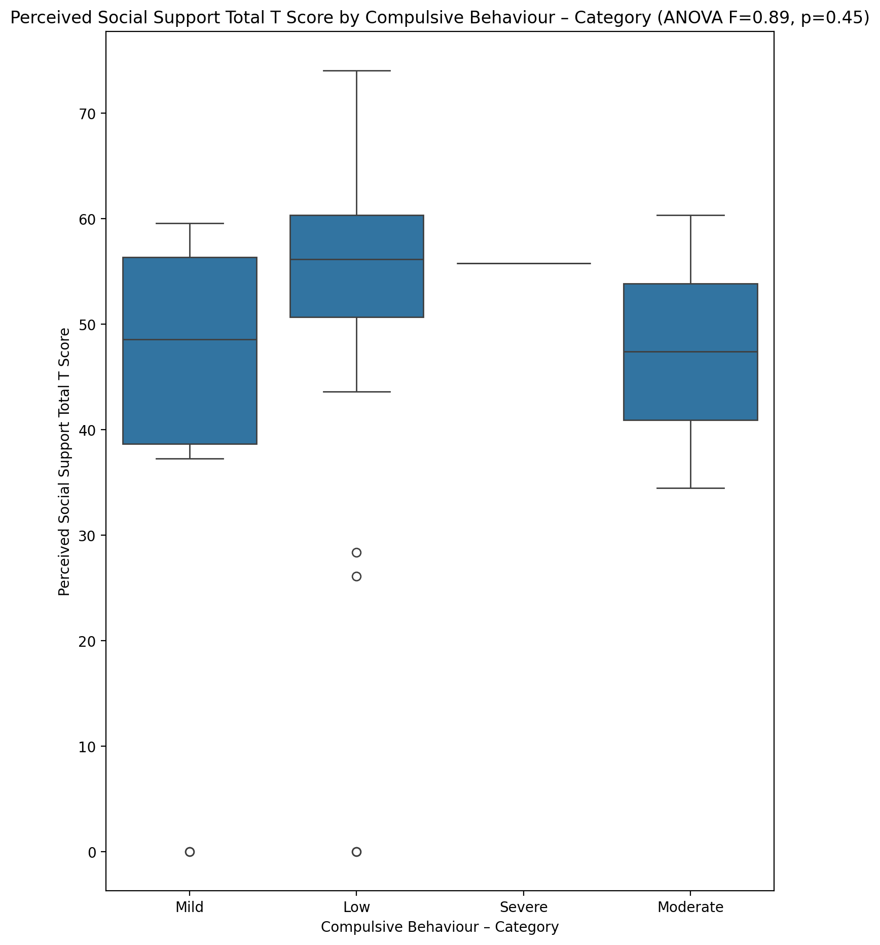

## Emotional Support - Rank vs Compulsive Behaviour – Category

Test: chi2; statistic: 17.66583333333333; p-value: 0.12622009562334746;

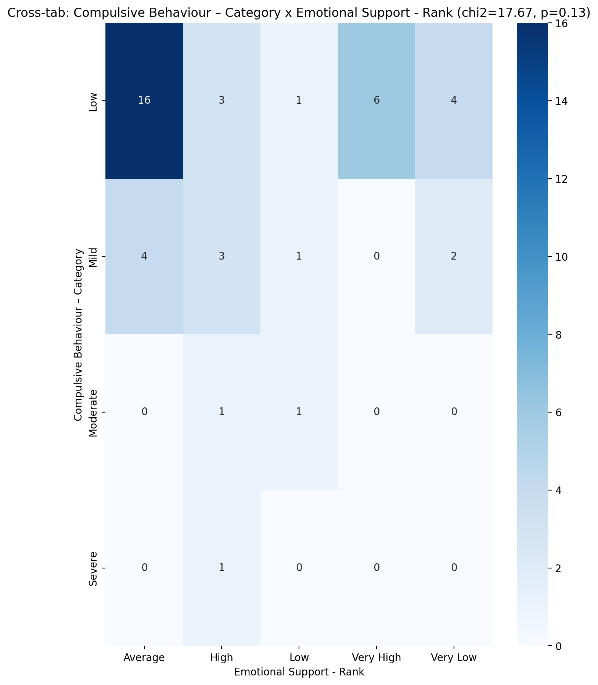

## Informational Support - Rank vs Compulsive Behaviour – Category

Test: chi2; statistic: 10.217619047619046; p-value: 0.33315680975898626;

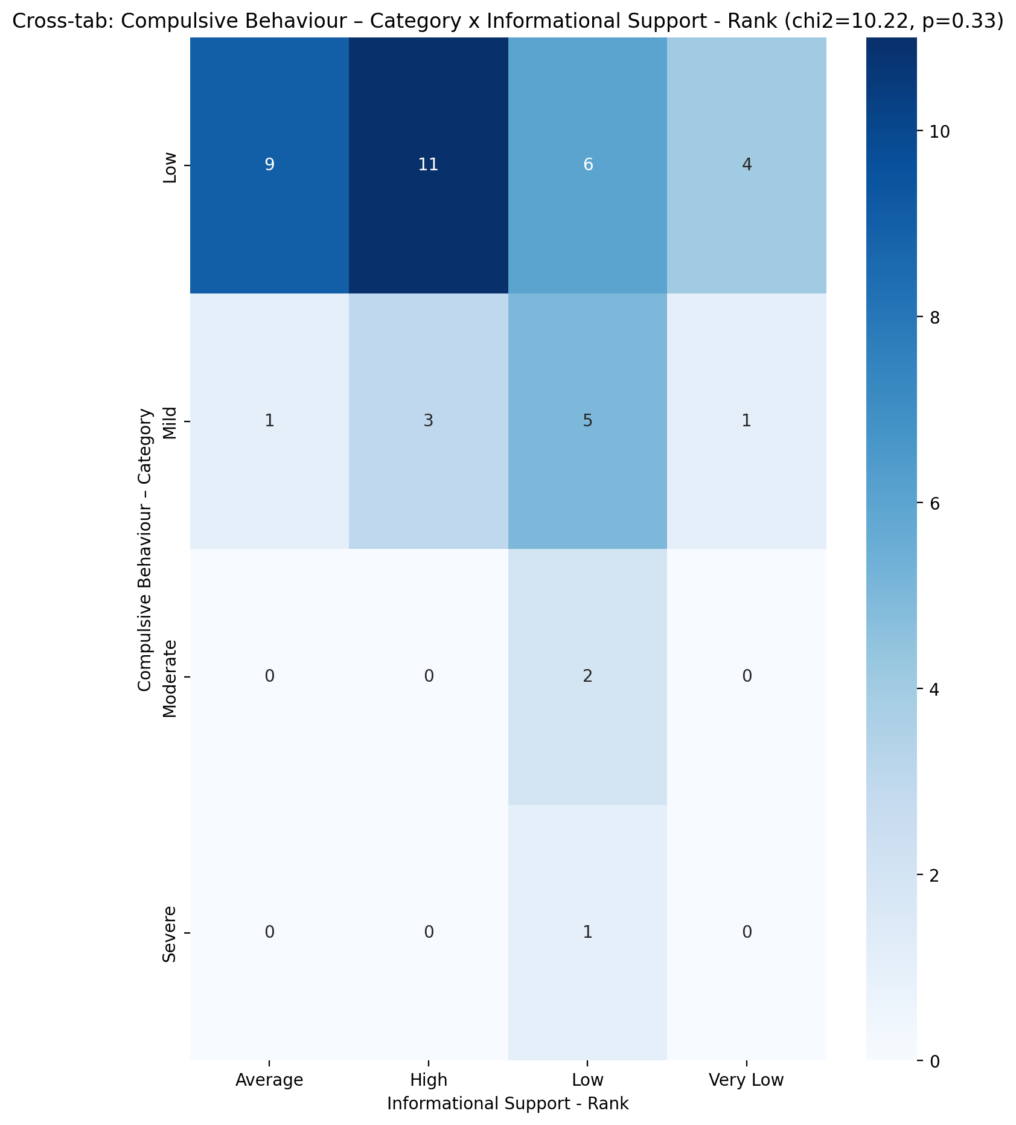

## Instrumental Support - Rank vs Compulsive Behaviour – Category

Test: chi2; statistic: 9.260457516339871; p-value: 0.6805375965917793;

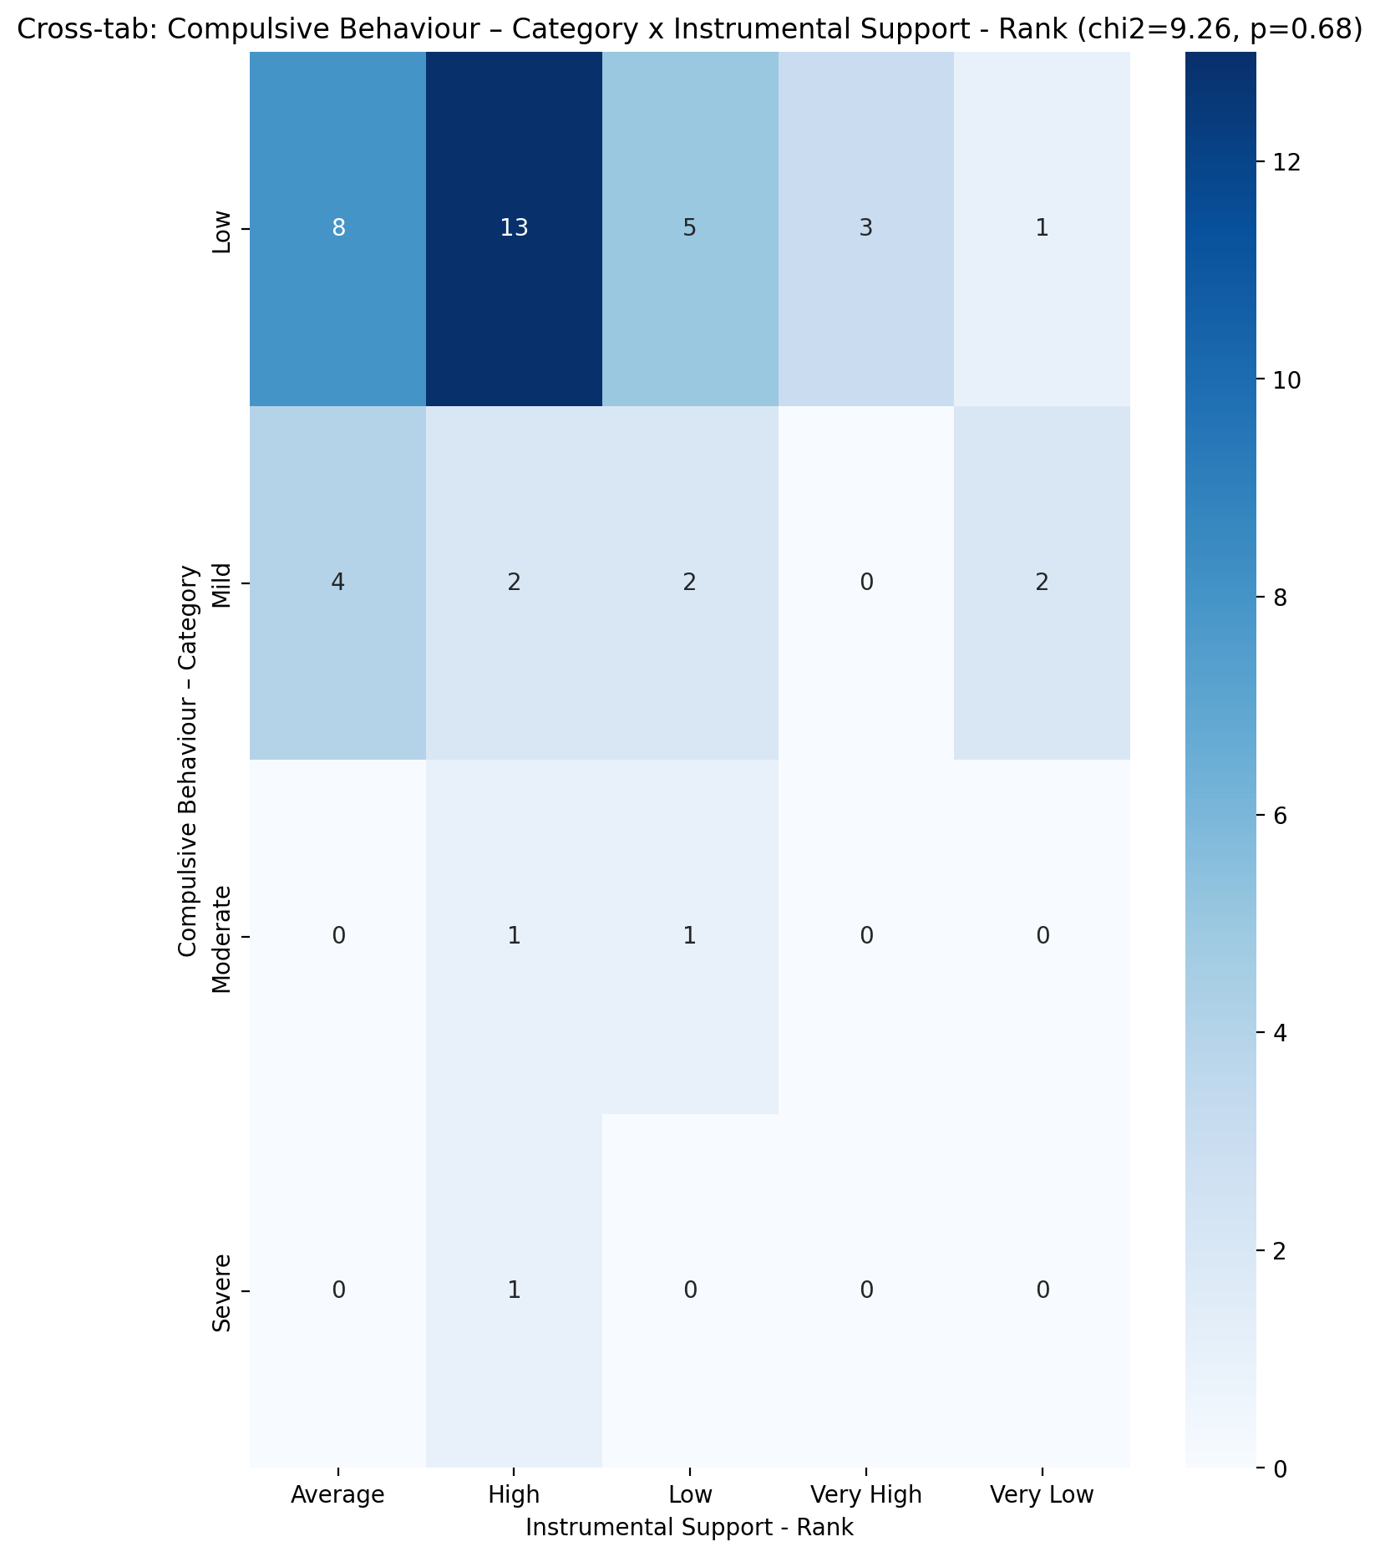

## Perceived Social Support TOTAL - Rank vs Compulsive Behaviour – Category

Test: chi2; statistic: 12.780555555555557; p-value: 0.3851906351834132;

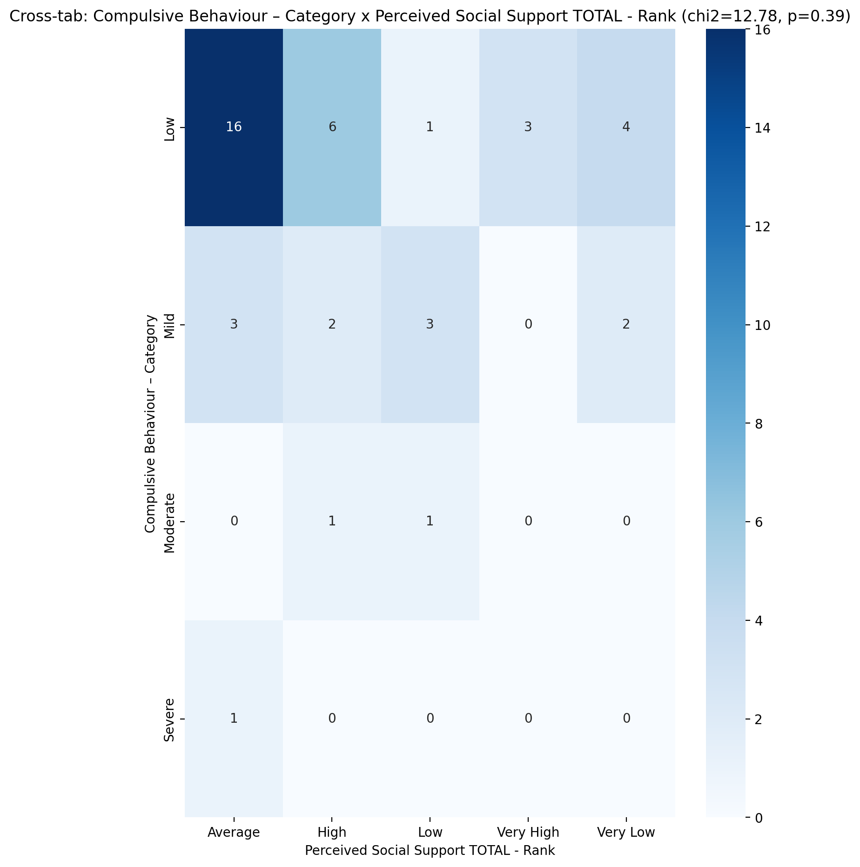

## Power Self Concept - Real Self Concept Score vs Compulsive Behaviour – Category

Test: anova; statistic: 0.6197926777186784; p-value: 0.6064062549547993;

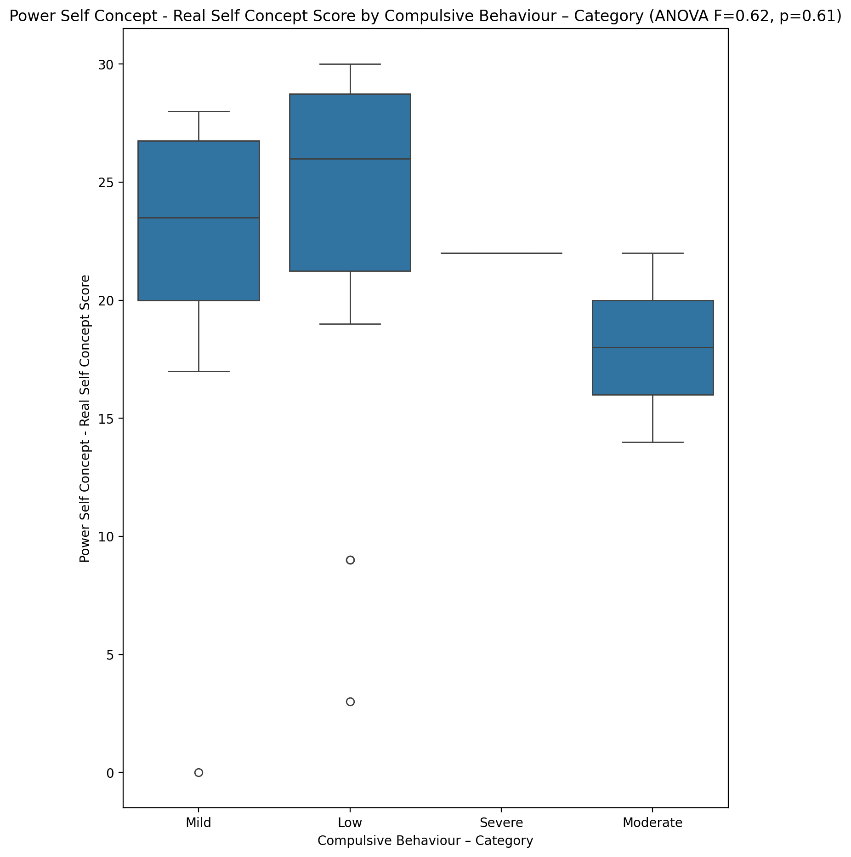

## Power Self Concept - Ideal Self Concept score vs Compulsive Behaviour – Category

Test: anova; statistic: 0.8169675095519378; p-value: 0.4923384392230228;

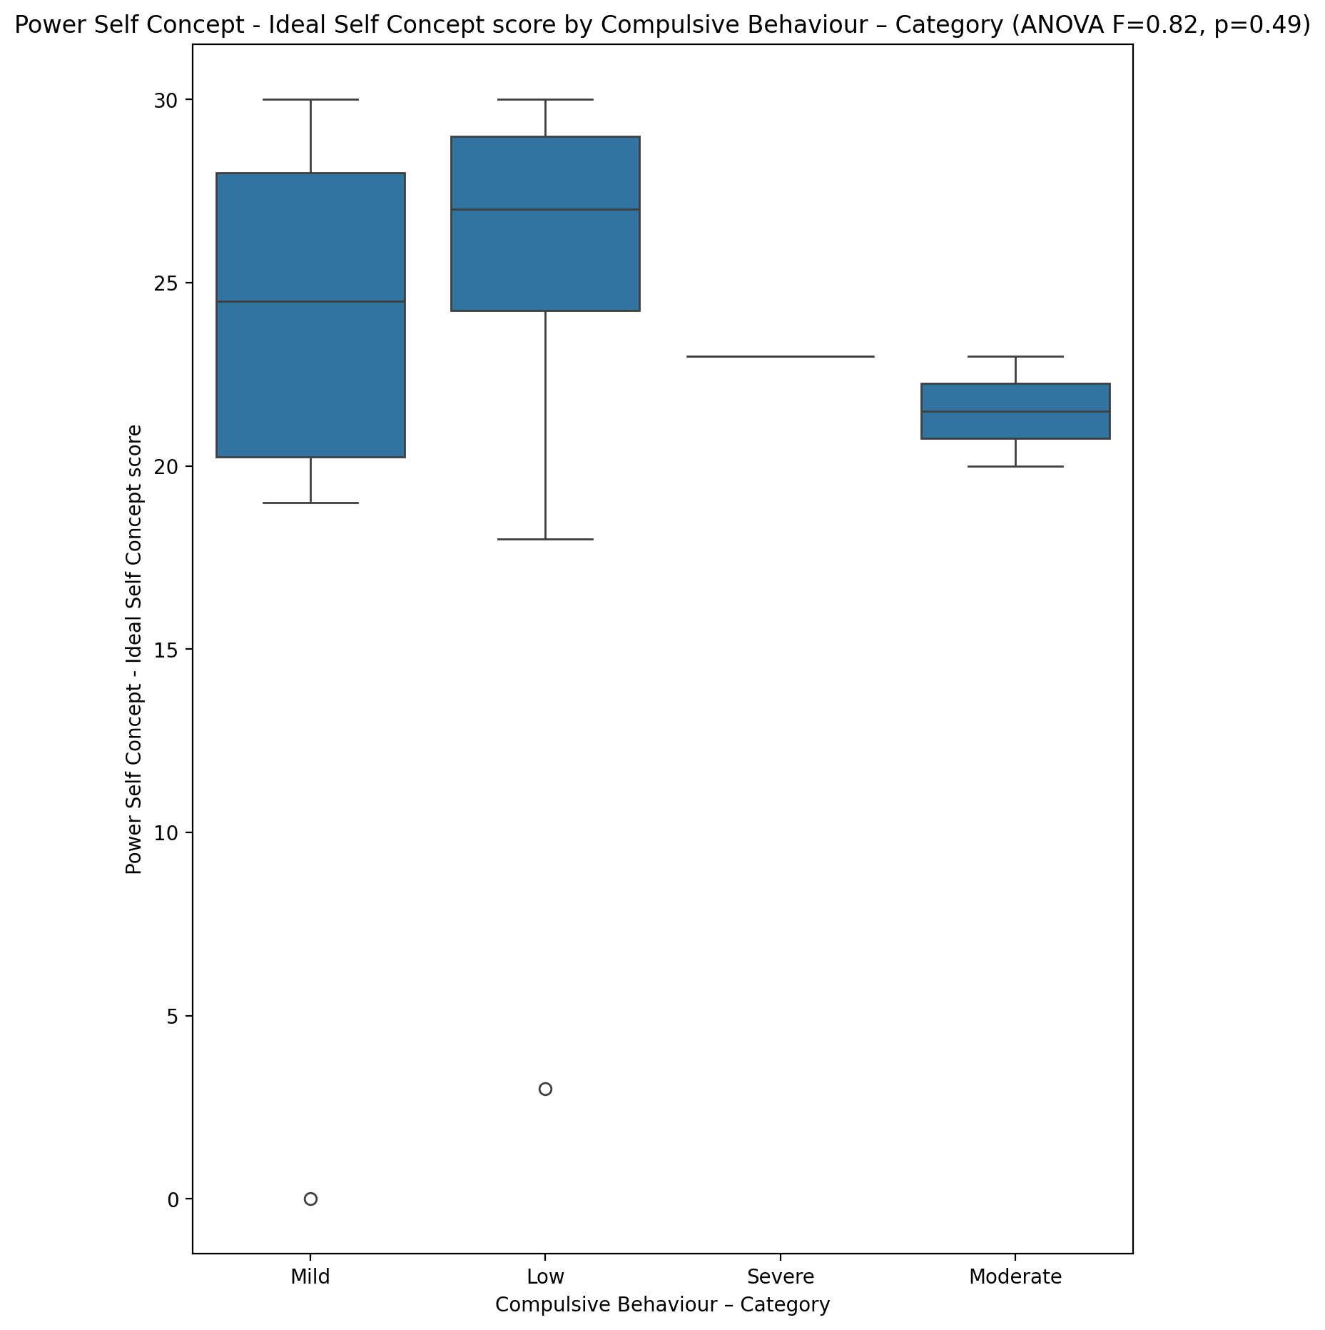

## Power Self Concept – Social Self Concept Score vs Compulsive Behaviour – Category

Test: anova; statistic: 0.9392031027900992; p-value: 0.4309970104460993;

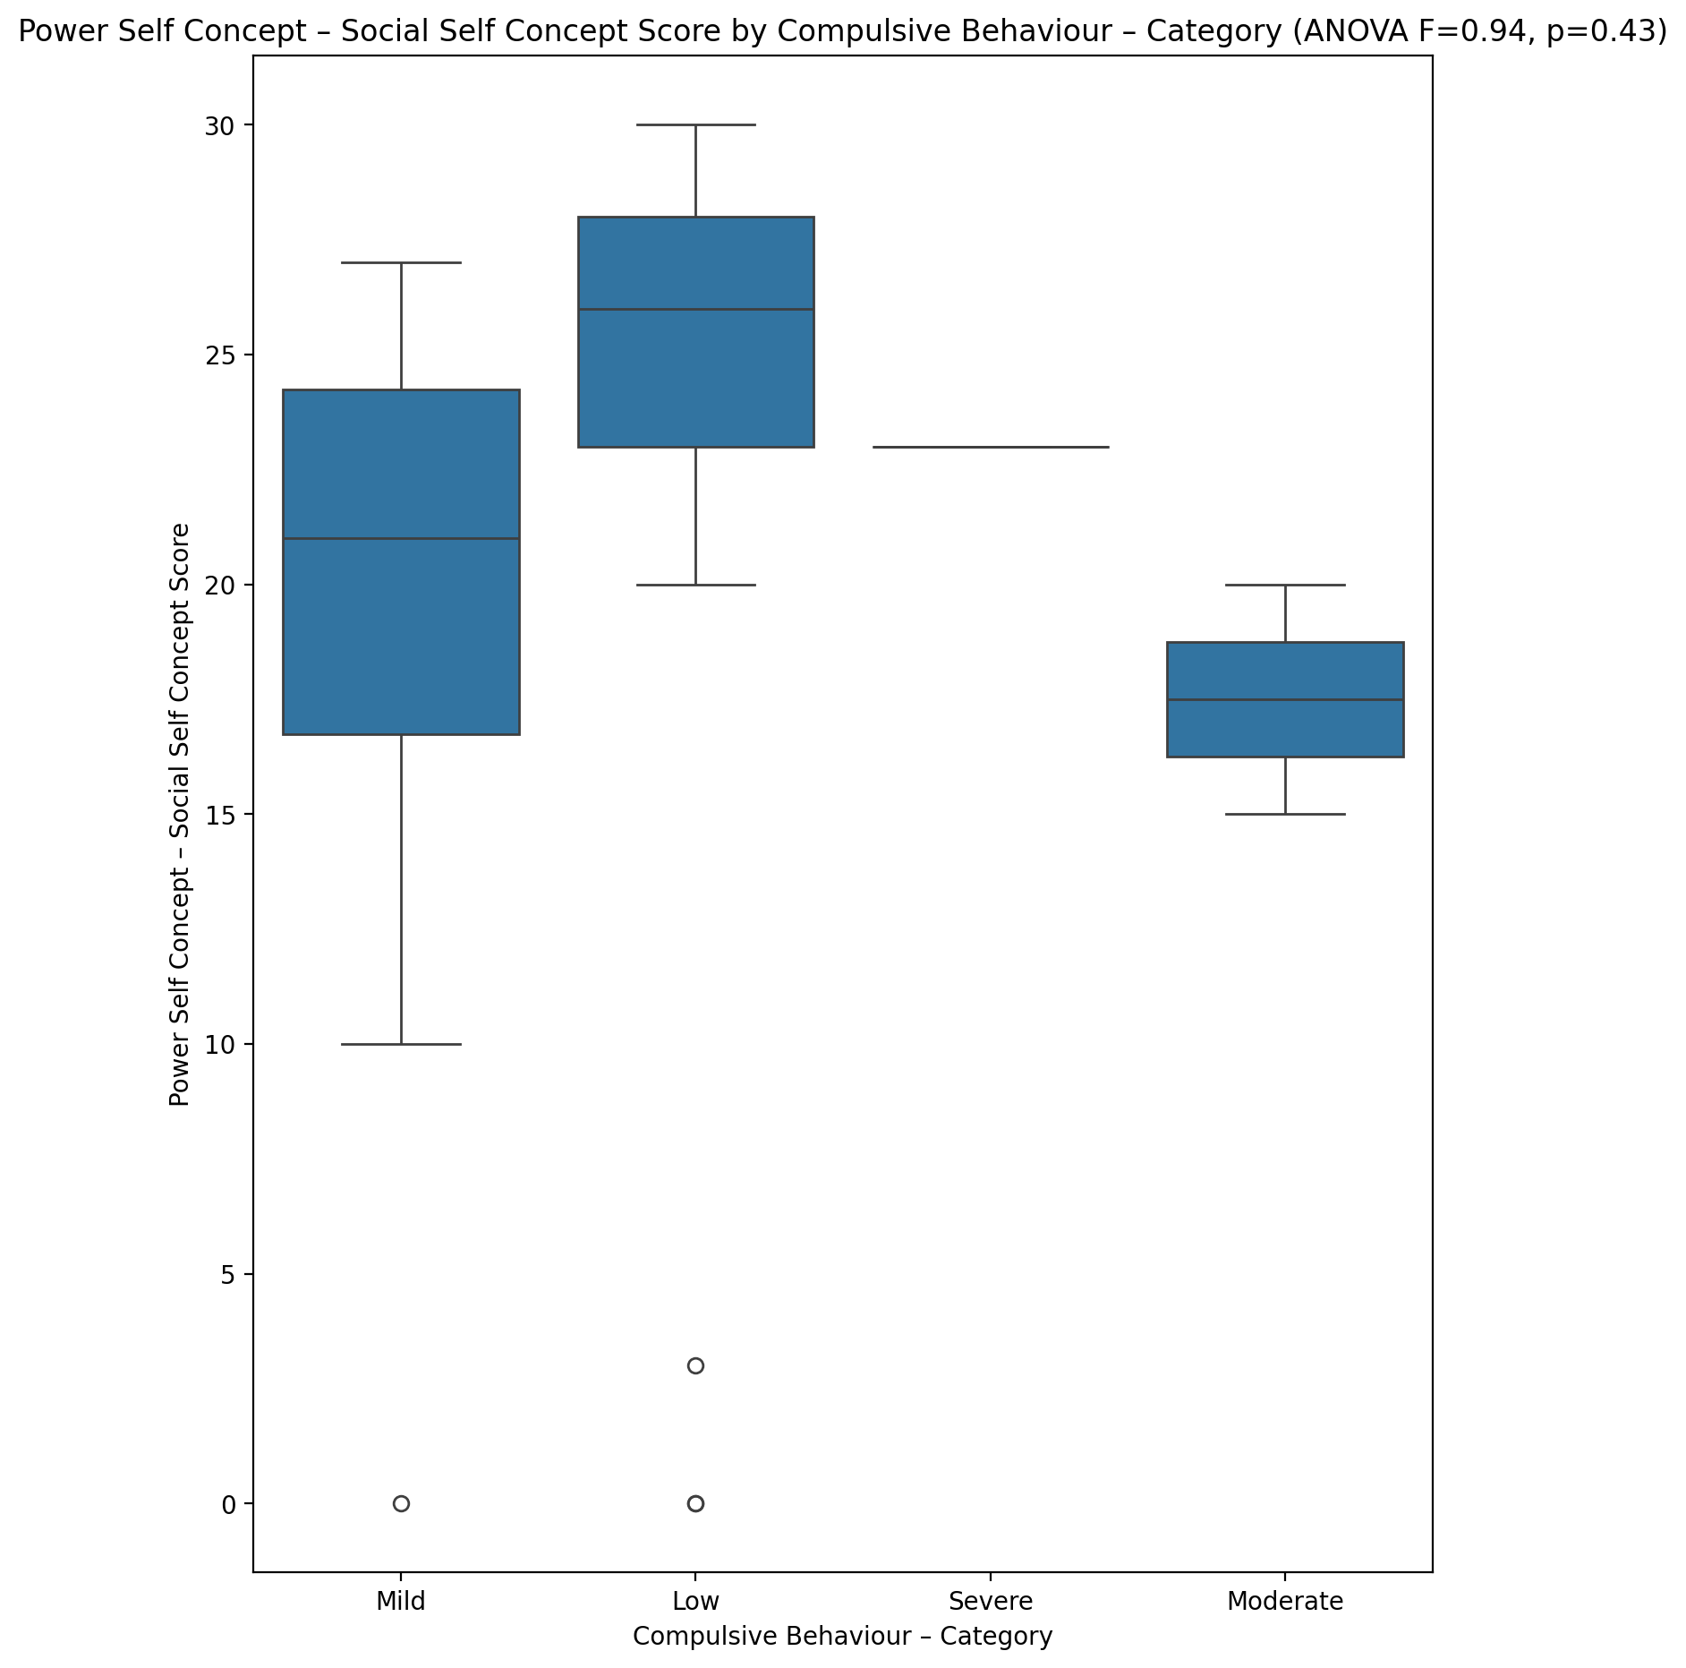

## Social Self Concept - Real Self Concept Score vs Compulsive Behaviour – Category

Test: anova; statistic: 1.2150077487663227; p-value: 0.3170872116354125;

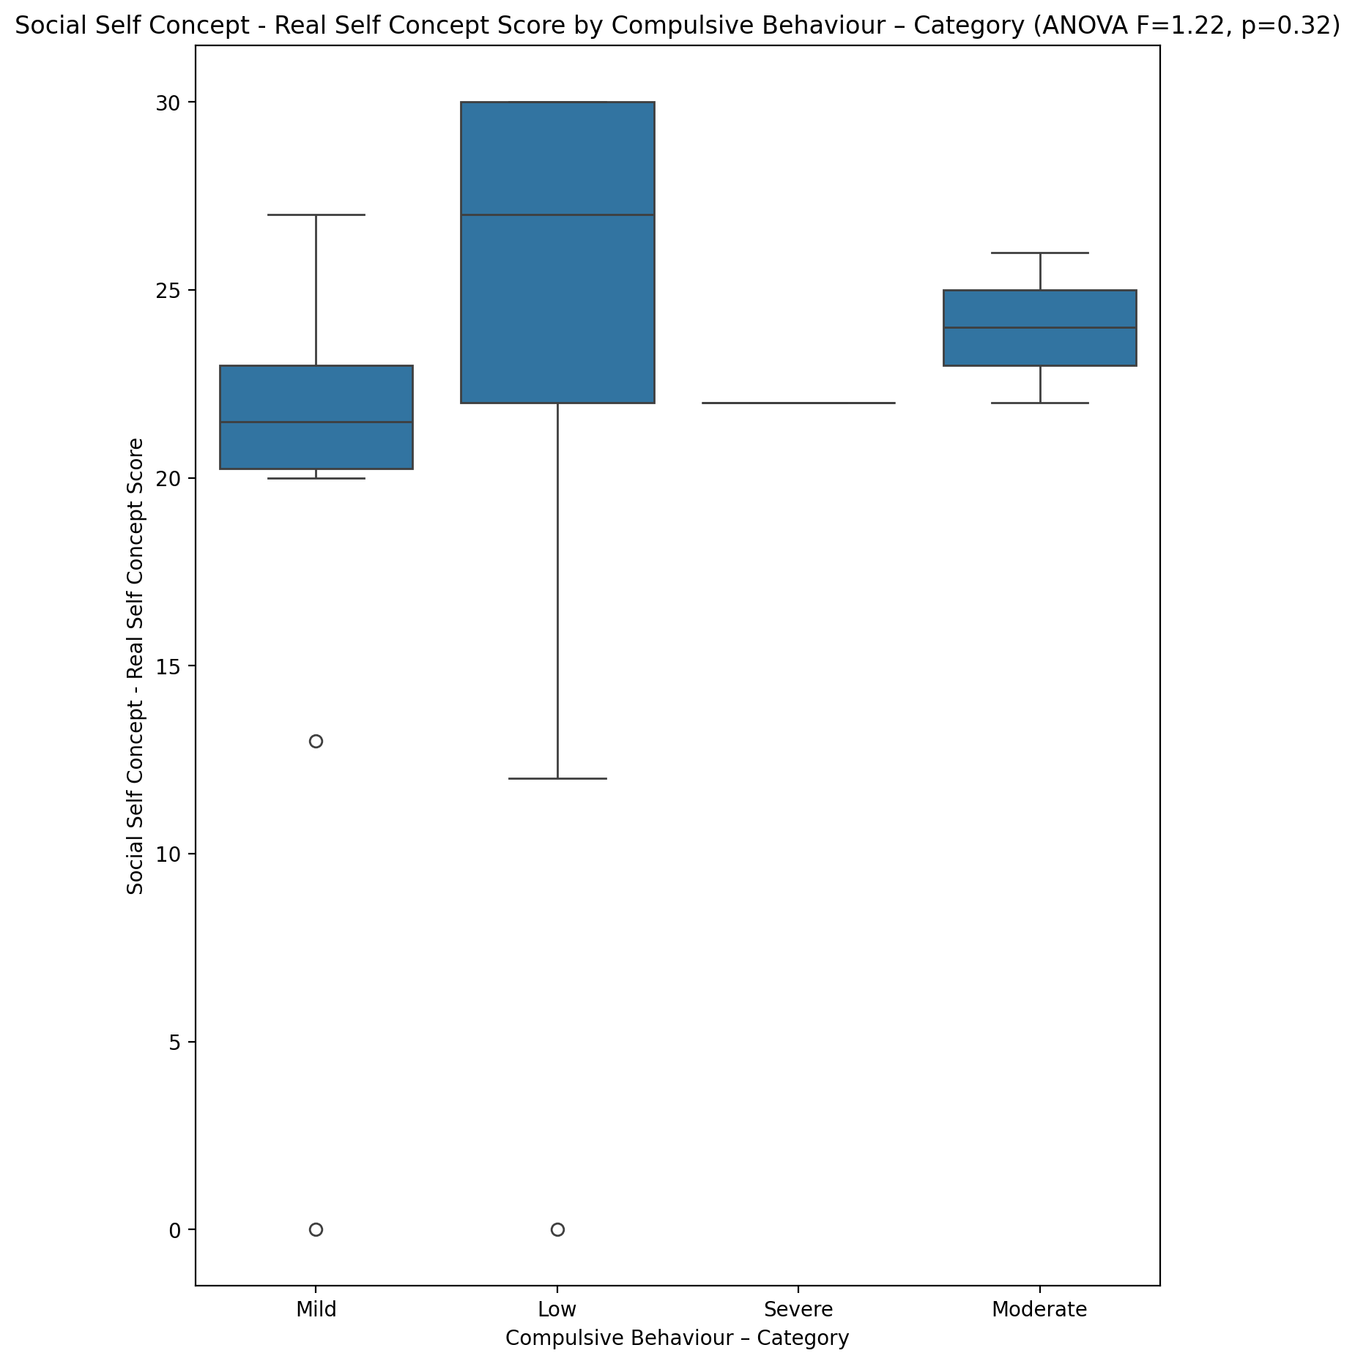

## Social Self Concept – Social Self Concept Score vs Compulsive Behaviour – Category

Test: anova; statistic: 1.0645043612415903; p-value: 0.37524656045815624;

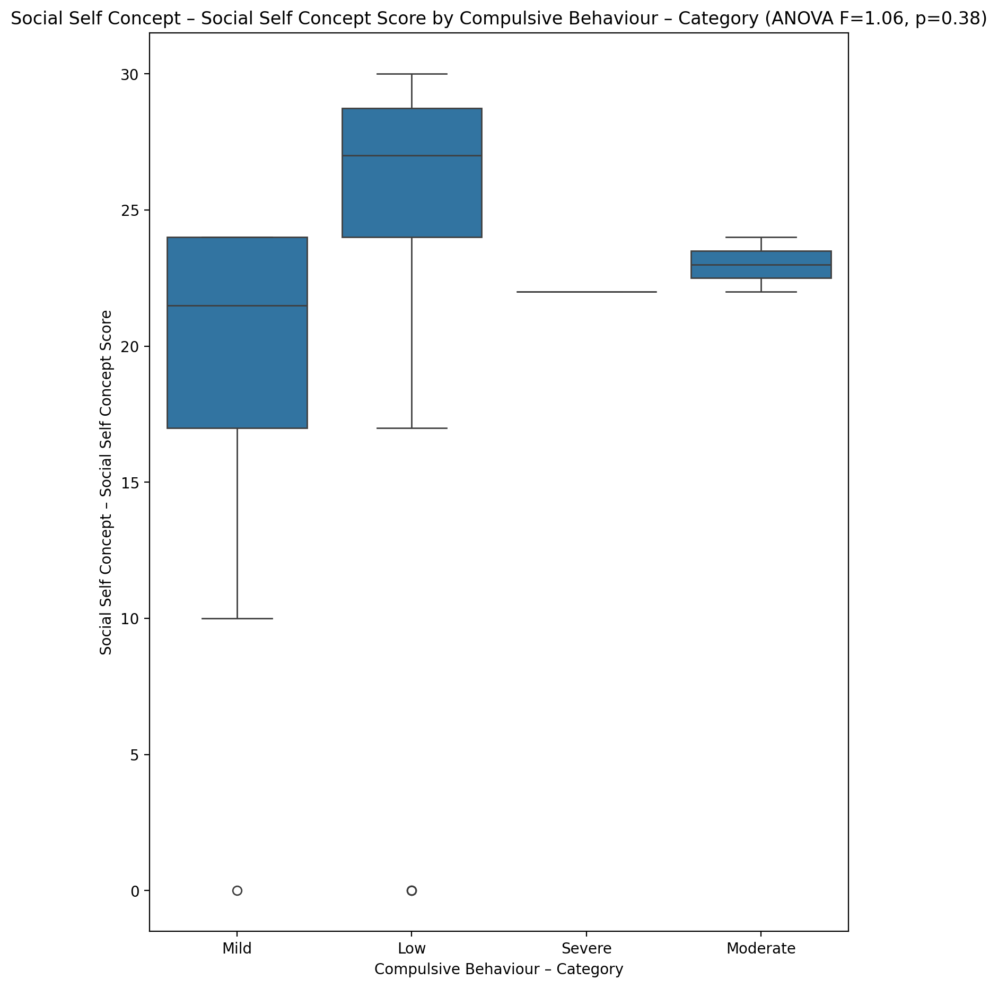

## Ability Self Concept - Real Self Concept Score vs Compulsive Behaviour – Category

Test: anova; statistic: 0.6471076093717603; p-value: 0.5894963375449124;

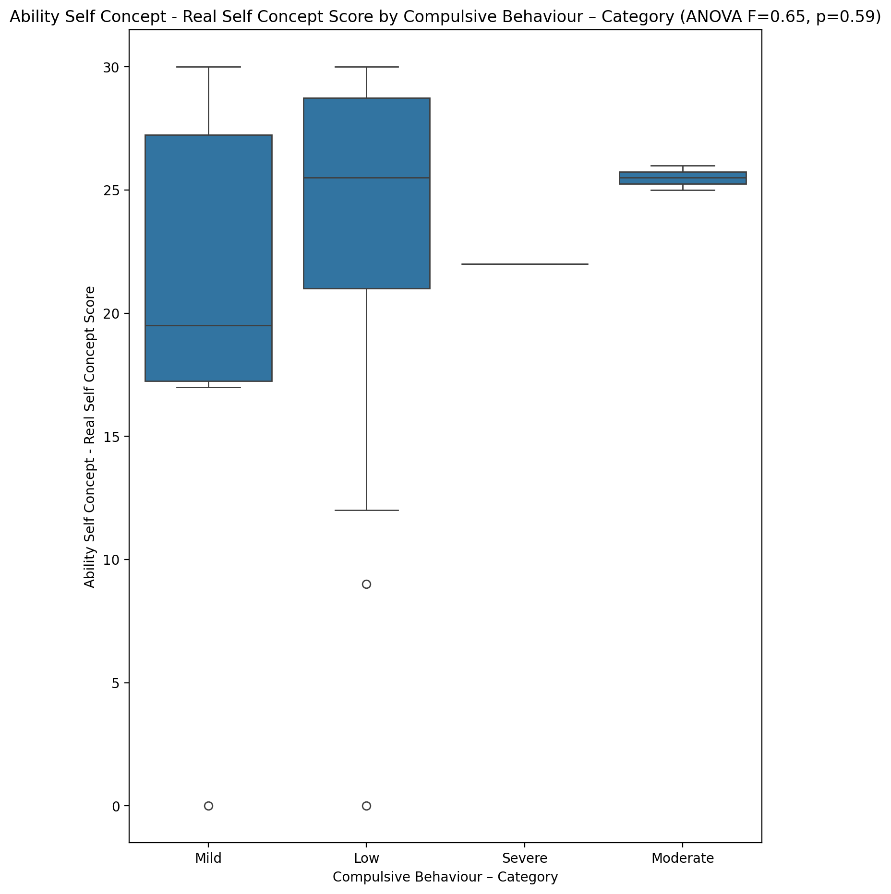

## Ability Self Concept - Ideal Self Concept Score vs Compulsive Behaviour – Category

Test: anova; statistic: 0.9074286149569225; p-value: 0.44626493318793126;

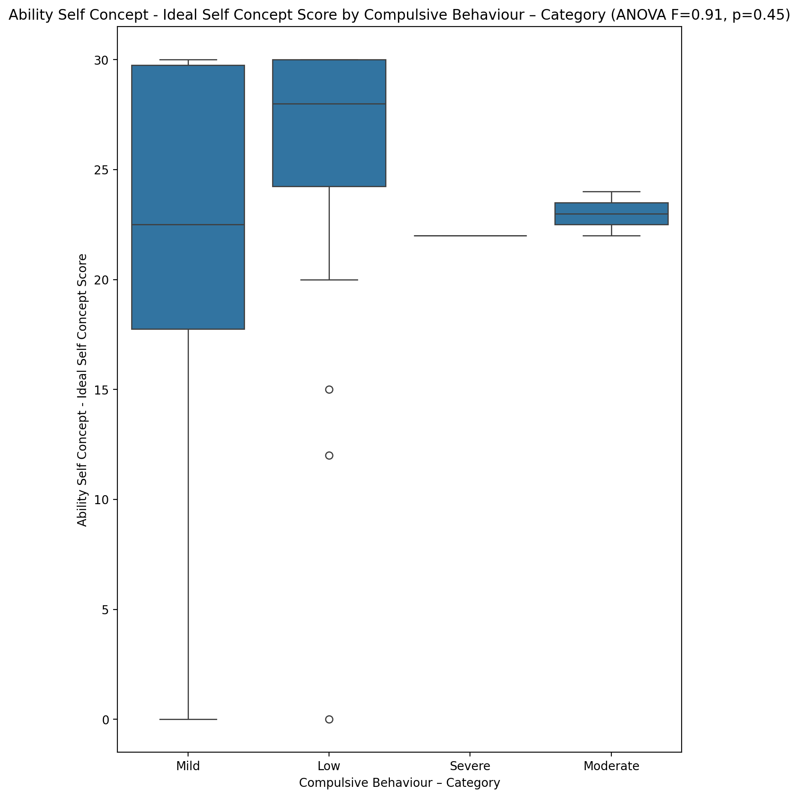

## Ability Self Concept – Social Self Concept Score vs Compulsive Behaviour – Category

Test: anova; statistic: 0.32073877898758063; p-value: 0.8103075696352156;

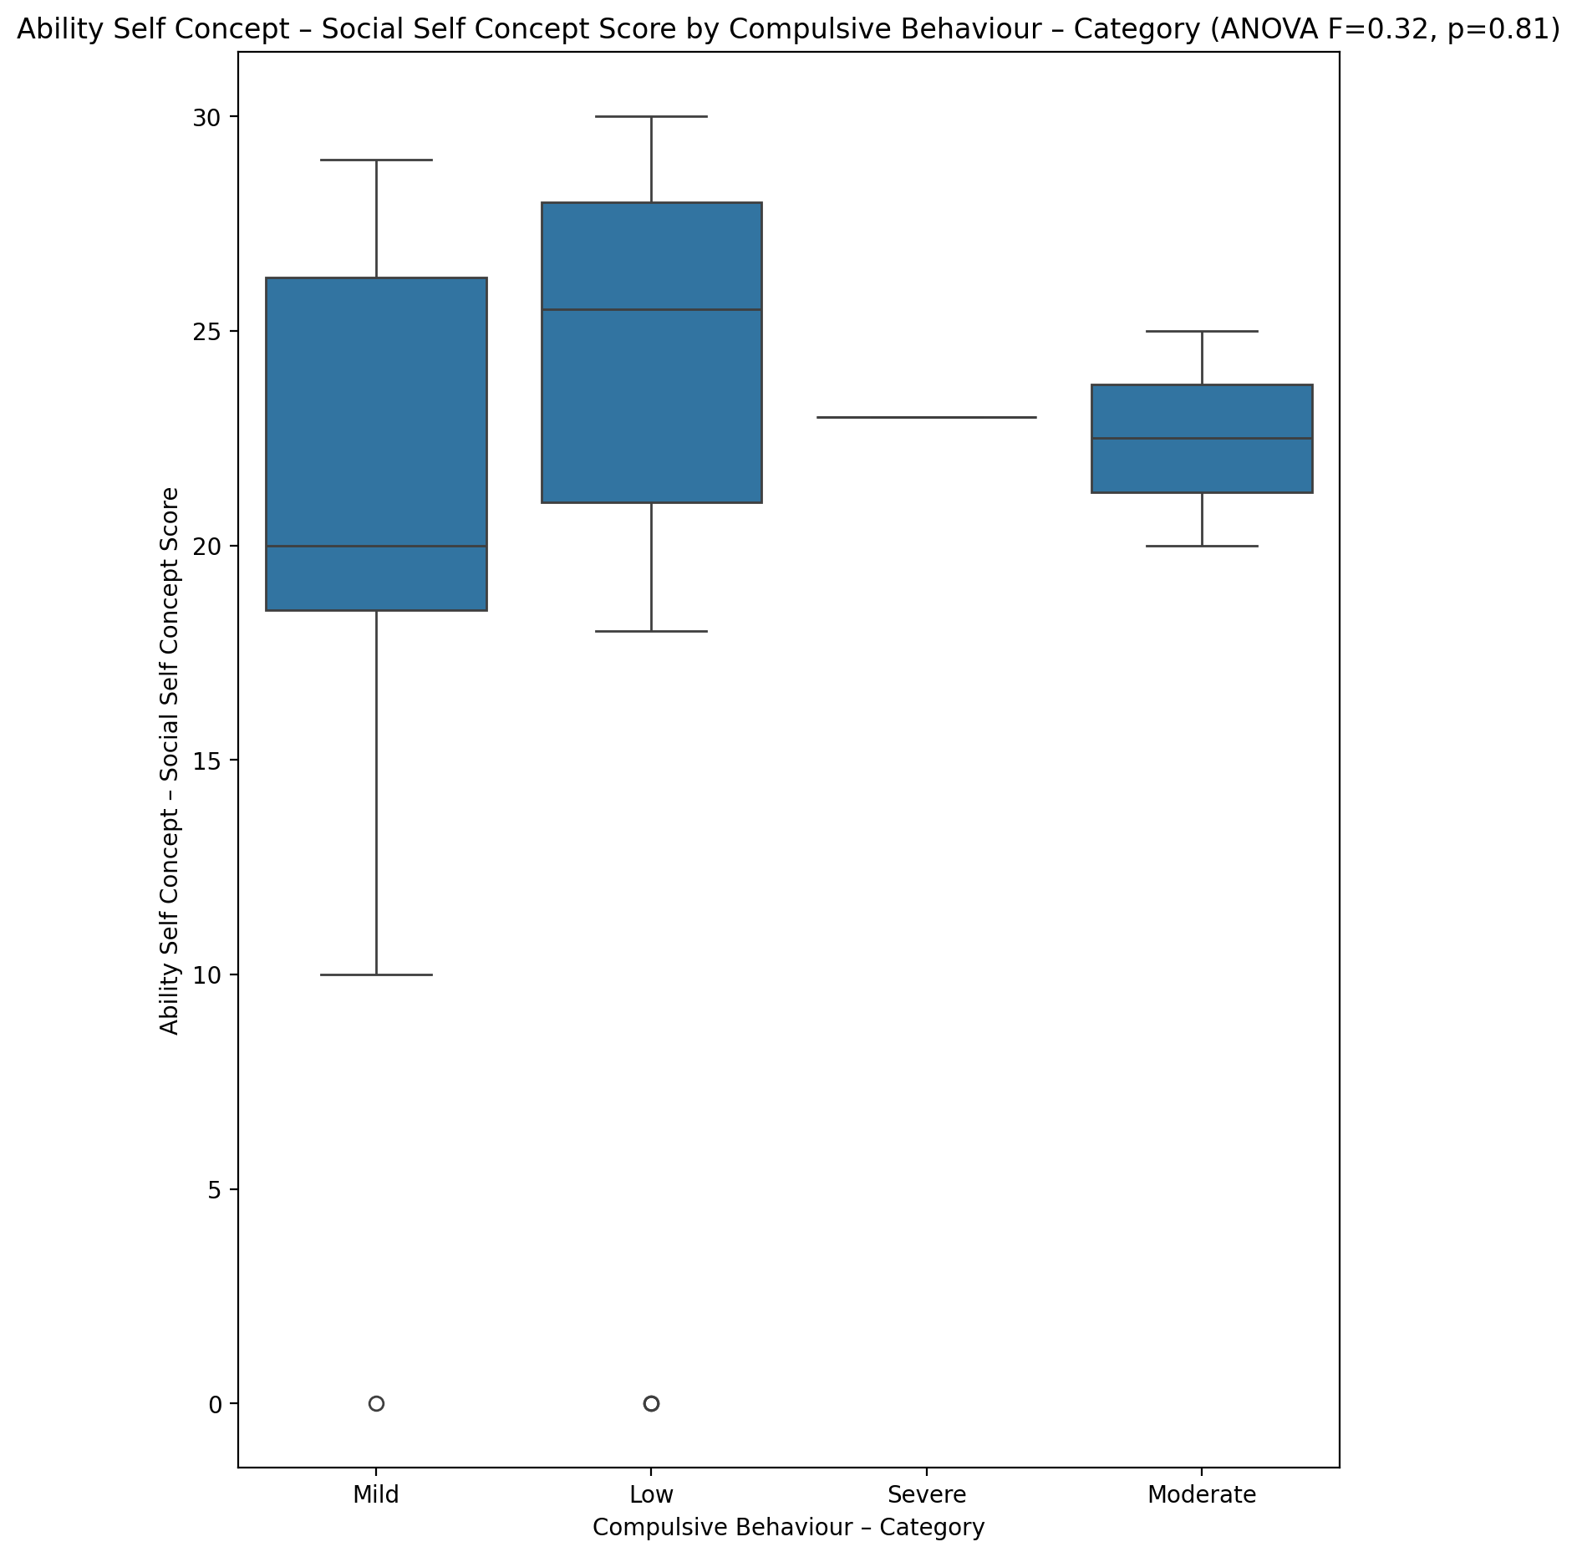

## Physical Self Concept - Real Self Concept Score vs Compulsive Behaviour – Category

Test: anova; statistic: 0.6794517512344265; p-value: 0.5699260966425621;

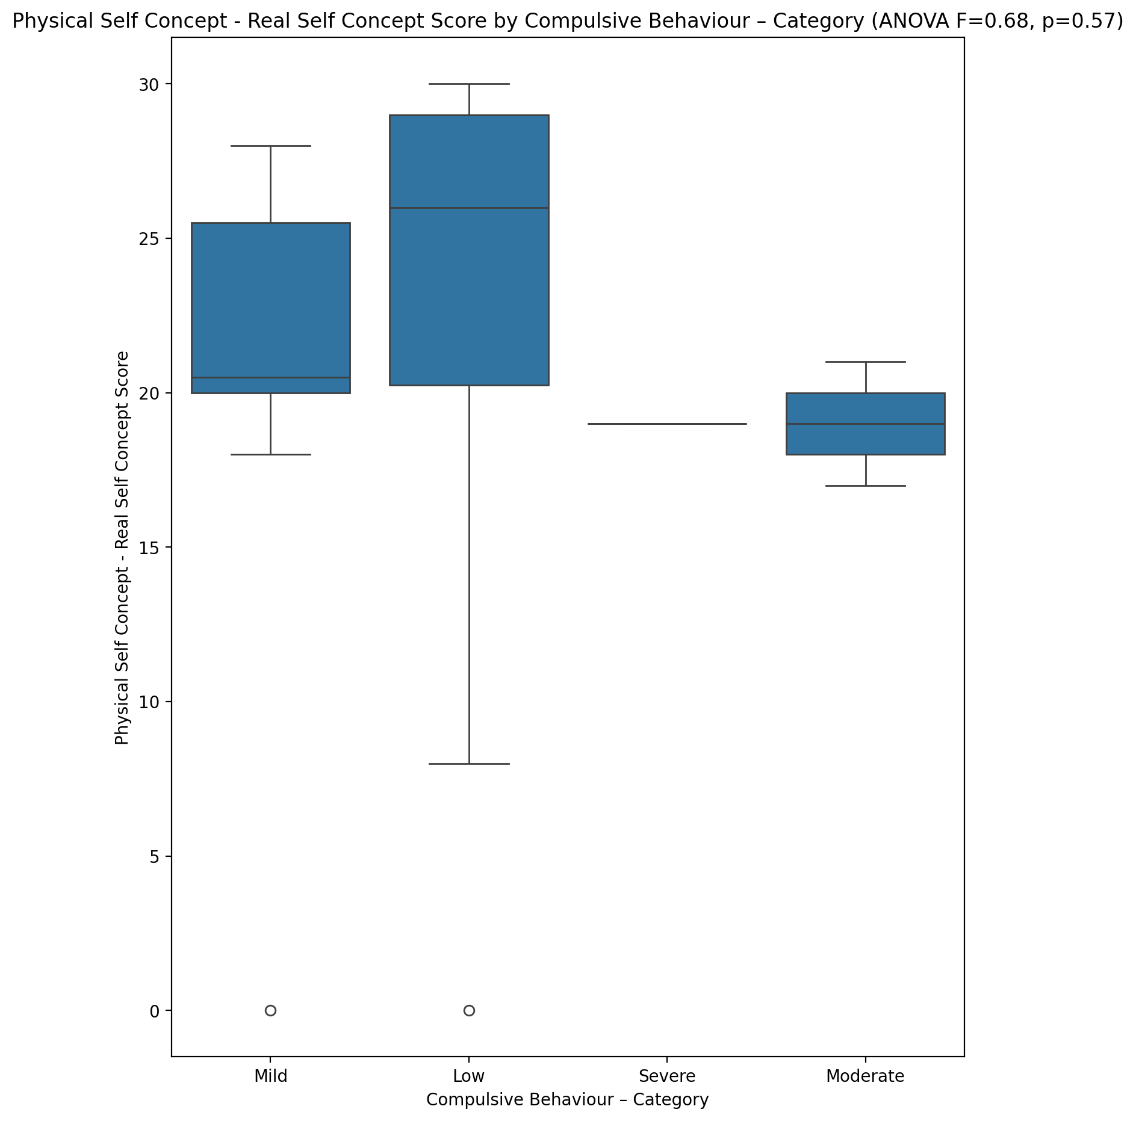

## Physical Self Concept – Ideal Self Concept Score vs Compulsive Behaviour – Category

Test: anova; statistic: 1.0053899269156499; p-value: 0.40067867208539654;

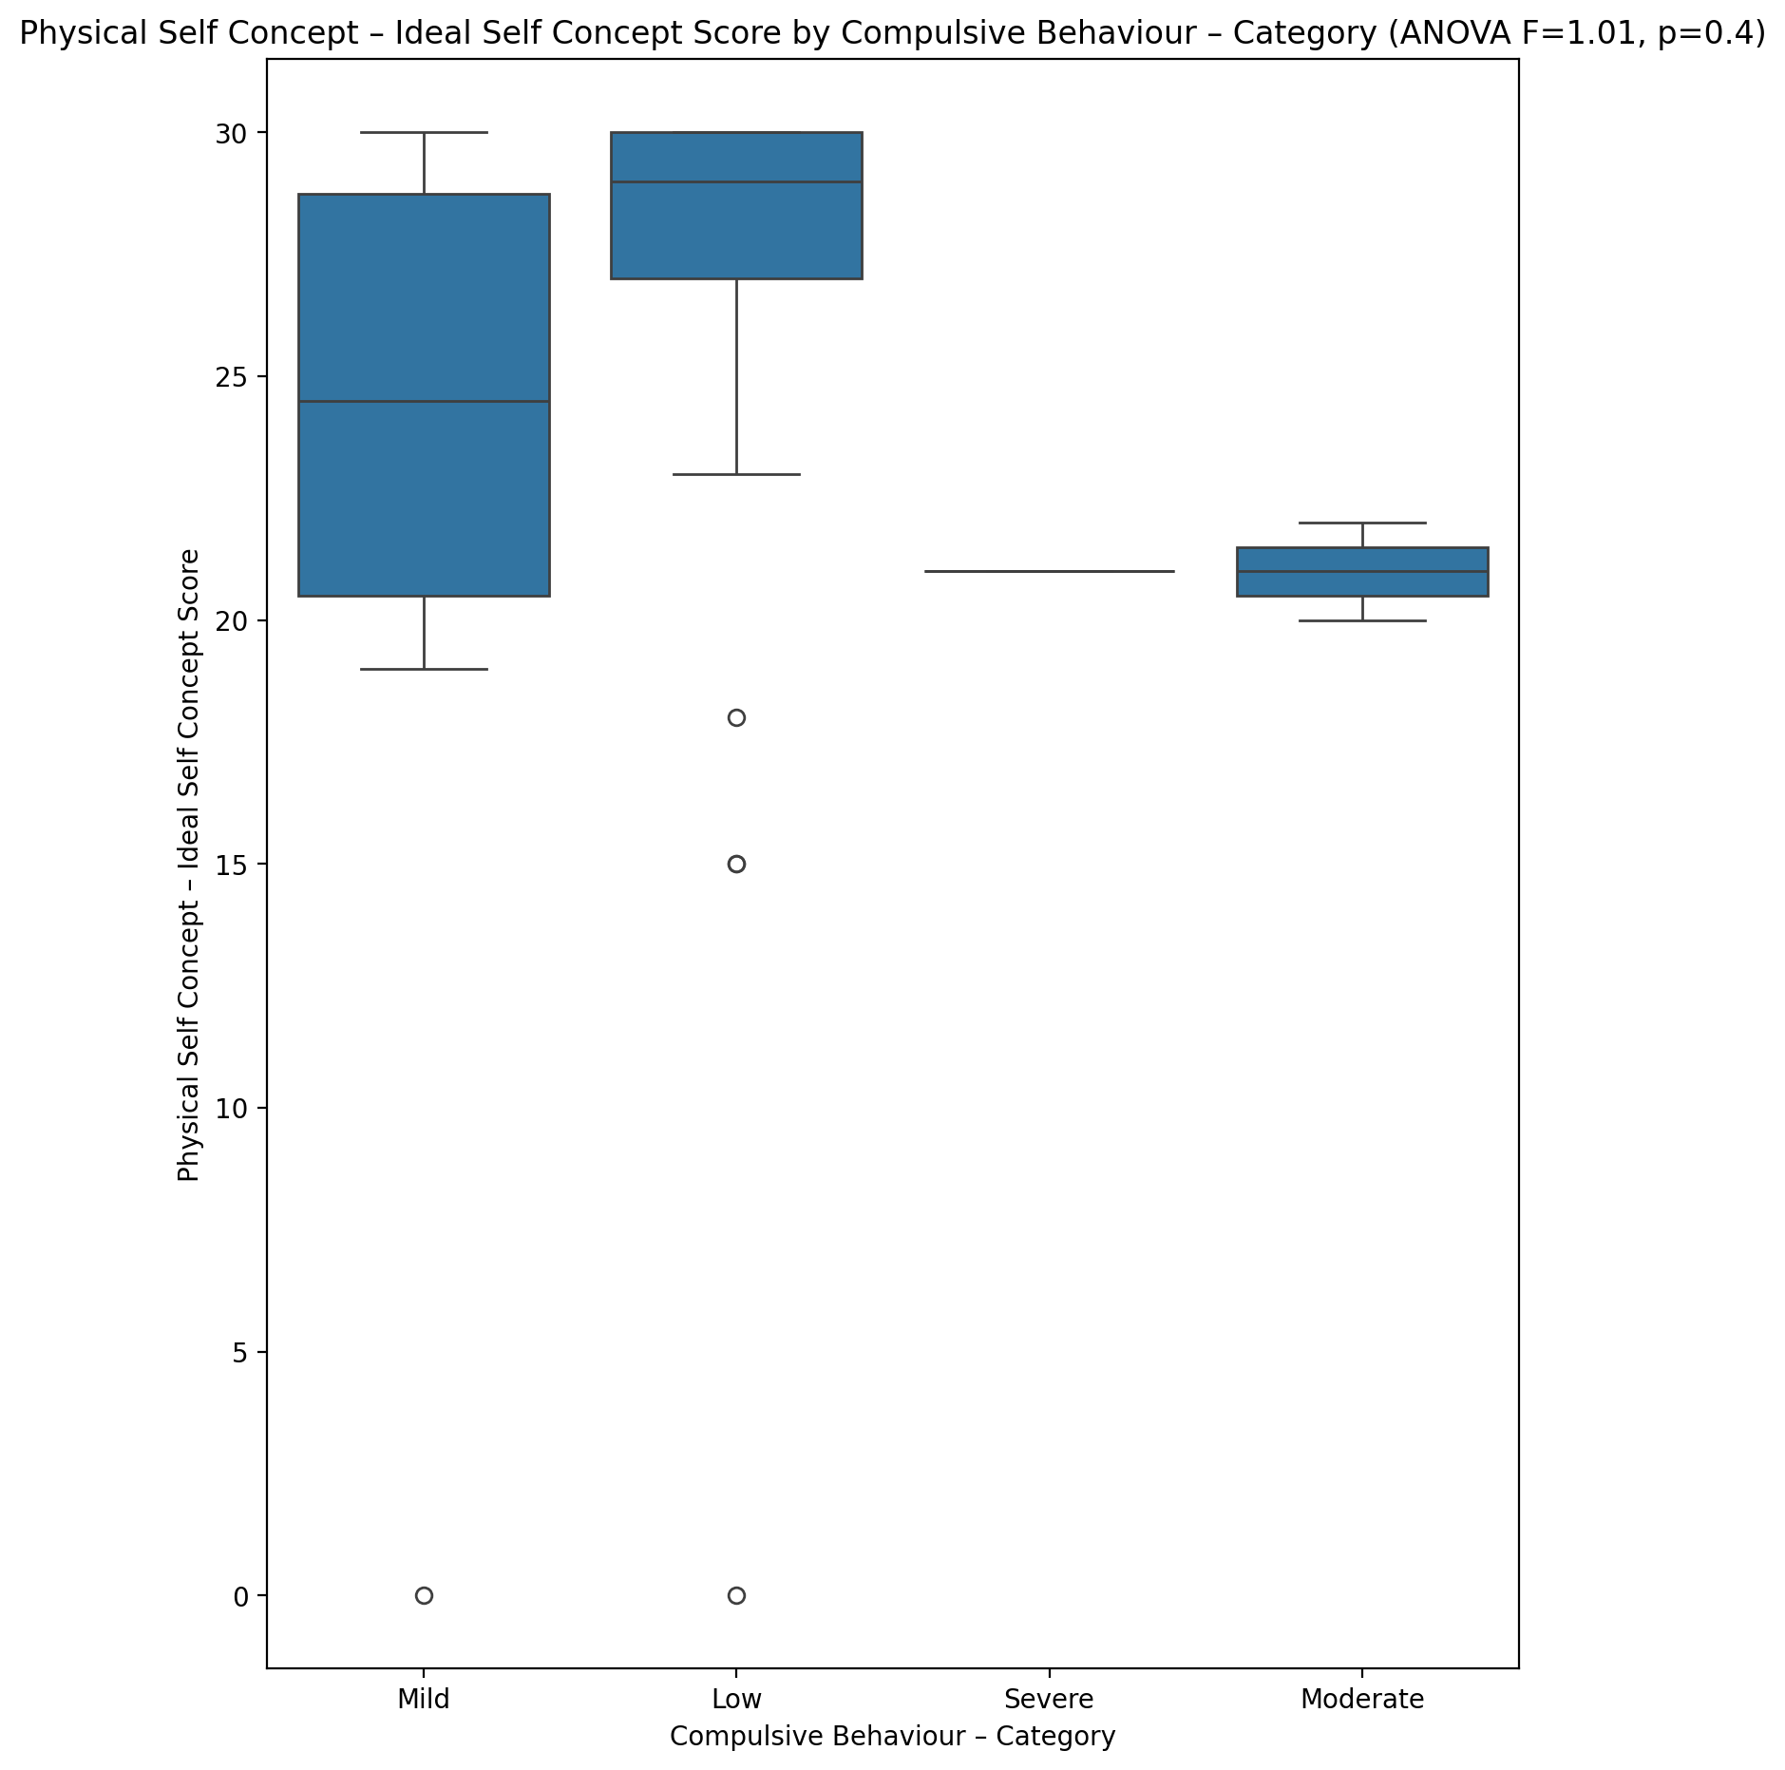

## Physical Self Concept – Social Self Concept Score vs Compulsive Behaviour – Category

Test: anova; statistic: 0.4465080631146483; p-value: 0.7211483103527888;

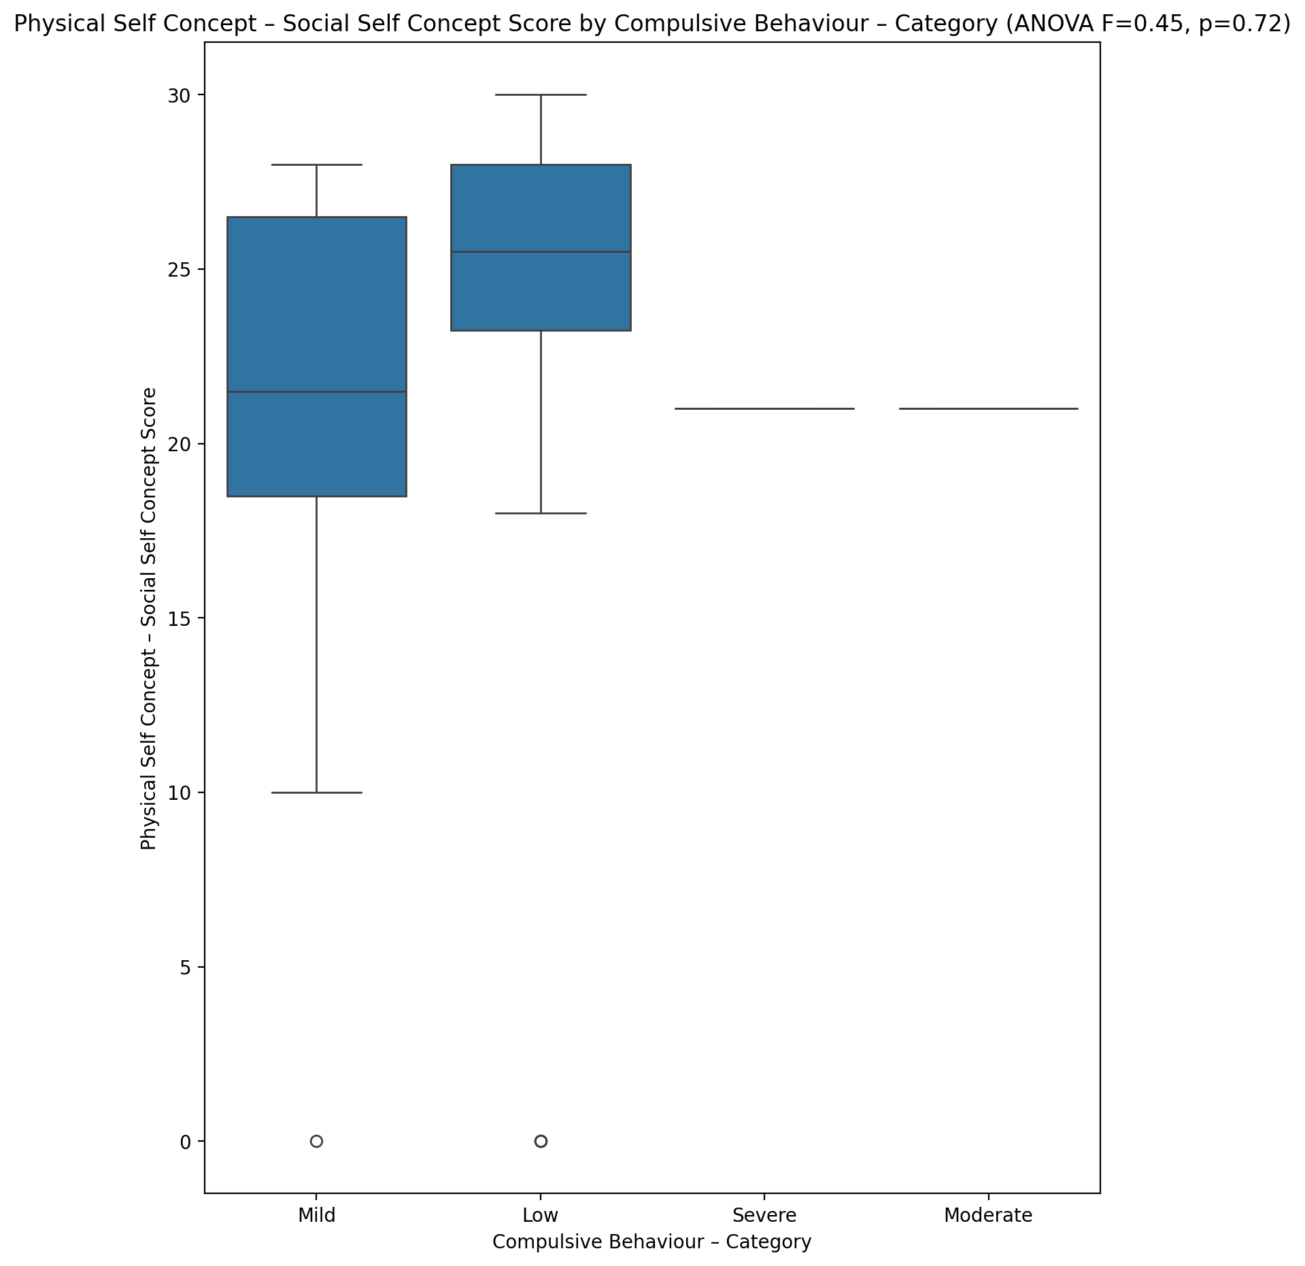

## Psychological Self Concept - Real Self Concept Score vs Compulsive Behaviour – Category

Test: anova; statistic: 0.9633176666933212; p-value: 0.4197207187898774;

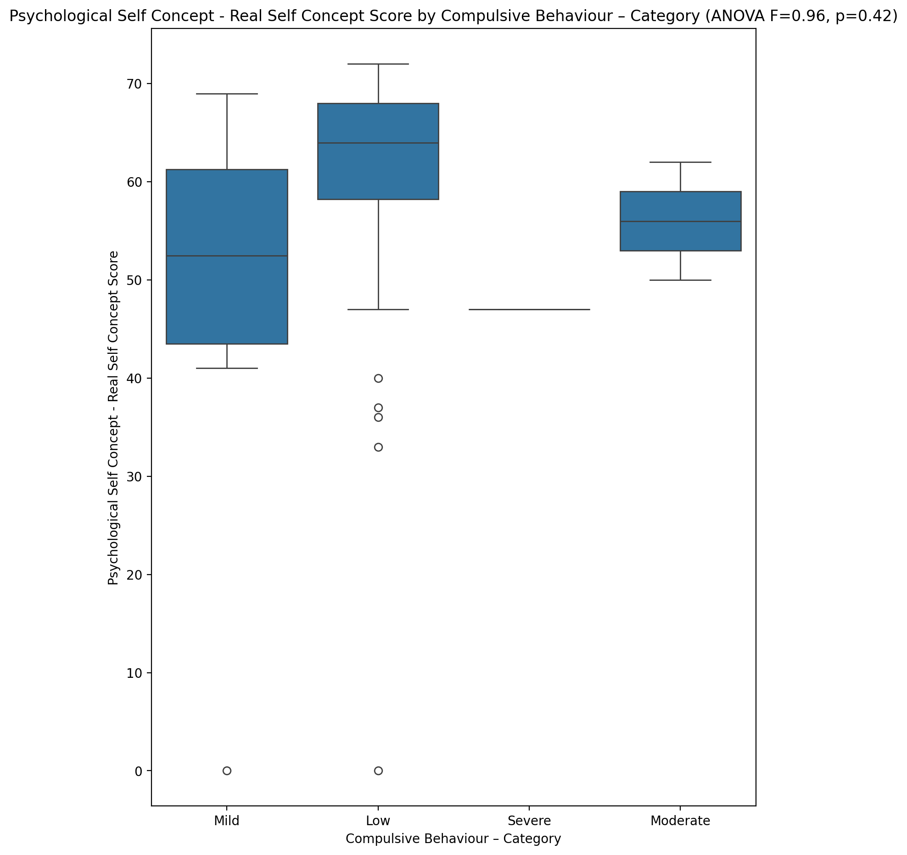

## Psychological Self Concept – Ideal Self Concept Score vs Compulsive Behaviour – Category

Test: anova; statistic: 0.8175736641772829; p-value: 0.49201669338194465;

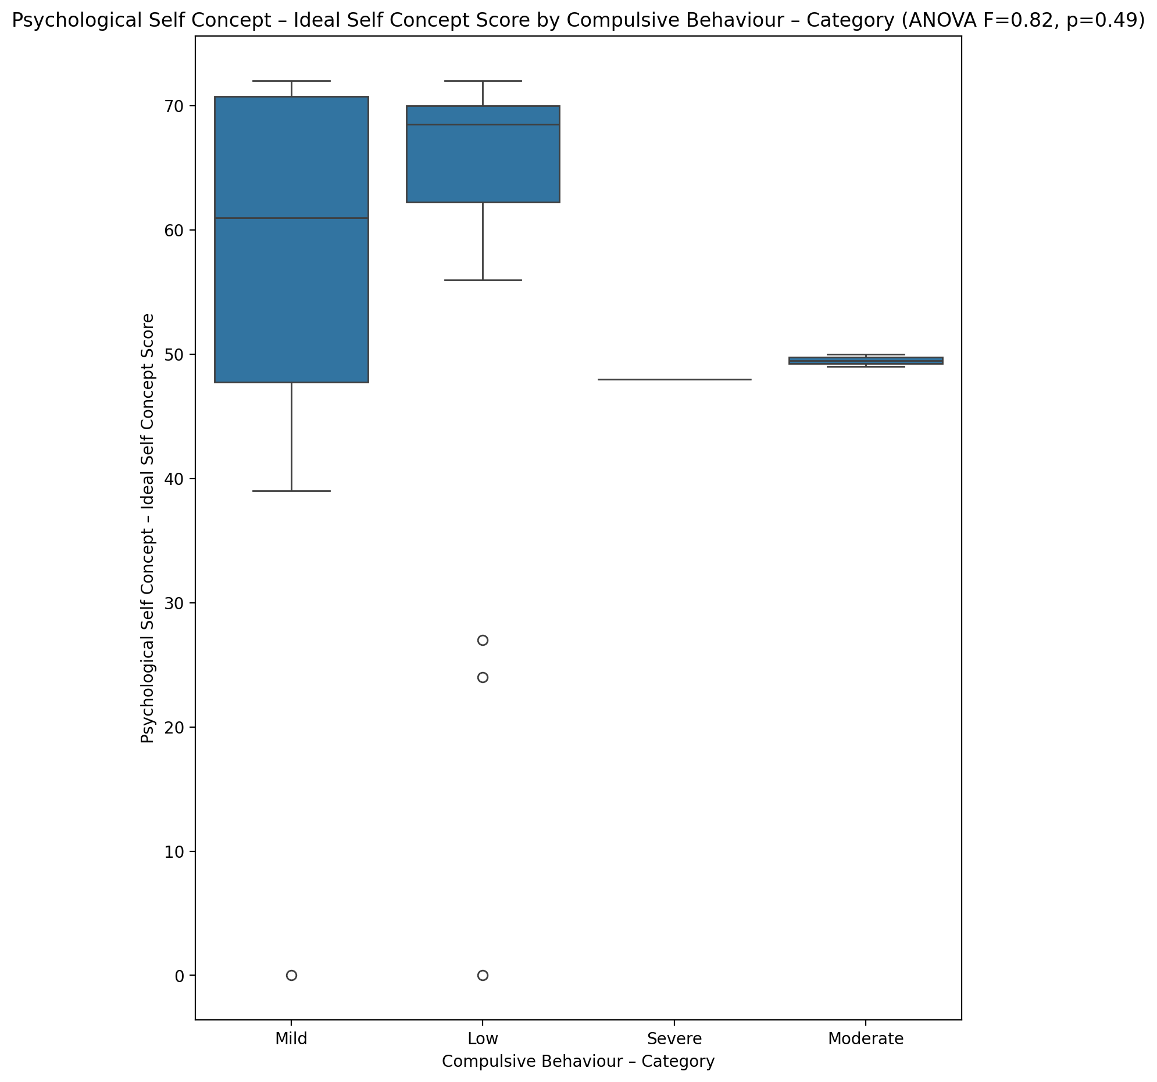

## Psychological Self Concept – Social Self Concept Score vs Compulsive Behaviour – Category

Test: anova; statistic: 0.7222860295912812; p-value: 0.5447779597547775;

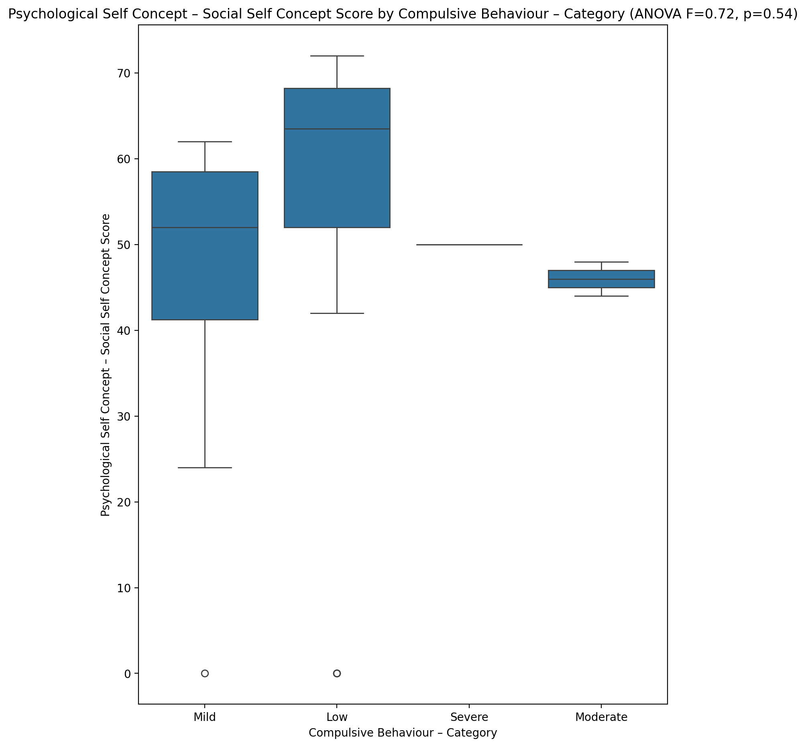

## Real Self Concept Total Score vs Compulsive Behaviour – Category

Test: anova; statistic: 0.7647364182278985; p-value: 0.5207295820216908;

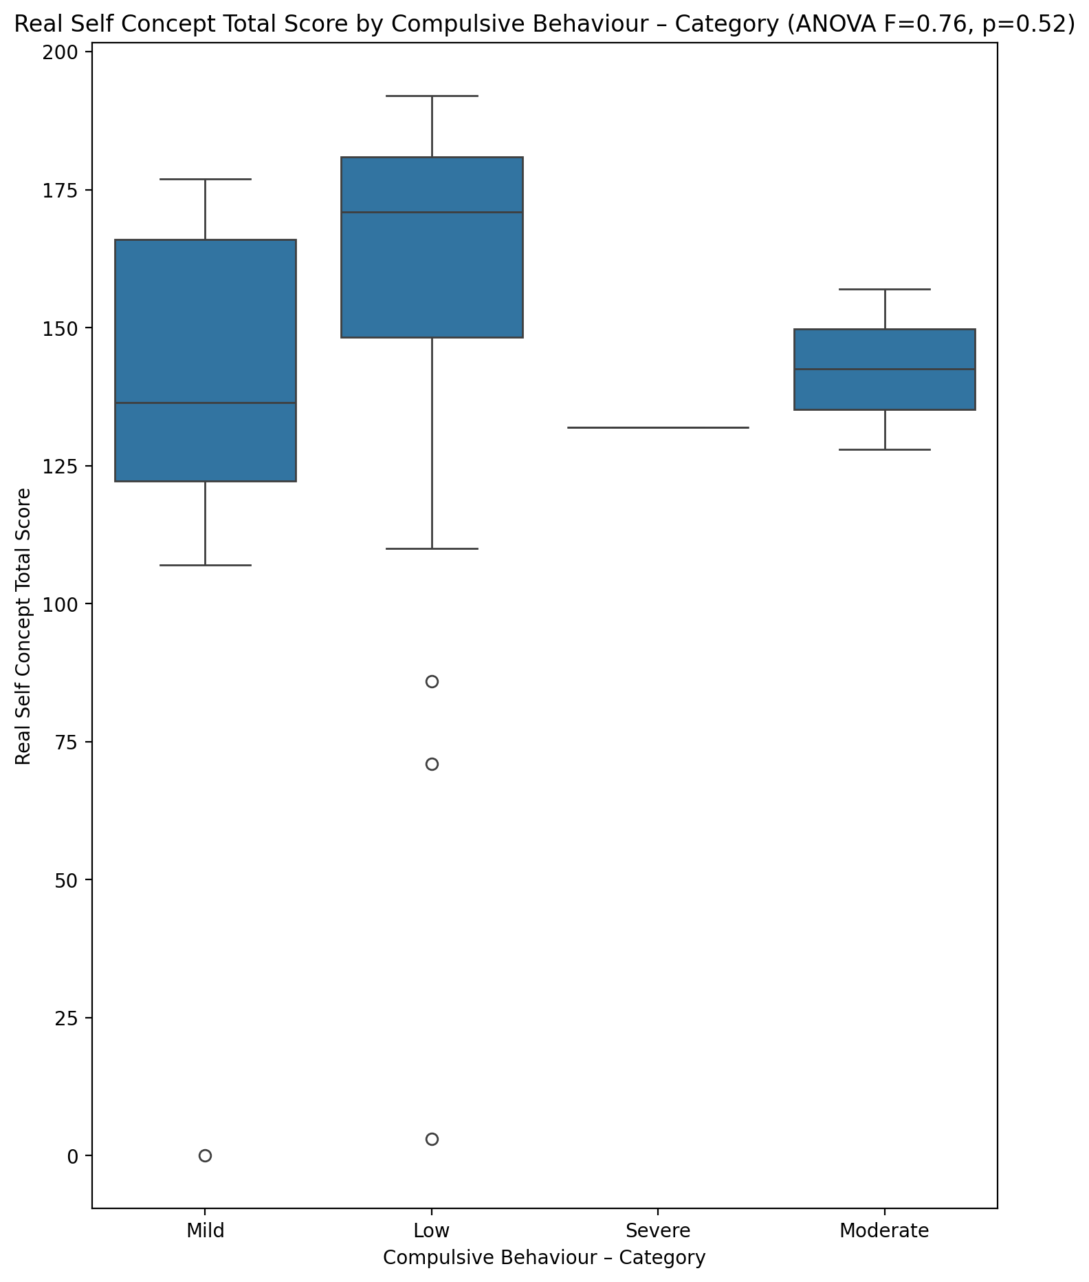

## Ideal Self Concept Total Score vs Compulsive Behaviour – Category

Test: anova; statistic: 0.8100415407085031; p-value: 0.49602730971149334;

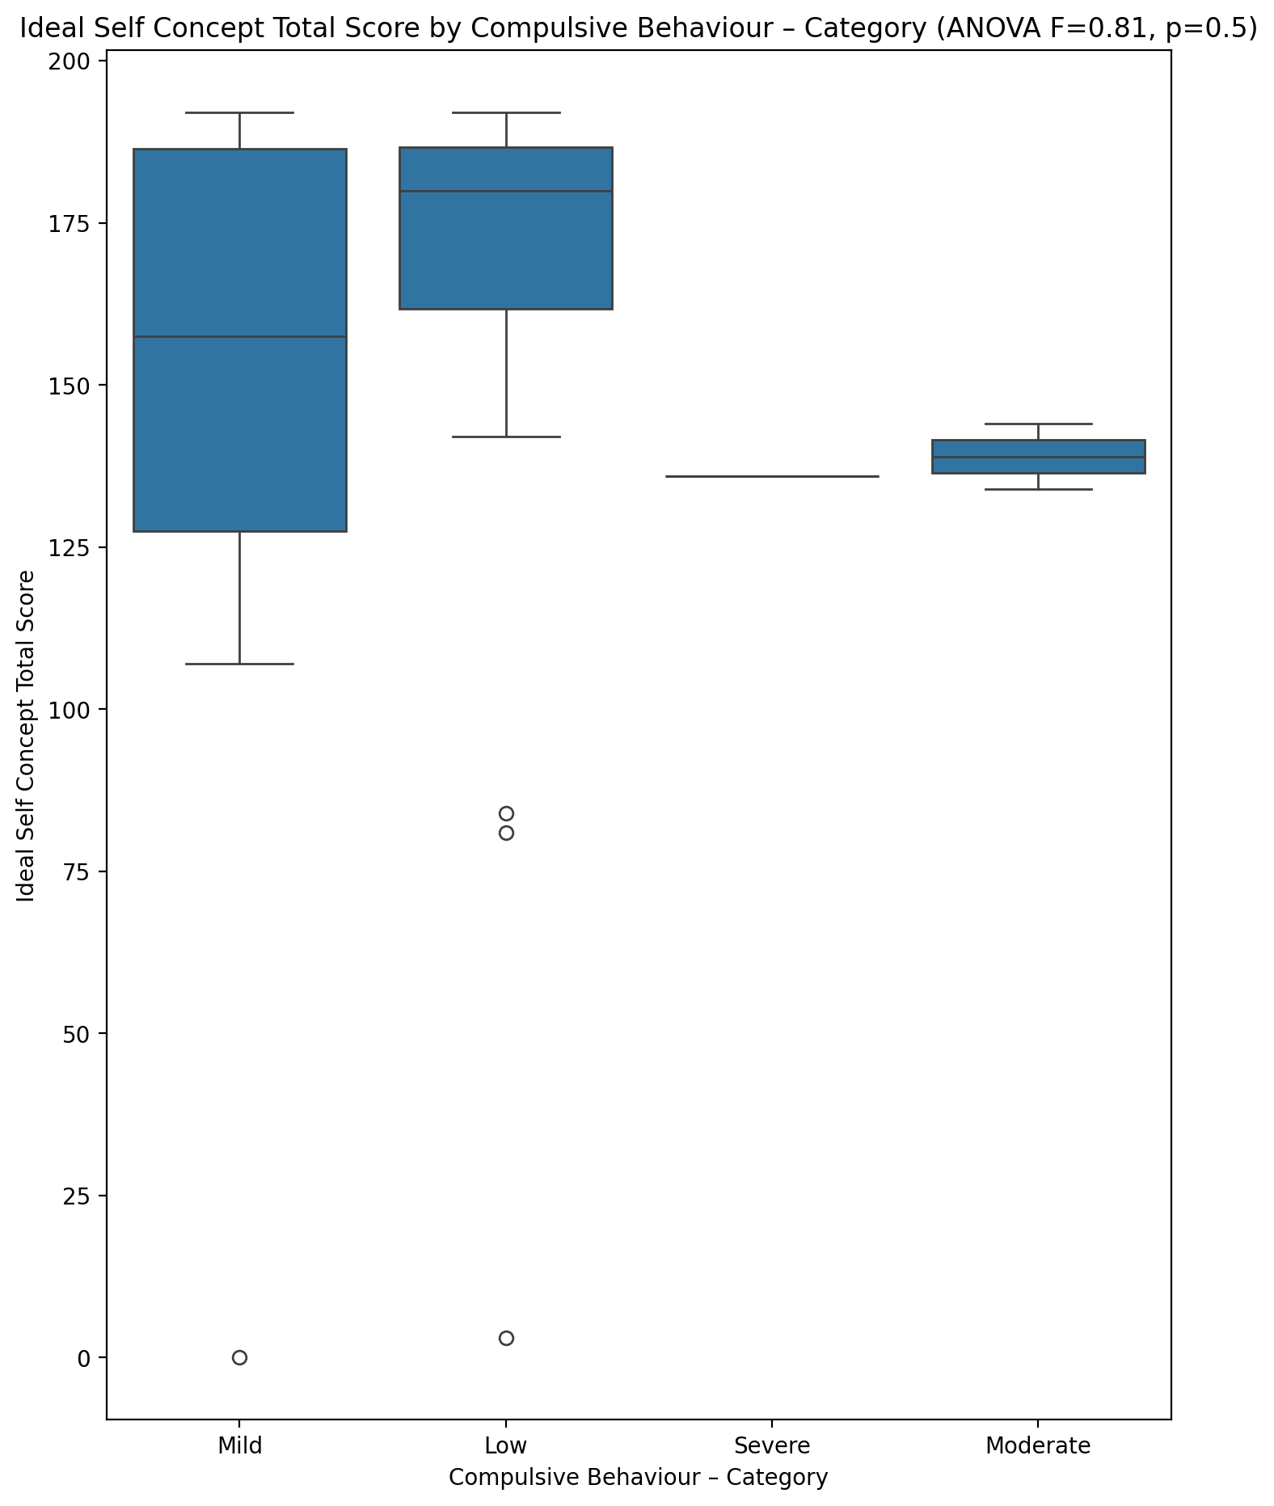

## Social Self Concept Total Score vs Compulsive Behaviour – Category

Test: anova; statistic: 0.6667421258492682; p-value: 0.5775570683781843;

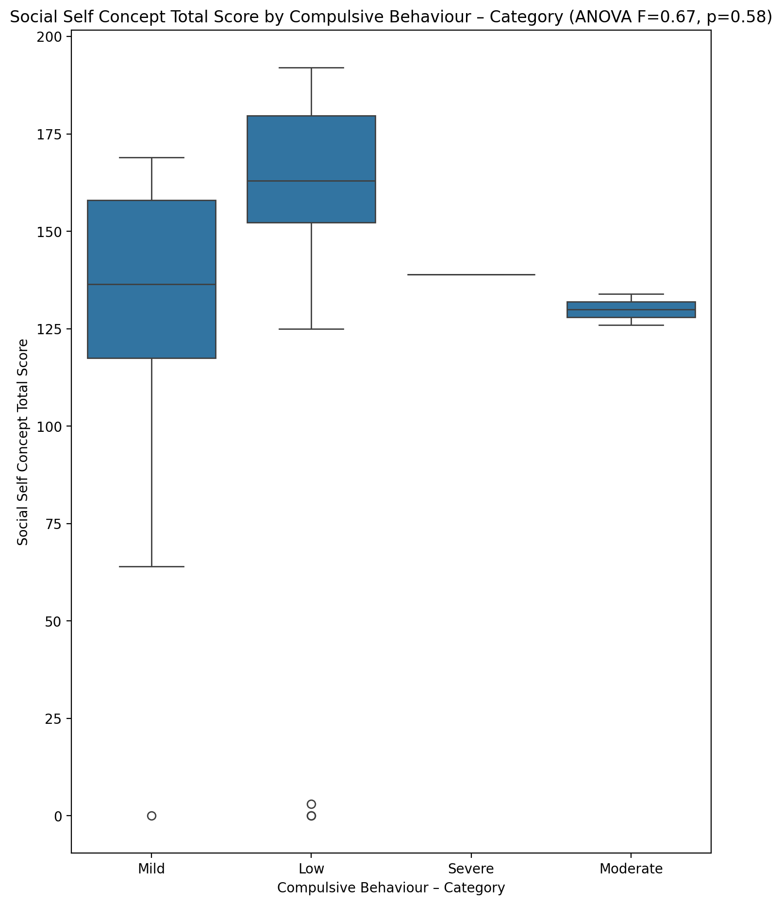

## Ideal Self Concept Total Category vs Compulsive Behaviour – Category

Test: chi2; statistic: 20.927822580645163; p-value: 0.0018902045077564972;

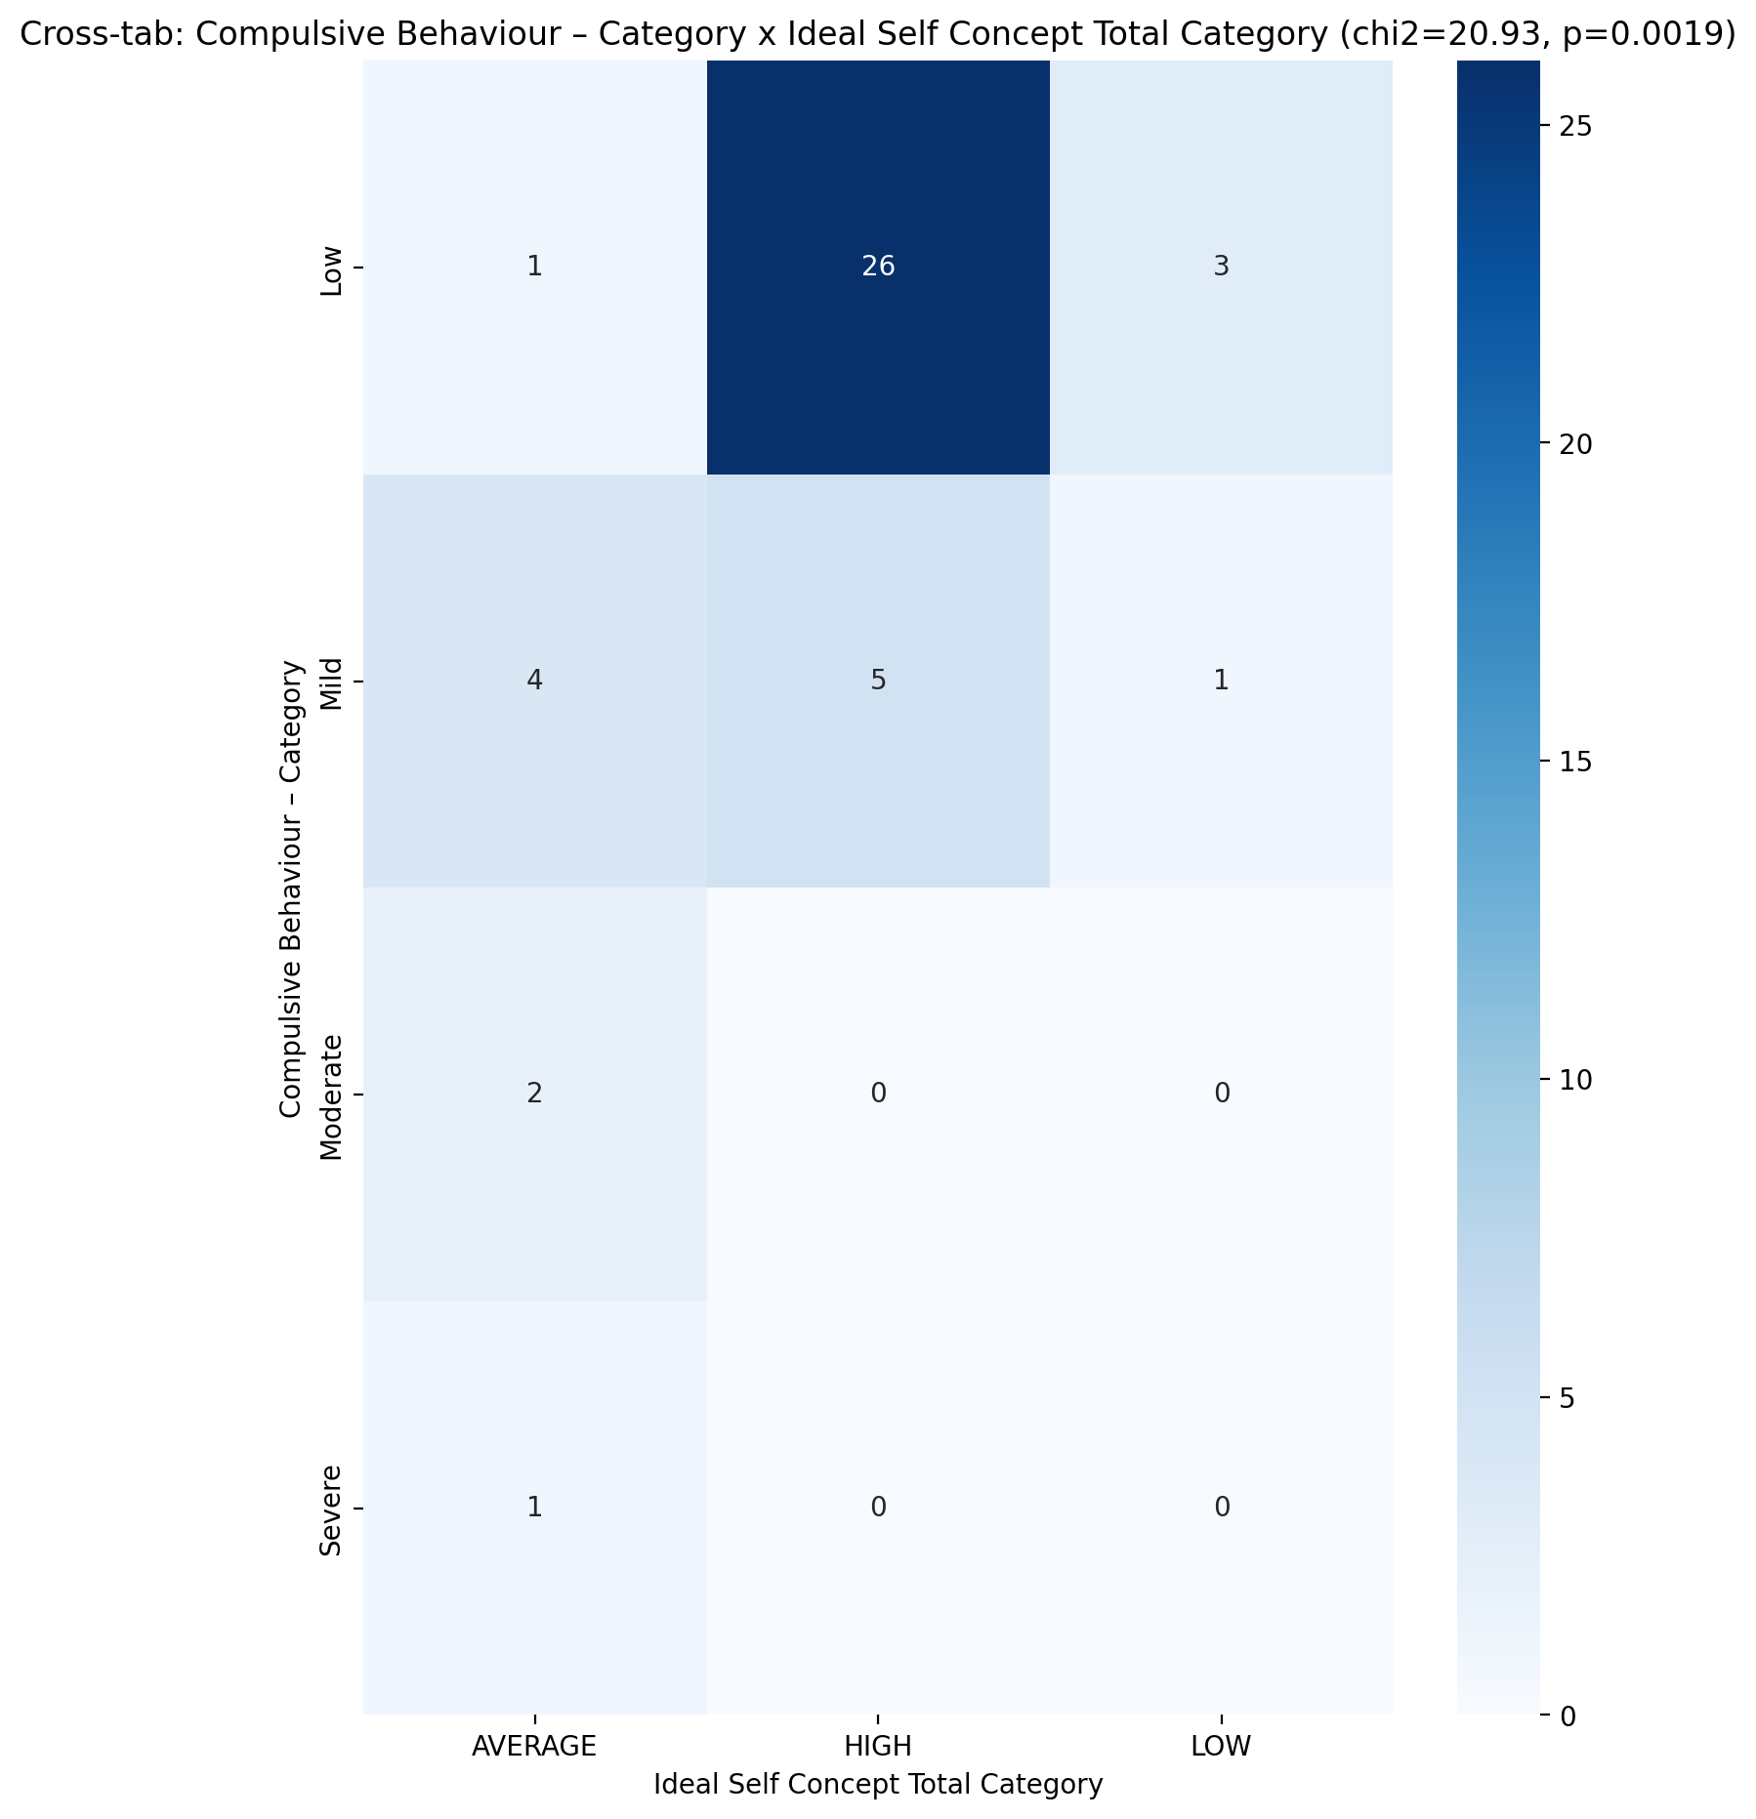

## Perceived Social Stress Score vs Compulsive Behaviour – Category

Test: anova; statistic: 0.46910186785899743; p-value: 0.7055360444421732;

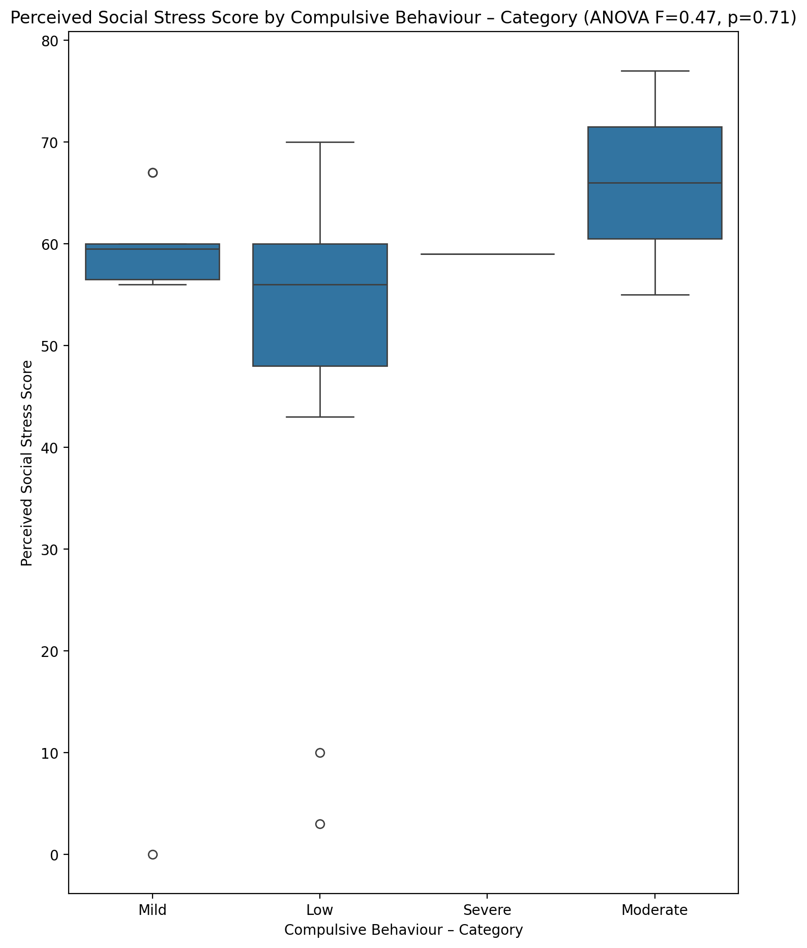

## Perceived Social Stress Category vs Compulsive Behaviour – Category

Test: chi2; statistic: 0.3702777777777778; p-value: 0.9463115973080725;

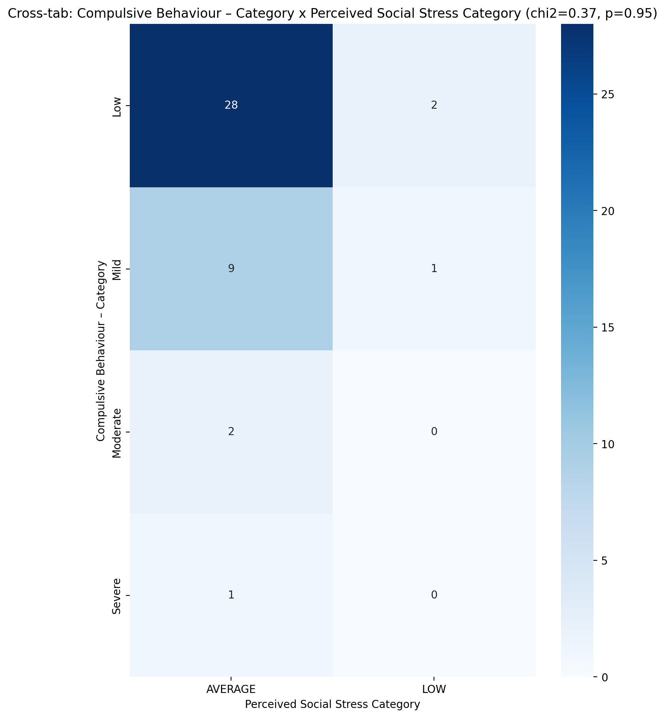

## Emotional Support - Raw Score vs Obsession with Internet – Category

Test: anova; statistic: 2.8973348653545936; p-value: 0.04716773061658144;

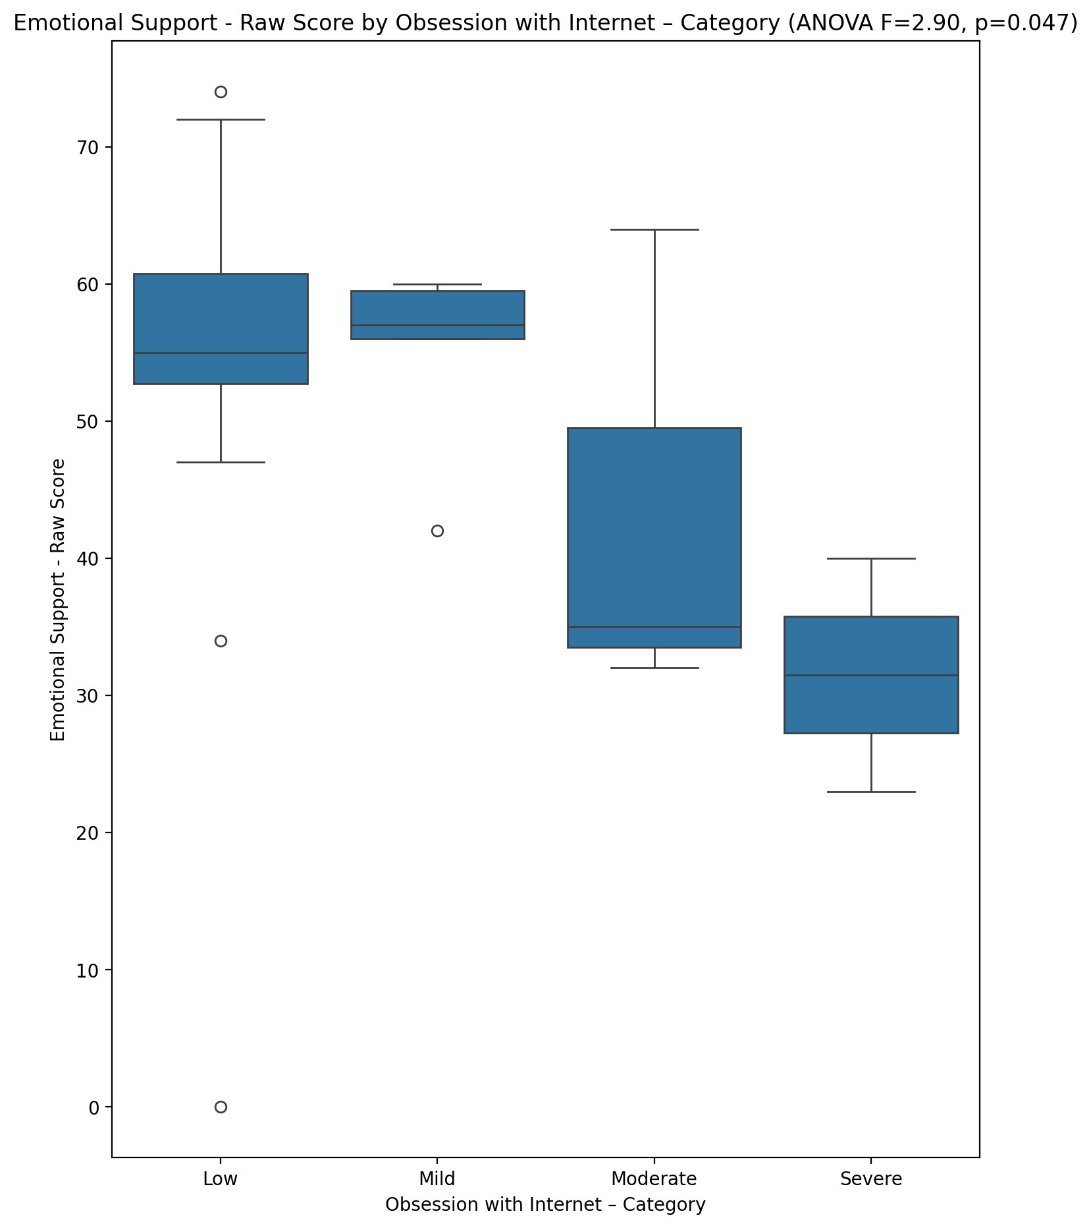

## Informational Support - Raw Score vs Obsession with Internet – Category

Test: anova; statistic: 1.7527729158866596; p-value: 0.17218608751963574;

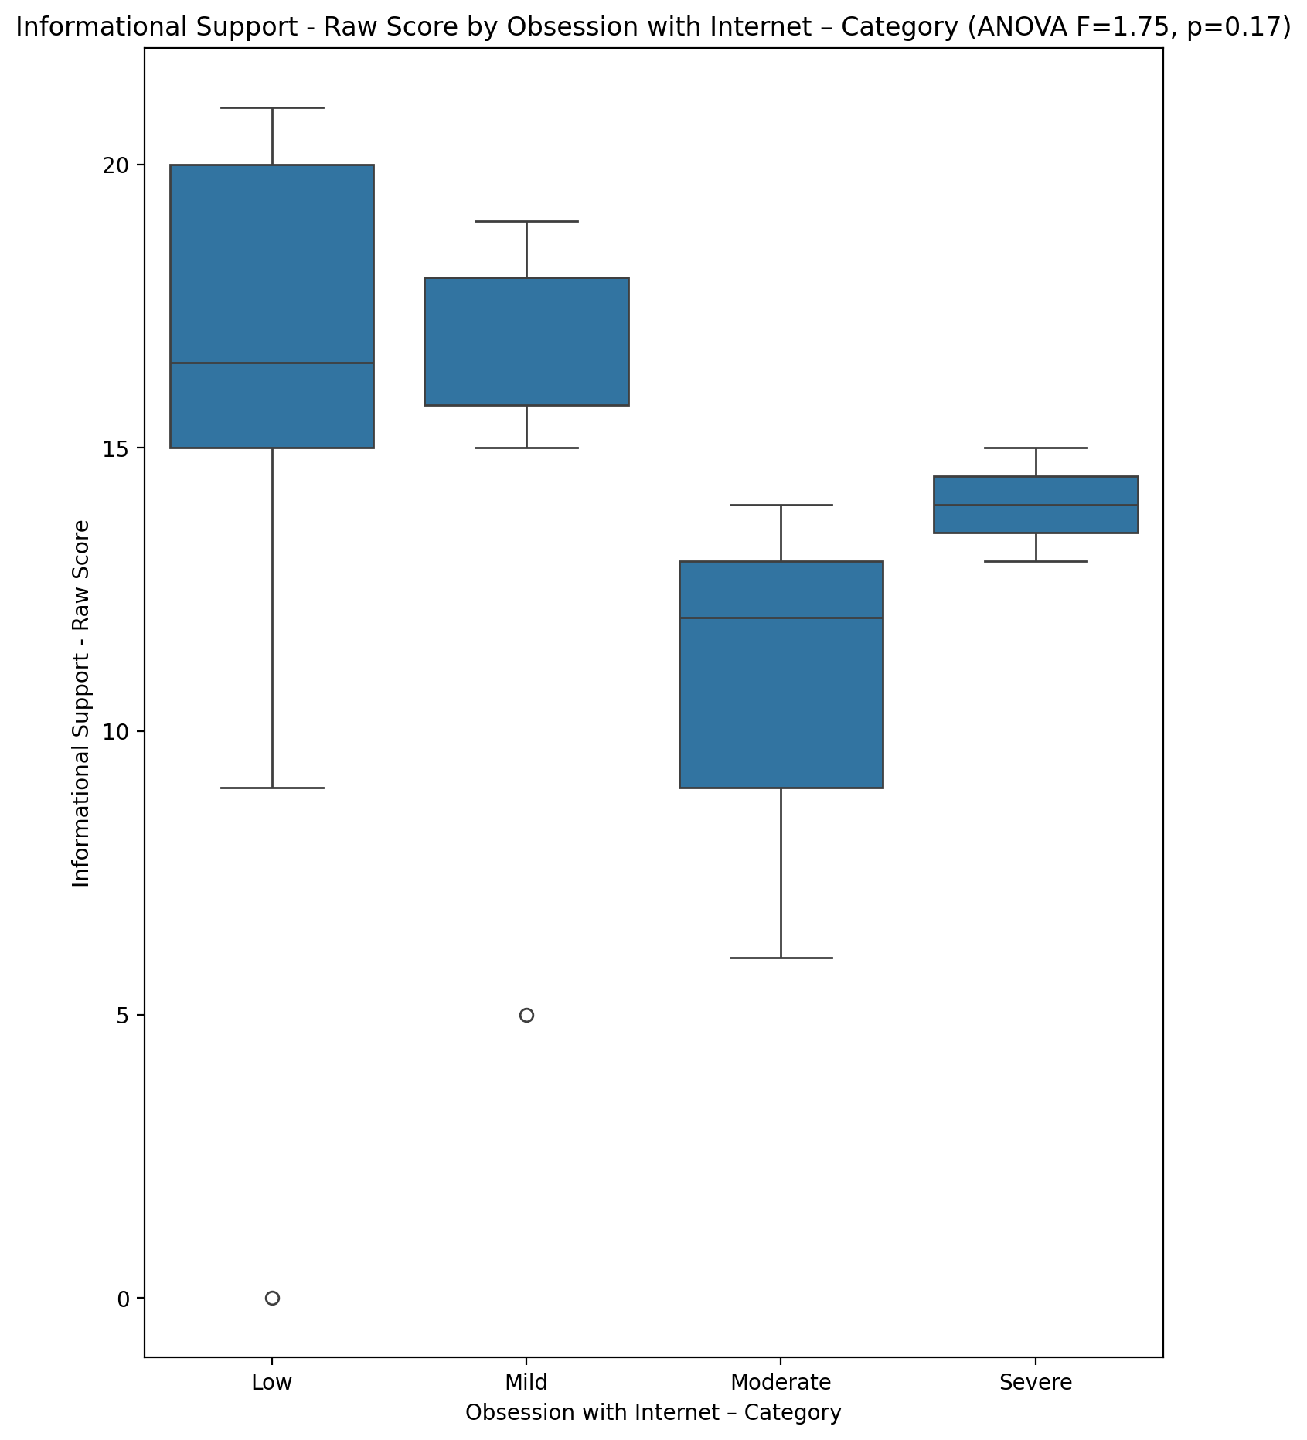

## Instrumental Support - Raw Score vs Obsession with Internet – Category

Test: anova; statistic: 1.6842220700931163; p-value: 0.1861875003199261;

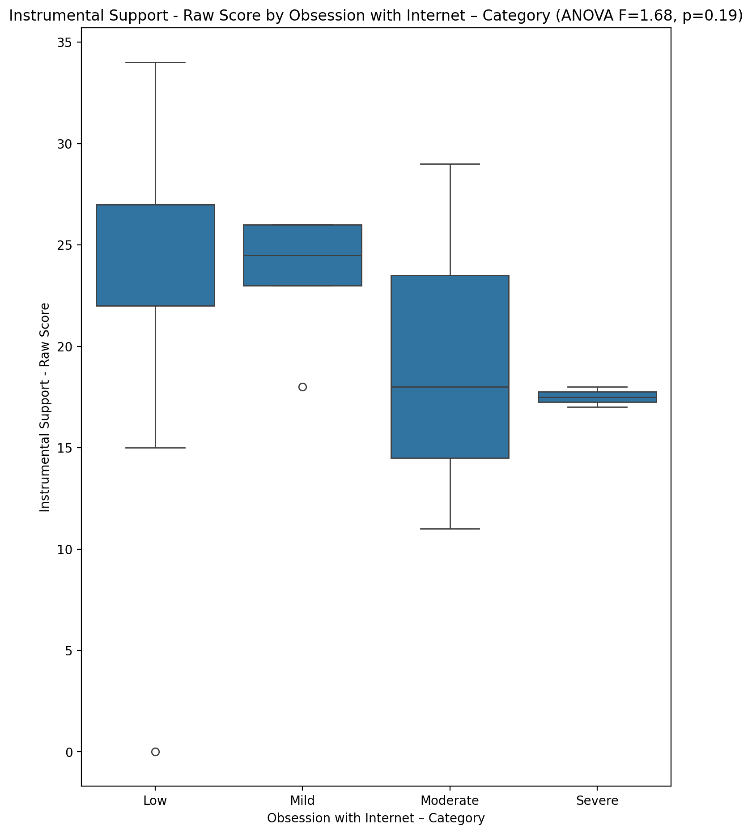

## Emotional Support - T Score vs Obsession with Internet – Category

Test: anova; statistic: 3.238863117730891; p-value: 0.03230703738215413;

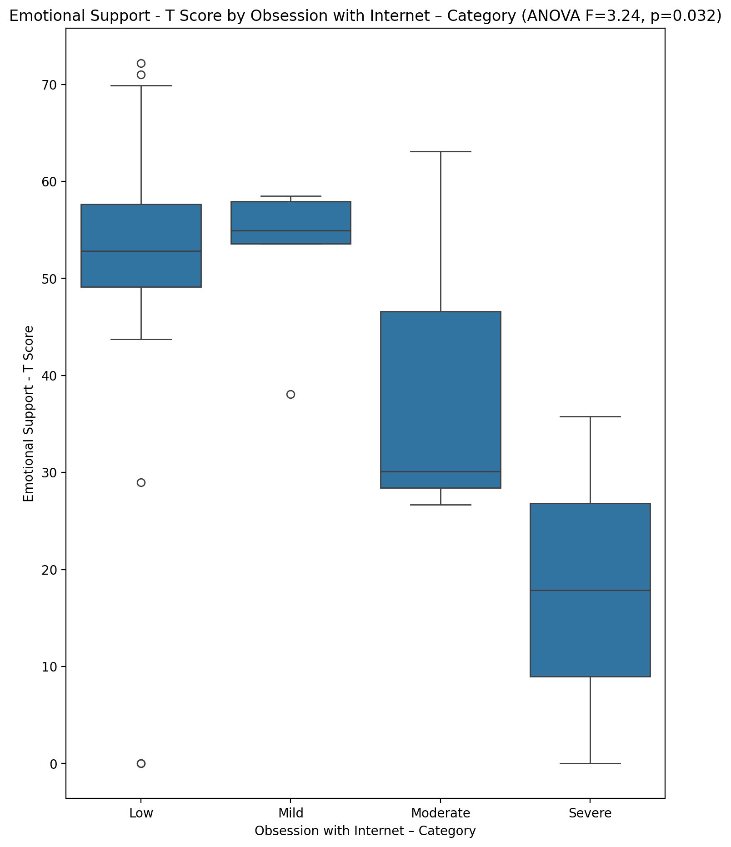

## Informational Support - T Score vs Obsession with Internet – Category

Test: anova; statistic: 2.465431397973304; p-value: 0.076587312068061;

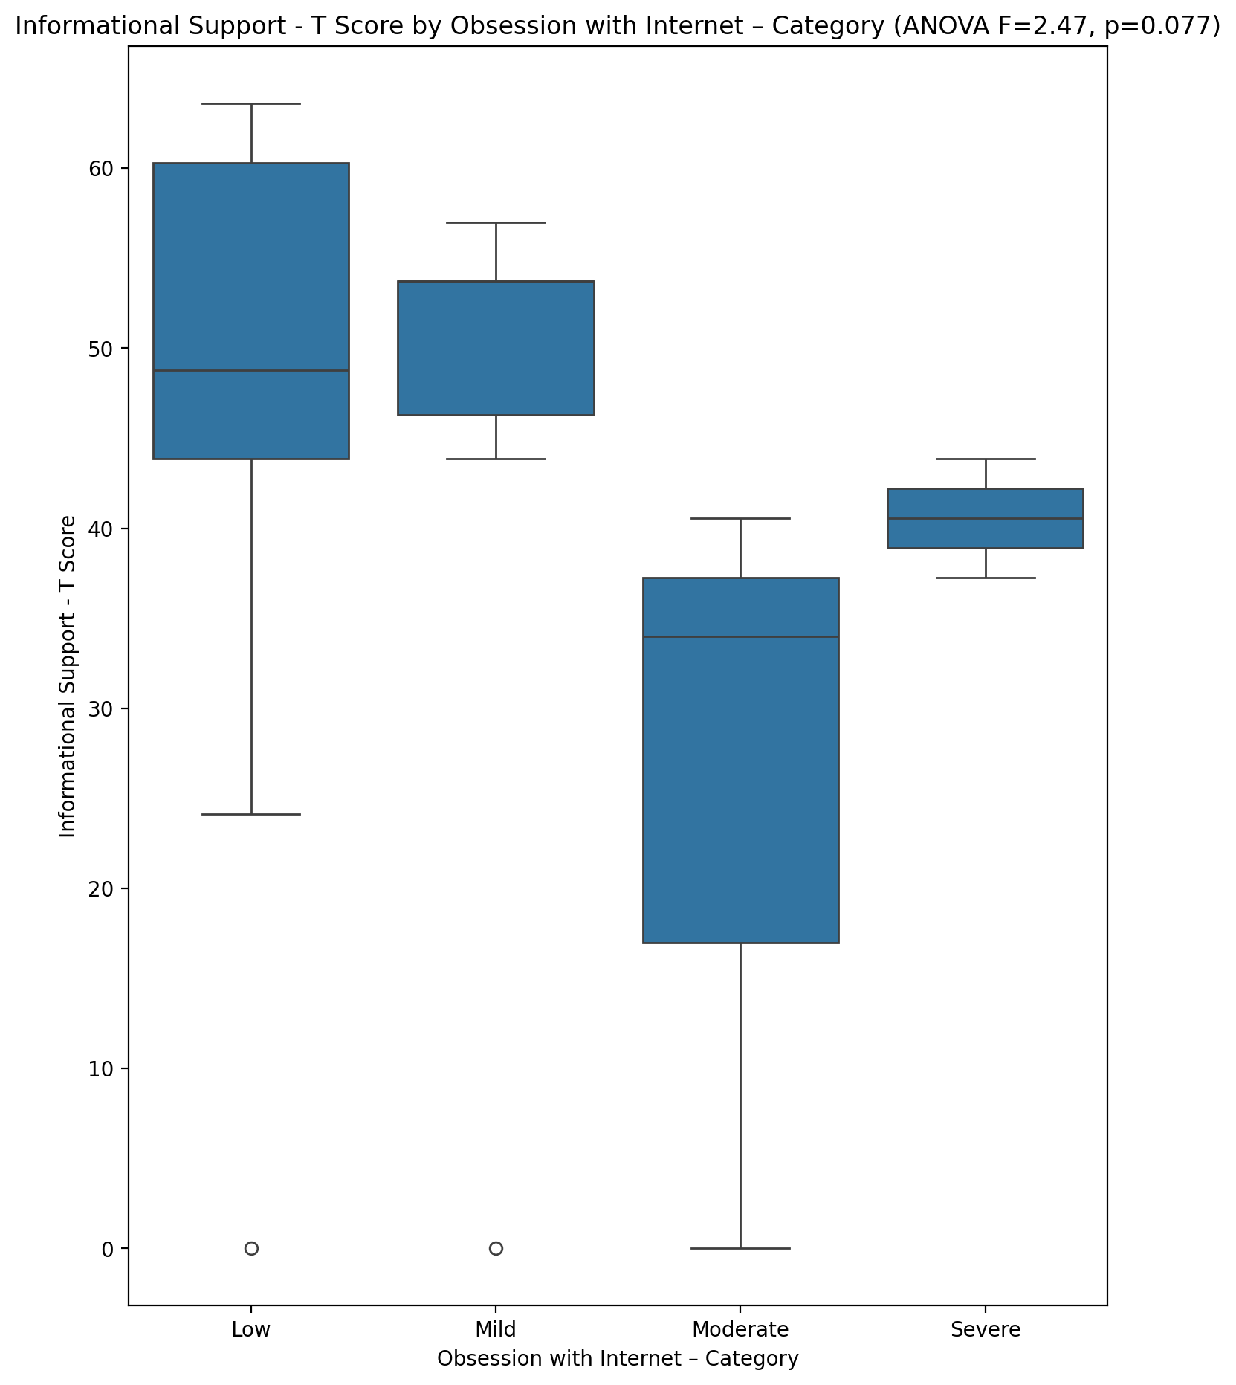

## Instrumental Support - T Score vs Obsession with Internet – Category

Test: anova; statistic: 2.6316096250476932; p-value: 0.06350957974933638;

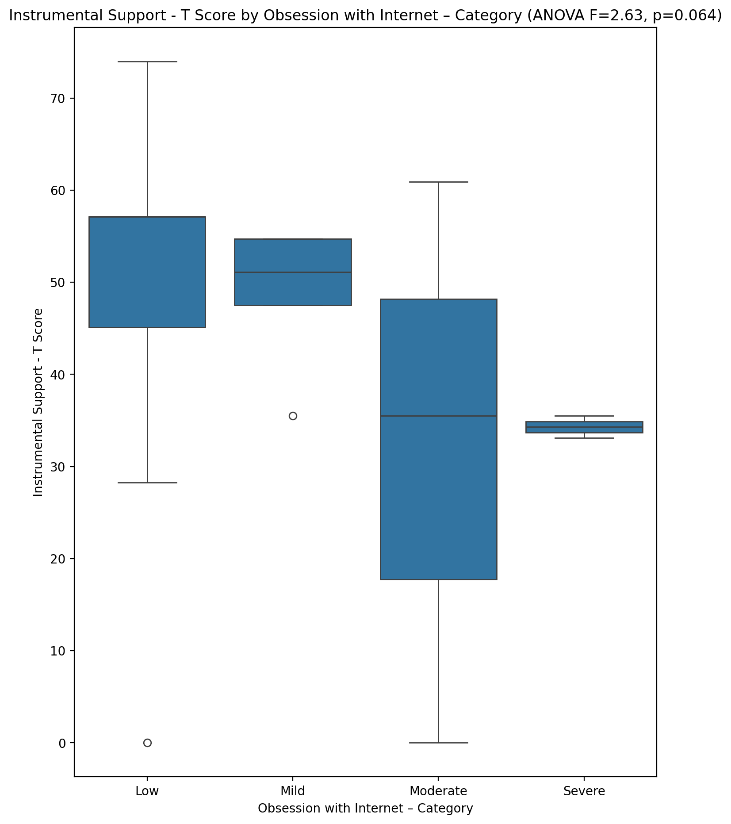

## Perceived Social Support Total T Score vs Obsession with Internet – Category

Test: anova; statistic: 6.750785566391157; p-value: 0.0008906833220241554;

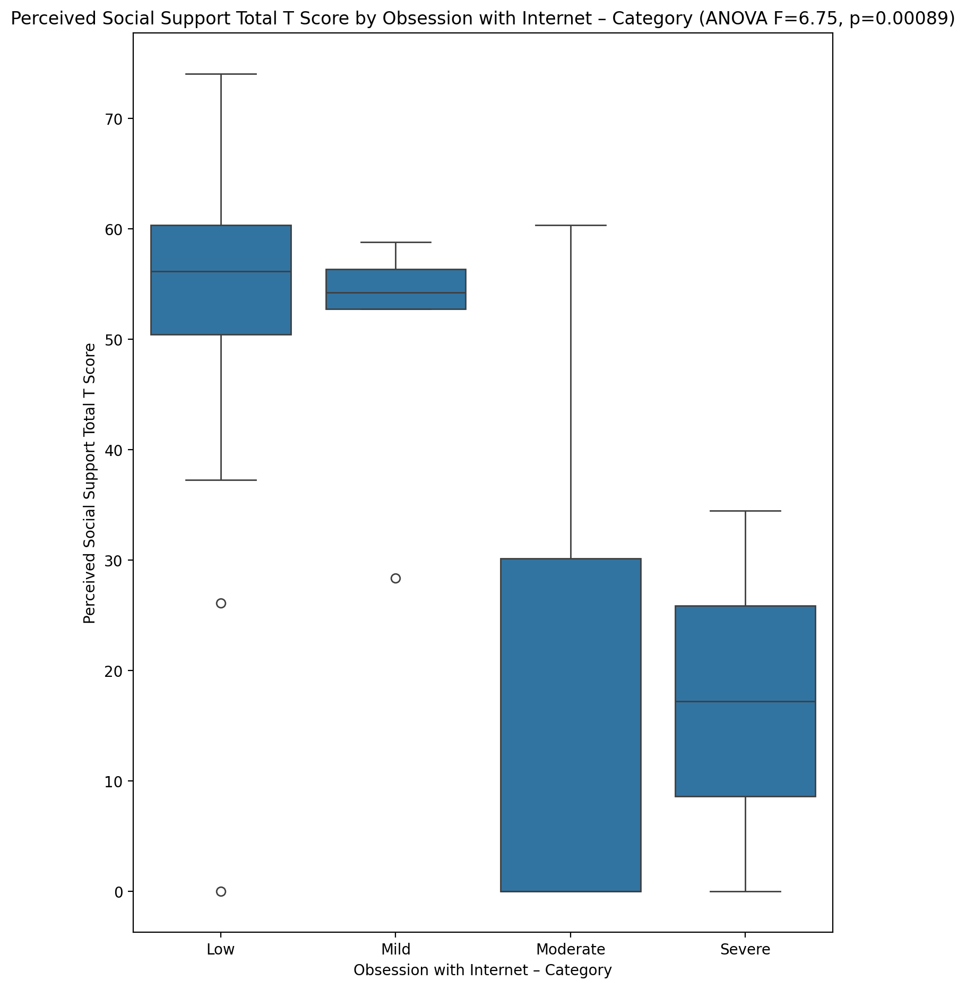

## Emotional Support - Rank vs Obsession with Internet – Category

Test: chi2; statistic: 22.43689236111111; p-value: 0.03290522049607788;

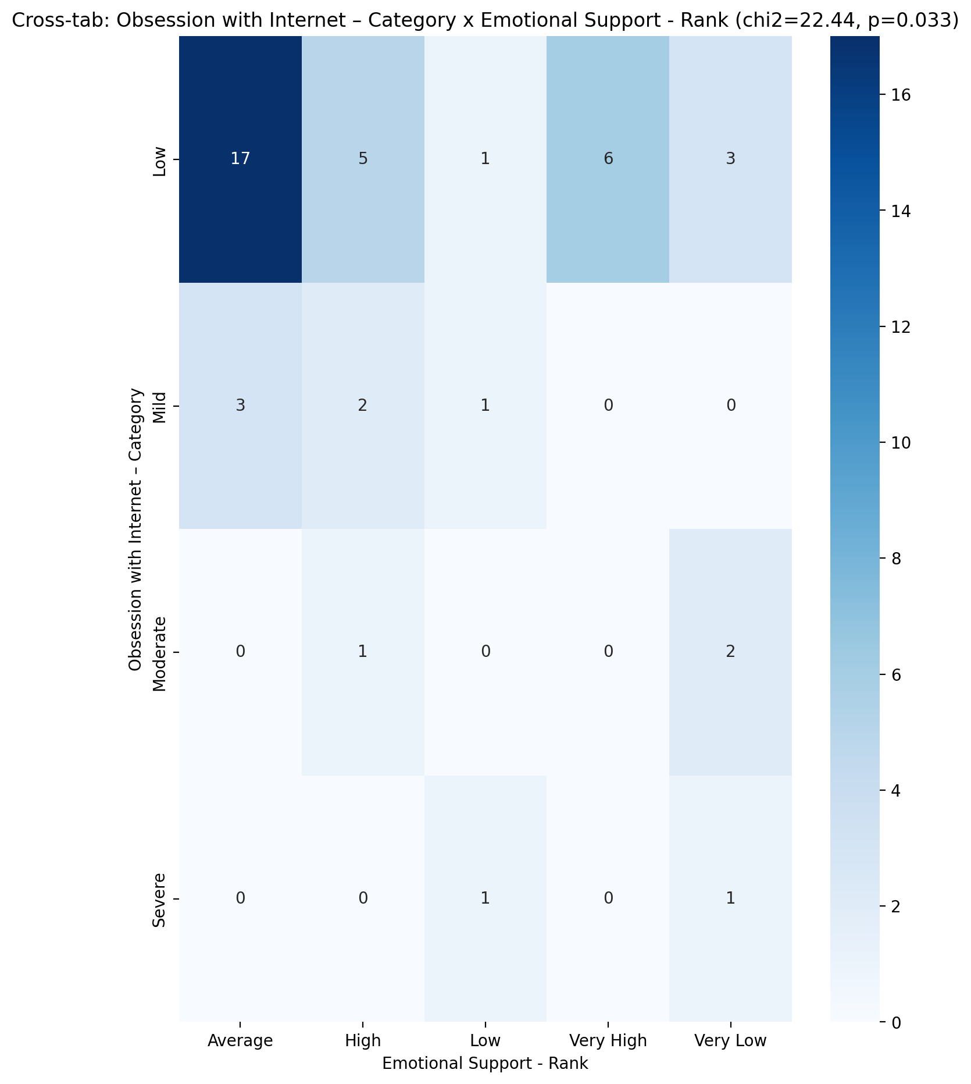

## Informational Support - Rank vs Obsession with Internet – Category

Test: chi2; statistic: 12.010565476190475; p-value: 0.21271432937883916;

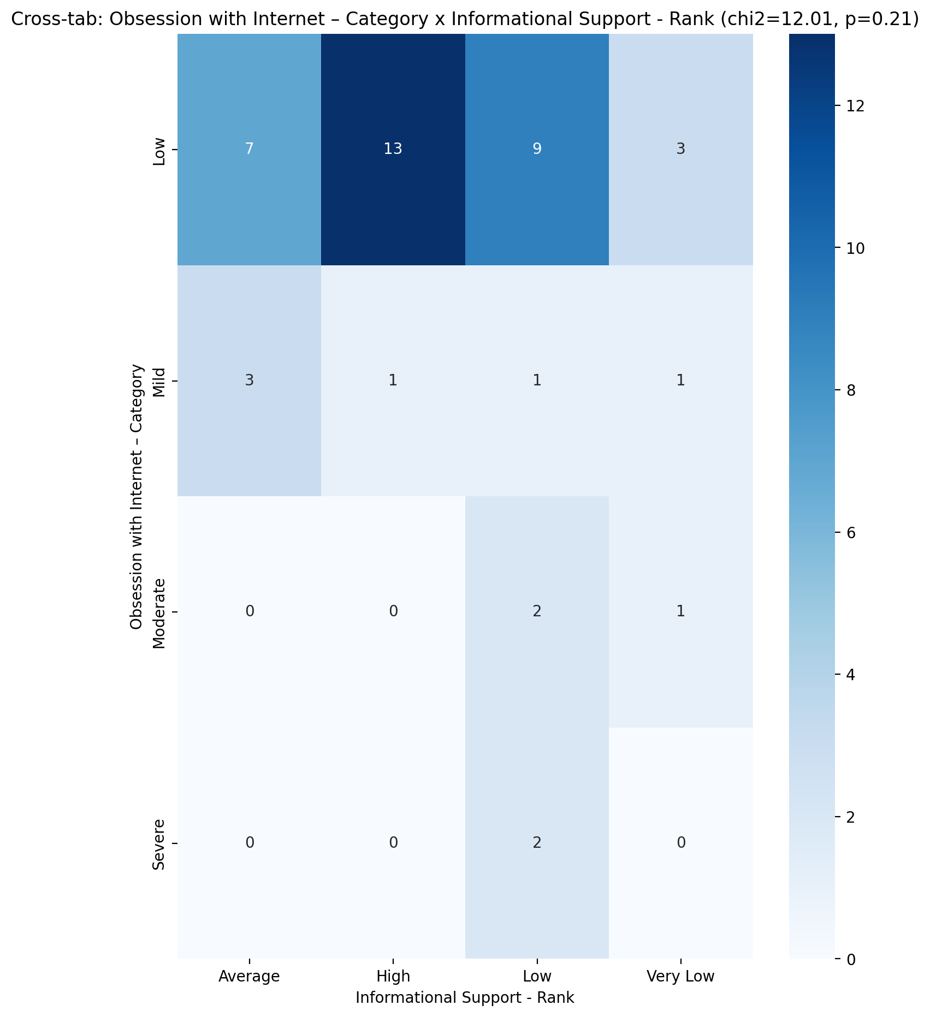

## Instrumental Support - Rank vs Obsession with Internet – Category

Test: chi2; statistic: 25.221660539215687; p-value: 0.013806723120045798;

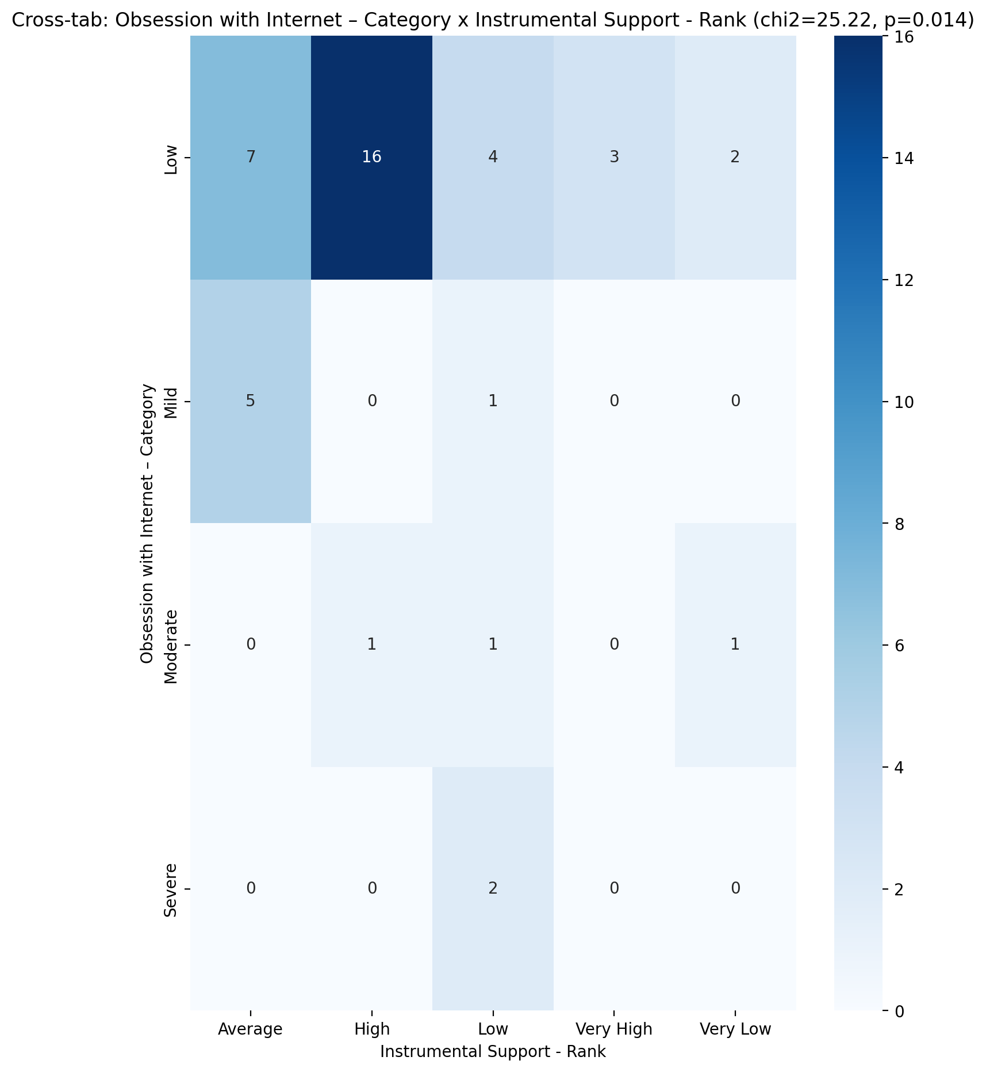

## Perceived Social Support TOTAL - Rank vs Obsession with Internet – Category

Test: chi2; statistic: 17.49861111111111; p-value: 0.13178407984653012;

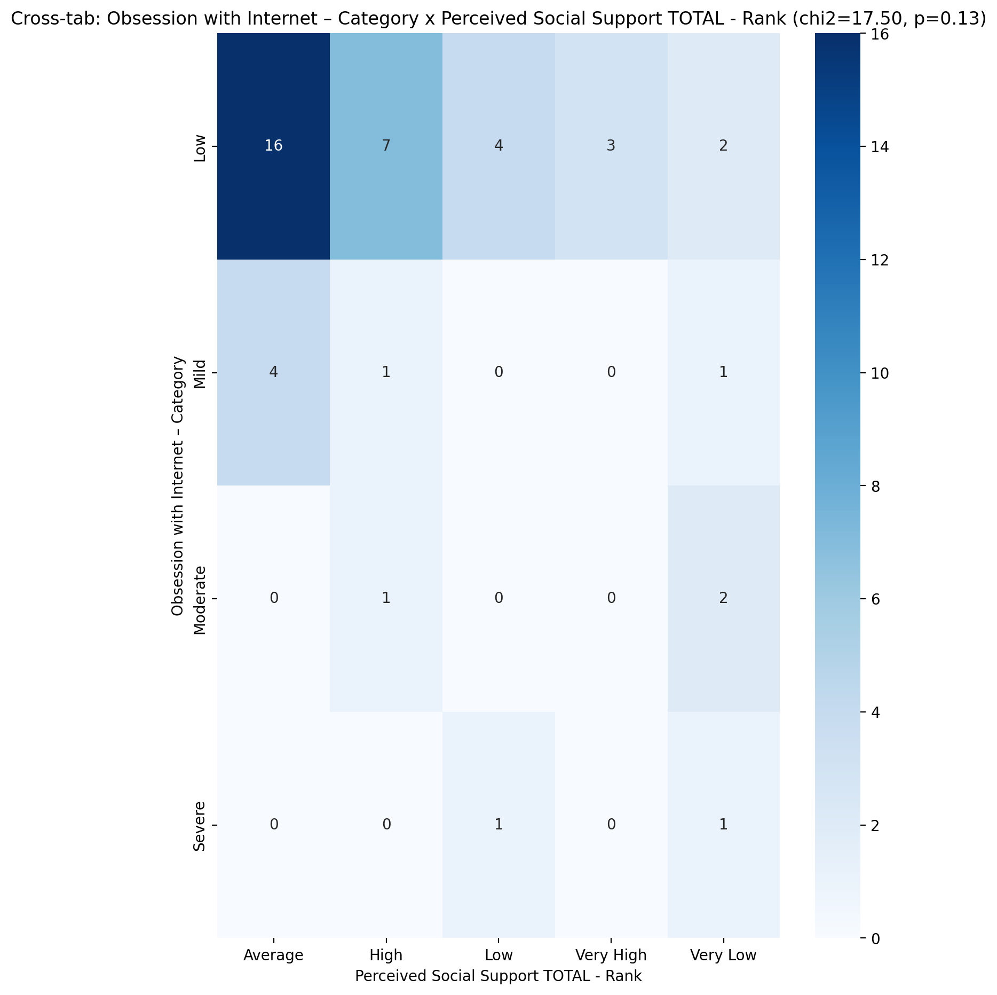

## Power Self Concept - Real Self Concept Score vs Obsession with Internet – Category

Test: anova; statistic: 0.33114989093715114; p-value: 0.8028428062821064;

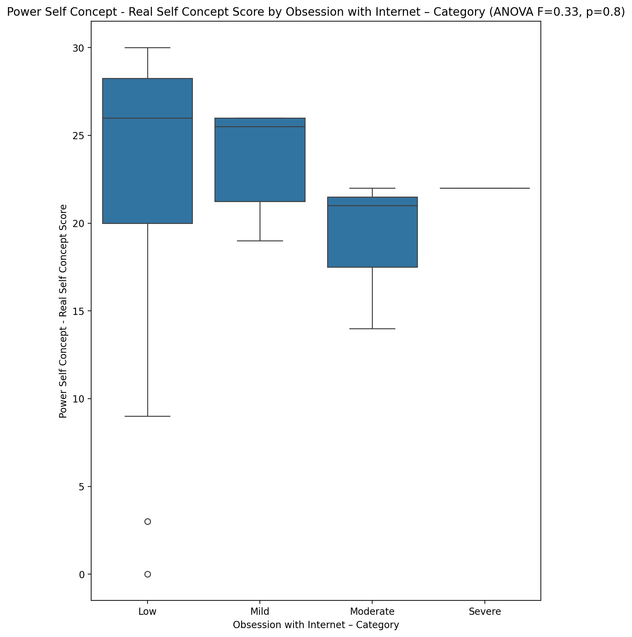

## Power Self Concept - Ideal Self Concept score vs Obsession with Internet – Category

Test: anova; statistic: 0.4630977426508216; p-value: 0.7096686467902373;

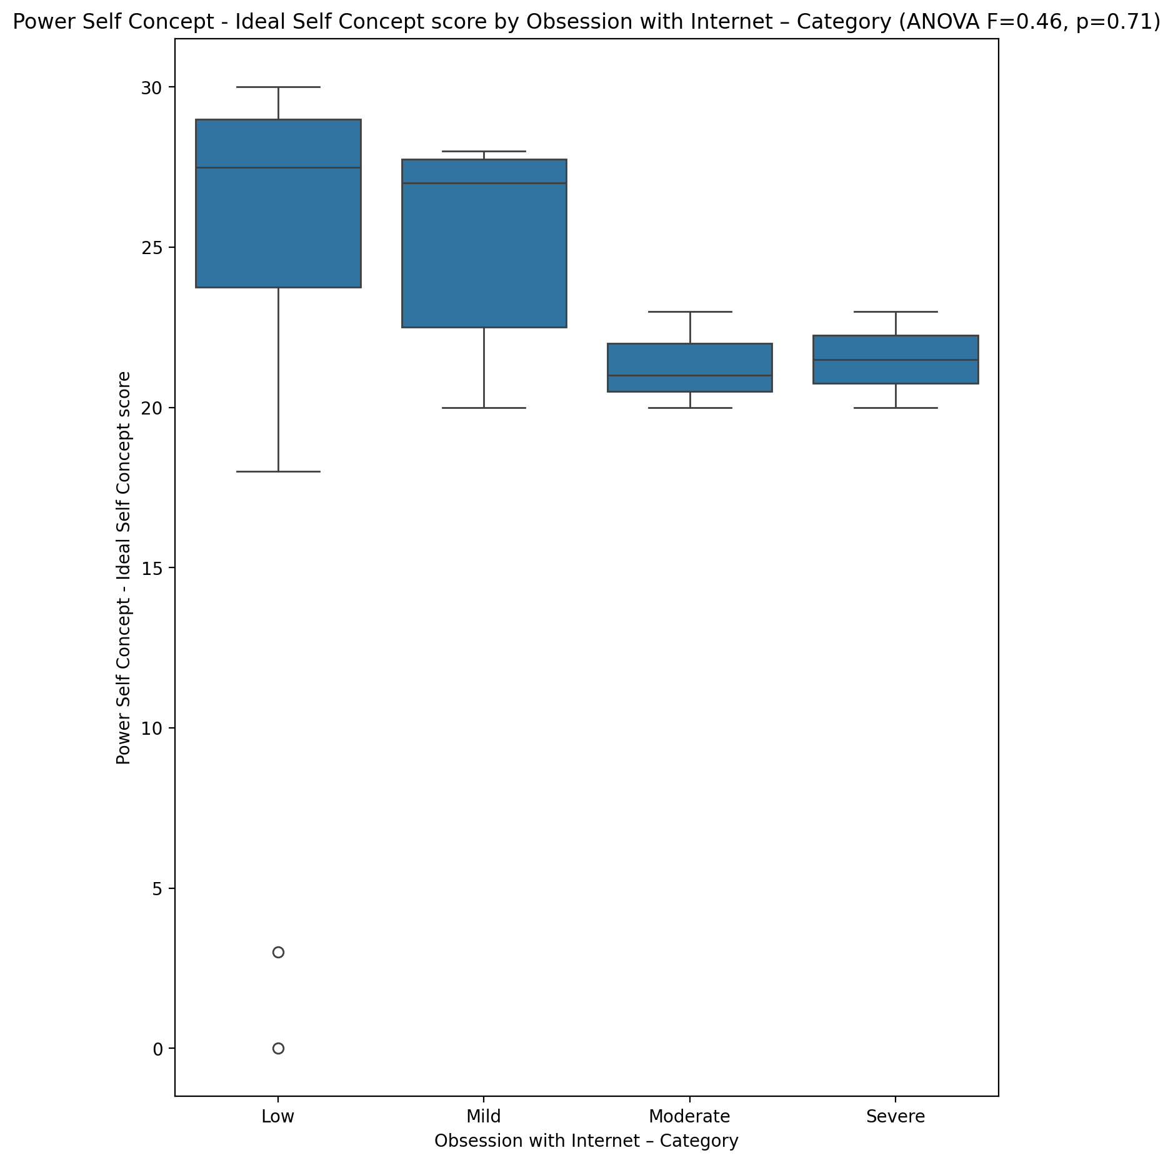

## Power Self Concept – Social Self Concept Score vs Obsession with Internet – Category

Test: anova; statistic: 0.10349821104941982; p-value: 0.9575298348623993;

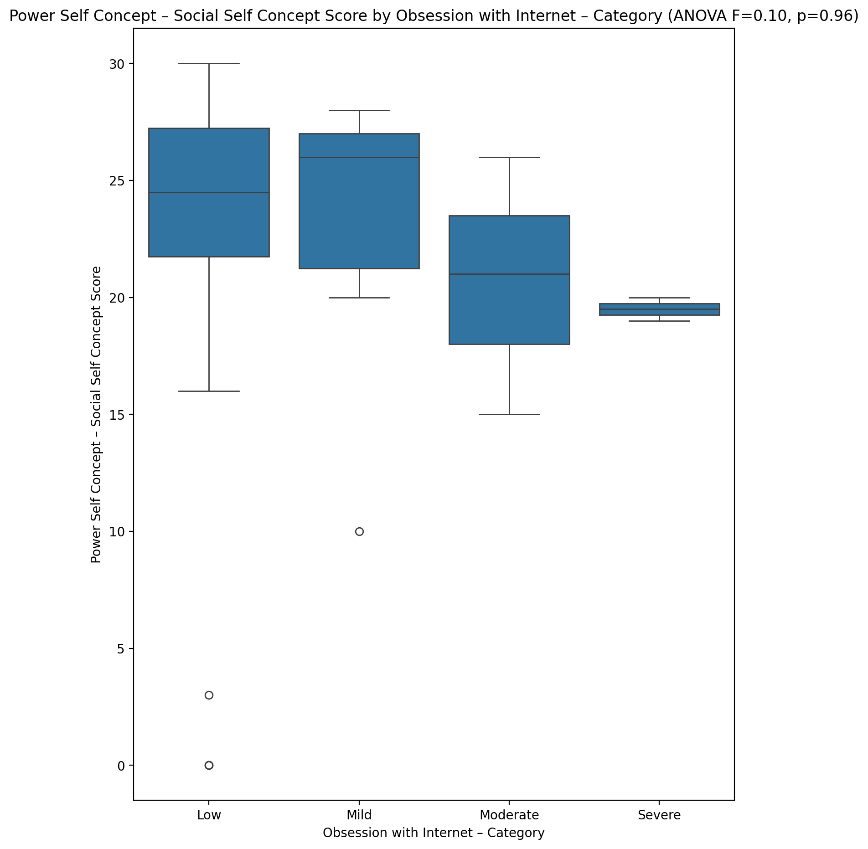

## Social Self Concept - Real Self Concept Score vs Obsession with Internet – Category

Test: anova; statistic: 0.42916985757740794; p-value: 0.7332360410403118;

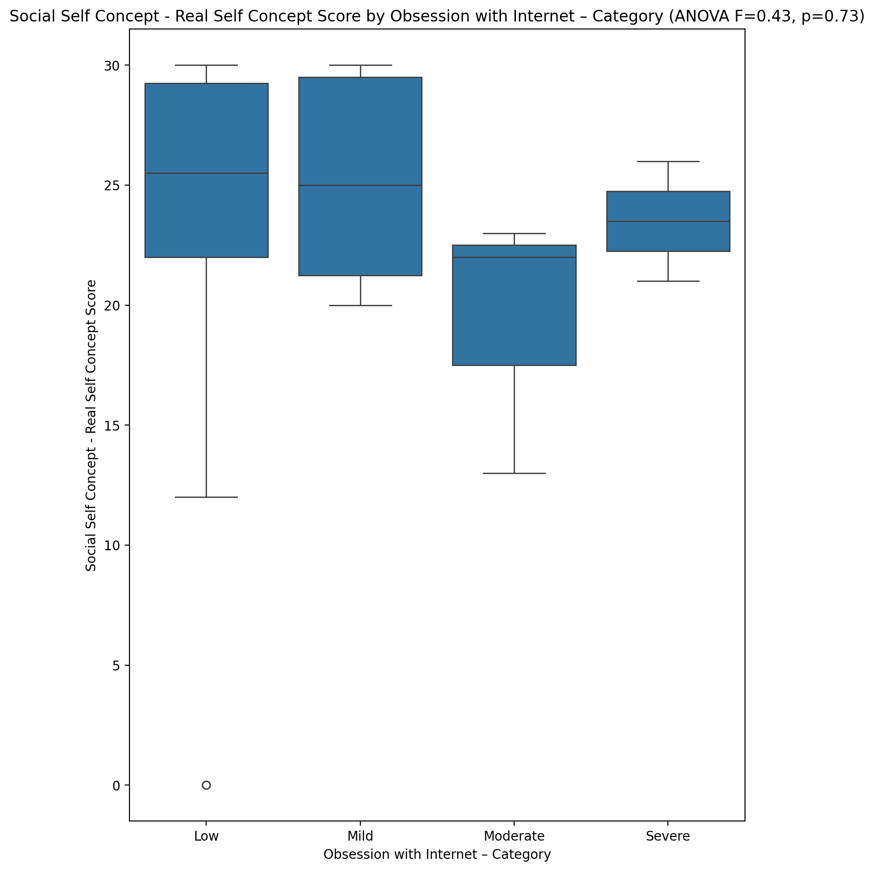

## Social Self Concept – Social Self Concept Score vs Obsession with Internet – Category

Test: anova; statistic: 0.01706369308104154; p-value: 0.9969121655423939;

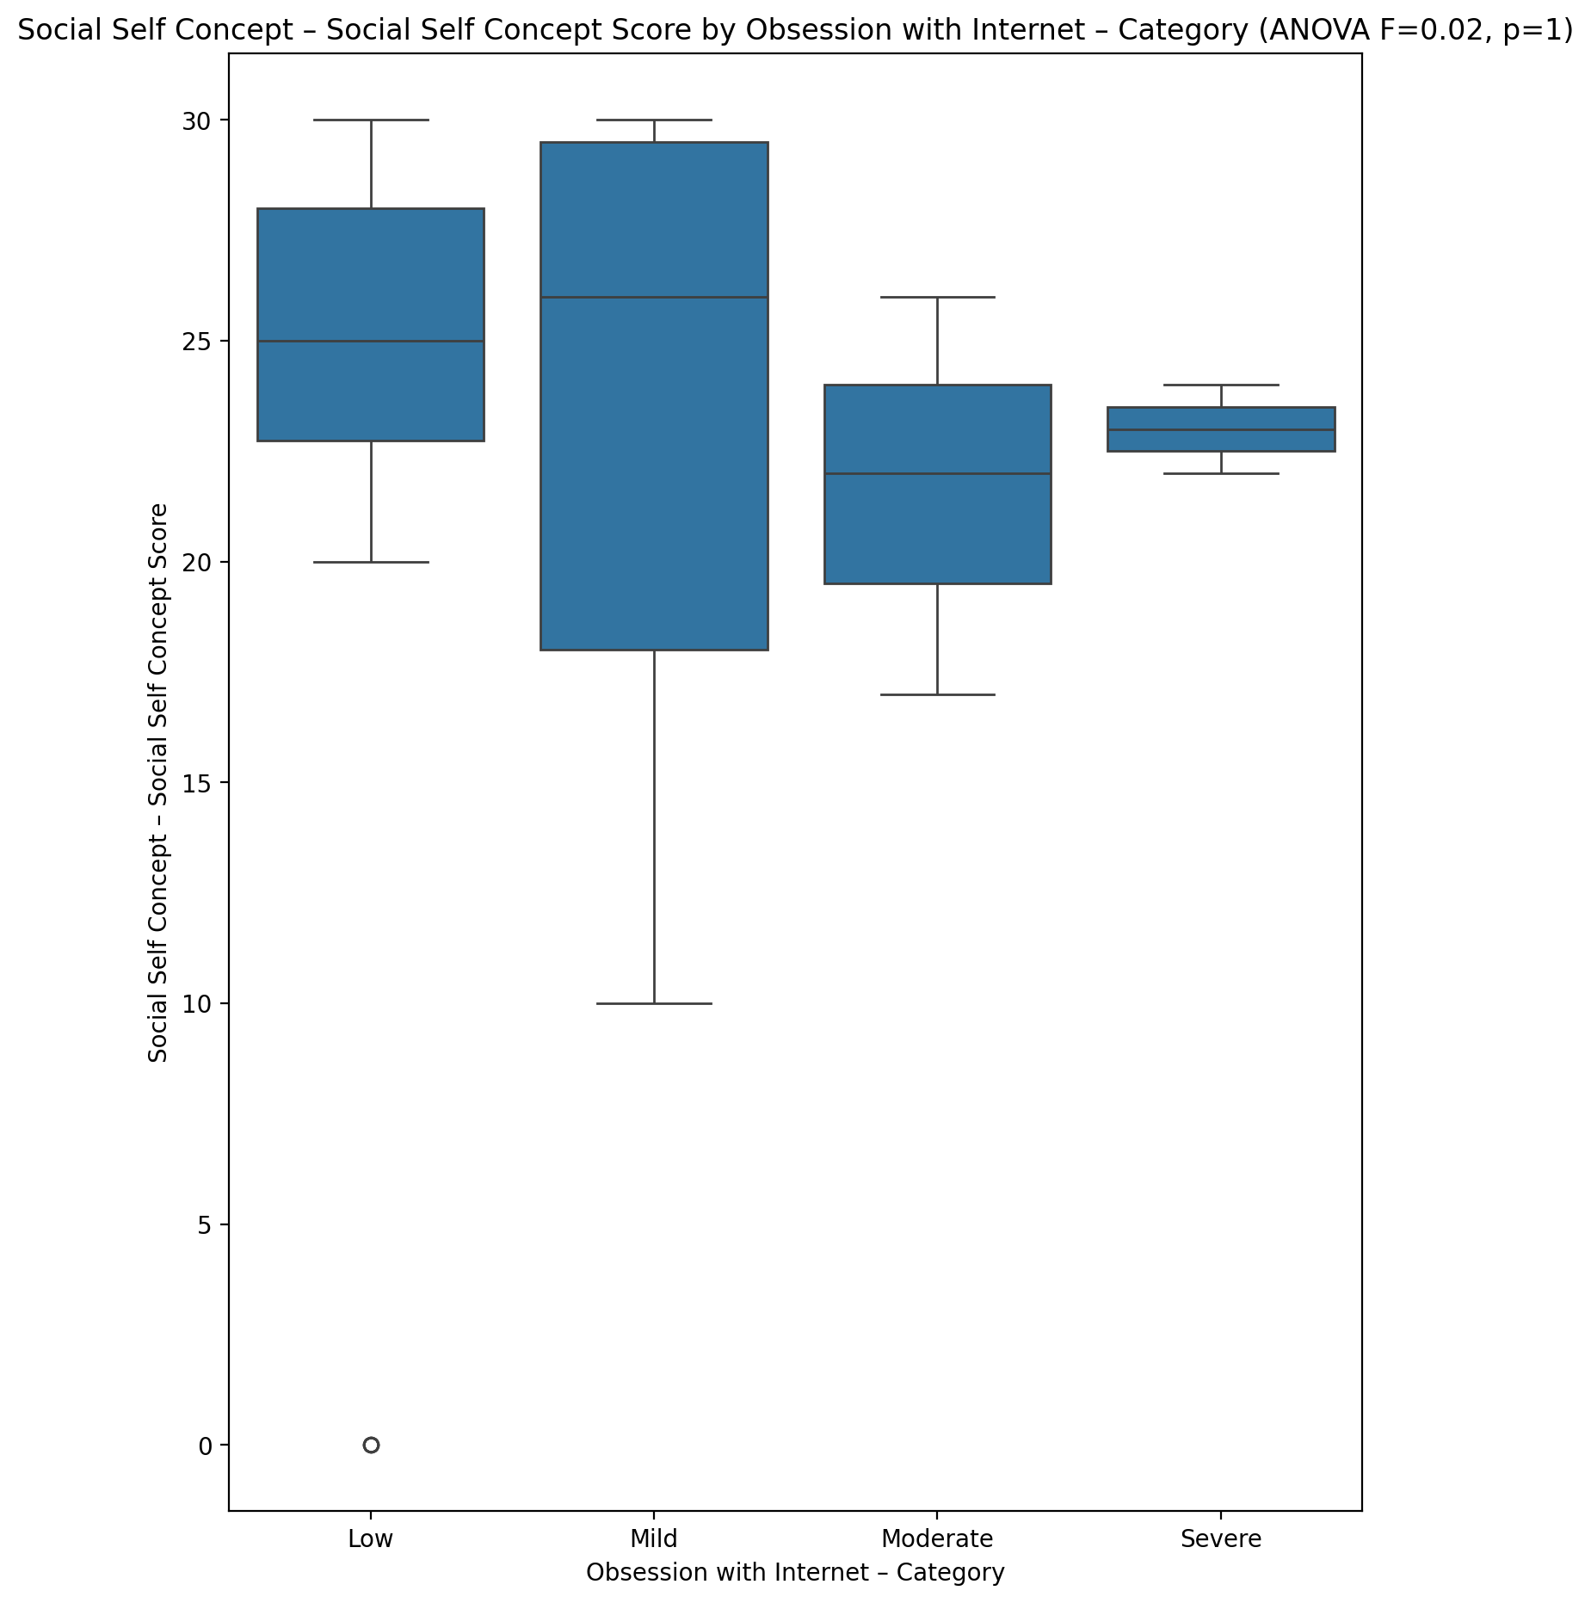

## Ability Self Concept - Real Self Concept Score vs Obsession with Internet – Category

Test: anova; statistic: 0.028391977731782172; p-value: 0.9934446569081884;

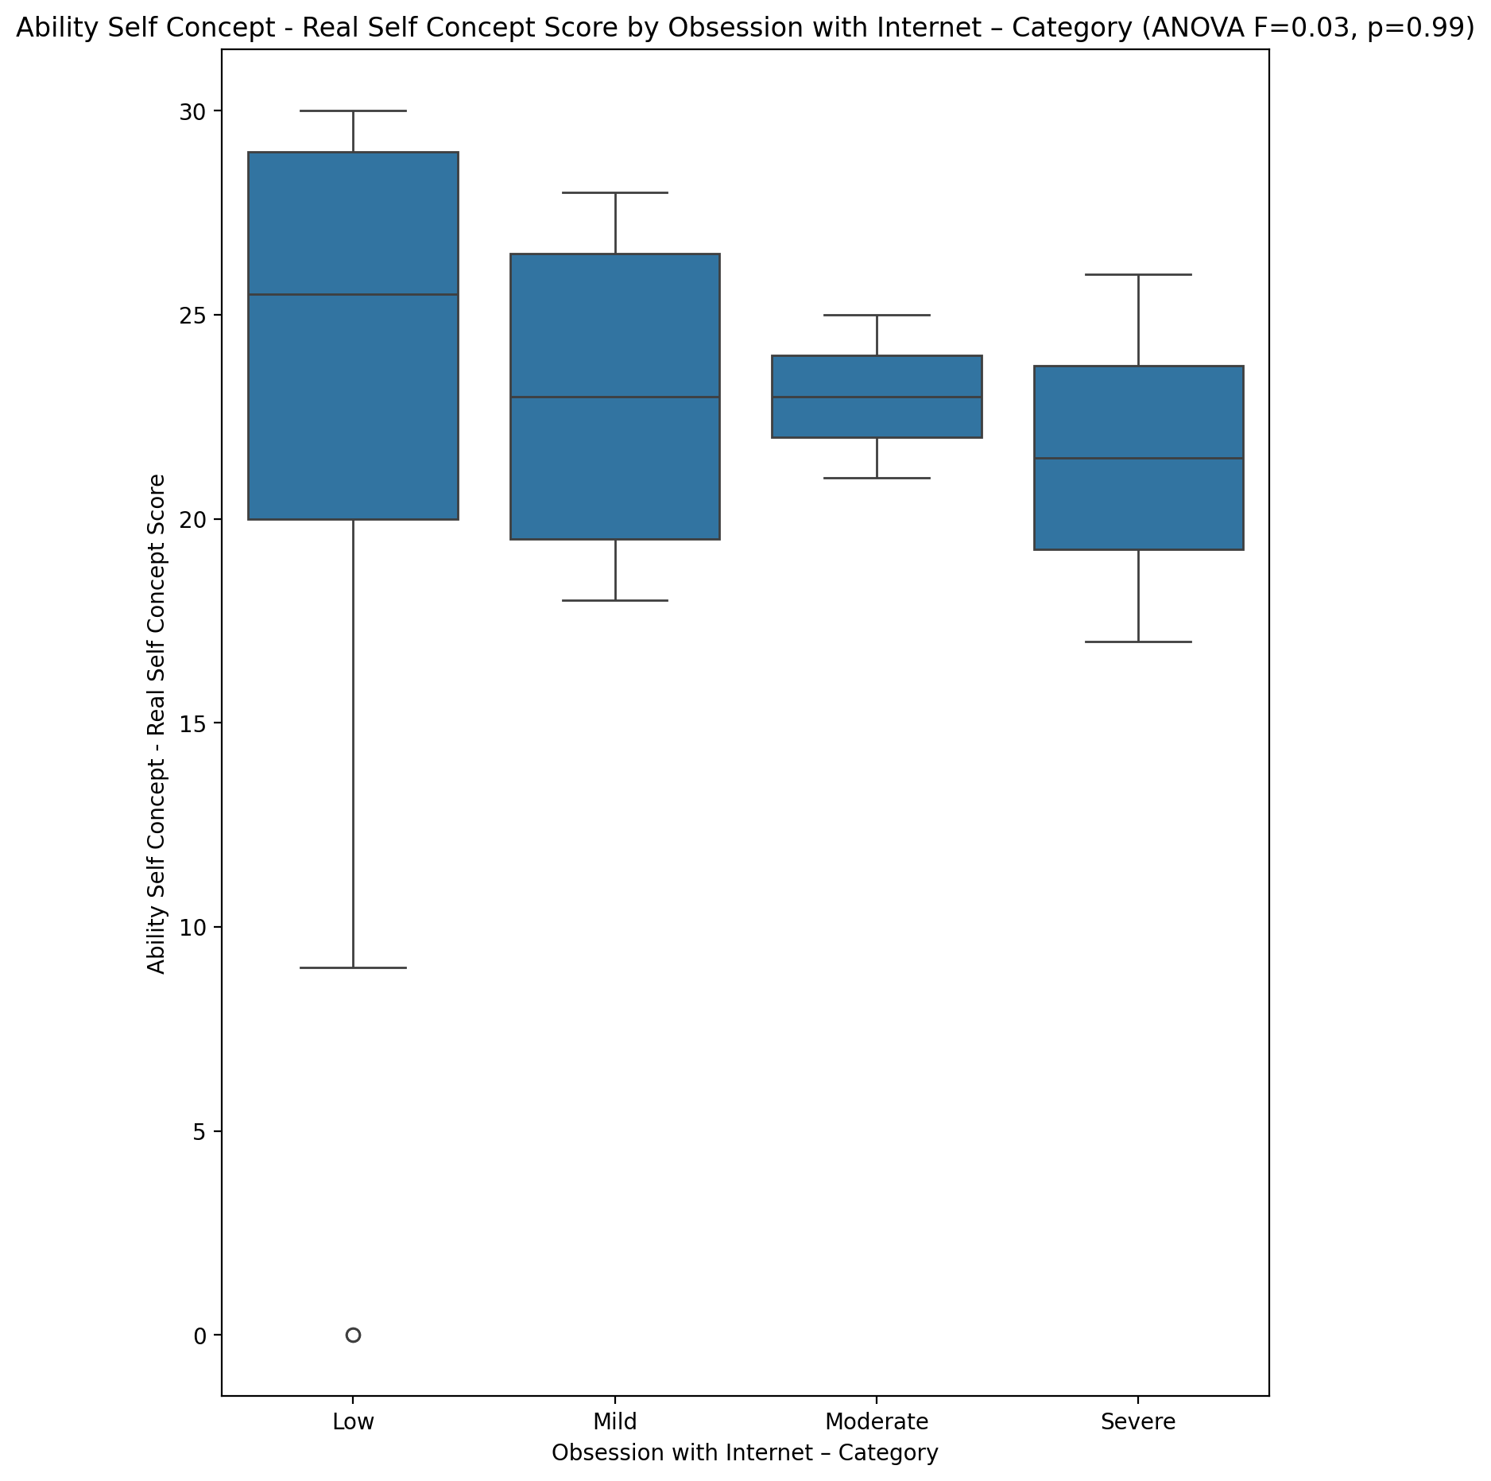

## Ability Self Concept - Ideal Self Concept Score vs Obsession with Internet – Category

Test: anova; statistic: 0.2239405899014831; p-value: 0.8791757888441877;

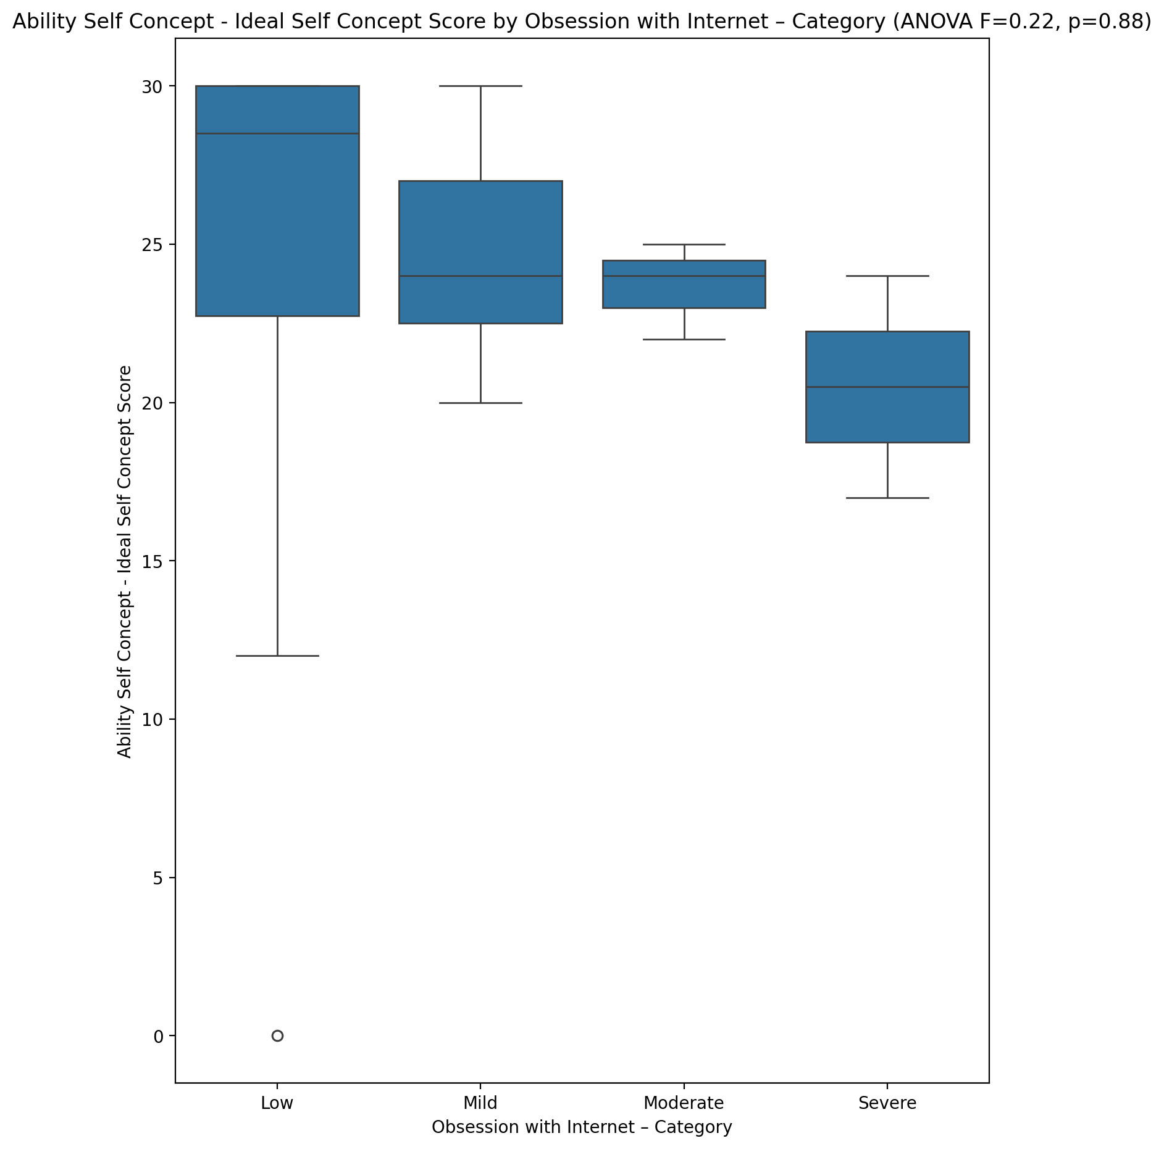

## Ability Self Concept – Social Self Concept Score vs Obsession with Internet – Category

Test: anova; statistic: 0.06291045629254399; p-value: 0.9790822602488337;

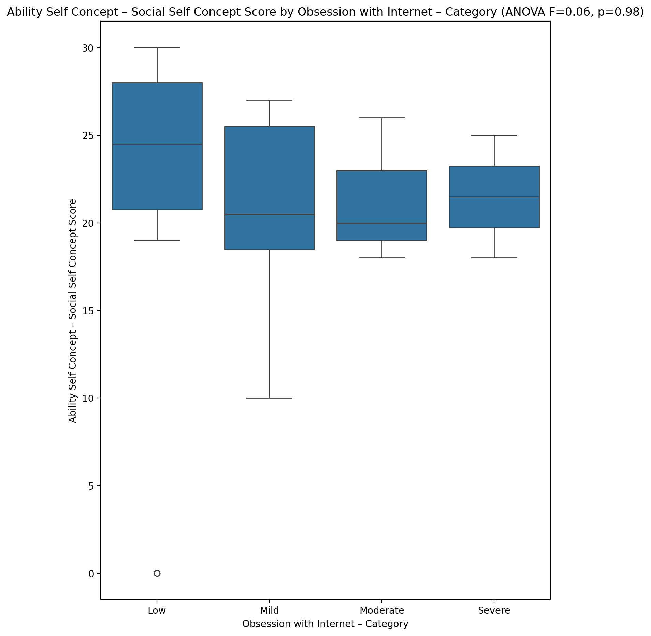

## Physical Self Concept - Real Self Concept Score vs Obsession with Internet – Category

Test: anova; statistic: 0.49212303075768954; p-value: 0.6898063718694671;

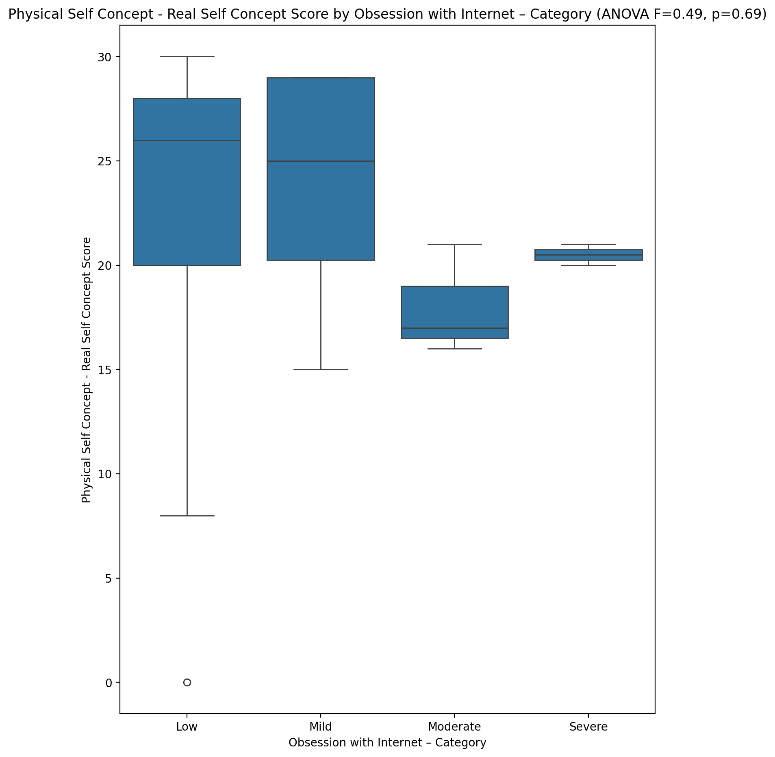

## Physical Self Concept – Ideal Self Concept Score vs Obsession with Internet – Category

Test: anova; statistic: 0.20064252091428098; p-value: 0.895310350176974;

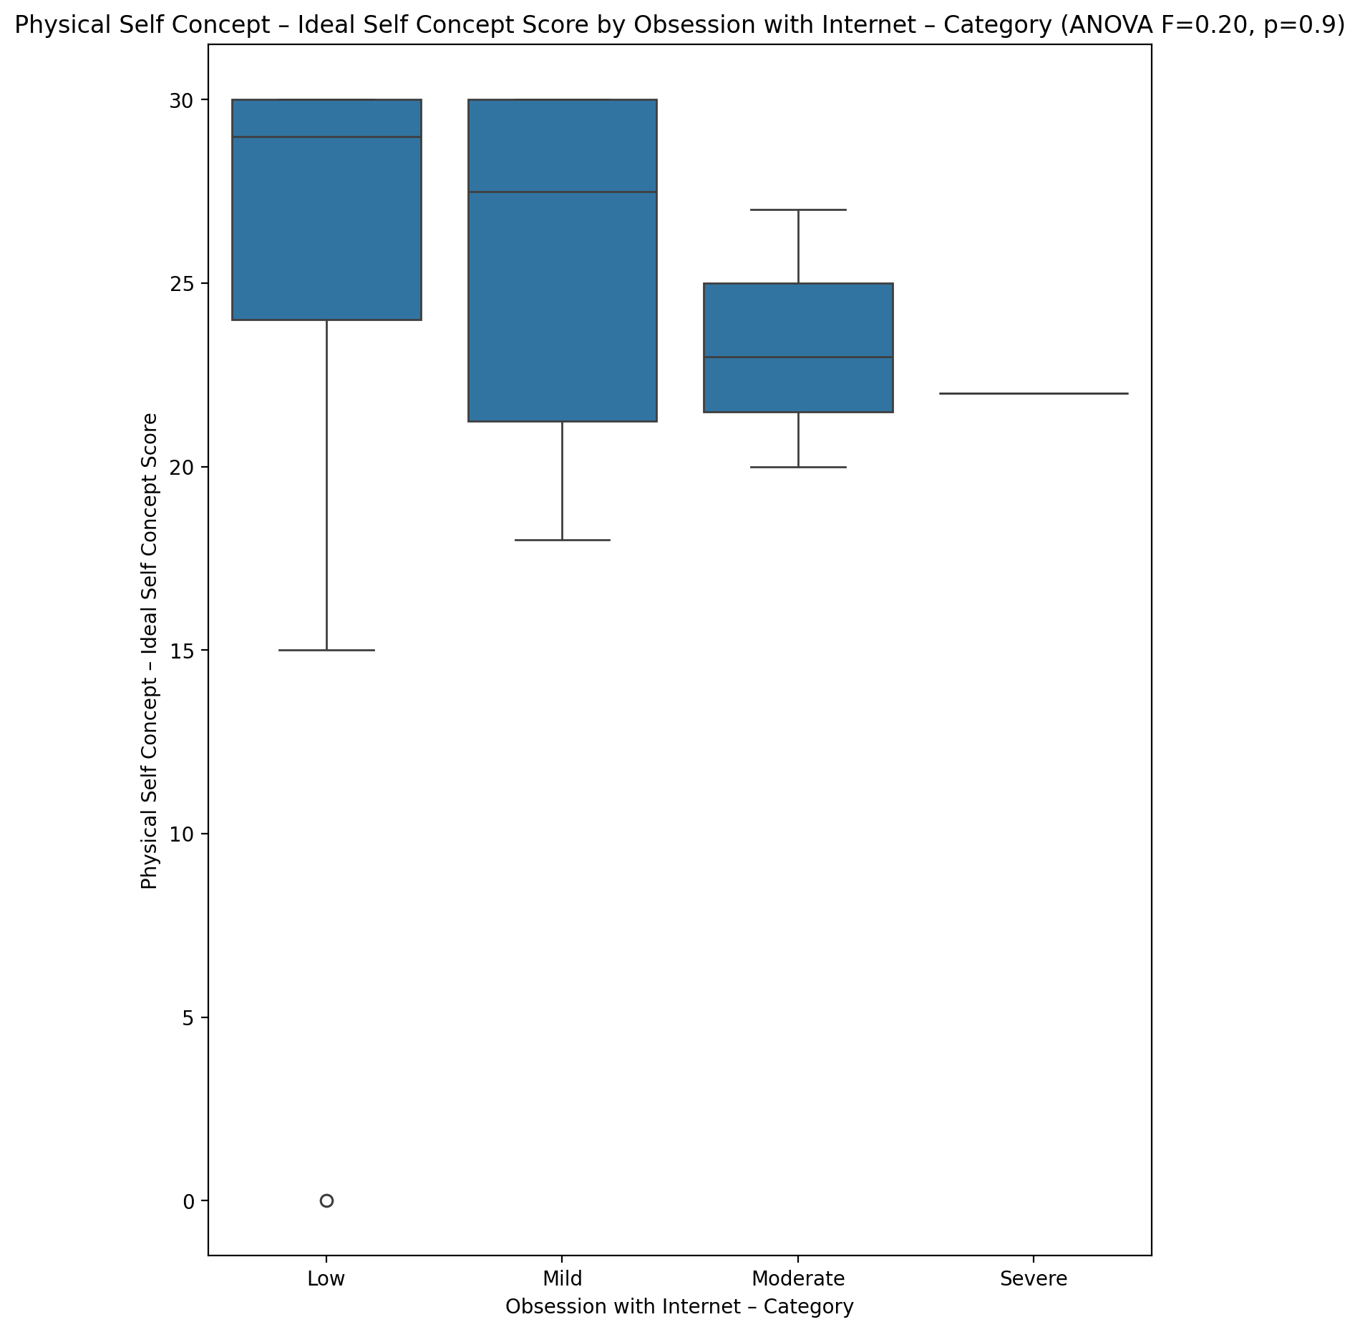

## Physical Self Concept – Social Self Concept Score vs Obsession with Internet – Category

Test: anova; statistic: 0.1585698006571518; p-value: 0.9235185727986763;

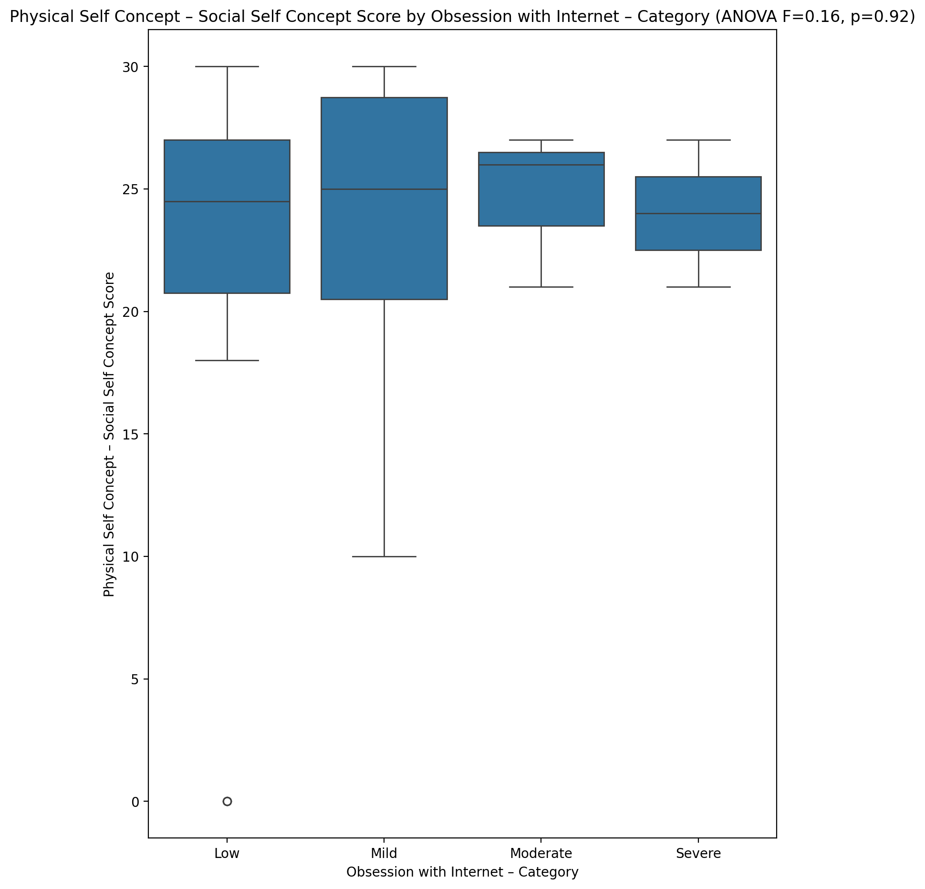

## Psychological Self Concept - Real Self Concept Score vs Obsession with Internet – Category

Test: anova; statistic: 0.1850578427767801; p-value: 0.9059213557856288;

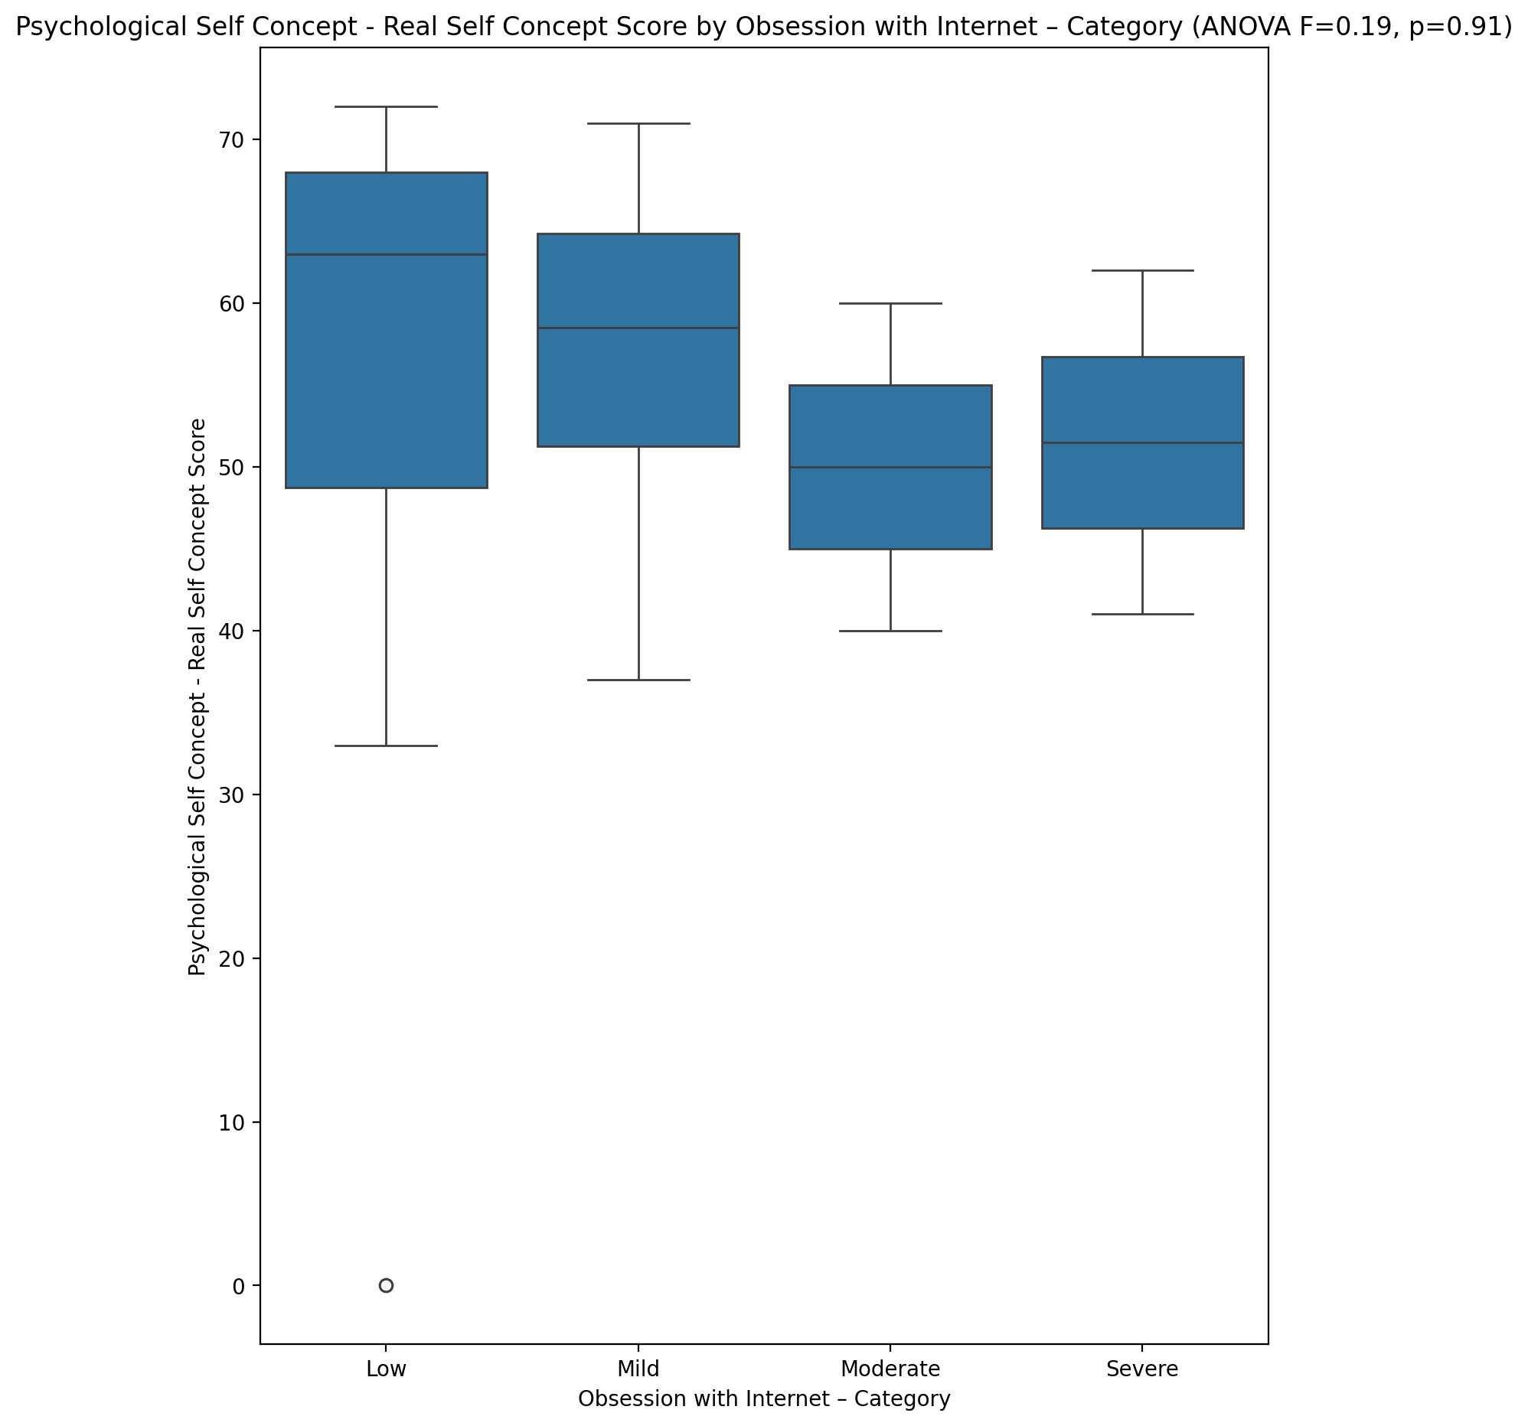

## Psychological Self Concept – Ideal Self Concept Score vs Obsession with Internet – Category

Test: anova; statistic: 0.3249132783181073; p-value: 0.8073140797522166;

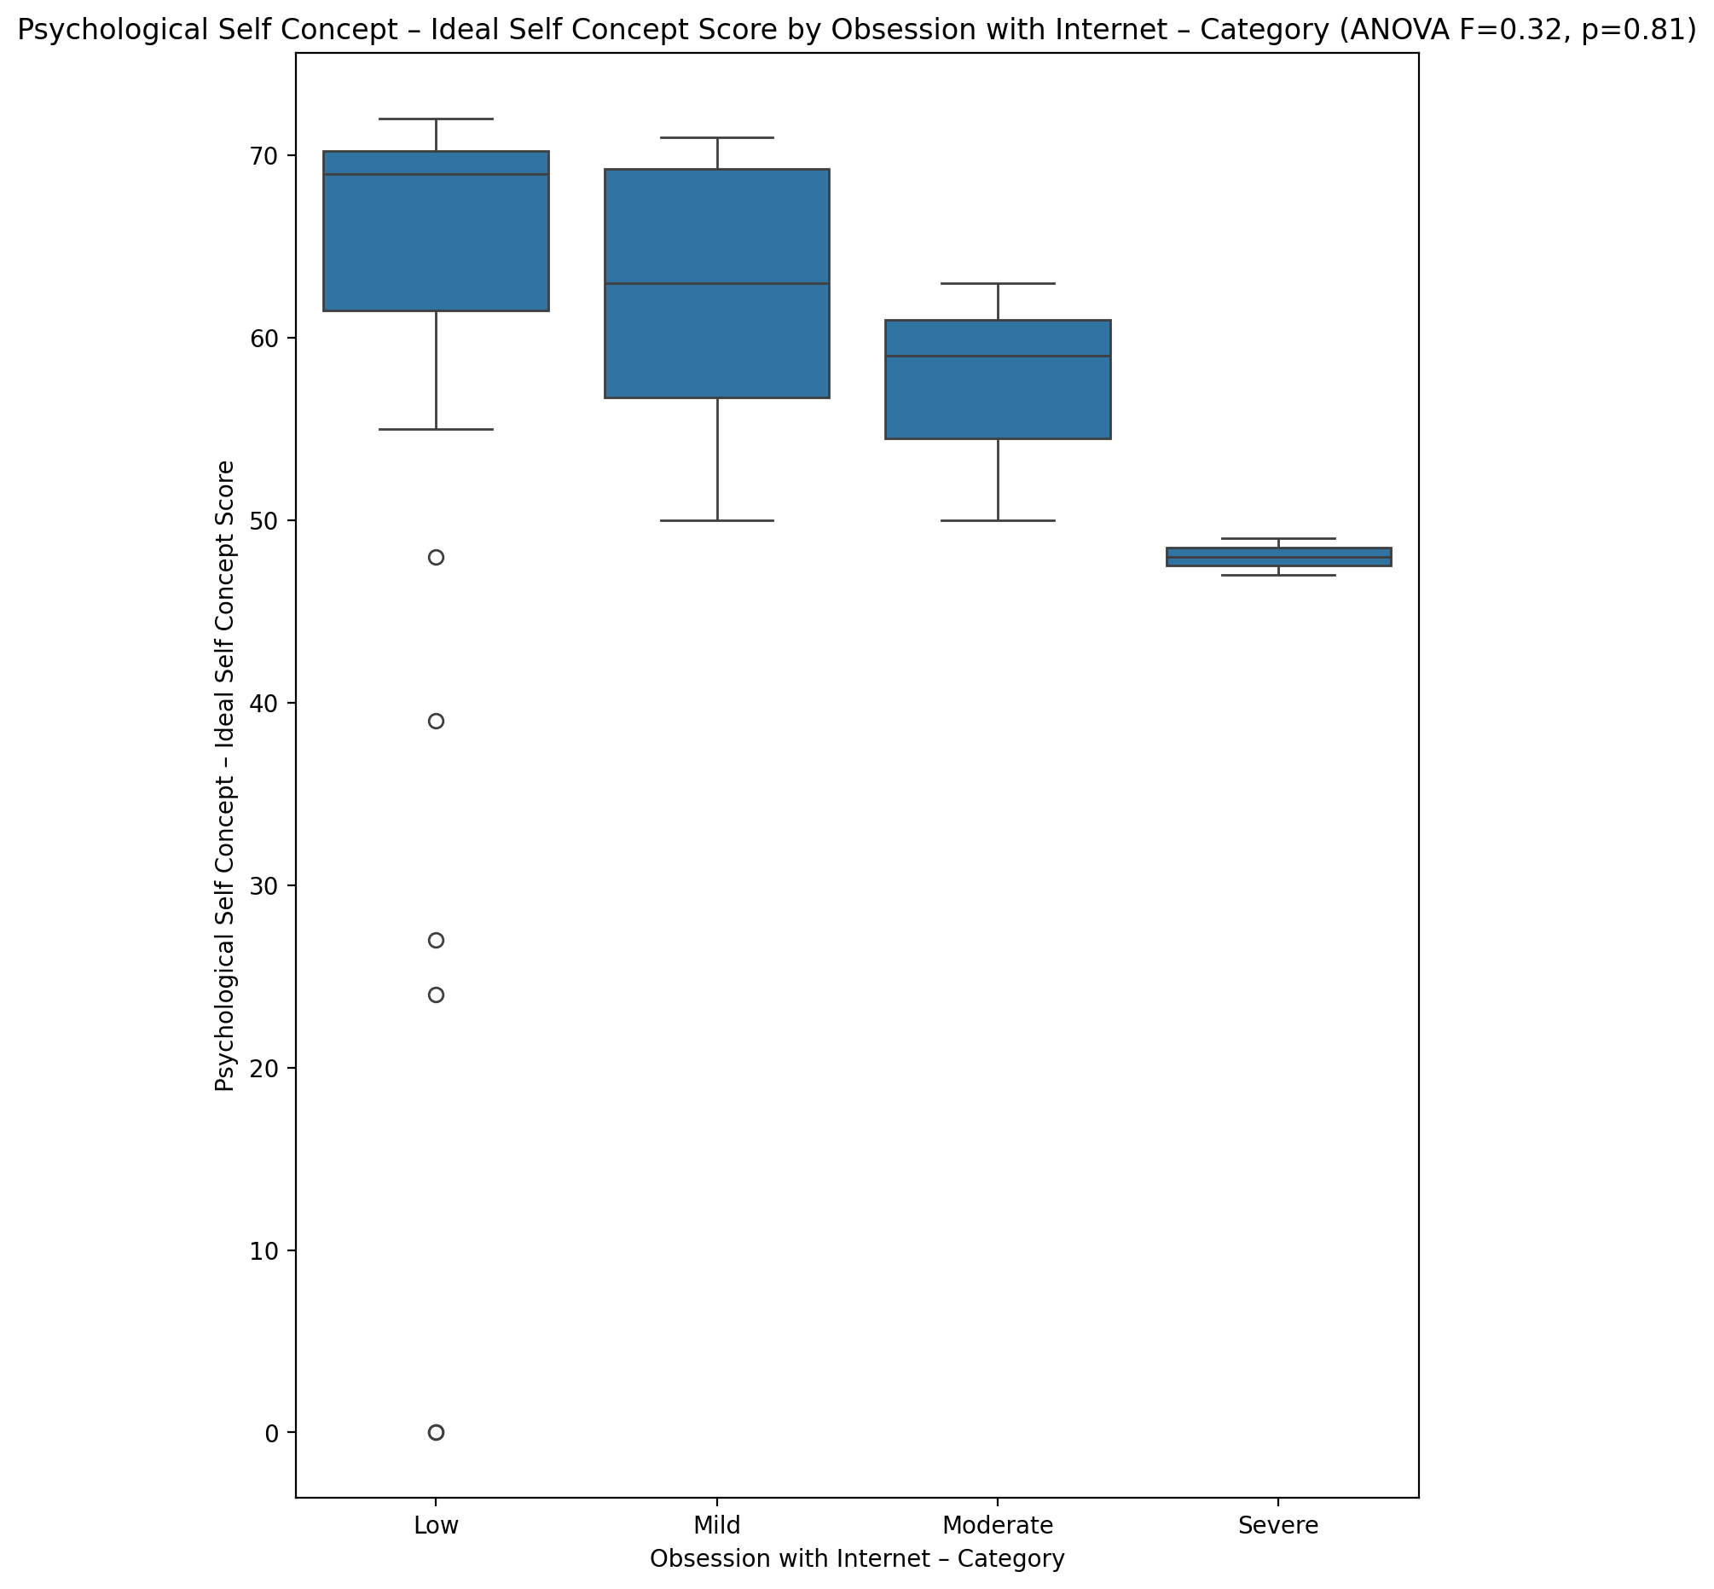

## Psychological Self Concept – Social Self Concept Score vs Obsession with Internet – Category

Test: anova; statistic: 0.11724701820585184; p-value: 0.9494522167438791;

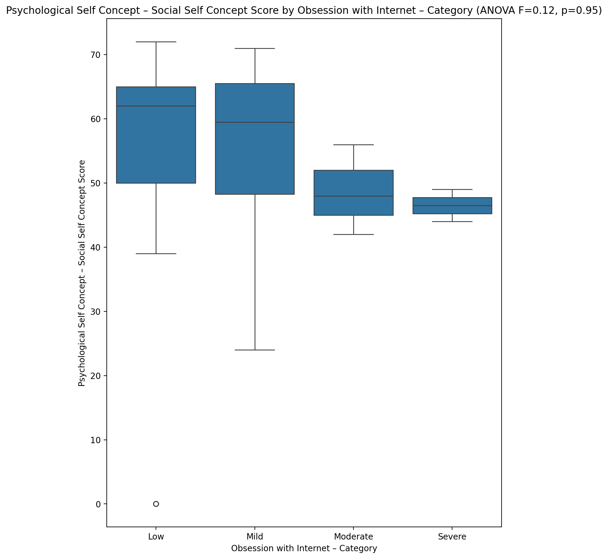

## Real Self Concept Total Score vs Obsession with Internet – Category

Test: anova; statistic: 0.21725826674065968; p-value: 0.8838323128628168;

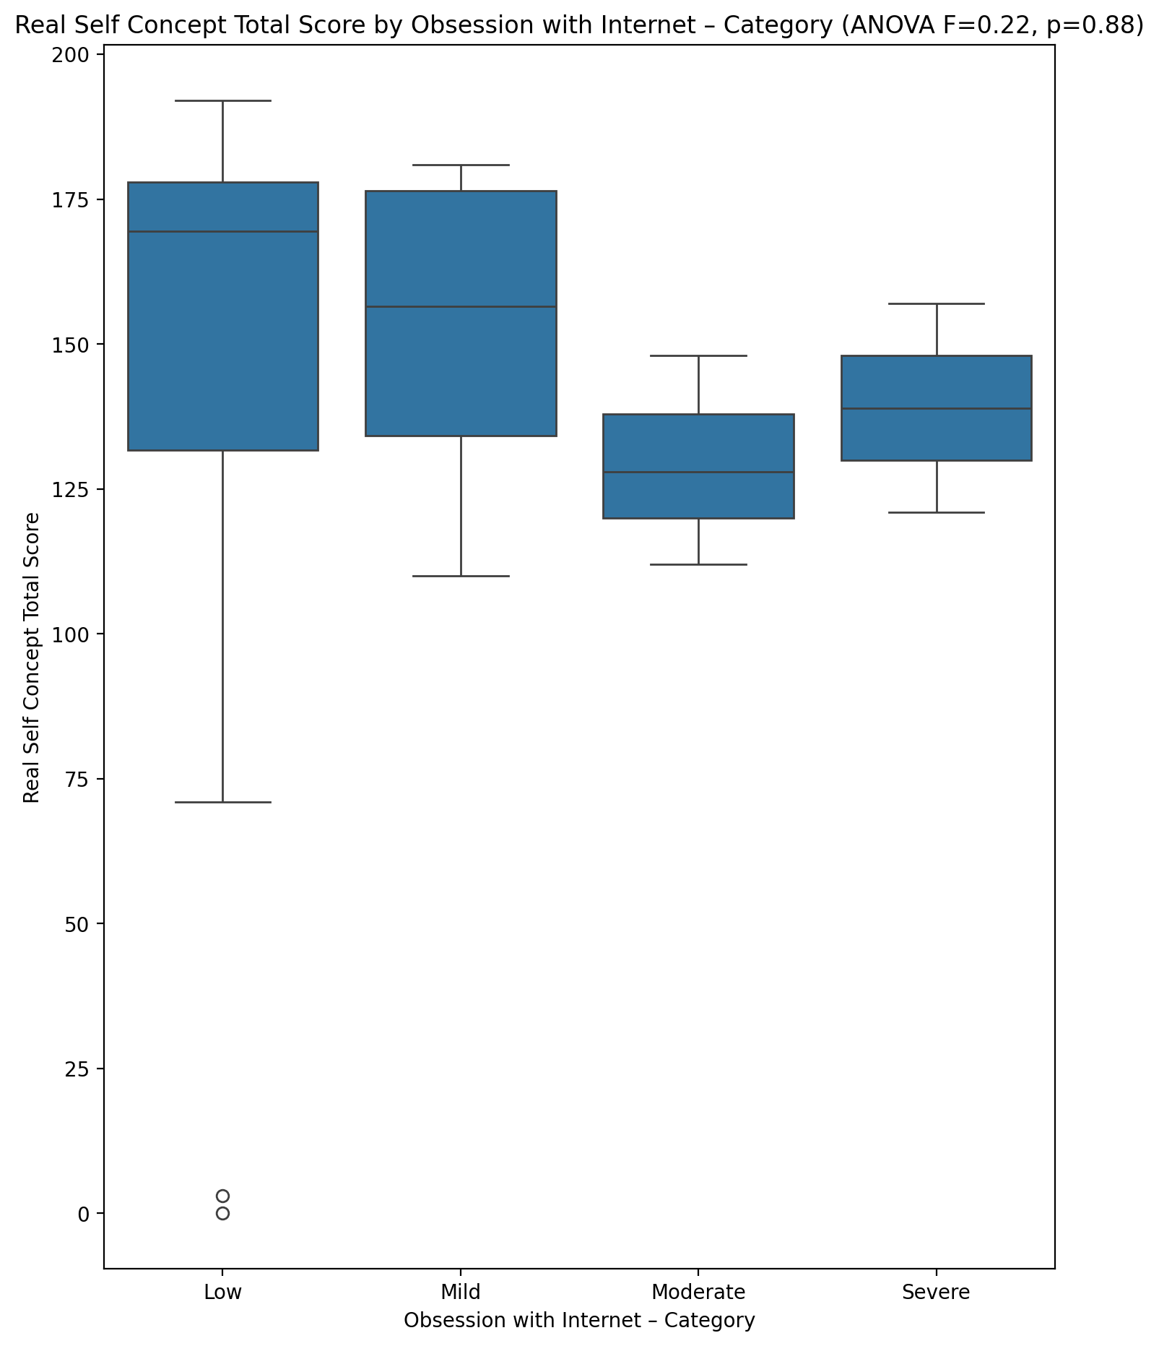

## Ideal Self Concept Total Score vs Obsession with Internet – Category

Test: anova; statistic: 0.23736147527097026; p-value: 0.8697647339783608;

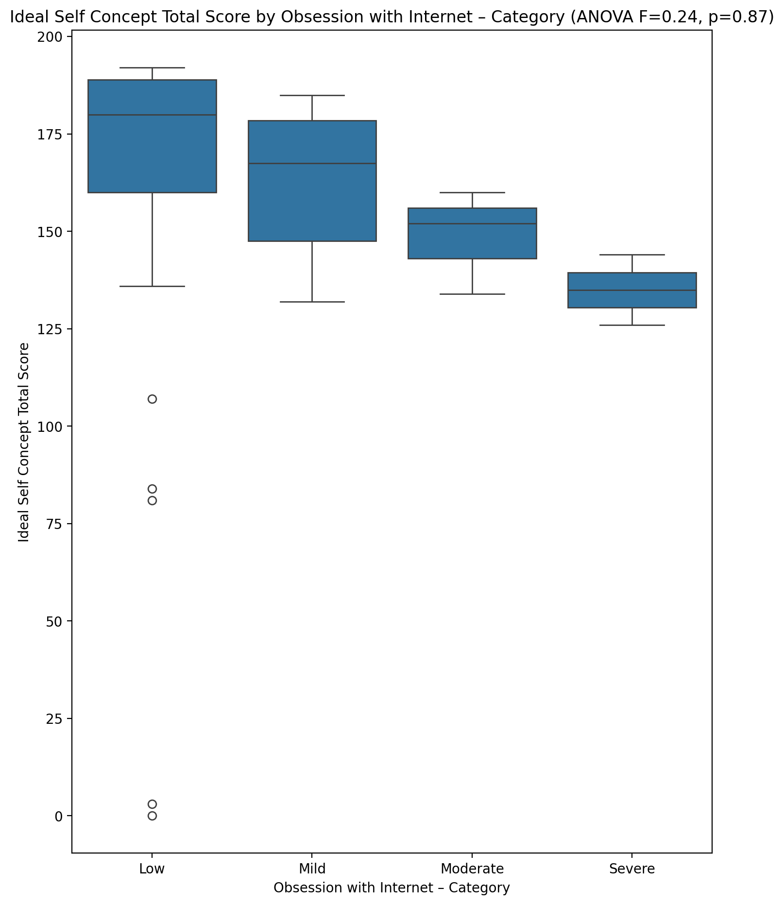

## Social Self Concept Total Score vs Obsession with Internet – Category

Test: anova; statistic: 0.021894588384355016; p-value: 0.9955329003341216;

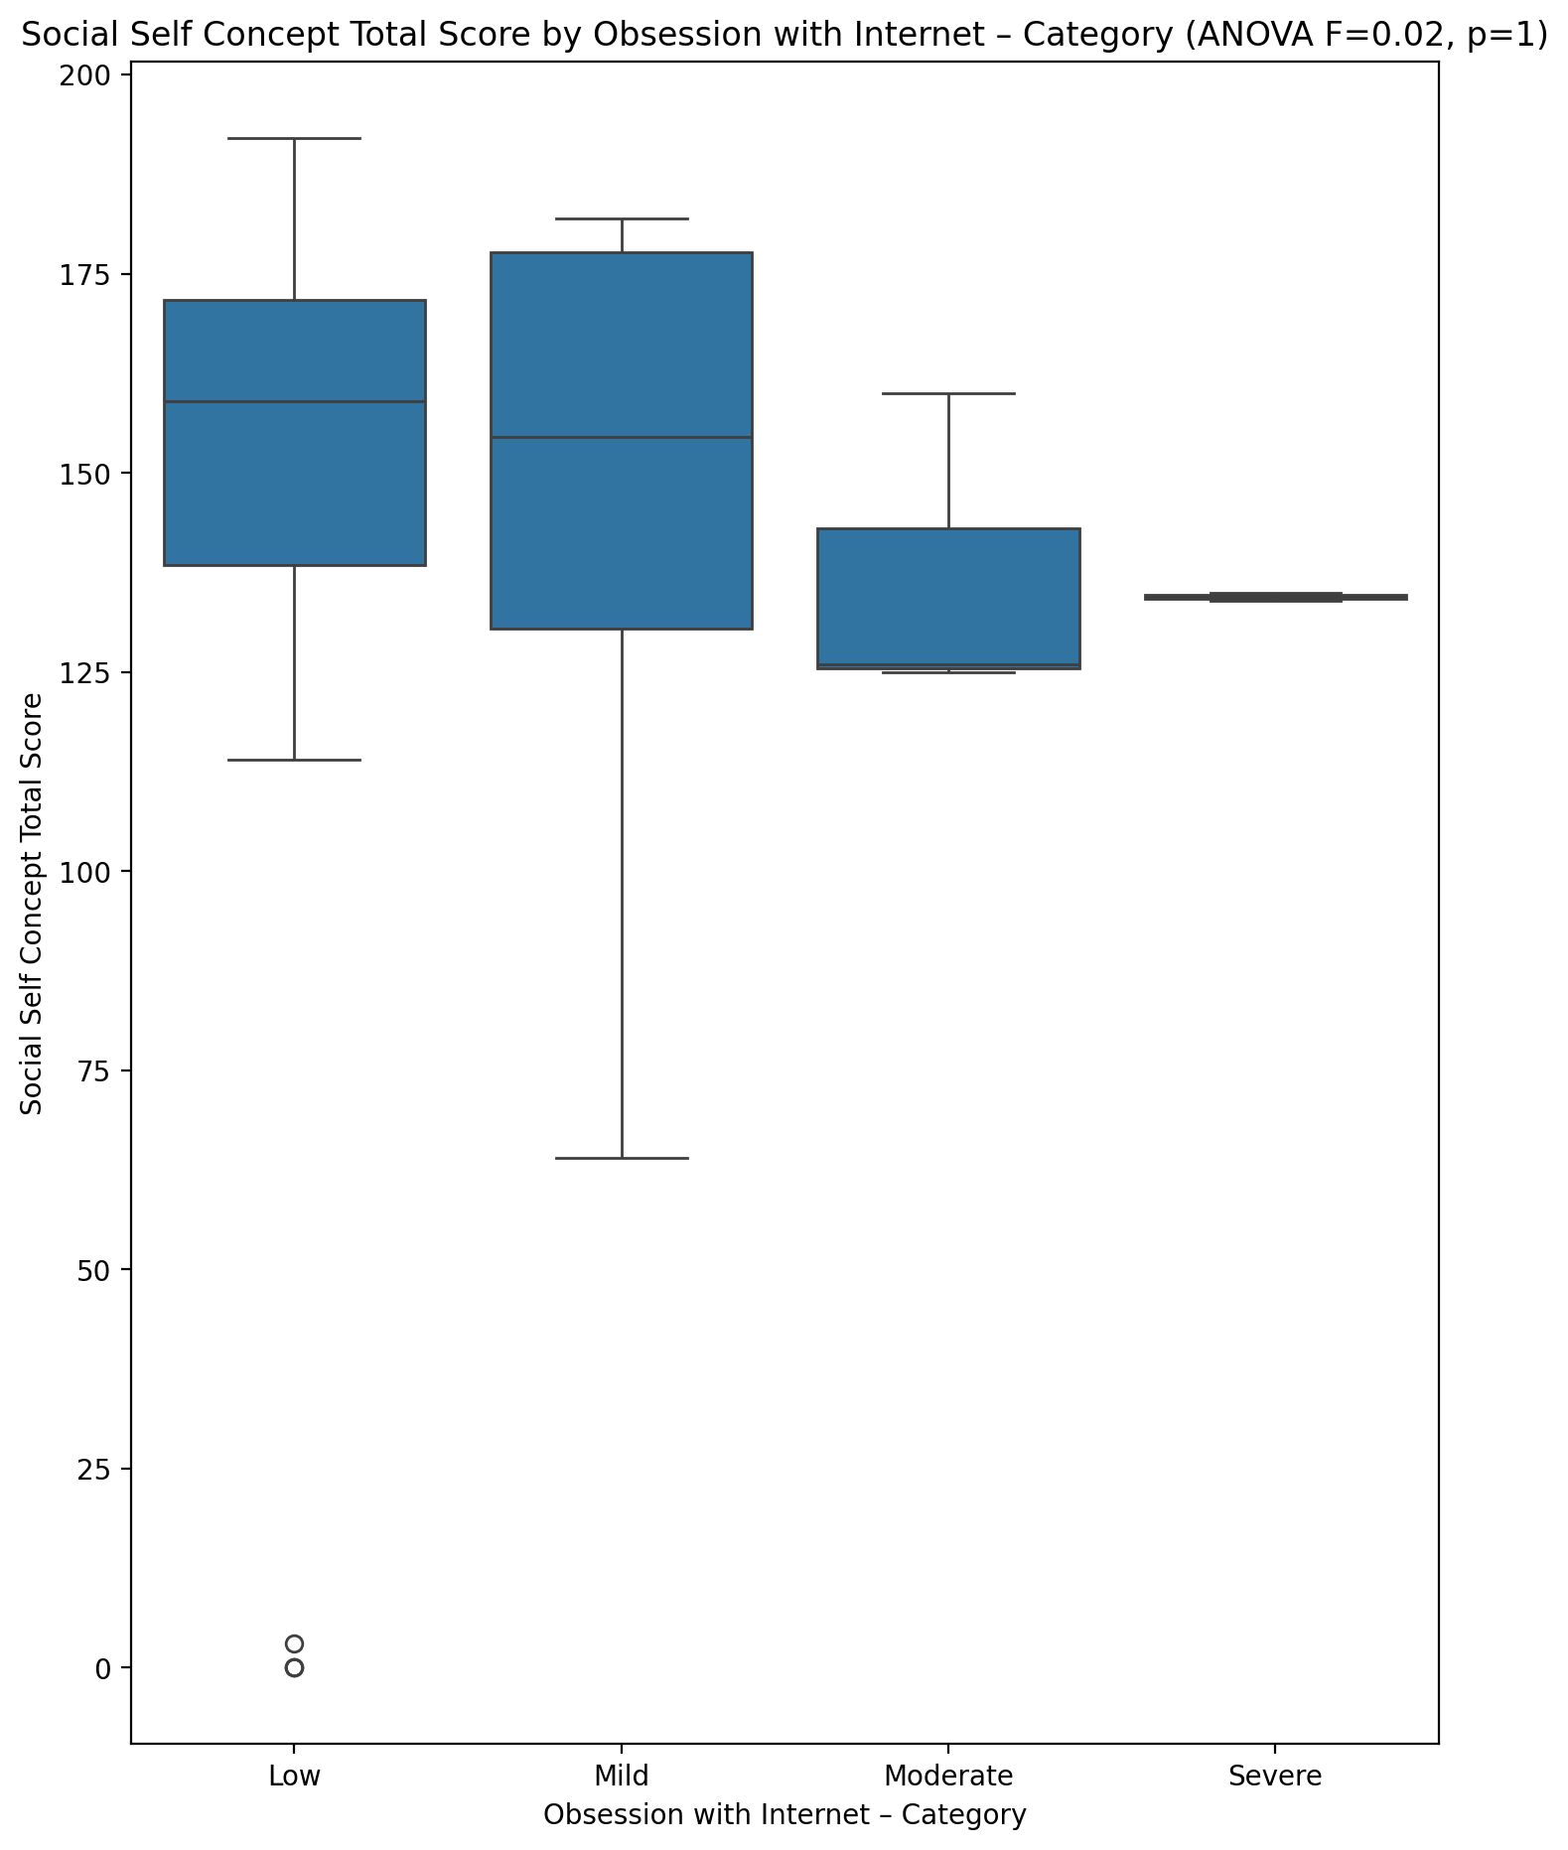

## Ideal Self Concept Total Category vs Obsession with Internet – Category

Test: chi2; statistic: 12.651839717741936; p-value: 0.04891024689314061;

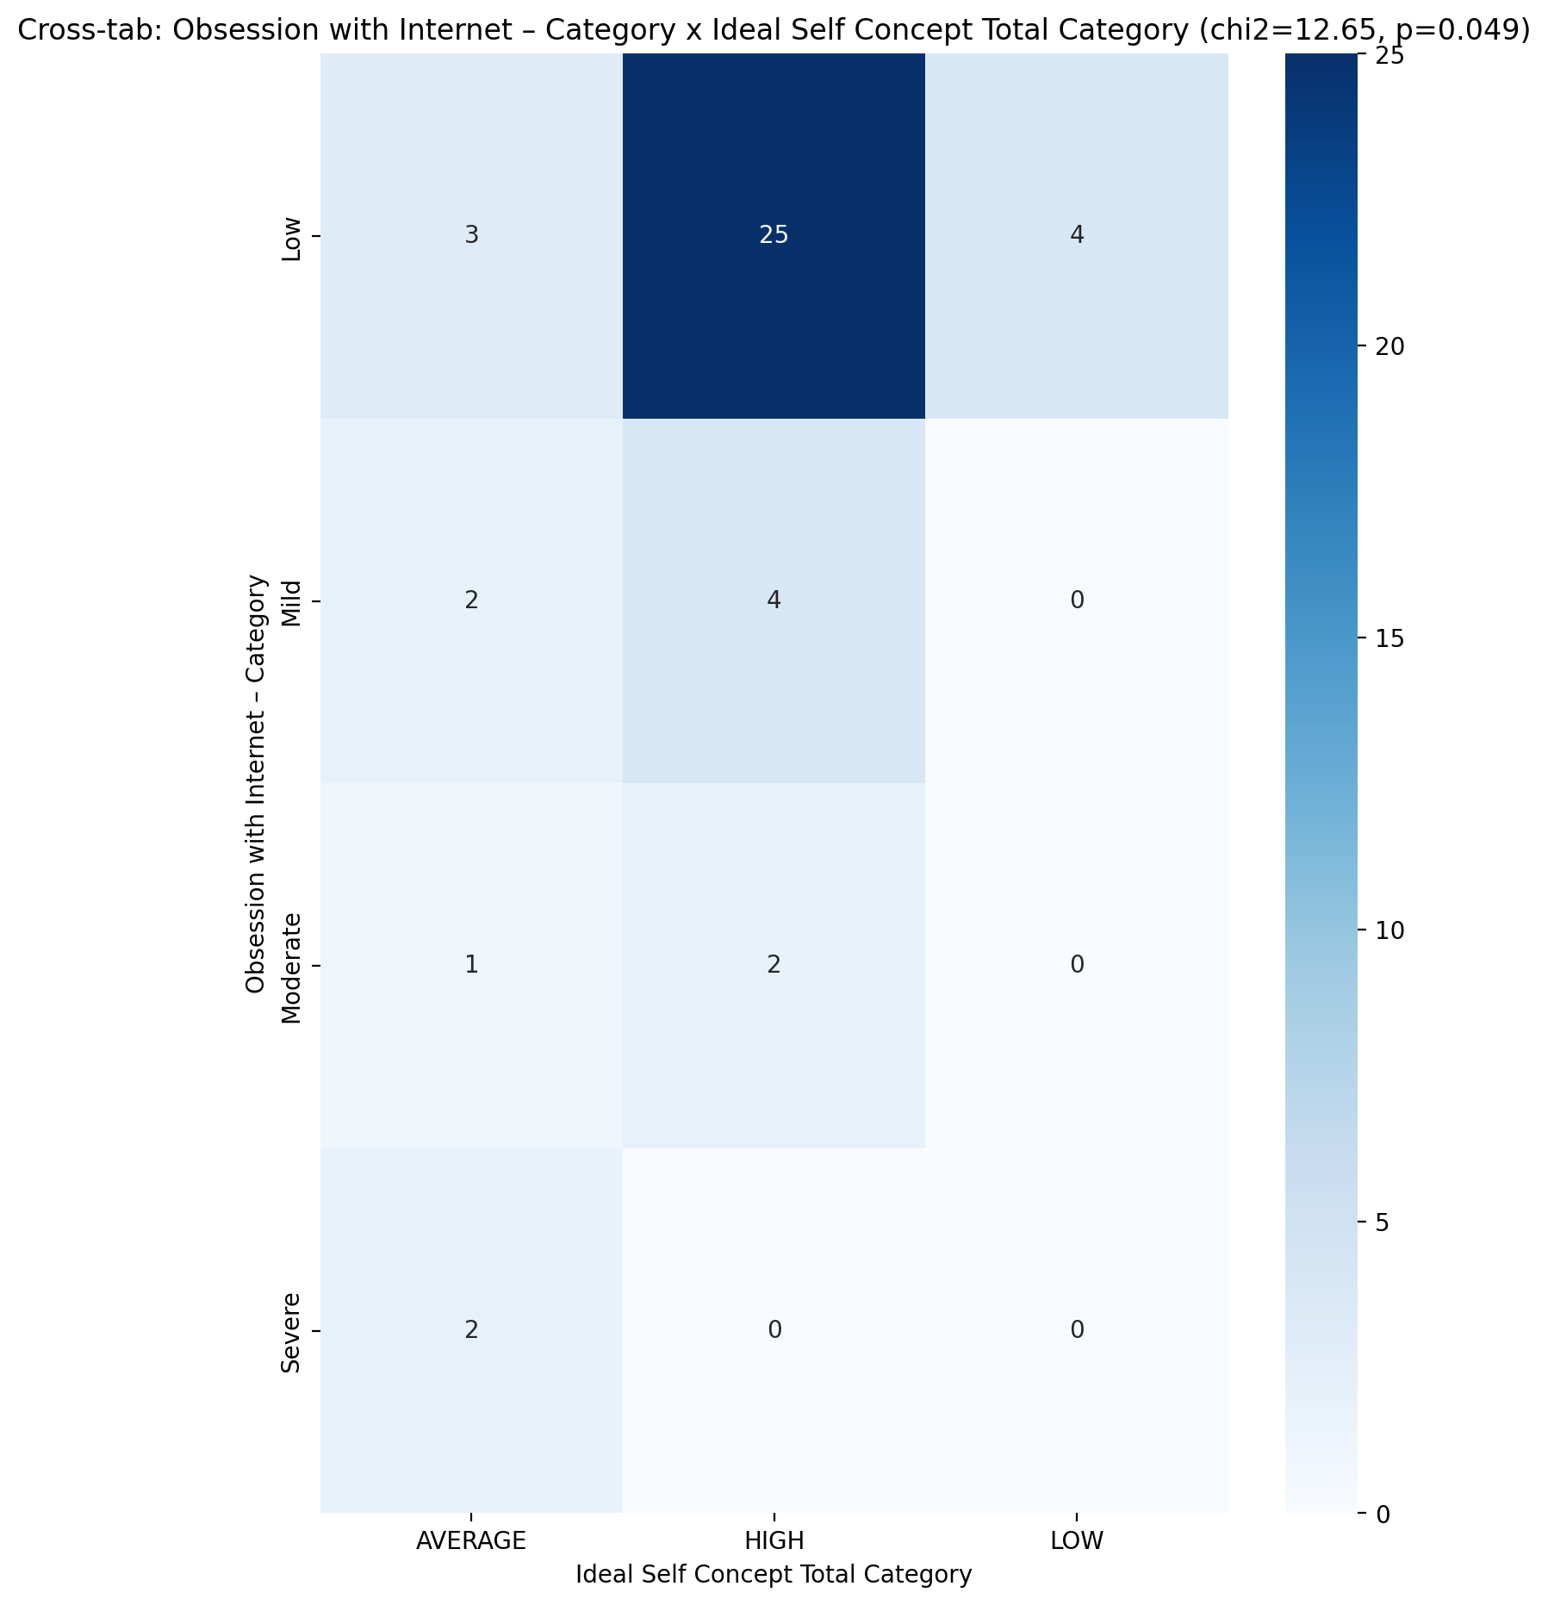

## Perceived Social Stress Score vs Obsession with Internet – Category

Test: anova; statistic: 1.9163811924196434; p-value: 0.14287610299559875;

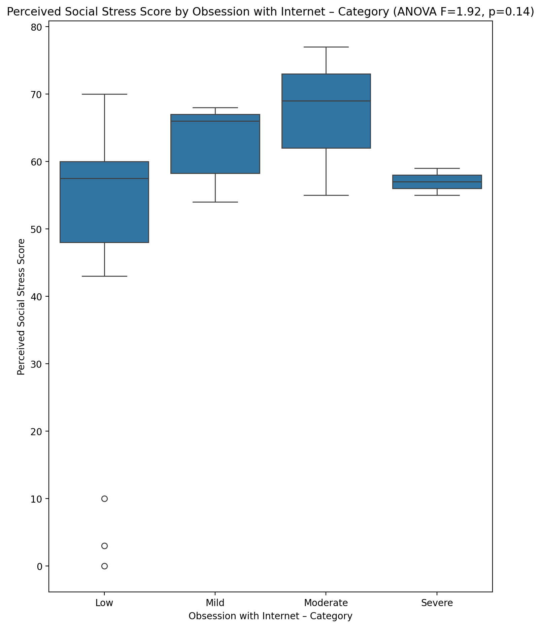

## Perceived Social Stress Category vs Obsession with Internet – Category

Test: chi2; statistic: 1.10859375; p-value: 0.7749999337216861;

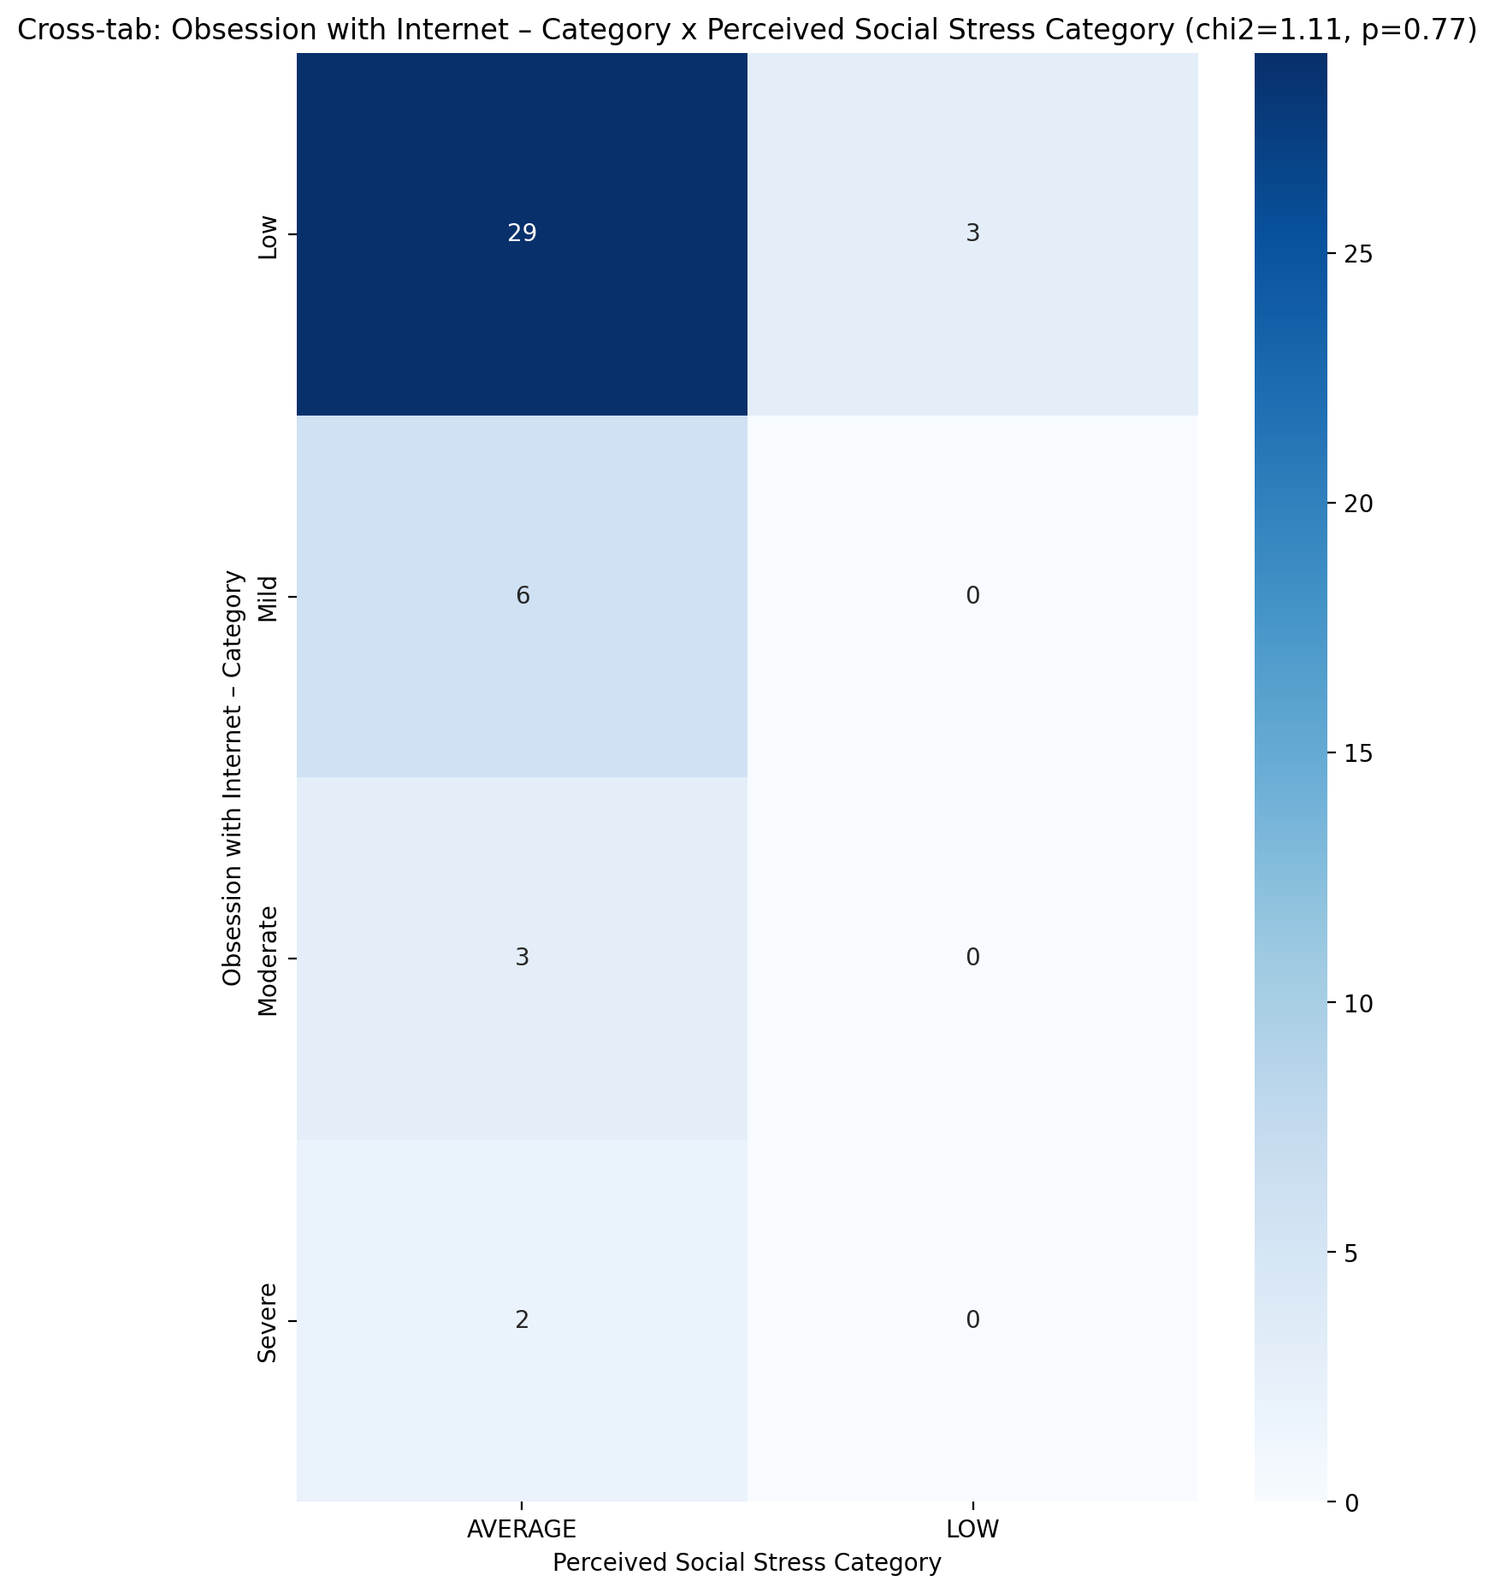

## Emotional Support - Raw Score vs Internet as a Source of Recreation – Category

Test: anova; statistic: 2.1416101794438074; p-value: 0.1105511164338491;

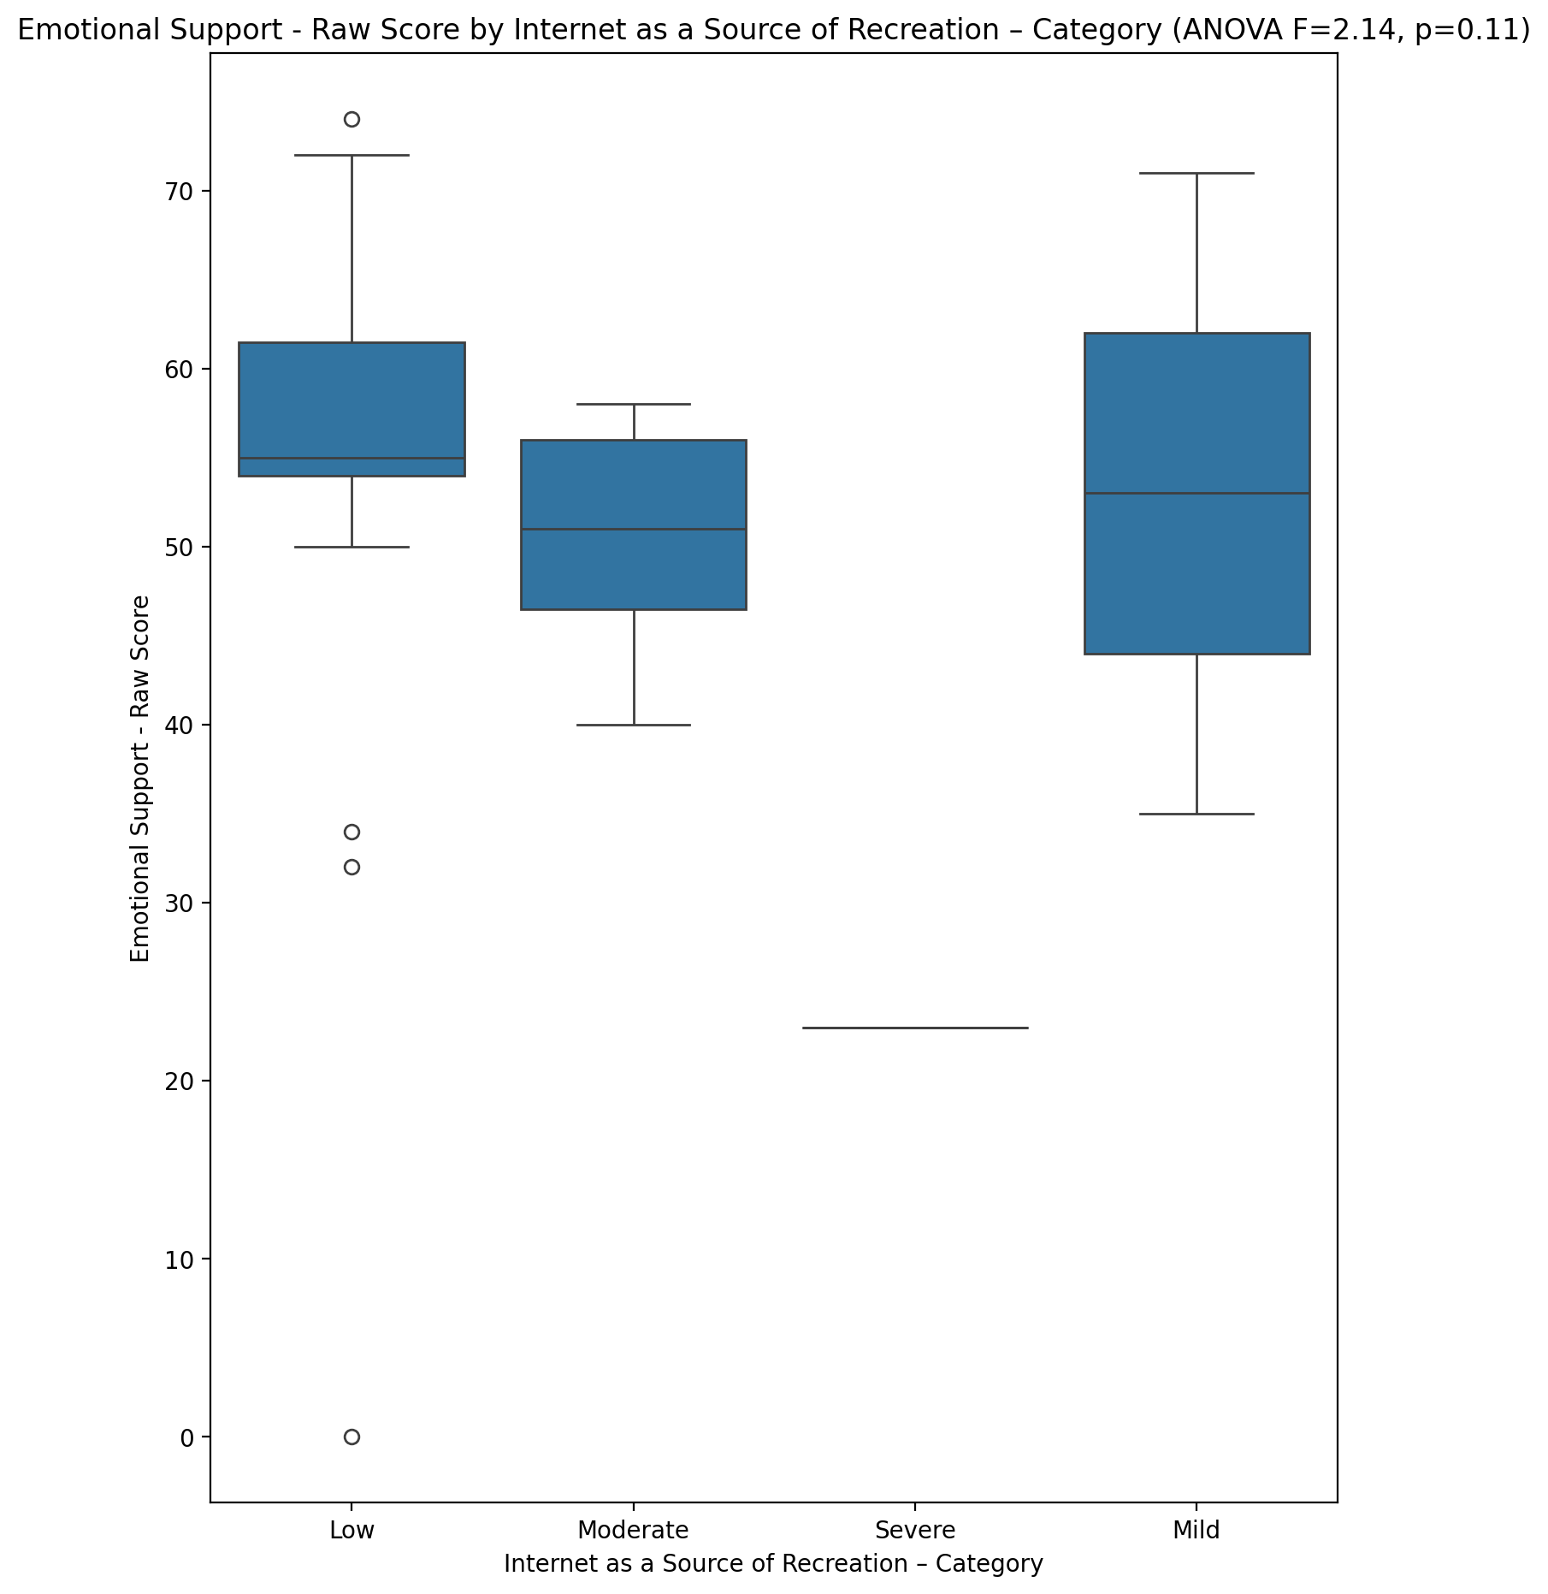

## Informational Support - Raw Score vs Internet as a Source of Recreation – Category

Test: anova; statistic: 0.5198581429248269; p-value: 0.6711151012361409;

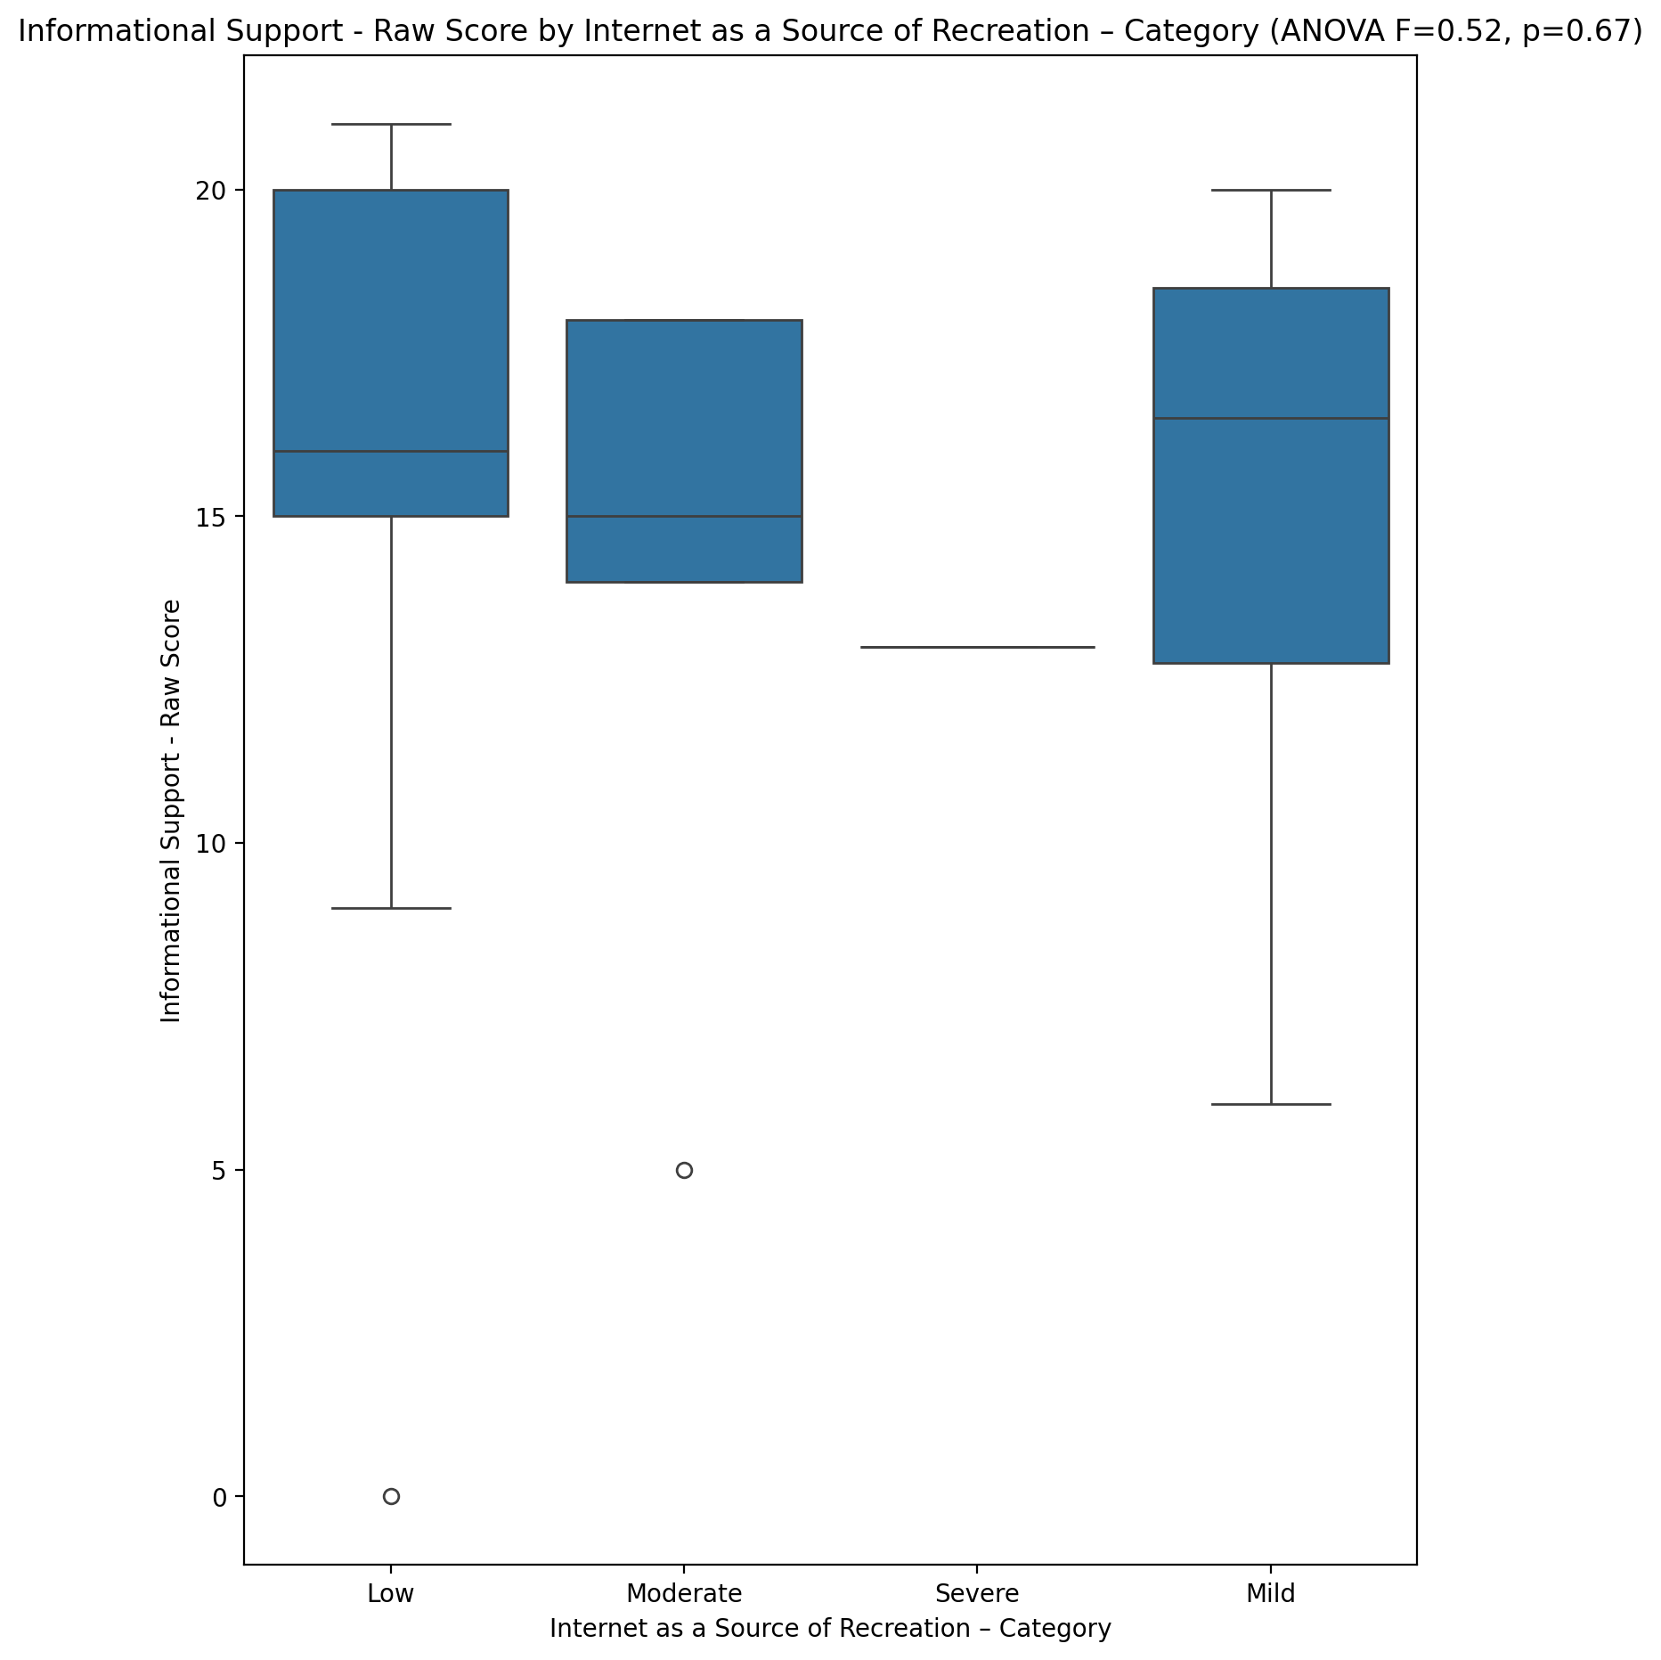

## Instrumental Support - Raw Score vs Internet as a Source of Recreation – Category

Test: anova; statistic: 1.287216747883151; p-value: 0.29230625950975203;

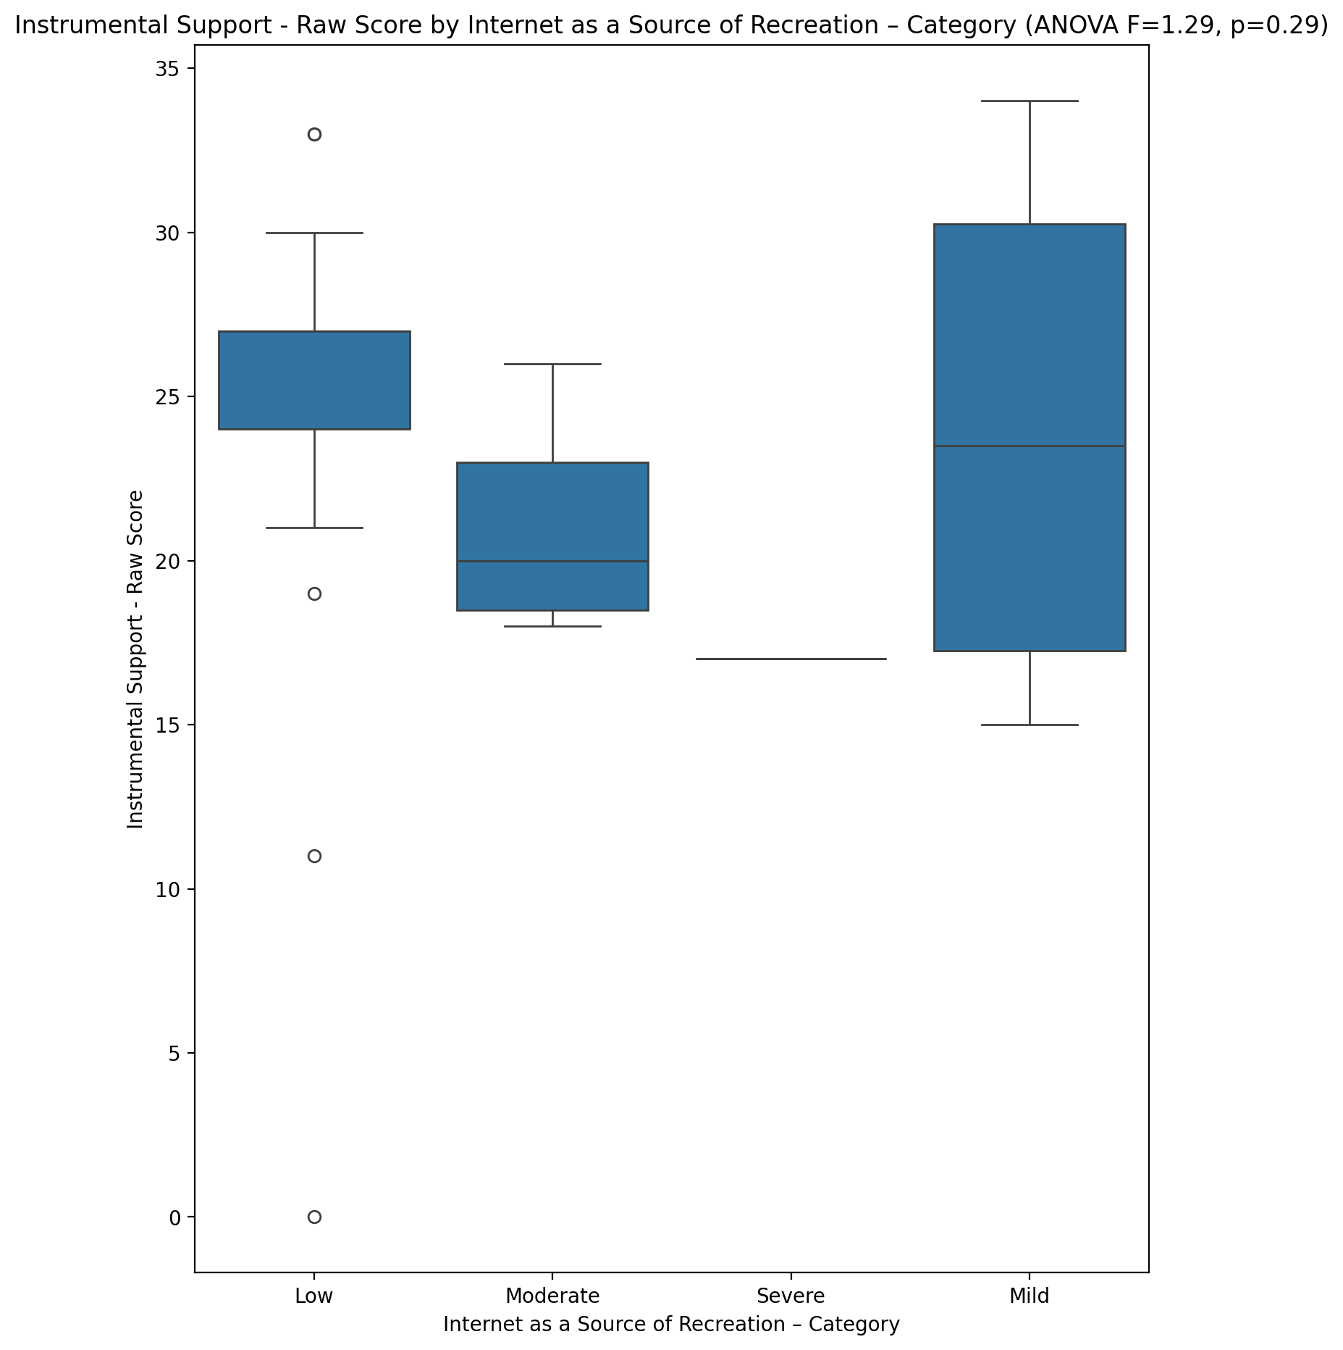

## Emotional Support - T Score vs Internet as a Source of Recreation – Category

Test: anova; statistic: 3.3702693033732682; p-value: 0.027964866284655065;

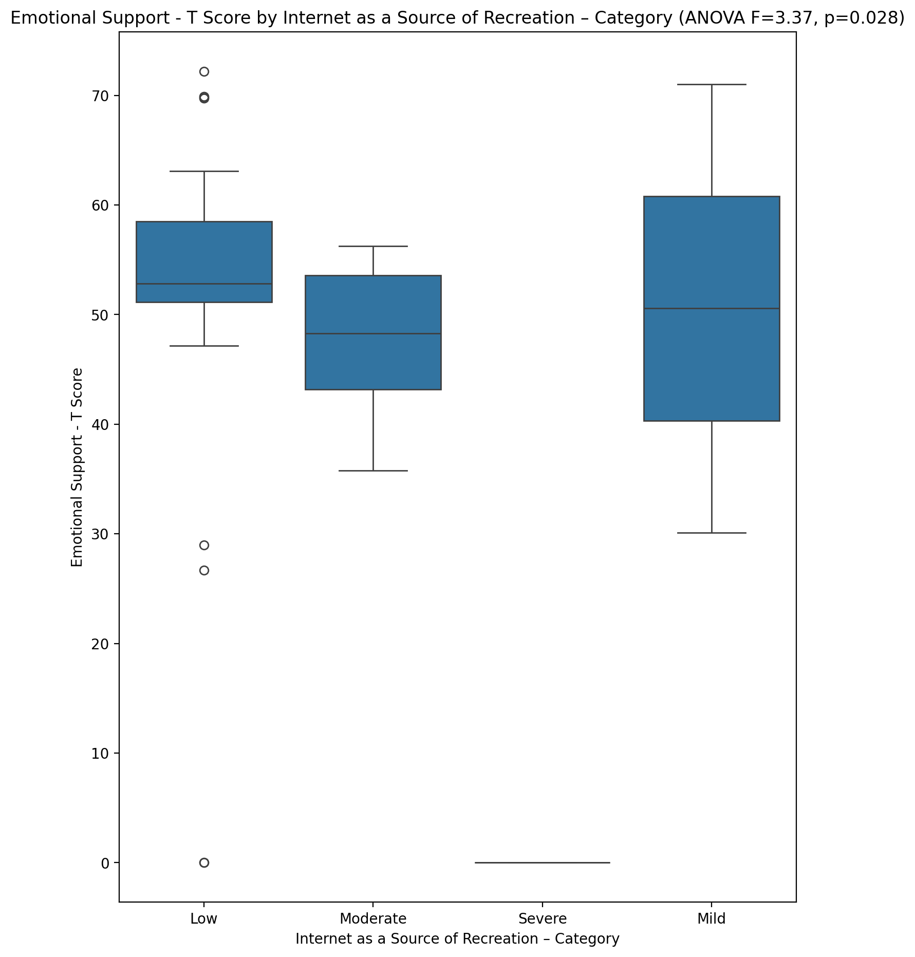

## Informational Support - T Score vs Internet as a Source of Recreation – Category

Test: anova; statistic: 0.8092818564772926; p-value: 0.4964333369561431;

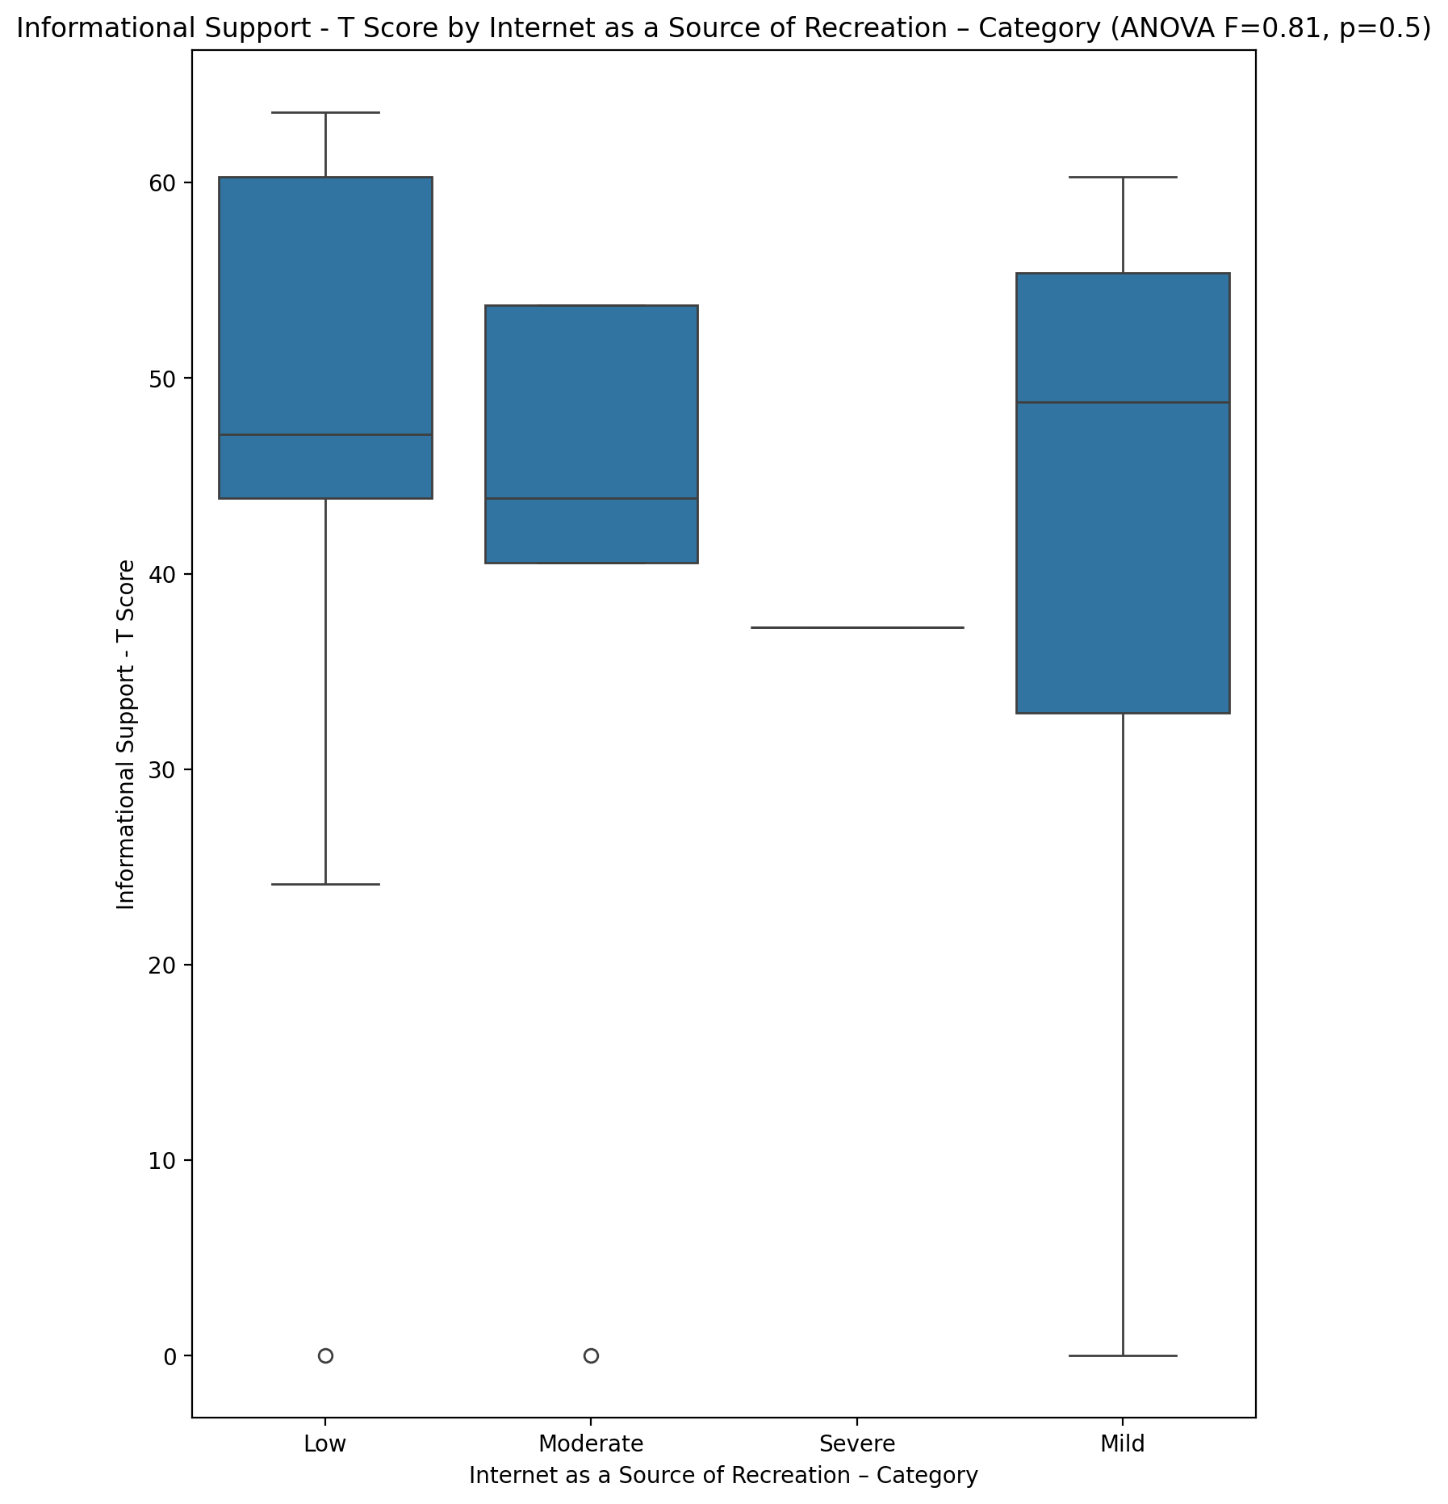

## Instrumental Support - T Score vs Internet as a Source of Recreation – Category

Test: anova; statistic: 1.1139585742072329; p-value: 0.35511964594357465;

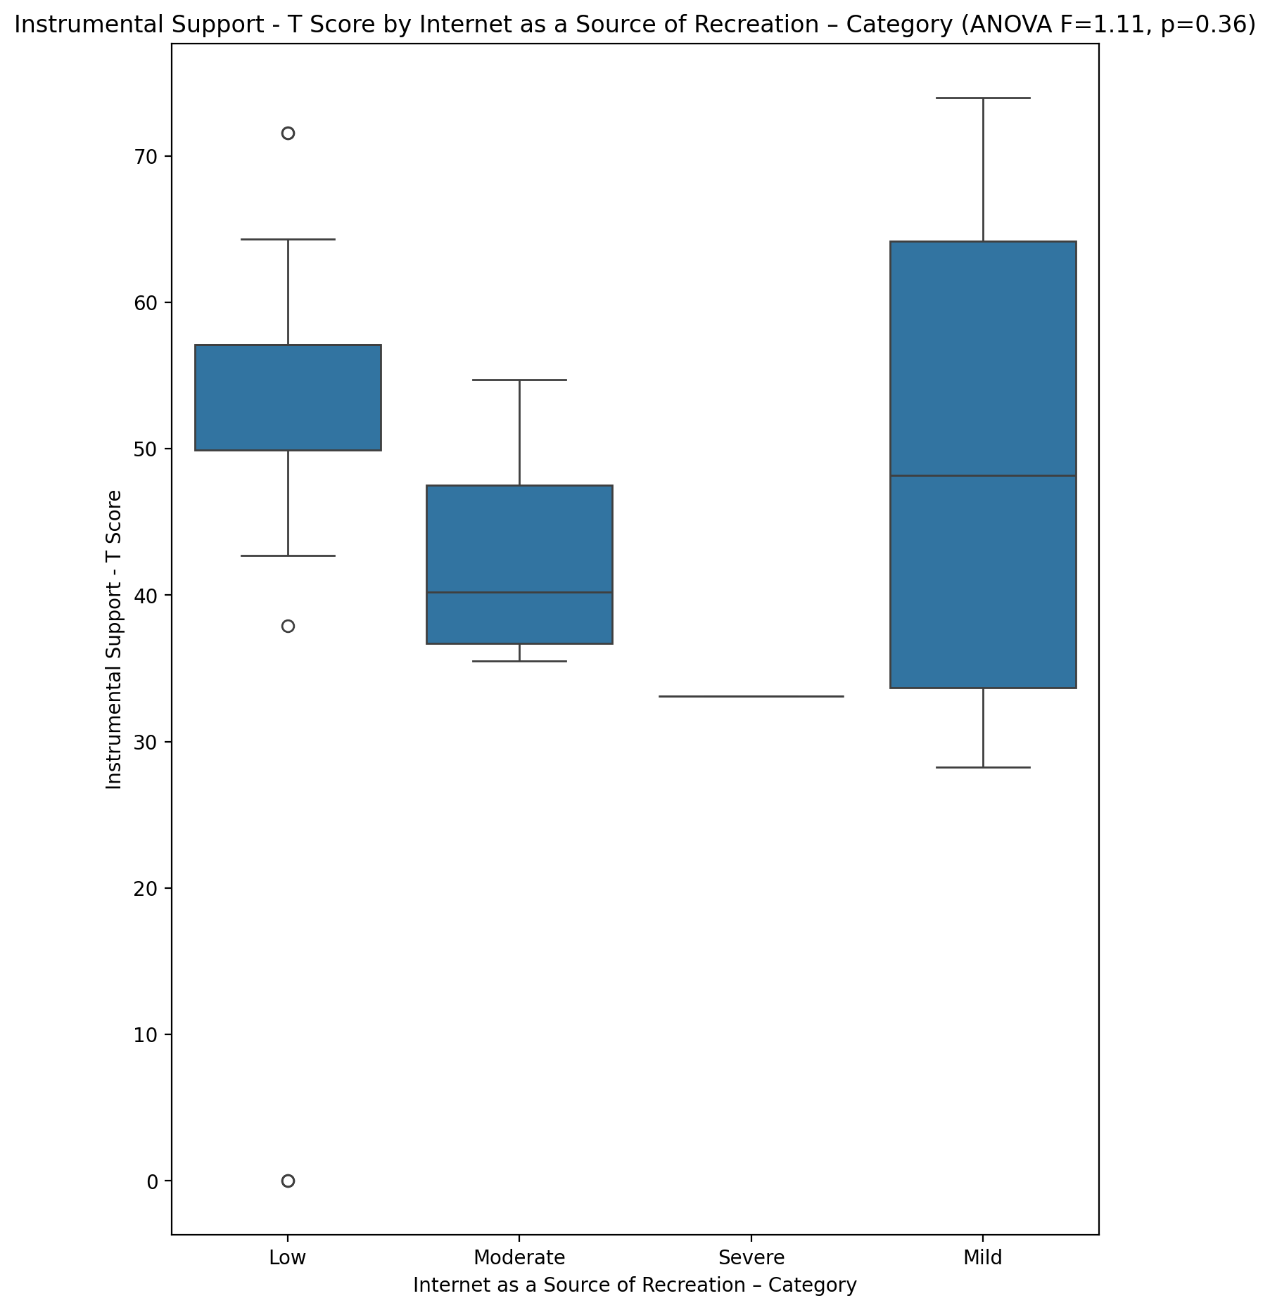

## Perceived Social Support Total T Score vs Internet as a Source of Recreation – Category

Test: anova; statistic: 3.3438270815286724; p-value: 0.02878730578206471;

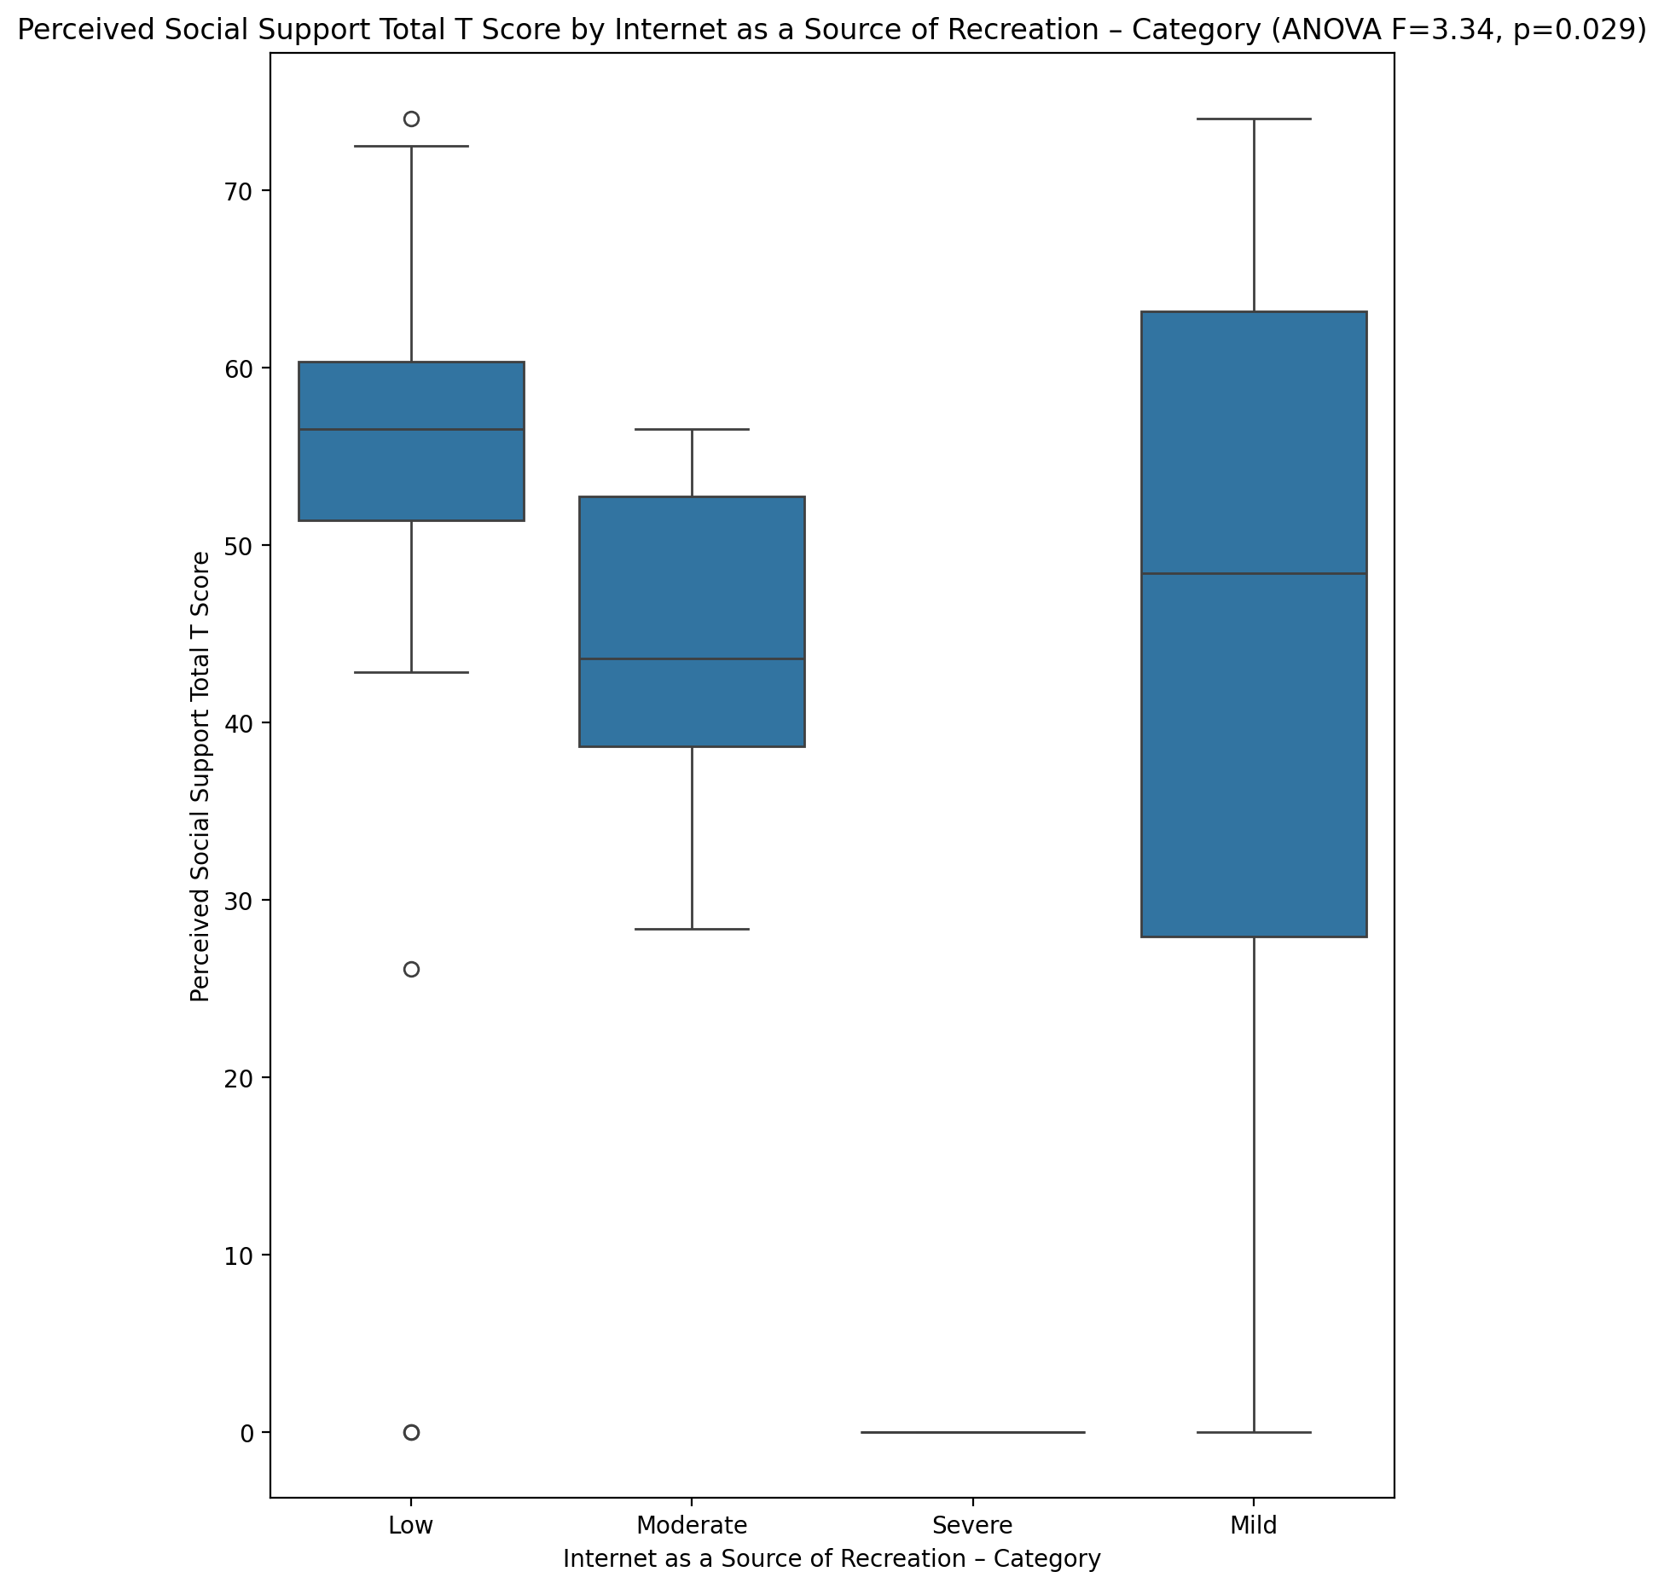

## Emotional Support - Rank vs Internet as a Source of Recreation – Category

Test: chi2; statistic: 22.125432027649765; p-value: 0.0361378316174999;

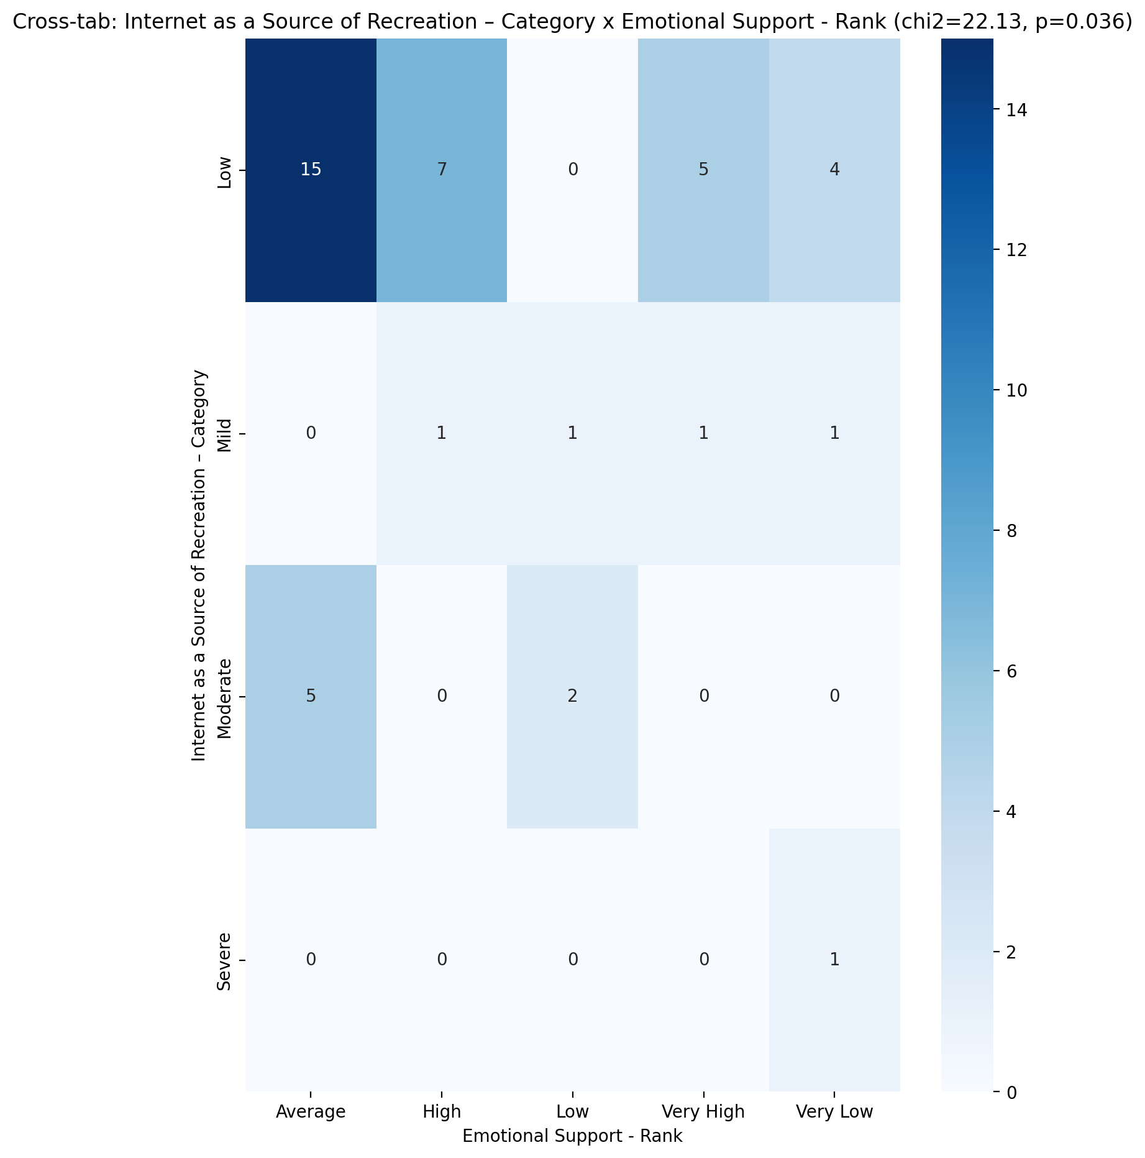

## Informational Support - Rank vs Internet as a Source of Recreation – Category

Test: chi2; statistic: 7.798173140223832; p-value: 0.5546066569953199;

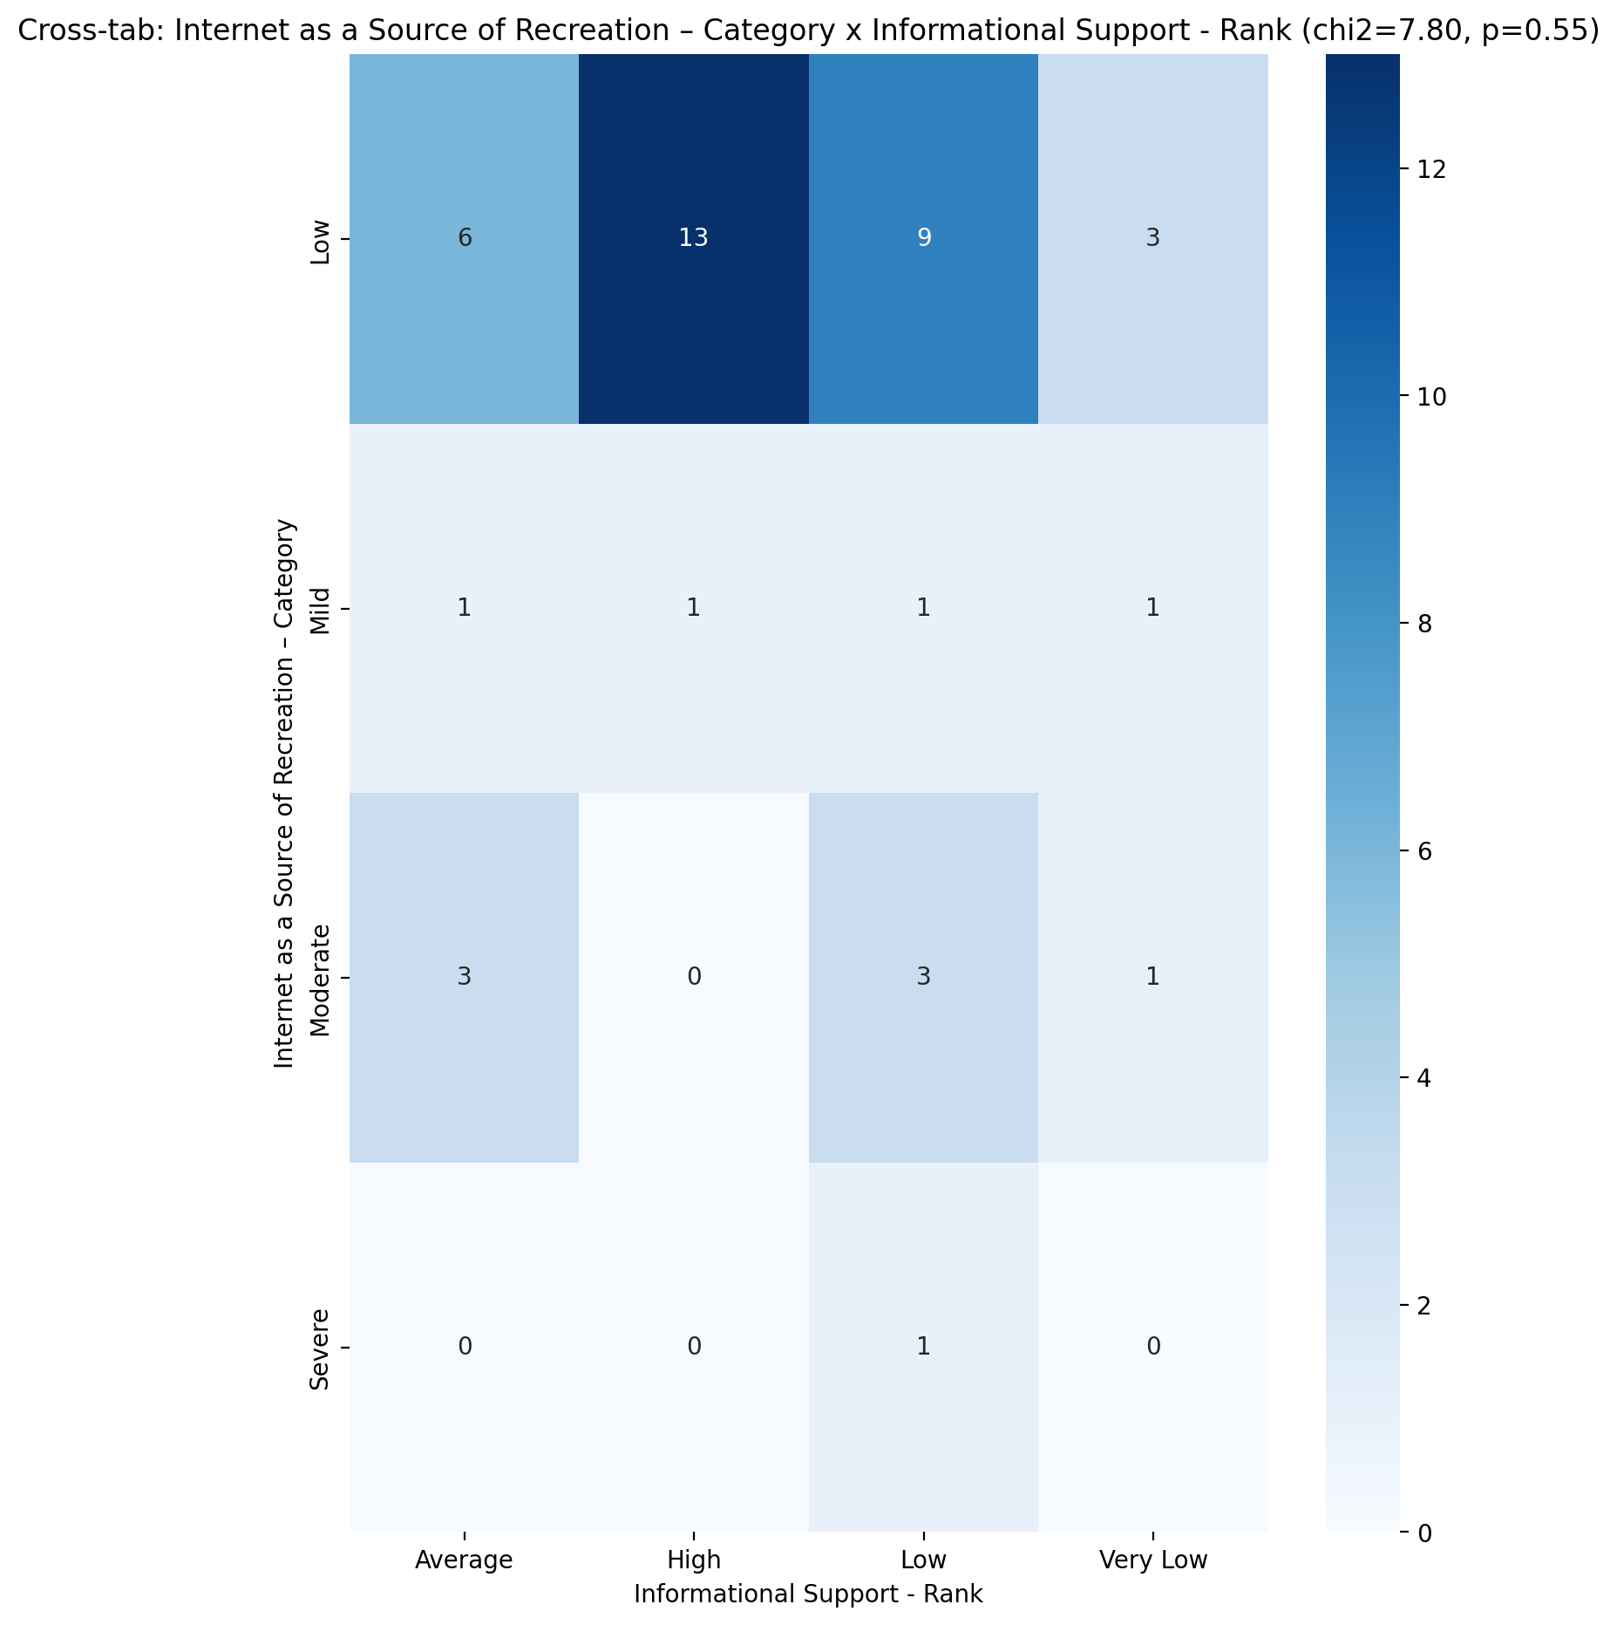

## Instrumental Support - Rank vs Internet as a Source of Recreation – Category

Test: chi2; statistic: 23.05404863558326; p-value: 0.02727057520011637;

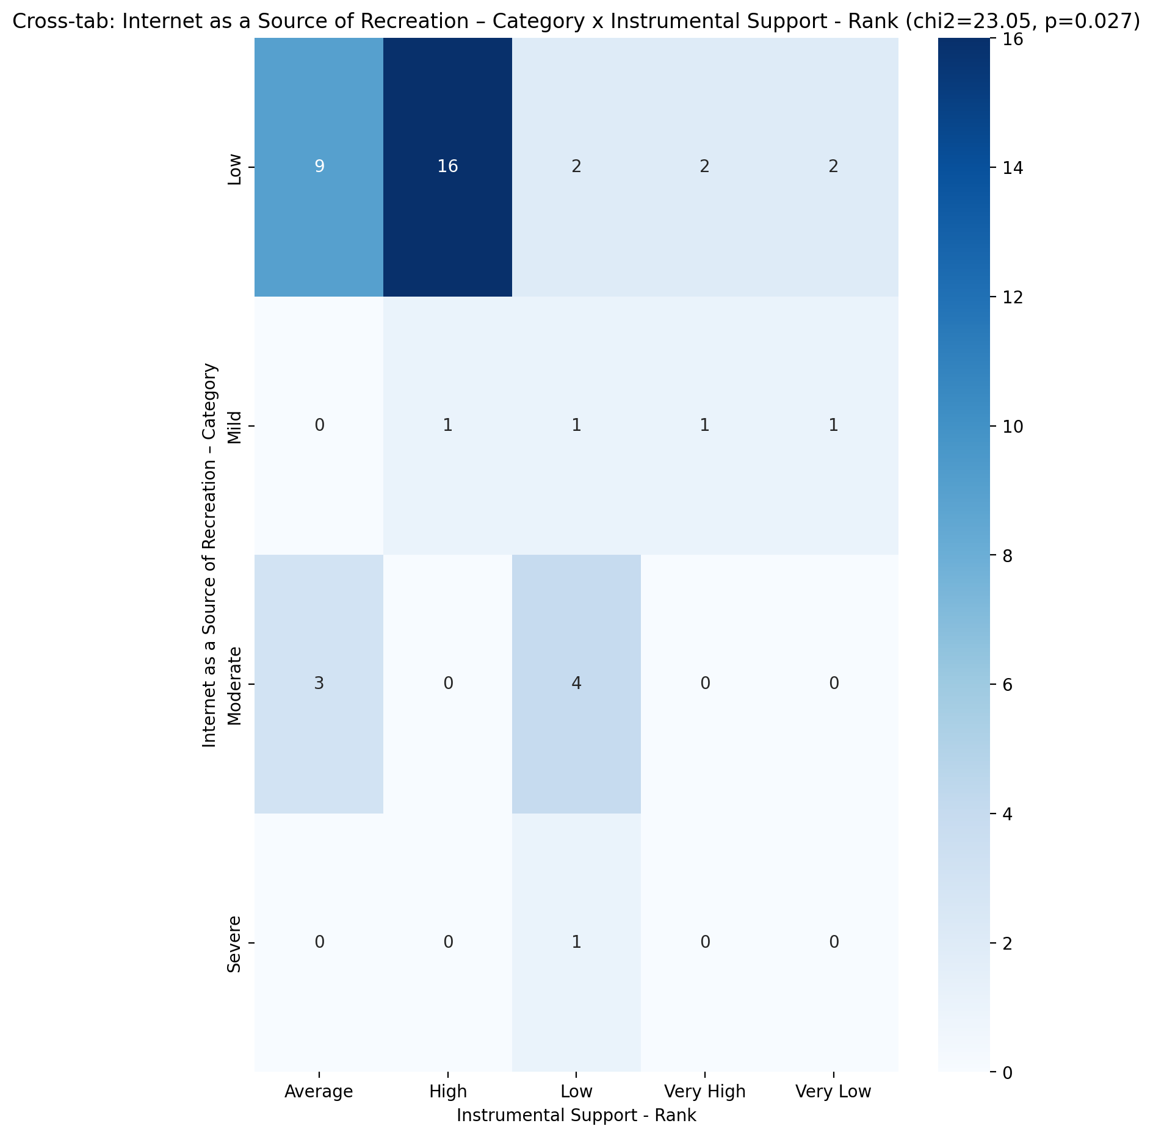

## Perceived Social Support TOTAL - Rank vs Internet as a Source of Recreation – Category

Test: chi2; statistic: 21.846223758320527; p-value: 0.039279855793398585;

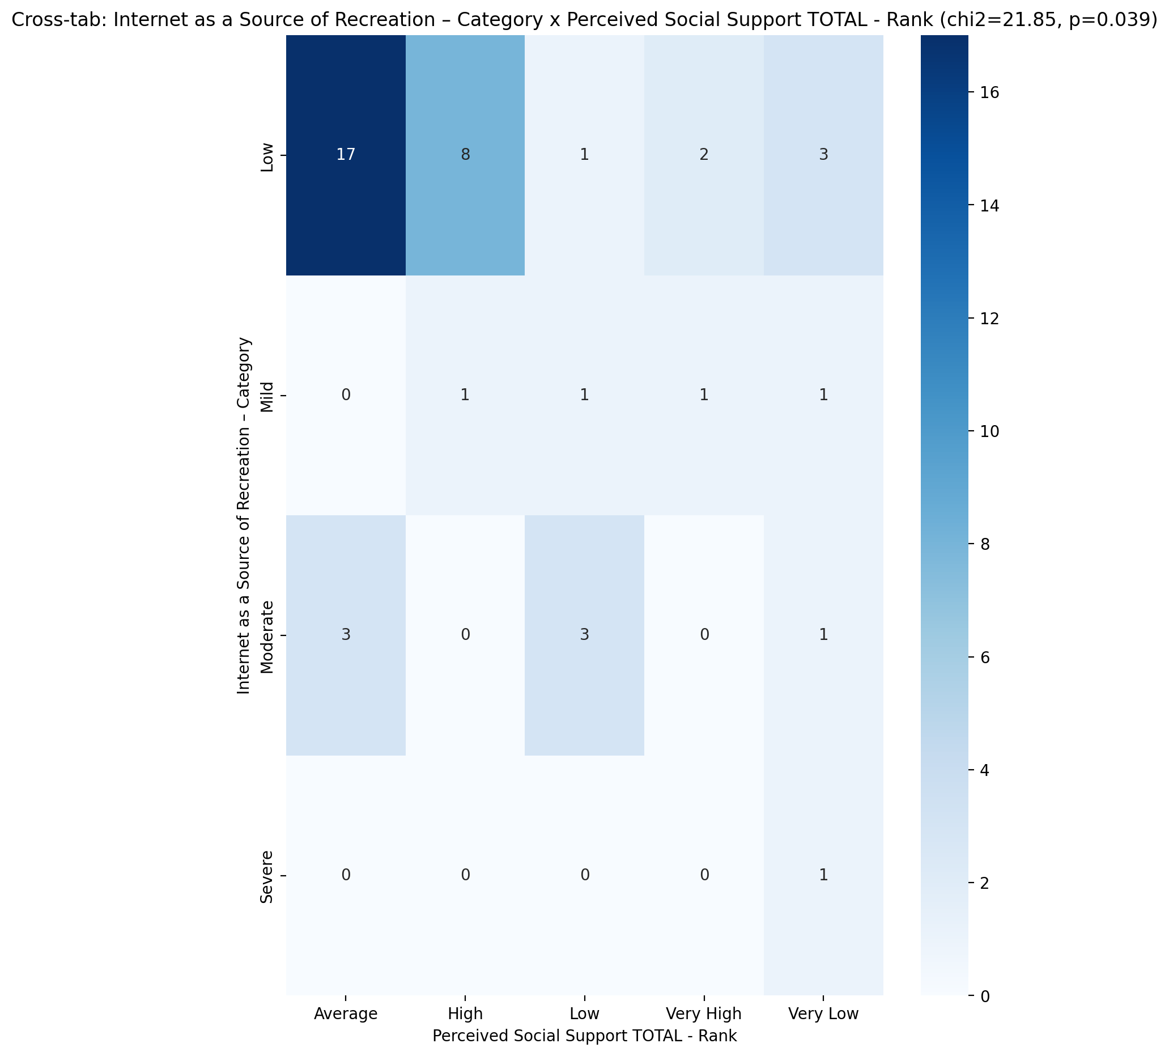

## Power Self Concept - Real Self Concept Score vs Internet as a Source of Recreation – Category

Test: anova; statistic: 0.28802306005208944; p-value: 0.8337546604612657;

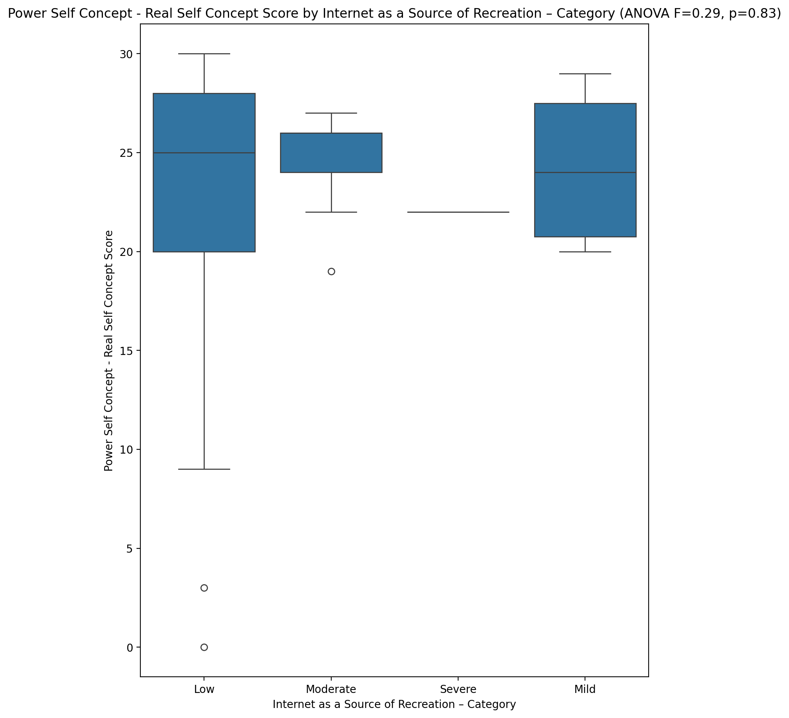

## Power Self Concept - Ideal Self Concept score vs Internet as a Source of Recreation – Category

Test: anova; statistic: 0.43030809176988927; p-value: 0.7324398284618026;

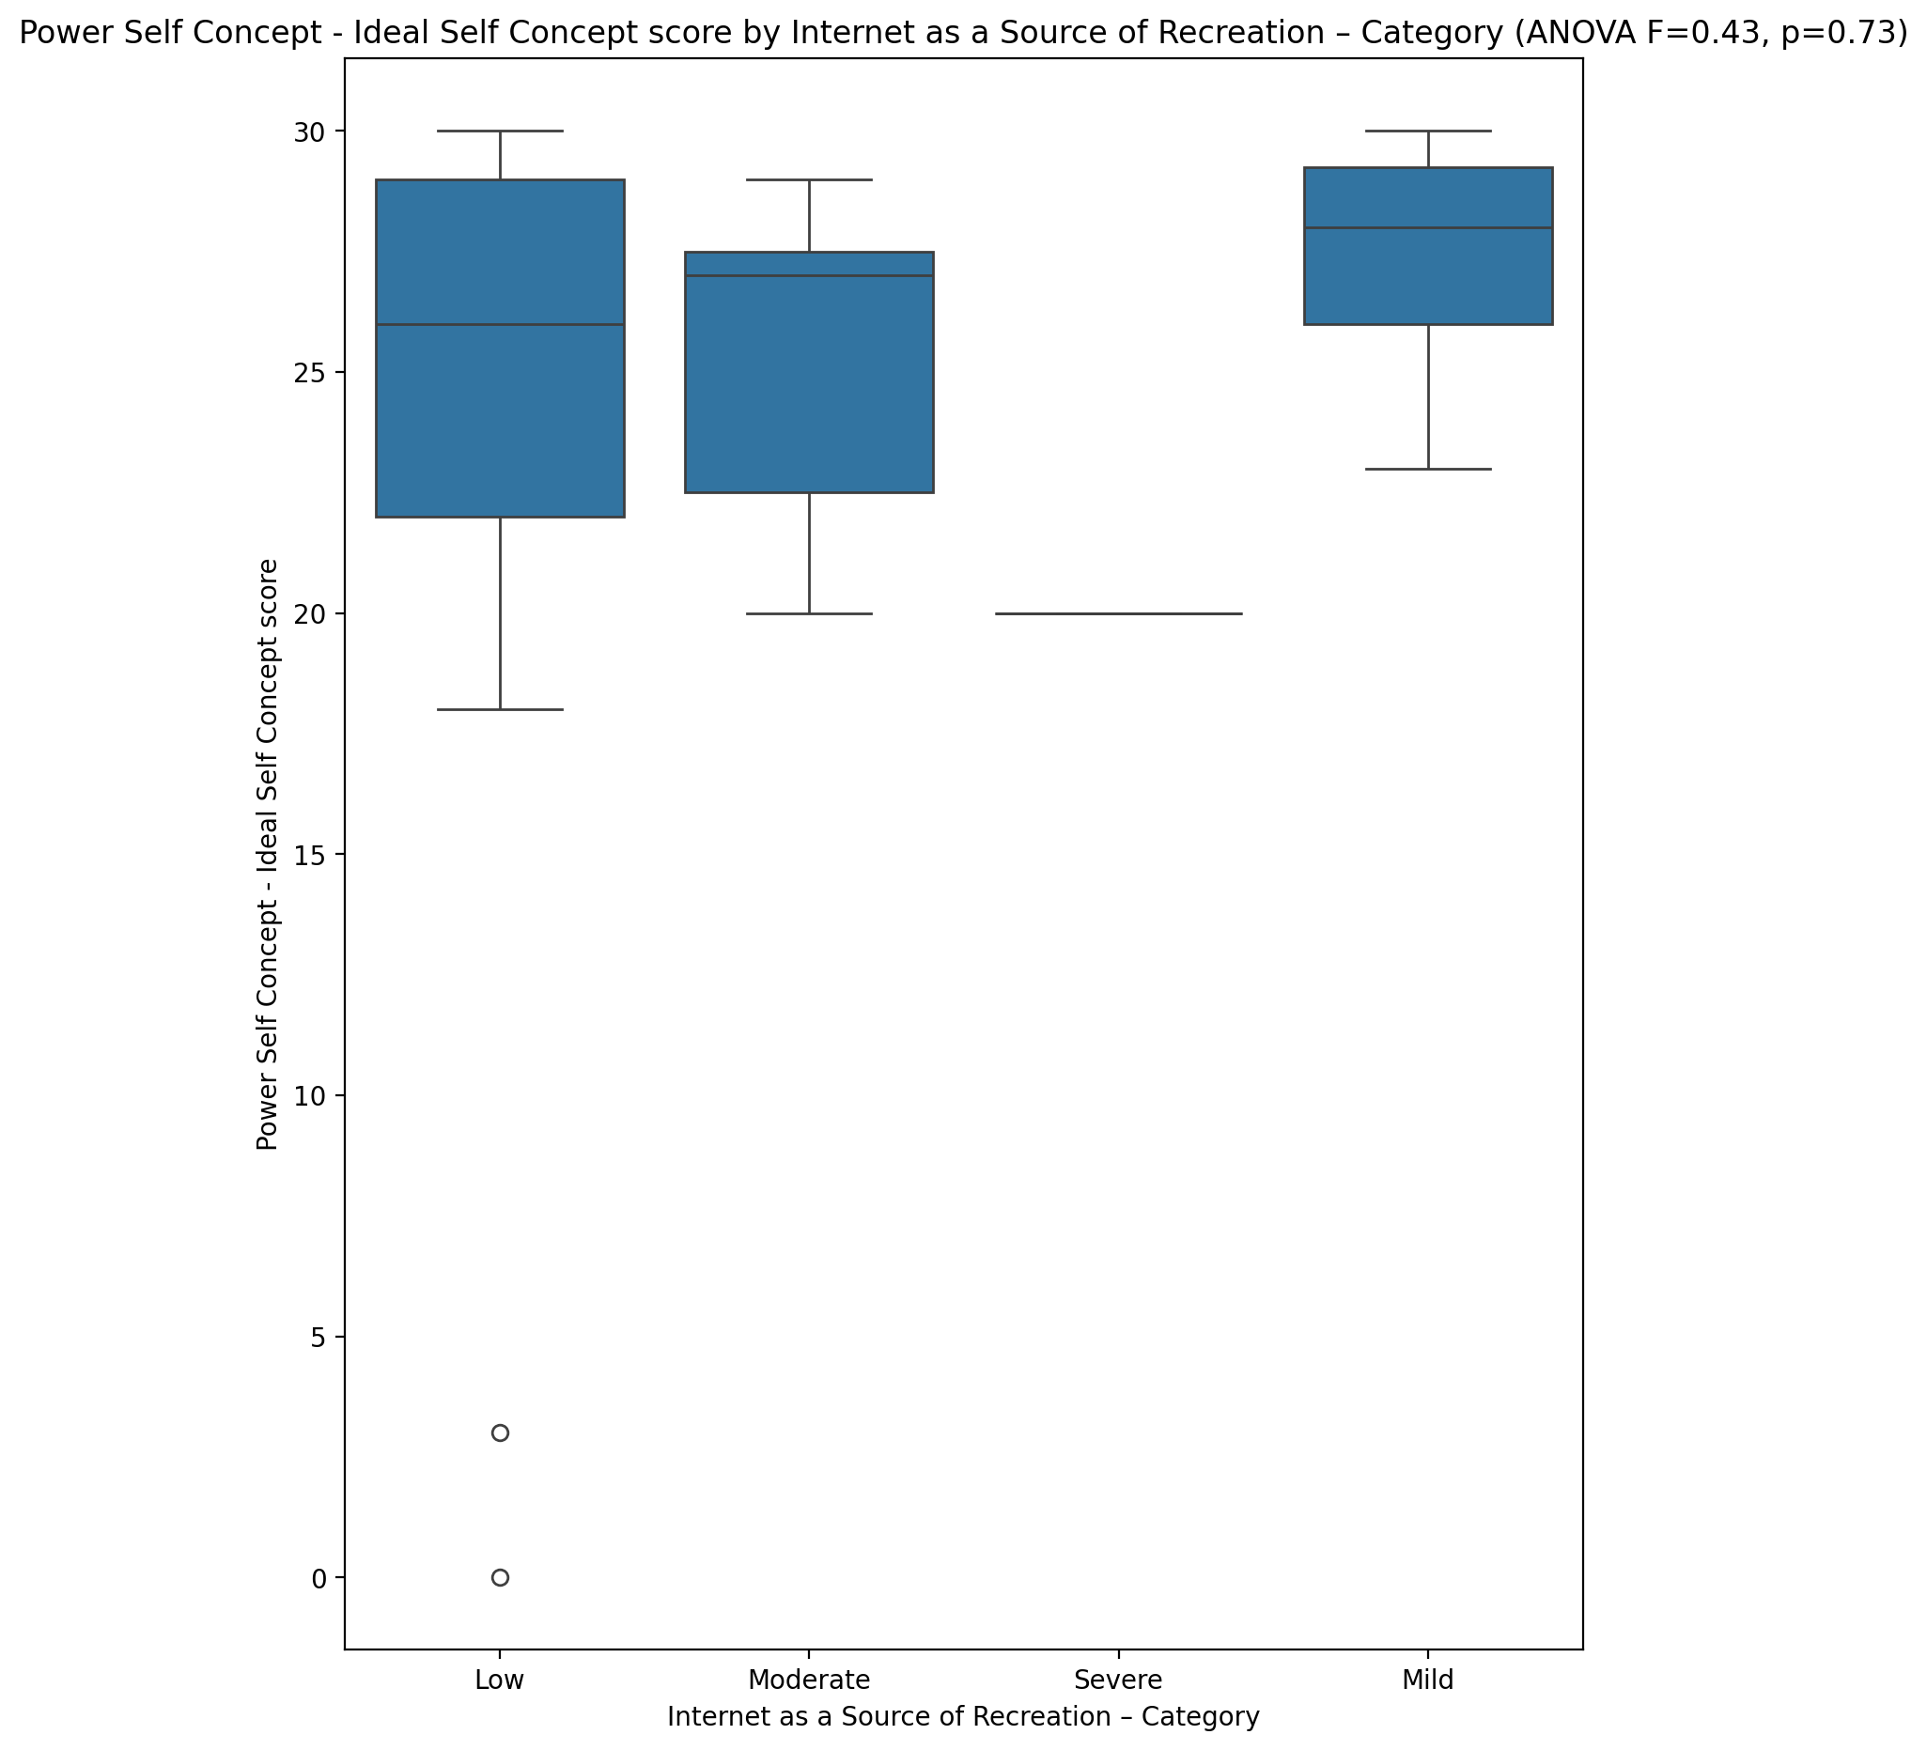

## Power Self Concept – Social Self Concept Score vs Internet as a Source of Recreation – Category

Test: anova; statistic: 0.728211576102537; p-value: 0.5413686913647915;

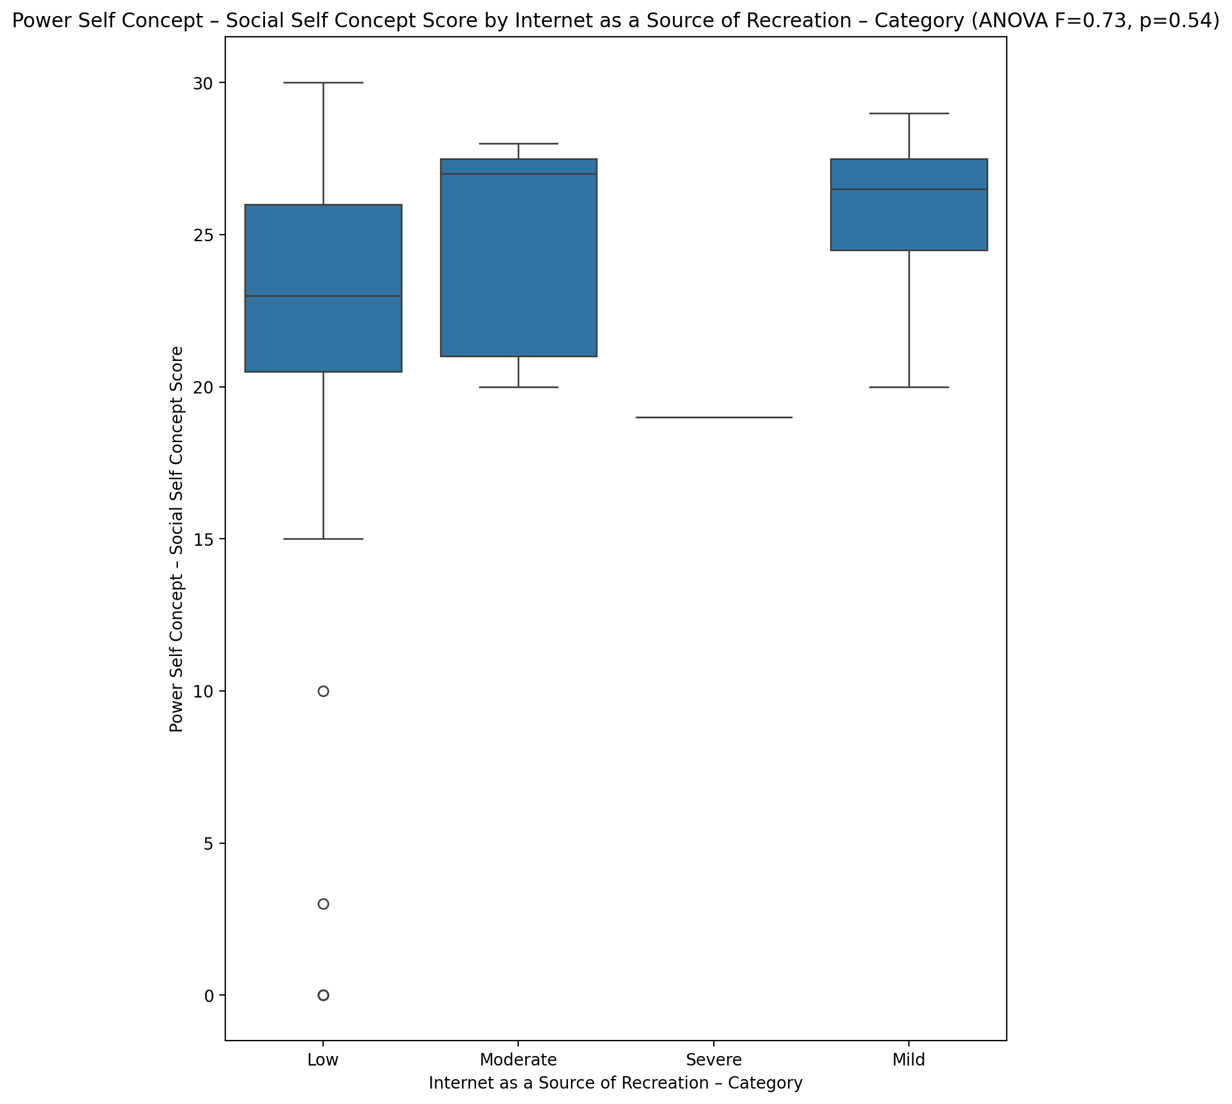

## Social Self Concept - Real Self Concept Score vs Internet as a Source of Recreation – Category

Test: anova; statistic: 0.4612087874443728; p-value: 0.7109712840501968;

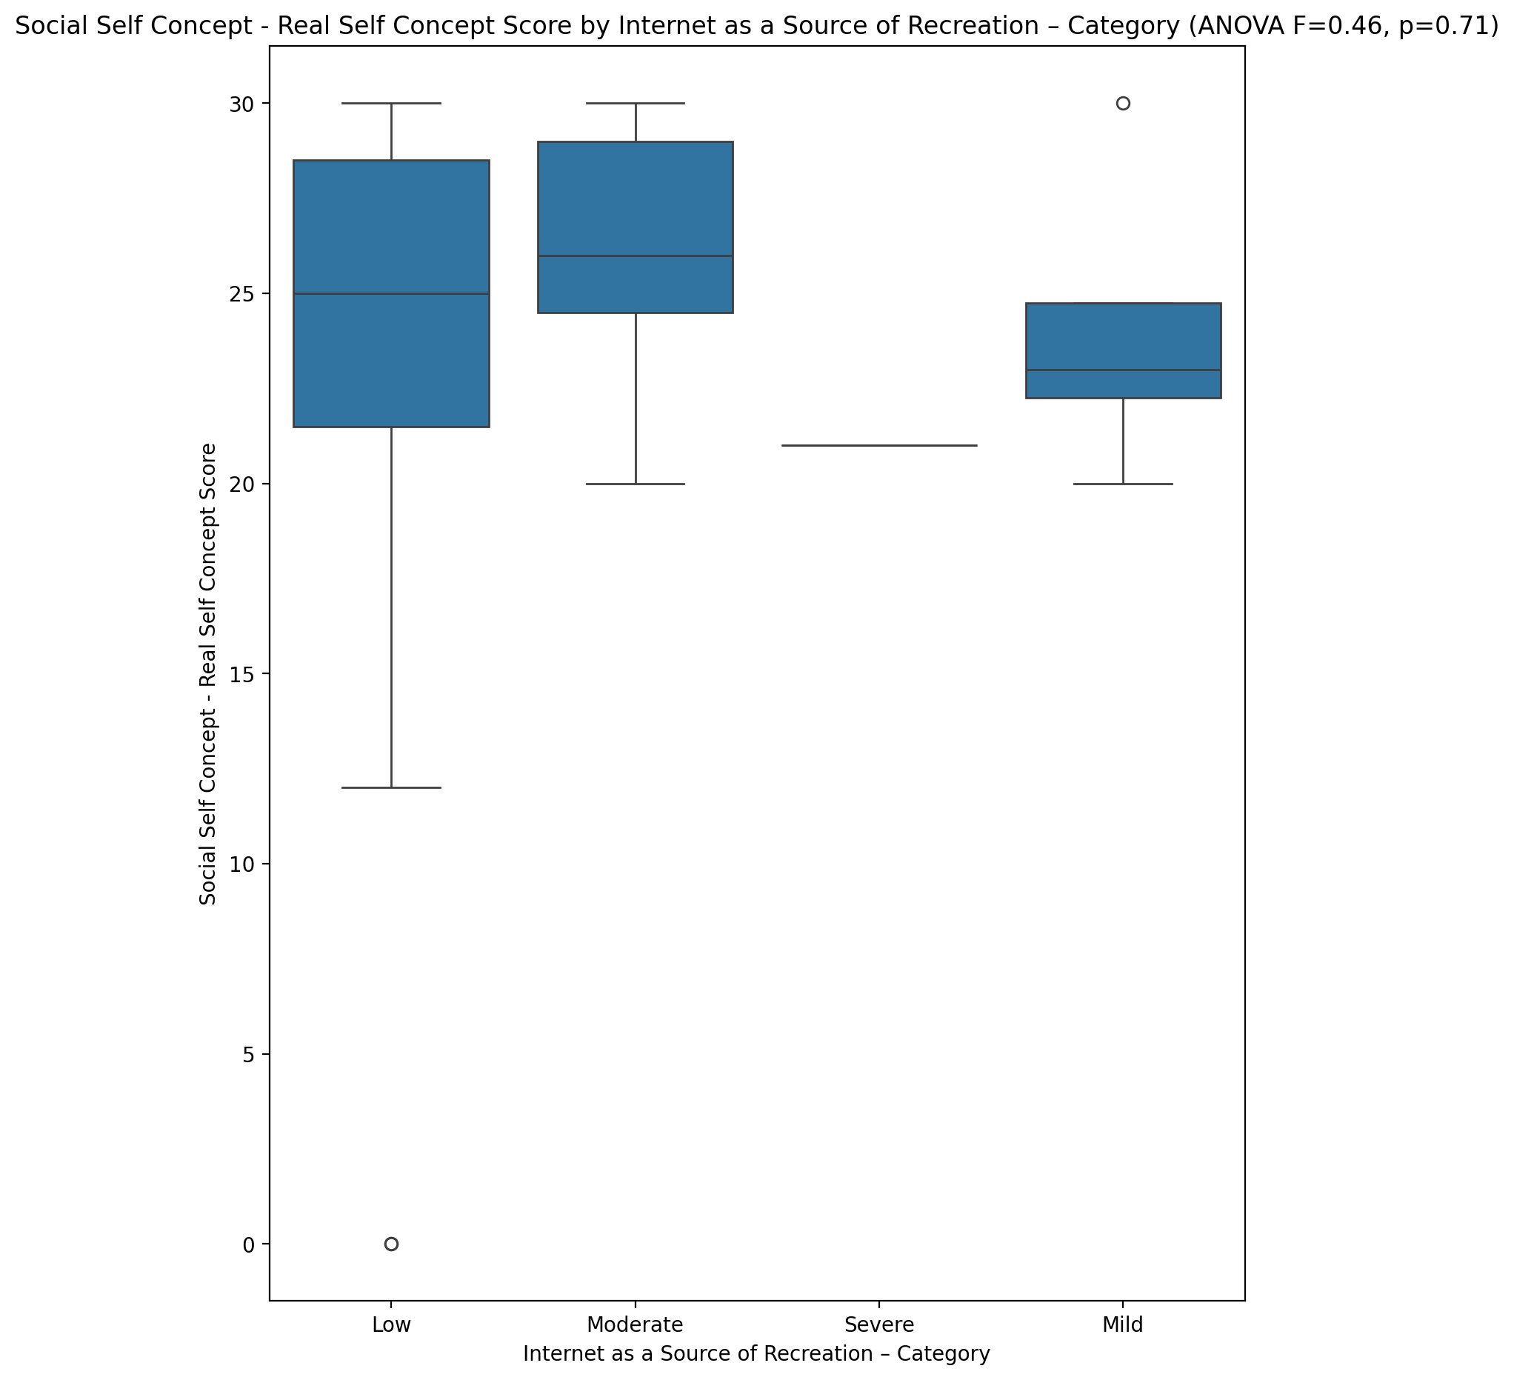

## Social Self Concept – Social Self Concept Score vs Internet as a Source of Recreation – Category

Test: anova; statistic: 0.7738967541193578; p-value: 0.5156547929279465;

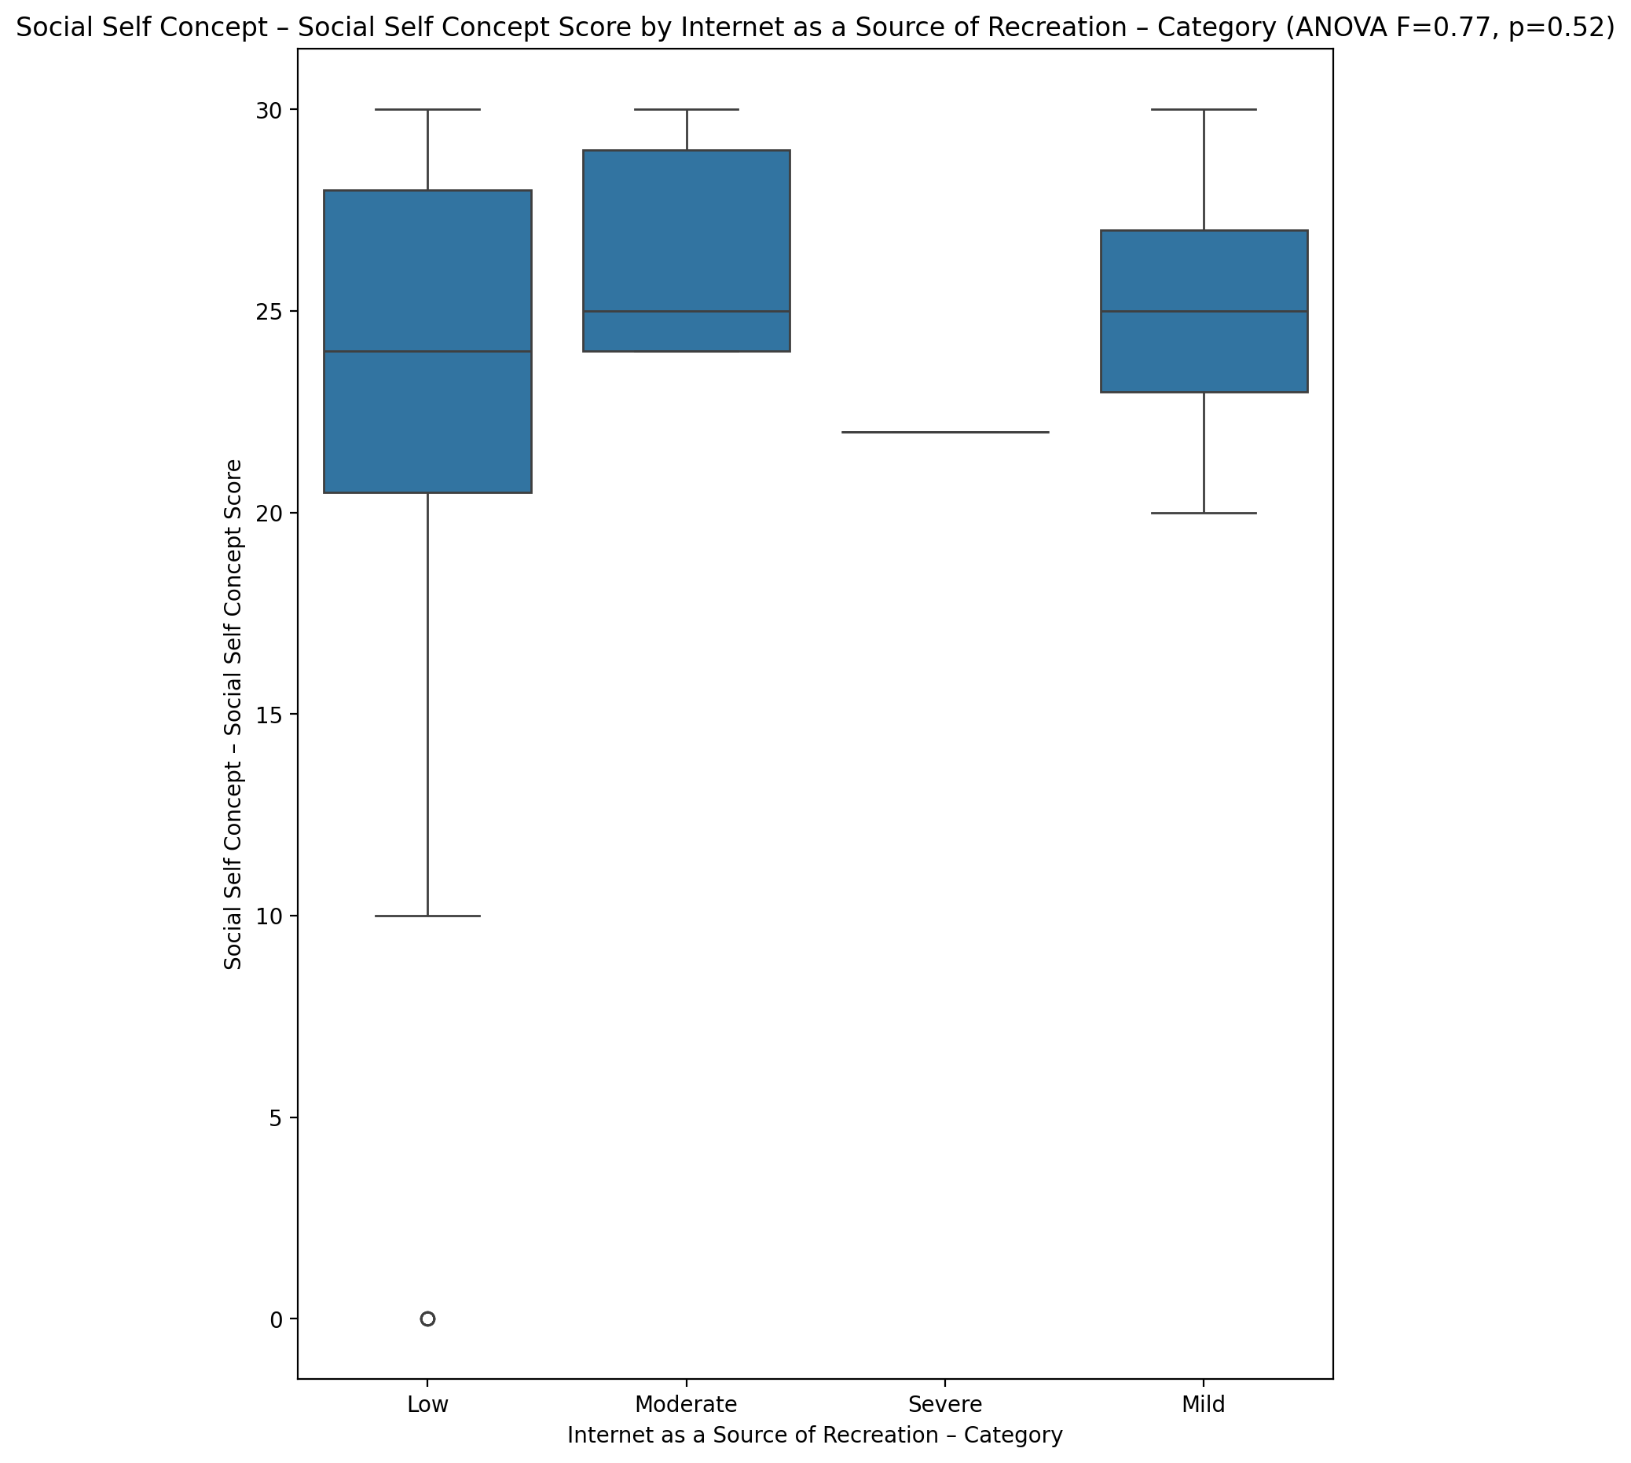

## Ability Self Concept - Real Self Concept Score vs Internet as a Source of Recreation – Category

Test: anova; statistic: 0.6611450993722088; p-value: 0.5809419192670408;

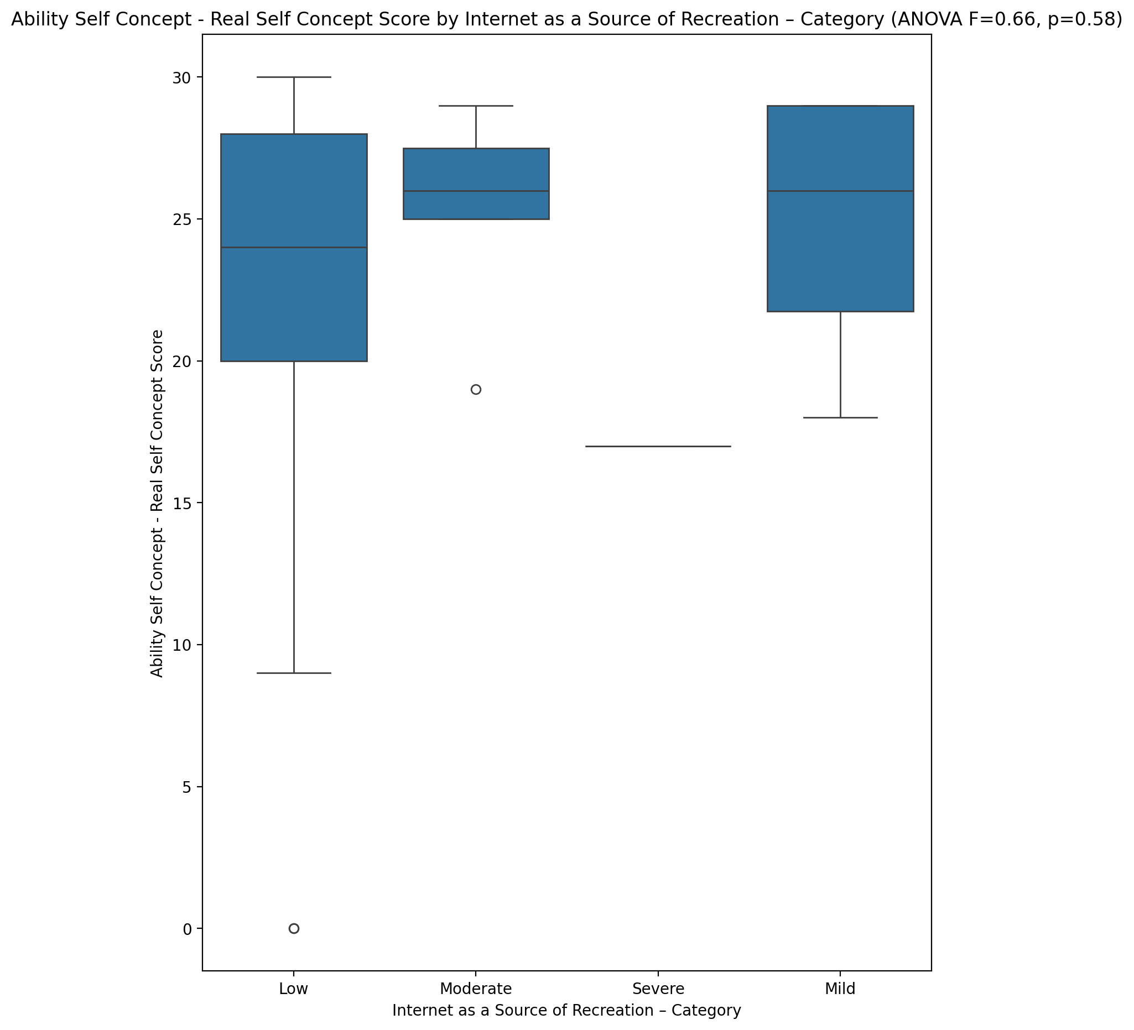

## Ability Self Concept - Ideal Self Concept Score vs Internet as a Source of Recreation – Category

Test: anova; statistic: 0.7762056932275955; p-value: 0.5143820692843585;

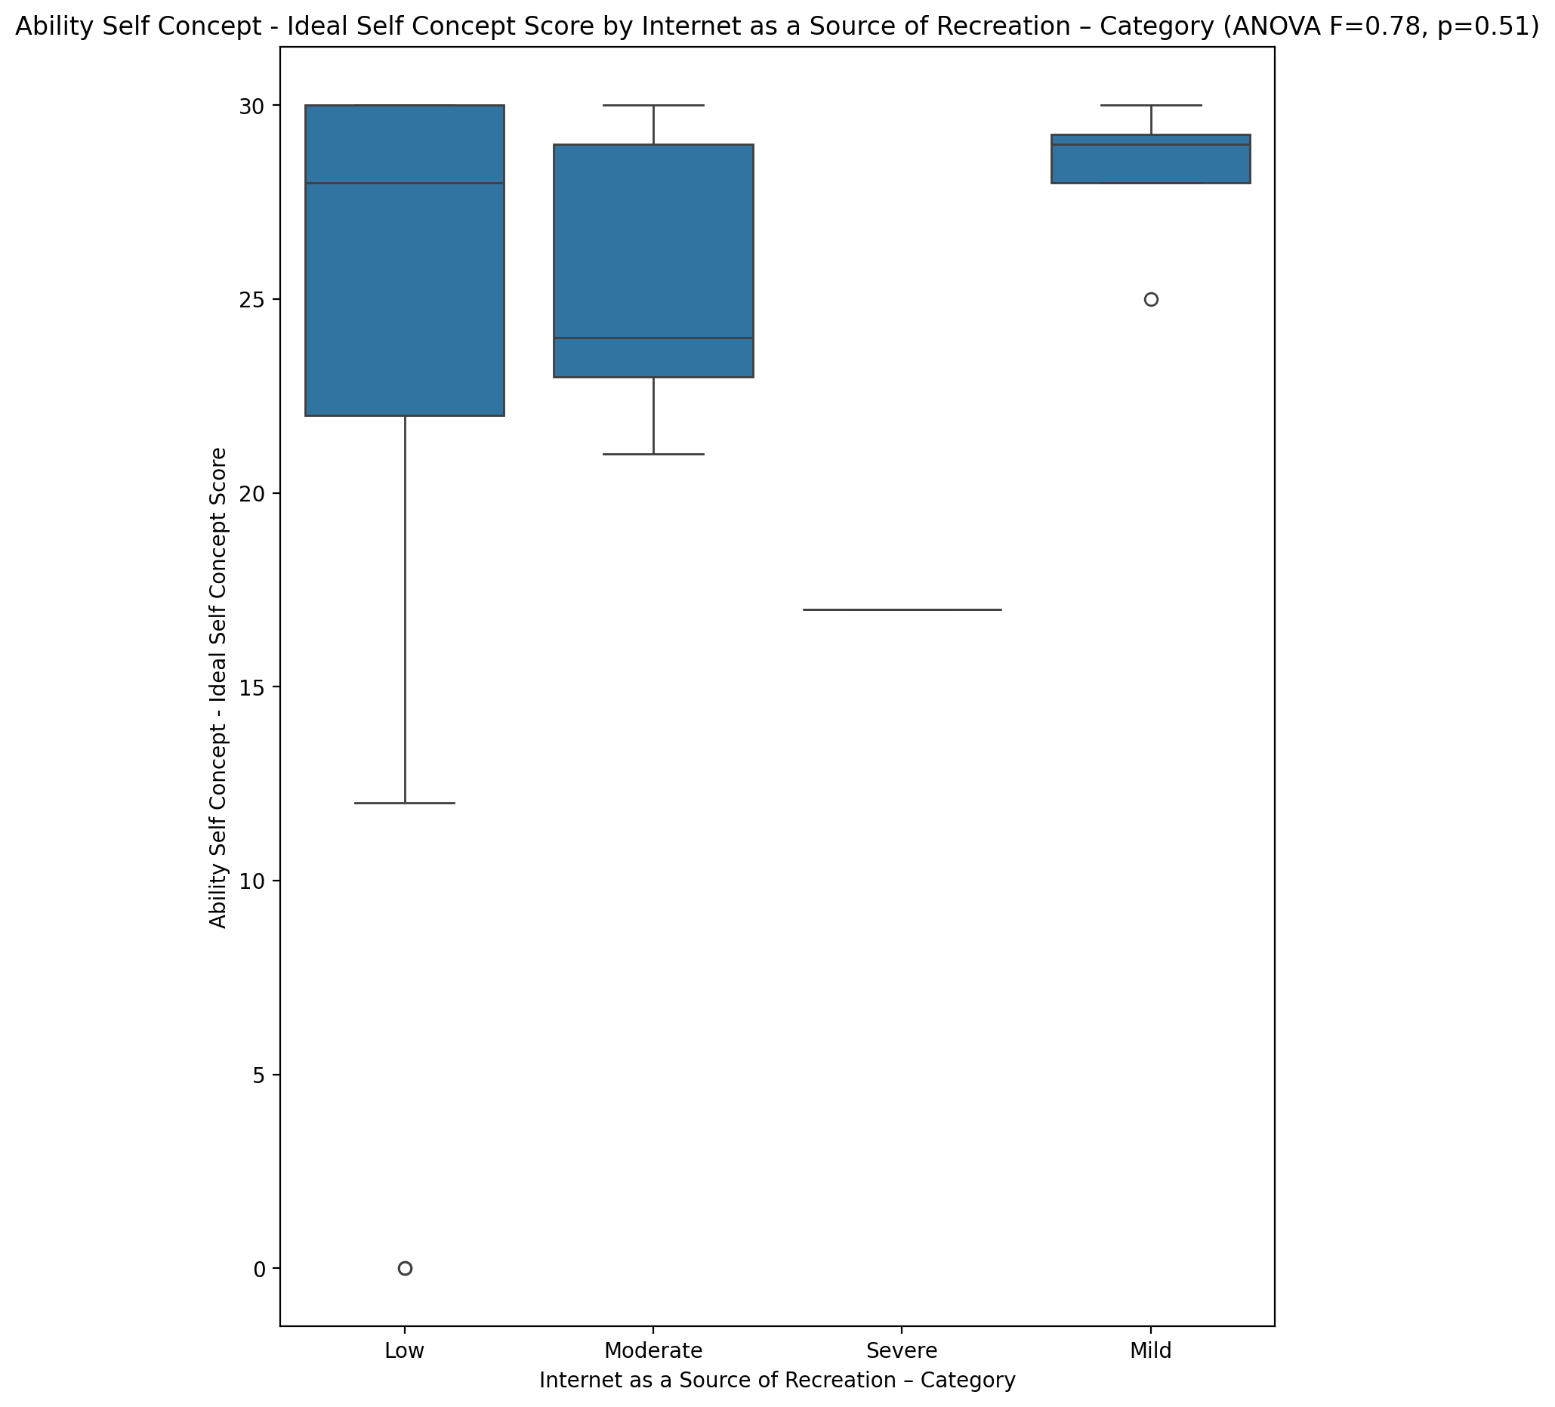

## Ability Self Concept – Social Self Concept Score vs Internet as a Source of Recreation – Category

Test: anova; statistic: 0.8036003378489759; p-value: 0.4994787648027055;

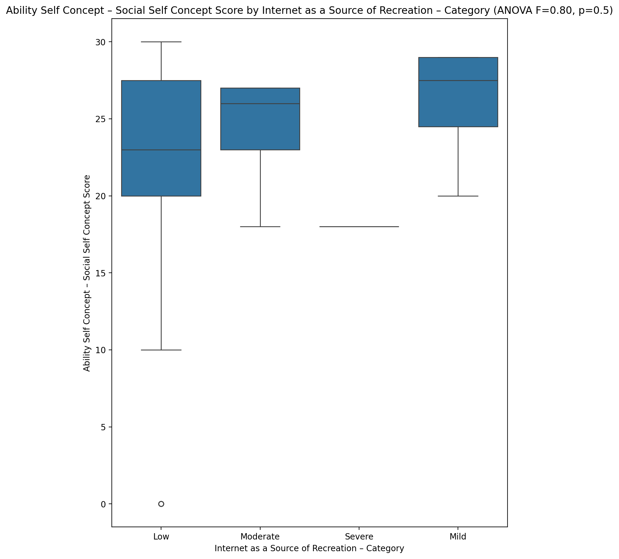

## Physical Self Concept - Real Self Concept Score vs Internet as a Source of Recreation – Category

Test: anova; statistic: 0.516940514392435; p-value: 0.6730673960403089;

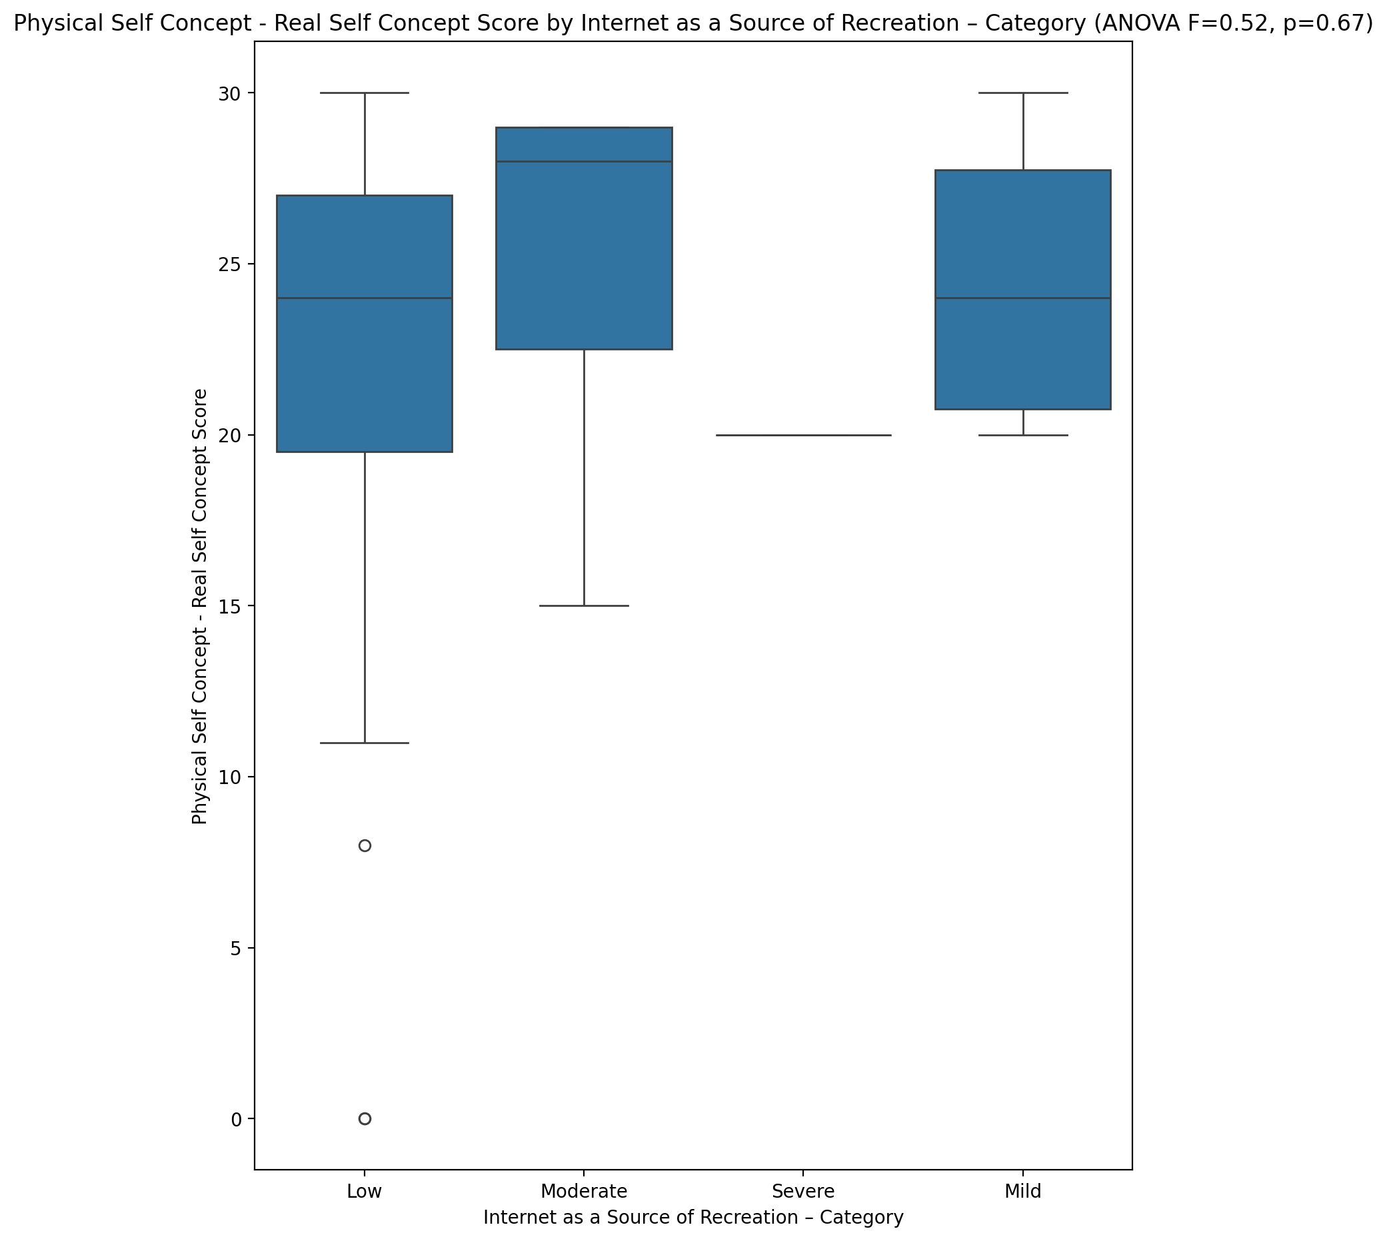

## Physical Self Concept – Ideal Self Concept Score vs Internet as a Source of Recreation – Category

Test: anova; statistic: 0.34212231997788195; p-value: 0.7949811227935895;

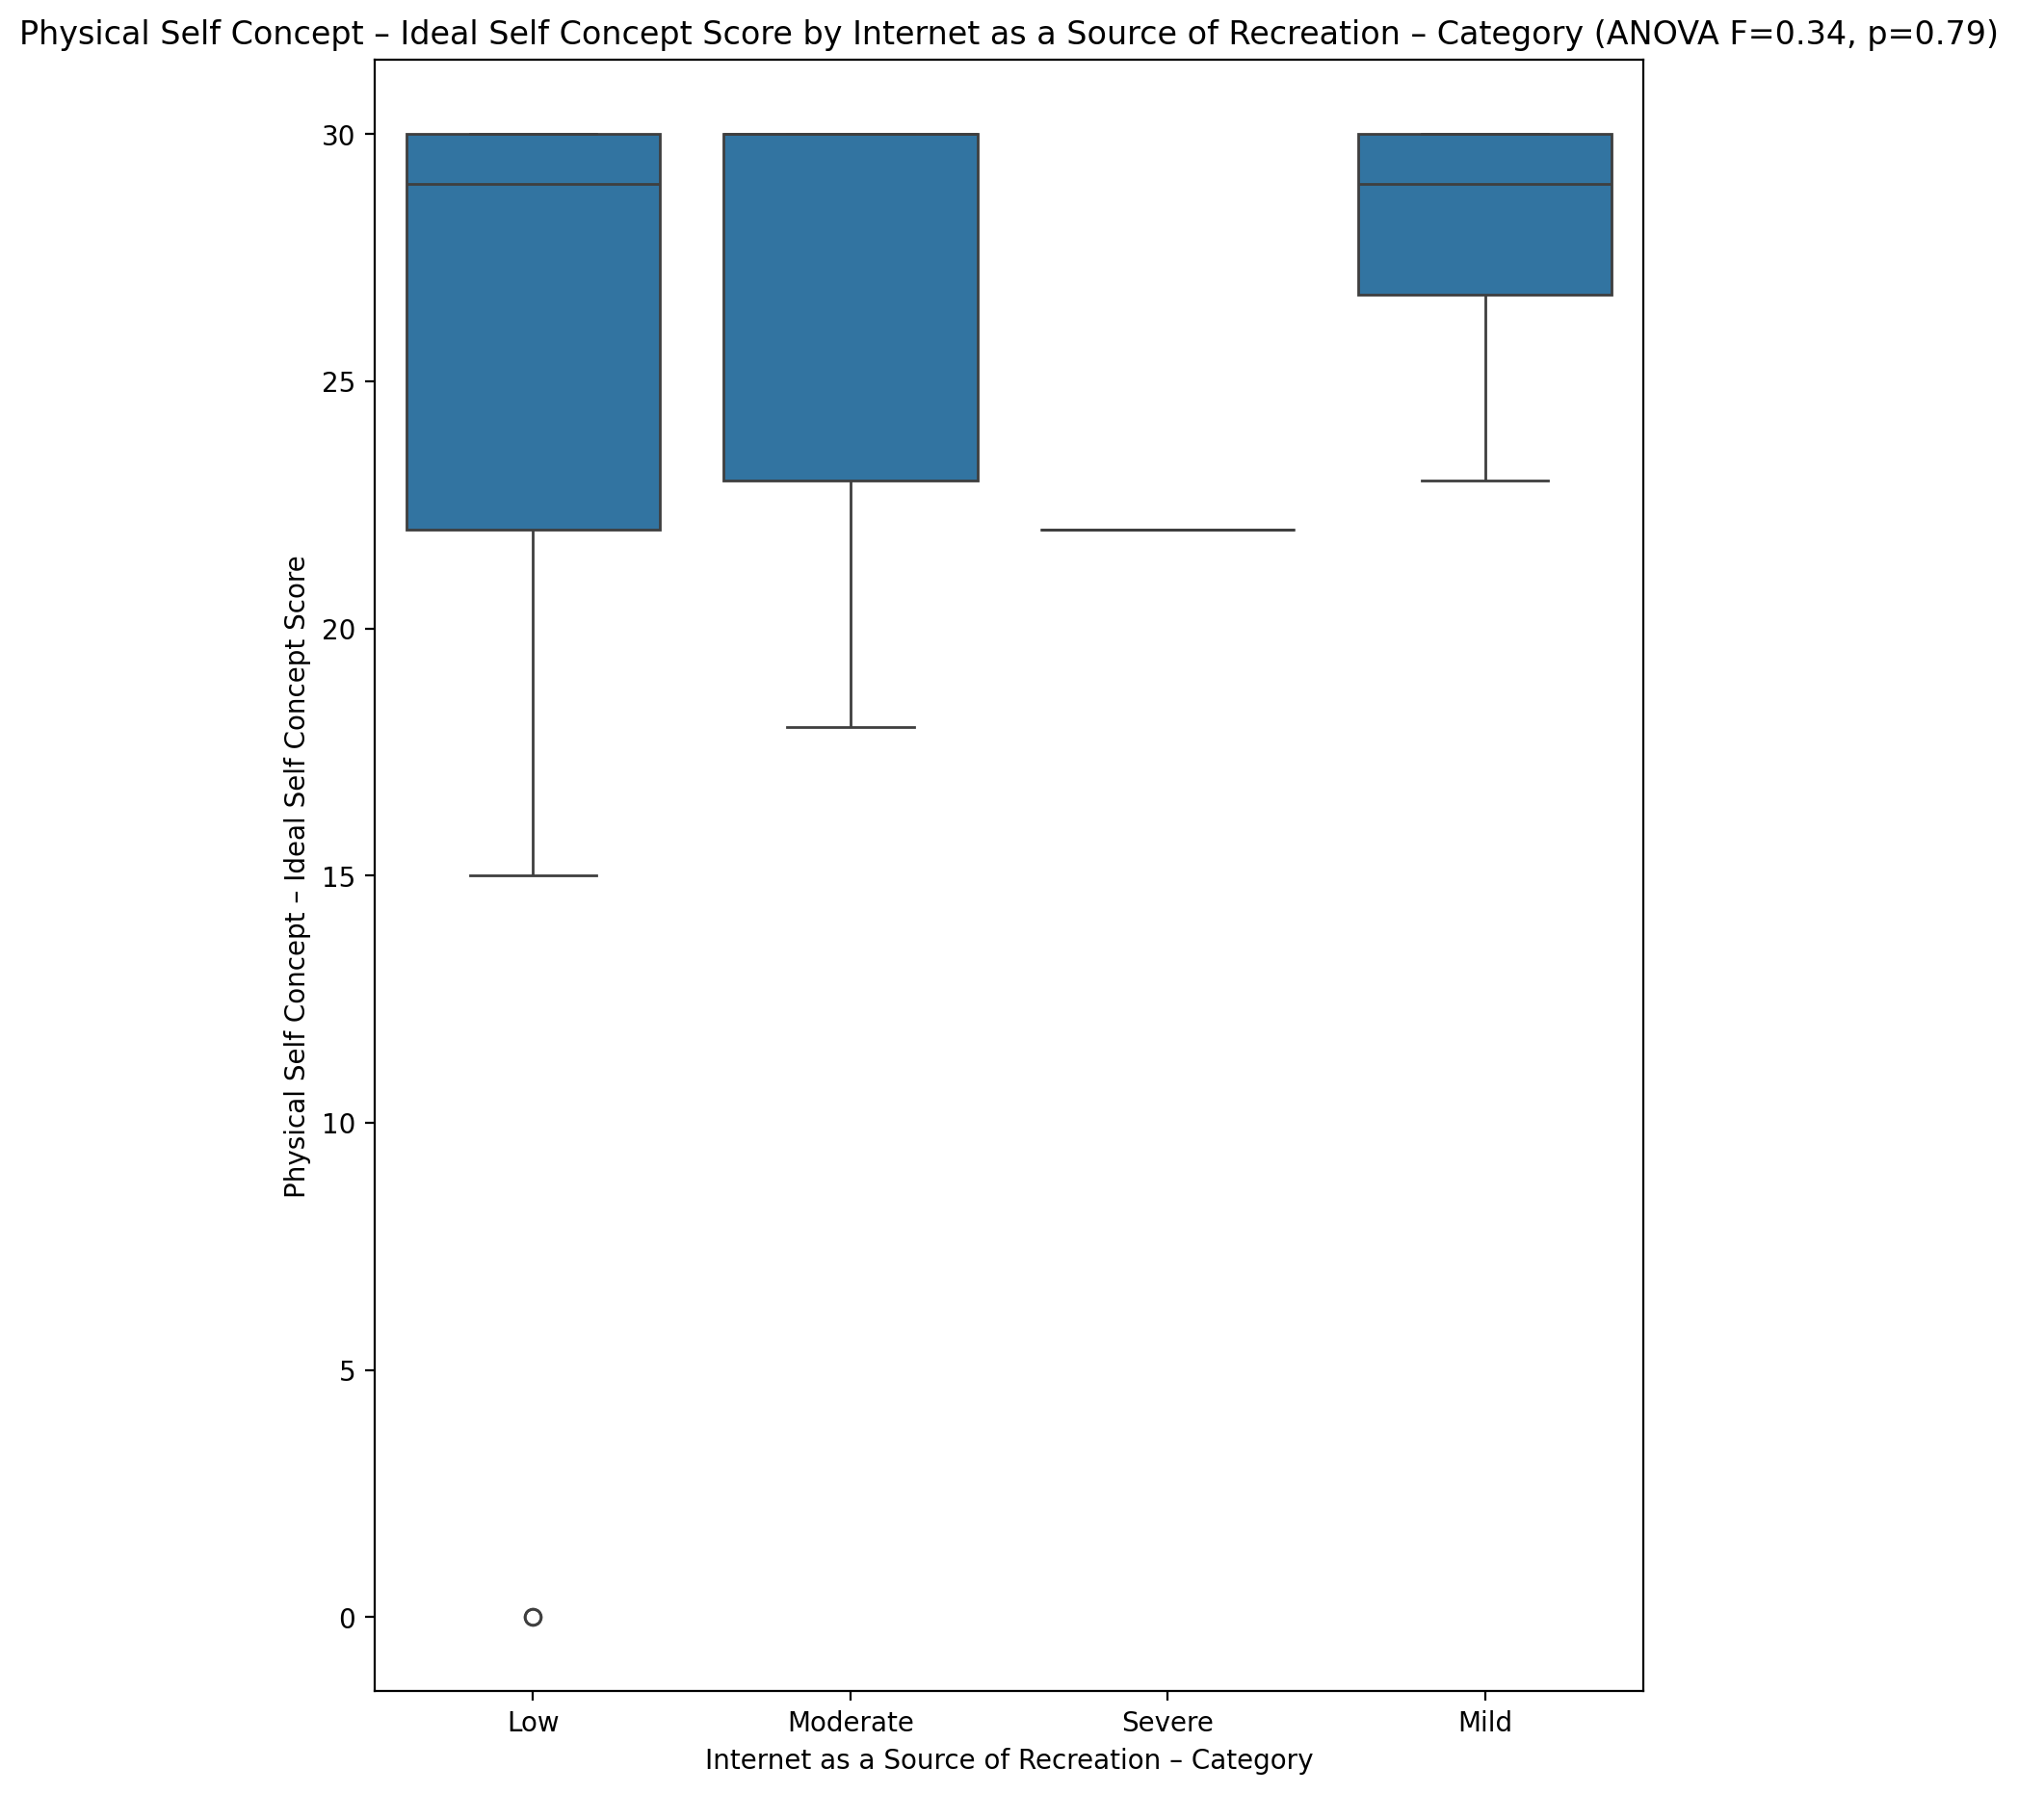

## Physical Self Concept – Social Self Concept Score vs Internet as a Source of Recreation – Category

Test: anova; statistic: 1.2364628965081543; p-value: 0.30952267470257616;

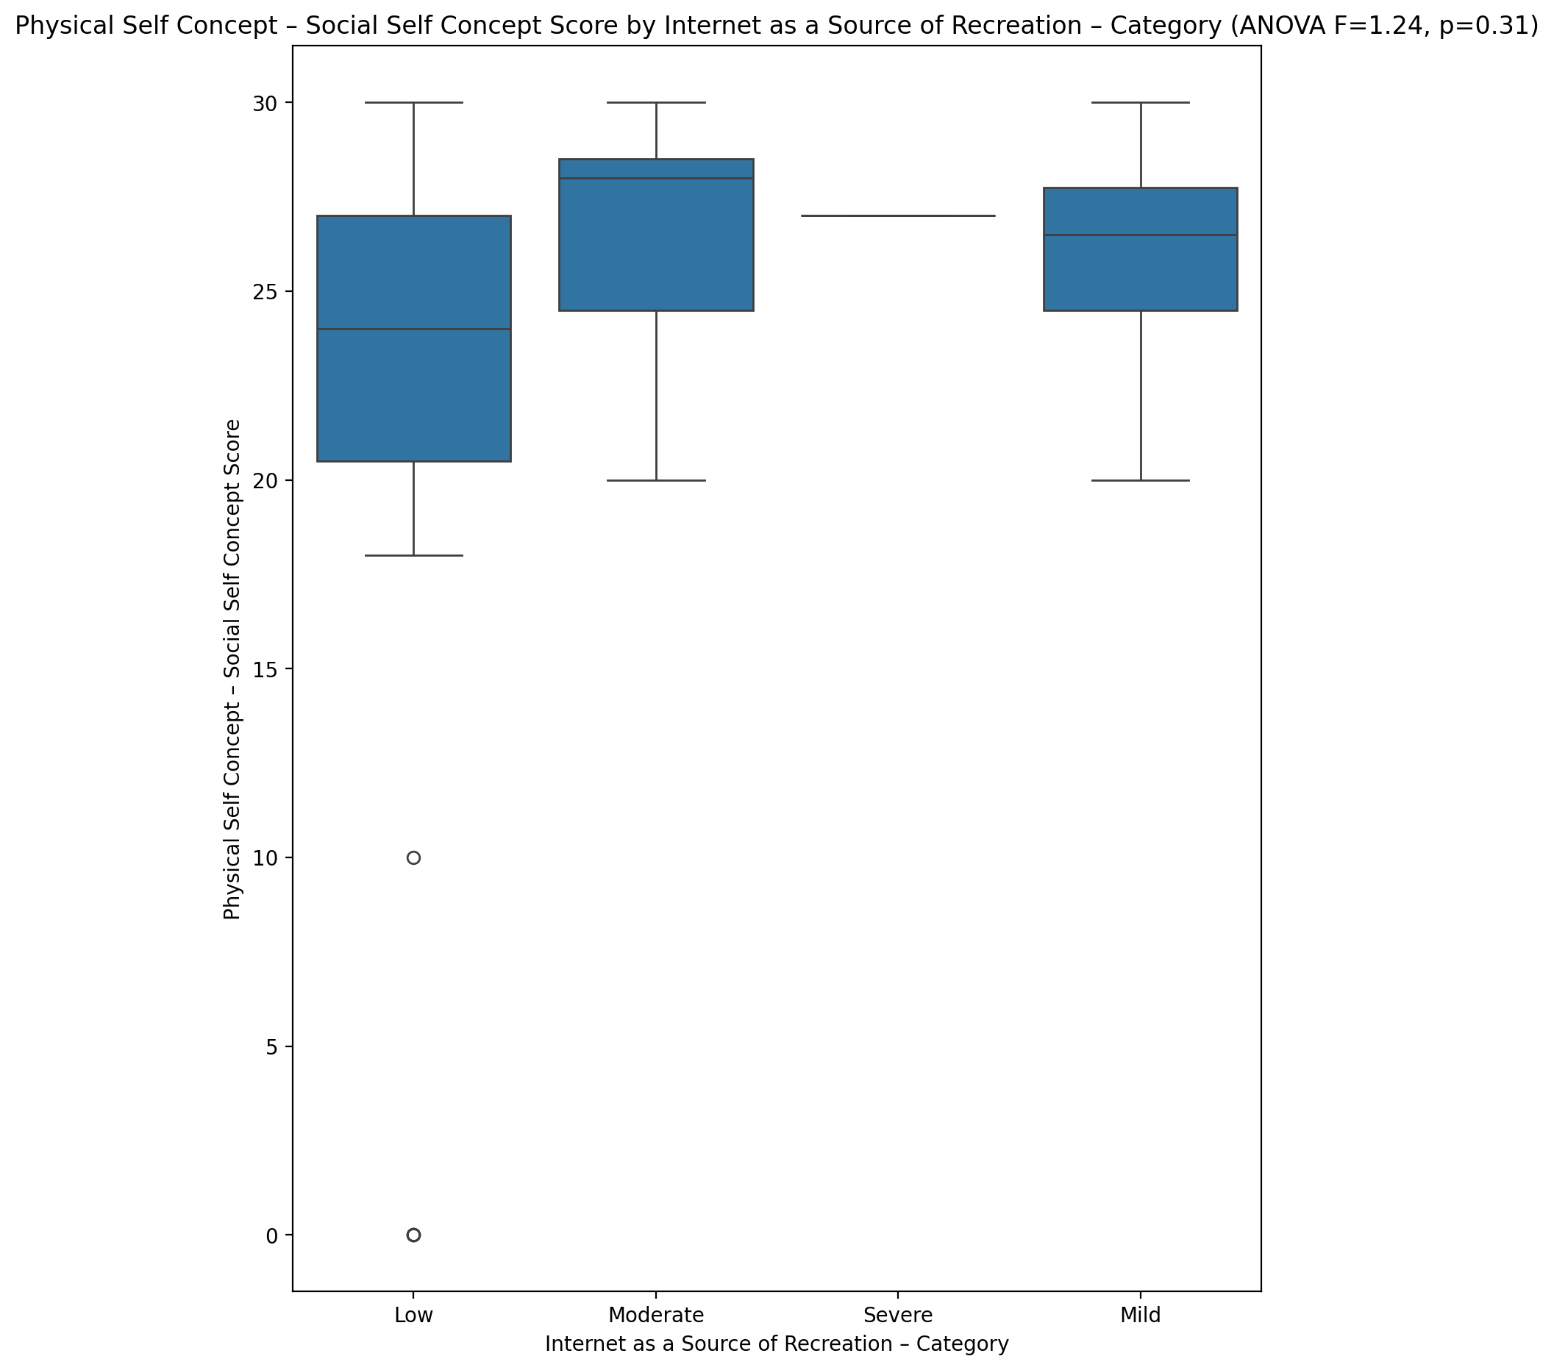

## Psychological Self Concept - Real Self Concept Score vs Internet as a Source of Recreation – Category

Test: anova; statistic: 0.4591241060015558; p-value: 0.7124102551608069;

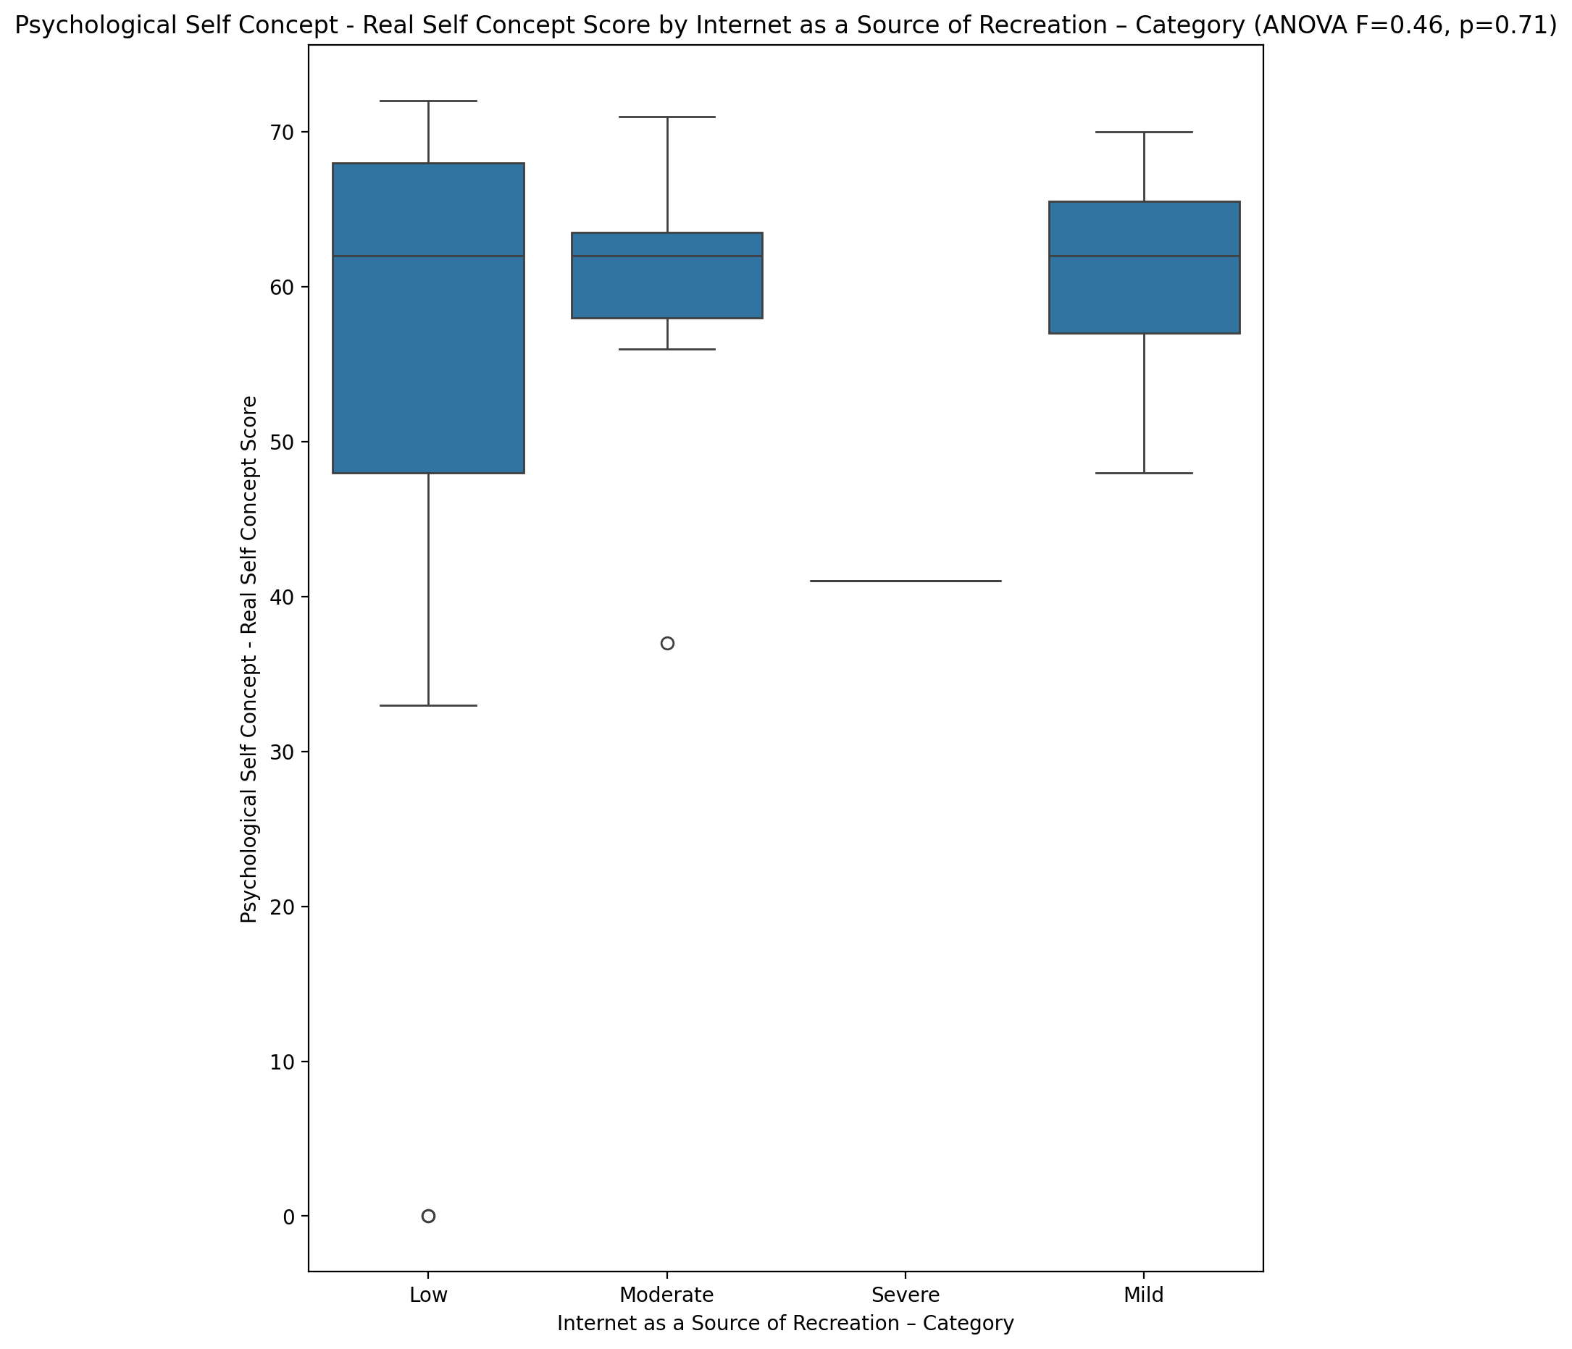

## Psychological Self Concept – Ideal Self Concept Score vs Internet as a Source of Recreation – Category

Test: anova; statistic: 0.6268687761235415; p-value: 0.6019924070682985;

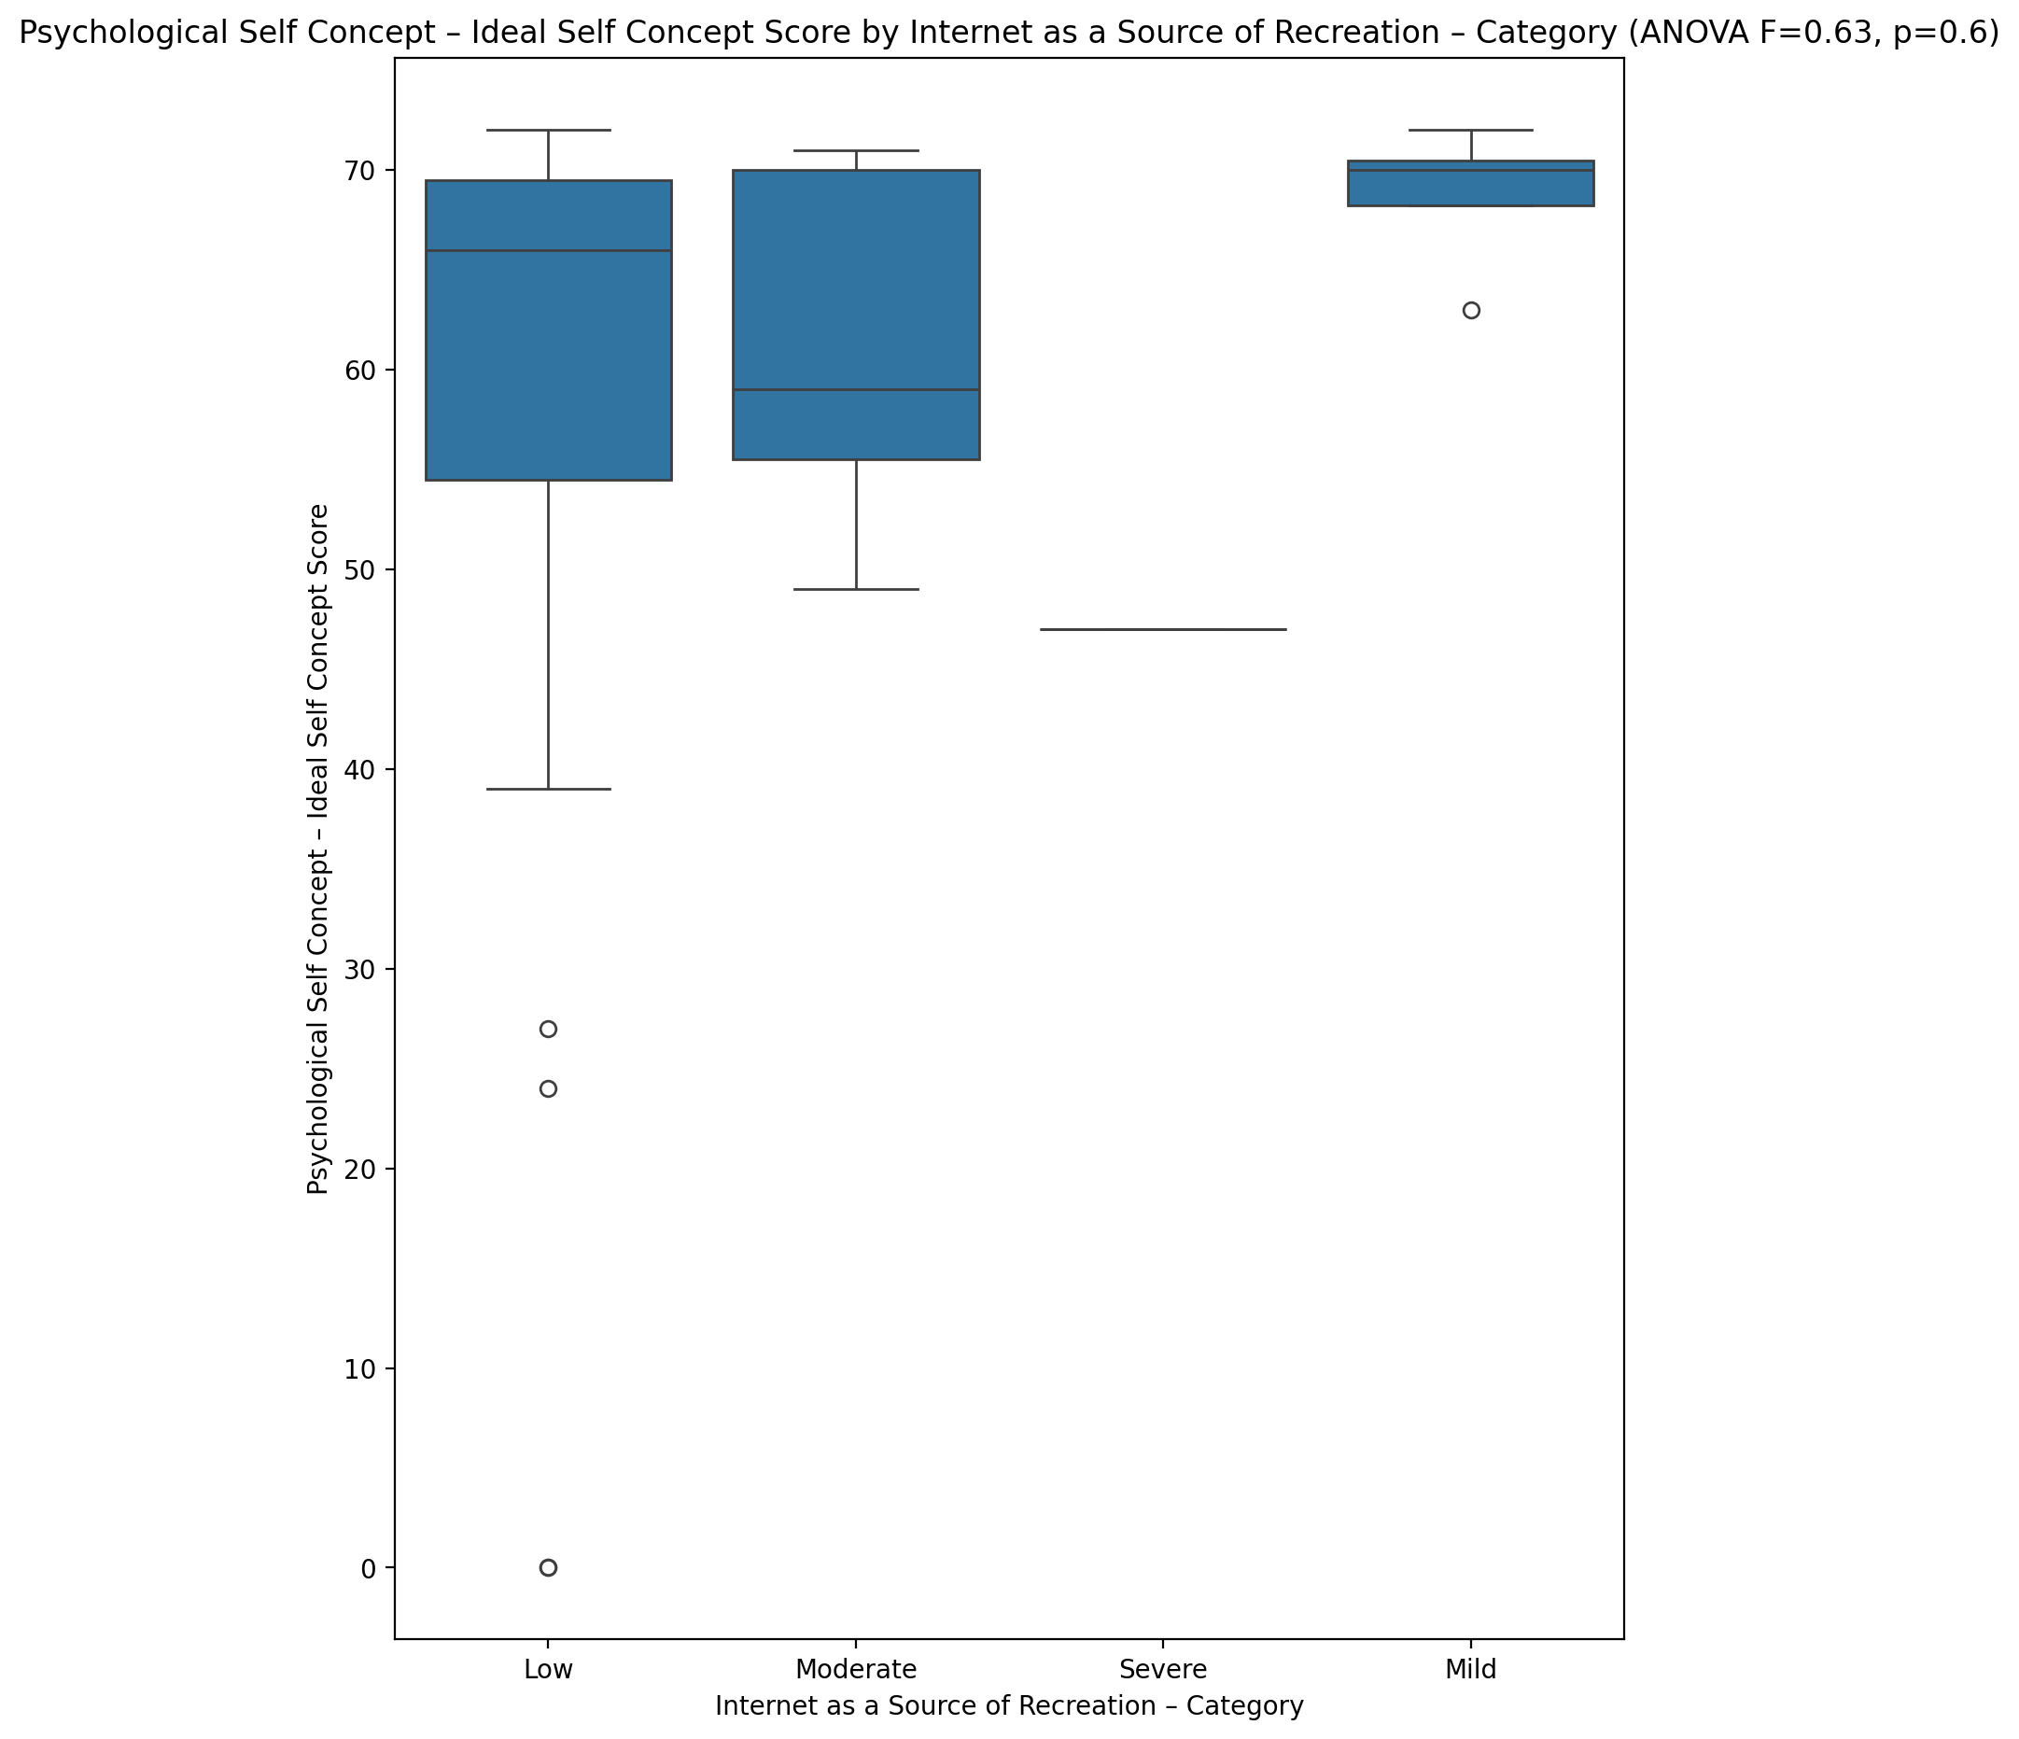

## Psychological Self Concept – Social Self Concept Score vs Internet as a Source of Recreation – Category

Test: anova; statistic: 0.32122059691659144; p-value: 0.8099620471452988;

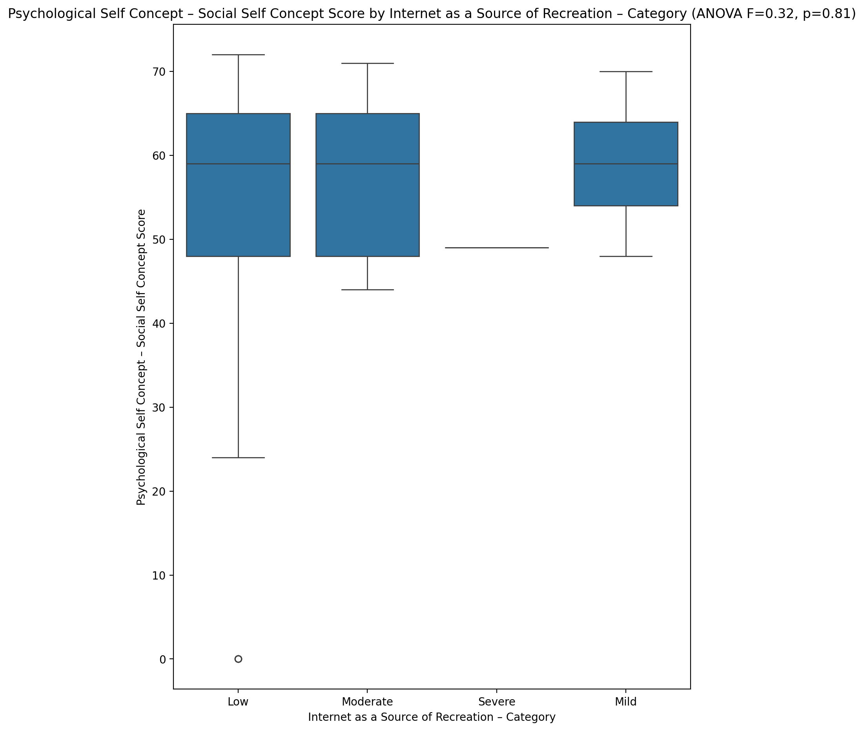

## Real Self Concept Total Score vs Internet as a Source of Recreation – Category

Test: anova; statistic: 0.4396459966141364; p-value: 0.7259217814260197;

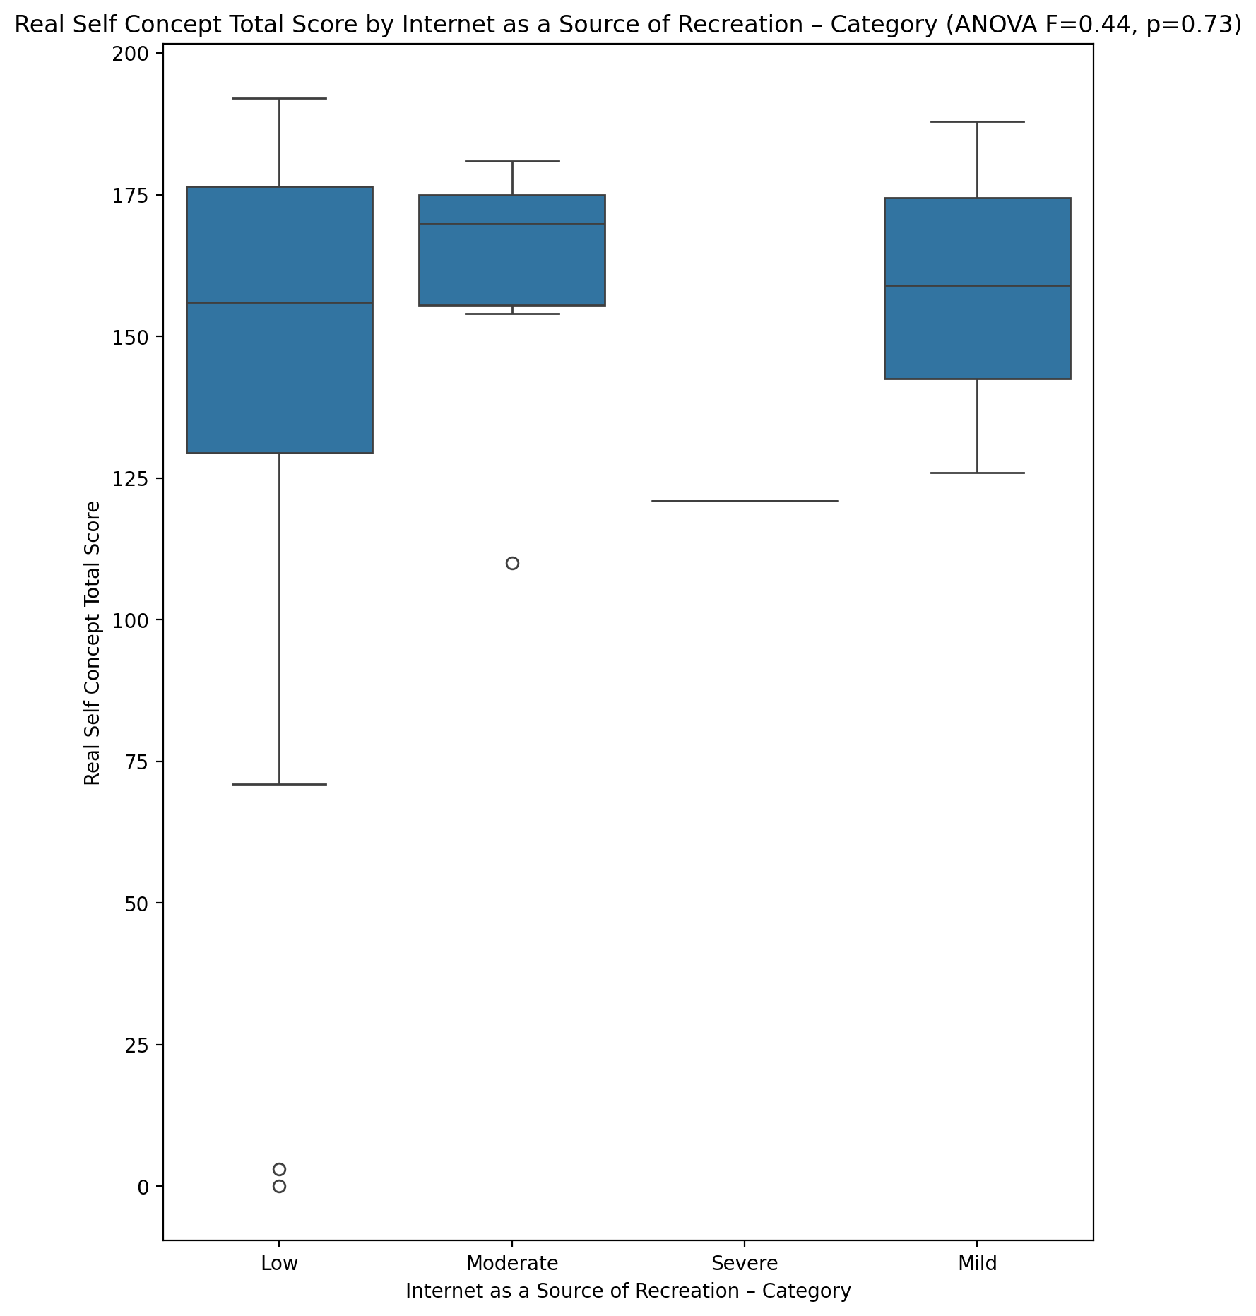

## Ideal Self Concept Total Score vs Internet as a Source of Recreation – Category

Test: anova; statistic: 0.5555640121011088; p-value: 0.6475021771665972;

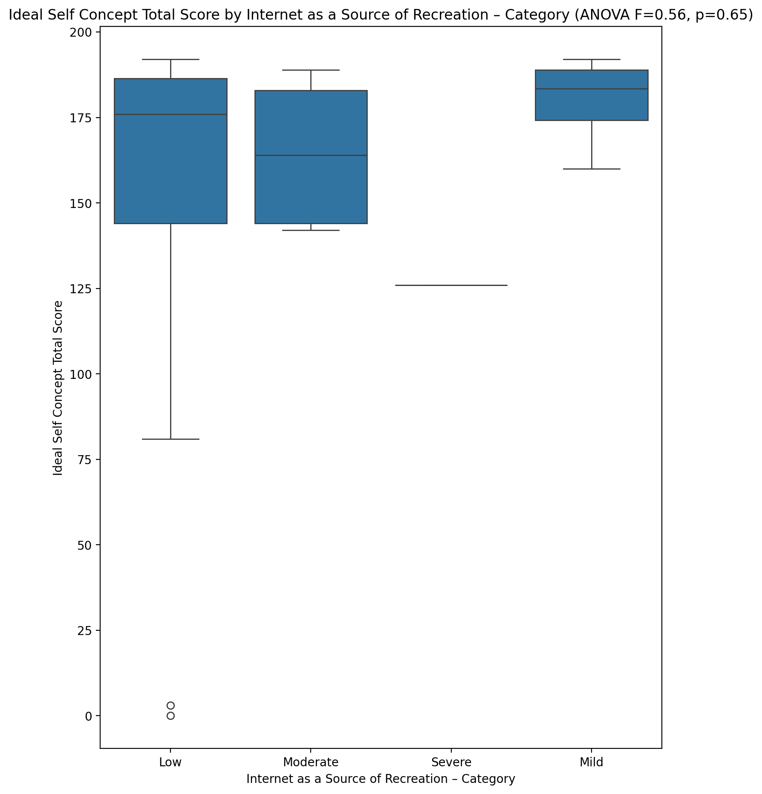

## Social Self Concept Total Score vs Internet as a Source of Recreation – Category

Test: anova; statistic: 0.612046039583554; p-value: 0.6112647546703722;

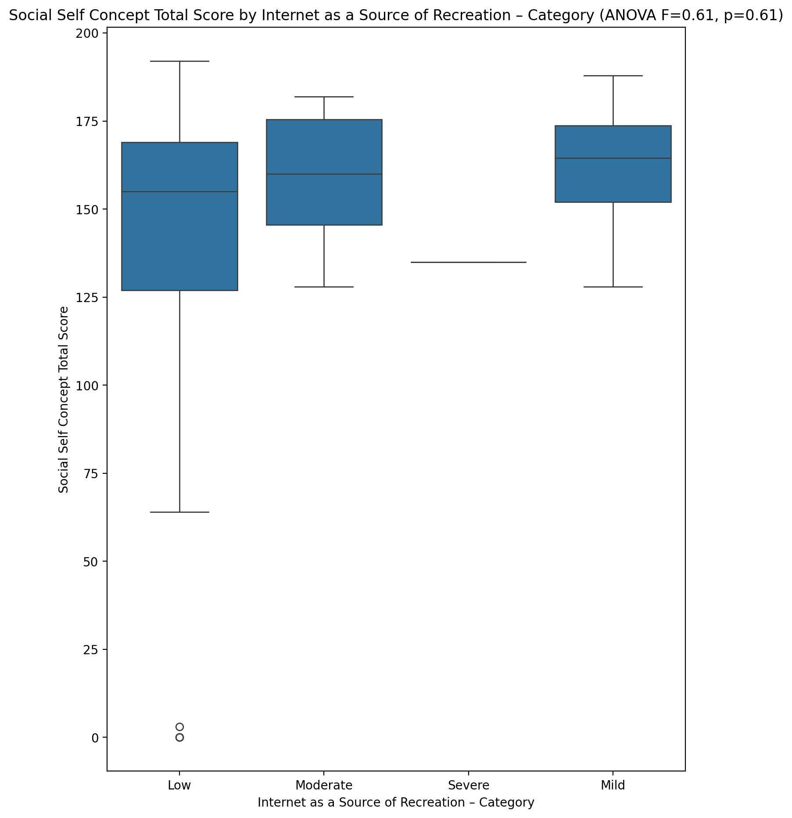

## Ideal Self Concept Total Category vs Internet as a Source of Recreation – Category

Test: chi2; statistic: 9.99732421584659; p-value: 0.12476474779362333;

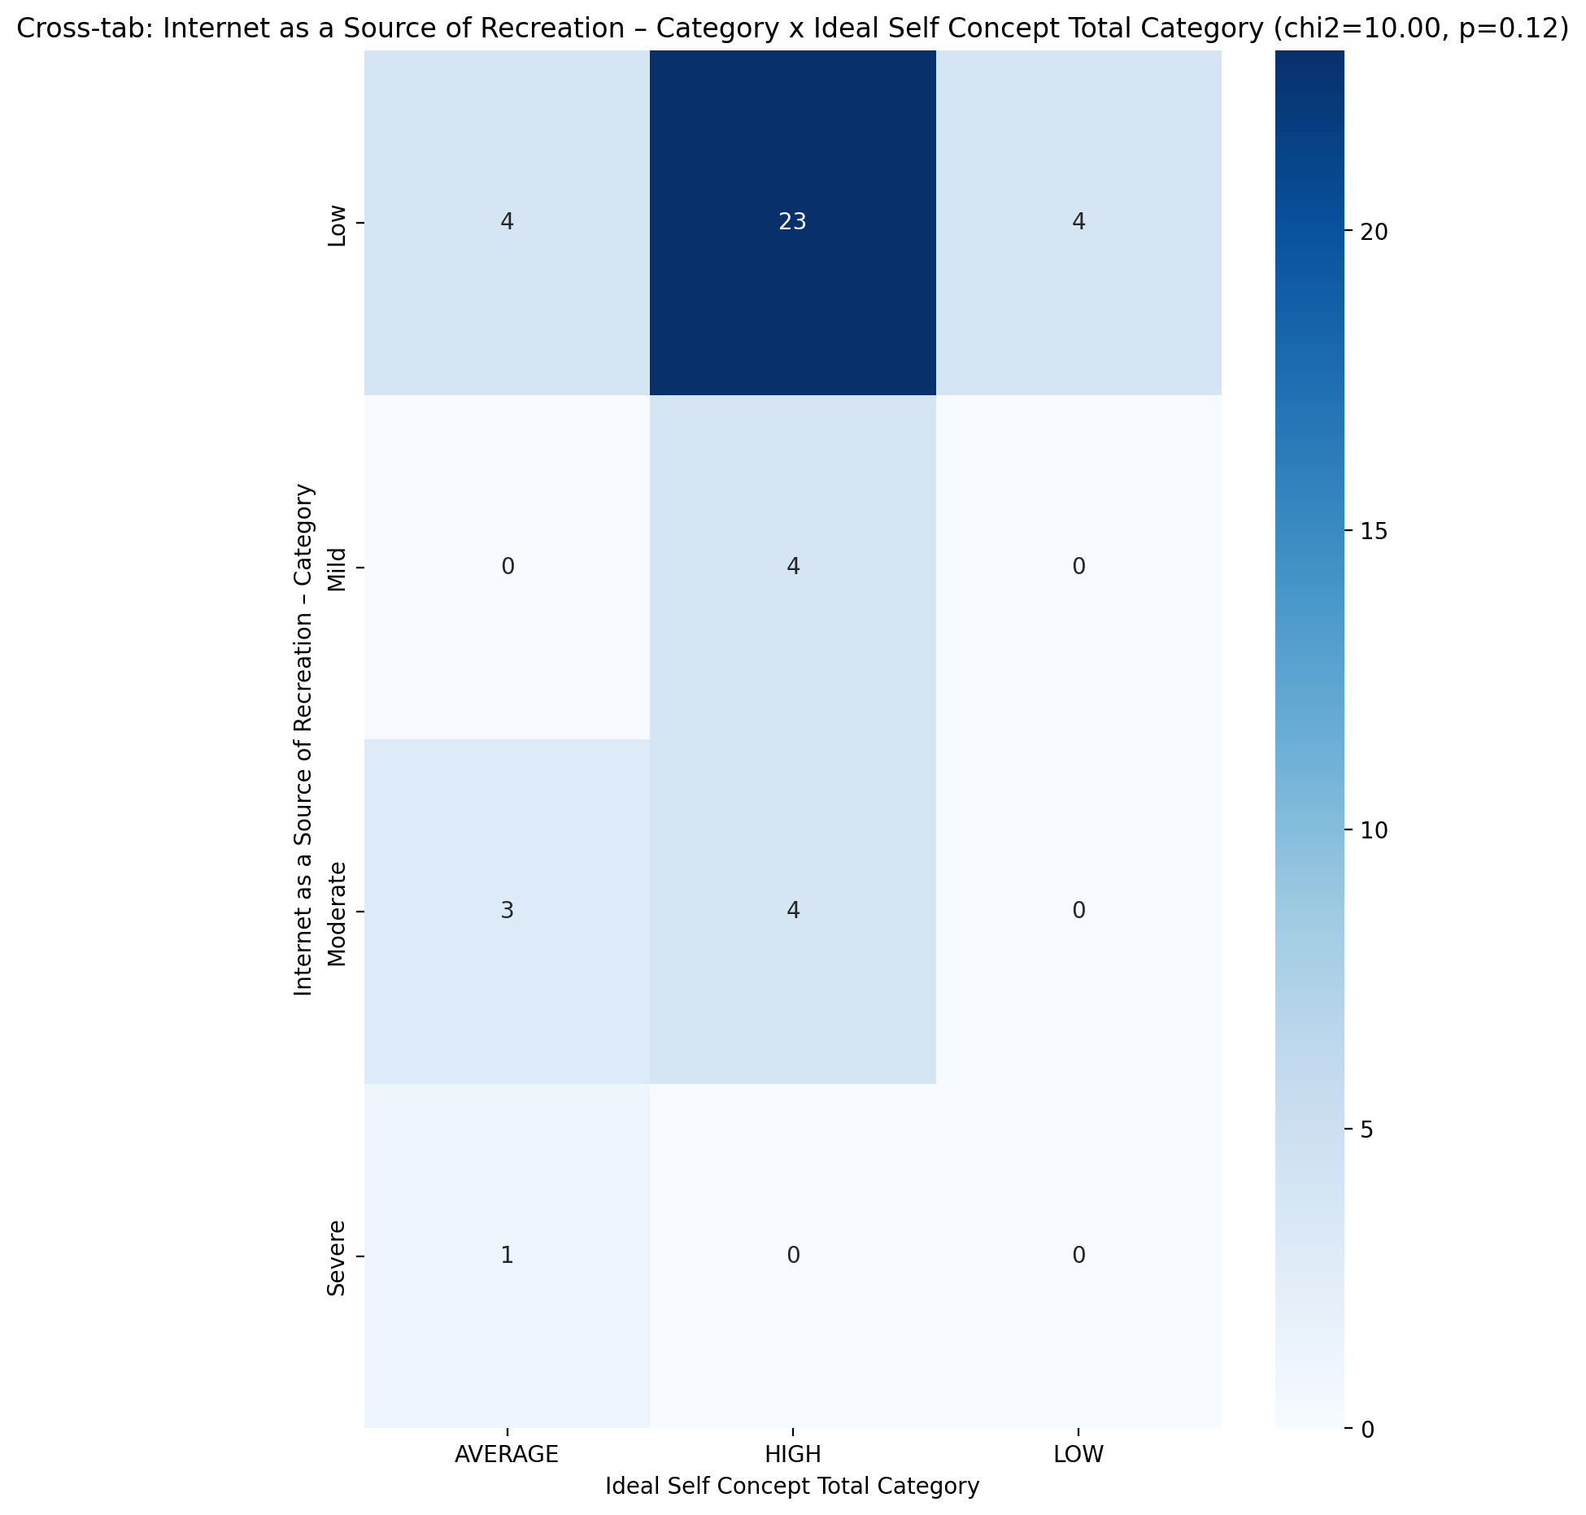

## Perceived Social Stress Score vs Internet as a Source of Recreation – Category

Test: anova; statistic: 0.8139285885955582; p-value: 0.493954163400413;

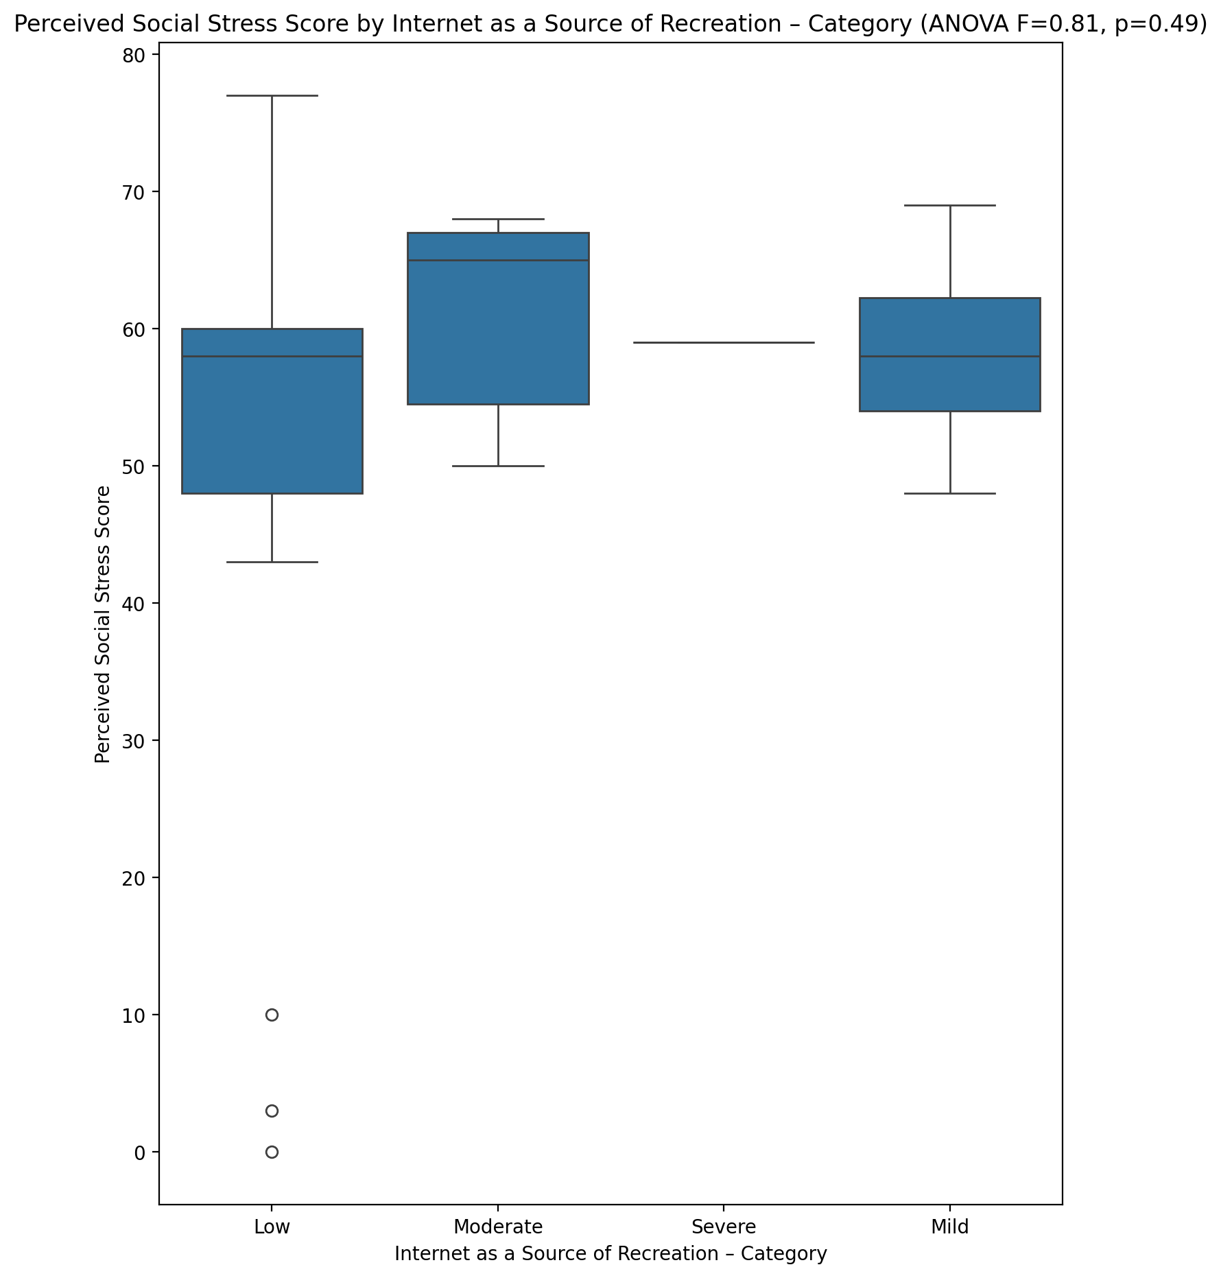

## Perceived Social Stress Category vs Internet as a Source of Recreation – Category

Test: chi2; statistic: 1.2483870967741937; p-value: 0.7414239895054593;

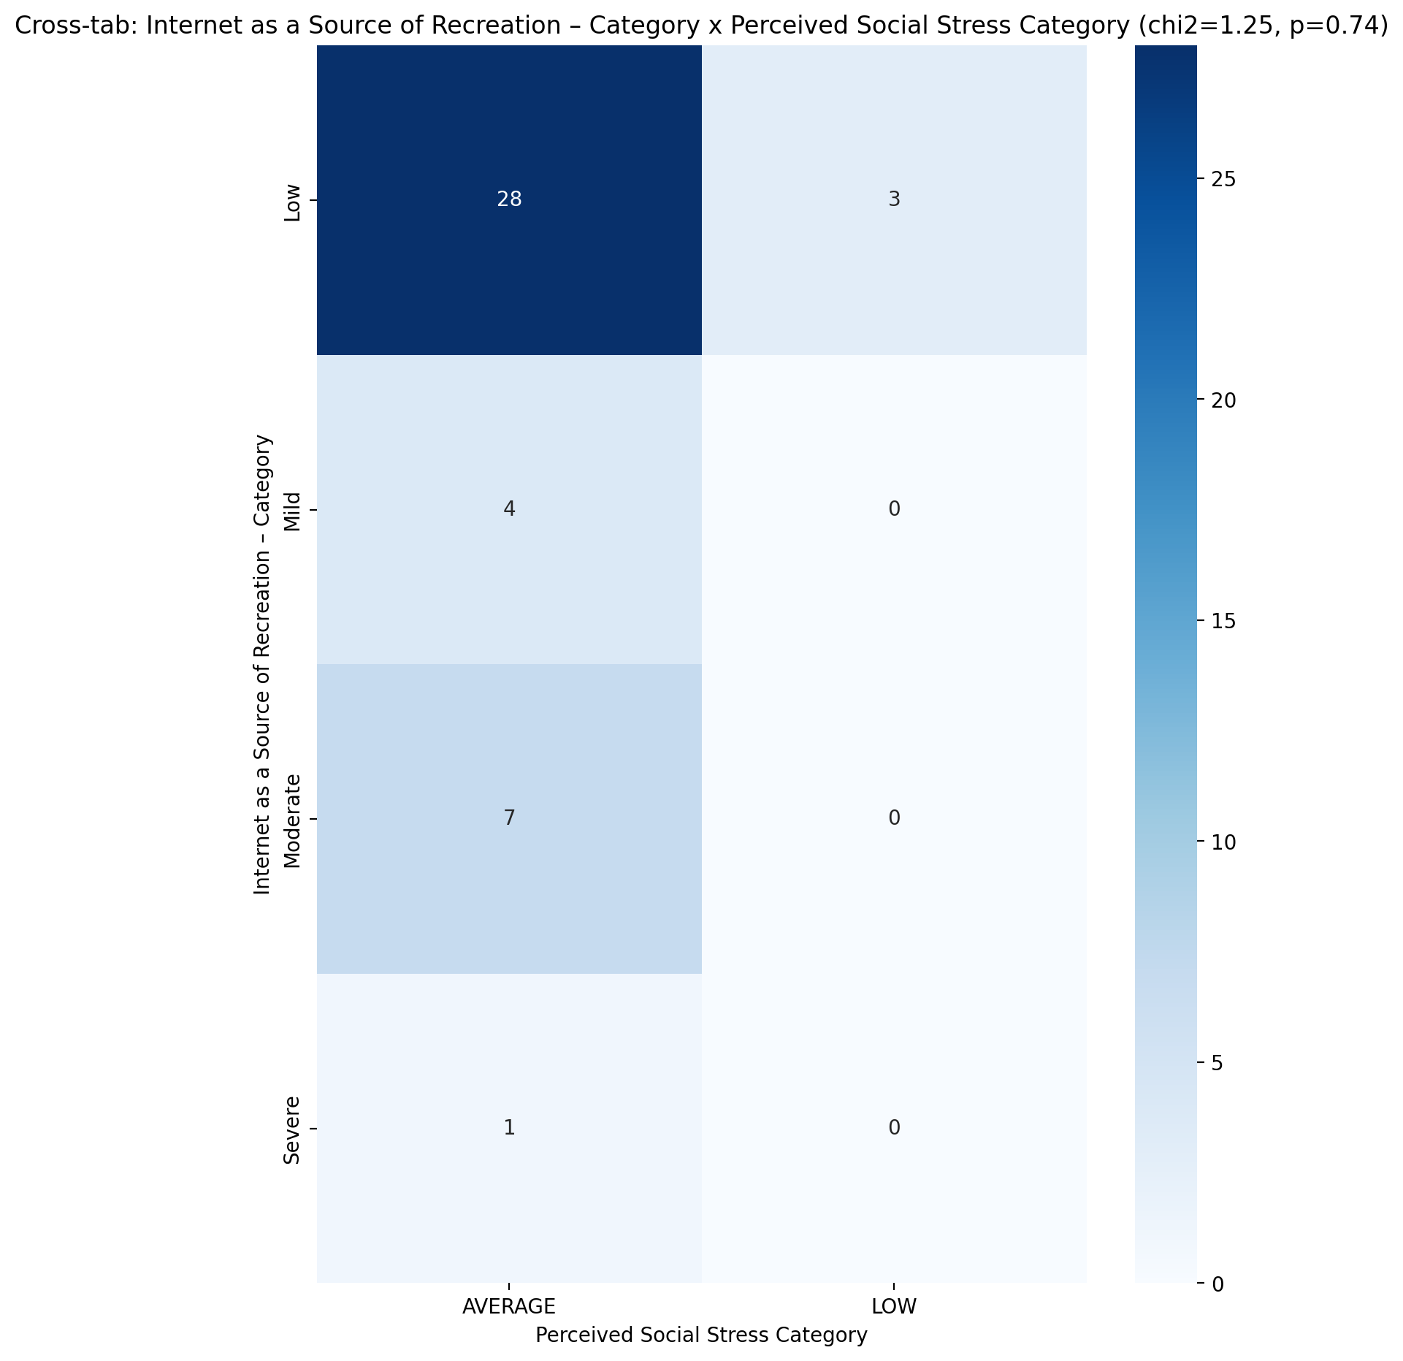

## Emotional Support - Raw Score vs Internet Usage Total Categoty

Test: anova; statistic: 1.935083251159963; p-value: 0.15769363799460093;

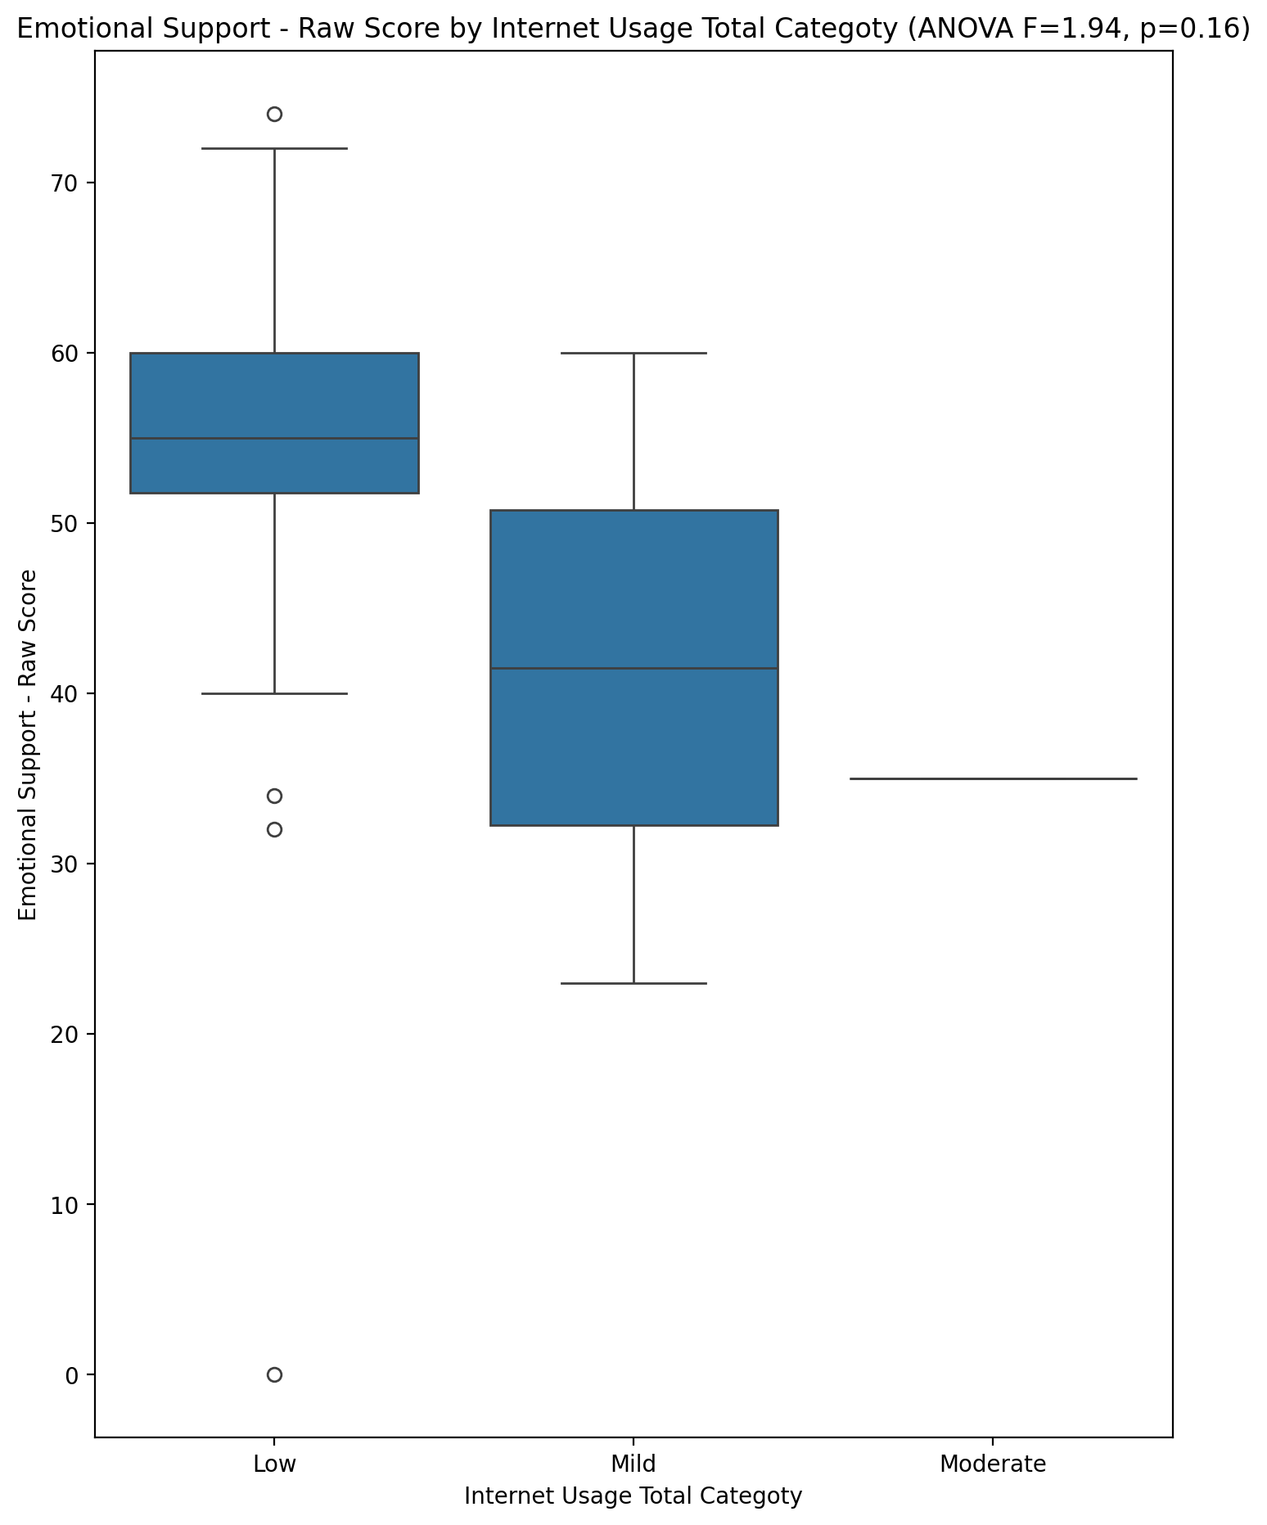

## Informational Support - Raw Score vs Internet Usage Total Categoty

Test: anova; statistic: 2.615492503932829; p-value: 0.08560101504719485;

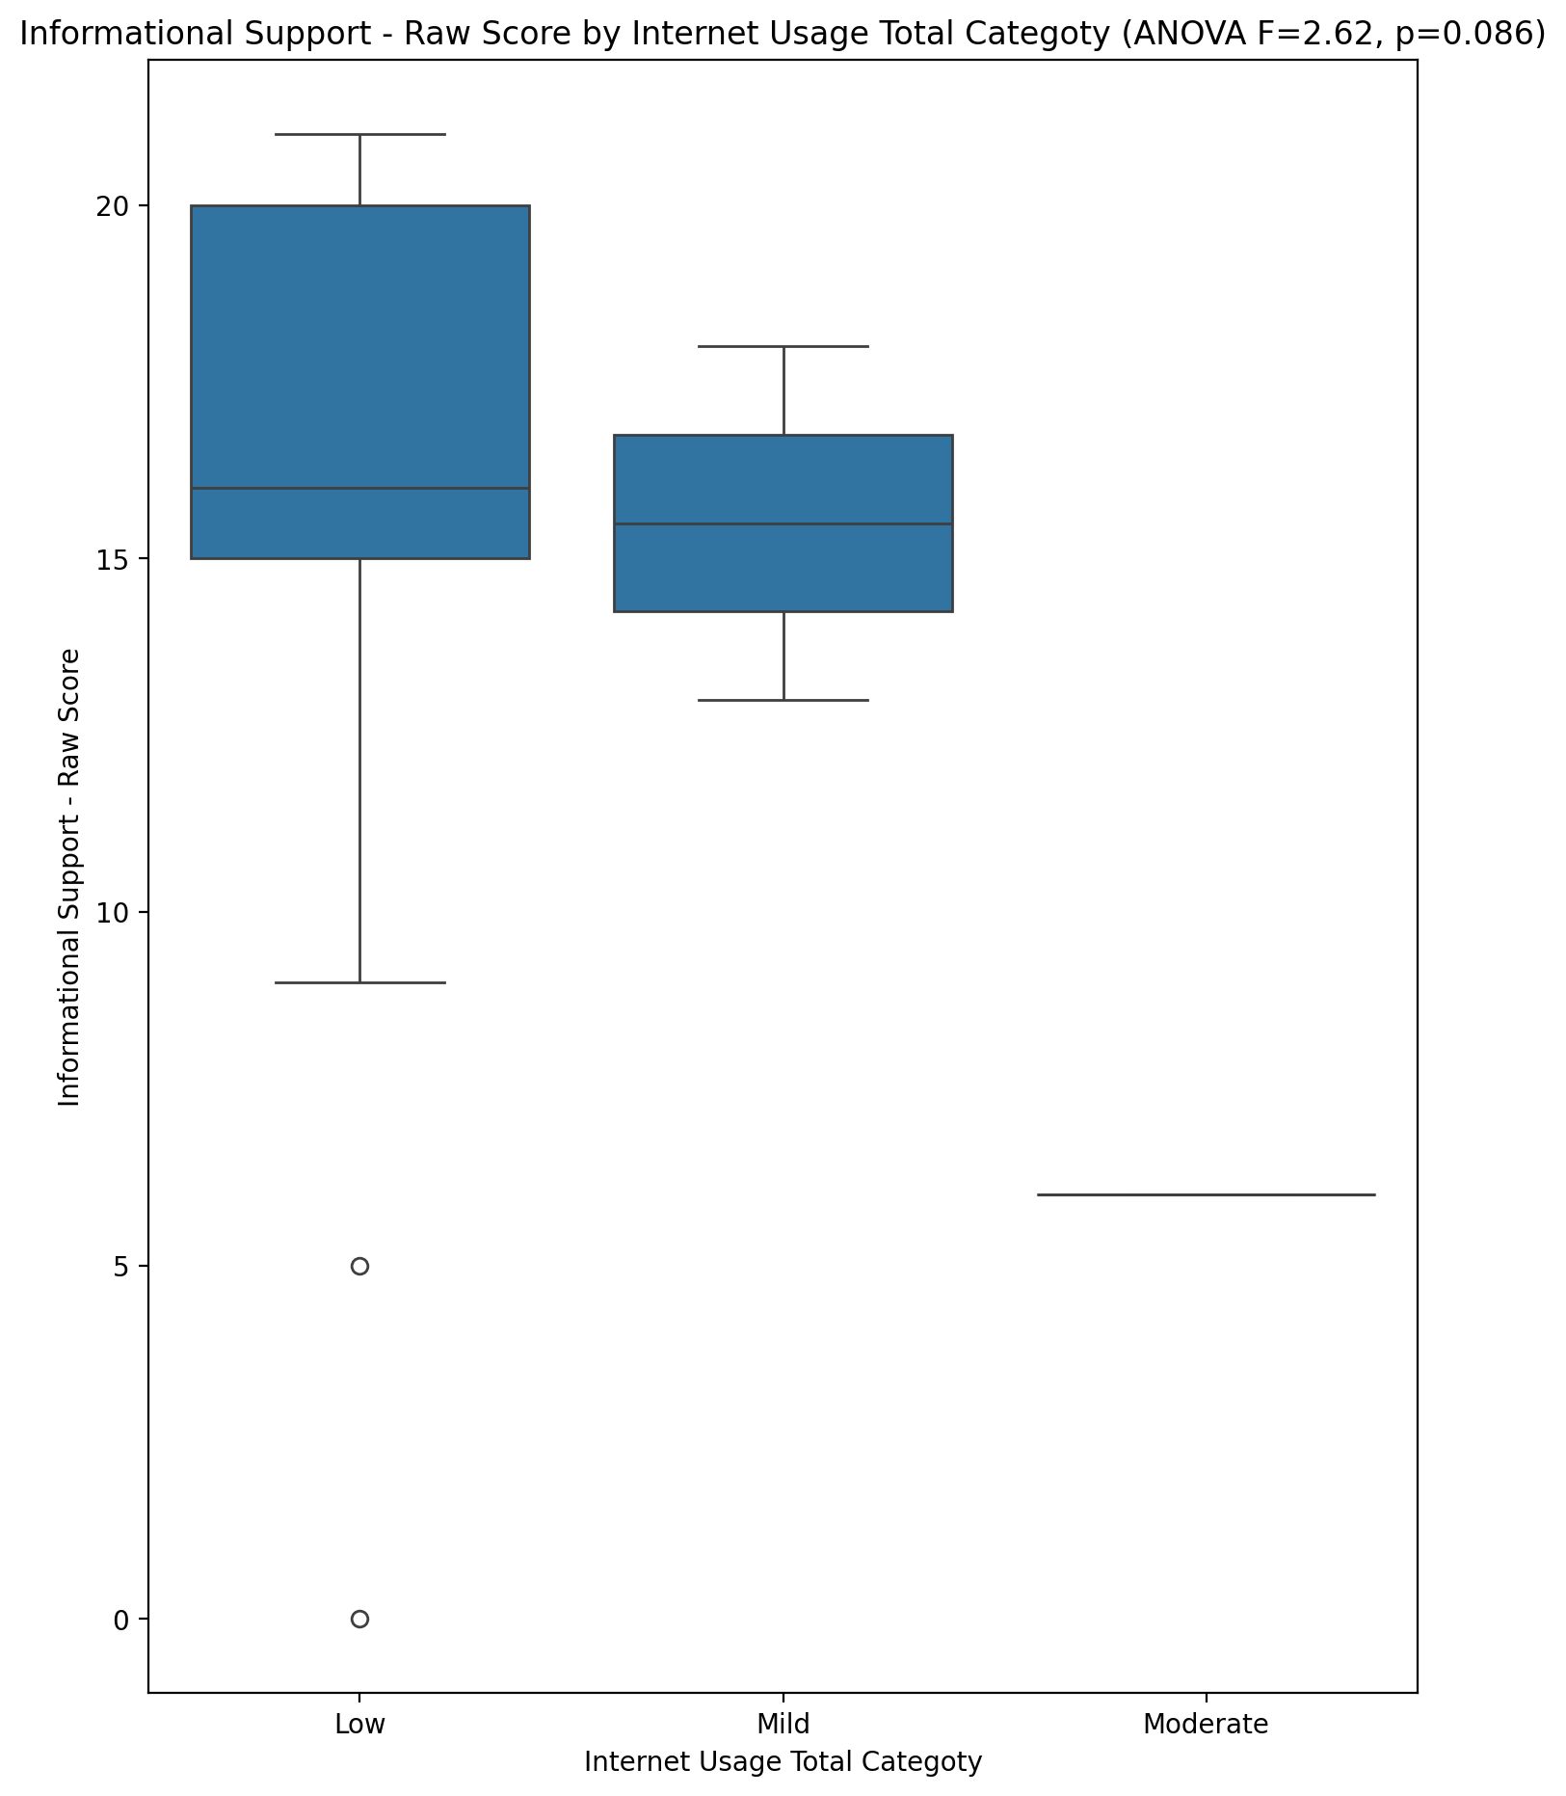

## Instrumental Support - Raw Score vs Internet Usage Total Categoty

Test: anova; statistic: 0.5270762845403245; p-value: 0.5943715146847555;

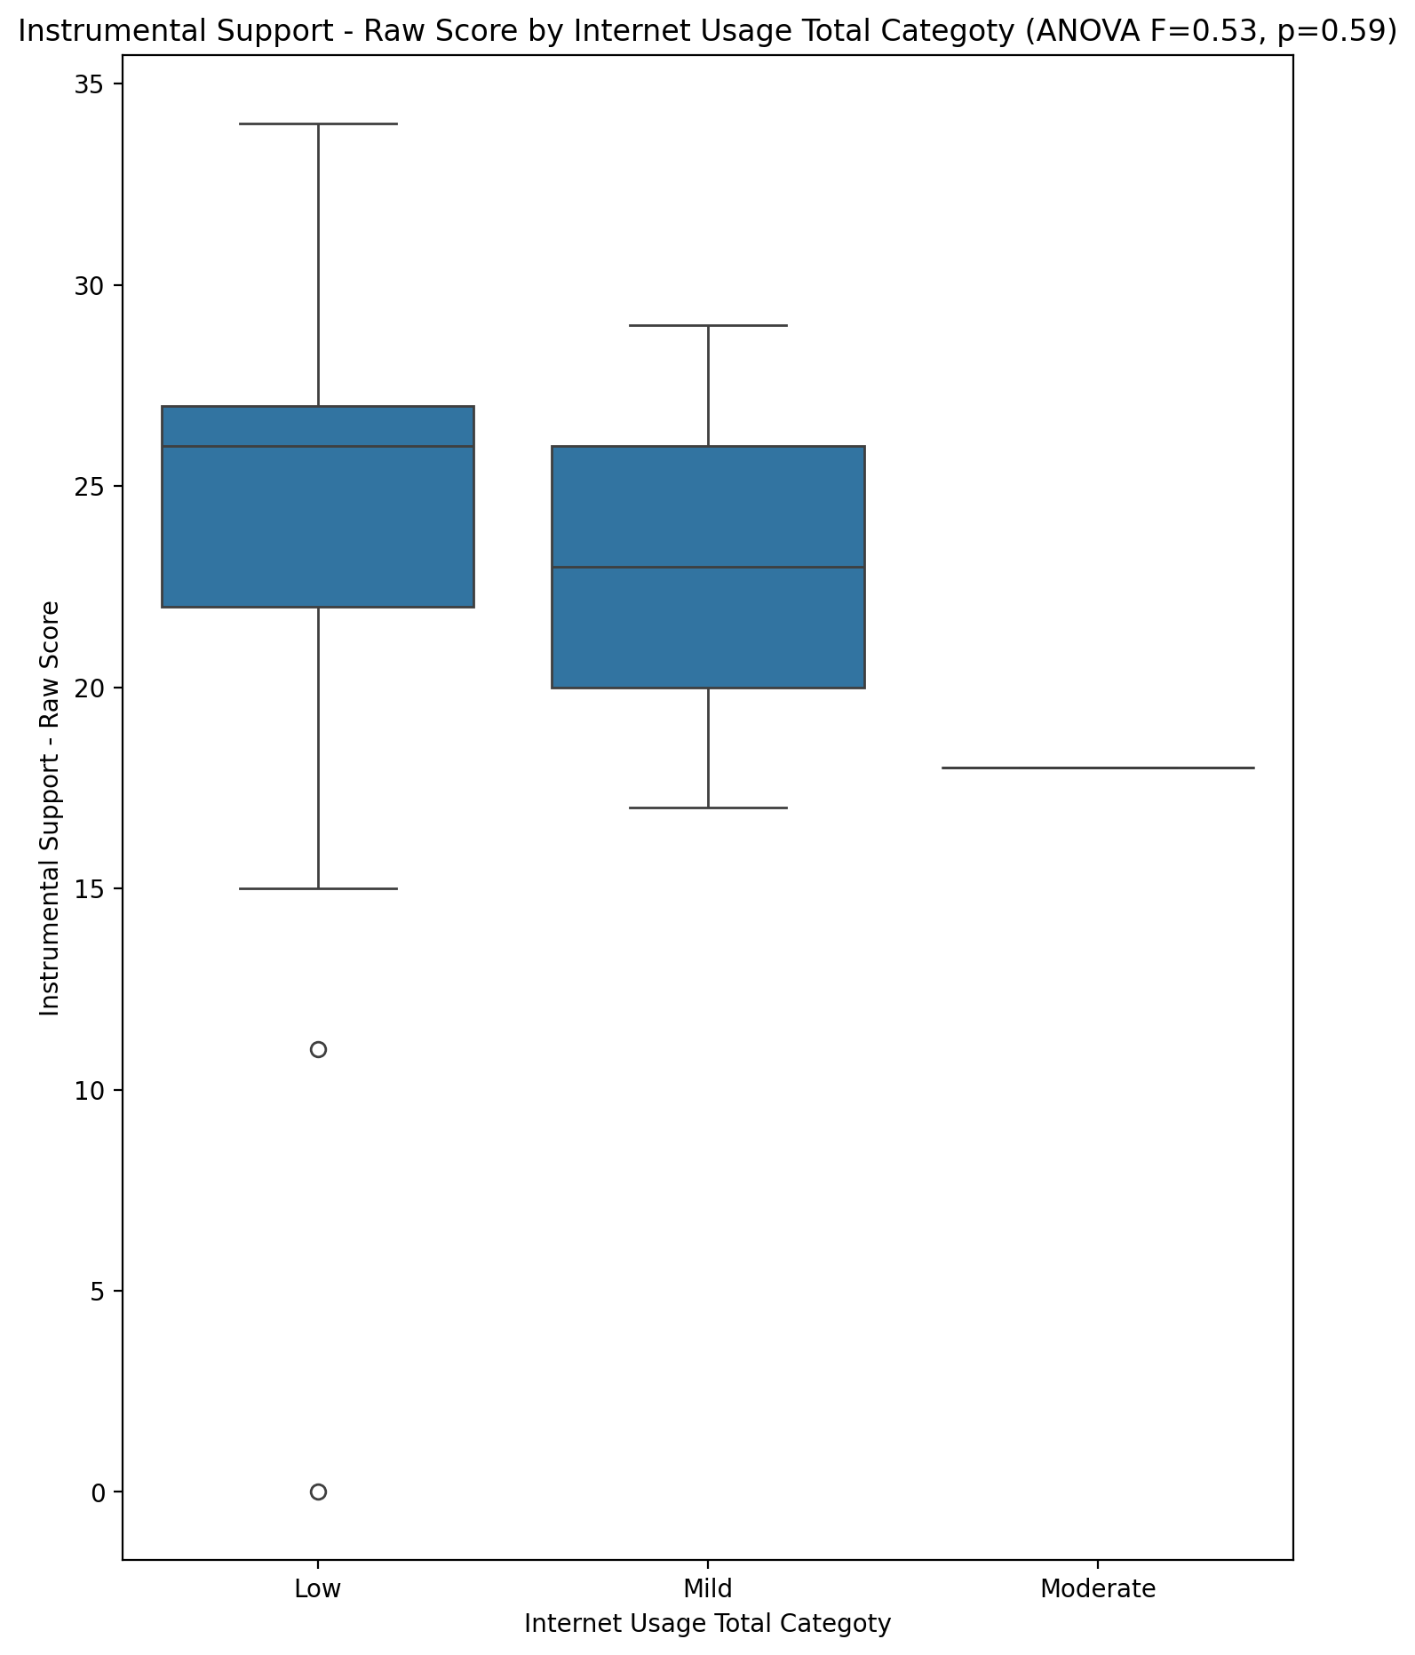

## Emotional Support - T Score vs Internet Usage Total Categoty

Test: anova; statistic: 2.2866327684536016; p-value: 0.11473892427253787;

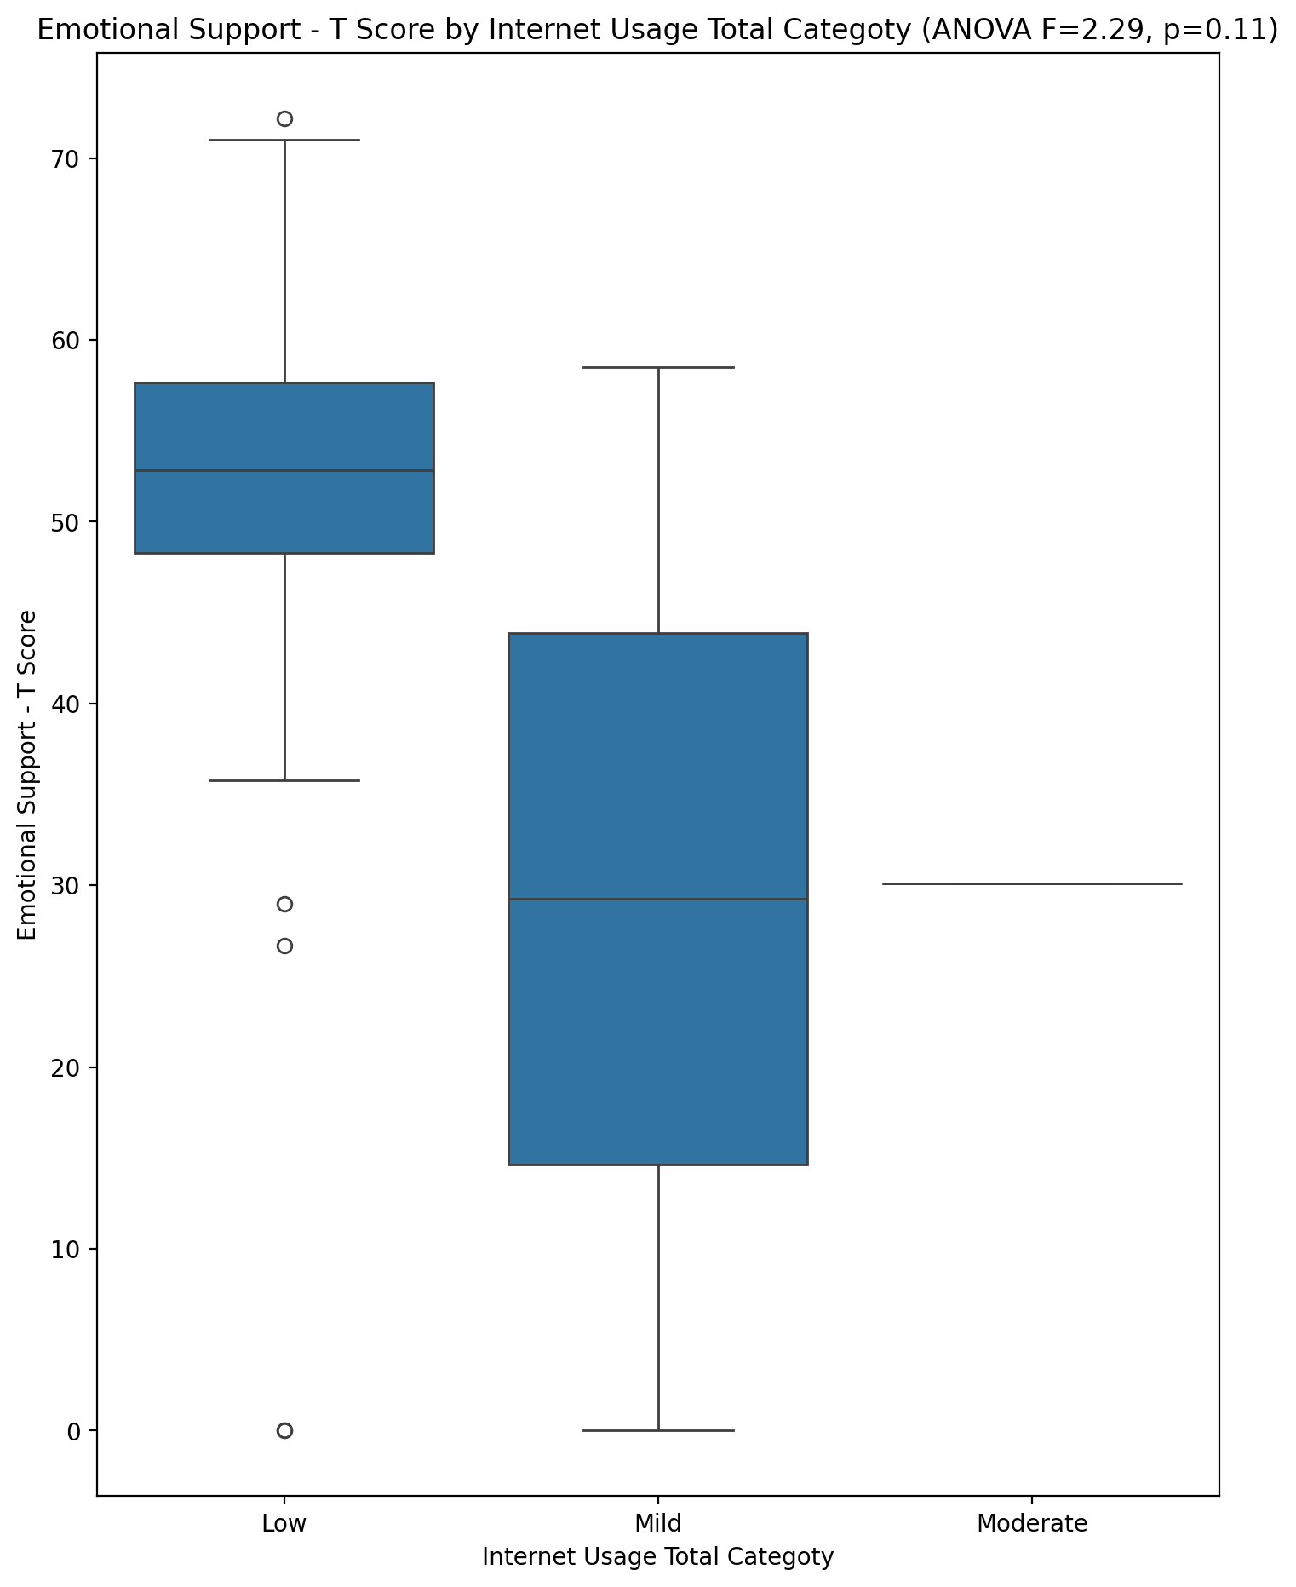

## Informational Support - T Score vs Internet Usage Total Categoty

Test: anova; statistic: 5.063600110741232; p-value: 0.010957988943586409;

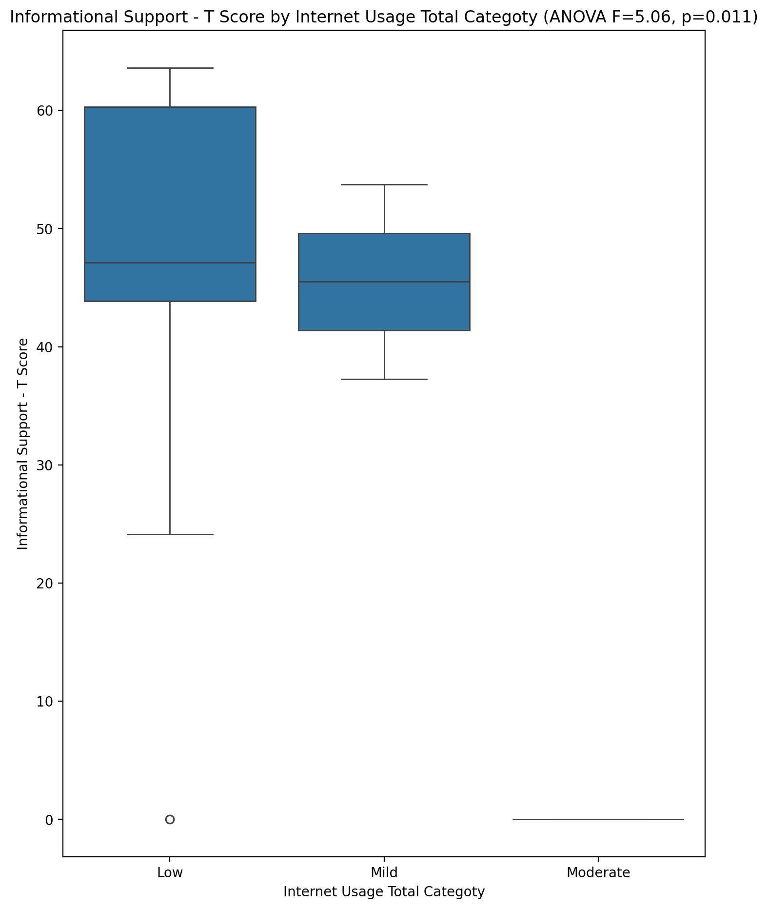

## Instrumental Support - T Score vs Internet Usage Total Categoty

Test: anova; statistic: 0.4778347951398902; p-value: 0.6236188199735975;

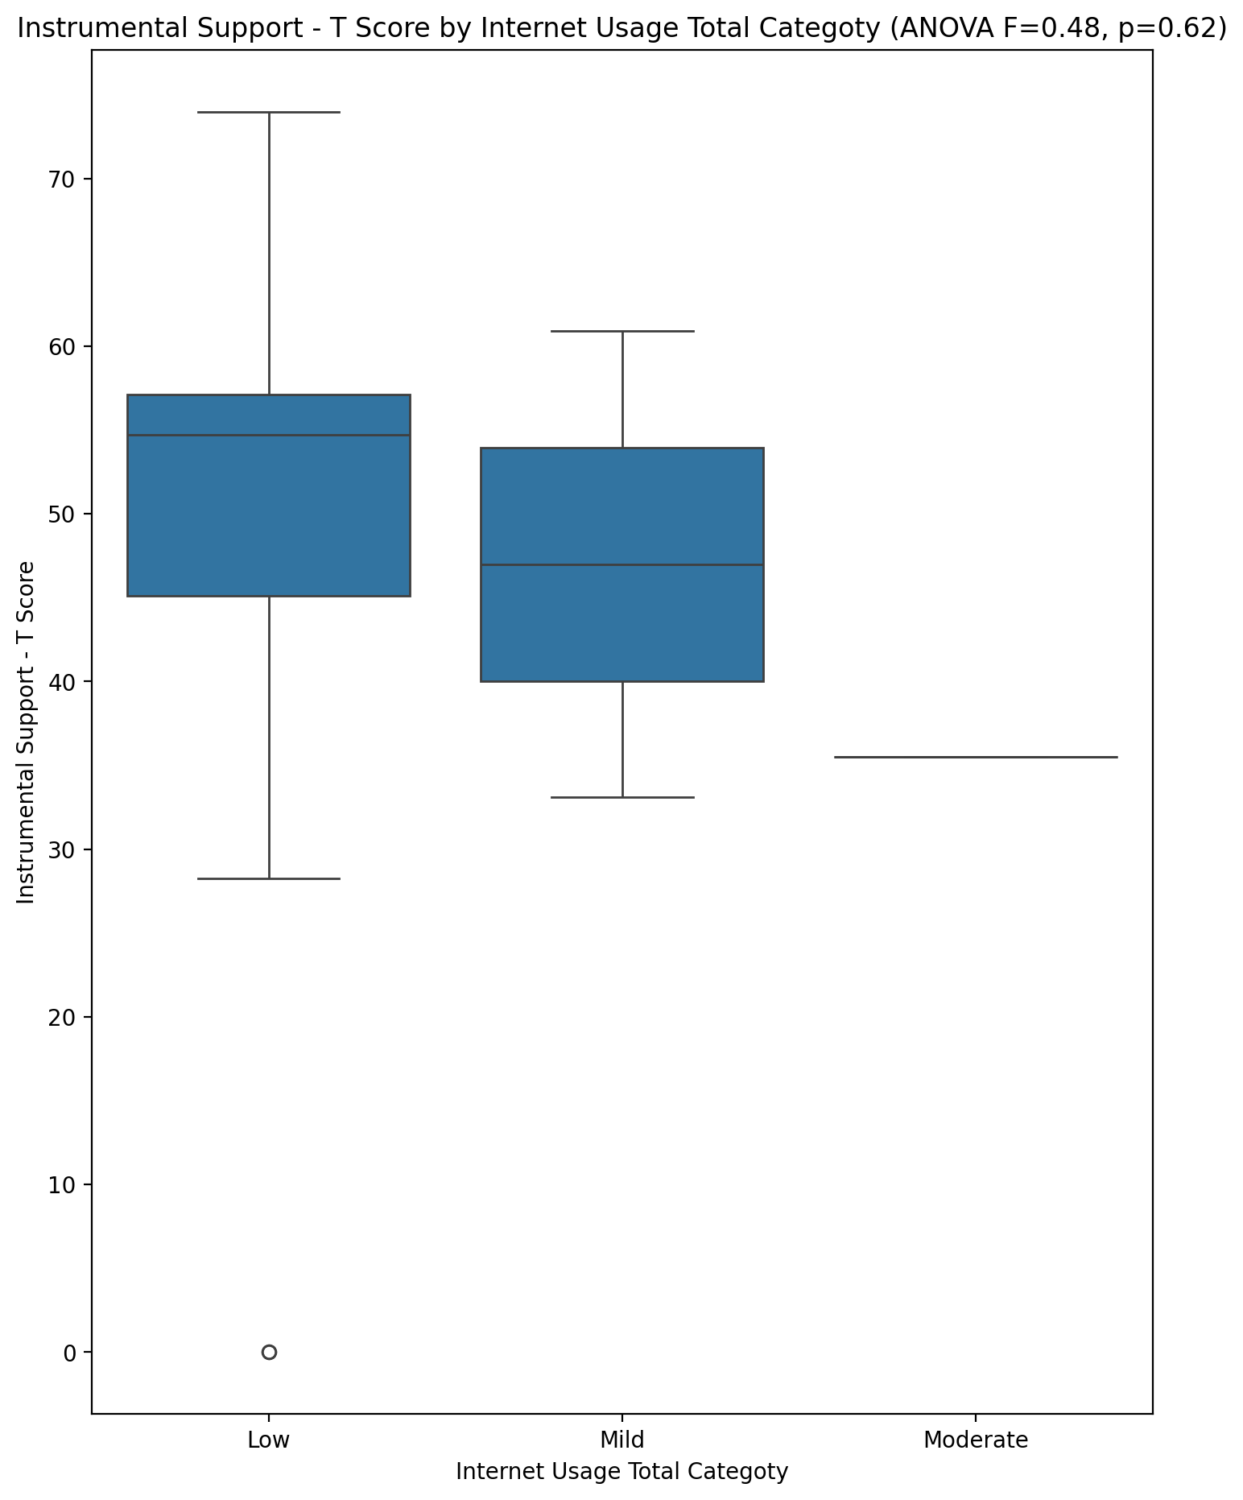

## Perceived Social Support Total T Score vs Internet Usage Total Categoty

Test: anova; statistic: 5.581144908974485; p-value: 0.0072811563406789655;

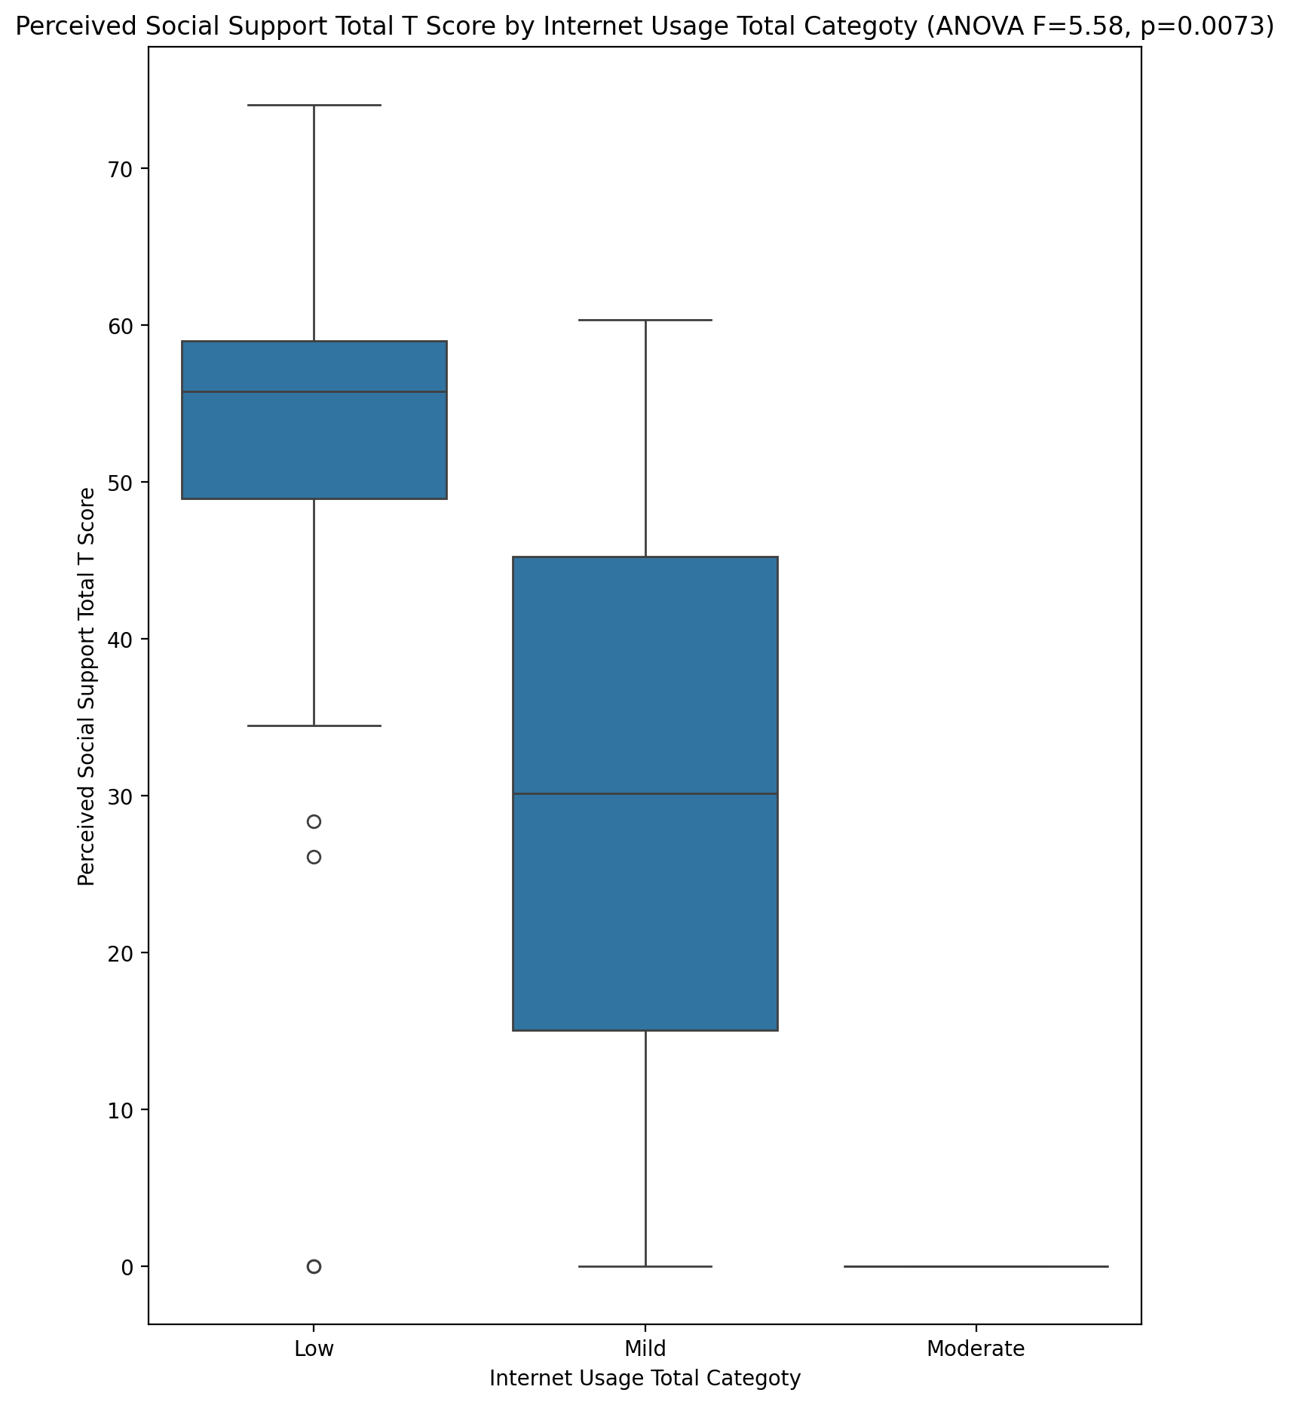

## Emotional Support - Rank vs Internet Usage Total Categoty

Test: chi2; statistic: 11.063541666666666; p-value: 0.19812477144599444;

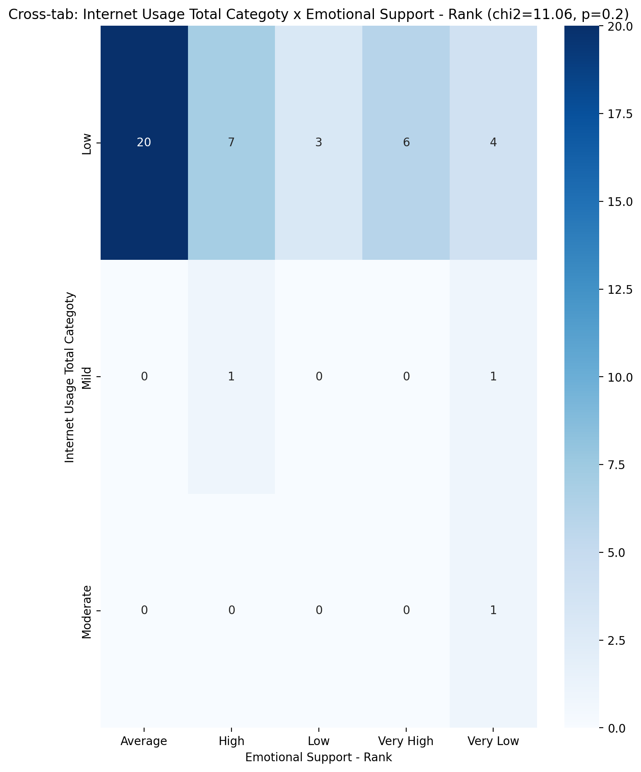

## Informational Support - Rank vs Internet Usage Total Categoty

Test: chi2; statistic: 9.46; p-value: 0.14931255601998514;

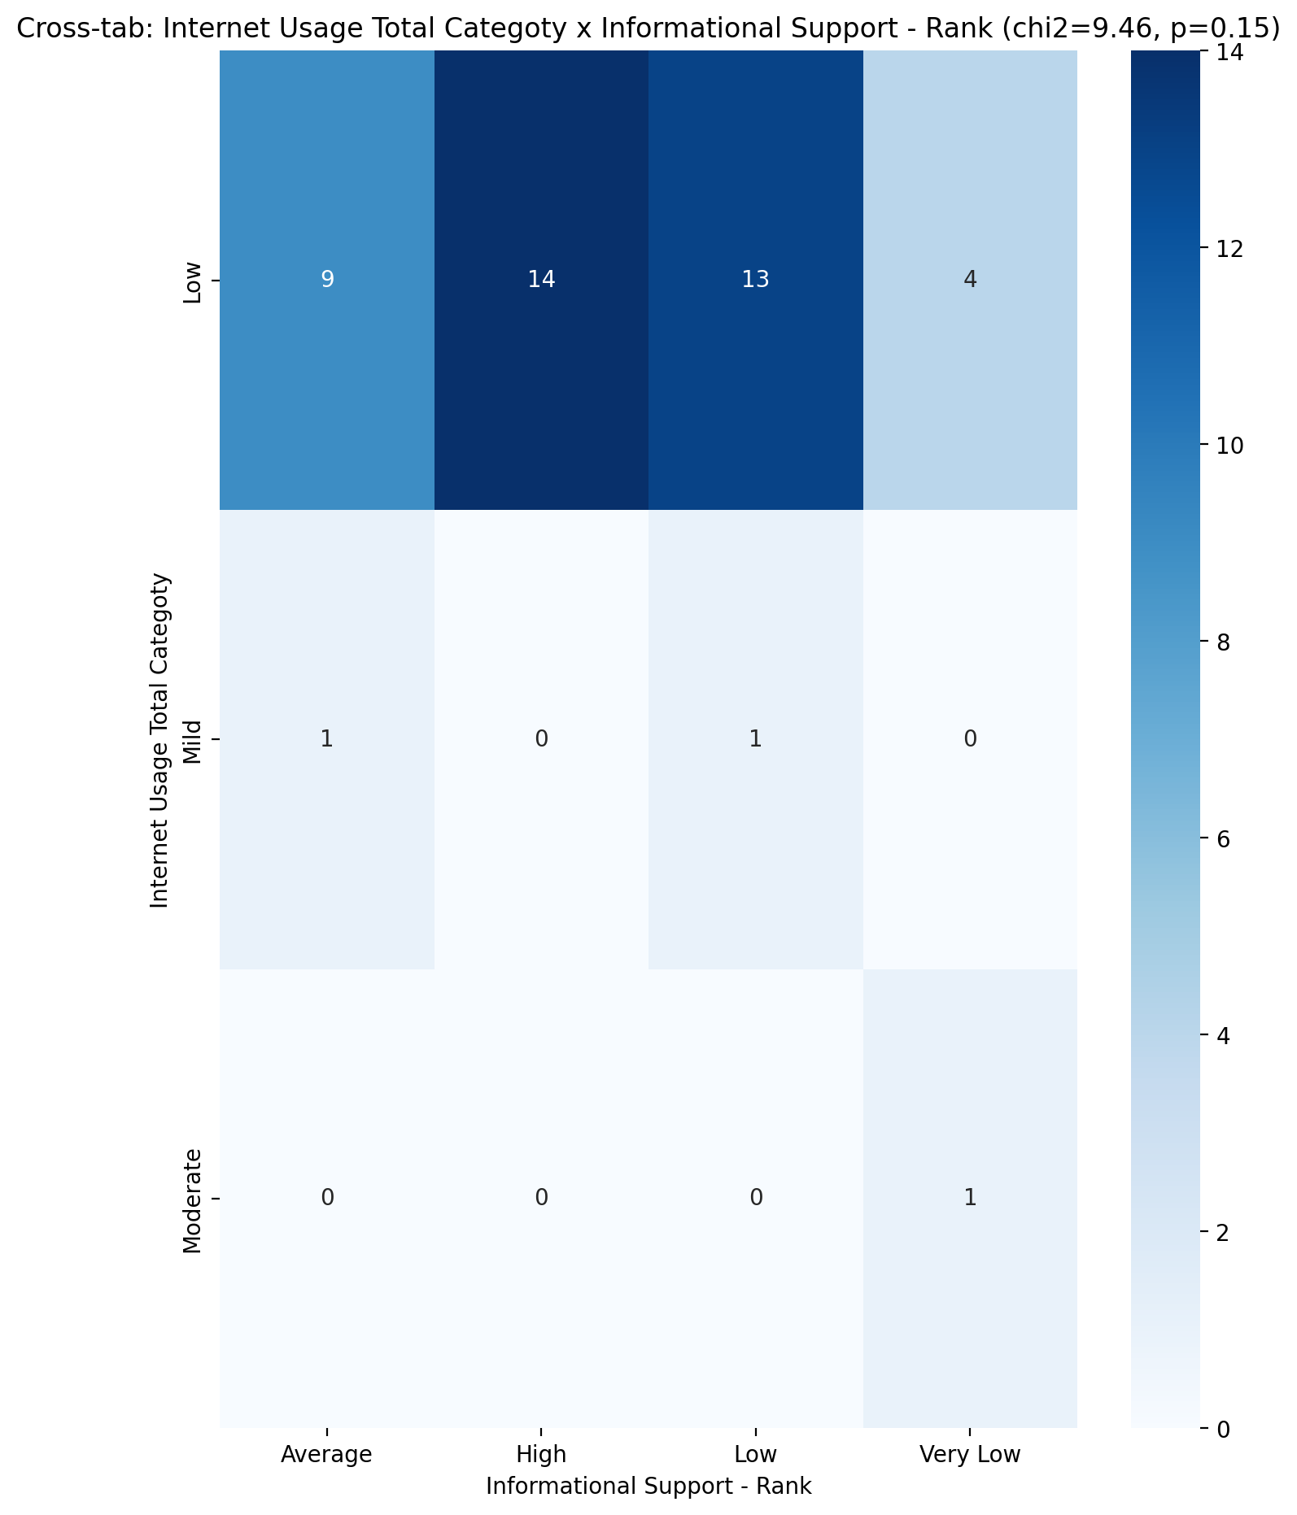

## Instrumental Support - Rank vs Internet Usage Total Categoty

Test: chi2; statistic: 6.702941176470588; p-value: 0.5689956686983678;

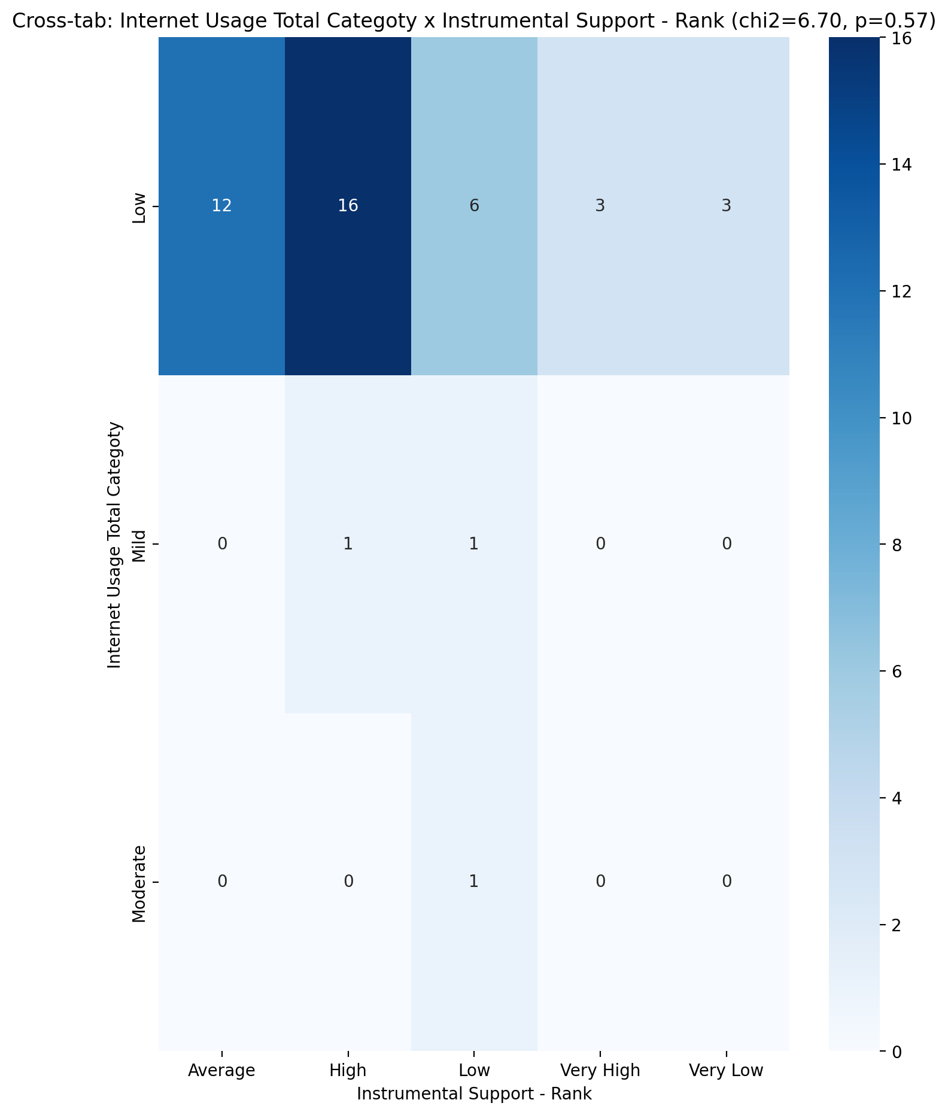

## Perceived Social Support TOTAL - Rank vs Internet Usage Total Categoty

Test: chi2; statistic: 10.75; p-value: 0.21627083917441858;

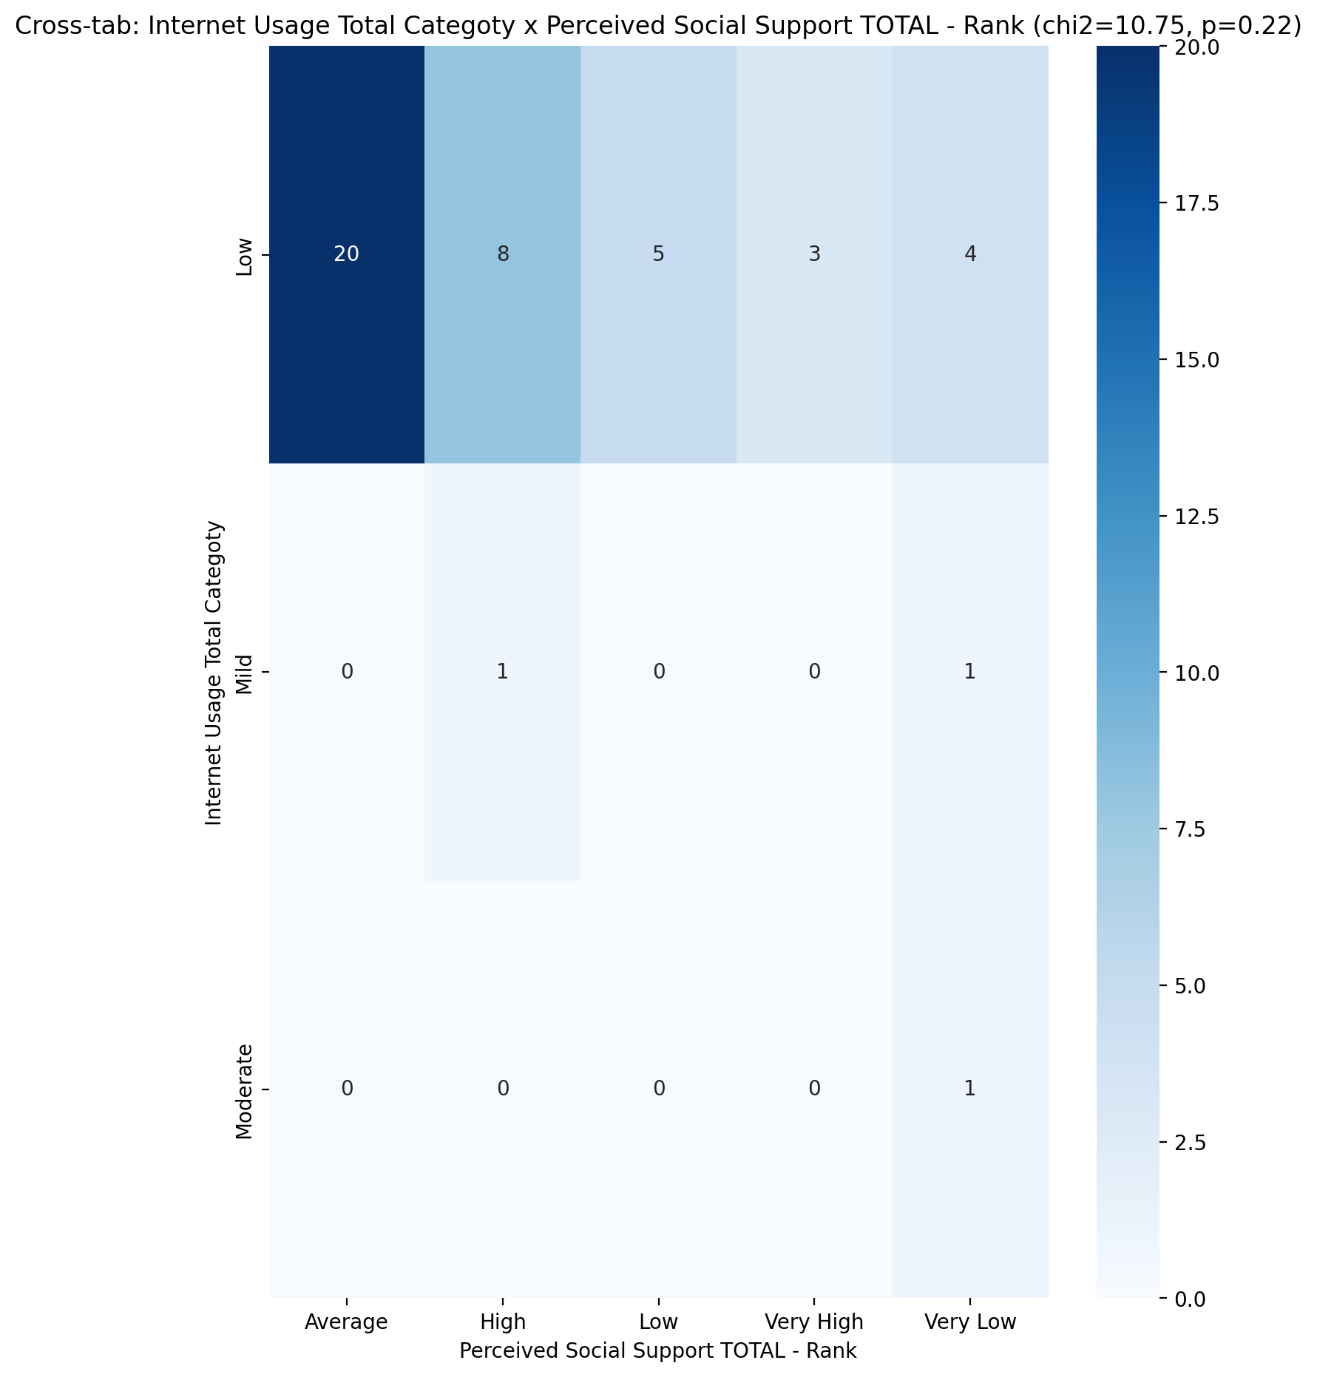

## Power Self Concept - Real Self Concept Score vs Internet Usage Total Categoty

Test: anova; statistic: 0.09819024469008977; p-value: 0.9066942395120291;

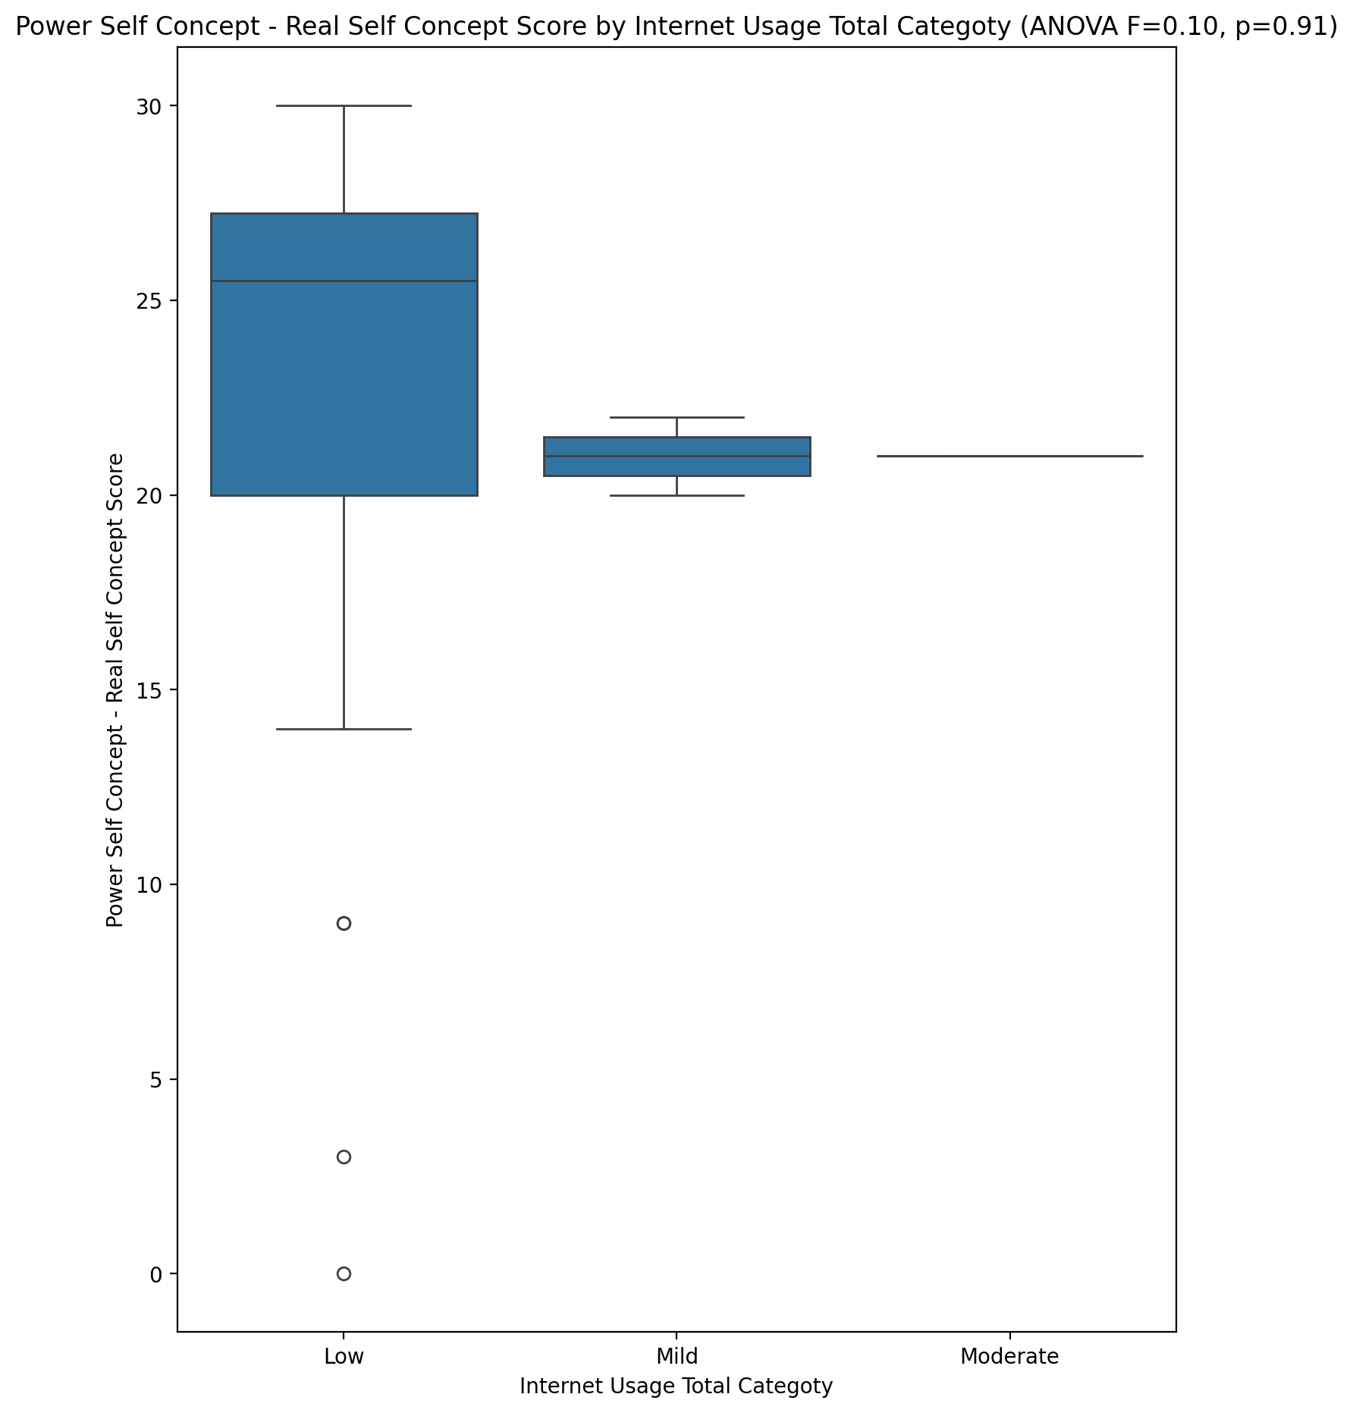

## Power Self Concept - Ideal Self Concept score vs Internet Usage Total Categoty

Test: anova; statistic: 0.034339750409481756; p-value: 0.9662716205019083;

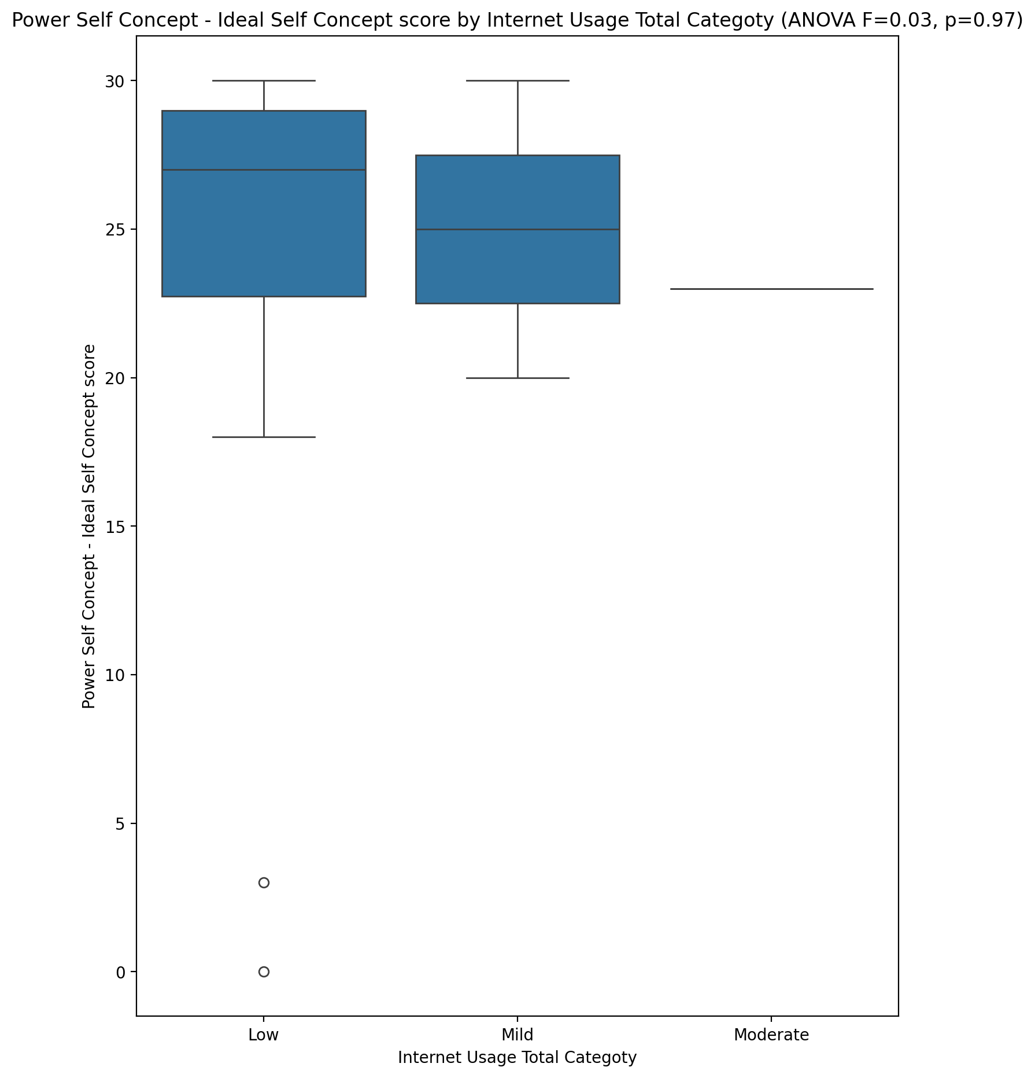

## Power Self Concept – Social Self Concept Score vs Internet Usage Total Categoty

Test: anova; statistic: 0.13212291952436095; p-value: 0.8766140875950245;

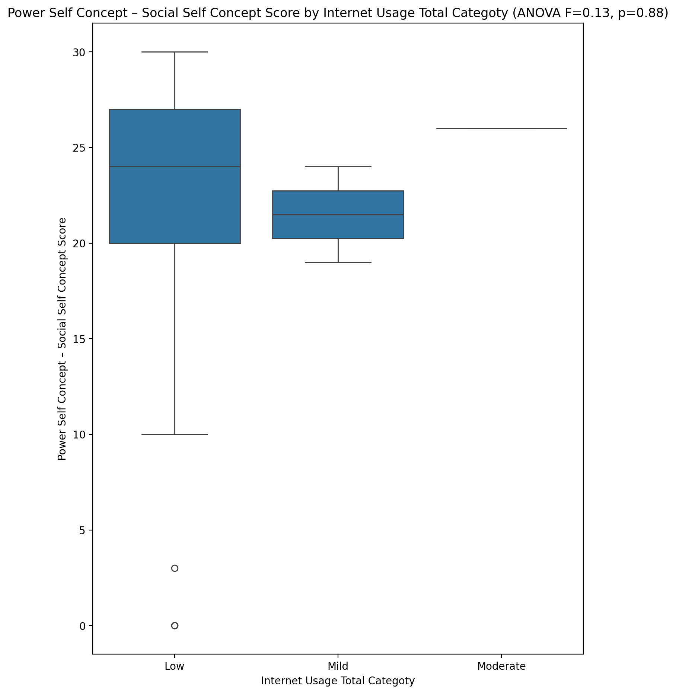

## Social Self Concept - Real Self Concept Score vs Internet Usage Total Categoty

Test: anova; statistic: 0.07107815513354514; p-value: 0.9315064627326561;

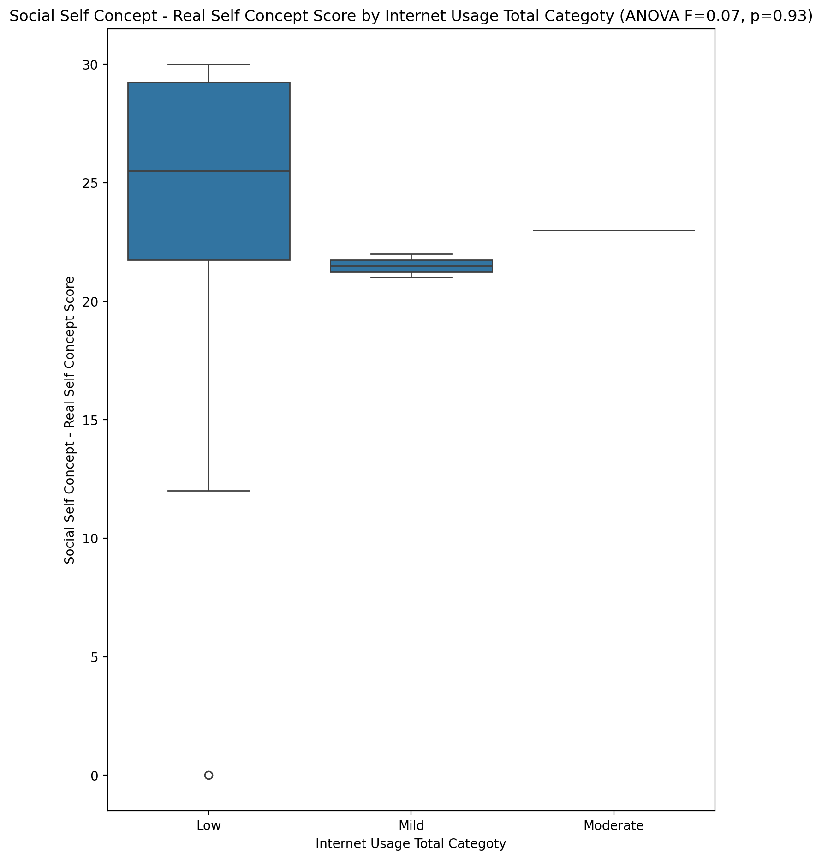

## Social Self Concept – Social Self Concept Score vs Internet Usage Total Categoty

Test: anova; statistic: 0.09338194821496451; p-value: 0.9110435122127671;

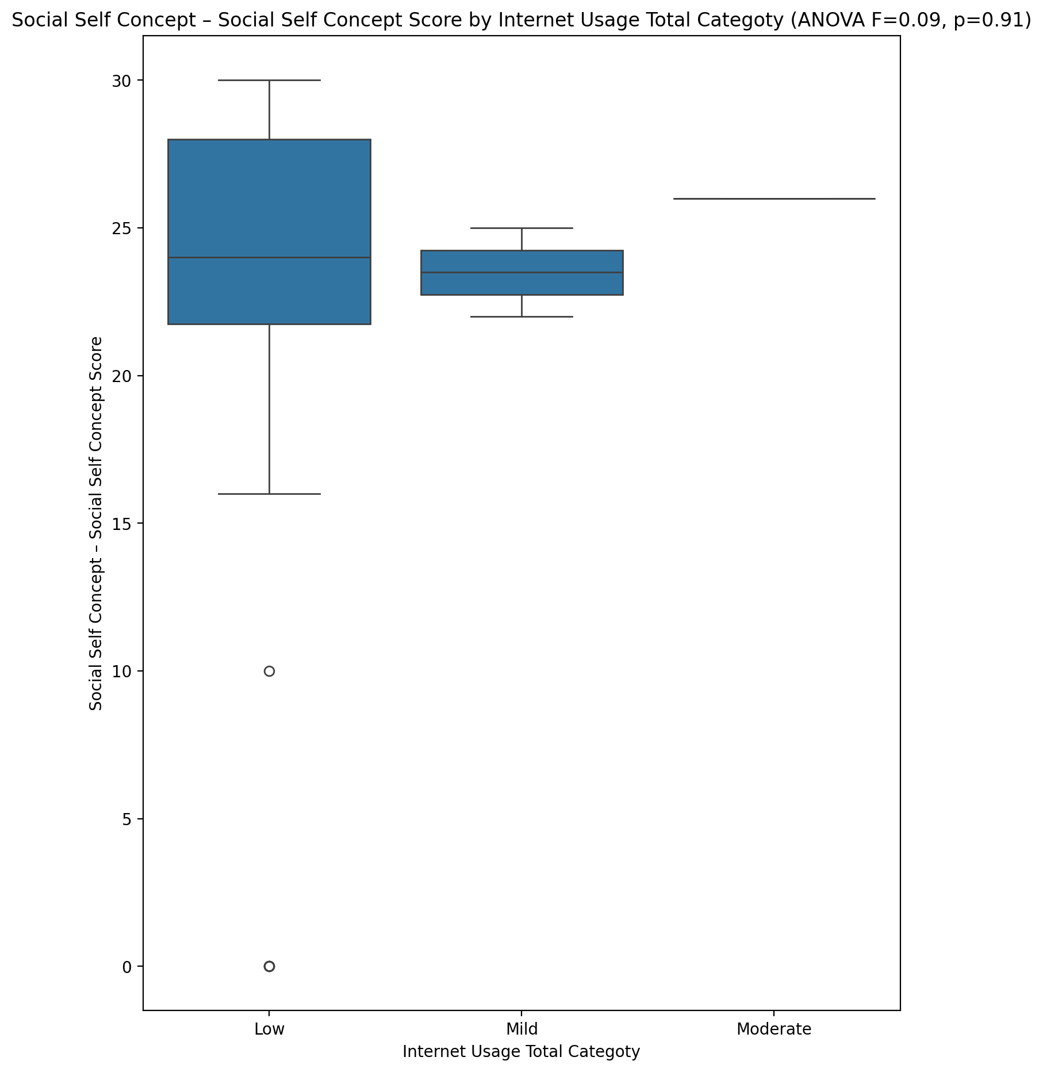

## Ability Self Concept - Real Self Concept Score vs Internet Usage Total Categoty

Test: anova; statistic: 0.39531019416911656; p-value: 0.6760730352371773;

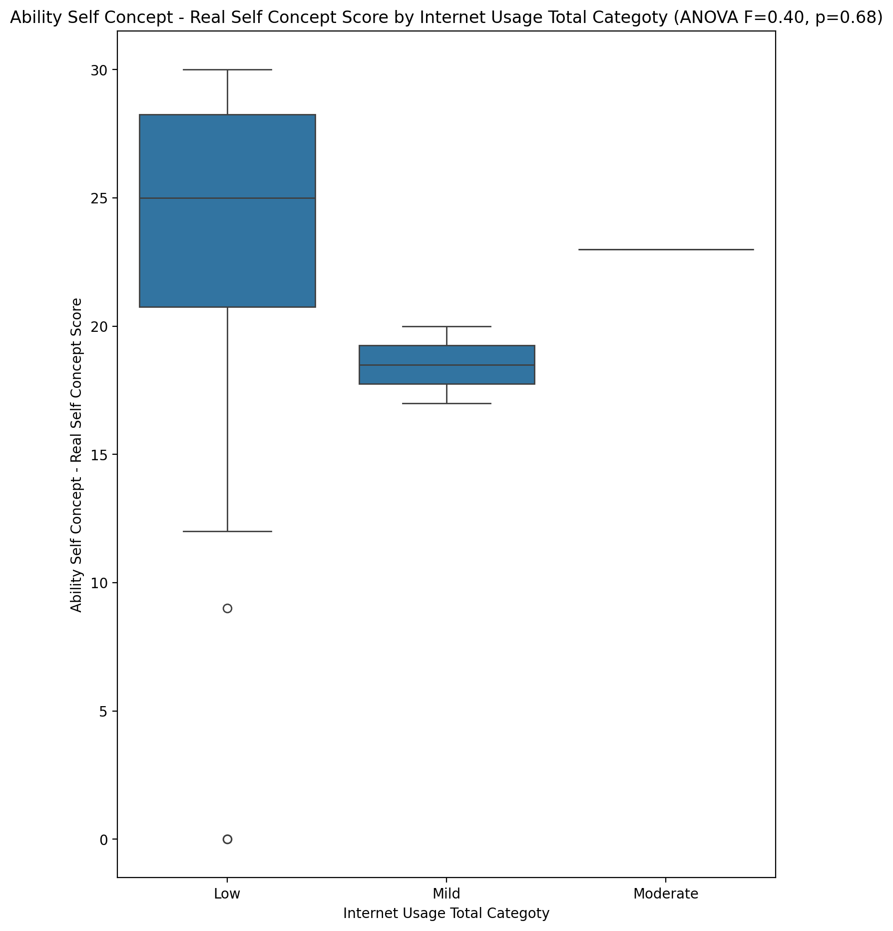

## Ability Self Concept - Ideal Self Concept Score vs Internet Usage Total Categoty

Test: anova; statistic: 0.04556376848949456; p-value: 0.9555081882346135;

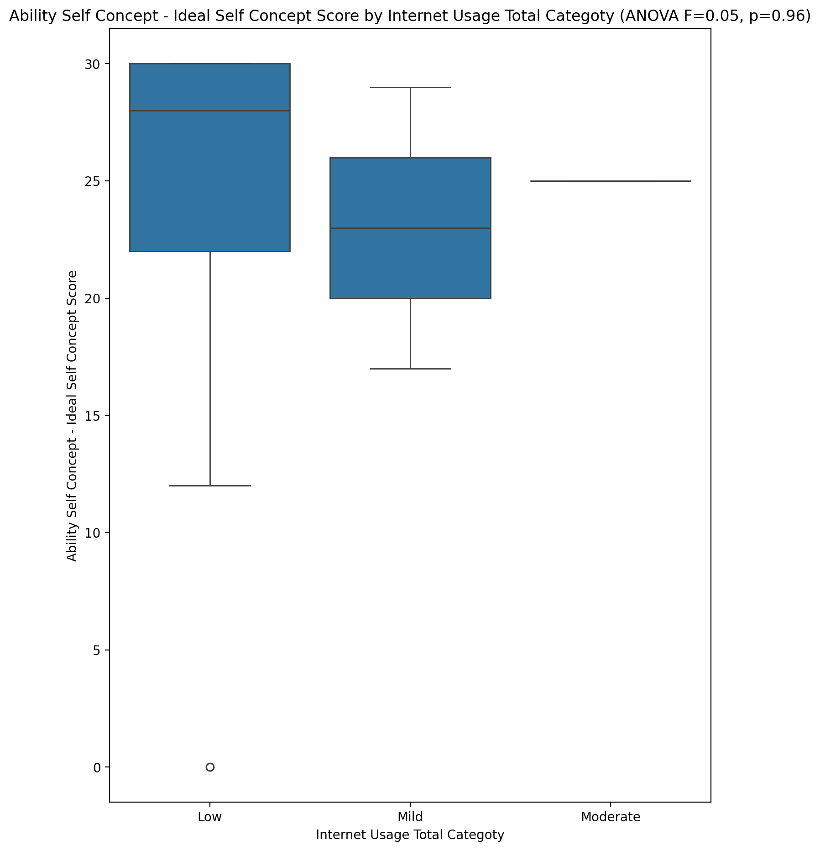

## Ability Self Concept – Social Self Concept Score vs Internet Usage Total Categoty

Test: anova; statistic: 0.1351797178277876; p-value: 0.8739562803524449;

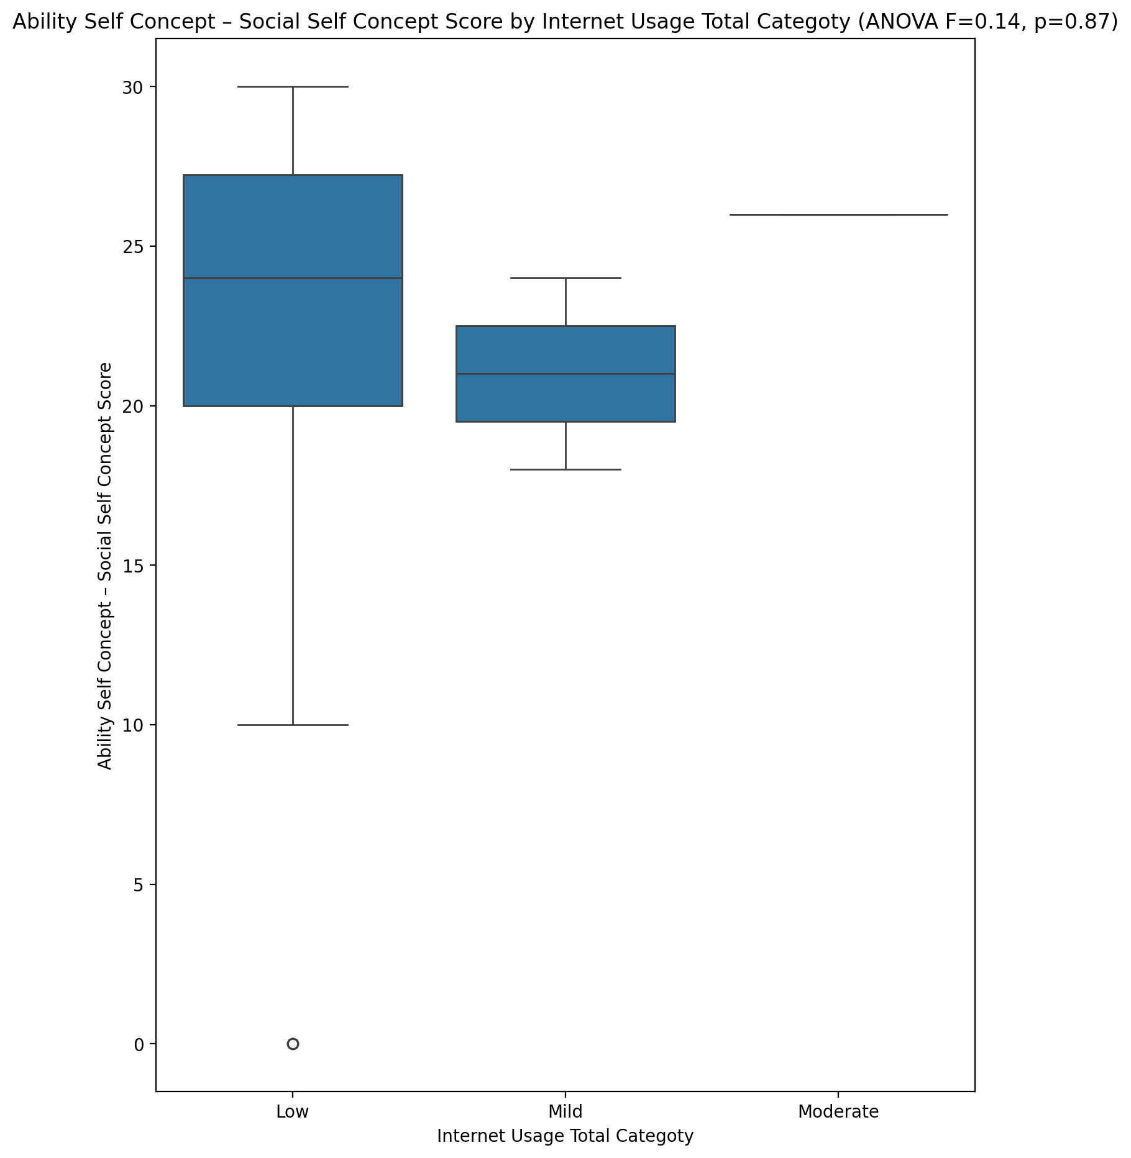

## Physical Self Concept - Real Self Concept Score vs Internet Usage Total Categoty

Test: anova; statistic: 0.13833030000433022; p-value: 0.8712257832953082;

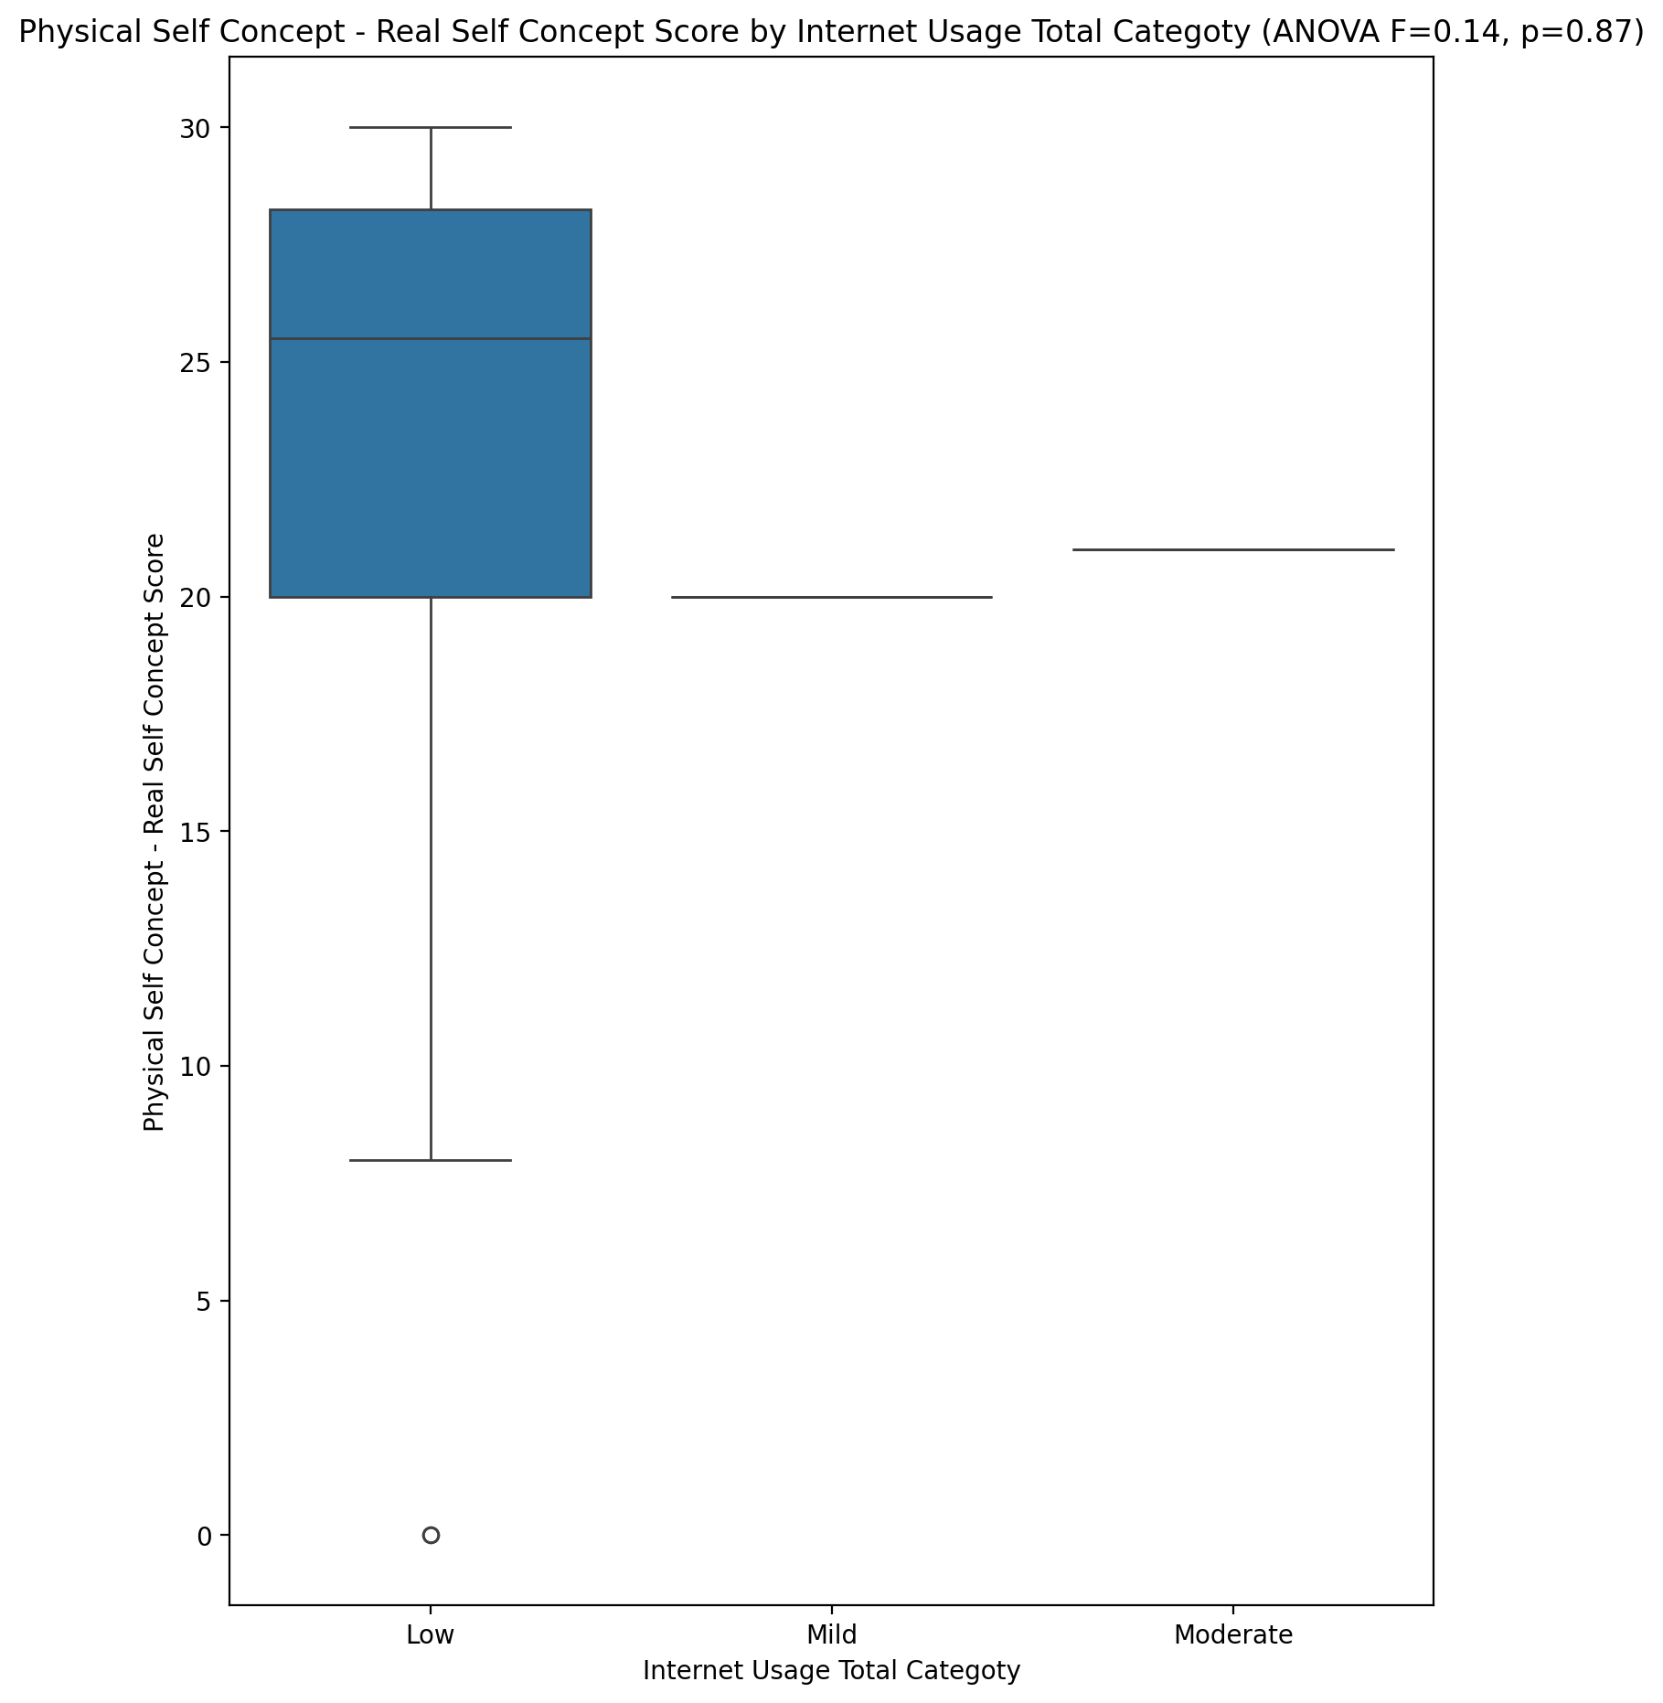

## Physical Self Concept – Ideal Self Concept Score vs Internet Usage Total Categoty

Test: anova; statistic: 0.056631141680002724; p-value: 0.9450181781319819;

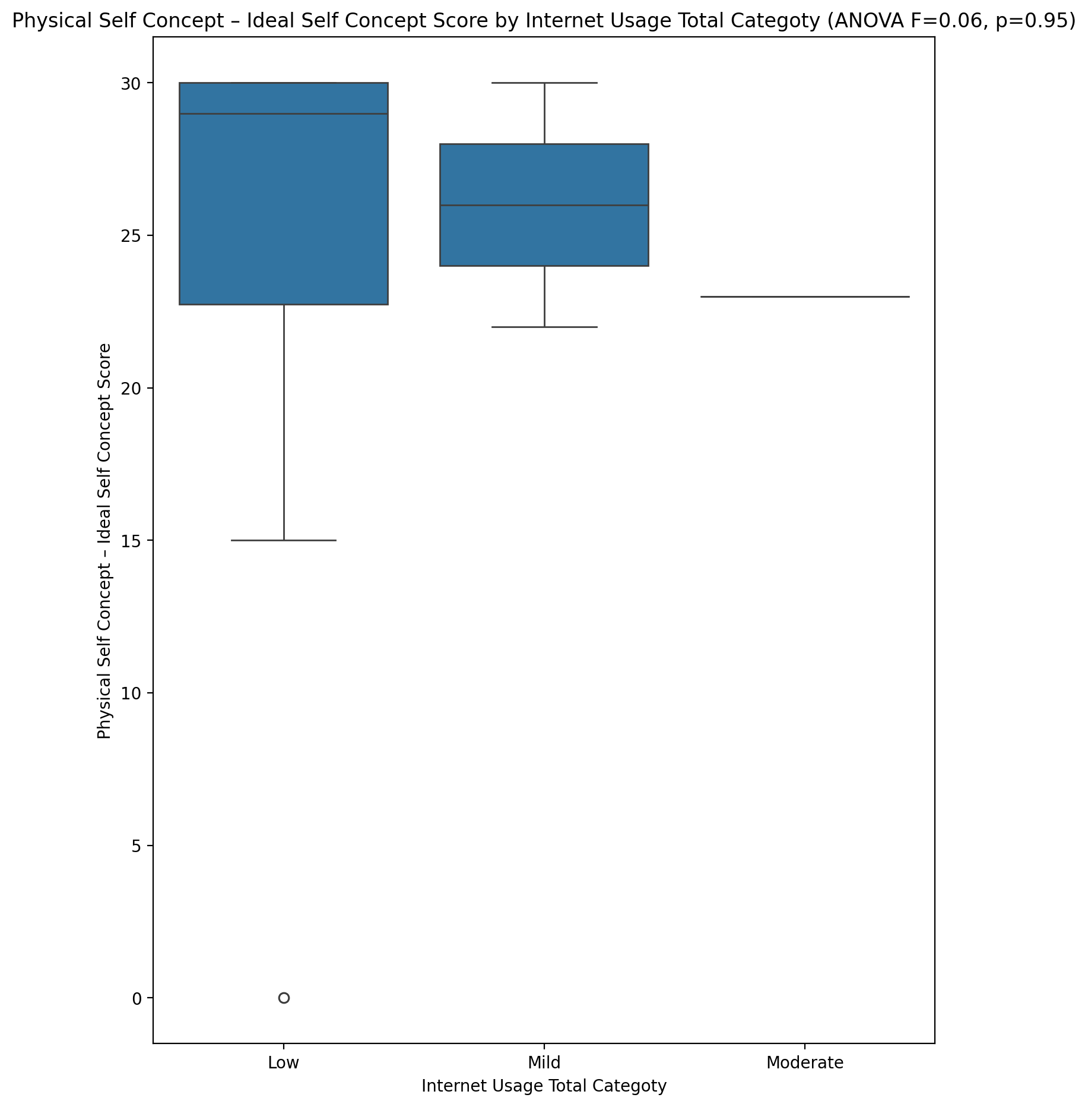

## Physical Self Concept – Social Self Concept Score vs Internet Usage Total Categoty

Test: anova; statistic: 0.31107694030360383; p-value: 0.7344138982922614;

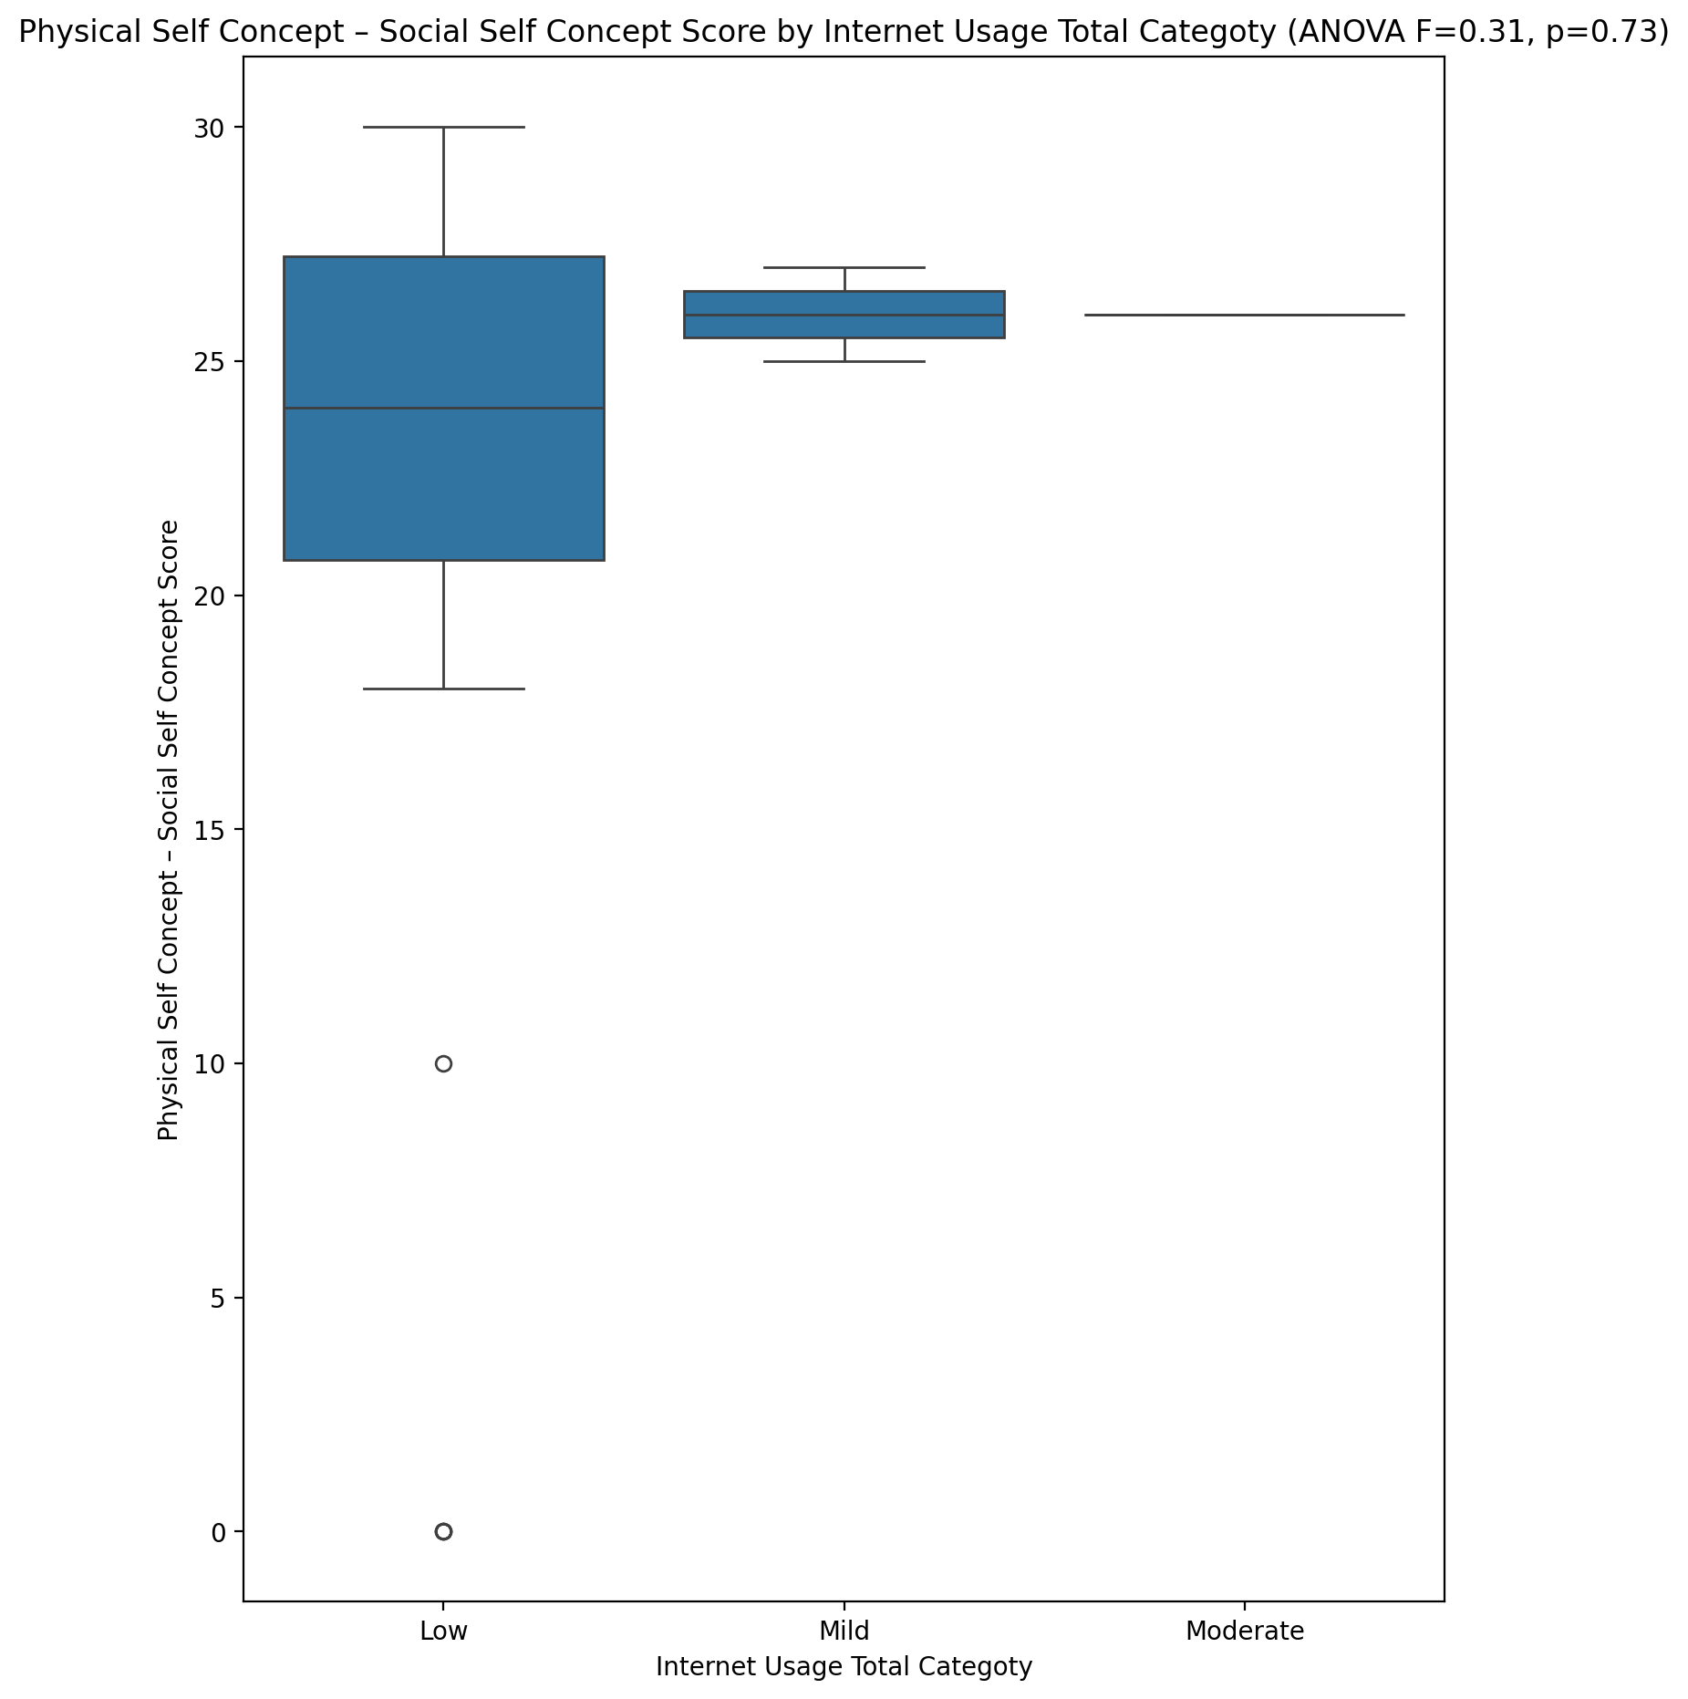

## Psychological Self Concept - Real Self Concept Score vs Internet Usage Total Categoty

Test: anova; statistic: 0.46526465335131145; p-value: 0.631324449145082;

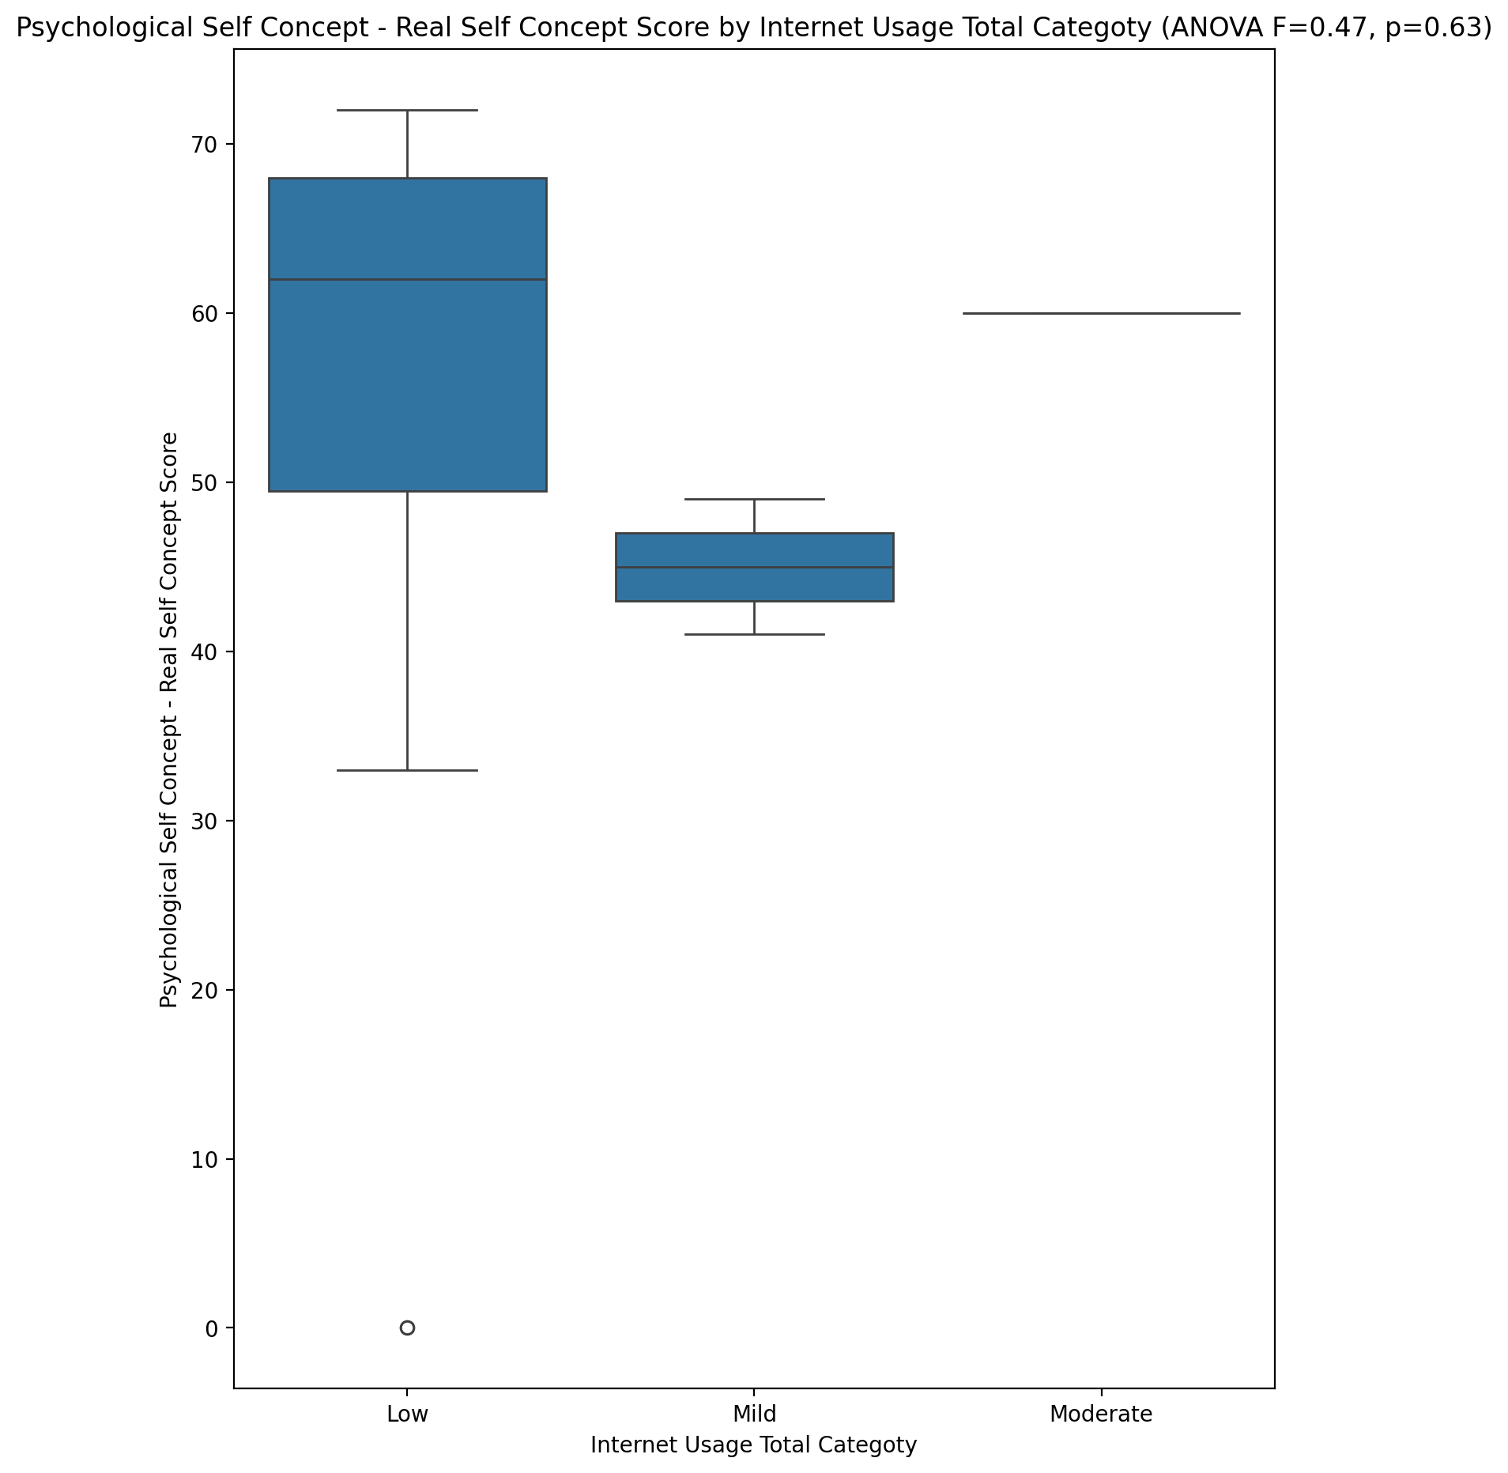

## Psychological Self Concept – Ideal Self Concept Score vs Internet Usage Total Categoty

Test: anova; statistic: 0.044837766750139514; p-value: 0.9562005753266881;

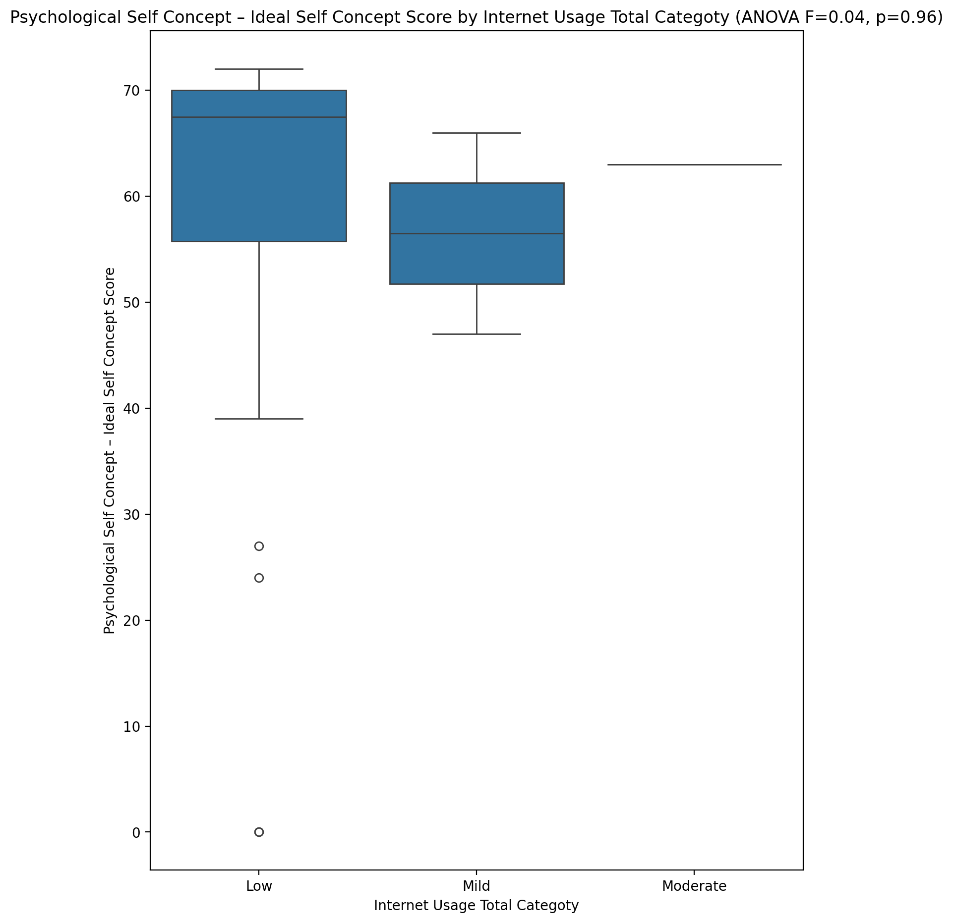

## Psychological Self Concept – Social Self Concept Score vs Internet Usage Total Categoty

Test: anova; statistic: 0.051702375902128554; p-value: 0.949674806002061;

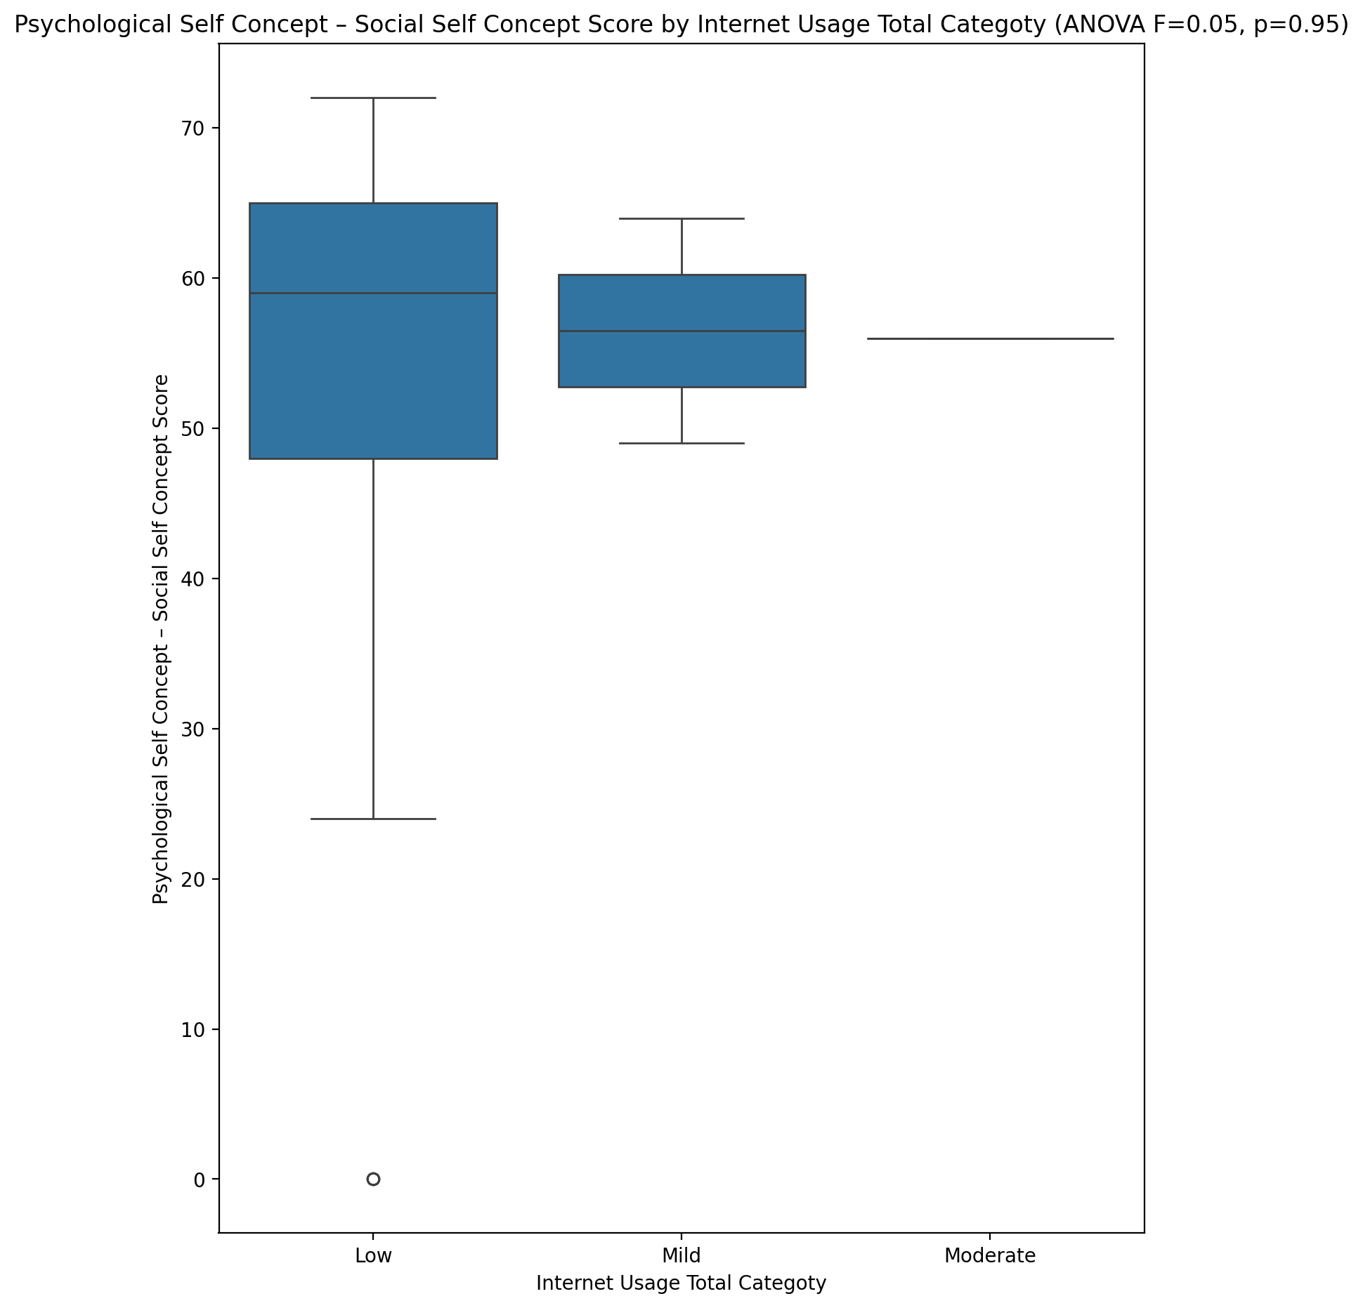

## Real Self Concept Total Score vs Internet Usage Total Categoty

Test: anova; statistic: 0.24240527373720985; p-value: 0.7858824685838809;

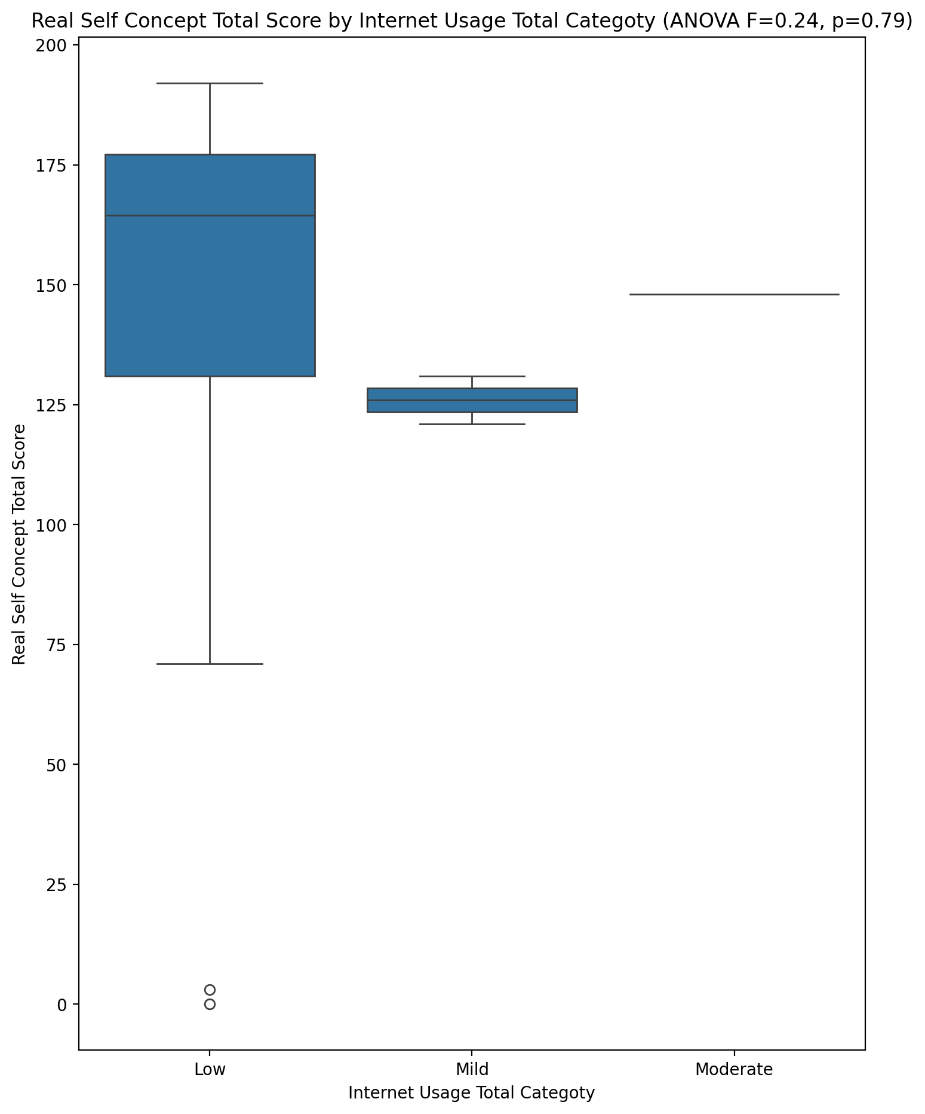

## Ideal Self Concept Total Score vs Internet Usage Total Categoty

Test: anova; statistic: 0.011054835721404954; p-value: 0.989009064965789;

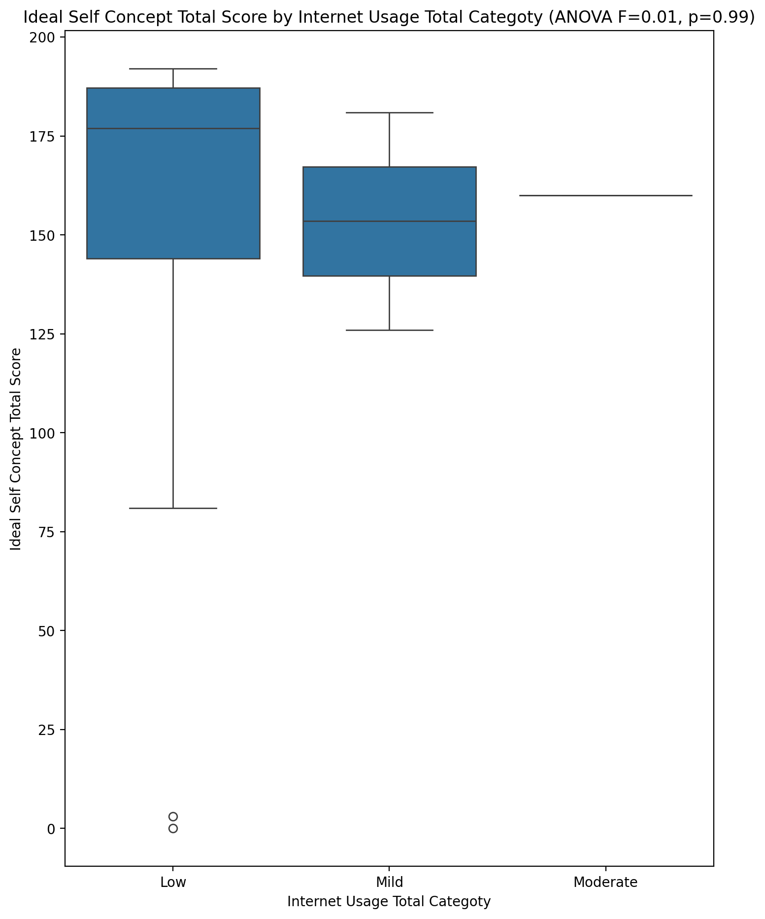

## Social Self Concept Total Score vs Internet Usage Total Categoty

Test: anova; statistic: 0.08640938866157168; p-value: 0.917389391983986;

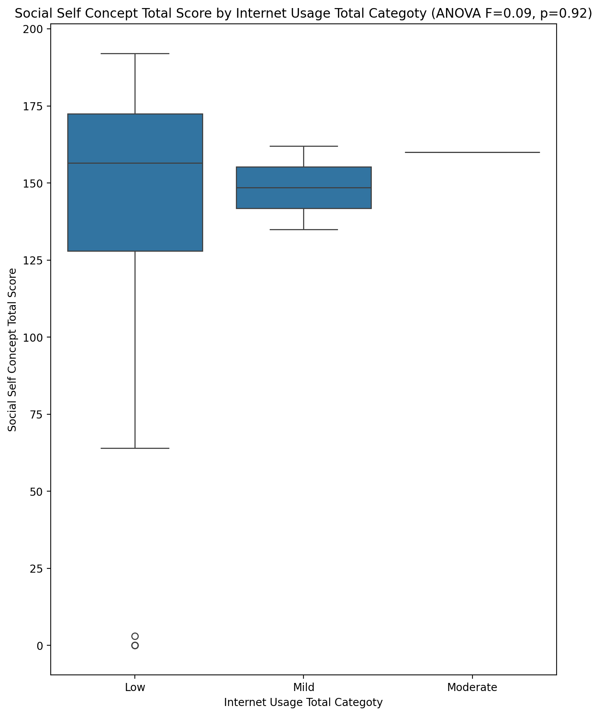

## Ideal Self Concept Total Category vs Internet Usage Total Categoty

Test: chi2; statistic: 1.8162298387096774; p-value: 0.7695117025145706;

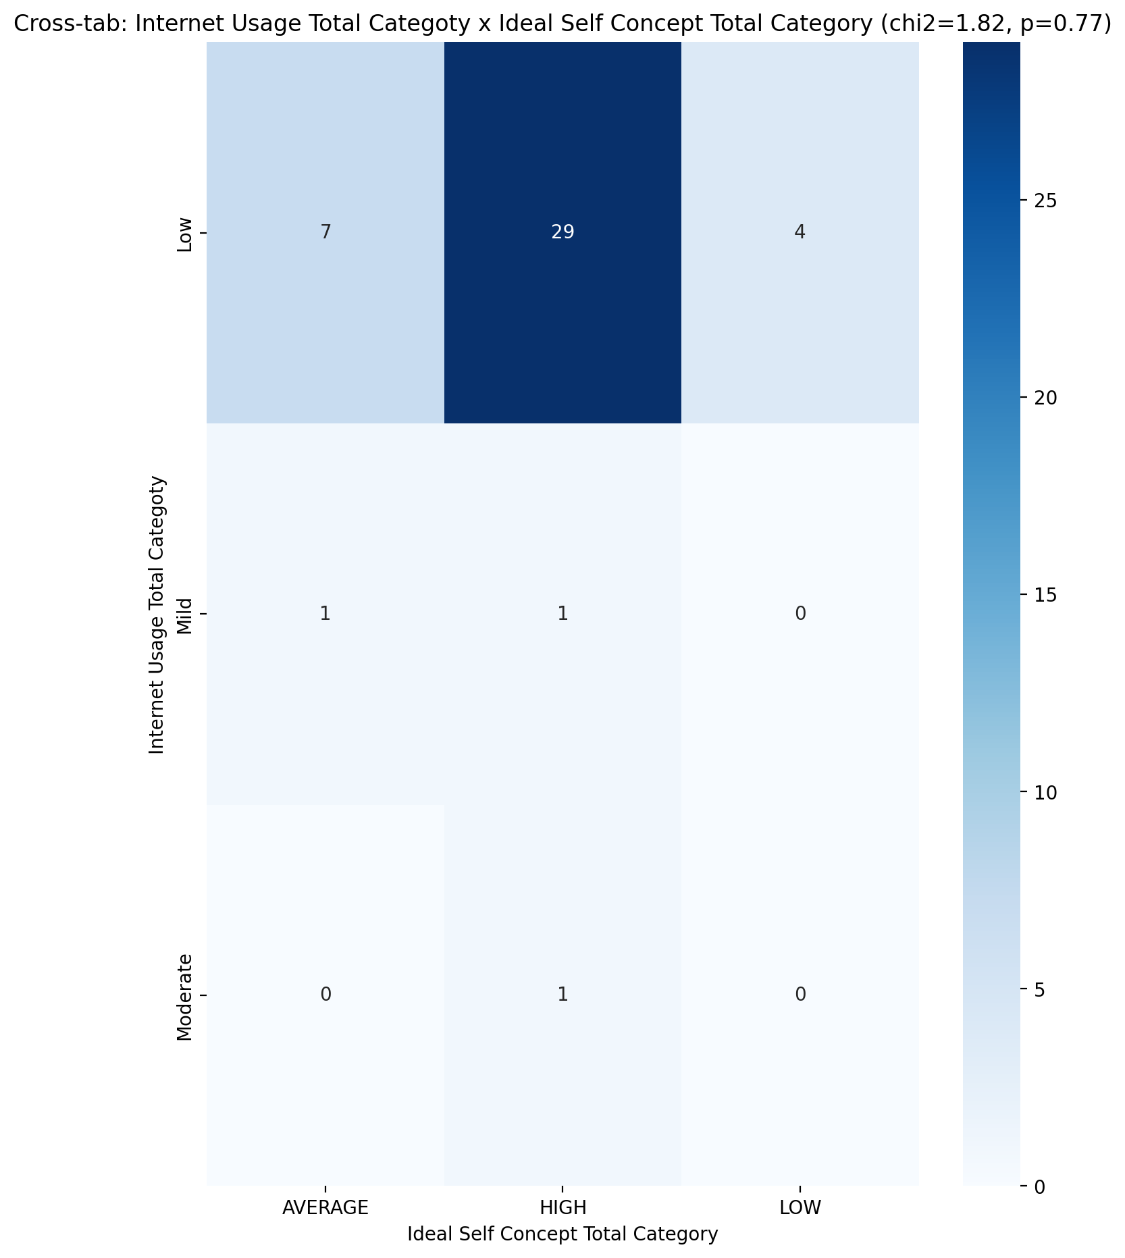

## Perceived Social Stress Score vs Internet Usage Total Categoty

Test: anova; statistic: 0.5503641024309354; p-value: 0.5810446340805411;

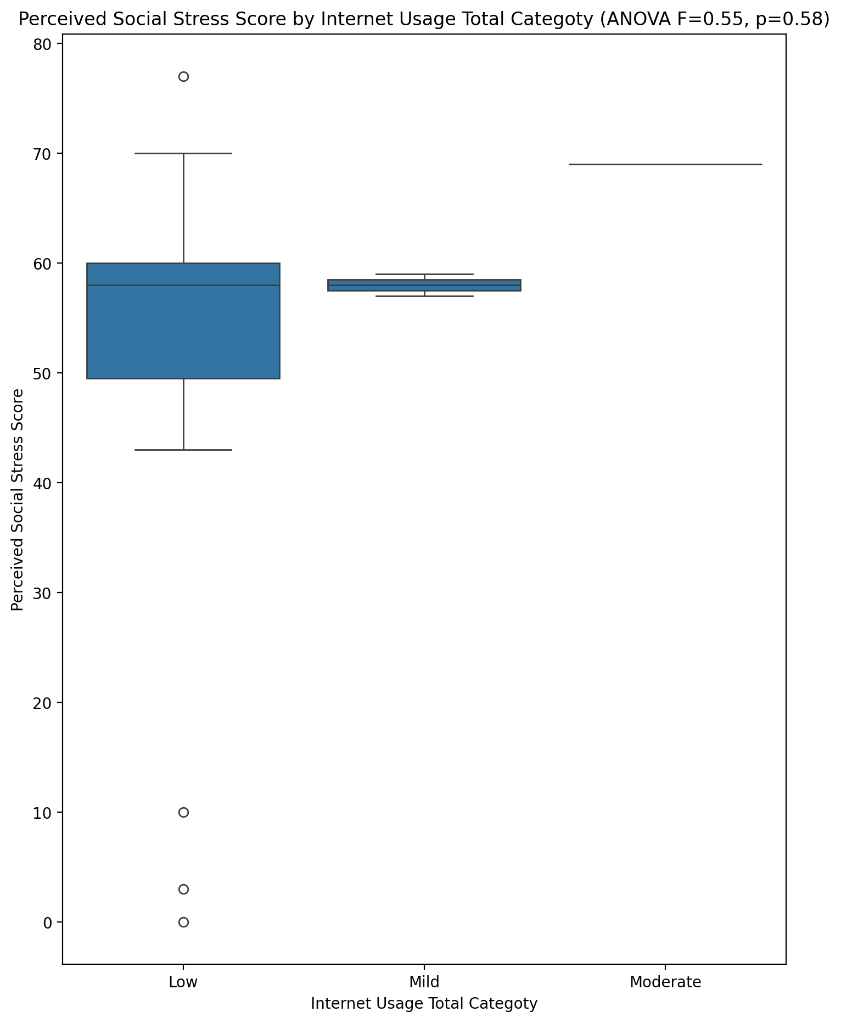

## Perceived Social Stress Category vs Internet Usage Total Categoty

Test: chi2; statistic: 0.241875; p-value: 0.8860893384459212;

